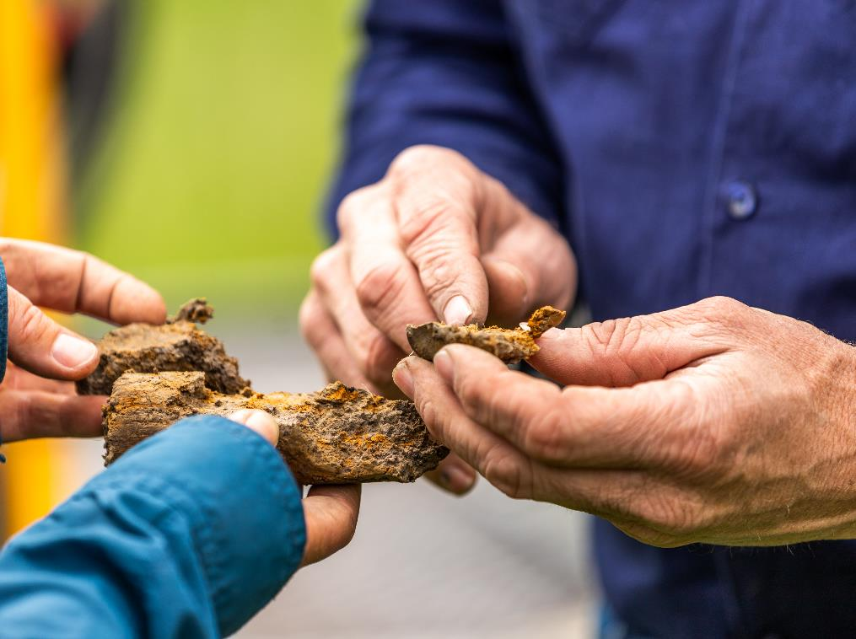Safeguard Mechanism

Trade-exposed baseline-adjusted facility audit report template

Version 1.0 – July 2024

## Disclaimer

This template sets out how the Clean Energy Regulator (CER) expects an assurance engagement report to be structured for an audit of an application for an trade-exposed baseline-adjusted facility determination under the Safeguard Mechanism. It is not mandatory to follow this template, but it is recommended.

It is the responsibility of auditors to ensure their audit reports meet legislative requirements.

Where text is included within brackets, for example [audited body], information **must** be provided in line with the suggested text.

Some parts of the template are optional and the auditor should exercise their own discretion as to whether to use them. These parts are marked in brackets as **[Optional]**. The auditor will need to ensure that the audit report includes all specified information.

The audit must be conducted in accordance with the relevant requirements for assurance engagements under:

* ASQM 1 - Quality Management for Firms that Perform Audits or Reviews of Financial Reports and Other Financial Information, or Other Assurance or Related Services Engagements
* ASQM 2 - Engagement Quality Reviews
* the National Greenhouse and Energy Reporting (Audit) Determination 2009 (NGER Audit Determination)
* relevant national and international audit standards, including:
  + ASAE 3000 *Assurance Engagements Other than Audits of Reviews of Historical Financial Information*
  + ASAE 3100 *Compliance Engagements*
  + ASAE 3410 *Assurance Engagements on Greenhouse Gas Statements*
* Please note, only some components of ASAE 3410 will be relevant. Auditors should use these standards as guidance.

This coversheet requires auditors to disclose both audit and non-audit fees, as well as the hours spent on the audit by the audit team. Please refer to 5.7.1 of the [Audit determination handbook](https://www.cleanenergyregulator.gov.au/Infohub/Audits/forms-and-resources/audit-determination-handbook) for more information on fee disclosure.

Refer to Division 3.4 of the [NGER Audit Determination](https://www.legislation.gov.au/Series/F2010L00053) for further information on the legislative requirements for reporting an assurance engagement.

**Main features of Safeguard Mechanism audits**

The table below outlines the main features of audits under the Safeguard Mechanism.

|  |  |
| --- | --- |
| Legislation or guidance | [National Greenhouse and Energy Reporting (Safeguard Mechanism) Rule 2015](https://www.legislation.gov.au/Details/F2023C00600) (the Safeguard Rule)  [*National Greenhouse and Energy Reporting Act 2007*](https://www.legislation.gov.au/Details/C2023C00090)(NGER Act)  [National Greenhouse and Energy Reporting Regulations 2008](https://www.legislation.gov.au/Details/F2023C00558) (NGER Regulations)  [National Greenhouse and Energy Reporting (Audit) Determination 2009](https://www.legislation.gov.au/Details/F2017C00509) (Audit Determination)  Applicable standards:   * ASAE 3000 *Assurance Engagements other than Audits or Reviews of Historical Financial Information* * ASAE 3100 *Compliance Engagements* * ASAE 3450 *Assurance Engagements involving Corporate Fundraisings and/or Prospective Financial Information* * ASQM 1 *Quality management for Firms that Perform Audits and Reviews of Financial Reports and Other Financial Information, and Other Assurance Engagements* * ASQM 2 *Engagement quality reviews* |
| Nature of engagement | Reasonable assurance engagement conducted over trade-exposed baseline-adjusted facility determination application in accordance with the Safeguard Rule and Audit Determination. |
| Assurance practitioner | The audit team leader must be a Category 2 registered greenhouse and energy auditor.  Other members of the audit team do not need to be registered. However, the NGER Regulations do contain requirements for other members of an audit team. |

## Type of audit

|  |  |  |
| --- | --- | --- |
|  | Subject matter | Criteria |
| Trade-exposed baseline-adjusted facility determination audits | The matters to be audited and covered by the audit report are whether, in all material respects:   * the information included in the application is correct; and * the facility satisfies the criteria specified in subparagraphs 42(2)(a)(vi) and (vii) of the Safeguard Rule. | Section 40 of the Safeguard Rule. |

## Key risk area guidance

The table below sets out the key risk areas that the CER expects auditors will consider as part of their reasonable assurance conclusion on subsection 40(3)(a) of the Safeguard Rule—whether, in all material respects, the information included in the application is correct. The table does not provide an exhaustive listing of risks auditors are expected to address. It focuses on what the CER believes are key risks that should be addressed as part of audit procedures.

The CER expects auditors to use their professional judgement in determining what risks they are to address in conducting audits and what procedures they will conduct to address these risks. This may entail auditors addressing risks not included in this and other guidance from the CER.

|  |  |
| --- | --- |
| Key Risk Areas | Description |
| Information provided in the application being incorrect | The reasonable assurance conclusion required for this application provides that all information included in the application is materially correct.  Auditors must ensure that each information requirement set out in the application is correct.  Particularly, the financial information required for this application is a high-risk area auditors should focus their attention on.  The financial information for this application is either the earnings before interest and tax (EBIT), or revenue, of the facility. This value must be calculated according to the facility boundary, as opposed to broader corporate structure. |
| Operational control and defining the corporate reporting boundary | It is expected that auditors will review the procedures used in determining the facility boundaries. Auditors should also review the procedures used to determine operational control and the responsible emitter of the facility.  These determinations must meet the requirements listed within the NGER Regulations 2008.  Records of these determinations must be retained to meet record keeping requirements and should be reviewed to ensure that they are still current. |

# Safeguard Mechanism audit report for a trade-exposed baseline-adjusted facility determination application

## Audit report coversheet

### Audited body (the applicant)

|  |  |
| --- | --- |
| Name of audited body |  |
| ABN of audited body |  |
| Name of contact person for audited body |  |
| Contact person phone number |  |
| Contact person email address |  |

### Audit description

|  |  |
| --- | --- |
| Kind of audit | Reasonable assurance engagement under section 40 of the *National Greenhouse and Energy Reporting (Safeguard Mechanism) Rule 2015* (the Safeguard Rule). |
| Objective of the assurance engagement | Assurance on the [audited body’s] application for a trade-exposed baseline-adjusted facility determination under the Safeguard Rule. |
| Audit fee *(inclusive of GST and disbursements)* |  |
| Total hours spent on the audit by audit team |  |
| Fees paid:   * by the audited body to the audit team leader (or their firm or company), * for services and activities provided by the audit team leader (or his or her firm or company, or by another person or firm on the audit team leader’s behalf) other than services or activities under Part 6 of the [National Greenhouse and Energy Reporting Regulations 2008](http://www.comlaw.gov.au/Series/F2008L02230) ([NGER Regulations](http://www.comlaw.gov.au/Series/F2008L02230));   from the date 12 months prior to the date of signing the terms of engagement for the audit, to the date of signing the audit report. |  |
| If any fees for non-Part 6 services or activities are described above, why did the provision of non-Part 6 services or activities not result in a conflict of interest situation (as that term is defined the NGER Regulations)?  (write *not applicable* if no non-audit fees were paid to the audit firm) |  |
| Reporting period covered by audit |  |
| Date terms of engagement signed |  |
| Date audit report signed |  |

### Auditor details

|  |  |
| --- | --- |
| Name of audit team leader |  |
| Greenhouse and energy auditor registration number |  |
| Organisation |  |
| Phone number |  |
| Address |  |
| Names and contact details of other audit team members |  |
| Details of any exemption granted under regulation 6.71 of the [NGER Regulations](http://www.comlaw.gov.au/Series/F2008L02230) in relation to this audit for the audit team leader or professional member of the audit team.  This must include:   * The details of the exemption (including but not limited to the basis for the exemption);   Additionally, for an exemption granted for a conflict of interest situation:   * details of the procedures for managing the conflict of interest put in place by the audit team leader so that the CER is satisfied that the audit findings will not be affected by that conflict.   (write *not applicable* if no exemption was granted under regulation 6.71 of the [NGER Regulations](http://www.comlaw.gov.au/Series/F2008L02230)) |  |

### Peer reviewer details

|  |  |
| --- | --- |
| Name of peer reviewer |  |
| Organisation |  |
| Phone number |  |
| Address |  |

## Part A — Auditor’s report

To [Directors]

We have conducted a reasonable engagement, being an audit pursuant to section 40 of the *National Greenhouse and Energy Reporting (Safeguard Mechanism) Rule 2015* (the Safeguard Rule) of [audited body’s] application for a trade-exposed baseline-adjusted facility determination, to conclude whether in all material respects:

* The information included in the application is correct; and
* the facility satisfies the criteria specified in subparagraphs 42(2)(a)(vi) and (vii) of the Safeguard Rule

### Details of audited body

|  |  |
| --- | --- |
| Name of audited body |  |
| Address |  |
| ABN |  |

|  |  |
| --- | --- |
| Facility name | [insert site name] |

### Responsibility of [audited body’s] management

The management of [audited body] is responsible for the preparation and fair presentation of the application in accordance with the Safeguard Rule, application form and [audited body’s] compliance with the *National Greenhouse and Energy Reporting Act 2007* (NGER Act), and the Safeguard Rule

The management of [audited body] is responsible for the interpretation and application of the requirements of the Safeguard Rule.

This responsibility includes:

* establishing and maintaining internal controls relevant to the preparation and presentation of the application to ensure that it is free from material misstatement, whether due to fraud or error,
* selecting and applying measurement methods to prepare and present the data, and
* making estimates that are reasonable in the circumstances.

### Our independence and quality control

We have complied with the relevant ethical requirements relating to assurance engagements, which include independence and other requirements founded on fundamental principles of integrity, objectivity, professional competence, due care, confidentiality and professional behaviour. This includes all of the requirements defined in the *National Greenhouse and Energy Reporting Regulations 2008* (the NGER Regulations) regarding the code of conduct, independence and quality control.

Furthermore, we have complied with the Australian Standards on *Quality management for Firms that Perform Audits and Reviews of Financial Reports and Other Financial Information, and Other Assurance Engagements* (ASQM 1) and *Engagement quality reviews* (ASQM2). [Name of assurance practitioner’s firm] maintains a comprehensive system of quality control including documented policies and procedures regarding compliance with ethical requirements, professional standards and applicable legal and regulatory requirements.

### Our responsibility

Our responsibility is to express a conclusion on whether the audited elements of the application (as described above) have been prepared, in all material aspects, in compliance with the requirements of the Safeguard Rule and measurement policies adopted and disclosed in the application.

We conducted our assurance engagement in accordance with the *National Greenhouse and Energy Reporting (Audit) Determination 2009* (the NGER Audit Determination) and relevant national and international standards, as listed below. The NGER Audit Determination and relevant Auditing and Assurance Standards Board require that the CER complies with relevant ethical requirements and plan and perform the assurance engagement to obtain reasonable assurance as to whether the subject matter is free from material misstatement.

[List any audit standard used in undertaking the assurance engagement.]

Our procedures were designed to obtain a reasonable level of assurance on which to base our conclusion. An assurance engagement involves performing procedures to obtain evidence about the matter being audited.

The procedures selected depend on the audit team leader’s judgement, including the assessment of the risks of material misstatement or material non-compliance of the matter being audited, whether due to fraud or error. In making those risk assessments, we consider internal controls relevant to [audited body’s] determination of the amounts and disclosures in the matter being audited in order to design assurance procedures that are appropriate in the circumstances; but not for the purpose of expressing an opinion on the effectiveness of [audited body’s] internal controls.

An assurance engagement also includes evaluating the reasonableness of production variable estimates made by management of the company, and evaluating the overall presentation of the application by management of the company.

The CER believes that the assurance evidence it has obtained is sufficient and appropriate to provide a basis for our assurance conclusion.

### Summary of procedures undertaken

Our procedures included the following:

[Insert a summary of procedures undertaken. You must include a comprehensive list of procedures you and your audit team have undertaken in completing this engagement. More detailed procedures can be included in Part B of the audit report.]

### Use of our reasonable assurance engagement report

This report is intended solely for the use of [audited body], the CER [and intended users identified in the terms of the engagement] for the purpose of reporting on [audited body’s] application for a trade-exposed baseline-adjusted facility determination. Accordingly, we expressly disclaim and do not accept any responsibility or liability to any party other than [audited body], the CER and [names of intended users] for any consequences of reliance on this report for any purpose.

### Inherent limitations

There are inherent limitations in performing assurance—for example, assurance engagements are based on selective testing of the information being examined. Because of this, it is possible that fraud, error or non‑compliance might occur and not be detected. An assurance engagement is not designed to detect all instances of non-compliance with the NGER Act and safeguard legislation, because such an engagement is not performed continuously throughout the period being examined, and because the procedures performed in respect of compliance with NGER Act and safeguard legislation are undertaken on a test basis. The conclusion expressed in this report has been formed on the above basis.

**[Include if conclusion is modified]** Basis for [qualified/adverse/disclaimer] conclusion

[Insert basis for modification to the auditor’s report.]

### Our conclusion

[Insert conclusion as appropriate, referring to section 3.17 of the NGER Audit Determination]

In our opinion, in all material respects:

[Audited Body’s] application:

* the information included in [Audited Body’s] application is correct; and
* the facility satisfies the criteria specified in subparagraphs 42(2)(a)(vi) and (vii).

*[Signature—of audit team leader]*

*[Name—of audit team leader]*

*[Firm]*

*[Location]*

*[Date]*

## Part B — Detailed findings

[Section 5.7.3 of the [Audit determination handbook](https://www.cleanenergyregulator.gov.au/Infohub/Audits/forms-and-resources/audit-determination-handbook) provides detailed advice on how to fill out Part B of the audit report.]

As required under section 3.23 of the NGER Audit Determination, audit team leaders must outline the following:

*[If no entry is needed, indicate that it is not applicable]*

1. Items or issues requiring particular attention

|  |  |
| --- | --- |
| Response: |  |

1. Aspects that particularly impacted on carrying out of assurance engagement

|  |  |
| --- | --- |
| Response: |  |

1. Details of any contraventions of the National Greenhouse and Energy Reporting (Safeguard Mechanism) Rule 2015, *National Greenhouse and Energy Reporting Act 2007*, National Greenhouse and Energy Reporting Regulations 2008, National Greenhouse and Energy Reporting (Audit) Determination 2009 or the associated provisions

|  |  |
| --- | --- |
| Response: |  |

1. Matters corrected during the course of the audit

|  |  |
| --- | --- |
| Issue A: |  |
| Issue B: |  |
| Issue C: |  |

1. Other matters

|  |  |
| --- | --- |
| Response: |  |

### Audit findings and conclusions table

|  |  |  |  |
| --- | --- | --- | --- |
| Risk area investigated  *[as outlined in the audit plan]* | Testing conducted | Findings | Conclusion |
| Issue A | *[Provide a description of the audit procedures carried out to audit this item of the scope]* | *[Provide a description of the audit finding. The auditor should include a summary of the process/figures audited and whether any material misstatements were identified]* | *[Insert conclusions against the issue/risk area]* |
| Issue B |  |  |  |
| Issue C |  |  |  |

### Peer reviewer conclusion

|  |  |
| --- | --- |
| Name of the peer reviewer |  |
| Peer reviewer’s credentials |  |
| Peer reviewer contact details |  |
| Outcome of the evaluation undertaken by the peer reviewer |  |

*[Signature—of audit team leader]*

*[Name—of audit team leader]*

*[Firm]*

*[Location]*

*[Date]*