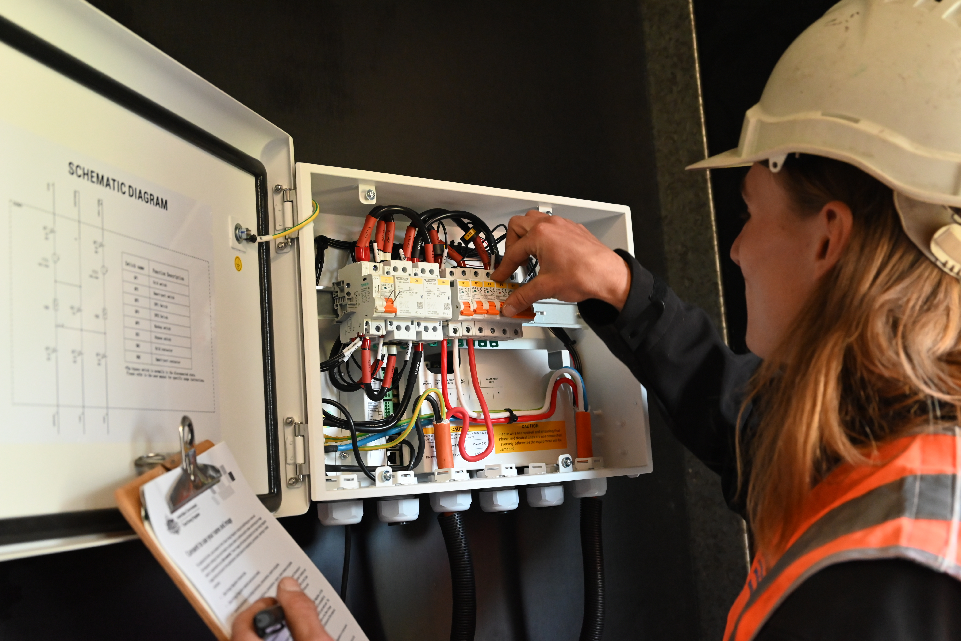
Solar battery photo guide
Evidence requirements for solar battery installations
Version 1.2 June 2026

Contents
Solar battery photo guide 3
Why we’re implementing additional photo evidence requirements 3
Where to find information about labelling requirements 3
New critical labelling photo requirements 4
Labels located on, or visible when approaching, the meter box 4
Figure 1: Example of emergency services labels located on the outside of a meter box 5
Labels on and around the switchboard 5
Figure 2: Example of critical labels located on the switchboard and the inside of the meter box cover 7
Solar battery front and sides 8
Figure 3: Example of labels mounted adjacent to the solar battery 9
Photo file format 9
How to submit photos 10
Existing installer on-site verification photo requirements 10
More information 10

Solar battery photo guide
This document outlines the Clean Energy Regulator’s (CER) new photo evidence requirements for solar battery installations claiming small-scale technology certificates (STC) under the Small-scale Renewable Energy Scheme (SRES).
As of 1 March 2026, all installers must take clear, geotagged and timestamped photos of critical labelling for every solar battery installation. This is in addition to existing installer on-site verification photos which includes photo evidence of the installer being present during the main stages of installation.
All accredited installers and registered agents are required to collect on-site evidence as part of their compliance paperwork. This requirement is legislated under 20ACA(12)(h)(iii) for batteries of the Renewable Energy (Electricity) Regulations 2001. Failure to comply with the new photo requirements may result in failed STC claims and compliance action.

Why we’re implementing additional photo evidence requirements
CER audits and on-site inspections have highlighted that non-compliant labelling is the most common reason for solar battery installations to not meet Australian standards and state and territory requirements.
In addition to industry engagement and education to address this issue, our new photo evidence requirements will encourage and support installers to meet labelling requirements.
Compliant labelling on solar battery installations is essential to support the safety of installers, emergency responders and future trades working on systems with solar batteries.

Where to find information about labelling requirements
Accredited installers under the SRES are legally required to ensure that every installation is safe, compliant and meets Australian standards, the Regulations and state or territory requirements.
To ensure that all labelling meets requirements, installers should refer to:
- the relevant Australian standards that include, but are not limited to:
  - AS/NZS 5139 – Safety of battery systems
  - AS/NZS 5033 – Installation and safety requirements for PV arrays
  - AS/NZS 4777.1 – Grid connection of energy systems via inverters
  - AS/NZS 3000 – Wiring rules
- the Regulations which outline conditions for solar PV systems and battery-connected solar PV systems that include, but are not limited to:
  - Regulation 20AC – conditions for creation of STCs
  - Regulations 20ACA – conditions for creation of additional certificates for battery connected (solar PV) small generation units
- state or territory electrical safety requirements
- SAA’s requirements.
Installers can also refer to our solar battery inspection checklist for the labelling requirements that are assessed as part of our inspections program.

New critical labelling photo requirements
As of 1 March 2026, installers must take geotagged and timestamped photos of critical labelling for every solar battery installation.
These photos must be provided to us as part of installer’s compliance paperwork. Only one battery claim can be provided per email.
We’ll use sophisticated artificial intelligence (AI) as part of our comprehensive assessment process to ensure that all claims meet the new photo requirements. Read our AI transparency statement.
If photos show that labelling doesn’t meet requirements, the claim will be failed, and installers will need to go back to site to rectify.
Failure to meet the new photo requirements will result in delayed or rejected small-scale technology certificate claim processing.

Labels located on, or visible when approaching, the meter box
Installers must take a photo of the critical labels typically located on or around the meter box. This photo should include:
- the circular, green reflective label with the letter “ES” which provides vital information to emergency workers. It must:
  - be at least 100mm in diameter
  - include the United Nations number for the primary chemistry of the battery system installed below the lettering – for example, UN3480 representing a Lithium Iron Phosphate or LiFePO4 Battery system
- other relevant labels according to Australian standards and state and territory electrical safety regulations, such as a circular, green label with the letters “PV”.

Figure 1: Example of emergency services labels located on the outside of a meter box

Disclaimer
Figure 1 is an example only of the photo installers may take to comply with the new photo requirements. It does not show all labels that are required to meet installation requirements. Refer to the relevant Australian standards for labelling requirements.
Labels may also be placed in other visible locations, provided they are visible on approach, on or near the meter box by emergency services. Installers should take the most appropriate photo depending on the individual installation. Photos should clearly show:
- labels with legible text
- labels are placed in a compliant location.

Figure 1: Example of emergency services labels located on the outside of a meter box
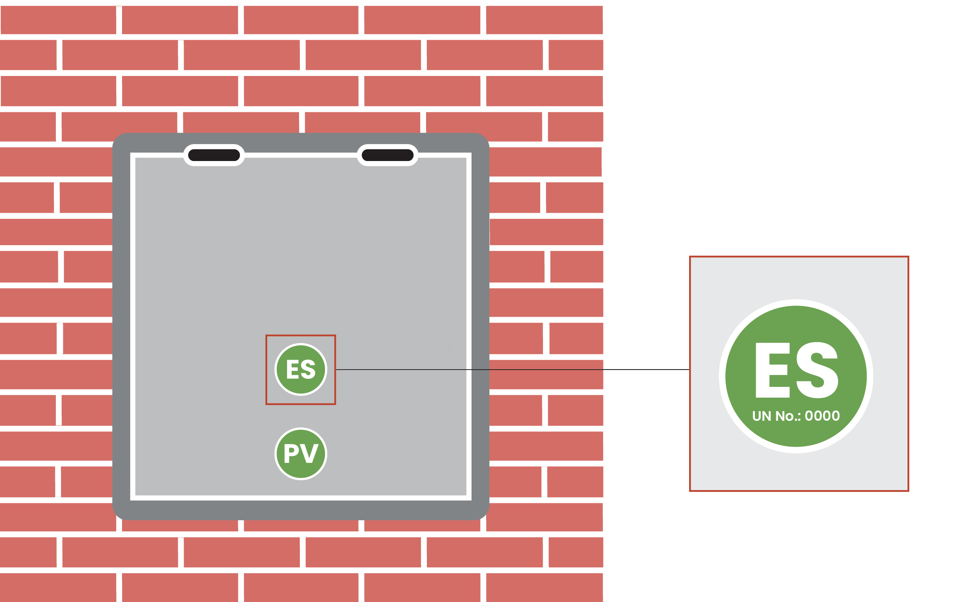

Labels on and around the switchboard
Installers must take a photo of the labels typically located on or around the switchboard, including the inside cover of the meter box. If there is more than one switchboard, a photo must be taken of each switchboard and inside cover of meter box where critical labelling is located.
This must include:
- the emergency shutdown procedure label
  - includes label placed adjacent to, and visible from, the equipment to be operated in the event of a shutdown
  - where the power conversion equipment (PCE) is adjacent to the switchboard it is directly connected to, the shutdown procedure may be placed within that switchboard
  - where the PCE is located away from the switchboard, a separate photo of the emergency shutdown procedure must be supplied
- any other relevant labels according to Australian standards and state and territory electrical safety regulations.
Systems that are configured to provide backup power must also include:
- a warning label placed on the switchboard or inside the meter box that clearly states “WARNING”, “MULTIPLE MODE INVERTER CONNECTED” and “NEUTRAL AND EARTH CIRCUITS MAY BE LIVE UNDER NORMAL AND FAULT CONDITIONS” and reference to the shutdown procedure for safe isolation
- labelling for Alternative Supply (commonly known as back-up or standalone) systems – includes the main switch back-up supply and any backed-up circuits with correct labelling, ensuring that the main switch for the back-up supply and backed-up circuits are grouped together.
For systems that are not configured to provide backup power, the installer must provide evidence of this in writing. The correspondence can be included as part of your compliance paperwork.

Figure 2: Example of critical labels located on the switchboard and the inside of the meter box cover

Disclaimer
Figure 2 is an example only of the photo installers may take to comply with the new photo requirements. It does not show all labels that are required to meet installation requirements. Refer to the relevant Australian standards for labelling requirements.
Labels may also be placed in other visible locations other than the switchboard. Installers should take the most appropriate photo depending on the individual installation. Photos should clearly show:
- labels with legible text
- labels are placed in a compliant location.

Figure 2: Example of critical labels located on the switchboard and the inside of the meter box cover
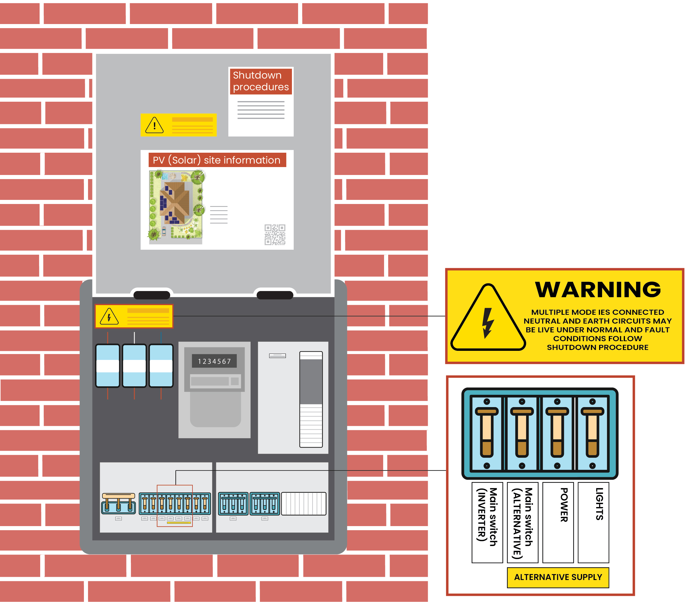

Solar battery front and sides
Installers must take a photo of the front and sides of the solar battery including all relevant warning signs installed in a compliant position appropriate to the battery and chemistry type.
Signs shall be mounted either adjacent to the enclosure or on all doors to the room where the battery system is located. Some of these signs may include:
- ’Danger, toxic fumes’
- ‘Danger, risk of battery explosion’
- ‘Arc Flash Hazard’
- ‘Hazardous D.C. Voltage’ for systems above Decisive Voltage Class A (DVC-A)
- a chemical hazard sign giving instructions on what to do if the skin, eyes or other parts of the body are exposed to the battery chemicals
- other relevant labels according to the battery and chemistry type, Australian standards and state and territory electrical safety regulations that should be located on or adjacent to the solar battery.
If an installer determines that certain signage isn’t required, such as when it’s not appropriate to the battery or chemistry type, they must provide supporting documentation. This may include references to the safety data sheet (SDS) stating which specific signage isn’t required.

Figure 3: Example of labels mounted adjacent to the solar battery

Disclaimer
The following illustration is an example only of the photo installers may take to comply with the new photo requirements. It does not show all labels that are required to meet installation requirements.
Labels must be placed in visible locations in accordance with Australian standards. Installers should take the most appropriate photo depending on the individual installation. Photos should clearly show:
- labels with legible text
- labels are placed in a compliant location.

Figure 3: Example of labels mounted adjacent to the solar battery
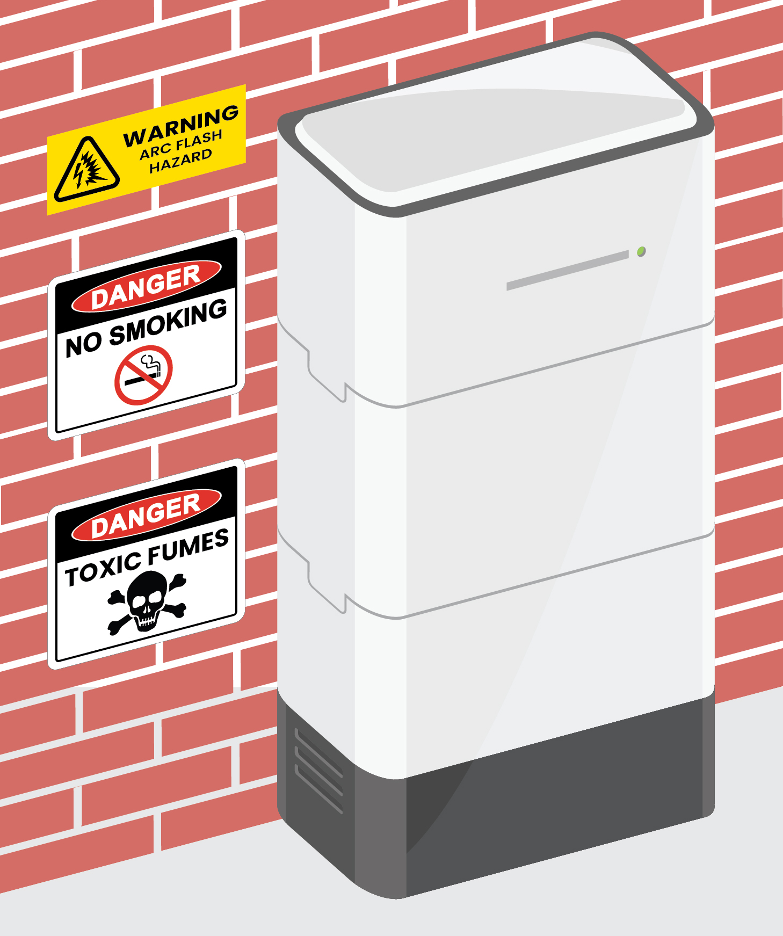

Photo file format
Photos must be geotagged and timestamped, and the metadata must match the existing installer on-site verification photos taken at each phase of installation.
Photos can be provided in one of the following formats:
- JPEG
- PNG
- HEIC.
Photos provided in PDF format won’t be accepted.
Photos must be supplied in the original photo file format. Photos embedded in a document aren’t suitable as they don’t have the required metadata.

How to submit photos
You must provide these photos to us as part of your compliance paperwork. Make sure you send photos for only ONE battery claim per email.
Photos must be kept on file for 5 years following the submission of a claim. They may be audited by us at any time, even after the claim has been approved.
Failure to comply with the photo requirements outlined in this guidance may result in delayed or failed STC claims and compliance action including surrender of STCs and/or suspension of the account.

Existing installer on-site verification photo requirements
Installers have been required to provide on-site verification photos of solar battery installations since 1 July 2025 when solar batteries became eligible under the SRES. These existing on-site verification photos include:
- geotagged and timestamped photos (‘selfies’) at each phase of installation, including:
  - job setup
  - mid-installation
  - testing and commissioning – the final ‘completion’ photo should match the test date on the electrical certificate of compliance (or equivalent)
- geotagged and time-stamped photos showing that the serial numbers on each solar battery and inverter (if new) match the listed numbers in the REC Registry
  - photos of the main battery unit must also be taken if the solar battery contains individual battery modules within a CEC listed model.
These photos must continue to be provided in addition to the new critical labelling photos.

More information
Visit solar battery installers and designers for more information.
If you have any questions, get in touch:
- 1300 553 542
- enquiries@cer.gov.au

https://cer.gov.au/schemes/renewable-energy-target/renewable-energy-target-participants-and-industry/solar-battery-installers-and-designers#supervision-of-installations
https://www.legislation.gov.au/F2001B00053/
https://cer.gov.au/schemes/renewable-energy-target/small-scale-renewable-energy-scheme/small-scale-renewable-energy-systems/small-scale-renewable-energy-system-inspections
https://cer.gov.au/about-us/our-policies/artificial-intelligence-transparency-statement
https://cer.gov.au/schemes/renewable-energy-target/renewable-energy-target-participants-and-industry/solar-battery-installers-and-designers#supervision-of-installations
https://cer.gov.au/schemes/renewable-energy-target/renewable-energy-target-participants-and-industry/solar-battery-installers-and-designers

