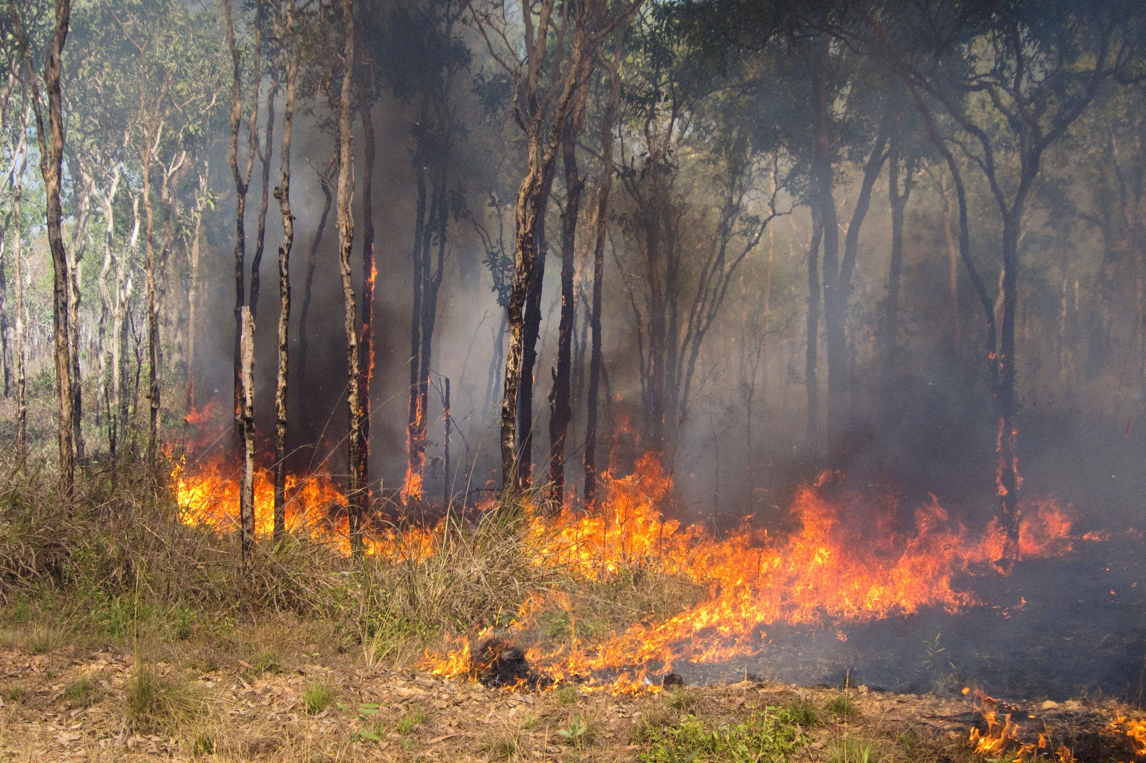
A guide to using the Savanna fire management—emissions avoidance method 2026

Version 1.0 12 August 2026

Contents
Contents 2
1. Background 4
1.1. The 2026 savanna fire management methods 4
1.2. Who this guide is for 4
1.3. Using this guide 5
1.4. Method and ACCU Scheme legislation 5
1.5. Additional requirements and information 5
1.6. Key updates from previous savanna fire management methods 6
2. Participating in the method 8
2.1. Suitability 8
2.2. Choose a proponent 9
2.3. Legal right 10
2.4. Eligible interest-holder consent 10
2.5. Regulatory approvals 11
2.6. Additionality – in lieu of newness 12
2.7. Additionality – in lieu of regulatory additionality 12
3. Planning a project 13
3.1. Stages of a savanna emissions avoidance project 14
3.2. Considerations for running a savanna emissions avoidance project 14
4. Understanding the method 16
4.1. Understanding savanna fire management 16
4.2. Project management plan 18
4.3. Eligible land 18
5. Applying to register a new project 21
5.1. Project timelines 21
5.2. Information to accompany applications to register a new project 23
6. Delivering a project 27
6.1. Activity 27
6.2. Project management plan 28
6.3. Weed management 30
6.4. Fire permits 31
6.5. Vegetation fuel type maps 32
6.6. Notification requirements 34
6.7. Monitoring and record keeping requirements 36
7. Reporting on your project 38
7.1. Offsets report 38
7.2. Audits 41
7.3. Calculating net abatement 41
8. Transferring a project 45
8.1. Provisions for transferring projects 46
8.2. Transferring from a previous emissions avoidance method 46
8.3. Transferring from a savanna sequestration method 48
9. Making changes to your project 53
9.1. Varying project areas 54
9.2. Varying the project method 56
Appendix 57
Resources 57
Planned burning 58
Matters of national environmental significance 59
Air quality and smoke 59
Gamba grass 60
Checklists 62
Before you start 62
Checklist 1: Considerations before registering a new project 63
Checklist 2: Registering a new project 64
Checklist 3: Submitting an offsets report 65
Checklist 4: Transferring a project from a previous emissions avoidance method 68
FullCAM 69
SavCAM 70
SavCAM versions 70

Background

The 2026 savanna fire management methods
Two savanna fire management methods were made in 2026:
  - an emissions avoidance method
  - a sequestration and emissions avoidance method.
The methods are designed for eligible projects to earn Australian carbon credit units (ACCUs) by reintroducing controlled fire burning during the early dry season. This reduces the frequency and severity of fires in the late dry season.
This guide provides information on the 2026 savanna fire management—emissions avoidance method (referred to throughout this guide as ‘the method’).
The 2026 savanna fire management—sequestration and emissions avoidance method has a separate simple method guide.

Choosing a method
The emissions avoidance method credits reductions in methane and nitrous oxide emissions. The sequestration and emissions avoidance method builds on this approach by also crediting carbon stored in the landscape. The methods share many of the same eligibility, project management, and reporting requirements.
Using the sequestration method may increase the amount of ACCUs your project receives. However, sequestration projects are also subject to permanence obligations. Permanence obligations mean that if you stop project activities, revoke the project, or a reversal of stored carbon occurs before the end of the permanence period, you may be required to relinquish some or all of the ACCUs issued for the project. For further information on permanence obligations, see the 2026 savanna fire management—sequestration and emissions avoidance method simple method guide.

Who this guide is for
This guide is designed for current and potential project proponents, agents, landholders, and others involved in savanna emissions avoidance projects. It is intended to support both people who are new to the ACCU Scheme and those with experience managing carbon projects.
While some familiarity with the ACCU Scheme and savanna fire management will help you to understand the information in this guide, technical knowledge of the method is not assumed.
We are here to support you. Contact us on enquiries@cer.gov.au or 1300 553 542 if you need assistance.

Using this guide
This guide includes information on how to plan, register, transfer, deliver and report on a project under the savanna emissions avoidance method. If you have not yet decided which savanna fire management method is most suitable for your circumstances, see ‘1.1.1 Choosing a method’.
This guide is designed as a practical resource and does not need to be read from start to finish. You can use the contents page to navigate to the sections most relevant to your circumstances, stage of project development, and level of technical experience.
This guide provides a brief overview of ACCU Scheme requirements that are relevant to projects under the method. However, it does not provide comprehensive information on all ACCU Scheme requirements and is not a substitute for more detailed ACCU Scheme guidance.
Links to further resources are provided in the Appendix. You can also visit our website for more guidance to help you plan and run your ACCU Scheme project. Start your search with the ACCU Scheme guidance library, which has an easy-to-use search tool.
The information in this guide is accurate at the date of publication and does not reflect future changes to legislation. You should refer to the latest version of the method, the relevant ACCU scheme legislation, and any incorporated documents when making decisions about your project.

Method and ACCU Scheme legislation
The ACCU Scheme is established in legislation so that all projects operate under government regulated rules that provide integrity. The following pieces of legislation set out the rules for projects under this method.
- The Carbon Credits (Carbon Farming Initiative—Savanna Fire Management—Emissions Avoidance) Methodology Determination 2026
- Carbon Credits (Carbon Farming Initiative) Act 2011 (the CFI Act)
- Carbon Credits (Carbon Farming Initiative) Rule 2015 (the CFI Rule)

Additional requirements and information
  - Savanna Fire Management Carbon Accounting Model (SavCAM) – a mandatory tool that calculates abatement for your project. For further information on SavCAM, see ‘7.3. Calculating net abatement’
  - Technical Guidance Document for the 2026 Savanna Fire Management Methods – contains the technical requirements and recommendations to support the method. The Technical Guidance covers requirements for vegetation fuel type maps, guidance for developing project management plans, and technical information about FullCAM and SavCAM.

Key updates from previous savanna fire management methods
The method builds on previous savanna fire management methods. Existing proponents, agents, landholders and others familiar with earlier methods may find it useful to understand the updates introduced in this method. The table below summarises the key changes, and further information on each update is provided throughout this guide.
Update | Description
Introduction of SavCAM | SavCAM must be used to calculate abatement.  SavCAM has a similar user interface to SavBAT. It applies the latest science and modelling to align abatement with the National Greenhouse Gas Accounts.
Vegetation fuel types | The method introduces an additional vegetation fuel type for the low rainfall zone (pindan).
Extension of baseline period for new projects | Baseline periods for new projects are extended to 20 years. This is influenced by recently available historical fire scar data dating back to 1988.
Project management plans | Project management plans must be prepared before planned burning commences each year. Project management plans must:  - include a description of planned burning that will be undertaken  - demonstrate that you have considered the likely impact of burning on air quality in areas where people live  - include a plan for monitoring relevant weed species.
Weed management | Relevant weed species must be treated using herbicide or mechanical removal every 12 months until eradicated.
Transferring to the method | Existing projects under alternative savanna fire management methods can apply to transfer to the method. If new eligible interest-holder consents are obtained, transferring projects will gain a crediting period extension.  Projects that transfer from previous savanna emissions avoidance methods without evidence of new eligible interest-holder consents will keep their existing crediting period.
No fossil fuel usage reporting | Projects under the method will not need to keep records or report on fossil fuel usage from project activities.
Capacity building fire management | The method recognises a capacity building fire management gap for up to 6 calendar years, where requirements are met, between the end of the baseline period and the project start date. This allows proponents to practice fire management prior to the start of the project.
Project area subdivision | Project areas may be ‘subdivided’ into smaller project areas. This allows proponents to manage different parts of a project separately, including removing subdivided project areas where necessary.

Participating in the method

 | Summary of this section  This section outlines key ACCU Scheme and method requirements. It is relevant if you are considering registering a new project under the method. If you are considering transferring an existing project to the method, you should refer to ‘8. Transferring a project’.  Before applying to register a project, you should:  - confirm the method is suitable for your circumstances  - check that your project will meet the in lieu of newness and in lieu of regulatory additionality requirements  - decide who will be the project proponent and whether you will use an agent  - establish legal right to carry out the project and receive ACCUs  - identify and engage with eligible interest-holders  - identify any required regulatory approvals  - understand the deadlines for providing consents and approvals  We recommend you seek independent technical, legal, audit and financial advice regarding your circumstances.

Suitability
The method may be suitable if you:
  - hold the legal right to eligible land in northern Australia (see ‘2.4. Legal right’ and ‘4.3. Eligible land’)
  - can gain consent from eligible interest-holders (see ‘2.5. Eligible interest-holder consent’)
  - can reintroduce controlled early dry season burns into the landscape
  - can monitor and manage relevant weed species.

 | Consider seeking independent advice  There are a range of factors which may influence your eligibility to participate in the ACCU Scheme. We recommend you seek independent technical, legal, audit and financial advice regarding your circumstances.

Choose a proponent
Before you apply to register a project, you need to decide who the project proponent will be. The project proponent is responsible for carrying out the project, will be issued ACCUs and is legally responsible for meeting all obligations under the law. A project proponent can be either an individual, sole trader, company or a local, state or territory government trust or body. There may be multiple proponents with joint responsibility and legal right to carry out the project. Joint proponents may appoint a nominee in relation to the project. See Choose an ACCU Scheme proponent.

Using an agent
You can also appoint an ‘agent’ to the project. This means the proponent maintains responsibility and the agent can complete the administration on their behalf. To authorise your agent, you should include an authority letter with your application confirming that you authorise the agent for the purposes of:
  - making an application
  - giving information in connection with an application
  - withdrawing an application
  - giving a report
  - giving a notice (including an electronic notice)
  - making a submission
  - making a request
  - giving information in connection with a request.
It is a good idea to seek professional legal and financial advice before entering into any agreement with another person or organisation to be the project proponent or as an agent.
Visit Choosing a proponent for more information on using an agent.

Fit and proper person assessment
Project proponents need to prove their identity and pass a fit and proper person assessment to participate in the ACCU Scheme. The fit and proper person test generally considers a person’s past compliance with the law, whether they are insolvent, and whether they have the necessary capabilities and competence to run a project.
Find out more about Fit and proper person requirements in the ACCU Scheme.

Legal right
You must demonstrate that you have the exclusive legal right to carry the project. This means you must have the lawful and exclusive right to carry out the project and receive all ACCUs.
It is likely that you have the legal right if you own or hold a lease to the project land. Legal right may also be established through rights and interests such as native title or Aboriginal land rights land. See Native title, legal right and eligible interest-holder guidance for further information.
If you are the project proponent but not the landholder, you may need a written agreement to show you have the exclusive legal right. See How does a project proponent demonstrate legal right for more information.
You need to maintain legal right for the life of the project. You also need to maintain records showing how you hold, or have obtained, legal right to carry out the project. The CER may require evidence of ongoing legal right to be provided with offsets reports.
Where legal right is lost and cannot be re-obtained, the project may be revoked.
Visit Legal right and native title for more information.

Eligible interest-holder consent
You must obtain consent from all people or organisations that hold an eligible interest in the project area. Eligible interest-holder consent ensures all stakeholders understand the nature of your savanna fire management activities and any associated risks or benefits. Eligible interest-holders must be fully informed before giving consent. Once the project is registered unconditionally, consent cannot be withdrawn.
An eligible interest-holder is any person or organisation with a legal interest in the land where your project will operate. These may include:
  - landholders
  - banks or mortgagees
  - state and territory Crown Lands Ministers
  - registered native title bodies corporate
  - Aboriginal land councils
  - other legal interest-holders (for example, easement holders)
When a project is on land subject to native title, you should consider the principles outlined in the United Nations Declaration on the Rights of Indigenous Peoples, especially ‘free, prior and informed consent’, to ensure traditional owners and native title holders clearly understand and consent to project activities. To ensure ‘free, prior and informed consent’ principles are met, it is best practice to obtain consent from all eligible interest-holders before you apply to register a project, add area or transfer an existing project.
Where consent is being provided by registered native title bodies corporate, the requirements of the Native Title Act 1993 must be considered in determining the process for consent.
You must provide evidence of eligible interest-holder consent in either the CER’s approved Eligible interest-holder consent form or optionally for consent from registered native title bodies corporate, an Indigenous Land Use Agreement.
See Eligible interest-holder consent and our Native title eligible interest-holder consent guidance document for more information.

Regulatory approvals
You are responsible for checking whether your project needs regulatory approvals. You should do this before registering your project. To find out, contact your local government, federal or relevant state or territory departments.
Deadlines for consent and approvals
For new projects registering under the method, eligible interest-holder consents and regulatory approvals must be obtained before the end of your first reporting period. This will be, at the latest, 2 years after your project start date. Your project will be registered ‘conditionally’ until all consents and approvals are provided. Conditionally registered projects cannot receive ACCUs. You can apply to remove conditions by providing consents through a project variation application in Online Services (see ‘9. Making changes to your project’ for more information).

Additionality – in lieu of newness
The method contains in lieu of newness provisions.
This means that you may be able to start fire management before you apply to register the project. If you would like to conduct multiple years of planned burning before beginning the project, you should consider the impacts of capacity building fire management provisions in the method.
To meet the in lieu of newness provisions, you need to check whether your project area has previously had another savanna project registered on it. If no savanna project has ever been registered on any part of the land, your project will meet the in lieu of newness requirements.
If there has been a savanna project that was previously registered on any part of the land, your project may still meet in lieu of newness requirements, provided that the former project either:
  - is transferring project areas to the new project (see ‘8. Transferring a project’)
  - was revoked prior to any ACCUs being issued
  - was revoked 10 or more years ago.
You can check if a project was previously registered on your land through the ACCU project and contract register. You can filter the register by ‘method type’ and select ‘Savanna Fire Management’.

Additionality – in lieu of regulatory additionality
The method contains in-lieu of additionality provisions. These requirements will be met if you’re not legally required to reduce your emissions from fire or to sequester carbon in living biomass or dead organic matter by any state, territory or Commonwealth law.
If a project is required by law to undertake planned fire management for any other purpose, such as asset protection, the project will not fail this requirement.

Planning a project

Summary of this section
This section is relevant if you are ready to plan a new project under the method. If you are considering transferring an existing project to the method, you should refer to ‘8. Transferring a project’.
This section provides an overview of the key stages involved in planning, registering, delivering, reporting on and receiving ACCUs from a project. It also highlights important factors you should consider.
Before registering a project under the method, you should ensure that:
  - you understand any environmental, fire management and other regulatory obligations that relate to your project
  - you have the resources, capability and commitment to manage the project over the crediting period.
There can be significant costs associated with establishing, operating, reporting on and auditing a project.

Stages of a savanna emissions avoidance project
The key steps involved in running a project under the method are outlined in the figure below.
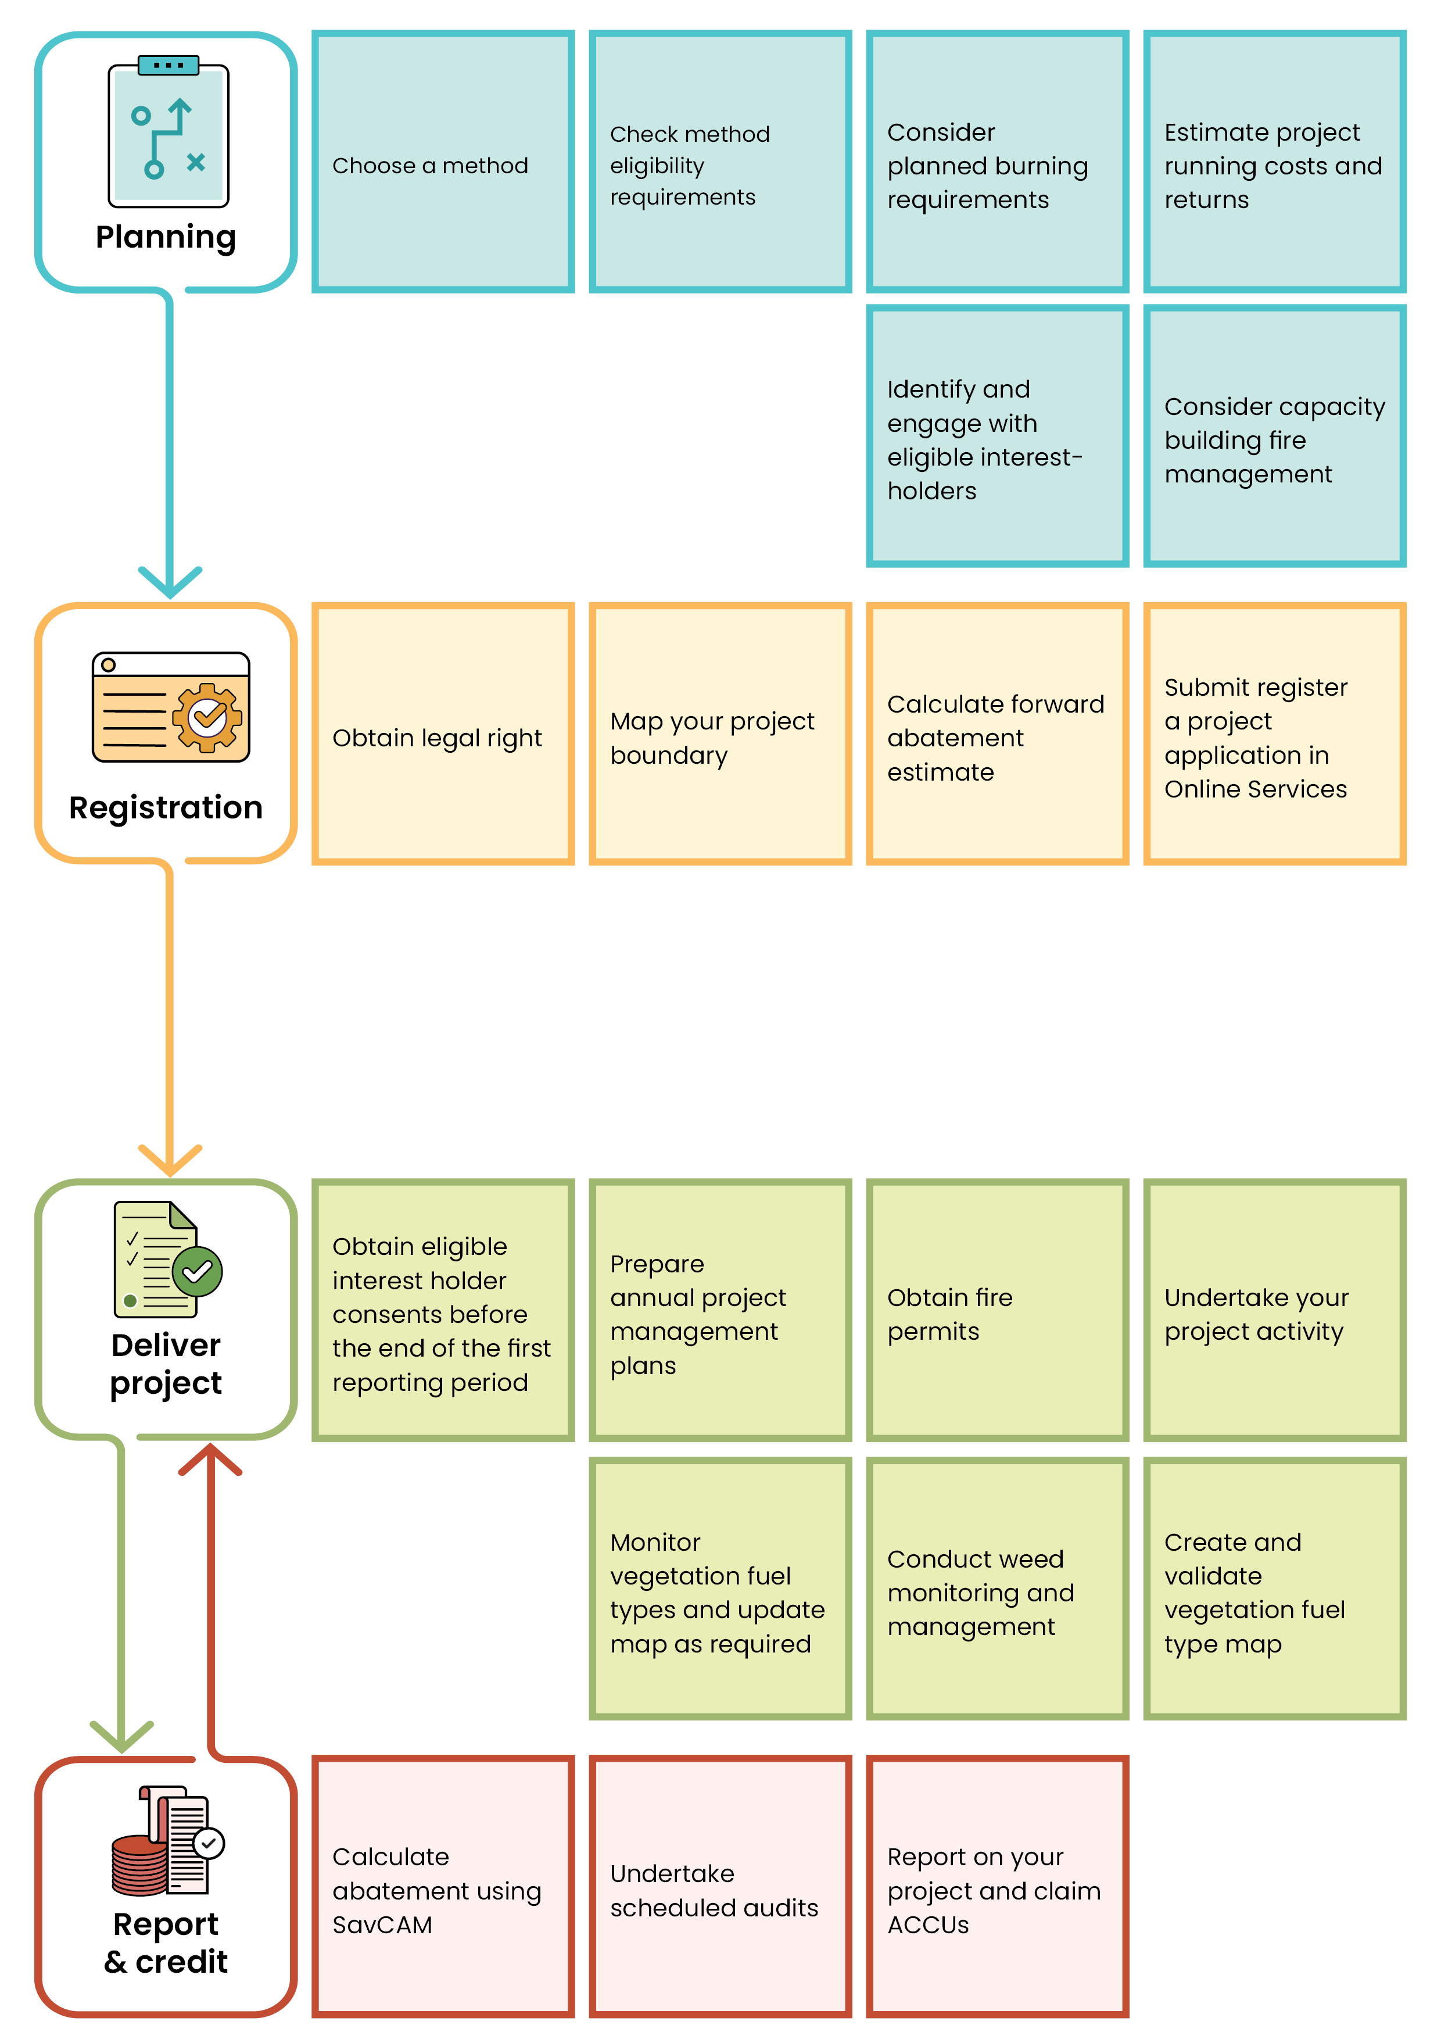
Figure 1: Key steps involved in running a project under the method.

Considerations for running a savanna emissions avoidance project
Savanna is land that is characterised by a tropical or sub-tropical vegetation formation with continuous grass cover occasionally interrupted by trees and shrubs.
In some circumstances, a project under the method may not be suitable for your land. Before registering a project it’s important you consider the following information:
- if your project potentially impacts nationally significant (protected) animals, plants, habitats or places, it is your responsibility to identify if you need approvals under Commonwealth, state or territory legislation before undertaking the project activity (see ‘Referrals and environmental assessments under the EPBC Act - DCCEEW’ for more information)
- you may have obligations under state or territory regulations to mitigate the risk of adverse impacts to air quality from fire management activities.

Estimating costs
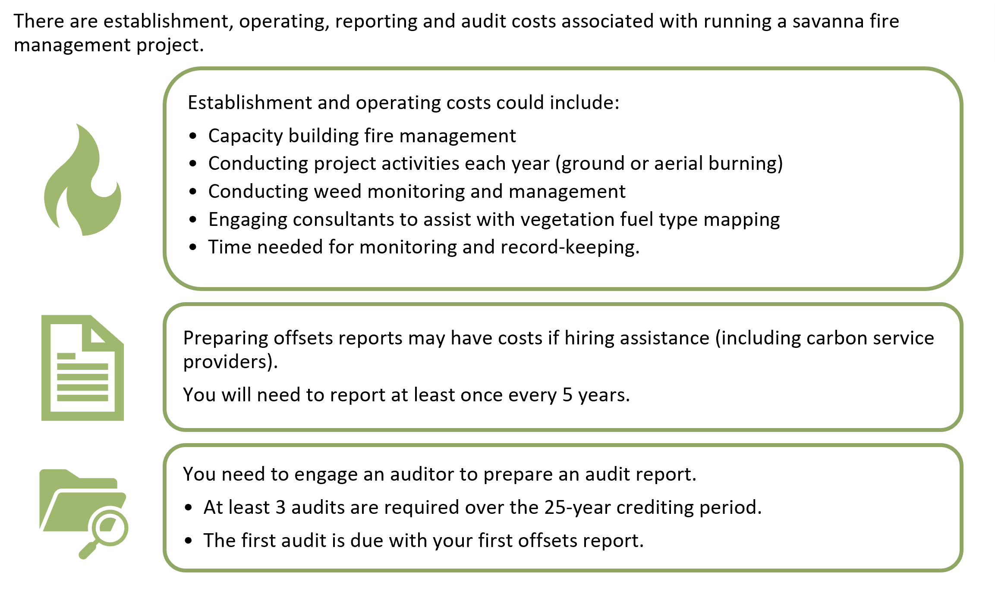
Project costs
New projects that register under the method have a 25-year crediting period. You should consider the long-term costs, resources and commitments associated with establishing, managing, delivering, auditing, monitoring and reporting on a project throughout the crediting period.

Understanding the method

Summary of this section
This section is relevant if you want to understand how savanna fire management generates carbon abatement, and whether your land is eligible under the method.
By conducting early dry season burning and reducing severe late dry season fires, projects can reduce methane and nitrous oxide emissions compared with historical fire patterns. Savanna fire management also provides significant environmental, cultural and socio-economic benefits.
Before undertaking fire management each year, project proponents must prepare a project management plan that documents how fire management will be carried out to achieve the method's objectives.
In addition to the general ACCU Scheme and method additionality requirements, to be eligible under the method, project areas must:
  - be located within the high and/or low rainfall zones
  - contain at least one eligible vegetation fuel type
  - either not contain any relevant weed species, or have had all relevant weed species treated within 12 months before applying to register.
Understanding your project's rainfall zone and vegetation fuel types is important because these determine eligibility and are used to estimate emissions avoidance under the method.

Understanding savanna fire management
Annual early dry season burning with cooler smaller fires, helps to break up fuel loads. Producing a mosaic of burnt and unburnt patches across the landscape assists to slow or stop the spread of fires. As a result, there is a reduction in the number, size and severity of late dry season fires.
In the absence of early dry season fire management, the risk of late dry season fires is high. By increasing early dry season burning, which is typically cooler and more controlled than late dry season wildfires, emissions of methane and nitrous oxide are avoided or reduced compared with emissions during the baseline period.
Savanna fire management projects must undertake planned burning in each project area each calendar year. For more information on what is required when delivering the project under the method, see ‘6. Delivering a project’.
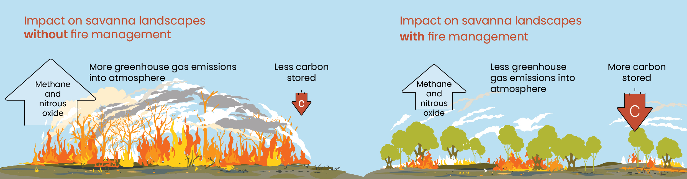
Figure 2: Comparison of fire management on savanna landscapes.

Benefits
In addition to carbon abatement, savanna fire management projects can generate a wide range of co- benefits.




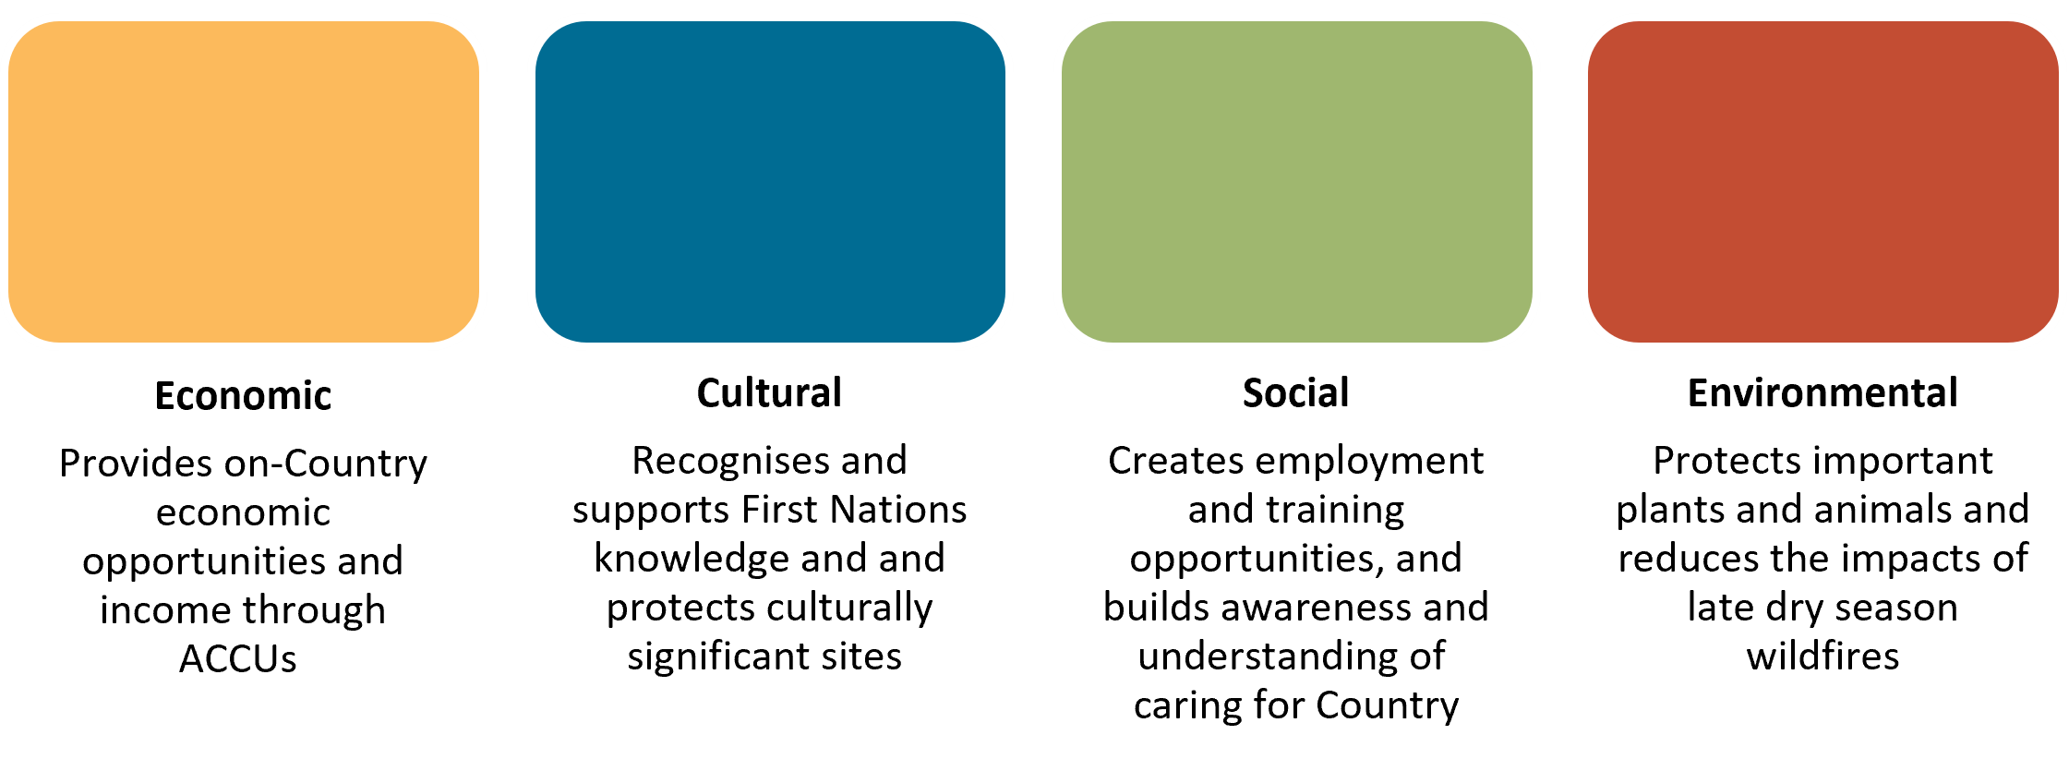
The method offers flexibility in fire management strategies to maximise benefits and reduce the risk of adverse impacts.
 | Traditional Indigenous savanna burning practices in Kakadu National Park  “Given our perspective of the land, Indigenous people understand the intricacies relevant to fire burning processes so we know the impact fire will have on the ground. Many of us are professors in our own right given the knowledge of the land that we hold. It’s a specialty instilled in us literally since we can walk. We get our children out on Country and that’s where fire practice takes place”  - Mandy Muir, a descendant of the Murumburr people and connected to the Wardaman people of the Katherine region.

Project management plan
You need to prepare a project management plan each year before you start burning. This ensures that fire management activities are planned and documented. It helps you achieve the method objectives of avoiding emissions of methane and nitrous oxide.
See ‘6.2 Project management plan’ for further details.

Eligible land
In addition to meeting the additionality requirements (see ‘2.7. Additionality – in lieu of newness’ and ‘2.8. Additionality – in lieu of regulatory additionality’) eligible land must also:
  - be within the high or low rainfall zones
  - contain an eligible vegetation fuel type
  - not include an area that was previously removed from a savanna fire management project due to becoming ineligible or weed-affected
  - meet requirements for weed-affected areas.
These requirements are outlined in further detail below.

Rainfall zones
All areas of land included in a project must be in either the high rainfall zone, the low rainfall zone, or across both rainfall zones. This means that projects cannot be undertaken on an area of land that is not in either of these rainfall zones.
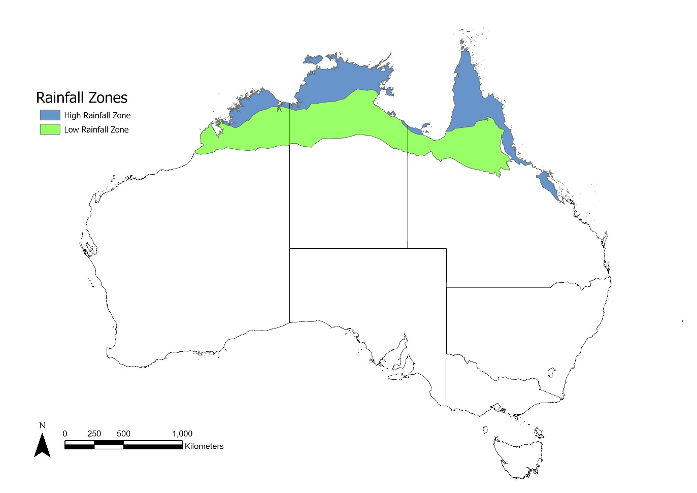
Figure 3: Savanna fire management rainfall zones.
Figure 3 shows the rainfall zones under the method. These rainfall zones are defined by the Savanna Fire Management High Rainfall Zone and Savanna Fire Management Low Rainfall Zone spatial data layers.
The method has flexibility to allow the rainfall zones to be updated over time. This allows for a future extension of the low rainfall zone.

Eligible vegetation
Each project area must include an area of land with an eligible vegetation fuel type. These are used to describe how vegetation in an area influences fire behaviour. Each rainfall zone has different eligible vegetation fuel types. The Full Carbon Accounting Model (FullCAM), which underpins the method’s net abatement calculation tool (SavCAM), has been calibrated to estimate emissions avoidance for each eligible vegetation fuel type.
Vegetation fuel type classifications are based on:
  - the dominant vegetation layer (the main layer of vegetation)
  - vegetation structure (how tall the vegetation is, and the projected foliage cover)
  - grass type (the dominant type of grass growing in the area).
Table 1: Comparison of vegetation fuel types in the high and low rainfall zones
Rainfall zone | Eligible vegetation fuel types
High rainfall zone | - Open forest with mixed grasses  - Woodland with mixed grasses  - Woodland with hummock grasses  - Shrubland (heath) with hummock grasses
Low rainfall zone | - Woodland with hummock grasses  - Woodland with mixed tussock / hummock grasses  - Woodland with tussock grasses  - Open woodland with mixed grasses  - Shrubland with hummock grasses  - Acacia shrublands (Pindan)

Relevant weed species
Relevant weed species can increase fire intensity compared to the eligible vegetation fuel types used in the abatement calculations. Increased fire intensity can lead to more greenhouse gas emissions. To support the integrity of abatement calculations under the method, relevant weed species must be appropriately managed.
Relevant weed species are identified in the Technical Guidance. At the time of publication, the only relevant weed species is Andropogon gayanus (Gamba grass).
Your project area must either be free of relevant weed species or have had all weeds appropriately treated within 12 months before you submit your project registration application. To treat weeds appropriately, you must have either:
- treated all weeds with herbicide to kill all their aboveground biomass
- subjected all weeds to mechanical removal to destroy all their aboveground biomass.
You must also ensure your treatment took place in accordance with any relevant Commonwealth, state or territory laws.
Fire is not a permitted treatment option as it can increase fire intensity and therefore can impact genuine abatement.
If you cannot treat relevant weed species appropriately, you can choose to exclude weed-affected areas from your project area when you register the project.

Applying to register a new project

Summary of this section
This section is relevant if you are preparing to register a project and need to understand the key project timeframes, information required for registration, and the ongoing obligations associated with a project.
The baseline period and crediting period determine how project abatement is calculated, how long ACCUs can be earned, and how long project obligations continue. New projects may also be able to recognise capacity building fire management for up to 6 years before the start of the crediting period if the required evidence is supplied.
To register a project, you must provide:
  - information about the project area, including mapping and land titles
  - details and evidence of any capacity building fire management
  - a forward abatement estimate
  - Information on native title, land rights and indigenous land use agreements
  - information on whether there are relevant weed species in the project area, and the date and details of any treatment
  - information about when you will require fire permits
  - a statement on whether you have informed the relevant state or territory government of your project
Our Online Services form to register a project will assist you with providing this information.

Project timelines

Baseline period
The baseline period is the period of full calendar years before the project starts. It is used to calculate the average baseline emissions. New projects will have a 20-year baseline period, which has increased from previous savanna fire management methods.
Your baseline period will generally end the calendar year before your project’s crediting period begins. If you have conducted capacity building fire management, you may have a gap of up to 6 calendar years between the end of the baseline period and the calendar year in which your project’s crediting period begins (see ‘5.1.2. Capacity building fire management’).
Fire scar mapping is used to calculate emissions caused by fires in the early and late dry seasons. It is used to estimate baseline emissions across the 20-year baseline period, which is averaged to calculate the mean baseline emissions (t CO₂-e).
Abatement is calculated by subtracting the emissions from the reported calendar year from the average baseline emissions. After any adjustments, this shows how many t CO₂-e was avoided in that calendar year.
For transferring projects, see ‘8.1. Provisions for transferring projects’ for information relevant to your project.

Capacity building fire management
New projects may be able to apply a gap between the end of the baseline period and the start of the project, where method and evidence requirements are met. This means that capacity building for up to 6 years before the first calendar year reported on will not be included in the baseline period. The period spent doing capacity building fire management is not included in abatement calculations.
You can use capacity building fire management to learn how best to manage the land without affecting your baseline. You must provide evidence of capacity building with your application to register a project, such as fire permits, burning records, proposals, photos, GPS tracks or burning plans.
Transferring projects keep their existing baseline periods.
Example: A new project is registered in June 2026. The project conducted capacity building fire management for one year in 2025 and provided evidence of fire permits and burn plans with the application to register the project. Therefore, the 2025 calendar year will be excluded from the baseline period, and the project’s baseline period will be 2005 – 2024.
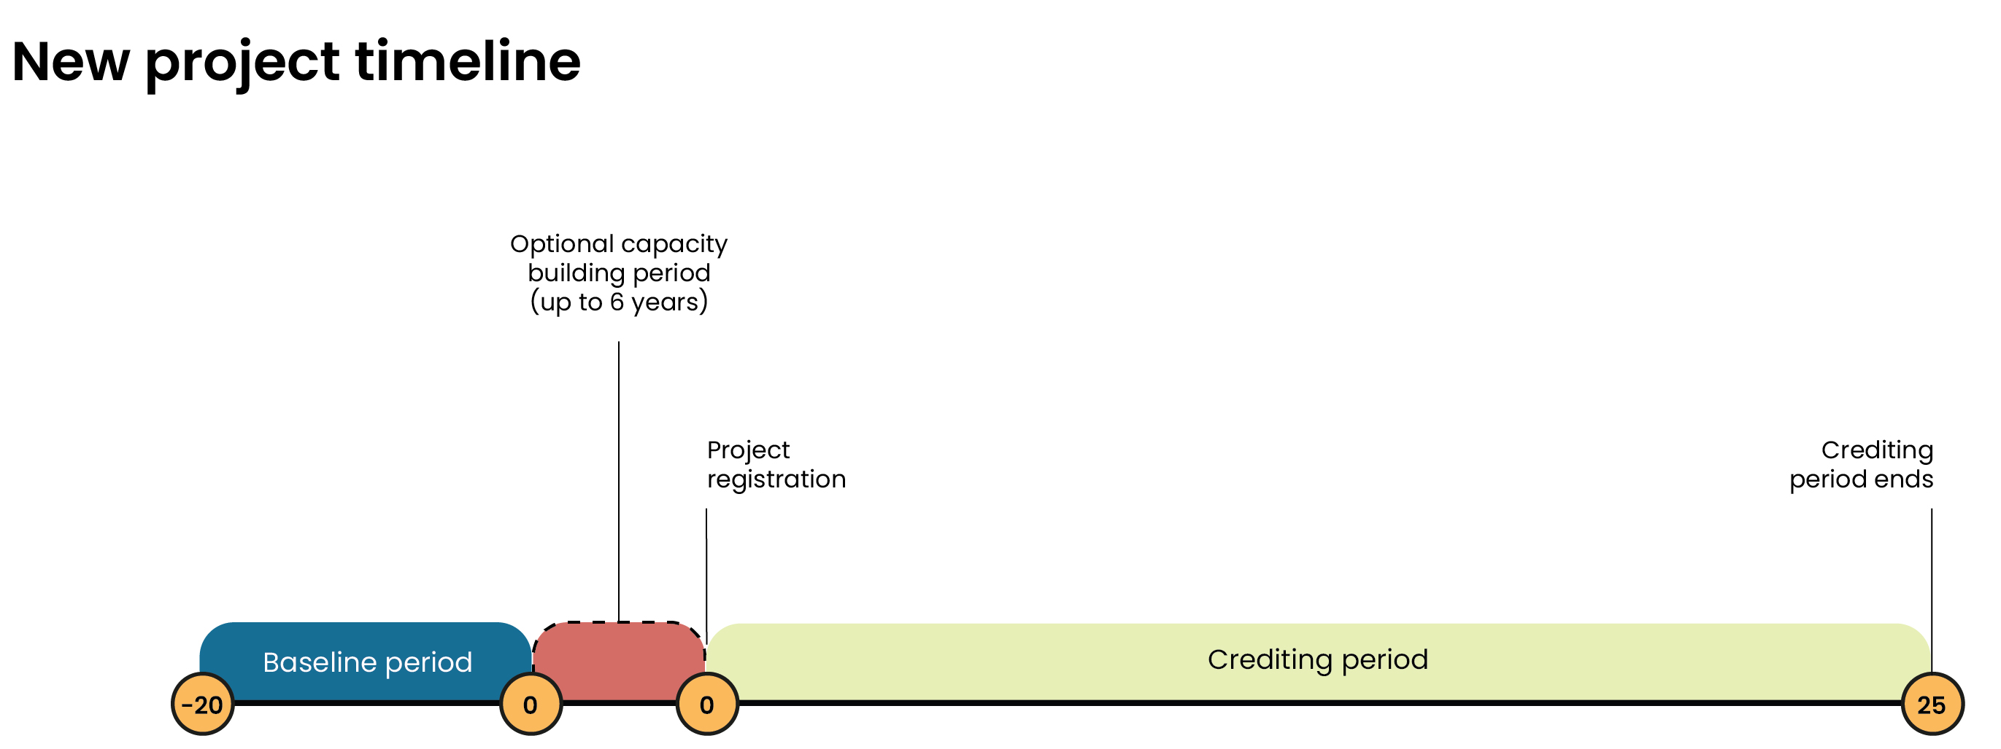
Figure 4: Timeline for a new project conducting capacity building. Note the capacity building does not influence the baseline period.

Crediting period
The crediting period for a new project will be 25 years. The crediting period begins either:
- when the project is declared
- the date that you have chosen.
Note that a chosen date cannot be more than 18 months from the date of declaration. If the date you choose is before the date of declaration, the crediting period will begin from the date of declaration.
You can claim abatement under the method for all years that end during the crediting period.
Example: A project is declared and has a start date of 1 October 2026. The project will have a crediting period of 1 October 2026 to 30 September 2051. The project will be able to claim abatement for the 2026-2050 calendar years, because the crediting period will end before the end of the 2051 calendar year ends.

Project timeline
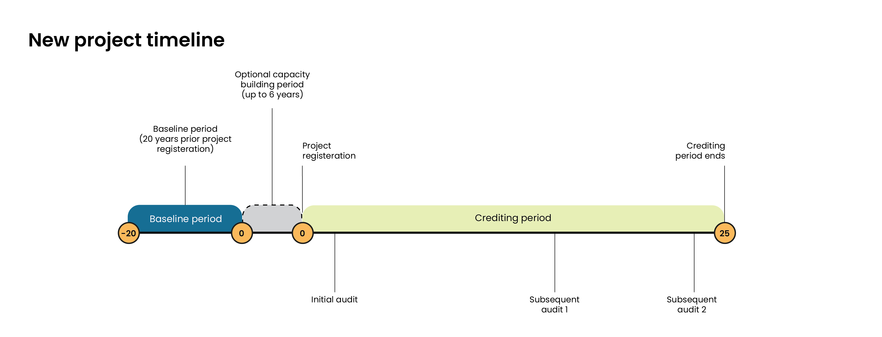
Figure 5: Timeline for a new project under the method with two subsequent audits.

Information to accompany applications to register a new project
To register a new project under the method, you will need to submit an application to ‘Register a project’ through Online Services. The form will prompt you to provide the information required, which is also outlined below.

Project area information

Project boundary mapping
When you apply to register your project, you need to provide a project boundary in an interchangeable GIS (geographic information system) format that meets the CFI mapping guidelines.
The map will be used to:
- accurately identify the project area
- check for overlaps or duplicate registrations
- confirm the proponent’s legal right and authority to carry out the project on the land
- determine whether the area is subject to any ongoing obligations or restrictions.
Your project area map is the official spatial description of where your project will take place and will be identified in the project declaration. If the project is declared, we will publish the project boundary on the project register. You can create your map using GIS software. QGIS (free), Google Earth (free) and ArcGIS (paid) are examples of commonly used GIS tools.
To meet the CFI mapping guidelines
- Identify the project area.
- Gather the base spatial information.
- Create a boundary polygon.
- Save the file in a common interchangeable GIS format accepted by us.
- Retain the source data, version history, and notes on how the boundary was created in case you need to explain or update it later.
Your project boundary does not need to follow property or land title boundaries. However, you must be able to prove that you have the legal right to all areas within the boundary and provide evidence of any eligible interest-holder consent before the end of the first reporting period.

Project location information
To further identify the project’s location, you must also provide:
  - a description of its geographical location
  - street address
  - lot numbers and land title details
  - local government area.
Your application must include the name and date of the relevant natural resource management plan. Providing these details at registration confirms which natural resource management region your project is within, and which version of the plan you are using. You must confirm if your project is consistent with the natural resource management plan.

Other information about the project

Forward abatement estimate
You must provide a forward abatement estimate for the project. This is an estimate of the amount of ACCUs predicted to be issued in relation to the project for the crediting period. This information is used to assign an audit schedule to your project. See Forward abatement estimates for information on calculating your forward abatement estimate.
All projects under the method will require at least 3 audits. For more information, see ‘7.2. Audits’.
      - Information on native title, land rights and indigenous land use agreements
Your application to register a project must include information on whether there is a native title determination or claim in the project area for the project. You can check for native title by following our guide to identifying land subject to native title and using Native Title Vision.
You must also include a statement on whether the project activities are, or are intended to be, covered by an Indigenous land use agreement.
This information will be used to assess legal right and eligible interest-holders for the project. We recommend that your application includes information on how best practice for engaging with native title holders or any other Aboriginal or Torres Strait Islander stakeholders prior to application submission has been implemented. Consideration should be given to the principles of free, prior and informed consent.
      - Information on relevant weed species in the project area
You must provide information on how your project area meets the relevant weed species eligibility requirements of the method. If you have chosen to include an area of land that contains a relevant weed species in your project area, your application must include:
- a statement of that fact, and information about the identity of the weed-affected areas
- the date and details of any treatment.
Treatment must have occurred within 12 months before the application to register the project is submitted, and must have used herbicide or mechanical removal to kill or destroy all aboveground biomass, in accordance with any Commonwealth, state or territory laws. For more information see ‘4.3.3. Relevant weed species’.
Examples of information you could provide to meet these requirements could include maps showing the location and extent of weed-affected areas, photographs, treatment records, contractor reports, herbicide application records, or any other documentation demonstrating that treatment occurred within 12 months before the application was submitted and met the method requirements.
      - Explanation of when fire permits may be required
With your application to register the project, you must include an explanation of when fire permits may be required to conduct your activities. You should consider the relevant state or territory bushfire legislation, including:
- Bush Fires Act 1954 (WA)
- Bushfires Management Act (NT)
- Fire and Emergency Services Act 1990 (Qld)

      - State or territory government notification
Your application to register a project must also include an explanation of whether you have informed the relevant state or territory government about the project. You should attach evidence that that they were informed, such as a copy of the relevant email.
      - Skills and expertise
Your application to register a project must also include a description of the skills and expertise (of the project proponent and any other person) that you intend to use in carrying out the project.

Delivering a project

Summary of this section
This section is relevant if you are delivering or preparing to deliver a project and need to understand your obligations for fire management, project planning, weed management, mapping, reporting, and monitoring.
You must undertake planned burning in each project area every calendar year in a way that supports the method objectives. You must also get fire permits to carry out the project activities if required by state or territory legislation.
Before you start burning each year, you must also prepare a project management plan which outlines:
  - your planned burning activities
  - how you considered potential air quality impacts from your burning on areas where people live
  - a plan for monitoring and relevant weed species.
If there are relevant weed species in the project area, they must be treated appropriately every 12 months until they are eradicated.
Before the end of the first reporting period, you must create a vegetation fuel type map that classifies eligible and ineligible vegetation in your project. These maps must be independently validated, and revised if you become aware that eligible vegetation classifications are incorrect.
You also have an obligation to notify the CER of certain changes or events, including changes relating to project proponents, detection of relevant weed species, vegetation fuel type map revisions and other matters that may affect project eligibility.
Ongoing monitoring, reporting and record-keeping requirements apply throughout the crediting period. You must retain sufficient evidence to demonstrate your project’s compliance with the legislative requirements.

Activity
To meet the method requirements, you must undertake planned burning in each project area each calendar year. The method does not prescribe a particular type or amount of planned burning, which gives you flexibility in how you conduct project activities. For example, activities can include igniting planned fires from aircrafts, vehicles or by walking across country with handheld drip torches.
Planned burning activities can be adjusted on the ground to reflect local conditions and operational considerations. For example, the exact location, timing or extent of a burn may differ from what was originally planned. When this occurs, make sure you record the activities in your project management plan.
Planned burning must be undertaken in a way that meets the method objectives. Factors such as climate variability, seasonal conditions, drought cycles, the number of years since an area was last burnt, and previous patterns of burning may all be relevant considerations when determining the most appropriate approach for each calendar year.
Planned burning in the late dry season is permitted and may include fire to control unplanned fire activity, such as burning containment lines. The aim of containment lines is to minimise the spread of unplanned fire, reducing the overall area burnt during the late dry season. Other fire suppression activities are also permitted and proposed approaches could be included in the project management plan. Grading firebreaks is also allowed but is not an activity under the method.
You cannot increase the density of livestock in the project area in an attempt to reduce fuel loads and modify fire activity. You also cannot undertake activities that would increase the rate of decomposition of organic carbon (for example, activities that increase water content of soil or biomass, or increase the activity of termites or other organisms involved in decomposition of organic matter).
Occasionally, you might not be able to undertake annual planned burning in a project area due to circumstances beyond your reasonable control. If this occurs, you must justify to us why you were unable to undertake planned burning (‘see 7.1.1. Details of project activities and project management plans’). Examples of what could be considered beyond your reasonable control include:
  - a late finish to the wet season leaves vegetation too moist for planned burning for most or all the early dry season
  - extensive late dry season fires in the previous fire season, which may have burnt most of the project area or used a significant proportion of the fire management resources for the subsequent fire season
  - resources such as helicopters and rangers were unable to complete the planned burning for reasons beyond the project proponent’s reasonable control.
Financial difficulty will not be considered as a circumstance beyond your reasonable control.
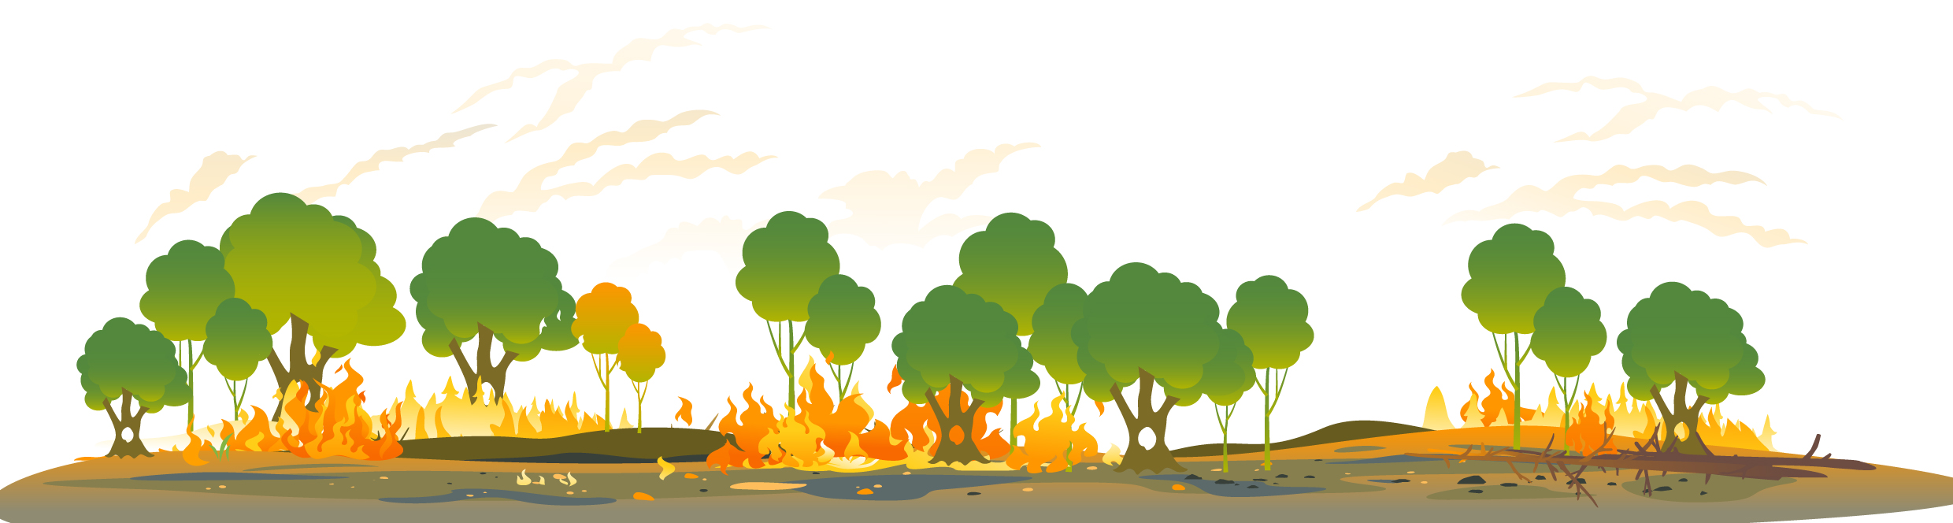
Figure 6: Land under active fire management (illustrative only). Cool, patchy burns in the early dry season leave a mix of burnt and unburnt areas. This mosaic approach helps reduce the risk of larger, more intense fires later in the dry season.

Project management plan
For each year of the project, you must prepare a project management plan that covers each entire project area.
The project management plan must be prepared before the start of annual planned burning. It needs to:
- describe all planned burning that is intended to be undertaken during the fire season that year. This includes the type of ignition (such as aerial or ground burning), the expected month, season and weather conditions of the burning, and the approximate locations that will be burnt. It also needs to state the objectives of the burning, including how they will support the objectives of the method
- demonstrate that the likely impact of burning on air quality in areas where people live have been considered (see ‘6.2.1. Demonstrating consideration of air quality impacts from planned burning’)
  - include a plan to monitor and manage the presence of relevant weed species in the area (see ‘6.2.2. Weed monitoring plan’).
Your project management plan does not need to be a standalone document produced solely for the method. You can meet the requirements through:
- a standalone project management plan including any maps, tables or figures
- relevant sections of another document(s) prepared for another purpose
- for example, if you created a fire management plan or weed monitoring plan, including if required under relevant legislation
- a combination of existing material and a short supplementary plan
- a section of a project offset reporting template that clearly addresses all project management plan requirements.
You are allowed to update or revise your project management plans throughout the year. This includes if planned burning activities were adjusted on the ground to reflect local conditions and operational considerations.
If you revise or update your project management plan, include the date of the revision or update. This recognises that fire management sometimes needs to respond to changing environmental conditions and operational constraints, such as weather variability, access limitations, or updated ecological priorities. The annual project management plans must be submitted to us with the relevant offsets reports (‘see 7.1.1. Details of project activities and project management plans’).

Demonstrating consideration of air quality impacts from planned burning
Smoke from fires, including fires from early dry season savanna fire management planned burns, can impact air quality by producing elevated levels of pollutants, including PM2.5 (particulate matter 2.5 micrometres (μm) or less in diameter). PM2.5 is known to have human health impacts. PM2.5 generated from savanna fire management planned burns can drift into areas where people live depending on weather conditions.
Your project management plan must demonstrate that you have considered the likely impact of PM2.5 particulate matter on air quality from planned burning in areas where people live. You should consider whether your planned burns might contribute to exceeding the Australian National Environment Protection (Ambient Air Quality) Measure standard for average daily maximum concentrations of PM2.5. At the time of publishing this document, the standard for average daily maximum concentration of PM2.5 is 25µg/m^{3.}
To meet this requirement, you could describe how any considerations and information influenced your burn planning decisions. For example, evidence of consultation with people that live near the planned burning areas, timing burns for days with appropriate weather and wind conditions or using available air quality information or guidance to understand when PM2.5 levels may be elevated.
See ‘Air quality and smoke’ for resources you can use to consider the impact of planned burning.

Weed monitoring plan
Your project management plan must include a plan for monitoring each relevant weed species in each project area. This plan should explain:
  - the risk level for each project area. For example, low, medium or high
  - how you determined the risk. For example, distance to known infestations, likely spread pathways, site conditions, land use and any past weed records
  - your monitoring approach, including who will do it, where you will monitor, and how often. For example, on-ground surveys (such as transects, fixed routes along tracks/fence lines, or targeted checks in high-risk corridors), aerial surveys (such as helicopter or drone flights), fixed photo-points, or remote sensing (such as satellite imagery). Monitoring frequency should match the risk. This means that higher risk areas may need more frequent checks.
      - How to meet this requirement
To meet this requirement, you could:
- map or describe areas most likely to be affected. For example, along roads, waterways, fence lines, tracks, drainage lines or near known infestations
- set a monitoring schedule. For example, at least once each fire season, or more often in high-risk areas
- keep records of what was checked, when, by who, what was found, and any actions such as managing any relevant weed species that were found.
You must review this monitoring plan at least every 5 years. If you update the plan during the reporting period, include the updated project management plan with your offsets report.

Weed management
A weed-affected area is an area of land within the project area that contains a relevant weed species. Relevant weed species are identified in the Technical Guidance. At the time of publication, the only relevant weed species is Andropogon gayanus (Gamba grass).
If you become aware of a weed-affected area in a project area, you must treat it within 18 months. The requirements to monitor and manage relevant weed species apply until the end of the crediting period for the project. You may become aware during your weed monitoring activities or if we notify you.
To treat relevant weed species, you need to use herbicide or mechanical removal to destroy the above-ground biomass. You must also ensure any treatment or removal occurs in accordance with any relevant Commonwealth, state or territory laws.
You must continue to treat weed-affected areas at least once every 12 months until they are eradicated. Eradicated means the relevant weed species have not been detected for 24 months. You must keep records of your weed management. If it is not possible to appropriately treat weed-affected areas, you can choose to remove these areas from the project (see ‘9.1. Varying project areas’).
There are exemptions for weed management if it is not possible due to circumstances beyond your reasonable control. For example, extreme seasonal conditions may make treatment unsafe or ineffective in a particular year. The ‘reasonable control’ test is the same as the test applied under sections 82, 90 and 91 of the CFI Act. This exception also recognises that gamba grass may only be treatable in a shorter seasonal window, and that treatment programs can be complex to deliver across large and remote areas.

Fire permits
If a fire permit is required under state or territory bushfire legislation, you must ensure that all burning carried out as part of the project complies with that permit. This means that throughout each reporting period, any burning that requires a permit must be carried out during the dates, times and conditions as by that permit.
In limited circumstances, burning that required a permit may occur outside the time allowed under a permit, or without a permit. This will only be acceptable where:
- there was a reasonable excuse for not complying with the permit requirement
- no court has found that bushfire legislation was breached because a permit was not obtained
- there is no ongoing pattern of failing to obtain required permits for the project area.
Failure to comply with applicable bushfire legislation or permit requirements may result in the project not meeting eligibility requirements under the ACCU Scheme. You should keep records of all fire permits and any related correspondence and provide these to us with each offsets report.
State and territory governments have informative webpages on bushfire safety, and how and when to obtain a fire permit. Examples are linked below:
- Western Australia: Planned burning
- Northern Territory: Prescribed burning
- Queensland: Lighting fires in Queensland.

Vegetation fuel type maps

Requirement to create vegetation fuel type maps
Before you reach the end of the first reporting period, you must create and validate a vegetation fuel type map for each project area. Vegetation fuel type maps cover the entire project area using 250 metre by 250 metre pixels (mapping units). Each mapping unit classifies the dominant eligible vegetation fuel type or classifies the area as ineligible land. This could include areas of land dominated by other vegetation fuel types, cleared land, or land used for agriculture.
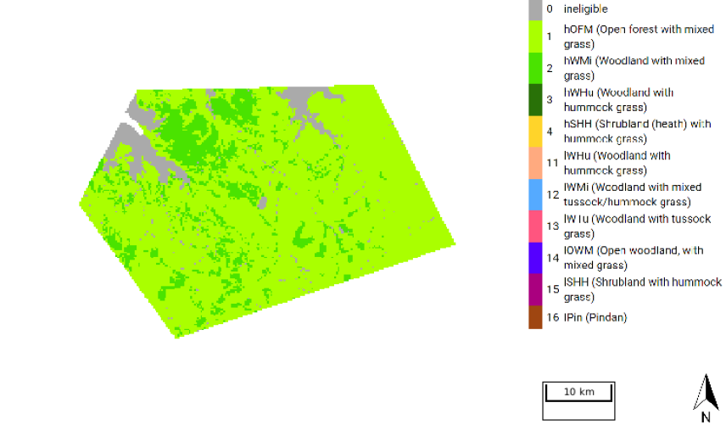
Figure 7: Example project area in the high rainfall zone with hOFM and hWMi fuel types.
You can derive vegetation fuel type maps from:
  - remote-sensing data interpretation, using object-based image analysis techniques
  - reclassifying existing vegetation map products
  - recent aerial photo interpretation.
The SavCAM tool provides an example vegetation fuel type map for users that do not have a custom map for a project. While this can be used for planning a project and investigating potential indicative abatement estimates, it does not meet the relevant method requirements and cannot be used to estimate abatement under the method.
Further information on creating vegetation fuel type maps can be found in the Technical Guidance.
We are required to publish all vegetation fuel type maps submitted with offsets reports from 11 October 2026, unless you make an application for non-publication and we are satisfied that:
  - the withholding of the information is required to protect or respect Aboriginal tradition
  - publication of the information may threaten, damage or cause harm to a threatened ecological community or threatened species
  - the information is subject to a contractual obligation between the project proponent, and a person contracted to create or validate that information which prevents its publication.
In this case, we are still required to publish a map which identifies any parts of the project areas that are classified as ineligible in accordance with the vegetation fuel type map. If you would like to make an application to withhold the publication of the vegetation fuel type map, you should fill out and submit an application to withhold publication of certain project information on the ACCU Scheme project register.

Validating vegetation fuel type maps
Once you have created a vegetation fuel type map, it must be validated.
Validation involves comparing the vegetation fuel type mapping units against independent observations (waypoints) collected across the project area. These observations may be collected on the ground or using aerial imagery. They must be collected by someone with sufficient knowledge and experience to recognise the different vegetation fuel types. Remote sensing cannot be used to validate vegetation fuel type maps. A vegetation fuel type map is valid if it has an overall accuracy of at least 80%.
Validation must also:
  - use data independent from the data used to create the map
  - cover all vegetation fuel types included in the project area
  - be completed no earlier than three years before the project or project area was added and no later than when the first offsets report is submitted that relies on that map.
If validation shows the map does not meet the required accuracy threshold, you must revise and re-validate the map before it can be used for reporting. If a vegetation fuel type map is revised, additional validation may be required depending on the extent of the revision. You must retain records relating to the creation, revision and validation of vegetation fuel type maps and provide this information to us if requested.
Further information on validating vegetation fuel type maps is set out in the Technical Guidance.

Revising vegetation fuel type maps
You must revise a vegetation fuel type map if it no longer accurately represents the vegetation within the project area. You may become aware of mapping units being incorrectly classified through your monitoring activities, audits or other project assessments. You may also be notified by other parties.
A revision is required if you become aware that either:
  - an area shown as an eligible vegetation fuel type should instead be classified as ineligible
  - an area has been assigned an incorrect vegetation fuel type.
If a revision is required, you must:
  - notify us
  - revise the vegetation fuel type map so that it correctly reflects the vegetation classifications
  - complete the revision (and re-validation, where required by the Technical Guidance) before you submit the offsets report for the reporting period during which the issue was identified.
You can choose to revise a vegetation fuel type map where an area previously classified as ineligible is later identified as containing an eligible vegetation fuel type. This might include areas with Pindan vegetation that were not eligible under previous savanna fire management methods. However, if you do choose to revise the map, abatement can only be credited for project areas once the map has been revised and, where required, re-validated.
If at any time, a change to the land would result in a significant portion of land being classified as ineligible in a vegetation fuel type map, you have two options. You can either:
  - revise the vegetation fuel type map to re-classify the affected land as ineligible
  - remove the affected land from the project area.
A significant portion of land refers to adjoined areas of land in the project area that are larger than 5% of the total area of the project or larger than 50 hectares.
If you choose to remove land, you can only do so by removing an entire project area or an entire subdivided project area. See ‘9.1. Varying project areas’ for further information on removal of project areas.

Notification requirements
ACCU Scheme legislation requires you to notify us about certain project changes or events to help confirm ongoing eligibility, reporting and integrity. You must notify us when any of the specified events occur, within the relevant timeframe. The Notify the Regulator form will enable your notification to be processed by the CER in a timely manner. If you are unsure whether a notification applies or you have extenuating circumstances and are unable to meet a notification requirement or timeframe, contact us as soon as you are able to discuss your circumstances.
Change type | Event | Notification requirement
Project proponent | The project proponent changes, other than because of death | Notify us within 90 days of the project proponent ceasing to be the project proponent. This includes if legal right is lost
Project proponent | The project proponent dies | Notify us within 90 days of their death
Project proponent | There is a change to the project proponent’s business name or trading name or contact details | Notify us within 30 days after the change occurs
Project proponent | There is an event that would affect whether a project proponent is a fit and proper person | Notify us within 90 days of the event  Further details of events relevant to whether a project proponent is a fit and proper person can be found in section 84 of the CFI Act and Part 4 of the CFI Rule
Errors in offsets reports | If the error relates to project eligibility requirements of net abatement amounts | Notify us within 60 days of becoming aware of the error
How the project operates | If the way the project is being operated has changed, and the change could result in the project being revoked due to not meeting scheme or method eligibility requirements | Notify us within 60 days of becoming aware of the change
Relevant weed species | You first detect relevant weed species in a project area | Notify us within 60 days of becoming aware of the detection  The notification must include the date of the detection, the name of the weed species detected, and the location (in geospatial format) of its detection
Vegetation fuel type maps  For more information on requirements to revise vegetation fuel type maps, see ‘6.5.3 Revising vegetation fuel type maps’. | You become aware that:  - an area of land classified as eligible vegetation in your vegetation fuel type map should be classified as ineligible  - an eligible area of land has been classified as the incorrect vegetation fuel type | Notify us within 90 days of becoming aware
 | You become aware that an area of land has been classified as ineligible in the vegetation fuel type map but should be classified as eligible, and you choose to revise the vegetation fuel type map accordingly | Notify us of the date and nature of the revision within 90 days of the revision
 | A vegetation fuel type map for a transferring project area required revision under a previous method | Notify us when the project is declared or varied
Project becomes inconsistent with a regional natural resource management plan | Your project becomes inconsistent with the relevant regional natural resource management plan from a change to the project | Notify us within 90 days of the change

Some notification events will require a project variation application to be submitted. See ‘9. Making changes to your project’ for more information.

Monitoring and record keeping requirements

Monitoring and record-keeping
Monitoring and record keeping are ongoing obligations throughout your project. Maintaining accurate records will help you meet reporting, audit and compliance requirements and demonstrate that your project is being carried out in accordance with the method.
You should ensure that you allocate appropriate time and resources to meet monitoring and record-keeping obligations.

Monitoring requirements
You must monitor for the presence of each relevant weed species in each project area in accordance with the project management plan.

Record-keeping requirements
You must keep records of:
- any correspondence between the project proponent and us that is relevant to the project
- any notifications given to us under the CFI Act or CFI Rule, and supporting information for those notifications
- information associated with the application to declare the project
- all offsets reports for the project, as well as information used to prepare offsets reports. This includes each SavCAM report, any other SavCAM outputs used to calculate net abatement for a reporting period, including all data files and inputs used in those calculations
- any audit reports prepared for the project, and information provided to auditors to support audit findings
- information that shows that the project is being implemented and operated in a manner that is consistent with method eligibility requirements. This includes fire management activities, such as when and where burning occurred, whether burning was undertaken in the early or late dry season, and any unplanned fire affecting the project area
- details of changes to the scope or location of the project
- information used to prepare, update or revise a project management plan, including records of planned burning, unplanned fires and reasons why planned burning did not occur, and where applicable:
  - all data collected while monitoring the project, and information that shows that monitoring requirements for the project are being complied with. This includes data and information related to monitoring for the presence of relevant weed species in each project area, and records of any detection, treatment or management of weed-affected areas
  - information about any event that is reasonably likely to significantly increase or decrease the carbon abatement that results from carrying out of the project
- fire permits, where permits were required, and evidence that burning was carried out in accordance with applicable state or territory bushfire legislation
- the vegetation fuel type map used for the project, including records relating to its creation, validation and any revision.
You must retain these records for the period required under the CFI Act and CFI Rule and ensure they are complete and sufficient to demonstrate compliance with the legislative requirements.

Reporting on your project

Summary of this section
This section is relevant if you are preparing, or would like to understand what is required to prepare an offsets report under the method. This section is also relevant if you are interested in understanding the technical information on how abatement is calculated.
To receive ACCUs, you must submit regular offsets reports that provide information about project activities, weed management, vegetation fuel type maps, project area changes and net abatement. Net abatement must be calculated using SavCAM and reported for each relevant calendar year.
To prepare for reporting on your project, you should ensure that you:
  - understand the required timeframes for offsets reports to be submitted
  - can provide required supporting information
  - have calculated net abatement using SavCAM
  - have records and evidence supporting your offsets report
  - understand the audit schedule and requirements, and have planned accordingly.

Offsets report
An offsets report is the document you submit each time you report on your project. It includes supporting information and outlines your project’s progress, including the net abatement amount.
You must submit an offsets report within 6 months of the end of each reporting period. You can choose the length of each reporting period to be between 6 months and 2 years. However, in most cases, projects choose to align reporting periods with calendar years as abatement is calculated for calendar years that end during a reporting period.
You can submit your offsets report through Online Services. To be issued ACCUs, you need to set up an Australian National Registry of Emissions Units (ANREU) account before the end of the first reporting period for your project.
To help ensure your offsets report is assessed promptly, it’s in your interest to provide all required information accurately. This may include responding to a request for further information by the due date specified in the request. If you don’t provide the required information, we may refuse to assess your report or issue ACCUs.
If you need clarification or support while preparing your offsets report, contact us.

Details of project activities and project management plans
In your offsets report, you must provide copies of the project management plans. If any of the fire management activities were not undertaken in accordance with the plan, you must provide information describing how and why.
If you undertook planned burning, your offsets report must include:
- a statement confirming that planned burning was undertaken
- a description of:
  - where the planned burning occurred
  - when it occurred
  - the extent of burning
- an explanation of whether the planned burning met the requirements to undertake savanna fire management, and if so, to what extent. This means describing:
  - how the planned burning for the calendar year went, considering planned and unplanned burning in previous years of the project
  - any planned burning proposed for future years
  - how the planned burning forms part of an ongoing and coherent savanna fire management program for the project area.
Your explanation should show how this program of burning meets the method objectives.
If you did not undertake planned burning, your offsets report must include:
- a statement confirming that planned burning was not undertaken
- the reasons why planned burning did not occur.

Information on relevant weed species
Your offsets report must include information about monitoring and management of relevant weed species. You must state that the project area was monitored in accordance with the project management plan and describe the results of that monitoring for the reporting period.
If a relevant weed species was detected in a project area during the reporting period, you must state that the weed species was detected and identify the location of weed-affected areas using geospatial mapping. You must also provide evidence showing when and how weed-affected areas were first treated, as well as evidence of ongoing treatment. If treatment of a relevant weed species was not possible in any year due to circumstances beyond your reasonable control, the offsets report must explain that treatment could not occur, describe those circumstances, and include evidence to support that explanation.
If a relevant weed species was eradicated from a previously weed-affected area during the reporting period, the offsets report must include a statement confirming eradication, a map of the area in a geospatial format, and evidence demonstrating that the relevant weed species was permanently removed from the area.

Information on vegetation fuel type maps
Your offsets reports must include a copy of the latest vegetation fuel type maps used to calculate abatement in SavCAM. If a map was newly created or revised, you must state this in the offsets report, including the date it was created or revised, and provide any audit reports that relate to the validation of the map. If you were required to or elected to revise a map, you must also provide an explanation of why the map was revised.

Information on subdivided and removed project areas
Subdivision involves dividing a project area into 2 or more smaller project areas. The total area of land covered by those smaller project areas needs to be identical to the area of land covered by the original project area. A subdivision is made through an application to vary project area and is different to a division to split report, which allows project areas within the same project to be treated as separate projects
Your offsets report must state if you are reporting on a subdivided project area for the first time. You must also include the date the relevant variation took effect and the result of Equation 5, along with the inputs you used for that calculation.
If any project area (including a subdivided project area) was removed from the project, the offsets report must state this, describe the area that was removed, and include the date of removal.
We have developed a subdivision calculator to help with Equation 5.

Information relating to net abatement
You must provide a copy of each abatement report as produced by SavCAM for the reporting period.
If during a reporting period, you use a factor or parameter that is defined or worked out by referring to another instrument or written document (for example, a determination, legislative instrument, standard, or guideline), that factor or parameter must be based on the version of that instrument or document that is in force at the end of the reporting period. If this isn’t possible, you must include:
  - versions of the instrument or writing that were instead used to calculate the factor or parameter
  - the start and end dates for each version used
  - the reasons why it was not possible to define or calculate the factor or parameter using the version in force at the end of the reporting period.
This includes versions of SavCAM.

Relevant statements and declarations:
The method also requires that offsets reports include relevant statements and declarations, including:
  - if the project area was varied to add a project area the project and the added project area is being reported on for the first time
  - that the project area was not varied, other than in accordance with the CFI Rules
  - that the project area was monitored for relevant weed species in accordance with the project management plan
  - that the livestock density did not increase as a consequence of the project.

Audits
Your project must be audited to meet legislative requirements. The number of audits you will have depends on your forward abatement estimate:
  - projects with an annual average abatement amount of less than 50,000 tCO₂-e will have one initial audit and two subsequent audits
  - projects with an annual average abatement amount of 50 001 to 150 000 tCO₂-e will have one initial audit and three subsequent audits
  - projects with an annual average abatement amount of more than 150,001 tCO₂-e will have one initial audit and four subsequent audits.
Each audit report must be submitted at the same time as the corresponding offsets report and be conducted by an independent greenhouse and energy auditor to a reasonable assurance standard. When your project is registered, we’ll provide an audit schedule that outlines which offsets reports must include an audit.
In addition to scheduled audits, we can require compliance audits at our expense, or your expense if we have reasonable grounds to suspect non-compliance. You must also provide a threshold audit with an offsets report if you claim more than 100,000 tCO2-e as the net abatement amount for a reporting period.
Audit costs
You are responsible for audit costs.
We recommend early engagement of an auditor when developing your project to help establish audit costs. See a list of registered auditors.

Calculating net abatement
While previous savanna fire management methods allowed net abatement to be calculated either manually or using SavBAT, this method requires that net abatement is calculated using SavCAM.
SavCAM is a tool that automates GIS processes and mathematical calculations required to calculate abatement under the method. SavCAM requires inputs of your vegetation fuel type map and information about the project and the calendar year that you are reporting on. See the step-by-step guide on using SavCAM. SavCAM uses a similar user interface to SavBAT, but integrates FullCAM to calculate abatement. For more information on SavCAM and FullCAM, see the Appendix.
You must use the version of SavCAM that was in place at the end of the reporting period, unless it’s not available, in which case the latest version must be used.
You must calculate net abatement separately for each project area for each calendar year that ends during a reporting period. Then, you must sum abatement for all project areas for all calendar years being reported on.
You must calculate net abatement separately for each project area for each calendar year that ends during a reporting period. Then, you must sum abatement for all project areas for all calendar years being reported on.
For example, if you are reporting on the 2026 and 2027 calendar years, and you have two project areas, you will calculate net abatement for Project Area 1 in 2026, Project Area 2 in 2026, Project Area 1 in 2027, and Project Area 2 in 2027. You will then add the four net abatement amounts together to determine the total net abatement for the reporting period.
For project areas that span both the high and low rainfall zones, SavCAM will separately account for each part of a project area that is in a single rainfall zone, then add the amounts for the different rainfall zones together.
Because of the way net abatement is calculated, reporting more frequently than annually would not serve any practical purpose. You may choose to align your project reporting periods with the calendar year to ensure consistency and reduce administrative burden.
For example, if your project is registered on 1 August 2026, you could choose to report with two reporting periods as follows.
Reporting period | Entire calendar years reported on | Offsets report due
1 August 2026 to 31 December 2027 | 2026 and 2027 | 30 June 2028
1 January 2028 to 31 December 2028 | 2028 | 30 June 2029

Emissions avoidance
When calculating the contribution to the net abatement amount from emissions avoidance, SavCAM calculations account for emissions of nitrous oxide and methane for grass fuel, fine fuel, coarse fuel, heavy fuel and the fire impacted proportion of living biomass.
To calculate abatement, first SavCAM will calculate the difference between baseline fire emissions and fire emissions in the project year. Then, abatement is adjusted using an uncertainty buffer, which accounts for inter-annual variability of fires and risk of over-crediting.
If no planned burning was undertaken in a calendar year, then the adjusted net abatement will be taken to be 0, but any negative abatement will still be reflected in the uncertainty buffer.

Uncertainty buffer
A project area’s uncertainty buffer will start at 0, unless the project area is a transferring project area or is a subdivision of an existing project area.
For each year, if the total abatement from emissions avoidance is positive, up to 10% of the total abatement will be added to the uncertainty buffer until it reaches 5% of the baseline emissions for the project area.
If emissions are higher than the baseline average in a particular year, the negative abatement is subtracted from the uncertainty buffer. Then, if the uncertainty buffer remains negative in future years, the balance must be returned to 0 or greater before abatement can be issued.
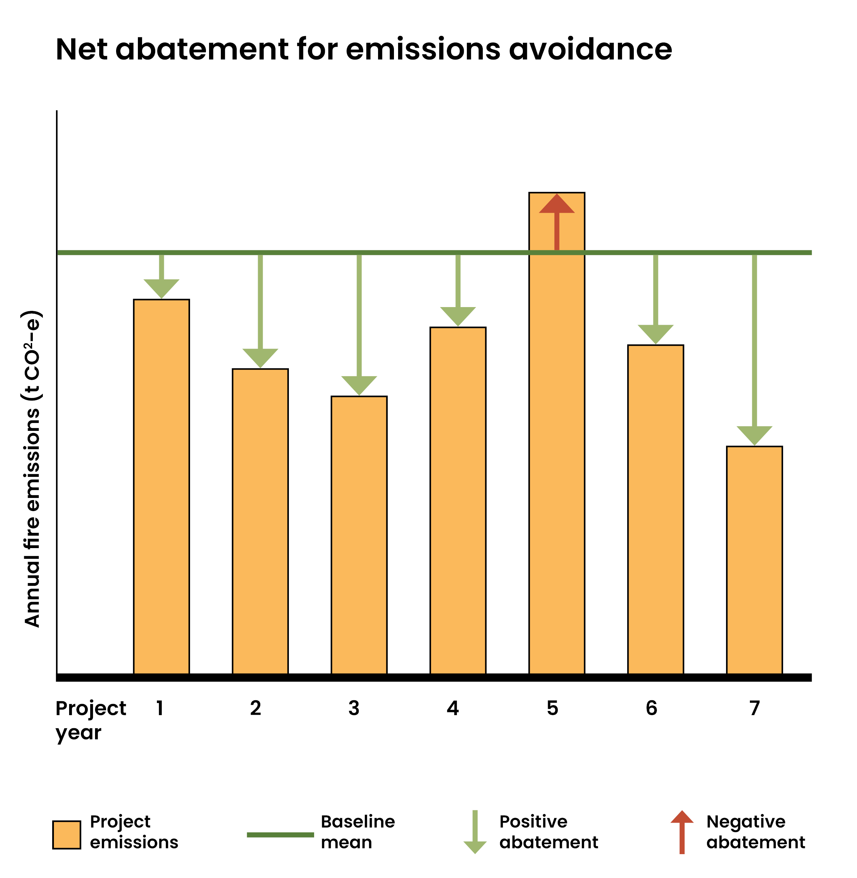
For most projects, consistently lower emissions mean the uncertainty buffer reaches the cap within the first few years of reporting. Once the cap is reached, SavCAM does not continue to add to the buffer. The buffer cap value is recalculated each year and may change due to updates to referenced documents, revisions to the vegetation fuel type map, or changes to project area boundaries. Over the life of the project, the uncertainty buffer generally results in an overall reduction of around 5% of the baseline emissions in credited abatement, helping ensure the method is conservative.
Figure 8: Example of abatement for emissions avoidance. Annual project emissions are shown relative to the baseline mean. Years in which emissions fall below the baseline represent positive (creditable) abatement, while years with emissions above the baseline represent negative abatement.

Adjustments for transferring projects
If an uncertainty buffer was calculated for the previous year while the project was under a different method, that number is the previous year’s uncertainty buffer for the first year reported on in this method.

Transferring a project
Summary of this section
This section is relevant if your project is already registered under another savanna fire management method and you are considering transferring it to this method.
The transfer process depends on whether your project is currently registered under a sequestration method or an emissions avoidance method:
  - projects transferring previous emissions avoidance methods can apply to vary the project method. Gaining new eligible interest-holder consents is optional, but if they are provided, the crediting period will be extended
  - projects transferring from sequestration methods need to revoke or vary the existing project and register a new project under this method.
Before applying to transfer, you should understand:
  - which transfer pathway applies to your project
  - whether new eligible interest-holder consents are required
  - how the transfer may affect your crediting period
  - eligibility requirements, including treating or removing weed-affected areas
  - the timing requirements for applications.
Transferring a project can involve multiple steps. You should plan early, particularly if you need the transfer to be approved before 11 October of the relevant year.

If you have a project that is already registered under another savanna fire management method, you can apply to transfer to this method. Different processes apply depending on which method your project will be transferring from:
  - ‘8.2. Transferring from a closed savanna emissions avoidance method’
  - ‘8.3. Transferring from a savanna sequestration method’.
Transferring projects timing
Transferring a project can involve multiple steps, and we recommend you plan carefully to ensure applications are processed in time.
For timing estimates, refer to our average and legislative processing times for applications.

Provisions for transferring projects
Transferring projects are subject to provisions in the method to ensure integrity and practicality.
  - baseline periods for transferring project areas will remain the same
  - if the project area includes weed-affected areas, those areas must be treated within one year before applying to transfer to the method. If you can’t meet this requirement, the weed-affected areas must be removed from the project area. Further details about weed management can be found in ‘6.3. Weed management’
  - vegetation fuel type maps that were created and validated under other methods may continue to be used under the method. If a map required revision under the previous method, you must notify us and revise the map in accordance with that method. If you choose to update a vegetation fuel type map (for example, to include Pindan vegetation), it must be validated in line with the Technical Guidance. Further details about vegetation fuel type maps can be found in ‘6.5. Vegetation fuel type maps’
  - if uncertainty buffers and carry-over amounts were calculated for the previous year under a different method, they must be used as the previous year’s values for the first calendar year reported on under this method.
Once a project under a previous method (for example, the 2013, 2015 or 2018 savanna methods) is transferred to this method, it cannot return to that previous method.

Transferring from a previous emissions avoidance method
When applying to transfer a project from a previous emissions avoidance method, providing evidence of new eligible interest-holder consents is optional. However, if new eligible interest-holder consents are provided, the project will gain a crediting period extension. The transfer will apply from the start of the current reporting period.
You should also be aware that if you apply to transfer your project with new eligible interest-holder consents and we declare the new project between 11 October and 31 December of any year, your crediting period will end in 2050 instead of 2051. To get the full crediting period extension and claim abatement for the 2050 year, you should apply to transfer your project earlier in the year to allow time for the application(s) to be approved before 11 October.

Apply to vary method
If you have a project under a previous savanna emissions avoidance method, you can apply to vary the project method through Online Services.
Your application must:
  - state that the project includes transferring project areas
  - identify each transferring area
  - include a description of the project and a statement it meets the requirements of the applicable method
  - contain any eligible interest-holder consents for the area of land in the transferring project area and evidence that they have consented to the application to transfer of the project. This does not mean that you must gain new consents to vary the method. If consents from all eligible interest-holders are obtained upfront, then the project will be eligible for a crediting period extension
- identify any part of the project that includes a known weed-affected area. The application also needs to include the date and details of any treatment applied to the area.
When you vary the project method, the variation will take effect from the start of the current reporting period. The effect of this provision is that in some cases, the method will apply to a project prior to the method being made.
For example, a project registered under the 2015 emissions avoidance method that has reported up until 31 December 2024 could apply to transfer to the 2026 emissions avoidance method before 31 December 2026. The transfer would take effect from 1 January 2025. The project could then include the 2025 and 2026 calendar years in its first reporting period under the 2026 method.
For us to approve the variation, we need to be satisfied that the project is covered by this method. This means that from the start of current reporting period, the project must have met the method requirements. This includes:
  - the requirement to prepare a project management plan before conducting planned burning, including consideration of air quality impacts and a plan to monitor relevant weed species (see ‘6.2. Project management plan’)
  - the requirement to monitor and manage relevant weed species (see ‘6.3. Weed management’).
If your project can’t meet method requirements for a previous year, you can choose to report on that year under the previous emissions avoidance method before you apply to transfer.
For example, a project registered under the 2015 emissions avoidance method that has reported up until 31 December 2024 could submit an offsets report for a reporting period ending on 31 December 2025. Then, the project could apply to transfer to the 2026 emissions avoidance method, which would take effect from 1 January 2026. The project could then report on the 2026 calendar year in its first reporting period under the 2026 method.

Crediting periods
The crediting period for projects that transfer from previous savanna emissions avoidance methods will begin from the project start date. Applying to vary the method will not change the project start date.
When evidence of new eligible interest-holder consents has been provided with the application to transfer, the total crediting period will be worked out by starting with the standard 25‑year period, then adding the number of years the project operated under the previous savanna fire management method and adjusting for the time between when the method was made and when the method first applied to the project.
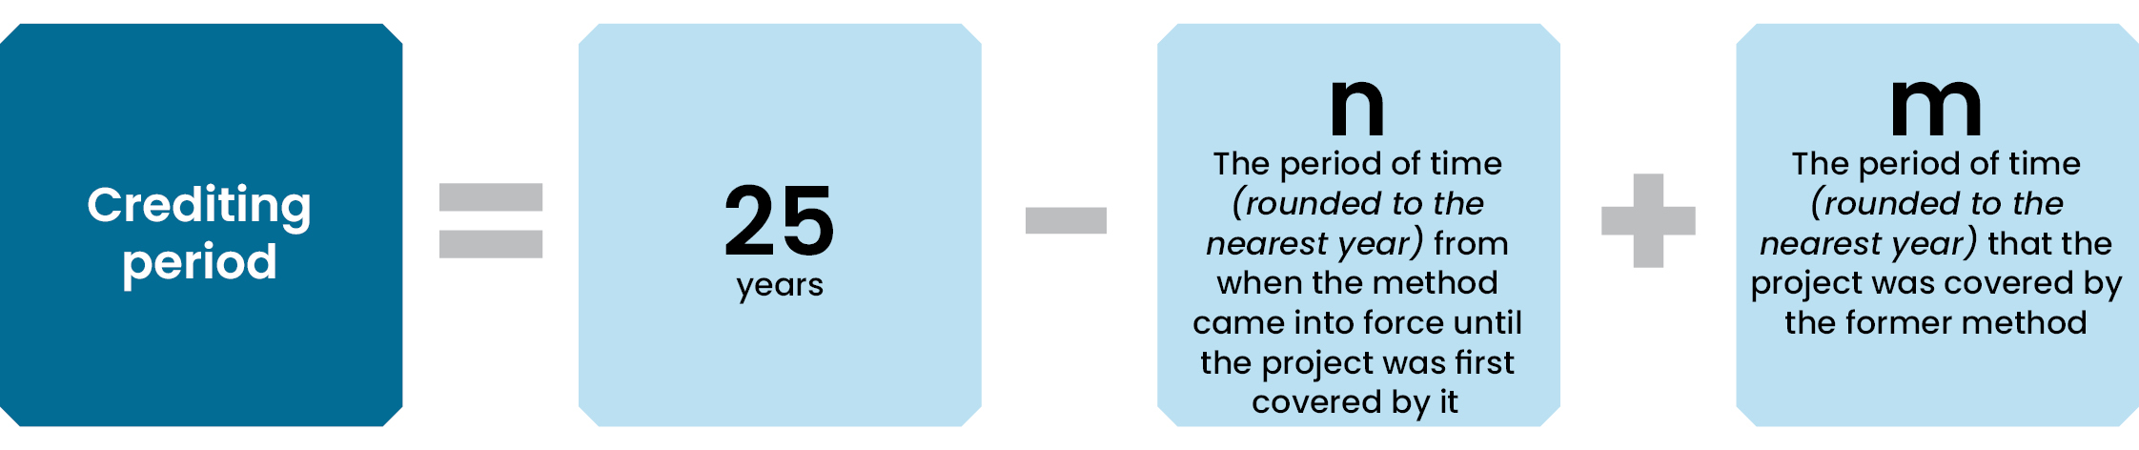
Figure 9: Crediting period calculation for a project transferring from a previous emissions avoidance method that provided upfront evidence of eligible interest-holder consents.
You should be aware that if you apply to transfer your project with new eligible interest-holder consents and we approve the application between 11 October and 31 December of any year, your crediting period will end in 2050 instead of 2051. To get the full crediting period extension and claim abatement for the 2050 year, proponents should apply to transfer your project earlier in the year to allow time for the project application to be approved before 11 October.
Projects that transfer without evidence of new eligible interest-holder consents will keep the same crediting period of 25 years.
You could transfer a project under a previous emissions avoidance method to the 2026 emissions avoidance method without consents, and later transfer to the 2026 sequestration method with consents to gain an extended crediting period.

Transferring from a savanna sequestration method
Savanna sequestration projects can apply to transfer to this method. The project will become a ‘restarting transferring project’, and the transfer will apply from the new project start date.
Before you transfer, you’ll need to:
  - ensure you can obtain new consents from all eligible interest-holder consents before the end of the first reporting period of the new project
  - ensure you can maintain legal right for the duration of the project
- relinquish ACCUs issued for the transferring project areas that were attributable to sequestration (see Relinquishment of ACCUs under joint emissions avoidance and sequestration methods).
Your application to register a project under the method must:
  - state that the project includes transferring project areas
  - identify each transferring area
  - contain details of consents obtained from any persons who hold an eligible interest in any area of land in the transferring project area and evidence that they have consented to the application to transfer of the project. If consents from all eligible interest-holders are not provided, the emissions avoidance project will be registered conditionally and may have a shorter crediting period
  - if any part of the project area includes a known weed-affected area, state this and identify the weed-affected area. The application also needs to include the date and details of any treatment applied to the area.
The transfer will take effect from the date that we declare the new project under the method.
We require that all steps in this process are completed by 1 December of the year following the most recent calendar year. This means that while you can transfer in any year, there cannot be a gap between when the sequestration project was revoked or varied and the new project was registered under the method.
Typically, applications to revoke or vary and register projects are processed within 90 days. In certain circumstances, there may be delays in processing applications, including when we require you to provide further information, so allow plenty of time when planning to transfer.

Transferring an entire project
If you are transferring an entire sequestration project to the method, you must complete a multi-step process that includes revoking the project and applying to register a new project.
The revocation and registration steps must be completed simultaneously using the Register a project and Revoke a project form in Online Services.

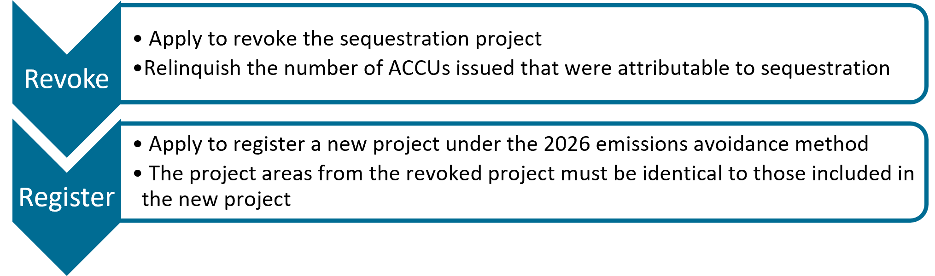

Transferring part of a project
If you are transferring only part of an existing sequestration project to this method, the project needs to be divided into separate project areas that will be transferred to this method, and project areas that will remain under a sequestration method.
If your project is not already divided into project areas that you will transfer to this method and project areas that will remain under the sequestration method, you must first apply to subdivide the existing project area.
To subdivide the project areas, you need to apply to vary the project area. If approved, this variation will take effect from the start of the current reporting period.
Then, you must complete a multi-step process that includes varying the project area to remove the transferring project areas and applying to register a new project.
If ACCUs were issued to the sequestration project, the project must be restructured so that there are two projects, one with project areas that will remain under the sequestration method and one with project areas that will transfer to the emissions avoidance method.
The project with transferring project areas can then be revoked, and the transferring project areas can be registered under the emissions avoidance method (see Relinquishment of ACCUs under joint emissions avoidance and sequestration methods).
The area variation or revocation and registration steps must be completed simultaneously using the Register a project form and Vary area or Revoke a project form in Online Services.

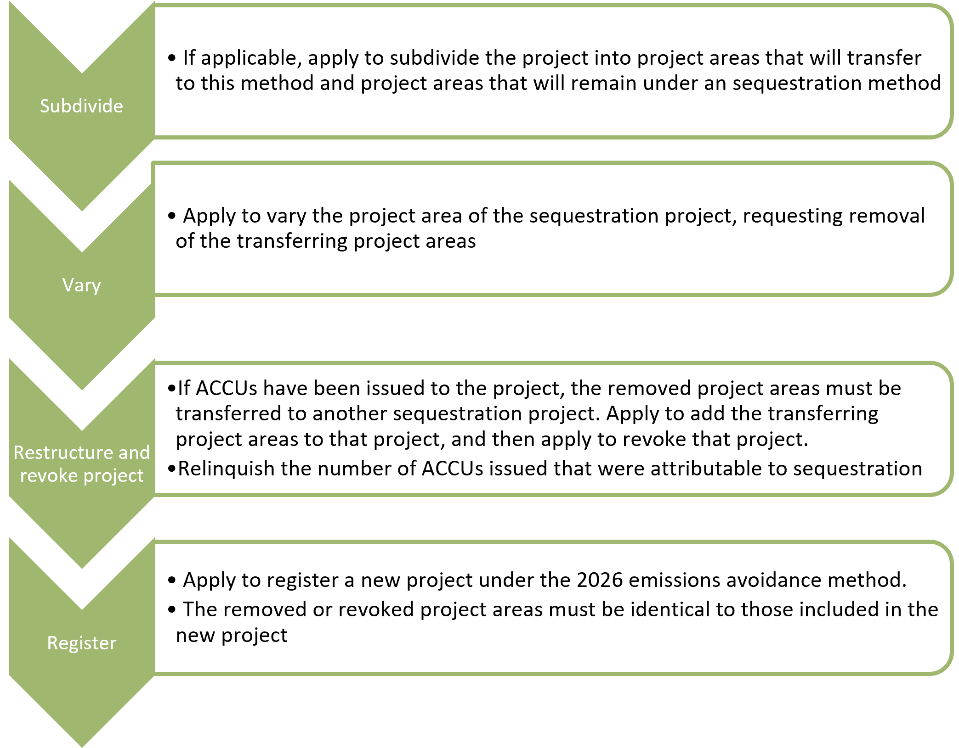

Crediting periods
The crediting period for projects that transfer from a sequestration method will begin from the start date of the new project.

Transferring with upfront evidence of new eligible interest-holder consent
If evidence of new eligible interest-holder consent is provided with the application to register the new project, the crediting period will be worked out by starting with the standard 25‑year period, then adjusting for the time between when the method was made and when the project was declared under it.
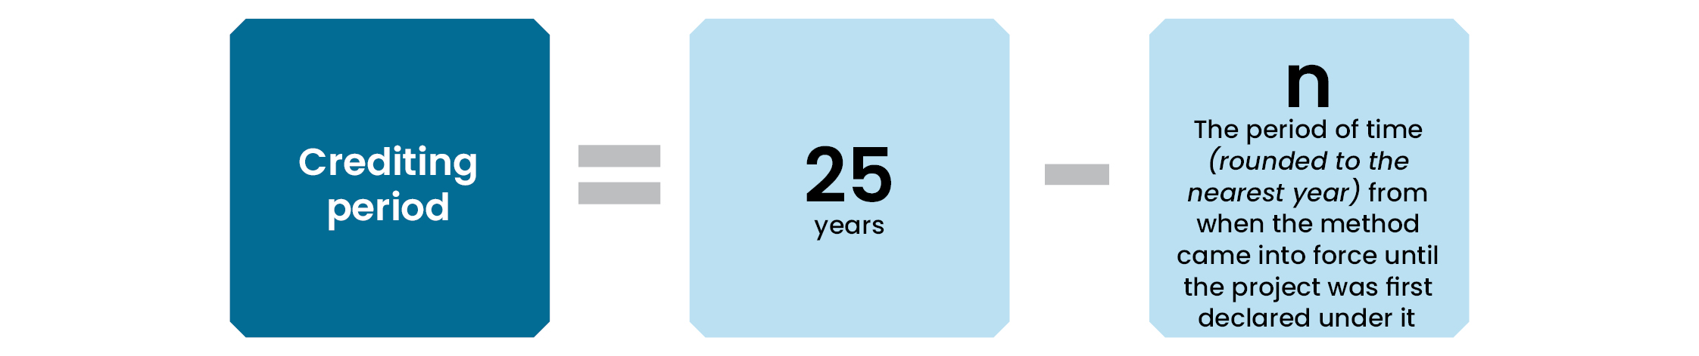
Figure 10: Crediting period calculation for a restarting transferring project that provided upfront evidence of eligible interest-holder consents.
You should be aware that if you apply to transfer your project with new eligible interest-holder consents and we declare the new project between 11 October and 31 December of any year, your crediting period will end in 2050 instead of 2051. To get the full crediting period extension and claim abatement for the 2050 year, you should apply to transfer your project earlier in the year to allow time for the application to be approved before 11 October.

Transferring without upfront evidence of new eligible interest-holder consent
If you are unable to provide consents upfront with the application to transfer, your project will be registered with the condition that consents are provided before the end of the first reporting period. The crediting period may be shorter than if consents were provided with the application to transfer.
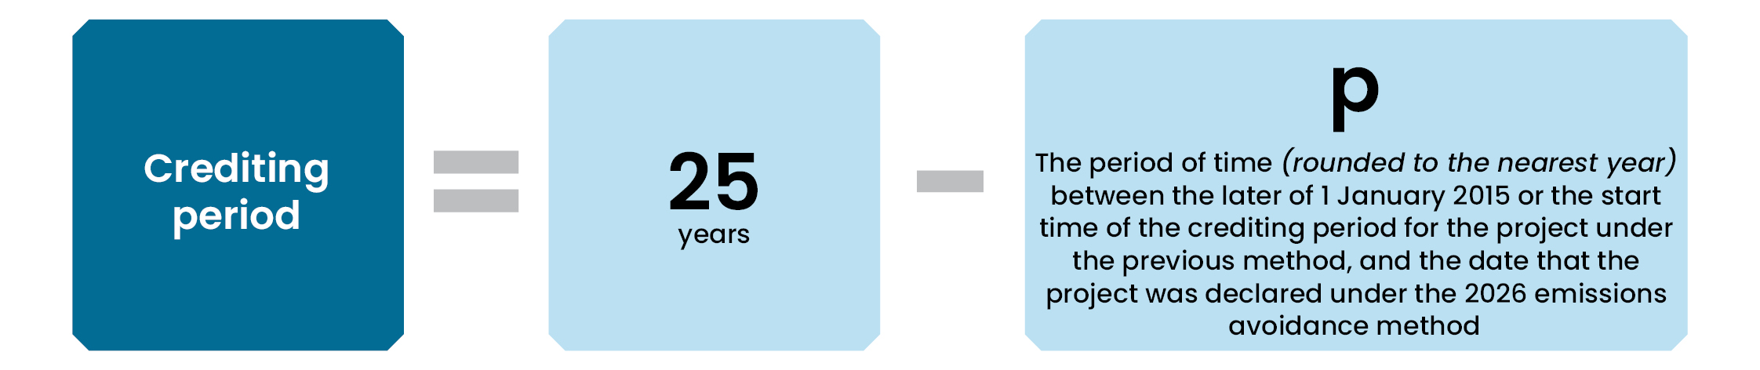
Figure 11: Crediting period calculation for a restarting transferring project that did not provide upfront evidence of eligible interest-holder consents.

Project timeline
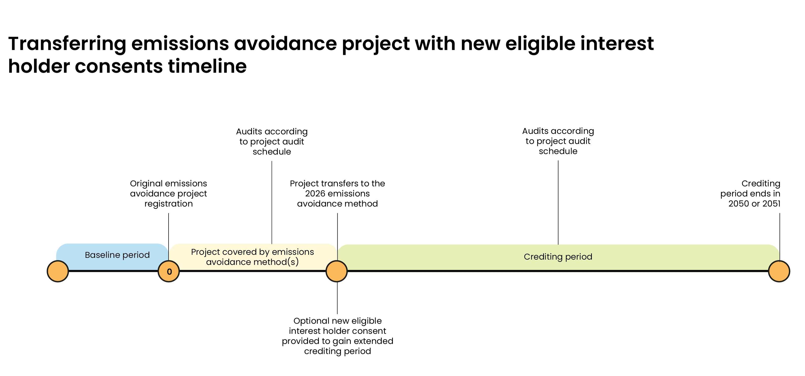
Figure 12: Timeline for a restarting transferring project with two subsequent audits.

Making changes to your project

Summary of this section
This section is relevant if your project is already registered under this method and you would like to make changes to it.
Depending on the type of change, you may need to apply for a project variation through Online Services or notify us through another process. Variations can be used to change the project area, project start date, project proponent, project method or remove conditions from a conditional registration.
Before making changes to a project, you should understand which changes require a project variation application, and when you need to notify us of a change
Project areas can be:
  - subdivided into smaller project areas
  - removed from a project
  - added to a project, including through transfers from other savanna projects.
Subdivision may be useful where different parts of a project need to be managed separately, transferred to another project, or removed because of weed-affected areas or substantial areas of ineligible vegetation.
When project areas are added, removed or subdivided, additional requirements may apply, including adjustments to abatement calculations, updates to vegetation fuel type maps, and provision of supporting information.
You can also transfer a project to the 2026 savanna fire management—sequestration and emissions avoidance method. This involves varying or revoking and re-registering the project.
Under the CFI Act, you can make changes to your project to adhere to changing circumstances.
You can apply to vary the project area, project start date, the proponent, the method or to remove conditions from a conditional registration. For these changes, you will need to complete a project variation form in Online Services.
Other changes may be made to your project without our approval, but we must be informed via a formal notification or in an offsets report. See sections 78-85 in the CFI Act and sections 81-87 in the CFI Rule for further information about the general notification requirements.
Below, we provide information specific to the method about varying project areas and varying the project method. See our website for general information about varying a project.

Varying project areas
ACCU Scheme projects can have multiple project areas within one project. Under the method, separate project areas must individually meet method requirements. This means the project activity must be undertaken in each project area in each calendar year.
Under the CFI Rule, projects under the method are restricted to area variations that add an entire project area, remove an entire project area, or subdivide a project area into multiple smaller project areas.
Your application to vary the project area must:
- state whether the project will include transferring project areas. If there are transferring project areas, you must:
  - identify each transferring project area and provide the ERF or EOP number of the project that the area is transferring from
  - provide details of any persons who hold an eligible interest in any area of land that is part of the transferring project areas and evidence that those persons consented to the project
- include the results of Equation 5 if you have applied for a project area to be subdivided
- state whether capacity building fire management was conducted. If it was conducted, you must provide details and relevant evidence (for example, relevant fire permits)
- identify any part of the project area that includes a known weed-affected area.
- include the date and details of any treatment applied to a weed-affected area.

Subdividing a project area
Subdivision means that a single project area is replaced with 2 or more separate subdivided project areas within the same project. Together, the subdivided project areas must cover an identical area of land to the project area that they replaced.
You may choose to subdivide a project area to transfer part of the area to a different project, report separately on different parts of the project area, or to remove subdivided project areas because of the presence of relevant weed species or substantial areas of ineligible vegetation.
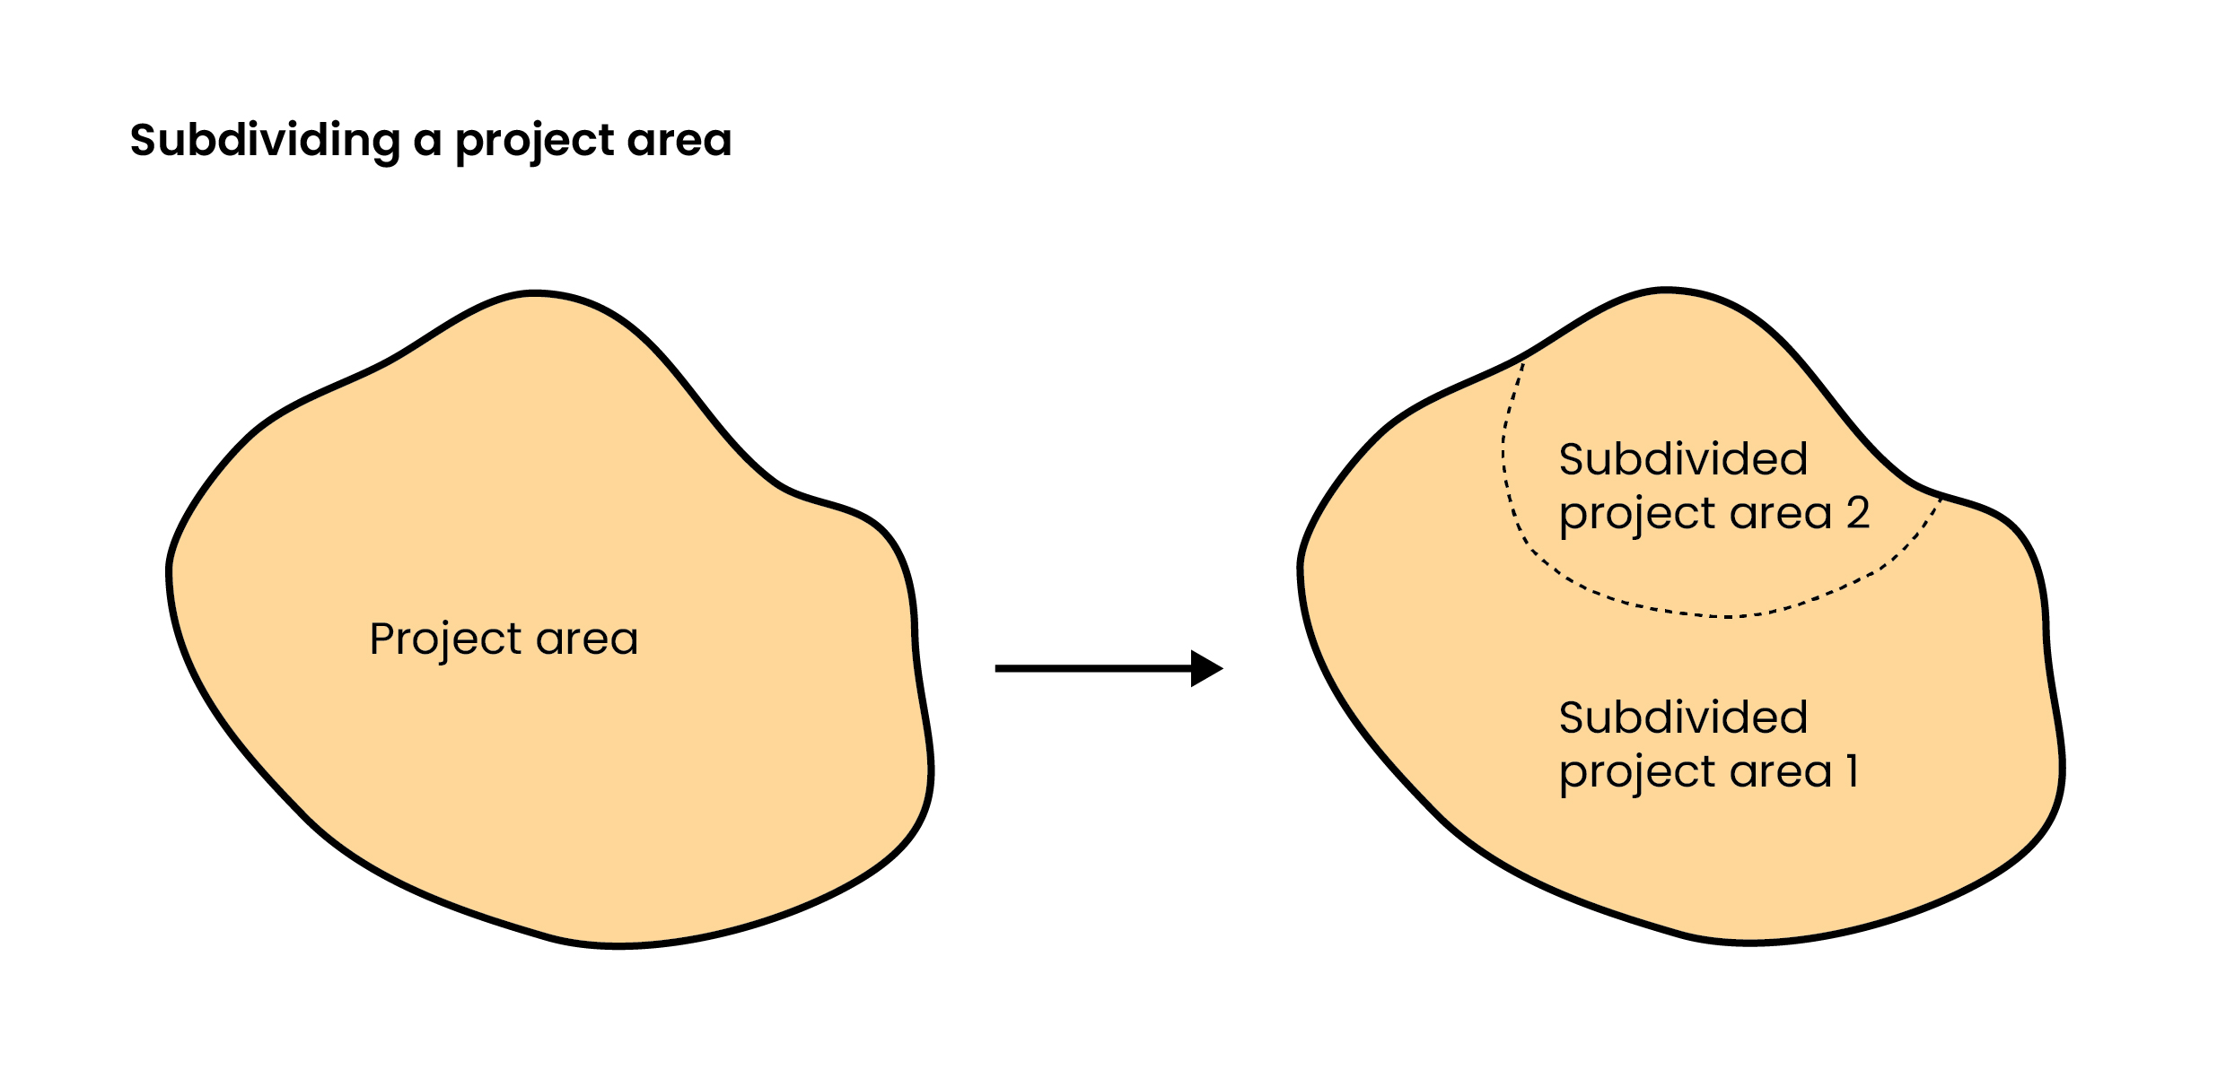
Figure 13: Visualisation of removing an entire project area and replacing it with subdivided project areas.

Adjustments to calculations for subdivided project areas
Once you have subdivided a project area, you must calculate net abatement separately for each subdivided project area and then sum this across all project areas (unless you have elected to separately report on project areas).
Subdivided project areas will have their own uncertainty buffer. For the first calendar year that ends after a subdivision takes effect, you should follow the equations in the method for adjustments resulting from subdivided project areas to determine the uncertainty buffer for each of the subdivided project areas.
To help with this, we have developed a subdivision calculator.

Reporting separately on project areas
If your project consists of multiple project areas, including subdivided project areas, you can elect to report separately on project areas. Each area is treated like an independent project with the same conditions, reporting obligations and compliance requirements. You will need to calculate net abatement for each separate part and submit separate offsets reports and requests for ACCUs. You can apply to divide a project into parts for separate reporting using our Notify the Regulator form.

Vegetation fuel type maps for subdivided project areas
If a vegetation fuel type map has already been created and validated for a project area, and that area is later subdivided, the existing map can be split into maps for each subdivided project area. However, if this affects the accuracy of a vegetation fuel type map and it no longer meets the requirements in the Technical Guidance, you must update and re-validate the map as necessary within two years of the subdivision.

Removing a project area
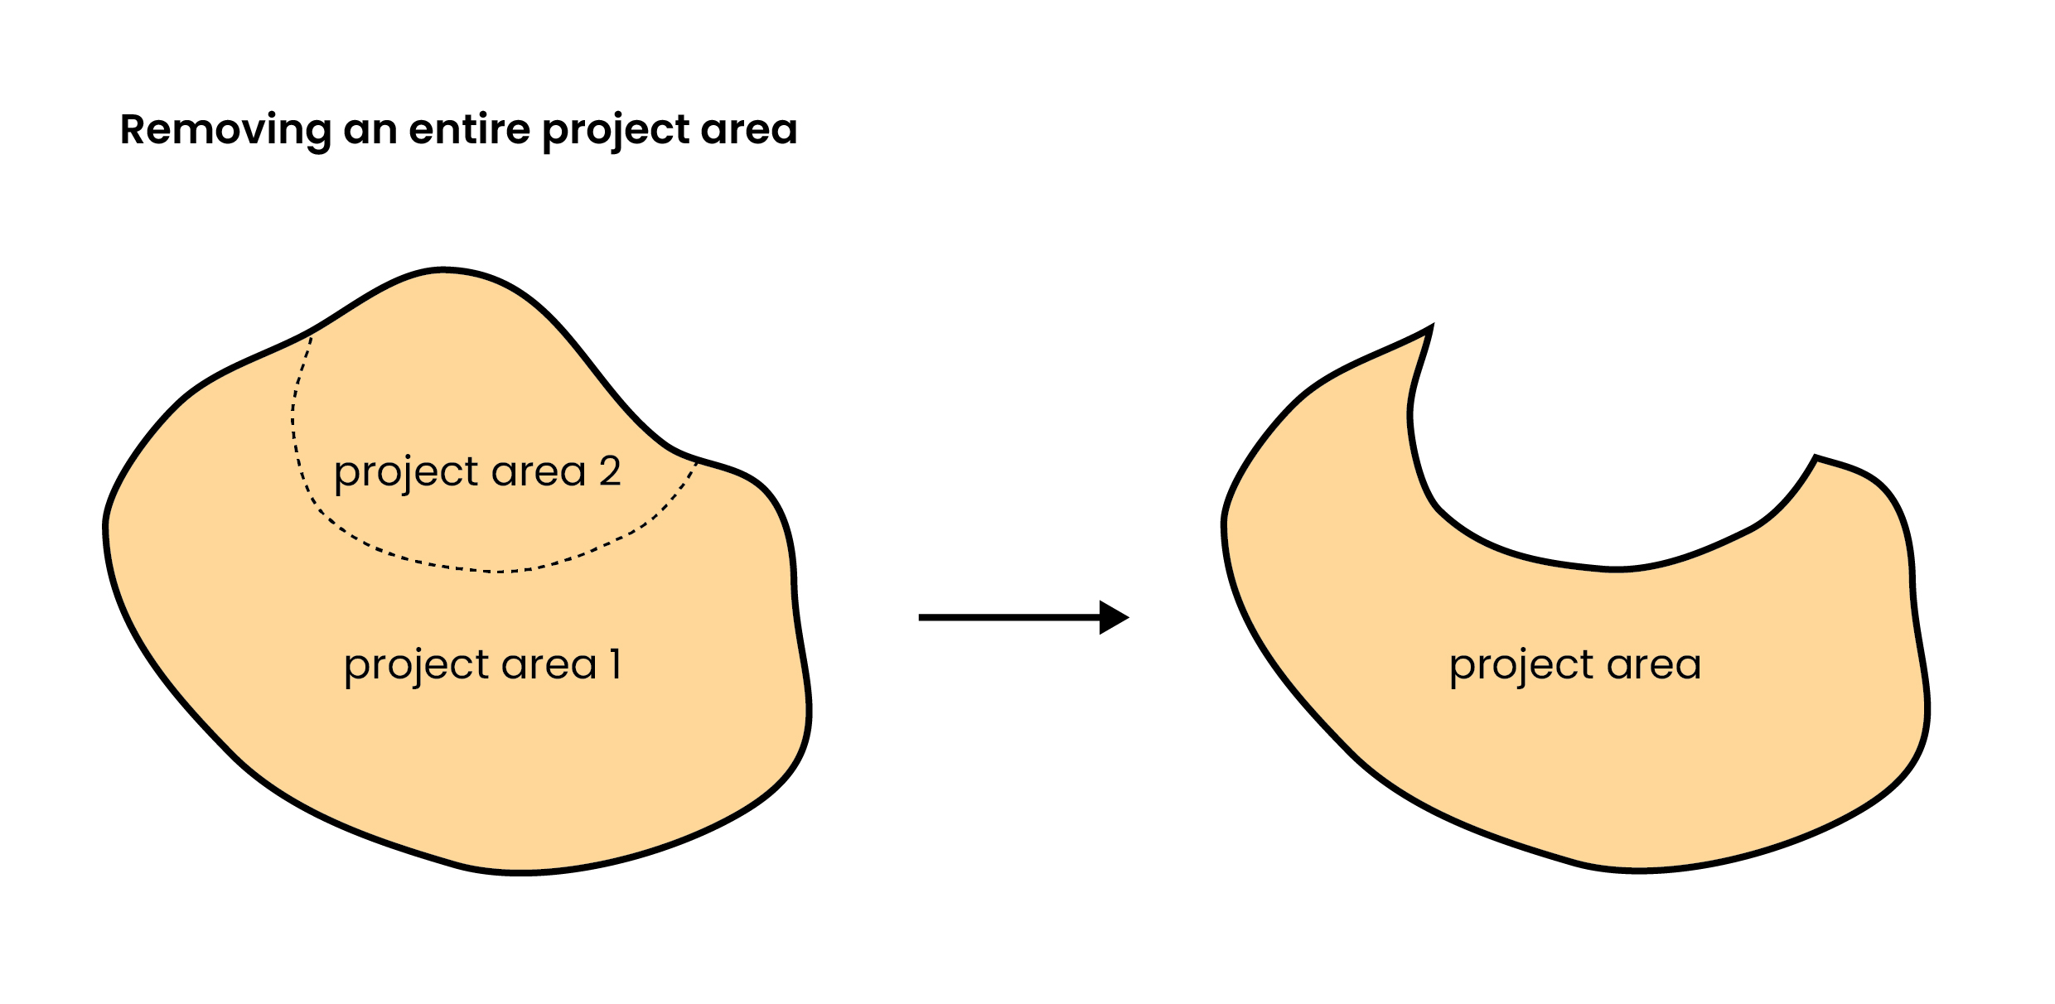
You can only remove an entire project area. To remove a part of a project area, you first have to subdivide the original project area into a subdivided project area that will be removed and a subdivided project area that will remain. The subdivision and removal can be submitted as part of the same application.
Figure 14: Visualisation of removing an entire project area.

Adding a project area
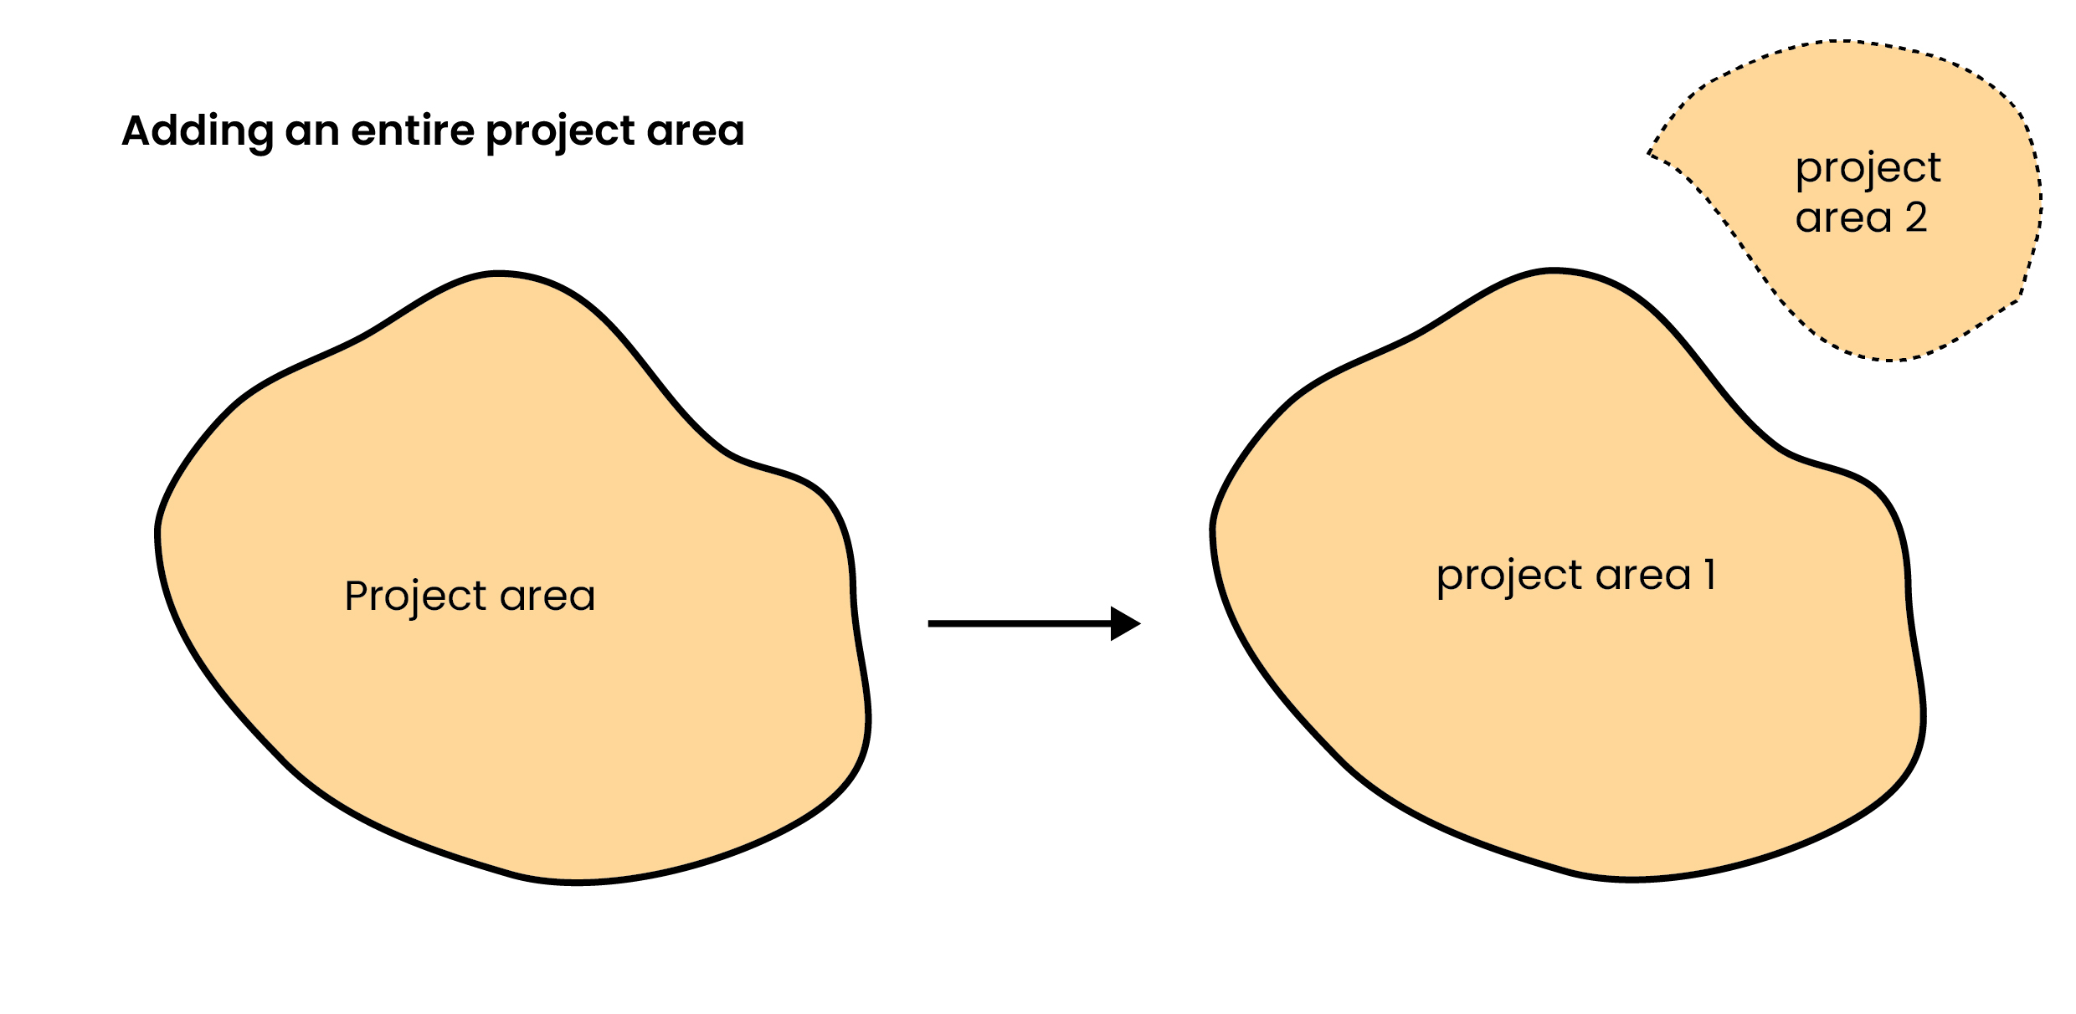
You can add an entire project area to your project. This could be a project area that transfers from another savanna emissions avoidance project, or a new project area. If the project is not a transferring project area, it will have a new baseline period (and capacity building fire management period if applicable).
Figure 15: Visualisation of adding a project area to a project.

Varying the project method
You can transfer your project to the 2026 sequestration and emissions avoidance method. This requires revoking and re-registering the project. For more information on varying the project method, see the simple method guide for the 2026 savanna fire management – sequestration and emissions avoidance method.

Appendix

Resources
Below are links to resources you may find useful for planning and delivering a project under the method. These resources are provided for general guidance only. We don't accept responsibility for the accuracy, currency or completeness of the information. You should consult the relevant legislation and seek your own legal or professional advice.

CER resources
- Choose an ACCU Scheme project proponent
- How to participate in the ACCU Scheme
- Plan your project
- Making changes to your project
- Transferring your project to the 2026 savanna fire management methods
- Native title legal right and eligible interest-holder consent guidance document
- Eligible interest-holder consent
- Legal right and native title
- State and territory land law and summary of land rights law
- Legal right under the Aboriginal Land Rights (Northern Territory) Act
- Identifying land subject to native title
- How does a project proponent demonstrate legal right

Other resources
- Engagement with Indigenous stakeholders - Carbon Market Institute
- Indigenous rights and interests - Indigenous Carbon Industry Network
- Indigenous carbon projects guide - Indigenous Carbon Industry Network
- Free, prior and informed consent (FPIC) - Indigenous Carbon Industry Network
- Native Title Vision free online visualisation, mapping and query tool
- Seeking eligible interest-holder consent from your bank - Australian Banking Association
- Carbon rights on state land - Queensland Government
- Make a code of conduct complaint - Carbon Market Institute

Planned burning
These resources provide information on planned burning.

National guidance
- Prescribed burning guidelines and frameworks - Australian Institute for Disaster Resilience
- Risk management framework for prescribed burning - National Burning Project
- Risk management framework – smoke and greenhouse gas emissions - National Burning Project
- National guidelines for prescribed burning operations - National Burning Project
- Warnings and alerts - The Bureau of Meteorology
- Savanna fire management - Indigenous Land and Sea Corporation (ILSC)

State and territory guidance

Western Australia
- Planned burning - Department of Fire and Emergency Services
- Prescribed burning - Department of Biodiversity, Conservation and Attractions

Queensland
- Obligations and responsibilities of permit holders - Queensland Fire Department
- Fire management guidelines - Queensland Government

Northern Territory
- Prescribed burning - Northern Territory Government
- Permit to burn and lighting fires - Northern Territory Government

Matters of national environmental significance
These resources may assist you to understand your obligations under the Environment Protection and Biodiversity Conservation Act 1999 when planning a project. You should also consider your obligations under state and territory laws.
- Referrals and environmental assessments under the EPBC Act - DCCEEW
- Self-assessment before making a referral under the EPBC Act - DCCEEW
- Protected matters search tool - DCCEEW
- Matters of national environmental significance: significant impact guidelines 1.1 - DCCEEW

Air quality and smoke
These resources provide general information on air quality, smoke and particulate matter.
Availability of monitoring data varies across northern Australia, particularly in remote savanna regions.

National
- National environment protection (ambient air quality) measure - National Environment Protection Council
- Risk management framework – smoke and greenhouse gas emissions - National Burning Project
- Particulate matter (PM10 and PM2.5) - DCCEEW

State and territory

Northern Territory
- Air quality - Northern Territory Environmental Protection Authority
- Air quality monitoring - Northern Territory Environmental Protection Authority

Western Australia
- Air quality index – Western Australia Department of Water and Environmental Regulation
- Air quality guidance – Western Australia Environmental Protection Authority
- Environmental factor guideline – air quality - Western Australia Environmental Protection Authority

Queensland
- Live air quality data - Queensland Government
- Air quality monitoring information - Queensland Government

Other sources
- Wildfire smoke – guide for public health officials - AirNow, USA
- AirRater and AQFx - CSIRO

Gamba grass
These resources provide information on the distribution and management of gamba grass.
- Gamba grass current and potential distribution - Territory Natural Resource Management
- Gamba grass profile - Weeds Australia
- Control gamba grass - NT Government
- Gamba grass declaration zones - NT Government
- Gamba grass risk assessment – Queensland Department of Primary Industries

Checklists

Before you start
These checklists outline approaches under the 2026 emissions avoidance method for:
- considering whether to register a project
- registering a project
- submitting an offsets report
- transferring an emissions avoidance project from a previous savanna emissions avoidance method.
You are not required to use these checklists. They are provided as a tool only, and should be used in conjunction with the methodology determination, Carbon Credits (Carbon Farming Initiative) Act 2011 and the Carbon Credits (Carbon Farming Initiative) Rule 2015. We advise that you seek independent legal, technical, financial or audit advice before carrying out a project.
The Clean Energy Regulator and the Commonwealth of Australia do no warrant that the checklists address all requirements of the method. Use of the checklists does not guarantee project or ACCU eligibility. Project proponents remain responsible for meeting all legislated requirements of the method.
The Commonwealth shall not be liable for any loss or damage that may be occasioned directly or indirectly through the use of, or reliance on, these checklists.

Checklist 1: Considerations before registering a new project
Tick | Task | Relevant section
 | Do you hold exclusive legal right to eligible land within the savanna rainfall zones? Can you maintain legal right for the duration of the project? | 2.4. Legal right
 | Have you chosen who will be the project proponent? | 2.2. Choose a proponent
 | Does the project proponent meet the fit and proper person requirements? | 2.3. Fit and proper person assessment
 | Can you engage with and obtain consent from eligible interest-holders? | 2.5. Eligible interest-holder consent
 | Can you conduct yearly planned early dry season burns? | 2.1. Suitability  4.1. Understanding savanna fire management
 | Can you monitor and manage gamba grass? | 4.3.3. Relevant weed species  6.2.2. Weed monitoring plan  6.3. Weed management
 | Can you obtain any required regulatory approvals? | 2.6. Regulatory approvals
 | Check that the project area hasn’t had any previous savanna project registered on it, or, if there was a project previously registered, the former project did not have any ACCUs issued. | 2.7. Additionality - in lieu of newness
 | Ensure you are not legally required to reduce your emissions from fire or to sequester carbon in living biomass or dead organic matter by and state, territory or Commonwealth law. | 2.8. Additionality - in lieu of regulatory additionality
 | Have you considered the costs associated with running a savanna fire management project? This could include:  - capacity building fire management  - conducting early dry season burning each year  - conducting weed monitoring and management  - vegetation fuel type mapping  - preparing offsets reports  - at least 3 audits over the 25-year crediting period  - monitoring and record-keeping | 3.2. Considerations for running a savanna emissions avoidance project

Checklist 2: Registering a new project
- See ‘5.2. Information to accompany applications to register a new project’ for further information.
- Tasks with asterisks (*) are mandatory requirements.
Tick | Task | Relevant section
 | Obtain project location information and evidence of legal right * | 5.2.1.2. Project location information
 | Create a map of the project boundary * | 5.2.1.1. Project boundary mapping
 | Obtain information on native title, land rights and indigenous land use agreements over the project area * | 5.2.2.2. Information on native title, land rights and indigenous land use agreements
 | Identify and engage with eligible interest-holders  Have eligible interest-holder consents been obtained? If not, will you obtain consents before the end of the first reporting period? * | 2.5. Eligible interest-holder consent
 | Has the project proponent registered as an ACCU Scheme participant? * | 2. Participating in the method
 | Have all required regulatory approvals been obtained? If not, will you obtain approvals before the end of the first reporting period? * | 2.6. Regulatory approvals
 | Obtain details and evidence of any capacity building fire management | 5.1.2. Capacity building fire management
 | Calculate a forward abatement estimate * | 5.2.2.1. Forward abatement estimate
 | Has all gamba grass in the project area been treated appropriately within 12 months before applying to register the project? * | 6.3. Weed management
 | Inform the relevant state or territory government(s) about the project * | 5.2.2.5. State or territory government notification
 | Submit an application to Register or transfer a Project* | 5.2. Information to accompany applications to register a new project

Checklist 3: Submitting an offsets report
- For more information, see ‘7.1. Offsets report’.
- Tasks with asterisks (*) are mandatory requirements.
Tick | Task | Relevant section
 | Project management plan that was prepared before planned burning commenced each year, including: *  a description of the planned burning that was intended to be undertaken in the project area(s) for each year  demonstration that the likely impact of PM2.5 particulate matter on air quality, as a result of that burning, in areas where people live has been considered  a plan for monitoring for the presence of each relevant weed species in each project area that:  - demonstrates the level of risk of relevant weed species occurring in each project area has been considered  - describes how that risk has been determined  - describes a monitoring approach (including the methods and frequency of monitoring)  the date of any revision or update if applicable | 4.2. Project management plan  7.1.1. Details of project activities and project management plan
 | Net abatement details, including a copy of each SavCAM report * | 7.1.5. Information relating to net abatement  7.3. Calculating net abatement
 | A copy of the latest vegetation fuel type map used to calculate abatement in SavCAM.*  If the map was newly created or revised, state this in the offsets report. Include:  - the date it was created or revised  - any audit report relating to the validation of the map.  If you were required to revise a map, include an explanation of why the map was revised. | 6.5. Vegetation fuel type maps  7.1.3. Information on vegetation fuel type maps
 | Information about the project activities for the reporting period, including: *  a statement confirming that planned burning was undertaken  a description of:  - where the planned burning occurred  - when it occurred  - the extent of burning  an explanation of whether the planned burning met the requirements to undertake savanna fire management, and if so, to what extent. This means describing:  - how the planned burning for the calendar year went, considering planned and unplanned burning in previous years of the project  - any planned burning proposed for future years  - how the planned burning forms parts of an ongoing and coherent savanna fire management program for the project area  an explanation of how this program of burning meets the method objectives  If you did not undertake planned burning, your offsets report must include:  - a statement confirming that planned burning was not undertaken  - the reasons why planned burning did not occur. | 7.1.1. Details of project activities and project management plan
 | Information on relevant weed species, including: *  A statement that the project area was monitored in accordance with the project management plan  a description of the results of monitoring for the reporting period  if a relevant weed species was detected in a project area during the reporting period:  - a statement that the weed species was detected  - identification of the weed-affected areas using geospatial mapping  - evidence of when and how weed-affected areas were first treated, as well as evidence of ongoing treatment.  if treatment was not possible due to circumstances beyond your reasonable control:  - an explanation that treatment could not occur  - a description of the circumstances  - any evidence to support the explanation.  if a relevant weed species was eradicated from a previously weed-affected area during the reporting period:  - a statement confirming eradication  - a map of the area in a geospatial format  - evidence demonstrating the relevant weed species was permanently removed from the area. | 4.3.3. Relevant weed species  6.2.2. Weed monitoring plan  6.3. Weed management  7.1.2. Information on relevant weed species
 | If you are reporting on a subdivided project area for the first time, information including: *  a statement that you are reporting on a subdivided project area for the first time  the date the relevant variation took effect  the results of Equations 5 and the inputs used for that calculation. See our subdivision calculator to help with Equations 5. | 7.1.4. Information on subdivided and removed project areas
 | If a project area (including a subdivided project area) was removed from the project, information including: *  a statement of this  a description of the area removed  the date of removal | 7.1.4. Information on subdivided and removed project areas
 | Provide relevant statements and declarations: *  a statement of if a project area was added to the project and is being reported on for the first time  a statement that the project area was not varied, other than in accordance with the CFI Rules  a declaration that the livestock density did not increase as a consequence of the project | 7.1.6. Relevant statements and declarations
 | Set up an Australian National Registry of Emissions Units (ANREU) account before the end of the first reporting period * | 7.1. Offsets report
 | Submit the offsets report through Online Services within 6 months of the end of the reporting period * | 7.1. Offsets report

Checklist 4: Transferring a project from a previous emissions avoidance method
- For further information, see ‘8.2. Transferring from a previous emissions avoidance method’.
- Tasks with asterisks (*) are mandatory requirements.
Tick | Task | Relevant section
 | Obtain new eligible interest-holder consents (optional) | 2.5. Eligible interest-holder consent
 | Ensure you can maintain legal right for the duration of the project * | 2.4. Legal right
 | Treat all weed-affected areas appropriately, or remove all weed-affected areas from the project * | 6.3. Weed management
 | Submit offsets reports for all previous reporting periods * | 7.1. Offsets report
 | Submit a Vary method application * | 8.2.1. Apply to vary method

FullCAM
The tool required to calculate abatement under the method is SavCAM, which integrates FullCAM. The Department of Climate Change, Energy, the Environment and Water (DCCEEW) uses FullCAM to track the greenhouse gas emissions and changes in stocks of carbon and nitrogen associated with land use and management.
FullCAM is a carbon accounting model for estimating and predicting biomass, litter and soil carbon pools in various components of the land sector, such as savanna, forest and agricultural systems. In addition, it accounts for changes in major greenhouse gases, nitrogen cycling, and human-induced land use practices.
FullCAM is used to construct Australia's National Greenhouse Gas Accounts for the land sector, including for land use, land use change and forestry. In particular, DCCEEW uses the modelling results from FullCAM to produce the annual totals for Australia’s National Inventory Reports that are used to meet Australia’s inventory reporting requirements under the United Nations Framework Convention on Climate Change (UNFCCC), Paris Agreement and Kyoto Protocol.
Incorporating FullCAM into the method allows projects to estimate greenhouse gas emissions in a way that aligns with the approach used for Australia's inventory reporting requirements.
FullCAM integrates data on land cover change, land use and management, climate, plant productivity, and soil carbon over time, and estimates carbon stock change and greenhouse gas emissions at fine spatial and temporal scales using a wide range of spatially referenced data.
In the method, FullCAM is used to calculate the emissions avoidance abatement associated with live biomass, grass fuel, fine fuel, heavy fuel and coarse fuels.
FullCAMs accuracy was improved in 2024 by using detailed field data from different types of savanna vegetation. To understand how living plants become dead material, researchers measured litterfall such as leaves, twigs and bark at 61 savanna sites. They estimated how biomass is split between stems, branches, bark and roots using existing research, as well as how quickly this dead material breaks down over time. Fire impact parameters were also updated using observed fire effects.
FullCAM was then calibrated to reflect how fires in the early and late dry seasons affect vegetation. The model was tested, and it was found that it predicted above-ground biomass with 82–93% accuracy across all vegetation types. FullCAM also reliably estimated changes in dead wood and other fuel types over time.
FullCAM is updated over time to ensure it is based on the most up to date and accurate science and that it remains aligned with Australia's National Greenhouse Gas Accounts. DCCEEW consults on revisions to FullCAM calibrations when developing and implementing new FullCAM versions.

SavCAM
For each eligible pixel in the vegetation fuel type map uploaded to SavCAM, FullCAM uses the fire history and vegetation fuel type to model greenhouse gas emissions. SavCAM automates FullCAM for a project area and collates the output into reports suitable for submission with offset reports.
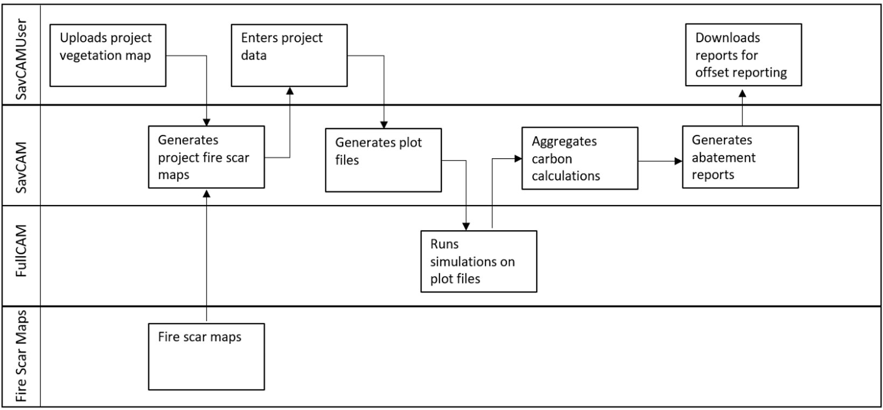
Figure 15: SavCAM logic flow showing interactions with FullCAM. From the Technical Guidance
SavCAM also applies mechanisms and adjustments from the method and provides an adjusted net abatement number for each project area. In some cases, additional adjustments may apply.
SavCAM has been validated by the Commonwealth Scientific and Industrial Research Organisation (CSIRO), who independently coded a replica of SavCAM and produced results nearly identical to SavCAM.
By comparing FullCAM simulations with and without climate variability, CSIRO was also able to distinguish the effects of fire from those of climate. The results showed that SavCAM abatement outcomes are mainly driven by changes to fire management, with fire extent and timing accounting for 91.9% of annual changes in emissions and carbon storage.

SavCAM versions
Under the method, project proponents are required to use the most recent version of SavCAM available at the time of reporting to calculate the net abatement amount for their project. SavCAM will be updated as necessary to align with the most recent versions of FullCAM, which means that updates to FullCAM will feed into the abatement calculations for projects under the method.
If a FullCAM update lowered abatement estimates for a project for, the new estimates would not have any impact on credits issued to-date. Future issuances of credits may be smaller in volume.

https://cer.gov.au/schemes/australian-carbon-credit-unit-scheme
https://cer.gov.au/schemes/australian-carbon-credit-unit-scheme
https://cer.gov.au/schemes/australian-carbon-credit-unit-scheme/accu-scheme-guidance-library
https://www.legislation.gov.au/F2026L00430
https://www.legislation.gov.au/C2011A00101
https://www.legislation.gov.au/F2015L00156
https://savtools.dcceew.gov.au/home
https://www.dcceew.gov.au/sites/default/files/documents/technical-guidance-2026-savanna-methods.pdf
https://www.dcceew.gov.au/climate-change/publications/national-greenhouse-gas-inventory-quarterly-updates
https://cer.gov.au/schemes/australian-carbon-credit-unit-scheme/how-to-participate-accu-scheme/plan-your-project/choose-accu-scheme-project-proponent
https://cer.gov.au/schemes/australian-carbon-credit-unit-scheme/how-to-participate-accu-scheme/plan-your-project/choose-accu-scheme-project-proponent#choosing-a-project-proponent
https://cer.gov.au/about-us/our-policies/fit-and-proper-person-posture
https://cer.gov.au/about-us/our-policies/fit-and-proper-person-posture/fit-and-proper-person-requirements#australian-carbon-credit-unit-(accu)-scheme
https://cer.gov.au/schemes/australian-carbon-credit-unit-scheme/how-to-participate/plan-your-project/legal-right-and-native-title
https://cer.gov.au/document_page/native-title-legal-right-and-eligible-interest-holder-consent-guidance
https://cer.gov.au/document_page/how-does-project-proponent-demonstrate-legal-right
https://cer.gov.au/schemes/australian-carbon-credit-unit-scheme/how-to-participate-accu-scheme/plan-your-project/legal-right-and-native-title
https://www.un.org/development/desa/indigenouspeoples/wp-content/uploads/sites/19/2018/11/UNDRIP_E_web.pdf
https://www.legislation.gov.au/C2004A04665
https://cer.gov.au/document_page/cer-accu-eih001-eligible-interest-holder-consent-form
https://cer.gov.au/schemes/australian-carbon-credit-unit-scheme/how-to-participate-accu-scheme/apply-to-participate-accu-scheme/eligible-interest-holder-consent
https://cer.gov.au/document_page/native-title-legal-right-and-eligible-interest-holder-consent-guidance
https://cer.gov.au/markets/reports-and-data/accu-project-and-contract-register
https://www.dcceew.gov.au/environment/epbc/approvals
https://www.dcceew.gov.au/sites/default/files/documents/australia1000mmbandozalbers.zip
https://www.dcceew.gov.au/sites/default/files/documents/australia600mm1000mmbandozalbers.zip
https://www.dcceew.gov.au/climate-change/publications/full-carbon-accounting-model-fullcam
https://v1.savcam.savtools.dcceew.gov.au/
https://www.dcceew.gov.au/sites/default/files/documents/technical-guidance-2026-savanna-methods.pdf
https://onlineservices.cer.gov.au/forms/ERF-094
https://onlineservices.cer.gov.au
https://www.dcceew.gov.au/climate-change/publications/carbon-farming-initiative-cfi-mapping-guidelines
https://cer.gov.au/markets/reports-and-data/accu-project-and-contract-register
https://www.dcceew.gov.au/climate-change/publications/carbon-farming-initiative-cfi-mapping-guidelines
https://cer.gov.au/schemes/australian-carbon-credit-unit-scheme/how-to-participate/apply-to-participate/forward-abatement-estimates
https://cer.gov.au/document/identifying-land-subject-to-native-title
https://www.nntt.gov.au/assistance/Geospatial/Pages/NTV.aspx
https://www.dcceew.gov.au/environment/protection/npi/substances/fact-sheets/particulate-matter-pm10-and-pm25
https://www.legislation.gov.au/F2007B01142
https://www.dcceew.gov.au/sites/default/files/documents/technical-guidance-2026-savanna-methods.pdf
https://dfes.wa.gov.au/hazard-information/bushfire/planned-burning
https://nt.gov.au/emergency/bushfire/managing/prescribed-burning
https://www.fire.qld.gov.au/safety-education/using-fire-outdoors/lighting-fires-in-queensland
https://www.dcceew.gov.au/sites/default/files/documents/technical-guidance-2026-savanna-methods.pdf
https://view.officeapps.live.com/op/view.aspx?src=https%3A%2F%2Fcer.gov.au%2Fdocument%2Fcer-accu-005-application-to-withhold-publication-certain-project-information-accu-scheme-project&wdOrigin=BROWSELINK
https://www.dcceew.gov.au/sites/default/files/documents/technical-guidance-2026-savanna-methods.pdf
https://onlineservices.cer.gov.au/forms/NTR?section=1
https://onlineservices.cer.gov.au
https://cer.gov.au/online-systems/anreu-account-guidance
https://cer.gov.au/about-us/contact-us
https://onlineservices.cer.gov.au/forms/ERF-011?section=1
https://cer.gov.au/document_page/savanna-subdivision-calculator
https://cer.gov.au/schemes/australian-carbon-credit-unit-scheme/how-to-participate/project-reporting-and-audits#audits
http://www.cleanenergyregulator.gov.au/Infohub/Audits/register-of-auditors
https://savtools.dcceew.gov.au/home
https://v1.savcam.savtools.dcceew.gov.au/assets/pdf/How%20to%20use%20SavCAM.pdf
https://cer.gov.au/schemes/australian-carbon-credit-unit-scheme/how-to-participate-accu-scheme/apply-to-participate-accu-scheme/processing-times
https://cer.gov.au/schemes/australian-carbon-credit-unit-scheme/how-to-participate-accu-scheme/making-changes-to-your-project
https://onlineservices.cer.gov.au
https://cer.gov.au/document/relinquishment-accus-under-joint-emissions-avoidance-and-sequestration-methods
https://onlineservices.cer.gov.au/forms/ERF-094
https://onlineservices.cer.gov.au/forms/ERF-082
https://onlineservices.cer.gov.au
https://cer.gov.au/document/relinquishment-accus-under-joint-emissions-avoidance-and-sequestration-methods
https://onlineservices.cer.gov.au/forms/ERF-094
https://onlineservices.cer.gov.au/forms/ERF-011
https://onlineservices.cer.gov.au/forms/ERF-082
https://onlineservices.cer.gov.au
https://onlineservices.cer.gov.au
https://cer.gov.au/schemes/australian-carbon-credit-unit-scheme/how-to-participate-accu-scheme/making-changes-to-your-project
https://onlineservices.cer.gov.au/forms/ERF-011?section=1
https://cer.gov.au/schemes/australian-carbon-credit-unit-scheme/how-to-participate-accu-scheme/making-changes-to-your-project/dividing-project-parts-separate-reporting
https://cer.gov.au/document_page/savanna-subdivision-calculator
https://onlineservices.cer.gov.au/forms/NTR?section=1
https://cer.gov.au/schemes/australian-carbon-credit-unit-scheme/how-to-participate-accu-scheme/plan-your-project/choose-accu-scheme-project-proponent
https://cer.gov.au/schemes/australian-carbon-credit-unit-scheme/how-to-participate-accu-scheme
https://cer.gov.au/schemes/australian-carbon-credit-unit-scheme/how-to-participate-accu-scheme/plan-your-project
https://cer.gov.au/schemes/australian-carbon-credit-unit-scheme/how-to-participate-accu-scheme/making-changes-to-your-project
https://cer.gov.au/schemes/australian-carbon-credit-unit-scheme/accu-scheme-methods/savanna-fire-management-methods/transferring-your-project-to-2026-savanna-fire-management-methods
https://cer.gov.au/document/native-title-legal-right-and-eligible-interest-holder-consent-guidance
https://cer.gov.au/schemes/australian-carbon-credit-unit-scheme/how-to-participate-accu-scheme/apply-to-participate-accu-scheme/eligible-interest-holder-consent
https://cer.gov.au/schemes/australian-carbon-credit-unit-scheme/how-to-participate-accu-scheme/plan-your-project/legal-right-and-native-title
https://cer.gov.au/document/state-and-territory-land-law-and-summary-land-rights-law
https://cer.gov.au/schemes/australian-carbon-credit-unit-scheme/how-to-participate/plan-your-project/legal-right-and-native-title/legal-right-under-aboriginal-land-rights-northern-territory-act
https://cer.gov.au/document_page/identifying-land-subject-to-native-title
https://cer.gov.au/document_page/how-does-project-proponent-demonstrate-legal-right
https://carbonmarketinstitute.org/code/consumers/indigenous-engagement
https://www.icin.org.au/resource_files?filter=rights_and_interests
https://www.icin.org.au/indigenous_carbon_projects_guide_downloads
https://assets.nationbuilder.com/icin/pages/185/attachments/original/1664414313/7._Free__Prior_and_Informed_Consent_%28FPIC%29.pdf?1664414313
https://www.nntt.gov.au/assistance/Geospatial/Pages/NTV.aspx
https://www.ausbanking.org.au/wp-content/uploads/2022/11/ABA-Fact-Sheet-Seeking-Eligible-Interest-Holder-Consent.pdf
https://www.qld.gov.au/environment/land/state/use/carbon-rights/carbon-rights-apply-eligible
https://carbonmarketinstitute.org/code/consumers/complaints
https://knowledge.aidr.org.au/resources/national-burning-project-prescribed-burning-guidelines-and-frameworks
https://knowledge.aidr.org.au/media/4907/risk-management-framework-for-prescribed-burning.pdf
https://knowledge.aidr.org.au/media/4895/risk-management-framework-smoke-and-greenhouse-gas-emissions.pdf
https://www.aidr.org.au/media/4871/national-guidelines-for-prescribed-burning-operations.pdf
https://www.bom.gov.au/weather-and-climate/warnings-and-alerts
https://www.ilsc.gov.au/our-work/working-together/savanna-fire-management
https://www.dfes.wa.gov.au/hazard-information/bushfire/planned-burning
https://www.dbca.wa.gov.au/management/fire/prescribed-burning
https://www.fire.qld.gov.au/sites/default/files/2022-06/Obligations-Responsiblities.pdf
https://www.qld.gov.au/environment/plants-animals/plants/ecosystems/fire-management
https://nt.gov.au/emergency/bushfire/managing/prescribed-burning
https://nt.gov.au/emergency/bushfire/prepare-and-plan/permit-to-burn
https://www.dcceew.gov.au/environment/epbc/referral-and-assessment-process
https://www.dcceew.gov.au/environment/epbc/advice-on-complying-with-the-epbc-act/self-assessments
https://www.dcceew.gov.au/environment/epbc/protected-matters-search-tool
https://www.dcceew.gov.au/sites/default/files/documents/nes-guidelines_1.pdf
https://www.nepc.gov.au/nepms/ambient-air-quality
https://knowledge.aidr.org.au/media/4895/risk-management-framework-smoke-and-greenhouse-gas-emissions.pdf
https://www.dcceew.gov.au/environment/protection/npi/substances/fact-sheets/particulate-matter-pm10-and-pm25
https://ntepa.nt.gov.au/your-environment/air-quality
https://ntepa.nt.gov.au/your-environment/air-quality/air-quality-monitoring
https://www.der.wa.gov.au/your-environment/air/air-quality-index
https://www.epa.wa.gov.au/policies-guidance/air
https://www.epa.wa.gov.au/sites/default/files/Policies_and_Guidance/EFG - Air Quality - 03.04.2020.pdf
https://apps.des.qld.gov.au/air-quality/
https://www.qld.gov.au/environment/management/monitoring/air
https://www.airnow.gov/publications/wildfire-smoke-guide/wildfire-smoke-a-guide-for-public-health-officials
https://research.csiro.au/aqfx/aqvx-and-airrater
https://www.territorynrm.org.au/_files/ugd/da28f0_f3d10ee8b6c147cc974656f5fa3dc81f.pdf
https://weeds.org.au/profiles/gamba-grass
https://nt.gov.au/environment/weeds/weeds-in-the-nt/A-Z-list-of-weeds-in-the-NT/gamba-grass/control
https://nt.gov.au/environment/weeds/weeds-in-the-nt/A-Z-list-of-weeds-in-the-NT/gamba-grass/declaration-zones
https://www.dpi.qld.gov.au/__data/assets/pdf_file/0017/58004/IPA-Gamba-Grass-Risk-Assessment.pdf
https://onlineservices.cer.gov.au/forms/ERF-095
https://cer.gov.au/document_page/savanna-subdivision-calculator
https://cer.gov.au/online-systems/anreu-account-guidance
https://onlineservices.cer.gov.au/
https://onlineservices.cer.gov.au/forms/ERF-011
https://www.dcceew.gov.au/climate-change/publications/full-carbon-accounting-model-fullcam
https://www.dcceew.gov.au/climate-change/publications/national-inventory-reports
https://unfccc.int
https://www.dcceew.gov.au/climate-change/international-climate-action
https://unfccc.int/process-and-meetings/the-kyoto-protocol
Paul, K.I. & Roxburgh, S.H., 2024. A national accounting framework for fire and carbon dynamics in Australian savannas. International Journal of Wildland Fire, 33, WF23104. https://doi.org/10.1071/WF23104

