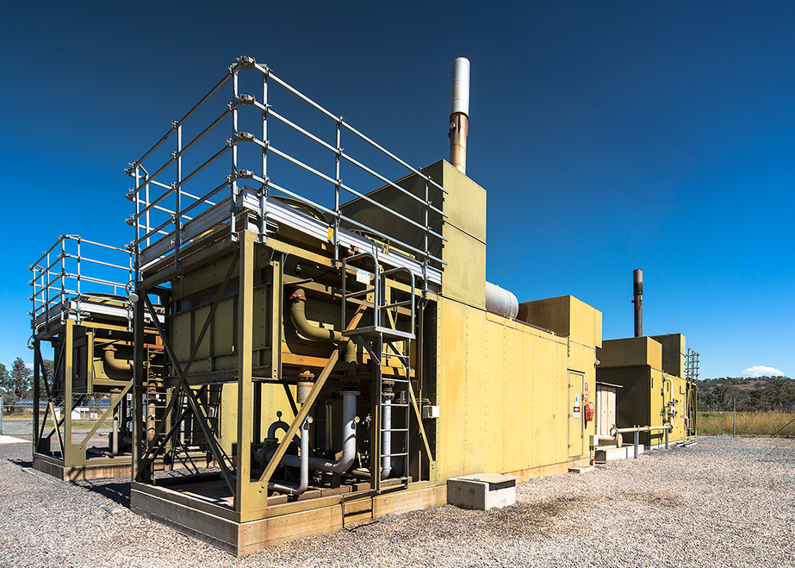
Simple method guide for the landfill gas method 2025
User guide for the Carbon Credits (Carbon Farming Initiative—Reducing Methane Emissions from Landfill Gas) Methodology Determination 2025
Version 1.0 2025

Contents
Using this guide 4
The landfill gas 2025 method 4
Key changes from previous landfill gas methods 5
Participating in the ACCU Scheme 5
Planning and registering your landfill gas project 6
General eligibility requirements 6
Deciding on a project proponent 7
Fit and proper person assessment 7
Legal right 7
Regulatory approvals 8
Additionality – in lieu of newness provision 8
Additionality – regulatory requirements 9
Understanding project activities and classifications 9
Combination of project type and sub-type 14
Safeguard status of the project 15
Covered emissions under the Safeguard Mechanism 16
Non-covered emissions 16
When project classification happens 16
Applying to register a project 17
Previously unregistered projects 17
Existing projects 17
When the LFG 2025 method applies 19
Determining key parameters 22
Crediting periods 22
Project baseline 23
Regulatory proportion WB, Reg 23
Default baseline proportion WB, Def 24
Default baseline proportion determination and application 27
Change of project type or sub-type 28
Running and reporting on your project 28
Calculating net abatement 28
Offsets reports and claiming carbon credits 31
Information required in your offsets report 32
Audits 34
Notification requirements 34
Making changes to your project 34
Disclaimer 35
Appendix A: Method specific eligibility requirements 36
Specific requirements by project type and sub-type 36
Non-biomethane projects 36
Biomethane projects 36
Existing enhanced projects 36
Upgrade projects and existing upgrade projects 37
Flaring-only projects 37

Using this guide
This document provides a high-level step-by-step guide on how to plan, register, deliver and report on a project under the Carbon Credits (Carbon Farming Initiative—Reducing Methane Emissions from Landfill Gas) Methodology Determination 2025 (the LFG 2025 method). The method is a key component of the legislative framework for running a landfill gas project under the Australian Carbon Credit Unit (ACCU) Scheme.
This simple method guide complements the method and the following legislation:
- Carbon Credits (Carbon Farming Initiative) Act 2011 (the CFI Act)
- Carbon Credits (Carbon Farming Initiative) Rule 2015 (the CFI Rule).
There are a range of factors which may influence a decision to participate in the ACCU Scheme. We recommend you seek independent technical, legal, audit and/or financial advice regarding your circumstances and requirements.
Our website contains a wealth of information and guidance to help you plan and run your ACCU Scheme project. Start your search for additional guidance with the ACCU Scheme guidance library, which has an easy-to-use search tool.

The landfill gas 2025 method
The LFG 2025 method builds on 2 previous ACCU Scheme methods designed for projects that reduce methane emissions from landfill sites:
- Carbon Credits (Carbon Farming Initiative—Landfill Gas) Methodology Method 2015 (the LFG 2015 method) which expired on 31 March 2025
- Carbon Credits (Carbon Farming Initiative—Electricity Generation from Landfill Gas) Methodology Method 2021 (the EG-LFG 2021 method) repealed on 29 November 2025.
The LFG 2025 method applies to projects that collect and treat landfill gas and either combust methane to destroy emissions (conversion abatement) or upgrade biogas to biomethane, which is then reasonably expected to be combusted and used as a natural gas substitute within Australia (displacement abatement). The 3 core activities in the LFG 2025 method are:
- emissions destruction – collecting methane and burning methane via a combustion device
- landfill gas capture for biomethane – collecting methane and upgrading it into biomethane
- biomethane production – refining biogas into a natural gas substitute that’s combusted elsewhere.
A project must include one or more of these activities to be considered a landfill gas capture and destruction project under the LFG 2025 method.
Net abatement is calculated as the sum of conversion abatement and displacement abatement, depending on the project type. The abatement calculations factor in:
- baseline abatement
- biomethane facility outputs
- eligible biogas fraction
- any project emissions from producing and delivering biomethane to a facility.
The LFG 2025 method introduces project classifications based on biomethane, safeguard, origin and combustion status. The origin status relates to the project type under the previous version of the method, (e.g. new, expansion, transitioning). These classifications are used to determine the default baseline factor and crediting period of a project. This is detailed in the project classification and crediting periods of a project in later parts of this guide.

Key changes from previous landfill gas methods
The 2025 landfill gas method introduces several changes to support continued abatement from existing projects and ensure all projects continue to generate high integrity abatement. These changes include:
- offering a crediting period extension for existing projects
- strengthening methane measurement requirements used to calculate net abatement from landfill gas projects
- using an upward sloping baseline
- setting a regulatory baseline factor that applies when state and territory landfill licences mandate gas capture higher than the default baseline factor.

Participating in the ACCU Scheme
The ACCU Scheme offers participants the opportunity to run new projects in Australia that:
- reduce or avoid greenhouse gas emissions (emissions avoidance)
- remove and store carbon from the atmosphere in biological systems such as vegetation or soil (sequestration).
Methodology determinations (methods) set out the rules for conducting project activities under the ACCU Scheme.
By running a project, you can earn one Australian carbon credit unit (ACCU) for every tonne of carbon dioxide equivalent (t CO₂-e) emissions your project stores or avoids. You may then choose to sell your ACCUs on the market to generate income or retain them to meet safeguard obligations or voluntary emissions reduction targets.
There are 4 general steps involved in running an ACCU Scheme project:
 | Planning your project  Determine whether your proposed landfill gas project fits within the LFG 2025 method. This involves identifying the project type and sub-type that your project fits into.
 | Registering your project  Apply to register your project with us – the Clean Energy Regulator. We will check that the project meets eligibility requirements and is likely to result in real abatement. If your project meets the requirements, it will be declared as an eligible offsets project.
 | Delivering your project  Commence the project activities and any monitoring and record keeping required.
 | Reporting on your project and claiming ACCUs  Report on your project by submitting an offsets report. It details your project’s progress, including the net abatement amount.  You can claim ACCUs each time you submit an offsets report, based on your net abatement over that reporting period. If your offsets report and application for ACCUs meets all requirements, we will issue ACCUs to your project.

Planning and registering your landfill gas project
To participate in the ACCU Scheme, you must meet general and specific requirements to undertake the LFG 2025 method. The type or sub-type of project you register will also determine additional requirements.

General eligibility requirements
Your application to register your project must show us how you meet all eligibility requirements under the CFI Act, CFI Rule and the method.
For more information on general eligibility, see how to plan your project.
To be an eligible project under the LFG 2025 method, your landfill gas capture and destruction project must involve one or both of the following:
- collection and treatment of landfill gas in a way that destroys methane
- treatment of landfill gas from a landfill site – alone or combined with biogas produced from other biogas waste – by upgrading it at a biomethane facility to produce biomethane. You must then send the biomethane to an end use where it can reasonably be expected to be combusted in Australia as substitute natural gas.

Deciding on a project proponent
Before you apply to register a project, you must choose a project proponent. A project proponent holds the legal right to carry out a project and is responsible for meeting all obligations for the life of the project. ACCUs created by the project will be issued to the project proponent. A project may have multiple project proponents, though one of those proponents must be appointed as the nominee for the project. If a nominee is appointed, they will be issued the ACCUs from the project.
You can choose to be the project proponent yourself or appoint a third party – such as a carbon service provider – if you prefer not to have direct control or responsibility for conducting the project. If you want to retain control but don’t have the technical expertise or administrative capacity, you can act as the project proponent and engage an agent to help manage it.
It is a good idea to seek professional legal and financial advice before entering into any agreement with another person or organisation to be the project proponent or as an agent.

Fit and proper person assessment
You need to prove your identity and pass a fit and proper person assessment before you can participate in the ACCU Scheme. The fit and proper person test generally considers a person’s past compliance with the law, whether they are insolvent, and whether they have the necessary capabilities and competence to run a project.

Legal right
You must demonstrate that you have the legal right to carry out the project. This means you have the right to carry out the project activities and have the lawful and exclusive right to receive all ACCUs. You need to maintain legal right for the life of the project.
You must provide evidence that you hold or have acquired legal right through a written agreement, such as a commercial contract. You also need to maintain records showing how you hold, or have obtained, legal right to carry out the project. This includes evidence of the steps you took, any advice received and who you consulted with.
If there are multiple parties involved in the project, you may need to provide evidence of the arrangements between them such as a written agreement or contractual arrangements. Regulatory approvals and licensing arrangements may determine whether you hold the legal right to carry out a project.

Regulatory approvals
The LFG 2025 method does not duplicate requirements governing how landfill sites should be selected, operated, monitored, or closed. Rather, it builds on the existing laws and regulatory frameworks and participating in a project under the LFG 2025 method is voluntary.
You are responsible for checking whether your project needs regulatory approvals, and you should do this before registering your project. To find out, contact your local government, federal or relevant state or territory departments.
Once your project is registered under the ACCU Scheme, you must ensure that your project meets the requirements set out by the local government, state or territory throughout the life of the project.
You must provide evidence of regulatory approvals before submitting your project’s first offsets report. If you don’t obtain the necessary approvals, we can’t issue ACCUs for your project and your project may be revoked.

Additionality – in lieu of newness provision
For a project to be declared an eligible offsets project, the CFI Act requires that it ‘has not begun to be implemented’. A project remains new until a final investment decision has been made. You can undertake activities such as the following without breaching the newness requirement:
- identify and assess a site
- complete any required environmental approvals under State, Territory or Commonwealth laws
- establish commercial agreements that will govern the project, if applicable
- undertake activities contingent on project approval
- complete engineering and design work for the required facilities
- procure equipment.
To provide greater certainty about newness, the method includes in-lieu of newness provisions under section 27(4A)(a)(ii) of the CFI Act for new projects and certain existing projects that are being upgraded or restarted. These requirements are set out in sections 26 to 28 of the method and apply to:
- new project
- restarting biomethane displacement only projects
- upgrade projects
You’ll find more information about the requirements for all project types and sub-types later in this simple method guide.

Additionality – regulatory requirements
For a project to be declared an eligible offsets project and registered under the ACCU Scheme, the CFI Act requires the project is ‘not required to be carried out by or under a law of the Commonwealth, a State or a Territory’.
In the LFG 2025 method, this requirement is addressed through the application of the project baseline, so all landfill gas capture and destruction projects have an in lieu of regulatory additionality requirement.

Understanding project activities and classifications
To understand the requirements for your project, you must first identify the activities your project involves. There are 3 types of project activities:
- landfill gas capture for biomethane
- biomethane production
- emissions destruction.
Your project must include one or more of the 3 activities. See Table 1 for a description of each activity.
Table 1: Description of project activity
Project activity | Description
Landfill gas capture for biomethane | Collect landfill gas and send it to a biogas upgrading system that is part of a project biomethane facility.  Conversion abatement only occurs when biomethane produced from landfill gas is reasonably expected to be combusted in Australia as a natural gas substitute.
Biomethane production | - Treat biogas (including landfill gas) at a project biomethane facility using biogas upgrading, with or without biogas from other biogas waste sources.  - Send the biomethane to an end use where it is reasonably expected to be combusted in Australia as a natural gas substitute.  Acceptable end uses include sale and transport to a gas retailer or gas consumer, or on-site combustion for heat or power.  Combustion may occur on site, or off-site via injection into a gas distribution or transmission network, road transport, or another method.
Emissions destruction | Collect landfill gas and destroy the methane component using a combustion device either by flaring only or in combination with electricity generation.
Each project must identify its activity and be classified by project type and project sub-type.
Under the method, a project will have a project type under each of the below categories:
- biomethane status
- safeguard status.
You must select one option for each of these project types.
Some project types also require classification known as project sub-types. These sub-types apply only to non-biomethane projects, and biomethane conversion and displacement projects.
If your project falls into either of these project types, you must generally choose one option for each sub-type.
There are 2 categories for project sub-types:
- origin status – the origin of the project type including new, upgrade, existing upgrade or existing enhanced project
- combustion status – whether the project is flaring only or is also an electricity generation project.
Table 2 describes the available project types and sub-types.
There are some exceptions to choosing a sub-type:
- If a non-biomethane project is also a restarting flaring only project, it does not require an origin status sub-type classification.
- A biomethane conversion and displacement project does not require a sub-type classification under combustion status. However, it will still need to have a sub-type classification under origin status
An existing enhanced project must have a ‘biomethane conversion and displacement project’ biomethane status project type or have a ‘flaring only project’ or ‘electricity generation and flaring project’ combustion status sub-type.
Table 2: Description of project types and sub-types
Project type or sub-type | Description
Project type – biomethane status
Non-biomethane project | Captures and destroys landfill gas without producing biomethane.  A project that involves only emissions destruction activities.  ACCUs issued for conversion abatement only.
Biomethane conversion and displacement project | Converts landfill gas into biomethane and displaces natural gas use.  A project that involves:  - installing a biogas upgrading system at a project biomethane facility  - biomethane production, if collecting and sending landfill gas to a biogas upgrading system.  It may involve building new waste treatment and biomethane production infrastructure at sites that have never undertaken an ACCU Scheme project and may occur when an existing ACCU Scheme LFG project decides to start producing biomethane for the first time.  ACCUs issued for both conversion abatement and displacement abatement.
Biomethane displacement only project | Generate abatement by displacing natural gas with biomethane without involving conversion activities.  A project that:  - involves the installation of a biogas upgrading system at a project biomethane facility  - involves biomethane production  - does not involve collecting landfill gas and sending it to a biogas upgrading system or combusting the methane component of the landfill gas  - is not a restarting biomethane displacement only project.  These projects may be suitable for new ACCU Scheme projects at facilities that wish to earn ACCUs for producing biomethane from biogas.  For example, a project that involves construction of a ‘biomethane hub’ facility that upgrades biogas from a range of sources but does not directly involve treatment of landfill gas may be suited to this project type.  It may also be appropriate in situations where the newness requirements (see Additionality – Newness) for conversion abatement activities cannot be met. For example, where a landfill gas collection system had already been collecting and combusting methane at a landfill with an ACCU Scheme project.  In this example, the landfill could commence biomethane production from captured landfill gas as a new activity and earn displacement ACCUs as a biomethane displacement-only project.  ACCUs issued for displacement abatement only.
Restarting biomethane displacement only project | Restarts a previously inactive project that displaces natural gas with landfill gas.  A project that:  - takes place at a biomethane facility that was part of an eligible offset project (the forerunner project). That project must have:  - involved biomethane production  - used either this method, the 2021 landfill gas method or 2015 landfill gas method  - completed its crediting period  - involves biomethane production  - has a crediting period greater than zero under section 30.  A project classified as a restarting biomethane displacement only project cannot be -reclassified as any other project type.
Project type – safeguard status
Safeguard LFG project | The project landfill is covered under the Safeguard Mechanism under the National Greenhouse and Energy Reporting Act 2007 (NGER Act) – a designated large facility.  A landfill gas capture and destruction project either:  - for which the project landfill is a designated large facility at and after making the registration or method variation application relating to the project, or  - that the proponent elects to classify as a safeguard LFG project (if the project landfill only becomes a designated large facility after making the registration or method variation application).
Non-safeguard LFG project | Any landfill gas capture and destruction project that is not a safeguard LFG project.
Project sub-type – origin status
New project | A project that involves either:  - no prior landfill gas collection system at the site  - combusting landfill gas in a new electricity generator where the landfill gas has never previously been combusted to produce electricity.
Upgrade project | Adds or improves an existing gas collection system.  A project that:  - is carried out at a landfill site or project biomethane facility where no ACCUs were issued under section 11 of the CFI Act for the 4-year period ending immediately before the registration application or method variation application for the project is made  - treats collected gas by emissions destruction or landfill gas capture for biomethane.
Existing upgrade project | Previously upgraded system with historical performance data.  A project that was initially registered under an earlier landfill gas method as an upgrade project or a transitioning (upgrade) project and has applied for a method variation to transition to the LFG 2025 method.
Existing enhanced project | Already operating with landfill gas capture.  A project that:  - was initially registered under an earlier LFG method, other than as an upgrade project or transitioning (upgrade) project  - has applied for a method variation to transition to the LFG 2025 method  - is a biomethane conversion and displacement project, flaring only project or electricity generation and flaring project.
Project sub-type – combustion status
Electricity generation and flaring project | Uses landfill gas to generate electricity and flare any remaining gas. The project:  - collects landfill gas and combusts it in an electricity generator  - may combust landfill gas in a flare at any time that electricity generation is not viable (including for commercial reasons).
Flaring only project | Only flares the captured gas. The project:  - collects landfill gas for emissions destruction  - combusts landfill gas only with a flare  - does not generate electricity after its classification as a flaring-only project.
Flaring-only project (small and regional landfill) | A category for smaller or regional landfills. The project:  - collects landfill gas for emissions destruction  - combusts landfill gas only with a flare  - does not generate electricity after its classification as a flaring-only project (small and regional landfill)  - is located in an outer regional, remote or very remote area (within the meaning of the Remoteness Areas | Australian Bureau of Statistics.
Restarting flaring-only project | A restarting flaring-only project must meet all the following conditions:  - the landfill was previously part of an eligible offsets project that:  - involved emissions destruction  - used this method as the applicable methodology  - the project combusts landfill gas only using a flare  - the project does not generate electricity after its classification as a restarting flaring-only project  - the project has a crediting period greater than zero.

Combination of project type and sub-type
Use the flowchart below to help identify your project’s classification. Start by determining the safeguard project type, then biomethane project type. Depending on your selections, your project may also need to be classified by the origin status sub-type and/or combustion status sub-type.

Figure 1: Project classifications
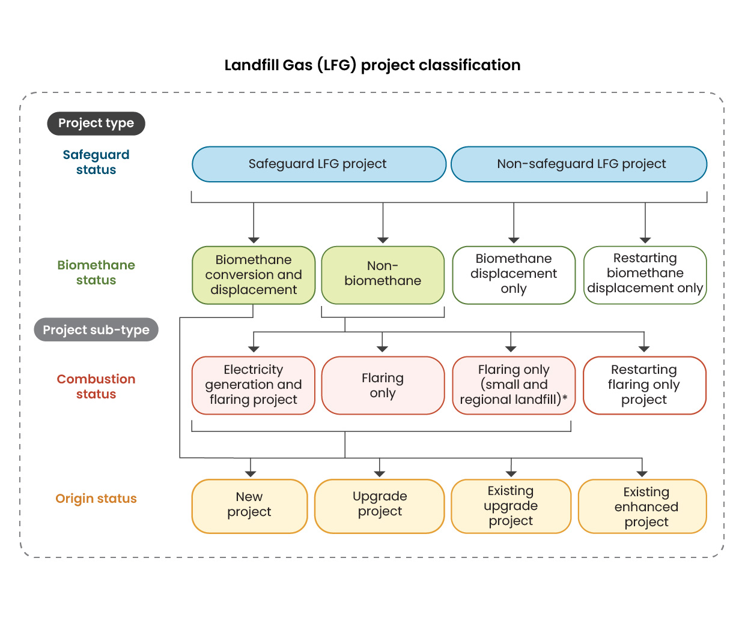

Safeguard status of the project
Designated large facilities have scope 1 emissions greater than 100,000 tonnes of carbon dioxide equivalence from operating that facility during a financial year.
If your project was registered under an earlier method and the landfill site has since become a designated large facility under the Safeguard Mechanism, transitioning to the new method will classify your project as a ‘safeguard LFG project’ at the time of registration. Under this classification the:
- project will only be credited for abating non-covered emissions
- add-back provision does not apply to this project type.
Alternatively, you can choose to stay under the earlier method. This means:
- the project will continue receiving credits for both covered and non-covered emissions
- ACCUs issued for the abatement of the landfill’s covered emissions will be added to the net emissions number of the landfill facility, as described in our guidance on Attributable ACCUs. This prevents ‘double counting’ of the carbon abatement.
If the project landfill was not a Safeguard facility when you registered under the new method but becomes covered by the Safeguard Mechanism during the crediting period, your project may be reclassified as a safeguard LFG project at your election. This change takes effect from the start of the reporting period for your next offset report. From that point, you’ll only be credited for abating non-covered emissions.
- If you elect for the project not to be reclassified as a safeguard LFG project, then any ACCUs issued for the abatement of the landfill’s covered emissions will be added to the net emissions number of the landfill facility, as described in our guidance on Attributable ACCUs.
Project proponents of safeguard LFG projects are also able to reclassify as non-safeguard LFG projects, if the project landfill is no longer a designated large facility for the purposes of the NGER Act.
To understand what counts as covered and non-covered emissions under the Safeguard Mechanism, see the explanation below.

Covered emissions under the Safeguard Mechanism
Scope 1 emissions – greenhouse gas emissions released into the atmosphere as a direct result of the activities at a facility. For example:
- non-legacy emissions from landfills (emissions from waste deposited on or after the Safeguard Mechanism began on 1 July 2016)
- emissions from the use of refrigerants in air conditioning units
- emissions from fuels used in transport
- fugitive emissions, such as methane leaks from coal mines
- production of electricity by burning coal.
These are emissions reportable under the NGER scheme and counted towards the Safeguard obligations under the Safeguard Mechanism

Non-covered emissions
Emissions not counted towards the Safeguard obligations under the Safeguard Mechanism. These include:
- legacy emissions from landfills (emissions from waste deposited before the Safeguard Mechanism began on 1 July 2016)
- emissions from grid-connected electricity generators in a financial year covered by sectoral baselines
- emissions not measured under the NGER Measurement Determination.

When project classification happens
Your project’s type and sub-type are determined at any one of these points:
- when your project is declared eligible (following the approval of your section 22 registration application)
- when your project is varied to the new method, from the start of the reporting period noted on the varied project declaration document (following the approval of your section 128 method variation request).
- when you submit an offset report showing a change in project type or sub-type, the classification becomes effective from the start date of the reporting period covered by that offset report.

Applying to register a project
Before applying to register a project under this method, you should consider whether a project has already been declared for the facility under an earlier method. If no project is registered, it is considered a previously unregistered project. If a project is already registered under an earlier method, it is considered an existing project.
Existing projects may change to the LFG 2025 method. This process involves submitting a method variation application.
The registration processes for previously unregistered projects and existing projects are outlined below.

Previously unregistered projects
If the project is a previously unregistered project, it should follow the standard project registration process as shown in Figure 2.
Figure 2: Previously unregistered project registration and existing project method variation process

Existing projects
Transitioning an existing project to the LFG 2025 method will requires you to submit a method variation application. Process is shown in Figure 2.

Figure 2: Previously unregistered project registration and existing project method variation process
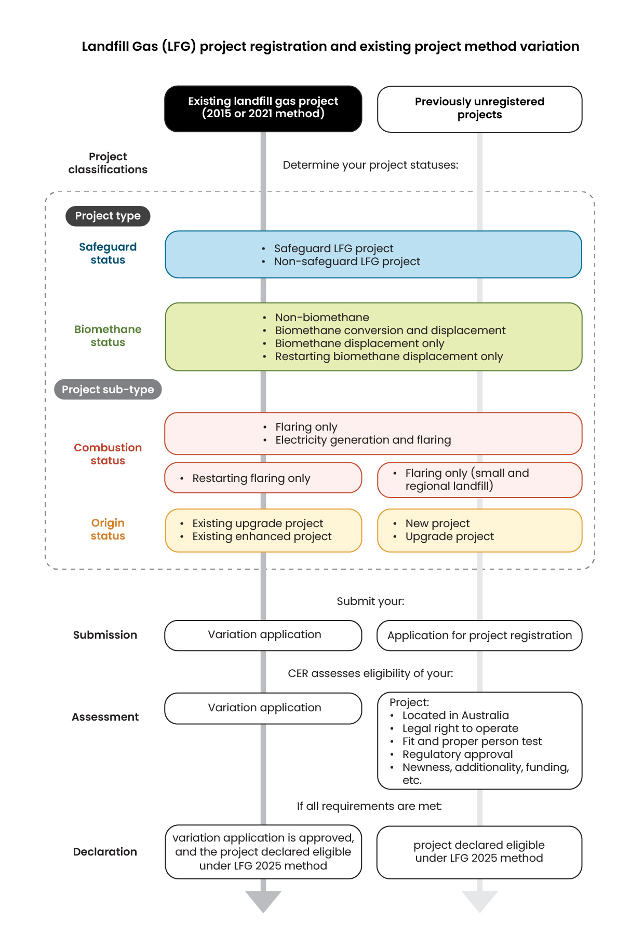
Project types and sub-types have changed significantly between the earlier methods and the new method, so it’s important to understand how your existing project aligns with the new method.

When the LFG 2025 method applies
Once a method variation application is approved, the LFG 2025 method applies from the start of the reporting period in which the method variation was received. For example, if a project submits a variation application on 1 May 2026, and its last reporting period ended on 30 June 2025, the LFG 2025 method will apply from 1 July 2025 (the start of the reporting period that includes the application date).

Crediting period commencement for existing projects transitioning
The crediting period does not restart when a method variation is approved. It continues from the original commencement date, but its remaining length is recalculated under the LFG 2025 method.
For existing upgrade projects or existing enhanced projects, the formula is:
144 months | plus (+) | the number of months credited under an earlier determination (excluding the months in the reporting period containing the variation application) | minus (−) | the months between the new LFG 2025 method’s commencement and variation application date.
The months are rounded up or down to the nearest whole month.
Refer to Table 3 for crediting periods by project type/sub-type.

Baseline commencement for existing projects transitioning
The project baseline refers to the amount of methane that would have been combusted or destroyed without the project.
The project baseline commences from the first day of the reporting period for which the LFG 2025 method applies to the project. This will be the day after the end of the last reporting period for the project. For example, if the projects previous reporting ended on 30 June 2025, and the application to vary the project was approved on 1 May 2026, the baseline would commence from 1 July 2025 because this is the day the new method applies from. From that point onwards, emissions accounting and performance assessment follow the new method requirements.
Refer to Table 4 for default baseline proportion by project sub-types.

Examples of existing projects transitioning to LFG 2025 method

This example for Project A explains relevant dates that apply to a project covered by a previous method being varied to LFG 2025 method.

Project A – calculations for the crediting period and baseline commencement
Project action | Date
Original crediting period commencement | 13 December 2014
Section 128 method variation request submitted | 1 June 2026
End date of previous reporting period | 30 June 2025
Effective date in varied project declaration following s128 request approval and commencement of project baseline | 1 July 2025
LFG 2025 method instrument commenced | 28 November 2025
The crediting period for Project A does not restart when the method variation is approved. It continues from the original commencement date of 13 December 2014.
Under the LFG 2025 method, the remaining length of the crediting period is the number of months credited under the earlier method (excluding the reporting period containing the section 128 application). This is 127 months (from 13 December 2014 to 30 June 2025). The months are counted up to, but not including, the start of the reporting period containing the section 128 application.
Project timeframe | Crediting period calculation
Months between instrument commencement and section 128 application | 6 months  (from 28 November 2025 to 1 June 2026 inclusive)
Total crediting period | 144 + 127 − 6 = 265 months
Crediting period end date | original commencement date (13 December 2014)  + 265 months = 13 December 2036
The baseline under LFG 2025 method starts from the same reporting period that the method variation takes effect.
In this scenario, the section 128 application was made on 1 June 2026, but the variation takes effect from the project’s current reporting period, which began on 1 July 2025. Therefore, the baseline calculation for the project under LFG 2025 method commences from 1 July 2025. From this point onwards, emissions accounting and performance assessment follow the LFG 2025 method requirements.

This further example (Project B) shows the same calculation, but for a project more recently registered project.

Project B – calculations for the crediting period and baseline commencement
Project action | Date
Crediting period commenced | 1 March 2022
Section 128 application submitted | 15 August 2026
End date of previous reporting period | 30 June 2026
Effective date in varied project declaration following s128 request approval | 1 July 2026
LFG 2025 method instrument commenced | 28 November 2025
Project timeframe | Crediting period calculation
Months credited under earlier method | 52 months  (March 2022 to June 2026)
Months between instrument commencement and application | 6 months  (28 November 2025 to July 2026)
Total crediting period | 144 + 52 − 6 = 188 months
Crediting period end date | original commencement date (1 March 2022)  + 52 months – 6 months = 1 November 2036
The baseline commencement starts from 1 July 2026, being the beginning of the reporting period containing the section 128 application.

Project co-location
Under the new method, you can’t register a non-biomethane project at the same project landfill as another non-biomethane project or biomethane conversion and displacement project.
If both a core and upgrade project are registered at the same landfill site under an earlier method, you must transition them under a single registered project in the LFG 2025 method. To do this, you must revoke the upgrade project under the existing method and vary the core project as an existing enhanced project under the new method. The upgrade project will need to be revoked before the core project can be registered as an existing enhanced project, because there cannot be two projects under the LFG 2025 method or another determination, on the same landfill. All abatement from the landfill site will then be credited under the transitioned core project.
Your application must meet the eligibility requirements for an existing enhanced project under the new method.

Flaring only project to electricity generation and flaring project

If your project is initially registered under the LFG 2025 method as an existing enhanced project with flaring-only activity, the landfill was not used to produce electricity in the past and you later introduce electricity generation, you may register the project as a new project and have a 12 year crediting period from the crediting period start date of the new project. To do this, you must revoke the existing flaring-only project and register a new electricity generation and flaring project.

Determining key parameters

Crediting periods
Once you have determined the project type and sub-type based on the project activities, project safeguard, origin and combustion status, use the table below to identify the applicable crediting period. Note that not all crediting periods are fixed durations. For some project types and/or sub-types, the crediting period depends on additional factors.
The crediting period must begin on the date the project is declared or within 18 months of that date, as nominated by the project proponent.
Table 3: Crediting period by project type/sub-type
Project type/sub-type | Crediting period
Biomethane displacement only project | 12 years
Restarting biomethane displacement only project | 12 years minus the length of time between start of first reporting period of forerunner project and end of the forerunner project’s crediting period
New project | 12 years
Restarting flaring-only project  Upgrade project | 144 months minus the number of months between when the LFG 2025 method came into force and the registration application date
Existing upgrade project  Existing enhanced project | 144 months plus months credited under earlier determination (excluding the reporting period containing the variation application) minus months between when this instrument came into force and the method variation application date

Project baseline
The project baseline refers to the amount of methane that would have been combusted or destroyed without the project.
To determine the baseline proportion (WB) for a new project, an upgrade project, restarting flaring only project or existing enhanced project, you must compare the following 2 values during the reporting period:
- the regulatory proportion of methane combusted or taken to be combusted (WB, Reg)
- the default proportion of methane combusted (WB, Def).
The higher of these values is taken to be the baseline proportion for the project.
To determine the baseline proportion (WB) for an existing upgrade project, you must compare the following 3 values during the reporting period:
- the regulatory proportion of methane combusted or taken to be combusted (WB, Reg)
- the default proportion of methane combusted (WB, Def).
- the previously calculated proportion of methane combusted or taken to be combusted (W_{B, Ex}), or 0% if no previous value exists.
The highest of these values is taken to be the baseline proportion for the project. The approaches used to derive these values are outlined below.

Regulatory proportion WB, Reg
The regulatory proportion is determined using Schedule 1 of the methodology. It reflects the amount of methane combusted to meet quantitative state and territory regulatory requirements.
There are 3 options for determining the regulatory proportion, outlined below.

Option 1: Using the relevant State or Territory regulatory licence conditions
You can use the conditions in your landfill licence to determine the regulatory proportion.
A relevant landfill licence is a State or Territory licence, or equivalent permission issued to the landfill owner by the relevant State or Territory environmental regulator.
If the State or Territory landfill licence specifies one or more of the following requirements to limit, collect or release a particular amount of methane, these are to be used to determine the regulatory proportion:
- permitted methane concentration limits for the project landfill
- permitted methane flux rates for the project landfill
- proportion of landfill gas generation required to be collected (collection efficiency)
- proportion of landfill gas generation allowed to be released to the atmosphere
- annual amount of landfill gas required to be collected
If only one relevant condition is included in the licence (e.g. methane concentration limit to the landfill site is specified) the regulatory proportion W_{B, Reg} is worked out by directly applying that limit.
If more than one relevant condition is specified, apply each condition individually to work out separate regulatory proportion (W_{B, Reg}) and then use the highest resulting value.
If there are no relevant conditions specified in the licence, the regulatory proportion W_{B, Reg} is taken to be the default baseline proportion W_{B, Def}.
You must provide a copy of the landfill licence with the relevant application. If the licence is varied or renewed with different conditions during the project’s crediting period, the project proponent must provide a copy of the updated licence to the Regulator with the offset report for the reporting period in which the variation or renewal occurred. If the updated licence results in a higher W_{B, Reg} that exceeds the existing W_{B, Reg}, then the new W_{B, Reg} must be applied for that and all subsequent offset reports, until any further licence changes occur.

Option 2: Asking the relevant State or Territory environmental regulator
The regulatory proportion may be requested from the State or Territory environmental regulator. The regulatory proportion must be determined in accordance with Schedule 1, Part 3, and provided as the environmental regulator ‘s written response with the offsets report for the reporting period.

Option 3: Engaging an independent expert.
To meet the criteria for being an independent expert, the person must provide to the project proponent evidence that verifies that the person has:
- no conflict of interest in determining W_{B,Reg}
- a relevant university degree – typically a science, engineering or environmental management qualification
- more than 3 years’ experience in both:
  - landfill management
  - the design and operation of landfill gas collection systems
- extensive knowledge of the regulatory framework relevant to landfill gas management in the jurisdiction in which the project landfill is located.
The expert must also provide to the project proponent, in writing, evidence that verifies the calculations, assumptions, information, inputs and references used to determine W_{B, Reg.}
You must provide a copy of such written evidence to the Regulator with the relevant offset report.

Default baseline proportion WB, Def
The default proportion is outlined in sections 48 to 50 of the method and is based on the project’s origin and combustion status. You can use the default baseline proportion table below to determine the applicable default baseline proportion for your project.
To determine the default proportion from Table 4, select the correct project sub-type(s). This will determine the calculation of the default baseline proportion shown on the right column of the table.
The default baseline proportion is calculated throughout the project’s crediting period and is applied to ACCU calculations.
Table 4: Default baseline proportion by project sub-types
Project sub-type (origin status) | Project sub-type (combustion status) | Default baseline proportion
New project | Flaring-only (small and regional landfill) | 0.00 for the first 12 months after the project is classified as an existing enhanced project (year 1)  For later years, 0.00 + 0.005 multiplied by the number of whole years in the period that starts immediately after year 1 and ends at the end of the reporting period (rounding to the nearest year)
New project | Flaring-only | 0.30 for the first 12 months after the project is classified as an existing enhanced project (year 1)  For later years, 0.30 + 0.005 multiplied by the number of whole years in the period that starts immediately after year 1 and ends at the end of the reporting period (rounding to the nearest year)
New project | Electricity generation and flaring | 0.37 for the first 12 months after the project is classified as an existing enhanced project (year 1)  For later years, 0.370 + 0.005 multiplied by the number of whole years in the period that starts immediately after year 1 and ends at the end of the reporting period (rounding to the nearest year)
New project | Biomethane conversion and displacement | 0.37 for the first 12 months after the project is classified as an existing enhanced project (year 1)  For later years, 0.370 + 0.005 multiplied by the number of whole years in the period that starts immediately after year 1 and ends at the end of the reporting period (rounding to the nearest year)
Upgrade project | Flaring-only | 0.30 for the first 12 months after the project is classified as an existing enhanced project (year 1)  For later years, 0.30 + 0.005 multiplied by the number of whole years in the period that starts immediately after year 1 and ends at the end of the reporting period (rounding to the nearest year)
Upgrade project | Electricity generation and flaring | 0.40 for the first 12 months after the project is classified as an existing enhanced project (year 1)  For later years, 0.40 + 0.005 multiplied by the number of whole years in the period that starts immediately after year 1 and ends at the end of the reporting period (rounding to the nearest year)
Upgrade project | Biomethane conversion and displacement | 0.40 for the first 12 months after the project is classified as an existing enhanced project (year 1)  For later years, 0.40 + 0.005 multiplied by the number of whole years in the period that starts immediately after year 1 and ends at the end of the reporting period (rounding to the nearest year)
Existing upgrade project | Flaring-only | 0.30 for the first 12 months after the project is classified as an existing upgrade project  for later years, 0.30 + 0.005 multiplied by the number of whole years in the period that starts on the day this instrument comes into force and ends at the end of the reporting period (rounding to the nearest year)
Existing upgrade project | Electricity generation and flaring | 0.40 for the first 12 months after the project is classified as an existing upgrade project  for later years, 0.40 + 0.005 multiplied by the number of whole years in the period that starts on the day this instrument comes into force and ends at the end of the reporting period (rounding to the nearest year)
Existing upgrade project | Biomethane conversion and displacement | 0.40 for the first 12 months after the project is classified as an existing upgrade project  for later years, 0.40 + 0.005 multiplied by the number of whole years in the period that starts on the day this instrument comes into force and ends at the end of the reporting period (rounding to the nearest year)
Existing enhanced project | Flaring-only | 0.30 for the first 12 months after the project is classified as an existing enhanced project (year 1)  For later years, 0.30 + 0.005 multiplied by the number of whole years in the period that starts immediately after year 1 and ends at the end of the reporting period (rounding to the nearest year)
Existing enhanced project | Electricity generation and flaring | 0.40 for the first 12 months after the project is classified as an existing enhanced project (year 1)  For later years, 0.40 + 0.005 multiplied by the number of whole years in the period that starts immediately after year 1 and ends at the end of the reporting period (rounding to the nearest year)
Existing enhanced project | Biomethane conversion and displacement | 0.40 for the first 12 months after the project is classified as an existing enhanced project (year 1)  For later years, 0.40 + 0.005 multiplied by the number of whole years in the period that starts immediately after year 1 and ends at the end of the reporting period (rounding to the nearest year)
Restarting project | Flaring only | 0.30 for the first 12 months after the project is classified as an existing enhanced project (year 1)  For later years, 0.30 + 0.005 multiplied by the number of whole years in the period that starts immediately after year 1 and ends at the end of the reporting period (rounding to the nearest year)

Default baseline proportion determination and application

The default baseline proportion is generally determined at the time the project is classified by its project types and subtypes. Project classification is determined at registration, variation or when an offset report is submitted, but the classification commencement date may differ. For example, in the case of a variation, the classification is determined on the day the variation is approved, but commences from the day after the end of the last reporting period. The project starts with an initial default baseline for 12 months after the project is classified, for example 40%, and increases by 0.5% every year after the first 12 months until the end of the crediting period. The baseline proportion that applies to a project is the one in force at the end of the reporting period and this proportion is applied to the entire duration of that reporting period.
Example default baseline determination, commencement and application of upward slope
A project variation has been approved on 1 November 2026 and classified as an existing enhanced and electricity generation and flaring project after varying to the LFG 2025 method.
The projects last reporting period under the earlier method ended on 30 June 2025, so the project classification and baseline commences on 1 July 2025. This is because under s16(2)(b), the project classification applies from the first day of the reporting period for which the LFG 2025 method instrument applies to the project, and under s130 of the CFI Act, a method variation applies with effect from the start of the project’s current reporting period.
The project default baseline in the first 12 months (year 1) from 1 July 2025 to 30 June 2026 is 40% (0.40).
The project default baseline for a report submitted with a reporting period ending between 1 July 2026 to 30 June 2027 is 40.5% [0.40 + (0.005 x 1) = 0.405].
For a two year reporting period (1 July 2026 to 30 June 2028), if the project submitted a reporting period ending between 1 July 2027 to 30 June 2028, the project default baseline would be 41% [0.40 + (0.005 x 2) = 0.41] for the whole of the reporting period. This is because if the reporting period ended anytime between 1 July 2027 to 30 June 2028 and is rounded to the nearest year (year 2), the number of whole years that commenced on 1 July 2026 (i.e. immediately after the end of year 1) would be 2.
The default baseline continues to increase annually by 0.5% until the end of the projects crediting period.

Change of project type or sub-type
When a change in project type or sub-type occurs during a reporting period, reclassification will take effect from the start date of the next reporting period. In such cases, baseline proportion determination is based on the new classification, and a 'new' baseline proportion will be applied from the start date of that reporting period onwards until the end of the crediting period.

Running and reporting on your project

Calculating net abatement
The flowcharts below can help you understand how to calculate net abatement for your project. They show the calculation steps from Parts 4 and 5 of the method, including reference to relevant equations and their sequence.

Figure 4: Project conversion abatement calculation (Part 4, Division 2 of the LFG 2025 method)
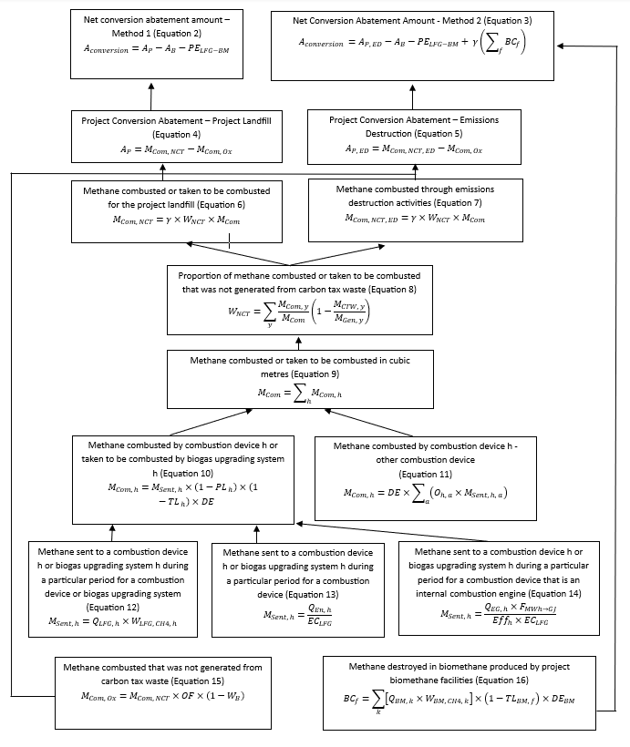

Figure 5: Baseline conversion abatement and project emissions from landfill gas capture for biomethane calculations (Part 4, Division 3 and 4 of the LFG 2025 method)
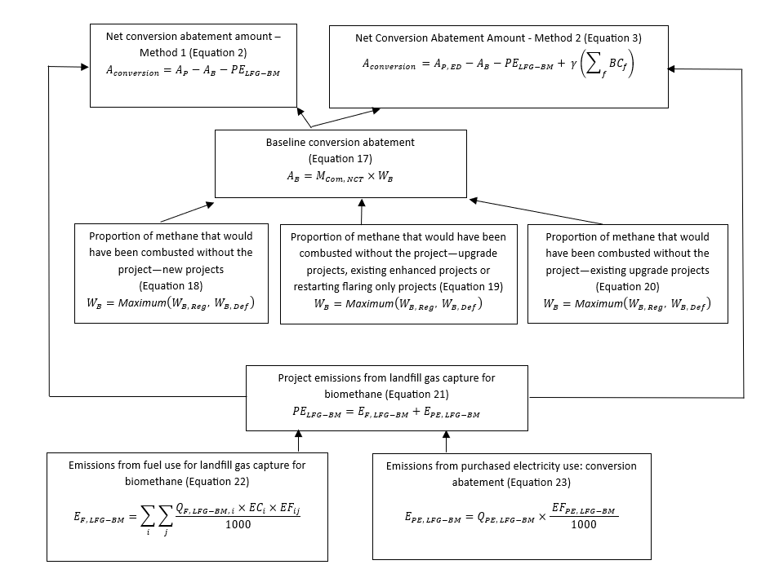

Figure 6: Net displacement abatement amount calculation (Part 5, Division 2 of the LFG 2025 method)
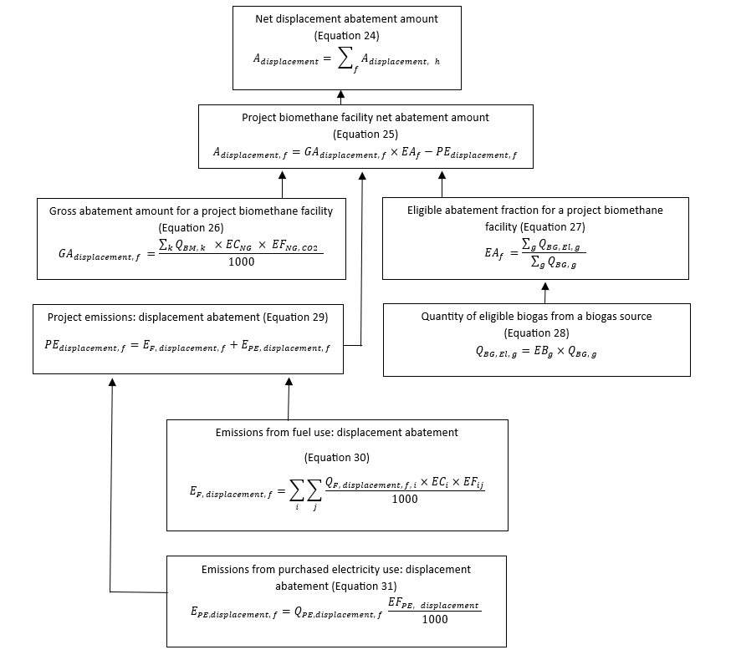

Offsets reports and claiming carbon credits
An offsets report is the document you submit each time you report on your project. It includes supporting information and outlines your project’s progress, including the net abatement amount.
You must submit an offsets report at the end of each reporting period. You can choose the length of each period – between 6 months and 2 years. Reports must be submitted no later than 6 months after the end of the reporting period.
You can submit your offsets report through Online Services. To be issued ACCUs, you need to set up an Australian National Registry of Emissions Units (ANREU) account.
We aim to assess your offsets report and application for ACCUs within the 90 days unless further information is required.
To help ensure your offsets report is assessed promptly, it’s in your interest to provide all required information accurately when submitting. This may include responding to a request for further information (RFI) and supplying the required information by the due date specified in the RFI. If you don’t provide the required information, we may refuse to assess your report or issue ACCUs.
If you need clarification or support while preparing your offsets report, or if you are unsure what information to include, please contact us. This will help you submit a complete and accurate report.

Information required in your offsets report
Sections 70–76 of the LFG 2025 method outline the information you must include in your offsets report. A simplified summary is provided below.

Landfill licence
If your project abates the emission from a landfill, include a copy of the relevant State or Territory licence.

Project activities
List all the activities carried out at the landfill or biomethane facility, noting any:
  - new activities started since your last report or application, including start dates
  - activities that have stopped, including end dates.

Sources of emissions
Describe the sources of greenhouse gas emissions within your project.

Biomethane use evidence
If your project produces biomethane from landfill gas, provide evidence that it is used in Australia as a substitute for natural gas. Invoices or contracts can be used to demonstrate this.

Biomethane production details
If your project produces biomethane, include:
  - the source of the biogas
  - equipment used to upgrade the biogas
  - how and where the biomethane is or will be used
  - how the volume of biomethane was measured and the location of measurement
  - a signed statement confirming the biomethane will be used in Australia as a natural gas substitute.

Net abatement calculations
Provide the results of all equations used to calculate net abatement. If producing biomethane, include the loss factor used for gas lost during the process.
If the project involves biomethane production, also include the:
  - volume and methane concentration of biomethane produced
  - volume of biogas treated and the portion eligible for abatement
  - source and volume of emissions generated during biogas treatment
If the quantity of eligible biogas from a biogas source is calculated, also include:
  - an explanation of how the eligible biogas proportion (EBg) was calculated
  - evidence or data supporting how the eligible biogas proportion was calculated
  - a signed statement from the person who estimated eligible biogas proportion that the value for that factor is accurate and conservative.

Project changes
Report any changes since your last application or report, including:
  - switching to a different landfill
  - adding or modifying a biomethane facility, including:
  - who will receive the biomethane from the new or changed facility
  - a signed statement confirming its use in Australia as a natural gas substitute
  - changes to biogas upgrading equipment
  - changes to project type or sub-type, explaining how the project now meets the new requirements
  - any other updates to previously submitted information. Using external sources for calculations.
If you did not use the latest version of a document or tool (e.g. guidelines or formulas) to calculate a value:
  - explain why the current version at the end of the reporting period wasn’t used specify the version used
  - include the start and end dates of when that version was used
  - include details of references you used to make a conservative estimate of a value, such as historical project data or measurement or estimation approaches in the National Greenhouse and Energy Reporting (Measurement) Determination 2008.
If you estimated a value (e.g. gas levels) instead of measuring it, state:
  - what was estimated:
  - provide the start and end dates of when measurement wasn’t possible
  - show how the estimate was calculated
  - explain why your direct measurement wasn’t done.

Flaring-only projects
If your project only flares landfill gas, demonstrate that your gas measurement device was checked against a field-calibrated handheld gas analyser in the field to confirm accuracy.

Calculating the regulatory proportion
If your project captures and destroys landfill gas:
  - calculate the proportion of methane that would have been combusted without your project
  - use the rules in sections 49–51 and Schedule 1
  - include this figure in your report.

Audits
Your project must be audited to meet legislative requirements. The number of audits during the crediting period depends on your project size and forward abatement estimate. Most landfill gas projects will require 3 audits, with the first audit report submitted alongside the first offsets report.
Each audit report must be submitted at the same time as the corresponding offsets report. When your project is registered, we’ll provide an audit schedule that outlines which offsets reports must include an audit.
If your project is registered under an earlier method and is now re-registered as an existing enhanced or upgrade project under the new method, we’ll issue a new audit schedule. This will be based on your forward abatement estimate (FAE) and the crediting period start date under the new method.

Notification requirements
The legislation, including the CFI Act, CFI Rule, and the LFG 2025 method, set out situations where you are required to report to us within various timeframes.
General notification requirements include if the:
- project proponent changes
- project proponent has identified errors in previous offsets reports
- way the project is being operated has changed where the change is likely to result in the project being revoked.
See sections 78-85 in the CFI Act and sections 81-87 in the CFI Rule for further information about the general notification requirements.

Making changes to your project
You can make changes to your project to adjust for changing circumstances.
For some of these changes, you will need to complete a project variation form, located in Online Services. See our website for further information about varying a project.
Other changes may be made without our approval, but we must be informed via a formal notification or in an offsets report.

Disclaimer
This document provides general guidance on using the LFG 2025 method. It does not replace or supersede any legal requirements, address all applicable legal requirements or recommend any investment. Examples are indicative and are not necessarily applicable to individual circumstances.
ACCU Scheme projects involve ongoing legal obligations and returns can vary. You are encouraged to carefully consider if a project is right for you and seek independent professional advice relating to your unique circumstances.

Appendix A: Method specific eligibility requirements
Projects under the LFG 2025 method must comply with specific requirements to ensure accurate classification, eligibility and operational integrity. These requirements cover project activities, types, sub-types, documentation and operational constraints.
All project registration and method variation applications must include:
- the project details for project type and sub-type
- a copy of the State or Territory landfill licence
- written evidence of the project proponent’s intent to combust landfill gas for electricity (onsite or grid), upgrade landfill gas to biomethane for combustion in Australia, or combust landfill gas in a flare
Projects involving biomethane capture or emission destruction must have only one project landfill.

Specific requirements by project type and sub-type

Non-biomethane projects
Include in your application a description of how inputs used to calculate net conversion abatement will cover the whole project landfill.

Biomethane projects
Include the following in your application for biomethane conversion and displacement projects, biomethane displacement only projects, and restarting biomethane displacement only projects:
- project activities – describe the activities you will undertake
- biomethane facility details –
  - location and annual capacity of biomethane produced
  - planned expansions
  - recipient of the biomethane
  - how you plan to meet the requirements in Part 3 of the method
  - biogas upgrading system – provide details of at least one to be used
  - usage declaration – confirm that the biomethane will be used in Australia as a substitute for natural gas
  - emissions reduction – describe how the project will reduce emissions
  - restarting projects – provide evidence that the previous (forerunner) project has ended.

Existing enhanced projects
These projects must have installed new gas collection infrastructure after being declared eligible under an earlier method, and before submitting a new application under section 22 of the CFI Act.

Include the following in your application:
- project identifier – the unique ID project identifier from the earlier method
- executive statement – a signed statement by the chief executive officer (CEO) or chief financial officer (CFO) confirming:
  - planned investment in landfill gas or biogas upgrading infrastructure (e.g. drilling new wells, enhanced gas field optimisation, investment in extra generators, investment in batteries to optimise electricity generation over flaring)
  - that the investment will contribute to eligible carbon abatement
  - consultation with the relevant regulatory authorities, owner and operator of the project landfill or project biomethane facility supports the project
  - if the project landfill is or is likely to become a designated large facility, that the landfill operator is aware of the effect of the Safeguard Mechanism relating to carbon abatement of any covered emissions from the project landfill and consents to the project on that basis.

Upgrade projects and existing upgrade projects
Include in your application a signed statement from the CEO or CFO confirming:
- planned investment in infrastructure (e.g. gas collection or biogas upgrading systems)
- that the investment will contribute to eligible carbon abatement
- consultation with the landfill or biomethane facility owner/operator
- if the project landfill is or is likely to become a designated large facility, that the landfill operator is aware of the effect of the Safeguard Mechanism relating to carbon abatement of any covered emissions from the project landfill and consents to the project on that basis.
For existing upgrade projects, also include the project identifier, which is the unique ID from the previous approval.

Flaring-only projects
Include the following in your application:
- economic viability – a signed statement from the CEO or CFO confirming that modelling was run within the past 12 months which showed that electricity generation would not be financially viable
- regulatory and contractual obligations – confirm there is no legal or contractual requirement to combust landfill gas beyond what would occur without the project
- consultation with the landfill owner and operator supports the project.

Flaring-only projects for small and regional landfills
As with other flaring only projects, you must include the same economic viability and consultation details. For small and regional landfills, your application must also include landfill site and history – evidence that:
- the landfill received less than 50,000 tonnes of waste per year on average over the past 3 years
- no eligible offsets project ever operated at the site

Restarting flaring only projects
These projects must only involve restarting flaring (burning of landfill gas). They cannot include electricity generation or biomethane production either:
  - immediately before the application is submitted
  - at the start of the first reporting period.
Include the following in your application:
  - confirmation that the project is solely flaring landfill gas.
  - consultation with the landfill owner and operator supports the project.

https://www.legislation.gov.au/F2025L01430
https://www.legislation.gov.au/C2011A00101
https://www.legislation.gov.au/F2015L00156
https://cer.gov.au/schemes/australian-carbon-credit-unit-scheme/accu-scheme-guidance-library
https://www.legislation.gov.au/F2015L00059
https://www.legislation.gov.au/F2021L01254
https://cer.gov.au/schemes/australian-carbon-credit-unit-scheme
https://cer.gov.au/schemes/australian-carbon-credit-unit-scheme/accu-scheme-methods
https://cer.gov.au/schemes/australian-carbon-credit-unit-scheme/australian-carbon-credit-units
https://cer.gov.au/schemes/australian-carbon-credit-unit-scheme/how-to-participate-accu-scheme/plan-your-project
https://cer.gov.au/schemes/australian-carbon-credit-unit-scheme/how-to-participate-accu-scheme/plan-your-project/choose-accu-scheme-project-proponent
https://cer.gov.au/about-us/our-policies/fit-and-proper-person-posture
https://cer.gov.au/schemes/australian-carbon-credit-unit-scheme/how-to-participate/plan-your-project/legal-right-and-native-title
The definition of new project has changed from earlier determinations where it only referred to installing capture and combustion on a landfill where no such system had been previously installed. In LFG 2025 new project means either a project that involves: - the installation of a landfill gas collection system for a project landfill, if no such system has previously been installed for that landfill; or - the combustion, in an electricity generator, of landfill gas from a project landfill, if that landfill has not previously been used to produce electricity.
A core project refers to a project registered under an earlier determination that was registered on the landfill prior to the upgrade project being registered. The upgrade project is a separate ACCU Scheme project, and is an upgrade of the core project. Both projects have separate baselines under the earlier determinations
The definition of ‘new project’ has changed from earlier determinations where it only referred to installing capture and combustion on a landfill where no such system had been previously installed. In LFG 2025, new project means either a project that involves either: - the installation of a landfill gas collection system for a project landfill, if no such system has previously been installed for that landfill - the combustion, in an electricity generator, of landfill gas from a project landfill, if that landfill has not previously been used to produce electricity.
https://onlineservices.cer.gov.au/
https://cer.gov.au/online-systems/anreu-account-guidance
https://cer.gov.au/schemes/australian-carbon-credit-unit-scheme/how-to-participate/project-reporting-and-audits#audits
https://onlineservices.cer.gov.au/
https://cer.gov.au/schemes/australian-carbon-credit-unit-scheme/how-to-participate-accu-scheme/making-changes-to-your-project

