Screenshots and validation rules of solar battery small generation unit (SGU) applications

Introduction

This document is designed to provide guidance to registered agents or persons applying to claim STCs on solar batteries through the Cheaper Home Batteries Program. The screenshots below show the questions in the solar battery form along with the validation rules that applications must comply with to be submitted. We have included some guidance to ensure information is entered into the form correctly.
Disclaimer: Please note that the below is reflective of the current state of the form as of 18 September 2025.
The form is subject to change in future as the functionality in the REC Registry is built.

Screenshots and Validation Rules
TYPE DETAILS
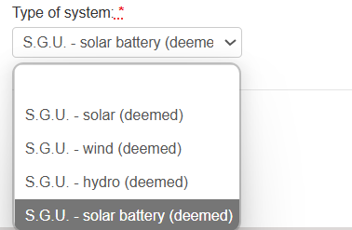

INSTALLATION DETAILS
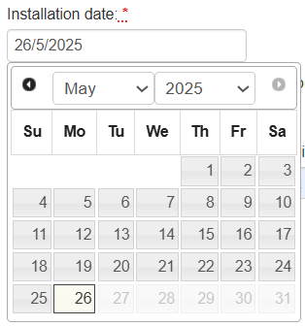 | 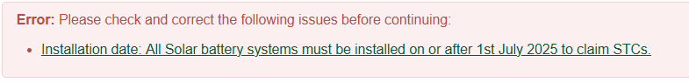
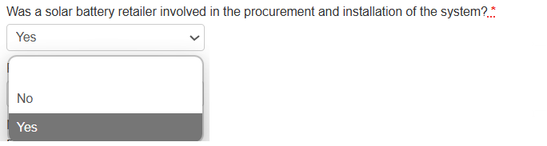 | Solar retailers procure, sell and arrange the installation of solar PV and solar batteries systems. If your business sold a battery installation to your customer, select ‘Yes’ for this question as your business is the solar retailer.  For more information on solar retailers visit Rooftop solar and solar battery retailers.
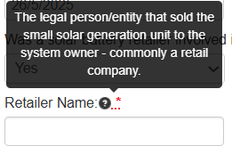 | 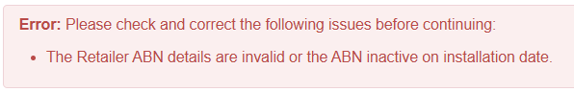  The retailer name entered into the REC Registry must match the entity name exactly as it appears on the Australian Business Register (ABN Lookup), including punctuation. Do not use your trading or business names.
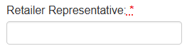
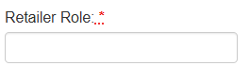
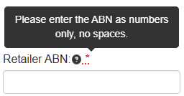 | 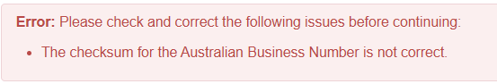
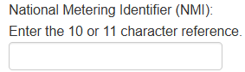 | This is a mandatory field for all systems connected to an electricity network. If the system is off-grid, you can leave it blank.
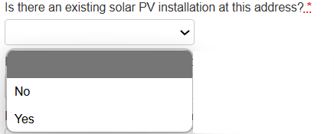 | 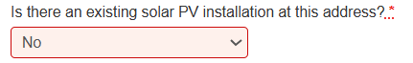  If the solar PV system and solar battery were installed at the same time, please make sure you submit the solar PV claim first. This will assist us to keep processing timeframes low.
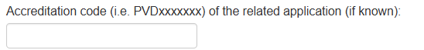
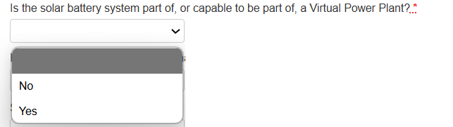 | 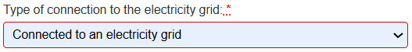
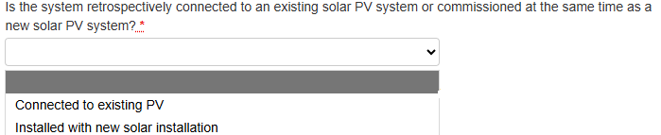 | You should use ‘Connected to existing PV’ if the system is a retrofit or you are installing an extension system. You should use ‘Installed with new solar installation’ if you are also installing a solar PV system such as a first-time concurrent install, a second additional system or replacement system.
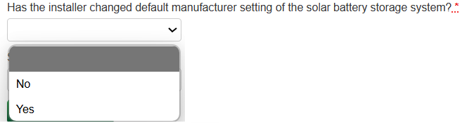
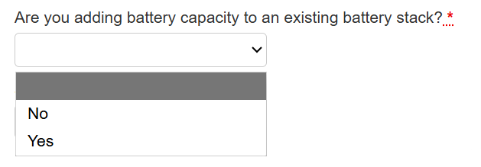 | If you are adding battery modules to a pre-existing stack at the property, choose ‘Yes’ and answer the additional questions regarding the nominal and usable capacities of the existing and newly installed stacks.
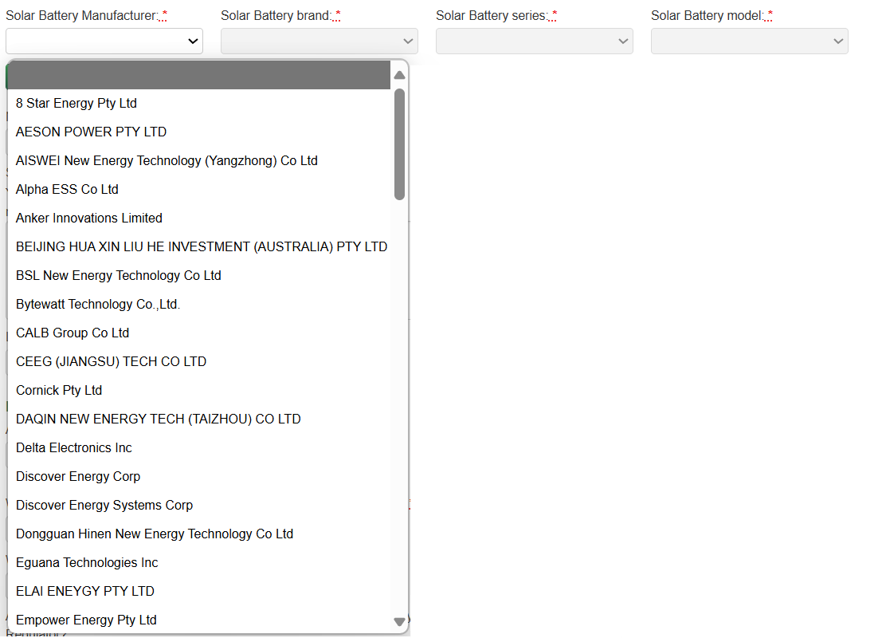 | Please ensure you enter the model for the group of batteries you have installed (noting the model may be made of a number of stackable battery cells/modules).
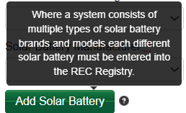
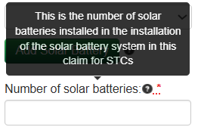 | 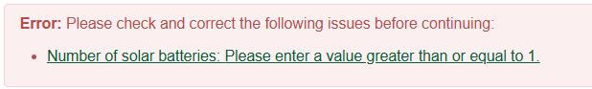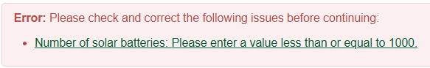  Where the solar battery model installed is made up of a number of battery cells (or modules) that make up that model, you will need to enter the total number of cells/modules installed. This is to ensure that the serial numbers for each battery module in the solar battery are captured in the following field. Where there is existing capacity onsite installed prior to 1 July 2025, do not include those modules here.
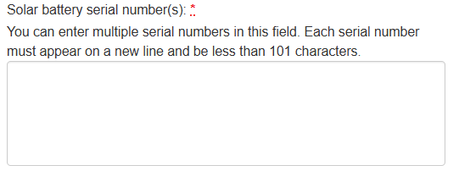 | 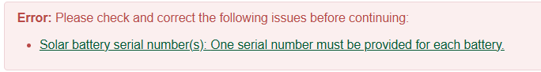  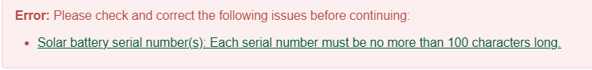
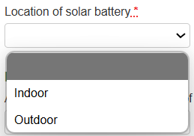
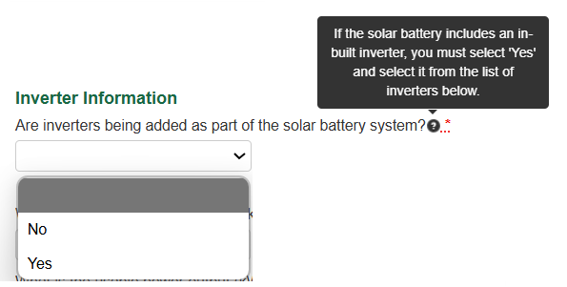 | If the solar battery installed is an integrated product (also contains a PV inverter) or if the solar battery and solar PV are installed together, you must enter the inverter details into this question. If you are adding a solar battery to an existing system (retrofit) and not installing a new inverter, you can answer no.
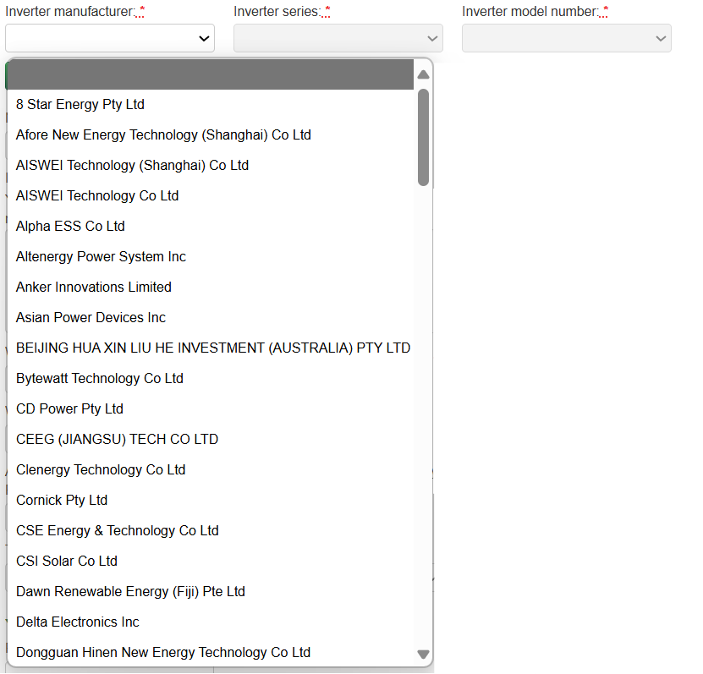
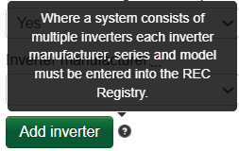
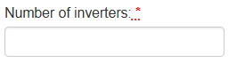 | 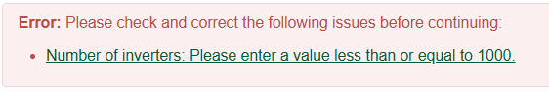
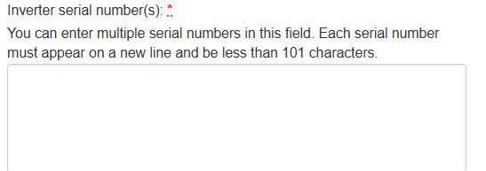 | 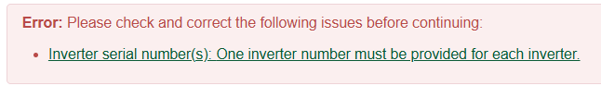  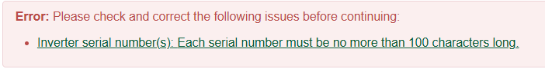
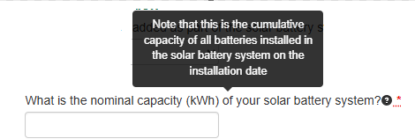 | 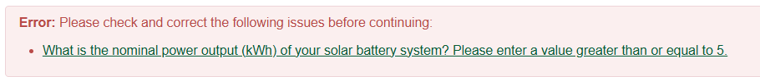  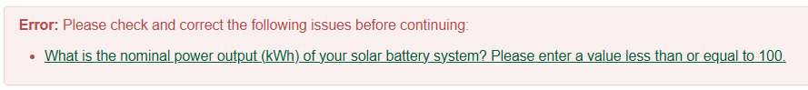  Please ensure this value is correct as per the CEC battery list. Do not include any existing capacity installed prior to 1 July 2025.
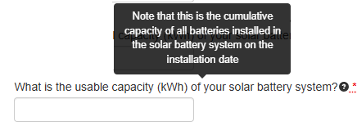 | 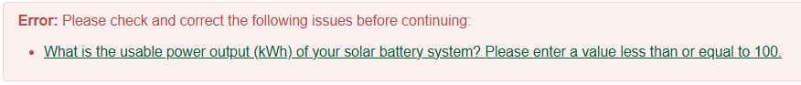  Please ensure this value is correct as per the CEC battery list. Where the battery is modular, ensure the total useable capacity is calculated correctly. Do not include any existing capacity installed prior to 1 July 2025.
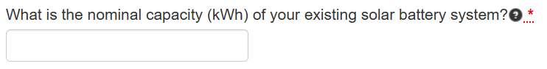 | This question will only appear if you have selected that you are adding to a pre-existing stack at the property.  Please add the nominal capacity of the existing solar battery system.
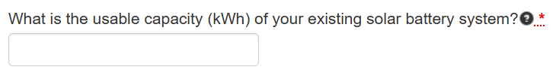 | This question will only appear if you have selected that you are adding to a pre-existing stack at the property.  Please add the usable capacity of the existing solar battery system.
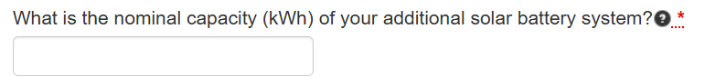 | This question will only appear if you have selected that you are adding to a pre-existing stack at the property.  Please add the nominal capacity of the added battery system. This should not be the total battery stack but the additional nominal capacity only.
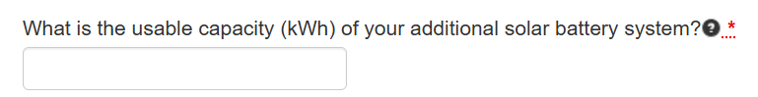 | This question will only appear if you have selected that you are adding to a pre-existing stack at the property.  Please add the usable capacity of the added battery system. This should not be the total battery stack but the additional usable capacity only.
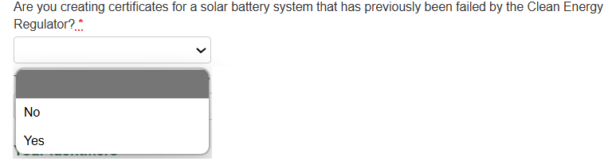
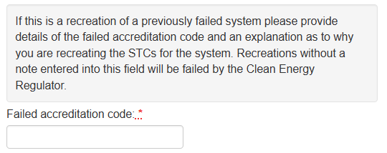

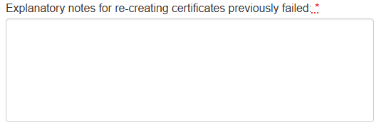

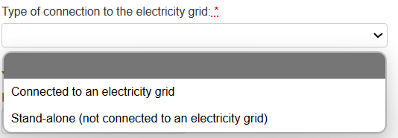
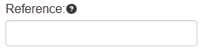
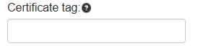

Installer and Designer written statement
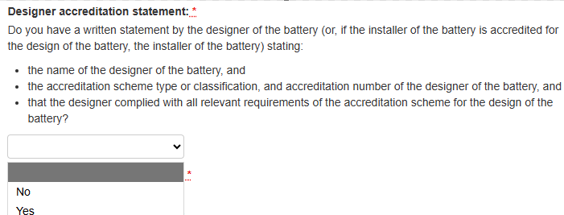

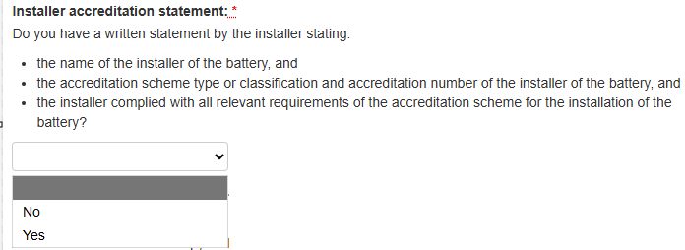
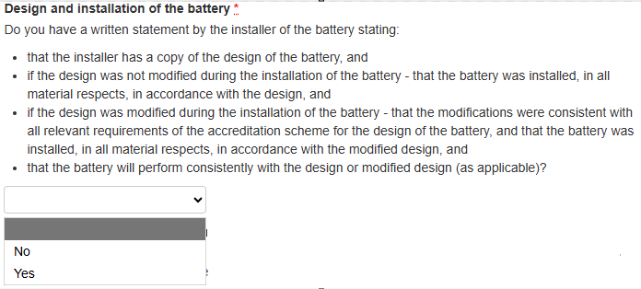
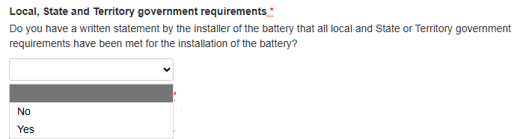
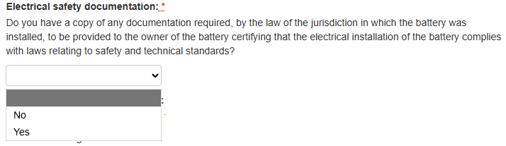
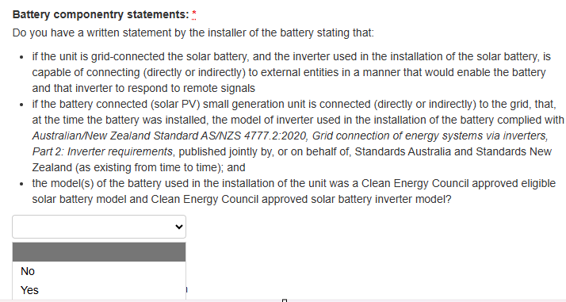
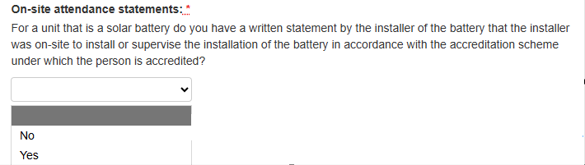

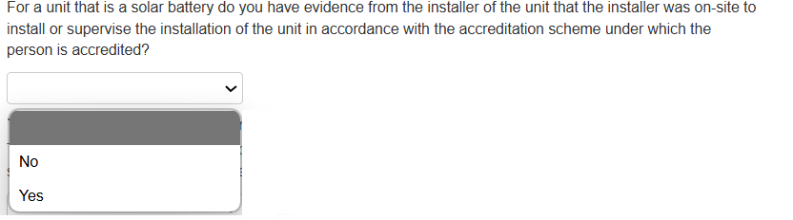
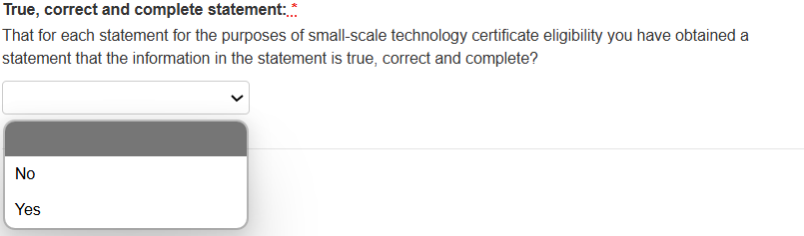

Retailer written statement
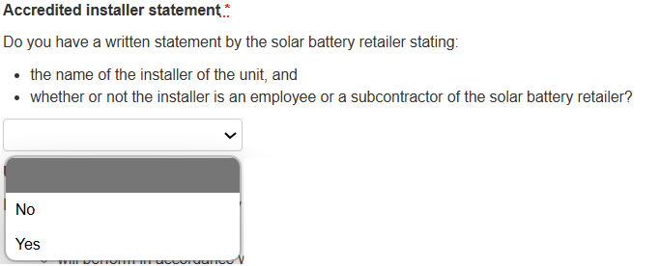
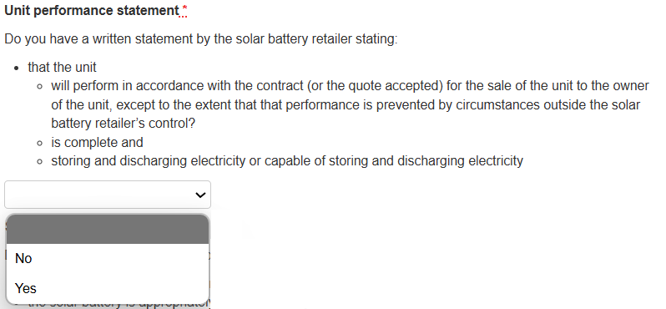
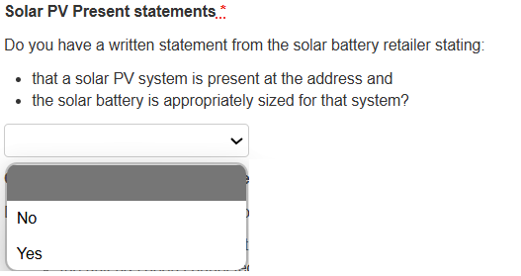
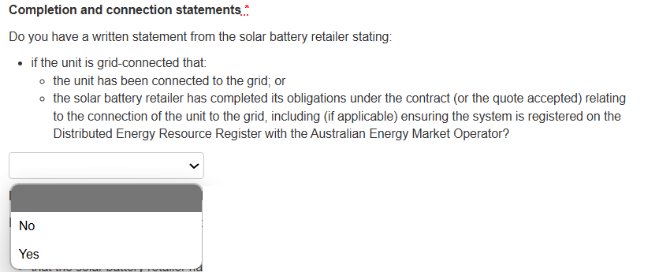

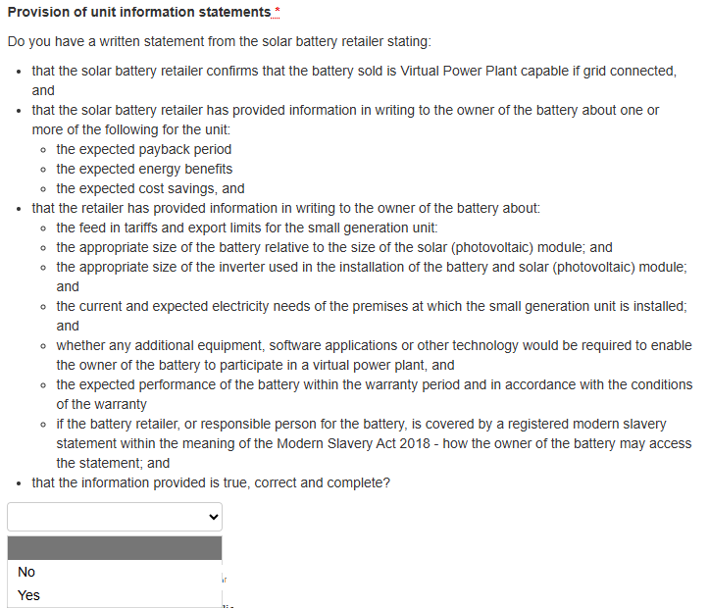
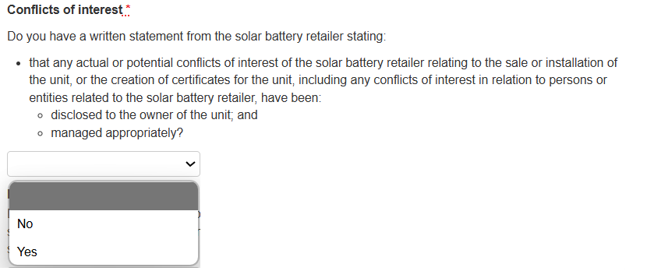
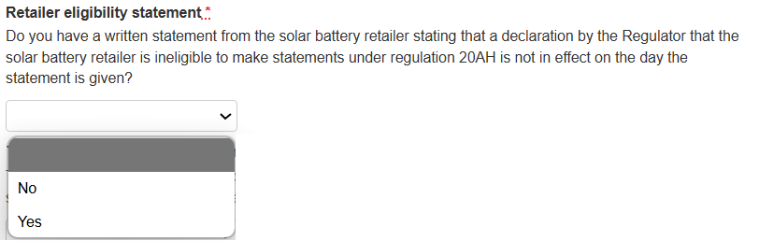
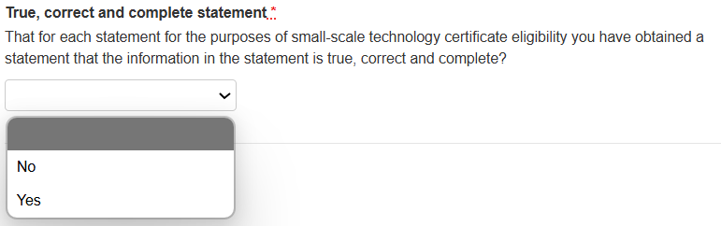
Installation address
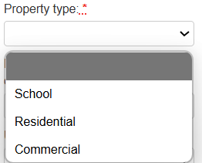
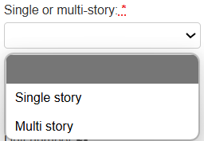
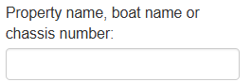
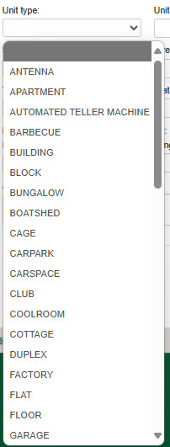 | This is not a mandatory field. You can leave it blank if the property has not been subdivided to a unit type.
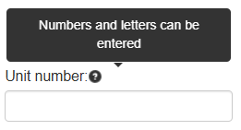 | This field is mandatory if you entered a unit type. If you left the previous question blank, you can leave this field blank also.
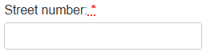
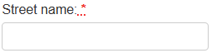
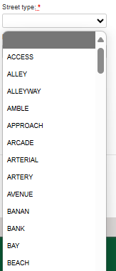 | Please make sure you are entering the correct street type. If the correct street type is ‘Road’ and you enter ‘Street’, the claim may be failed.
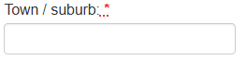 | 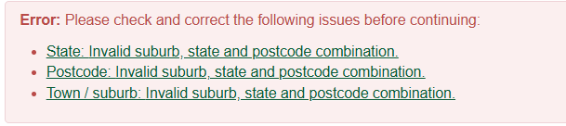
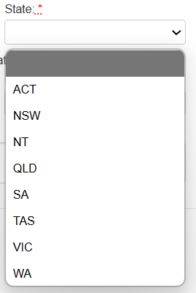

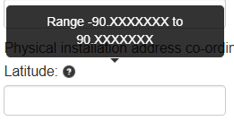 | 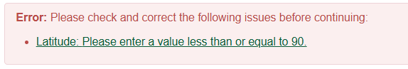
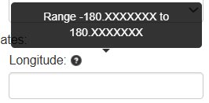 | 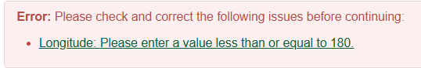
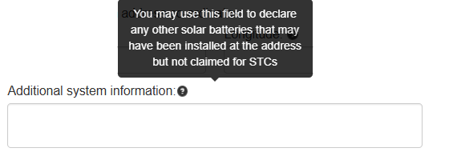 | You can use this field to enter any additional information about the claim. For example, if there is existing battery capacity installed prior to 1 July 2025, or the serial number of the battery management unit.

Owner details
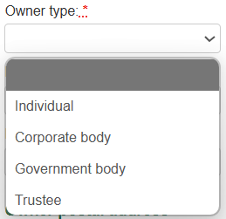
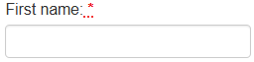
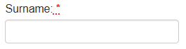
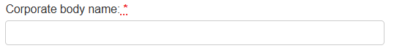
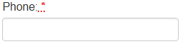 | 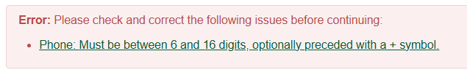
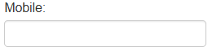 | 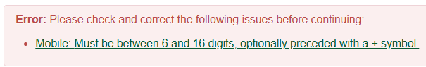
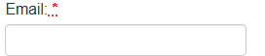 | 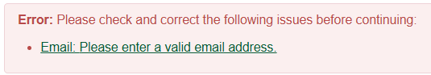
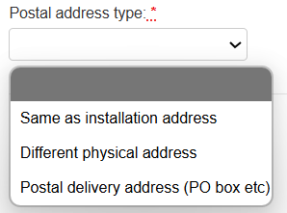
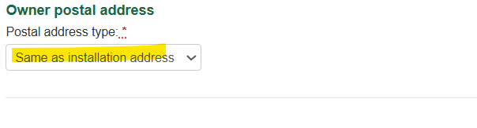
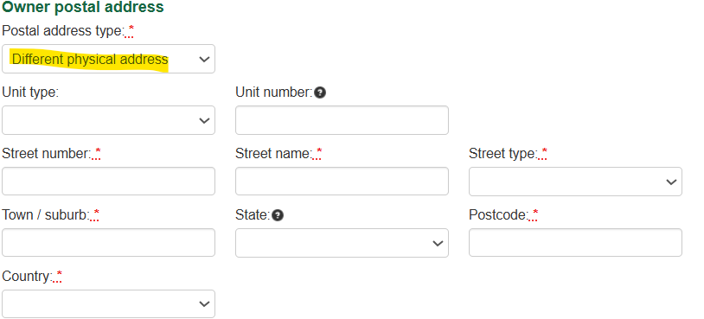 | 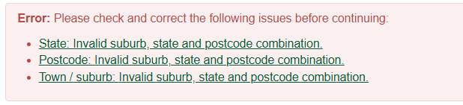  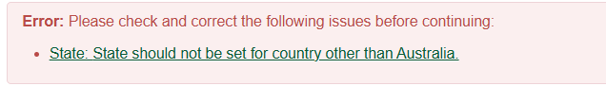
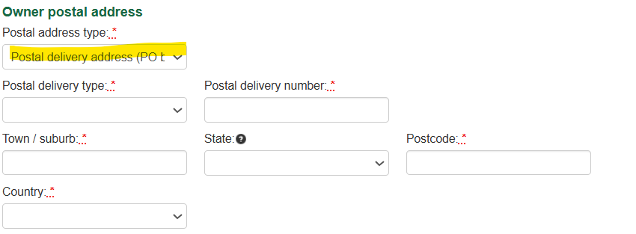 | 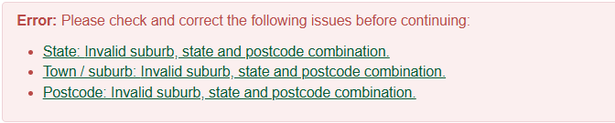  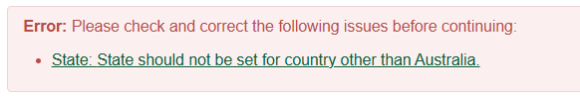

Installer details
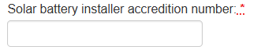 | 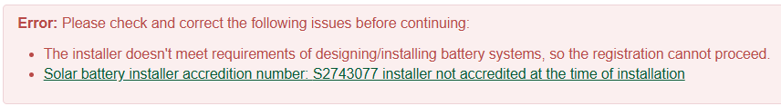
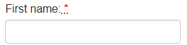
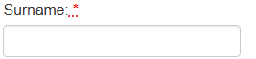 | 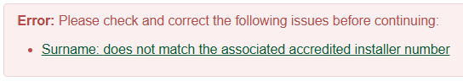
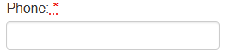 | 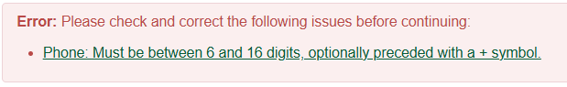
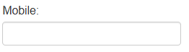 | 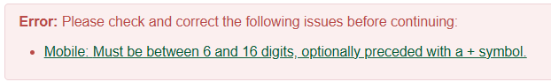
 | 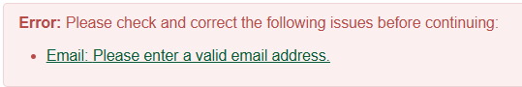
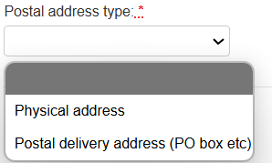
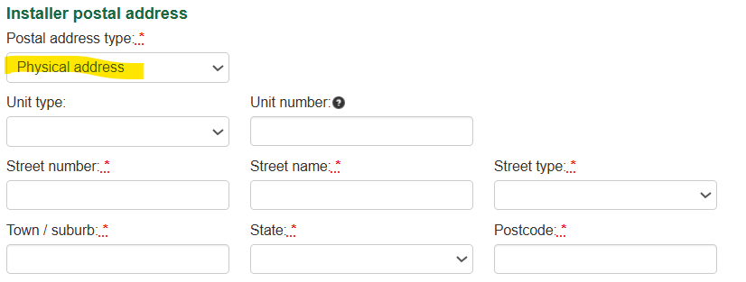 | 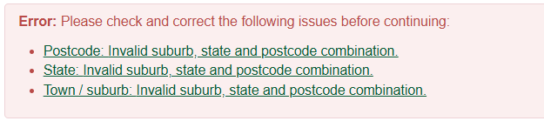
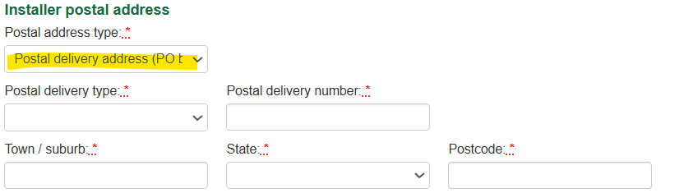 | 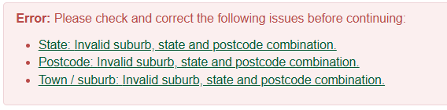
Electrician details
Checkbox prefills fields from installer
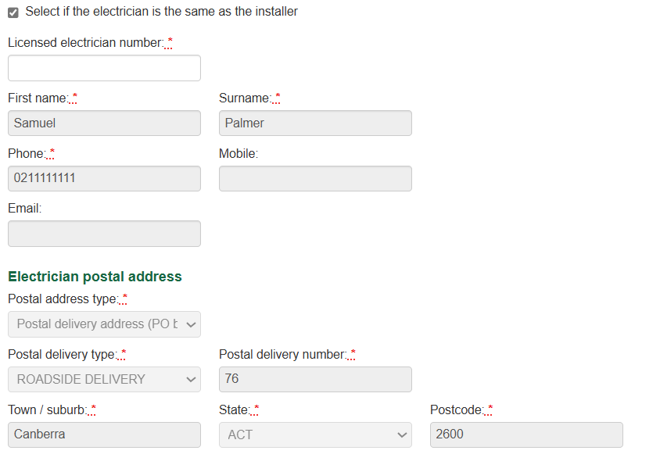
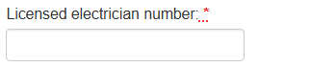
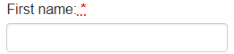
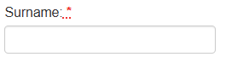
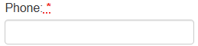 | 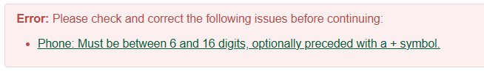
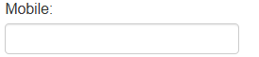 | 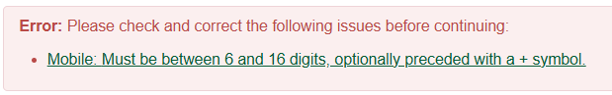
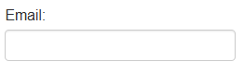 | 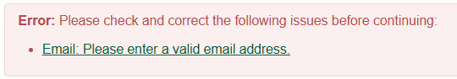
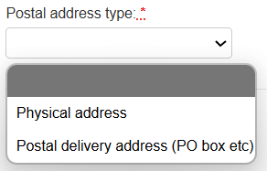
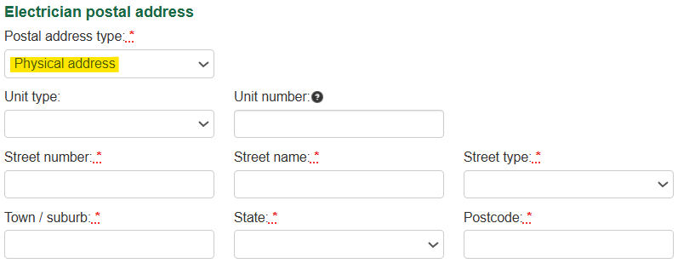 | 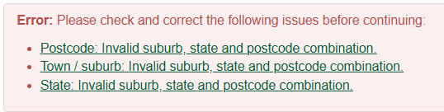
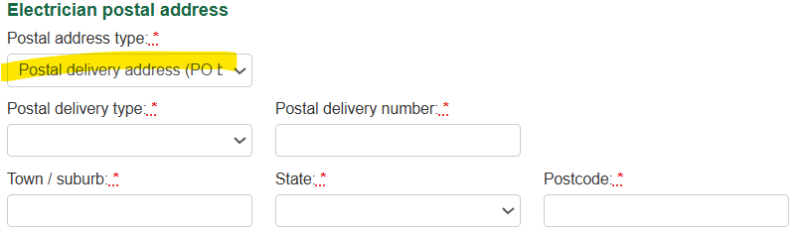 | 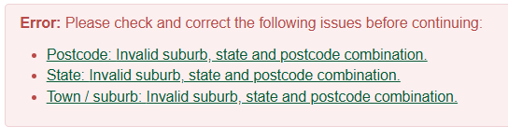

Designer details
Checkbox – prefills details from installer
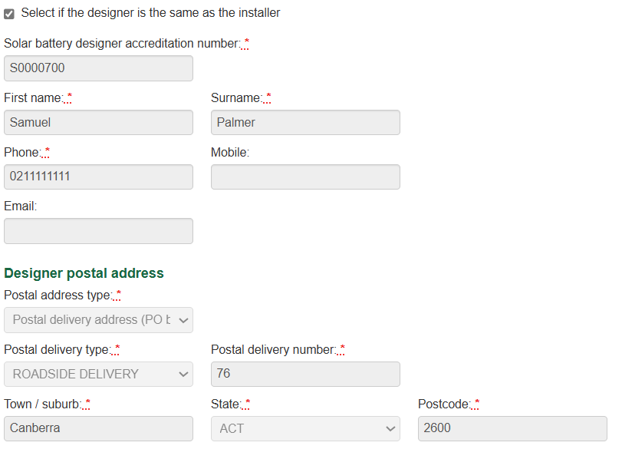
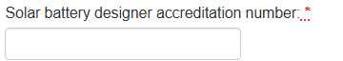 | 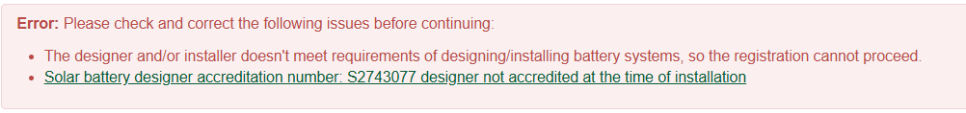
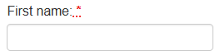
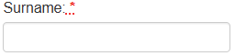 | 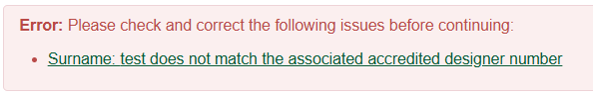
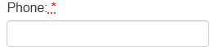 | 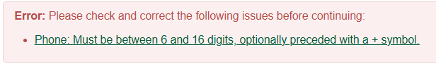
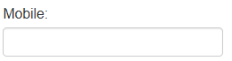 | 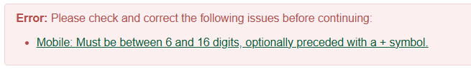
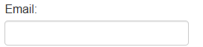 | 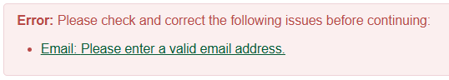
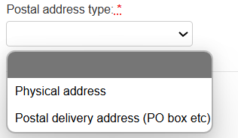
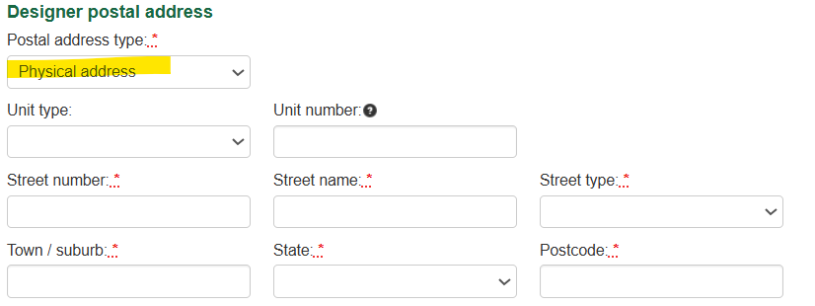 | 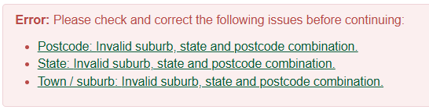
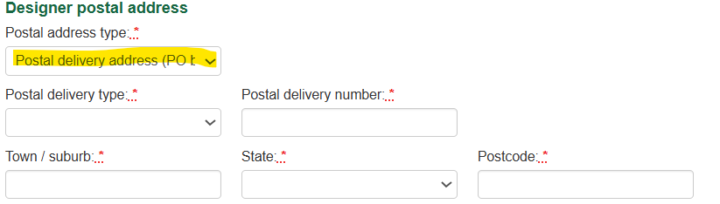 | 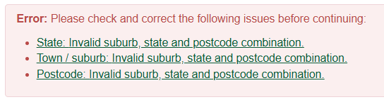

Legal declaration
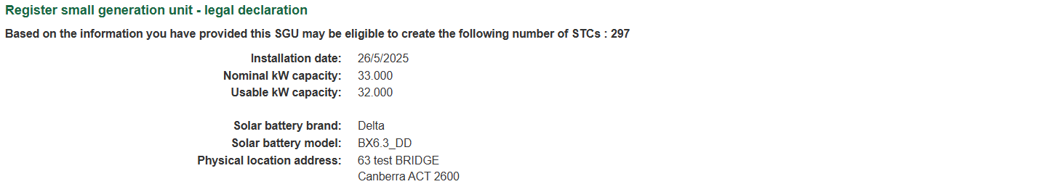
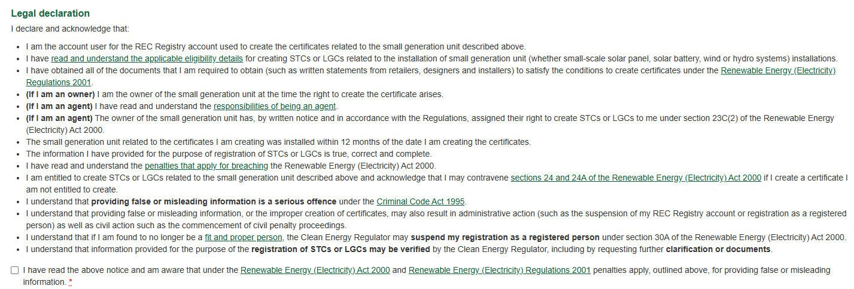

Further useful information
- Solar batteries
- Solar battery installers and designers
- Rooftop solar and solar battery retailers
- The Department of Climate Change, Energy, the Environment and Water’s Cheaper Home Batteries Program

