
Safeguard Online Services user guide
Version 1.0 November 2025

Contents
Contents 2
Safeguard Online Services user guide 3
Introduction 3
Creating an Online Services account 3
Logging into Online Services 3
Setting a default organisation 5
User permissions 5
Using the Dashboard 6
Viewing details of your Safeguard facility 6
Support 9

Safeguard Online Services user guide

Introduction
This guide will help you navigate the sections of Online Services that relate to the Safeguard Mechanism.
The NGER Online Services user guide provides more general guidance on using Online Services.

Creating an Online Services account
Select the ‘sign-up now’ link from the Online Services login page and follow the steps. To ensure secure login, Multi-Factor Authentication is enabled and requires an additional authentication method (email, text or phone call) after entering your username and password.
To use Online Services on behalf of an organisation (such as a Safeguard responsible emitter), your new account will need to be added to the organisation’s account by another user with the appropriate permissions for the organisation.

Logging into Online Services
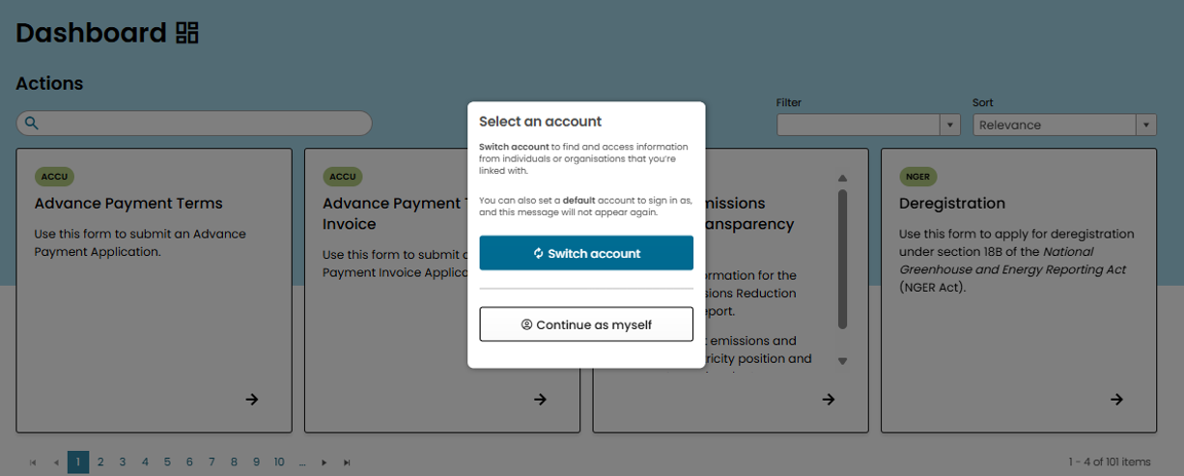
Logging into Online Services will open the Dashboard. If you’re new to Online Services a pop-up box will appear asking if you want to ‘Switch account’ or ‘Continue as myself’. To act on behalf of an organisation and access their NGER/EERS data, select ‘Switch account’ and select the organisation you wish to view, edit, or act on behalf of.
You can switch accounts using the white profile menu in the top right corner. Select ‘Switch account’ from the drop-down menu. A green pop-up alert will appear to confirm this change and the profile menu will read ‘You’re acting on behalf of [account name]’.
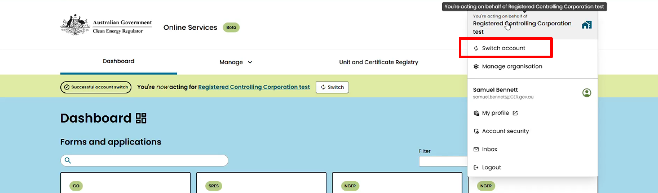

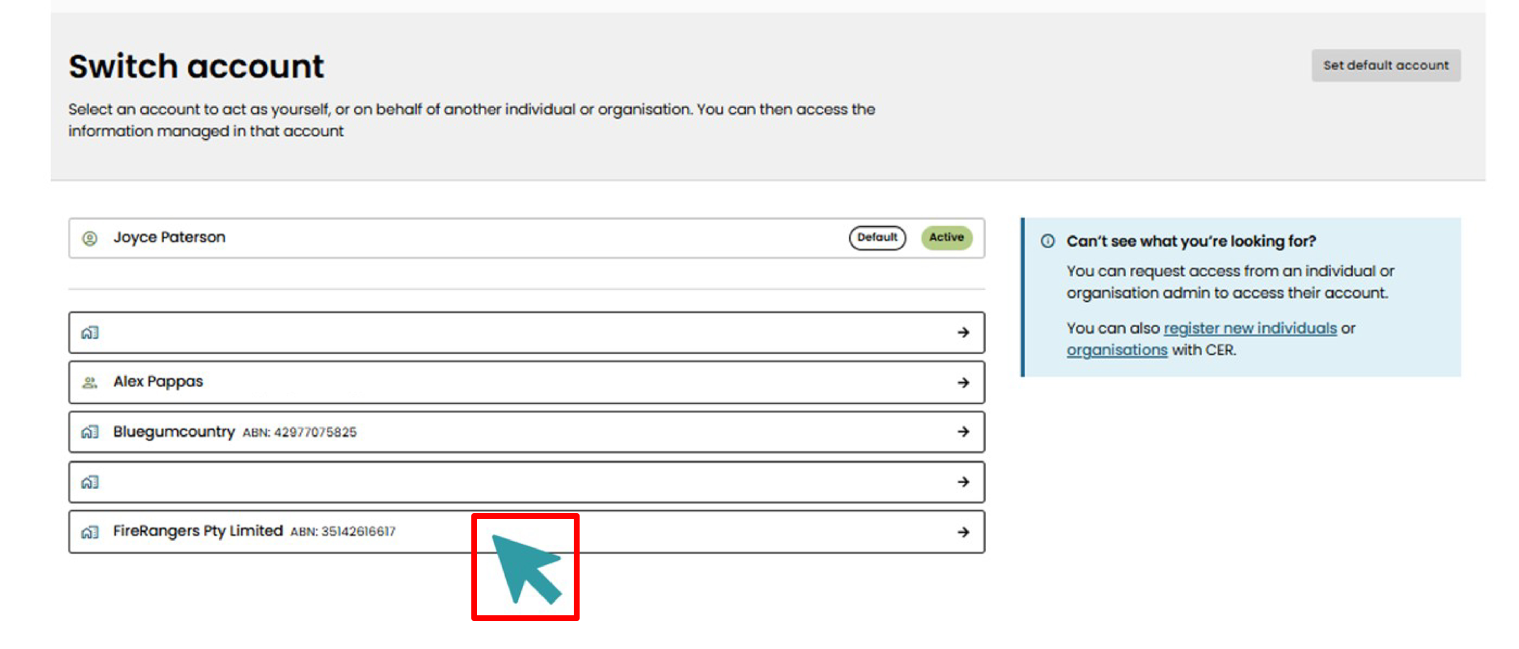

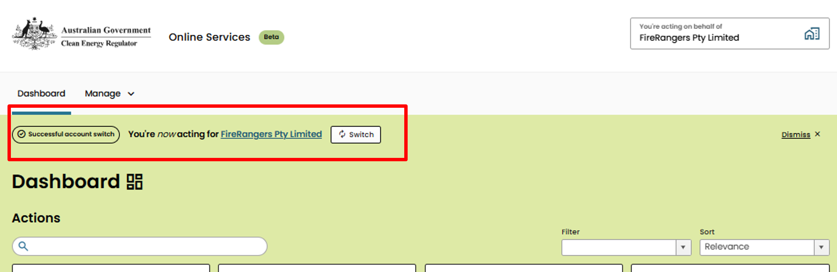

Setting a default organisation
Select one organisation to be your ‘default account’. It will open automatically when you sign into Online Services.
Go to ‘Switch account’ from the white profile menu drop-down and select the grey ‘Set default account’ option at the top-right of the screen. A pop-up text box will ask you to select which account you wish to make your default. Once chosen, select ‘Confirm’.
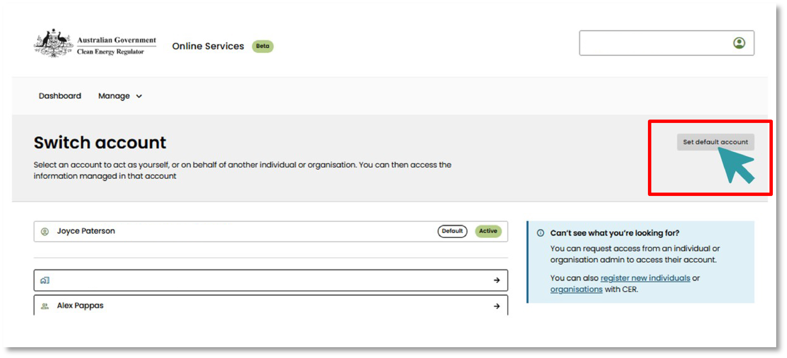

User permissions
Find more information about setting up user permissions and adding users to an organisation in the National Greenhouse and Energy Reporting (NGER) Online Services user guide.

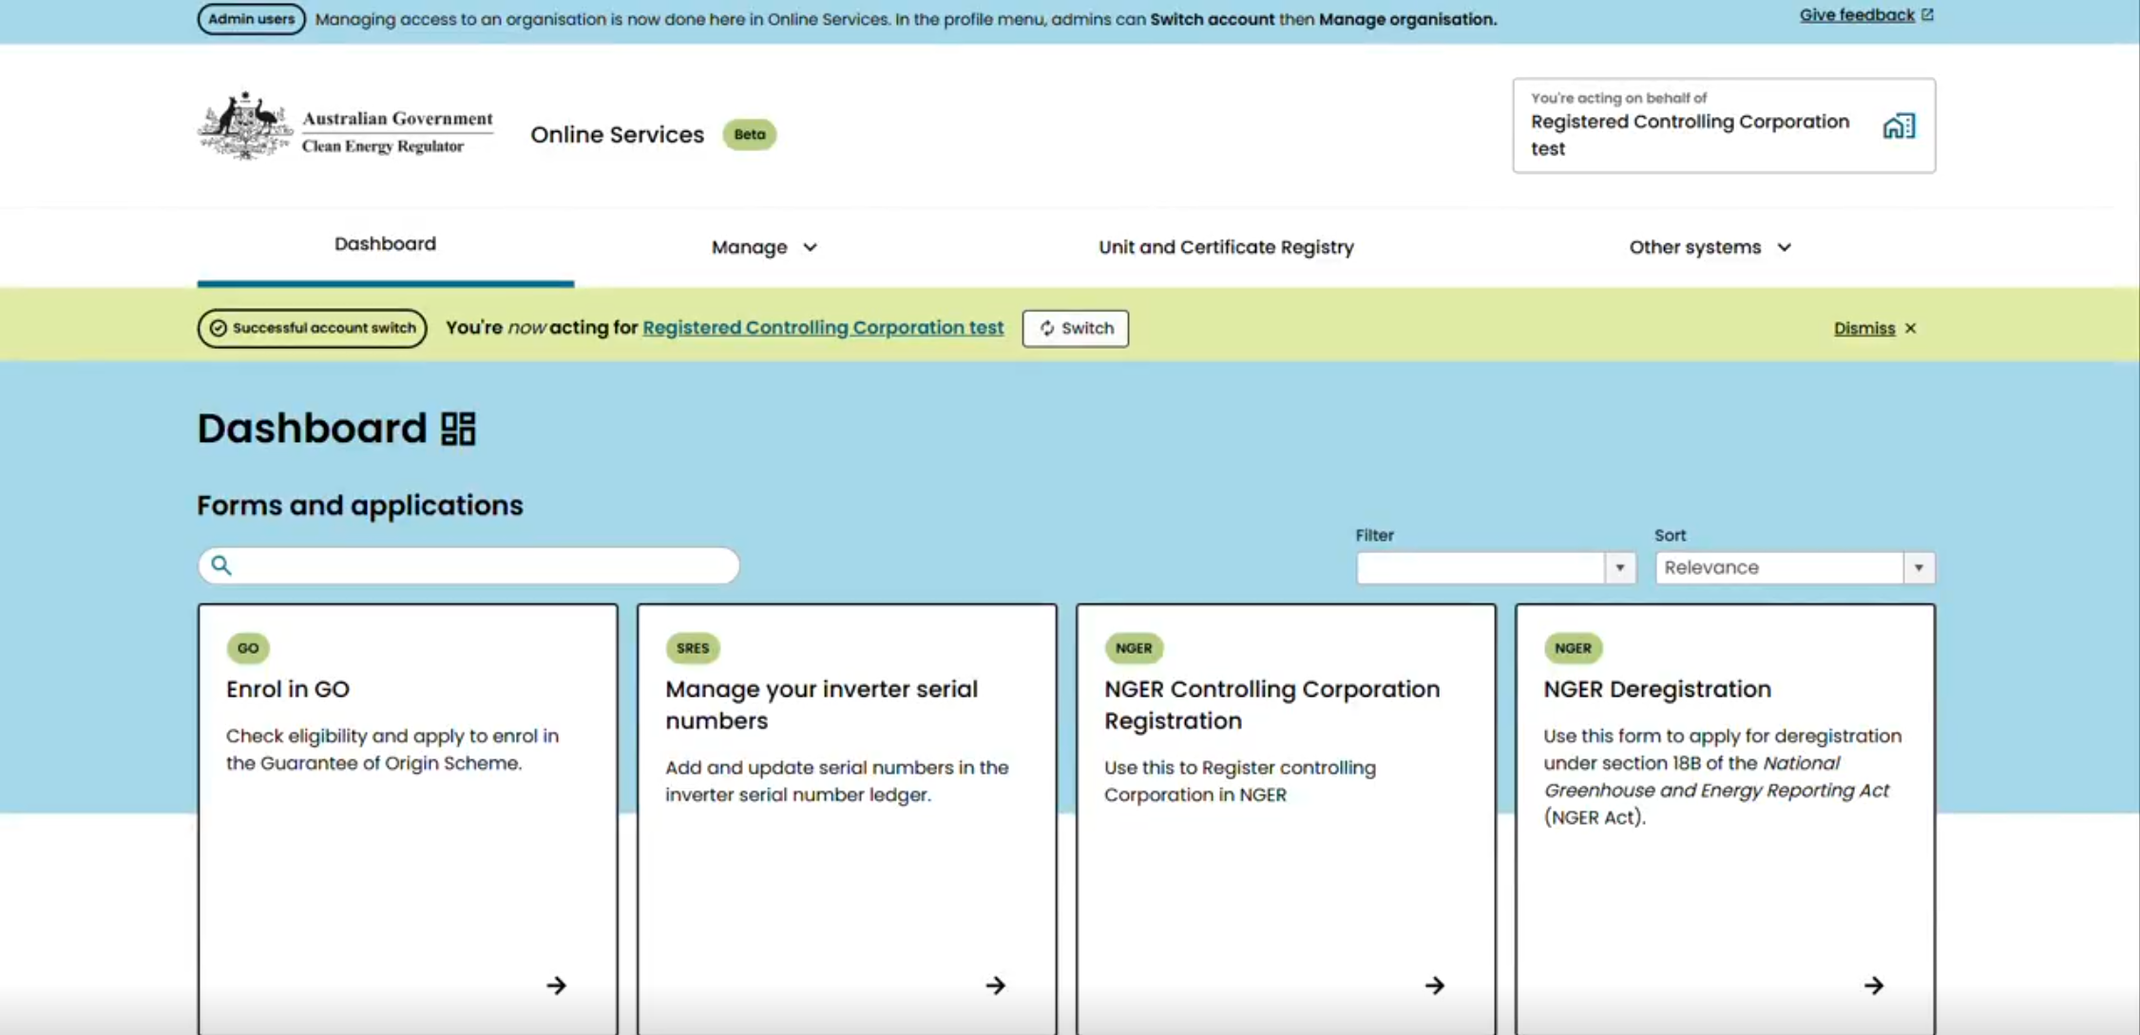
Using the Dashboard

Use the Dashboard to access:
- Other CER systems through the top navigation bar.
- Forms and Applications. Each tile in this section links to an application form you can fill in on behalf of the account you are currently signed into. You can browse through these tiles, filter by scheme or use the search bar to locate a specific form.
- Your Inbox, where system notifications and messages from the CER display underneath the tiles. These may include notifications about application forms, approvals or required actions.
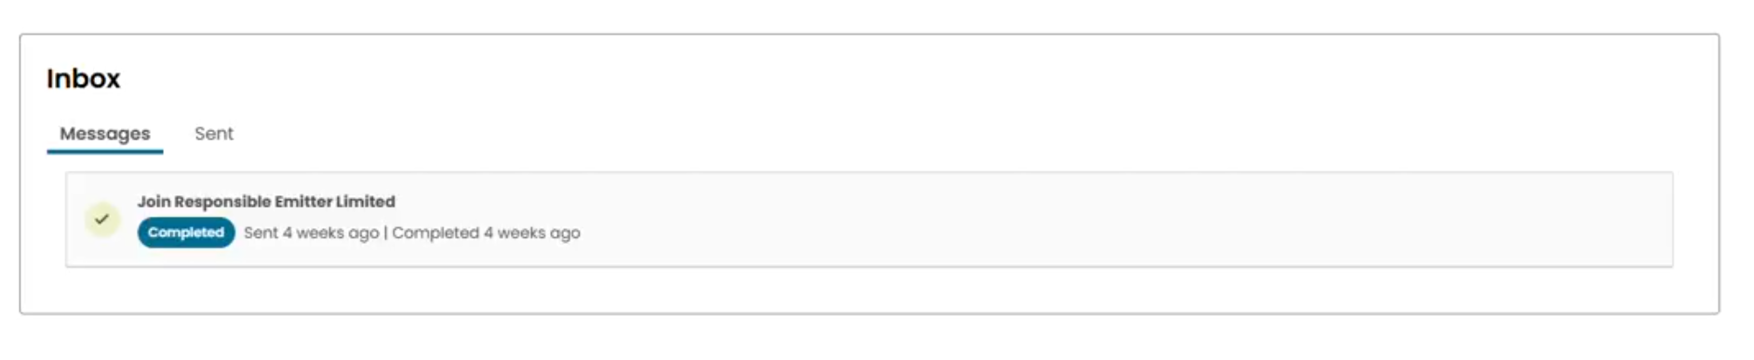
- Submissions, which shows all draft and submitted applications at the bottom of the screen. Each entry includes a submission ID, description, scheme, status, and available actions, such as continuing a draft or viewing a submitted application.

Viewing details of your Safeguard facility
The Facility Overview page provides a detailed view of your facility’s performance against its baseline. To access this page, select “Safeguard Facilities” under “Manage” and choose the relevant facility and reporting year.
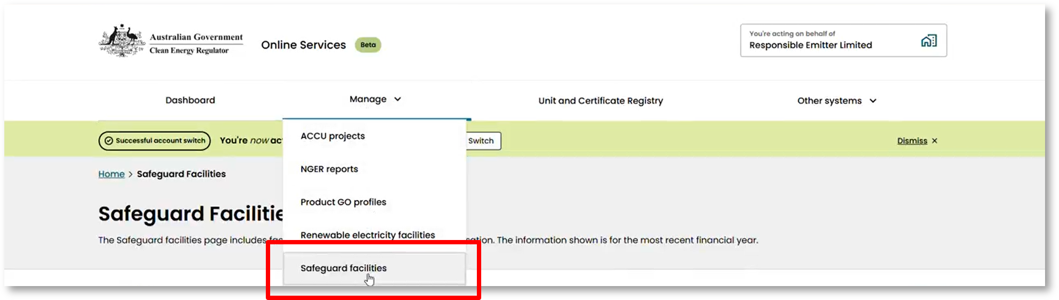

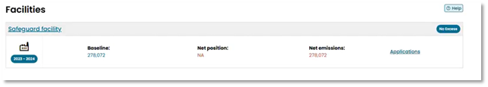
On the Facility Overview page you can view or download the facility’s position statement. This is our calculation of the facility’s Safeguard-related data for the financial year, including:
- baseline
- covered emissions
- net emissions number
- Safeguard Mechanism Credit (SMC) eligibility
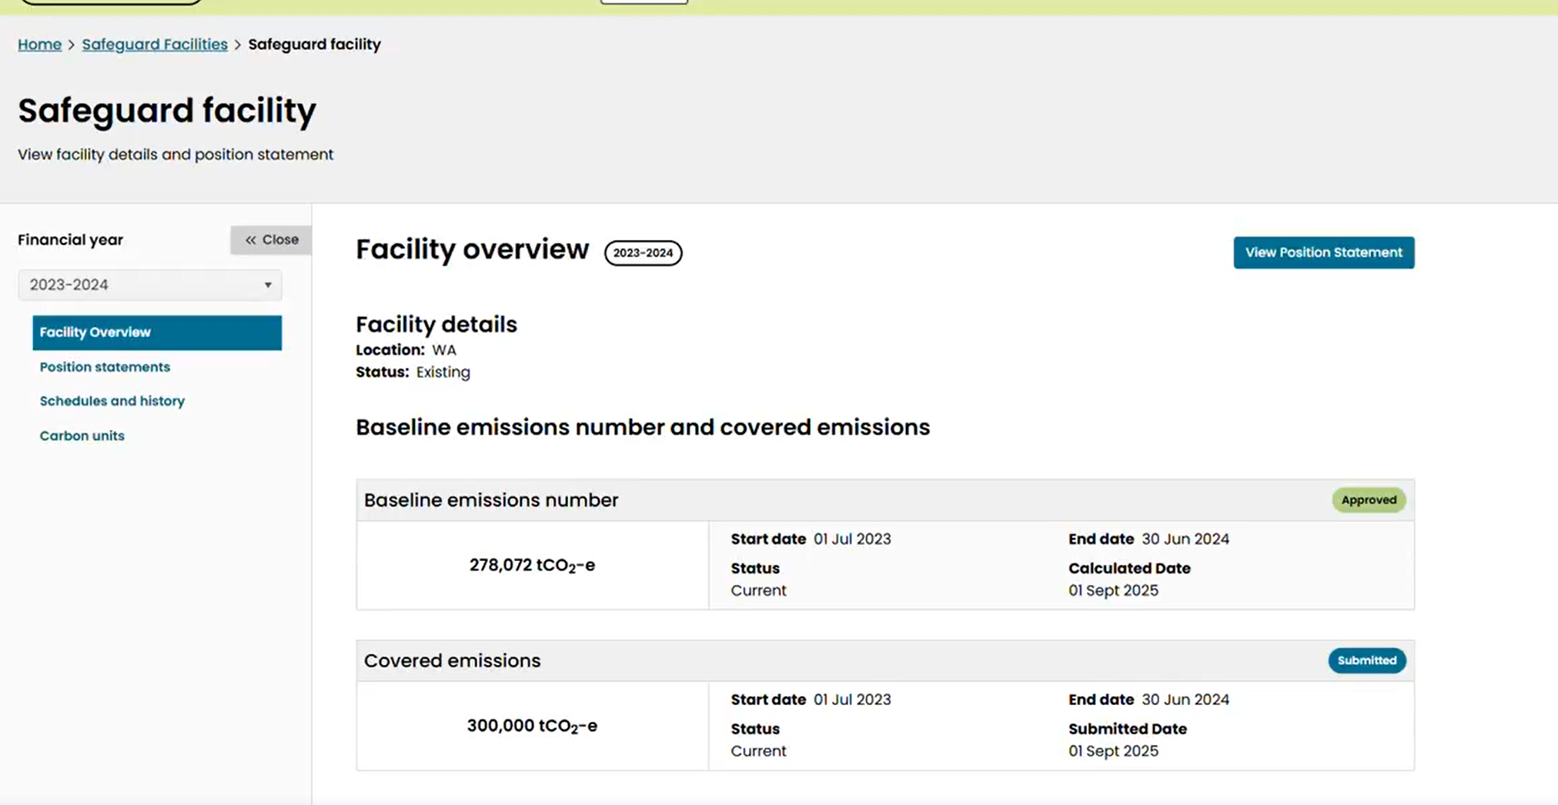
- key submission dates.

The Facility Overview also includes details of the production variables and emissions intensities used to calculate the facility’s baseline.
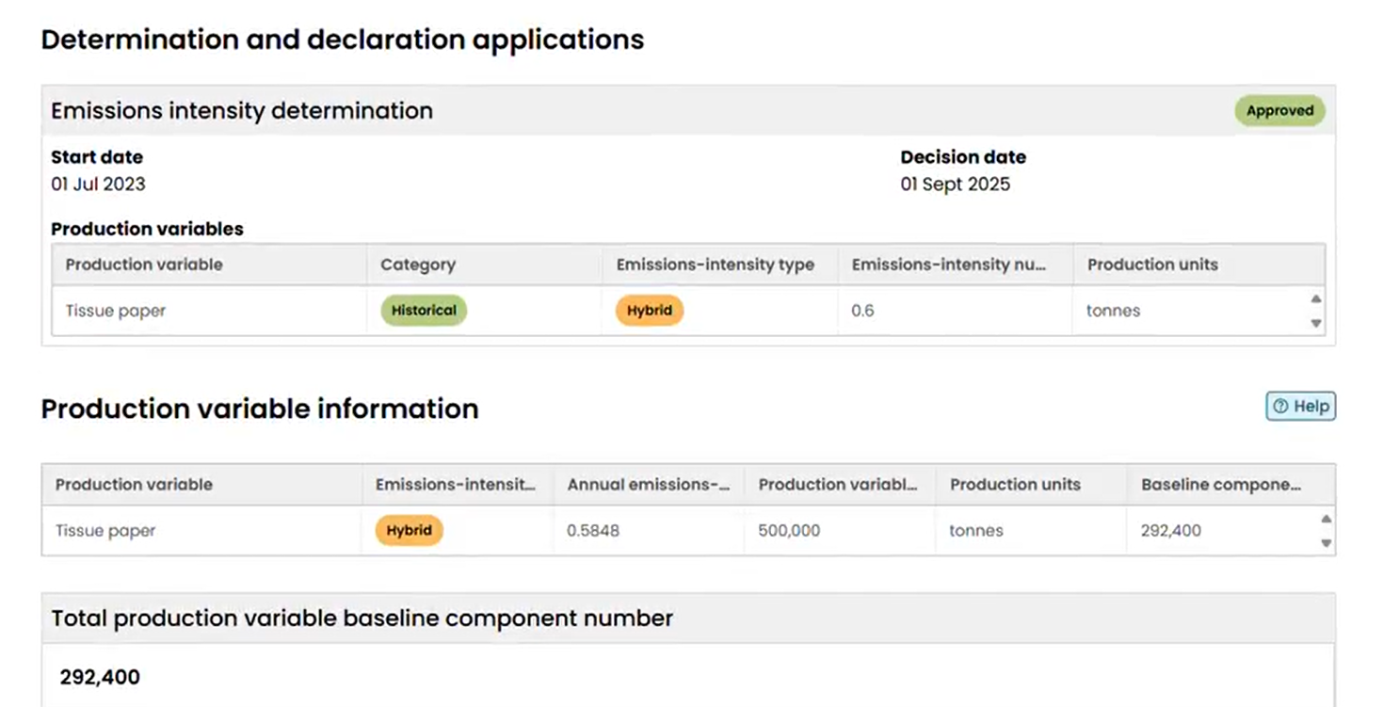
You can download a copy of the facility’s position statement from this page. This is particularly useful for internal audits, board reporting or Safeguard Mechanism Certificate issuance requests. To download, click “View Position Statement,” then “Generate Position Statement,” and “Download Position Statement” from the top-right corner.

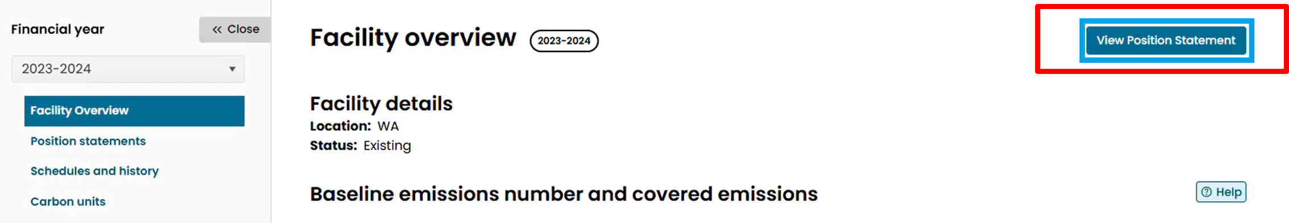

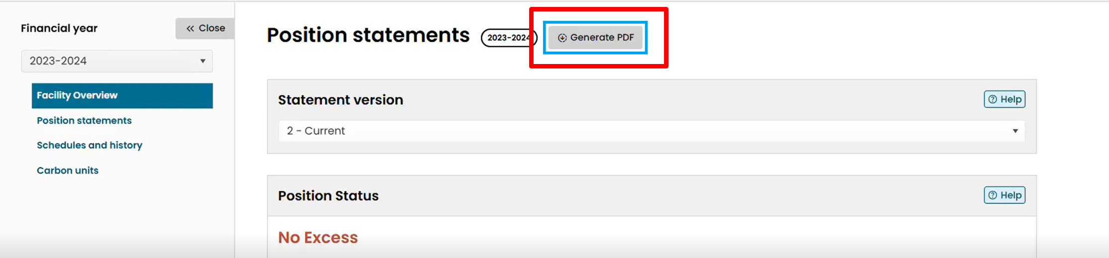
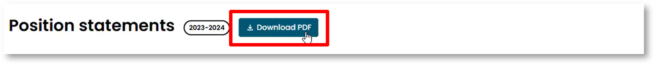
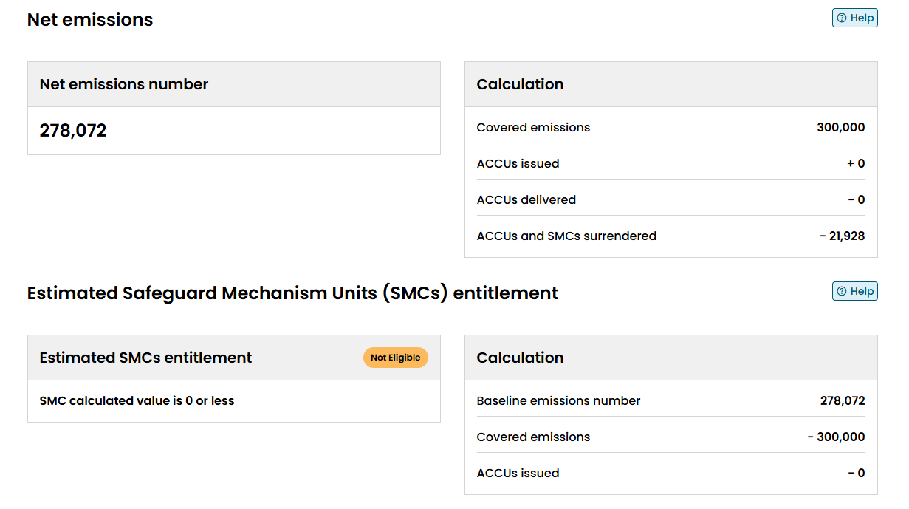
The calculation of attributable Australian Carbon Credit Units surrendered units and SMC entitlement is listed at the bottom of the Position Statement.

Support
Email: CER-Safeguardbaselines@cer.gov.au
Phone: 1300 553 542 within Australia
Web: www.cer.gov.au

https://onlineservices.cer.gov.au/
https://cer.gov.au/document_page/nger-online-services-user-guide
https://onlineservices.cer.gov.au/
https://cer.gov.au/document_page/nger-online-services-user-guide

