
Safeguard Mechanism surrender walkthrough
Version 1.1 February 2026







Contents
Safeguard Mechanism surrender walkthrough 3
Introduction 3
Overview 3
1. Open a Surrender Request form in Online Services 4
Note: User permissions 4
2. Complete the Surrender Request form in Online Services 5
Starting the form 5
Select the correct financial year 5
Facility and Contact Officer 6
ANREU Account Details 7
30% ACCUs explanation requirement 8
Nominating an applicant 9
Review request 10
Receipt of surrender request 11
3. Initiate surrender transaction in the Unit and Certificate Registry 11
Navigate to Safeguard surrender in the Unit and Certificate Registry 12
Begin the Surrender Transaction 12
Select units for surrender 13
Review selections 15
Transaction awaiting approval 16
4. Finalise the surrender in the Unit and Certificate Registry 16
Navigate to Safeguard surrender 16
Review transaction details and approve 16
Surrender transaction completed 18

Safeguard Mechanism surrender walkthrough

Introduction
This guide demonstrates how to surrender Australian carbon credit units (ACCUs) and Safeguard Mechanism credit units (SMCs) to comply with the Safeguard Mechanism. To complete the process you’ll need access to the Clean Energy Regulator (CER)’s Online Services portal, including the Unit and Certificate Registry.
You may also find these guidance documents useful:
- The Safeguard Mechanism credit unit issuance and carbon unit surrender guideline provides detailed information about the requirements and processes for Safeguard Mechanism surrenders.
- The Safeguard Online Services user guide offers general help on using Online Services.
- The Unit and Certificate Registry guidance provides general help on using the Unit and Certificate Registry system.

Overview
There are 4 steps to successfully surrendering ACCUs and/or SMCs:
- Open a Surrender Request form in Online Services.
- Complete the Surrender Request form in Online Services.
- Initiate the surrender transaction in the Unit and Certificate Registry.
- Finalise the surrender in the Unit and Certificate Registry.
You must complete all four of these steps to reduce your facility’s net emissions number for the selected monitoring period.

Open a Surrender Request form in Online Services

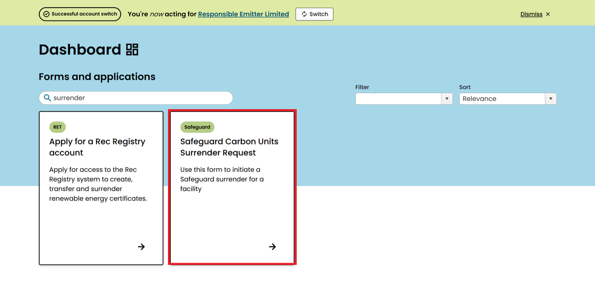
To begin the surrender process, log into Online Services. Make sure you are acting on behalf of the relevant responsible emitter.
On the dashboard, find the ‘Safeguard Carbon Units Surrender Request’ form by searching for ‘surrender’ in the search bar.
Select the form by clicking the arrow icon on its tile.

Note: User permissions
The Safeguard Carbon Units Surrender Request form can only be submitted by a user acting on behalf of the facility’s responsible emitter. If you are acting on behalf of the responsible emitter, ensure that your Online Services user account has the ‘manage facilities’ permission, which allows you to prepare and edit a draft application before submission. These permissions can be managed through the ‘manage user’ function in Online Services.
If a draft application has already been started by another user, you can continue editing it if you have the ‘view submissions list’ and ‘manage submissions’ permissions (located in the ‘form’ permissions list). To continue editing a pre-existing application, locate the application within the dashboard ‘submissions’ table and select ‘edit’. For more information on these permissions and how they are assigned, see the accessing submissions guide.
Guidance on updating user permissions is available in the Safeguard Online Services User Guide.

2. Complete the Surrender Request form in Online Services

Starting the form
The form is designed to be flexible, allowing you to save progress at any point and return later. You can also generate a PDF copy for review or printing before submission.
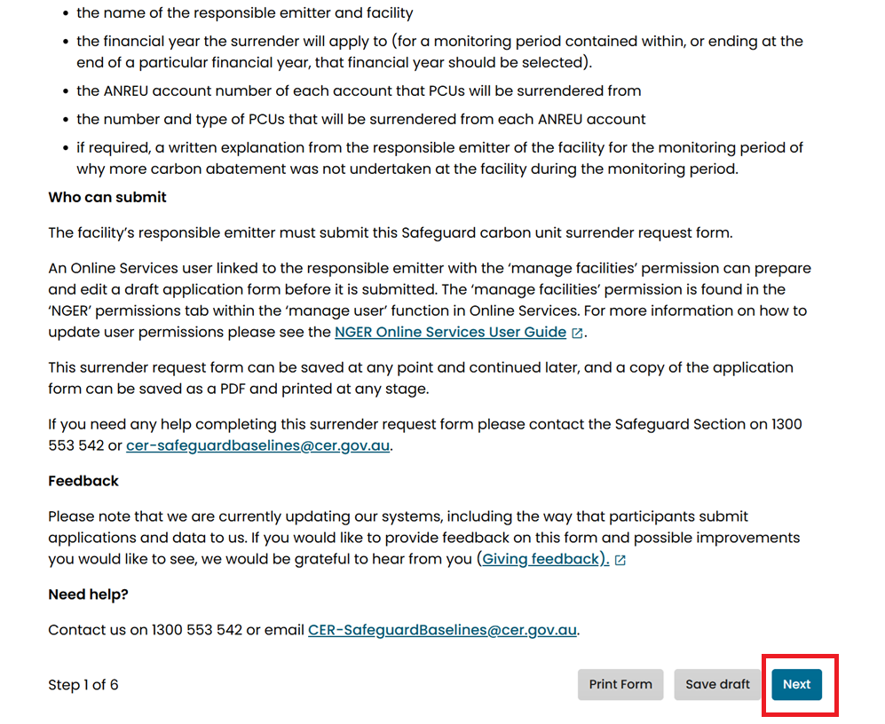
If you need assistance, please contact the CER’s Safeguard Section via the details provided on the ‘Before You Start’ page. Once you have reviewed the instructions and confirmed your permissions, click the Next button at the bottom of the page to proceed.

Select the correct financial year
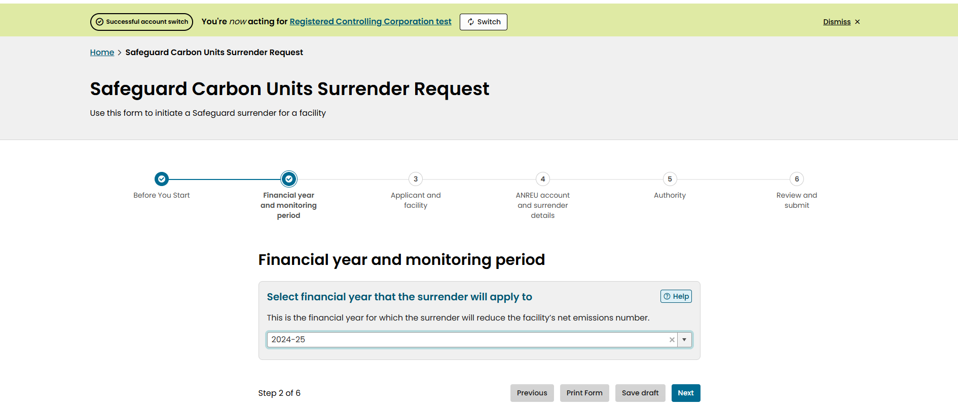
Select the financial year the surrender applies to.
Choose the correct financial year that corresponds to the reporting and compliance obligations for your facility. The facility’s net emissions number for the financial year you select will be reduced by the total amount of surrendered ACCUs and/or SMCs.

Facility and Contact Officer
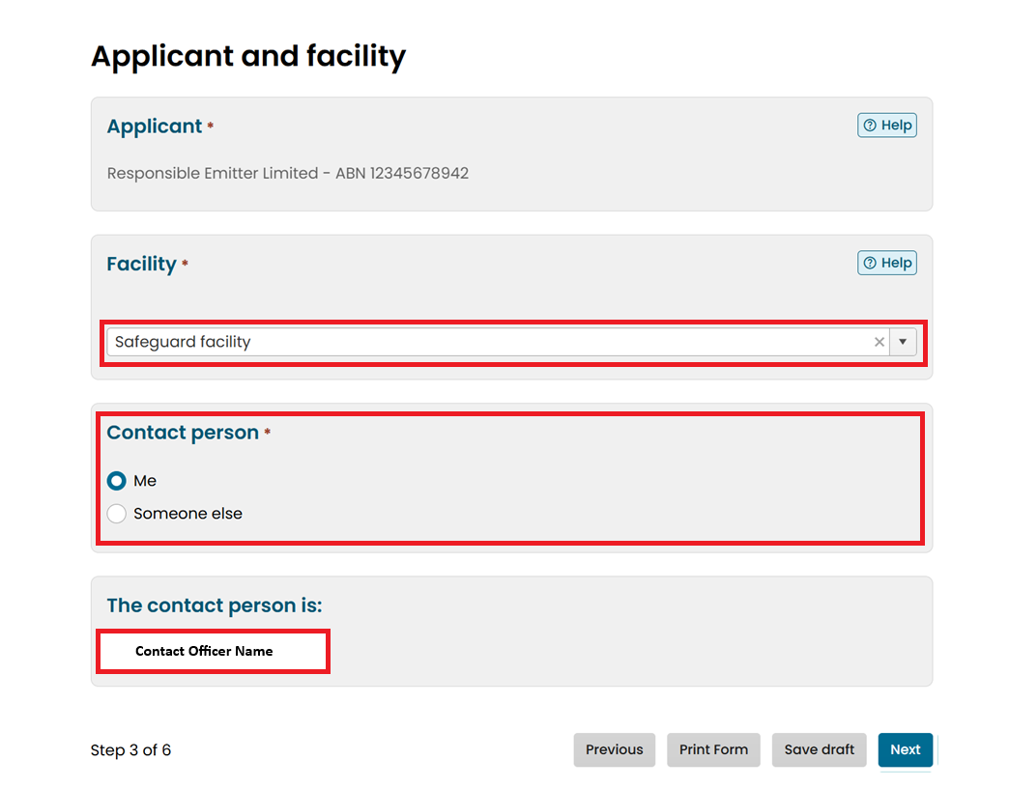
Provide details about the applicant and the facility associated with the surrender request. The form will display the applicant’s information automatically. Confirm that these details are correct before proceeding.
Use the dropdown list to select the safeguard facility that will have its net emissions reduced by this surrender. It is important to ensure that the correct facility is chosen, as this links the surrender to the appropriate emissions obligations.
If you are unable to see your facility, contact us.
If there are no facilities available, check that the ‘manage facilities’ permission is selected. If it is not, ask an admin user with the ‘admin – manage users’ permission to add it. This permission is found in the ‘NGER’ permissions tab within the ‘manage user’ function in Online Services. Refer to the NGER Online Services user guide for detailed steps.
Identify the contact person for this application. You can choose either ‘Me’ if you are the person completing the form or ‘Someone else’ if another individual will act as the contact. When ‘Me’ is selected, the system will automatically populate your name in the contact details section.
Once all fields have been reviewed and completed accurately, click ‘Next’ to move to the next stage of the process.

ANREU Account Details
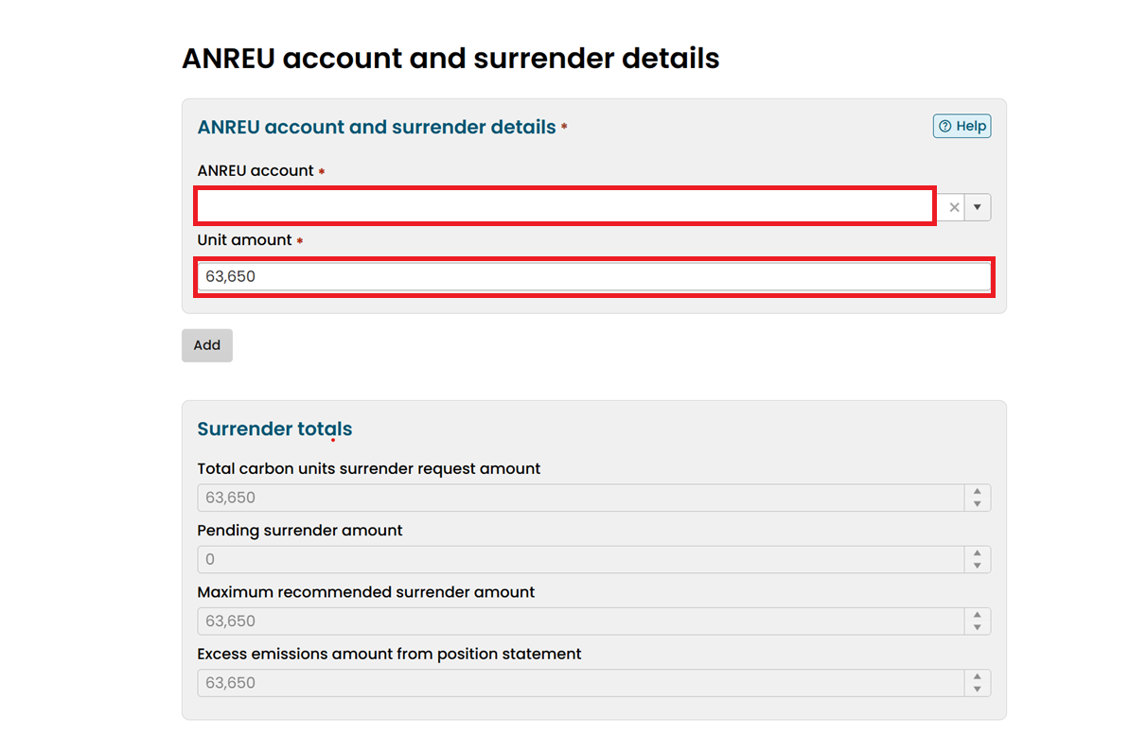
This form must be completed by the responsible emitter, but the surrender transaction in the Unit and Certificate Registry (Step 3) can be completed by any ANREU account holder.
To surrender from an ANREU account associated with the responsible emitter, identify the Australian National Registry of Emissions Units (ANREU) account that the carbon units will be surrendered from in the dropdown list. Confirm the account name and identifier match your records before proceeding.
For surrenders from an ANREU account not associated with the responsible emitter please contact us.
Enter the unit amount to be surrendered from the selected account. This figure represents the total number of carbon units you intend to surrender from that ANREU account.
You can use the “Add” button to identify additional ANREU accounts and enter unit amounts to be surrendered from those accounts.
The ‘Surrender totals’ section will automatically calculate and display the:
- total carbon units surrender request amount – the sum of surrender amounts entered
- pending surrender amount – any units identified in surrender applications already in progress for the same facility and financial year
- maximum recommended surrender amount – this is the excess emissions amount from the position statement, minus any pending surrender amounts assuming those transactions will be completed
- excess emissions amount from position statement – the amount shown in the current position statement for the facility for the selected financial year (if available).

30% ACCUs explanation requirement

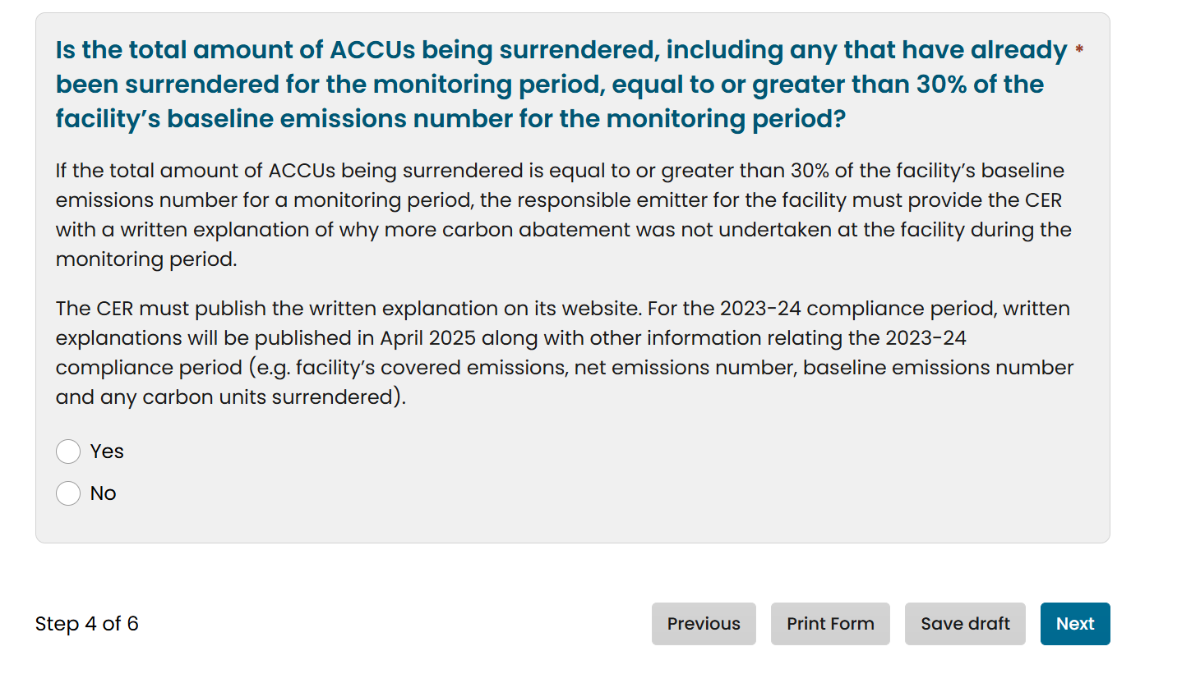

Confirm whether the total amount of ACCUs being surrendered for the facility for the monitoring period (taking into account any previously surrendered units for the same monitoring period) is equal to or greater than 30% of the facility’s baseline emissions number for that period.
If the amount of ACCUs meets or exceeds 30% of the baseline, the responsible emitter must provide the CER a written explanation outlining why more carbon abatement was not undertaken at the facility during the monitoring period. Without this explanation the surrender cannot be finalised.
This explanation will be published on the CER website alongside other information, such as the facility’s covered emissions, net emissions number, baseline emissions number, and surrendered carbon units. See the published explanations for the 2023–24 compliance period as an example.
Review these figures carefully to ensure accuracy. Once confirmed, click ‘Next’ to proceed to the authority section of the form.

Nominating an applicant
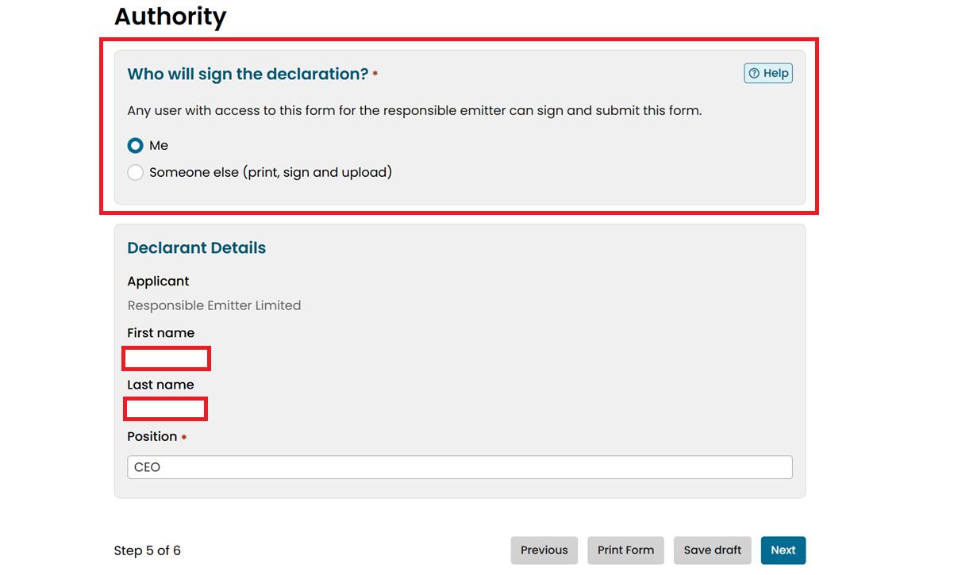
Confirm who will sign the declaration and provide the declarant’s details. The declaration is a formal confirmation that the information provided in the surrender request is accurate and that the responsible emitter authorises the submission.
Indicate who will sign the declaration. You can select ‘Me’ if you are the authorised user completing the form or choose ‘Someone else’ if another person will sign. If you select ‘Someone else’ you will need to print the form, obtain their signature, and on the next page upload the signed document before submission.
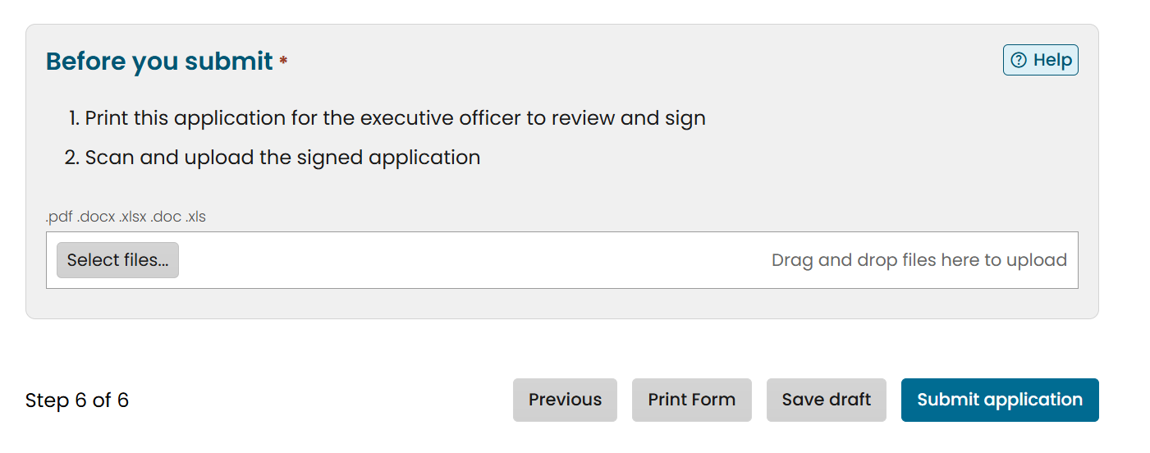
Review the declarant details displayed on the form. This includes your first and last name, and your position within the organisation. Ensure that the position field accurately reflects the declarant’s role, as this is a compliance requirement.
After verifying all details, click ‘Next’ to proceed to the final step, where you will review the entire application and submit it.

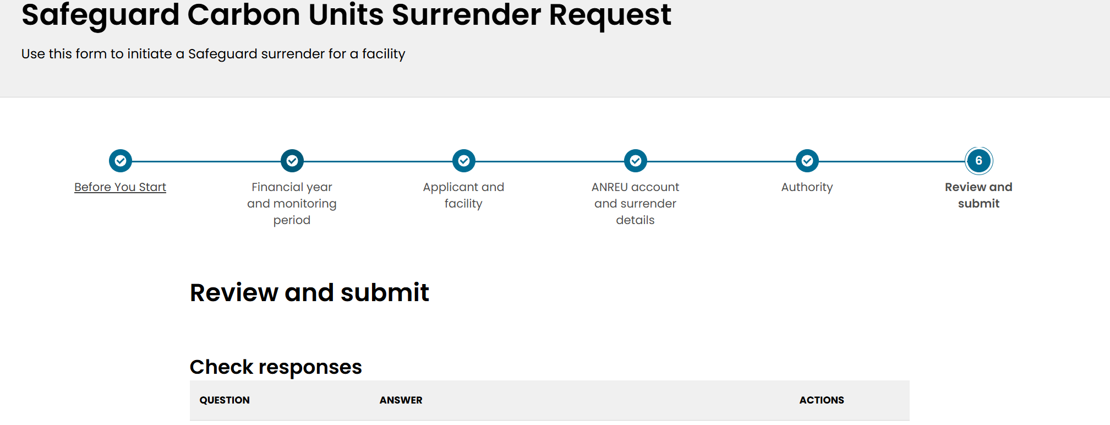
Review request

The ‘Review and Submit’ page displays a summary of your responses for each section, including the financial year, facility details, ANREU account information, surrender amounts, and authority details.
This is your last opportunity to make corrections before submission. If any changes are required, use the ‘Actions’ column to return to the relevant section and update the information.
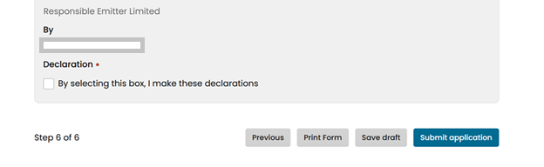
Once you are satisfied that all details are correct, scroll to the declaration section. Here, you must confirm your agreement by selecting the checkbox that states: ‘By selecting this box, I make these declarations.’ This confirms that you have reviewed the application and are authorised to submit it on behalf of the responsible emitter.

After ticking the declaration box, click ‘Submit application’ to complete the form.

Receipt of surrender request
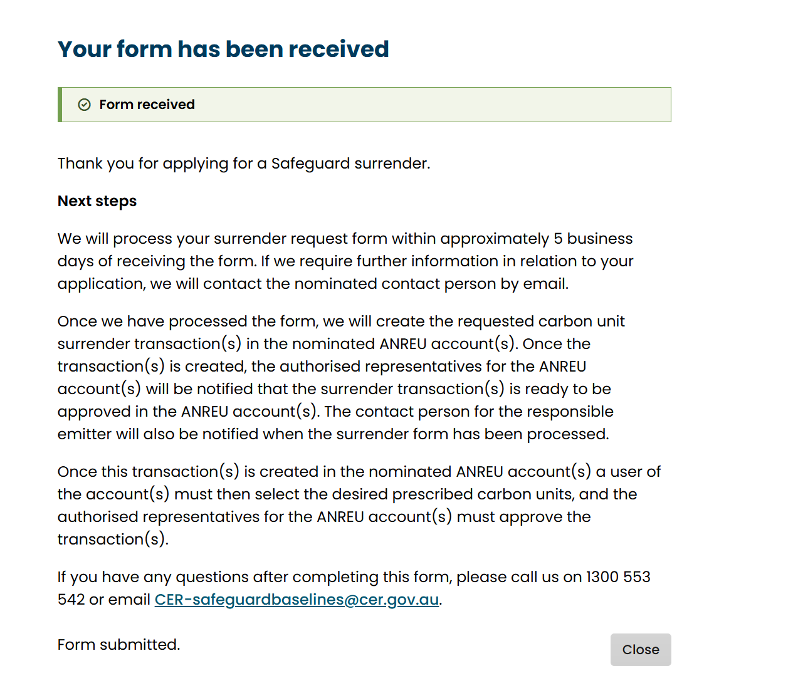
The CER will review and process your surrender request within approximately five business days. If additional information is required, the nominated contact person will be contacted via email.
The contact person will be notified when the surrender form has been processed.
If you have any questions after submission, you can contact the safeguard section via the phone number or email provided on the confirmation page.
This concludes the online form submission process.

3. Initiate surrender transaction in the Unit and Certificate Registry
After receiving and processing the Safeguard Carbon Units Surrender Request form, the CER will create the surrender transaction in the nominated ANREU account. At this point, the authorised representatives for the ANREU account will be notified that the transaction is ready in the Unit and Certificate Registry.
To finalise the surrender, you and/or other users authorised to act on behalf of the responsible emitter must use the Unit and Certificate Registry o:
- initiate the surrender transaction, and
- approve the surrender transaction.
Your surrender will not be finalised, and the facility’s net emissions number will not be reduced, until these steps are completed in the Unit and Certificate Registry.
General information is available in our Unit and Certificate Registry guidance.

Navigate to Safeguard surrender in the Unit and Certificate Registry
After logging into the Unit and Certificate Registry and selecting the correct trading account, go to the left-hand navigation menu and click ‘Safeguard surrender’. Your new surrender should display with ‘Pending’ status.

Begin the Surrender Transaction
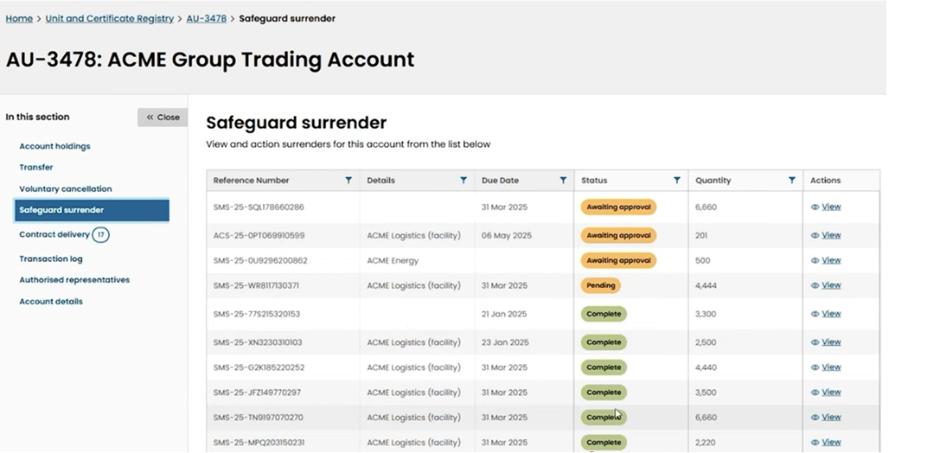

The ‘Surrender details’ page provides a summary of the surrender transaction.

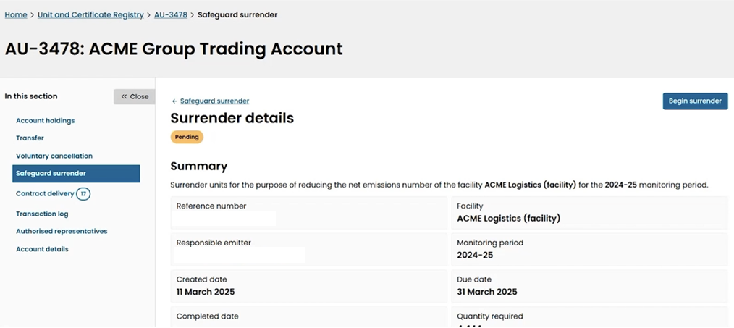

To proceed, click the ‘Begin surrender’ button in the top-right corner of the page. This will take you to the next screen where you can select ACCUs and/or SMCs from your ANREU account holdings to surrender.
Select units for surrender
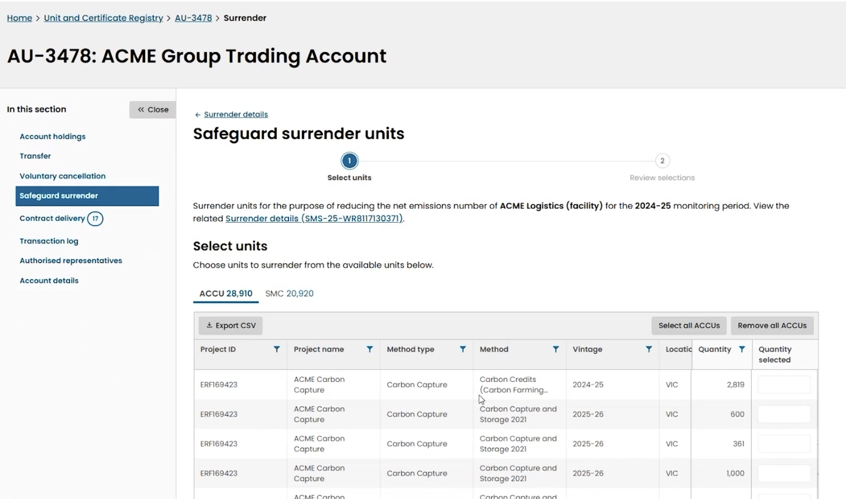

The ‘Safeguard surrender units’ page allows you to choose which ACCUs and/or SMCs to surrender for the selected facility and monitoring period.
Review the table and identify the number of units you want to surrender from each unit block by entering the quantity to surrender in the relevant row.
Use the buttons at the top of the table to toggle between viewing ACCUs and SMCs. You can select both ACCUs and SMCs within the same surrender transaction.
In the ‘Quantity selected’ column, type the amount you wish to surrender from each unit block. For example, if the required amount is 4,444 units, you might select 2,000 units from one unit block and the remainder from another. As you enter quantities, the summary at the bottom updates to show the total selected against the quantity specified by the responsible emitter in the Surrender Request form for the surrender transaction (displayed as ‘Quantity required’). Continue adjusting until the total equals the ‘Quantity required’.
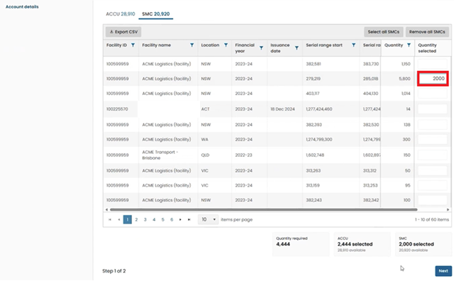
The system will display an alert and will not permit surrenders which total more or less than the ‘Quantity required’.
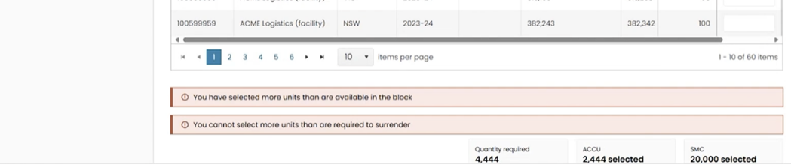
Once the correct quantity of units has been selected, click ‘Next’.

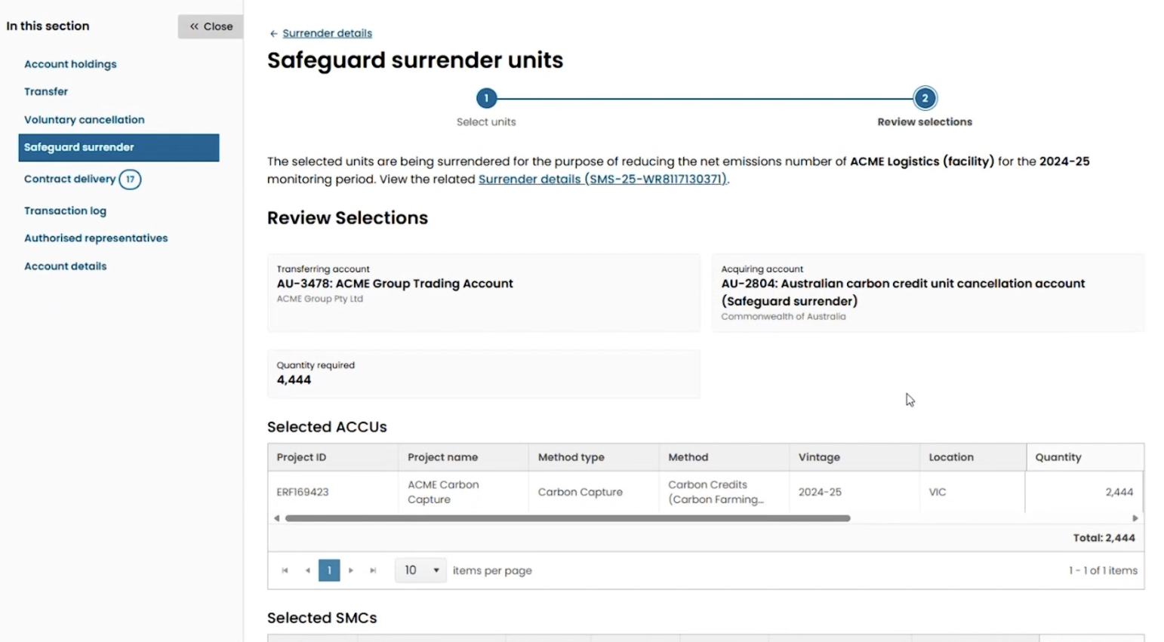
Review selections
The ‘Review selections’ page provides a summary of the surrender transaction to confirm before initiating. At the top, you can see the facility name, monitoring period, transferring account (your trading account) and acquiring account, which is the ‘Australian carbon credit unit cancellation account (Safeguard surrender)’. This confirms that the units you select will be surrendered and permanently cancelled to reduce the net emissions number for the displayed facility and monitoring period.
You can add comments to other users at the bottom of the page before you initiate the surrender. This may be useful if the approver for the surrender transaction is another individual.
If all details are correct, click ‘Initiate Surrender’. This will not finalise your surrender. The surrender must now be approved.
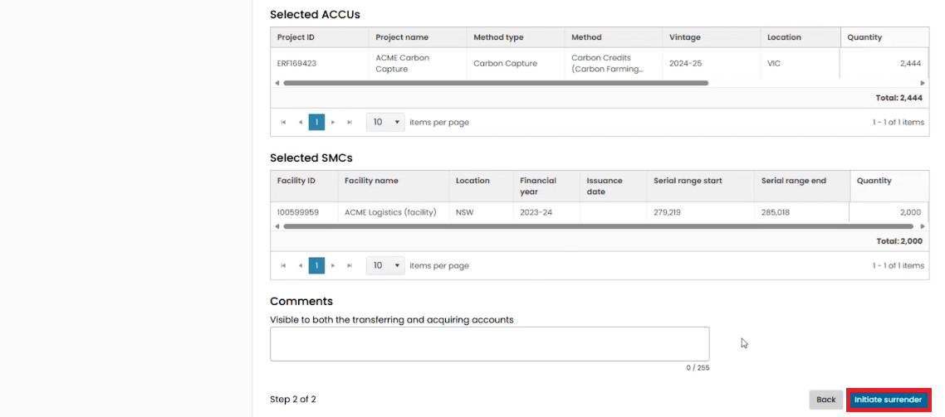

Transaction awaiting approval
Once you have initiated the surrender transaction, all authorised representatives for the ANREU account are notified.
The transaction status will display as ‘Awaiting approval’ in your Online Services account.
At this stage, the surrender is not yet complete. An authorised representative with approver permissions must log in to the Unit and Certificate Registry, review the transaction details, and finalise the approval.

4. Finalise the surrender in the Unit and Certificate Registry

Navigate to Safeguard surrender
Log into the Unit and Certificate Registry to approve the transaction. From the left-hand menu, select ‘Safeguard surrender’ and select the transaction. The transaction status should be listed as ‘Awaiting approval’.

Review transaction details and approve
Select the ‘Review surrender’ button in the top right.
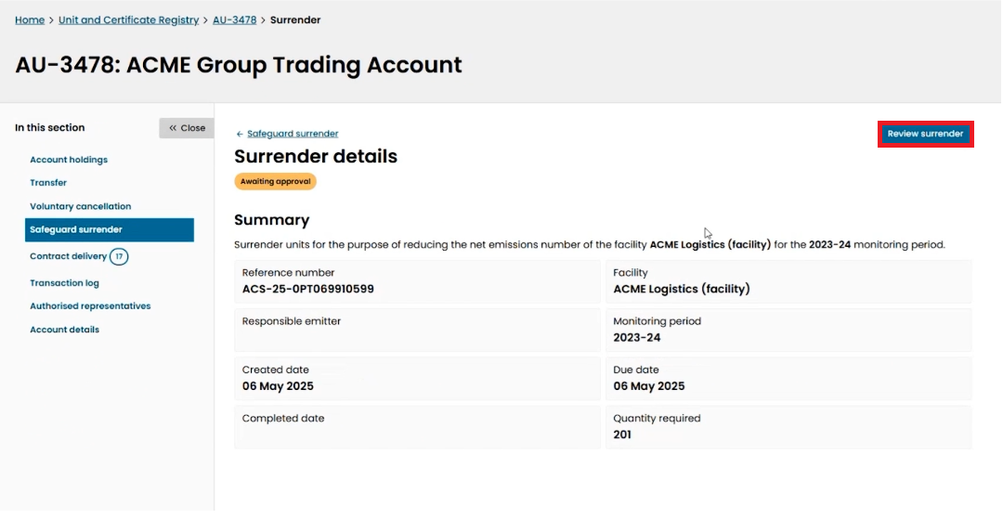
The ‘Surrender details’ page confirms that the surrender is awaiting approval and provides the details of the surrender.
You can add comments to other users at the bottom of the page before approving the surrender.
If the details are correct, select the ‘Approve surrender’ button on the bottom right.
Selecting the ‘Approve surrender’ button will finalise your surrender. This will cause the net emissions number for the selected facility to be reduced for the selected monitoring period by the number of surrendered units (except if a 30% ACCU surrender explanation is required and still outstanding, in which case the net emissions number will not be reduced until that explanation is provided).
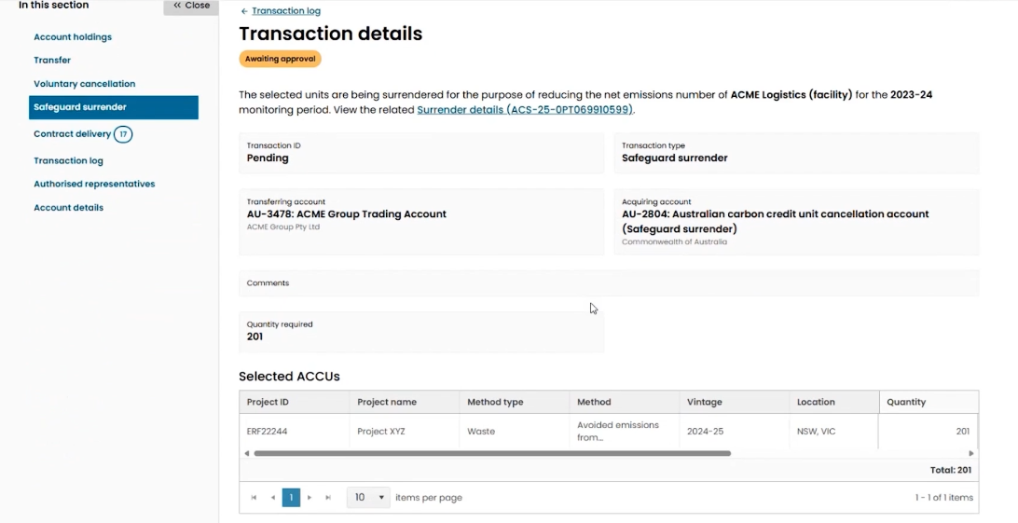
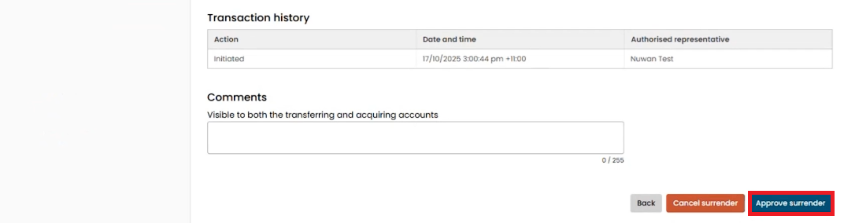

Surrender transaction completed
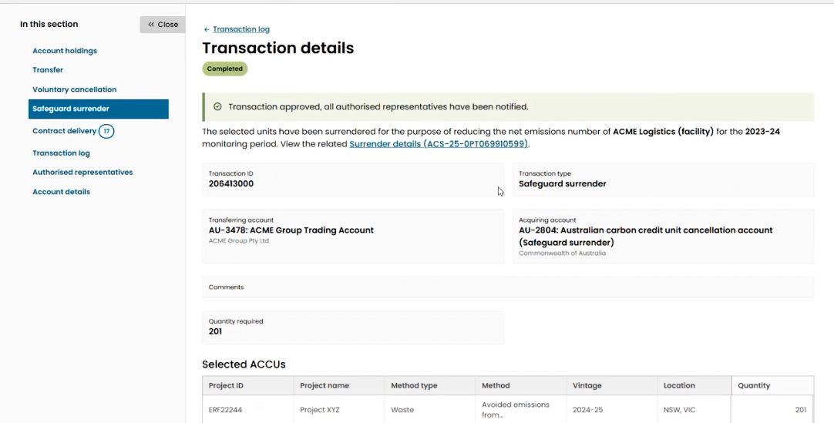

Once a surrender transaction is complete:
- A record of the completed transaction will be available in the ANREU account.
- The responsible emitter for the facility will be able to view the draft and completed surrender transactions on the facility’s carbon units page in Online Services.
- A new position statement will be available in the responsible emitter’s Online Services account within 5 business days.
- An email will be sent to the contact person for the responsible emitter when the new position statement is available.

https://cer.gov.au/online-systems#online-services
https://cer.gov.au/online-systems/new-unit-and-certificate-registry
https://cer.gov.au/document_page/safeguard-mechanism-credit-unit-issuance-and-carbon-unit-surrender-guideline
https://cer.gov.au/document_page/safeguard-online-services-user-guide
https://cer.gov.au/online-systems/new-unit-and-certificate-registry/unit-and-certificate-registry-guidance
https://cer.gov.au/document_page/accessing-submissions-online-services-guide
https://cer.gov.au/document_page/safeguard-online-services-user-guide
https://cer.gov.au/online-systems/new-unit-and-certificate-registry/unit-and-certificate-registry-guidance

