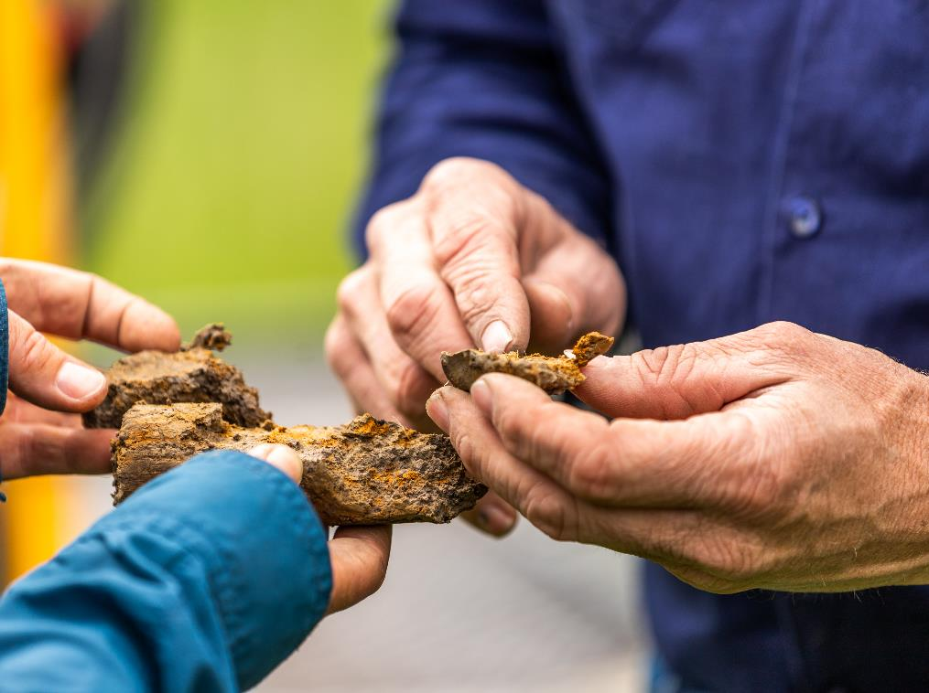

**High emissions facility audit report template**

Version 1 - July 2024

## Disclaimer

This template sets out how the Clean Energy Regulator (CER) expects an assurance engagement report to be structured for an audit of a facility with high emissions[1] as required under section 78A of the National Greenhouse and Energy Reporting (Safeguard Mechanism) Rule *2015* (the Safeguard Rule).

It is the responsibility of auditors to ensure their audit reports meet legislative requirements.

Where text is included within brackets, for example [audited body], information **must** be provided in line with the suggested text.

Some parts of the template are conditional on whether the responsible emitter is required to provide a report under section 19, 22G, 22X or 22XB of the *National Greenhouse and Energy Reporting Act 2007* (the NGER Act). These parts are marked in brackets as **[Delete if not applicable]**. The auditor will need to ensure that the audit report includes all specified information.

The audit must be conducted in accordance with the relevant requirements for assurance engagements under:

* ASQM 1 Quality Management for Firms that Perform Audits or Reviews of Financial Reports and Other Financial Information, or Other Assurance or Related Services Engagements (ASQM 1) and ASQM 2 Engagement Quality Reviews (ASQM 2).
* the National Greenhouse and Energy Reporting (Audit) Determination 2009 (NGER Audit Determination)
* relevant national and international audit standards, including:
  + ASAE 3000 *Assurance Engagements Other than Audits of Reviews of Historical Financial Information*
  + ASAE 3100 *Compliance Engagements*
  + ASAE 3410 *Assurance Engagements on Greenhouse Gas Statements*
* Please note, only some components of ASAE 3410 will be relevant. Auditors should use these standards as guidance.

This coversheet requires auditors to disclose both audit and non-audit fees, as well as the hours spent on the audit by the audit team. Please refer to 5.7.1 of the [Audit determination handbook](https://www.cleanenergyregulator.gov.au/Infohub/Audits/forms-and-resources/audit-determination-handbook) for more information on fee disclosure.

Refer to Division 3.4 of the [NGER Audit Determination](https://www.legislation.gov.au/Series/F2010L00053) for further information on the legislative requirements for reporting an assurance engagement.

**Main features of safeguard mechanism audits**

The table below outlines the main features of audits under the safeguard mechanism.

|  |  |
| --- | --- |
| Legislation or guidance | [National Greenhouse and Energy Reporting (Safeguard Mechanism) Rule 2015](https://www.legislation.gov.au/F2015L01637/latest/text) (Safeguard Rule)  [National Greenhouse and Energy Reporting Act 2007](https://www.legislation.gov.au/C2007A00175/latest/text)(NGER Act)  [National Greenhouse and Energy Reporting Regulations 2008](https://www.legislation.gov.au/Details/F2023C00558) (NGER Regulations)  [National Greenhouse and Energy Reporting (Audit) Determination 2009](https://www.legislation.gov.au/Details/F2017C00509) (Audit Determination)  Applicable standards:   * ASAE 3000 *Assurance Engagements other than Audits or Reviews of Historical Financial Information* * ASAE 3100 *Compliance Engagements* * ASAE 3450 *Assurance Engagements involving Corporate Fundraisings and/or Prospective Financial Information* * ASQM 1 *Quality management for Firms that Perform Audits and Reviews of Financial Reports and Other Financial Information, and Other Assurance Engagements* * ASQM 2 *Engagement quality reviews* |
| Nature of engagement | Reasonable assurance engagement conducted over high emissions facilities in accordance with the Safeguard Rule and Audit Determination. |
| Assurance practitioner | The audit team leader must be a Category 2 registered greenhouse and energy auditor.  Other members of the audit team do not need to be registered. However, the NGER Regulations do contain requirements for other members of an audit team. |

## Type of audit

|  |  |  |
| --- | --- | --- |
|  | Subject matter | Criteria |
| Emissions intensity determination audits | **Reasonable assurance conclusion for amounts exceeding 1 Mt CO2-e**  The matters to be audited and covered by the audit report are whether, in all material respects:   * the quantities specified in the [audited body’s] regulatory report that relate to the following are correct:   + covered emissions of greenhouse gases from the operation of those facilities;   + production variables for those facilities; * (if the regulatory report was under section 19 of the NGER Act)—the [audited body’s] compliance with section 22 of the NGER Act (about record-keeping) in relation to the financial year and so much of the report as relates to facilities to which section 74AA(1)(b) of the NGER Act applies; or * (if the regulatory report was under section 22G of the NGER Act) —the [audited body’s] compliance with section 22H of the NGER Act (about record-keeping) in relation to the financial year; or * (if the regulatory report was under section 22X of the NGER Act)—the [audited body’s] compliance with section 22XA of the NGER Act (about record-keeping) in relation to the financial year; or * (if the regulatory report was under section 22XB of the NGER Act)—the [audited body’s] compliance with section 22XC of the NGER Act (about record-keeping) in relation to the financial year. | Section 78A of the Safeguard Rule. |

## Key risk area guidance

The table below sets out the key risk areas that the CER expects auditors will consider as part of their audit of a high emissions facility. The table does not provide an exhaustive listing of risks auditors are expected to address. It focuses on what the CER believes are key risks that should be addressed as part of audit procedures.

The CER expects auditors to use their professional judgement in determining what risks they are to address in conducting audits and what procedures they will conduct to address these risks. This may entail auditors addressing risks not included in this and other guidance from the CER.

|  |  |
| --- | --- |
| Key Risk Area | Description |
| Operational control and defining the corporate reporting boundary | It is expected that auditors will review the procedures used in determining the facility boundaries. Auditors should also review the procedures used to determine operational control and the responsible emitter of the facility.  These determinations must meet the requirements listed within the NGER Regulations 2008.  Records of these determinations must be retained to meet record keeping requirements and should be reviewed to ensure that they are still current. |
| All relevant items included in NGER report under the facility | Auditors must ensure that all activities which are carried out at the facility are appropriately included in the NGER report. |
| Measurement methodology correctly applied | Auditors must ensure that emissions have been calculated according to the NGER Measurement Determination 2008.  All methodologies which have been used to calculate emissions included in an annual NGER report should also be checked to ensure compliance with the relevant methodology. |
| Record keeping | It is expected that auditors will review company record keeping protocols and fraud prevention systems. |
| Metric of production variable is met | Auditors need to ensure that the quantity which is included in an NGER report for the purpose of the Safeguard Mechanism has been measured consistently with the metric/methodology which is established in Schedule 1 and the Safeguard Mechanism Document, along with relevant measurement methods included in the NGER Measurement Determination 2008. |

# Safeguard mechanism audit report for a high emissions facility

## Audit report coversheet

### Audited body (the applicant)

|  |  |
| --- | --- |
| Name of audited body |  |
| ABN of audited body |  |
| Name of contact person for audited body |  |
| Contact person phone number |  |
| Contact person email address |  |

### Audit description

|  |  |
| --- | --- |
| Kind of audit | Reasonable assurance engagement under section 78A of the *National Greenhouse and Energy Reporting (Safeguard Mechanism) Rule 2015* (the Safeguard Rule). |
| Objective of the assurance engagement | Assurance on the [audited body’s] regulatory report for the high emission facility under the Safeguard Rule. |
| Audit fee *(inclusive of GST and disbursements)* |  |
| Total hours spent on the audit by audit team |  |
| Fees paid:   * by the audited body to the audit team leader (or their firm or company), * for services and activities provided by the audit team leader (or his or her firm or company, or by another person or firm on the audit team leader’s behalf) other than services or activities under Part 6 of the [National Greenhouse and Energy Reporting Regulations 2008](http://www.comlaw.gov.au/Series/F2008L02230) ([NGER Regulations](http://www.comlaw.gov.au/Series/F2008L02230));   from the date 12 months prior to the date of signing the terms of engagement for the audit, to the date of signing the audit report. |  |
| If any fees for non-Part 6 services or activities are described above, why did the provision of non-Part 6 services or activities not result in a conflict of interest situation (as that term is defined the NGER Regulations)?  (write *not applicable* if no non-audit fees were paid to the audit firm) |  |
| Reporting period covered by audit |  |
| Date terms of engagement signed |  |
| Date audit report signed |  |

### Auditor details

|  |  |
| --- | --- |
| Name of audit team leader |  |
| Greenhouse and energy auditor registration number |  |
| Organisation |  |
| Phone number |  |
| Address |  |
| Names and contact details of other audit team members |  |
| Details of any exemption granted under regulation 6.71 of the [NGER Regulations](http://www.comlaw.gov.au/Series/F2008L02230) in relation to this audit for the audit team leader or professional member of the audit team.  This must include:   * The details of the exemption (including but not limited to the basis for the exemption);   Additionally, for an exemption granted for a conflict of interest situation:   * details of the procedures for managing the conflict of interest put in place by the audit team leader so that the CER is satisfied that the audit findings will not be affected by that conflict.   (write *not applicable* if no exemption was granted under regulation 6.71 of the [NGER Regulations](http://www.comlaw.gov.au/Series/F2008L02230)) |  |

### Peer reviewer details

|  |  |
| --- | --- |
| Name of peer reviewer |  |
| Organisation |  |
| Phone number |  |
| Address |  |

## Part A — Auditor’s report

To [Directors]

We have conducted a reasonable engagement, being an audit pursuant to section 78A of the *National Greenhouse and Energy Reporting (Safeguard Mechanism) Rule 2015* (the Safeguard Rule) of [audited body’s] the regulatory report for the high emissions facility, to conclude whether, in all material respects:

* the quantities specified in [audited body’s] regulatory report that relate to the following are correct:
  + covered emissions of greenhouse gases from the operation of those facilities;
  + production variables for those facilities;
* (if the regulatory report was under section 19 of the NGER Act)—the [audited body’s] compliance with section 22 of the NGER Act (about record-keeping) in relation to the financial year and so much of the report as relates to facilities to which section 74AA(1)(b) of the NGER Act applies **[Delete if not applicable]**; or
* (if the regulatory report was under section 22G of the NGER Act) —the person’s [audited body’s] compliance with section 22H of the NGER Act (about record-keeping) in relation to the financial year **[Delete if not applicable]**; or
* (if the regulatory report was under section 22X of the NGER Act)—the [audited body’s] compliance with section 22XA of the NGER Act (about record-keeping) in relation to the financial year **[Delete if not applicable]**; or
* (if the regulatory report was under section 22XB of the NGER Act)—the [audited body’s] compliance with section 22XC of the NGER Act (about record-keeping) in relation to the financial year. **[Delete if not applicable]**.

### Details of audited body

|  |  |
| --- | --- |
| Name of audited body |  |
| Address |  |
| ABN |  |

|  |  |
| --- | --- |
| Facility name | [insert site name] |

### Responsibility of [audited body’s] management

The management of [audited body] is responsible for the preparation and fair presentation of the regulatory report for the high emission facility in accordance with the Safeguard Rule, and [audited body’s] compliance with the *National Greenhouse and Energy Reporting Act 2007* (NGER Act), and the Safeguard Rule

The management of [audited body] is responsible for the interpretation and application of the requirements of the Safeguard Rule.

This responsibility includes:

* establishing and maintaining internal controls relevant to the preparation and presentation of the application to ensure that it is free from material misstatement, whether due to fraud or error,
* selecting and applying measurement methods to prepare and present the data, and
* making estimates that are reasonable in the circumstances.

### Our independence and quality control

We have complied with the relevant ethical requirements relating to assurance engagements, which include independence and other requirements founded on fundamental principles of integrity, objectivity, professional competence, due care, confidentiality and professional behaviour. This includes all of the requirements defined in the *National Greenhouse and Energy Reporting Regulations 2008* (the NGER Regulations) regarding the code of conduct, independence and quality control.

Furthermore, we have complied with the Australian Standards on *Quality management for Firms that Perform Audits and Reviews of Financial Reports and Other Financial Information, and Other Assurance Engagements* (ASQM 1) and *Engagement quality reviews* (ASQM2). [Name of assurance practitioner’s firm] maintains a comprehensive system of quality control including documented policies and procedures regarding compliance with ethical requirements, professional standards and applicable legal and regulatory requirements.

### Our responsibility

Our responsibility is to express a conclusion on whether the audited elements of the regulatory report (as described above) have been prepared, in all material aspects, in compliance with the requirements of the Safeguard Rule and measurement policies adopted and disclosed in the application.

The CER conducted our assurance engagement in accordance with the *National Greenhouse and Energy Reporting (Audit) Determination 2009* (the NGER Audit Determination) and relevant national and international standards, as listed below. The NGER Audit Determination and relevant Auditing and Assurance Standards Board require that the CER complies with relevant ethical requirements and plan and perform the assurance engagement to obtain reasonable assurance as to whether the subject matter is free from material misstatement.

[List any audit standard used in undertaking the assurance engagement.]

Our procedures were designed to obtain a reasonable level of assurance on which to base our conclusion. An assurance engagement involves performing procedures to obtain evidence about the matter being audited.

The procedures selected depend on the audit team leader’s judgement, including the assessment of the risks of material misstatement or material non-compliance of the matter being audited, whether due to fraud or error. In making those risk assessments, we consider internal controls relevant to [audited body’s] determination of the amounts and disclosures in the matter being audited in order to design assurance procedures that are appropriate in the circumstances; but not for the purpose of expressing an opinion on the effectiveness of [audited body’s] internal controls.

An assurance engagement also includes evaluating the reasonableness of estimates made by management of the company, and evaluating the overall presentation of the application by management of the company.

The CER believes that the assurance evidence it has obtained is sufficient and appropriate to provide a basis for our assurance conclusion.

### Summary of procedures undertaken

Our procedures included the following:

[Insert a summary of procedures undertaken. You must include a comprehensive list of procedures you and your audit team have undertaken in completing this engagement. More detailed procedures can be included in Part B of the audit report.]

### Use of our reasonable assurance engagement report

This report is intended solely for the use of [audited body], the CER [and intended users identified in the terms of the engagement] for the purpose of reporting on [audited body’s] regulatory report for the high emission facility. Accordingly, we expressly disclaim and do not accept any responsibility or liability to any party other than [audited body], the CER and [names of intended users] for any consequences of reliance on this report for any purpose.

### Inherent limitations

There are inherent limitations in performing assurance—for example, assurance engagements are based on selective testing of the information being examined. Because of this, it is possible that fraud, error or non‑compliance might occur and not be detected. An assurance engagement is not designed to detect all instances of non-compliance with the NGER Act and safeguard legislation, because such an engagement is not performed continuously throughout the period being examined, and because the procedures performed in respect of compliance with NGER Act and safeguard legislation are undertaken on a test basis. The conclusion expressed in this report has been formed on the above basis.

**[Include if conclusion is modified]** Basis for [qualified/adverse/disclaimer] conclusion

[Insert basis for modification to the auditor’s report.]

### Our conclusion

[Insert conclusion as appropriate, referring to section 3.17 of the NGER Audit Determination]

### Reasonable assurance conclusion

In our opinion, in all material respects:

* the quantities specified in [audited body’s] regulatory report that relate to the following are correct:
  + covered emissions of greenhouse gases from the operation of those facilities;
  + production variables for those facilities;
* (if the regulatory report was under section 19 of the NGER Act)—the person’s (or name of the reporter) compliance with section 22 of the NGER Act (about record-keeping) in relation to the financial year and so much of the report as relates to facilities to which section 74AA(1)(b) of the NGER Act applies **[Delete if not applicable]**; or
* (if the regulatory report was under section 22G of the NGER Act) —the person’s (or name of the reporter) compliance with section 22H of the NGER Act (about record-keeping) in relation to the financial year **[Delete if not applicable]**; or
* (if the regulatory report was under section 22X of the NGER Act)—the person’s compliance with section 22XA of the NGER Act (about record-keeping) in relation to the financial year **[Delete if not applicable]**; or
* (if the regulatory report was under section 22XB of the NGER Act)—the person’s compliance with section 22XC of the NGER Act (about record-keeping) in relation to the financial year **[Delete if not applicable]**.

*[Signature—of audit team leader]*

*[Name—of audit team leader]*

*[Firm]*

*[Location]*

*[Date]*

## Part B — Detailed findings

[Section 5.7.3 of the [Audit determination handbook](https://www.cleanenergyregulator.gov.au/Infohub/Audits/forms-and-resources/audit-determination-handbook) provides detailed advice on how to fill out Part B of the audit report.]

As required under section 3.23 of the NGER Audit Determination, audit team leaders must outline the following:

*[If no entry is needed, indicate that it is not applicable]*

1. Items or issues requiring particular attention

|  |  |
| --- | --- |
| Response: |  |

1. Aspects that particularly impacted on carrying out of assurance engagement

|  |  |
| --- | --- |
| Response: |  |

1. Details of any contraventions of the National Greenhouse and Energy Reporting (Safeguard Mechanism) Rule 2015, *National Greenhouse and Energy Reporting Act 2007*, National Greenhouse and Energy Reporting Regulations 2008, National Greenhouse and Energy Reporting (Audit) Determination 2009 or the associated provisions

|  |  |
| --- | --- |
| Response: |  |

1. Matters corrected during the course of the audit

|  |  |
| --- | --- |
| Issue A: |  |
| Issue B: |  |
| Issue C: |  |

1. Other matters

|  |  |
| --- | --- |
| Response: |  |

### Audit findings and conclusions table

|  |  |  |  |
| --- | --- | --- | --- |
| Risk area investigated  *[as outlined in the audit plan]* | Testing conducted | Findings | Conclusion |
| Issue A | *[Provide a description of the audit procedures carried out to audit this item of the scope]* | *[Provide a description of the audit finding. The auditor should include a summary of the process/figures audited and whether any material misstatements were identified]* | *[Insert conclusions against the issue/risk area]* |
| Issue B |  |  |  |
| Issue C |  |  |  |

### Peer reviewer conclusion

|  |  |
| --- | --- |
| Name of the peer reviewer |  |
| Peer reviewer’s credentials |  |
| Peer reviewer contact details |  |
| Outcome of the evaluation undertaken by the peer reviewer |  |

*[Signature—of audit team leader]*

*[Name—of audit team leader]*

*[Firm]*

*[Location]*

*[Date]*

1. For the purposes of this template a facility with high emissions is defined under 78A(1) of the Safeguard Rule as a facility with covered emissions exceeding 1 million tonnes of carbon dioxide equivalence for a financial year.