# Reporting transfer certificate guideline

Version 2.0 – 27 November 2024

# Contents

Contents 2

1. Disclaimer 3

2. Introduction 4

3. Criteria that must be met before an RTC can be issued 4

3.1 The reporting transfer test 4

3.2 Establishing that the applicant has financial control over a facility 4

3.3 Other criteria 5

4. Applying for an RTC 5

4.1 Consents and statements 5

4.2 Shared responsibility 6

4.3 External administration 6

4.4 Timeframes for granting an RTC 6

4.5 Refusal of applications 6

5. When an RTC is issued 7

5.1 Start date of an RTC 7

5.2 Start date 7

5.3 Validity of RTCs 7

5.4 Registration of an RTC holder 7

6. Reporting obligations for RTC holders 7

7. Record keeping 14

8. Surrendering or cancelling an RTC 14

8.1 Surrendering an RTC 14

8.2 Cancelling an RTC 14

9. Further information 15

# 1. Disclaimer

Thisguideline has been developed by the Clean Energy Regulator (CER) to assist entities to comply with their reporting obligations under the [*National Greenhouse and Energy Reporting Act 2007*](https://www.legislation.gov.au/C2007A00175/latest/text)[1](NGER Act)and associated legislation.

This guideline should be read in conjunction with the NGER Act, [National Greenhouse and Energy Regulations 2008](https://www.legislation.gov.au/F2008L02230/latest/text)[2] (NGER Regulations), and [National Greenhouse and Energy Reporting (Measurement) Determination 2008](https://www.legislation.gov.au/F2008L02309/latest/text)[3] (NGER Measurement Determination), as in force for this reporting period. These laws and their interpretation are subject to change, which may affect the accuracy of the information contained in the guideline.

The guidance provided in this document is not exhaustive, nor does it consider all circumstances applicable to all entities. This guidance is not intended to comprehensively deal with its subject area, and it is not a substitute for independent legal advice. Although entities are not bound to follow the guidance provided in this document, they must ensure they meet their obligations under the [National Greenhouse and Energy Reporting (NGER) scheme](https://cer.gov.au/schemes/national-greenhouse-and-energy-reporting-scheme)[4] at all times. The CER encourages all users of this guidance to seek independent legal advice before taking any action or decision on the basis of this guidance.

The CER and the Australian Government will not be liable for any loss or damage from any cause (including negligence) whether arising directly, incidentally or as consequential loss, out of or in connection with, any use of this guideline or reliance on it, for any purpose.

If an entity chooses to meet their obligations under the NGER scheme in a manner that is inconsistent with the guidance provided in this document, the CER, or an independent auditor, may require the entity to demonstrate that they are compliant with requirements of the NGER Act, NGER Regulations, and/or the NGER Measurement Determination. Entities are responsible for determining their obligations under the law and for applying the law to their individual circumstances.

# 2. Introduction

Reporting Transfer Certificates (RTCs) allow a corporation with operational control over a facility to transfer NGER reporting obligations to the corporation that has financial control over the facility.

RTCs relate to a specific facility. If a corporation wishes to take on reporting obligations for a number of facilities over which it has financial control, it will need to obtain an RTC for each facility.

The corporation with financial control must apply for the RTC using the application for a reporting transfer certificate form.

## 3. Criteria that must be met before an RTC can be issued

### 3.1 The reporting transfer test

To be eligible for an RTC, the corporation with financial control over a facility, or applicant, must first pass the reporting transfer test set out in Section 22J of the NGER Act:

* the facility must be under the operational control of another corporation
* the applicant must have financial control over the facility
* the applicant must be a company registered under Part 2A.2 of the *Corporations Act 2001*
* the applicant must be a constitutional corporation
* the corporation with operational control over the facility must be a member of a controlling corporation’s group, but **not** the applicant’s corporate group

### 3.2 Establishing that the applicant has financial control over a facility

The applicant must have financial control over a facility to receive an RTC for it. In the application, evidence must be provided to show how the applicant fulfills at least **one** situation of having financial control of the facility, as set out in Section 22R of the NGER Act. The applicant is:

* by itself or together with one or more other corporations, and the corporation with operational control of the facility are parties to a contract which specifies that the corporation with operational control operates the facility on behalf of the applicant (and the other party or parties to the contract, where applicable).
* able to control the trading or financial relationships of the corporation with operational control of the facility
* the economic beneficiary from the facility
* a participant in a joint venture with one other participant where:
  + the participants share the economic benefits from the facility
  + the applicant’s share equals or exceeds the other participant’s share.
* a participant in a joint venture with two or more other participants where:
  + the participants share the economic benefits from the facility
  + no other participant’s share exceeds the applicant’s share.
* in a partnership with one other partner where:
  + the partners share the economic benefits from the facility
  + the applicant’s share equals or exceeds the other partner’s share.
* in a partnership with two or more other partners where:
  + the partners share the economic benefits from the facility
  + no other partner’s share exceeds the applicant’s share
* able to direct or sell the output of the facility.

In some cases, there will be more than one corporation that could meet one or more of the abovecriteria for the same facility, and the applicant itself may meet more than one of the criteria.

Financial control for the purposes of the NGER Act means a corporation has significant ability to control a facility through financial means only, and therefore make possible decisions relating to greenhouse gas emissions reductions.

### 3.3 Other criteria

In addition to establishing that an applicant passes the reporting transfer test, the Clean Energy Regulator must also be satisfied that both of the following are true:

* the applicant is able, and is likely to continue to be able to comply with its obligations under the NGER Act for the facility it will hold a RTC for, by having:
  + capacity
  + access to necessary information.
* the operation of the facility during a financial year has caused, or is likely to cause, one of the following:
  + greenhouse gas emissions with a carbon dioxide equivalence of 25 kilotonnes or more
  + production of energy of 100 terajoules or more
  + consumption of energy of 100 terajoules or more.

## 4. Applying for an RTC

The RTC application form and information on how to complete it is available in the [Report emissions and energy[5]](https://cer.gov.au/schemes/national-greenhouse-and-energy-reporting-scheme/report-emissions-and-energy) section of the Clean Energy Regulator website.

### 4.1 Consents and statements

An RTC application must be accompanied by written consents signed by an executive officer of the corporation giving consent.

Written consent must be received from the **applicant’s controlling corporation**, unless the applicant is the controlling corporation of its corporate group.

Written consent must also be provided by **one** of the following:

* the **controlling corporation** of the corporation with operational control
* the **corporation with operational control**, when it is the controlling corporation of its corporate group.

A written statement from the corporation with operational control must also be signed by an executive officer and submitted with the application. This will state the corporation has agreed to give the applicant all information necessary to comply with obligations that will be imposed on it by the NGER Act if the RTC is issued.

Executive officer, in relation to a corporation means:

* a director of the body corporate
* the chief executive officer (however described) of the body corporate
* the chief financial officer (however described) of the body corporate
* the secretary of the body corporate.

### 4.2 Shared responsibility

Where more than one executive fits this category, the corporation should identify the person who has primary responsibility for the discharge of the relevant function under the NGER Act.

### 4.3 External administration

Where a corporation is under external administration within the meaning of the *Corporations Act 2001*, the chief executive officer or equivalent may be the most senior administrator.

### 4.4 Timeframes for granting an RTC

The Clean Energy Regulator must take all reasonable steps to ensure a decision is made on an RTC application within 90 days of receiving the application.

To assist the Clean Energy Regulator’s decision making, we may, by written notice, request an applicant to provide additional information within a period specified in the notice. If the applicant does not provide the information in the time required, the Clean Energy Regulator may refuse to consider the application or refuse to take any action, or any further action, concerning the application.

In the case where additional information is requested, the Clean Energy Regulator must take all reasonable steps to ensure that a decision is made within 90 days of being provided with the additional information.

### 4.5 Refusal of applications

The Clean Energy Regulator must not issue an RTC unless satisfied that the applicant meets the relevant criteria.

## 5. When an RTC is issued

### 5.1 Start date of an RTC

When an application for an RTC is approved by the Clean Energy Regulator, the applicant will be issued with an RTC. The RTC will take effect on the day specified on the certificate, unless the application nominates an alternative start date.

Where an RTC is issued part-way through a financial year, part-year reporting obligations will apply. These obligations arise regardless of whether a start date is or is not provided. This means that the corporation with operational control over the facility will be required to report on the facility for the period before the RTC was issued and the RTC holder will report on the facility for the period when they held the RTC.

### Where a start date is nominated, the application must also include written consent regarding the start day, from the same corporations outlined in section 4.1 Consents and statements.

### 5.2 Start date

The nominated start date of an RTC may be earlier than the day on which the RTC is issued, provided that the start date occurs in either:

* the same financial year as the day on which the RTC is issued
* the financial year immediately preceding the financial year in which the RTC is issued.

The nominated start date may be later than the day on which the RTC is issued, provided that the start date occurs in either:

* the same financial year as the day on which the RTC is issued
* the next financial year.

### 5.3 Validity of RTCs

An RTC remains in force indefinitely, unless surrendered by the holder of the RTC or cancelled by the Clean Energy Regulator.

RTCs cannot be transferred to other parties.

### 5.4 Registration of an RTC holder

If an RTC holder is not already registered under the NGER Act, the Clean Energy Regulator will register the RTC holder and will enter its name on the National Greenhouse and Energy Register when the RTC is issued. The RTC holder does not have to separately apply for registration under the NGER Act.

Once registered, the RTC holder must provide annual emissions and energy reports to the Clean Energy Regulator.

## 6. Reporting obligations for RTC holders

An RTC holder is required to report on the facility under section 22G of the NGER Act. This relates to scope 1 and scope 2 greenhouse gas emissions, energy production and energy consumption from the operation of the facility during the period the RTC is in place in a financial year. This report is due by 31 October following the end of each financial year, or part of a financial year, in which the RTC is in place.

An RTC holder must provide the required data for an RTC facility, regardless of whether that facility reached any of the facility thresholds set out in section 13 of the NGER Act. However, data totals will only be published by the Clean Energy Regulator if the facility reaches a section 13 facility threshold.

Greenhouse gas emissions, energy production and energy consumption from the operation of the facility do not count towards the NGER Act section 13 threshold assessments and section 19 reporting obligations of:

* the controlling corporation of the RTC holder
* the RTC holder itself if it is a controlling corporation
* the controlling corporation of the corporation with operational control over the facility, for the days that the RTC is in place.

|  |
| --- |
| Example 1— Before the issue of an RTC Group Members 1 and 2 are members of different corporate groups. Group Member 1 is contracted by Group Member 2 to operate Facility 1. Due to the terms of the contract, Group Member 1 has operational control over Facility 1.  Controlling Corporation A would include Facility 1’s total emissions, energy production and energy consumption in its NGER Act Section 19 report. This is because a member of its corporate group has operational control over the facility.  Controlling Corporation B and Group Member 2 have no reporting obligations in relation the facility. |

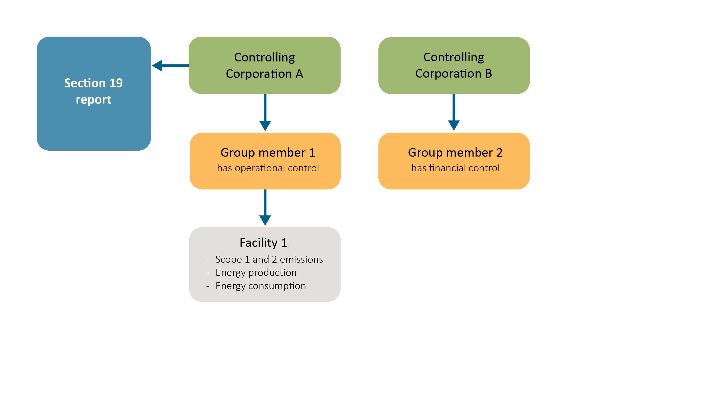

|  |
| --- |
| Example 2— After the issue of an RTC The same circumstances outlined in example 1 exist here. However in this example, Group Member 2 has applied to the Clean Energy Regulator for an RTC for Facility 1.It has financial control over the facility and is in a separate corporate group from the corporation with operational control over the facility. The RTC has been issued.  As a result of the RTC issuance, Group Member 2 will provide a report under Section 22G of the NGER Act which will include Facility 1’s total emissions, energy production and energy consumption.  Controlling Corporation A, Controlling Corporation B, and Group Member 1 have no reporting obligations in relation to Facility 1. |

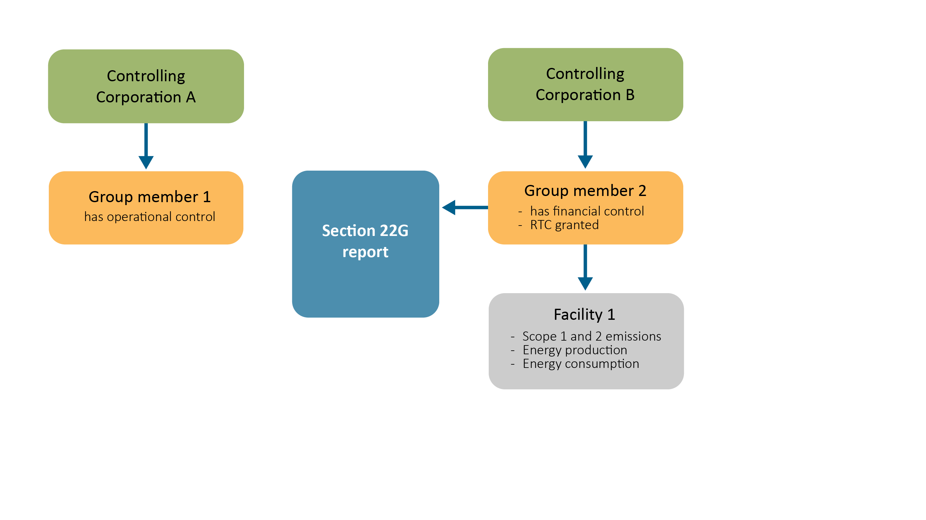

|  |
| --- |
| Example 3 – Before the issue of an RTC: a more complex scenario Group Member 1, a member of Controlling Corporation A’s corporate group, has operational control over Facility 1. Facility 1 has total scope 1 and scope 2 emissions of 26 kilotonnes and total energy consumption of 90 terajoules. It does not produce energy. Therefore, Facility 1 reaches the emissions facility-level threshold under section 13 of the NGER Act.  Controlling Corporation A would include Facility 1’s total emissions, energy production and energy consumption in its NGER Act Section 19 report. This is because a member of its corporate group has operational control over the facility.  Group Member 2, a member of Controlling Corporation B’s corporate group, has financial control over Facility 1. In addition, it has operational control over Facility 2. Facility 2 has total scope 1 and scope 2 emissions of 24 kilotonnes and total energy consumption of 140 terajoules. It does not produce energy. Therefore, Facility 2 reaches the energy consumption facility-level threshold under section 13 of the NGER Act.  Group Member 3, also a member of Controlling Corporation B’s corporate group, has operational control over Facility 3. Facility 3 has total scope 1 and scope 2 emissions of 20 kilotonnes and total energy consumption of 50 terajoules. It does not produce energy. Therefore, Facility 3 does not reach any of the facility-level thresholds under section 13 of the NGER Act  As Facility 2 and 3 together do not meet a corporate group threshold, Controlling Corporation B only includes Facility 2 in its NGER Act section 19 report. |

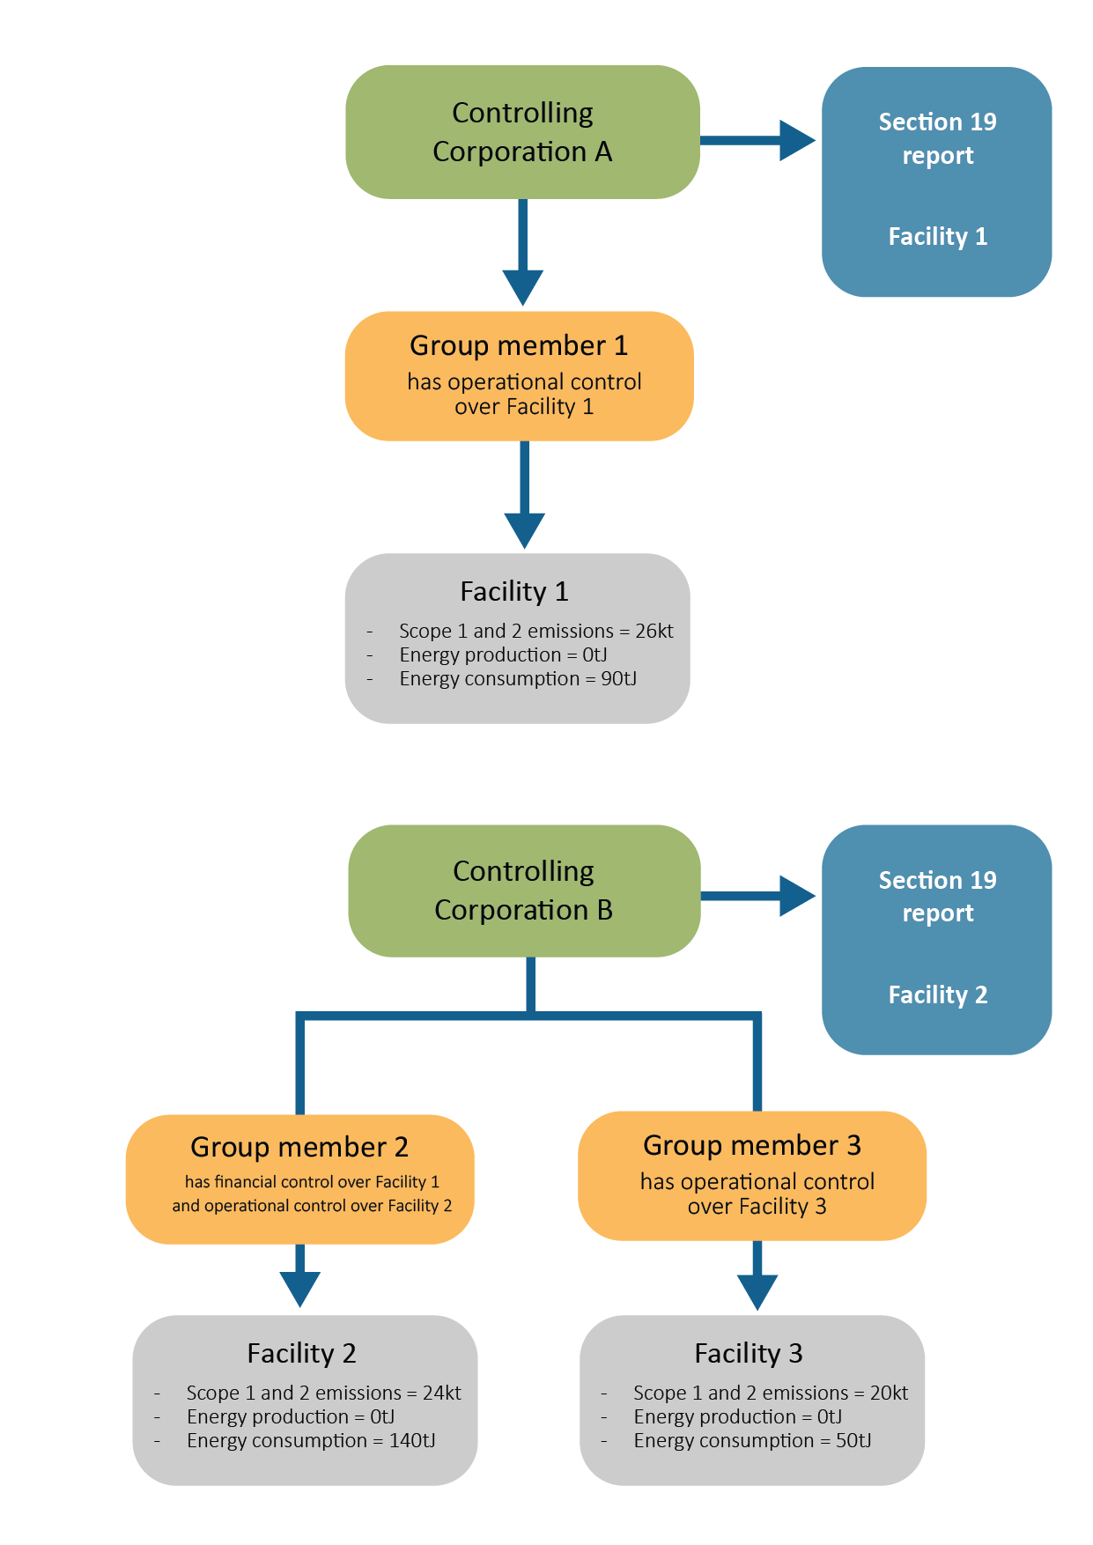

|  |
| --- |
| Example 4 – After the issue of RTC: a more complex scenario The same circumstances outlined in example 3 exist here. However, in this example, Group Member 2 has been issued with an RTC in relation to Facility 1.  As the emissions, energy production and energy consumption from Facility 1 no longer count towards Controlling Corporation A’s section 13 threshold assessments and section 19 reporting obligations, Controlling Corporation A would submit a below threshold section 19 report and could apply for deregistration.  Group Member 2, as the holder of an RTC in relation to Facility 1, would submit a section 22G report on Facility 1’s emissions, energy production and energy consumption.  Controlling Corporation B would continue to provide a section 19 report in relation to Facility 2’s emissions, energy production and energy consumption.  **Note:** the total emissions and energy consumption from Facilities 1, 2 and 3 would mean that Controlling Corporation B’s group would meet the corporate group thresholds for both emissions and energy consumption. However, emissions and energy data from a facility that is the subject of an RTC does not count towards section 13 threshold assessments of either the controlling corporation of the corporation with operational control or the controlling corporation of the RTC holder. As the totals for facilities 2 and 3 are below the corporate report threshold, only facility 2 needs to be reported as it is above the facility threshold. |

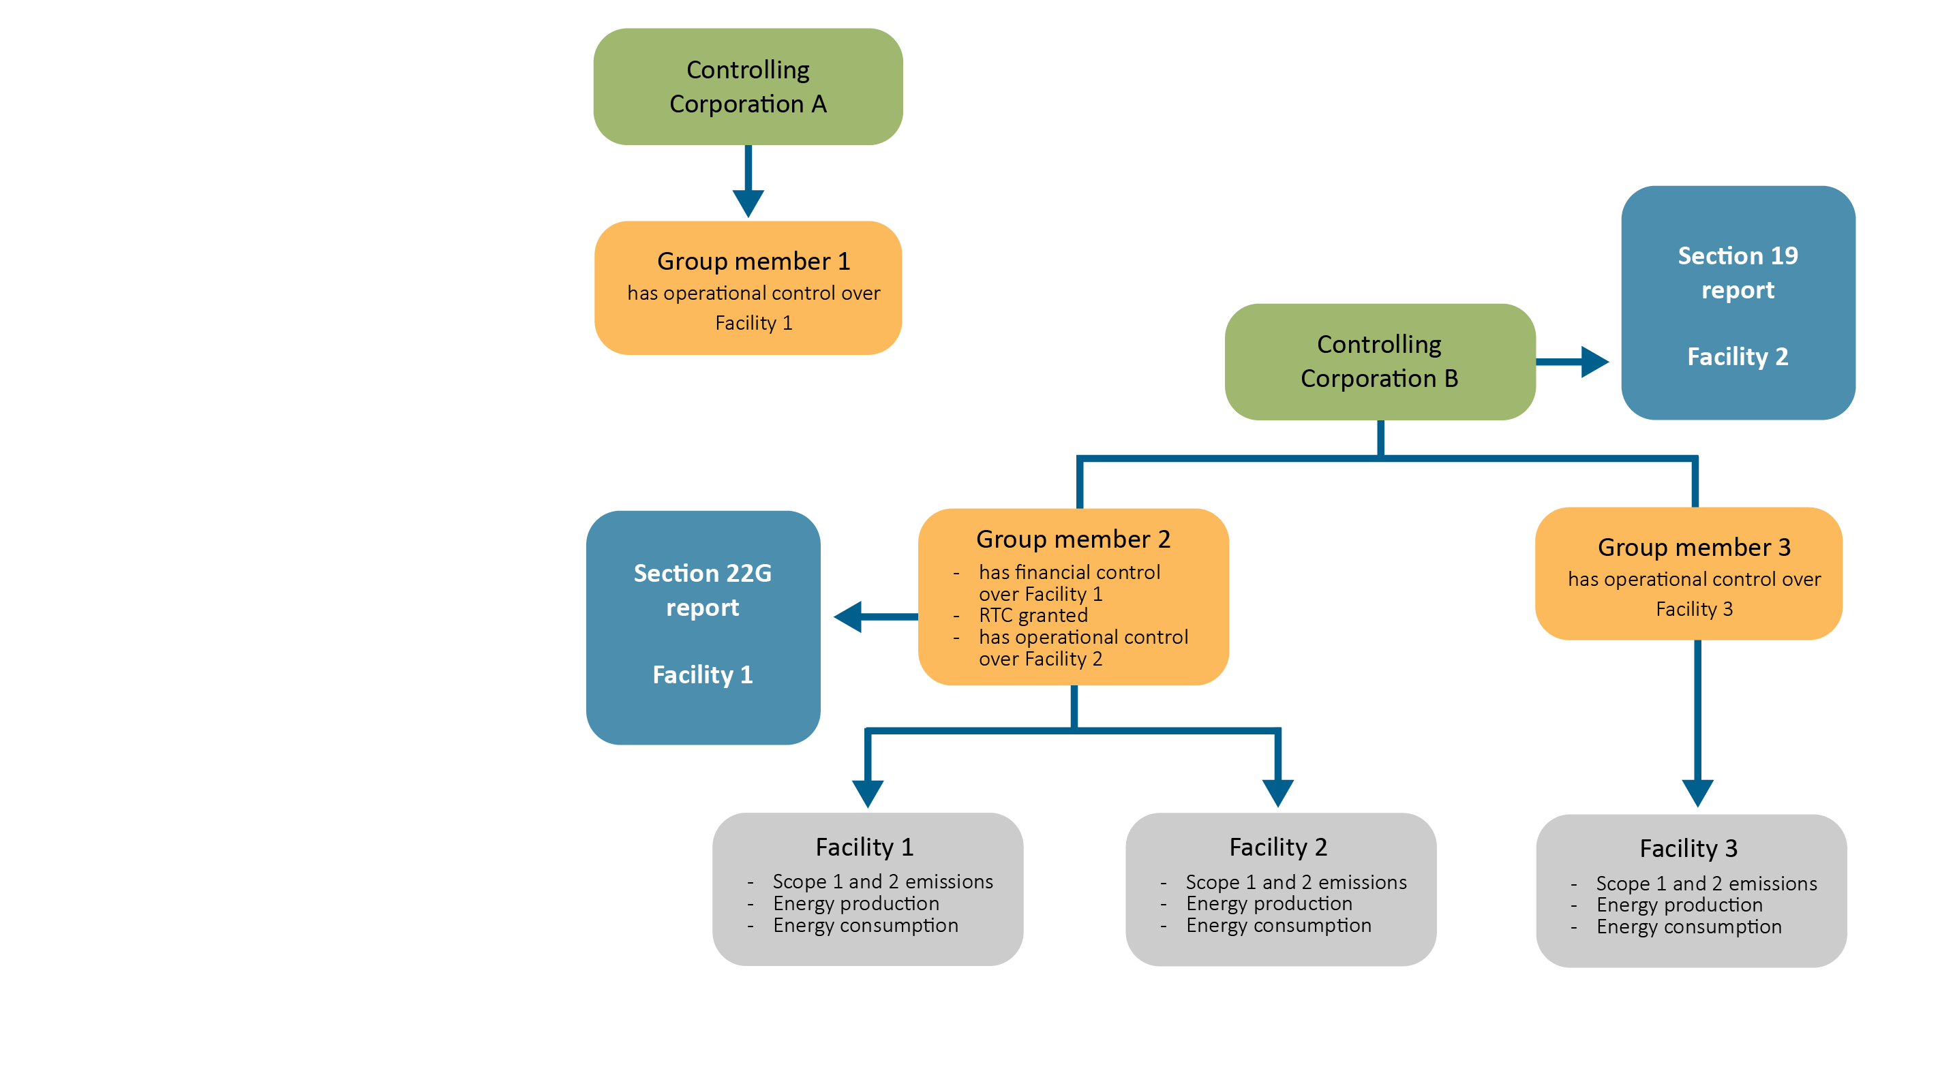

## 7. Record keeping

A corporation that is or was an RTC holder is required to keep records of its activities that allow it to report accurately under section 22G of the NGER Act and that allow the Clean Energy Regulator to ascertain whether it has complied with its reporting obligations.

These records must be retained for five years from the end of the financial year in which the activities took place. Failure to keep records may incur a civil penalty of up to 1 000 penalty units.

## 8. Surrendering or cancelling an RTC

### 8.1 Surrendering an RTC

An RTC holder may, with the written consent of the Clean Energy Regulator, surrender its RTC. The surrender takes effect from the date the Clean Energy Regulator gives consent. Surrenders cannot be backdated.

The Clean Energy Regulator will only consent to the surrender of an RTC when:

* the corporation that consented to the application (either the corporation with operational control of the facility or its controlling corporation) has agreed to the surrender
* the Clean Energy Regulator is satisfied that there are special circumstances that warrant consenting to the surrender.

**Note**: Where there is a change in the RTC holder’s circumstances, such that it no longer meets the relevant criteria (see below), the RTC will be cancelled rather than surrendered.

### 8.2 Cancelling an RTC

The Clean Energy Regulator must cancel an RTC in any of the following circumstances:

* The facility is no longer under the operational control of the corporation that had operational control at the time the RTC was issued.
* The RTC holder no longer has financial control over the facility.
* The RTC holder has ceased to be a company registered under Part 2A.2 of the *Corporations Act 2001.*
* The RTC holder has ceased to be a constitutional corporation.
* The RTC holder and the corporation with operational control over the facility are now part of the same corporate group.
* The corporation with operational control over the facility has ceased to be part of a controlling corporation’s group.
* The RTC holder has become an externally administered body corporate (within the meaning of the *Corporations Act 2001*).

If the Clean Energy Regulator cancels an RTC, all affected parties will receive written notification of the cancellation.

**Note**: Regulations can be made specifying further grounds on which the Clean Energy Regulator must cancel an RTC. At present, no such regulations have been made.

The cancellation will take effect on the date that the Clean Energy Regulator cancels the RTC. Cancellation cannot be backdated.

## 9. Further information

Email: [reporting@cer.gov.au](mailto:reporting@cer.gov.au)

Phone: 1300 553 542

Website: [www.cer.gov.au](https://www.cer.gov.au/)

1. https://www.legislation.gov.au/C2007A00175/latest/text
2. https://www.legislation.gov.au/F2008L02230/latest/text
3. https://www.legislation.gov.au/F2008L02309/latest/text
4. https://cer.gov.au/schemes/national-greenhouse-and-energy-reporting-scheme
5. https://cer.gov.au/schemes/national-greenhouse-and-energy-reporting-scheme/report-emissions-and-energy