Reporting hydrofluorocarbons and sulphur hexafluoride gases guideline

July 2025

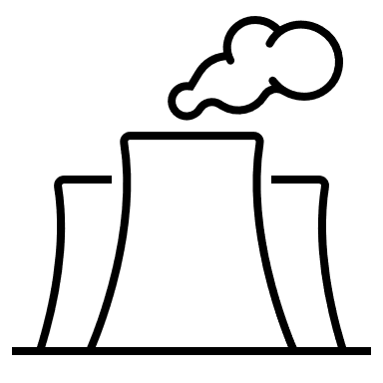J**Contents**

Definitions and Abbreviations 3

2024–25 updates 6

1. Available methods for reporting hydrofluorocarbons and sulphur hexafluoride 6

2. Hydrofluorocarbons and sulphur hexafluoride reporting thresholds 8

3. Hydrofluorocarbons reporting requirements 8

3.1 ANZSIC industry classification 8

3.2 Equipment type 9

3.3 Refrigerant charge and global warming potential thresholds 9

3.4 General rules for reporting hydrofluorocarbons 10

4. Reporting sulphur hexafluoride (SF6) gases 10

5. Is R-22 a reportable gas? 10

6. Entering data into EERS 10

Using Method 1 10

Using Method 2 11

Using Method 3 12

7. Using incidental reporting provisions 14

8. More information and references 14

More information 14

References 14

Appendix A – Examples for hydrofluorocarbon reporting requirements 16

# Definitions and Abbreviations

| Term | Meaning |
| --- | --- |
| CO2 | Carbon dioxide |
| CO2-e | Carbon dioxide equivalence |
| EERS | The Clean Energy Regulator’s Emissions and Energy Reporting System which is used for NGER Reporting |
| Facility | Has the meaning given by section 9 of the NGER Act. For more information on defining a facility under the NGER scheme, see [What is a Facility](https://cer.gov.au/schemes/national-greenhouse-and-energy-reporting-scheme/assess-your-obligations#what-is-an-nger-facility)[1] |
| GWP | Global Warming Potential is defined by the UNFCCC as an index representing the combined effect of the differing times greenhouse gases remain in the atmosphere and their relative effectiveness in absorbing outgoing infrared radiation. |
| HFC | Hydrofluorocarbon |
| Listed HFC | Any of the hydrofluorocarbons listed in section 7A (2) of the NGER Act and 2.02 of the NGER Regulations. These are listed in Table 1 of this guideline. |
| NGER | National Greenhouse and Energy Reporting |
| NGER Act | *National Greenhouse and Energy Reporting Act 2007* |
| NGER Legislation | NGER Act, NGER Regulations, NGER Measurement Determination |
| NGER Measurement Determination | National Greenhouse and Energy Reporting (Measurement) Determination 2008 |
| NGER Regulations | National Greenhouse and Energy Reporting Regulations 2008 |
| Refrigerant charge | The total volume of gas contained within the equipment. |
| Scope 1 emissions | Means the release of greenhouse gas into the atmosphere as a direct result of an activity or series of activities (including ancillary activities) that constitute the facility. |
| SF6 | Sulphur hexafluoride |
| Stock | The total gas contained in the equipment from the gases listed in section 7A of the NGER Act (or 2.02 of the NGER Regulations) measured in t CO2-e. |
| t CO2-e | Tonnes carbon dioxide equivalence |

Terms in NGER legislation may have specific meanings within the law. These key words and phrases are normally identified under a heading such as Definitions, Interpretation or Dictionary or in other parts of the document.

For more information on interpreting legislation see [Federal Register of Legislation - Understanding Legislation](https://www.legislation.gov.au/help-and-resources/understanding-legislation/reading-legislation)[2].

**Disclaimer**

Thisguideline has been developed by the Clean Energy Regulator (CER) to assist entities to comply with their reporting obligations under the [*National Greenhouse and Energy Reporting Act 2007*](https://www.legislation.gov.au/Series/C2007A00175)[3](NGER Act)and associated legislation.

This guideline only applies to the 2024–25 NGER reporting year and should be read in conjunction with the NGER Act, [National Greenhouse and Energy Regulations 2008](https://www.legislation.gov.au/Series/F2008L02230)[4] (NGER Regulations), and [National Greenhouse and Energy Reporting (Measurement) Determination 2008](https://www.legislation.gov.au/Series/F2008L02309)[5] (NGER Measurement Determination), as in force for this reporting period. These laws and their interpretation are subject to change, which may affect the accuracy of the information contained in the guideline.

The guidance provided in this document is not exhaustive, nor does it consider all circumstances applicable to all entities. This guidance is not intended to comprehensively deal with its subject area, and it is not a substitute for independent legal advice. Although entities are not bound to follow the guidance provided in this document, they must ensure they meet their obligations under the [National Greenhouse and Energy Reporting (NGER) Scheme](https://cer.gov.au/schemes/national-greenhouse-and-energy-reporting-scheme)[6] at all times. The CER encourages all users of this guidance to seek independent legal advice before taking any action or decision based on this guidance.

The CER and the Australian Government will not be liable for any loss or damage from any cause (including negligence) whether arising directly, incidentally, or as consequential loss, out of or in connection with, any use of this guideline or reliance on it, for any purpose.

If an entity chooses to meet their obligations under the NGER scheme in a manner that is inconsistent with the guidance provided in this document, the CER, or an independent auditor, may require the entity to demonstrate that they are compliant with requirements of the NGER Act, NGER Regulations, and/or the NGER Measurement Determination. Entities are responsible for determining their obligations under the law and for applying the law to their individual circumstances.

# 2024–25 updates

Changes in this document for the 2024–25 reporting year:

* Minor edits, corrections, and formatting changes have been made to this document

Read about the [changes to the NGER Legislation for the 2024–25 reporting period[7].](https://cer.gov.au/schemes/national-greenhouse-and-energy-reporting-scheme/report-emissions-and-energy/amendments)

|  |
| --- |
| New Emissions and Energy Reporting System (EERS) for 2024–25.  The EERS screenshots in this guideline are from the legacy version of EERS but the input data (source/activity/method) will be very similar in the current system. Please contact us if you have any questions. |

# Available methods for reporting hydrofluorocarbons and sulphur hexafluoride

Methods available for estimating emissions from hydrofluorocarbon (HFC) and sulphur hexafluoride (SF6) gases are listed in the below table:

| Method | Hydrofluorocarbons | Sulphur hexafluoride |
| --- | --- | --- |
| 1 | Section 4.102 of the NGER Measurement Determination | Section 4.102 of the NGER Measurement Determination |
| 2 | Section 4.103 of the NGER Measurement Determination | Section 4.103 of the NGER Measurement Determination |
| 3 | Section 4.104(1) of the NGER Measurement Determination | Section 4.104(2) of the NGER Measurement Determination |
| 4 | Not available | Not available |
| Incidental | A method consistent with Section 1.13 of the NGER Measurement Determination | A method consistent with Section 1.13 of the NGER Measurement Determination |

See the [Aggregated facility reporting, percentage estimates and incidental emissions and energy guideline](https://cer.gov.au/document_page/guidance-aggregated-facility-reporting-percentage-estimates-and-incidental-emissions-and-energy)[8] for more information about the incidental method.

If you are using Method 2 or 3 to estimate emissions of HFC or SF6 gases from a reportable activity, and the resulting amount of emissions estimated is zero (0 t CO2-e), you still must report the activity and enter zero as the emissions quantity in EERS. This is required to ensure your NGER submission meets section 1.13(d) of the NGER Measurement Determination.

Methods 1 to 3 require the quantity of emitted gas to be converted from mass (in metric tonnes) to tonnes of carbon dioxide equivalence (t CO2-e). This is done by multiplying the mass of a gas (tonnes) by its global warming potential (GWP). The value of the relevant GWPs listed in Table 1 below, and specified in 2.02 of the NGER Regulations, must be used for determining the CO2-e for HFCs and SF6. The GWP figures represent the findings published by the Intergovernmental Panel on Climate Change in its Fifth Assessment Report.

Table 1: Global warming potentials as per 2.02 of the NGER Regulations.

| Greenhouse gas | Chemical formula | Global Warming Potential (GWP) |
| --- | --- | --- |
| Sulphur hexafluoride | SF6 | 23,500 |
| HFC-23 | CHF3 | 12,400 |
| HFC-32 | CH2F2 | 677 |
| HFC-41 | CH3F | 116 |
| HFC-43-10mee | C5H2F10 | 1,650 |
| HFC-125 | C2HF5 | 3,170 |
| HFC-134 | C2H2F4 (CHF2CHF2) | 1,120 |
| HFC-134a | C2H2F4 (CH2FCF3) | 1,300 |
| HFC-143 | C2H3F3 (CHF2CH2F) | 328 |
| HFC-143a | C2H3F3 (CF3CH3) | 4,800 |
| HFC-152a | C2H4F2 (CH3CHF2) | 138 |
| HFC-227ea | C3HF7 | 3,350 |
| HFC-236fa | C3H2F6 | 8,060 |
| HFC-245ca | C3H3F5 | 716 |

# Hydrofluorocarbons and sulphur hexafluoride reporting thresholds

Section 4.101 of the NGER Determination details the thresholds for reporting synthetic gas generation activities for emission of hydrofluorocarbons and sulphur hexafluoride gases.

Table 2: Hydrofluorocarbons and sulphur hexafluoride reporting thresholds.

| Item | Provision in NGER Determination | Threshold |
| --- | --- | --- |
| Hydrofluorocarbons | Subparagraph 4.100(1)(a)(ii) | 100 kilograms of refrigerants for each unit from use of commercial air conditioning, commercial refrigeration, and industrial refrigeration |
| SF6 | Subsection 4.100(2) | Any emission from insulated switch gear and circuit breaker applications |

# Hydrofluorocarbons reporting requirements

## ANZSIC industry classification

According to section 4.100(1)(b) of the NGER Measurement Determination, only registered corporations with operational control over a facility with the principal activity attributed to any of the following ANZSIC industry classifications must report synthetic gas generating activities for emissions from hydrofluorocarbons:

* food product manufacturing (ANZSIC classification, Subdivision 11)
* beverage and tobacco product manufacturing (ANZSIC classification, Subdivision 12)
* retail trade (ANZSIC classification, Division G)
* warehousing and storage services (ANZSIC classification number 530)
* wholesale trade (ANZSIC classification, Division F)
* rental, hiring and real estate services (ANZSIC classification, Division L).

If the principal activity of your facility is not attributed to one of the above ANZSIC industry classifications, then you are not required to report stock or emissions of hydrofluorocarbons.

The Australian Bureau of Statistics website lists [ANZSIC codes and descriptions of the activities included under each code](https://www.abs.gov.au/statistics/classifications/australian-and-new-zealand-standard-industrial-classification-anzsic)[9].

## Equipment type

Synthetic gas generating activities for emissions of hydrofluorocarbons are activities of the facility that emit hydrofluorocarbons from the use of the following equipment as specified in 4.16(1)(a) to 4.16(1)(c) of the NGER Regulations:

* commercial air conditioning
* commercial refrigeration
* industrial refrigeration.

If you do not use the above equipment in your facility, then you are not required to report stock or emissions of hydrofluorocarbons.

## Refrigerant charge and global warming potential thresholds

A facility with a principal activity that is attributable to any one of the ANZSIC industry classifications mentioned in section 3.1 of this guidance must report the emissions of HFCs from the use of equipment listed in section 3.2 of this guideline when both of the following thresholds are met:

* The equipment contains a refrigerant charge of more than 100 kilograms (kg) of refrigerants for each unit (section 4.100(1)(a)(ii) NGER Measurement Determination).

|  |
| --- |
| In this context, the term ‘charge’ refers to the total volume of the gas contained within the equipment.  The gas contained in the unit may be a single refrigerant (for example, R-32) or a refrigerant blend (for example, R-410A). |

* The refrigerant is a greenhouse gas with a GWP of more than 1000 [2.02 of the NGER Regulations and 4.100 (1)(a)(iii) of the NGER Measurement Determination section].

|  |
| --- |
| This threshold is met if the refrigerant gas contained in the unit is composed of at least one ‘listed HFC’ that has a GWP greater than 1000.   A listed HFC is a greenhouse gas listed in section 7A (2) of NGER Act (or 2.02 of the NGER Regulations. |

## General rules for reporting hydrofluorocarbons

If the conditions outlined in section 3.1 to 3.3 of this guideline are met, then the following rules should be applied when reporting stock and emissions of HFCs:

* Only emissions of ‘listed HFCs’ are required to be reported. There are 13 HFCs that are required to be reported under NGER Legislation as shown in Table 1.
* Emissions of any non-listed HFCs (those that are not listed in subsection 7A(2) of the NGER Act) are not required to be reported.
* If a refrigerant is composed of single gas type with a GWP less than or equal to 1000 (for example, R-32) then emissions of this HFC are not required to be reported.
* If a refrigerant blend contains one or more listed HFCs with a GWP greater than 1000, then emissions of all listed HFCs in the refrigerant blend are required to be reported. This includes listed HFCs with a GWP less than or equal to 1000. Non-listed HFCs are not required to be reported.
* You need to create separate activities in EERS for each applicable equipment type listed in section 3.2 of this guideline.

|  |
| --- |
| Read ‘Appendix A – Examples for hydrofluorocarbon reporting requirements’ for more information on how to report stock and emissions of HFCs. |

# Reporting sulphur hexafluoride (SF6) gases

All emissions of sulphur hexafluoride (SF6) are reportable from the operation of facilities across all industry sectors (NGER Measurement Determination sections 4.100 and 4.101), when any of the activities of the facility require the use of gas insulated switch gear and circuit breaker applications (paragraph 4.16 (1)(d) of the NGER Regulations).

# Is R-22 a reportable gas?

R-22 is not listed in 2.02 of the NGER Regulations and is not a reportable gas under the NGER Scheme.

# Entering data into EERS

## Using Method 1

The estimation of emissions of HFC and SF6 gases using Method 1 is performed using the equation listed within section 4.102 of the NGER Measurement Determination.   
  
Follow these steps to enter the required data into the EERS for Method 1:

1. Determine the mass of HFC or SF6 in the relevant equipment, measured in tonnes.
2. Multiply the mass of gas (tonnes) by the GWP value of the gas (2.02 of the NGER Regulations) to determine the stock in carbon dioxide equivalence (CO2-e) tonnes.
3. Enter the stock of gas in tonnes CO2-e into EERS in the ‘Gas contained in equipment (tCO2-e)’ field.
4. Press the ‘calculate’ button.
5. EERS then will apply the applicable leakage rate to obtain the emissions in t CO2-e.

For example, if the equipment used for commercial refrigeration contains 7.2048 tonnes of HFC-143a, which has a GWP of 4800 (2.02 of the NGER Regulations), then the calculation of stock of CO2-e is:

Stock (HFC) = mass of HFC (tonnes) x GWP  
= 7.2048 x 4800   
= 34,583 t CO2-e

Enter the 34,583 tonnes stock CO2-e in the EERS data entry screen shown in Figure 1 below.

Figure 1: EERS data entry screen for Method 1 (emissions of HFC from commercial refrigeration).

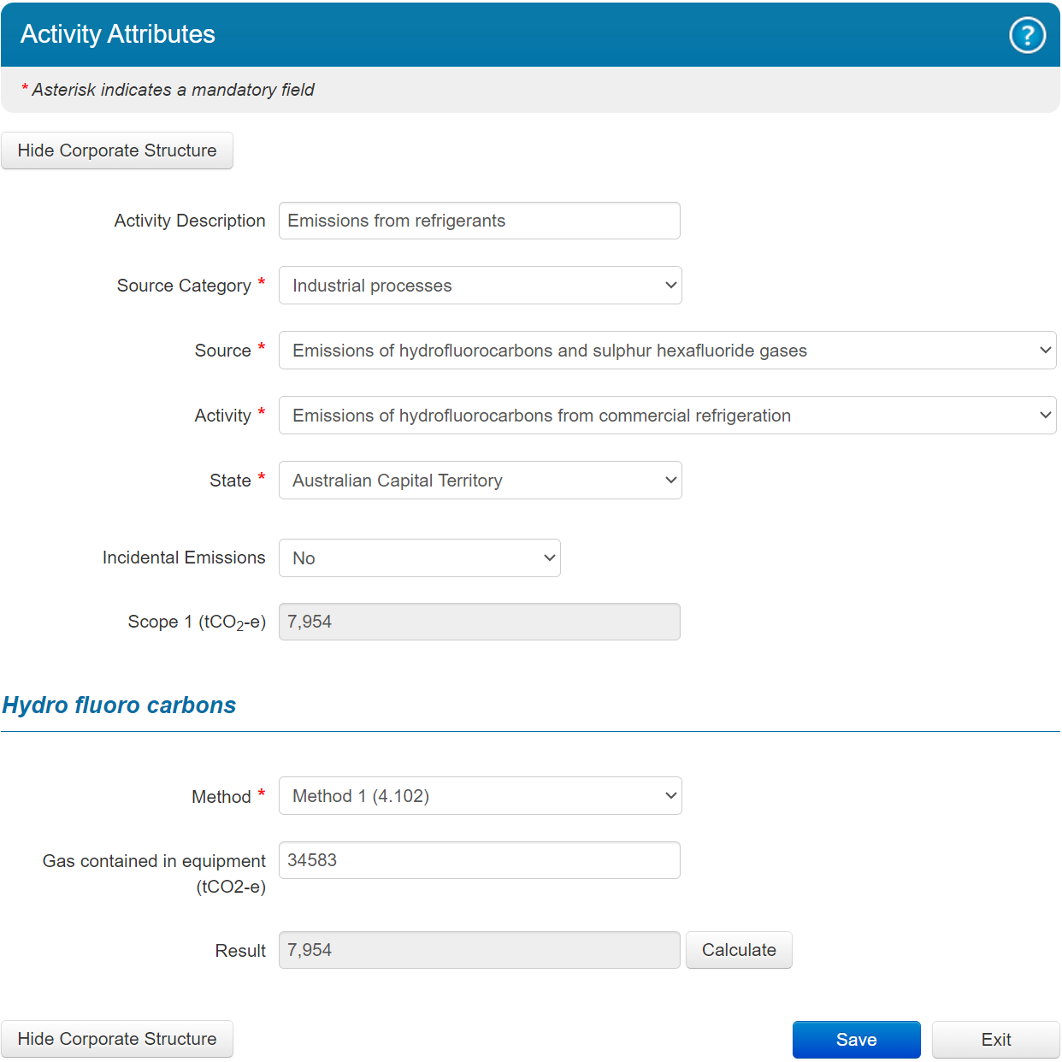

The data input in EERS is very similar for SF6.  
  
Read Table 3: Example of HFC reporting under the NGER SchemeAppendix A – Examples for hydrofluorocarbon reporting requirements when calculating the stock of HFCs where more than one HFC is contained in a refrigerant blend.

## Using Method 2

The estimation of emissions of HFC and SF6 gases using Method 2 is performed using a mass balance calculation. Until the 2020–21 reporting year, the method was described in Appendix A of the ENA Industry Guideline for SF6 Management - ENA DOC 022-2008 (ENA Industry Guideline). From 2022–23 onwards, the method is described in section 4.103 of the NGER Measurement Determination.

The mass balance calculation uses the opening stock of gas, transfers into the facility from additions of gas from purchases of new equipment, and replenishments and transfers out of the facility from disposal of equipment or gas. Stock of gas may be estimated from the nameplate capacities of the relevant cylinders or equipment.

The method described in section 4.103 of the NGER Measurement Determination is based on the following:

***Storage at the beginning of the year***, in kg, minus

***Storage at the end of the year***, in kg, plus

|  |
| --- |
| ‘Storage’ means all equipment, cylinders and other containers which hold HFCs or SF6 not in use and which meet the requirements of Section 4.100 and 4.101 of the NGER Measurement Determination. |

***Additions*** (from purchases, including inside equipment, and returned to site after recycling), in kg, minus

***Subtractions*** (from sales, returns to suppliers, destructions and recycling), in kg, minus

***Changes to nameplate capacity* (**taking into account new and retiring equipment), in kg.

A separate mass balance calculation should be conducted for each type of reportable greenhouse gas, with the estimated emissions converted into CO2-e using the GWP for the relevant gas. When entering your estimation into EERS, you will be prompted to include the total quantity of gas contained in the equipment (stock) in t CO2-e. Once all fields are completed, press the ‘Calculate’ button to display the estimated emissions. This is shown in Figure 2.

Figure 2: Method 2 EERS data entry screen.

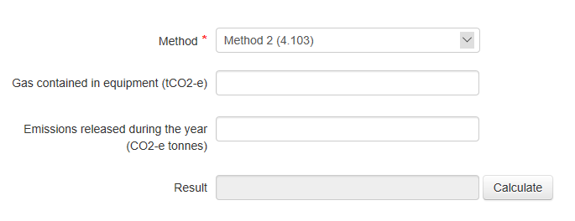

## Using Method 3

Alternatively, emissions may be estimated from data on replenishments of HFC and SF6 gases in equipment as a proxy for leakage and using an assumption that the stock levels of gases within the equipment are maintained at constant levels to maintain constant operating efficiency levels. Method 3 uses this aggregate loss estimation approach to estimate emissions. Until the 2021–22 reporting year, the required approach was described in the table in Appendix B of the ENA Industry Guidelines. From 2022–23 onwards, the required approach is described in section 4.104 of the NGER Measurement Determination

The aggregate loss at emissions source accounting method described in section 4.104 of the NGER Measurement Determination includes, but is not limited to, the following potential loss vectors:

* top up of gas for leaking equipment
* complete loss of containment of equipment
* losses during filling of new (or refurbished) equipment
* complete loss of containment of cylinders
* leakage of gas from cylinders
* losses during decanting between cylinders
* losses during manual handling including handling equipment failure or accidental venting
* leakage from equipment spares in storage
* leakage from decommissioned equipment awaiting disposal
* determinations of gas loss from sealed equipment at point of disposal
* losses during reprocessing, recycling or rebottling of gas
* losses due to gas sampling and analysis.

This list may not include all the point sources of losses for both HFCs and SF6 and may be modified to include more point sources where they have been identified by the reporter.

Note the total annual loss of each type of gas should be converted into CO2-e using the relevant GWP.

|  |
| --- |
| ‘Storage’ means all equipment, cylinders and other containers which hold HFCs or SF6 not in use and which meet the requirements of Section 4.100 and 4.101 of the NGER Measurement Determination. |

When entering your estimation into EERS, you will be prompted to include the total quantity of gas contained in the equipment (stock) in t CO2-e. Once all fields are completed, press the ‘Calculate’ button to display the estimated emissions. This is shown in Figure 3.

Figure 3: Method 3 EERS data entry screen

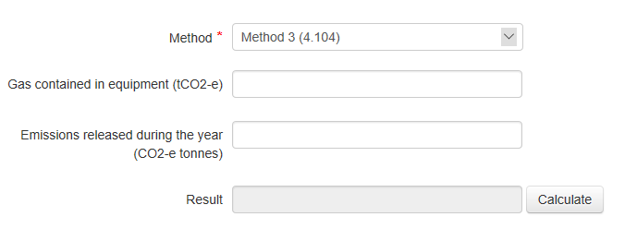4

# Using incidental reporting provisions

Subsection 4.98(2) of the NGER Measurement Determination allows for estimates of emissions to be made using the incidental reporting provisions available within 4.27 of the NGER Regulations, provided that the method used is consistent with the principles set out in section 1.13 of the NGER Measurement Determination. See the [Aggregated facility reporting, percentage estimates and incidental emissions and energy guideline](https://cer.gov.au/document_page/guidance-aggregated-facility-reporting-percentage-estimates-and-incidental-emissions-and-energy)[10] for more information.

# More information and references

This guideline has been provided by the CER to assist in the consistent accounting and reporting of greenhouse gas emissions, energy consumption and energy production using the NGER Legislation.

## More information

For more information, please contact the CER:

Email: [cer-nger-reporting@cer.gov.au](mailto:cer-nger-reporting@cer.gov.au)

Phone: 1300 553 542within Australia

Website: [www.cer.gov.au](https://www.cer.gov.au)

## References

See [NGER Reporting Guides[11]](https://cer.gov.au/schemes/national-greenhouse-and-energy-reporting-scheme/report-emissions-and-energy/nger-reporting-guides) for information on:

* defining a facility
* methods and measurement criteria
* reporting energy production and consumption
* reporting blended fuels, other fuel mixes, bitumen, and explosives guideline
* petroleum-based oils and greases
* reporting uncertainty.

# 

## Appendix A – Examples for hydrofluorocarbon reporting requirements

Provided the conditions listed in section 3.1 to 3.3 of this guideline are met then emissions of HFCs should be reported as shown in Table 3.   
  
Please note that the following terms are defined in the Definitions and Abbreviations table:

* GWP
* listed HFC
* stock.

Table 3: Example of HFC reporting under the NGER Scheme

| Example | Refrigerant | Composition | Which HFCs must be reported and why |
| --- | --- | --- | --- |
| A | R-143A | 100% R-143A  (GWP = 4,800) | **R-143A**  R-143A is a listed HFC with a GWP greater than 1000, therefore stock and emissions of R-143A are required to be reported. |
| B | R-22 | 100% R-22 | **Not reportable** R-22 is not a listed HFC and therefore does not need to be reported. |
| C | R-410A | * 50% R-32  (GWP = 677) * 50% R-125  (GWP = 3170) | **R-32 and R-125**  R-410A contains at least one listed HFC with a GWP greater than 1000, so stock and emissions from all listed HFCs must be reported.  R-32 and R-125 are both listed HFCs. |
| D | R-407C | * 23% R-32  (GWP = 677) * 25% R-125  (GWP = 3,170) * 52% R-134A (GWP 1,300) | **R-32, R-125 and R-134A** R-407C contains at least one listed HFC with a GWP greater than 1000, so stock and emissions from all listed HFCs must be reported.  R-32, R-125 and R-134a are listed HFCs. |
| E | R-32 | 100% R-32  (GWP = 677) | **Not reportable** The refrigerant does not contain a listed HFC with a GWP greater than 1000.  R-32 is a listed HFC, but its GWP is less than or equal to 1000. |
| F | HCFC-402A | * 38% HCFC-22  (GWP = 1760) * 60% HFC-125  (GWP = 3170) * 2% HC-290  (GWP = 3.3) | **HFC-125 only.**  At least one HFC in the refrigerant blend has a GWP greater than 1000, therefore stock and emissions of all listed HFCs are required to be reported.       You are only required to report stock and emissions of listed HFCs. The only listed HFC is HFC-125.   Do not report stock or emissions of ‘non-listed HFCs’ (HCFC-22 and HC-290).  **How to calculate the stock of HFC-125\*** Multiply the mass of HFC-125 (tonnes) by its GWP.  For example, if equipment contains 7.2048 tonnes of HCFC-402A, then:  Stock = mass HFC-125 (t) x GWP HFC-125              = 60% x mass of HCFC-402A (tonnes) x                  GWP of HFC-125            = 0.6 x 7.2048 x 3170             = 13,703 t CO2-e  *Assumes HFC-125 is 60% of HCFC-402A on a mass basis. |
| G | **HFO-513A** | * 44% HFC-134A (GWP = 1300) * 56% HFO-1234yf  (GWP = 1) | **HFC-134A only.** At least one HFC in the refrigerant blend has a GWP greater than 1000, therefore stock and emissions of all listed HFCs are required to be reported.     You are only required to report stock and emissions of listed HFCs. The only listed HFC is HFC-134A.  Do not report stock or emissions of ‘non-listed HFCs’ (HFO-1234yf).  **How to calculate the stock of HFC-134A\*** Multiply the mass of the HFC-134A (tonnes) by its GWP.  For example, if equipment contains 7.2048 tonnes of HFO-513A, then:   Stock = mass HFC-134A (t) * GWP HFC-134A              = 44% * mass of HFO-513A (tonnes) x                     GWP of HFC-134A             = 0.44 x 7.2048 x 1300              = 4,121 t CO2-e  *Assumes HFC-134A is 44% of HCFC-513A on a mass basis. |

1. https://cer.gov.au/schemes/national-greenhouse-and-energy-reporting-scheme/assess-your-obligations#what-is-an-nger-facility
2. https://www.legislation.gov.au/help-and-resources/understanding-legislation/reading-legislation
3. https://www.legislation.gov.au/Series/C2007A00175
4. https://www.legislation.gov.au/Series/F2008L0223
5. https://www.legislation.gov.au/Series/F2008L02309
6. https://cer.gov.au/schemes/national-greenhouse-and-energy-reporting-scheme
7. https://cer.gov.au/schemes/national-greenhouse-and-energy-reporting-scheme/report-emissions-and-energy/amendments
8. https://cer.gov.au/document_page/guidance-aggregated-facility-reporting-percentage-estimates-and-incidental-emissions-and-energy
9. https://www.abs.gov.au/statistics/classifications/australian-and-new-zealand-standard-industrial-classification-anzsic
10. https://cer.gov.au/document_page/guidance-aggregated-facility-reporting-percentage-estimates-and-incidental-emissions-and-energy
11. https://cer.gov.au/schemes/national-greenhouse-and-energy-reporting-scheme/report-emissions-and-energy/nger-reporting-guides