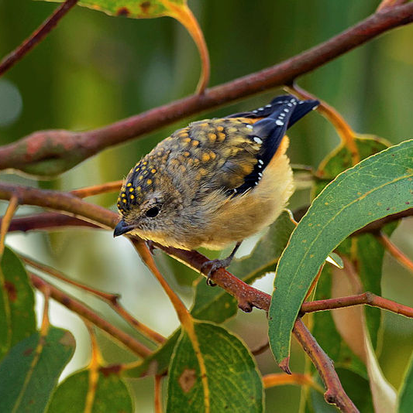
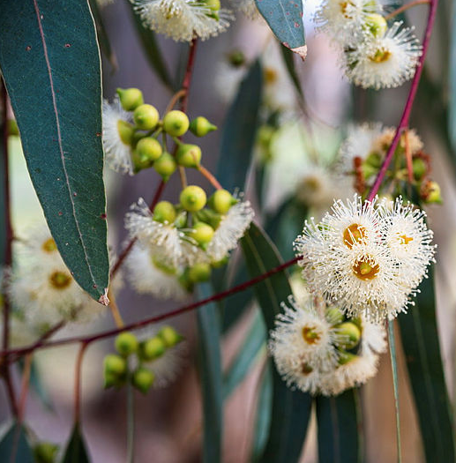
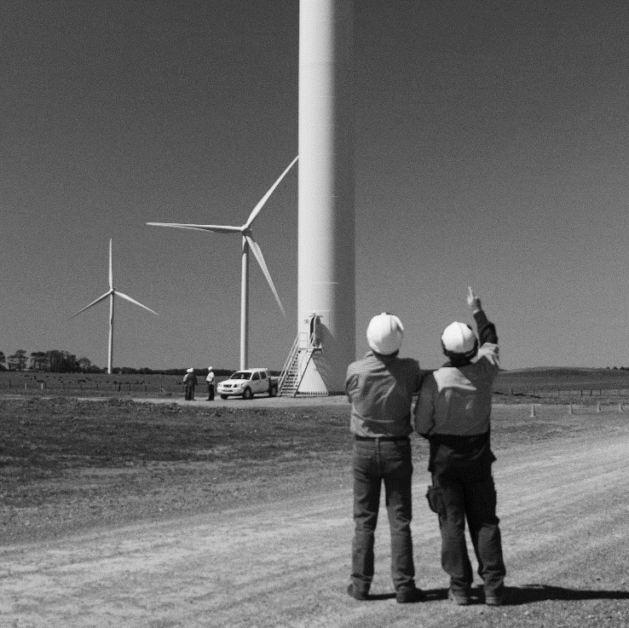
Replanting native forest and woodland ecosystems
Starting state assessment guidelines
Version 1.0

Contents
Contents 2
1. Purpose 3
2. Background 3
2.1 Suitably Qualified Persons 3
2.2 Key SSA documents 4
3. Land eligibility 5
4. Indigenous land interests 5
5. Assessment of the project context 5
5.1 Threats 6
5.2 Vulnerability to climate change 6
5.3 Significant hydrological features 6
5.4 Threatened species and threatened ecological communities 6
5.5 Natural regeneration 7
6. Ecosystem Assessment 7
6.1 Optimal Growth Period 7
6.2 Reference ecosystem 8
6.3 Benchmark values 9
6.4 Permanent sampling plots 9
6.5 Ecosystem condition 10
6.6 Ecosystem scores 11
7. Historic drivers of change 11
8. Checklists of SSA requirements 11
8.1 Prior to the field survey – Desktop Analysis 12
8.2 During the field survey – On ground field work 13
8.3 After the field survey – Desktop analysis 14

1. Purpose
These guidelines outline the requirements for conducting the starting state assessment (SSA) under the Replanting Native Forest and Woodland Ecosystems Methodology Determination 2025 (the method).

2. What is the starting state assessment?
The SSA is an assessment which informs the design of a project and is documented in the site assessment report. The SSA is a requirement of the method and establishes the starting site conditions which future changes in the ecosystem condition will be measured against.
To establish the starting state, the SSA must include a field survey that has been conducted as close as practicable to the optimal growth period for the relevant Natural Resource Management region. This maximises the potential to identify species.
Completing site preparation (for example, ripping) before the SSA may affect your eligibility or influence the starting values for ecosystem condition indicators. Prospective proponents should ensure that the SSA is completed at a point that allows for an accurate representation of the site's ecological condition.
The SSA must reflect the condition of the project area at the time the registration application is made. Any changes occurring between when the SSA is conducted and the application date, must be recorded in the site assessment report. This will then be considered in determining eligibility and ecosystem condition.

2.1 Suitably qualified persons
A suitably qualified person (SQP) or persons is someone who meets all the following requirements:
- holds a qualification in ecology, botany, or an equivalent discipline
- has at least 3 years of professional experience working in their discipline
- has practised as an ecologist, botanist, or equivalent practitioner within the past 3 years.
The SQP who undertakes, or certifies, the starting state assessment and the site assessment report may be either:
- the project proponent if they are suitably qualified and experienced
- a suitably qualified person the project proponent has engaged.
Some requirements of the SSA must be done by the suitably qualified persons, while others can be done by the project proponent who is certified by the suitably qualified person.
- The field survey and the ecosystem assessment process of the SSA must be completed by a SQP.
- The remainder of the SSA, and the preparation of the site assessment report, must be either undertaken by a suitably qualified person, or by the project proponent and then certified by a suitably qualified person.
This ensures that assessments of ecosystem condition, field survey data, and site level ecological judgements are informed by appropriate scientific expertise and uphold the ecological integrity of the project.
Qualifications and experience must be shown in the site assessment report, by attaching a CV or qualification certificate. This information will also be published on the Biodiversity Market Register.

2.2 Key project documents
There are two key documents under the method that support project registration and implementation:
- the site assessment report
- the project plan.
While closely related, these documents serve different but complementary purposes. Both documents are submitted as part of the registration application and are published on the Biodiversity Market Register.

Site assessment report

The site assessment report captures the SSA’s findings at the specific point in time when the registration application is submitted.
The site assessment report must meet the requirements of section 35 of the method and demonstrate that the SSA has been carried out in accordance with Division 2.5. The site assessment report must be either prepared or certified by a SQP.
Project proponents are encouraged to use the site assessment report template, available on the Clean Energy Regulator’s website, to ensure all required information is captured.

Project plan
The project plan and proposed activities will be informed by the site assessment report and will guide the ongoing management of the project over time. The project plan must include the information specified under division 2.6 of the method.
The project plan (including any updates or amendments) must:
- be either prepared or certified by a SQP
- be informed by the findings of the SSA and translate into design and management decisions.
Ensure that the information in the site assessment report and the project plan is consistent, including reference ecosystems, activity area boundaries, ecosystem condition results, and proposed management actions.

3. Land eligibility
As part of the SSA and before the field survey is undertaken, the project proponent or SQP must assess the eligibility of the project area and each proposed activity area to confirm that the project complies with sections 18 -20 and each activity area consists only of eligible land, as required by section 27 of the method. Confirming land eligibility at an early stage ensures that field survey only includes eligible project areas.
The assessment may use desktop analysis of available records, including recent and historical satellite imagery and other relevant spatial or documentary evidence. This information may be used to demonstrate compliance with land eligibility requirements, for example, that the land has been comprehensively cleared.
As part of land eligibility, the SSA must describe any covenants or other legal interests that apply to each proposed activity area.
Where land does not meet the eligibility requirements, it must be excluded from proposed activity areas and the field survey. The outcome of the land eligibility assessment must be documented and supported by evidence in the site assessment report.
The SQP must certify the land eligibility information as part of the SSA.

4. Indigenous engagement
Indigenous engagement may be required as part of the SSA where Indigenous land interests apply to the project area. Proponents may undertake voluntary engagement where it is not required under the method. Any Indigenous knowledge, values or data included the in the SSA that was informed by engagement (as per s29(b)) is subject to the requirements for attribution, consent and culturally appropriate management, outlined in sections 29(c-e).

4.1 Indigenous land interests
The project proponent or SQP must identify any areas within the project area that are subject to Indigenous land interests. If any part of the project area is subject to Indigenous land interests, appropriate engagement must be undertaken with relevant Indigenous representative.
Indigenous land interests and the relevant Indigenous representatives are:
- For a native title area with a registered native title body corporate → that body corporate
- For a native title area with no registered native title body corporate → the persons, or group of persons, who hold the common or group rights comprising the native title in relation to the native title area
- For an area with a native title claim → the native title claim group
- For Aboriginal land rights land → the Aboriginal land council
- For an ILUA area → any Indigenous representatives party to the ILUA.

Indigenous representatives must be given the opportunity to engage (if they wish) in relation to the design and implementation of the project, including:
- planning and conduct of the initial field survey
- using Indigenous knowledge, values or data in a culturally appropriate way
- identifying any culturally sensitive or significant areas.
Details on Indigenous land interests and engagement carried out (whether required or voluntary) must be included in the site assessment report. Where Indigenous engagement informs project design or implementation, this must also be documented in the project plan.

4.2 Voluntary engagement
Even where the project area does not include Indigenous land interests, the project proponent may engage with relevant Indigenous persons for the project area in relation to the design and implementation of the project. Any voluntary engagement undertaken, including outcomes relevant to project design, implementation or Culturally Significant Entity nomination, should be documented in the site assessment report and supported by evidence, where appropriate.

5. Assessment of the project context
As part of the SSA, project proponents or SQPs are required to assess the project context should inform project design.
Where the surrounding landscape is mentioned below, a 500 m buffer around activity areas should be considered if possible.

5.1 Threats
The project proponent or the SQP must identify and describe any potential threats that could affect the project outcome being achieved within each activity area and the surrounding landscape. This includes:
- non-native animal and plant species
- contaminants, (including but not limited to biological or chemical sources) or contaminant sources
- significant natural disturbances, such as wildfire, drought, flood or disease.
Where relevant, the assessment must also be informed by records of pest treatments from the past 10 years.
The SQP must certify the identified threats as part of the SSA and document in the site assessment report.

5.2 Vulnerability to climate change
The project proponent or SQP must identify and describe any parts of the project area that may be vulnerable to the effects of climate change, based on one or more projections. These vulnerabilities must be assessed where they could affect the likelihood of the project outcomes being achieved.
This assessment must also be informed, where relevant, by regional information to determine potential future climate change effects. These could include climate projections, regional climate datasets or guidance published by recognised scientific or government sources (such as CSIRO and the Department of Climate Change, Energy, the Environment and Water.
This assessment may be undertaken at any time during the SSA, noting that identification of climate-related vulnerabilities may inform the design and establishment of activity areas.
The SQP must certify the identified vulnerabilities in the site assessment report.

5.3 Significant hydrological features
The project proponent or the SQP must identify and describe any significant hydrological features within each activity area and the surrounding landscape that may affect or be affected by the project activities. This assessment must be informed, where relevant, by information obtained from the Protected Matters Search Tool (PMST).
It is recommended that the PMST report be generated prior to the field survey, and that hydrological features be verified on-ground during the field survey. This is to confirm their presence and identify any additional significant features not captured in the PMST. These may include, for example, flood-prone areas or features that materially affect plant water availability. The details of any significant hydrological features must be documented in the site assessment report.
The SQP must certify all identified hydrological features and the information relied upon.

5.4 Threatened species and threatened ecological communities
The project proponent or the SQP must identify and describe any threatened species or ecological communities that occur, or are likely to occur, within each activity area and the surrounding landscape. The PMST must be used to identify species and ecological communities that occur or are likely to occur in the area. It is recommended that the PMST report be generated prior to the field survey, with the results considered on-ground during the field survey. Any threatened species or ecological communities must be documented in the site assessment report.
The SQP must certify all identified species and communities as well as the information sources relied upon.
Proponents should also check whether any regulatory approvals are required for their project under the Environment Protection and Biodiversity Conservation Act 1999 (EPBC Act). The EPBC Act protects nationally significant animals, plants, habitats and places in Australian territories. You may need to submit a referral if your project potentially impacts any matters protected under the EPBC Act. For more information, see: Self-assessment before making a referral under the EPBC Act - DCCEEW.

5.5 Natural regeneration
The project proponent or the SQP must identify and describe any areas within each activity area that contain native trees or shrubs with a diameter at breast height of less than 5 centimetres that have regenerated from natural sources, including soil seed stock, root stock or lignotubers.
As the presence and extent of natural regeneration may influence the establishment and delineation of activity areas, this work should be completed prior to or during the field survey. The SQP must certify any natural regeneration information and the evidence relied upon. This assessment must also be documented in the site assessment report.
For any natural regeneration within activity areas, the project proponent or SQP must record in the site assessment report the:
- number of native plant species which have regenerated from natural sources and have a DBH of less than 5cm
- approximate age and approximate number of such plants of each species or genus.

6. Ecosystem Assessment
The ecosystem assessment measures the starting ecosystem condition and must be carried out in accordance with section 30 of the method. The whole of the ecosystem assessment, including the field survey and associated activities, must be undertaken by the SQP. All outcomes of the ecosystem assessment must then be documented in the site assessment report.

6.1 Optimal Growth Period
The SSA must include a field survey undertaken at, or as close as practicable to, the time of optimal plant growth for the relevant Natural Resource Management region, in order to maximise potential to identify species.
The role of the suitably qualified person is to form a judgement on when species identification can be maximised to inform the SSA. This judgement should be supported by regionally relevant sources and on-ground seasonal evidence.

Identifying the optimal growth period
The SQP should determine the optimal growth period using one or more of the following sources:
- the expert judgement of the SQP
- advice from local herbaria, NRM groups, or other regional ecological sources
- long-term rainfall and temperature records and recent remote-sensing or field observations (for example, flowering and seasonal biomass increases).

Surveying outside the optimal growth period
In some instances, it may be impractical to conduct the field survey during the optimal growth period. In these circumstances, the SQP may conduct the survey outside the optimal growth period for the relevant Natural Resource Management region, provided the timing is as close as practicable to that period and the SQP demonstrates that the timing of the survey maximises the potential to identify species. Any departure from the optimal growth period must be clearly documented and justified in the site assessment report.

6.2 Reference ecosystem
Reference ecosystems describe the pre-1750 cleared land or undegraded condition of a vegetation community type and are used as the benchmark for assessing project outcomes. Before undertaking the field survey, the SQP must identify candidate reference ecosystems for each proposed activity area using desktop analysis. This initial desktop identification is intended to inform survey planning rather than to finalise the reference ecosystem assignment.
Refer to the Nature Repair Market – Reference ecosystems for the replanting method guidance for detailed information on how to identify the reference ecosystem including the desktop analysis.

During the field survey, the SQP must use on-ground observations to confirm whether the desktop identified reference ecosystem or ecosystems are appropriate. Where field observations indicate that the desktop identified ecosystem is unlikely to be correct, the SQP must apply the process set out in section 46 of the method to determine and assign the appropriate reference ecosystem.
The approach the SQP takes to identifying the reference ecosystem, including the desktop assessment undertaken prior to the field survey and the on-ground validation undertaken during the field survey, must be documented and supported by evidence in the site assessment report. The final reference ecosystem assignment for each activity area must be reflected in the project plan.
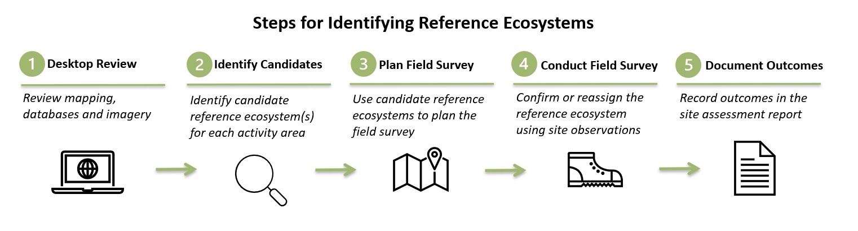
Reference ecosystems that do not meet the definition of forest cover in the method cannot be used under the replanting method.

6.3 Benchmark values
Benchmark values describe the expected condition of a reference ecosystem for each ecosystem condition indicator and are used to assess project outcomes. Benchmark values must be determined in accordance with paragraph 30(1)(b) of the method. Before undertaking the field survey, the SQP must use the Approved Benchmark Source List to check whether benchmark values are available and appropriate for each ecosystem condition indicator or sub-indicator, based on the preliminary reference ecosystem identified through desktop assessment. Where a benchmark value from the list is not used for an indicator or sub-indicator, the site assessment report must include a justification for why the value was not considered appropriate.
After the field survey, and once the reference ecosystem has been validated or re-assigned, the SQP must determine whether the benchmark values identified in the Approved Benchmark Source List remain appropriate for the validated reference ecosystem.
If data from the Approved Benchmark Source List is not appropriate or available, benchmark values must be determined in accordance with Schedule 2 of the method.

6.4 Establishing permanent sampling plots
Section 2 of Schedule 5 of the method sets out the requirements for establishing permanent sampling plots that will be used as a part of the SSA and for ongoing monitoring. The SQP must follow the steps in subsections (3)-(10) of section 5 to establish permanent sampling plots for each activity area.
Before the field survey, the SQP must plan the establishment of permanent sampling plots by confirming preliminary activity area boundaries, determining the required number of plots and generating randomly selected plot locations. Desktop assessment should be used to ensure proposed plot locations are likely to be representative of at least 90% of the activity area and to identify any access, safety or cultural considerations. The location and number of permanent sampling plots may need to be revised based on any adjustments to proposed activity areas from field-based assessments. In this case, it may be useful to randomly generate extra permanent sampling plots when initial plots need may need to be discarded.
If sub areas are utilised, there must be at least one permanent sampling plot within each sub-area.
During the field survey, the SQP must verify and finalise the location of permanent sampling plots on ground, adjusting locations where necessary to ensure coverage of at least 90% of the activity area. Permanent markers must be installed and unique identifiers assigned, with marker placement consistent with safe access and culturally informed project design. Any changes from preliminary plot locations must be recorded and justified.

6.5 Ecosystem condition
Ecosystem condition is assessed to establish the starting condition of each activity area and is measured again at each reporting period to show whether the project is achieving its intended outcomes. The ecosystem condition of each activity area must be assessed in accordance with section 30 and Schedule 5 of the method. This includes determining the values of the indicators for ecosystem condition and the starting ecosystem condition state for each activity area.
The information generated through the assessment of ecosystem condition must be included in the site assessment report. The outcomes of the ecosystem condition assessment must also be reflected in the project plan.
Use the Site assessment and monitoring report field capture template to record the required data and calculations for the field survey.

During the field survey
The following requirements must be undertaken on-ground as part of the ecosystem assessment process for each permanent sampling plot. The SQP must:
- take six photos of each permanent sampling plot
- measure canopy height. Where there are fewer than three representative trees within a permanent sampling plot, the canopy height must be recorded as zero. This measurement reflects the baseline ecosystem condition of the plot at the time of the field survey. The absence of representative trees, together with the justification for recording a zero-value canopy height, must be clearly documented in the site assessment report
- apply the point intercept method to the permanent sampling plots
- apply the quadrat method to the permanent sampling plots
- apply the plot survey to gather plant species composition data.
If the SQP cannot identify a plant to the species level during the field survey, they must deal with the unidentified species in accordance with section 4 of Schedule 5 of the method.

After the field survey
After field data has been collected, the SQP must complete the calculations required to finalise the ecosystem condition results for each activity area. The SQP must:
- calculate the indicator values for ecosystem condition
- determine the starting ecosystem condition state.

6.6 Ecosystem scores
After the field survey has been completed and once all required field data has been collected, verified and finalised, the SQP must calculate the required ecosystem scores in accordance with subsections 30(2–3) and Schedule 8 of the method. Ecosystem scores must be calculated using the National Biodiversity Assessment System (NBAS), accessed through PLANR.
If any issues are experienced in relation to PLANR, please refer to the PLANR Guidance. If issues persist, contact the PLANR Team at planr@dcceew.gov.au. To help the PLANR team assist you, please include:
- a brief description of what you're trying to do
- any relevant files, including geospatial data
- a short summary of the data’s history, including:
  - how the data was created or processed
  - software used
  - source datasets or references.

7. Historic drivers of change
The project proponent or the SQP must assess the historic drivers of change associated with the biodiversity of native species within the project area. This assessment provides context for the condition of the project area.
The assessment must be informed by desktop analysis and on ground inspection. The SQP must certify the identified historic drivers, the evidence relied upon, and how these were considered in the SSA. This information must be documented in the site assessment report.

8. Checklists of SSA requirements
The following checklists provide a summary of the tasks and requirements involved in completing the SSA. The checklists outline the recommended order for undertaking the SSA, grouped into activities that should be completed prior, during, and after the field survey. These checklists are intended as an aid only and do not replace the requirements set out in the method.

8.1 Prior to the field survey – Desktop analysis
 | Requirement | Legislative reference
☐ | Land eligibility for the project area and each proposed activity area has been assessed including the identification of covenants and legal interests | Sections 27 and 33(5)
☐ | Indigenous land interests have been identified for the project area | Section 28
☐ | Where Indigenous land interests apply, appropriate engagement has been undertaken | Section 28
☐ | Preliminary reference ecosystem(s) have been identified | Sections 30(1)(a) and 46
☐ | Availability and suitability of benchmark values have been checked using the Approved Benchmark Source List | Section 30(1)(b)
☐ | Preliminary permanent sampling plot locations have been randomly generated for each proposed activity area | Section 30(1)(c)
☐ | Potential threats within each activity area and the surrounding landscape have been identified | Sections 32(a) and 34
☐ | Significant hydrological features have been identified using the PMST | Section 32(c)
☐ | Threatened species and threatened ecological communities likely to occur have been identified using the PMST | Section 32(d)
☐ | Historic drivers of change have been identified | Section 31
☐ | The optimal growth period for the relevant NRM region has been identified | Section 26(3)

8.2 During the field survey – On ground field work
 | Requirement | Legislative reference
☐ | Where Indigenous land interests apply, appropriate engagement has occurred for the field survey | Section 28
☐ | Field survey was conducted at, or as close as practicable to, the optimal growth period | Section 26(3)
☐ | Desktop-identified reference ecosystems have been validated or reassigned where necessary | Section 46
☐ | Permanent sampling plots have been established for each activity area | Section 30(1)(c) and (Schedule 5(2)
☐ | Six photographs were taken for each permanent sampling plot | Section 30(1)(d) and Schedule 5(3)
☐ | Canopy height was measured for each permanent sampling plot | Section 30(1)(e) and Schedule 5(5)
☐ | Point-intercept surveys were completed for each permanent sampling plot | Schedule 3 and Schedule 5(6)
☐ | Quadrat surveys were completed for each permanent sampling plot | Schedule 4 and5(7)
☐ | Natural regeneration data (species, age, abundance) was identified and recorded where present | Section 32(e)
☐ | Threats to the project were verified and refined on ground | Sections 32(a) and 34
☐ | Significant hydrological features were verified and refined on ground | Section 32(c)
☐ | Threatened species and threatened ecological communities were verified and refined on ground | Section 32(d)
☐ | Historic drivers of change were verified and refined on ground | Section 31
☐ | Where the approved source benchmark list is not appropriate for one or more indicators, benchmark values have been established through surveying benchmark survey sites | Section 30(1)(b)(ii) and Schedule 2

8.3 After the field survey – Desktop analysis
 | Requirement | Legislative reference
☐ | Indicator values for ecosystem condition have been calculated | Schedule 5, part 10
☐ | The starting ecosystem condition state has been determined for each activity area | Schedule 5, part 11
☐ | The SQP has confirmed benchmark values and finalised Schedule 2 benchmark survey values where required | Section 30(1), Schedule 2
☐ | Ecosystem scores were calculated using NBAS in PLANR | Section 30(2-3), Schedule 8
☐ | Climate change vulnerabilities relevant to the project area have been identified | Section 32(b)
☐ | Where Indigenous knowledge or values or data has informed project’s design or implementation, consent has been obtained for the use of the knowledge or values or data, culturally appropriate ways have been used for the use of the knowledge values or data | Section 29
☐ | The site assessment report has been prepared | Division2.5
☐ | The SQP has certified the site assessment report | Section 26(6)
☐ | The project plan has been prepared | Division 2.6
☐ | The SQP has certified the project plan, unless they or another SQP has prepared it | Section 36(3)

