Replanting Native Forest and Woodland Ecosystems

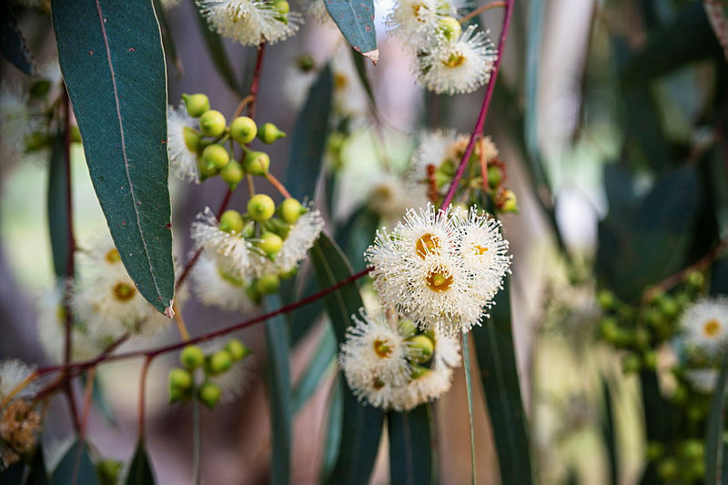Information Pack

V1.0 2025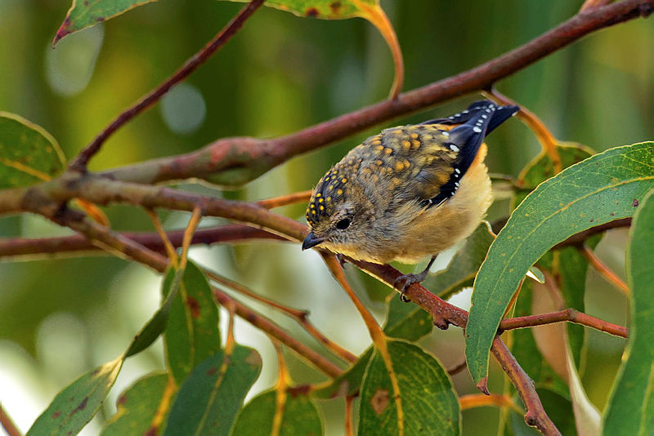

Contents

1. Purpose 3

2. Nature Repair Market scheme 3

2.1 The method 3

2.2 Steps to participate 4

3. Participation 5

4. Running your project 6

4.1 Right to carry out your biodiversity project 6

4.2 Regulatory approvals 7

4.3 Project area boundary 8

4.4 Remediation measures 8

4.5 Changes to your project 9

4.6 Permanence requirements 9

4.7 Relinquishment requirements 9

5. Method requirements 9

5.1 Land eligibility requirements 10

5.2 Indigenous engagement 13

5.3 Starting state assessment and project plan 13

5.4 Project outcomes 14

5.5 Management activities 16

5.6 Activities not to be carried out 16

6. Reporting, auditing and certificate issuance 17

6.1 Reporting 17

6.2 Audits 17

6.3 Certificate Issuance 17

7. Stacking with the Australian Carbon Credit Unit scheme 18

7.1 Stratification 18

7.2 Areas of alignment 19

8. Key Terms 20

# Purpose

This document provides general guidance on running a project under the [Nature Repair (Replanting Native Forest and Woodland Ecosystems) Methodology Determination 2025](https://www.legislation.gov.au/F2025L00253/asmade/text)[1] (the method). As a potential project proponent, you should ensure you are aware of all requirements under the method and its associated legislation. You can find further information on the [Nature Repair Market scheme](https://cer.gov.au/schemes/nature-repair-market-scheme)[2] on the Clean Energy Regulator website.

# Nature Repair Market scheme

The Nature Repair Market scheme is an Australian Government initiative that provides a framework to restore and protect the environment. It encourages land management practices that deliver improved *biodiversity outcomes* for Australia.

Individuals and organisations who run successful projects can apply for a *biodiversity certificate*. One certificate is issued per project. This certificate can be:

* sold to a range of buyers to generate income
* held by the owner
* deposited with the Clean Energy Regulator.

## Individuals and organisations that invest in a project or hold a biodiversity certificate may wish to make public statements or ‘claims’ about biodiversity outcomes being delivered by the project.

## 2.1 The method

This method is designed to enhance or protect biodiversity in native species by replanting native forest and woodland ecosystems on historically cleared land landscapes that will improve native vegetation or support ecological connectivity.

The method specifies:

* the planting activities to be carried out
* engagement with *relevant Aboriginal persons or Torres Strait Islanders*
* how you measure biodiversity
* monitoring, record keeping and reporting requirements.

You must run your project in accordance with the method.

2.2 Steps to participate

#### Eligibility criteria and scheme requirements

Review the [method](https://www.legislation.gov.au/F2025L00253/asmade/text)1 requirements and the Nature Repair Market scheme requirements on our [website](https://cer.gov.au/schemes/nature-repair-market-scheme/how-to-participate-nature-repair-market-scheme)2 to determine you and your project’s eligibility. There may be requirements for early engagement with relevant Indigenous representatives in relation to design and implementation of the project. You can also visit Platform for Land and Nature Repair ([*PLANR*](https://planr.gov.au/)[3]), which is an online tool to support landholders to participate in the scheme.

#### Undertake starting state assessment and develop project plan

A starting state assessmentand *project plan* undertaken by a suitably qualified personwill determine:

* + - * + the *starting ecosystem condition* state of the land
        + the *reference ecosystem* to be restored
        + the restoration *target level* to be achieved from the planting.

For projects nominating to enhance a *culturally significant entity*, the *starting state assessment* must include this information (see section 5.4 below for more details).

#### Register project

You must submit the application to register the project through our [Online Services](https://cer.gov.au/online-systems#online-services)[4] platform. We will assess the application to verify that the project meets the requirements. Once your project is registered, we will publish it on the *Biodiversity Market Register*.

#### Establish and maintain project

Following registration, you must ensure the project will be carried out in accordance with the *project plan*. The method defines activities can be undertaken to support the implementation and maintenance of the project.

#### Monitor and report

You will need to monitor the project and will need to submit this to us along with a *biodiversity project report* to demonstrate that the project is on track. A report must be submitted at least every 6 months to 5 years. Review and update your *project plan* if required.

#### Claim biodiversity certificate

You can apply for a biodiversity certificate when:

* + - * + the *ecosystem condition* *indicators* in the planting reaches certain *threshold values* for *biodiversity certificate* issuance
        + if relevant, any *culturally significant entity* indicators have reached certain thresholds
        + it is clear the project can achieve the biodiversity outcome.

One certificate will be issued per project.

# 3. Participation

#### Project proponent

The project proponent is the individual or organisation responsible for carrying out a project. The project proponent will be issued the *biodiversity certificate* generated by the project and has a legal relationship with us.

#### Nominee

If a project has multiple project proponents, one must be appointed as the nominee for the project. The nominee is authorised to act on behalf of multiple project proponents. Each project proponent will need to provide their written consent to the appointment of the nominee.

#### Identity check and fit and proper person assessment

To be a project proponent, you will need to provide proof of identity as a part of your project registration application and be recognised as a fit and proper person (FPP).

Each project proponent will be required to undergo a FPP assessment. It involves providing information about any convictions or insolvency and whether you have the appropriate capabilities to run a project. This includes undergoing an [Australian Federal Police (National Police Check](http://www.cleanenergyregulator.gov.au/DocumentAssets/Documents/AFP%20National%20Police%20Check%20-%20Clean%20Energy%20Regulator.doc)). Each project proponent must provide 100 points of identification, with options for the electronic verification of your identity through [greenID](https://gbg-greenid.com/)[5] or providing scanned, certified true copies of original, current identity documents.

#### Skills and expertise

At the time of project registration, you need to be able to demonstrate that you understand the likely appropriate skills, experience, or expertise required to carry out the project in accordance with the method requirements. For example, you can include details of contractors, experts or third parties you plan to engage to assist with establishing the project and to support project administration.

#### Project administration – Online Services account

[Online Services](https://cer.gov.au/online-systems#online-services)[6] is a secure digital platform that supports participation across all schemes administered by us including the Nature Repair Market scheme. This is where you access online forms, and other important information.

To apply to register your biodiversity project, you will need to create an Online Services account. For projects with multiple project proponents, each project proponent will need an Online Services account to complete scheme enrolment.

#### Agents

You can be the project proponent and still engage someone else as an agent for your project. An agent will act on your behalf according to the terms of your agreement with them.

#### Cultural Statement and/or Acknowledgement of Country

The Nature Repair Market scheme is actively supporting the inclusion of Indigenous knowledge and values in line with the consent and preferences of knowledge holders. We encourage project proponents who are interacting with Indigenous knowledge and values in project design and implementation to submit a cultural statement, prepared by a relevant First Nations person, to be published alongside the project on the *Biodiversity Market Register*.

We also encourage project proponent(s) to provide an Acknowledgement of Country with respects to their *project area* to be published on the *Biodiversity Market Register*.

Only the project proponent can submit the cultural statement and/or Acknowledgement of Country. You can submit this with your application to register your biodiversity project, or at any time throughout the life of the project by emailing us at naturerepairmarket@cer.gov.au.

The submission and publication of a cultural statement or Acknowledgement of Country is voluntary and optional. The process to submit a cultural statement or Acknowledgement of Country does not replace and cannot be used to meet requirements under the legislation applicable for the project. For more information please see [guidance on the Department of Climate Change, Energy, the Environment and Water’s (the department) website](https://www.dcceew.gov.au/environment/environmental-markets/nature-repair-market/incorporated-documents-and-resources)[7].

# 4. Running your project

## 4.1 Right to carry out your biodiversity project

You will need demonstrate that you have the right to carry out project activities on the land. You can either:

* have the right to carry out the project on that land, or
* have received consent to carry out the project on that land.

This ensures projects aren’t registered on land without the landholder’s knowledge and consent. If your right to carry out the project or your responsibility for it ceases after your project is registered, you must notify us within 90 days.

#### Land interest holder consent

If a project proponent(s) for the *project area* is not the landholder, or does not have exclusive ownership of the land, they will need to obtain consent to carry out the project from the relevant individual, company or organisation who owns the land.

You can use the [Land interest holder consent](https://cer.gov.au/schemes/nature-repair-market-scheme/how-to-participate-nature-repair-market-scheme/apply-to-participate-nature-repair-market-scheme/right-to-carry-out-your-biodiversity-project)[8] form to obtain and demonstrate this consent.

Land interest holder consent must be demonstrated upon registration of your biodiversity project and cannot be conditionally registered.

#### Native title area consent

If your project is on determined native title area, and you are not the registered native title body corporate for the *project area*, you need to get consent from the registered native title body corporate to register and carry out your project.

|  |
| --- |
| * + - * You must get consent to register your project before you submit your application for registration.       * If the registered native title body corporate provides consent to the registration of the project but has not yet provided consent to you carrying out the project, we can register it with a condition that you provide evidence of this consent before we can issue your project a certificate.       * Consent can also be set out in a registered Indigenous Land Use Agreement. |

You can use this [Registered native title body corporate consent form](https://cer.gov.au/schemes/nature-repair-market-scheme/how-to-participate-nature-repair-market-scheme/apply-to-participate-nature-repair-market-scheme/right-to-carry-out-your-biodiversity-project)8 to obtain this consent.

#### Eligible Interest Holders

If another individual or organisation has an eligible interest in the *project area*, you must get their consent to undertake your biodiversity project.

Eligible interest holders may include:

* banks or mortgagees
* Crown Lands Ministers of the state and territory
* Aboriginal land councils.

If you have identified any eligible interest-holders, they must sign an [Eligible interest-holder consent form](https://cer.gov.au/schemes/nature-repair-market-scheme/how-to-participate-nature-repair-market-scheme/apply-to-participate-nature-repair-market-scheme/right-to-carry-out-your-biodiversity-project)8. A project will be registered ‘conditionally’ until all consents and approvals are provided through a project variation**.** Conditionally registered projects cannot receive a biodiversity certificate.

## 4.2 Regulatory approvals

You will need to obtain all relevant planning or environmental approvals to carry out your project activity. This relates to relevant Australian Government, state and territory and local government approvals, permits and licence requirements relating to land use, the environment and water that are required to carry out your land management activities.

Regulatory approvals may be required for:

* preparation prior to planting
* planting
* weed control treatment
* the application of fertiliser.

If your project requires regulatory approvals or permits, these must be obtained and supplied to us when applying to register your biodiversity project or within 5 years of registering the project.

If you are unsure if any regulatory approvals are required, you should contact your state planning authority and local government or [Natural Resource Management (NRM) group](https://nrmregionsaustralia.com.au/nrm-regions-map/)[9]. Project registration does not replace or include relevant local, state or federal approvals.

## 4.3 Project area boundary

The *project area* is the area or areas of land on which the biodiversity project is to be carried out.

When you apply for project registration, you will be required to:

* supply the location details of the project
* declare your *project area* boundaries by attaching a geospatial map of your *project area* to your application
* demonstrate that you have the right to carry out your project and identify if there any eligible interest holders.

#### Geospatial mapping requirements

Your map of the *project area* needs to comply with the [Nature Repair Mapping Guidelines](https://www.dcceew.gov.au/environment/environmental-markets/nature-repair-market/incorporated-documents-and-resources)[10]. You must use a common, interchangeable digital geographic information system (GIS) format, such as, Shapefile, Geodatabase, or KML.

Platform for Land and Nature Repair *(*[*PLANR*](https://planr.gov.au/)[11]*)* can be used to map your *project area* boundary and export a Shapefile to upload with your biodiversity project registration application.

## 4.4 Remediation measures

Biodiversity projects will not be registered by us if the project is required to be carried out, either wholly or in part, as a remediation measure for the contravention of a Commonwealth, State or Territory law.

## 4.5 Changes to your project

#### Variations

Once you register your project, you need to apply for a variation if you want to make changes to your project, update its details or cancel it.

#### Notifications

You must also let us know if certain conditions of your project change, such as an event or conduct that causes, or is likely to cause a reversal of biodiversity outcome, or there is a change to your project plan.

For more information on how to vary your project or notification requirements, please see our [website](https://cer.gov.au/schemes/nature-repair-market-scheme/how-to-participate-nature-repair-market-scheme/apply-to-participate-nature-repair-market-scheme/right-to-carry-out-your-biodiversity-project)[12].

## 4.6 Permanence requirements

The permanence period for a registered biodiversity project is the minimum length of time that the project proponent must achieve and maintain the *biodiversity outcome*. You must choose whether your project has a 25-year (type A) or 100-year (type B) permanence period at project registration. The permanence period will begin when the project is approved for registration.



## 4.7 Relinquishment requirements

You are required to maintain the biodiversity in the *project area* over the duration of the permanence period. However, you can cancel your project, for example because you wish to use the land for another purpose. If your project has been issued a *biodiversity certificate*, this would require you to voluntarily relinquish that certificate. We may also require you to relinquish your certificate by issuing a relinquishment notice under certain circumstances.

The first way to comply with a relinquishment notice is to give back the particular certificate that the notice relates to (the *original biodiversity certificate*). Alternatively, if you have sold the *biodiversity certificate* or it’s been cancelled, then you would need to ensure that one or more other equivalent certificates are relinquished.

Relinquishment requirements may also apply if the permanence period for the project has not ended, and biodiversity is reversed through non-natural disturbance (clearing vegetation or mismanagement of project), then you may be issued a relinquishment notice by us.

#### Biodiversity maintenance declarations

We can make a biodiversity maintenance declaration in relation to a specified area of land (known as a biodiversity maintenance area) where there has been non-compliance or likely non-compliance with a relinquishment notice. A biodiversity maintenance declaration may specify one or more activities that are declared prohibited activities in relation to the biodiversity maintenance area.

# 5. Method requirements

Projects registered under this method will undertake plantings of species consistent with the relevant *reference ecosystem* on that land. Generally, the *reference ecosystem* will be the native vegetation type that was present on the land prior to clearing.

## 5.1 Land eligibility requirements

This method is applicable to Australia’s in modified landscapes that have been cleared of native forest or woodlands at some time in the past and currently do not support native forest cover. Only certain areas of land are eligible to be included in the *project area*.

Eligible regions

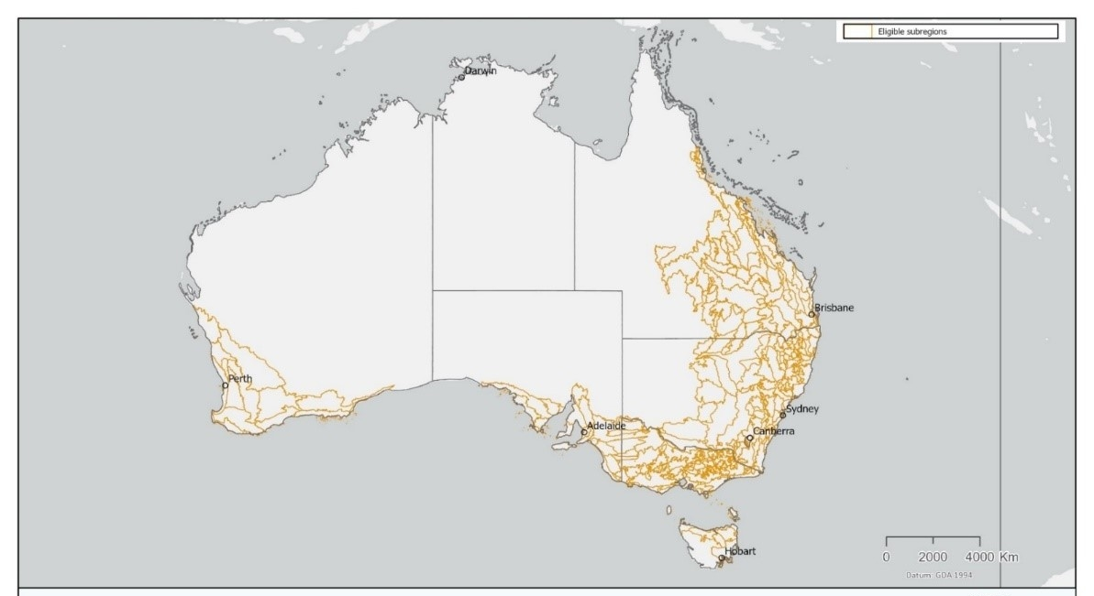Your *project area* must be entirely located within specific Australian biogeographic regions, as listed in the method (see Figure 1). Visit the department’s website to view a [map of eligible regions](https://fed.dcceew.gov.au/datasets/erin::replanting-native-forest-and-woodland-ecosystems-method-eligible-regions/about)[13].

**Figure 1: Map of regions that are eligible under the method**

Activity areas

Your *project area* will need to contain one or more *activity areas*, which are the areas where you will conduct your planting. Land in *activity areas* must also meet certain land eligibility requirements. For example, *activity areas* must be on land that has historically been cleared, is not currently forested and does not already contain significant amounts of regenerating trees.

*Activity areas* will need to be further stratified (that is, split up, or aggregated, into different units) so that they each have a *starting ecosystem condition state* and aim to the designated restoration *target level*. *Activity areas* will also need to be planted with vegetation from its *reference ecosystem*, reflecting the condition of the relevant ecosystem in an ‘unmodified’, ‘natural’ or ‘intact’ state.

You may be able to include multiple *reference ecosystems* within a single *activity area* if they are mapped as separate sub-areas and meet certain requirements. This allows for the same amount of monitoring to be undertaken, even though there are different vegetation mixes within the *activity area*.

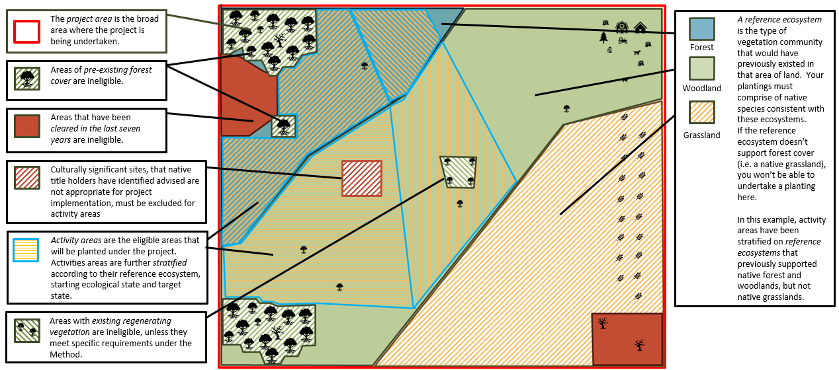

**Figure 2. Example stratification of project area and activity areas**

## 5.2 Indigenous engagement

If your *project area* is subject to Indigenous land interests (land interests), you must engage appropriately with the *relevant Indigenous representatives* on the design and implementation of the project. Land interests are when the *project area* or part of the *project area* includes:

* native title areas
* Aboriginal land rights land
* areas subject to an Indigenous Land Use Agreement
* areas of land with undetermined claimant applications (within the meaning of the *Native Title Act 1993).*

However, if there are no land interests, the project proponent may still engage with *relevant Aboriginal persons or Torres Strait Islanders* for the *project area* in relation to the design and implementation of the replanting project. This would also contribute to the project being designed and implemented in a culturally informed way.

#### Engaging appropriately

Appropriate Indigenous engagement means engaging in a way that acknowledges and respects the customs of the *relevant Aboriginal persons or Torres Strait Islanders*. The intent is to ensure they are provided the opportunity to contribute their knowledge and values to the design or implementation of the project in a way that reflects their wishes and traditions.

Any required or voluntary engagement, including prior to nominating a *culturally significant entity*, must be documented in the *starting state assessment*. The *project plan* must also include any description of such engagement with *relevant Aboriginal persons and Torres Strait Islanders* for the *project area* that has occurred in relation to the design and proposed implementation of the project.

**Using Indigenous knowledge and values or Indigenous data**

If your project includes or is informed by Indigenous knowledge, values or Indigenous data, you must document how it is used in the design or implementation of your project. You must also obtain the appropriate attribution, and the consent for the use of that information. This must be done in a culturally appropriate way for the collection and use of that information, and you must ensure that you continue to implement your project consistently with the consent provided.

## 5.3 Starting state assessment and project plan

#### Engage a suitably qualified person

You will need to engage a suitably qualified person to help with your project. This person is involved with the field survey during the starting state assessment, ecosystem assessment and developing the *project plan*. They will also need to be involved in monitoring and preparing monitoring reports for your project when you submit *biodiversity project reports* to us as your project progresses. The suitably qualified person must:

* have qualifications in ecology, botany or an equivalent discipline
* have at least 3 years, post the award of the qualification, working as an ecologist or botanist or equivalent, and
* have practised as an ecologist or botanist or equivalent within the past 3 years.

#### Starting state assessment

You and the suitably qualified person will prepare a *site assessment report* summarising the fieldwork undertaken during the starting state assessment. This will determine the *starting ecosystem condition state* of each *activity area*, the *reference ecosystem* that will guide restoration efforts and the restoration *target level* to be achieved. You must submit the *site assessment report* with your application to register a project.

The starting state assessment must be informed by data obtained from:

* virtual (desktop) assessments of the *project area* including PLANR
* permanent sampling plots established within your *project area*
* field surveys of these sampling plots undertaken by the suitably qualified person.

#### Project plan

When submitting your registration for your project, you must include a *project plan*. The *project plan* serves as a working document to guide the implementation of your project towards your nominated *biodiversity outcome* and will address management of risks.

The *project plan* must:

* be prepared or certified by a suitably qualified person
* be maintained and kept up to date throughout the permanence period of the project
* present data consistent with the [Data Submission Guidelines](https://www.dcceew.gov.au/environment/environmental-markets/nature-repair-market/incorporated-documents-and-resources)[14]
* if applicable, include the description of, and plan for enhancement or protection to, any *culturally significant entities* as part of the project.

We can only approve your registration if we are confident that the design of your project and how it will be carried out, as presented in the *project plan*, will achieve the *biodiversity outcome* and result in a *biodiversity certificate* being issued for your project. 

## 5.4 Project outcomes

#### Ecosystem condition

To deliver the *biodiversity outcome*, you will need to track its *ecosystem condition*. *Ecosystem condition* relates of the condition of the land being enhanced through your project. This is tracked through the measurement of a range of *ecosystem condition indicators*, which are assessed at key project checkpoints. These *ecosystem condition indicators* are compared to the *reference ecosystem* and *benchmark values.*You can apply for a *biodiversity certificate* when the *ecosystem condition indicators* reach certain threshold values. This is the point where it is considered likely the *biodiversity outcome* will be achieved.

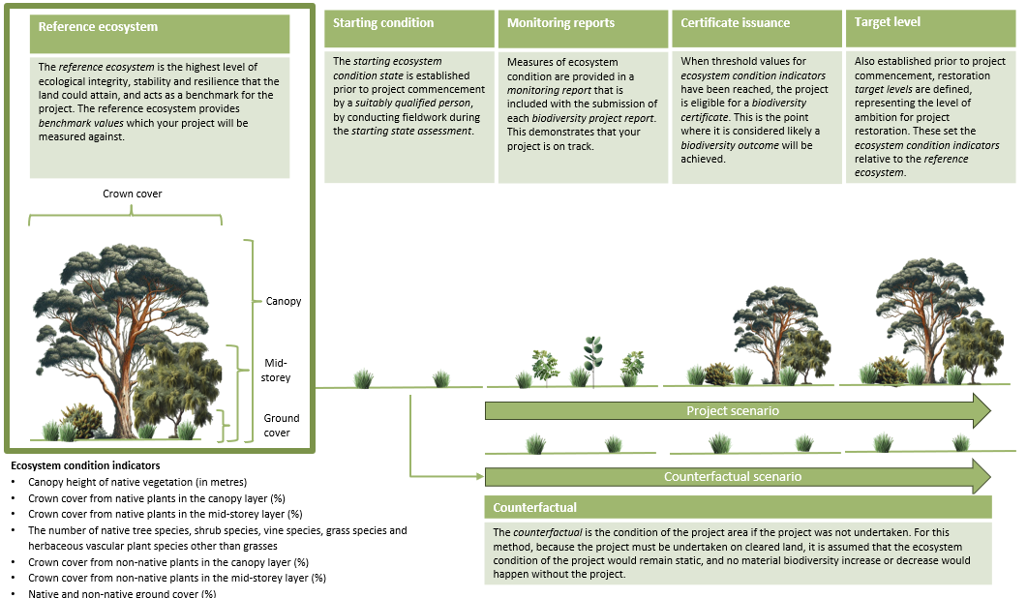

**Figure 3. Timeline of ecosystem condition through key checkpoints**

#### Culturally significant entities

Your *biodiversity outcome* may also be informed by the enhancement or protection of *culturally significant entities*. *Culturally significant entities* are a thing, place, matter or process within the *project area* that has cultural significance to *relevant Aboriginal persons or Torres Strait Islanders* (for example, a totem species, significant tree or ecosystem or meeting place).

Including a *culturally significant entity* is optional and can be nominated either before, or after, project registration. You may nominate a *culturally significant entity* whether or not your *project area* is subject to Indigenous land interests, so long as you appropriately engage with *relevant Aboriginal persons or Torres Strait Islanders* for the *project area*.

You must ensure that you understand the specific legislative requirements around nominating a *culturally significant* entity. For example, you must come to an agreement with the *relevant Aboriginal persons or Torres Strait Islanders* on how the *culturally significant entity* will be identified, its indicators, starting state, *threshold values,* restoration targets, and how it will be verified and monitored in a culturally appropriate manner, in addition to what extent this information should be included on the *Biodiversity Market Register*.

First Nations knowledge, values and culture is specific to particular people and places. A process to identify culturally significant entities will be guided by the relevant Aboriginal Persons and Torres Strait Islanders, to suit their cultural priorities and needs.

## 5.5 Management activities

Management activities are taken to support the achievement and maintenance of the *biodiversity outcome* or to minimise threats, and must be undertaken in accordance with certain requirements.

#### Fire

Fire can be used as a mechanism for managing your *activity area* however you must ensure that you are meeting the specific method requirements.

#### Grazing

You must carefully manage grazing pressure during your project according to the following requirements:

* Exclusion of livestock: all livestock grazing must be excluded from an *activity area* until the plantings are established, defined as 90% of individual trees within the area reaching a height of 1.5 metres
* Managing total grazing pressure: manage all grazing pressure, including from livestock, vertebrate pests and overabundant native species (such as kangaroos and wombats).

#### Ecological thinning

Thinning may be conducted where appropriate to achieve the *biodiversity outcome* within the *activity area* no earlier than 10 years after the project registration.

## 5.6 Activities not to be carried out

Throughout your permanence period, there are some activities which cannot be carried out in the project area.

#### Biomass and other removals

The destruction or removal of native plant biomass, including woody debris, standing dead trees, rocks, soil, fruits, nuts, and seeds, is prohibited in the *project area* with some exceptions. These exceptions include using some fallen timber for personal use, thinning for ecological purposes, harvesting of fruits, nuts and seeds, and activities conducted in accordance with traditional Indigenous practices or native title rights.

#### Rubbish

Disposal, dumping, or burning of rubbish within the *project area* is prohibited.

#### Ground and rock disturbance

Ground and rock disturbance, including ploughing, ripping or equivalent, is prohibited, other than necessary for the purpose of establishing plantings.

# 6. Reporting, auditing and certificate issuance

## 6.1 Reporting

You must report on your project to receive a certificate and must report at least every 5 years. Reporting on your project could include:

* **category B report** – you must submit a category B report at least every 5 years when a *biodiversity certificate* hasn’t been issued for your project. The report must include an assessment of the project implementation against the *project plan*.
* **initial category A report** - you must submit an initial category A report with your application for a *biodiversity certificate.*
* **subsequent category A report** - you must submit a subsequent report at least every 5 years from when we issue you a *biodiversity certificate* (unless an exemption applies). You must also provide an assessment of the project implementation against the *project plan*.

## 6.2 Audits

You will be required to provide an audit with your initial category A report to accompany your application for a *biodiversity certificate*. A registered greenhouse and energy auditor must prepare the audit report. You can [find an auditor](https://cer.gov.au/schemes/audits-our-schemes/find-auditor)[15] on our website.

## 6.3 Certificate Issuance

You can apply for a *biodiversity certificate* when the project is sufficiently progressed to have resulted in, or be likely to result in, the *biodiversity outcome*, and the *threshold values* for *ecosystem condition indicators* has been met. If nominated, the *culturally significant entity threshold values* of the indicators must also be met.

If you use Indigenous knowledge and values in project design or implementation, you must demonstrate that you have done so with in line with the consent, when applying for a *biodiversity certificate*.

We can issue one certificate per project.

You need to provide a category A report with your application. We will assess your claim to make sure it complies with legislative requirements. The method sets out detailed requirements for when we can issue a *biodiversity certificate*.

If we approve your application, we will issue you a *biodiversity certificate.*

Ownership of a *biodiversity certificate* may have financial implications. Individuals may benefit from seeking independent advice on the implications and responsibilities of owning or trading a *biodiversity certificate*.

# 7. Stacking with the Australian Carbon Credit Unit scheme

* A stacked project refers to a two or more projects being undertaken on the same, or partially overlapping, areas of land that are being rewarded for different outcomes.
* A project being rewarded under the ACCU scheme for the carbon sequestered in woody vegetation and debris can also be rewarded under the Nature Repair Market scheme for the *biodiversity outcome* from improvement in the extent and condition of native vegetation.

If you wish to register a stacked project under both the Australian Carbon Credit Unit (ACCU) Scheme and Nature Repair Market scheme, you must submit 2 separate applications to us. This is necessary to comply with the separate legislative requirements under each scheme.

|  |
| --- |
| Stacking with ACCU method  There may be opportunities to design a planting project that meets the requirements under [Reforestation by Environmental and Mallee Plantings – FullCAM 2024 method](https://cer.gov.au/schemes/australian-carbon-credit-unit-scheme/accu-scheme-methods/reforestation-environmental-or-mallee-plantings-fullcam-method-2024)[16] and the [Nature Repair (Replanting Native Forest and Woodland Ecosystems) Methodology Determination 2025](https://www.legislation.gov.au/F2025L00253/asmade/text)[17]  Make sure you understand ACCU scheme and Nature Repair Market scheme eligibility requirements before starting your planting activities to ensure you can participate in both schemes for the same plantings. In particular:   * to meet the ‘newness’ test under the ACCU scheme, your ACCU project registration application must be submitted first * if you have already started planting trees for a biodiversity project but you haven’t registered your ACCU project, you will not be able to claim the carbon benefit from the plantings. |

## 7.1 Stratification

Stratification under each scheme enables the delineation of areas to support the quantification of the specific outcomes being delivered:

* **Carbon estimation areas** under the ACCU Scheme represent the areas where the project mechanism is being undertaken to enable the calculation of carbon stock change and emissions from biomass burning through the FullCAM model, based on management and disturbance events experienced within that area of land subject to planting.
* **Activity areas** under the Nature Repair Market scheme represent the areas where the project mechanism is being undertaken to describe, forecast and quantify the *biodiversity outcome* being delivered by the project, including the *reference ecosystem*, its *starting ecosystem condition state* and its restoration *target level*.

As a result, there are differing stratification requirements under each scheme, including differing requirements for inclusion and exclusion of land, and the delineation of these areas to support carbon modelling or *biodiversity outcomes*.

## 7.2 Areas of alignment

#### Planning your Nature Repair Market and ACCU project

You can undertake common activities that will support project planning for both the ACCU scheme and Nature Repair Market scheme including:

* planning, designing or determining the feasibility of the project
* obtaining consents or regulatory approval to conduct the project (noting these requirements may differ across the schemes)
* engaging experts to support both carbon and biodiversity aspects of the project.

#### Linking your ACCU project on the Biodiversity Market Register

****If an ACCU scheme project is taking place on the same area of land as a biodiversity project, you can request to publish this detail of this overlap and a link to the project on the *Biodiversity Market Register*.

To submit this request, download and complete the [Request to publish additional information about a project in a related scheme on the Biodiversity Market Register](https://cer.gov.au/markets/reports-and-data/biodiversity-market-register)[18] form.

#### Reporting

Offsets reports under the ACCU Scheme and *biodiversity project reports* under the Nature Repair Market scheme must be submitted every 6 months to 5 years. You can align the submission of reports under both schemes to support efficiencies.

#### Auditing

You may benefit from reduced audit costs by engaging a single auditor to cover requirements of both schemes at the same time, where possible. You can align the timing of audits by:

* timing the preparation and submission of the first category A biodiversity report to coincide with one of the scheduled audits of the ACCU Scheme project
* requesting that we vary your audit schedule for your ACCU Scheme project to align with the first category A biodiversity report.

|  |
| --- |
| We are here to help!  Contact us on 1300 553 542 or send an email to [naturerepairmarket@cer.gov.au](mailto:naturerepairmarket@cer.gov.au).  Visit the [Nature Repair Market](https://cer.gov.au/schemes/nature-repair-market)[19] webpage for more information or download guidance resources to help you register. |

# 8. Key Terms

|  |  |
| --- | --- |
| Term | Definition |
| activity area | An area within your project area where the project activities, (i.e. an environmental planting), will be or are being carried out. |
| benchmark values | The value of an indicator within a particular reference ecosystem of an activity area, providing a benchmark for a biodiversity project to be measured against. |
| biodiversity certificate | The tradable personal property established under the *Nature Repair Act 2023*, which is issued by the CER on satisfaction that a registered biodiversity project and project proponent meets statutory requirements. |
| ecosystem condition indicators | A measure used to evaluate ecosystem condition. Under the method, these indicators representing the structure and composition of vegetation are used to track progress of the project through comparison with benchmark values of the reference ecosystem. |
| Biodiversity Market Register | A publicly available electronic repository of information about registered biodiversity projects and biodiversity certificates issued under the Nature Repair Market scheme, hosted on the CER’s website. |
| biodiversity outcome | In relation to a biodiversity project, means the enhancement or protection of biodiversity that the project is designed to achieve. |
| biodiversity project report | Regular reports on the progress of a project and its achievement or maintenance of a biodiversity outcome. Biodiversity project reports can be submitted 6 monthly or at least 5 yearly. |
| CER | The Clean Energy Regulator (CER), an independent, statutory authority responsible for administering climate change and biodiversity law, including the *Nature Repair Act 2023*. |
| counterfactual | The predicted condition of the land if the project was not undertaken. Under this method, the counterfactual scenario is in the absence of the project, the condition of the land would remain static and the land would remain clear of forest cover. |
| culturally significant entities | A thing, place, place, matter or process within the project area that has cultural significance to relevant Aboriginal persons or Torres Strait Islanders. |
| department | The Department of Climate Change, Energy, the Environment and Water. |
| ecosystem condition | The ecosystem condition of an activity area or sub-area is the quality of its ecosystem, measured in in terms of its biotic and abiotic characteristics, in comparison with the reference ecosystem for the activity area or sub-area. |
| PLANR | PLANR is the Platform for Land and Nature Repair database available at [planr.gov.au](https://planr.gov.au/), which is provided by the department and supports participation in the Nature Repair Market Scheme. |
| project area | The land within which your biodiversity project occurs. The project area may be made up of one or more activity areas. Area within the project where activities are not occurring are exclusion areas. |
| project plan | A document prepared or certified by a suitably qualified person, that sets out the biodiversity outcome, the way in which the project will achieve it and all the information required under the legislation. |
| reference ecosystem | in relation to an activity area or sub-area,means an ecosystem that will serve as the model or benchmark for restoration, against which to compare the ecosystem condition of the activity area or sub-area. |
| relevant Aboriginal persons or Torres Strait Islanders | Relevant Aboriginal persons or Torres Strait Islanders to the project area means the Aboriginal persons and Torres Strait Islanders who have a demonstrated connection to the land or waters on or in which the project area is located. |
| relevant Indigenous Representative | Relevant Indigenous representatives for a project area means:   * the registered native title body corporate for the native title area; or * if the project area includes a native title area and there is no registered native title body corporate for the native title area—the persons, or group of persons, who hold the common or group rights; or * if the project area is or includes an area of land in relation to which a claimant application (within the meaning of the *Native Title Act 1993*) has been made but not yet determined—the native title claim group (within the meaning of that Act); or * Aboriginal land council that holds an eligible interest in the land; or * if the project area is subject to an indigenous land use agreement, a person who is a party to the agreement. |
| site assessment report | A report prepared or certified by the suitably qualified person upon completion of the starting state assessment, submitted as part of the application for registration of your project and used to inform the project plan. |
| starting state assessment | The assessment of your project area that involves a suitably qualified person. Used to determine the starting ecosystem condition state of your activity areas and the biodiversity outcome, and obtain the information and data required by the legislation. |
| starting ecosystem condition state | The initial ecosystem condition of an activity area, representing the condition of the land to support native biodiversity at the date of the site assessment. |
| target level | The nominated restoration target ecosystem condition level, reflecting the level of vegetation structure and composition aimed to be achieved within an activity area. This will set a goal for each biodiversity indicator, in relation to the reference ecosystem. |
| threshold values | The value that a biodiversity indicator has to reach in order for a project to be issued with a biodiversity certificate. |

1. https://legislation.gov.au/F2025L00253/asmade/text
2. https://cer.gov.au/schemes/nature-repair-market-scheme
3. https://planr.gov.au/
4. https://cer.gov.au/online-systems#online-services
5. https://gbg-greenid.com/
6. https://cer.gov.au/online-systems#online-services
7. https://www.dcceew.gov.au/environment/environmental-markets/nature-repair-market/incorporated-documents-and-resources
8. https://cer.gov.au/schemes/nature-repair-market-scheme/how-to-participate-nature-repair-market-scheme/apply-to-participate-nature-repair-market-scheme/right-to-carry-out-your-biodiversity-project
9. https://nrmregionsaustralia.com.au/nrm-regions-map/
10. https://www.dcceew.gov.au/environment/environmental-markets/nature-repair-market/incorporated-documents-and-resources
11. https://planr.gov.au/
12. https://cer.gov.au/schemes/nature-repair-market-scheme/how-to-participate-nature-repair-market-scheme
13. https://fed.dcceew.gov.au/datasets/erin::replanting-native-forest-and-woodland-ecosystems-method-eligible-regions/about
14. https://www.dcceew.gov.au/environment/environmental-markets/nature-repair-market/incorporated-documents-and-resources
15. https://cer.gov.au/schemes/audits-our-schemes/find-auditor
16. https://cer.gov.au/schemes/australian-carbon-credit-unit-scheme/accu-scheme-methods/reforestation-environmental-or-mallee-plantings-fullcam-method-2024
17. https://legislation.gov.au/F2025L00253/asmade/text
18. https://cer.gov.au/markets/reports-and-data/biodiversity-market-register
19. https://cer.gov.au/schemes/nature-repair-market