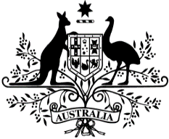
Australian Government
Climate Change, Energy, the Environment and Water
Clean Energy Regulator

COST RECOVERY IMPLEMENTATION STATEMENT
Renewable Energy Target
2024-2025

Charging for regulatory activity involves government entities charging individuals or organisations in the non-government sector some or all of the minimum efficient costs of a specific government activity. The Cost Recovery Policy along with the Australian Government Charging Framework (the Charging Framework) sets out the policy under which government entities design, implement and review charging for regulatory activities. The CRIS is the public document to ensure the transparency and accountability for the level of the charging and to demonstrate that the purpose for charging, as decided by Government, is being achieved.

Contents
1. INTRODUCTION 3
1.1. Purpose 3
2. POLICY AND STATUTORY AUTHORITY TO CHARGE (COST RECOVER) 5
2.1. Government policy approval to charge for this regulatory activity 5
2.2. Statutory authority to charge 5
3. CHARGING (COST RECOVERY) MODEL 5
3.1. Outputs and business processes of the activity 6
3.2. Design of the regulatory charge 9
4. RISK ASSESSMENT 10
5. STAKEHOLDER ENGAGEMENT 10
5.1. Stakeholder groups 10
5.2. Stakeholder consultation 11
6. FINANCIAL PERFORMANCE 11
6.1. Financial Estimates 11
6.2. Financial Outcomes 12
7. NON-FINANCIAL PERFORMANCE 12
8. KEY FORWARD DATES AND EVENTS 14
9. CRIS APPROVAL AND CHANGE REGISTER 14
Appendices 15
Glossary of terms and abbreviations 18

INTRODUCTION

Purpose
This Cost Recovery Implementation Statement (CRIS) provides information on how Clean Energy Regulator implements cost recovery charging for Renewable Energy Target. It reports actual financial and non-financial performance information for Renewable Energy Target and contains financial and demand forecasts for 2024-25 and three forward years. The Clean Energy Regulator will maintain the CRIS until the activity or cost recovery for the activity has been discontinued.

Description of the activity
The Renewable Energy Target (RET) scheme is designed to ensure that an additional 33,000 gigawatt­ hours of Australia's electricity comes from renewable sources every year from 2020 to 2030. The Renewable Energy Target creates a market to incentivise the generation and use of renewable energy. This supports the transition towards a more sustainable and less carbon-intensive energy system.
The Renewable Energy Target is underpinned by the Renewable Energy (Electricity) Act 2000 and the Renewable Energy (Electricity) Regulations 2001.
Since January 2011 the Renewable Energy Target scheme has operated in two parts-the Large­ scale Renewable Energy Target (LRET) and the Small-scale Renewable Energy Scheme (SRES).
Large-scale Renewable Energy Target
The LRET creates a financial incentive for large-scale renewable projects, like wind and solar farms or hydro-electric power stations. One LGC can be created for each megawatt-hour of eligible renewable electricity produced by an accredited renewable power station.
Under the Large-scale Renewable Energy Target, liable entities surrender large-scale generation certificates (LGC) to meet the annual target of renewable electricity each year. The annual target increased each year until 2020 and is now constant at 33,000,000 megawatt hours (MWh) until 2030.
Small-scale Renewable Energy Scheme
The SRES creates a financial incentive for households, small businesses and community groups to install eligible small-scale renewable energy systems such as solar water heaters, heat pumps, solar photovoltaic (PV) systems, solar batteries, small-scale wind systems, or small-scale hydro systems.
STCs are created for these systems at the time of installation, according to the amount of electricity they are expected to produce or displace in the future. For example, the SRES allows eligible solar PV systems to create, at the time of installation, STCs deemed equivalent to 15 years of expected system output. The deeming period decreases to 10 years in 2021 and by one year each year until 2030 when the scheme ends.
Certificate demand
The Minister sets a Small-scale Technology Percentage (STP) and Renewable Power Percentage (RPP) each year by regulation which determines the number of certificates liable entities are required to surrender each year. Liable entities, generally electricity retailers, under the Renewable Energy Target have a statutory obligation to purchase a certain number of certificates and surrender them to the Clean Energy Regulator on a quarterly basis for STCs and annually for LGCs.
STCs can be sold on the open market generally at a lower price or through the STC clearing house at a fixed price of $40 (GST exclusive). While it is possible for owners of renewable energy systems to create and sell the STCs themselves, in practice, installers of these systems usually offer a discount on the price of an installation, or a cash payment, in return for the right to create the STCs.

LGCs can be sold on the open market or directly to liable entities and corporations through power purchase agreements.
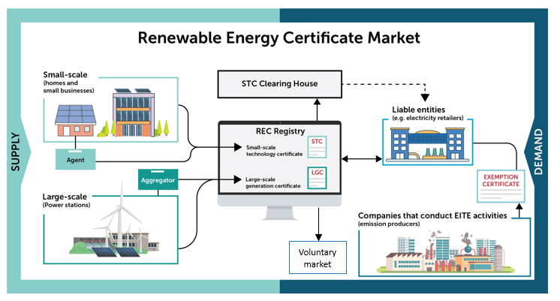
Inspections Program
In 2011 the Government introduced a provision in the Act for the Clean Energy Regulator to inspect a statistically significant sample of installed systems each year for compliance with SRES eligibility criteria. This includes relevant Australia/New Zealand standards related to electrical safety.
Responsibility for electrical licensing and safety sits with the state and territory electrical safety regulators. Each year the Clean Energy Regulator inspects a sample of small generation units installed under the SRES and provides the results of these inspections to the state and territory regulators to assist them in performing their regulatory functions.
The objective of the inspection program is to ensure that the increased installation demand resulting from Renewable Energy Target incentives does not lead to any reduction in installation standards.
Renewable Electricity Guarantee of Origin (REGO)
The RET and REGO schemes will co-exist until the RET ends in 2030 and are likely to have significant overlap in participants and registered power stations. Eligible renewable electricity facilities can be registered under both schemes simultaneously but can only certify a MWh of electricity under either the LRET or REGO. That is, those eligible facilities can be registered under both schemes but cannot ‘double certify’ generation.
The REGO certification mechanism will certify renewable electricity produced from eligible renewable electricity sources. It builds on the large-scale generation certificate (LGC) framework under the RET and expands certification eligibility to renewable energy storage and ‘below-baseline’ renewable electricity, generated by power stations that existed pre-1997. A REGO certificate will certify 1 MWh of electricity. REGO certificates will also be able to be ‘time-stamped’ down to an hourly level, increasing the level of transparency for renewable electricity claims and supporting the evolution of the renewable energy market.

POLICY AND STATUTORY AUTHORITY TO CHARGE (COST RECOVER)

Government policy approval to charge for this regulatory activity

Policy authority for partial cost recovery of the Renewable Energy Target was outlined in the 2011- 12 Budget Paper 2, Part 2, and Expense Measures.
As noted in the Budget Paper, '[t]he cost of the inspection regime from 2011-12 onwards will be partially recovered through an increase in the registration fee for Small-scale Technology Certificates for small renewable generation units. The fee increase, from 8 cents to 47 cents, will commence from the date of effect of the enabling regulations and is estimated to increase revenue by $14.1 million over 4 years’.
The fees for power station registration, certificate creation and surrender, large-scale generation shortfall refund administration will remain unchanged’.

Statutory authority to charge

The Renewable Energy (Electricity) Act 2000 came into effect on 18 January 2001. The Act enables fees to be prescribed in the regulations in relation to applications for registrations and accreditations, registration, transfer and surrender of certificates, Clearing House operations and various changes. These fee types are detailed in Attachment A.

Fee charging began with the commencement of the Renewable Energy (Electricity) Regulations
2001 on 15 March 2001. Section 28 of the Regulations prescribes the fees payable by transaction type. The current fees are detailed at Attachment B.

CHARGING (COST RECOVERY) MODEL
The characteristics of a government activity determine the type of cost recovery charge used. There are 2 types of cost recovery charges:
- Cost recovery fees: fees charged when a good, service or regulation (in certain circumstances) is provided directly to a specific individual or organisation.
- Cost recovery levies: charges imposed when a good, service or regulation is provided to a group of individuals or organisations (e.g. an industry sector). A cost recovery levy is a tax and is imposed via a separate taxation Act. It differs from general taxation as it is 'earmarked' to fund activities provided to the group that pays the levy.
Fees are used to partially recover the cost of the application, registration and surrender transactions and the inspections program. All fees charged in respect of the RET are returned to the Official Public Account.
The Clean Energy Regulator receives an administered appropriation for the cost of administering the inspections regime.
The Clean Energy Regulator receives a departmental appropriation for the operating costs associated with the administration of the Renewable Energy Target scheme.

Outputs and business processes of the activity

The Clean Energy Regulator administers the Renewable Energy Target in line with its objectives: efficient and effective administration; active and compliant clients; a trusted, relevant and expert institution; and securing and enduring infrastructure.
It provides the supporting structure for the Renewable Energy Target including facilities for registering and trading renewable energy certificates, and ongoing client liaison, education and compliance activities to help ensure the efficiency and integrity of the market.
REC Registry
The Renewable Energy Certificate Registry (REC Registry) is the secure web-based system for all transactions under the Renewable Energy Target including creating, registering, selling, trading and surrendering certificates. The REC Registry also provides access to several public registers that contain data about the Renewable Energy Target.
Fees are charged for some activities undertaken in the REC Registry as detailed below.
Clearing House
The REC Registry includes the STC Clearing House. This facility allows liable entities to purchase small-scale technology certificates at a fixed price of $40 (GST exclusive) when the supply from the open market does not meet their demand. This provides certainty to liable entities by guaranteeing a supply of certificates to meet their liability and setting a maximum price, which allows them to protect their risk and pass-through costs efficiently. Sellers can also use this facility and receive the fixed price. Large-scale generation certificates are not included in the STC Clearing House.
Currently there is no fee charged for transactions occurring in the Clearing House.
Application to become a registered person or agent
A registered person may:
- seek accreditation of a renewable energy power station for which they are a nominated person, by applying to the Clean Energy Regulator;
- create STCs for an eligible solar water heater, heat pump, small-scale solar panel, wind or hydro system; and
- apply for registration as an Agent.
An Agent can create STCs on behalf of owners of solar water heater, heat pump, small-scale solar panel, wind and hydro installations who assign their right to create STCs to the Agent.
All registered person applicants must complete an online registration and proof of identity process. The agency will undertake a document verification of the application to ensure it is complete before completing the proof of identity checks and 'fit and proper person' checks including:
- background checks
- criminal history
- insolvency checks
Once registered with the Clean Energy Regulator, Agents can have the right to create small-scale technology certificates assigned to them for systems that meet the eligibility criteria. The right to create certificates is often assigned in exchange for an upfront financial benefit such as a discount on the final invoice or cash payment.
An application fee is charged in accordance with the Regulations.

Accreditation of power stations
The Clean Energy Regulator assesses applications for accreditation of power stations, including verifying that applications are complete, that the applicant is a 'registered person' in the REC Registry and that the metering specifications are compliant with national electricity rules.
Once an application is assessed as properly made under Section 13 of the Renewable Energy (Electricity) Act 2000 and the application fee is paid, details of the renewable energy power station are listed on the public Register of Applications for Accredited Power Stations, which can be accessed through the REC Registry.
From the time the application is assessed as being properly made, the Clean Energy Regulator has 6 weeks to determine matters under Section 14 of the Act and either approve or refuse the application under Section 15 of the Act. If the application is approved, the accreditation start date is the date the application was assessed as being properly made under the Act, or the date the power station started generating electricity for the first time, whichever is later. The 'nominated person' (the applicant) is then notified of the accreditation of the power station and the power station is listed on the public Register of Accredited Power Stations. The nominated person can create large-scale generation certificates from the date of accreditation.
An application fee is charged in accordance with the Regulations.
Certificate creation and registration
The Clean Energy Regulator's certificate validation activities are an important component of maintaining the integrity of the Renewable Energy Target and the certificate market. Scheme participants creating small-scale technology certificates and large-scale generation certificates must provide thorough supporting documentation before the Clean Energy Regulator validates and registers certificates. As part of this process, accredited power stations must also confirm they are operating in accordance with all Commonwealth, state, territory and local government planning and approval requirements through a 'standing notice' to the Clean Energy Regulator.
Once an STC and/or LGC has been created in the REC Registry, the Clean Energy Regulator conducts an assessment to determine the eligibility of the claim. Assessments include automated checks conducted by the REC Registry, as well as the examination of documentation to support the claim. The Clean Energy Regulator also utilises aerial photographs and/or site visits to determine if eligibility criteria have been met. When the STC and LGC are validated, the applicant is able to generate an invoice in their REC Registry account and pay the certificate creation fee.
A certificate creation fee is charged in accordance with the Regulations.
A certificate creation fee is not required for an entity or individual creating less than 250 STCs. However, entities creating more than 250 certificates are required to pay the fee for all certificates registered. This threshold aims to protect individual households who choose to create STCs themselves from an additional administrative expense. Only a small number of households choose to create STCs rather than assigning their rights to an agent, for whom the threshold is not relevant due to the large numbers of STCs a typical agent would create.
Transfer of certificates
The Clean Energy Regulator provides participants with the facility to transfer certificates within the REC Registry. However, we do not oversee the transfer or payment arrangements for certificates outside of the STC Clearing House. Buyers and sellers negotiate this directly as per the business contracts they sign or terms they mutually agree to.
Currently there is no fee charged for transfer of certificate transactions.

Inspections
The Clean Energy Regulator inspects a statistically significant sample of Small Generation Unit (SGUs) installed, for which STCs have been registered, in that year to determine their compliance with the Australian Standards and other standards and requirements relevant to the creation and registration of STCs. This is an extensive post STC validation inspection program.
Appointed inspectors undertake inspections across geographic areas and provide inspection outcomes.
The cost of an inspection varies depending on the geographic location of the installations. The cost of inspections includes liaising with the owner of the system, employment of inspectors, travel and conduct of inspection, data collection and necessary notification of adverse inspection findings to the parties identified in the Regulations.
The cost recovery for the inspection regime has occurred via an increased fee for the registration of STCs for SGUs. The fee for the registration of an STC for an SGU was increased from $0.08 to $0.47 in 2011. The fee provides for a partial cost recovery of the inspection regime.
Solar water heater (SWH) accreditations
Under the SRES, the Clean Energy Regulator is responsible for managing the register of solar water heaters, which lists all solar water heaters and air source heat pumps eligible under the scheme, and the assessment of applications for new systems to be added to the register. The Clean Energy Regulator regularly calls for applications from manufacturers to update the models listed on the register of solar water heaters.
During the assessment process, the Clean Energy Regulator checks all models listed in the applications against the Australian and New Zealand Standard AS/NZS 2712:2007 licensing schedule. The Clean Energy Regulator also audits selected models to ensure their small-scale technology certificate entitlements are calculated correctly. During the audit process, the Clean Energy Regulator may request supporting information from applicants such as test reports and TRNSYS files.
Before the register of a solar hot water systems is published, applicants are provided with a final opportunity to review each model to make sure they are listed correctly.
Once the register is published on the Clean Energy Regulator website small-scale technology certificates may be created for newly approved and listed models.
There is no fee charged for solar water heater accreditation.
Liability Assessment
Liable entities (usually electricity retailers who acquire electricity in a grid of 100 megawatts or more) have an obligation to purchase and surrender large-scale generation certificates and small-scale technology certificates based on the volume of electricity they purchase each year.
The Clean Energy Regulator sets a Small-scale Technology Percentage (STP) and Renewable Power Percentage (RPP) each year which determines the number of certificates liable entities are required to purchase and surrender each year.
Liable entities submit an annual Energy Acquisition Statement which the Clean Energy Regulator examines before accepting the offered STCs, LGCs or imposing a Shortfall Charge (see below). The Clean Energy Regulator does a comparison between the current and previous statements and third-party data, where available. They will also perform an audit when necessary to confirm the accuracy of the submission.

Entities are also able to make revisions to previous assessments.
There is no fee charged for liability assessment.
Surrender of LGC and STCs
To meet compliance obligations under the Renewable Energy Target, liable entities must surrender certificates through the REC Registry. Liable entities may be required to surrender sufficient LGCs and/or STCs created in the assessment year or earlier. A liable party must either pay a renewable energy shortfall charge or surrender the required number of certificates to the Regulator in proportion to the amount of electricity purchased in a year.
A certificate surrender fee is charged in accordance with the Regulations.
Large-scale Generation Shortfall Charge (LGSC) refund
Liable entities who chose to go into shortfall and pay a large-scale generation shortfall charge can in a future year (if eligibility criteria have been met) surrender certificates within the allowable refund period and seek a refund of any paid shortfall charge amounts.
A LGSC refund administration fee is charged in accordance with the Regulations.
Voluntary surrender of certificates
Individuals or companies that are registered owners of certificates can choose to surrender certificates to the Clean Energy Regulator for any reason. Offers made for these reasons are considered 'voluntary surrender' offers. This is covered under Section 28A of the Renewable Energy {Electricity) Act 2000.
Individuals or companies may also choose to offer certificates for voluntary surrender to offset the impacts of improper creation of certificates under the civil penalties and other remedies.
Surrender fees are not applied to voluntary surrender offers.

Design of the regulatory charge

Table 1 – 2024-25 revenue
Output title | Type | Charge Rate | 2024-25  Total revenue ($)
Register persons | Fee | $20 | $7,200
Register agents | Fee | $230 | $22,770
STC certificate creation SWH | Fee | $0.08 | $199,251
STC certificate creation SGU | Fee | $0.47 | $12,855,676
LGC creation | Fee | $0.08 | $4,281,006
Power station accreditation - large (> 25 MW) | Fee | $1,000 | $17,000
Power station accreditation - medium (>= 10 MW, <=25 MW) | Fee | $200 | $2,000
Power station accreditation - small (< 10 MW) | Fee | $50 | $21,350
LGC surrender | Fee | $0.08 | $2,501,476
STC surrender | Fee | $0.08 | $3,127,284
TOTAL |  |  | $23,035,013

Design of cost recovery charges
Of the STC registration fee, approximately $0.055 covers the pre-January 2011 cost of the REC Registry, including the ongoing software development, hardware purchases and operational costs. A further $0.025 contributes to meeting the cost of validating STC registrations. The remaining $0.39 was designed to partially recover the estimated cost to undertake inspections. The cost per inspection varies depending on the type of SGU and its location.
Power station application fees increase based on the size of the system, taking into consideration the level of complexity involved in assessing each application.
These fees do not cover the additional cost of the mid-2010 legislative amendments which includes system changes to support the introduction of small and large scale certificate categories, quarterly surrender of STCs, and the STC Clearing House.
Due to anticipated overlap of scheme participants for the RET and REGO scheme, it is proposed that REGO cost recovery pricing will be broadly set to align with RET cost recovery pricing. REGO cost recovery arrangements will be subject to ongoing review and pricing and may be adjusted over time, once the scheme is established.

RISK ASSESSMENT

Cost Recovery Risk Assessment

The activities and associated fees in this CRIS are continuing without change from the previous CRIS.

From 1 July 2025, the installation of a solar battery/batteries under the Cheaper Home Battery Program were eligible for an incentive under the Renewable Energy Target. Batteries are defined as a component of a small generation unit; therefore, no new charges will be introduced to the existing design.
The Clean Energy Regulator has implemented financial controls to ensure that it collects revenue due and payable.
Certificates are not registered, and therefore tradeable, until the registration fee has been received in full by the Clean Energy Regulator. Appropriate processes have been established to manage the collection of surrender fees consistent with the Clean Energy Regulator's approved financial policies and procedures.

STAKEHOLDER ENGAGEMENT

Stakeholder groups

Under the Renewable Energy Target a variety of individuals, businesses and industry groups interact with the scheme, including:
- individuals and business who voluntarily invest in small-scale and large-scale renewable energy systems, generate renewable energy, or actively lower their consumption of main grid electricity, and
- industry groups who are required by law to surrender large-scale generation certificates and small-scale technology certificates to offset the generation of emissions intensive energy and meet scheme compliance obligations.

Stakeholder consultation

Maintaining and strengthening relationships with clients and stakeholders is essential to the Clean Energy Regulator's role in administering the Renewable Energy Target. The Clean Energy Regulator helps to ensure the efficiency and integrity of the renewable energy certificate market by regularly working with a wide range of stakeholders and clients to:
- communicate regulations, policy and procedures
- provide information and outreach to facilitate market participation/proposed changes
- educate liable entities about their obligations and how to comply
- monitor and enforce compliance if necessary, including working with other regulators and law enforcement bodies, and
- track and report on key market trends.

FINANCIAL PERFORMANCE

The Clean Energy Regulator's administration of the Renewable Energy Target is funded through an annual budget appropriation and is currently partially cost recovered based on the fees provided for in the Renewable Energy {Electricity) Act 2000 and the associated Regulations. The CER does not retain any cost recovered monies. All fees charged in respect of the Renewable Energy Target are returned to the Official Public Account.

Cost recovery revenue will be reported in the Clean Energy Regulator's Annual Report in accordance with the Public Governance, Performance and Accountability (Financial Reporting) Rule 2015.

In 2024-25 total revenue for the Renewable Energy Target was $22,536 million. The total cost associated in generating that revenue was $25,642 million.

The financial impact of Renewable Energy Target cost recovery depends on several variable factors which must be estimated in the Budget and forward years. Principal amongst these is the number of renewable energy certificates created, traded and surrendered each year. Certificate numbers are subject to external influences and can vary significantly from the estimated number. In contrast, Renewable Energy Target administration costs are relatively fixed and vary less in response to changes in certificate numbers.

It is important to note that not all activities relating to the Renewable Energy Target are currently cost recovered. The expenses forecast in Table 2 include all Renewable Energy Target activities.

Financial Estimates
The Clean Energy Regulator's performance in managing the Renewable Energy Target is set out in Table 2 below.
The figures in Table 2 are based on the ABC allocations and include indirect allocations.

Table 2 – 2024-25 actuals and estimates in out years
Financial Item | 2024-25  Actuals  $'000 | 2025-26  Estimates  $'000* | 2026-27 Forward Estimates  $'000 | 2027-28 Forward Estimates  $'000
Total Departmental Operating expenses | 25,642 | 26,539 | 27,468 | 28,429
Total Cost recovered Administered revenue | 23,035 | 21,534 | 20,779 | 20,254
Balance = revenue - expenses | -2,606 | -5,006 | -6,689 | -8,175
Cumulative balance | -2,606 | -7,612 | -14,301 | -22,477

Financial Outcomes
Table 3 – 2020-21 to 2023-24 Actual revenue
Financial Item | 2020-21  '000 | 2021-22  '000 | 2022-23  '000 | 2023-24  '000
Actuals
Revenue = X | 30,648 | 27,025 | 26,783 | 24,552

Table 4 – Aggregate Depreciation
 | 2024-25  Actuals  $'000 | 2025-26  Estimate  $'000 | 2026-27  Forward Estimates  $'000 | 2027-28  Forward Estimates  $'000
Aggregate Depreciation
Aggregate Asset Value | 10,713 | 10,748 | 10,782 | 10,782
Depreciation Expense* | 84 | 35 | 35 | 0
Accumulated Depreciation (investment returned to government) | 10,629 | 10,713 | 10,748 | 10,782
*REC Registry useful life ends 30 June 2027.

NON-FINANCIAL PERFORMANCE

The Renewable Energy Target Administrative Report
Each year, the Clean Energy Regulator prepares The Renewable Energy Target Administrative Report which covers the operations of the Act for the calendar year.
The report is prepared in accordance with Section 105 of the Act and is tabled in Parliament.
The Renewable Energy Target Administrative Report provides information about the Clean Energy Regulator's administration of the Act and how the Renewable Energy Target is performing against its legislated objectives, which are:
- to encourage additional generation of electricity from renewable sources
- to reduce emissions of greenhouse gases in the electricity sector
- to ensure generation of electricity from ecologically sustainable renewable energy sources.

Reform of business processes
The Clean Energy Regulator administers the Renewable Energy Target in line with its objectives:
- efficient and effective administration
- engaged, active and compliant clients
- a trusted, relevant and expert institution, and
- secure and enduring infrastructure.

Administrative processes continue to operate smoothly, and some significant improvements have been made. For example, the redesigned REC Registry, released in September 2014, provides a more streamlined and responsive facility for participants to create, trade and surrender renewable energy certificates. As a result, the average time for validation of small-scale technology certificates reduced from 16 to 5 days.

Table 5 – Volumes of Outputs for prior years, current and forward estimates
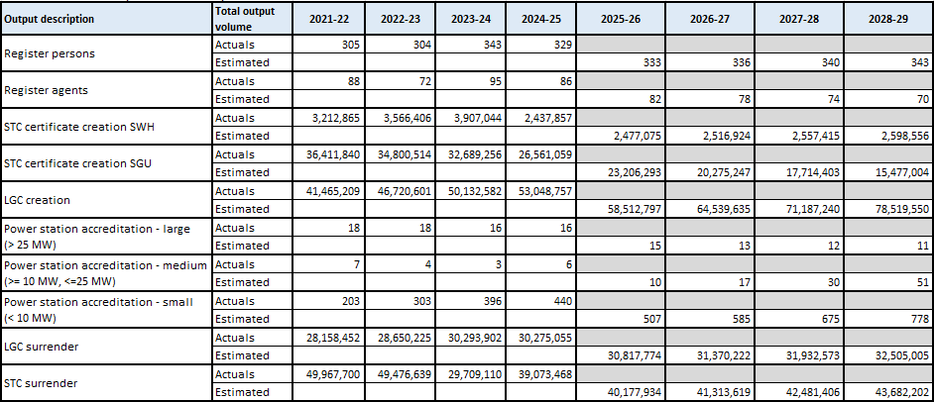

KEY FORWARD DATES AND EVENTS

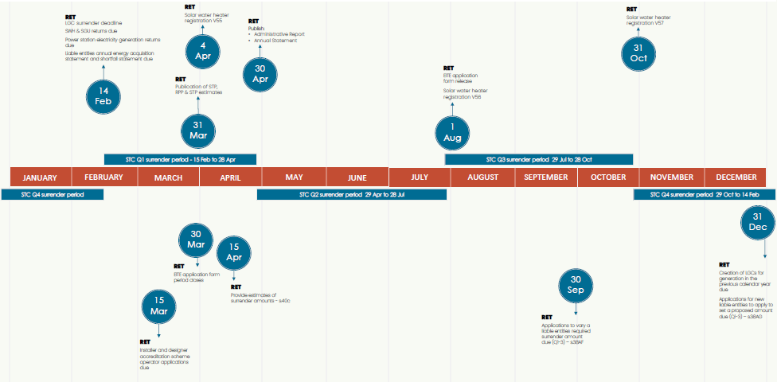

CRIS APPROVAL AND CHANGE REGISTER

Key forward event schedule | Next scheduled update
Forward (financial) estimates | 31 October 2026
Update of actual (financial results) | 31 October 2026
Stakeholder engagement | Ongoing
Scheduled portfolio charging review | 2028 for the 2028-29 Budget

Appendices

Attachment A - Fees that can be prescribed in the regulations

The Renewable Energy Electricity (Act) 2000 enables the following fees to be prescribed in the regulations:

Fee Type | Section
Application for registration of persons | 10(2)(d)
Application for provisional accreditation of a power station | 12A(2)(f)
Application for accreditation of eligible power stations | 13(2)(e)
Registration of certificates | 26(3A)
Transfer of certificates | 28(2A)
Changing the nominated person for an accredited power station | 30B(2)(d)
Varying what constitutes a power station | 30C(3)(d)
Application for purchase of certificate through the clearing house | 30M(3)(d)
Operation of the clearing house | 30U(2)(h)
No energy acquisition statement lodged for previous year: application to have amount apply as if it were previous year's reduced acquisitions | 38Al(l)(f)
Energy acquisition statement lodged for previous year:  application to have amount apply instead of previous year's reduced acquisitions | 38Al(l)(f)
Fees for surrender of certificates under Subdivision 45E | 45E(l)
Fees for Large-scale Generation Shortfall Charge (LGSC) refund | 98

Attachment B - Fee Schedule

Section 28 of the Renewable Energy (Electricity) Regulations 2001 prescribes the fees payable for various transactions. The current fees are set out below.

Certificate creation and surrender fees

Fee Item | Fee Amount
Fee Item | First 250 certificates | 251st certificate | Certificates after 251st
LGC creation fee | Nil | $20.08 | $0.08
STC SGU solar creation fee | Nil | $117.97 | $0.47
STC SGU wind creation fee | Nil | $117.97 | $0.47
STC SGU hydro creation fee | Nil | $117.97 | $0.47
STC SWH/ASHP creation fee | Nil | $20.08 | $0.08
LGC surrender fee | $0.08 | $0.08 | $0.08
STC surrender fee (payable for  Regulator created STCs also) | $0.08 | $0.08 | $0.08

Power station provisional accreditation or accreditation applications
Item | Generator | 1997 eligible renewable power baseline type | Fee
1 | < 10 kW, small generation unit or solar water heater for which the right to create certificates is not assigned under subsection 23(2) or 23C(2) of  the Act | Any baseline | $ 20
2 | < 10MW, other than small generation unit or solar water heater to which item 1 applies | a) default or nil baseline | $ 50
 |  | b) special baseline with data | $ 150
 |  | (c) special baseline without  required data (modelling required) | $ 250
3 | ≥10 MW, ≤25 MW | a) default or nil baseline | $ 200
 |  | b) special baseline with data | $ 500
 |  | (c) special baseline without  required data (modelling required) | $ 1,000
4 | > 25MW | a) default or nil baseline | $ 1,000
 |  | b) special baseline with data | $ 1,700
 |  | (c) special baseline without  required data (modelling required) | $ 3,000

Account application fees

Application | Fee
Registered person | $20.00
Agent | $250.00

Large-scale Generation Shortfall Charge (LGSC) administration fee
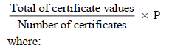
total of certificate values is the total of the certificate values of all certificates surrendered by the liable entity under paragraph 95(1)(b) for that year.
number of certificates is the number of certificates surrendered by the liable entity under section 95 for that year.
P is:
- if the total of certificate values for the number of certificates surrendered for the charge year is less than $1 000—2%; or
- if the total of certificate values for the number of certificates surrendered for the charge year is at least $1 000 but less than $5 000—1.5%; or
- if the total of certificate values for the number of certificates surrendered for the charge year is at least $5 000 but less than $15 000—1%; or
- if the total of certificate values for the number of certificates surrendered for the charge year is $15 000 or more—0.5%.

Glossary of terms and abbreviations

Australian Government Charging Framework
(Charging Framework) - consists of the Australian Government Charging Policy, released in 2015, and the Cost Recovery Policy released in 2014, which incorporates overseeing charging of regulatory and non-regulatory government activities.
Australian Government Charging Policy
Australian Government Policy released in 2015, previously known as the Australian Government Charging Framework. It sets out the requirements and better practice for non-regulatory charging activities.
Australian Government Cost Recovery Policy
Australian Government Policy released in 2014, previously known as the Cost Recovery Guidelines (CRG). It sets out the requirements and better practice for regulatory charging activities under which Commonwealth entities design, implement and review regulatory activities.
CER
Clean Energy Regulator
Cost recovery
Involves Commonwealth entities (on behalf of the Australian Government) charging the non-government sector some or all of the efficient costs of a specific regulatory government activity.
Cost recovery fee
A type of government cost recovery (regulatory) charge used when a good or service or regulation is provided directly to a specific individual or organisation.
Cost recovery implementation statement (CRIS)
A tool for documenting cost recovery design and operation and reporting on a cost recovered activity. A CRIS must be prepared for each cost recovered activity conducted by a government entity in line with the Cost Recovery Policy minimum requirements for CRIS.
Full cost recovery
Involves Commonwealth entity charging the non-government sector all of the efficient costs of a specific regulatory activity.
LGC
Large‐scale generation certificate
LGSC
Large-scale Generation Shortfall Charge
LRET
Large‐scale Renewable Energy Target
MWh Megawatt hour
A measurement of electrical energy equivalent to power consumption of one megawatt or 1,000 kilowatts for one hour.

Official Public Account
The Commonwealth's central bank account. The OPA is one of a group of linked bank accounts, referred to as the Official Public Account Group of Accounts. OPAs are maintained with the Reserve Bank of Australia (RBA), as required by subsection 53(3) of the PGPA Act.
Partial cost recovery
Charging the non-government sector less than all of the efficient costs of a specific government activity.
REC Registry
Renewable Energy Certificate Registry
REE Act
Renewable Energy (Electricity) Act 2000
REGO
Renewable Electricity Guarantee of Origin
RET
Renewable Energy Target
RPP
Renewable Power Percentage
SGU
Small- Generation Unit
SRES
Small‐scale Renewable Energy Scheme
STC
Small‐scale technology certificate
STP
Small-scale Technology Percentage
SWH
Solar water heater

