
Participant handbook
Renewable Electricity Guarantee of Origin
18 December 2025

Contents
Disclaimer 4
Who should use this handbook 5
Overview 6
About the REGO 6
Key features 6
Timestamping 6
Voluntary participation 6
Expanded eligibility 6
Benefits 6
Fees and charges 7
The differences between the REGO and the LRET 7
About the PGO 9
Participation in the REGO 10
Becoming a registered person 11
How to become a registered person 11
Fit and proper person 11
Registering a facility 12
How to register a facility 12
Facility types 13
RET accredited power station 13
REGO facility 13
Order of filling out facility application 14
Eligible renewable energy sources 15
Other government permits and approvals 16
Eligible energy storage systems 17
Facility components 17
Reporting other stakeholders 18
Registering a RET accredited power station if someone else is the nominated person 18
Requests for further information and cease to consider 18
Facility registration conditions 18
Creating and managing REGO certificates 19
How to create and register REGO certificates 19
Timestamping certificates 19
Required information for submitting a claim for REGO certificates 20
Completing the generation data template 20
Adding interval data 20
Allocating eligible amounts across schemes 20
Requesting the number of certificates to create and register 21
Below baseline certificates 21
Claiming residuals 21
Generation data template for complex facilities 21
Temporary alternative measurement methods 22
Demonstrating stored renewable electricity 22
Retiring upstream REGO certificates 22
Surrendering upstream LGCs 22
Direct supply relationships 23
Transfer and retire REGO certificates 24
Make claims about the use of renewable electricity in PGO 24
Make claims about the use of renewable electricity in other frameworks 24
Maintaining your facility 25
Notice of events 25
Variations 25
Annual Reconciliation checks 27
Audits 27
Engaging with the CER 28
Clean Energy Regulator Assessments 28
Engagement with CER Assessors 28
Information available on the GO Register 29
Request to withhold, remove, or amend information on the GO Register 32
Person or facility registration compliance 32
Complaints and concerns 32
Fees and charges 33
REGO Glossary 34
Resources and Forms 36
Legislation 36
Appendices 37
Appendix A: Electricity generation calculation diagrams 37
Appendix B: Energy storage calculation diagrams 42

Version history
Version | Change description | Date published
v1.0 | Initial publication | 18/12/2025

NOTE: This version of this document was valid at the time it was printed. Please regularly check for any updated versions.

Disclaimer
This Renewable Electricity Guarantee of Origin (REGO) participant handbook (the handbook) is intended to provide general information about participating in the REGO Scheme in accordance with the Future Made in Australia (Guarantee of Origin) Act 2024 (GO Act). It is the responsibility of registered persons to understand their individual duties under the GO Act and to act in accordance with those obligations to comply with the law.
To the extent permitted by law, neither the Clean Energy Regulator (CER) nor the Commonwealth of Australia accepts responsibility or liability for any direct, incidental or consequential loss or damage resulting from the use of this user guide.
The information presented in this handbook is not a substitute for legal, business or financial advice. Users should seek independent advice before taking any action or decision on the basis of the information provided in this document.
The CER and the Commonwealth of Australia may, at their discretion, vary or modify this handbook without notice.

Who should use this handbook
The REGO participant handbook is your guide to the Renewable Electricity Guarantee of Origin Scheme, and is intended for facility owners or operators, certificate traders, certificate consumers, or people participating in the scheme in other ways.
Facility owners and operators
As a registered person in the scheme, you can:
- register a facility
- create and register REGO certificates
- transfer or retire those certificates.
Scheme participants are obliged to:
- provide accurate information to the CER
- ensure information is kept up to date
- notify the CER when certain events occur
- report on facility operations and any changes to facility operations
- comply with all requirements when creating, transferring, and retiring certificates
- pay required application fees and annual facility charges.
Certificate traders
As a registered person in the scheme, you can:
- transfer certificates
- retire certificates on behalf of a third party.
Scheme participants are obliged to:
- provide accurate information to the CER
- ensure information is kept up to date
- notify the CER when certain events occur
- comply with all requirements when creating, transferring, and retiring certificates.
Certificate consumers
As a registered person in the scheme, you can:
- receive transferred REGO certificates
- retire REGO certificates.
Scheme participants are obliged to:
- provide accurate retirement information to the CER or third-party consumers.

Overview

About the REGO
Australia’s Renewable Electricity Guarantee of Origin (REGO) Scheme is a voluntary certification framework for renewable electricity administered by the Clean Energy Regulator (CER). It is designed to verify renewable electricity generation and consumption within the renewable electricity sector and the broader electricity market, building upon the existing large-scale generation certificate (LGC) mechanism from the Large-scale Renewable Energy Target (LRET) (one of 2 schemes under the Renewable Energy Target (RET)). The REGO Scheme is an enduring mechanism, and will continue to operate beyond 2030, following the scheduled conclusion of the current Renewable Energy Target (RET).
The purpose of REGO certificates is to facilitate tracking and verification of renewable electricity generation. This will enable organisations to credibly claim the use of green electricity in their operations. Each REGO certificate is digitally issued for one megawatt-hour (MWh) of renewable electricity generated or dispatched in accordance with the legislation.

Key features

Timestamping
Each REGO certificate is timestamped to indicate the specific hour of electricity generation, or a different time period nominated by the generator. This feature allows consumers to align their energy consumption with particular periods of renewable generation.

Voluntary participation
Participation in the scheme is entirely voluntary.
Businesses may elect to acquire REGO certificates to substantiate claims regarding their use of renewable electricity. To hold certificates, a business must become a registered person in the scheme. Note that once someone is a registered person they will be required to comply with the scheme requirements.

Expanded eligibility
The scheme allows REGO certificates to be created for eligible forms of renewable electricity, provided certificates have not already been issued for that electricity. This includes electricity generated or stored and dispatched from:
- new or existing generation facilities
- energy storage systems
- aggregated systems.

Benefits
REGO certificates enhance transparency and confidence in Australia's renewable electricity market on both domestic and international fronts. The scheme also supports the ongoing development of renewable electricity initiatives and other government or private initiatives for enterprises to invest in renewable electricity solutions.

Fees and charges
The REGO Scheme is cost recovered, and the associated fees are subject to change. The fees for 2025-2026 are detailed in Table 4.
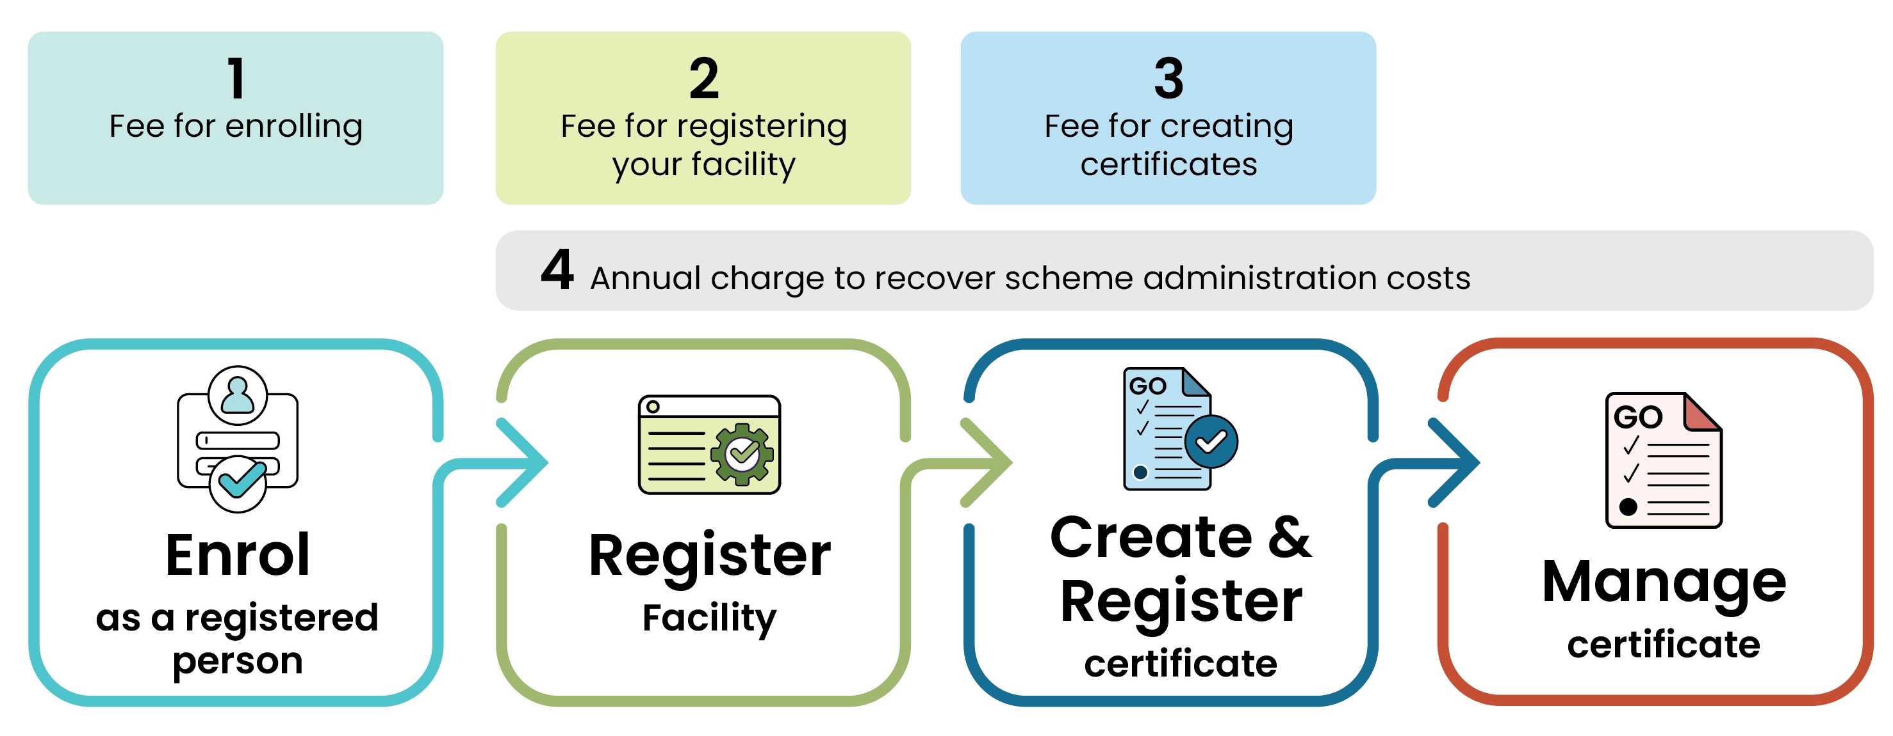
Figure 1 REGO Fees and Charges Timeline

The differences between the REGO and the LRET
The REGO certificate mechanism builds on the design strengths of the LRET, but there are some differences. These are outlined in table 1.
Table 1 Comparison of features of the LRET and REGO schemes
Topic | Large-scale Renewable Energy Target (LRET) | Renewable Electricity Guarantee of Origin (REGO)
Commencement and lifespan | The LRET commenced in 2001 and is scheduled to end on 31 December 2030. No electricity generated after the end date can be used to create LGCs. | The REGO Scheme began on 3 November 2025. It will be an enduring framework.
Creating certificates  See Creating and managing REGO certificatesCreate REGO | LGCs can be created any time up to the end of the calendar year following the generation year. | REGO certificates cannot be created and registered more than one year after the end of the relevant generation or dispatch period. This means that there is usually a smaller period in which facilities can create certificates, unless yearly timestamping is used (see below).  There are clauses in the GO Act and the Renewable Energy (Electricity) Act 2000 (REE Act) that prevent LGCs, REGO certificates, and other certificates like I-RECs from being created for the same generated electricity.
Timestamping  See Timestamping certificates | LGCs are created for electricity generated within a calendar year, but they can be issued monthly throughout that year. The certificates are marked with the calendar year of generation. | By default, REGO certificates are timestamped with the hour in which the generation or storage dispatch occurs. Facilities can choose a different timestamp period for certificates instead, including daily, monthly, or yearly timestamps.
Energy storage systems  See Direct supply relationships | Batteries can be included as part of LRET power stations, but the losses of the battery system are treated as an eligible on-site demand for electricity.  Standalone batteries are unable to create LGCs. | REGO certificates can be created for standalone energy storage systems for renewable electricity stored and then dispatched by a facility.
Baselines  See Below baseline certificates | Power stations are subject to baselines which were calculated as the yearly amount of electricity generated by a power station before 1 January 1997. Power stations cannot create LGCs for annual generation below the baseline. | The REGO Scheme allows for certification of below baseline generation. Baselines are determined in the same way as the LRET. All below-baseline certificates for electricity occurring on or before 31 December 2030 are then labelled as ‘below-baseline’.
Liable entities | The LRET operates on a mix of voluntary and mandatory demand where liable entities are required to surrender LGCs based on an annually calculated renewable power percentage. | There is no obligation in the GO Act for any party to retire REGO certificates. However, these certificates can be retired voluntarily to meet zero-emissions or renewable electricity reporting obligations under other reporting frameworks.
Online portal | The LRET is administered using the Renewable Energy Certificate (REC) Registry. This portal is where you can apply to become a registered person, apply to accredit a power station, and create, transfer and surrender LGCs. | The REGO Scheme uses Online Services, a portal where you can apply to become a registered person, register a facility and create and apply to register certificates.  Certificates are stored in the Unit and Certificate Registry (UCR) in Online Services.
Cost recovery | The LRET is not fully cost recovered. There are minimal fees associated with certain activities like registering a facility and certificate registration.  Invoices for power station applications are generated and paid before the application is assessed. However, LGC fees are paid after the LGCs have been assessed and approved. | The REGO is a fully cost recovered scheme where a Cost Recovery Implementation Statement outlines the associated fees. There are registration fees, certificate creation fees and annual charges associated with various aspects of REGO participation.  Invoices for fee-bearing applications are generated and must be paid before the application is assessed.

About the PGO
The Product Guarantee of Origin (PGO) Scheme is the other scheme established in the GO Act. It operates similarly to the REGO Scheme, requiring applicants to first enrol, then register a production, delivery or consumption profile. Production profile holders can then create PGO certificates that show where a product has come from, how it was made, and its emission intensity throughout its life cycle. These certificates enable businesses to demonstrate the environmental attributes of their products to consumers and trading partners. Products are certified with an emissions intensity that includes upstream and downstream emissions from their production and supply chain.
Throughout this handbook, PGO will be referenced where it interacts with the REGO Scheme or its certificates.
Find out more about the PGO.

Participation in the REGO
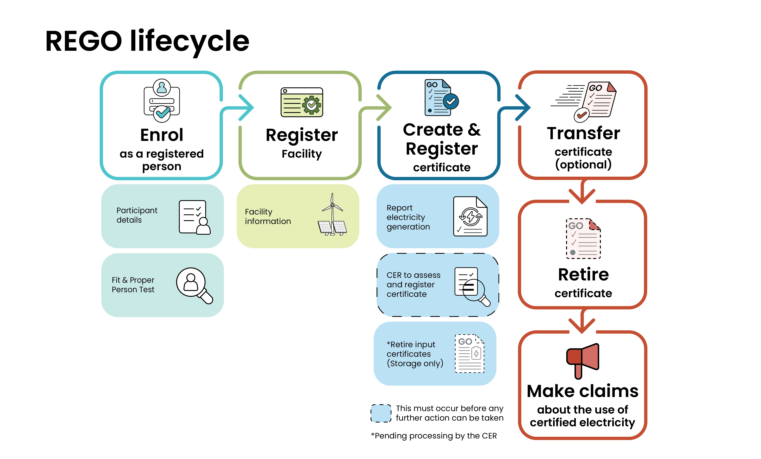
Figure 2 REGO Participation Lifecycle
Participation in Australia’s GO Scheme, including the REGO Scheme, requires registration with the CER. Both the legal entity participating in the scheme and their renewable electricity facilities must be registered.
Registered persons can create and apply to register REGO certificates for eligible renewable electricity dispatched from registered facilities.
REGO certificates that are registered by the CER can be transferred to other registered persons and retired by registered persons to make claims regarding their use of certified renewable electricity.

Becoming a registered person
Before undertaking any activity under the GO Scheme, you must first enrol to become a registered person.

How to become a registered person
A registered person for the purposes of the GO Act refers to a legal entity, which can be either an individual or organisation. To apply to register a REGO facility, the facility's owner or operator must first be a registered person. The registration process is shown in the diagram below.
- Create a user account in Online Services if you don’t have one.
- From the Dashboard, search for and select ‘Enrol in GO’.
- Complete the online form, with the option to save progress and return later if needed. Once complete, review the declaration and select ‘Submit application’.
- On submission, the CER will issue an invoice for the associated registration fee which must be paid to progress the application.
- Wait for the CER to issue a decision. You may be asked to provide additional information regarding your application. Applicants must undergo a ‘fit and proper person test’ as described below.
- Upon approval of an application, the CER will send an approval decision notice. The registered person will then be added to the public GO Register.
- When the CER registers a legal entity for the GO Scheme, you will automatically be given a new Unit and Certificate registry account for REGO certificate creation and management.
- If your application is unsuccessful, the CER will notify you and provide you with details and the next steps required.

Fit and proper person
Participation in a number of CER administered schemes requires a fit and proper person (FPP) assessment. This assessment includes factors such as prior convictions related to fraud or dishonesty, breaches of climate change regulations, and financial solvency.
To approve your registration in the GO Scheme, we need to be satisfied that you are a ‘fit and proper person’ for the purposes of the GO Act.
If you are already registered under another scheme administered by the CER, we recommend that you include this in your application to become a registered person as it may assist us in assessing your application.

Registering a facility
Facility registration is a two-stage process
- Create a 'shell' facility to initiate a facility application. This pre-application stage requests high-level facility information including energy source(s), storage type, components and instrumentation.
- Complete the registration application with further details and submit the application for the CER to review.
For more details, see the User guide – register a REGO facility.

How to register a facility
Once you have been approved as a registered person, you can apply to register a REGO facility.
Stage 1
- Sign in to Online Services.
- Ensure you are operating within your organisation’s account. To verify this, click your name in the top right corner, select ‘Switch account’, and choose the relevant organisation for your application. The selected organisation will be registered as the eligible registered person responsible for the facility.
- From the Dashboard, locate and select ‘Renewable electricity facilities’ and add a new facility by following the prompts.
Stage 2
- Start an application for the newly added facility and complete each section as directed. You may save your progress at any point and return later if necessary.
- Upon completion, review the declaration carefully before submitting your application by clicking ‘Submit application’.
- Ensure you pay the applicable registration fee when issued with an invoice, otherwise the assessment will not commence.
- During the application process, you will be required to provide comprehensive information regarding your facility, any relevant stakeholders, its network connection details, all measurement equipment, and the individual components that make up the facility. Supporting evidence for planning, building, electrical safety, and other necessary approvals and stakeholder agreements must also be submitted.
- The CER will receive your application and consider whether any further information is required to assess the application. The CER may request additional information that it requires to progress with assessing the application. If this information is not provided by the specified date, the CER may stop considering the application and you will need to submit a new application with the applicable fee required to register the facility.
- The CER will evaluate the information provided to determine the outcome of your application.
- If your application is approved, you will be notified by the CER, and the facility will be listed on the public GO Register.
- If your facility is considered ineligible, you will be sent a notice of intent to refuse the application, and will have the opportunity to respond withing a specified period. If it is still considered ineligible after this period, you will be notified of the decision to refuse your application. Refusal of a facility application is a reviewable decision.

Facility types
When you set up a facility registration application, you will be asked to choose between two options:
- RET accredited power station
- REGO facility.

RET accredited power station
Power stations already accredited under the LRET can be registered in the REGO Scheme by selecting ‘RET accredited power station’ in the application form. If any components of a system are part of an accredited power station, this option should be chosen, unless those components are of a type that may be shared in accordance with the Future Made in Australia (Guarantee of Origin) Rules 2025 (GO Rules).
When this option is selected, the accreditation code for the power station and the name of the nominated person must be provided. This information must match what is recorded in the REC Registry. The CER will use information about the accredited power station to assess the application in accordance with the legislation.
If the registered person applying for the facility registration is not the nominated person for the accredited power station under the Renewable Energy Target (RET), written agreement from the nominated person submitted with the application.

REGO facility
If a facility is not accredited under the LRET, 'REGO facility' should be selected in the application form. This may be an electricity generation system that is not an accredited power station, an energy storage system, or an aggregated system.
An aggregated system consists of at least two electricity generation systems, at least two energy storage systems, or at least one system from each category. Note that small-scale generation units that create small-scale technology certificates under the RET are not eligible to be part of a REGO facility registration until after 1 January 2031.
While the GO Act makes provisions for a group of systems to register as an aggregated system renewable electricity facility, aggregated systems will not be able to register as REGO facilities until rules for aggregated systems are made in the GO Rules.
If any components of the system are already included in an accredited power station, the RET accredited power station option must be selected unless those components are a type that may be shared in accordance with the GO Rules.

Order of filling out facility application
There are certain questions in the application that refer to information already provided in other sections, so order is important. For example, for each stakeholder you must add all the components they either own or operate, in part or in full. This means that all the components forms must be completed before the stakeholder section can be marked as ‘Ready for Review’ in the system.
Below is a recommended order of filling out the application to ensure you can select the correct information when completing each section.
- Selected sections in Key Information section:
- accredited power station (only applicable for RET accredited power stations)
- network distribution and supply (network connections)
- cross-scheme participation
- legacy baseline details (not applicable for RET accredited power stations)
- regulatory approvals and evidence (not applicable for RET accredited power stations).
- Locations
- Energy sources / Energy storage
- Electricity meters / Monitoring systems (Instrumentation) – not applicable for RET accredited power stations
In these sections you are required to describe the energy source or energy storage system that the devices measure or relate to. All energy sources must be added before completing these sections. For each measurement device, the associated energy source or energy storage system must be added first, so the Energy Sources / Energy Storage section should be completed prior to proceeding.
- Components – not applicable for RET accredited power stations
For each component, you must specify the energy source or energy storage system that it serves or is associated with. You should ensure all energy sources are added before completing this section.
- Contact and Stakeholders
For each stakeholder, you must provide a list of the facility components they own and/or operate, either partially or fully. Ensure all components are added before completing this section.
- Calculation methodology
For each term in the eligible amount formula, you must reference the electricity meter or monitoring system that supplies measurement data for that term, or the component associated with a specific auxiliary measurement. Ensure all electricity meters, monitoring systems and components are added before completing this section.

Eligible renewable energy sources
The GO Act specifies all eligible renewable energy sources that can be used to create REGO certificates and allows the GO Rules to add additional sources to this list.
This list is identical to the list of eligible renewable energy sources in the RET, except for ‘energy crops’, which is listed as ‘energy crops other than biomass from a native forest’ in the GO Act.
Eligible renewable energy sources under section 69(1) of the GO Act:
- hydro  - wave  - tide  - ocean  - wind  - solar  - geothermal‑aquifer  - hot dry rock  - energy crops other than biomass from a native forest  - wood waste  - agricultural waste | - waste from processing of agricultural products  - food waste  - food processing waste  - bagasse  - black liquor  - biomass‑based components of municipal solid waste  - landfill gas  - sewage gas and biomass‑based components of sewage  - any other source prescribed by the GO Rules.
The GO Act also outlines ineligible fuel sources which are:
- fossil fuels
- any by-products, materials or waste products derived from fossil fuels
- biomass from a native forest
- any other energy source prescribed by the GO Rules.
Where native forest means a local indigenous plant community:
- whose dominant species are trees
- that contains, throughout its growth, the complement of native species and habitats normally associated with that forest type or has the potential to develop those characteristics
- that includes a forest with these characteristics that has been regenerated with human assistance following disturbance
- excludes a plantation of native species or previously logged native forest that has been regenerated with non-endemic native species.
Energy crops other than biomass from a native forest are defined as a biomass from a plantation. A plantation is not considered an energy crop unless:
- the biomass is a product of a crop harvesting operation
- the land for the plantation was not cleared of native vegetation after 31 December 1989
- the plantation is managed in accordance with either:
  - a code of practice approved under the Export Control (Wood and Woodchips) Rules 2021
  - the requirements in subparagraph (i) of the Australian Standard AS 4707 and AS 4708.

Other government permits and approvals
You need to ensure that your facility complies with any other relevant state, territory, and local requirements and laws. This may include obtaining necessary permits, licenses and other evidence related to land use, the environment, or water. Examples include, but are not limited to:
Eligible renewable energy source | Examples of required approvals or evidence
Wood Waste | Harvest plans, sales contract, responsible wood certification. Refer to Illegal Logging rules issued by the Department of Agriculture, Fisheries and Forestry.
Solar | AEMO generator license
Hydro | State water licences
Biomass (i.e. waste from processing of agricultural products, biomass-based components of municipal solid waste) | The CER is developing guidance notes to help you navigate the eligibility of these fuel sources. Keep an eye out in your email and REGO’s webpage on the CER website for developments.
Each source must undergo separate approvals and verification. For example, the following principles apply to biomass eligibility:
Biomass refers to organic matter obtained from forestry, agriculture, or renewable waste streams. It may also encompass combustible elements of municipal solid waste. Bioenergy is a category of renewable energy produced by converting biomass into heat, electricity, biogas, or liquid fuels.
This term covers several eligible renewable energy sources, including energy crops, wood waste, agricultural residues, waste resulting from the processing of agricultural products, food waste, byproducts from food processing, bagasse, black liquor, biomass components within municipal solid waste, as well as sewage gas and biomass-derived elements of sewage.
To ensure compliance, it is necessary to verify that a facility generates electricity from approved forms of biomass. The CER will provide guidance notes for energy source types in the future to help you determine the due diligence records and approval evidence required when creating REGO certificates from biomass fuelled generation.

Eligible energy storage systems
An energy storage system (ESS) is a facility designed to store electricity for later use. It receives electricity as input and stores it in another form of energy such as chemical, mechanical, kinetic, thermal or gravitational. The system then converts the energy back to electricity to dispatch at a later time. An EES does not generate electricity itself, instead storing electricity generated by other systems, which may or may not use eligible renewable energy sources.
REGO certificates can only be created for stored electricity that was generated from an eligible renewable energy source. Read more about ESS certificates.
The GO Rules provide guidelines on which components may be included in the facility record for different kinds of energy storage systems. These include:
- battery
- compressed gas
- thermal
- kinetic
- gravitational
- pumped hydro.
Find out more about facilities and management.

Facility components
Components are parts of a facility that are essential to the operation of the system, the import or export of electricity, or the storage of energy. This includes buildings or stationary infrastructure. The specific components included may vary depending on the type of facility.
In general, a registered facility cannot include components that form part of another facility which is either registered as a REGO facility or an accredited as a power station under the RET. However, there are some types of components that are exempt from this rule, including:
- system transmission and distribution infrastructure
- fuel processing and delivery equipment
- water management equipment
- supplementary power supplies
- DC power conversion systems.
Any shared components must be declared in the application, including details of the sharing arrangement.
There is also a specific requirement for accredited power stations that include energy storage systems in their components. You will need to tell us if either:
- the sum of the power station’s capacity and the energy storage system’s storage power is more than 5 megawatts
- the energy storage system’s storage power is more than 1 megawatt.
If either of these apply to your facility, we will need to determine if the electricity generation is going to be affected by the storage system.

Reporting other stakeholders
If you do not own and operate all facility components, you must include details and written consent from all other owners or operators in your application.
Registering a RET accredited power station if someone else is the nominated person
If you are applying to register a facility that is already an accredited power station in the RET and you are not the nominated person for that power station, you must obtain written consent from the nominated person to submit the application.

Requests for further information and cease to consider
The CER may request additional information or supporting documentation in relation to your application through Online Services. If the responsible person does not provide a satisfactory response addressing all requested items by the specified due date, the CER may cease considering the application.

Facility registration conditions
During the facility registration process, the CER may impose conditions on a facility. These conditions must be of a type prescribed by the GO Rules. For example, a condition may be imposed that requires reporting on the operation of the facility or any other aspect of compliance with the GO Act, or one may be imposed that requires the use of a stated component or process.

Creating and managing REGO certificates
Once your facility is registered you can start creating REGO certificates for eligible electricity generated or dispatched from the date of registration.

How to create and register REGO certificates
REGO certificates contain information about the origin, location, energy sources, and other attributes of the renewable electricity and the facility it was generated or dispatched from. Once registered by the CER, certificates can be traded in the market and retired to make renewable electricity claims.
- Log on to Online Services.
- Go to the Renewable electricity facilities page.
- Download a Generation data template for a facility.
- Input the required data in the template.
- Upload the completed template and await validation and processing.
- For energy storage facilities, include details of directly supplied renewable electricity or retire any upstream certificates to demonstrate that stored electricity is renewable (LGCs and above baseline REGOs are accepted).
- Answer the standing notice questions and respond to any open conditions on the facility registration. Review the declaration carefully before submitting your application by clicking ‘Submit application’.
- Upon submission, the requested certificates will be created in your Unit and Certificate Registry account and submitted to the CER for registration.
- Pay the application fee and then wait for the CER to assess the application. Respond to any requests for further information from the CER.
- Once registered, certificates become visible on the public GO Register and are made available for transfer or retirement.

Timestamping certificates
Certificates can be created to reflect a specific hour, day, month, or year. This is referred to as the time period or timestamp of the certificate. You must nominate the certificate time period when you register your facility and it can’t be changed between claims unless approved by the CER. If you don’t specify your preferred time stamp during registration, hourly time periods will apply by default.
You must provide measurement data to support your REGO certificate claims. This could be meter or other data that forms part of the calculation of REGO certificates. The measurement data must be at a resolution that allows the eligible amount of electricity to be determined for each time period. For example, if you are creating hourly certificates, you must provide measurement data at intervals of one hour or less. If you can’t provide data at the required resolution, the CER may accept larger time intervals depending on the type and quantity of measurement data and whether it meets the requirements (GO Measurement Standard).

Required information for submitting a claim for REGO certificates
When applying for REGO certificates you need to:
- verify the quality of the measurement data
- confirm that the measurement standard is correctly applied
- provide evidence of demonstrated renewable electricity stored for energy storage systems.
Providing accurate and complete data helps the CER to process your application faster.

Completing the generation data template

Adding interval data
Online Services generates a data template in the form of an excel spreadsheet for your facility based on the details you provide in the ‘Calculation Methodology’ section of the facility registration application. The template includes a column for each measurement instrument and a row for each time interval at the nominated resolution. It covers the entire claim period you select in the download window. Once you add the measurement data, the template automatically calculates the eligible amount of REGO certificates.
Certificate time intervals are aligned to the start of the nominated time period. You should shift raw measurement intervals in the template so they match reporting intervals exactly. All interval data must be provided to ensure the eligible amount calculations are correct.

Allocating eligible amounts across schemes
You can only create REGO certificates for an eligible amount if no other certificates specified in the GO Act or GO Rules have been created for any part of that eligible amount. This includes large-scale generation certificates (LGCs) and international renewable energy certificates (I-RECs).
This restriction prevents double-counting by allowing you to create and use only one certificate to support a specific renewable electricity claim.
When providing generation data, you must indicate where an eligible amount has been used as the basis for creating certificates in other schemes in the ‘Certificates’ and ‘Below-baseline certificates’ tabs of the spreadsheet. The total amount, including any residual fractions, should be included in the amount allocated.
The number of REGO certificates available for creation is based on the amount allocated to the REGO Scheme and the number of certificates already created or registered for that amount:
$$REGOs available for creation$$
$$=eligible amount allocated to REGO-certificates registered or under assessment$$
The CER will check the allocation across schemes as part of certificate assessment. This means we will make sure that large-scale generation certificates (LGCs) and international renewable energy certificates (I-RECs) have not been created for the same electricity being used to create REGO certificates.

Requesting the number of certificates to create and register
For each time period, you must declare how many REGO certificates you wish to claim for the available eligible amount – this is done via the ‘Certificates’ and ‘Below-baseline certificates’ tabs. Certificates are created in your UCR account in Online Services when submitting the certificate registration application.

Below baseline certificates
A baseline is applied to each RET power station that has been generating since before 1997. Baselines for REGO facilities registered prior to 2031 are referred to as legacy baselines and are calculated using the same approach as in the LRET.
REGO certificates can be created for generation that is below the annual legacy baseline. For generation occurring before 2031, these certificates are designated as ‘below-baseline’ REGOs.
The generation data template contains above and below baseline tabs for data entry. Below baseline certificates are created by entering data in the ‘Below-baseline certificates’ tab of the spreadsheet.
Below-baseline certificates have restrictions and may only be retired in three scenarios:
- to demonstrate that electricity used in the production process or supply chain of a PGO profile is renewable and has an associated emissions intensity of zero.
- where the beneficiary of the retirement is the holder of a non-zero emissions intensive and trade-exposed (EITEs) exemption certificate in the RET for the year in which the request is made.
- in relation to electricity consumed at a registered renewable electricity facility, excluding stored electricity, where the eligible registered person for that facility is the same person that created the certificate and is requesting its retirement.

Claiming residuals
REGO certificates can only be created for each whole megawatt-hour in the eligible amount. For hourly time periods, you can’t claim a REGO certificate for a sub-hour amount allocated to the REGO Scheme. Instead, these amounts are added together monthly to form a cumulative residual amount of electricity.
Residual certificates can be created for each whole megawatt-hour in the residual amount, and these certificates are stamped with the month of generation rather than an individual hour. Use the ‘Residual certificates’ and ‘Below-baseline residual certificates’ tabs in the spreadsheet to create and submit residual certificates for registration.
Fractional amounts in the monthly residual can be carried over to the following month only if both months fall within the same calendar year.
Residual amounts and certificates are only applicable to facilities that use an hourly time period.

Generation data template for complex facilities
If your facility has a sufficiently complex method of measuring electricity flows that inhibits correct eligible amount calculation, the CER may require you to use a generic generation data template. Instead of inputting raw measurement data, you will be required to calculate your own eligible amount in accordance with the GO Rules and record the eligible amount for each time period in the spreadsheet.
In addition to the generic template, you will be required to provide the raw measurement data and a calculation workbook that clearly details the calculations performed. The CER will review this when assessing the application.

Temporary alternative measurement methods
The GO Measurement Standard allows for the use of temporary alternative measurement methods for up to 3 consecutive months and for 6 months within a 24-month period. This is to cover situations where the normal measurement data is unavailable.
Should the facility's components be unable to measure generation accurately, and reliable meter data is unavailable to determine REGO certificate eligibility, the GO Measurement Standard permits the use of other measurement data for a short period of time, including:
- data used for trading and billing
- check meter data
- SCADA data
- inverter data
- data from comparable periods or a statistical average for comparable facilities for auxiliary measurements.
If you use alternative measurement data, select the ‘alternative measurement’ option when you download the generation data template. Instead of receiving your unique facility template you will receive the generic generation data template for complex facilities (see above). You must submit the alternative measurement data and accompanying calculations with your application.
The CER checks that the alternative measurement data complies with the GO Measurement Standard when assessing the application.

Demonstrating stored renewable electricity
Energy storage facilities can create certificates for each megawatt-hour of eligible renewable electricity they dispatch. For dispatched electricity to be eligible you must demonstrate that the stored electricity came from eligible renewable sources. This can be demonstrated in one of two ways, or a combination of both:
- Through a direct supply relationship with an eligible renewable electricity generator where the amount of renewable electricity supplied to the energy storage system is measurable.
- By surrendering LGCs or retiring REGOs equal to the amount of electricity that was stored, accounting for storage losses.
You can only create REGO certificates for stored energy that you can demonstrate came from renewable electricity.
After generation data has been uploaded, the CER system calculates how much of the stored electricity must be demonstrated as renewable to support the claimed REGO certificates. This deficit must be met with direct supply or upstream certificates, otherwise the data must be uploaded again with a reduced REGO certificate request.
See the GO Rules for more information about this calculation.

Retiring upstream REGO certificates
As part of the application process for storage REGOs, eligible registered persons can select a quantity of REGO certificates from their holdings to mark for retirement against the application. Once the application is approved, the CER actions the retirement request.

Surrendering upstream LGCs
LGCs can be surrendered against a storage REGO application. This is done in the REC Registry by submitting a voluntary surrender offer. To do this, the REGO application ID provided during the application process must be entered into the REC Registry when making the voluntary surrender offer. Once submitted, a voluntary surrender offer ID is provided which should then be entered in the space provided in the REGO application.

Direct supply relationships
When a registered energy storage system has an eligible direct supply relationship with a renewable electricity generation facility, electricity transferred directly from the generator to the energy storage system can be used to demonstrate stored renewable electricity. This applies as long as the transfer of electricity and both systems meet the requirements of the GO Rules and the GO Measurement Standard.
Some examples of direct supply relationships are shown in the diagrams below.
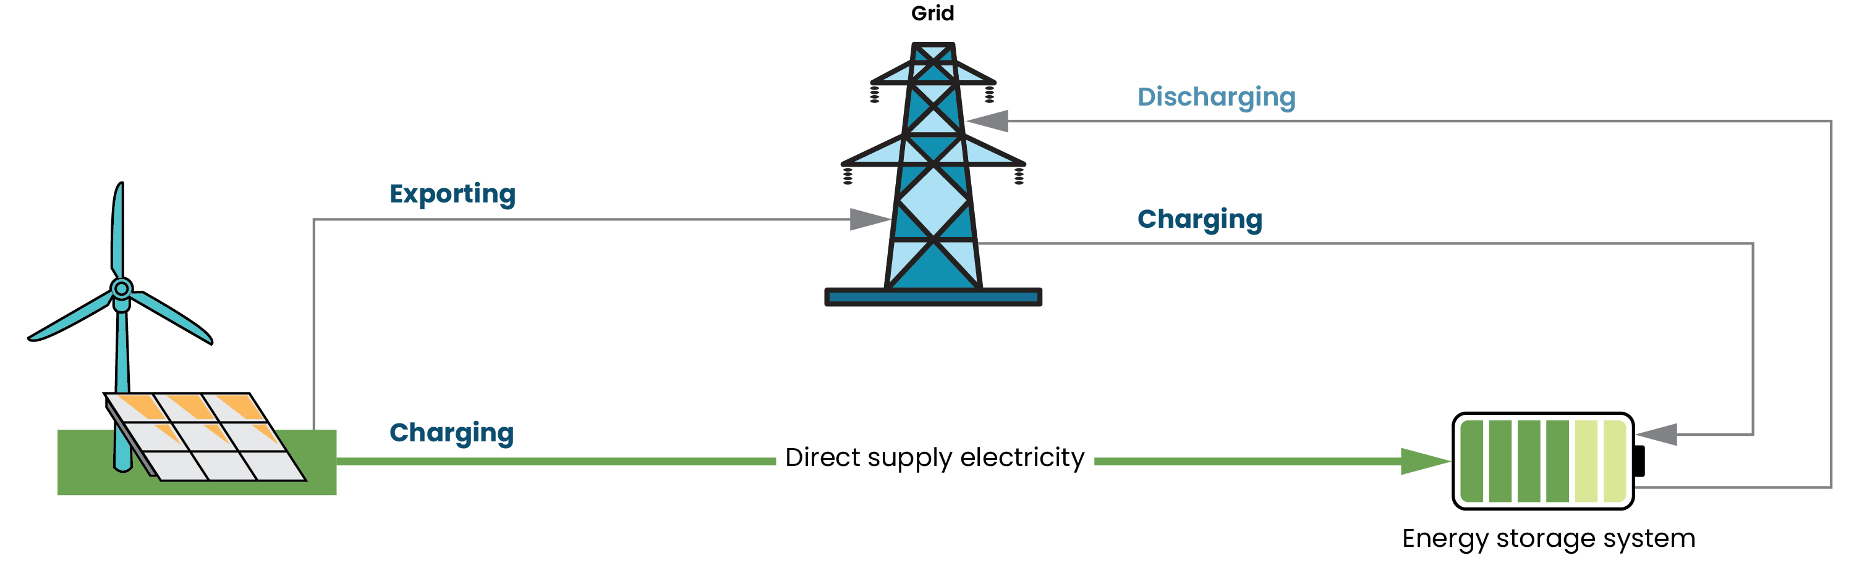
Figure 3 Direct supply relationship with one connection to the grid
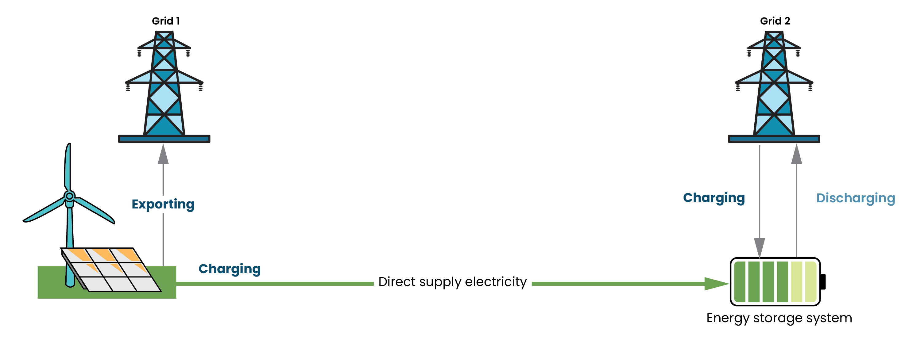
Figure 4 Direct supply relationship with separate connections to the grid
See the GO Rules and GO Measurement Standard for more information about how to report direct supply renewable electricity.

Transfer and retire REGO certificates
You will be able to transfer and retire certificates in the Unit and Certificate Registry, accessed via Online Services. The ability to transfer and retire certificates is not available yet. We’ll let participants know when this functionality is available.

Make claims about the use of renewable electricity in PGO
The REGO Scheme interacts with the PGO Scheme where electricity is used in the production or transport and storage of a PGO-certified product. For any electricity used in the production process or supply chain, REGO certificates may be retired to demonstrate that this electricity is renewable and has an associated emissions intensity of zero. Either below baseline or above baseline REGO certificates may be used for these purposes.
When you surrender LGCs or retire REGO certificates for this purpose, you can enter the surrendered or retired certificate details when creating PGO certificates to lower the emissions intensity recorded on the PGO certificate.

Make claims about the use of renewable electricity in other frameworks
Other emissions reporting frameworks may recognise retired REGOs as a displacement of electricity used with zero-emissions electricity, such as the National Greenhouse and Energy Reporting (NGER) Scheme. When retiring REGO certificates, you must accurately report the purpose of the retirement and relevant beneficiary details. These will be published on the GO Register, enabling auditors and regulators to verify claims associated with those certificates. Keeping a record of the retirement ID for future reference is recommended.

Maintaining your facility

Notice of events
There are several events that the eligible registered person must notify the CER of within one month of the event occurring. These events are outlined in section 85(2) of the GO Act and section 44 of the GO Rules.
Notifiable events include the following:
- a component is added to, or removed from, the facility*
- the facility ceases to comply with a requirement prescribed by a measurement standard
- the facility starts to generate electricity from a different eligible renewable energy source*
- For a facility that is an electricity generation system:
  - the facility starts using an energy source that is not a recorded energy source*
  - the facility stops using an energy source that is a recorded energy source for more than one month*
  - the eligible person intends a facility to permanently stop using a recorded energy source*
- for a facility that is a hydro system – there’s a change in water flows for the system
- for a facility that is an energy storage system – the facility has added or removed a connection for the import of electricity*
- the facility takes part in another scheme*
- the facility stops taking part in another scheme*
- there’s a contravention of Commonwealth, State, Territory or local government planning and approval requirements in relation to the facility
- the eligible registered person for the facility becomes aware that evidence they gave related to a REGO certificate that included a First Nations attribute was not accurate or complete.
You can notify the CER of these events either by lodging a variation application in Online Services for any of the items above marked with an asterisk (*), or by emailing us at REGO-Assessments@cer.gov.au.
After notification, the CER may vary the facility record to reflect the changes. If the notification was made by email, you may be asked to submit a variation application to update the facility details.
The CER may also vary a facility record on its own initiative in response to new information received through other channels. This includes response to variations to an accredited power station made under section 30C of the REE Act.

Variations
Facilities can apply for variations via Online Services, where the CER will assess continued eligibility for the REGO Scheme and update records if approved.
Variation applications are submitted through a single online function that uses existing registration details. You can review, update, or add information and agree to the required declarations before submitting your application.
The variation process follows the same steps as facility registration (see How to register a facility). You may need to request a variation to report a notifiable event or to ensure facility records remain accurate and complete.
Reasons for requesting a variation may include:
- Facility component details
This includes any changes to components installed at the facility. If you add, remove, or replace components, you must notify the CER (see Notice of events).
You should also let us know if the owner or operator of any component changes.
- Energy source details
If you start generating electricity from a new energy source, or if you stop using an energy source for more than one month, you must notify the CER (see Notice of events).
You must also let us know if you intend to permanently stop using an energy source.
- Generation capacity details
You should notify the CER if your facility’s capacity changes due to adding or removing components. Maintenance-related capacity changes do not require notification. While not mandatory under the GO Act, informing us of generation capacity changes helps to ensure accurate assessment of REGO certificates, which can speed up the process and reduce the need for additional information requests.
- Measurement details
If you are permanently replacing a meter or measurement device used in your eligibility calculation you must update the calculation methodology details and electricity meter or monitoring system details with the new instrumentation. This is so your certificates are calculated correctly in accordance with the GO Rules and your facility components meet the requirements in the GO Measurement Standard.
Short term alternative measurements do not require a variation application to be submitted.
- Accredited power station details
Variations to accredited power station details such as name, baseline or nominated persons must be made through the relevant LRET forms under the REE Act. On receipt of a variation application under the LRET we will use the information provided to update the REGO records as required. This type of variation cannot be applied for through Online Services.
- Legacy baseline details
You can apply to vary a determined legacy baseline for REGO each year via an annual adjustment request. This should be done through the relevant process and LRET form under the REE Act, and we will use the information to vary the REGO determination if approved.
This type of variation cannot be applied for through Online Services.
- Marginal loss factors
To ensure eligible amount calculations use up to date system characteristics, it is important that marginal loss factors (MLFs) are updated each time a new factor is assigned to your facility. The CER will update this data periodically on your behalf using the latest MLF data from the Australian Energy Market Operator. If you believe this information is wrong, please contact us.
If you become aware of a new MLF being assigned to your facility, please notify the CER of the updated MLF immediately by emailing us at REGO-Assessments@cer.gov.au.
This type of variation cannot be applied for through Online Services.
- Change of eligible registered person (ERP)
This process is similar to a change of nominated person in the RET. If you sell or transfer control of the facility to another entity, or if a different registered person intends to start managing the facility in Online Services and managing REGO certificates, you must apply for a change in ERP.
If you are also applying to change the nominated person for the accredited power station, you can include both changes in a single form. If you are not changing the nominated person, you must obtain signed approval from them to change the ERP for the facility.
You can’t apply for this variation through Online Services. Instead, email us at REGO-Assessments@cer.gov.au.
- If the change of person relates to a RET Power Station, you must complete a 30B application form and email it to RET-Powerstations@cer.gov.au

Annual Reconciliation checks
Under the GO Act, the CER requires participants involved in PGO certificate activity to complete Annual Reconciliation Checks. This process is similar to the Annual Electricity Generation Return that power stations provide in the LRET.
The REGO Scheme does not require annual reporting. If you are the eligible registered person of a REGO facility, you do not need to complete annual reporting to remain compliant. Instead, you must follow the notice of events requirements. This means that if a notifiable event occurs at your facility, as defined in the GO Act, you must notify the CER within one month of the event occurring.
See Notice of events for more detail.

Audits
Under the GO Act, the CER can request audits to assess a participant’s compliance with the Act. These audits can be requested under certain circumstances.
The GO Act does not require audits for REGO facilities or certificates. However, we may request an audit if there is reasonable suspicion of non-compliance with any part of the GO Act for a facility or certificate.

Engaging with the CER

Clean Energy Regulator Assessments
The CER conducts assessments to ensure that REGO registered persons, facilities, notifications, variations, certificates, and transfers or retirements comply with legal requirements. Applications are approved only when all legislative criteria are met, and no issues are identified.
If non-compliance is suspected or detected, the application will be escalated and referred to the CERs compliance team. For more information on our compliance approach, see our website.
Before submitting an application, make sure you meet all eligibility requirements and provide complete and accurate information. The CER is not obligated to refund application fees if it refuses or stops considering an application.

Engagement with CER Assessors
Processing times may vary depending on the complexity of each application. While standard assessment timelines apply, these may change if more information is required.
Assessors will keep applicants updated on their assessment status and notify them if a request for further information (RFI) is issued. Responding promptly is essential to avoid delays. If you fail to respond, the CER may stop considering your application. In that case, you’ll need to submit a new application and pay the associated fee to complete the registration.
There are no legislated timeframes for processing applications under the GO Act, however the below table provides indicative timeframes for each application type.
Table 2 Expected timelines for each assessment
Application assessment | Expected timeline  (restarts if application is amended)
Become a registered person | Up to 6 weeks
Register a facility | Up to 6 weeks
Vary a facility record or change the ERP | Up to 6 weeks
Register a REGO certificate | Up to 28 days
Transfer a REGO certificate | Up to 28 days
Retire a REGO certificate | Up to 28 days
Withhold or remove information from the GO Register | Up to 6 weeks
Request review of a decision | Up to 90 days

Information available on the GO Register
Under the GO Act, the CER is required to keep an up-to-date public register (the GO Register) of the following information:
- the name of each registered person
- each registered profile
- each registered PGO certificate
- the name of each registered renewable electricity facility
- each registered REGO certificate.
The CER must ensure the GO Register is made available for inspection on the internet. Anyone can view basic information about all participants, profiles, facilities, and certificates registered under the GO Act.
The GO Act and GO Rules outline specific details that must be included on the GO Register. These are outlined in the table below.
Table 3 Required information to be published in the GO Register according to the GO Act and GO Rules
- Registered persons | Person information  - name  - business identifier (ABN, ACN, ARBN, ICN or other unique number)  - business name or trading name  - entity type (an individual/sole trader, body corporate, corporation sole, body politic, local governing body, trust).  Registration information  - date first registered for the GO Act  - registered profiles held by the person  - registered facilities for which they are the eligible registered person  - registration status (registered, suspended, cancelled, surrendered).  Compliance information  - if suspended or cancelled, the date of the effect of the suspension or cancellation and the reason  - if suspended, the period of suspension  - whether the person has given an undertaking in relation to a provision of the GO Act  - details of specified non-compliance, including criminal convictions or civil penalty orders in respect of contraventions under the GO Act.
- Registered renewable electricity facilities | Registration information  - name  - facility identification code  - RET accreditation code (if relevant)  - the eligible registered person for the facility  - date first registered for the GO Act  - registration status (registered, suspended, cancelled, surrendered).  Facility information  - whether the facility is an accredited power station, an electricity generation system other than an accredited power station, an energy storage system or an aggregated system  - eligible renewable energy sources (if relevant)  - energy storage type (if relevant)  - a description of the type of technology by which the facility generates or stores electricity  - nameplate capacity  - location of the facility  - commissioning date of the facility  - the electricity network to which the facility is connected  - if the facility is subject to a related scheme, the name of that scheme  Native title and land use information  - native title description and agreement  - indigenous Land Use Agreement reference.  Compliance information  - if suspended or cancelled, the date of the effect of the suspension or cancellation and the reason  - If suspended, the period of suspension.
- Registered REGO certificates | Registration information  - certificate ID  - registered owner name  - registered owner receipt date  - creator name  - creation date  - registration date  - certificate status (registered, retired, improperly created).  Electricity and dispatch information  - time period of eligible electricity generation (calendar year, calendar month, calendar day, or hour of generation)  - whether electricity is exported from Australia  - whether it is a below baseline certificate  - retirement date and purpose and on whose behalf the certificate was retired  Facility information  - name of the facility in which the certificate was created  - facility ID  - location  - facility type (Accredited power station, Generation system, Energy storage system, Aggregated system)  - commissioning date  - electricity network connections  - eligible renewable energy sources (where relevant).  Energy storage information (if applicable)  - storage type  - network supply details (if relevant)  - if the facility has a direct supply relationship with an electricity generation system, the facility name, the facility identification code (if a renewable energy facility), the RET accreditation code (if accredited under the LRET) and each eligible renewable energy source  - upstream REGO or LGC energy sources.  First nations attributes (if applicable)  - majority ownership  - minority ownership  - verified consent  - verified procurement  - verified employment  - cultural heritage management  - benefit-sharing

Request to withhold, remove, or amend information on the GO Register
Although the CER must publish the information in the above table on the GO Register, you can request its removal or exclusion if it is commercially sensitive, poses national security risks, may harm public safety or the safety of an individual, or meets other reasons specified in the GO Rules.
This request can be made by emailing: REGO-Assessments@cer.gov.au.

Person or facility registration compliance
Compliance is monitored through:
- suitability event declarations made when applying to register a facility
- standing notices completed when creating renewable electricity generation certificates (REGO)
- assessment and ongoing review of REGO certificate claims
- site visits and inspections
- our annual risk-based audit program
- the collection of information from you or other parties.
If we suspect breaches of the GO Act, we may take appropriate action following our compliance and enforcement approach. We may suspend or cancel a person’s or facility’s registration in the scheme for failing to meet its obligations under the GO Act.

Complaints and concerns
Facilities must comply with relevant Commonwealth, state, territory and local government law. These government bodies are responsible for enforcing laws governing the development and operation of facilities. This includes:
- health and safety issues
- environmental concerns
- planning approvals.
If people have concerns or complaints in respect of the development or operation of a facility, they can contact the relevant government authority. The relevant authority is responsible for investigating complaints against their approvals and legislation.
We monitor compliance and work with other government authorities in respect of suspected breaches of the law.
If you have concerns or issues with CER assessors and would like to escalate the matter, ask to speak to the assessors supervisor or contact us at the Clean Energy Regulator.

Fees and charges
The Guarantee of Origin is a cost-recovered scheme. This means you’ll pay assessment fees and a yearly facility charge.
The Department of Climate Change, Energy, the Environment and Water have calculated the assessment fees based on the anticipated expenses required to run the GO Scheme when it’s fully operational.
However, fees will be lower during the initial phase of the scheme to broadly align with those of the Renewable Energy Target. The only exception is the enrol as a registered person fee, which aligns with the Product Guarantee of Origin.
In future financial years, the fees will likely increase to fully cost-recover the scheme, as required by the legislation.
You’ll pay each fee when you submit the application. We won’t start assessing your application until you’ve paid.
Table 4 Application fees in the REGO for financial year 2025-2026
Action | Fee (with waiver)
Enrol as a registered person | $490
Register an accredited power station or electricity generation system with nameplate capacity less than 10 MW | $50
Register an accredited power station or electricity generation system with nameplate capacity at least 10 MW but not more than 25 MW | $200
Register an accredited power station or electricity generation system with nameplate capacity more than 25 MW | $1,000
Register an energy storage system | $1,429
Register an aggregated system | $1,429
Create REGO certificates | $0.08 per certificate

The charge you pay for each facility is based on cost-recovering the scheme.
Usually, you’ll pay a charge at the end of each financial year. If your facility has only been registered for part of the financial year, you will only have to pay part of the charge.
However, the annual charge is waived for the first year of the scheme: financial year 2025–2026.

REGO Glossary
Table 5 Glossary of terms used in this document
Term | Meaning
Aggregated system | A facility type that consists of at least two electricity generation systems, at least two energy storage systems, or at least one system from each category.
Baseline / Below baseline | A baseline is defined in the REE Act as the amount of electricity that a power station generated annually before 1997. In the REGO, this same definition is applied to facilities. Before a facility meets its baseline for a year, all REGO certificates it creates are below-baseline certificates.
CER | Clean Energy Regulator
DCCEEW | Department of Climate Change, Energy, the Environment and Water
Double counting | Electricity generation is ‘double counted’ if it is used to create multiple certificates in different schemes. This includes REGO certificates, large-scale generation certificates (LGCs) and international renewable energy certificates (I-RECs).
EGS or electricity generation system | A facility type that generates electricity and is not an accredited power station in the LRET.
ERP or eligible registered person | The registered person that is responsible for the facility. This can be the owner, operator, or an aggregator of the facility (depending on facility type). ERPs can create certificates for the facility.
ESS or energy storage system | A facility type that stores energy.
Facility | A system that is registered in the REGO Scheme to create REGO certificates. This can be electricity generation, energy storage, or both.
GO | Guarantee of Origin
GO Act | Future Made in Australia (Guarantee of Origin) Act 2024
GO Measurement Standard | Future Made in Australia (Guarantee of Origin) Measurement Standard 2025
GO Rules | Future Made in Australia (Guarantee of Origin) Rules 2025
LGC | Large-scale generation certificate, created under the REE Act
LRET | The Large-scale Renewable Energy Target is a scheme within the Renewable Energy Target, also administered by the CER.
MLF or marginal loss factor | A factor applied to the calculation of REGO certificates. The factor is applied by AEMO to generators exporting to the NEM or WEM.
Nominated person | The organisation or individual responsible for power stations accredited in the LRET. roughly equivalent to an eligible registered person for a registered facility in the REGO.
PGO | Product Guarantee of Origin
Power station / Accredited power station | A system that is accredited in the LRET to create certificates is called a power station. These systems can also register as facilities in the REGO, under a facility type called accredited power stations.
Profile | In the GO Act, profile refers to a registered PGO production operation or a transport or storage operation involved in a PGO product supply chain.
REC | Renewable energy certificate is a term that used to be used for the certificates in the RET. These are now either called large-scale generation certificates (LGCs) or small-scale technology certificates (STCs). The registry where the certificates are created, held, traded and surrendered is still called the REC Registry.
REE Act | Renewable Energy (Electricity) Act 2000
Registered person | A legal entity in the GO Scheme that has been approved by the CER. Registered persons can apply to register PGO profiles and REGO facilities. They can also create and manager PGO and REGO certificates.
REGO | Renewable Electricity Guarantee of Origin
Retire | REGO certificates can be ‘retired’. This means the electricity they represent has been consumed and they are being used to claim use of renewable electricity. This is like ‘surrendering’ certificates in the RET.
The Regulator | This refers to the Clean Energy Regulator as described in the GO Act. The Regulator has power under the GO Act to request certain information, require persons to conduct audits, and other actions.
UCR | The Unit and Certificate Registry is where all REGO certificates are created, registered, transferred and retired. It is accessed through Online Services.

Resources and Forms
Check out these resources and forms on our website:
- Online Services user guide – Register a REGO facility
- Guarantee of Origin Cost Recovery Implementation Statement

Legislation
The GO Scheme is established by and administered by the CER through the following legislative framework:
- Future Made in Australia (Guarantee of Origin) Act 2024
- Future Made in Australia (Guarantee of Origin) Rules 2025
- Future Made in Australia (Guarantee of Origin) Measurement Standard 2025
The cost-recovery framework and the various fees applicable to participate in GO Scheme are provided for in the following:
- Future Made in Australia (Guarantee of Origin Charges) Act 2024
- Future Made in Australia (Guarantee of Origin Charges) Regulations 2025

Appendices

Appendix A: Electricity generation calculation diagrams
The calculations used to determine REGO certificate eligibility for electricity generation systems (EGS) are prescribed in the GO Rules. Equation 1 below is the main one, but you can see an explanation of this equation on our website.
Equation 1
These calculations can be difficult to understand, especially if you’re used to the LGC formula used in the RET. To help make the calculations easier to understand, this appendix includes useful diagrams.
Table 6 describes the terms that are used in the diagrams in this appendix.
Table 6 Values included in the calculation of REGO certificate entitlement for an EGS facility
Term | Meaning
TLEG | The total amount of electricity generated by the system.
AUX | The auxiliary loss of the system.
FSL | The amount of electricity generated by the facility, either using anything other than an eligible renewable energy source in a way that’s ecologically sustainable, or for a purpose other than to meet the demand for electricity.
DLEG | The amount of electricity dispatched to the network.
MLF | The marginal loss factor determined by the Australian Energy Market Operator.
DSE | The total amount of electricity supplied to a registered energy storage facility through a direct supply relationship.

Note that all examples given in this appendix assume that the certificates are being calculated monthly, where the time period t is equal to one month.

EGS facility with all possible inputs and outputs
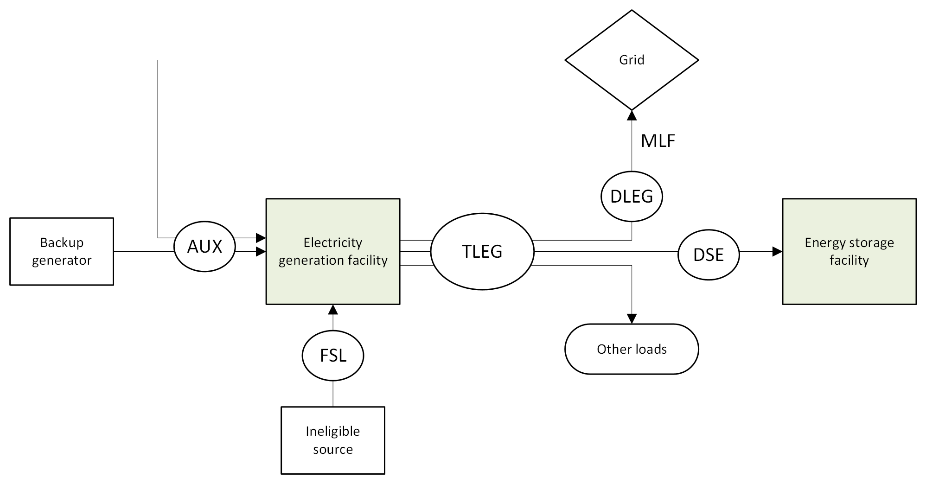
Figure 5 Electricity generation facility with all possible inputs and outputs
To calculate your REGO certificates, you will need to measure AUX, the auxiliary loss of the system, and TLEG, the total generation. You will need to measure FSL, the generation from any ineligible sources. You will need to measure DLEG, export to a distribution or transmission network. If you have an MLF provided by AEMO, you will use this in the calculation. Finally, if the facility is supplying electricity directly to an energy storage facility, you will need to measure DSE, the direct supply.
All these measurements must comply with the GO Measurement Standard. This means that appropriate meters or other energy measurement methods must be used.

EGS facility simplified
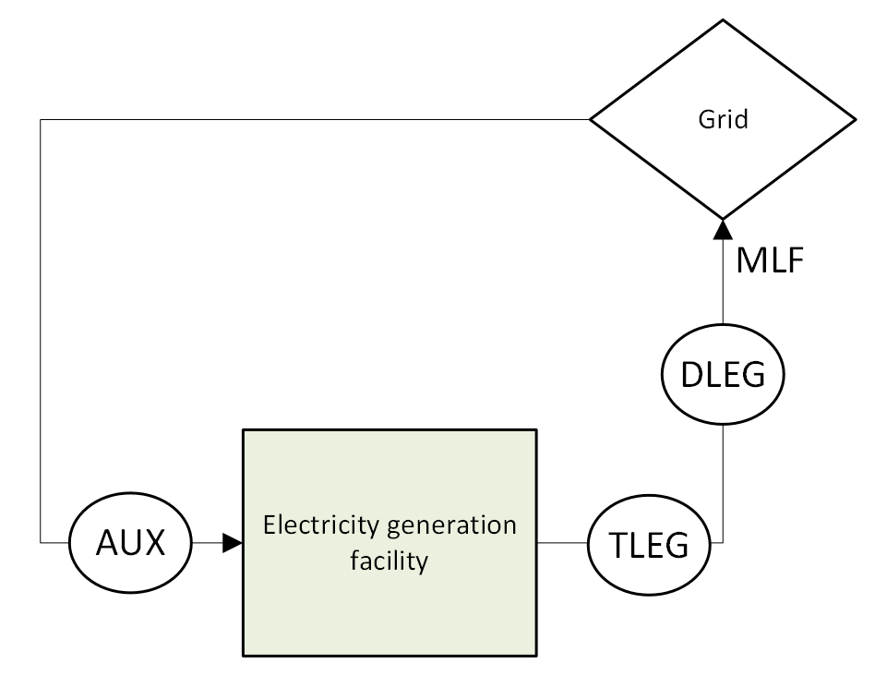
Figure 6 Simplified electricity generation facility
The facility represented in Figure 6 would have auxiliary losses and electricity generation. There is no DLEG in this diagram because at this facility, all the generation is dispatched to the grid. This means that in this case, DLEG = TLEG. This facility also does not generate from ineligible sources and does not directly supply any energy storage facilities.
The REGO calculation formula for this facility might look like Equation 2 below.
E_{A} = TLEG – AUX – (DLEG x (1 – MLF)) Equation 2
If the facility exports electricity to a local distribution grid, or uses the electricity on-site, then the MLF is 1. This means that the formula might look like Equation 3 below.
E_{A} = TLEG – AUX Equation 3

EGS facility with direct supply output
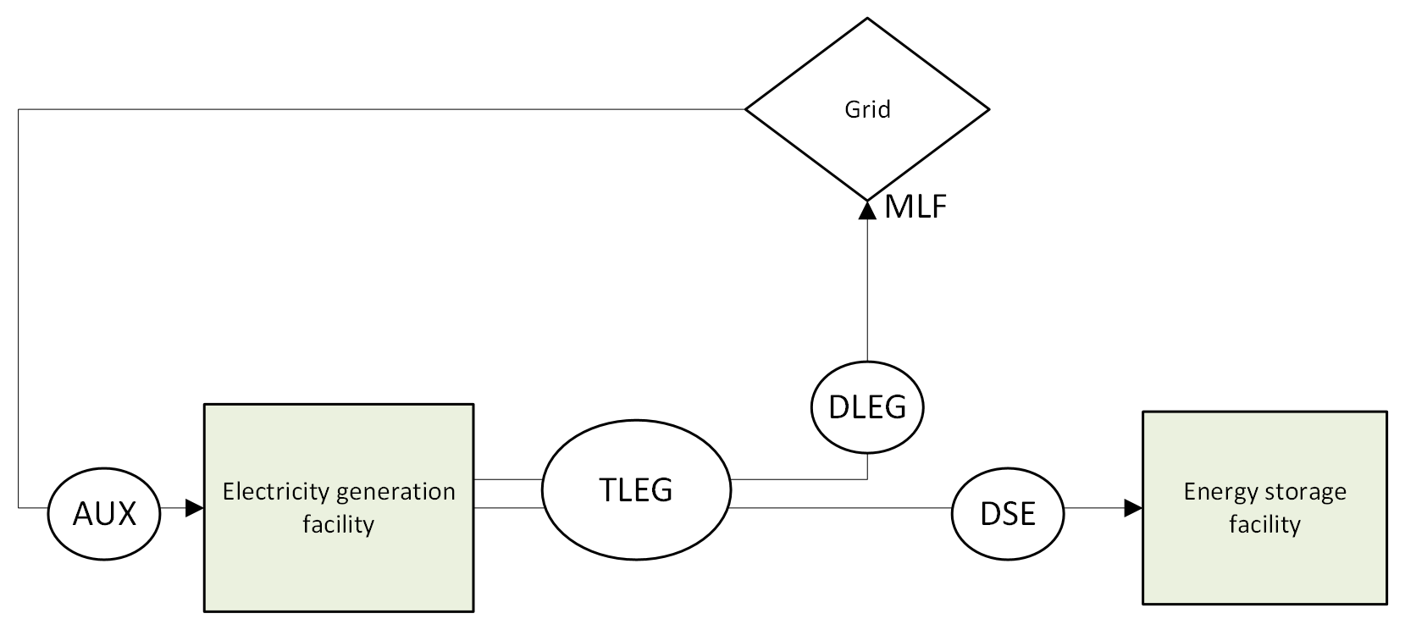
Figure 7 Electricity generation facility with direct supply output to an energy storage facility
The facility represented in Figure 7 would have auxiliary losses, electricity generation and direct supply to an energy storage facility. The electricity generated either gets dispatched to the grid or directly supplied to an energy storage facility, meaning that it would need to measure DLEG as well as TLEG.
The REGO calculation formula for this facility might look like Equation 4 below.
E_{A} = (TLEG – AUX) – (DLEG x (1 – MLF)) – DSE Equation 44

EGS facility with an ineligible energy source
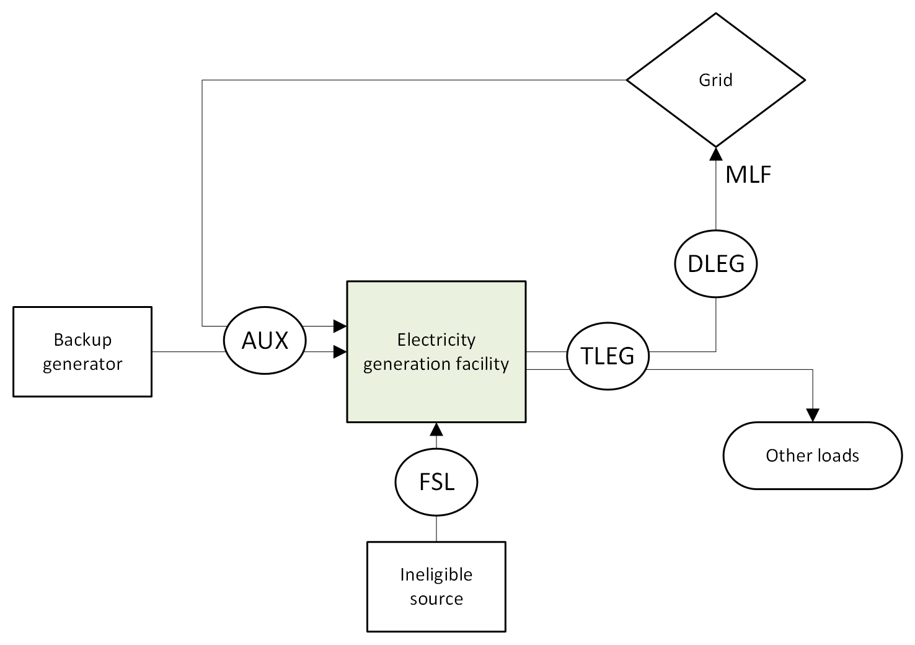
Figure 8 Electricity generation facility with an ineligible energy source and other loads
The facility represented in Figure 8 would have auxiliary losses and electricity generation from both eligible and ineligible sources. The electricity generated either gets dispatched to the grid or gets used by other loads on site, meaning that it would need to measure DLEG as well as TLEG. The use of ineligible sources means that FSL, the amount of electricity generated from those ineligible sources, must be subtracted from TLEG.
The REGO calculation formula for this facility might look like Equation 5 below.
E_{A} = [(TLEG – FSL) x (1 – (AUX ÷ TLEG)] – (DLEG x (1 – MLF)) Equation 55

Appendix B: Energy storage calculation diagrams
The calculations used to determine REGO certificate eligibility for energy storage systems (ESS) are prescribed in the GO Rules. Equations 6 and 7 below are the main ones, but you can see an explanation of these equations on our website.
Equation 6 6
Equation 77
These calculations can be difficult to understand, especially if you’re used to the LGC formula used in the RET. To help make the calculations easier to understand, this appendix includes useful diagrams.
Table 7 describes the terms that are used in the diagrams in this appendix.
Table 7 7 Values included in the calculation of REGO certificate entitlement for an EGS facility
Term | Meaning
TLED / Electricity Out | The total amount of electricity exported by the system.
AUX | The auxiliary loss of the system.
Electricity In | The total amount of electricity imported to the system.
EX | The electricity used for network support and control ancillary services.
DLED | The amount of electricity dispatched to the network.
MLF | The marginal loss factor determined by the Australian Energy Market Operator.
DSEE | The total amount of electricity supplied from a registered electricity generation facility through a direct supply relationship.

Note that all examples given in this appendix assume that the certificates are being calculated monthly, where the time period t is equal to one month.

ESS with all possible inputs and outputs
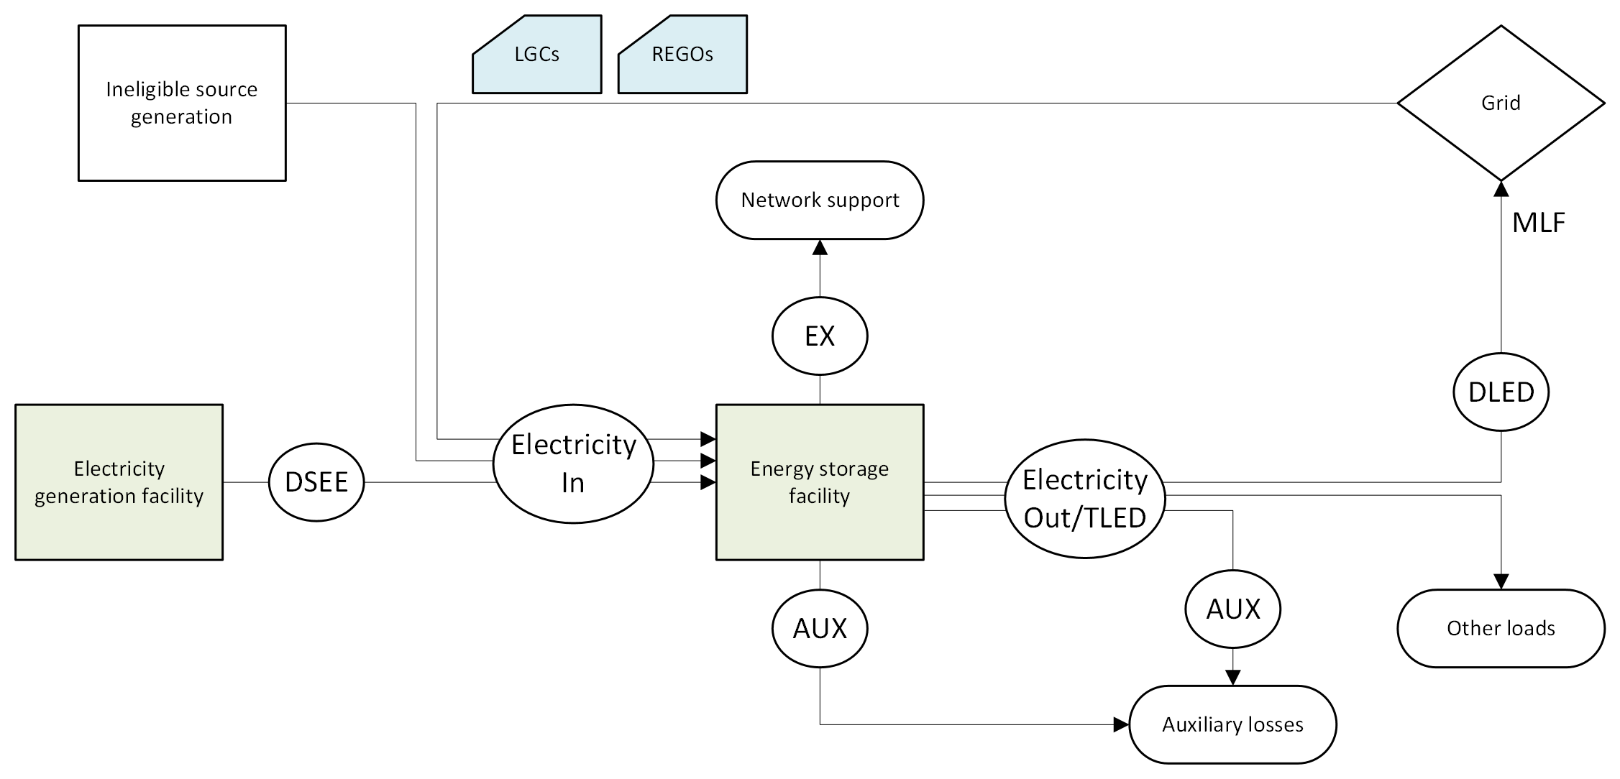
Figure 9 Energy storage facility with all possible inputs and outputs
To calculate your REGO certificates, you will need to measure AUX, the auxiliary loss of the system, and TLED, the total export. You will need to measure DLED, export to a distribution or transmission network. If you have an MLF provided by AEMO, you will use this in the calculation. You will also need to measure EX, any electricity used for network support or control ancillary services.
You will need to measure all electricity in to the system. If the facility is importing electricity directly from an electricity generation facility, you will need to measure DSEE, the direct supply of electricity generated from eligible sources. The electricity imported from the grid must be renewable to be eligible for REGO certificates, so to support this calculation you must surrender LGCs or retire REGOs.
All these measurements must comply with the GO Measurement Standard. This means that appropriate meters or other energy measurement methods must be used.

ESS facility with input from the grid
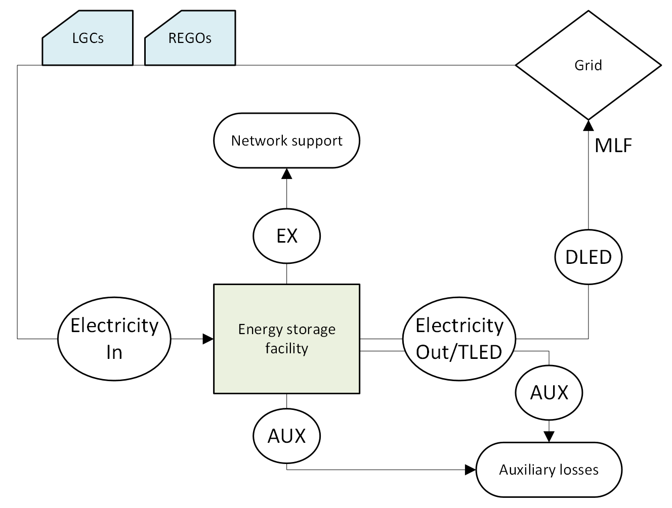
Figure 10 Energy storage facility with input from the grid
The facility represented in Figure 10 would have electricity import from the grid, and export back out to the grid. There is no DLED in this diagram because at this facility, all the electricity from the ESS is dispatched to the grid. This means that in this case, DLED = TLED. This facility does have auxiliary losses and has used electricity for network support or control ancillary services.
Since all electricity in is from the grid, and not direct supply from an electricity generation facility, LGCs or REGOs must be surrendered or retired to represent the imported electricity.
The REGO calculation formulas for this facility might look like Equations 8 and 9 below.
E_{A} = [TLED – AUX – DLED x (1 – MLF)] x [(LGCs + REGOs) ÷ Required Elec] Equation 8
Required Elec = Electricity In – EX – AUX Equation 98
If the registered person for this facility surrendered LGCs or retired REGOs to completely match the Required Electricity amount described in Equation 9, the REGO calculation formula might look like Equation 10 below.
E_{A} = TLED – AUX – DLED x (1 – MLF) Equation 10

ESS facility with direct supply input
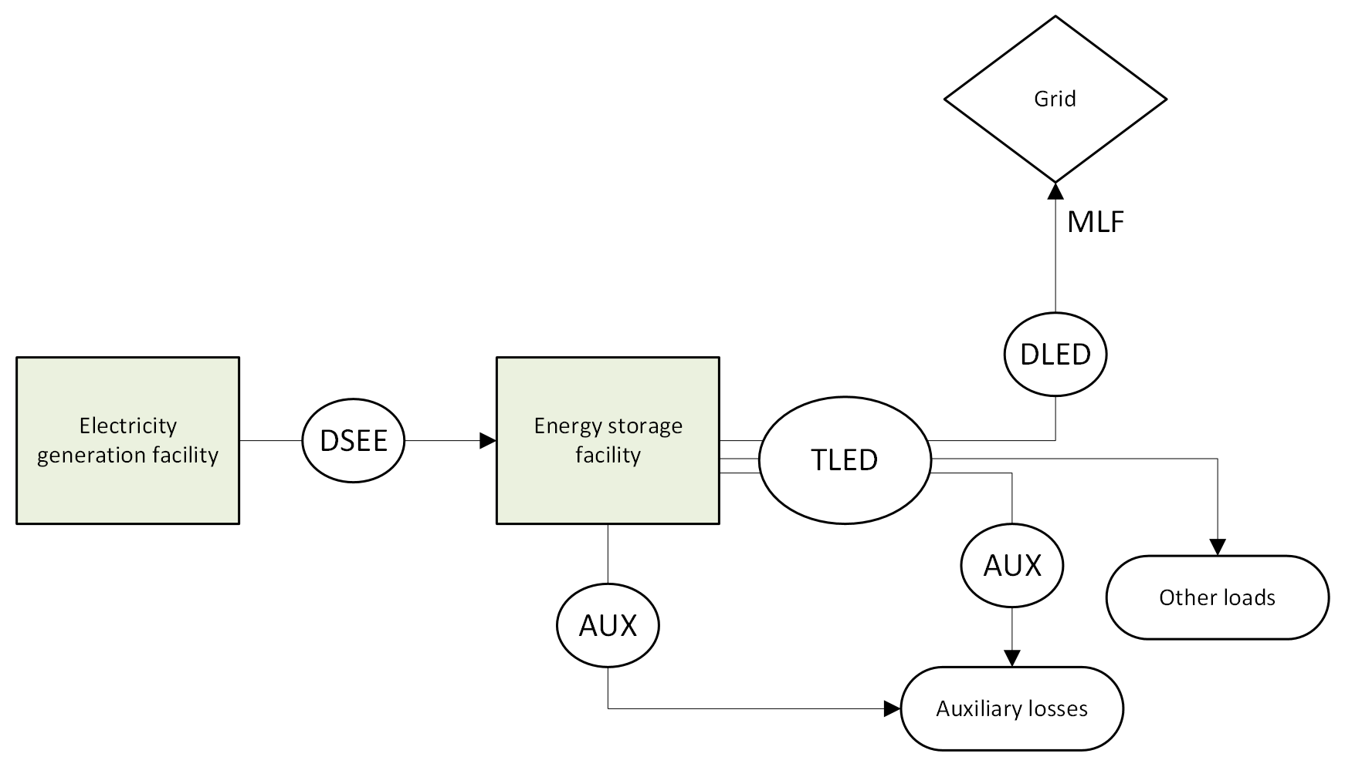
Figure 11 Energy storage facility with direct supply input from an electricity generation facility
The facility represented in Figure 11 would have direct supply electricity import from an electricity generation facility. The exported electricity either gets dispatched to the grid or gets used by other loads on site, meaning that it would need to measure DLED as well as TLED. This facility also has auxiliary losses to measure.
Since all electricity in is directly supply from an electricity generation facility, no LGCs or REGOs need to be surrendered or retired to represent the imported electricity.
The REGO calculation formula for this facility might look like Equation 11 below.
E_{A} = [TLED – AUX – DLED x (1 – MLF)] Equation 11

https://www.legislation.gov.au/C2024A00121/latest/text
https://cer.gov.au/schemes/large-scale-renewable-energy-target
https://cer.gov.au/schemes/renewable-energy-target
https://www.legislation.gov.au/C2004A00767/latest/text
https://www.rec-registry.gov.au/rec-registry/app/home
https://onlineservices.cer.gov.au/
https://cer.gov.au/document_page/guarantee-origin-cost-recovery-implementation-statement
https://cer.gov.au/schemes/guarantee-origin-scheme/product-guarantee-origin
https://onlineservices.cer.gov.au/
https://cer.gov.au/about-us/our-policies/fit-and-proper-person-posture/fit-and-proper-person-requirements
https://cer.gov.au/document_page/online-services-user-guide-register-rego-facility
https://onlineservices.cer.gov.au/
https://cer.gov.au/about-us/our-policies/internal-review-decisions
https://www.legislation.gov.au/F2025L01281/asmade/text
https://www.legislation.gov.au/F2021L00318/latest/text
https://www.standards.org.au/standards-catalogue/standard-details?designation=as-4707-2021
https://www.standards.org.au/standards-catalogue/standard-details?designation=as-4708-2007
https://www.agriculture.gov.au/sites/default/files/documents/due-diligence-toolkit-processors-illegal-logging.pdf
https://cer.gov.au/schemes/guarantee-origin-scheme/renewable-electricity-guarantee-origin/renewable-electricity-guarantee-origin-certificates
https://cer.gov.au/schemes/guarantee-origin-scheme/renewable-electricity-guarantee-origin/eligibility-rego
https://www.legislation.gov.au/F2025L01301/asmade/text
https://cer.gov.au/online-systems/new-unit-and-certificate-registry
https://cer.gov.au/document/application-to-change-nomination-person-accredited-power-station-form
https://cer.gov.au/about-us/our-compliance-approach/compliance-policy-education-monitoring-and-enforcement-activities
https://cer.gov.au/about-us/our-compliance-approach/compliance-policy-education-monitoring-and-enforcement-activities
https://cer.gov.au/about-us/our-policies/complaints
https://www.legislation.gov.au/C2024A00121/asmade/text
https://www.legislation.gov.au/F2025L01301/asmade/text
https://www.legislation.gov.au/F2025L01281/
https://www.legislation.gov.au/C2004A00767/
https://cer.gov.au/document_page/online-services-user-guide-register-rego-facility
https://cer.gov.au/document_page/guarantee-origin-cost-recovery-implementation-statement
https://www.legislation.gov.au/C2024A00121/
https://www.legislation.gov.au/F2025L01281/
https://www.legislation.gov.au/F2025L01301/
https://www.legislation.gov.au/C2024A00122/
https://www.legislation.gov.au/F2025L01267/
https://cer.gov.au/schemes/guarantee-origin-scheme/renewable-electricity-guarantee-origin/renewable-electricity-guarantee-origin-certificates
https://cer.gov.au/schemes/guarantee-origin-scheme/renewable-electricity-guarantee-origin/renewable-electricity-guarantee-origin-certificates

