Online Services user guide

Renewable Electricity Guarantee of Origin
V1 3 September 2026

Contents
Introduction 3
Before you begin 3
Edit a facility record 3
Step 1: Start a variation application 3
Step 2: Update the facility details 4
Step 3: Review your application 6
Step 4: Complete the declaration and submit 6
Submission confirmation 7
Track your application 7
Application outcome 7
Create REGO certificates 8
Step 1: Download the certificate data template 8
Step 2: Complete the certificate data template 9
Step 3: Upload your claim 14
Step 4: Provide extra claim information 14
Step 5: Upload supporting evidence 16
Step 6: Review and submit your claim 17
Step 7: Pay your invoice 18
Application outcome 18
Requests for more information 19
System statuses 20
File upload statuses 21
Validation messages and how to resolve them 22
File upload errors and how to resolve them 25

Introduction
This guide explains how to complete key processes in Online Services for participants in the Renewable Electricity Guarantee of Origin (REGO). It includes stepped instructions and screenshots to help you submit applications and manage your certificates.

Before you begin
Familiarise yourself with Guarantee of Origin user access and permissions guide.
You may need to switch accounts to make sure you’re acting on behalf of your registered organisation.
Make sure you’re:
- logged in to Online Services
- using the correct account
- aware of the system validation messages to help you resolve error messages that you may encounter when submitting applications.

Edit a facility record
Follow these steps to apply to vary your facility record by submitting a variation application in Online Services.
You’ll use this process if there are changes to your facility that we need to be made aware of.
Once you’ve submitted the application, we will check to make sure you’ve provided the information we need and make sure your facility is still eligible.

Step 1: Start a variation application
- From the dashboard or the Manage tab, select Renewable electricity facilities.
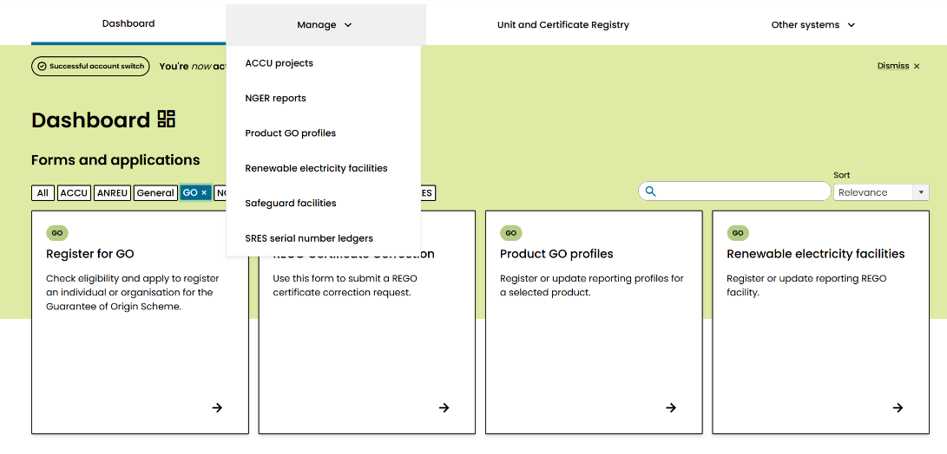

- Select the facility you want to edit.

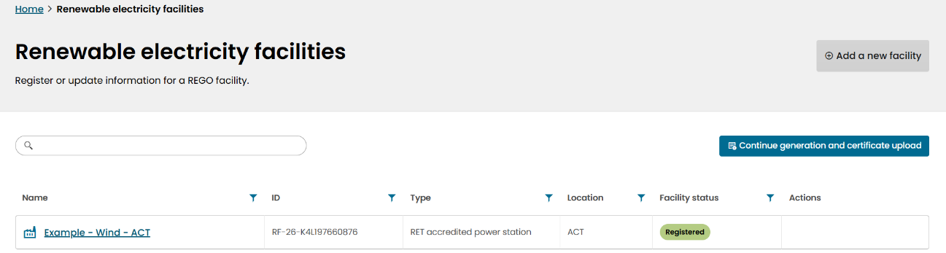

- Select Facility details from the list on the left of the screen.
- Select Edit facility.
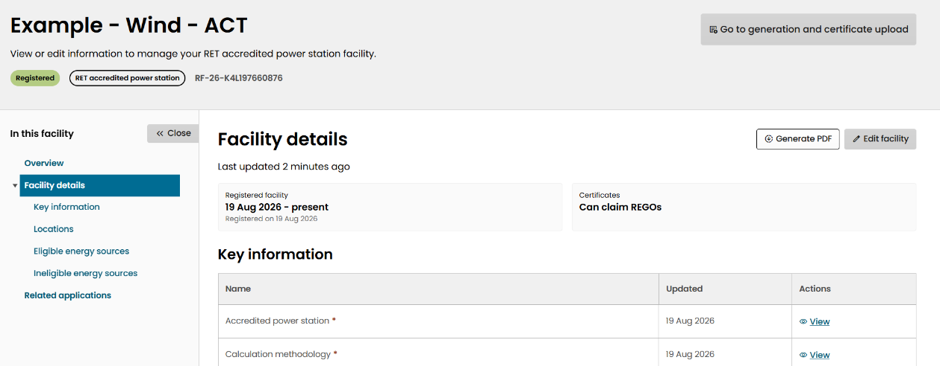

- In the confirmation pop-up, select Edit facility to create a new application.
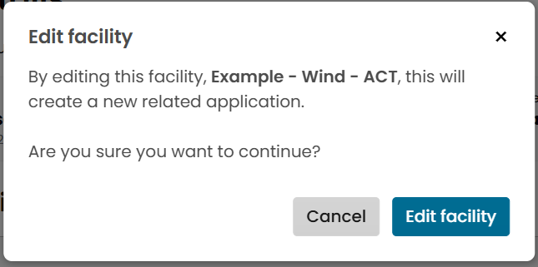

Step 2: Update the facility details
Update the sections you need to change:
- Select Edit to update an existing section.
- Select Delete to remove a section (some parts require at least one section to be included, such as locations).
- Select Add to include a new section.
- Select Change to update the facility name. If you receive an error message, refer to the trouble shooting section to help resolve the issue.
Each section has a status to let you know whether you need to provide more information or update it.
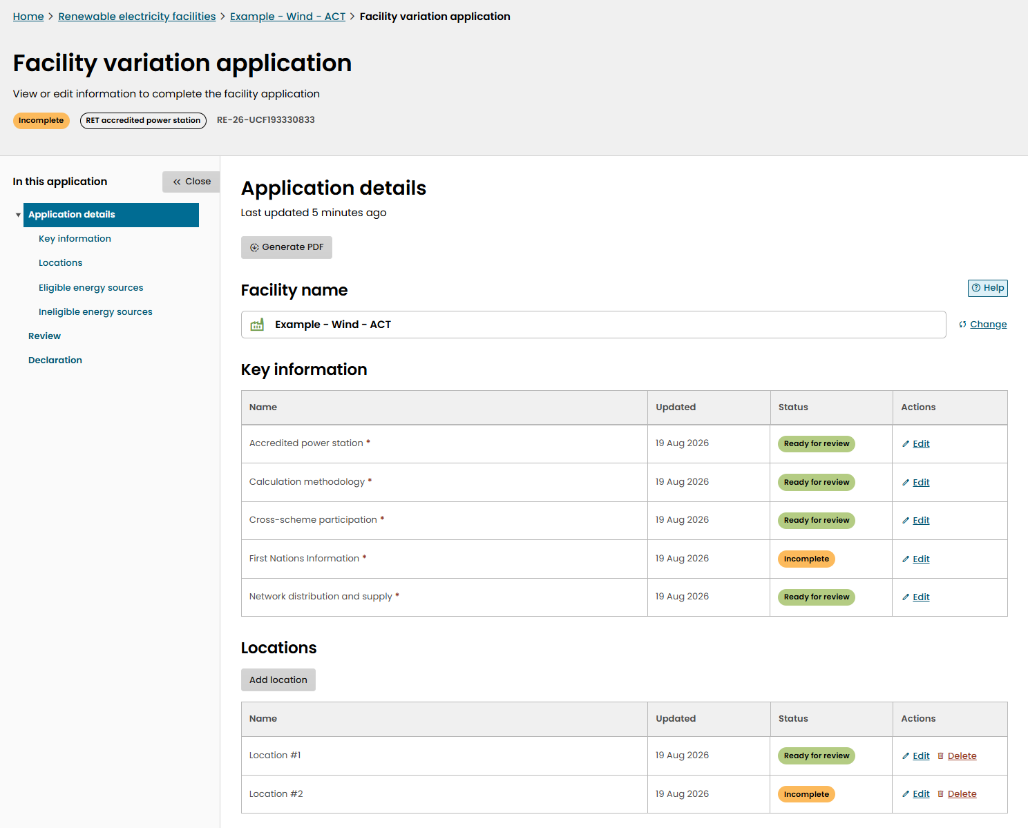

You can save and exit at any time. The application will show on the facility overview page as incomplete until you submit it or delete it.
When you’ve finished making changes, select Next at the bottom of the page.
Remember to upload all relevant documents to this application before you submit, which may include, but is not limited to:
- photos of any new components or meters
- electrical single line diagrams
- certificates of electrical safety
- any new required approvals.

Step 3: Review your application
- Review the information you’ve entered.
- If everything is correct, select Next.

Step 4: Complete the declaration and submit
- Enter the variation start date and reason for the variation.
We’ll check the proposed start date against the documents you provide. We’ll contact you to determine a different start date if we find any inconsistencies.
The effective start date is the first date that certificates can be claimed against the updated version of the facility.
- Provide details of any suitability events relating to yourself and, if the facility is also a RET power station, the nominated person. For more details on suitability events, see section 24 of the GO Act.
- Upload any supporting evidence not already included in the application (e.g. correspondence with other regulators or documents that support your start date).
- Read the declaration and select the acknowledgement checkbox.
- Select Submit.
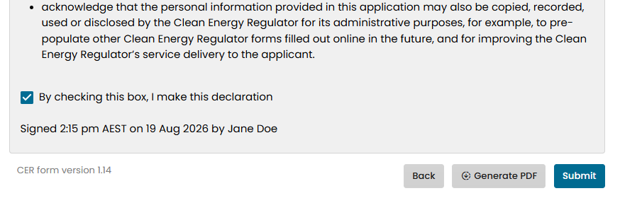

Once you submit a variation application you can’t withdraw it. If you have accidentally submitted a variation application, contact us at 1300 553 542 or REGO-Assessments@cer.gov.au to cancel it.
There is no application fee for variations. This is incorporated in the facility’s annual fee.

Submission confirmation
After you select Submit, you’ll be shown a message indicating whether your application was submitted successfully.
If the application submitted successfully, no further action is needed.
If the application did not submit, select Continue application and try submitting again.
If that doesn’t work, check the system validation messages section of this guide or contact us for help at 1300 553 542 or REGO-Assessments@cer.gov.au.

Track your application
- Go to the Facility overview page.
- Check the application Status.
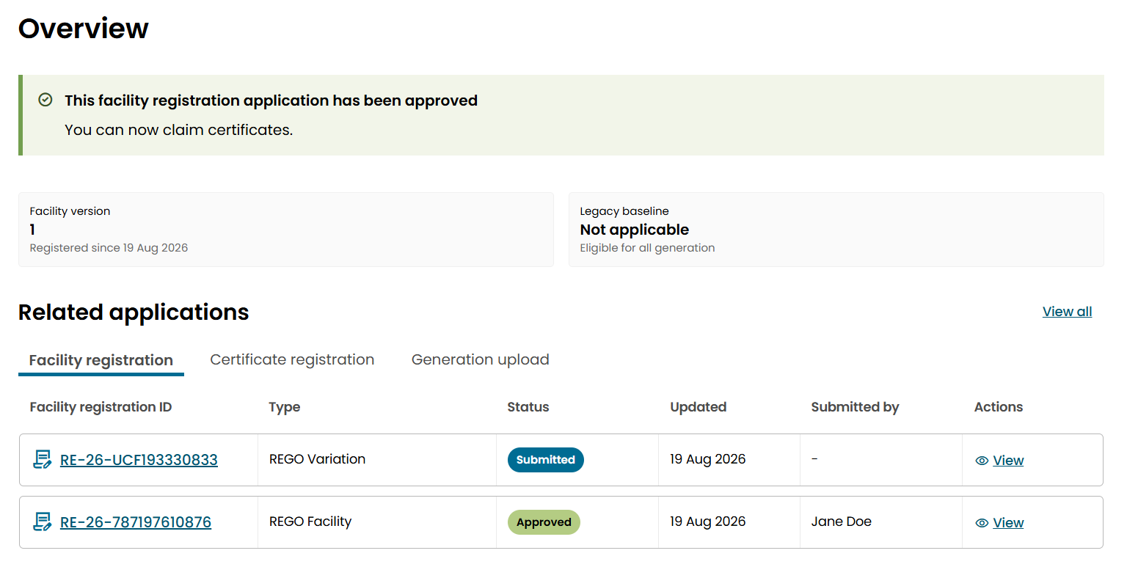
The status tells you where your application is in the assessment process.

Application outcome
Once we’ve assessed your application, it will either be approved or refused.
If your application meets the requirements, we’ll approve it and let you know by email.
We may refuse your application if:
- you don’t respond to a request for more information by the due date
- we determine the variation is incorrect or inappropriate, and decide not to vary the facility.
If your application is refused, we’ll let you know by email.
If a change to your facility results in the facility no longer being eligible to create REGO certificates, we’ll contact you about next steps. This may include a notice of intent to suspend or cancel the facility’s registration.

Create REGO certificates
Follow these steps to create REGO certificates in Online Services.
You’ll use this process you’re a registered person who wants to create certificates for the electricity your facility has generated or stored.
Once you’ve submitted the application, you will need to pay an invoice before we assess your claim.

Step 1: Download the certificate data template
- From the dashboard or the Manage tab, select Renewable electricity facilities.
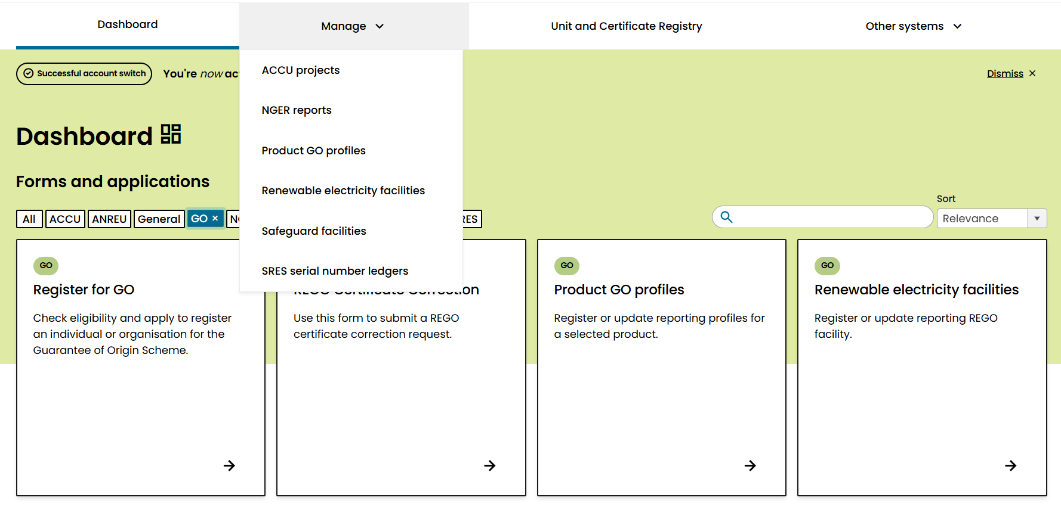
- Download the facility’s certificate data template.
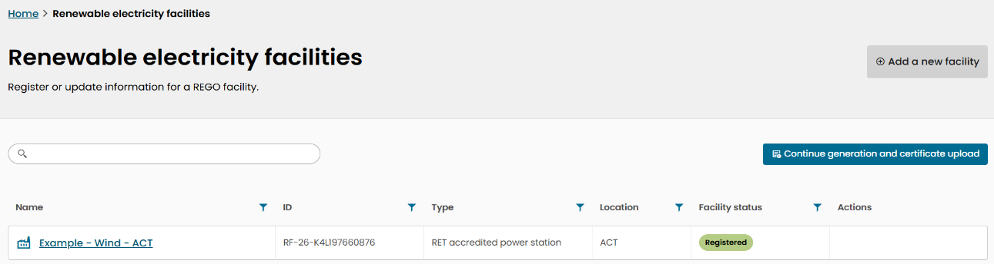
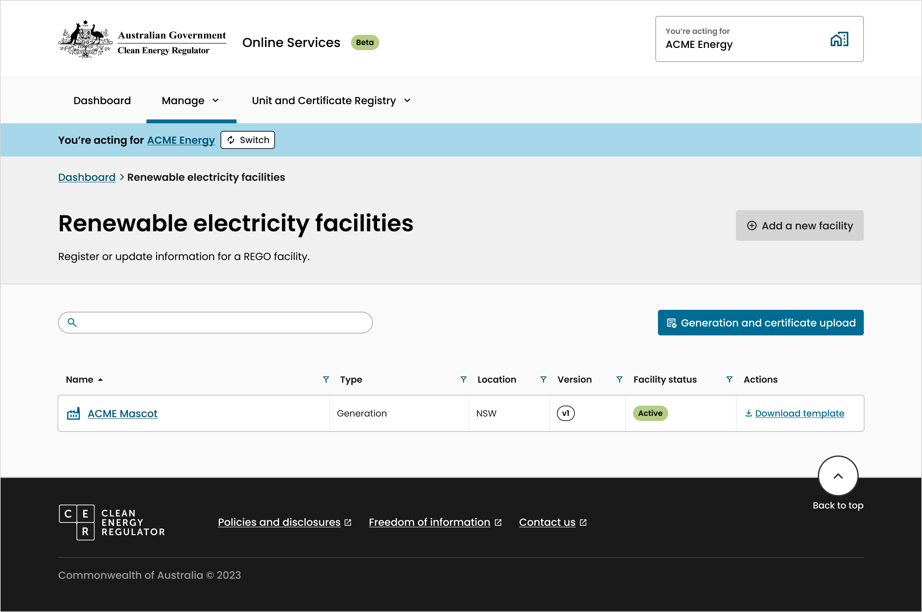

- Select the claim period, then select Download in the confirmation window.
This will trigger an Excel template to download for the selected claim period.

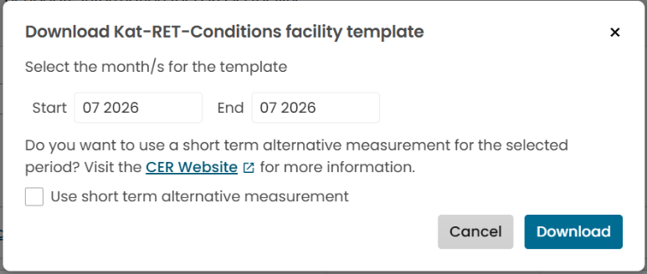
Download Example – Wind – ACT facility template

- Download a separate template for each facility you’re claiming for
- Each template can include claims for multiple months within the claim period (unless your facility has nominated to create yearly certificates)

Step 2: Complete the certificate data template
- Open the downloaded Excel template and enter the required information in each tab as outlined below.
- Save the completed template as a .xls or .xlsx file.
- Repeat this process for each facility you’re claiming for.
If you save your template as something other than a .xls or .xlsx file, your upload may not work.

Interval generation tab
You will need to copy and paste your meter data into the appropriate columns.
Each interval length is provided on a separate tab. Select the tab that matches the interval length of your measurement data and paste the data into the corresponding columns.
The column headings identify the REGO calculation methodology term and the measurement identifier provided in your REGO facility registration application. Use these headings to ensure data is entered into the correct column for each measurement point.
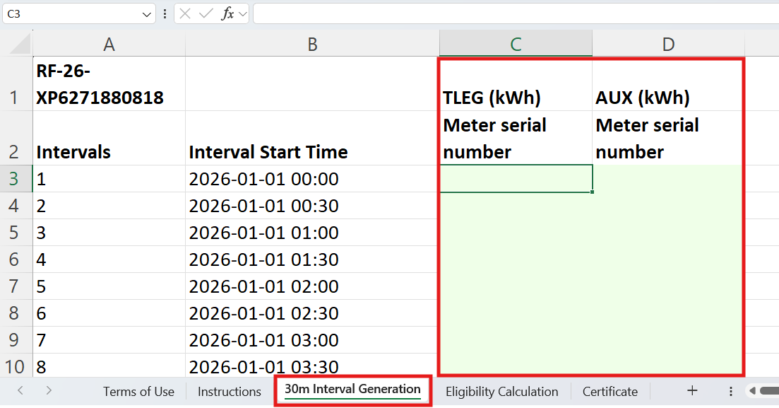
Data must be aligned with the correct interval start time shown in the template.

Eligibility calculation tab
Based on the data entered in the Interval Generation tab, the eligible amount will be automatically calculated in the Eligibility Calculation tab using the calculation methodology registered for the facility.
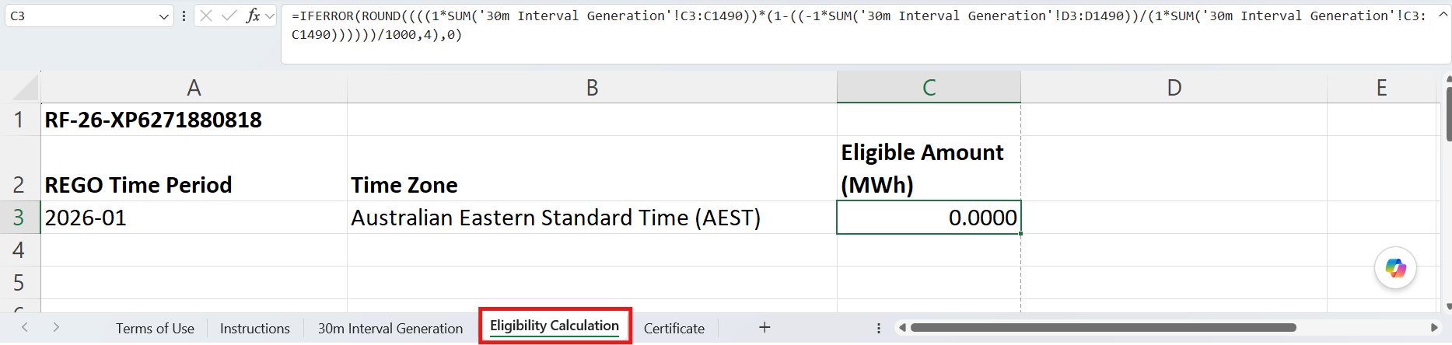
Go to the Certificate tab to allocate your eligible amount to certificates.

Complex methodology and short-term alternative measurement
If your facility has a complex calculation methodology, we may flag this as a complex facility during registration. A complex facility template will be provided to you when you download the template.
If you need to use an alternative measurement method for the claim period, select Short Term Alternative Measurement to generate a complex facility template for that claim.
When using a complex facility template, you’ll need to perform the eligible amount calculation yourself and upload the calculation as eligible amount evidence.
When you use a complex facility template you must calculate your eligible amount in MWh by using your generation meter data and your facility’s calculation methodology.
Calculate your eligible amount in MWh by using your generation meter data and your facility’s calculation methodology.
The raw meter data and calculations will also need to be uploaded to Online Services.
Paste your calculated eligible amount for each interval in column C of the template.
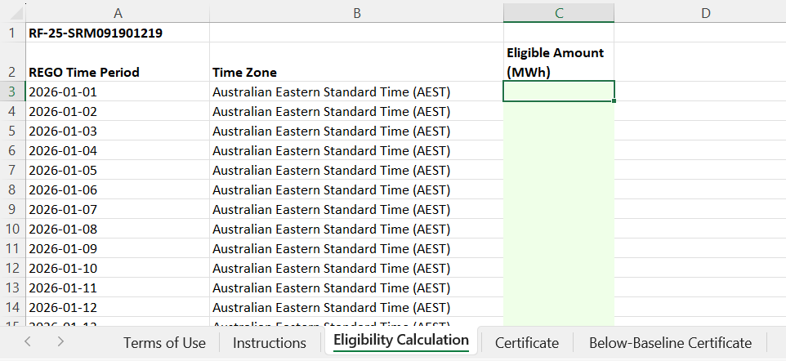

Certificate tab
Certificates can be allocated, created and registered here. If your facility has a baseline, use this tab to allocate above-baseline certificates and use the below-baseline certificate tab to allocate below-baseline certificates.
In this tab, you must fill in all green cells to allocate how many REGOs to create from the eligible amount.
In columns I, J and K, you can allocate the above-baseline eligible amount (column D) between REGO and other schemes. Allocating certificates to other schemes does not constitute an application for those certificates. This claim is only for REGO certificates.
An eligible amount that has not been allocated to any scheme will appear in unallocated eligible amount (column L).
The amount you can apply to create and register will appear in timestamped REGOs available to create and register (column M). This number will be rounded down to the nearest whole MWh amount.
Enter the number of timestamped REGOs to create and register (column N). You don’t need to create and register all available REGO certificates in this claim.
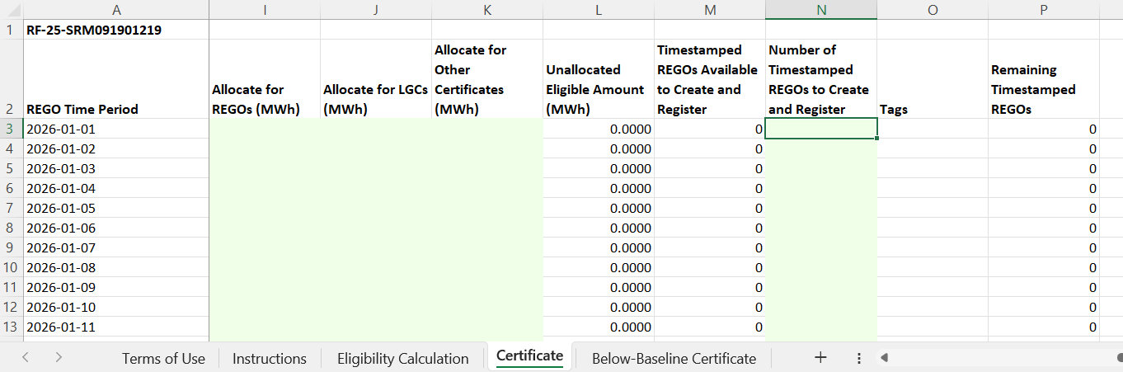

You can only create REGOs if you have not used the same generation to create certificates in other relevant schemes. This means that the total number of REGOs, large-scale generation certificates (LGCs) and other certificates you create can’t exceed the eligible amount.
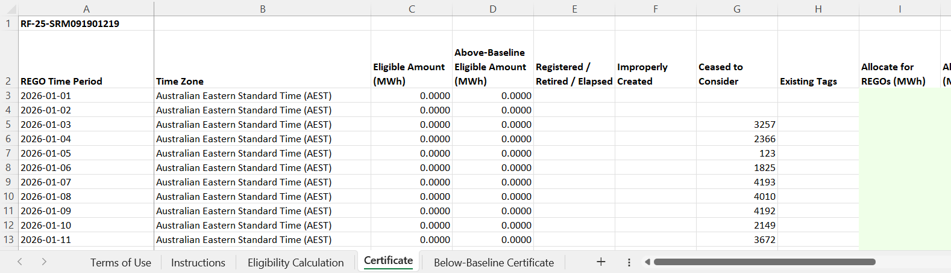
Previously created REGO certificates or pending REGO registrations for the same time period are removed from this amount; this information appears in columns E, F and G.

The residual fraction (column R) will only appear for those facilities using hourly timestamping of REGO certificates. It is the remaining partial MWh amount left over from rounding. They can be summed and used to create and register REGO certificates in the residuals tab.

Below-baseline certificate tab
This tab will not appear if your facility does not have a baseline.
This tab refers to generation that is below the baseline of the facility. It works the same as the certificate tab. They have been separated due to the restrictions set out by the GO Rules on how below-baseline REGO certificates can be used.
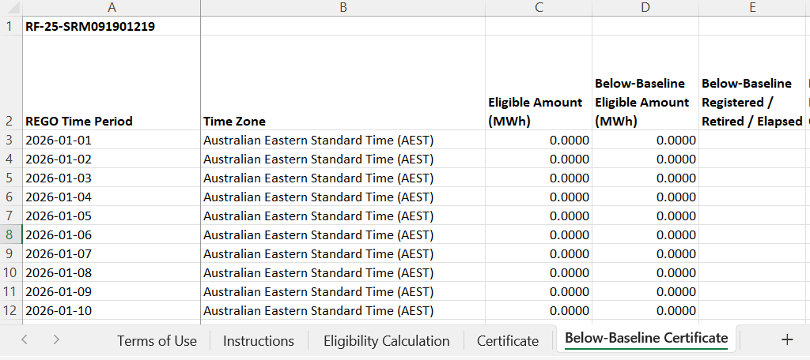
The below-baseline eligible amount (column D) will show 0 once the baseline is crossed, regardless of what the eligible amount is.

Residuals tab
This tab will only appear if you are applying to create and register REGO certificates on an hourly basis. Daily, monthly and yearly certificates don’t qualify for residual amounts.
The residuals tab refers to generation that occurred after the facility crossed its baseline.
As a REGO certificate can only be created for a whole MWh of eligible generation, this leaves residual fractions unclaimed for each hour. For example, if a facility creates 4.7MWh in the hour between 2 pm and 3 pm on 1 May 2025, only 4 REGO certificates can be created with that timestamp, so the residual fraction for that hour is 0.7MWh.
These residual fractions are summed within a month to form a residual amount. Residual certificates are timestamped with the month and year in which the generation occurred.
The residual REGOs available to create and register (column I) will autofill with the maximum number that can be created and registered. This is based on information in the certificate tab and on the previously registered (or pending registration) residual amounts for the same time period.
Enter the number of residual REGOs to create and register (column J). You don’t need to create and register all available residual REGO certificates in this claim.
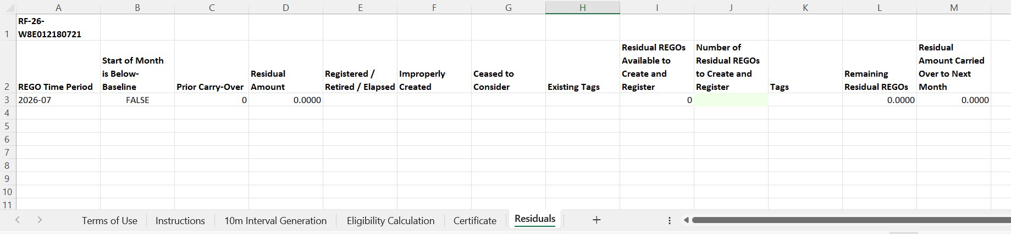

Below-baseline residuals tab
This tab will not appear if your facility does not have a baseline.
This tab will only appear if you are applying to create and register REGO certificates on an hourly basis. Daily, monthly and yearly certificates don’t qualify for residual amounts.
The below-baseline residuals tab refers to generation that occurred before the facility crossed its baseline. It works the same way as the residuals tab but specifically for below-baseline generation.

Step 3: Upload your claim
- On the Renewable electricity facilities page, select Generation and certificate upload.
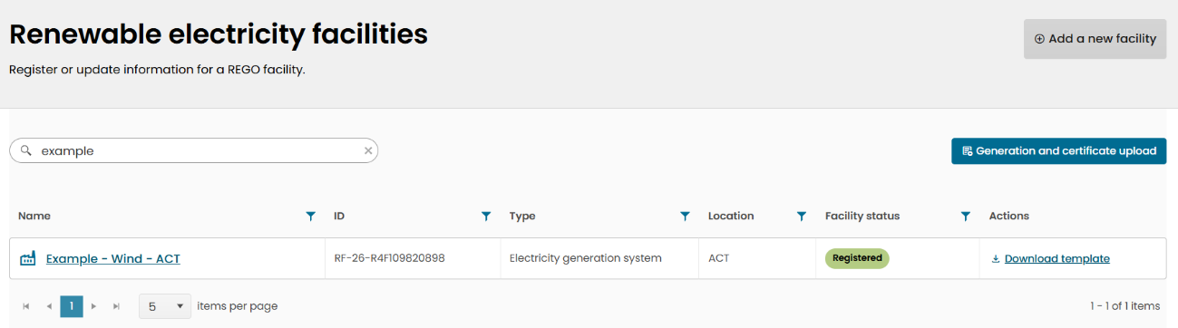

- Upload the completed template(s).
- Wait for the templates to finish uploading (this can take several minutes).
- Select Next.
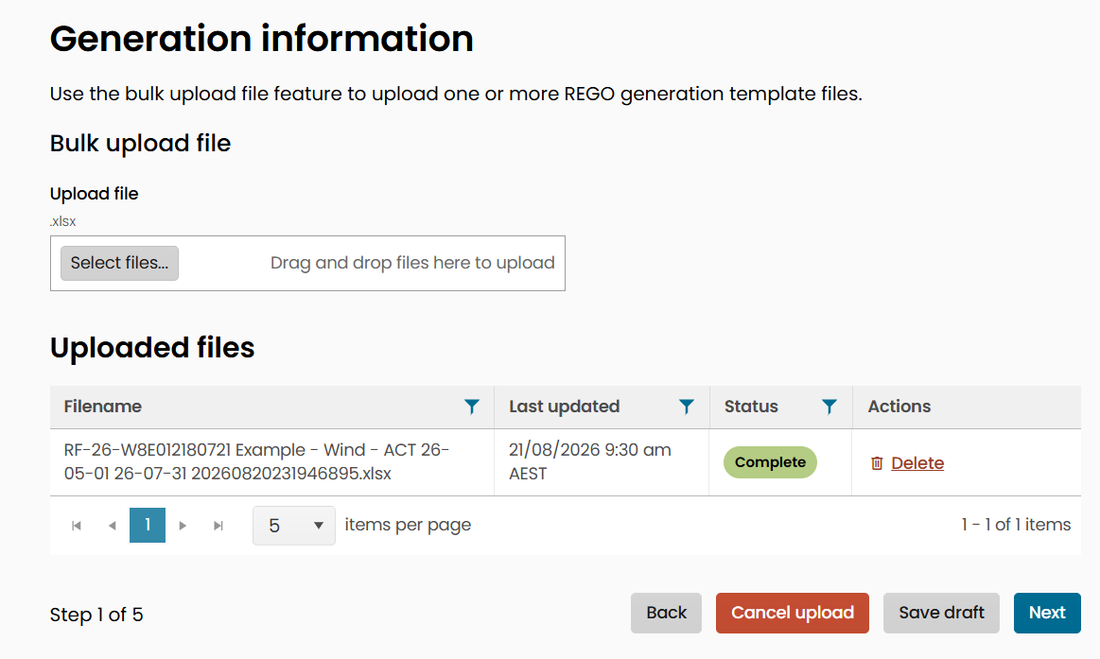

You can upload files for multiple facilities in one upload. This allows you to make claims for multiple facilities in the same workflow.
You can only upload one file for each facility. When uploading templates for multiple facilities, each facility’s claim will be considered as a separate application for assessment purposes

Step 4: Provide extra claim information
- Answer the standing notice questions for each facility.

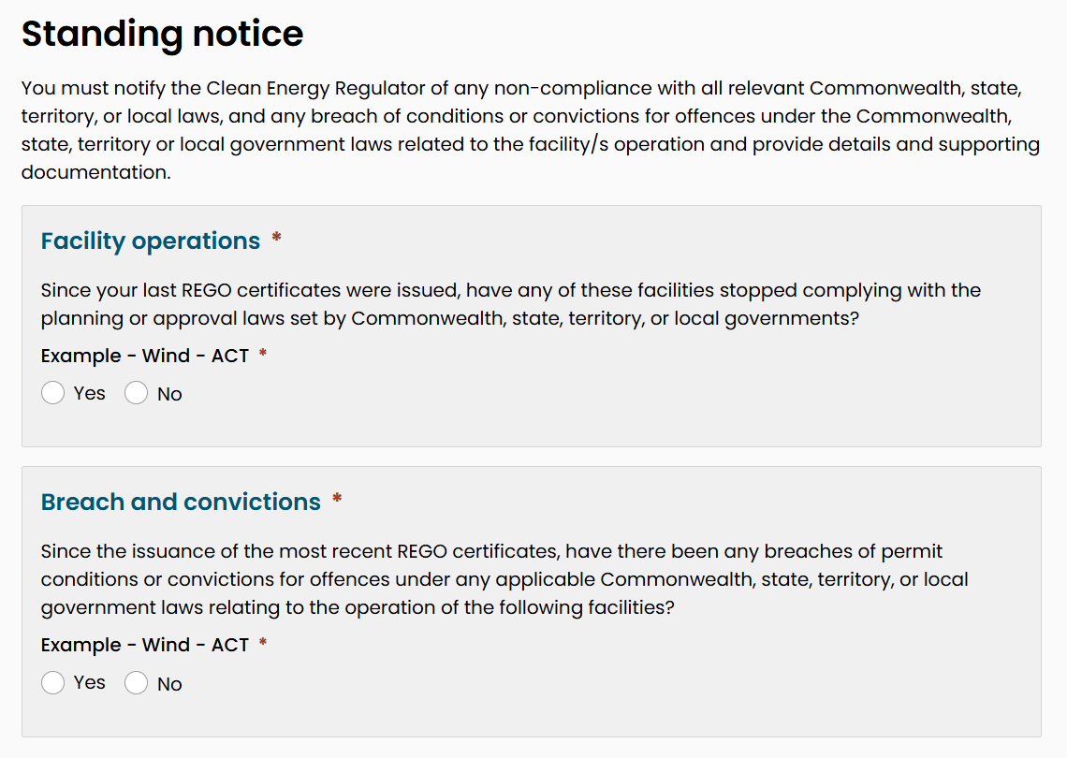

- Nominate the First Nations attributes, where applicable (these will be preselected based on facility registration details).
- Select Next.
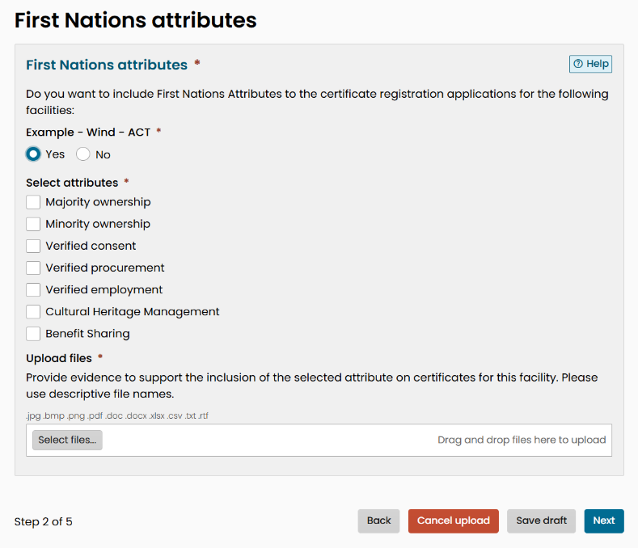

Nominated First Nations attributes will be included on all certificates included in the claim for the relevant facility.
As per the GO Rules, you will need to provide evidence of First Nations attributes with each certificate claim.
First Nations attributes that have received preliminary approval at facility registration may lead to shorter assessment times; however, preliminary approval does not guarantee their approval to be included on the certificates.
Including new First Nations attributes that have not received preliminary approval at facility registration may lead to longer assessment times.

Step 5: Upload supporting evidence
- Upload the required eligible amount evidence, including:
- calculation workbooks
- other supporting documentation (e.g. raw meter data).
- Provide any additional information.
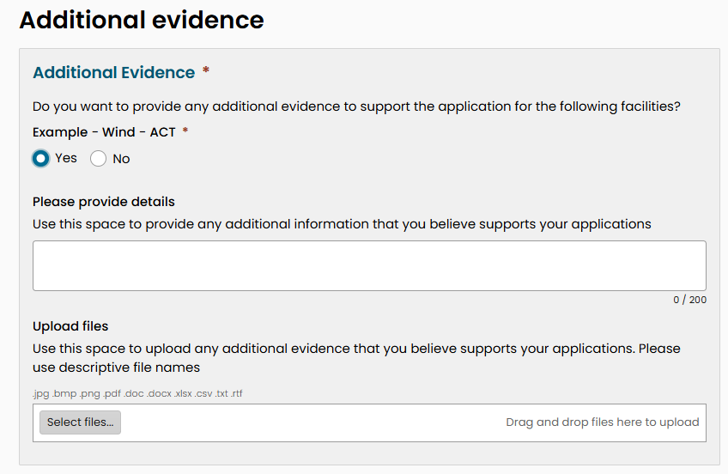

- Respond to any conditions imposed on your facility.
- Select Next.
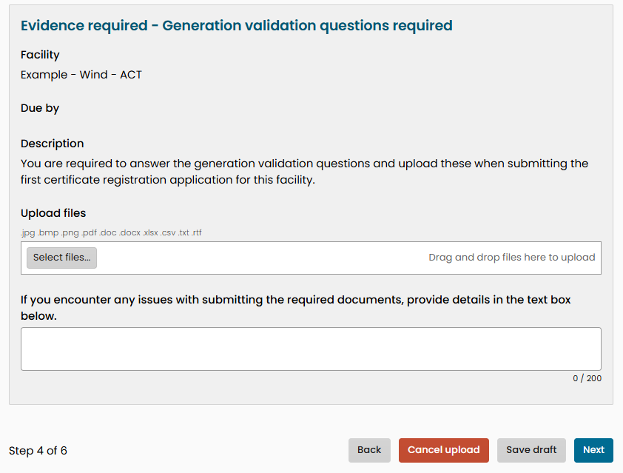

Step 6: Review and submit your claim
- Review the information you’ve entered.
This page displays the total eligible amount reported for each facility, and the amount allocated to REGO and number of certificates to be created and submitted for registration.
If there are any issues with the calculations, make sure you check your templates.
- If everything is correct, select Next.
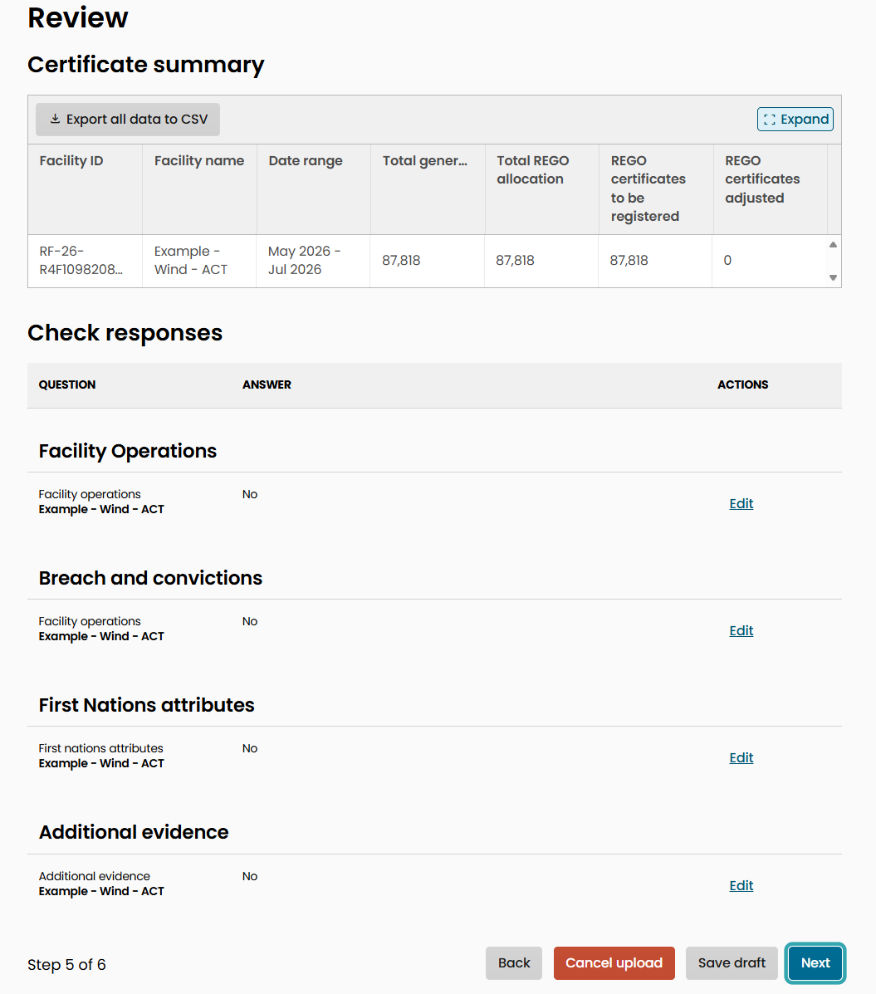

- Read the declaration and select the acknowledgement checkbox.
- Select Submit.
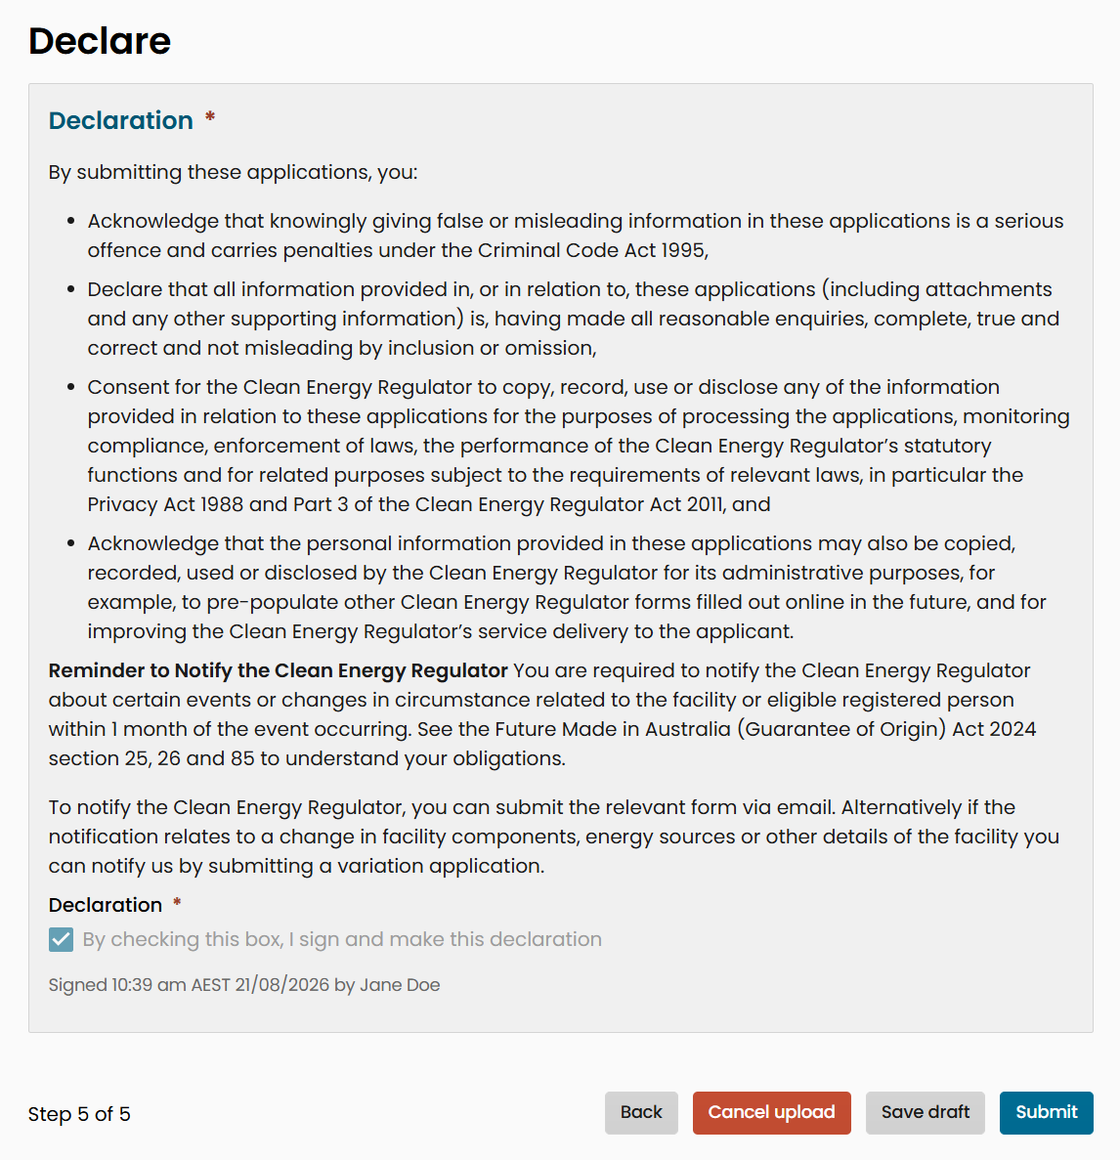

This is a legal declaration that you make when applying to create and register your REGO certificates. If you have improperly created the certificates, you could be subject to legal action.

Step 7: Pay your invoice
Once you submit your application, we’ll send you an invoice. You have to pay the invoice before we can begin assessing your claim.

Application outcome
Once we’ve assessed your claim, it will either be approved or refused.
If your claim meets the requirements, we’ll approve it and let you know by email. The certificates will be added to your Unit and Certificate Registry account and published on the GO Register.
We may refuse your application if we determine that the certificates have been improperly created.
If your application is refused, we’ll let you know by email.

Requests for more information
If we need more information to assess your application:
- We’ll let you know by via the OLS inbox.
- A request will appear in your inbox.
- Open the request to provide the requested information before the due date.
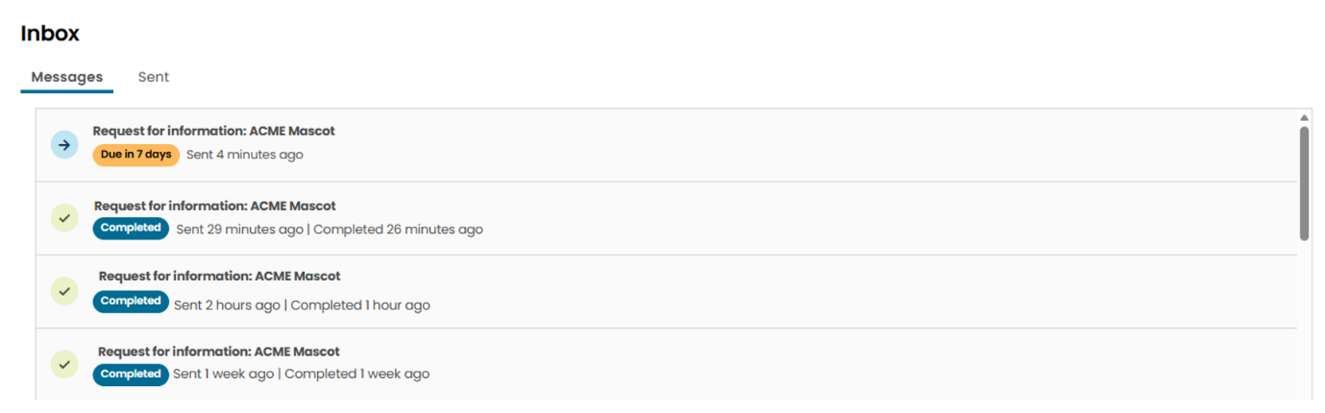

We’re not required to decide, and may cease considering, your application if you don’t provide the requested information before the date indicated in the request for information notice.

System statuses
Status | What it means | What you need to do
Incomplete   | The application has incomplete fields. | Complete the application by filling in all required areas and submit to start the assessment process.
Submitted   | The application has been submitted and is awaiting assessment. | Wait for us to assess your application.
Action required   | We need more information or to clarify something before we continue assessing your application. | Complete the request for further information before the due date.
Approved   | The application was successful. | No further action is required.
Refused   | The application was refused. | Check the reason in the refusal notification and ensure you have the requested information before submitting a new application.
Ceased to consider   | A request for further information was made and no response was received, so the Regulator has ceased considering the application. | Check the request for further information and ensure you have the requested information before submitting a new application.

File upload statuses
Status | What it means | What you need to do
Complete   | The file has been successfully uploaded. | Continue the application.
In progress   | The file is uploading and being read by the system. | Wait until the upload is finished.
Error   | There was an error uploading the file. | Check that you’ve provided the correct file.  Go to Step 1: Download the certificate data template for help with downloading and uploading certificate templates.

Validation messages and how to resolve them
Validation message | What do I do?
The information about ineligible energy sources in the Calculation Methodology form does not match the information provided in the Energy Source details. Any ineligible energy sources must be included in the Calculation Methodology and in an Energy source form. | Check that you have added all ineligible energy sources or update the Calculation Methodology details to reflect that there are no ineligible energy sources.
There is no measurement device declared for the energy source of _____. | Check that you have included all meters and monitoring systems, then make sure that each energy source is connected to at least one of them.
There is missing mandatory components for the energy source ___. Further details are required on _____(component). | You have included an energy source that requires a specific component to be included in the application. Update the component details to state that it services the correct energy sources.
The first-generation date in the Network Distribution and Supply form does not match with the answers provided in the RET Accredited Power Station form. Update the information to be consistent across forms. | Update either the RET accredited power station details or the Network Distribution and Supply details so that they match.  If the first-generation date is pre-1997, you must provide a baseline value. If it was after 1997, there should be no baseline value.
The related energy source selected in the Electricity Meter form no longer exists. At least one energy source must be selected to complete this form. | Make sure all electricity meter details include the correct energy source or remove the electricity meter if it’s not part of the facility.
The first-generation date in the Network Distribution and Supply form does not match with the answers provided in the Legacy Baseline form. Update the information about date of first generation to be consistent across forms. | Update either the Legacy baseline details or the Network Distribution and Supply details so that the dates match.  If the first-generation date is pre-1997, you must provide baseline details. If it was after 1997, there should be no baseline details.
The number of Connection Points with applicable Marginal Loss Factors in the Network Distribution and Supply form exceeds the number of DLEG measurements in the Calculation Methodology form. Provide at least one DLEG meter for each applicable MLF. | Update either the Calculation Methodology details to add any missing DLEG measurements or the Network Distribution and Supply form to include the correct connection point and MLF information.
The component _____ does not have an owner or operator. Further details are required regarding the ownership or operational control of this component. | Update the stakeholder and contact details to state who the owner or operator of each component is.
The related component selected in the registered person role section no longer exists. At least one valid component must be selected to complete this form. | You have removed a component from the facility that was included in the list of components you own or operate.  Update the stakeholder and contact details to remove the component from the list.
The related component selected in the stakeholder information section no longer exists. At least one valid component must be selected to complete this form. | You have removed a component from the facility that was included in the list of components a stakeholder operates or owns.  Update the stakeholder and contact details to remove the component from the list.
The related energy source selected in the Monitoring System form no longer exists. At least one energy source must be selected to complete this form. | Make sure all monitoring system details include the correct energy source or remove the monitoring system if it’s not part of the facility.
The related energy source selected in the component form no longer exists. At least one energy source or storage system must be selected to complete this form. | Make sure all component details include the correct energy source or remove the component if it’s not part of the facility.
The information in the Energy Storage form does not match the information in the Calculation Methodology form. Provide direct supply information in both forms or in neither. | Update either the Calculation Methodology details or the Energy Storage details so that both sections include direct supply information or neither do.
The location of this facility does not match the electricity network connection. | Update either the location details or network distribution and supply details so the location matches the selected network.
A multi-channel meter has been selected for measurement. Further details on the channel number are required. | If the selected meter is correct for each measurement reading, add the channel number to the Calculation Methodology details.
The connection type selected in the Network Distribution and Supply form does not match the information provided in the Calculation Methodology form. Provide direct supply details in both forms or in neither. | Update either the network distribution and supply details or the Calculation Methodology details so both sections include direct supply information or neither do.
The meter channel number in the Calculation methodology form is larger than the total number of channels indicated in electricity meter form for the selected meter. Please update with the correct information. | Check that the electricity meter details are correct and, if so, update the Calculation Methodology details with the correct channel number for this measurement.
A single channel meter has been selected for measurement. Channel number must be 1 or left blank. | Check that the electricity meter details are correct and, if so, update the Calculation Methodology details with the correct channel number for this measurement.

File upload errors and how to resolve them
Error message | Action
Multiple files for a single facility error: Only one file per facility | Make sure you only include one file for each facility. If needed, you can go back a few steps and download a different template.
Submission error: Something went wrong | Return to the upload page or the facility details and try your submission again. You may have to try again later or can contact us for help.
Waiting payment: Your application has been received | Complete payment for the created certificates. Once payment is received, we will start assessment.
Action required: Your application has been assessed, and we have requested additional information or edits | View your inbox to see the message from us. Respond to the request for further information or make the required edits.

https://cer.gov.au/document_page/guarantee-origin-user-access-and-permissions-guide
https://onlineservices.cer.gov.au/
https://www.legislation.gov.au/C2024A00121/asmade/2024-12-10/text/1/epub/OEBPS/document_1/document_1.html#_Toc184897376
https://cer.gov.au/online-systems/new-unit-and-certificate-registry/unit-and-certificate-registry-guidance#manage-a-rego-account-in-the-registry

