# Registration as a controlling corporation for National Greenhouse and Energy Reporting

January 2025

# Contents

Disclaimer 3

Introduction 4

Registration obligations of a controlling corporation 4

Registration is indefinite 4

No expiry on obligations 4

What is a controlling corporation? 5

Constitutional corporations 5

Incorporated government agencies 5

Australian incorporated holding companies 5

When will a company be a subsidiary of another company? 6

Foreign controlling corporations 10

When is a controlling corporation required to apply for registration under section 12 of the NGER Act? 11

Facility threshold 11

Corporate group threshold 12

Reporting Transfer Certificates (RTCs) 12

Defining the controlling corporation’s group 13

Australian incorporated controlling corporation 13

Affected group entity 13

Foreign controlling corporation 14

Facilities 15

Operational control 15

Applying thresholds to a controlling corporation’s group 15

Calculators 15

How to register 16

What information is required to register? 16

What happens next? 17

How does a controlling corporation apply for deregistration? 17

Record keeping 17

Penalties 18

Data publication 18

More information 18

# Disclaimer

Thisguideline has been developed by the Clean Energy Regulator (the agency) to assist entities to comply with their reporting obligations under the [*National Greenhouse and Energy Reporting Act 2007*](https://www.legislation.gov.au/Series/C2007A00175)[1](NGER Act)and associated legislation.

This guideline only applies to the 2021–22 NGER reporting year and should be read in conjunction with the NGER Act, [National Greenhouse and Energy Regulations 2008](https://www.legislation.gov.au/Series/F2008L02230)[2] (NGER Regulations), and [National Greenhouse and Energy Reporting (Measurement) Determination 2008](https://www.legislation.gov.au/Series/F2008L02309)[3] (NGER Measurement Determination), as in force for this reporting period. These laws and their interpretation are subject to change, which may affect the accuracy of the information contained in the guideline.

The guidance provided in this document is not exhaustive, nor does it consider all circumstances applicable to all entities. This guidance is not intended to comprehensively deal with its subject area, and it is not a substitute for independent legal advice. Although entities are not bound to follow the guidance provided in this document, they must ensure they meet their obligations under the [National Greenhouse and Energy Reporting (NGER) Scheme](http://www.cleanenergyregulator.gov.au/NGER/Pages/default.aspx)[4] at all times. The agency encourages all users of this guidance to seek independent legal advice before taking any action or decision based on this guidance.

The agency and the Australian Government will not be liable for any loss or damage from any cause (including negligence) whether arising directly, incidentally, or as consequential loss, out of or in connection with, any use of this guideline or reliance on it, for any purpose.

If an entity chooses to meet their obligations under the NGER scheme in a manner that is inconsistent with the guidance provided in this document, the agency, or an independent auditor, may require the entity to demonstrate that they are compliant with requirements of the NGER Act, NGER Regulations, and/or the NGER Measurement Determination. Entities are responsible for determining their obligations under the law and for applying the law to their individual circumstances.

# Introduction

This guidance provides information about a controlling corporation’s obligations under the NGER Act. It demonstrates how to apply to the Clean Energy Regulator (CER) for registration as a controlling corporation.

# Obligations to register

A controlling corporation must apply for registration under section 12 of the NGER Act if it meets one or more of the thresholds under section 13 of the NGER Act for a financial year. The thresholds are explained further on page 10 of this guide. A controlling corporation may also apply for registration if it is **likely** to meet one or more of these thresholds for a financial year.

In either case, the controlling corporation must apply for registration by 31 August following the financial year in which the threshold was first met or likely to be met (e.g. 31 August 2025 for a threshold met in 2024–25).

Failure to apply for registration by the due date is a contravention of the NGER Act and may attract civil penalties. In certain circumstances, the same penalties may also apply to Executive Officers of the controlling corporation.

If you discover your corporation met a threshold in a past reporting period, you are still obliged to register and report. Corporations only need to register once and must report by 31 October each year they remain registered.

# Registration is indefinite

Once a controlling corporation has been registered, it remains on the National Greenhouse and Energy Register until the CER approves an application for deregistration, or the controlling corporation ceases to exist. **Controlling corporations are not required to re-register for each reporting year.**

## No expiry on obligations

Obligations under the NGER Act continue indefinitely, even if the period has expired or the due date has passed for taking certain action. Failure to register and report may attract civil penalties that accrue each day the controlling corporation fails to comply with its NGER obligations.

Unregistered controlling corporations that believe they have NGER obligations for an earlier reporting year should submit an application for registration immediately.

Registered controlling corporations that have failed to submit their NGER reports (including below threshold reports) should submit these reports as soon as possible.

Controlling corporations that have difficulties in meeting their obligations to collect data and keep records under the NGER scheme are encouraged to [contact us](https://cer.gov.au/about-us/contact-us)[5].

# What is a controlling corporation?

A controlling corporation is a ‘constitutional corporation’ that does not have a holding company incorporated in Australia (section 7 NGER Act). It is generally the corporation at the top of the corporate hierarchy in Australia. It can be a ‘non-operational’ holding company. It may also be a foreign incorporated entity that operates directly in Australia (not operating through an Australian incorporated subsidiary).

It is important for corporations to correctly identify their controlling corporation, as this is the entity that must register and report under the NGER legislation.

## Constitutional corporations

Under paragraph 51(xx) of the Australian Constitution, the Australian Parliament has power to make laws with respect to foreign corporations and trading or financial corporations formed within the limits of the Commonwealth. These corporations are known as ‘constitutional corporations’.

### Incorporated government agencies

In determining whether an incorporated government agency (such as a local council) constitutes a ‘constitutional corporation’, organisations should consider if:

1. the council is trading by providing goods and services for reward, rather than providing goods and services under obligation (for example maintaining roads, collecting residents’ rubbish).
2. the trading activities form a substantial or sufficiently significant proportion of all total activities of the council.

For example, an incorporated government agency could consider whether it receives payment for the services it delivers. If so, it could also consider if those services or fees are comparable to a commercial operation, and what proportion of the council’s operations is made up of trading.

Independent legal advice should be sought if an incorporated government agency is unsure about their status as a ‘constitutional corporation’.

## Australian incorporated holding companies

If a corporation is a subsidiary of another Australian incorporated corporation (has an Australian incorporated holding company) it will not meet the definition of a ‘controlling corporation’ for the purposes of the NGER Act.

A controlling corporation’s registration and reporting obligations are the responsibility of the highest holding company incorporated in Australia. For a foreign corporation, the responsibility goes to the offshore company that has operational control over a facility within Australia. This means that even where the highest holding company is a shell company (or exists for investment purposes only), it will be the controlling corporation of its corporate group that must register and report the activities of facilities under the operational control of its subsidiaries.

# When will a company be a subsidiary of another company?

The NGER Act takes its definition of 'subsidiary' from section 46 of the *Corporations Act 2001* (the Corporations Act). A body corporate (the first body) is a subsidiary of another body corporate only if:

* the first body is a subsidiary of a subsidiary of the other body, or
* the other body:
  + controls the composition of the first body's board, or
  + is in a position to cast, or control the casting of, more than one-half of the maximum number of votes at a general meeting of the first body, or
  + holds more than one-half of the issued share capital of the first body (excluding any part of the issued share capital that carries no right to participate beyond a specified amount in a distribution of either profits or capital).

|  |
| --- |
| **Example 1 – Controlling corporations must be the highest Australian incorporated member of the corporate group’s structure**  Companies 1, 2 and 3 are all wholly owned subsidiaries of Company A. Company A is the name that is generally associated with the products and brands produced by the corporate group.  Company A is owned by investment Companies X, Y and Z. Company X holds 70 per cent of Company A’s shares. Company Y holds 20 per cent of Company A’s shares and Company Z holds the remaining 10 per cent. |

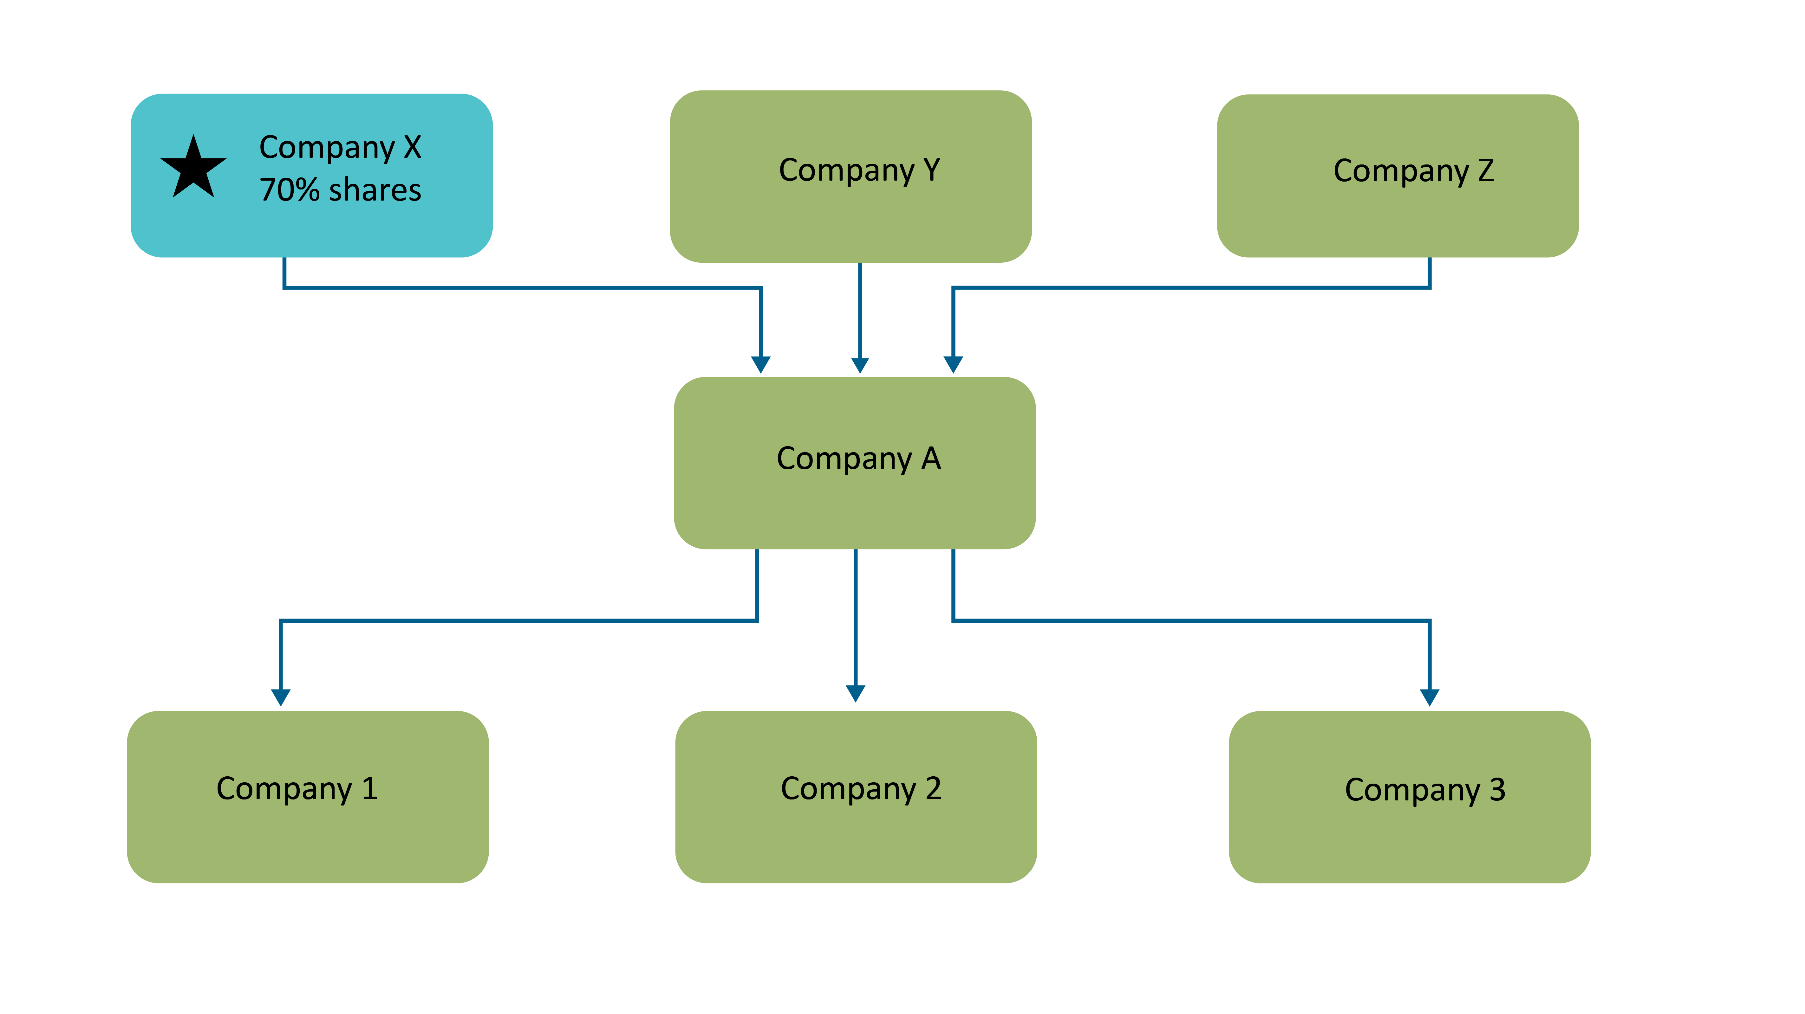

Figure 1: Diagram showing example 1 – controlling corporations must be the highest Australian incorporated member of the corporate group’s structure

Even though Company A may be the name or entity generally associated with, and responsible for, the group’s activities, Company X is the controlling corporation for the purposes of the NGER Act. This is because Company X holds the majority of shares in Company A and Company A is therefore a subsidiary of Company X. Company X does not have an Australian incorporated holding company, and therefore is the controlling corporation.

|  |
| --- |
| **Example 2 – no company holds more than 50% of issued share capital**  Companies 1, 2 and 3 are all wholly owned subsidiaries of Company A. Company A is the name that is generally associated with the products and brands produced by the corporate group.  Company A is owned by investment Companies Y and Z. They each own 50 per cent of Company A’s shares. |

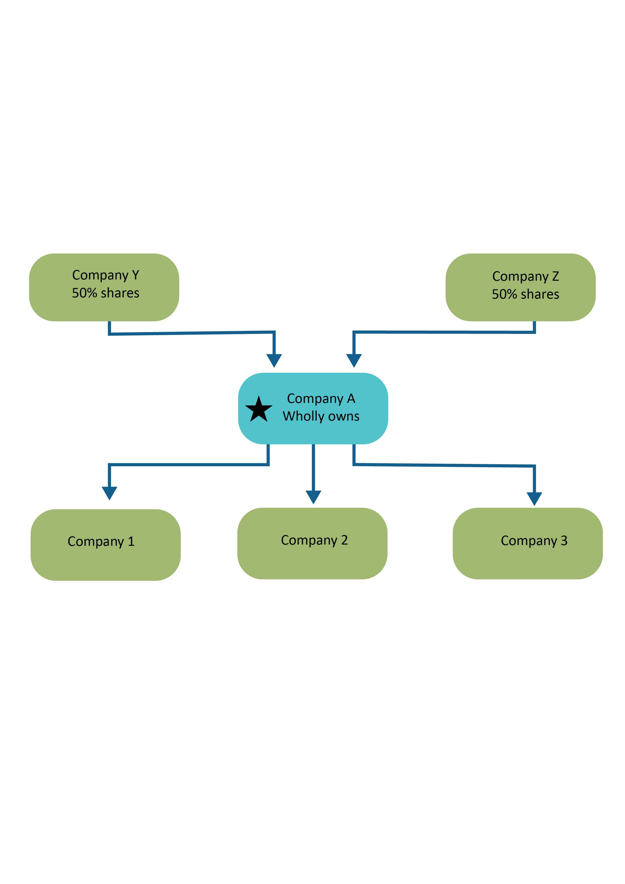

Figure 2: Diagram showing example 2 – no company holds more than 50% of issued share capital

In this example, Company A is not a subsidiary of either Company Y or Company Z, as neither holds *more* than half of the issued share capital in Company A. This means Company A does not have an Australian incorporated holding company, and therefore will be a controlling corporation for the purposes of the NGER Act.

|  |
| --- |
| Example 3 – offshore holding company with multiple arms of business within Australia  Companies A and X are both wholly owned subsidiaries of Offshore Company. Company A owns 100 per cent of shares in Company B, which in turn owns 100 per cent of shares in Company C. Similarly, Company X owns 100 per cent of shares in Company Y, which in turn owns 100 per cent of shares in Company Z.  As part of the same parent company’s group, all companies use the same brand name. |

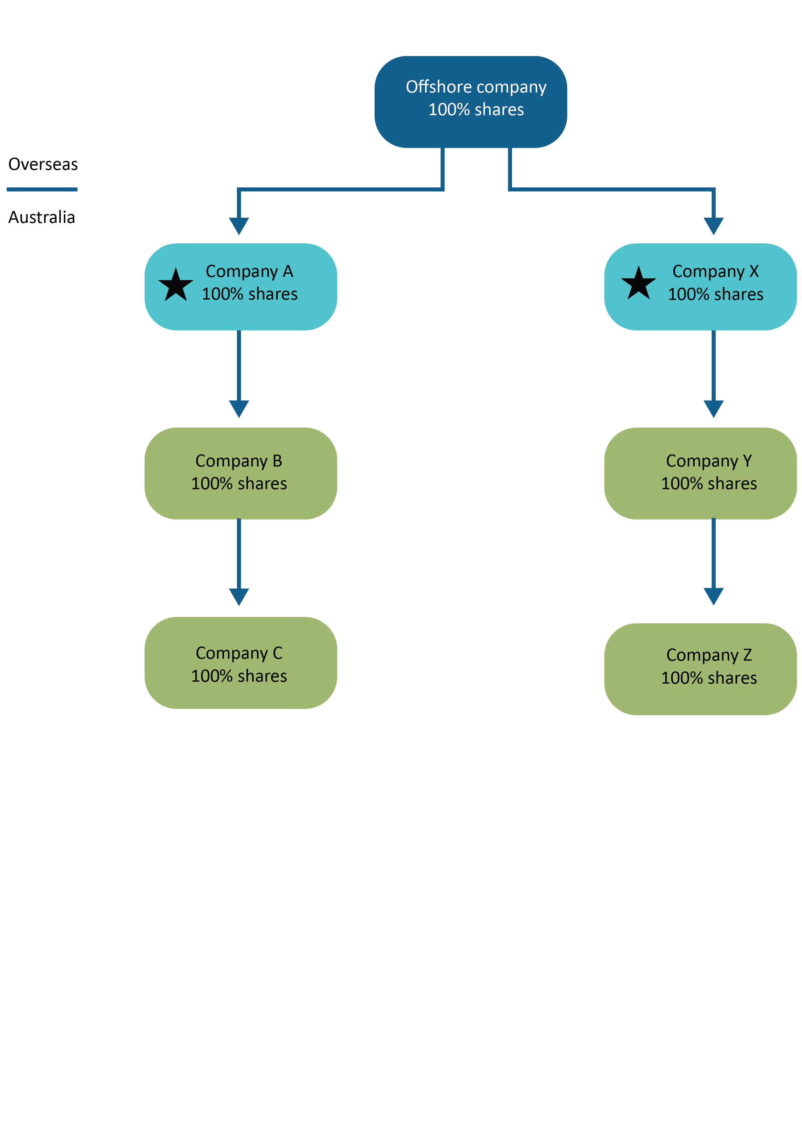

Figure 3: Diagram showing example 3 – offshore holding company with multiple arms of business within Australia

In this example, Company A and Company X **are both** controlling corporations. This is because neither company has an **Australian incorporated** holding company.

## Foreign controlling corporations

Where a foreign corporation has operational control over a facility in Australia (that is, it does not operate through an Australian incorporated subsidiary), that foreign corporation will also be a controlling corporation. A foreign corporation is either:

* incorporated outside Australia
* an authority of a foreign country.

It is important to note that a foreign corporation is only required to apply for registration under section 12 of the NGER Act where the foreign corporation itself has operational control over a facility.

|  |
| --- |
| Example 4 – Offshore holding company that operates through an Australian incorporated subsidiary  Company Z is a foreign incorporated company that owns 100 per cent of Company Y’s shares. Company Y has operational control over Facility 1.  Company Y is the controlling corporation for the purposes of the NGER Act. This is because it does not have an Australian incorporated holding company. |

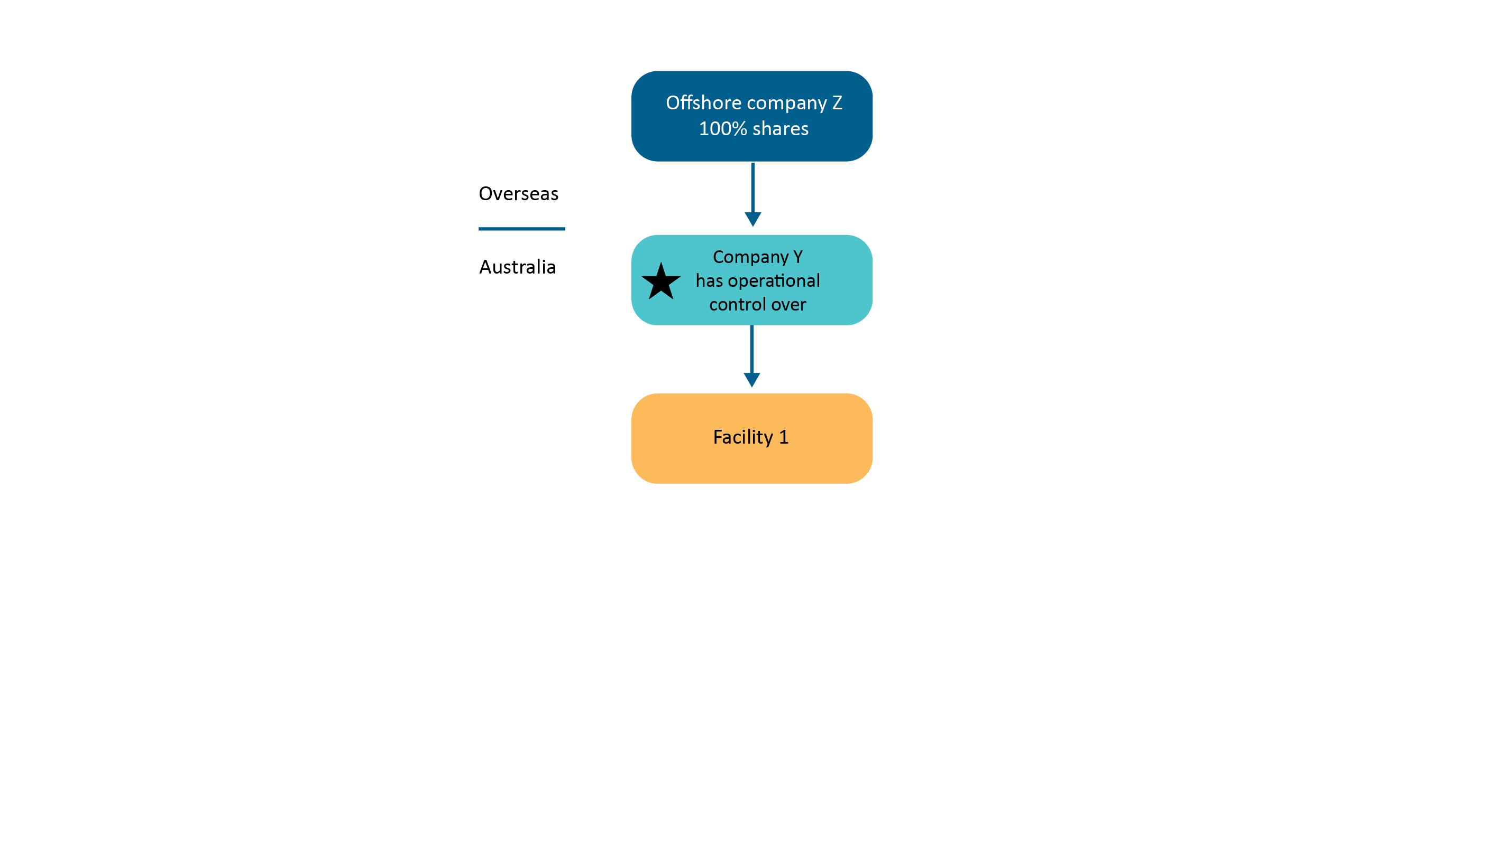

Figure 4: Diagram showing example 4 – offshore holding company that operates through an Australian incorporated subsidiary

|  |
| --- |
| Example 5 – Offshore company that operates directly in Australia  Company Z is a foreign incorporated company that has operational control over Facility 1. As it is Company Z itself, and not an Australian incorporated subsidiary which has operational control over Facility 1, Company Z is the controlling corporation for the purposes of the NGER Act. |

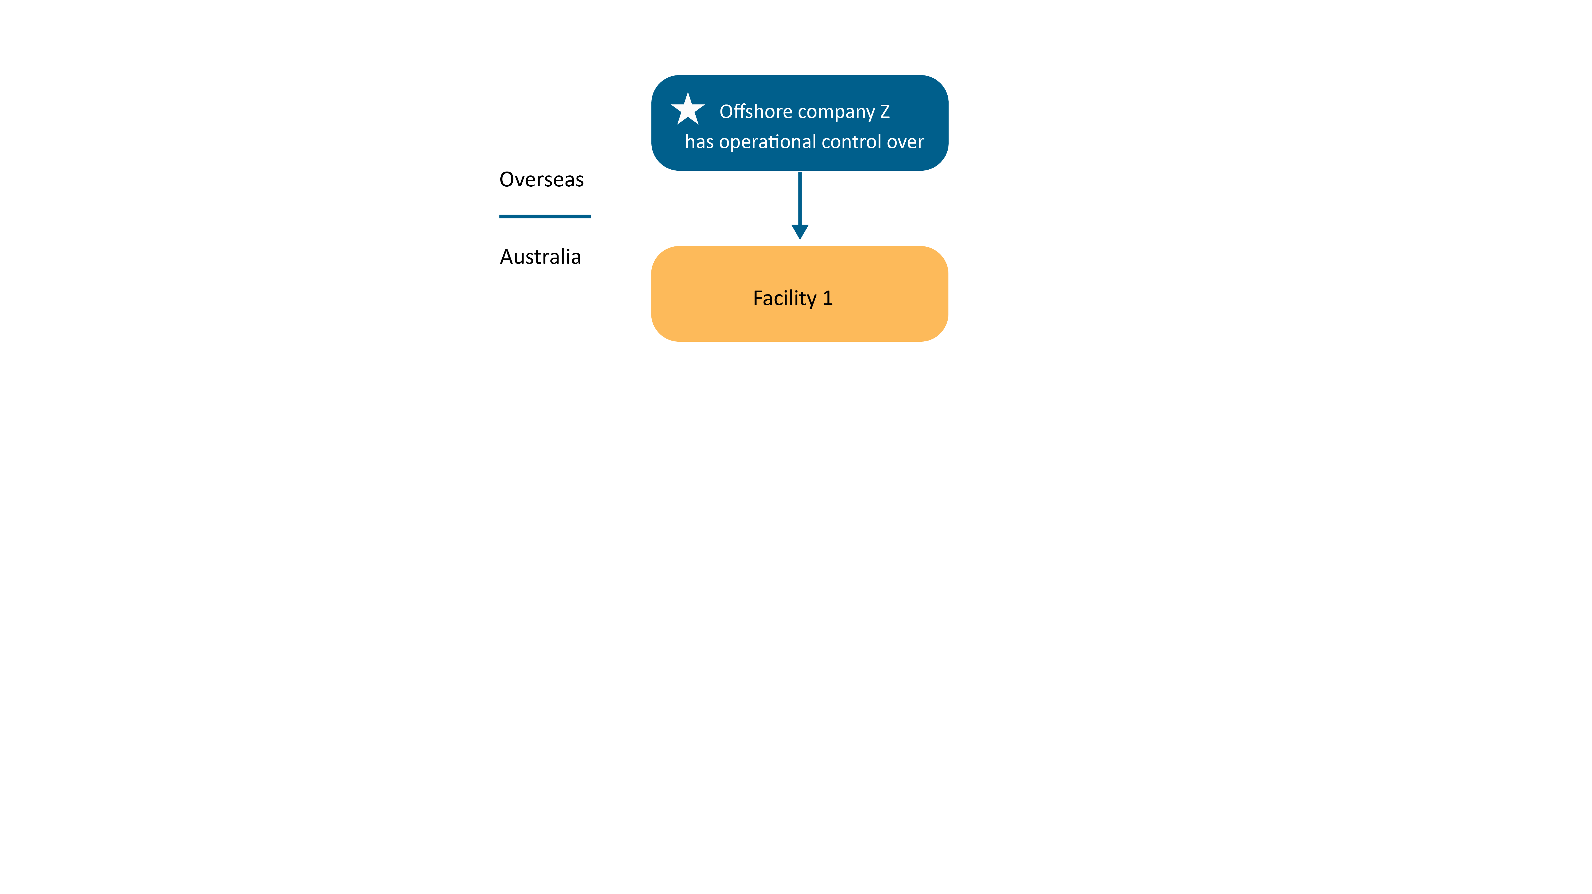

Figure 5: Diagram showing example 5 - offshore company that operates directly in Australia

In this example, Company Z is the controlling corporation. This is because it does not have an **Australian incorporated** holding company.

If the controlling corporation is a foreign corporation, the CER requires the corporation to provide the details of an Australian contact person. This ensures an application to register can be finalised as efficiently as possible, especially when further information is required. The contact person must be a resident in Australia. The CER does not have any other specific requirements about who the contact person is. It is the responsibility of the applicant to decide on the most appropriate person to perform this role.

# Thresholds

There are 2 types of thresholds that a controlling corporation must consider:

* facility thresholds
* corporate group thresholds.

## Facility threshold

A controlling corporation will meet a facility threshold if it, or a member of its corporate group, has operational control over a facility that causes, during the financial year:

* the emission of greenhouse gases with a carbon dioxide equivalence (CO2-e) of **25** **kilotonnes (kt)** or more
* the production of **100** **terajoules (TJ)** or more of energy
* the consumption of **100 TJ** or more of energy.

If the facility was under the operational control of the controlling corporation, or a member of the controlling corporation’s group, for part of the year only, the thresholds are adjusted by multiplying the relevant threshold by the number of operational control days, divided by the number of days in the financial year, as per the formula below:

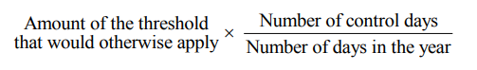

## Corporate group threshold

A controlling corporation will meet a corporate group threshold if during a financial year, the total amount of greenhouse gas emissions, energy production or energy consumption from all of the facilities under the operational control of the controlling corporation and members of the controlling corporation’s group meet any of the following thresholds:

* the emission of greenhouse gases with a carbon dioxide equivalence (CO2-e) of **50** **kilotonnes (kt)** or more
* the production of **200** **terajoules (TJ)** or more of energy
* the consumption of **200 TJ** or more of energy.

Once a corporate threshold has been reached, all of a group's facilities will be reported on, regardless of whether the individual facilities reach facility thresholds.

### Reporting transfer certificates

The CER may issue a reporting transfer certificate (RTC) to a member of a different corporate group that has financial control over a particular facility. If issued, the RTC transfers reporting obligations for that facility to the corporation with financial control for the days that it holds the RTC.

Emissions and energy production and consumption from an RTC facility are excluded from threshold assessments under section 13 of the NGER Act and section 19 reporting obligations of the controlling corporation of the corporation with operational control of the facility for the days the RTC is in place.

Emissions and energy production and consumption from facilities that are the subject of an RTC are excluded from section 13 threshold assessments.

An RTC is not transferable and remains in force unless it is surrendered or cancelled.

For further information, refer to [the NGER Guideline: Reporting Transfer Certificates](https://cer.gov.au/document_page/reporting-transfer-certificates-guideline)[6] on our website.

# Defining the controlling corporation’s group

It is important to correctly identify the members of a controlling corporation’s group, as this will determine which facilities the controlling corporation is responsible for reporting on.

## Australian incorporated controlling corporation

From 2012–13 onwards, a controlling corporation’s group will consist of the controlling corporation and, if the controlling corporation is an Australian incorporated controlling corporation, any of its subsidiaries.

However, for the purposes of determining a controlling corporation’s group members, any ‘subsidiary’ of an Australian incorporated controlling corporation will be a member of that controlling corporation’s group, unless the subsidiary is also a subsidiary of another body corporate as a result of the operation of subparagraphs 46(1)(a)(i) or 46(1)(a)(ii) of the Corporations Act, and the other company is not a member of the same body corporate.

For example, if a controlling corporation owns 60 per cent of the shares in Company A (and therefore Company A meets the definition of a ‘subsidiary’ of the controlling corporation), but a different controlling corporation control’s Company A’s board or can cast more than one-half of the votes at a general meeting of Company A, then Company A will not be a group member of either controlling corporation’s corporate group.

A controlling corporation that does not have any subsidiaries will be the only member of its corporate group.

Prior to 2012–13, joint ventures and partnerships could also be members of a controlling corporation’s group. Due to amendments to the NGER Act that took effect on 1 July 2012, joint ventures and partnerships are no longer group members.

### Affected group entity

While any subsidiary will be a member of a controlling corporation’s group, an application for registration as a controlling corporation only needs to include details of affected group entities. An affected group entity is a subsidiary of the controlling corporation that:

* has operational control over a facility that contributes towards the controlling corporation meeting or being likely to meet one of the thresholds under section 13 of the NGER Act
* *has a subsidiary* that has operational control over a facility that contributes towards the controlling corporation meeting or being likely to meet one of the thresholds under section 13 of the NGER Act.

|  |
| --- |
| Example 6 – Affected group entities  Companies A to G are all members of Controlling Corporation A’s corporate group. Controlling Corporation A directly owns 100 per cent of shares in Companies A to D. Companies E to G are also subsidiaries of Controlling Corporation A because they are subsidiaries of another subsidiary of Controlling Corporation A (for example, Company E is a subsidiary of Company A, and therefore is also a subsidiary of Controlling Corporation A). |

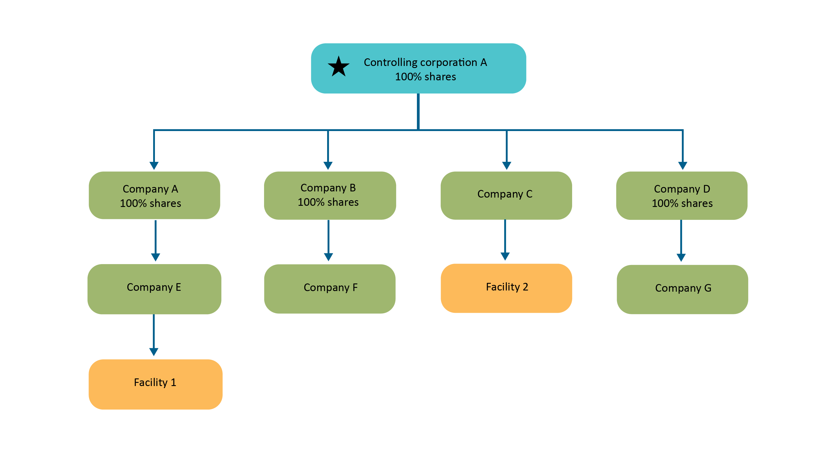

Figure 6: Diagram showing example 6 – affected group entities

Companies E and C are the only group members with operational control over facilities that contribute towards Controlling Corporation A’s section 13 thresholds. Therefore, they are both ‘affected group entities’.

Company A is also an affected group entity because it has a *subsidiary* that has operational control over a facility that contributes towards Controlling Corporation A’s section 13 thresholds.

Companies B, D, F and G are not affected group entities.

## Foreign controlling corporation

**A foreign controlling corporation will not have any group members for the purposes of the NGER Act**. This is because a foreign corporation is only required to apply for registration under section 12 of the NGER Act where the foreign corporation itself has operational control over a facility. If the foreign corporation had a subsidiary that had operational control over a facility, it would be this subsidiary that should apply for registration as a controlling corporation.

# Facilities

A controlling corporation must assess which of the thresholds in section 13 of the NGER Act it has met by looking at the facilities that are under its operational control and/or under the operational control of members of its corporate group. Once registered, a controlling corporation will be required to report on the greenhouse gas emissions, energy production and energy consumption from these facilities.

A facility is not just a physical location or ‘thing’, like a factory—it is an activity, or series of activities. For example, a ‘facility’ under the NGER Act might be a factory but might also be activities associated with the factory, such as transportation of goods outside the factory’s boundaries.

For further information, refer to the [NGER guideline: Defining a ‘facility’ for the purposes of the NGER legislation](https://cer.gov.au/document_page/defining-facility-national-greenhouse-and-energy-reporting)[7] on our website.

# Operational control

Operational control is defined in sections 11–11B of the NGER Act.

For further information, refer to the [NGER guideline: Operational control](https://cer.gov.au/document_page/operational-control-supplementary-guideline)[8] on our website.

# Applying thresholds to a controlling corporation’s group

Once a controlling corporation has determined the structure of its corporate group, and which facilities it and/or members of its corporate group has operational control over, it should calculate whether the greenhouse gas emissions and energy production and consumption from these facilities reach any of the facility or corporate group thresholds. Controlling corporations can use the ‘threshold estimator’ to help determine whether they have met one or more of the section 13 thresholds.

Controlling corporations could begin by examining their energy and greenhouse gas emissions for running costs, such as bills for gas, electricity, diesel and other fuels, and waste arrangements. For example, an abattoir may need to report on emissions from its natural gas/LPG use, waste (wastewater and/or landfill), electricity and liquid fuels. A mining operation (underground or open-cut) would need to report on liquid fuels, electricity and fugitive emissions. Coal mines would also need to consider the energy produced by the extraction of coal and methane. Corporations should note that other activities, such as commercial refrigeration, air conditioning and industrial processes, are reportable.

## Calculators

[The following calculators](https://cer.gov.au/schemes/national-greenhouse-and-energy-reporting-scheme/report-emissions-and-energy/nger-calculators)[9] are available on our website:

* Threshold estimator and user guide
* Solid waste calculator and user guide
* NGER wastewater (Domestic and Commercial) calculator
* NGER wastewater (Industrial) calculator
* Uncertainty calculators and user guides.

[Calculators](https://cer.gov.au/schemes/national-greenhouse-and-energy-reporting-scheme/report-emissions-and-energy/nger-calculators)[10] are updated each year. The NGER guidance material available on our website provides more detailed information to assist controlling corporations to understand and comply with obligations under the NGER legislation.

# How to register

A controlling corporation that has determined it is required to register will need to:

* identify the correct controlling corporation
* confirm the controlling corporation does not have an Australian incorporated holding company
* identify its affected group entities (that is, its subsidiaries that have operational control over a facility, or have subsidiaries that have operational control over a facility), that causes the controlling corporation to meet a section 13 threshold.

To register, complete the Controlling Corporation Registration form in [Online Services](https://onlineservices.cer.gov.au/)[11].

# What information is required to register?

First financial year in which a reporting threshold is met.

The controlling corporation’s:

* name (as it appears on the Australian Business Register or ASIC Register)
* trading name
* head office postal address
* head office street address and identifying details (ABN, ACN, ARBN or trading name and street address).

The controlling corporation’s Executive Officer’s:

* Position
* full name
* postal address
* contact phone numbers and email address.

The controlling corporation’s contact person’s:

* Position
* full name
* postal address
* contact phone numbers and email address.

Each affected group entity (subsidiary) that is a member of the controlling corporation’s group’s:

* name (as it appears on the Australian Business Register or ASIC Register)
* trading name and identifying details (ABN, ACN, ARBN or trading name and street address).

# What happens next?

Once the CER has received a completed and signed registration application form, the application will be verified and assessed to ensure that all the necessary information is provided.

Registration is complete when the CER adds the controlling corporation’s name to the National Greenhouse and Energy Register. Part or all the register may be published at the CER’s discretion. Also, once the registration has been approved, the Executive Officer and contact person named in the application will be given access to the controlling corporation’s Emissions and Energy Reporting System (EERS) account. EERS is used to prepare and submit NGER reports to the CER.

As the registration process may take some time, controlling corporations are encouraged to apply for registration ahead of the due date.

Controlling corporations are only required to register under the NGER Act for the first year in which a threshold is met under section 13 of the NGER Act. Once a controlling corporation is registered, it remains registered and must continue to report for subsequent financial years, until it is deregistered.

# How does a controlling corporation apply for deregistration?

A controlling corporation may apply to be deregistered providing it meets certain conditions.

Applicants should review the relevant parts of the NGER Act and NGER Regulations to understand what is required to deregister.

For further information, refer to [application for deregistration form](https://cer.gov.au/document/cer-der-001-application-deregistration)[12] on our website.

## Record keeping

Controlling corporations are required under the NGER Act to keep all records for 5 years, including those that inform decisions relating to the NGER Act.

## Penalties

Corporations should be aware that the NGER Act provides the CER with several administrative, civil, and criminal responses to contraventions of the Act. These include fines of up to $340,000 (2,000 penalty units) and daily fines of up to $17,000 (100 penalty units) for each day of non-compliance.

The CER will work with reporters to resolve any issues, however, substantial or repeated non-compliance will be addressed in line with our [Education, Compliance and Enforcement Policy](https://cer.gov.au/about-us/our-compliance-approach/compliance-policy-education-monitoring-and-enforcement-activities)[13]. The CER looks closely at repeated instances of non-compliant reporting and takes into account a reporter’s compliance history when considering regulatory action and penalties for non-compliance.

## Data publication

By 28 February following each reporting year, the CER must publish reported data of those corporate groups that met the corporate group threshold for emissions of greenhouse gas. Data published by the CER includes scope 1 emissions, scope 2 emissions and energy consumption totals.

The published data provides Australians with a snapshot of greenhouse gas emissions and energy consumption by controlling corporations.

The reported data is also used to inform the development of government policy, assist government programs and activities, and meet international reporting obligations, such as the National Greenhouse Gas Inventory.

# More information

Email: [reporting@cer.gov.au](mailto:reporting@cer.gov.au)

Phone: 1300 553 542 within Australia

Web: [www.cer.gov.au](http://www.cer.gov.au)

1. https://www.legislation.gov.au/Series/C2007A00175
2. https://www.legislation.gov.au/Series/F2008L0223
3. https://www.legislation.gov.au/Series/F2008L02309
4. https://cer.gov.au/schemes/national-greenhouse-and-energy-reporting-scheme
5. https://cer.gov.au/about-us/contact-us
6. https://cer.gov.au/document_page/reporting-transfer-certificates-guideline
7. https://cer.gov.au/document_page/defining-facility-national-greenhouse-and-energy-reporting
8. https://cer.gov.au/document_page/operational-control-supplementary-guideline
9. https://cer.gov.au/schemes/national-greenhouse-and-energy-reporting-scheme/report-emissions-and-energy/nger-calculators
10. https://cer.gov.au/schemes/national-greenhouse-and-energy-reporting-scheme/report-emissions-and-energy/nger-calculators
11. https://onlineservices.cer.gov.au/
12. https://cer.gov.au/document/cer-der-001-application-deregistration
13. https://cer.gov.au/about-us/our-compliance-approach/compliance-policy-education-monitoring-and-enforcement-activities