
Quarterly Carbon Market Report: methods
V1.0 May 2026

Contents
About this report 3
Scope of methods in this report 3
Australian Carbon Credit Unit (ACCU) Scheme 4
ACCU carbon abatement – current year 4
ACCU issuance projection – one year ahead 5
Renewable Energy Target 7
Large-scale generation certificates (LGCs) 7
LGC carbon abatement – current year 7
LGC carbon abatement – one year ahead 10
Small-scale technology certificates (STCs), excluding batteries 10
SRES carbon abatement – current year 10
SRES carbon abatement projection – one year ahead 12

Version history
Version | Date | Changes
1.0 | 3/6/2026 | Initial publication
Glossary
Our glossary includes definitions/explanations of many terms and acronyms used throughout this report.

About this report
The Quarterly Carbon Market Report (QCMR) provides a regular view of supply and demand trends in carbon markets administered by the Clean Energy Regulator. This document complements the QCMR by providing additional detail behind the estimates and projections presented in the reports. It’s intended primarily for analysts, researchers and other stakeholders seeking a deeper understanding of how we analyse carbon abatement and market outcomes, including key assumptions and limitations.
Publishing this document reflects our commitment to transparency. We are committed to improving the QCMR over time. This includes refining methodologies, and broadening coverage as data availability improves and markets evolve. This document will be updated as our methods are refined.
Projecting the outcomes of our schemes is inherently challenging, as outcomes in environmental markets are affected by developments in technology, the wider economy, market behaviour, and policy. We publish projections to help inform market participants and interested stakeholders and provide transparency on the projected abatement and other outcomes of the schemes we administer. When making these projections, we address uncertainty by:
- projecting ranges of outcomes rather than a point estimate, discussing important swing factors and assumptions underlying our projections, and updating our projections for annual outcomes as the year progresses and more information is available
- projecting outcomes over periods such as years rather than months or quarters, to focus on the bigger picture of scheme outcomes rather than movements in series subject to shorter-term fluctuations.
To help ensure this document and our QCMRs are as helpful and informative as possible, we welcome your questions and feedback. You can provide feedback to: Manager, Renewable Energy Market Analysis via enquiries@cer.gov.au or by post to Clean Energy Regulator, GPO Box 621 Canberra ACT.

Scope of methods in this report
This document describes the approaches we use to produce estimates and projections in the QCMR. The current version focuses on estimates of carbon abatement from schemes we administer, namely the Australian Carbon Credit Unit (ACCU) Scheme, the Large-scale Renewable Energy Target (LRET) and the Small-scale Renewable Energy Scheme (SRES). These abatement estimates are included in Q4 QCMRs for the concluding calendar year and the year ahead and are described in detail in the sections below.
Estimates of carbon abatement can be derived for ACCUs, large-scale generation certificates (LGCs) and small-scale technology certificates (STCs), but it is important to note they are not directly fungible. ACCUs are a measure of reduced or avoided emissions. LGCs and STCs are a direct measure of renewable generation or electricity displacement. They are used to estimate the avoided emissions from fossil fuel generation.
The QCMR includes a broader set of estimates and projections relating to scheme outcomes and market activity. While this document currently focuses on abatement methodologies, coverage will be expanded over time to additional methods.
While carbon abatement is a core purpose of the Clean Energy Regulator, not all the schemes we administer are included in the estimates.
- In the case of the Nature Repair Market, the scheme supports biodiversity rather than carbon abatement or displacement.
- The Guarantee of Origin (GO) Scheme launched in November 2025, so no Product Guarantee of Origin (PGO) or Renewable Electricity Guarantee of Origin (REGO) certificates were created by the time of publishing the Q4 2025 QCMR.
  - We will include REGO abatement in 2026 emissions reduction estimates.
  - PGO certificates represent the lifecycle emissions of eligible products, highlighting displacement opportunities rather than direct abatement or displacement compared to uncertified products for both producers and consumers. As such, emissions reductions are unlikely to be directly attributed to PGO certificates.
- The Safeguard Mechanism is the Australian Government’s policy for reducing emissions at Australia’s largest industrial facilities and sets limits (baselines) on greenhouse gas emissions from those facilities. We report on outcomes under the Safeguard Mechanism each year, showing that emissions covered by the reformed Safeguard Mechanism have reduced and the scheme is working as expected. Identifying and attributing this reduction directly to the scheme is more difficult than for the Renewable Energy Target (RET) and the ACCU schemes, so quantified emissions reductions haven’t been included in the QCMR to date.

Australian Carbon Credit Unit Scheme

ACCU carbon abatement – current year
An ACCU represents 1 tonne of carbon dioxide equivalent (tCO₂-e) abated. Annual ACCU issuances are used to represent abatement attributed to the ACCU Scheme in the same year.
The year of issuance is used as a proxy for the year of abatement and generally doesn’t reflect when the abatement physically occurred. Our analysis indicates this approach is robust.
- One reason for variance between abatement and ACCU issuance is reporting periods for ACCU projects range from 6 months to 5 years depending on the method. This means the timing of ACCU issuance is unlikely to line up directly with abatement occurrence. In addition, projects can submit project reports up to 6 months after the end of their reporting periods. These factors, plus the time required to process and issue ACCUs, means that in extreme cases there may be a 5-year lag between carbon abatement and ACCU issuance. Historically, around 30% of ACCUs are issued in the same year as abatement.
- Notwithstanding the challenge to the lag between abatement and issuance, it is possible to apportion issuances to the estimated year of abatement using CER data on individual ACCU claims. However, we judge that the gains in precision from this approach are minimal. CER analysis of historical issuance and abatement data suggests making this adjustment would not result in a meaningful change in estimated annual scheme abatement.
- For these reasons, the CER uses annual issuances as a proxy when reporting on ACCU Scheme abatement.
Using ACCU issuances as a proxy for abatement is likely to be a conservative measure of abatement. This is because issuances only capture a fraction of the abatement under the ACCU Scheme. For example:
- A 5% risk of reversal buffer discount is applied to the number of ACCUs issued to sequestration projects.
- Permanence period discounts are applied to projects that sequester carbon. For projects with a 25-year permanence period, a 20% discount applies (25% for certain projects).
- Conservatism is also built into the design of ACCU methods. For example, human-induced regeneration projects are only issued ACCUs for revegetation that occurs on land with forest potential and ultimately achieves forest cover. Abatement from revegetation occurring outside of areas meeting this strict definition, or abatement in other carbon pools such as soil carbon, are not credited.

ACCU issuance projection – one year ahead
The CER first provided more information on our ACCU projection approach for the next year of ACCU issuances in the Q4 2024 QCMR.
ACCU supply comprises issuances to existing projects and issuances to new projects not yet registered. While issuance from new projects will contribute to supply beyond the next calendar year, we don’t expect them to have an impact one year ahead. This means expected year-ahead issuances are driven by existing projects which can be further split into projects that have previously reported and projects that are yet to report for the first time (Table 1).
Table 1: Components of ACCU supply model
Component | Description and comments
Projects that have previously reported | Registered projects that have submitted at least one ACCU claim.  A subset of this component is projects with ACCU claims that are currently on hand. The volume of abatement claimed in applications is a strong leading indicator for near-term ACCU issuances.
Projects that have not yet reported | Registered projects that have not yet reported to the CER.  This category involves a high degree of uncertainty because there is less information available on the volume of abatement until projects begin reporting, and the timing of first reporting is also uncertain.
New projects under existing or new methods | Projects that have not been registered under either existing methods or methods that are approved during the year.  The CER does not expect this component to have a material contribution to issuances in the current year due to the lag between project registration and first issuance.
The CER uses administrative data on ACCU applications and issuances to derive an estimate of annual issuances. Figure 1 illustrates the type of data captured throughout the reporting pathway. Key parameters are described in Table 2.
Figure 1: Reporting pathway and key parameters for ACCU projects
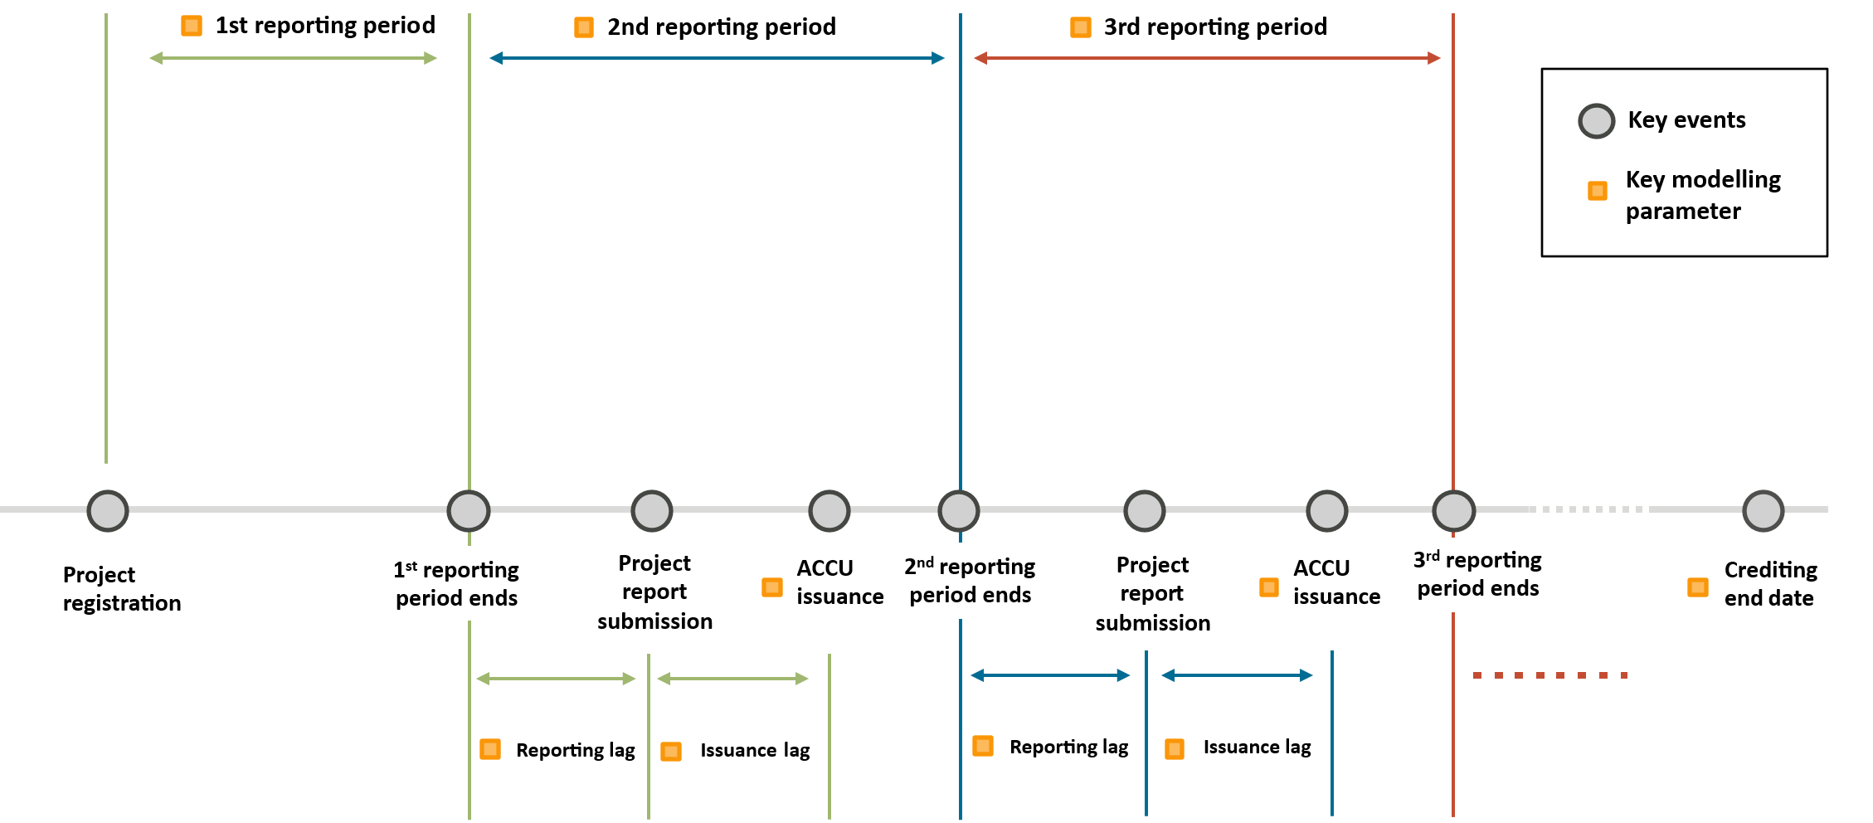
Table 2: ACCU supply model: key parameters
Key parameter | Description
Reporting period | Length of time for which abatement is claimed. This can be up to 2 years for emissions avoidance projects and 5 years for sequestration projects. A project’s reporting period can change over time, although most projects follow a regular reporting cadence.
Reporting lag | Time between the end of the reporting period and submission of the project report. This is generally within 6 months of the end of the reporting period under the reporting requirements of the scheme.
Issuance lag | Time between project report submission and ACCU issuance. This covers the time required to assess project reports and process issuances. This is typically within 90 days under the processing time requirements of the scheme. However, this may take longer if further information is required from project proponents.
ACCU issuance | The volume of abatement recorded on each project report. This is generally equal to the number of ACCUs issued. Our approach accounts for potential variations to the level of claimed abatement. This applies to applications on hand based on internal consultation with assessment teams.  This parameter must be considered in conjunction with the reporting period. A longer reporting period typically correlates with higher abatement volumes.
Crediting end date | The last date for which a project may claim abatement. This is published on the project register. Due to reporting and issuance lags, issuances can occur after a project’s crediting end date.
The above parameters are included in a bottom-up deterministic model to predict the timing of individual project report submissions and issuances, and the volume of ACCUs issued from each project report. Overall issuance is the sum of the results from each component model.
- For projects that have previously reported, parameters are project-specific, where there is sufficient data, and assume a continuation of historic behaviour. For example, a project may typically submit an ACCU claim every quarter. If this project last submitted a project report in December 2025, the model would predict future submissions to occur every quarter, starting March 2026.
- For projects that have not yet reported, parameters are based on reporting projects of the same method. For land-based projects, abatement is scaled to the project area. The model assumes that projects with a larger area have proportionally greater abatement potential.
  - Due to higher uncertainty for projects that have not yet reported, we adopt a more conservative approach to estimate future ACCU issuance. This accounts for method-specific potential underperformance, revocation, and delays in projects reporting for the first time. For example, we assume that some projects will be revoked before any issuance occurs, based on the historical rate of revocation.
We continue to refine our modelling approach with the goal of providing a longer-term outlook for ACCU supply and expanding the scope of projects in our projections. As discussed in the Q2 2025 QCMR, this includes expanding our approach to cover potential ACCU issuances from new projects under both existing and new methods.

Renewable Energy Target

Large-scale generation certificates

LGC carbon abatement – current year
A large-scale generation certificate represents 1 megawatt-hour (MWh) of renewable electricity generated by a power station. Renewable energy power stations like wind farms or solar farms create LGCs for the eligible renewable energy they produce.
The estimated abatement from LGCs is calculated by multiplying the number of LGCs created by the emissions intensity factor, which measures the amount of greenhouse gas emissions produced for each unit of electricity generated.
- Abatement is estimated first for each state, using each state’s LGC creations and emissions intensity factors, and then is summed to arrive at the Australia-wide LGC abatement.
- Prior to 2025, we used a single national grid-average emissions intensity factor. The revised methodology, first used in the Q4 2025 QCMR, better takes account of regional variations in emissions intensity across states and territories.
The key parameters are described in Table 3.

Box 1: Lag adjusting RET certificate creation estimates
Adjusting for lags between activity and certificate creation in the RET means that our reported figures more accurately reflect underlying generation and installation activity.
Renewable energy certificates are created and approved after electricity is generated or systems are installed, so raw end-of-period certificate counts do not capture all activity from the most recent period. To address this, we apply a lag adjustment to selected measures in the QCMR. The adjustment estimates the number of certificates that are expected to be created after period-end, once all eligible applications have been submitted and validation audits completed.
Under the LRET, entities may apply for LGCs up to 31 December of the year after the electricity is generated. Similarly, under the SRES, entities can apply for STCs for small-scale installations up to 12 months after the installation date.
Once applications are submitted, the CER must assess it and complete validation audits before certificates can be registered. For LGCs, this process can take up to 28 days, while STC assessments typically take around 4 to 6 weeks.
The lag adjustment applies a lag coefficient to the number of LGCs or STCs created for a given recent period, typically a year or a quarter – we use a year for the example below. The coefficient is derived from recent historical creation patterns and reflects the proportion of certificates that are typically created after the end of the year. This approach assumes that the pattern of delayed certificate creation observed for the previous year will also apply to the current year.
For both LGCs and STCs, the lag coefficient is calculated as the ratio between:
- the total number of certificates created for a given generation year (measured as at 31 December of the following year), and
- the number of certificates created for that same generation year as at 31 December of the generation year.
For example, to estimate total certificates for 2025 generation, the lag coefficient used to adjust 2025 data is derived using historical increases after the end of the year for 2024 generation. For small-scale solar capacity installed in 2024, 26.9 million STCs had been validated as at 31 December 2024 and 29.6 million STCs were ultimately validated as at 31 December 2025. The lag coefficient is therefore 29.6/26.9 = 1.10.
In early 2026, we would then adjust 2025 STC validation numbers upwards by this ratio to reflect the lag in certificate validation. That is, if 2025 certificate validations by the end of that year were 25.0 million, our estimate of lag-adjusted 2025 creations in early 2026 would be 25.0 x 1.10 = 27.5 million.
We apply similar lag adjustments on a quarterly basis to other key SRES measures in the QCMR, including small-scale solar capacity and installation numbers. Lag adjustment is not applied where it would not materially affect the outcome or where sufficient time has elapsed for reporting to be substantially complete. Typically, 99% of certificates are validated by 30 April of the following year.
Figure 2: Percentage of STCs associated with 2024 installs validated throughout 2025
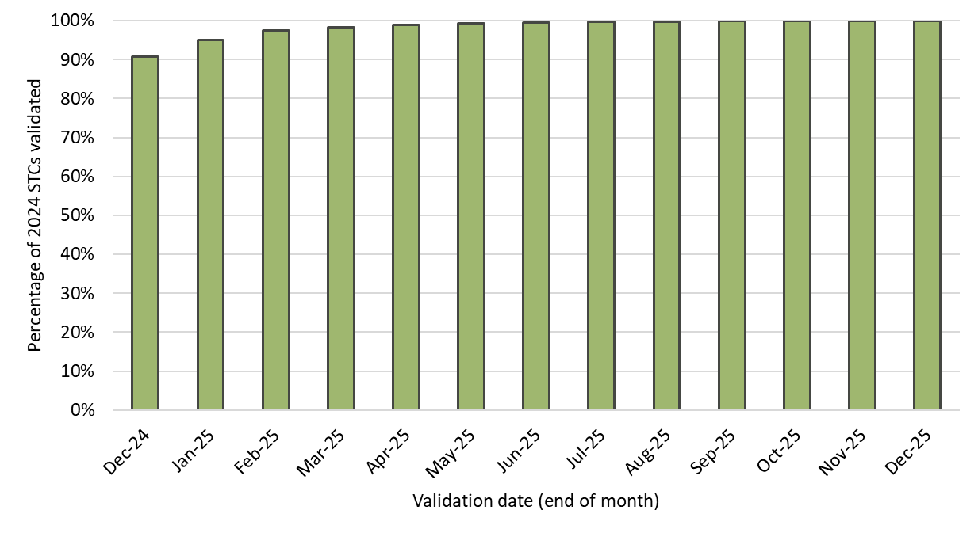

Table 3: Estimating abatement from the Large-scale Renewable Energy Target: key parameters
Key parameter | Description
LGCs by generation year | The number of LGCs created in each state based on the calendar year in which the electricity was generated at accredited power stations under the LRET scheme.  Because LGCs may be created up to 12 months after generation, creation figures are lag adjusted to estimate full year LGC creations. See Box 1 for an explanation of lag adjustment.
Emissions intensity factors | Greenhouse gas emissions produced per unit of electricity generated, expressed as tonnes of CO₂‑e per megawatt hour (tCO₂‑e/MWh).  State-based emissions intensity factors are from the National Greenhouse Accounts Factors, averaging across 2 financial years to arrive at the calendar year.  Emissions reduction from the LRET can also be calculated using the thermal displacement method, which assumes renewables are fully displacing electricity generated from fossil fuels such as coal and gas. This approach is likely to systemically over-estimate abatement by discounting renewables displacing other renewable generation. As a result, the estimate based on the National Greenhouse Accounts Factors is preferred.

LGC carbon abatement – one year ahead
The abatement projection is based on the midpoint of the CER’s projected range of LGC validations for the coming year. First a projected range for total national LGC validations is calculated using 3 methods:
- applying the current year’s growth in accredited LRET capacity to this year’s LGC validations
- adding the median annual increase in LGCs validated since 2019 to this year’s LGC validations
- adding the average annual increase in LGCs validated since 2019 to this year’s LGC validations.
The bounds of the LGC validation estimate reflect the highest and lowest outcomes across these 3 methods. The methods assume that historical patterns of LGC growth continue into the next year and that LGC creations grow linearly with accredited LRET capacity. This implicitly incorporates historical variation in factors that affect renewable energy production such as weather, economic and network factors, construction timing, and total demand for electricity. Major shocks to these factors can result in actual LGC validations being above or below the estimated range. Examples include prolonged weather disruptions like wind droughts, historically unusual delays or advancement in the commissioning of large-scale renewable energy projects, large variations in renewable generation due to significant changes in the wholesale electricity prices or curtailment by the electricity network operator, or historically unusual changes to overall electricity supply or demand.
Second, we use state-specific emissions factors to produce abatement projections from these LGC projections. This improves the accuracy of the abatement estimates relative to using a single national factor.
- The national LGC total is allocated across states and territories according to each jurisdiction’s share of LGCs generated in the current year.
- Each state’s projected LGC validations are combined with estimated emissions intensity factors by state to produce an estimate of emissions reduction from the LRET for each state in an equivalent manner to the current year estimate.
  - The projected emissions intensity factors are based on National Greenhouse Accounts Factors for the most recent year, linearly adjusted based on recent trends in National Greenhouse Accounts Factors.
  - In future QCMRs, we will transition to using the projected emissions factors published as an appendix to the annual Australia’s emissions projections report to develop the estimated emissions intensity factors.
Finally, these state estimates are summed to calculate the estimated national total emissions reduction from the LRET for the coming year.

Small-scale technology certificates, excluding batteries

SRES carbon abatement – current year
A small-scale technology certificate represents 1 MWh of renewable energy electricity generated or displaced by eligible systems. STCs are created when an individual or business installs an eligible small-scale renewable energy system.
The estimated abatement is calculated by modelling the renewable energy generated or displaced annually by eligible small-scale systems (excluding batteries) and applying a national average scope 2 emissions intensity factor. The emissions intensity factor is derived from the National Greenhouse Accounts Factors.
This approach does not include adjustments for environmental factors that can impact generation such as weather disruptions. It also does not adjust for some limitations that may occur in small-scale systems such as system degradation which may reduce performance efficiency for older systems. Consequently, actual generation from small-scale solar systems may differ from the estimated figure.
Descriptions of the key parameters for the SRES emissions reduction estimate are available at Table 4.
Table 4: Estimating abatement from the SRES: key inputs and parameters
Key parameters | Description
Solar installations and capacity | Solar PV systems installed up to and including the most recent year of data and their capacity. Because applications for more recent installations can be made up to 12 months after installation, the installations and capacity for the most recent year are lag-adjusted to estimate the full year.
Solar postcode zone rating | The postcode zone rating for solar panel systems takes account of the level of solar radiation for a geographical area, which is higher closer to the equator. Higher solar radiation leads to higher renewable electricity generation. Postcode zone ratings are set in accordance with the Renewable Energy (Electricity) (Zone Ratings and Zones for Solar (Photovoltaic) Systems) Instrument 2019.
Deeming period | Deeming periods¹⁰ are used to calculate the duration over which a system is likely to be generating. Deeming periods are set in accordance with the Renewable Energy (Electricity) Regulations 2001, Subdiv 2.3.3.
Solar replacement modifier | A factor accounting for solar PV systems replaced before the end of their deeming periods.  The modifier is a combination of 2 factors: the share of all solar PV installations that have replaced existing systems as of the end of that calendar year and the ratio of the average capacity being replaced to the average new capacity. The modifier is applied to the total solar PV generation estimate each year to account for replaced systems and capacity.  For example, if 15% of all PV systems were replacements as of 2025, replacing the average system size of 3 kW with a new average capacity of 9 kW, then the replacement modifier for 2025 would be 0.15 * (3/9) = 5%.
Non-solar installations data | The estimated small-scale renewable generation and displacement data from solar water heaters, air source heat pumps, and small-scale wind and hydroelectric systems use the same model as the solar data. Instead of installed capacity, renewable generation and displacement is calculated using STCs registered per month.  Each STC is used to represent 1 MWh of generated or displaced capacity.
Emissions intensity factors | See Table 3. The national emissions intensity factor is applied for estimated SRES abatement.
SRES abatement in the current year is calculated as follows:
- Generation from solar installations is calculated by multiplying the postcode zone rating by installed capacity. Generation is summed for installations that haven’t reached the end of their deeming period.
- Generation from solar installations is reduced by a solar replacement modifier percentage to account for the installations that are replaced ahead of reaching the end of their deeming period. Incorporating replacements into our estimates avoids over-estimating abatement from solar PV. The solar replacement modifier was first included in the Q4 2025 QCMR. The modifier is applied as an aggregate adjustment to other components of the calculation and provides an approximate estimate.
- For non-solar installations, a similar approach is used, where generation is summed for installations that have not reached the end of their deeming period, but we use validated STCs instead of capacity. Non-solar installations have not been adjusted for replacements or for the lag between installation and validation.
  - We expect these effects for solar water heaters and air source heat pumps would have comparatively minor effects on emissions abatement compared to small-scale solar. However, the likely impact may be investigated further in the future.
  - New installations of small-scale wind and hydroelectric systems are rare, making these adjustments unnecessary.
- The estimated generation or displacement is then multiplied by the national emissions intensity factor to calculate estimated abatement.
Battery-related STCs are deliberately excluded from abatement estimate as the source and timing of charging and discharging cannot be reliably determined with available data, and battery-related STCs aren’t designed as a proxy for abatement. The contribution of batteries to emissions reduction is instead captured implicitly through reductions in grid emissions intensity over time.

SRES carbon abatement projection – one year ahead
The abatement projection is calculated using the previous year’s estimated SRES generation as a base and adjusting for projected installations and removals.
Additional generation is estimated using the same STC modelling that underpins the small-scale technology percentage (STP). The range reflects different plausible outcomes for new installation capacity, with the central estimate matching the level of installed capacity consistent with the STP for that year as determined by the minister. As with any forecast, actual STC creations may differ from the modelled range if installation rates are affected materially by factors such as changes in consumer behaviour, economic conditions or policy settings.
As with the current year’s calculation, installations reaching the end of their deeming period are removed and the solar replacement modifier is applied to the generation estimate for small-scale solar.
Estimated SRES generation is then multiplied with an estimated national emissions intensity factor for the year ahead derived from the National Greenhouse Accounts Factors to produce an estimate of projected year-ahead emissions reduction from the SRES. As with the LRET estimates, we plan to derive this estimated national emissions intensity factor using the projected emissions factors published as an appendix to the annual Australia’s emissions projections report in future QCMRs.

https://cer.gov.au/glossary
https://cer.gov.au/markets/reports-and-data/safeguard-data
https://cer.gov.au/schemes/australian-carbon-credit-unit-scheme/how-to-participate-accu-scheme/permanence-obligations#risk-of-reversal-buffer
https://cer.gov.au/schemes/australian-carbon-credit-unit-scheme/how-to-participate-accu-scheme/permanence-obligations
https://cer.gov.au/document_page/human-induced-regeneration-method-managing-project-risk-to-deliver-carbon-abatement-australia
https://cer.gov.au/markets/reports-and-data/quarterly-carbon-market-reports/quarterly-carbon-market-report-december-quarter-2024/safeguard-and-australian-carbon-credit-unit-accu-schemes#2025-accu-issuances-expected-at-between-19-and-24-million
https://cer.gov.au/schemes/australian-carbon-credit-unit-scheme/how-to-participate-accu-scheme/project-reporting-and-audits
https://cer.gov.au/schemes/australian-carbon-credit-unit-scheme/how-to-participate-accu-scheme/apply-to-participate-accu-scheme/processing-times
https://cer.gov.au/markets/reports-and-data/accu-project-and-contract-register
https://cer.gov.au/markets/reports-and-data/quarterly-carbon-market-reports/quarterly-carbon-market-report-june-quarter-2025/australian-environmental-markets
https://cer.gov.au/schemes/renewable-energy-target/large-scale-renewable-energy-target/large-scale-generation-certificates
https://www.dcceew.gov.au/climate-change/publications/national-greenhouse-accounts-factors
https://www.dcceew.gov.au/climate-change/publications/australias-emissions-projections-2025
https://cer.gov.au/schemes/renewable-energy-target/small-scale-renewable-energy-scheme/small-scale-technology-certificates
https://cer.gov.au/markets/reports-and-data/small-scale-installation-postcode-data
https://cer.gov.au/schemes/renewable-energy-target/small-scale-renewable-energy-scheme/small-scale-technology-certificates/calculate-small-scale-technology-certificate-entitlements#how-we-calculate-entitlements
https://www.legislation.gov.au/F2019L01583/
https://www.legislation.gov.au/F2001B00053/
https://cer.gov.au/schemes/renewable-energy-target/small-scale-renewable-energy-scheme/small-scale-renewable-energy-systems#expanding,-upgrading-or-replacing-existing-solar-pv-systems
https://cer.gov.au/markets/reports-and-data/small-scale-installation-postcode-data
https://cer.gov.au/markets/reports-and-data/small-scale-technology-percentage-modelling-reports
https://cer.gov.au/schemes/renewable-energy-target/renewable-energy-target-liability-and-exemptions/small-scale-technology-percentage

