
Prototype interoperability models
Version 1.02
19 June 2026

Change log 3
Interoperability with Clean Energy Regulator systems 4
Types of APIs 5
Prototype interoperability models 6
Class A: Read and write from own ANREU account 6
A.1. Read and write API from own account 6
Class B: Third-party trading platform access 6
Table 1: Features and differences of class B prototype interoperability models 7
B.1. API connectivity for information only from third-party platforms 8
B.2. Account delegation model 9
B.3. Full custody model 9
B.4. Fleeting custody model 10
B.5. Escrow model 11
Class C: Third-party registries and certificates 12
C.1. Associating units with third-party certificates 12
Glossary 13
Table 2: Glossary of commonly used terminology 13

Change log
Version | Date | Change description
1.01 | 8 April 2026 | n/a
1.02 | 19 June 2026 | Addition of a definition for ‘third-party certificate registry’ to the glossary

Interoperability with Clean Energy Regulator systems
The Clean Energy Regulator’s (CER) Unit and Certificate Registry (the registry) is a key part of Australia’s carbon market infrastructure that will support the continued growth of deep, liquid, transparent and accessible carbon markets. It delivers a single, secure digital platform and enables new functionality including digital interoperability via application programming interfaces (APIs).
At a broad level, interoperability is the ability for different systems, devices, or applications to exchange and use information in a co-ordinated manner. This document provides detail on the prototype interoperability models the CER has identified through targeted consultation as part of our Registry Interoperability Project which ran during the second half of 2025. The focus of our targeted consultation included:
- the principles that could guide the CER’s interoperability work – this informed our draft interoperability principles
- the priorities for interoperability across the CER’s units, certificates and registers
- prototype interoperability models for interoperability use cases, as summarised in this document.
We held 3 workshops in July and August 2025, inviting respondents to our late 2024 consultation on carbon market infrastructure and other organisations identified as having a strong interest in interoperability with our systems. The workshops had 52 attendees from 39 organisations, representing CER registry account holders, carbon market trading platforms and third-party certificate schemes. Respondents re-affirmed support digital interoperability with CER systems, generally welcomed the draft principles for interoperability, and found the characterisation of prototype interoperability models present in this document to be accurate.
The Registry Interoperability Project has yielded good understanding of use cases and needs for interoperability as well as the relevant legal, IT and security considerations. The CER has found that legislative changes would be required to implement the registry prototype interoperability models for Australian Carbon Credit Units (ACCUs) and Safeguard Mechanism Credit units (SMCs) in this document.
The CER will look to develop some basic interoperability features within the existing legislative framework such as data exchange with third-party registries, and public project register APIs. This information is being published to provide a record for interested stakeholders. The CER is continuing to assess options to further improve the registry in the future.
While increased digital interoperability offers many benefits for participants in Australia’s carbon and environmental markets, any enhanced interoperability implemented in future would complement but not replace existing ways of accessing CER systems.
The CER welcomes questions and feedback on this document and possible future interoperability work. If you are interested in joining the stakeholder mailing list or have feedback, please email market-engagement@cer.gov.au.

Types of APIs
The proposed APIs designed to facilitate the identified prototype interoperability models can be categorised into read or write access to an Australian National Registry of Emissions Units (ANREU) account, or to a CER public register.
Where interoperability with CER systems is implemented, the CER will use a common design for each API instead of bespoke models where feasible. This approach had strong support from our targeted consultation.
Read access to an ANREU account would include functions such as:
- get a list of accounts
- get account details
- get holdings list
- get transaction history.
Write access for an ANREU account would include functions such as:
- initiate transfer
- rescind initiate transfer
- approve transfer
- initiate voluntary cancellation.
Read access to CER public registers would let the user obtain all publicly available information in the register. A possible function within this read access includes filtering of data by field or paging. Read access to CER public registers available on our Data Services platform is available via API. The CER is working to add all its public registers to Data Services as part of our forward work program.

Prototype interoperability models
Through targeted consultation, we identified models for interoperability between the CER’s Unit and Certificate Registry and:
- a user’s own registry account (‘Class A’)
- carbon market trading platforms (‘Class B’)
- a third-party registry (‘Class C’). This model would facilitate the reconciliation of information between CER units and a third-party’s units.
These prototype interoperability models capture the outcomes of targeted consultation that will inform the CER’s consideration of options to improve the registry in the future. However, the CER has found that legislative changes would be required to implement the registry interoperability cases in this document for all Classes A to C. Basic data exchange between third-party registries and the CER that does not use a registry API is feasible under existing legislation and is being progressed as part of the CER’s forward work program.

Class A: Read and write from own ANREU account

A.1. Read and write API from own account
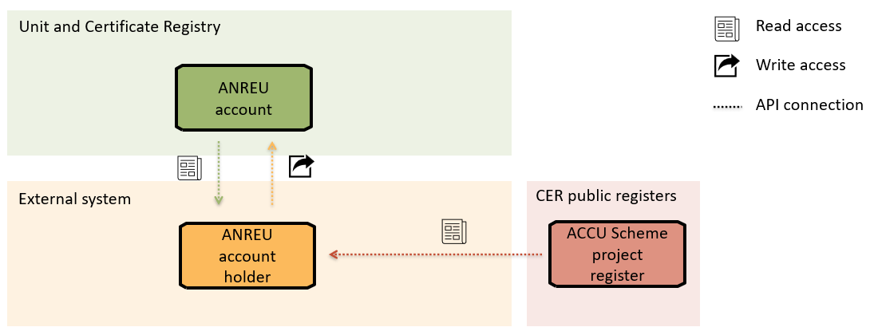
Figure 1: Read and write API from own account
Figure 1 represents the infrastructure where an authorised representative for an ANREU account has API access to read their own account or perform transactions from their own account.
This supports use cases such as mobile apps, integration with inventory and finance systems for daily reconciliation, and efficient workflow for users who trade frequently or in bulk.
Read access to CER public registers are provided via API, bypassing the need to log into Online Services.

Class B: Third-party trading platform access
The models in this class enable organisations to build and operate their own trading platforms that integrate information from CER registers and holdings from ANREU accounts. ANREU account holders will be required to provide consent for third-party platforms to view a set of holdings within the ANREU account.
There are different ways of delivering the functionality of selecting and reserving units for trading purposes. It may involve either tagging specific blocks of units or establishing a secondary account with read-only access granted to the trading platform. The benefits of ‘tagging’ units is that a user can manage reservation of units for trading within a single account. As a new feature, it would take considerably more time to develop and implement. On the other hand, establishing a secondary ANREU account for trading units creates additional administrative burden by requiring the management of multiple accounts. However, this would allow for a quicker implementation if interoperability were implemented, as the functionality of this proposed option is identical to providing a third-party view only access into the secondary account.
The first 3 models presented (Figure 2, Figure 3 and Figure 4) reflect existing market systems while Figure 5 and Figure 6 represent an extension of current system capabilities. That is, the first 3 models are already in operation with CER systems, but without API-based digital interoperability. Table 1 summarises some key characteristics of the models.

Table 1: Features and differences of class B prototype interoperability models
Class B models | Description | Platform’s permissions in the seller account | Reservation type | Who controls units during trade listing | Who performs settlement on the registry
B.1. API connectivity for information only from third-party platforms  (Figure 2) | Platform gets view-only access (seller maintains all control) | View (holdings) | None – holdings in account are visible to trading platform | Seller | Seller
B.2. Account delegation model  (Figure 3) | Seller shares control with platform by appointing platform’s representative as the seller’s authorised representative | View and transfer | None – holdings in account are visible to trading platform | Seller and platform’s representative appointed as the seller’s authorised representative | Platform’s representative appointed as the seller’s authorised representative
B.3. Full custody model  (Figure 4) | Seller transfers units to platform account | None | Platform has listed units in their account | Platform | Platform
B.4. Fleeting custody model  (Figure 5) | Platform gets view only access and informs seller to complete transaction | View (holdings) | Revocable reservation – holdings separated from main account are visible to trading platform | Seller | Seller and platform
B.5. Escrow model  (Figure 6) | Units are placed in escrow and control of those escrowed units are given to the trading platform | View (holdings)  Transfer (only of escrowed units) | Escrow | Platform | Platform

B.1. API connectivity for information only from third-party platforms
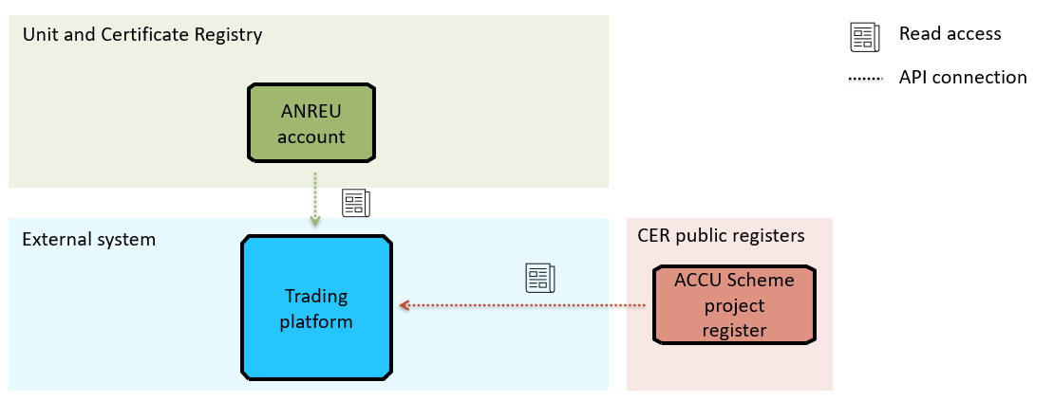
Figure 2: API connectivity for information only from third-party platforms
Figure 2 represents the simplest interoperability case within this class. This model shows a read only model where an ANREU account holder provides consent to a trading platform to view the ANREU account’s holdings and the trading platform can obtain project attributes from CER public registers. CER public registers are public information with unrestricted read access to the register’s published data.

B.2. Account delegation model
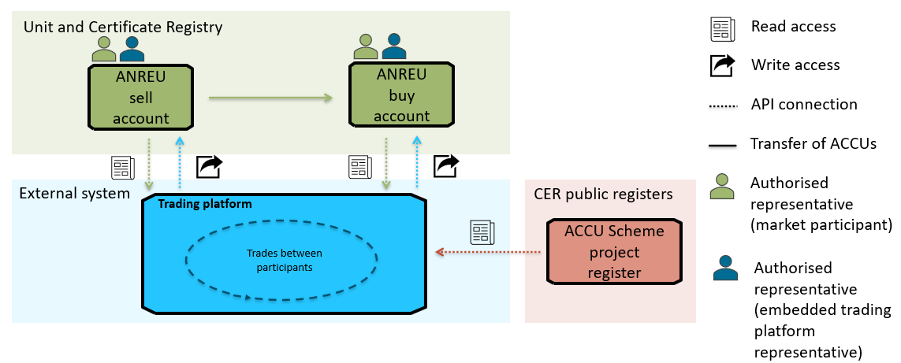
Figure 3: Account delegation model4
For the account delegation model (Figure 3), market participants seeking to trade units create an ANREU account and embed an authorised representative from the trading platform into the ANREU account. By embedding an authorised representative from the trading platform, the notice of transfer for buying and selling can be done by the embedded trading platform representative on behalf of the market participant as trades occur within the platform itself.

B.3. Full custody model
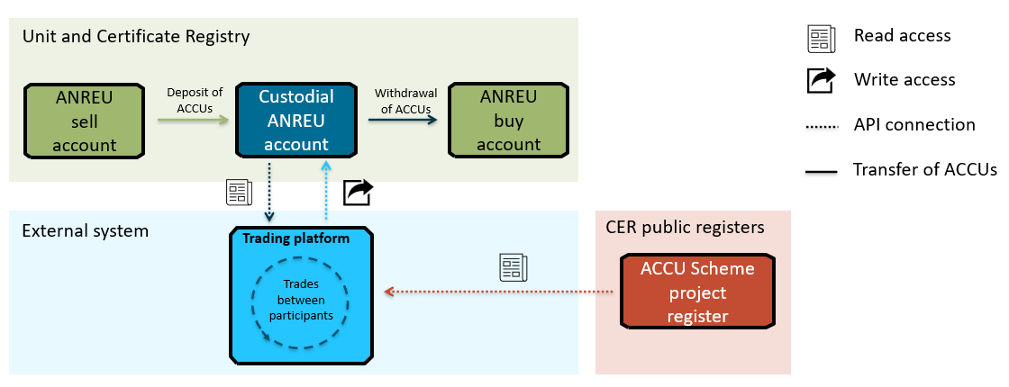
Figure 4: Full custody model
In the full custody model (Figure 4), the trading platform has a custodial ANREU holding account. Market participants selling on the trading platform transfer ACCUs to the trading platform’s custodial account. Trades are established on the platform and the trade is completed through a transfer of ACCUs from the operator’s holding account by the platform’s authorised representative to the buyer’s ANREU account.

B.4. Fleeting custody model
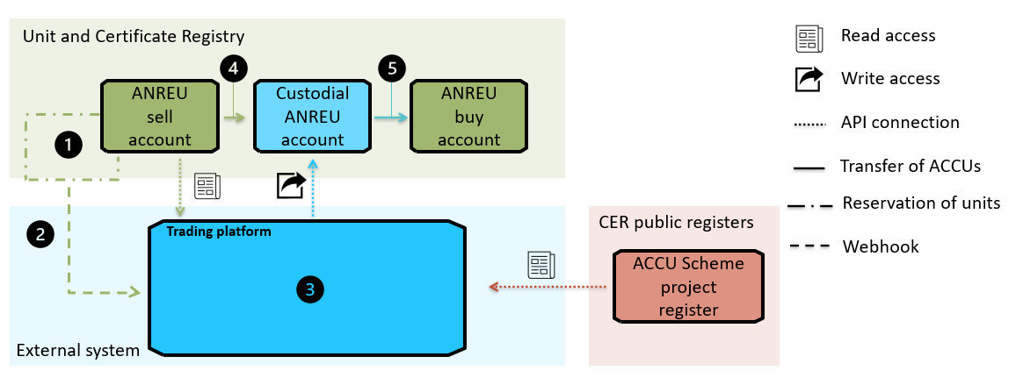
Figure 5: Fleeting custody model
The fleeting custody model (Figure 5) facilitates the anonymity of trading entities on the trading platform if performed through the custodial account. Sellers and buyers are afforded anonymity as the trading platform completes the trade by having momentary custody of the units.
The model functions as follows:
- ANREU authorised representative (sell account) selects (mechanism to be determined) a block of units for trade by reserving the units. This separates the units from the main holdings.
- Consent is provided for the trading platform to view all reserved units.
At any time, reserved units can be unreserved by the account holder. Trading platforms can use their view consent to monitor reserved units and are responsible for halting transactions on their own platforms when appropriate to minimise counterparty risk.
- The trading platform establishes a trade agreement and informs the seller to complete the transfer.
- Seller transfers units to the interim custodial account held by the trading platform.
- The platform’s authorised representative transfers the units from the interim custodial account to the buying ANREU account.
The purpose of reserving units is to ensure that units are available for trade. With seller consent, the trading platform can view the reserved units and be notified when units are unreserved. It is the responsibility of the trading platform to halt the trade and delist units on their trading platform if units are unreserved.

B.5. Escrow model
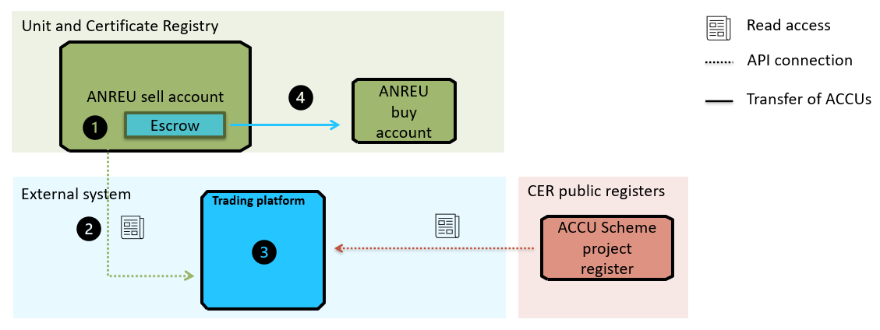
Figure 6: Escrow model
This model (Figure 6) has been included due to stakeholder feedback on this being a scalable and most efficient market model.
At present there is no active escrow function within the registry. An escrow function reduces the risk that contractual obligation to transfer the ACCUs is not fulfilled. The CER will not hold funds on behalf of any party, and the handling of funds will continue to be the responsibility of the transaction parties and any relevant third-party platforms.
The following steps detail how a trade will occur in this model:
- Selling ANREU account allocates units to be traded into an escrow section within their account. The units do not leave the seller’s account, however control of the units within the escrow is given to the trading platform as a specific type of authorised representative.
- Unit attributes of traded units are visible by the trading platform as the controller of the escrowed units.
- Trading platform establishes a trade agreement between buyer and seller.
- Trading platform completes the transfer of units as the controller of the escrowed units from the seller’s account to the buyer’s account.

Class C: Third-party registries and certificates

C.1. Associating units with third-party certificates
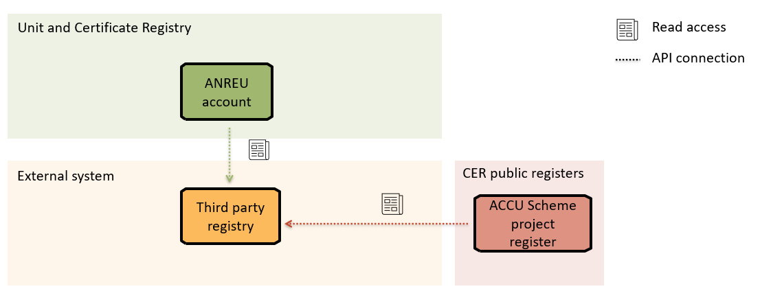
Figure 7: Associating units with third-party certificates and/or registries
This model (Figure 7) provides visibility of the holdings of units to third-party registries where the third-party unit or certificate derives its value from a unit or certificate administered by the CER with a 1:1 association. In this model, consent is provided by the ANREU account holder and API access enables third-party registries to easily collect, verify, and collate data from the registry. As noted above, while implementing this model via an API would require legislative change, an approach that does not use Unit and Certificate Registry APIs is feasible under the CER’s existing legislative framework and is being progressed.
In line with draft interoperability principle 4, the CER access does not endorse third-party registries and any claims associated that third-party certificate and product creators make about linked government-backed units and certificates must be accurate.

Glossary

Table 2: Glossary of commonly used terminology
Term | Definition
Application programming interface | A set of functions and procedures allowing the creation of applications that access the features or data of an operating system, application, or other service.
Authorised representative | An individual who is nominated under the ANREU Regulations 2011 to be an authorised representative for a particular registry account and act on behalf of the account holder for certain actions.
Escrow | A legal financial arrangement where a trusted and neutral third party holds funds and assets on behalf of 2 parties involved in a transaction until specific conditions are met.
Interoperability | In general terms, interoperability is the ability for different systems, devices or applications to exchange and utilise information in a coordinated manner.  For the purposes of this project, interoperability is API-based connectivity between CER systems and third-party systems.  CER systems include the Unit and Certificate Registry and scheme registers such as ACCU project register.
Read request | An electronic transmission to interrogate the holdings of an ANREU account but excludes a write request.
Register | A list of relevant information with respect to the subject of the register. For example:  - project attributes from the ACCU Scheme project register available on CER's website  - carbon abatement contract (CAC) attributes from the CAC register  - Guarantee of Origin project register.
Registry | A centralised record database where information is collected, stored and maintained.  For example, CER's Unit and Certificate Registry built on Trovio's CorTenX system, ANREU, REC registry.
Third-party certificates | Certificates issued by an organisation other than the CER. The certificates either relate to or derive value from the Clean Energy Regulator’s units and certificates.
Third-party certificate registry | A centralised record database where information on third-party certificates is collected, stored and maintained. These certificates are independent from the units and certificates administered by the CER but either relate to or derive value from the Clean Energy Regulator’s units and certificates.
Trading platforms | Market trading infrastructure or entities that connect buyers and sellers to facilitate the trading of carbon and environmental units.
Write request | An electronic transmission that instructs a transaction to be carried out in respect of units or certificates held in an ANREU account.

https://cer.gov.au/document_page/draft-interoperability-principles
https://cer.gov.au/news-and-media/public-consultations/carbon-market-infrastructure-holding-and-trading-certificates-and-units
https://data.cer.gov.au/
Consent here refers to consent provided through s51 Clean Energy Regulator Act 2011 and is likely to be via an automated process.
https://cer.gov.au/document_page/draft-interoperability-principles

