
Online Services user guide
REGO access and permissions
V1 January 2026

Contents
Disclaimer 2
Description of access in Online Services 3
How to update registered person details 3
How to edit contacts 5
How to add users to a registered person account 6
How to manage users and user permissions 9

Version history
Version | Change description | Date published
v0.1 | First publication | 13/01/2026

Disclaimer
This user guide is intended to provide general information about using Online Services and changing access and permissions for Renewable Electricity Guarantee of Origin (REGO) participants.
To the extent permitted by law, neither the Clean Energy Regulator nor the Commonwealth of Australia accepts responsibility or liability for any direct, incidental or consequential loss or damage resulting from the use of this user guide.
The information presented in this user guide is not a substitute for legal, business or financial advice. Users should seek independent advice before taking any action or decision on the basis of the information provided in this document.
The Clean Energy Regulator and the Commonwealth of Australia may, at their discretion, vary or modify this user guide without notice.

Description of access in Online Services
Online Services is the portal our participants use to interact with different schemes, including the Renewable Electricity Guarantee of Origin (REGO).
As an individual user, you can sign up to Online Services using your personal or business email address.
Once you’re a user, you can apply to become a registered person in the Guarantee of Origin (GO) Scheme. Registered person refers to a legal person (an individual or organisation) that acts in the REGO by registering facilities or creating or transferring REGO certificates.
The registered person account can have multiple users associated with it. This means that multiple individuals that work for the organisation or act on behalf of an individual can access that registered person account.
This user guide is a step-by-step guide on how to add and manage users in a registered person account and give them the right permissions in Online Services.
If your registered person account is for an individual instead of an organisation, you can follow the steps in this document. Instead of clicking the Manage organisation buttons, you can instead click the Manage individual buttons.

How to update registered person details
- Go to Online Services and sign in. Ensure that you are acting on behalf of the registered person account, and not as an individual user by switching your account.
- From the dropdown menu by your username, click the Manage organisation or Manage individual button.
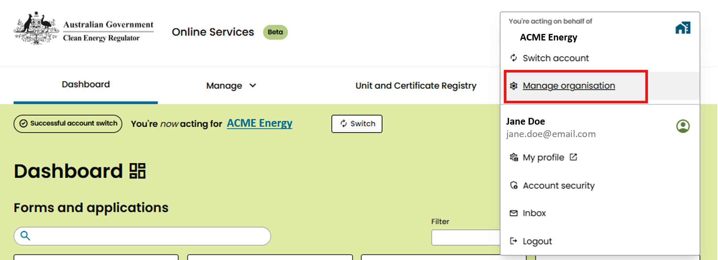
2
- On the Manage account page, you can see details of the registered person including the name, account type, business identifier number (ABN, ACN, or IBN) and address.
To edit any of these details, click the Edit details button.
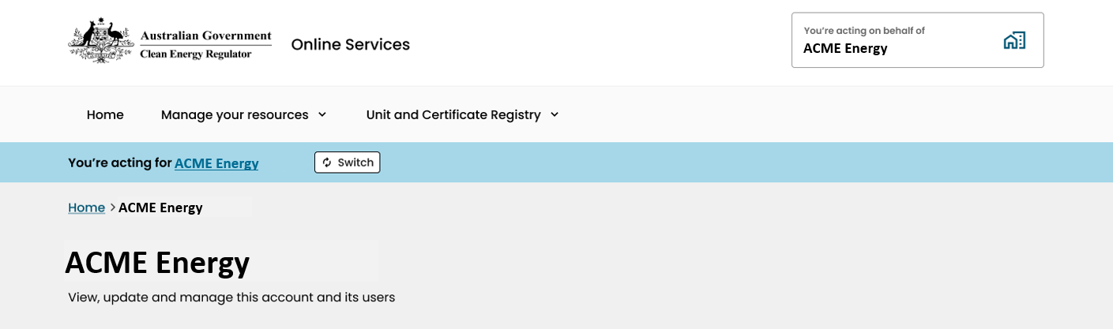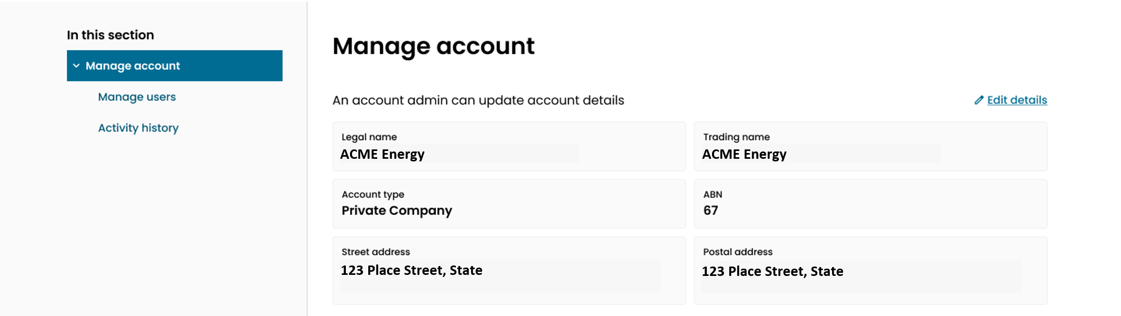
3.
- On the Edit account details page, you can update the street and postal address for the organisation.
Once these details are correct, click Update.
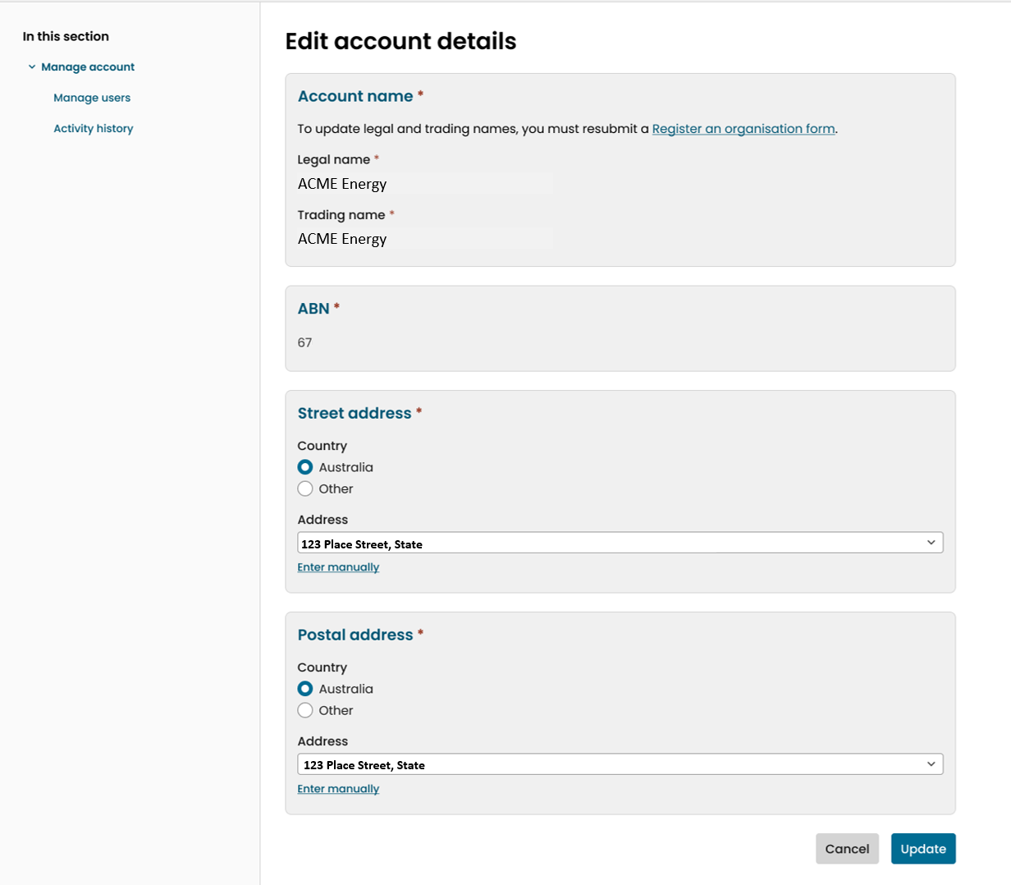
4

How to edit contacts
- Sign in to Online Services. Ensure that you are acting on behalf of the registered person account, and not as an individual user.
- In the dropdown menu from your username, click the Manage organisation or Manage individual button.
2
- On the Manage account page, you can see a list of the contact users for any schemes that the registered person is a participant in.
To edit these contact details, click the Edit contacts button.
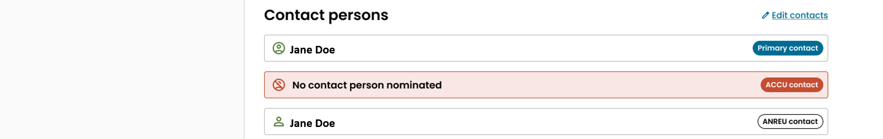
3.
- On the Edit contacts page, you can select a new primary contact person from the dropdown menu for the registered person. If you wish to select a user that is not in the dropdown list, you can add users by clicking Add a user (see How to add users to a registered person account).
Once these details are correct, click Update.
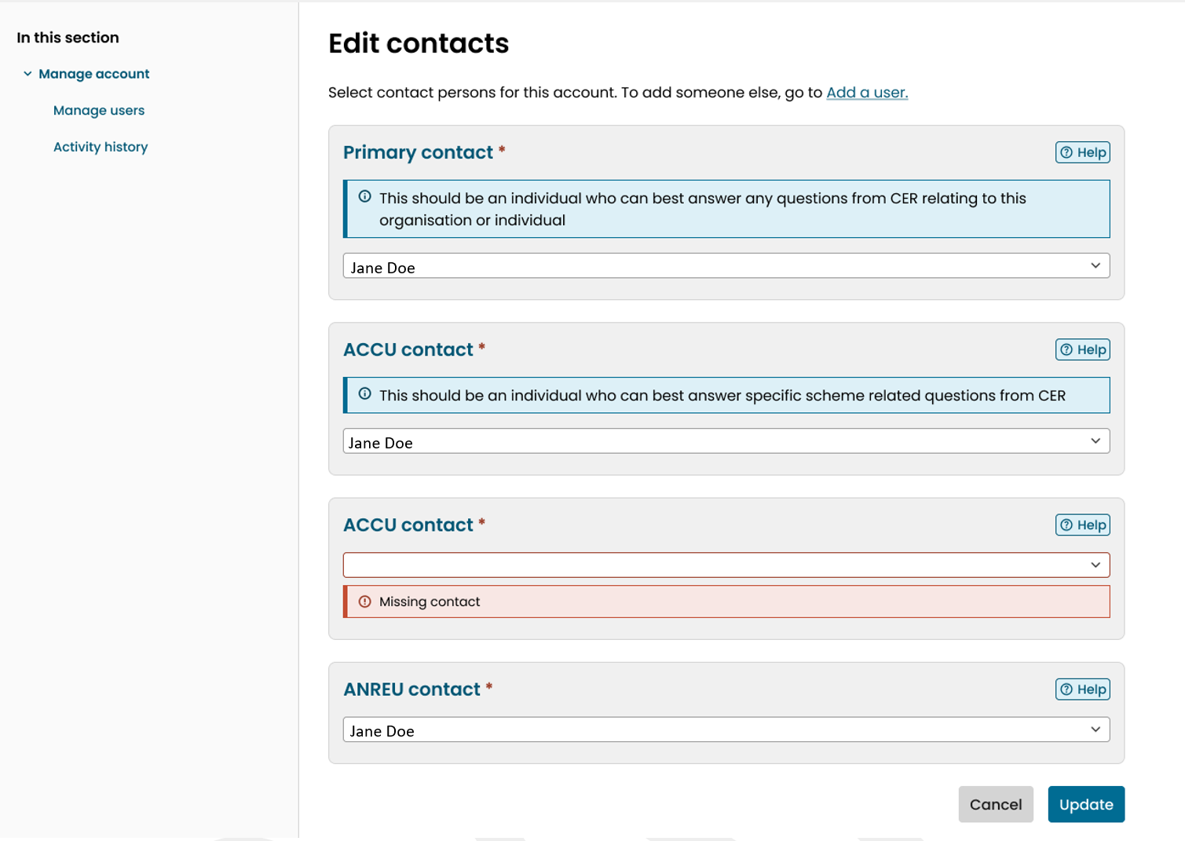
4b.
4a.

How to add users to a registered person account
- For the additional user to complete:
To sign up as a user in Online Services, go to the Online Services portal and click Sign up now. Once you have signed up with this email, the user can be added to the registered person account.
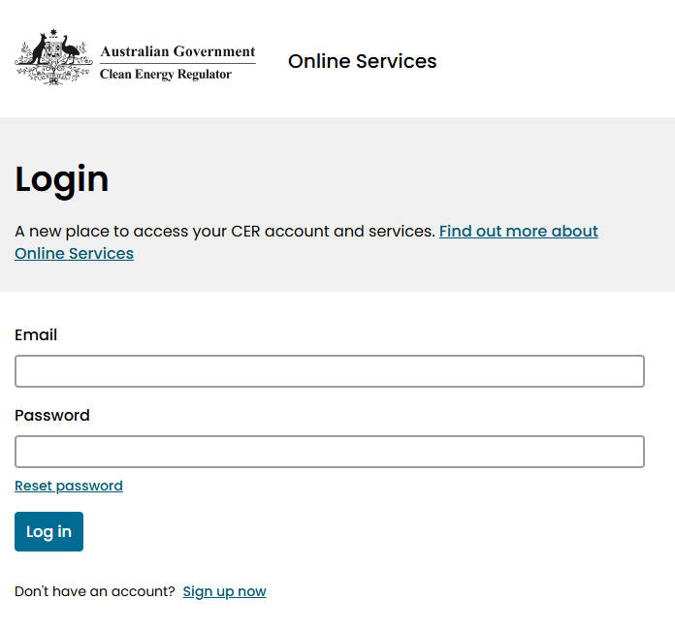
1

- For a user already in the registered person account to complete:
Go to Online Services and sign in as a user under the registered person account. In the dropdown menu from your username, click the Manage organisation or Manage individual button.
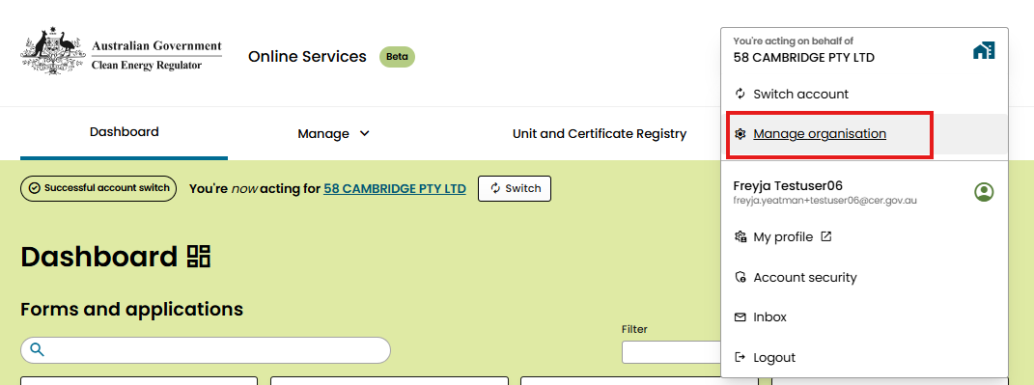
2
- On the menu at the left side of the Manage account page, click the Manage users button.
3
- The Manage users page displays all users that have access to the registered person account. Click Add user.
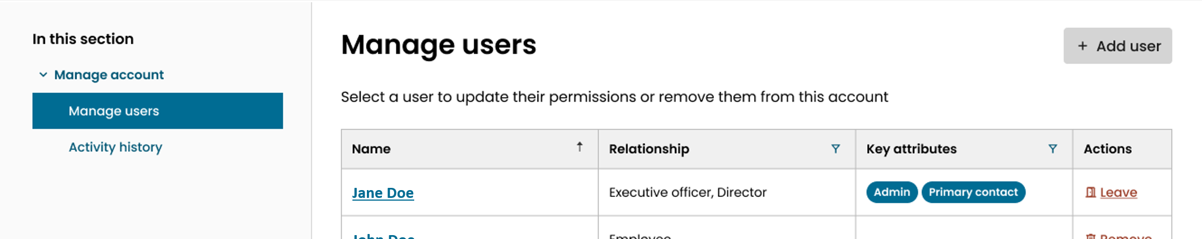
4
- Type in the email address of the user you wish to add to the registered person account.
Select the type of relationship the user has to the registered person. If the user is not an agent, consultant, or employee, you will have to check the box to sign a declaration acknowledging you must take further action to properly notify us.
Once the details are correct, click Add user.
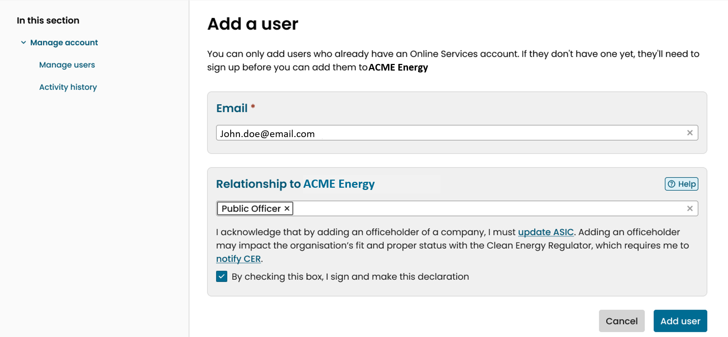
5b.
5a.
If an error message appears that says, ‘There doesn’t seem to be a CER account associated with this email address’, make sure the user has signed up to Online Services as in step 3.1.
If an error message appears that says, ‘This user is already associated with this account’, this user already has access to the registered person account. You can update the user’s permissions or delete them from this account by following the next process, How to manage users and user permissions.
- The additional user will remain as Invited until they accept the invitation to access the account.
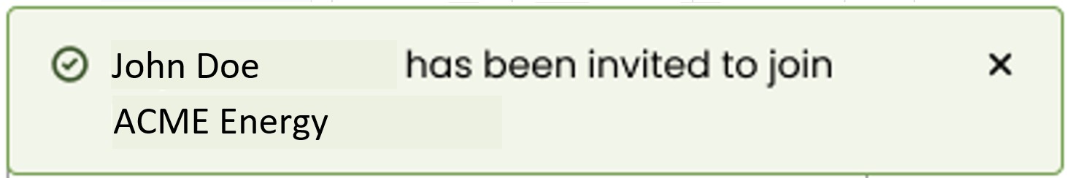
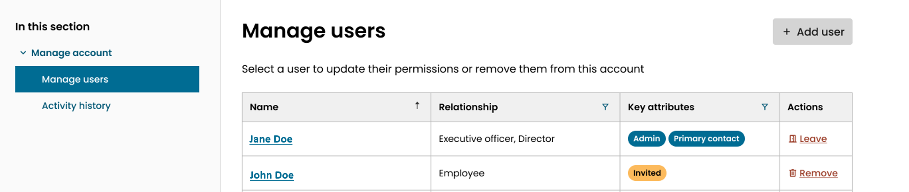
6

- For the additional user to complete:
Sign in to Online Services and scroll down on the home page to check your inbox. There will be a message inviting you to act on behalf of the registered person account.
Open the message and click Accept.
You will now be able to switch account and act on behalf of the organisation.
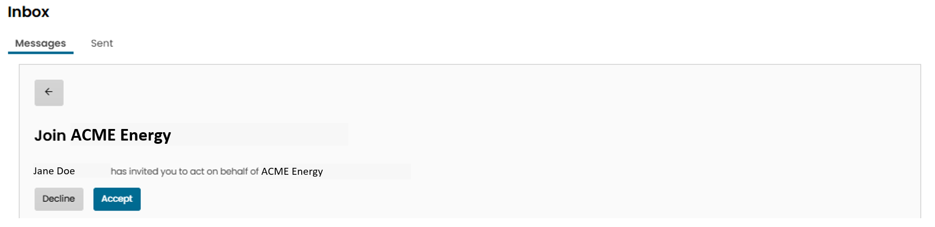
7

How to manage users and user permissions
- Go to Online Services and sign in as a user in the registered person account. In the dropdown menu from your username, click the Manage organisation or Manage individual button.
1
- On the menu at the left side of the Manage account page, click the Manage users button.
2
- The Manage users page displays all users that have access to the registered person account. Each user has a specific relationship to the registered person. They can be an admin user and they can be a contact for a specific scheme. There is also one primary contact who will be contacted by default.
If you wish to remove a user from the registered person account, you can click the Remove button next to their name.
If you wish to update their permissions, you can click their name.
3a.
3b.

- After clicking their name, click on the REGO tab to edit permissions specific to viewing and managing REGO facility and certificate applications. Click on the checkboxes to edit the user’s permissions.
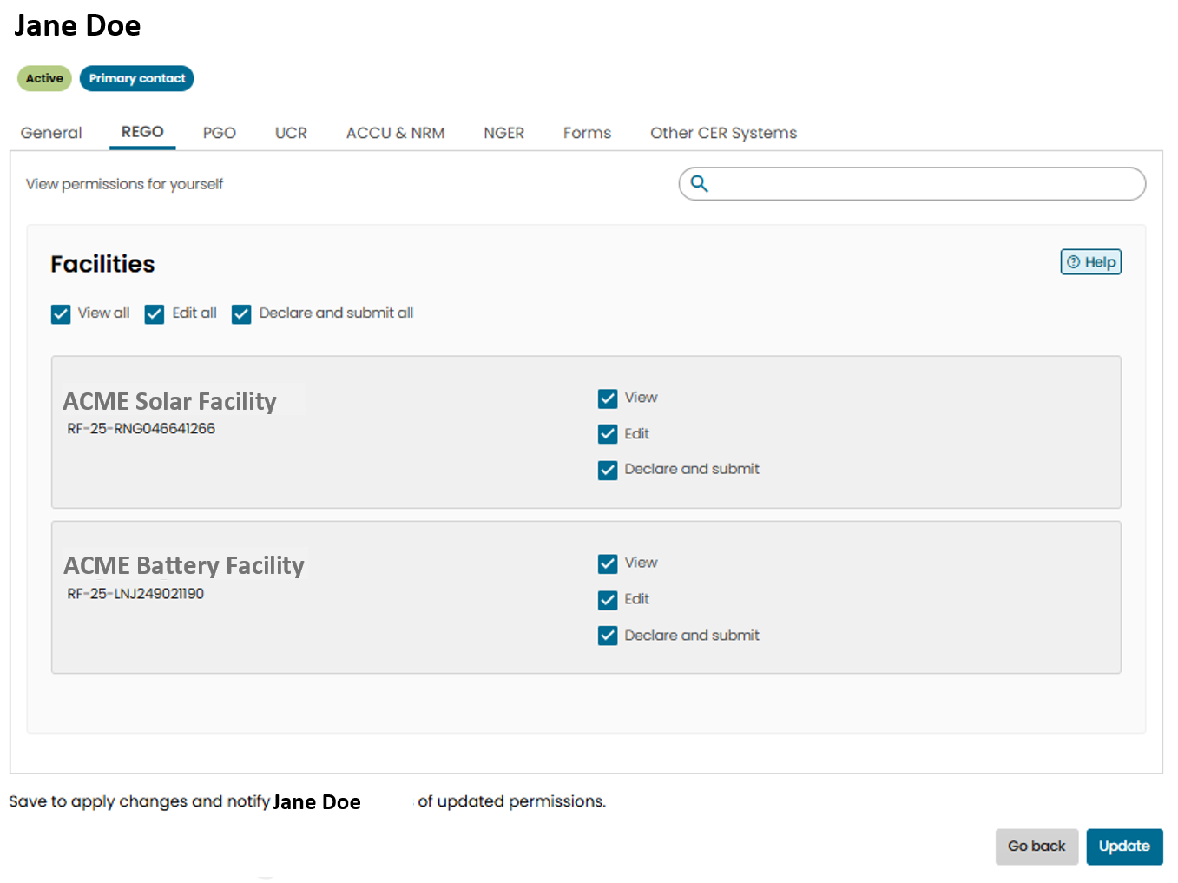
4c.
4b
4a.
You can choose to let the user view, edit or submit forms for all facilities within an organisation (4b), or only selected facilities (4c).

- To allow a user to create and register REGO certificates, you must also ensure they have permission to access the relevant Unit and Certificate Registry holding account. Edit these permissions in the UCR tab.
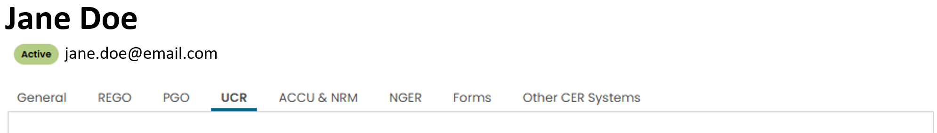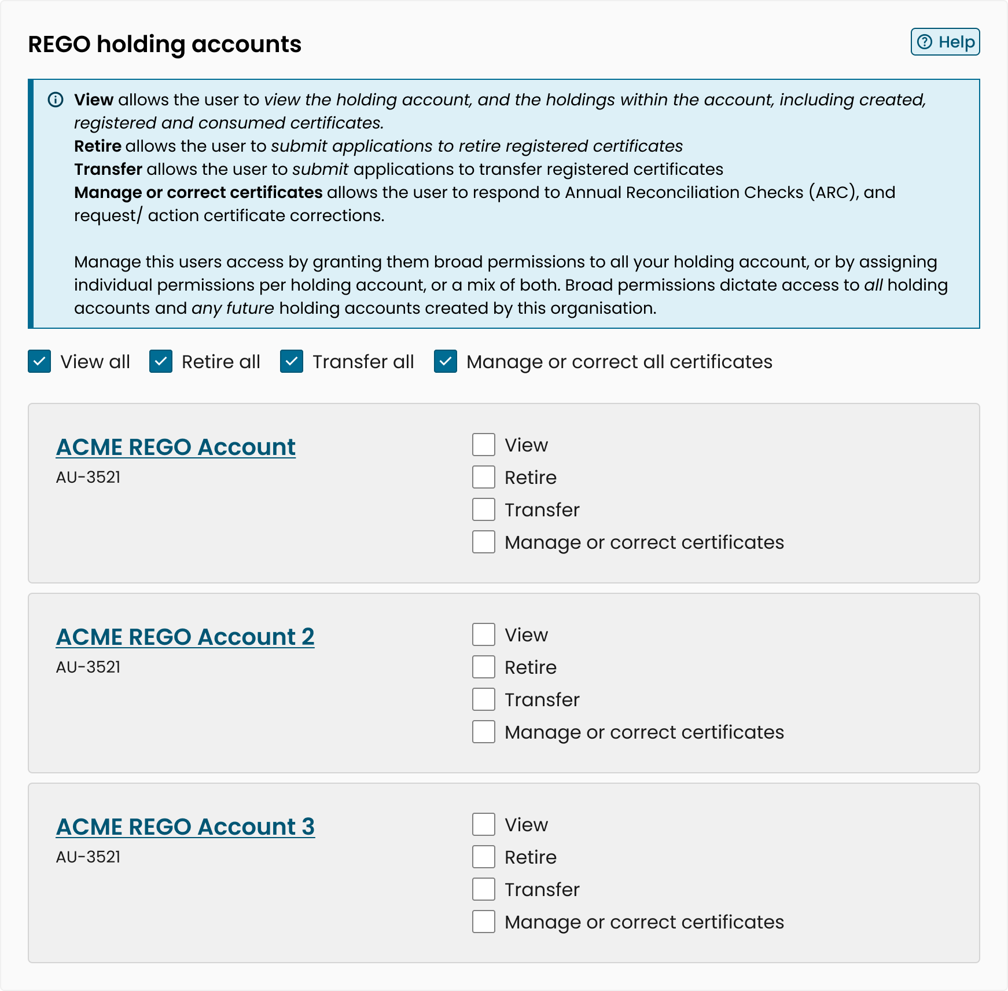
5
- You can also change the user’s relationship to the registered person account by choosing a different option from the drop-down menu (6a), when on the General tab.
Once you are happy with the checked permissions and relationship, click Update (6b).
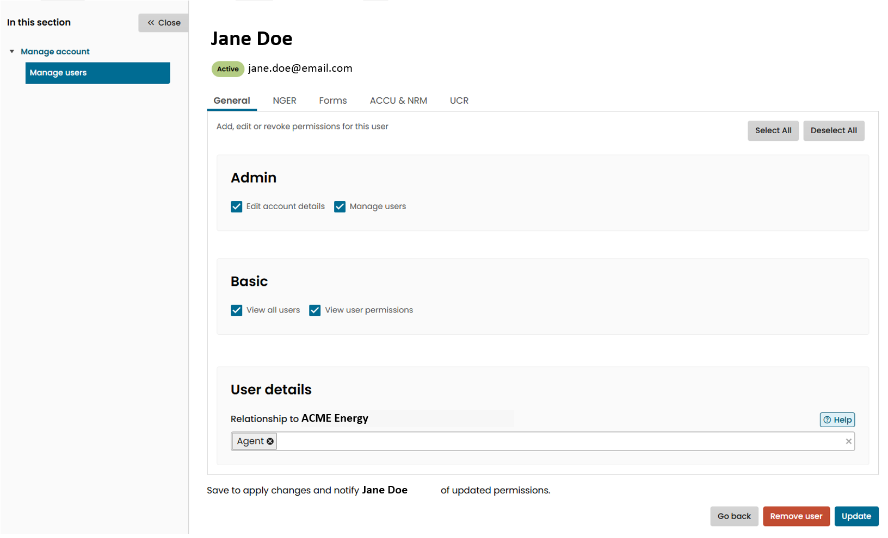
6b.
6a.

