Online Services user guide

Register a Renewable Electricity Guarantee of Origin (REGO) facility
V1 November 2025

Contents
Disclaimer 3
Description of the registration process 3
Stage 1: Create and configure a new facility 4
Stage 2: Complete a facility registration application for the new facility 13
System generated statuses: What do I do now? 20
System generated validation error messages: What does it mean? 21

Disclaimer
This user guide is intended to provide general information about the potential process for registering a renewable electricity facility under the Future Made in Australia (Guarantee of Origin) Act 2024 (GO Act) and the Future Made in Australia (Guarantee of Origin) Rules 2025 (GO Rules) may look like. Other subordinate legislation is still under development, and the process outlined in this user guide is subject to change once it’s finalised and passed into law.
To the extent permitted by law, neither the Clean Energy Regulator (CER) nor the Commonwealth of Australia accepts responsibility or liability for any direct, incidental or consequential loss or damage resulting from the use of this user guide.
The information presented in this user guide is not a substitute for legal, business or financial advice. Users should seek independent advice before taking any action or decision on the basis of the information provided in this document.
The CER and the Commonwealth of Australia may, at their discretion, vary or modify this user guide without notice.

Description of the registration process
Applying to register a renewable electricity facility under the Guarantee of Origin (GO) Scheme is a 2-stage process. The first stage is to create and configure your new facility in Online Services. This stage will guide you through a series of screens to help set up your facility and related registration application with the relevant sections needed to provide the required information.
Once you complete the facility set up wizard and submit, the system will create a record of your facility. When it is created you will be able to begin a new registration application for the facility. Once all required information is filled out, Online Services will perform checks for completeness and consistency before you are able to review the information and submit the application form.
When we receive the application, we will generate an invoice and send this to you. This invoice must be paid before we assess your application.
If we require further information or clarification we will send you a request for further information. As part of this we may request that you amend the application to resolve any inconsistencies or ambiguities. If you do not respond to a request for further information within the time period specified in the request, we may cease considering your application.
Once your application has been decided we will notify you of the outcome via email and reflect the outcome in online services. On a successful registration, details of the facility will be made publicly available on the GO register.

Stage 1: Create and configure a new facility
- Visit Online Services and click on the Renewable electricity facilities tile from the ‘Dashboard’. You can filter by scheme if needed.
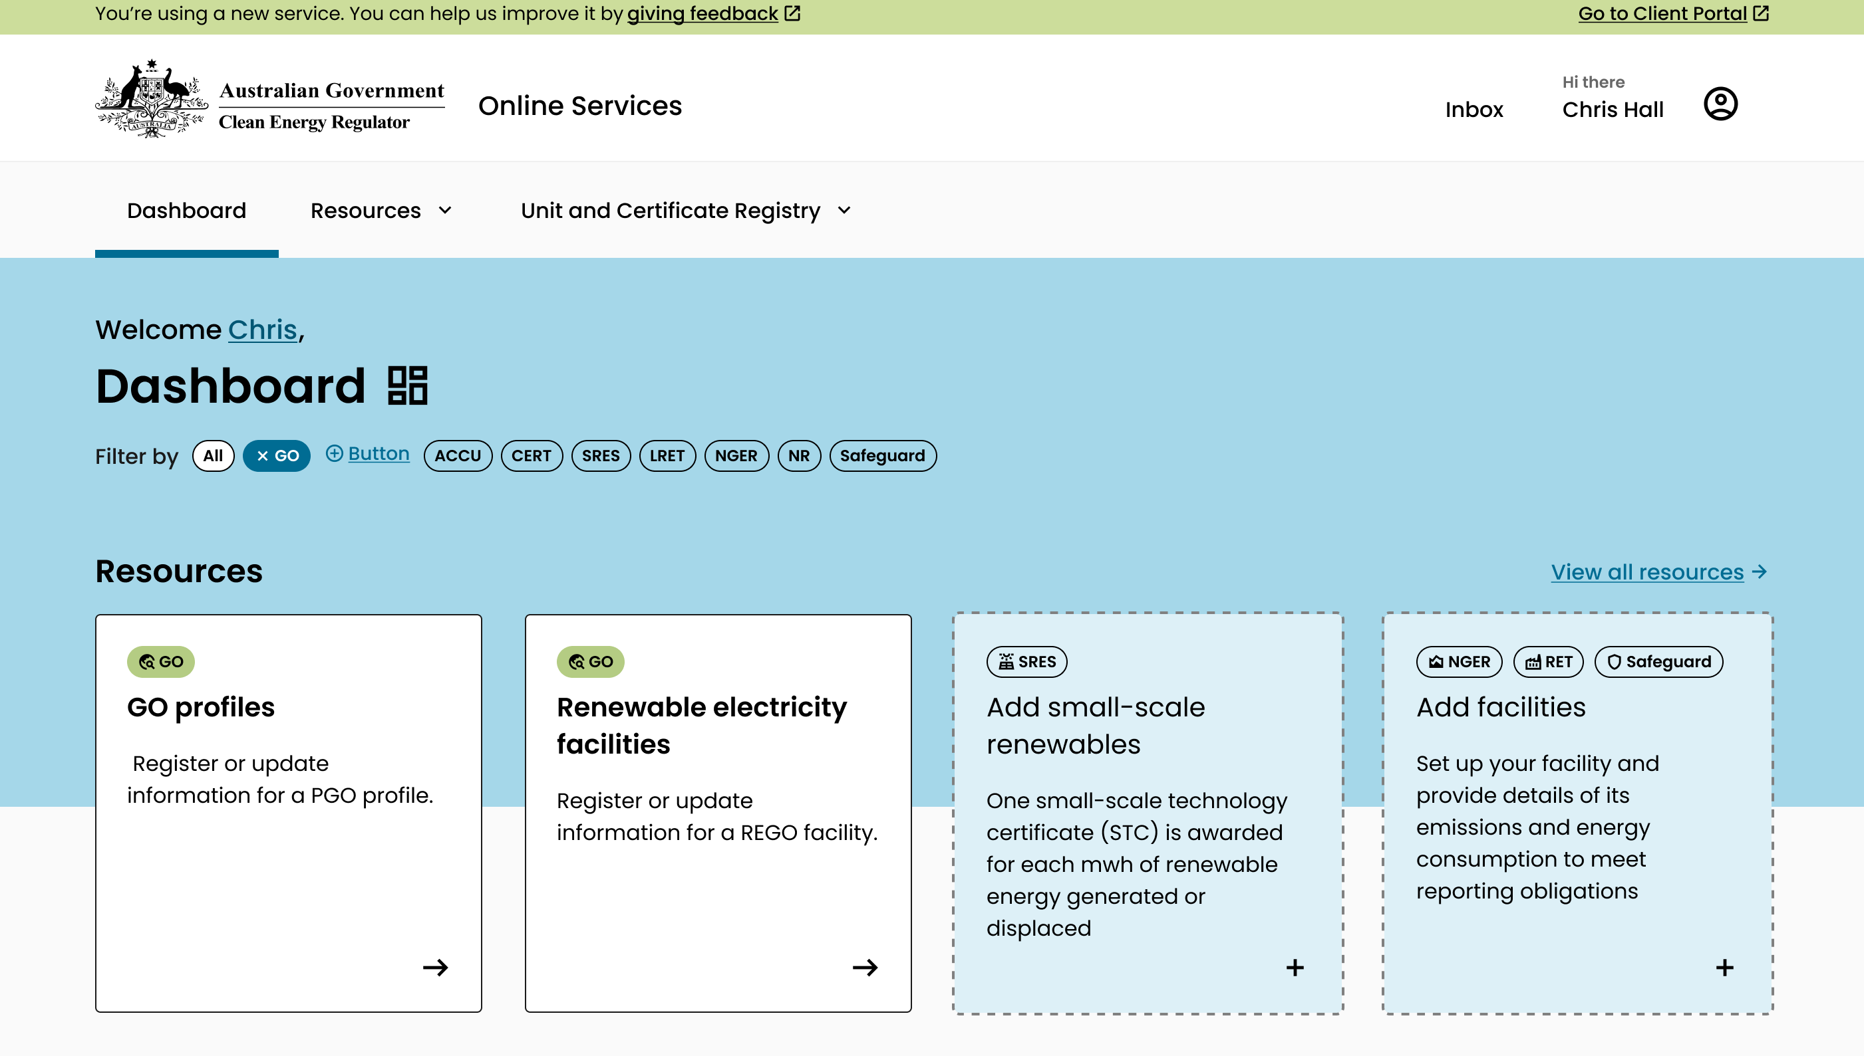
1a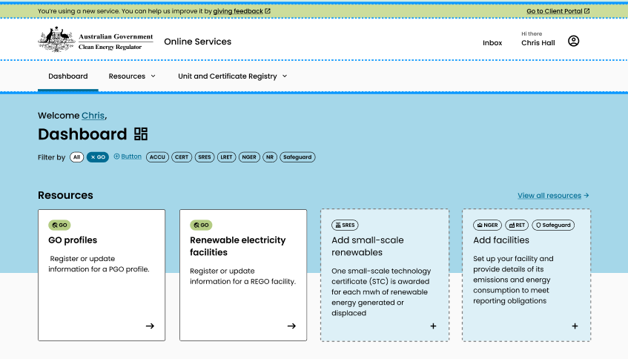.
Alternatively, you can click on the ‘Manage’ tab on the top ribbon and select ‘Renewable electricity facilities’:
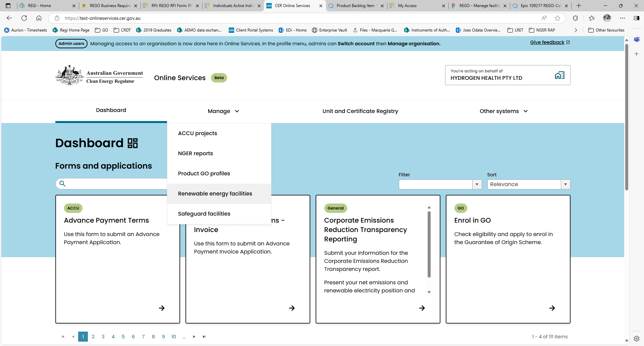
1b.
You may need to ‘switch account’ to ensure you’re acting on behalf of your registered organisation:
1c.

Enrol in GO first
You must first be a registered person in the GO Scheme to be able to view GO resources. Read our guidance on how to apply to become a registered person.

- Click on ‘Add a new facility’
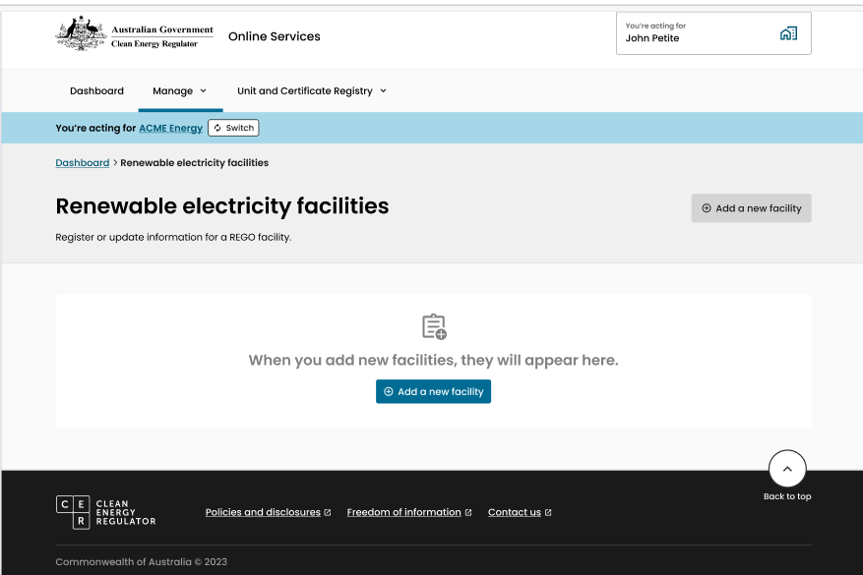
2

- Read the Before You Start screen carefully to ensure you have all the information you need to complete the registration of a new facility.
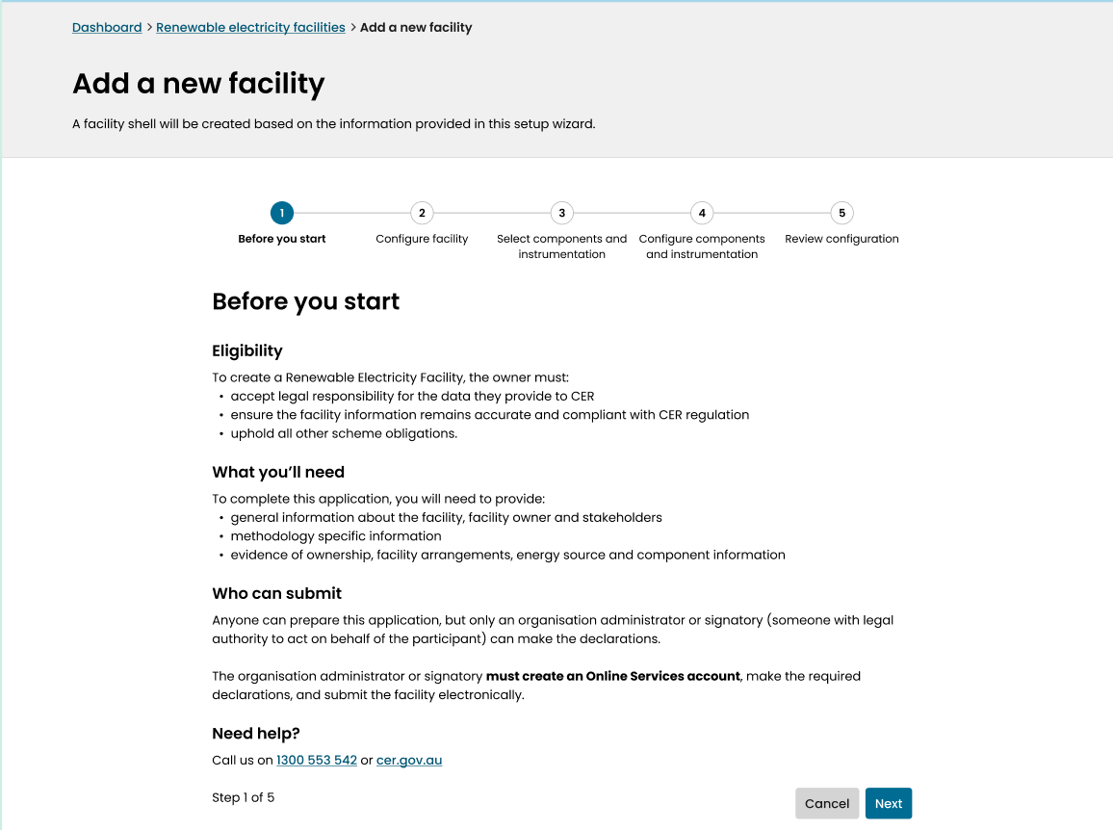
3

- Enter the name of your facility. If the facility is currently accredited under the Renewable Energy (Electricity) Act 2000 (REE Act) as a power station in the Large-scale Renewable Energy Target (LRET), use the same name that is recorded for the power station in the REC Registry.
- If creating a new facility that is not an accredited power station under the LRET, click on REGO facility under Type*.

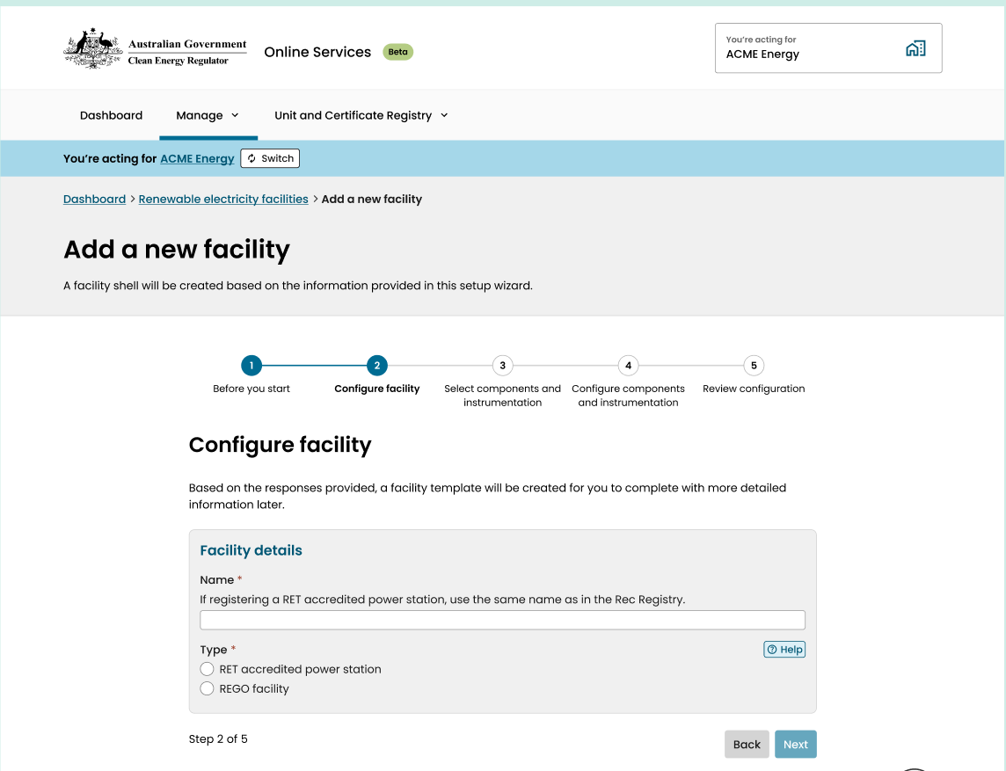
4
5

- For facilities that are not accredited under the RET, you must select the Method* that applies to the facility:
- Electricity generation – An electricity generation system that is not an accredited power station under the Renewable Energy (Electricity) Act 2000.
- Energy storage – A system by which electricity is converted to another form of energy and stored for a time before being converted back into electricity and dispatched to supply a load.
- Aggregate system – a system for generating or storing electricity that includes:
  - 2 or more electricity generation systems; or
  - 2 or more energy storage systems; or
  - at least one electricity generation system and at least one energy storage system.
Aggregated systems
While the GO Act makes provision for a group of systems to register as an aggregated system renewable electricity facility, aggregated systems will not able to register as a REGO facility until rules for aggregated systems are made in the GO Rules.

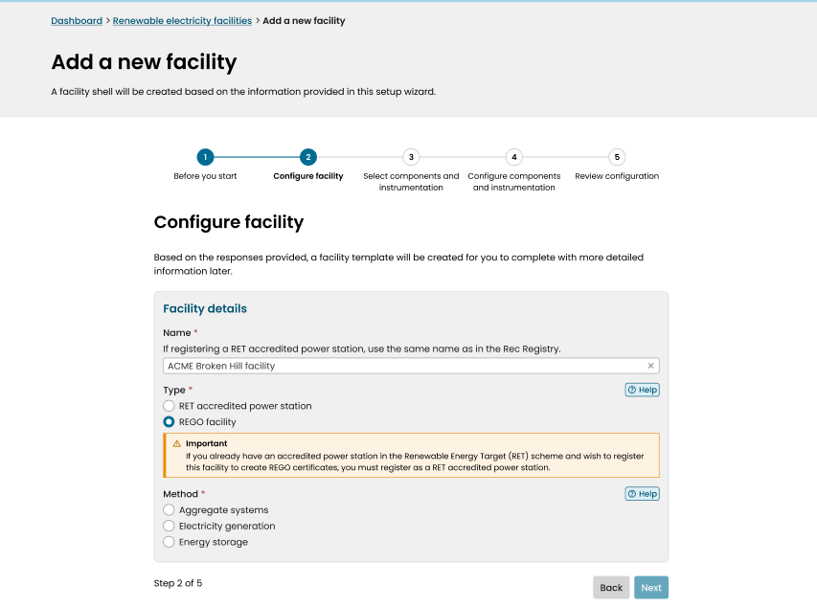
6
- If the RET accredited power station type or Electricity generation method is selected the portal will show a list of eligible energy sources. These are sources that generate eligible electricity for the creation of REGO certificates. At least one renewable energy source must be selected from the list.
- The portal will also show a list of ineligible energy sources. These are sources that generate electricity that is not eligible for the creation of REGO certificates. If the facility consumes any of these energy sources as part of the electricity generation process or in the operation of the generation facility you must select all that apply here.
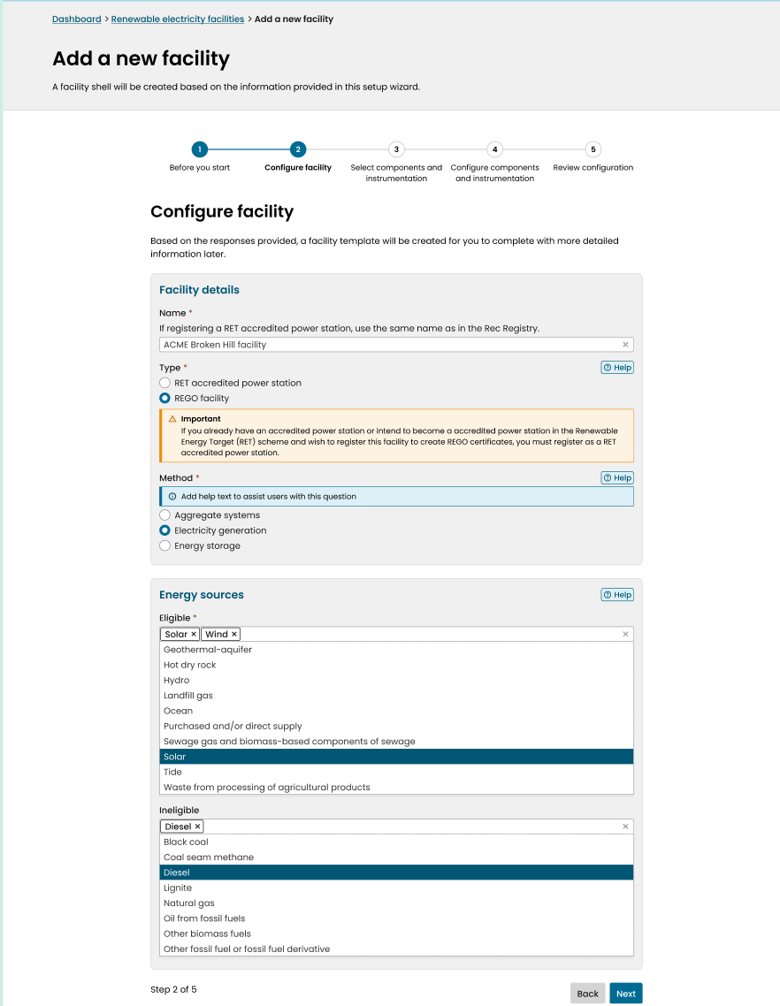
7
8
- If the Energy storage method is selected the portal will show a list of energy storage technologies. These are the storage technologies that a facility uses to store and dispatch eligible electricity for the creation of REGO certificates. The technology selected will determine which methodology will apply when calculating an eligible amount of electricity.
Only one storage technology may be selected per facility.
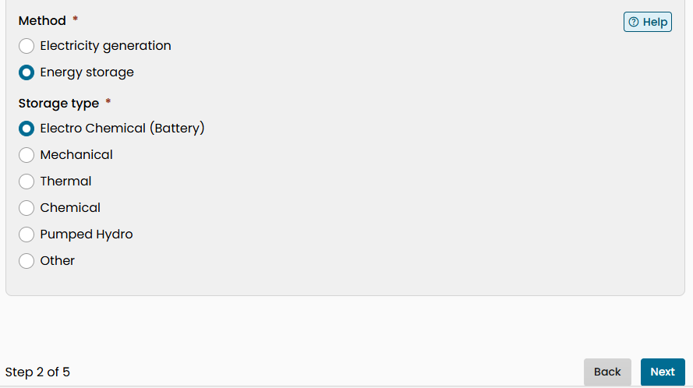
9
10

- Once energy sources or storage technologies are provided, continue to the following page to specify the components and instrumentation that make up the facility.
Application requirements for accredited power stations
RET-accredited power stations are not required to provide component and instrumentation details and can proceed to the review page at step 15.

- Select all components (11a) and instrumentation (11b) that is used to generate and measure electricity at the facility.
  - Some components will be mandatory based on the energy sources selected while others may be optionally added. You must include all applicable components.
  - If you make a mistake here, you will be able to add components to your application later.
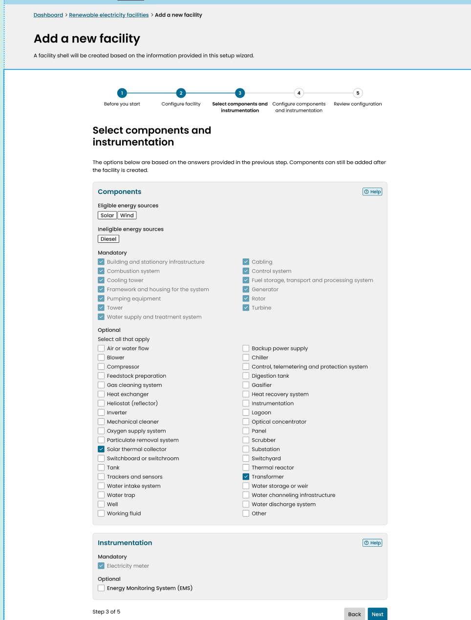
11b.
121..
11a.

- Once all required component types are selected, proceed to the next step.
- Configure the number of different kinds of each type of component that are included in the facility. If more than one kind exists, you will be asked to provide a reference name to distinguish between the two.
Configuring components
If a facility has 2 or more different kinds of the same component, you will need to specify each different kind individually. For example, if the facility uses a combination of different brands or sizes of solar photovoltaic panels.

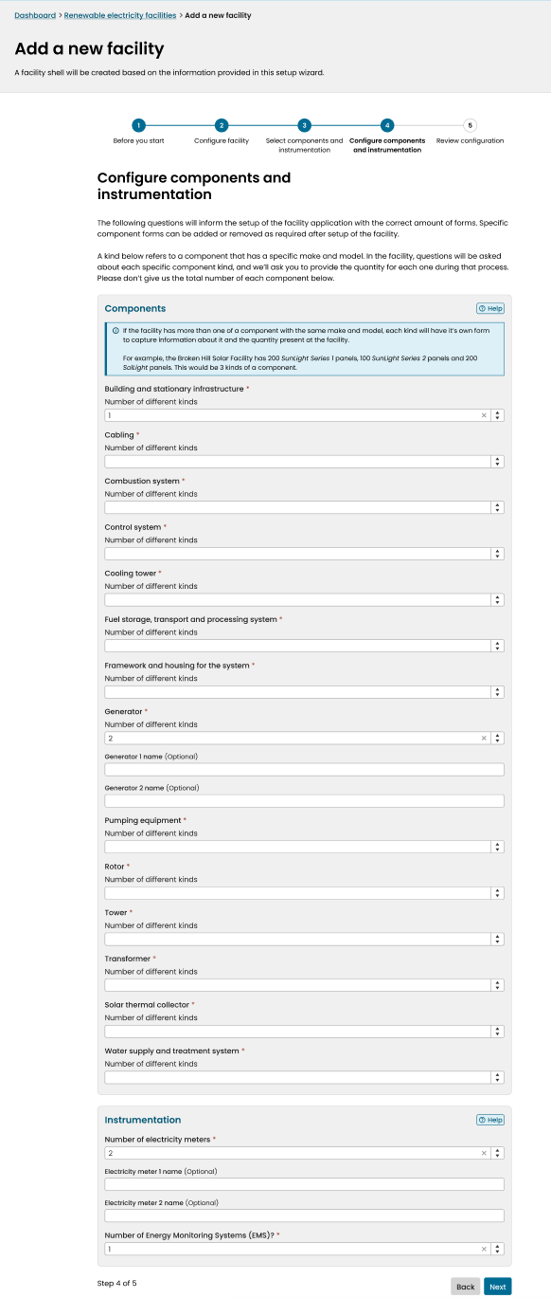
13.

- After adding the configuration details for all components and instrumentation, proceed to the next page to review the facility set up.
14

- The review page will display:
  - All the responses provided in the set-up wizard
  - An overview of the facility you are about to create
  - The sections of the registration application you will be required to complete in the next stage of the process.
Review carefully
You should review the facility details carefully before proceeding to the next step. Some information such as type and method cannot be changed after the facility has been created.

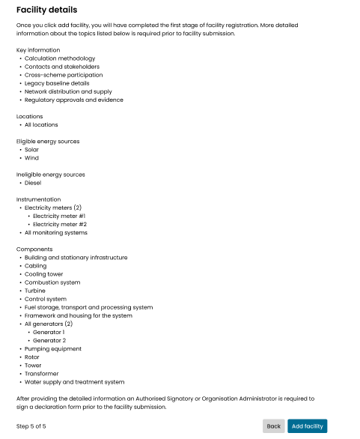
16
15
- When you click on Add facility, you have completed the basic set up for your facility registration application by creating a ‘facility shell’. However, you will now need create a new application for your facility, fill out the details of each section, and submit your application to the Clean Energy Regulator in stage 2 of the process.
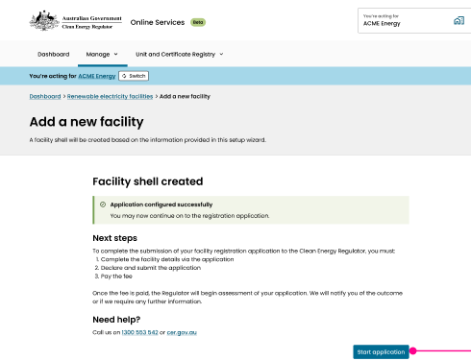
End of Stage 1
Start Stage 2

Stage 2: Complete a facility registration application for the new facility
- From the submission page in the previous stage you can click ‘start application’ to begin filling out your new facility registration application.
Alternatively, now that the facility is set up, it will be visible on the Renewable electricity facilities page in online services so you can come back later to start the application.
- On the Application details page, each section that requires filling will be marked as incomplete. Click on the ‘Edit’ button adjacent to open each Incomplete section and provide the required information.
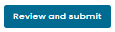
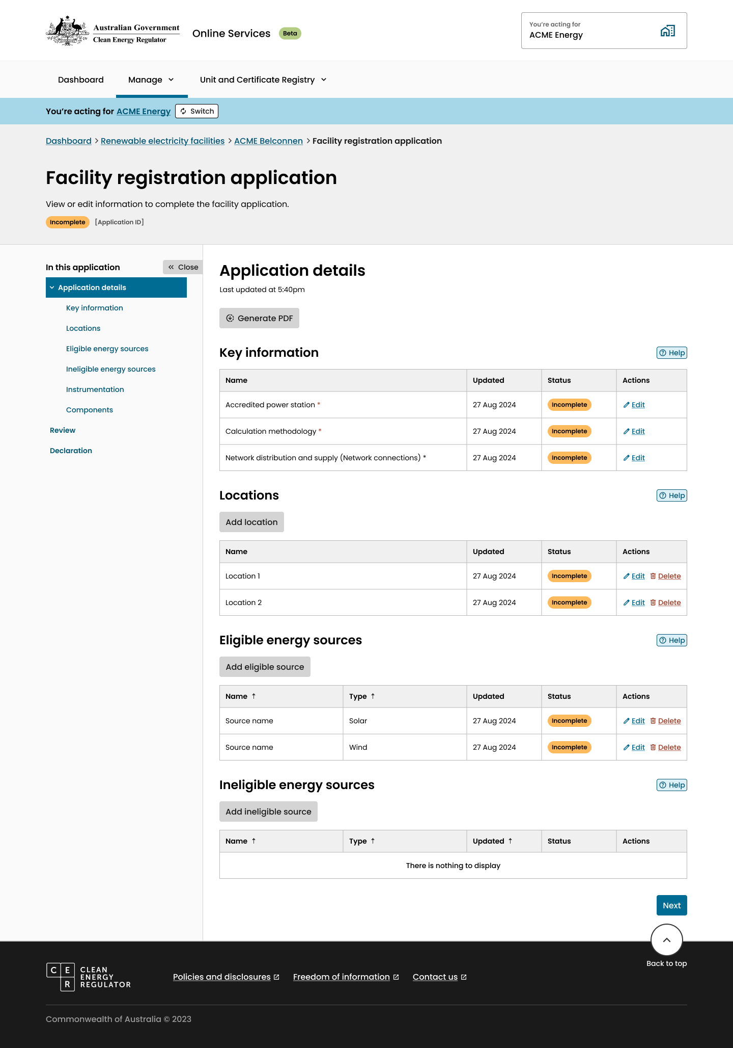
2
Optional details for accredited power stations
For RET accredited power stations, some questions in the application are optional where this information may already be recorded in the REC Registry.
You may choose not to provide this information with your REGO application, however, we may send a request for further information or require you to update the information after registration if we are unable to confirm these details using existing REC Registry data.

- Once a section has been completed it will be marked as ‘Ready for review’ on the application details page.
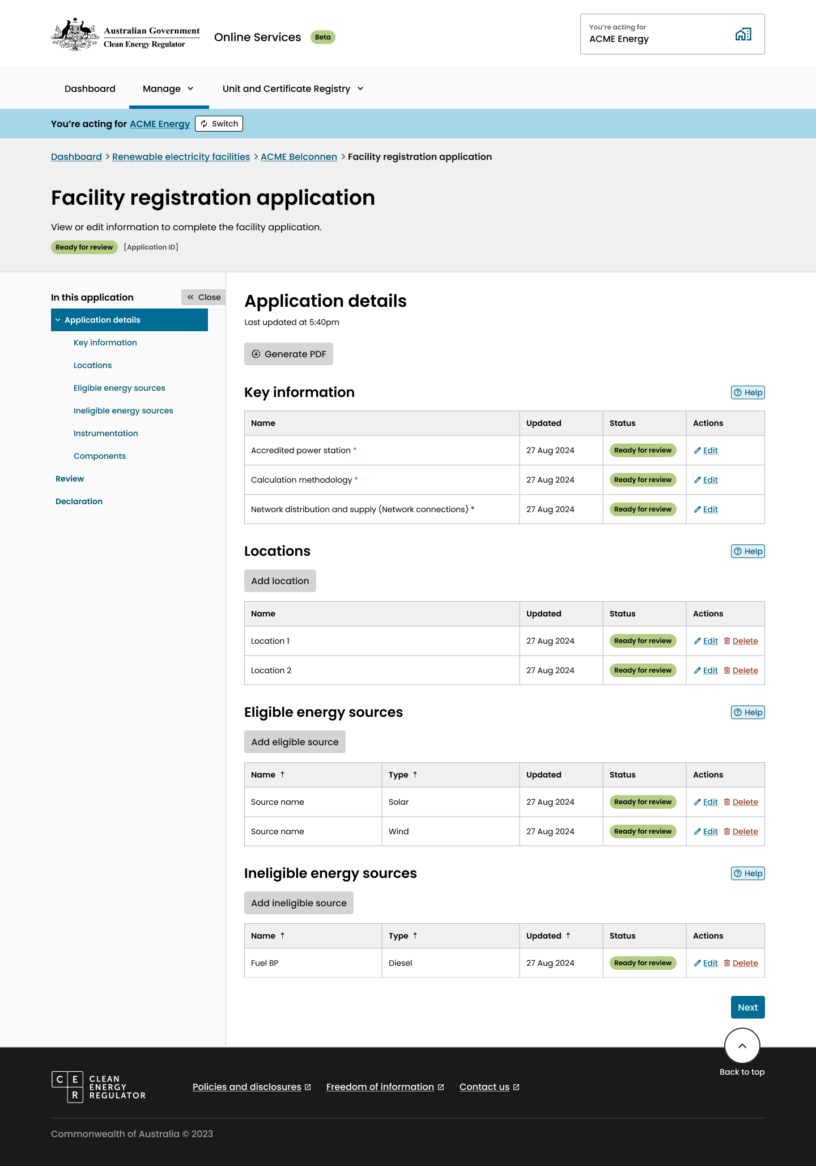
3

- For some categories of information, you can add a new section to the application and include a reference name for it. This is helpful if you forgot to include it in the facility set up wizard.
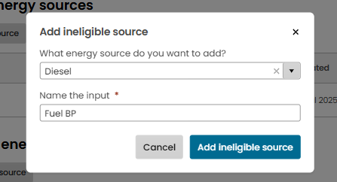
4b
4a

Order of filling out facility application:
There are certain questions in some sections of the application that refer to information provided in other sections, so you need to complete some sections before others. For example, in the stakeholders section you are asked to tell us, for each stakeholder, all of the components they either own or operate (in part or in full). This means that to complete the stakeholder section you first need to make sure all components have been added, as you are not able to add a component to a stakeholder’s owner/operator list if it does not already exist in the application.
Below is a recommended order of filling the application to ensure you can select the correct information when filling each section.
  - Selected sections in the key information part of the application:
    - Accredited power station (not applicable to other REGO facilities)
    - Network distribution and supply (network connections)
    - Cross-scheme participation
    - Legacy baseline details (not applicable to RET accredited power stations)
    - Regulatory approvals and evidence (not applicable to RET accredited power stations)
  - Locations
  - Energy sources / Energy storage
  - Electricity meters / Monitoring systems (Instrumentation) – not applicable to RET accredited power stations
In these sections you are asked to indicate the energy source or energy storage system that these devices provide measurements for or in relation to. You should make sure all energy sources are added before completing these sections.
  - Components – not applicable to RET accredited power stations
In this section you are asked to provide, for each component, the energy source or energy storage system that the component services or is used in relation to. You should make sure all energy sources are added before completing these sections.
  - Contact and Stakeholders
In this section you are asked to provide, for each stakeholder, a list of the facility components they either own or operate (in part or in full). You should make sure all components are added before completing this section.
  - Calculation methodology
In this section you are asked to provide, for each term in the eligible amount formula, a reference to an electricity meter or monitoring system used to provide measurement data for that term, or the component that a specific auxiliary use measurement relates to. You should make sure all electricity meters, monitoring systems and components are added before completing this section.

- When all items are ‘Ready for review’ you are ready to proceed to the review page by clicking on the ‘Review and submit’ button at the bottom of the page.

5
- When you go to the review page the application will perform some additional validation checks to ensure that information provided is consistent across sections. If an inconsistency is found it will be flagged as an error requiring your attention. Click the link in the error message to go to the relevant section to fix the error.

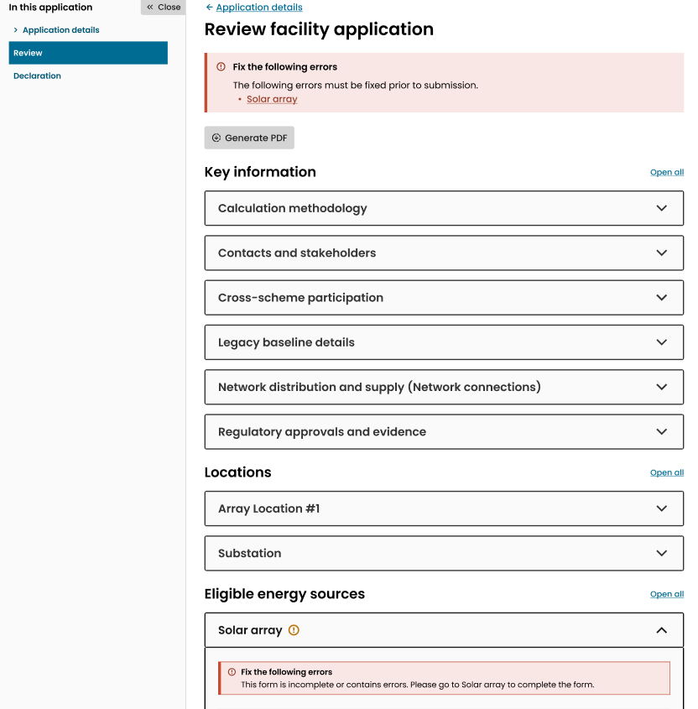
7
8
6
6

Fix all errors to continue
You will not be able to submit the application unless all errors flagged in red are fixed.
- On the review page you can generate a pdf of your application with all the responses you’ve provided. Note that this will exclude the declaration information provided on the declaration page at step 9. You will be able to generate the pdf again on the declaration page to include this information.
- When there are no errors flagged you are ready to proceed to the declaration page by clicking the ‘next button’ at the bottom of the page.
- On the declaration page you will be prompted to confirm if any suitability events have occurred in relation to the applicant (9a) and, if so, provide details (9b). This is a requirement of all facility applications.
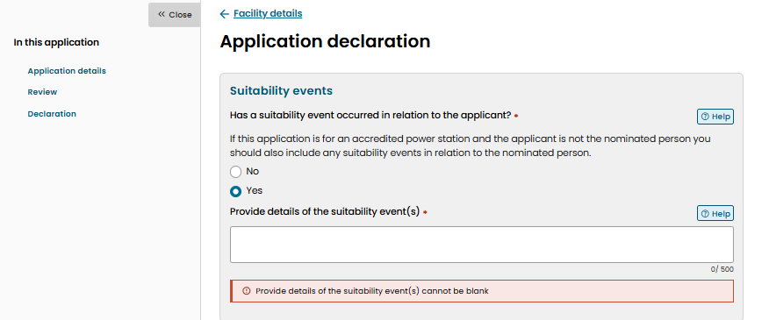
9a
9b
Reporting suitability events for accredited power stations
If you are applying to register a RET accredited power station and are not the nominated person for the power station under the RET, you must also include any suitability events that have occurred in relation to the nominated person.

- Read all the information in the declaration and tick the checkbox (9a) to make a declaration. Click submit (9b) to complete the facility registration application. You may generate a pdf to include Note, you will not be able to click ‘submit’ if the declaration checkbox is unticked.
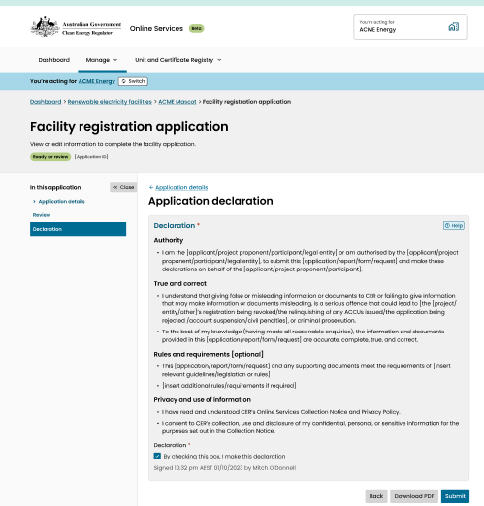
10a
10b

Permission to submit an application
You must have the correct permission from your organisation administrator to be able to make the declaration and submit an application. Check with your organisation administrator if you are unsure.
- If your application has been submitted successfully you will be taken to the submission confirmation page. You will be required to make a payment for your application before it can be processed. Read the next steps carefully for details on how to make payment.
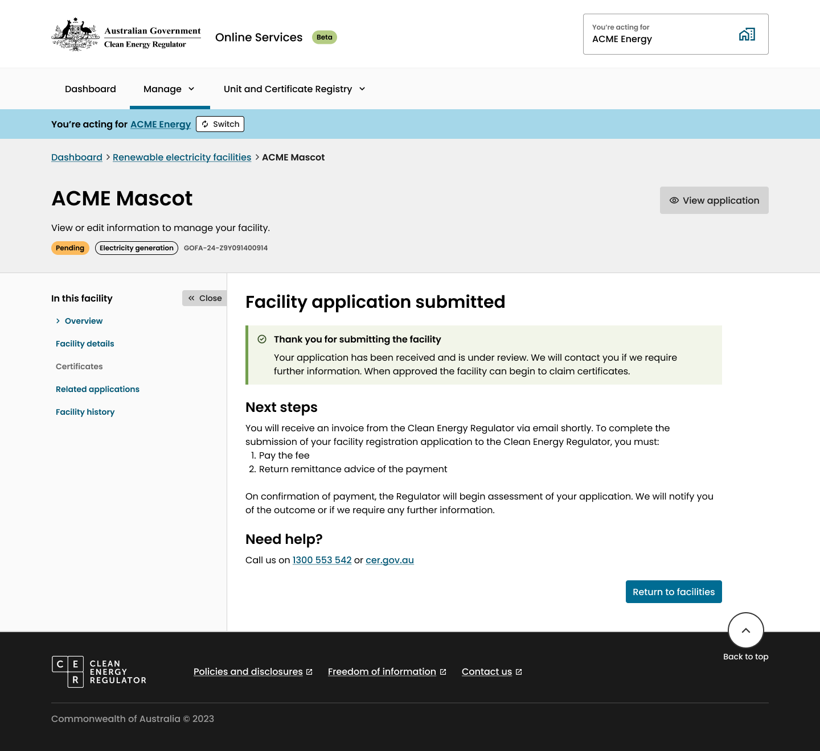
11

- If you do not have the required permission to submit the application, you will be shown a warning message and will not be able to submit the application.
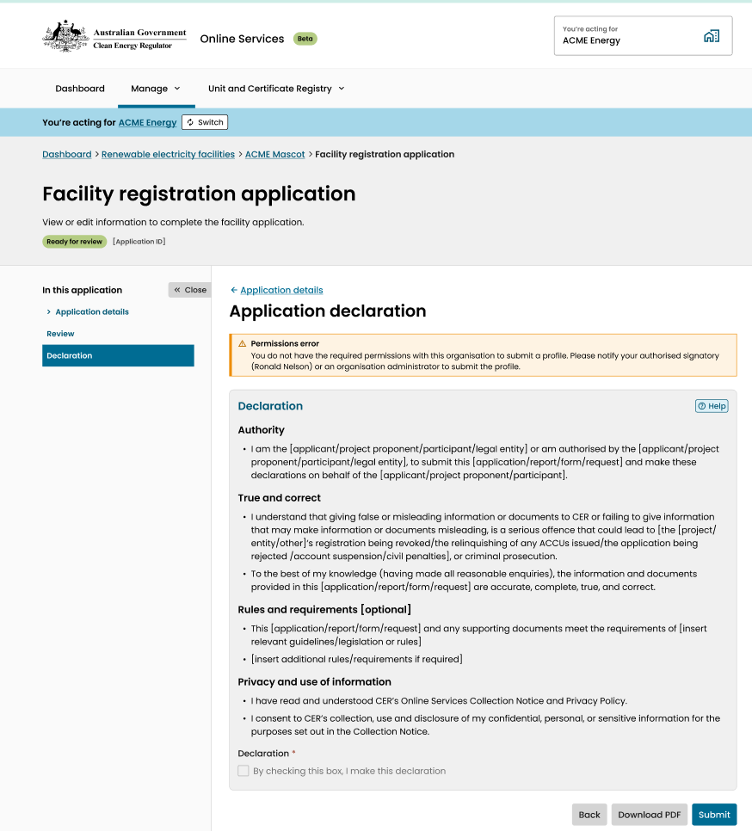
12
- If the application submission fails, it could be due to an Online Services system error or an update that is taking place in the background which requires a few minutes to complete. If this happens you will be taken to the submission failure page. Your submission will be saved in a draft state, and you will be able to try again.
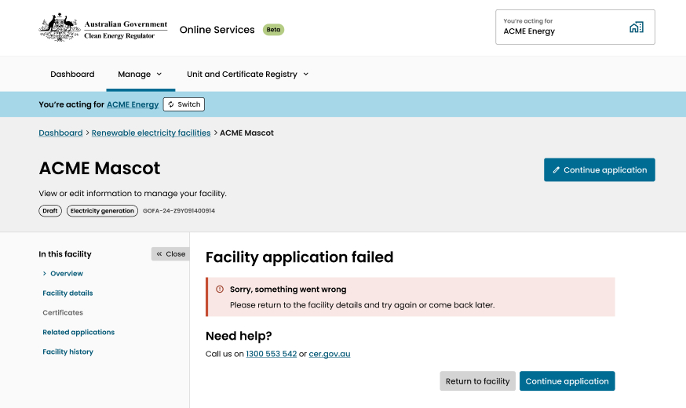
13
- Contact the Clean Energy Regulator if the problem persists.

System generated statuses: What do I do now?
Application task | Message | Action | Next steps
Renewable electricity facilities: registration application | Facility Status Field: Pending | Pay the registration application fee via the Pay Now button | Once CER has received the payment, the application assessment will begin.
Renewable electricity facilities: application unlocked | New line added under the facility profile and is marked as Active. | Click on the hyperlink, and complete the details requested by the CER to progress the application. | Upload the information and supporting documents requested by the CER in the upload link provided.
Renewable electricity facilities: registration application | Facility Status Field: Rejected | Click on the View button | A reason for ‘rejection’ will be provided in a notice/email providing you with information and next steps available to you.
Renewable electricity facilities: application cease to consider | New line added under the facility profile and is marked as Cease to Consider. | The decision to cease to consider is only taken when the Registered Person has failed to provide further information by a response due date contained in the RFI correspondence. | Check the reason in the cease to consider correspondence/RFI and ensure you have this information prior to submitting a new application.

System generated validation error messages: What does it mean?
Validation error message | Why am I seeing this? | How do I fix this?
More information required:  The information about ineligible energy sources in the Calculation Methodology form does not match the information provided in the Energy Source details. Any ineligible energy sources must be included in the Calculation Methodology and in an Energy source form. | You have responded 'Yes' to the question of 'Does this facility use any ineligible energy sources?' in the Calculation Methodology details but have not included an ineligible energy source in the application details.  OR  You have responded 'No' to the question of 'Does this facility use any ineligible energy sources?' in the Calculation Methodology details but have included an ineligible energy source in the application details. | Either add the ineligible energy source if it is supposed to be included in the facility or update the Calculation Methodology details to reflect that there are no ineligible energy sources.
More information required:  There is no measurement device declared for the energy source of _____. | You have not included a meter or monitoring system to measure electricity flows related to the energy source or energy storage stated in the message. | Check that all relevant meters and monitoring systems are included in the application and add any that are missing, then specify the correct energy source or storage system in the metering or monitoring system details.
More information required:  There is missing mandatory components for the energy source ___. Further details are required on _____(component). | You have included an energy source that requires a specific component to be included in the application but have not listed that energy source against the component. | Update the component details to state that it services the correct energy source(s).
More information required:  The first-generation date in the Network Distribution and Supply form does not match with the answers provided in the RET Accredited Power Station form. Update the information to be consistent across forms. | All accredited power stations that generated electricity before 1997 are given a non-zero baseline by the Clean Energy Regulator.  You have provided baseline information in the Accredited power station details and not provided a first-generation date prior to 1997 in the Network Distribution and Supply details  OR  You have included a pre-1997 first generation date here but have not provided any baseline details. | Update either the RET accredited power station details or the Network Distribution and Supply details so that they match.  A pre-1997 first generation date must have a corresponding baseline value. A post-1997 first generation date must have no corresponding baseline value.
More information required:  The related energy source selected in the Electricity meter form no longer exists. At least one energy source must be selected to complete this form. | You have removed an energy source that was included in the Electricity Meter details. | Either update the Electricity Meter details to include the correct energy source, remove the electricity meter if it is not part of the facility, or add the energy source if it should be included and then update the Electricity Meter details to include the new energy source.
More information required:  The first-generation date in the Network Distribution and Supply form does not match with the answers provided in the Legacy Baseline form. Update the information about date of first generation to be consistent across forms. | You have indicated that components of the facility generated or contributed to generation of electricity before 1997 in the Legacy Baseline form and not provided a first-generation date prior to 1997 in the Network Distribution and Supply details  OR  You have included a pre-1997 first generation date here but have indicated facility components did not generate or contribute to generation before 1997. | Update either the Legacy baseline details or the Network Distribution and Supply details so that the dates match.  A pre-1997 first generation date must be accompanied by details to determine a Legacy baseline. An application with a post-1997 first generation date must not include corresponding Legacy baseline details.
More information required:  The number of Connection Points with applicable Marginal Loss Factors in the Network Distribution and Supply form exceeds the number of DLEG measurements in the Calculation Methodology form. Provide at least one DLEG meter for each applicable MLF. | You have not provided at least one DLEG measurement in the Calculation Methodology details for each Connection Point that has an applicable Marginal Loss Factor included in the Network Distribution and Supply details. | Update either the Calculation Methodology details to add any missing DLEG measurements or the Network Distribution and Supply form to include the correct connection point and MLF information.
More information required:  The component _____ does not have an owner or operator. Further details are required regarding the ownership or operational control of this component. | You have included a Component in the application details but have not indicated an owner or operator of that component in the Stakeholder and Contact details. | Update the Stakeholder and Contact details to state who the owner or operator of the component is.
More information required:  The related component selected in the registered person role section no longer exists. At least one valid component must be selected to complete this form. | You have removed a component from the facility that was included in the list of components you own or operate. | Update the Stakeholder and Contact details to remove the component from the list.
More information required:  The related component selected in the stakeholder information section no longer exists. At least one valid component must be selected to complete this form. | You have removed a component from the facility that was included in the list of components a stakeholder operates or owns. | Update the Stakeholder and Contact details to remove the component from the list.
More information required:  The related energy source selected in the Monitoring System form no longer exists. At least one energy source must be selected to complete this form. | You have removed an energy source that was included in the Monitoring System details. | Either update the Monitoring System details to include the correct energy source, remove the electricity meter if it is not part of the facility, or add the energy source if it should be included and then update the Monitoring System details to include the new energy source.
More information required:  The related energy source selected in the component form no longer exists. At least one energy source or storage system must be selected to complete this form. | You have removed an energy source that was included in the Component details. | Either update the Component details to include the correct energy source, remove the component if it is not part of the facility, or add the energy source if it should be included and then update the Component details to include the new energy source.
More information required:  The information in the Energy Storage form does not match the information in the Calculation Methodology form. Provide direct supply information in both forms or in neither. | You have selected the ‘Direct supply’ option for an Electricity input the Calculation Methodology details and have not provided direct supply information in the Energy Storage details  OR  You have indicated in the Energy Storage details that there is a direct supply relationship with a generator but have not provided a ‘Direct supply’ measurement for this electricity input in the Calculation Methodology form. | Update either the Calculation Methodology details, or the Energy Storage details so that both sections include direct supply information or neither do.
More information required:  The location of this facility does not match the electricity network connection. | You have provided a location in a State or Territory that does not match the selected network in the Network Distribution and Supply details. | Update either the Location details or Network Distribution and Supply details so that the location matches the selected network.
More information required:  A multi-channel meter has been selected for measurement. Further details on the channel number are required. | You have selected a multi-channel meter for a measurement in the Calculation Methodology details and have not provided the channel number that the measurement is read from. | If the selected meter is correct, add the channel number for that specific measurement reading to the Calculation Methodology details.
More information required:  The connection type selected in the Network Distribution and Supply form does not match the information provided in the Calculation Methodology form. Provide direct supply details in both forms or in neither. | You have responded ‘No’ to the question of ‘Does this facility provide 'direct supply' electricity to a registered storage facility?’ in the Calculation Methodology details but have selected the ‘Direct Supply / Internal Use’ option in the Network Distribution and Supply details.  OR  You have responded ‘Yes’ to the question of ‘Does this facility provide 'direct supply' electricity to a registered storage facility?’ in the Calculation Methodology details but have not selected the ‘Direct Supply / Internal Use’ option in the Network Distribution and Supply details. | Update either the Network Distribution and Supply details or the Calculation Methodology details so that both sections include direct supply information or neither do.
More information required:  The meter channel number in the Calculation methodology form is larger than the total number of channels indicated in electricity meter form for the selected meter. Please update with the correct information. | You have included a channel number for a meter measurement in the Calculation Methodology details but the Electricity Meter details for the selected meter indicate fewer channels than the number provided. | Check that the electricity meter details are correct and, if so, update the Calculation Methodology details with the correct channel number for this measurement.
More information required:  A single channel meter has been selected for measurement. Channel number must be 1 or left blank. | You have included a channel number greater than 1 for a meter measurement in the Calculation Methodology details but the Electricity Meter details for the selected meter indicate that it is a single channel meter. | Check that the electricity meter details are correct and, if so, update the Calculation Methodology details with the correct channel number for this measurement.

https://www.legislation.gov.au/C2024A00121
https://www.legislation.gov.au/F2025L01281
https://cer.gov.au/schemes/guarantee-origin-scheme/renewable-electricity-guarantee-origin/how-to-participate-rego#steps-to-participate

