
Online Services user guide
Create REGO certificates
V1 January 2026

Contents
Disclaimer 2
Description of the certificate registration process 3
How to create REGO certificates 3
Filling out templates 13
Eligibility calculation 13
Certificate 14
Below-baseline certificate 14
Residuals and below-baseline residuals 15
System generated messages: What do I do now? 16

Version history
Version | Change description | Date published
V1 | First publication | 12/01/2026

Disclaimer
This user guide is intended to provide general information about what the process for registering a Renewable Electricity Guarantee of Origin (REGO) certificate under the Future Made in Australia (Guarantee of Origin) Act 2024 (GO Act) may look like. The Future Made in Australia (Guarantee of Origin) Rules (the Rules) and other subordinate legislation are subject to change, and the process outlined in this user guide is subject to change as systems are updated.
To the extent permitted by law, neither the Clean Energy Regulator nor the Commonwealth of Australia accepts responsibility or liability for any direct, incidental or consequential loss or damage resulting from the use of this user guide.
The information presented in this user guide is not a substitute for legal, business or financial advice. Users should seek independent advice before taking any action or decision on the basis of the information provided in this document.
The Clean Energy Regulator and the Commonwealth of Australia may, at their discretion, vary or modify this user guide without notice.

Description of the certificate registration process
If you’re a registered person under the GO Act and have registered a renewable electricity facility, you can create and apply to register REGO certificates in Online Services.
To do so, you will enter the calculated eligibility for your facility into an excel template provided in Online Services. This template will be tailored to the specific facility. You will also use the template to specify any eligible electricity allocated to other certification schemes and the number of REGO certificates to create and submit for the registration application.
Once filled in, you can upload one or more templates into Online Services to claim your certificates.
When we receive the claim, we will generate an invoice and send this to you. This invoice must be paid before we assess your certificates.
If we require further information or clarification we will send you a request for further information. If you do not respond to a request for further information within the time period specified in the request, we may cease considering your certificates and they won’t be registered. Another application (including the fee payment) would need to be made to register the certificates.
Once your certificates have been approved, Online Services will reflect this outcome. On a successful registration, details of the certificates will be made publicly available on the GO Register and the certificates can then be transferred or retired.

How to create REGO certificates
- Go to Online Services and sign in as a user in the eligible registered person account. To create REGO certificates, click on the Renewable electricity facilities button.
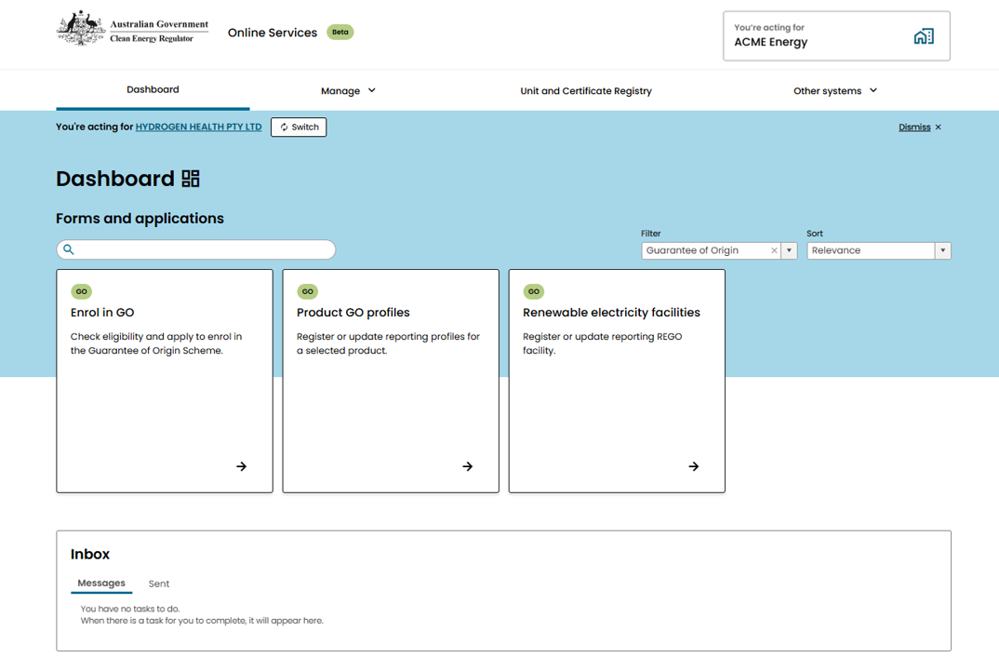
1.

- For the facilities you are creating certificates for, click Download template.
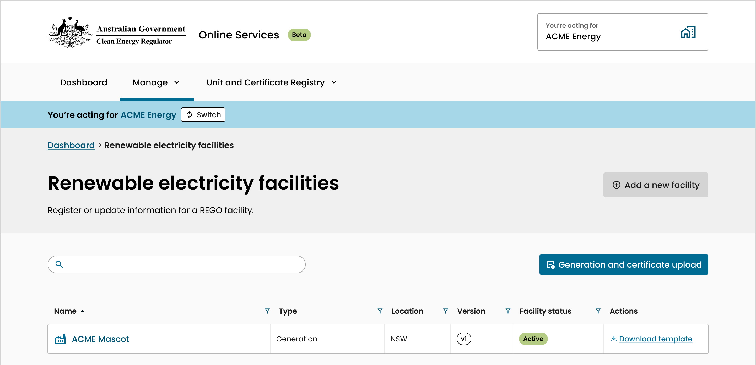
2.
- Select the claim period that you want to create and register REGO certificates for and click Download. This will download a certificate data template in the form of an excel spreadsheet.
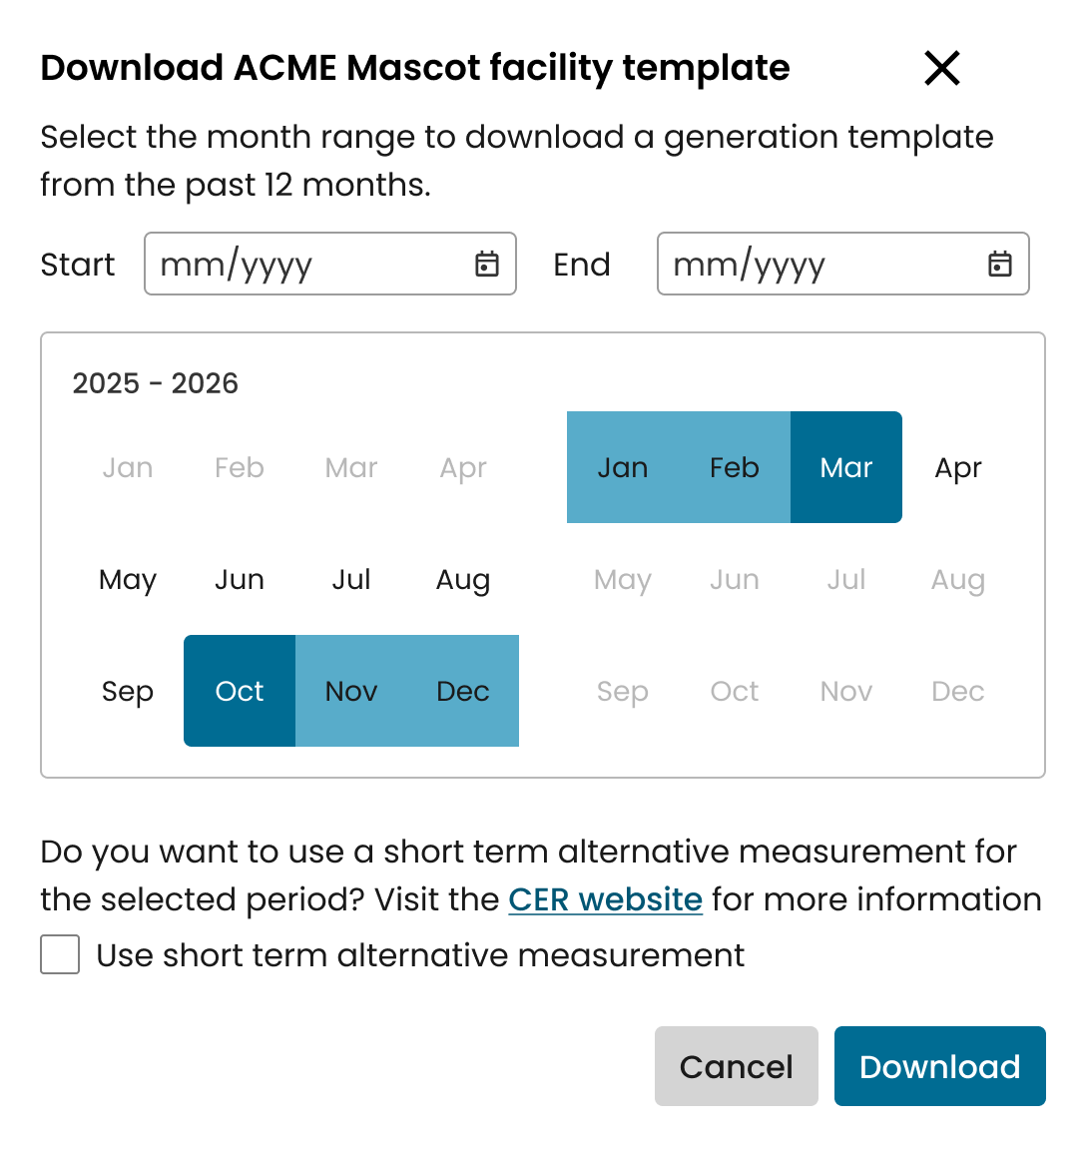
3.

- Fill out the templates you downloaded in step 3. You will have to download and fill out a different template for each facility, but each template can be used to claim multiple months at a time, unless your facility has nominated to create yearly certificates. Once filled, you will upload this to Online Services in the next steps.
For details on how to fill out the templates, see the section on Filling out templates on page 13.
Make sure you save your template as an .xls or .xlsx file before you upload it.

- In Online Services, on the Renewable electricity facilities page from step 2, click Generation and certificate upload. This will take you to the REGO generation and certificate upload form.
5.
- On the Generation information page, upload the generation data templates that you filled out in step 4. You can upload the templates for each facility here (6a). You must wait until all files have completed uploading (6b).
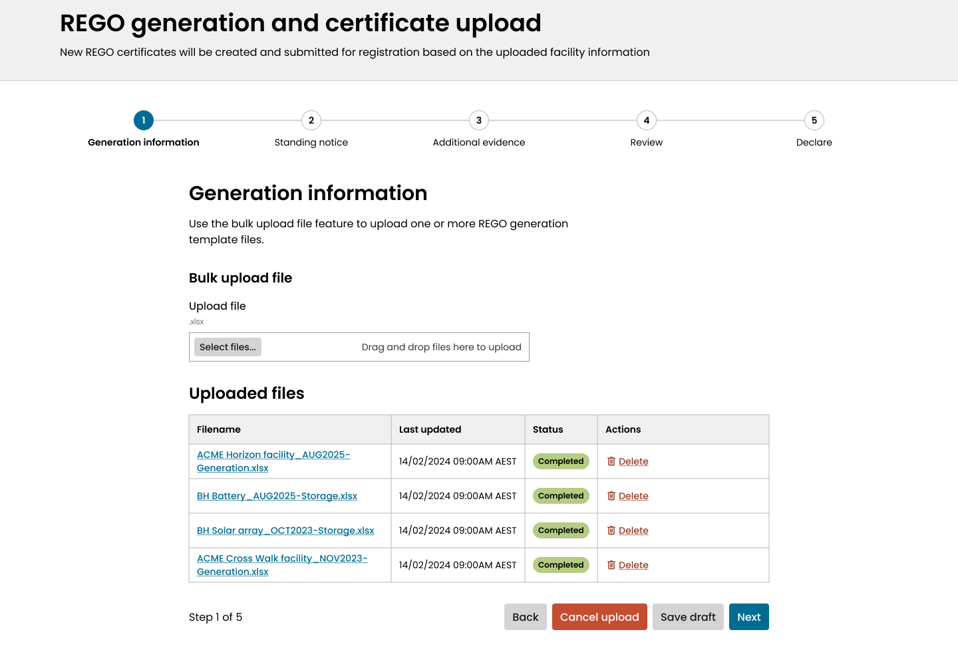
6a
6b

A template upload may take several minutes to complete while our system performs the necessary validation and calculations. You can leave and return later to check on the status of the file uploads if needed.

Online Services allows you to upload template files for multiple facilities in one upload, allowing you to make claims for multiple facilities in the same workflow.
You may only upload one file for each included facility. When uploading templates for multiple facilities, each facility’s claim will be considered as a separate application for assessment purposes.

- On the Standing notice page, answer the standing notice questions for each facility included in the claim.

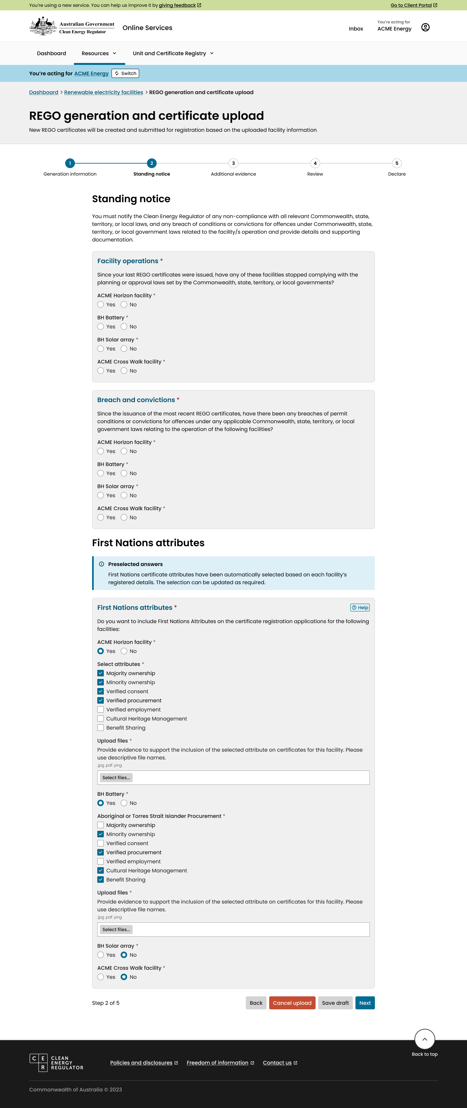

- The Standing notice page also includes a section for you to nominate any First Nations attributes you want to include on your certificates. These will be pre-selected based on the details on your facility registration and can be updated as needed for each application.
Nominated First Nations attributes will be included on all certificates included in the claim for the relevant facility
As per the GO Rules, you will need to provide evidence of First Nations attributes with each certificate claim.
First Nations attributes that have received preliminary approval at facility registration may lead to shorter assessment times, however preliminary approval does not guarantee their approval to be included on the certificates.
Including new First Nations attributes that have not received preliminary approval at facility registration may lead to longer assessment times.

- On the Additional evidence page, provide evidence of the eligible amount (9a), including calculation workbooks and other supporting documentation (such as raw meter data – mandatory). You will also be given an opportunity to provide additional information (9b) and respond to any conditions imposed on your facilities (9c).
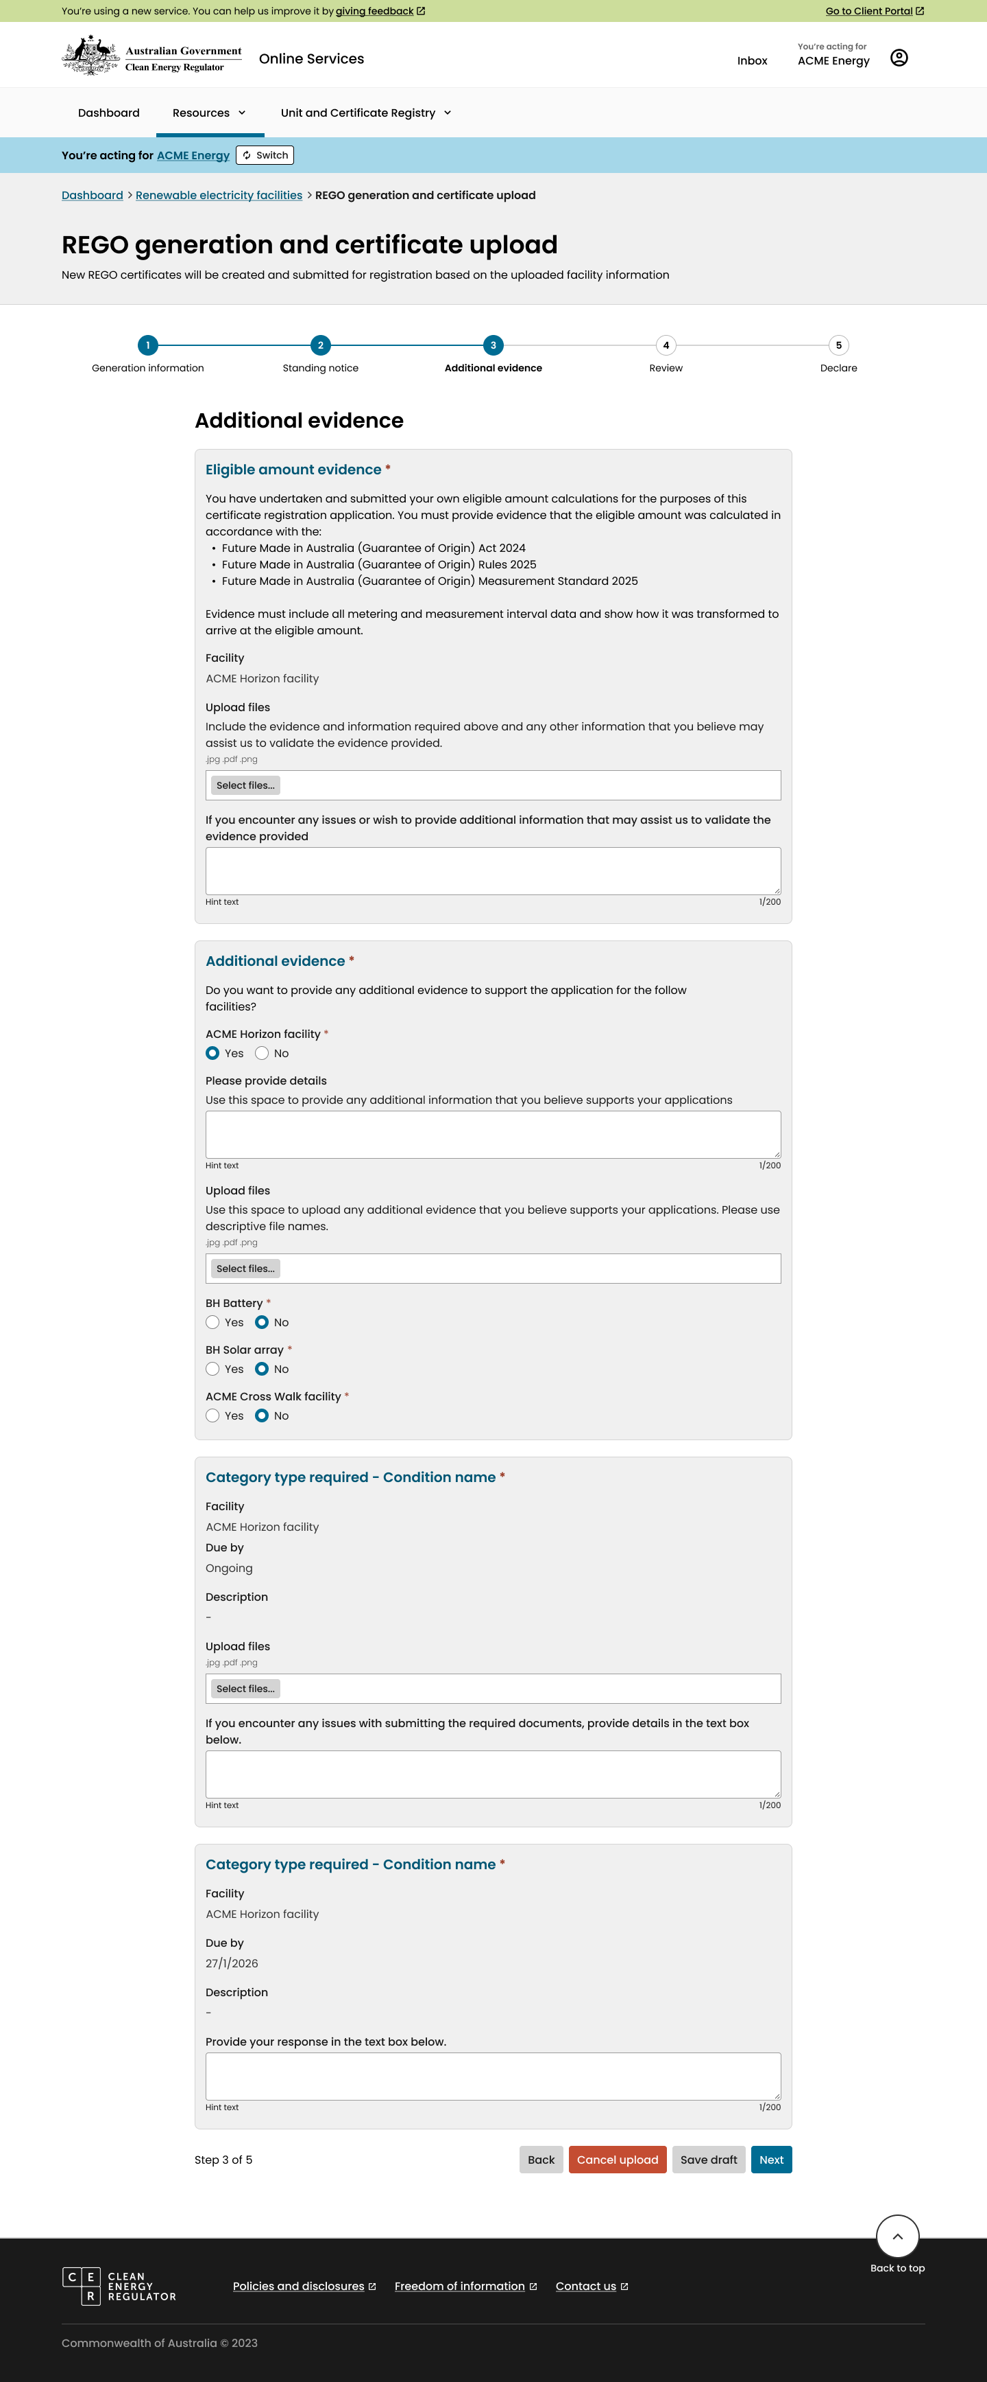
9a
9b
9c
- On the Review page, check that all details are correct. This page displays the total eligible amount reported for each facility, and the amount allocated to REGO and number of certificates to be created and submitted for registration.
If there are any issues with the calculations, make sure you check the templates that were filled out in step 4 and uploaded in step 6.
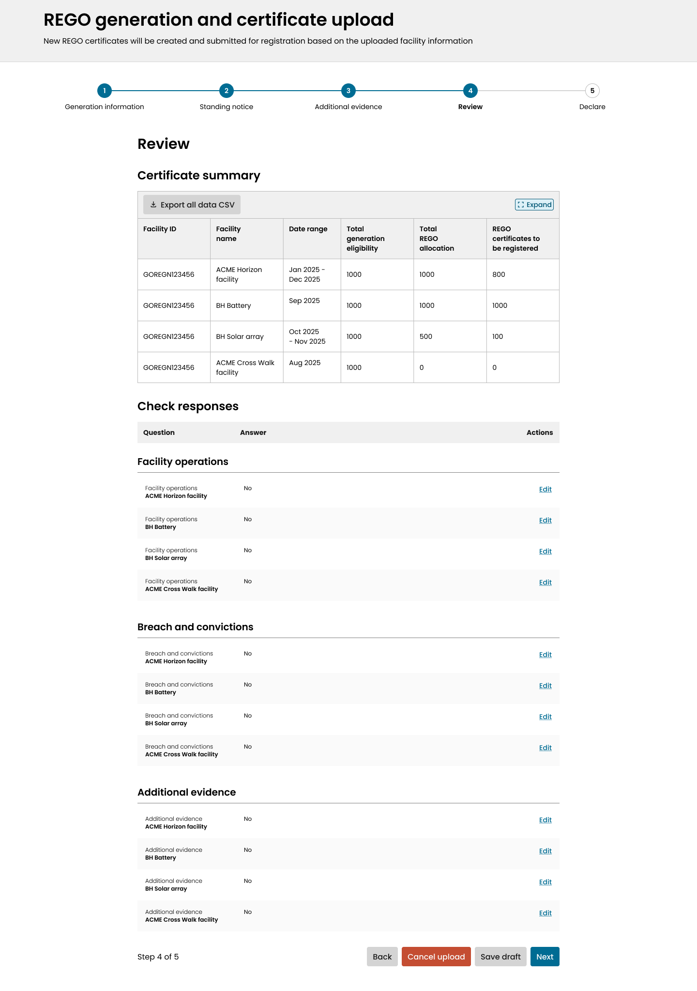

- On the Declare page, read and sign the declaration (11a). This is a legal declaration that you make when applying to create and register your REGO certificates. If you have improperly created the certificates, you could be subject to legal action.
If you agree with the declaration, check the box and click Submit (11b).

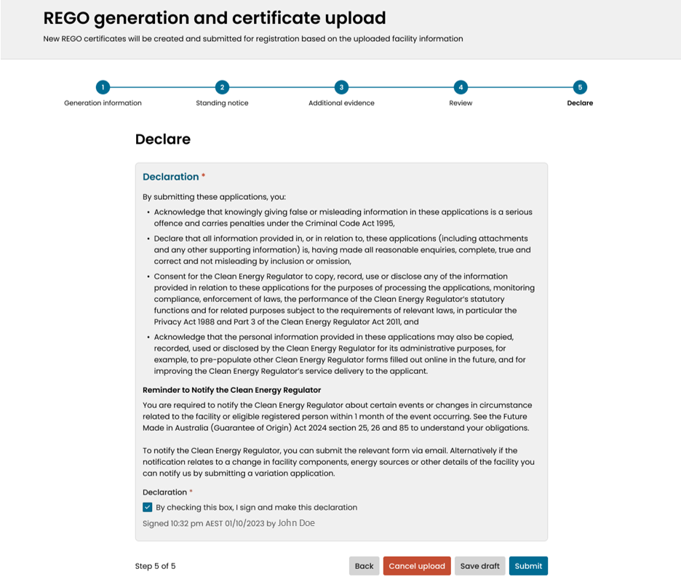
11ba
11aa

- Make the payment for your certificates. Once you apply to register the certificates, we will be in contact with an invoice. You will have to pay the fee before we can begin the assessment.
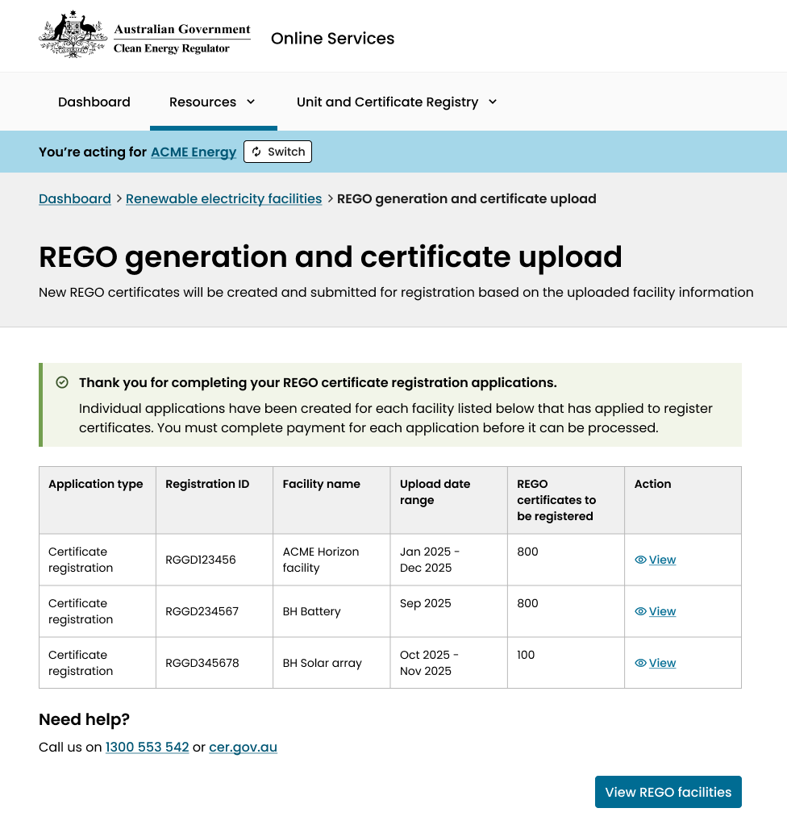

- Wait for us to complete our assessment. If you receive a request for further information, make sure you respond before the given deadline or we may cease considering your application and another application (including the fee payment) will need to be made.
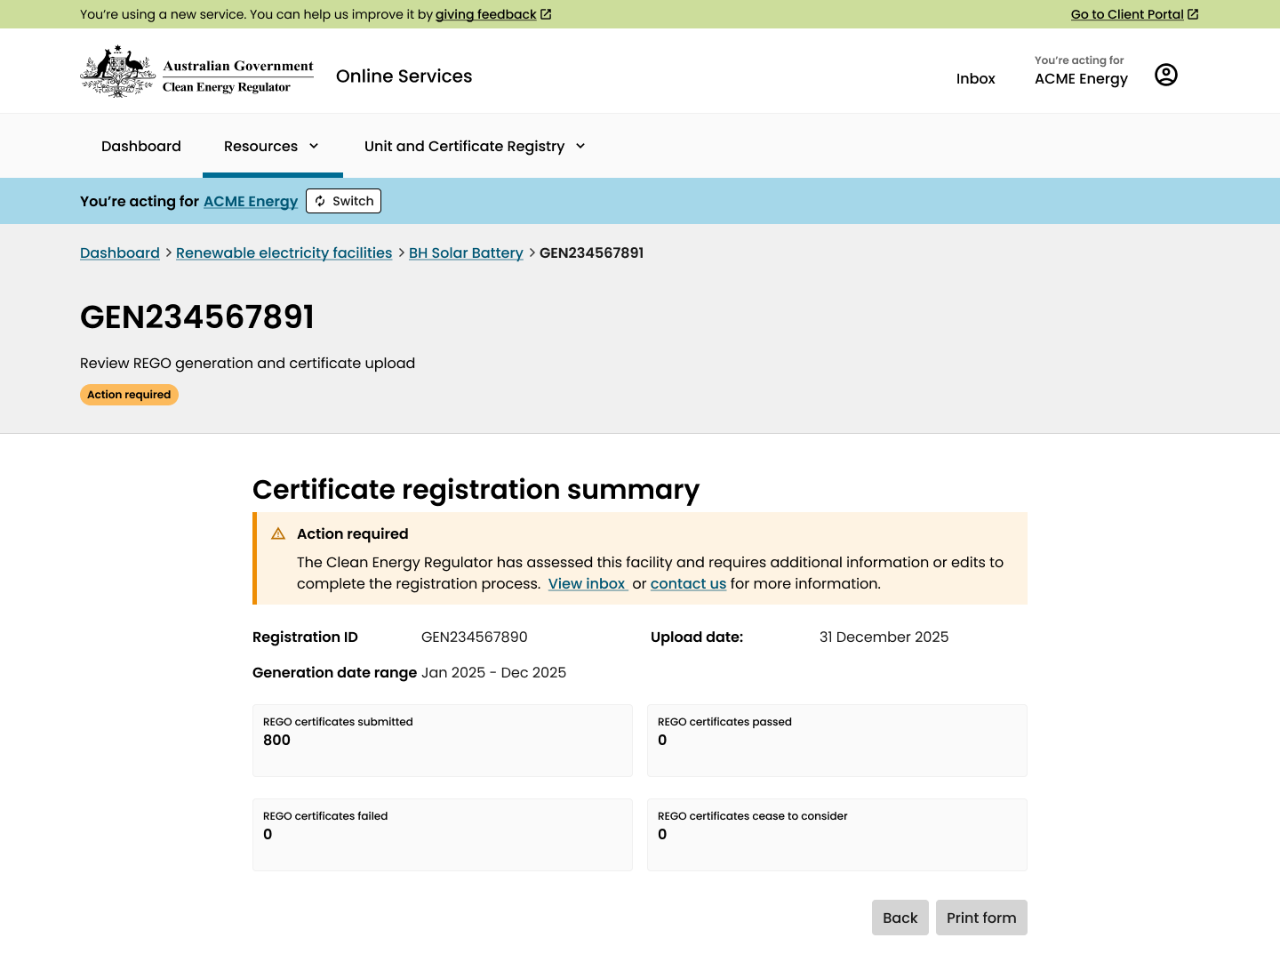
13..

- If the assessment turns up no issues, your certificates will be registered. This status will be reflected in your Online Services account and the registered certificates will be published on the GO Register.
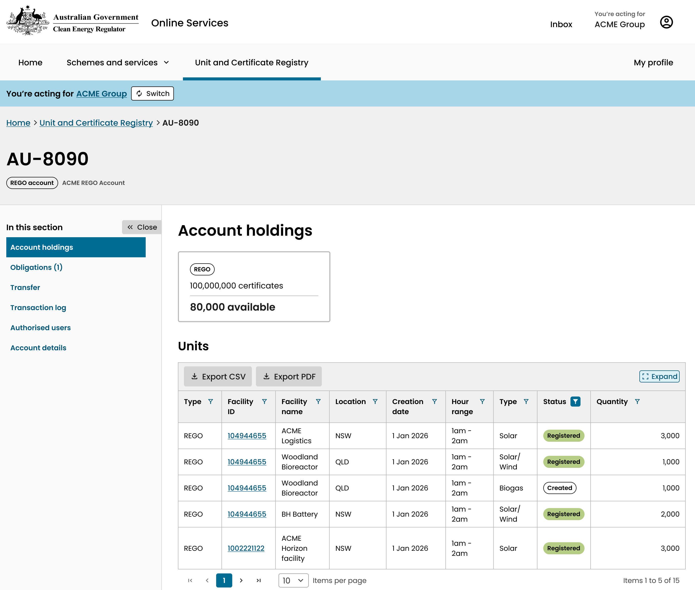

Filling out templates
The template that you download for your facility will be a .xlsx file with these tabs:
- Eligibility Calculation
- Certificate
- Below-Baseline Certificate (if applicable)
- Residuals (if applicable)
- Below-Baseline Residuals (if applicable)

Eligibility calculation
You will need to perform the eligible amount calculation yourself and upload the calculation as eligible amount evidence.

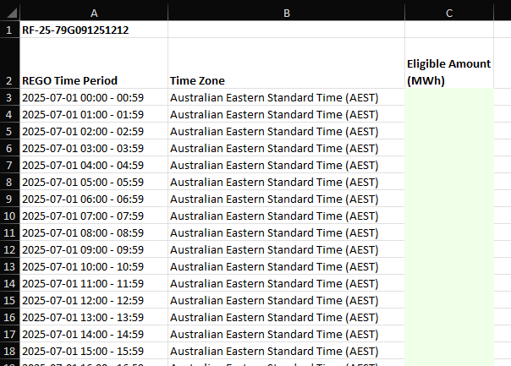
Perform your calculations of the eligible amount for the facility using meter data and following the relevant formulas from the GO Rules. Upload both the raw meter data and calculations to Online Services as eligible amount evidence.
Paste your calculated eligible amount for each interval in the Eligibility Calculation sheet (column C in the above).

Certificate
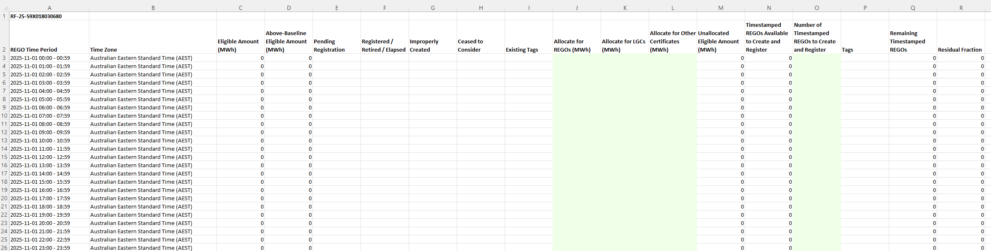
This tab refers to generation that is in excess of the baseline for the facility. Once the facility crosses its baseline, certificates can be allocated, created and registered here. If the baseline has not yet been crossed, use the ‘Below-Baseline Certificate’ tab instead. It is possible that both tabs will need to be completed if the baseline is crossed within the selected period.
The Above-Baseline Eligible Amount column (D) will show 0 until the baseline is crossed, regardless of what the Eligible Amount (column C) is.
In this tab, you can allocate how much of the eligible amount you are using for REGO claims. You can only create REGOs if you have not used the same generation as the basis for creating certificates in other relevant schemes. This means that the total number of REGOs, large-scale generation certificates (LGCs) and other certificates you create can’t exceed the Eligible Amount.
The allocation columns (J, K, and L above) allow you to split the Above-Baseline Eligible Amount (column D above) between REGOs and other schemes. An eligible amount that has not been allocated to any scheme will appear in the Unallocated Eligible Amount column (M).
The amount you can apply to create and register will appear in the Timestamped REGOs Available to Create and Register column (N). This number will be rounded down to the nearest whole MWh amount. Previously created REGO certificates or pending REGO registrations for the same time period are removed from this amount. Columns E-I show information about previous claims for the facility in the same time period.
Enter the Number of Timestamped REGOs to Create and Register in column O. You don’t need to create and register all REGO certificates in this claim that are available to create and register.
The Residual Fraction column (R) will only appear for those facilities using hourly timestamping of REGO certificates. It is the remaining partial MWh amount left over from rounding. They can be summed and used to create and register REGO certificates in the Residuals tab.
You can enter formulas in green cells.

Below-baseline certificate
This tab will not appear if your facility does not have a baseline.
This tab refers to generation that is below the baseline of the facility. It works the same as the Certificate tab as described above. They have been separated due to the restrictions set out by the GO Rules on how below-baseline REGO certificates can be used.
The Below-Baseline Eligible Amount will show 0 once the baseline is crossed, regardless of what the eligible amount is.

Residuals and below-baseline residuals
This tab will only appear if you are applying to create and register REGO certificates on an hourly basis. Daily, monthly, and yearly certificates don’t qualify for residual amounts.

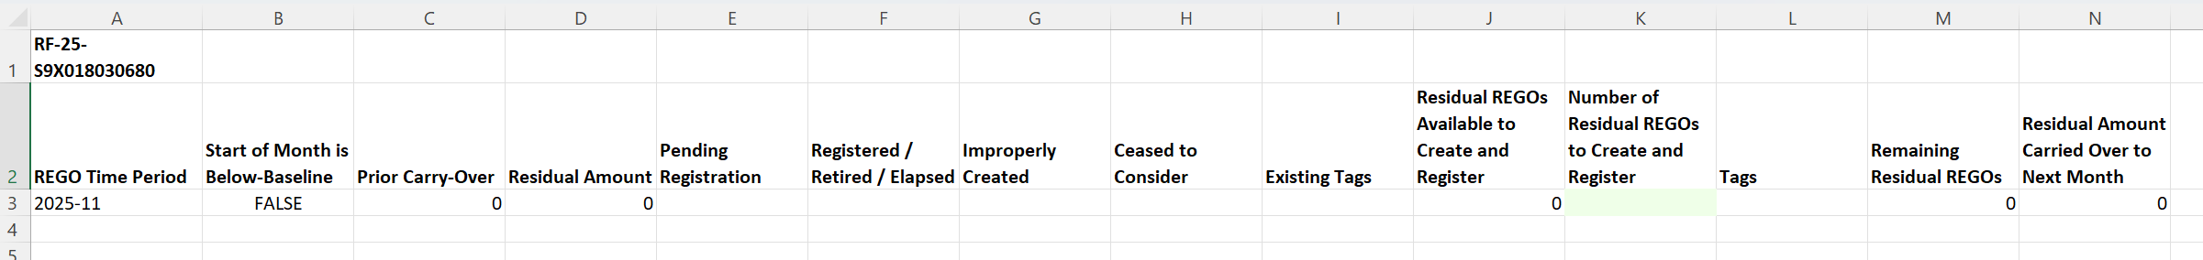
As a REGO certificate can only be created for a whole MWh of eligible generation, this leaves ‘residual fractions’ unclaimed for each hour. For example, if a facility created 4.7MWh in the hour between 2 pm and 3 pm on 1 September 2025, only 4 REGO certificates could be created with that timestamp and the residual fraction for that hour would be 0.7MWh. The GO Act allows these residual fractions to be summed within a month to form a ‘residual amount’. Residual certificates will be timestamped with only the month and year in which the generation occurred.
The Residual REGOs Available to Create and Register column (J) will autofill with the maximum number that can be created and registered. This is based on information in the Certificate tab, as well as previously registered (or pending registration) residual amounts for the same time period.
Enter how many residual REGO certificates you wish to create and register in column K.
The Residuals tab refers to generation that occurred after the facility crossed its baseline.
The Below-Baseline Residuals tab refers to generation that occurred before the facility crossed its baseline. Both tabs work in the same way yet need to be separated due to the restrictions on below-baseline REGO certificate use set out by the GO Rules.

System generated messages: What do I do now?

Application task | Message | Action | Next steps
REGO generation and certificate upload: generation information | File error: One or more files contain errors | Check your uploaded files for errors and replace the file with the corrected version. | Once you upload a corrected version, you can continue the form.
REGO generation and certificate upload: generation information | Multiple files for a single facility error: Only one file per facility | Make sure you only include one file for each facility. If needed, you can go back a few steps and download a different template. | Once you upload only one file per facility, you can continue the form.
REGO generation and certificate upload: submission page | Submission error: Something went wrong | Return to the upload page or the facility details and try your submission again. You may have to try again later. | Make sure your submission is successful or contact us for help.
REGO generation and certificate upload: review | Waiting payment: Your application has been received | Complete payment for the created certificates. | Once payment is received, we will commence assessment.
REGO generation and certificate upload: review | Action required: Your application has been assessed, and we have requested additional information or edits | View your inbox to see the message from us. Respond to the request for further information or make the required edits. | Once you have responded, we will continue assessment.
REGO generation and certificate upload: review | Under assessment: Your application is being assessed | Wait for a request for further information or for notification that your certificates have been registered. | Once your certificates are registered, they can be transferred or retired.

