NGER quick help topics  
National Greenhouse and Energy Reporting (NGER) Scheme and the Emissions and Energy Reporting System (EERS)

August 2025

****J

**Contents**

Disclaimer 4

2024–25 updates 5

National Greenhouse and Energy Reporting (NGER) Scheme 6

General EERS information 6

Carrying information over from the previous reporting period for an existing reporter 6

Entered data does not appear in the generated report 7

Unable to enter data for your facility because the Add Activity' button is disabled 7

Entering data when the ‘Data Entry’ function is locked 7

Correctly report facility location information in EERS 8

Facility location information you must provide in your NGER report 10

Confirming the latitude and longitude for a facility 10

Unable to generate a draft report in EERS 11

Attaching documents to your report in EERS 11

Confirming your NGER report has been successfully submitted in EERS 12

NGER reporting information 13

The reporting deadline cannot be extended 13

Errors in a submitted NGER report 13

Technical NGER reporting information 15

Nomination of energy commodity for liquefied petroleum gas (LPG) 15

Reporting E10 in EERS 15

The CO2 emission factors for petroleum-based oils and petroleum-based greases when used as lubricants 16

Determining if a fuel is primary or secondary 17

Reporting net energy consumption 17

The ANZSIC codes for oil and gas activities 18

Where to report appraisal and development activities associated with oil or gas wells 18

Reporting crude oil and natural gas condensates 18

The meaning of ‘tonnes of flared gas' when estimating emissions from oil and gas flaring activities 19

The requirements for reporting energy consumption associated with oil and gas venting, flaring and leakage activities 19

The requirements for the use of measurement criterion BBB (industry practice) 19

Activities that you are required to report for electricity generation from renewable energy sources 20

Reporting consumption of renewable energy commodities for electricity generation 21

Reporting production of electricity from renewable energy commodities 21

Reporting consumption of electricity that was produced for use by the operation of the facility (for use onsite) 22

What you need to report when producing charcoal 24

Choosing the correct fuel to report 25

Reporting equipment or component use 25

Reporting average hours of operation of equipment or components 25

Monitoring equipment isn't functioning correctly 25

Simplify your reporting or data collection 26

What you should do if your emissions are counted twice 27

Avoid non-compliance with NGER legislation by using a Basis of Preparation (BoP) 28

How to report scope 2 emissions if your electricity invoice includes ‘unaccounted for energy’ 29

Simulated Natural Gas 29

Production variable reporting for Safeguard facilities 29



# Disclaimer

This guideline has been developed by the Clean Energy Regulator (CER) to assist entities to comply with their reporting obligations under the [*National Greenhouse and Energy Reporting Act 2007*](https://www.legislation.gov.au/Series/C2007A00175)[1](NGER Act) and associated legislation.

This guidance only applies to the 2024–25 NGER reporting year and should be read in conjunction with the NGER Act, [National Greenhouse and Energy Regulations 2008](https://www.legislation.gov.au/Series/F2008L02230)[2] (NGER Regulations), and [National Greenhouse and Energy Reporting (Measurement) Determination 2008](https://www.legislation.gov.au/Series/F2008L02309)[3] (NGER Measurement Determination), as in force for this reporting period. These laws and their interpretation are subject to change, which may affect the accuracy of the information contained in the guideline.

The guidance provided in this document is not exhaustive, nor does it consider all circumstances applicable to all entities. This guidance is not intended to comprehensively deal with its subject area, and it is not a substitute for independent legal advice. Although entities are not bound to follow the guidance provided in this document, they must ensure they meet their obligations under the [National Greenhouse and Energy Reporting (NGER) Scheme](https://cer.gov.au/schemes/national-greenhouse-and-energy-reporting-scheme)[4] at all times. CER encourages all users of this guidance to seek independent legal advice before taking any action or decision on the basis of this guidance.

CER and the Australian Government will not be liable for any loss or damage from any cause (including negligence) whether arising directly, incidentally or as consequential loss, out of or in connection with, any use of this guidance or reliance on it, for any purpose.

If an entity chooses to meet their obligations under the NGER Scheme in a manner that is inconsistent with the guidance provided in this document, CER, or an independent auditor, may require the entity to demonstrate that they are compliant with the requirements of the NGER Act, NGER Regulations, and/or the NGER Measurement Determination. Entities are responsible for determining their obligations under the law and for applying the law to their individual circumstances.

## 2024–25 updates

Changes in this document for the 2024–25 reporting year:

* Removed information on managing users, logging into EERS and adding, editing or removing entities - this information is now in the Online Services user guide and the EERS navigation guide
* Updated information in the topics to reflect ‘new EERS’
* Reporting E10 in EERS – added information regarding newly-required matters to be identified (MTBIs)
* Reporting net energy consumption – added information on secondary fuel production
* Updated the information for reporting location information for a facility
* Added information about production variable reporting for Safeguard facilities
* Minor stylistic and formatting changes have been made to this document

Read about the [changes to the NGER Legislation for the 2024–25 reporting period](https://cer.gov.au/schemes/national-greenhouse-and-energy-reporting-scheme/report-emissions-and-energy/amendments)[5].

|  |
| --- |
| **New Emissions and Energy Reporting System (EERS) for 2024–25.**  The EERS screenshots in this guideline are from the legacy version of EERS but the input data (source/activity/method) will be very similar in the current system. Please contact us if you have any questions. |

## National Greenhouse and Energy Reporting (NGER) Scheme

The NGER Scheme is a single national framework for reporting and disseminating company information about greenhouse gas emissions, energy production and energy consumption.

Corporations that meet a NGER Scheme threshold must register and report each year once registered.

The Emissions and Energy Reporting System (EERS) is accessed through [Online Services](https://onlineservices.cer.gov.au/)[6] and must be used for all reporting under the NGER Scheme. NGER reporters can prepare and submit their emissions and energy reports in EERS. The [EERS navigation guide](https://cer.gov.au/document_page/emissions-and-energy-reporting-system-navigation-guide)[7] is available to provide assistance in navigating the system.

Online Services also enables the management of an organisation’s EERS accounts and user permissions, and provides secure access to other online forms, systems and additional information for the [schemes the CER administer](https://cer.gov.au/home/schemes)[8]. The [Online Services user guide](https://cer.gov.au/document_page/nger-online-services-user-guide)[9] is available for more information on these services.

Contact us on 1300 553 542 or [cer-nger-reporting@cer.gov.au](mailto:cer-nger-reporting@cer.gov.au) if you have questions.

## General EERS information

### Carrying information over from the previous reporting period for an existing reporter

If your organisation has an EERS account and submitted an NGER report in the previous reporting year, your EERS workspace for the current reporting year will automatically be populated with information from your previous reporting period workspace. This information will include:

* reporting entity details (name, ABN or ACN etc, addresses)
* the entire corporate structure (including group members, facilities, business units, facility aggregate and network or pipelines)
* details for entities in the corporate structure (that is, names, addresses, geographical coordinates and reporting status)
* facility activity data, except for activity values and matters to be identified.

Before you submit, it is important that all information carried over from a previous reporting period is reviewed for accuracy relative to the current reporting period and amended if necessary.

Please note:

* if the organisation's ABN has changed, it is a new legal entity as an existing corporation can't change its ABN
* if an organisation is taken over or the ABN has changed, the new controlling corporation needs to register for NGER reporting and the former corporation needs to deregister. Refer to the [Online Services User Guide](https://cer.gov.au/document_page/nger-online-services-user-guide)[10] for details on how to access these online registration and deregistration forms.

### Entered data does not appear in the generated report

Data entered into an EERS workspace may not appear in a generated report. This may be correct (meaning no action will be required by you) or you may need to take further action, as follows:

* Check that the facility and/or corporate [threshold](https://cer.gov.au/schemes/national-greenhouse-and-energy-reporting-scheme/assess-your-obligations#nger-thresholds)[11] has been met – If a facility is below the facility threshold, it will only appear in an NGER report if the controlling corporation has passed the corporate threshold. If a controlling corporation passes only the facility threshold, then only those facilities that pass the facility threshold will appear in the NGER report.
* Check that the facility is marked as 'Reporting' – To do this, click on the facility in the corporate structure to open the facility record, then check if the ‘Is Reporting' box is ticked. If it is not, you need to check this box and save the changes. For more information on editing facility details, see the [EERS navigation guide](https://cer.gov.au/document_page/emissions-and-energy-reporting-system-navigation-guide)[12].

If you have checked the above and believe that the data entered should appear in the report, contact the CER on 1300 553 542 or email [cer-nger-reporting@cer.gov.au](mailto:cer-nger-reporting@cer.gov.au).

### Unable to enter data for your facility because the Add Activity' button is disabled

The ‘Add Activity' button will remain greyed out (disabled) until all mandatory entity fields have been completed and any changes have been saved. These fields include ANZSIC code, state or territory of operation, latitude and longitude and operational control period.

All fields with a red asterisk (*) must be addressed. When all mandatory fields have been addressed, the tag for the facility will change from a yellow ‘Incomplete’ to a green ‘Ready for review’, and the ‘Add activity’ button will be available from the facility record page.

More information on facility details is available in the [EERS navigation guide](https://cer.gov.au/document_page/emissions-and-energy-reporting-system-navigation-guide).

### Entering data when the ‘Data Entry’ function is locked

If you are trying to enter data and the 'Data Entry' function is locked (a ‘Data entry locked’ message will appear at the top of the screen), this is because either:

* the report has been generated but not submitted
* the report has been submitted.

If the report has been generated but not submitted, you will need to withdraw the draft report to allow further data entry.

Select ‘Reports’ from the function drop-down menu, then click the ‘Withdraw’ link from the ‘Unsubmitted reports’ table on the ‘Reports’ landing page.

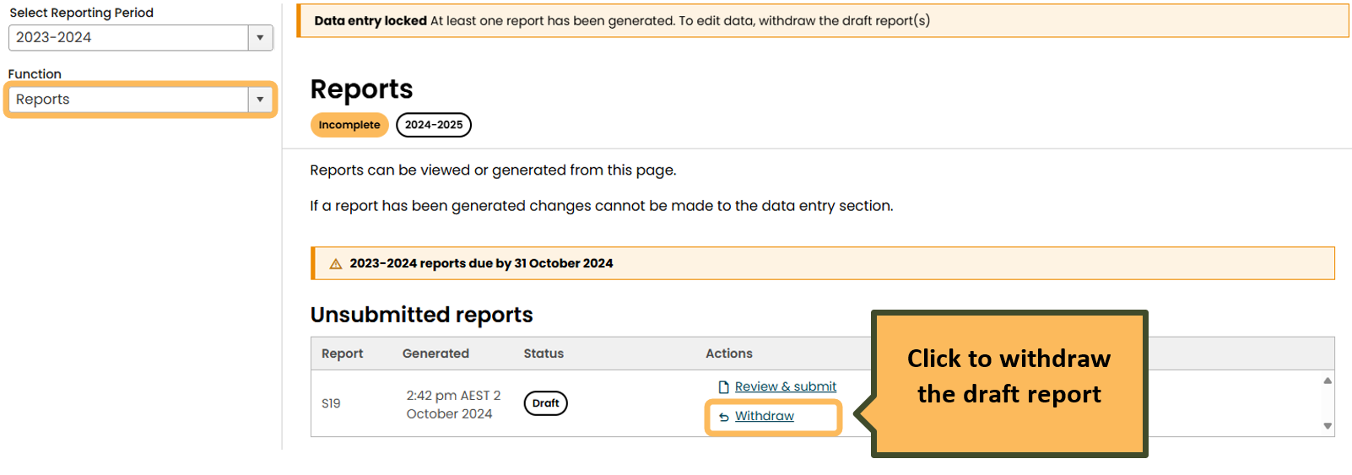

If your report has been submitted, you will be able to view information in the 'Data Entry' function but you will be unable to make any changes. If you believe you need to make changes to a submitted report, please [contact the CER[13].](https://cer.gov.au/about-us/contact-us)

### Correctly report facility location information in EERS

A corporation’s NGER report must include specific identifying information for a facility as per 4.04A(2)(a) to (h) of the NGER Regulations. Identifying information includes location information such as address, latitude and longitude and the state or territory in which the facility is located. You should enter accurate location information to ensure compliant reporting. Accurate location information also assists data users with analysis of the NGER data set.

Facility location information is automatically rolled over into your EERS workspace each year. We request that facility location information is reviewed each year to maintain its accuracy.

#### Enter, view or edit location information for a facility in EERS

For new facilities, please see the [EERS navigation guide](https://cer.gov.au/document_page/emissions-and-energy-reporting-system-navigation-guide)[14]for details on how to create a new facility and add identifying information, including facility location information. This information must be completed before you can add activities to a facility.

For existing facilities, click on the facility in the Corporate Structure then click the ‘Edit’ button in the top right corner of EERS.

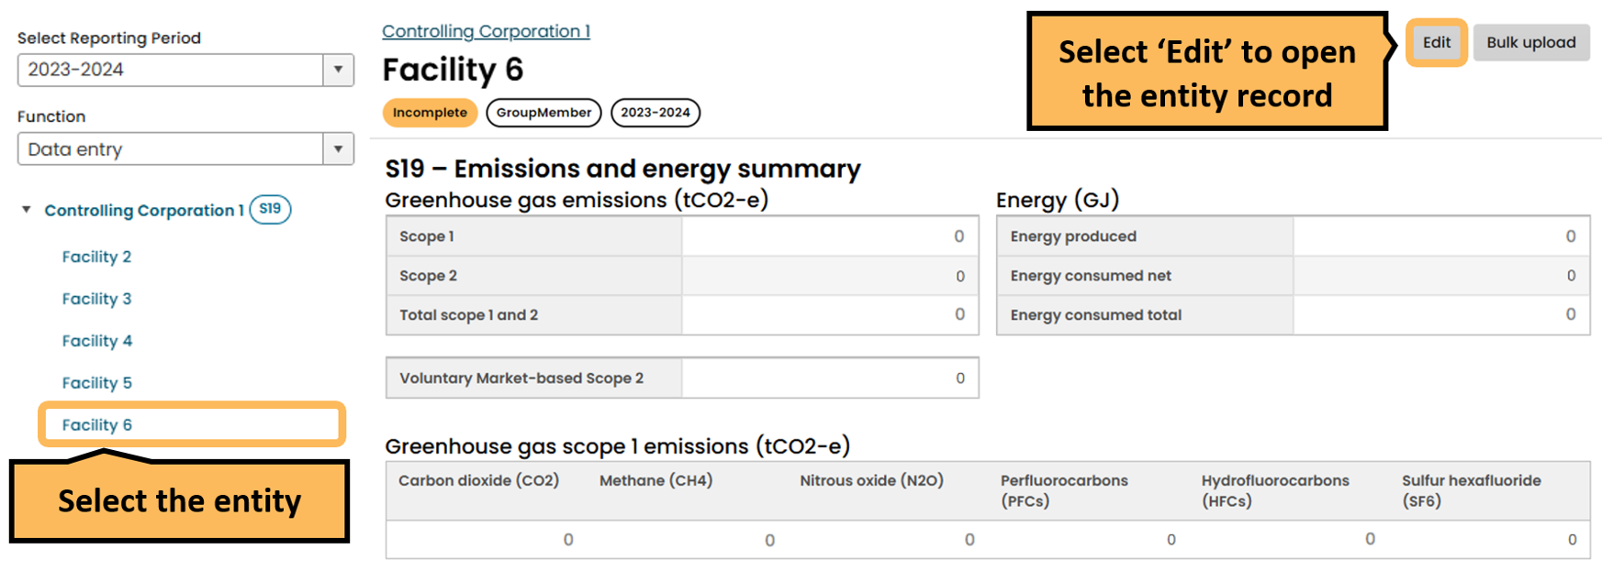

This will load a screen containing the current facility location information.

If there is a facility address change after the end of the financial year, report the address as it was at the end of the financial year and update the location change in the following financial year.

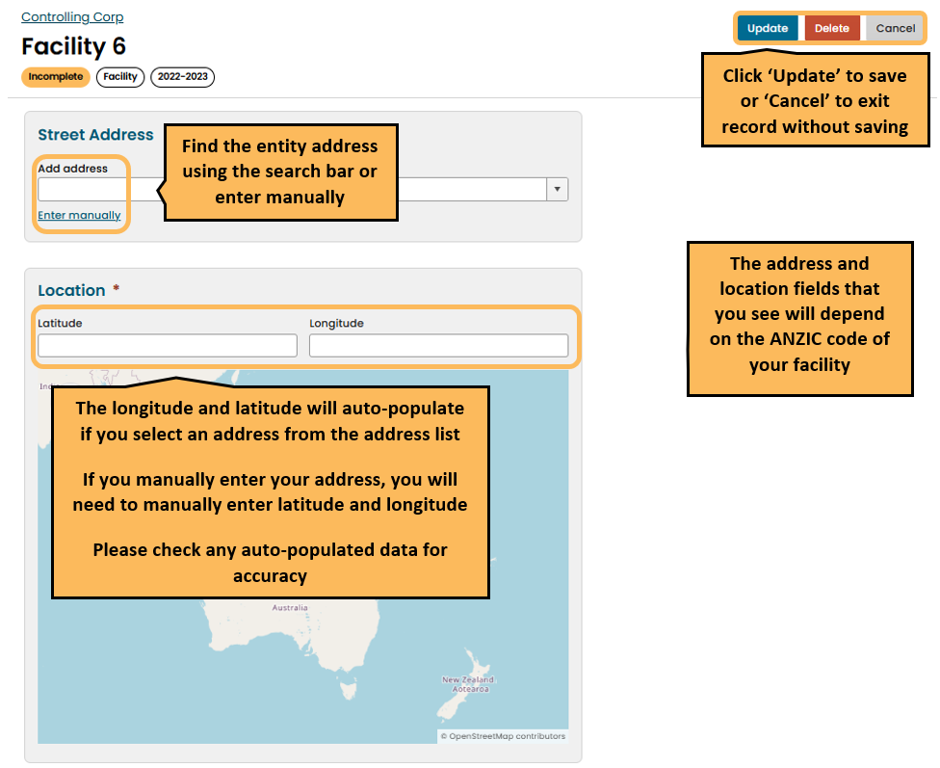

### Facility location information you must provide in your NGER report

There are different requirements for the location information that must be reported by facilities, depending on the facility’s Australian and New Zealand Standard Industrial Classification (ANZSIC) code. The requirements are outlined in 4.04A(2)(a) to (h) of the NGER Regulations and summarised in Table 1 below.

Table 1: Location information that you must submit for your facility

|  | Transport Facility (2.19 (3) of the NGER Regulations) | Network or Pipeline Facility (2.20 (2) of the NGER Regulations) | Multi-site cement facility | Other |
| --- | --- | --- | --- | --- |
| ANZSIC code | 291, 461, 462, 471, 472, 481, 482, 490, 501, 510 | 262, 263, 270, 281, 502, 580 | 203 | Any other ANZSIC code not listed for transport or network or pipeline |
| Address (if any) | Yes | Yes | Yes | Yes |
| Latitude and longitude | No | No | No | Yes |
| State – in which facility is located | No | Yes - may be located in more than one state or territory | Yes - may be located in more than one state or territory | No |
| State – to which activities constituting facility are attributable | Yes - refer to 2.19(2) of the NGER Regulations | No | Yes - refer to 4.28A(2) of the NGER Regulations | Yes - refer to 2.19(2) of the NGER Regulations |
| Location and activity description | A brief description of your facility’s location, activities and a state or territory designation must be provided in EERS if your facility:   * is a transport, network or pipeline, or multi-site cement facility * is not a ‘single site’ facility (refer to 1.03 of the NGER Regulations) * does not have an Australian street address | | | No |

### Confirming the latitude and longitude for a facility

Latitude and longitude coordinates (coordinates) for a facility must be provided in decimal degrees in EERS. EERS accepts input to six decimal places, but you are only required to provide precision to 3 decimal places. This is consistent with the formats used in internet and portable GPS tools commonly available in Australia.

Coordinates can be reported in EERS by either:

* selecting an address from the list in the address search bar will automatically populate the coordinates fields (precision to 6 decimal places)
* typing directly into the coordinates text fields (precision to 3 decimal places required)
* clicking on the interactive map will place a coordinates pin (location pin) and automatically populate the coordinates fields (precision to 6 decimal places).

If the latitude and longitude fields have been automatically populated, please confirm that this corresponds to the location of the facility. We expect the location pin to be placed as accurately as possible.

If you need to adjust the location of the pin, you can type directly into the coordinates fields.

#### Converting to decimal degrees

A street address can be converted to coordinates in decimal degrees using the Latitude and Longitude Finder at [LatLong.net](https://www.latlong.net/)[15].

A conversion calculator from degrees, minutes and seconds to decimal degrees is also available through LatLong.

### Unable to generate a draft report in EERS

You can generate draft reports in EERS by going to the 'Reports' function and, providing you have the required permissions, selecting the 'Generate' option in the 'Action' column against the unsubmitted report you wish to generate. This will open the ‘Generate report’ landing page. You will need to confirm the details of your NGER contact person and Executive Officer. If they are satisfactory, click the blue ‘generate’ button at the bottom of the screen to generate your report.

If the ‘generate’ button is not available to click, check that you have addressed all validations in the ‘validate’ function.

Updates to the NGER Contact Person or Executive Officers need to be done through the ‘Manage access’ function by your organisation administrator. See the [NGER Online Services user guide](https://cer.gov.au/document_page/nger-online-services-user-guide)[16] for more information.

If you have generated a report and the 'Generate' button against that report shows 'Generating', try hitting the 'F5' key. This refreshes the page, and the report should appear for you to view. If a report does not generate within 30 minutes, please contact us on 1300 533 542 or email [cer-nger-reporting@cer.gov.au](mailto:cer-nger-reporting@cer.gov.au).

The 'Action' column will then allow you to withdraw the report so you can continue entering data. Read Entering data when the ‘Data Entry’ function is locked, for information on removing a generated report.

### Attaching documents to your report in EERS

You can submit supporting information along with your EERS report if required. To attach supporting documents, select the 'Add/Edit Attachments’ button from the reports tab prior to generating your draft report. This allows you to select the required document from your computer. Once this has been selected, click on 'Attach File' to attach the document to your report.

Documents cannot be attached in EERS once a report has generated. If you generate a report and need to add an attachment, you will need to remove the report, add the required attachment and generate the report again.

Note: JPG, BMP, PNG, PDF, DOC, DOCX, XLSX, CSV, TXT, and RTF files can be uploaded.

**EERS users who can submit a report**

All reports are to be submitted by an 'executive officer' of your organisation. To submit a report, the executive officer must read through the declaration that appears both at the end of the report to be submitted and once the executive officer (or nominated report submitter) clicks 'Submit Report'.

The declaration states that the reporting entity is responsible for adhering to requirements under the NGER legislation and highlighting penalty provisions for those reports that do not comply. By clicking accept on this declaration, the report is electronically submitted and the executive officer has effectively signed the report.

An executive officer is defined as either a:

* director
* chief executive officer (however described)
* chief financial officer (however described)
* secretary (that is, company secretary).

While the executive officer may authorise someone to submit the report on their behalf, they maintain responsibility for the compliance of NGER reporting. The organisation must hold written evidence of this approval being allocated to someone other than the executive officer, and this person submitting the report on behalf of the executive officer must have the ‘submit report’ permission in Online Services. Refer to [Online Services user guide](https://cer.gov.au/document_page/nger-online-services-user-guide) [17] to learn how to set up this permission.

The executive officer who provided the authorisation must be the person whose details are selected in the executive officer field in EERS.

Note: An executive officer of a company can, in certain circumstances, be held accountable for their company's contraventions of civil penalty provisions.

### Confirming your NGER report has been successfully submitted in EERS

Once your report has been successfully submitted, it will appear in the 'Submitted Reports' table on the ‘NGER reports’ landing page. This table also includes the date and time of submission, and the version of the report.

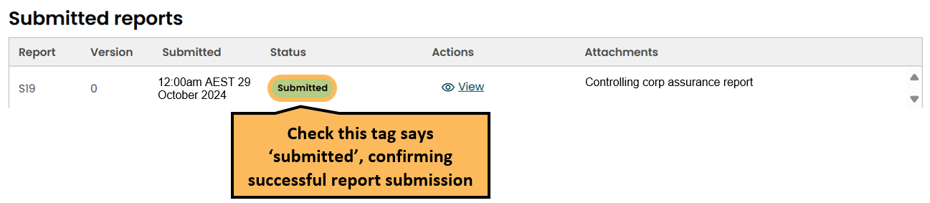

A submission receipt will also be available in EERS. The receipt will confirm the time and date of the submission, and the version and type of report submitted. It will also note who submitted the report. You will then be able to print or save a copy of this receipt for your records.

To locate the submission receipt in EERS, click on the 'Reports' function, then under 'Submitted Reports' click on the ‘view’ button in the ‘Actions’ column. Scroll down and click on the ‘Submission receipt.pdf’ link.

#### Tidying up your EERS workspace

EERS prefills any facility and activity descriptions that were present in your NGER report for the preceding reporting period.

To simplify reporting against your corporate structure, you are encouraged to remove facilities and activities that no longer apply to your operations. Removal of historical facilities and activities makes navigation easier and will reduce the time it takes to prepare your report.

Refer to the [EERS navigation guide](https://cer.gov.au/document_page/emissions-and-energy-reporting-system-navigation-guide)[18] for instructions on how to edit your corporate structure.

## NGER reporting information

### The reporting deadline cannot be extended

The NGER reporting deadline is a statutory deadline. The CER cannot provide extensions. All NGER reports for a reporting financial year (1 July to 30 June) must be submitted by 11:59 pm Australian Eastern Daylight Time (AEDT) the following 31 October.

Failure to submit your report by the due date is a contravention of the NGER Act that may attract a civil penalty of up to 2,000 penalty units. Additional civil penalties of up to 100 penalty units may also apply for each day that a report is late. The NGER Act provides for other possible regulatory responses to non-compliance, including the use of enforceable undertakings and infringement notices.

### Errors in a submitted NGER report

The CER encourages scheme participants to voluntarily notify us in writing to [cer-nger-reporting@cer.gov.au](mailto:cer-nger-reporting@cer.gov.au) when they become aware of incorrect reporting. The CER views this an indicator of a positive compliance attitude and that the scheme participant is committed to meeting its obligations under the legislation and to providing accurate and complete data.

Where a reporter requests EERS to be unlocked in order to provide an updated report for the current reporting period, all efforts will be made to fulfill that request. Resubmissions of current reporting year data completed prior to 31 October of the same reporting year do NOT contribute to an organisation's compliance history.

However, notifications of errors in historical reports or current year data received after 1 November will be reviewed and the reporter will be notified whether or not resubmission of the report is required. Resubmission will generally be required when the nature and extent of the reporting errors make the report non-compliant with the requirements of the NGER legislation and therefore will contribute to an organisation's compliance history. The voluntary nature of the disclosure will be taken into account when considering overall scheme compliance.

## Technical NGER reporting information

### Nomination of energy commodity for liquefied petroleum gas (LPG)

When reporting liquefied petroleum gas (LPG), you must nominate whether it is a primary or a secondary fuel.

Purchased LPG (item 44 in schedule 1 of the NGER Regulations) is a secondary fuel. When LPG is consumed at the same facility where it was produced, the LPG is considered a primary fuel.

Read Determining if a fuel is primary or secondary for more information.

### Reporting E10 in EERS

E10 is a common blended fuel produced by blending up to 10 per cent ethanol with gasoline.

Under section 1.8 of the [National Greenhouse and Energy Reporting (Measurement) Determination 2008](https://www.legislation.gov.au/Series/F2008L02309)[19] (NGER Measurement Determination) a blended fuel is a fuel that is a blend of fossil and biogenic carbon fuels. For example, E10 is a blend of gasoline (fossil fuel) and up to 10 per cent ethanol (biogenic carbon fuel).

Examples of biogenic carbon fuels under the NGER legislation are listed in items 10—16; 28—30 and 52—54 of Schedule 1 of the NGER Regulations.

The NGER legislation does not define fossil fuels. However, taking the ordinary meaning of the term, a fossil fuel is: a carbon-based fuel from fossil hydrocarbon deposits including coal, oil and natural gas.

E10 is not a listed fuel type under the NGER Regulations, therefore E10 is not reported in EERS. Rather, when E10 is consumed the components that make up E10 need to be reported. When reporting these components, you will need to provide additional information about the blended fuel, in the form of matters to be identified (MTBIs).

#### Example—reporting greenhouse gas emissions and energy consumption from combustion of E10

A facility purchases 10,000 litres of E10 for use in a transport facility. Using the product specifications provided by the manufacturer, it is determined that the E10 is made up of 7% ethanol and 93% gasoline.

Therefore, the purchased E10 contains 700 litres of ethanol and 9,300 litres of gasoline. The purchased E10 is used to fuel fleet cars for the corporations, meaning that the fuel is combusted for use in an internal combustion engine.

As both the ethanol and gasoline are listed fuels, the corporation with operational control of the facility must report the greenhouse gas emissions and energy consumption from the combustion of:

* ethanol (item 53—ethanol for use in an internal combustion engine, Schedule 1 of the NGER Regulations)
* gasoline (item 35—gasoline (other than for use as fuel in an aircraft, Schedule 1 of the NGER Regulations) as consumed by combustion).

A separate activity must be reported for each fuel. For each activity, the corporation needs to check the box in EERS specifying “Is the fuel combusted in this activity part of a blend?” and provide the following additional data as MTBIs:

* The section under Part 2.6 used to determine the amounts of each kind of fuel in a blended fuel
  + In this case, for both activities, the MTBI must be entered as ‘Section 2.67 Blended liquid fuels’, which permits adopting the manufacturer’s determination.
* The amount of each type of fuel
  + In this case, for both activities, the MTBI must be entered as 9.3 kL of gasoline and 0.7 kL of ethanol. Adding this data as an MTBI for both activities does not change the emissions or energy totals for the facility but rather provides context for the composition of the blend used.

Read the [reporting blended fuels, other fuel mixes, bitumen and explosives guideline](https://cer.gov.au/document_page/reporting-blended-fuels-other-fuel-mixes-bitumen-and-explosives-guideline)[20] for more information on the reporting of E10 and other blended fuels.

### The CO2 emission factors for petroleum-based oils and petroleum-based greases when used as lubricants

EERS requires reporters to specify the carbon dioxide emissions factor when entering activity data for petroleum-based oils and greases when used as lubricants, as shown below:

[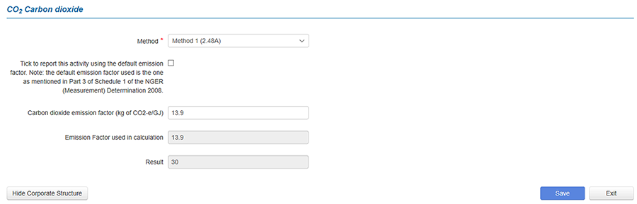](https://www.cleanenergyregulator.gov.au/PublishingImages/Oils%20and%20greases.jpg)

The carbon dioxide emission factor refers to the amount of carbon dioxide emitted per unit of fuel. Part 3 of Schedule 1 in the NGER Measurement Determination provides a default emission factor of:

* 13.9 (kg CO2-e/GJ) for the combustion of petroleum-based oils for stationary or transport energy purposes
* 3.5 (kg CO2-e/GJ) for the combustion of petroleum-based greases for stationary or transport energy purposes.

Alternatively, a site-specific carbon dioxide emissions factor can be used in accordance with Method 1 under section 2.48A(2) of the NGER Measurement Determination, or Method 2 or 3 under sections 2.48B and 2.48C respectively.

### Determining if a fuel is primary or secondary

Primary and secondary fuels and other energy commodities are defined in 1.03 of the NGER Regulations as follows:

* primary fuel or energy commodity means a fuel or energy commodity extracted or captured from natural sources with minimal processing, including the fuels and energy commodities mentioned in Schedule 1 (NGER Regulations) as being primary fuels or energy commodities
* examples include non-renewable fuels such as brown coal and crude oil, and renewable energy sources such as 'wind energy for electricity generation' and 'solar energy for electricity generation'
* secondary fuel or energy commodity means a fuel or energy commodity produced by converting energy from one form (usually a primary fuel or energy commodity) to another form for consumption and includes the fuels and energy commodities mentioned in Schedule 1 (NGER Regulations) as being secondary fuels or energy commodities
* examples include natural gas, coal seam methane gas and diesel oil.

EERS will indicate if a fuel or energy commodity is primary or secondary unless a nomination is required.

In some cases, the NGER Regulations will specify that a nomination (primary or secondary) is required, and you will need to determine if the fuel or energy commodity is primary or secondary. You may need to contact your supplier to confirm the source of the fuel or energy commodity. Generally, a fuel or energy commodity purchased from a supplier will be secondary.

### Reporting net energy consumption

Nominating a fuel as primary or secondary is necessary for calculating net energy consumption of the facility. A facility's net energy consumption is required to be reported in a controlling corporation's section 19 report, a reporting transfer certificate holder's section 22G report and a section 22X report.

You do not need to manually calculate net energy consumption. EERS automatically calculates net energy consumption based on reported energy consumption and production for each facility and this value will appear in a report generated in EERS.

To calculate net energy consumption, 5.03 of the NGER Regulations specifies that:

* for each facility of the corporation's group, adjust the facility's energy consumption by deducting the energy content of the secondary fuels and energy commodities produced from the operation of the facility from the total energy consumed by the operation of the facility.

The net energy consumption amounts derived for each facility appearing in the NGER report are summed to determine the net energy consumption for the controlling corporation.

Read the [Reporting energy production and consumption guideline](https://cer.gov.au/document_page/reporting-energy-production-and-consumption-guideline)[21] for more information.

Note: for net energy to be calculated correctly it is important to understand that a primary fuel type cannot be produced from the consumption of another primary fuel (including itself), and a secondary fuel type cannot be produced without the consumption of another fuel.

### The ANZSIC codes for oil and gas activities

In accordance with 4.04A(2)(g) of the NGER Regulations, the activities constituting the facility must be attributed to an industry sector. This is done using the ANZSIC industry classification codes.

The activity type constituting the principal activity of the facility determines the industry sector. A reporter should determine the ANZSIC code of the facility by comparing the principal activity at the facility with the list of ANZSIC industry classifications in Schedule 2 of the NGER Regulations.  
  
Principal activity is defined in NGER Regulation 4.31:

***Principal activity***, in relation to a facility, means the activity that:

 (a) results in the production of a product or service that is produced for sale on the market; and

 (b) produces the most value for the facility out of any of the activities forming part of the facility.

### Where to report appraisal and development activities associated with oil or gas wells

Oil or gas exploration and development involves carrying out activities with the purpose of finding and appraising natural underground oil and gas accumulations.

The CER considers that oil or gas exploration may include:

* conducting geochemical, geological, or geophysical surveys
* drilling wells
* well completions
* well workovers
* drilling mud degassing
* carrying out testing in relation to a well
* venting and flaring associated with oil or gas exploration activities
* taking samples for chemical or other analysis for exploration purposes.

Fugitive emissions from appraisal and development activities should be reported in EERS as the emissions source 'Oil or gas exploration and development—flaring' or 'Oil or gas exploration and development (other than flaring)'', as appropriate, using methods detailed under Division 3.3.2 of the NGER Measurement Determination.

Where water is pumped from wells during exploration and development activities, emissions from this source should be reported as the emissions source 'Produced water from oil and gas exploration and development, crude oil production, natural gas production or natural gas gathering and boosting (other than emissions that are vented or flared)' using methods detailed under Division 3.3.6D of the NGER (Measurement) Determination.

### Reporting crude oil and natural gas condensates

1.03 of the NGER Regulations includes the following definitions related to condensates, which have been changed as of the 2021-22 reporting period:

* **crude oil** includes field condensates
* **field condensate** means a mixture of lower molecular weight hydrocarbons that are recovered from an oil or gas field at surface separation facilities at or near the field
* **plant condensate** means liquid separated in a processing plant from a gaseous hydrocarbon stream by condensation, other than liquefied petroleum gas.

The list of fuel types in Schedule 1 of the NGER Regulations includes 'Crude oil' as item 33, and 'Plant condensate and other natural gas liquids not covered by another item in this table' as item 34. Energy production or consumption of condensates should be reported as one of these items, as appropriate.

### The meaning of ‘tonnes of flared gas' when estimating emissions from oil and gas flaring activities

Emissions released from gas flared during oil and gas flaring activities can be estimated using Method 1, 2, 2A or 3. The 'tonnes of flared gas' and 'tonnes of flared crude oil and liquids' referred to under Method 1 is the total waste gas stream (in tonnes) to pass through the flare during the year, not just the hydrocarbon component of the fuel. This includes any inert gases in the waste gas stream.

Methods 2 and 3 allow the total quantity of hydrocarbons within the waste gas stream to be determined and the calculation of facility specific emission factors.

### The requirements for reporting energy consumption associated with oil and gas venting, flaring and leakage activities

As disposal and loss of energy is considered to be consumption of energy (under 2.26 of NGER Regulations), it is necessary to report the energy content of fuels that are disposed of or lost through fugitive emissions activities, including venting, flaring or leakage activities, where the energy consumed is a fuel listed in Schedule 1 of the NGER Regulations.

When flaring emission sources and activities are entered into the EERS, a reporter will be required to select the type of fuel and quantity of gas flared. When a fuel type is selected, a reporter will then be required to enter the energy content factor associated with the fuel. This may be the default energy content factor associated with the fuel (from Schedule 1 of the NGER Measurement Determination) or a facility-specific energy content factor.

EERS will automatically calculate the energy consumption associated with the quantity of the selected fuel type. The energy consumption will be categorised in the NGER report as 'energy consumed by means of combustion for purposes other than producing electricity, producing a chemical or metal product, or for transport'.

When energy is consumed through venting or leakage, the energy consumption must be reported in EERS through a separate activity from the venting or leakage emissions activity.

Please note where production of a fuel type occurs at a facility, any quantity of that fuel type consumed at the facility through venting, flaring or leakage activities should be included in the reported quantity of fuel type produced.

### The requirements for the use of measurement criterion BBB (industry practice)

'Industry practice' is a concept widely referenced in the NGER Measurement Determination. It forms the basis of measurement criterion BBB for the measurement of quantities of fuels consumed when measurement equipment does not meet the requirements of criterion AAA. The use of industry practice is also permitted for the estimation of quantities of solid and gaseous fuels produced, and in certain circumstances, estimation of the amount of electricity consumed from the operation of a facility.

### Activities that you are required to report for electricity generation from renewable energy sources

This FAQ applies to the following renewable energy commodities in Schedule 1 of the NGER Regulations:

* item 59 – 'solar energy for electricity generation'
* item 60 – 'wind energy for electricity generation'
* item 61 – 'water energy for electricity generation'
* item 62 – 'geothermal energy for electricity generation'.

This FAQ does not apply to:

* item 28 – 'landfill biogas that is captured for combustion'
* item 29 – 'sludge biogas that is captured for combustion'
* item 29A – ‘Biomethane’
* item 61 – 'a biogas that is captured for combustion, other than those mentioned in items 28 to 29A'.

For reporting energy consumed/produced from renewable electricity generation at a facility, in general, the following energy activities are required to be reported in accordance with the NGER legislation:

* consumption of renewable energy commodities for electricity generation electricity production (from consumption of renewable energy commodities at the facility) broken down by electricity produced (in kWh units):
  + for use for the purposes of the facility (for use onsite)
  + exported to the grid for use outside the operation of the facility
  + exported to a network for use outside the operation of the facility
* consumption of electricity that was produced for use by the facility (for use onsite) (in GJ units).

More information on reporting of electricity production and consumption is available in sections 7.3 and 7.4 of our [Estimating emissions and energy from electricity production and consumption guideline](https://cer.gov.au/document_page/estimating-emissions-and-energy-electricity-generation-transmission-and-distribution-sectors)[22].   
  
You can also read the following sections of this guideline:

* Reporting consumption of renewable energy commodities for electricity generation
* Reporting production of electricity from renewable energy commodities
* Reporting consumption of electricity that was produced for use by the operation of the facility (for use onsite)
* Example— reporting production of electricity from 'wind energy for electricity generation' and consumption of the electricity that was produced for use for the purposes of the facility (for use onsite)

Note: consumption of electricity purchased from the main electricity grid in a State or Territory is reported separately, as 'scope 2' emissions. Read section 6 of the [Estimating emissions and energy from electricity production and consumption guideline](https://cer.gov.au/document_page/estimating-emissions-and-energy-electricity-generation-transmission-and-distribution-sectors)[23] for more information.

### Reporting consumption of renewable energy commodities for electricity generation

If the facility produces electricity from renewable energy commodities, the corresponding consumption of the solar, wind, water or geothermal energy commodity for electricity generation must also be reported. Under 6.5(1A) of the NGER Measurement Determination, the energy content of solar, wind, water or geothermal energy consumed is taken to be equal to the energy content of the electricity produced, as estimated under Part 6.1 of the NGER Measurement Determination. The relevant energy commodities are listed in Schedule 1 of the NGER Regulations:

* item 59 – 'solar energy for electricity generation'
* item 60 – 'wind energy for electricity generation'
* item 61 – 'water energy for electricity generation'
* item 62 – 'geothermal energy for electricity generation'.

Note: this FAQ does not apply to biogases such as landfill biogas and sludge biogas.

EERS was updated for the 2019-20 reporting year (and onwards) to automatically report an amount of consumption of solar, wind, water or geothermal energy, which is equal to the reported amount of electricity produced from the solar, wind, water or geothermal energy. Therefore, if you input production of electricity from solar, wind, water or geothermal energy into EERS you must not separately input consumption of solar, wind, water or geothermal energy.

It is important that you do not input into EERS any consumption of solar, wind, water or geothermal energy commodities, because EERS automatically reports this when you report production of electricity from these energy commodities.

Read Example— reporting production of electricity from 'wind energy for electricity generation' and consumption of the electricity that was produced for use for the purposes of the facility (for use onsite)for guidance, including screenshots.

It's also important to note that EERS does not automatically report consumption of other energy commodities (for example, landfill and sludge biogases) when production of electricity from that energy commodity is reported. Consumption of energy commodities other than solar, wind, water or geothermal energy must always be entered into EERS by the reporter.

### Reporting production of electricity from renewable energy commodities

NGER reports must include the amount of electricity that was produced during the reporting year for each of the following purposes (in kWh units):

* for use for the purposes of the facility (for use onsite)
* export to the grid for use outside the operation of the facility
* export to a network for use outside the operation of the facility.

However, the report does need not to include electricity produced by a generating unit that:

* does not have the capacity to produce 0.5 megawatts or more of electricity
* generates 100,000 kilowatt hours or less of electricity in the reporting year.

Note that a reporter can opt to report electricity production even if the above thresholds in sub-regulation 4.19(2) of the NGER Regulations are not met. If so, the corresponding onsite consumption from own produced electricity generation should also be reported (energy produced for the purposes of the operation of the facility).

Read Example— reporting production of electricity from 'wind energy for electricity generation' and consumption of the electricity that was produced for use for the purposes of the facility (for use onsite) for more details, including screenshots.

Note: This FAQ does not apply to production of electricity from biogases such as landfill biogas and sludge biogas.

### Reporting consumption of electricity that was produced for use by the operation of the facility (for use onsite)

When electricity is produced for 'use by the facility (for use onsite)' it must be reported, along with the corresponding electricity consumption. The quantity of electricity consumption at a generation facility should be the difference between the quantity of electricity produced as measured at the terminals of the generating units, and the quantity of electricity delivered for use outside the facility measured at the connection point — that is, supplied to an electricity transmission or distribution network, or for other use outside the facility.

EERS was updated for the 2019—20 reporting year (and onwards) so that it automatically reports the total amount of consumption of electricity produced 'for use by the facility (for use onsite)', which is equal to all reported amounts of electricity produced 'for use by the facility (for use onsite)'. Therefore, if you input electricity produced 'for use for the purposes of the facility (for use onsite)' into EERS, you must not separately input consumption of that electricity.

#### Example— reporting production of electricity from 'wind energy for electricity generation' and consumption of the electricity that was produced for use for the purposes of the facility (for use onsite)

A wind farm facility produces 1,100,000 kWh of electricity during a reporting year, composed of:

* 1,000,000 kWh (3,600 GJ) of electricity for 'exporting to the grid'
* 100,000 kWh (360 GJ) of electricity 'for use by the facility (for use onsite)'.

The reporter must enter these amounts into EERS in the units of kWh. EERS screenshots are included below in this example.

The total amount of 'wind energy for electricity generation' consumed to produce that electricity will be the same as the amount of electricity produced, 3,600 GJ + 360 GJ = 3,960 GJ. When solar, wind, water or geothermal energy commodities are consumed at a facility, the energy content of the consumed energy (for example, 'wind energy for electricity generation') is equal to the energy content of the electricity produced.

EERS will automatically record an activity for the total (3,600 GJ +360 GJ = 3,960 GJ) of 'wind energy for electricity generation' consumed to produce the electricity, because the reporter has already entered the two items of electricity production (1,000,000 kWh and 100,000 kWh).

The total amount of consumption of electricity produced 'for use by the facility (for use onsite)' will be the same as the amount of electricity produced 'for use by the facility (for use onsite)', 100,000 kWh (360 GJ).

EERS will automatically record this amount of consumption of electricity produced 'for use by the facility (for use onsite)', because the reporter has already entered 100,000 kWh (360 GJ) of electricity produced 'for use by the facility (for use onsite)'.

The reporter must input the following two items for production of electricity from 'wind energy for electricity generation' into EERS:

[A screenshot of the activity screen in the Emissions and Energy Reporting System (EERS). 
This is the first item a reporter must input in EERS. The screenshot shows:
* Source category = energy
* Source = Electricity production
* Activity = Electricity (wind generation)
* State = ACT
* Incidental energy = No
* Usage = for use offsite on a network
* Quantity = 1000000 kWh
* Energy content = 3,600 GJ](https://www.cleanenergyregulator.gov.au/PublishingImages/FAQ4a.jpg) [A screenshot of the activity screen in the Emissions and Energy Reporting System (EERS). 
This is the second item a reporter must input in EERS. The screenshot shows:
* Source category = energy
* Source = Electricity production
* Activity = Electricity (wind generation)
* State = ACT
* Incidental energy = No
* Usage = for use onsite
* Quantity = 100,000 kWh
* Energy content = 360 GJ](https://www.cleanenergyregulator.gov.au/PublishingImages/FAQ4b.jpg)

Based on these electricity production inputs, EERS automatically records an activity for the total consumption of 'wind energy for electricity generation', and the reporter must not separately input, and therefore duplicate, this automatically recorded activity. EERS also automatically records an activity for consumption of electricity that was produced 'for use for the purposes of the facility (for use onsite)', and the reporter must not separately input, and therefore duplicate, this automatically recorded activity. You can see the records for all items. That is, those inputted by the reporter and those automatically recorded by EERS, here:

[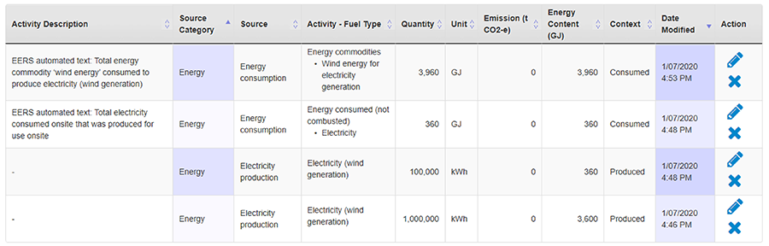](https://www.cleanenergyregulator.gov.au/PublishingImages/FAQ5.jpg)

The items in the table in order, are:

* consumption of 'wind energy for electricity generation' – automatically recorded by EERS
* consumption of electricity for use onsite – automatically recorded by EERS
* production of electricity for use onsite (wind generated) – manual entry
* production of electricity for use offsite (wind generated) – manual entry.

### What you need to report when producing charcoal

Charcoal is produced by consumption of wood through pyrolysis. The low oxygen pyrolysis environment means that regular combustion cannot occur, leading to the transformation of the wood through decomposition.

Within NGER, wood can fall under one of 2 different fuel types listed within Schedule 1 of the NGER Regulations depending on the moisture content:

* dry wood
* green and air-dried wood.

The definitions for 'dry wood' and 'green and air-dried wood' are listed within 1.03 of the NGER Regulations. Both fuels have a clause within their definition, that the fuel 'is combusted to produce heat or electricity'.

When wood is consumed for a purpose other than to produce heat or electricity, the wood does not meet the definitions listed for either 'dry wood' or 'green and air dried wood', and its consumption does not need to be reported.

Therefore, if wood is consumed for a purpose other than to produce heat or electricity, such as to produce charcoal, then its consumption does not need to be included within your report.

There is no prescribed definition of charcoal within the NGER legislation. Therefore, common usage should apply when classifying the resulting product.

Production of charcoal must be reported as per the energy production requirements as listed within Part 6.1 of the NGER Measurement Determination.

### Choosing the correct fuel to report

Energy production and consumption must be reported using fuel types listed within Schedule 1 of the NGER Regulations. Many of the fuels listed in Schedule 1 of the NGER Regulations are defined within 1.03 of the NGER Regulations and section 1.8 of the Measurement Determination. Common usage and dictionary definition should be used when not otherwise defined within the NGER legislation.

In instances where a novel fuel or fuel mixture is being used, please read the [Reporting blended fuels, other fuel mixes, bitumen and explosives guideline](https://cer.gov.au/document_page/reporting-blended-fuels-other-fuel-mixes-bitumen-and-explosives-guideline)[24].

If you have questions regarding how, or if, a fuel should be reported within NGER, please contact us via email at [cer-nger-reporting@cer.gov.au](mailto:cer-nger-reporting@cer.gov.au) or phone on 1300 553 542.

### Reporting equipment or component use

Many of the 'Matters to be identified' for the new 2021-22 oil and gas sources require reporting of the number and average hours of operation for particular 'types of equipment' or 'types of components'. In cases where equipment or components are used for multiple reportable activities, reporters must do one of the following:

* report all hours against one of the activities
* distribute the total hours across the different sources.

If you are distributing the hours, you must keep records describing how you determined how the usage should be split.

It is important that all hours, and therefore emissions, are included but not counted twice.

### Reporting average hours of operation of equipment or components

'Average hours of operation of equipment (or component) type X' is to be interpreted as the average number of hours a given equipment or component type is operated over the entire NGER reporting year. Do not include hours when equipment or components may be used for non-NGER reportable activities or not in use due to maintenance or other reasons.

### Monitoring equipment isn't functioning correctly

You are required to [notify the CER](https://cer.gov.au/about-us/contact-us)[25] when measuring equipment is not functioning:

* if the equipment down time in a year is 6 weeks (42 days) or less, each day of the down time fuels and emissions can be estimated consistent with the principles of section 1.13 of the NGER Measurement Determination.
* if the down time exceeds 6 weeks in a year, and within 6 weeks after the day when down time exceeds 6 weeks, the registered controlling corporation or responsible emitter must inform the CER in writing of the following:
  + the reason why down time is more than 6 weeks
  + how the corporation or entity plans to minimise down time
  + how emissions have been estimated during the down time.

This 'down time' requirement is applicable to all emissions sources. It is of particular relevance to thermal power stations conducting continuous monitoring of fuel quantities (for example, flow meters or weightometers under Methods 1, 2 and 3) and composition under Method 2 or 3.

If you have used Method 2, 3 or 4 to estimate emissions and the down time exceeds 6 weeks in a year, the CER may require you to estimate emissions using Method 1 instead.

Note that if you are reporting under Method 4 using continuous emissions monitoring (CEM), the CEM equipment must operate for more than 90% of the period for which it used to monitor an emission.

### Simplify your reporting or data collection

The NGER legislation contains a range of special provisions that apply in certain circumstances which can help to reduce the reporting burden for registered corporations. Reporters are encouraged to consider whether you qualify for any of the following options.

Aggregating facility data - applies to section 19 and 22X reports:

* In certain circumstances, reporters can report data for a group of facilities that individually have not triggered the facility threshold, as an aggregated amount. That is, instead of reporting data for each facility, an aggregated amount for several facilities may be reported.
* When reporting facility data in this way, a registered corporation also has the option of aggregating the data by business unit, rather than by group member with operational control. A 'business unit' is a unit that is recognised by a registered corporation as having administrative responsibility for one or more facilities of the corporation (2.01A of the NGER Regulations).

Percentage reporting - applies to section 19 and 22X reports:

* In certain circumstances, very low levels of greenhouse gas emissions, energy consumption and energy production from one or more facilities may be reported as a percentage estimate of the reporter's total emissions and energy.

Incidental reporting - applies to section 19, 22G and 22X reports:

* In certain circumstances, greenhouse gas emissions, energy consumption and energy production figures for a facility will be classified as 'incidental', and reporters may provide an estimated figure, provided this estimate is consistent with principles set out in the NGER Measurement Determination.

Further information on these special provisions are in the [Guidance on aggregated facility reporting percentage estimates and incidental emissions and energy](https://cer.gov.au/document_page/guidance-aggregated-facility-reporting-percentage-estimates-and-incidental-emissions-and-energy)[26].

Optional reporting of small amounts of fuel combustion, energy production and electricity consumption - applies to section 19, 22G and 22X reports:

* Reporting of small amounts of emissions and energy from the combustion of solid, gaseous and liquid fuel is optional, provided they fall below specified thresholds.

Further information on the thresholds below which low-level activities do not need to be reported are in the [Reporting energy production and consumption guideline](https://cer.gov.au/document_page/reporting-energy-production-and-consumption-guideline)[27] and the [Estimating emissions and energy from electricity production and consumption guideline](https://cer.gov.au/document_page/estimating-emissions-and-energy-electricity-generation-transmission-and-distribution-sectors).[28]

### What you should do if your emissions are counted twice

The fugitive emissions sources for oil and gas added from the 2021–22 reporting year have the potential to cause emissions to be double counted. The sources are designed to comprehensively cover the emissions from a facility. Your activities may meet the definition of multiple source categories. In this case, the emissions from these activities should only be reported once under a single source, to avoid double counting.

Reporters should assign the emissions to a single source and record their reasoning in their basis of preparation documents. CER expects that these assignments are consistent between reporting years. If there is a change in how the emissions are assigned to a source, CER expects that this decision is recorded for record keeping purposes as per section 22 of the NGER Act.

### Avoid non-compliance with NGER legislation by using a Basis of Preparation (BoP)

As per section 22 of the NGER Act, a registered corporation must keep records that:

1. allow it to report accurately under the NGER Act
2. enable the CER to ascertain whether the corporation has complied with its obligations under the NGER Act.

Your records must be kept in a form that is easily and quickly accessible for inspection and audit. You must keep the records for 5 years from the end of the financial year in which the relevant activity took place.

An Executive Officer (EO) must approve the NGER report that is submitted to the CER. The EO must also confirm that the NGER report has been prepared in accordance with the NGER legislation and that the general principles have been appropriately applied. It is up to you to determine the appropriate processes and internal controls to ensure that a compliant report is submitted on time and supported by adequate records. The processes should be documented and repeatable.

A Basis of Preparation (BoP) records the methodology by which an NGER report has been prepared. The use of a BoP gives you the ability to provide assurance over the data reported to the CER and minimises the likelihood of non-compliance with the record keeping requirements of the NGER Act.

While the structure of your BoP depends on your individual circumstances, a typical BoP would include your justifications and explanations of:

* assessment of operational control (including contractors)
* facility boundaries
* reportable activities and associated emissions and energy sources
* method selection and how you met the requirements of the method
* the sampling strategy for methods that involve sampling, including how the strategy:
  + meets standards for duration and frequency to enable reliable estimates
  + addresses bias, especially relating to under or over-stating emissions when compared to the likely true value.
* quality assurance and review processes, including:
  + written procedures
  + adjustments made for changes in legislation
* key personnel roles and responsibilities, such as those involved in the activities and producing the report (including consultants and experts)
* record keeping.

We encourage you to submit your BoP (or summary) with each year’s NGER report to clarify your key assumptions and decisions.

Submitting additional documents to support your NGER report submission is particularly helpful when the NGER data submitted in EERS does not tell the full story. For example, there may be a significant reduction in emissions from a particular source compared to the previous year, which may be explained by a three-month shut down for maintenance or a temporary shut down due to a natural disaster.

The submission of a BoP with an NGER report will reduce the need for us to contact you to clarify the information included in your NGER report.

### How to report scope 2 emissions if your electricity invoice includes ‘unaccounted for energy’

Read section 6.1.4 of the [Estimating emissions and energy from electricity production and consumption guideline](https://cer.gov.au/document_page/estimating-emissions-and-energy-electricity-generation-transmission-and-distribution-sectors)[29] for more information on reporting scope 2 emissions if your invoice includes ‘unaccounted for energy’.

### Simulated Natural Gas

Simulated Natural Gas (SNG), also known as ‘Synthetic Natural Gas’, is a mixture of vaporised ‘liquefied petroleum gas’ (LPG) and compressed air. SNG cannot be considered a ‘blended fuel’ because air is not a biogenic carbon fuel. SNG cannot be considered a ‘fuel mix’ because air is not a fossil fuel.

SNG is not separately listed as a fuel under NGER legislation. SNG can be categorised under Schedule 1 of NGER Regulations as ‘27 - Gaseous fossil fuels other than those mentioned in item 17 to 26’. The energy content and emission factor for this fuel is listed in Schedule 1 of the NGER Measurement Determination. When reporting the energy quantity of SNG, the reporter must consider the entire volume of air and LPG present.

To report the production and use of SNG, a reporter should include the following:

* energy consumed (without combustion) of the quantity of LPG used to make SNG during the reporting year
* energy production of ‘27 - Gaseous fossil fuels other than those mentioned in item 17 to 26’ as a Secondary fuel during the reporting year. Estimate the energy of the SNG either in GJ, or cubic meters in accordance with industry practice
* energy consumed (with or without combustion) of the SNG consumed during the reporting year. The measurement criteria available are dependent on how the SNG was acquired.

If the quantity of SNG has been acquired:

* without a commercial transaction, it must be estimated using measurement criteria AAA or BBB
* through a commercial transaction then measurement criterion A, AA, or AAA must be used.

See Division 2.3.6—Measurement of quantity of gaseous fuels in the NGER Measurement Determination for more information.

### Production variable reporting for Safeguard facilities

**Production variable quantities must be reported** for a financial year where a facility:

* has scope 1 [covered emissions](https://cer.gov.au/schemes/safeguard-mechanism#covered-emissions)[30] (tCO2-e) that exceed the Safeguard threshold of 100,000 tCO2-e in a financial year
* has an [multi-year monitoring period](https://cer.gov.au/schemes/safeguard-mechanism/managing-excess-emissions#apply-for-a-multi-year-monitoring-period)[31] covering the relevant financial year
* is an ‘eligible facility’ as defined under section 58B of the [Safeguard Rule](https://www.legislation.gov.au/F2015L01637/latest/versions)[32]

**Production variable quantities do not need to be reported** for a financial yearif where a facility:

* has scope 1 covered emissions that do not exceed the safeguard threshold
* is not an ‘eligible facility’ as defined under section 58B of the [Safeguard Rule](https://www.legislation.gov.au/F2015L01637/latest/versions)
* is part of a facility aggregate
* is a grid-connected electricity generator and the principal activity of the facility is electricity generation (ANZSIC code 261).

Production variable quantities are used to calculate a Safeguard facility’s [baseline emissions number](https://cer.gov.au/schemes/safeguard-mechanism/safeguard-baselines)[33] for the financial year, or part of a financial year if applicable.

Production variable quantities must be measured consistently with the requirements of each production variable in Schedule 1 of the [Safeguard Rule](https://www.legislation.gov.au/F2015L01637/latest/versions).

Production variables will be pre-filled based on production variables reported on in the previous financial year.

If there was no production of a production variable in a financial year enter zero.

If you need to add a production variable for a Safeguard facility:

* *and the facility produced a production variable(s) from 2017-18 to 2021-22 and does not have an* [*emissions-intensity determination*](https://cer.gov.au/schemes/safeguard-mechanism/safeguard-baselines#standard-baseline)[34] – add that production variable(s) in the form and select ‘historical’ production variable type.

A production variable is ‘historical’ if it was produced by the facility during any of the historical financial years (that is, 2017-18 to 2021-22) and it was not non-commercial production for any historical financial year.

Non-commercial production involves production where the product is not produced for sale but is only produced in the course of testing and pilot activities. Examples include production where the facility is in exploration phase, plant commissioning, piloting or testing of a new product.

* *and the facility did not produce a production variable(s) from 2017-18 to 2021-22 but commenced production in 2023-24* – add that production variable(s) in the form and select ‘new’ production variable type.
* *and the facility is a landfill facility* – select the ‘NLCH4’ production variable and then provide the quantity.

Further information on production variables including determining if a production variable is applicable to your facility, product specifications and measurement requirements can be found in Schedule 1 of the [Safeguard Rule](https://www.legislation.gov.au/F2015L01637/latest/versions)[35] and the [Safeguard Mechanism Document](https://www.dcceew.gov.au/climate-change/publications/safeguard-mechanism-document)[36].

1. https://www.legislation.gov.au/Series/C2007A00175
2. https://www.legislation.gov.au/Series/F2008L0223
3. https://www.legislation.gov.au/Series/F2008L02309
4. https://cer.gov.au/schemes/national-greenhouse-and-energy-reporting-scheme
5. https://cer.gov.au/schemes/national-greenhouse-and-energy-reporting-scheme/report-emissions-and-energy/amendments
6. https://onlineservices.cer.gov.au/
7. https://cer.gov.au/document_page/emissions-and-energy-reporting-system-navigation-guide
8. https://cer.gov.au/schemes
9. https://cer.gov.au/document_page/nger-online-services-user-guide
10. https://cer.gov.au/document_page/nger-online-services-user-guide
11. https://cer.gov.au/schemes/national-greenhouse-and-energy-reporting-scheme/assess-your-obligations#nger-thresholds
12. https://cer.gov.au/document_page/emissions-and-energy-reporting-system-navigation-guide
13. https://cer.gov.au/about-us/contact-us
14. https://cer.gov.au/document_page/emissions-and-energy-reporting-system-navigation-guide
15. https://www.latlong.net/
16. https://cer.gov.au/document_page/nger-online-services-user-guide
17. https://cer.gov.au/document_page/nger-online-services-user-guide
18. https://cer.gov.au/document_page/emissions-and-energy-reporting-system-navigation-guide
19. https://www.legislation.gov.au/Series/F2008L02309
20. https://cer.gov.au/document_page/reporting-blended-fuels-other-fuel-mixes-bitumen-and-explosives-guideline
21. https://cer.gov.au/document_page/reporting-energy-production-and-consumption-guideline
22. https://cer.gov.au/document_page/estimating-emissions-and-energy-electricity-generation-transmission-and-distribution-sectors
23. https://cer.gov.au/document_page/estimating-emissions-and-energy-electricity-generation-transmission-and-distribution-sectors
24. https://cer.gov.au/document_page/reporting-blended-fuels-other-fuel-mixes-bitumen-and-explosives-guideline
25. https://cer.gov.au/about-us/contact-us
26. https://cer.gov.au/document_page/guidance-aggregated-facility-reporting-percentage-estimates-and-incidental-emissions-and-energy
27. https://cer.gov.au/document_page/reporting-energy-production-and-consumption-guideline
28. https://cer.gov.au/document_page/estimating-emissions-and-energy-electricity-generation-transmission-and-distribution-sectors
29. https://cer.gov.au/document_page/estimating-emissions-and-energy-electricity-generation-transmission-and-distribution-sectors
30. https://cer.gov.au/schemes/safeguard-mechanism#covered-emissions
31. https://cer.gov.au/schemes/safeguard-mechanism/managing-excess-emissions#apply-for-a-multi-year-monitoring-period
32. https://www.legislation.gov.au/F2015L01637/latest/versions
33. https://cer.gov.au/schemes/safeguard-mechanism/safeguard-baselines
34. https://cer.gov.au/schemes/safeguard-mechanism/safeguard-baselines#standard-baseline
35. https://www.legislation.gov.au/F2015L01637/latest/versions
36. https://www.dcceew.gov.au/climate-change/publications/safeguard-mechanism-document