
Online Services user guide
National Greenhouse and Energy Reporting (NGER) Scheme
Version 2.0 May 2026






Contents
What is Online Services? 4
How to create an Online Services account 4
Accessing EERS via Online Services 4
Keeping details up to date in Online Services 5
Account types 5
EERS roles and permissions 5
Available roles 5
Primary contact 5
NGER contact 5
NGER Executive Officer 6
Available permissions 6
Admin 6
Basic 6
Forms 7
NGER 7
How to view and manage users 8
How to switch accounts 8
How to set a default organisation 10
How to add a user 11
How to give permissions 16
How to assign a Primary or NGER contact role 18
How to remove a user 20
Manage Organisation Details 22
How to update the organisation’s address 22
NGER Reports 23
Manage User Profile 24
Account Security Details 25
Submitting registration and deregistration applications 25
NGER Controlling Corporation Registration form 27
1. Before you start 27
2. Organisation Details 27
3. Foreign Corporation 30
4. Executive Officers and Organisation Contacts 31
5. Affected Group Entity Details 32
6. Eligibility Details 33
7. Declaration 34
NGER Responsible Emitter Registration 38
5. Controlling Corporation Details 38
NGER Controlling Corporation Deregistration form 41
1. Before you start 42
2. Applicant details 43
3. Deregistration details 44
4. Sign and submit 46
Support 47

What is Online Services?
Online Services is the secure gateway where our clients access systems including the:
- Australian National Registry of Emissions Units (ANREU)
- Emissions and Energy Reporting System (EERS)
- Renewable Energy Certificates (REC) Registry.
For National Greenhouse and Energy Reporting (NGER) participants, Online Services is necessary to:
- access EERS to enter data and submit NGER reports
- view and manage NGER user permissions for organisations
- access forms and submit applications.

How to create an Online Services account
Select the ‘sign-up now’ link from the Online Services login page and follow the steps to complete the process. To ensure secure login, Multi-Factor Authentication is enabled and requires an additional authentication method (email, text or phone call) after entering your username and password.
A new user will then need to be added to the organisation’s account by personnel with the appropriate permissions. Once complete, EERS can be accessed via the ‘NGER reports’ link from the ‘Manage’ dropdown menu in the Online Services Dashboard.

Accessing EERS via Online Services
‘As part of the initial NGER registration process for new controlling corporations, the nominated Executive Officer and NGER contact are automatically given:
- access to the organisation’s NGER Reports
- the ability to edit the company’s details and corporate structure in EERS
- the ability to link additional users via the self-service functionality.
Once registered, permissions can be changed in Online Services using the self-service function. Refer to How to give permissions. It is important this is managed before staff changes occur. For further support on managing access to EERS, please email us at cer-nger-reporting@cer.gov.au.
Once the right persons have the correct permissions to the organisation in Online Services, they can access EERS. Refer to our Emissions and Energy Reporting System navigation guide to help you navigate EERS in Online Services.

Keeping details up to date in Online Services
In addition to granting users the right permissions in EERS, we send the NGER contact news about reporting requirements, tips for reporting and important dates.
Keeping contact information up to date is particularly important when staff move on, or there are other changes within the organisation. The NGER contact should manage these updates, however, in instances where no-one else at the organisation can be contacted, we will contact the Executive Officer.

Account types
In Online Services a user is given an ‘individual’ account. The user can then associate (link) to one or more organisations. For NGER purposes, the user will primarily be performing actions on behalf of an organisation. It is important you are ‘acting on behalf of’ the organisation account to assign roles or permissions. This can be done by either switching the account when first logging in to Online Services, or setting a default to be taken to the organisation account when logging in. See how to switch accounts.
You may also link with an individual and ‘act on behalf’ of their account, but this has limited functions in the NGER scheme. For example, while acting on behalf of another individual, such as the Executive Officer of an organisation, the only function you can perform is to update their profile. You will not be able to submit an application or report while acting on their behalf. The individual will need to invite you to their account. See How to add a user for instructions.

EERS roles and permissions
Online Services has several roles and permissions that allow users to perform different functions. When a user’s details are added or updated, they can be assigned one or more ‘relationships’ that best describe their connection with the Clean Energy Regulator and the various schemes, such as employee, agent and Executive Officer. The main roles associated with NGER are described below.

Available roles

Primary contact
This role is useful when an organisation participates in several of the CER’s schemes and allows one person to be the main contact for an organisation.
See How to assign a Primary or NGER contact persons.

NGER contact
The NGER contact is the first point of contact in relation to an organisation’s NGER reporting obligations. This person will also be sent general EERS/NGER information and updates from us. Because this role is vital for communication between us and an organisation, this role cannot be unassigned (left blank when an existing user leaves the organisation) in Online Services.
An organisation can only have one NGER contact at a time. Assigning this role to a new user will automatically remove this role from the existing user.
The NGER contact has permissions (see available permissions) to perform any action within an organisation’s Online Services account, except ‘submit report’.
See How to assign a Primary or NGER contact persons.

NGER Executive Officer
A person assigned the role of Executive Officer must meet the definition in section 7 of the National Greenhouse and Energy Reporting Act 2007 (NGER Act). An Executive Officer is defined as a:
- Director
- Chief Executive Officer
- Chief Financial Officer
- Secretary (i.e. a company secretary).
The contact details of the NGER Executive Officer stored in Online Services are included in the NGER Report when submitted each year, so it is important that the organisation maintains a valid NGER Executive Officer and that their contact details remain up to date.
The NGER report must be submitted by either an NGER Executive Officer or another user who has specific written permission from an Executive Officer to submit the report on behalf of the organisation. Such written permission should be retained within the organisation in case of an audit.
Executive Officers can also act as the NGER Contact. It is recommended that organisations establish more than one Executive Officer role in EERS for greater flexibility and assurance the company will be able to submit NGER reports by the due date.
An Executive Officer should be allowed all permissions (see available permissions) in Online Services, but at a minimum must have the ‘submit report’ permission to submit NGER reports on behalf of an organisation.
See How to add a user to update Executive Officers for an organisation and Managing user profile to update contact details.

Available permissions
New users added to an organisation in Online Services and EERs will need permission to complete tasks. The permissions are described below.

Admin
Admin permissions apply to all schemes an organisation participates in.
There are two types of Admin permissions:
- Edit account details allows the user to edit the details of the organisation such as company address.
- Manage Users allows the user to:
  - manage other users for the organisation including adding or removing users
  - allocate roles to users
  - allocate permissions to different people in an organisation.
When a new organisation is registered with the NGER scheme, the designated NGER contact and NGER Executive Officer are given full Admin permissions.

Basic
Basic permissions allow you to control the personnel other users can see:
- View all users allows the user to view all of the users of the organisations, but not the Online Services permissions they have.
- View user permissions allows the user to view all users of the organisation and the Online Services permissions they have.
Basic permissions do not allow the user to update or change any user permissions.

Forms

Submissions
These permissions allow users to view submissions list, edit or delete draft submissions.

NGER

View corporate structure
This permission allows users to view the corporate structure but not make any changes to the corporate structure.

Edit corporate structure
This permission allows a user to change the corporate structure by adding or removing group members and facilities.

View report data
This permission allows a user to view the organisation’s report but not edit or generate a report.

Edit report data
This permission allows a user to enter and edit report data but not generate a report.

Generate report
This permission allows a user to generate a report prior to final submission but not submit the report.

Submit report
This permission allows a user to submit the report and it should be granted to the Executive Officer. If other users are allowed to submit the report on behalf of the organisation, the organisation should have a written record of this permission being provided to the appropriate user.

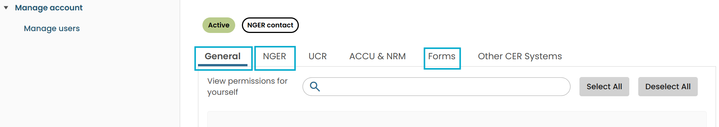

How to view and manage users

How to switch accounts
Logging into Online Services will open the Online Services Dashboard. A pop-up box will appear asking if you want to ‘Switch account’ or ‘Continue as myself’. You will need to switch account to act on behalf of an organisation to access their NGER/EERS data.
Select the organisation you wish to view, edit, or act on behalf of. You can set a default so when you login to Online Services, you are immediately taken to an organisation, and the pop-up box does not appear.
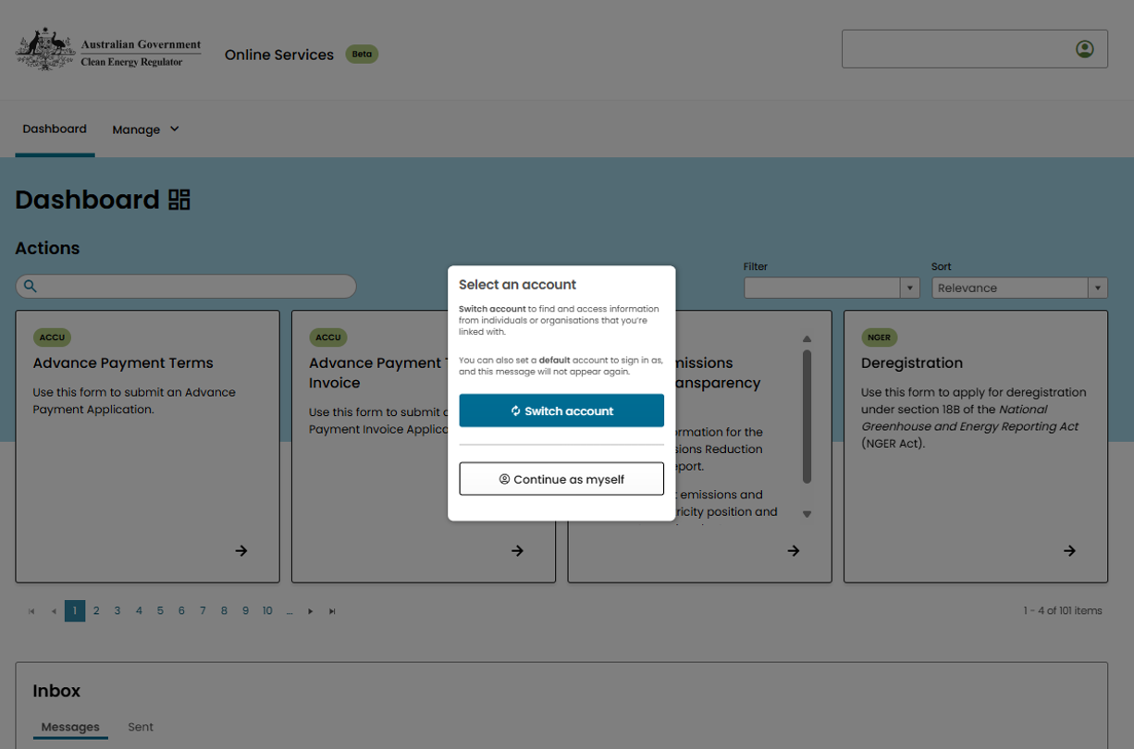
This function can also be performed by clicking the white profile menu box in the top right corner and from the drop-down menu, selecting ‘Switch account’. Select the account you want to view, edit, or act on behalf of. A green pop-up alert appears confirming this change and the profile menu will read ‘You’re acting on behalf of…’
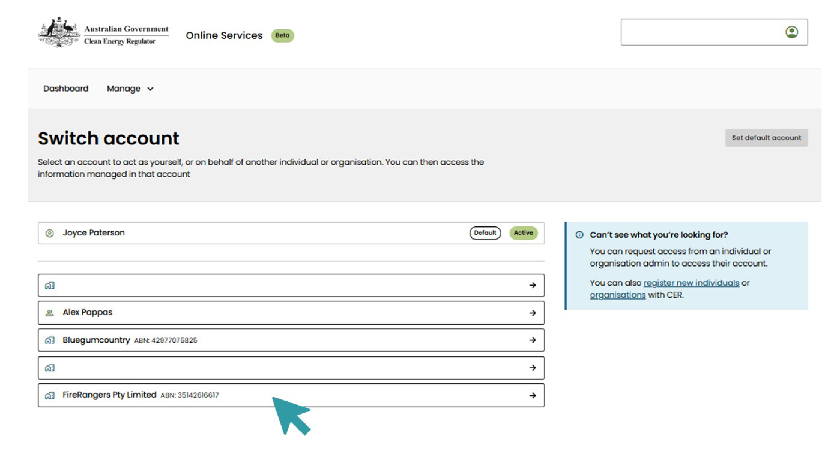
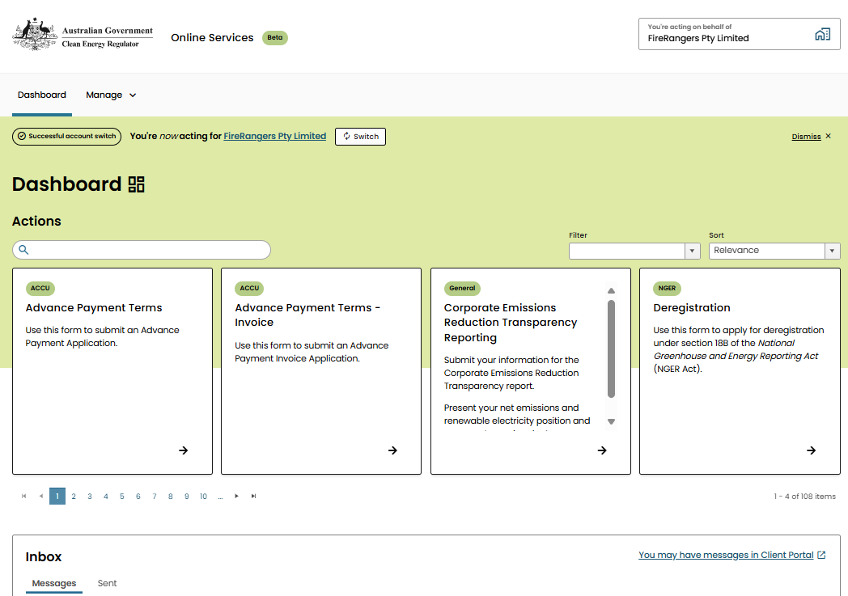

How to set a default organisation
You can select one organisation to open automatically when you sign into Online Services by choosing it as your ‘default account’. This means every time you log in, you will be automatically acting on behalf of this organisation.
Go to the ‘Switch account’ page and select the grey ‘Set default account’ box at the top-right of the screen. A pop-up text box will ask you to select which account you wish to make default, and then select ‘Confirm’.
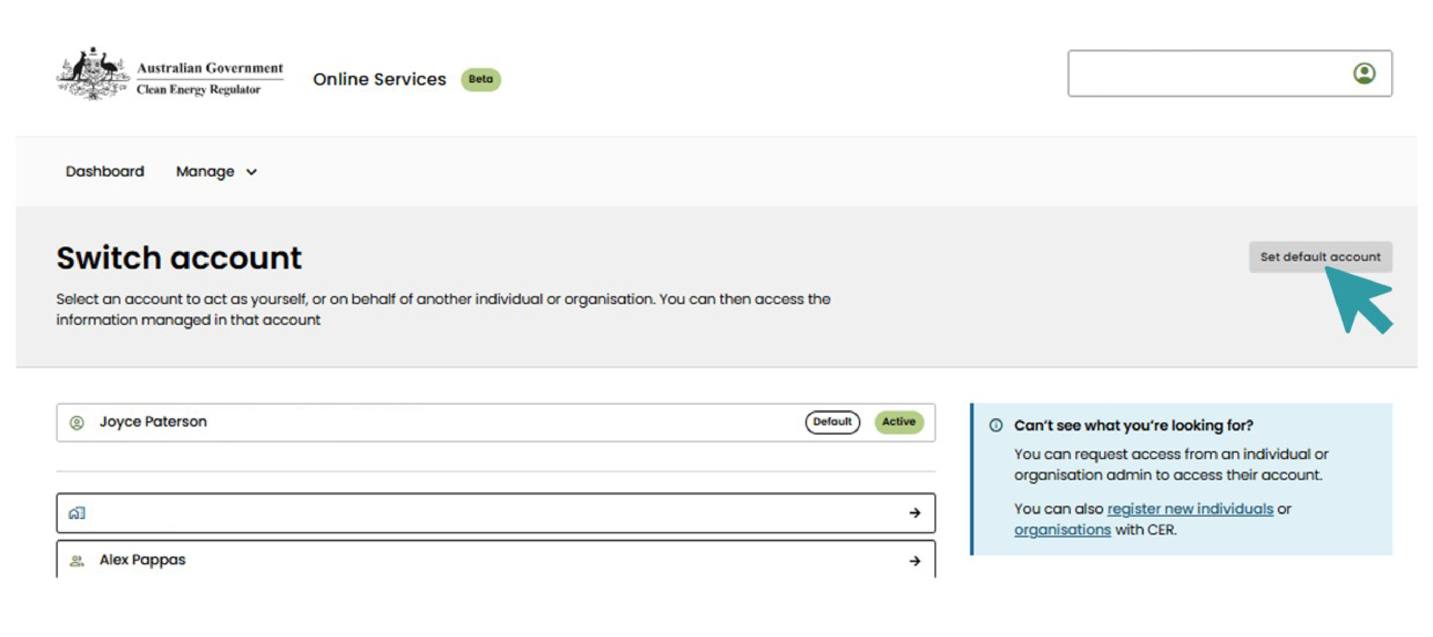

How to add a user
Anyone with the ‘manage users’ permission can add a user to the organisation, however, that user must first set up an Online Services account.
To add a user, go to the Online Services Dashboard, click on the white Profile Menu and select ‘Manage Organisation’ from the drop-down menu.
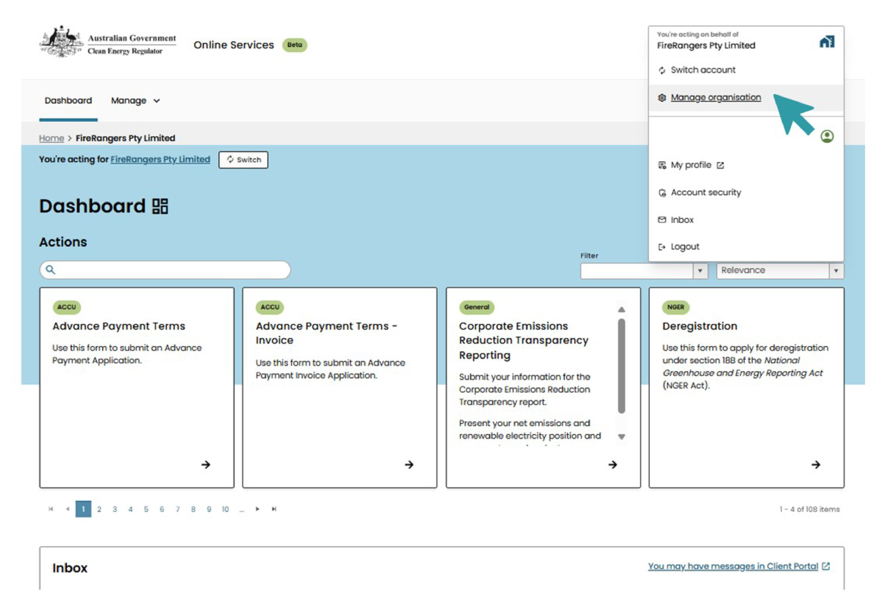

From the menu on the left side of the screen, select ‘Manage users’.
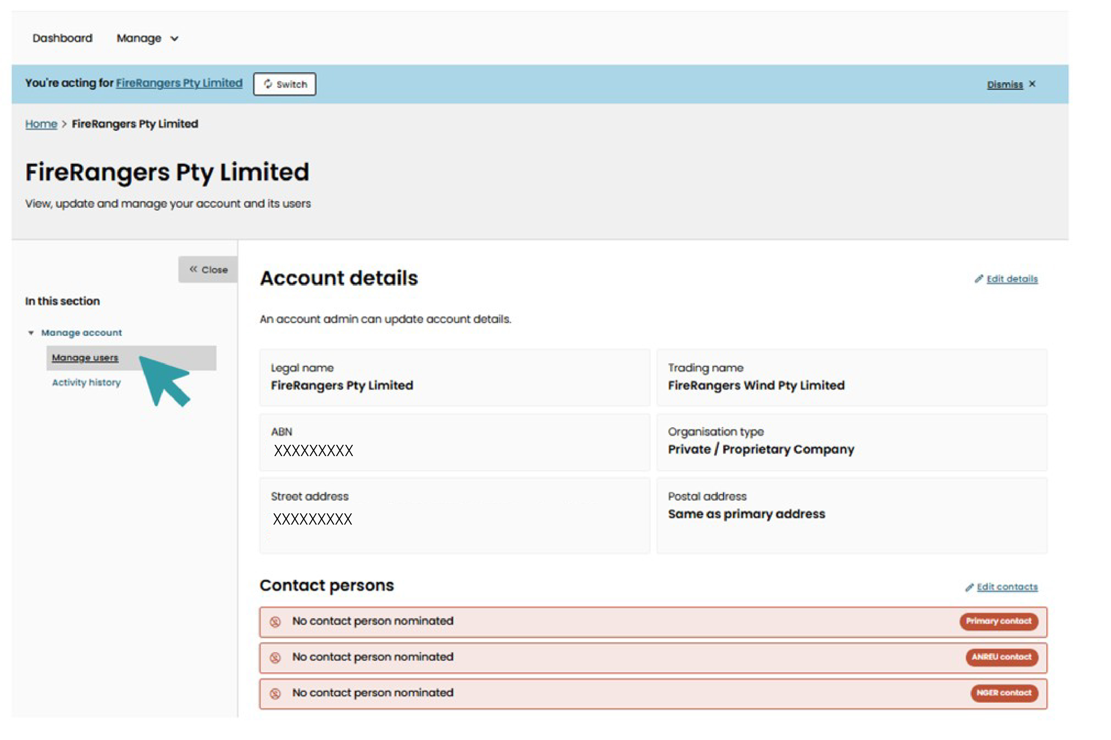
Then select the grey ‘Add user’ button to the right of the screen.
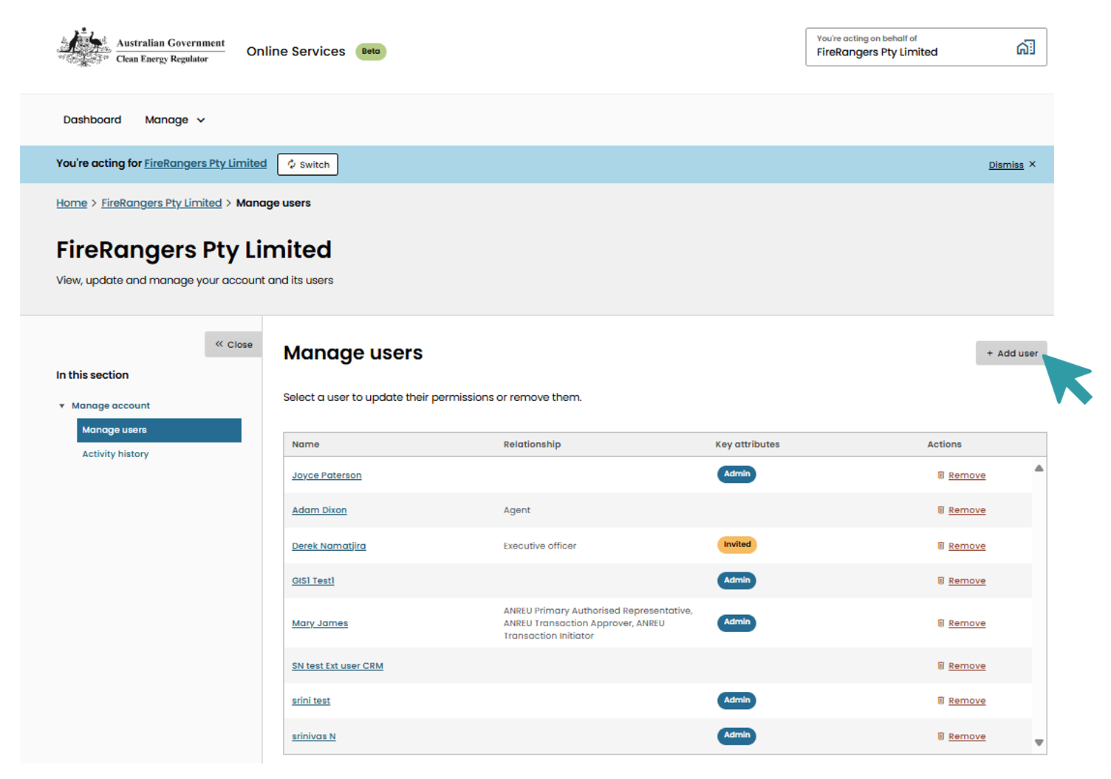
Type in the email address of the person you want to add, select the ‘Relationship type’, and select ‘add user’. If the user does not have an Online Services account, a red pop-up alert will appear. Ask the person to create an account following the steps described in the how to create an Online Services account section.

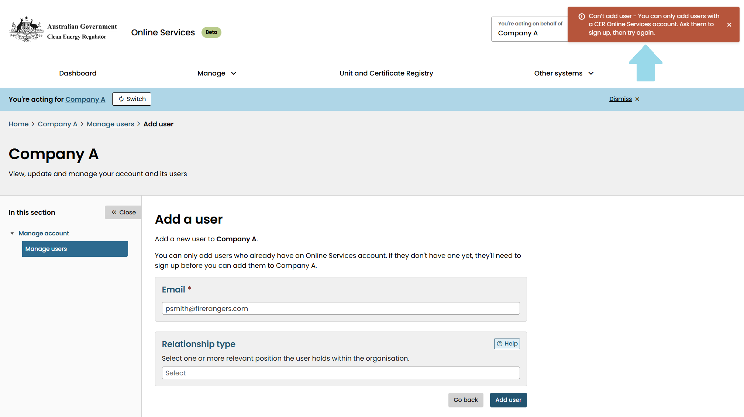
If a user has an Online Services account and is already linked to the organisation, an orange pop-up alert will appear. Continue assigning roles or other actions as normal.
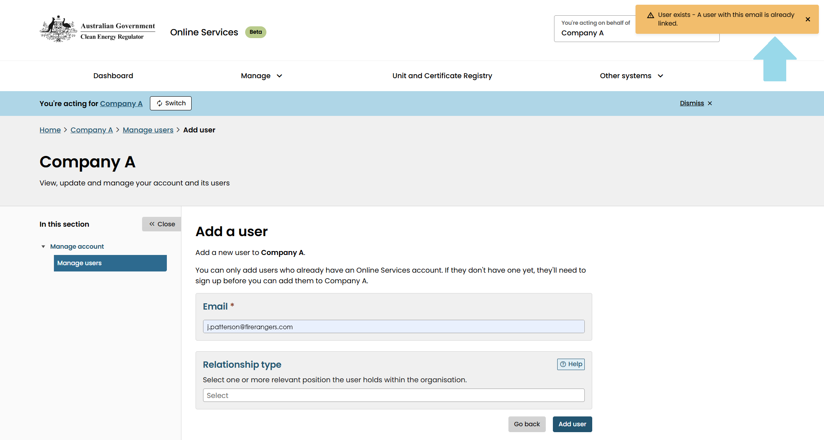

The Relationship Type list contains several roles that describe how the user will interact with our schemes and Online Services – Executive Officer, Employee or Agent. More than one type can be selected if the user has roles across other schemes.
The ‘help’ icon provides definitions of these relationships. This is where the Executive Officer is assigned – this role is required to submit an NGER report.
After the user has been invited to join the organisation’s account, they will receive an email asking them to check their Online Services inbox to accept the invitation. Their name will appear in the list of users with a yellow ‘Invited’ icon in the ‘Key attributes’ column until they accept the invitation. They can accept the invitation through their ‘Inbox’ in Online Services. Their permissions and relationship will only become active once they accept the invite.
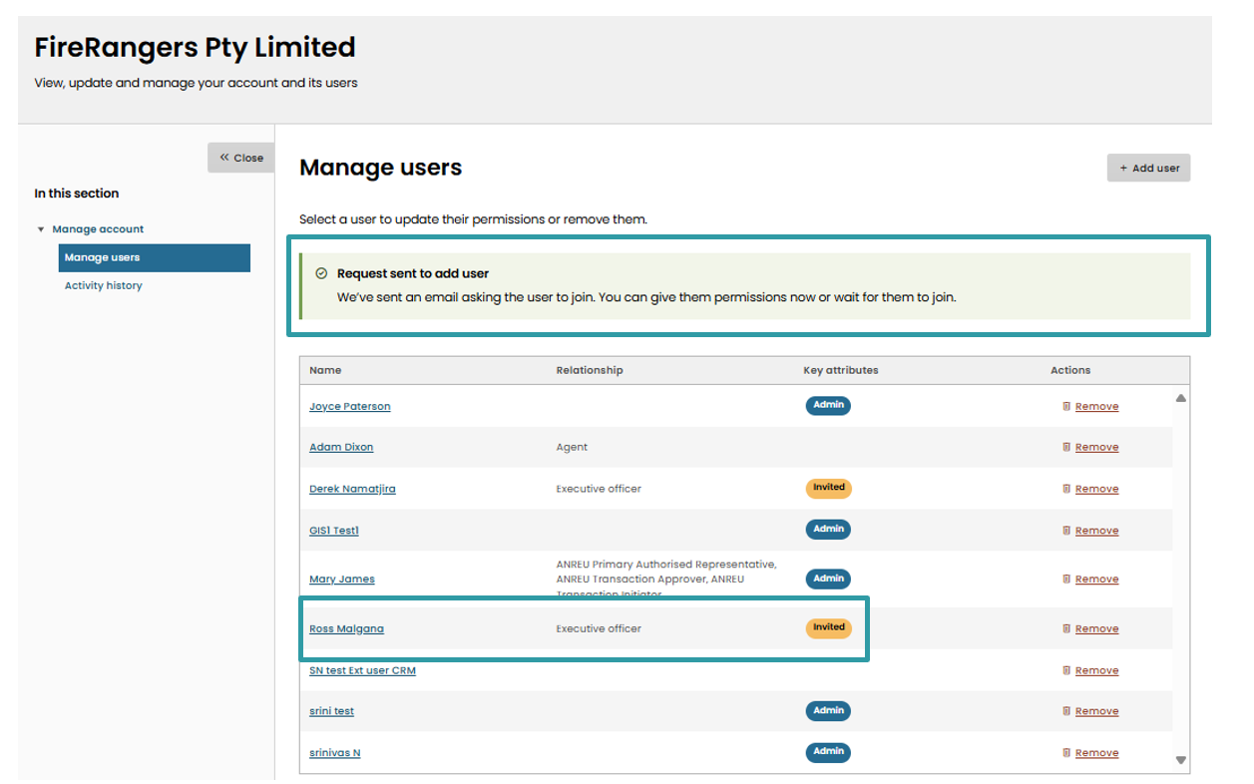

How to give permissions
A user with 'manage users’ permissions can assign roles, permissions and what other users can view. After adding a user to the organisation following the steps above, click on ‘Manage users’ and select the user’s name in the list. Assigning permissions can be done even before the person has accepted the invite but they will only become active once the invite is accepted.
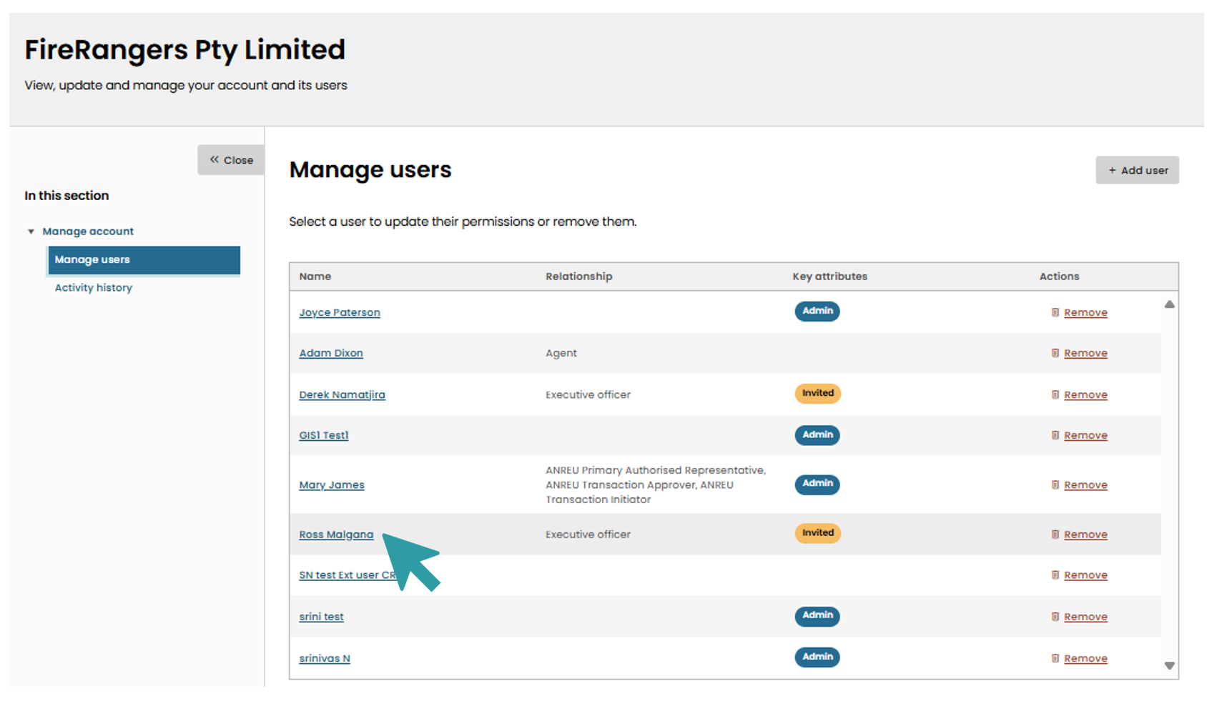
Next in the ‘General’ tab, select the appropriate permissions for the user.
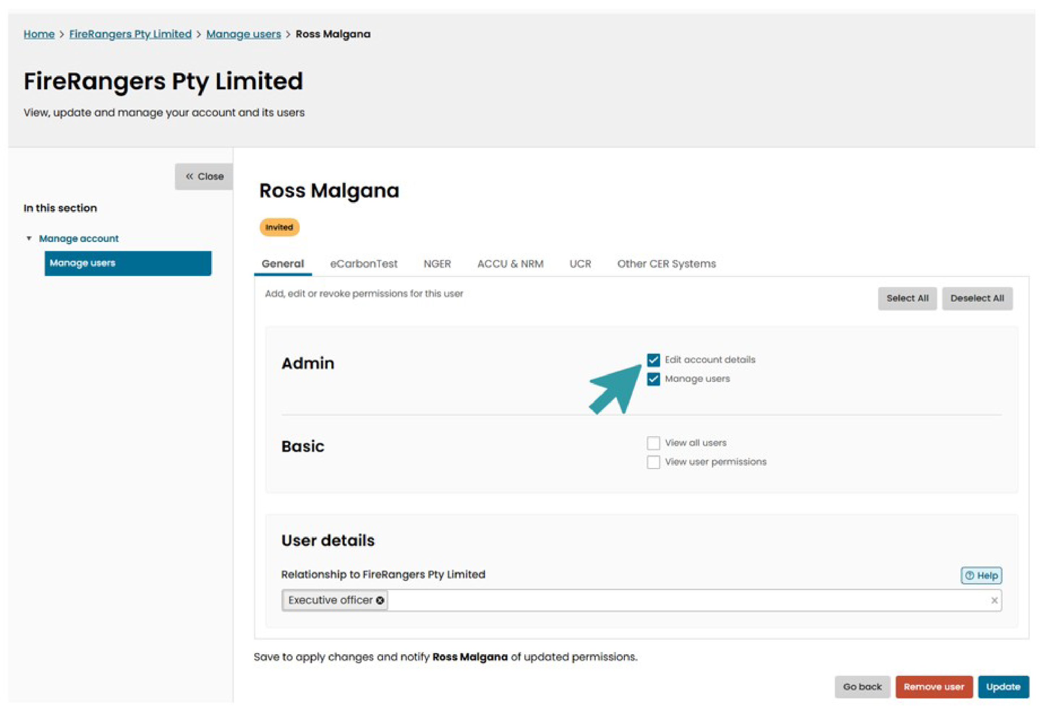
Select the NGER tab and check the boxes to allow the permissions for that user. Select ‘update’.
Note: the NGER report must be submitted by either an NGER Executive Officer or another user who has specific written permission from an Executive Officer to submit the report on behalf of the organisation.
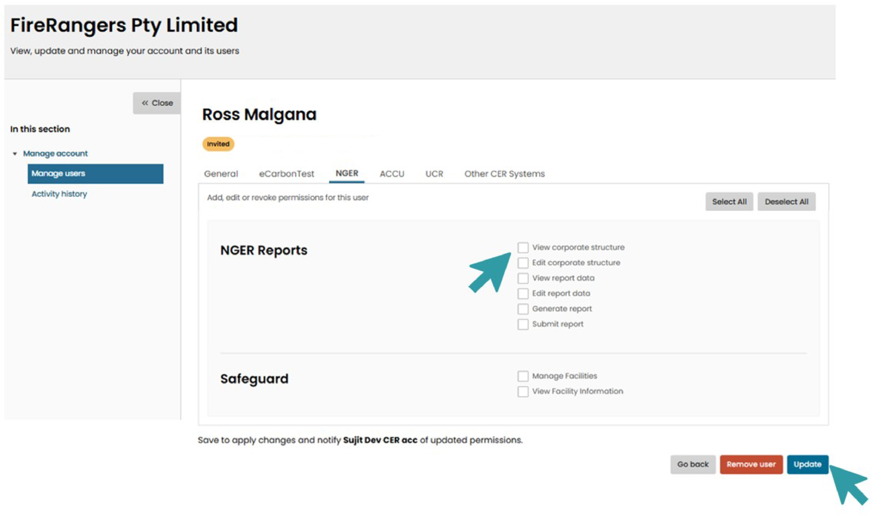
User permissions can also be changed in this section. Select the user you want to change the permission for from the ‘Manage users’ page. Go through the tabs and assign or unassign permissions as required.

How to assign a Primary or NGER contact role
A user with the ‘Manage users’ permission can add or edit a Primary or NGER contact. First, ensure the user you want to add as a contact has been added to the organisation following the steps described in How to add a user.
Select ‘Manage Organisation’ from the drop-down list under the Profile Menu. In the ‘Manage account’ page, select ‘Edit contacts’ above the Contact persons list.
Note: once assigned, the role of NGER contact cannot be blank, it can only be reassigned to new users. If a Primary or NGER Contact has not been assigned, these boxes will appear red to alert an Admin that this step needs completing.
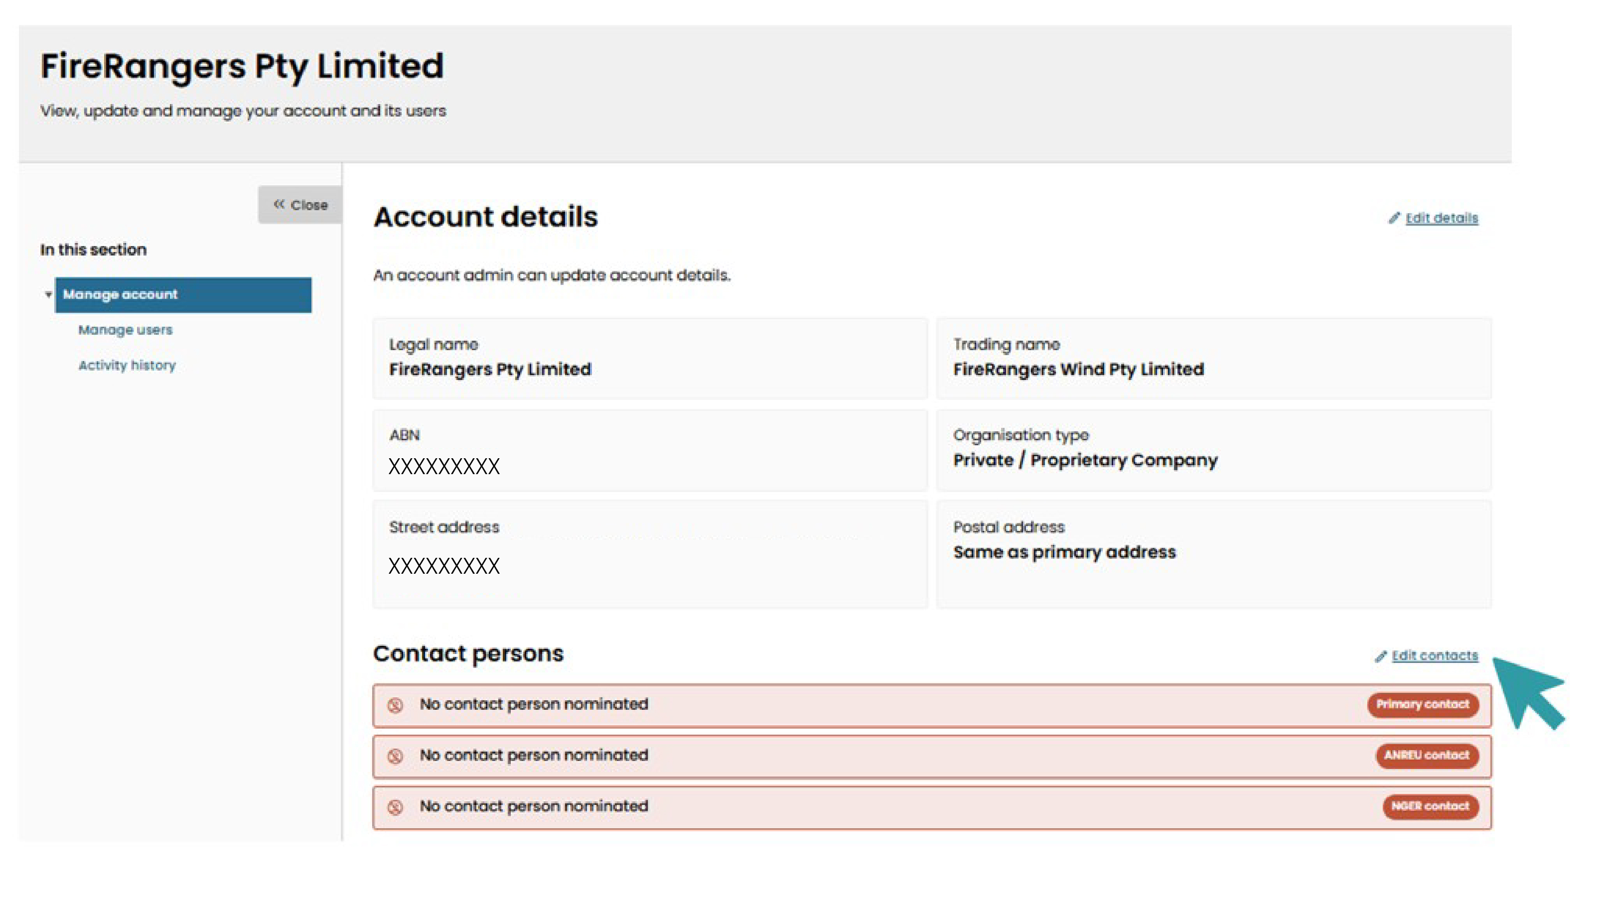

Select the drop-down arrow under the ‘NGER contact’ box. Find the name of the user you would like to add to this role. Select ‘Update’. A green pop-up alert appears to confirm the NGER contact has been updated. The user will receive a notification.
Note: the NGER contact should also have the Admin and the NGER report permissions (except submit report, unless authorised. See Submit report).
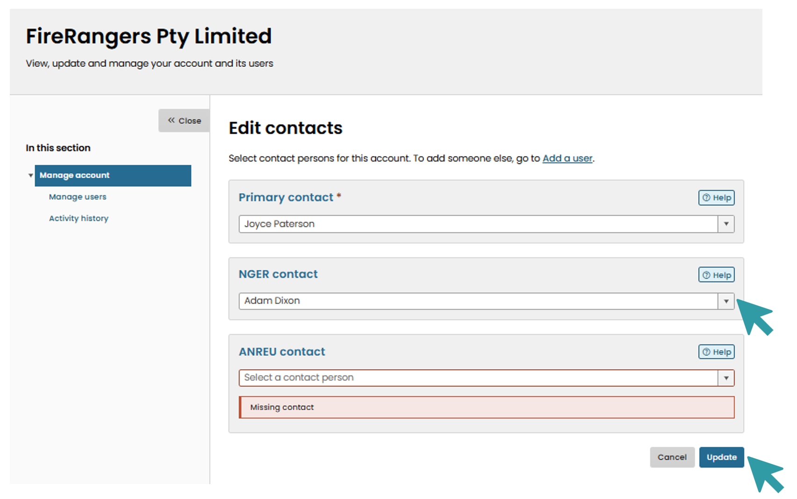

How to remove a user
Note: If a user has been assigned as a Primary or NGER contact, they must be replaced before they can be removed from the organisation. Also, if a user is the last user with admin permissions, they cannot be removed from the organisation until a new user is assigned admin permissions – refer to How to give permissions.
A user with ‘Manage users’ permission can remove other users from the organisation. To remove a user, select ‘Manage Organisation’ from the drop-down profile menu and then ‘Manage Users’.
A user can be removed from the organisation by selecting the red ‘remove’ icon next to the user’s name.
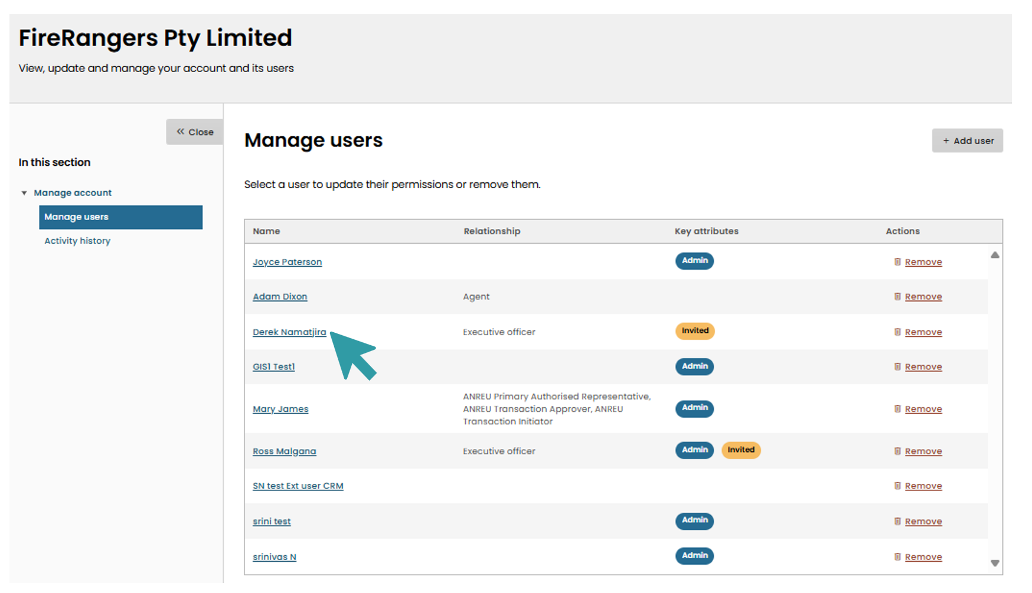

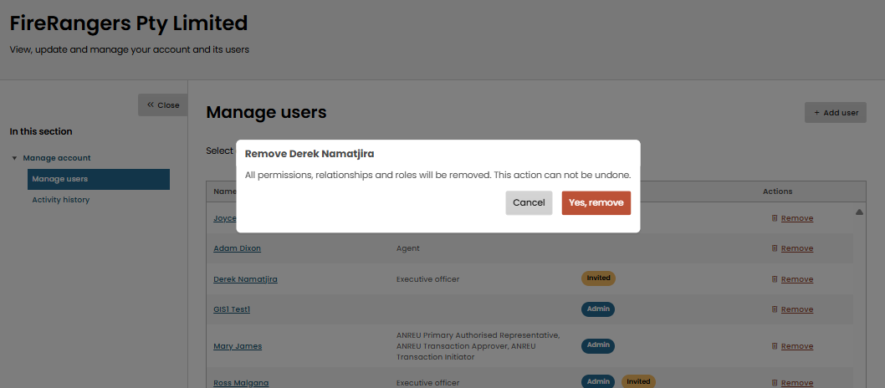

Manage Organisation Details

How to update the organisation’s address
Anyone with the ‘manage users’ permission can add a user to the organisation, however, that user must first set up an Online Services account.
To update the address of the organisation in Online Services, go to the Online Services Dashboard, click on the white Profile Menu and select ‘Manage organisation’ from the drop-down menu. This will open the ‘Manage account’ screen.
Note: changing the address will also change it in the NGER report. If the report is already generated, you will need to withdraw the report and regenerate it for the new address to flow through to the report. In some cases, you may need to log out and in again to Online Services for the change to take effect.
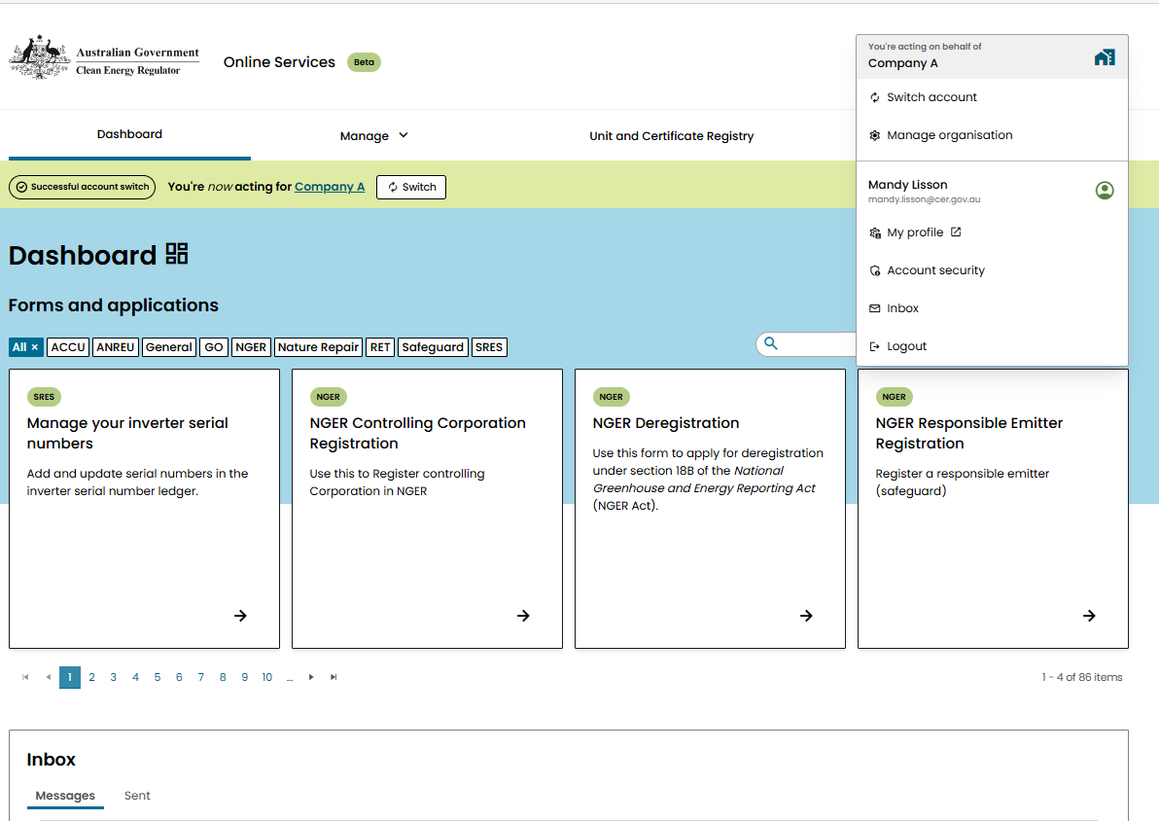

From the ‘Manage account’ page, click on the ‘Edit details’ link.
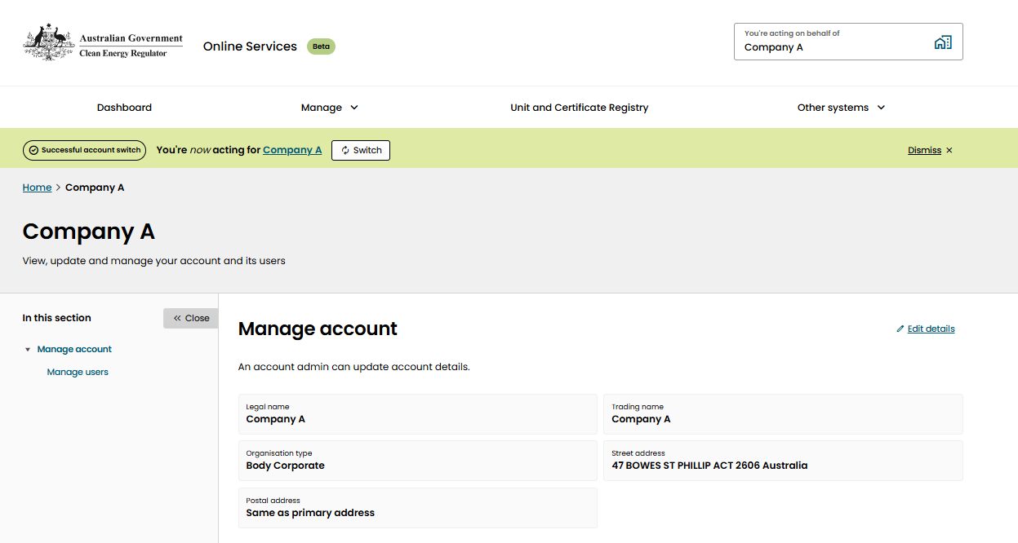
The address details for the organisation will then be editable. Start typing the new address and when the correct address appears in the list select it. Check the Postal address box if it is the same as the street address and select ‘update’.

NGER Reports
NGER Reports is the Emissions and Energy Reporting System (EERS). This is where entities can report on their greenhouse gas emissions, energy consumption and energy production required under NGER legislation.
To view and edit NGER Reports, ensure you are ‘acting on behalf of’ the relevant organisation (see How to switch accounts). From the Online Services Dashboard, select the drop-down arrow next to ‘Manage’. Select ‘NGER reports’.
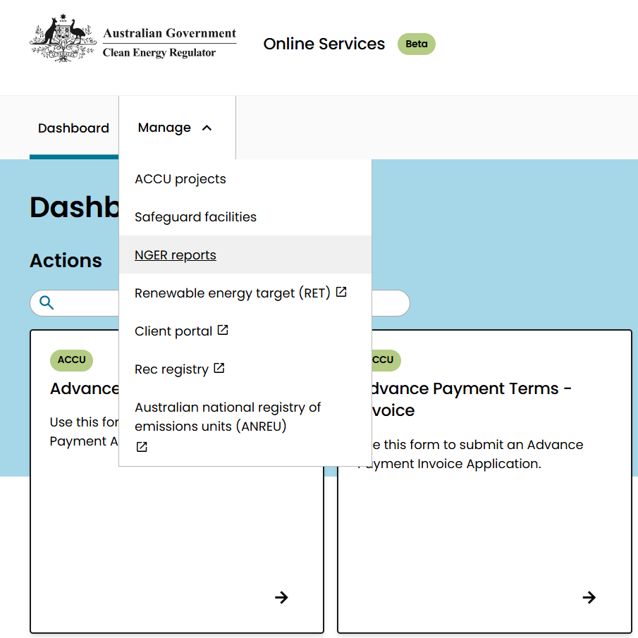

A list of available EERS workspaces for the organisation is displayed on the NGER reports landing page. Click the individual link to open the EERS workspace for that reporting period.
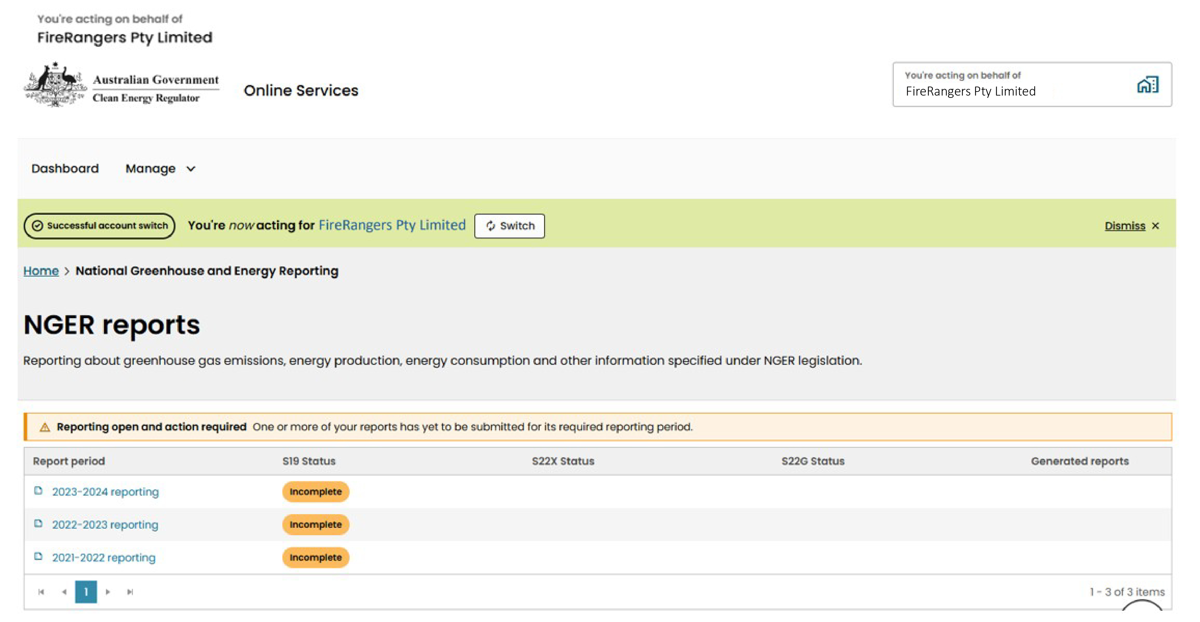
For further information on NGER reporting, please refer to the EERS Navigation Guide.

Manage User Profile
To access your personal user profile to view or update details (street address, contact phone, email address or account security details), click the profile menu box, select ‘My Profile’.
If you want to update your name or date of birth, and you have a ‘verified’ identity status, then follow the instructions to tell us about this change.
To update details, click on the ‘Edit overview’ and edit the relevant fields.
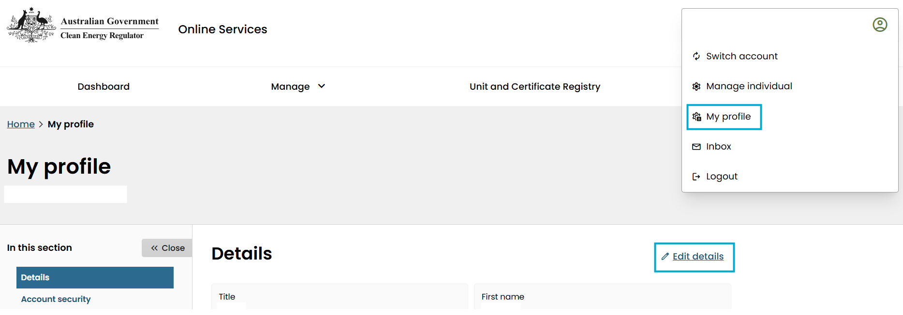

Account Security Details
To change the number where authentication texts are received when logging in, change the phone number by clicking on ‘Edit number’.
To change the password, click ‘Reset password’ and follow the prompts.
For certain schemes requiring an increased level of security, authenticator apps are required. You can add Online Services as a new service to these apps by generating a QR code. This is not required for the NGER scheme.
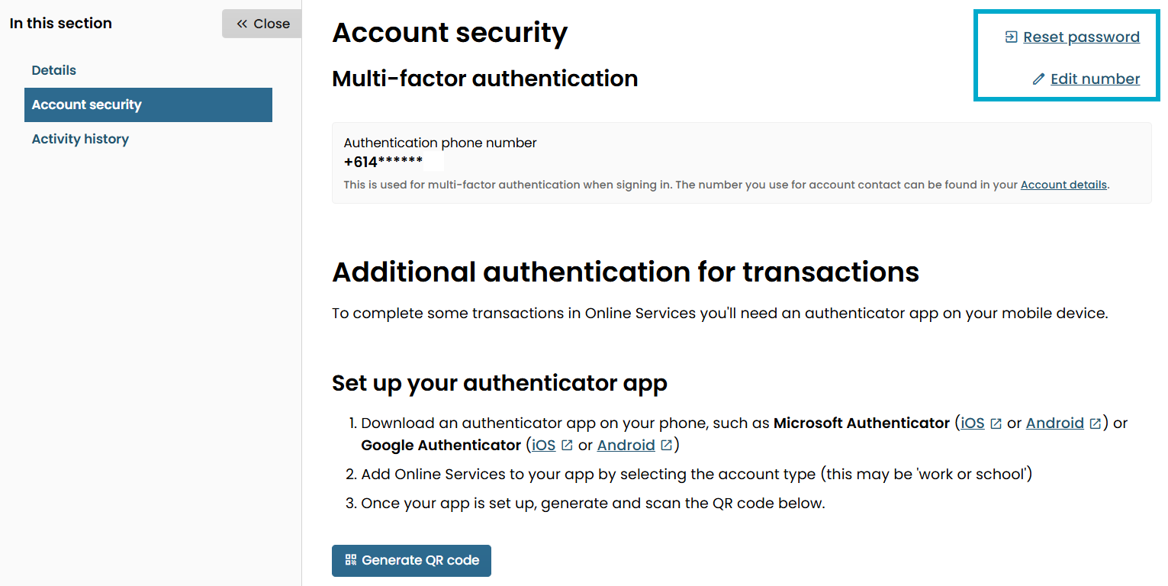

Submitting registration and deregistration applications
Corporations wishing to register for or deregister from the NGER scheme must complete applications via Online Services. This includes NGER Controlling Corporation Registration, NGER Responsible Emitter Registration, and Controlling Corporation Deregistration. For all other NGER scheme applications, please email us at cer-nger-reporting@cer.gov.au
To access the registration forms:
- Log in to your Online Services account (refer to How to create an Online Services account).
- From the Dashboard - Forms and applications - click on the NGER scheme button.
- Select the applicable registration form.
- The deregistration form tile will only appear when acting on behalf of the relevant organisation. Refer to How to switch accounts.
Note: you can leave and return to the application at any stage by selecting ‘save draft’ at the bottom of any page of the application. All draft applications are located in the Submissions list under the inbox on the Dashboard.

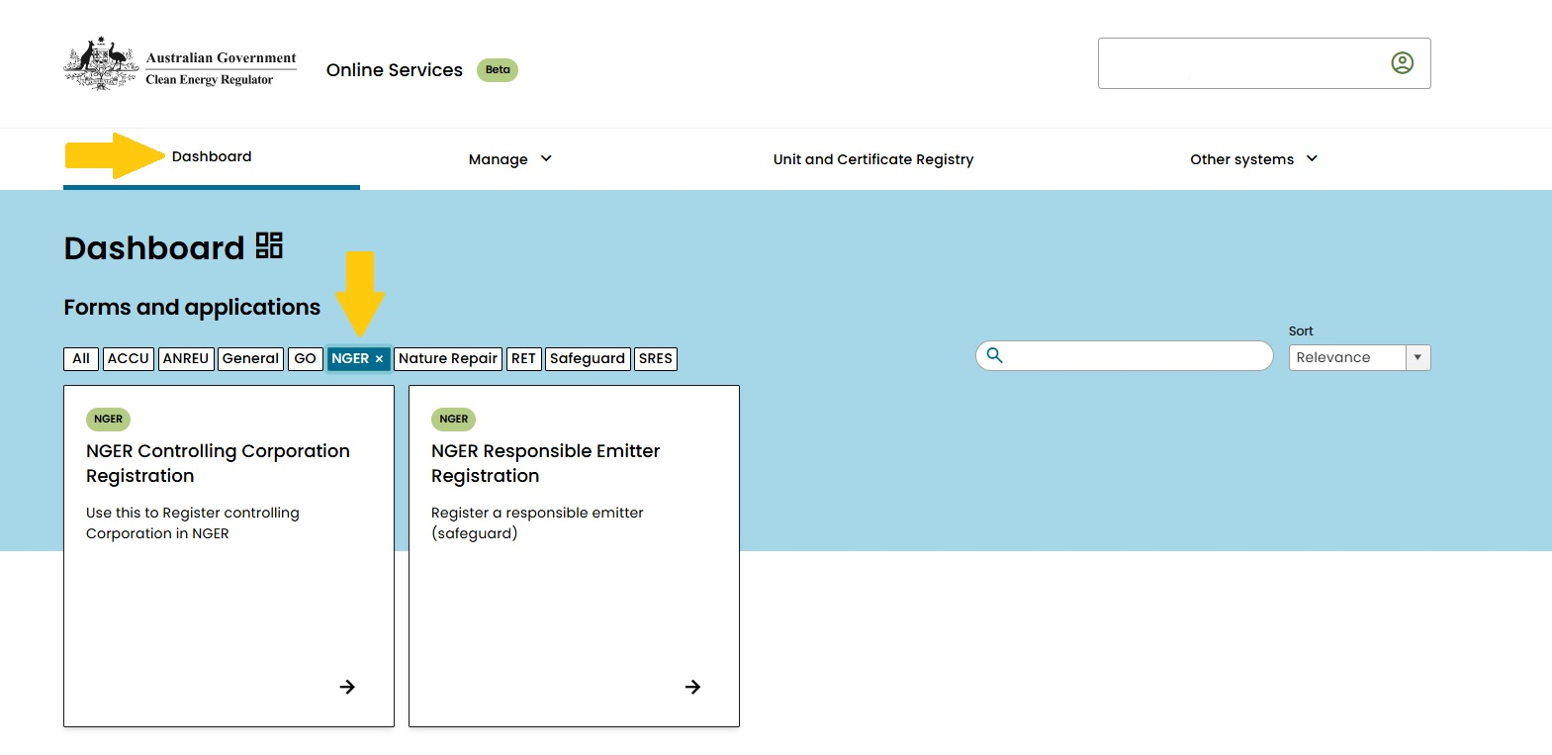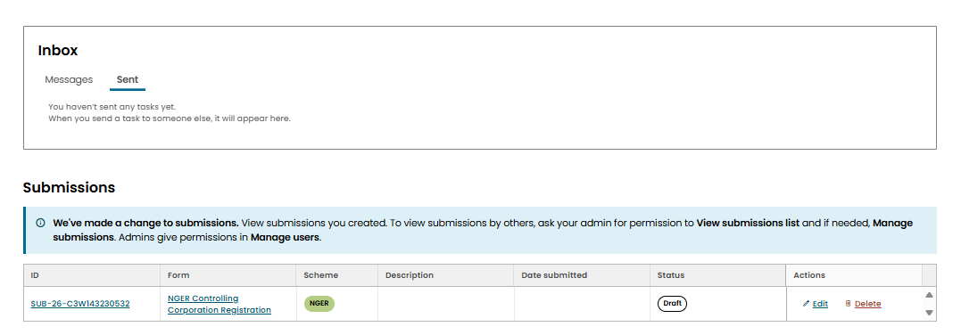

NGER Controlling Corporation Registration form
The information below follows the structure of the NGER registration form in Online Services and provides guidance to help you complete each numbered part of the form.

1. Before you start
On this page, read the information about NGER thresholds and ensure the organisation you are registering is eligible for the scheme.
If the organisation is already registered with other Clean Energy Regulator schemes, ensure you are ‘acting on behalf of’ the organisation by switching accounts. If the organisation is new to the CER you will only have the option of using your individual Online Services account.
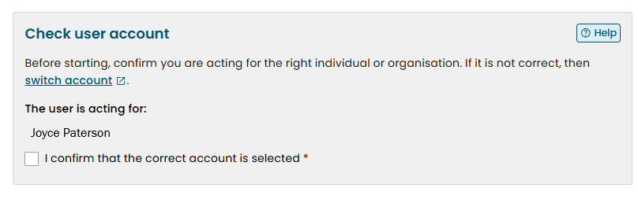

2. Organisation Details
If the organisation does not have an existing Online Services account and you are applying through your individual account, ‘New organisation’ is automatically selected. If the organisation is registered with other schemes, ensure you are ‘acting on behalf of’ the organisation, and select ‘Current selected organisation’.
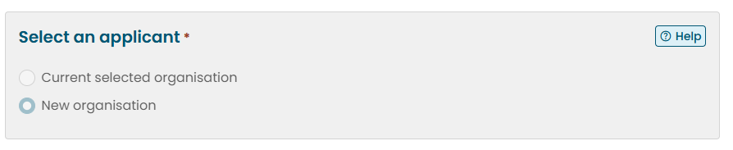

Identifying details
If the organisation has an ABN or ACN, select ‘yes’ and start entering the identifying number or organisation name and then select when the auto-populated list displays the correct entity.
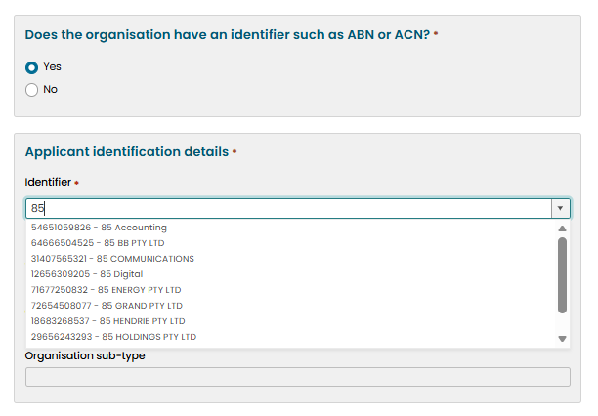
*Note, if the organisation has an ACN but not an ABN, the entity may not appear when the ACN is entered. If this is the case, select ‘no’ and enter the details manually. From these details, the CER will add the organisation’s ACN number to the system.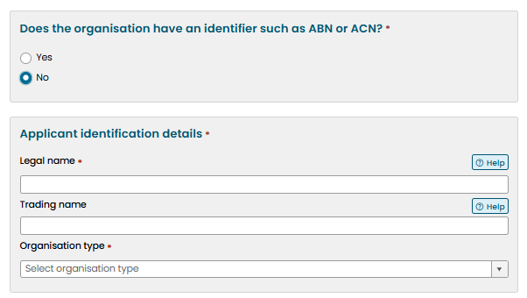

Address details
To enter the street address, start typing the address and select from the auto-populated drop-down list and select when you see the correct one.
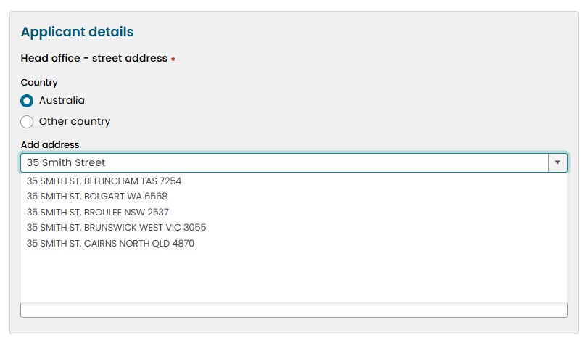
If the address does not appear in the list, you can select ‘Enter manually’.
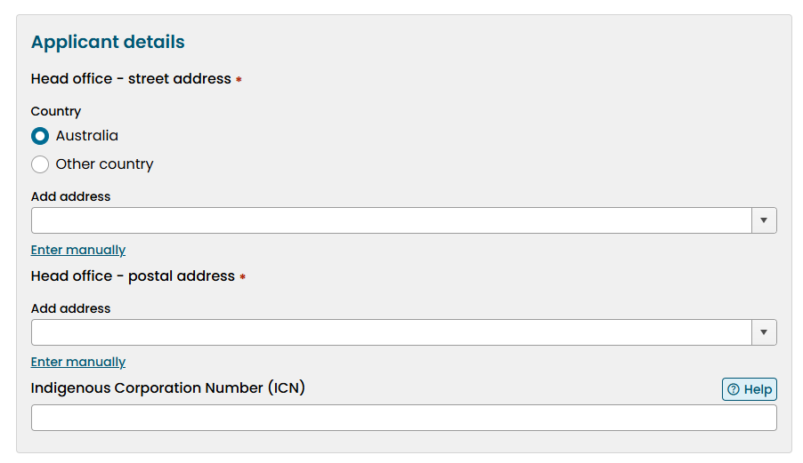
Fill in the address details. Enter the suburb and select from the auto-populated list. This will place a marker on the map with longitude and latitude details. If the address is still not available using this method, use the map tool to zoom in and click on the location to place a marker on the map which will populate the longitude and latitude coordinates. Do the same for postal address.
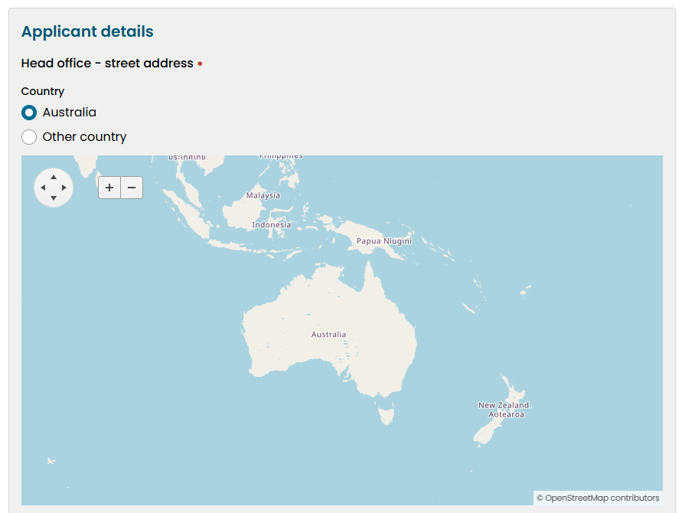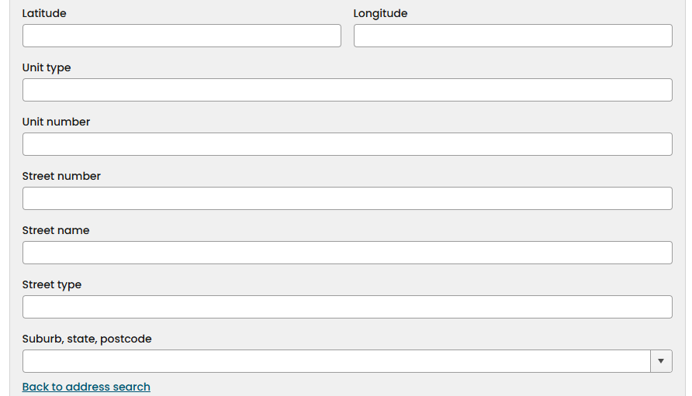

3. Foreign Corporation
If the organisation is incorporated outside Australia or an authority of a foreign country select ‘yes’. The option to add the details of the Australian agent will become active in the Executive Officers and Organisation Contacts page of the application.

4. Executive Officers and Organisation Contacts
For a description of these positions, refer to NGER Executive Officer and NGER Contact.
When registering a new organisation only the details for the current logged on user will appear in the ‘select individual’ drop down. If you are not the Executive Officer, select ‘Someone else’ then ‘The person isn’t listed’ then check the ‘Executive Officer’ field. Enter the email of the designated individual in the space provided and select ‘Send invite’.
Enter the details of their position with the organisation.
*Note, for the application to be approved, only a person meeting the NGER criteria of an Executive Officer will be accepted, which we will verify through the organisation’s ASIC details or supporting documentation attached to the application.
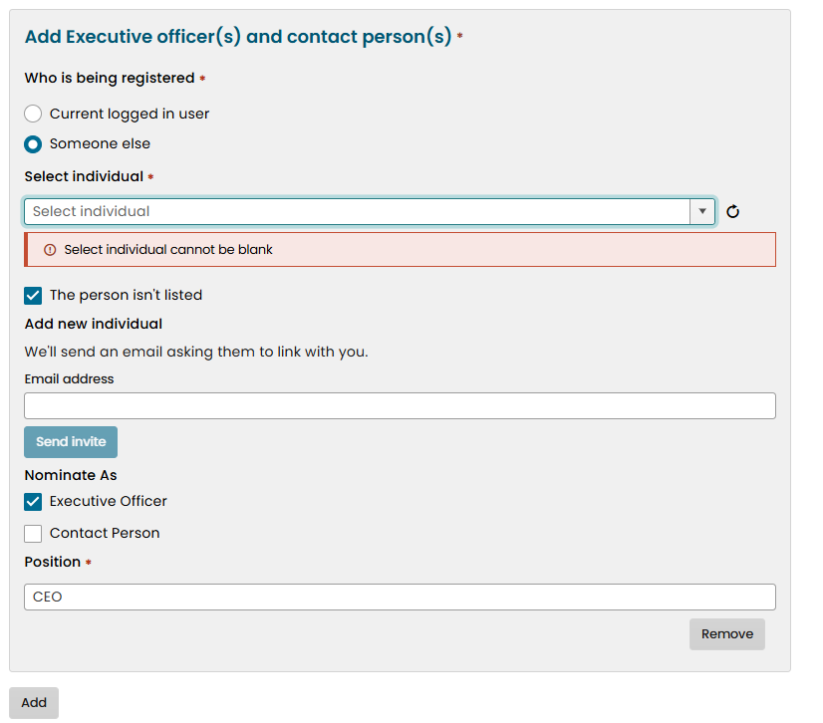
Once the invite is sent, the Executive Officer will receive an email notifying them someone wants to link with them in Online Service. They will need to log in to Online Services, and from the Dashboard, scroll down to the inbox and click on ‘yes, link’.
The person completing the application form will receive an email the Executive Officer has accepted the link request and their name will now be an option in the ‘select the individual’ drop-down arrow.
Select ‘Add’ and then enter the details for the Contact Person. If this is the logged on user, select ‘current logged in user’ and select your name from the drop-down arrow next to ‘select individual’ and check the ‘Contact Person’ box then press ‘next’.
If the Contact Person is not the person logged in, follow the same instructions as for adding the Executive Officer above.

5. Affected Group Entity Details
This page is where you will add the details of any group members.
If the controlling corporation is the only entity other than facilities, select ‘no’ and move to the next page.
If the controlling corporation is not the only entity of the corporate structure, select ‘yes’ and enter the details for each subsidiary.
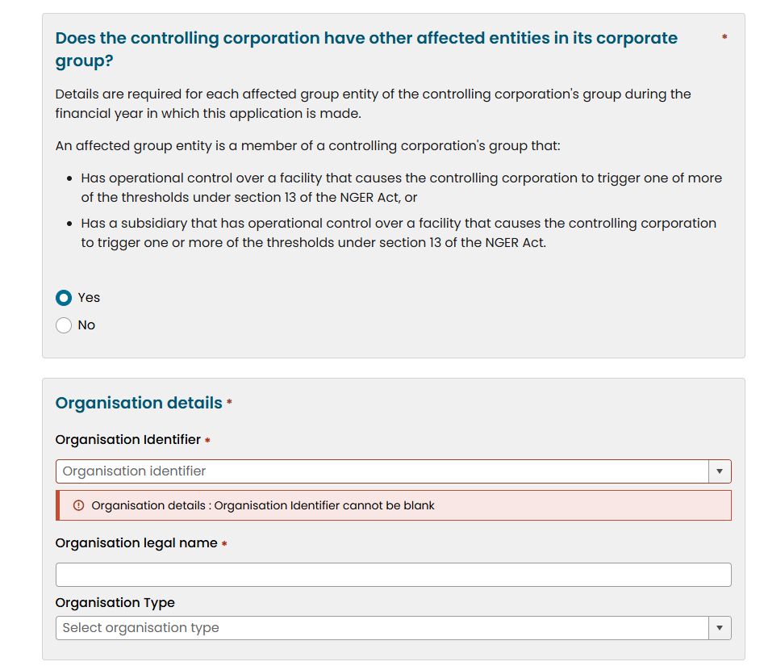
If the group member organisation has an ACN but not an ABN, the entity may not appear in the auto-populated list, and it will say ‘no data’. If this is the case, select ‘other’ and enter the details manually.

6. Eligibility Details
Using the drop-down arrow, select the financial year the applicant first exceeded an NGER threshold (read information on the ‘Before You Start’ page of the application about NGER thresholds).
Provide reasons why the trigger year was selected.
Reasons might include:
- this was the first financial year that measured emissions for your facilities exceeded the threshold
- you acquired a facility in this year that exceeds thresholds.
If the trigger year is earlier than the current financial year, provide an explanation as to why an application was not submitted at the time. Use the upload function at the bottom of the page to attach any documentation such as threshold calculation datasets.
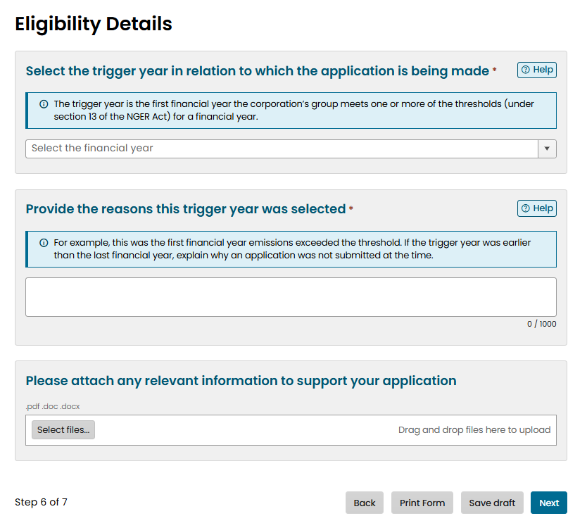

7. Declaration
This page will display in red any unfinished fields from earlier pages. These will all need to be addressed before the application can be submitted.
The applicant then needs to check each check box in the declaration statement, ensuring these statements are true.
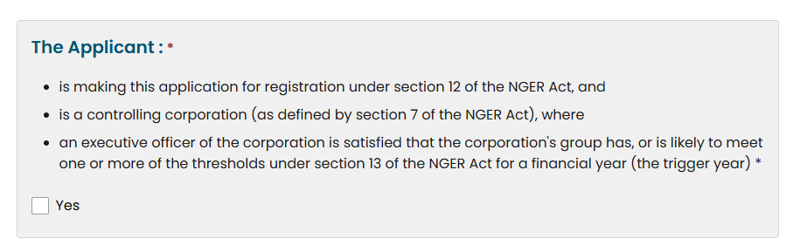
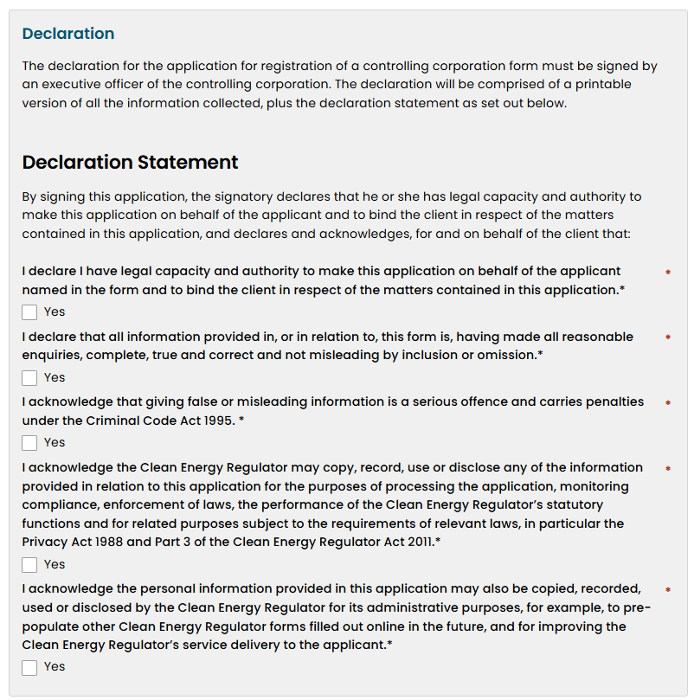

There are two ways to submit the application, by electronic submission or by printing and uploading.
Only the Executive Officer can submit the form electronically. They must be signed into their Online Services account and open the application from their submission box at the bottom of their Online Services dashboard.
If the form is submitted by anyone other than the Executive Officer, they will need to select the second signing option and then use ‘print form’ at the bottom of the page. This will create a PDF version of the application that can be signed by the Executive Officer. Once you have a signed copy available, press ‘select files’ and upload the signed PDF, then select ‘submit application’.
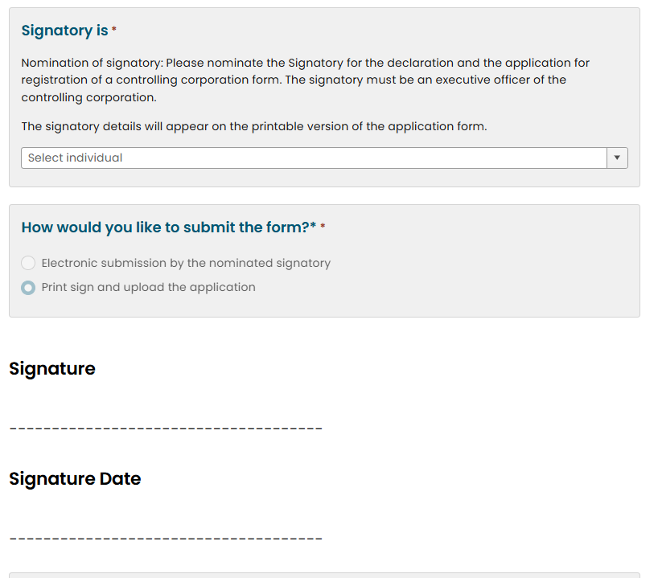
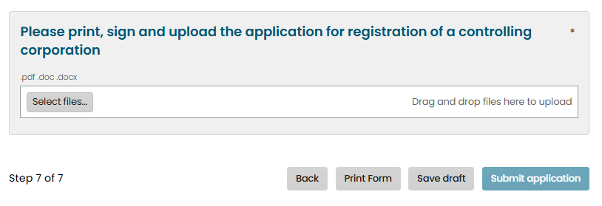

NGER Responsible Emitter Registration
The application steps for an NGER Responsible Emitter registration are the same as listed in NGER Controlling Corporation Registration form except for step 5.

5. Controlling Corporation Details
Select the drop down and arrow and either scroll to the correct controlling corporation or start typing until the organisation appears in the list and then select it.
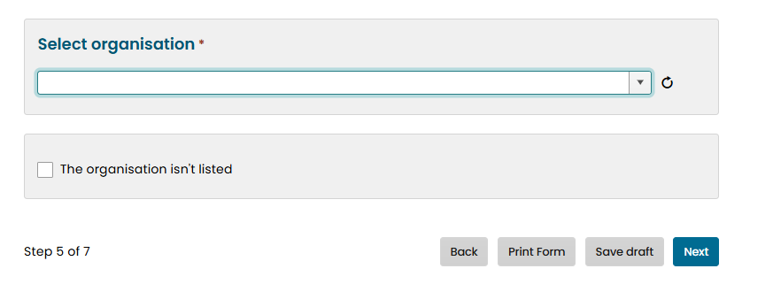
If the organisation does not appear in the list, check the box ‘The organisation isn’t listed’ and enter the ABN or ACN identifier details.
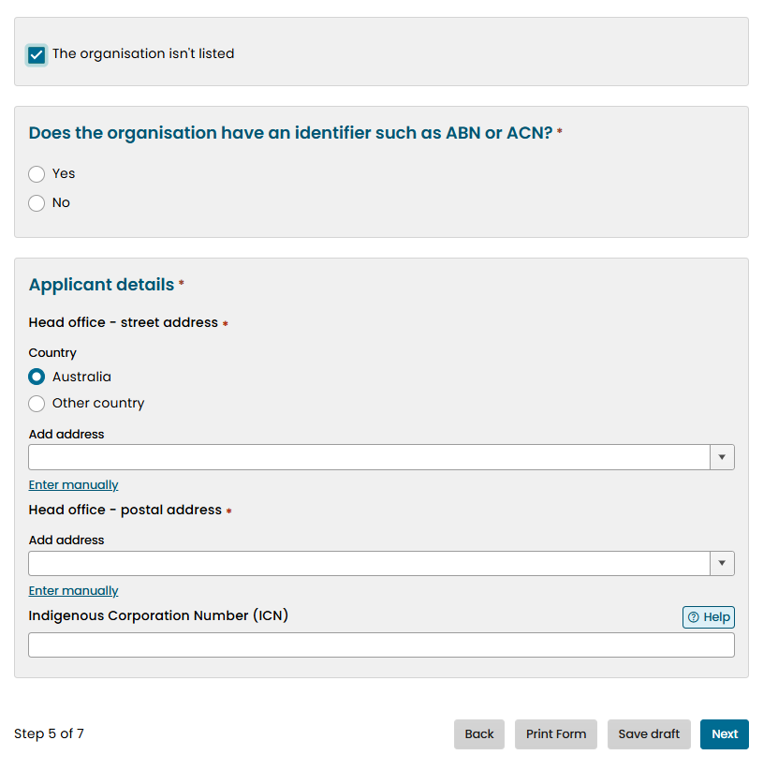

*Note, if the organisation has an ACN but not an ABN, the entity may not appear when the ACN is entered. If this is the case, select ‘no’ and enter the details manually. From these details, the CER will add the organisation’s ACN number to the system.

NGER Controlling Corporation Deregistration form
Note: to submit a deregistration form, you will need to be ‘acting on behalf’ of the organisation you wish to deregister. Refer to the section how to switch accounts.
Select the NGER button and the NGER Deregistration form.
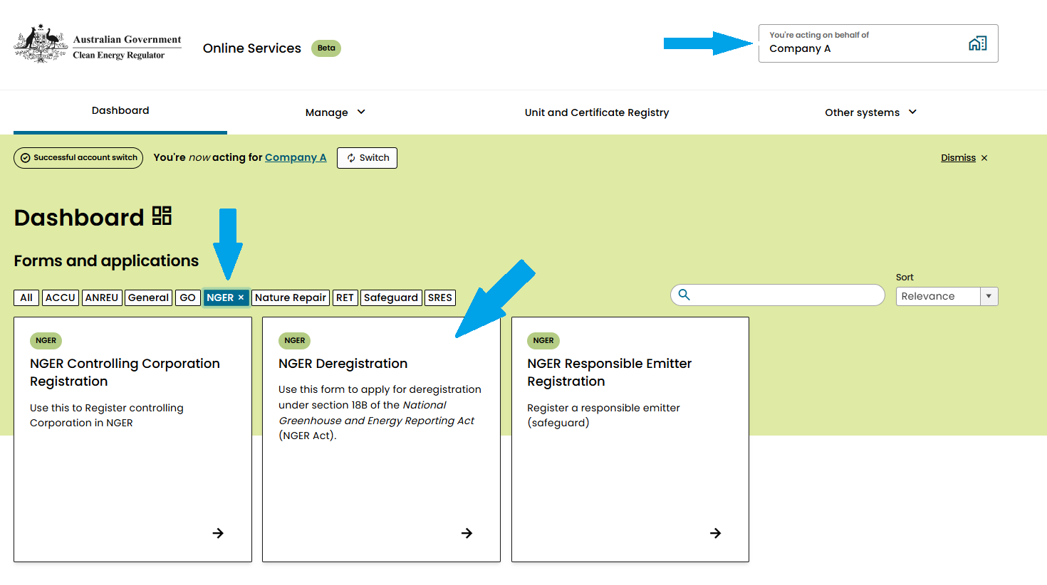

1. Before you start
Read the information about NGER thresholds and ensure the organisation you are deregistering is eligible.

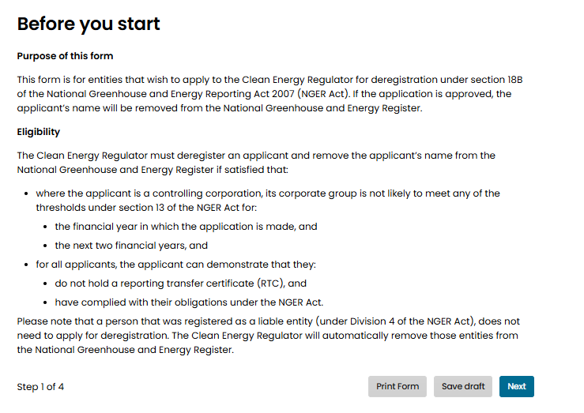

2. Applicant details

Controlling Corporation
The Controlling Corporation name will be auto populated when you are ‘acting on behalf of’ the correct organisation.
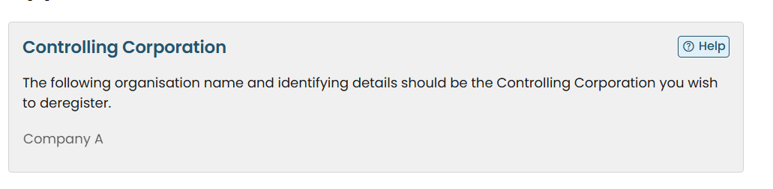

Australian Agent for a foreign corporation
The Australian Agent details are only required when deregistering a 'foreign corporation' that is incorporated outside Australia or an authority of a foreign country. If this does not apply, leave this field blank.
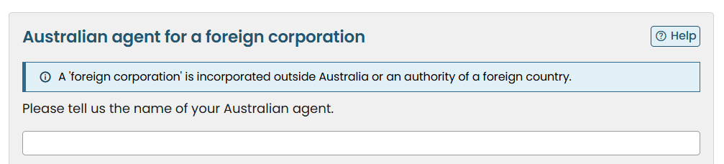

Executive Officer nomination
The Executive Officer that appears in the drop-down arrow is the person allocated this ‘relationship’ in the organisation’s Online Services account. If this is not the individual that should currently be acting in this role and signing the application, this role will need to be updated prior to completing this section, following the steps in How to add a user and ensuring the individual meets the definition of NGER Executive Officer. *Note, applicants will not be approved unless the CER is satisfied an individual meets this definition.
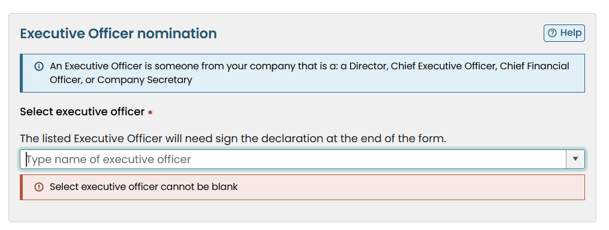

Review your contact details
These details are auto populated for the person completing this form. Ensure these are correct and if changes are required, update your details in My Profile prior to completing this form.

3. Deregistration details

Why is the applicant deregistering
Please select from one of the three options provided.
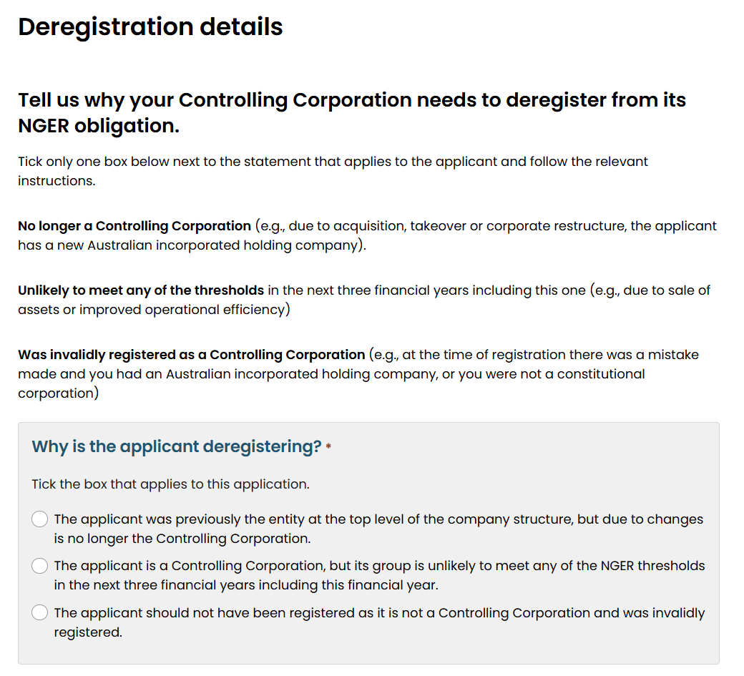

Once an option has been selected, another field opens for you to provide more information about the reason for deregistration.
*Note, the information you provide in this section is a key determinant of your organisation’s eligibility for deregistration. Please be as clear as possible and provide any supporting documents, the ‘Help’ includes examples.
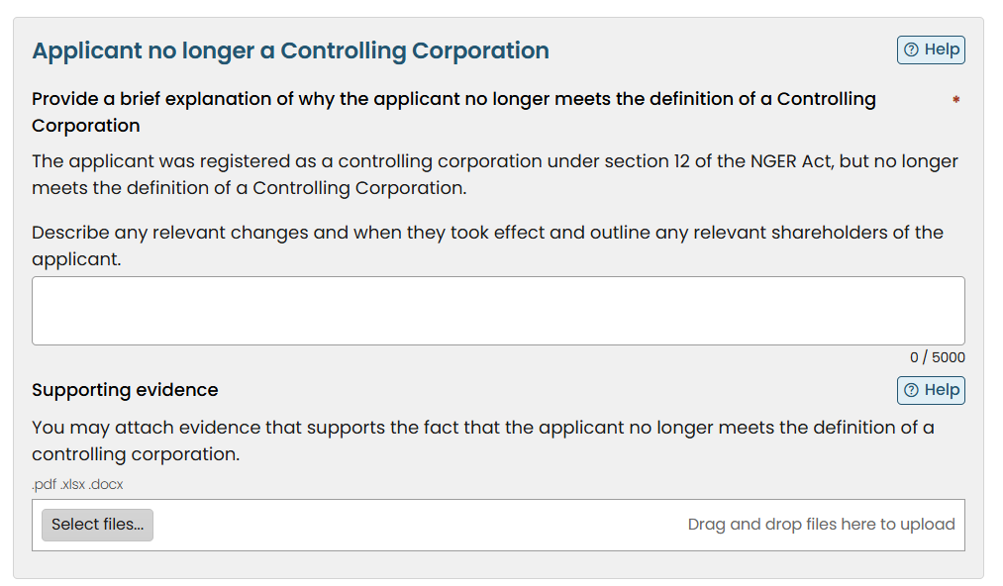

Eligibility statements
Ensuring both statements are true, check the eligibility statements. Please refer to explanations of these statements below.
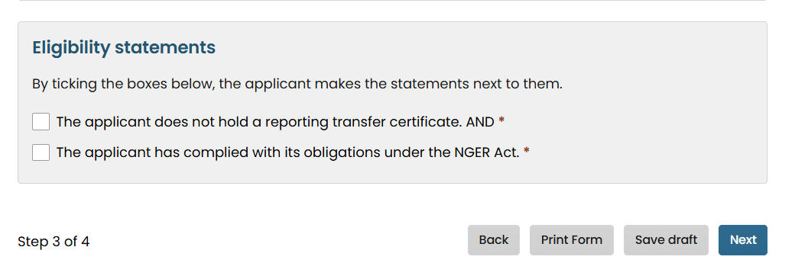Eligibility statement – The applicant does not hold a reporting transfer certificate
A reporting transfer certificate (RTC) allows the voluntary transfer of NGER reporting and record keeping obligations from a controlling corporation, where one member of its group has operational control of a facility, to a member of a different corporate group that has financial control of that facility. Holders of an RTC take on reporting, record keeping and compliance obligations under the NGER Act.

A deregistration application cannot proceed whilst a RTC, with reporting obligations, is in force.
If the applicant does hold a RTC they must make a request to the Clean Energy Regulator, in writing, that they would like to surrender the RTC. The surrender takes effect when consent is given by the Clean Energy Regulator.
Eligibility statement – The applicant has complied with its obligations under the NGER Act
Obligations of the applicant are to submit a compliant section 19 NGER report, by the statutory deadline, for each financial year the controlling corporation was registered. A controlling corporation must report for all affected group members (subsidiaries) and facilities within their corporate group that contribute to section 13 corporate group or facility thresholds regarding scope 1 emissions, scope 2 emissions, energy production and energy consumption.
A deregistration application cannot proceed if the applicant has not complied with their NGER obligations.
Failure to meet obligations under the NGER Act may attract civil penalties that accrue each day until obligations are met.

4. Sign and submit
This page summarises the responses and displays in red any unfinished fields from earlier pages – these fields must be completed before the application can be submitted.
There are two ways to submit the application, by electronic submission or by printing and uploading.
Only the Executive Officer can submit the form electronically. They must be signed into their Online Services account and open the application from their submission box at the bottom of their Online Services dashboard.
If the form is submitted by anyone other than the Executive Officer, they will need to select the second signing option and then use ‘print form’ at the bottom of the page. This will create a PDF version of the application that can be signed by the Executive Officer. Once you have a signed copy available, press ‘select files’ and upload the signed PDF, and select ‘submit application’.

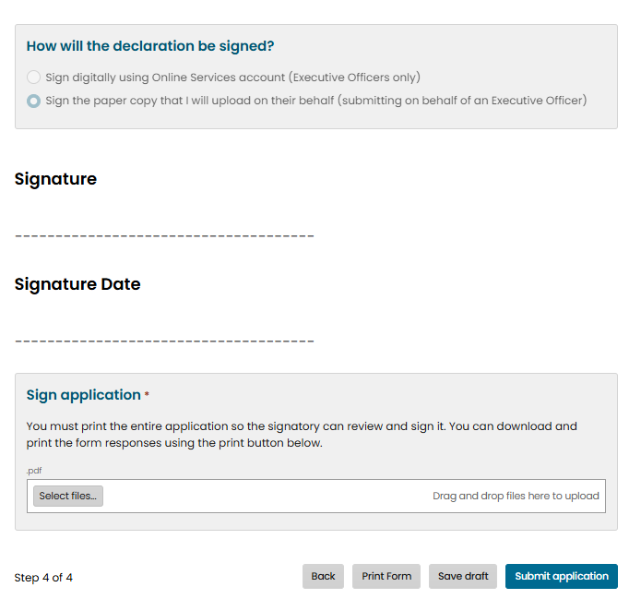

Support
For any further help with your Online Services account, please get in touch.
Email: cer-nger-reporting@cer.gov.au
Phone: 1300 553 542 within Australia
Web: www.cer.gov.au

https://onlineservices.cer.gov.au/
https://onlineservices.cer.gov.au/

