NGER Client Portal User Guide

July 2022

Version 4.0

# Bulldozer outlineSolar Panels outlineFactory outlinePower Plant outlineContents

What is the Client Portal? 3

Getting access to an Organisation’s EERS account 3

Use the Client Portal self-service function to manage permissions and changes to NGER contacts 3

Keeping details up to date in the Client Portal saves time and effort 3

EERS roles and permissions 4

Critical roles 4

NGER Executive Officer 4

NGER Contact Person 5

Organisation Administrator 5

Optional roles 5

NGER Coordinator 5

Nominated Report Submitter 5

NGER Data Provider 5

NGER Guest 5

How to view your organisation and manage users 5

How to add a user 8

How to assign a role 9

How to remove a role 10

How to remove a user 11

More information 11

# What is the Client Portal?

The [Client Portal](https://portal.cleanenergyregulator.gov.au/) is a secure gateway where clients of the Clean Energy Regulator access systems including The Australian National Registry of Emissions Units, the Emissions and Energy Reporting System (EERS) and the REC Registry. For NGER participants, the Client Portal is necessary to:

* access EERS to enter data and submit NGER reports
* view and manage EERS user permissions for organisations
* access forms and submit applications.

To create a Client Portal account, select the ‘sign-up now’ link from the [Client Portal login page](http://www.cleanenergyregulator.gov.au/OSR/CP) and follow the steps to complete the process. Once complete, you can access EERS via the ‘National Greenhouse and Energy Reporting’ tab in the Client Portal.

Multi-Factor Authentication is being introduced from late June 2022 to enhance security against identity theft and cyber-attacks. You will need to register for MFA by choosing an authentication method (email, text or phone call) to sign into Client Portal.

## Getting access to an Organisation’s EERS account

For new controlling corporations, the nominated Executive Officer and NGER Contact Person associated with each registered organisation are automatically given access to the organisation’s EERS account and issued the Organisation Administrator roles. This occurs as part of the initial NGER registration process.

Anyone with an administrator role can then log in to the Client Portal and link additional users via the self-service functionality.

If the NGER Contact Person and the Executive Officer have left, and there are no other organisation administrators, the new NGER Contact Person will need to submit [Addition of a New Contact Person form](http://www.cleanenergyregulator.gov.au/DocumentAssets/Pages/cer-nger-013-addition-of-a-new-contact-person.aspx) to gain access to the organisation’s EERS account.

## Use the Client Portal self-service function to manage permissions and changes to NGER contacts

The Client Portal self-service function lets organisations manage their own user permissions and access to EERS to make entering data and submitting NGER reports as easy as possible.

Anyone with an Organisation Administrator role can log in to the Client Portal and update user permissions via the self-service functionality.

## Keeping details up to date in the Client Portal saves time and effort

In addition to granting users the right permissions in EERS, the Clean Energy Regulator sends the NGER Contact Person news about reporting requirements, tips for reporting and important dates.

Keeping contact information up to date through self-service is particularly important when staff move on, or there are other changes within the organisation. In instances where no one else at the organisation can be contacted, we will contact the Executive Officer if necessary.

# EERS roles and permissions

User permissions in EERS are determined by the role they are assigned. There are many options to choose from, however every organisation will have an NGER Contact Person assigned and at least one Executive Officer. There are several optional roles that can be assigned to EERS users which provides greater flexibility for organisations to control user access based on their responsibilities.

|  |  |  |  |  |  |
| --- | --- | --- | --- | --- | --- |
| System | EERS | | | | Client Portal |
| Role description | **Update to corporate structure** | **Add data to report** | **Generate report** | **Submit report** | **Adding, removing and updating users and user roles** |
| NGER Executive Officer | ✔ | ✔ | ✔ | ✔ | ✔ |
| NGER Contact Person | ✔ | ✔ | ✔ | ✕ | ✔ |
| Organisation Administrator | ✕ | ✕ | ✕ | ✕ | ✔ |
| NGER Coordinator | ✔ | ✔ | ✔ | ✕ | ✕ |
| Nominated Report Submitter | ✕ | ✕ | ✔ | ✔ | ✕ |
| NGER Data Provider | ✕ | ✔ | ✕ | ✕ | ✕ |

## Critical roles

### NGER Executive Officer

The NGER Executive Officer can perform any action within an organisation’s EERS account. A person that is assigned this role must meet the definition of ‘Executive Officer’ as defined in section 7 of the NGER Act. An Executive Officer is defined as a:

* Director
* Chief Executive Officer
* Chief Financial Officer
* Secretary (i.e. a company secretary).

Executive Officers can also be assigned as the NGER Contact Person. It is recommended that organisations establish more than one Executive Officer in EERS for greater flexibility and assurance that the company will be able to submit NGER reports by the due date.

### NGER Contact Person

The NGER Contact Person can perform any action within an organisation’s EERS account, except submitting the NGER Report. This includes updating and adding entities to the organisation’s reporting structure, adding activity data, viewing summary data, and generating reports.

An organisation can only have one NGER Contact Person, therefore assigning this role to a user will automatically remove this role from the user that currently holds it.

|  |
| --- |
| Note: This is the first point of contact in relation to an organisation’s reporting obligations. This person will also be sent general EERS/NGER information and updates from the Clean Energy Regulator. |

### Organisation Administrator

The NGER Contact Person and Executive Officer are automatically assigned the Organisation Administrator role when a controlling corporation is registered. Anyone who is an Organisation Administrator can add or remove EERS users and update EERS user roles in the Client Portal.

## Optional roles

### NGER Coordinator

This role allows a user to update an organisation’s reporting structure, add activity data, view summary data and generate (but not submit) reports. However, an NGER Coordinator’s details will not appear in NGER reports and they will not be the first point of contact for the Clean Energy Regulator.

### Nominated Report Submitter

An NGER Nominated Report Submitter is a person authorised by an Executive Officer to submit NGER reports in EERS on their behalf. This is an optional role to provide further flexibility in relation to submitting EERS reports by the due date.

**Note**: Evidence of the authorisation should be retained for record keeping purposes. If a nominated report submitter lodges the NGER report, the Executive Officer who provided the authorisation should be selected in the Executive Officer field in the report.

### NGER Data Provider

This role allows a user to add activity data to a report. A user with this role cannot make amendments to the organisation’s corporate structure (e.g., the user cannot create group members or facilities), but the user will have read-only access to this information.

### NGER Guest

This role allows a user to have read-only access to an organisation’s account within EERS. The NGER Guest can view the organisation’s corporate structure and activity data, but not able to make any changes.

# How to view your organisation and manage users

Anyone with the Organisation Administrator role can use the Client Portal self-service functionality to manage users for the organisation/s being managed.

There are 2 ways to see which organisations are associated with your account:

* log in to the Client Portal, and from there choose from one of the 2 following options:
* **Option 1 – Your** **National Greenhouse and Energy Reporting page**
  + select ‘National Greenhouse and Energy Reporting’ from the tab at the top of the screen
  + scroll down to view a list of organisations for which you can add, edit or remove the Executive Officers, Contact Person, Nominated Report Submitters or other EERS users.
* **Option 2 - Your Profile page**
  + select ‘My Profile’ from the tab at the top of the screen
  + select ‘My organisations’ from the menu on the left-hand side.

The list will be the same on both pages and will show the level of access and any roles you hold for that organisation. To select an organisation, click on the ‘Manage’ button next to the relevant organisation.

Figure 1: Screenshot showing where to access 'My Profile' and 'My organisations' in EERS

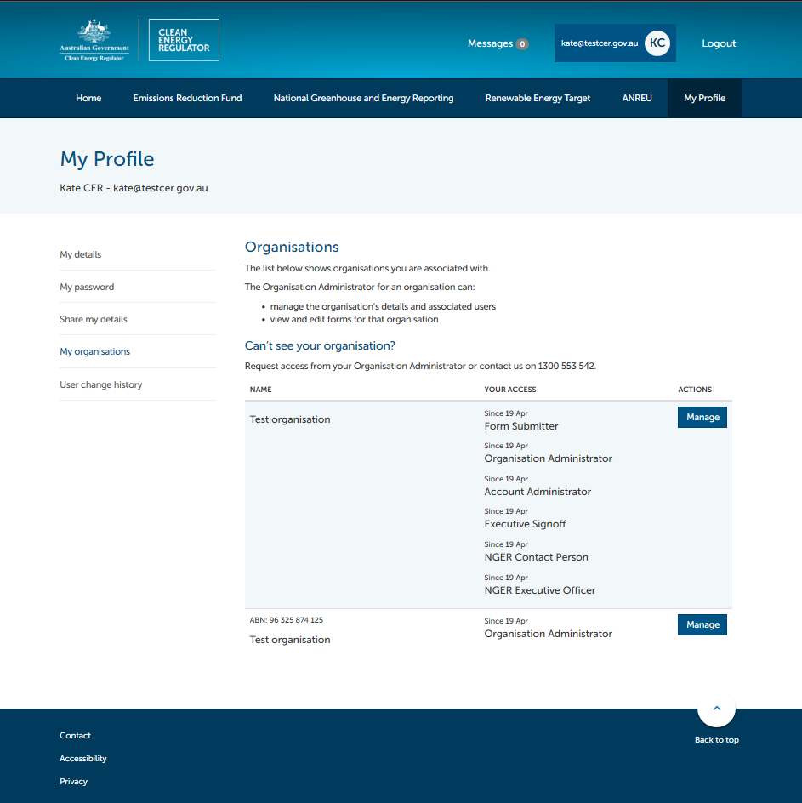

To manage the users related to an organisation:

* select the organisation that you wish to manage
* click on ‘Manage access’ from the left-hand side menu options.

A list of users that have access to that organisation’s EERS account will display and include each person’s name, and the roles they have. From this page, a variety of actions can be performed including adding and removing users or assigning and removing roles.

Figure 2: Screenshot showing where to find 'Manager access' in EERS

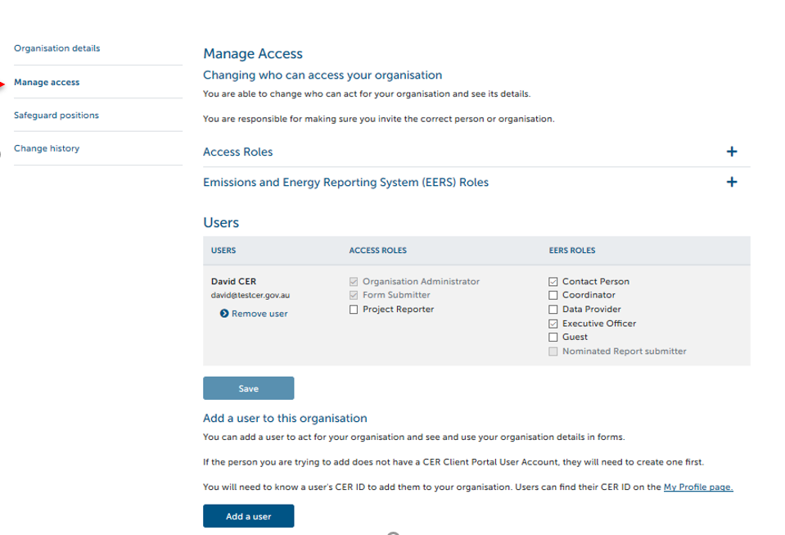

Please note that the roles of Project Reporter and Form Submitter that appear in Client Portal under ‘Access Roles’ are not related to the NGER scheme or EERS.

## How to add a user

An Organisation Administrator can add a user to an organisation’s EERS account. To add a user:

* select the organisation that you wish to manage
* click on ‘Manage access’, from the left-hand side menu options
* choose the ‘Add a user’ option at the bottom of the ‘Manage access’ screen

**Note**: The person you are adding must have a Client Portal account (see steps on creating a Client Portal account).

Figure 3: Screenshot showing where to add a user

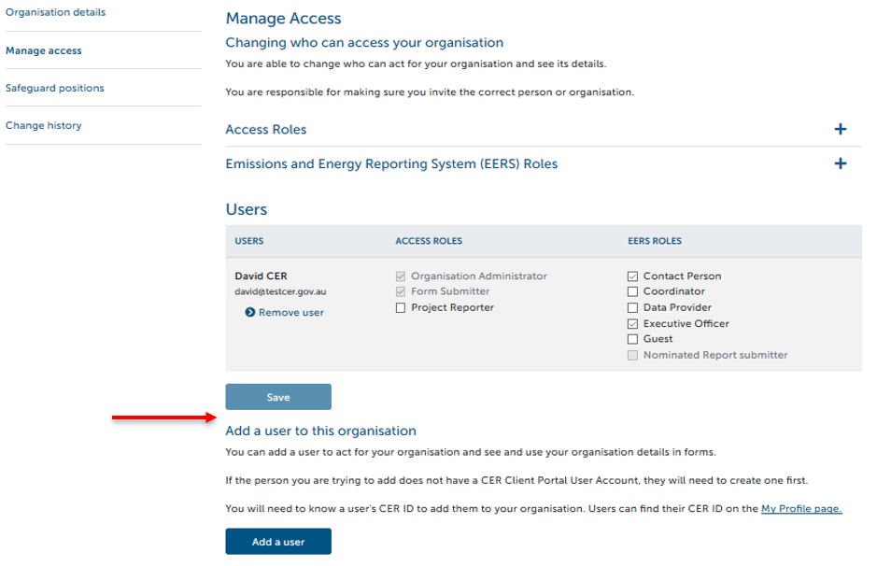

* enter the person’s Client Portal User ID (e.g. CER123456, which is found in the ‘My Profile’ page) and the user’s email address associated with the account in the fields provided and select ‘Save’.

Figure 4: Screenshot showing where to enter the person's Client Portal ID and email address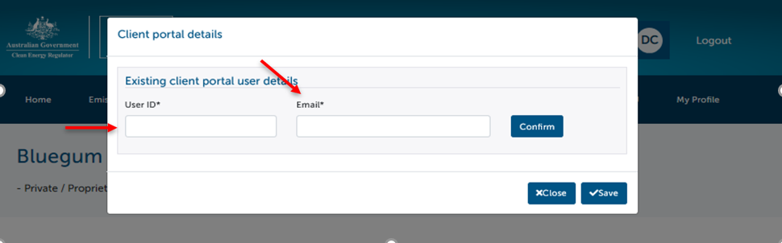

To confirm the new user has been successfully added, you will be taken back to the list of users for the organisation and the new user should appear in the table.

## How to assign a role

An Organisation Administrator can assign roles to a user that has access to the organisation’s EERS account.

To assign a role to a user:

* select the organisation that you wish to manage
* click on ‘Manage access’, from the left-hand side menu options
* click in the check box next to the role to ‘tick’ it
* select ‘Save’ at the bottom of the screen.

Figure 5: Screenshot showing where the 'Save' button is located

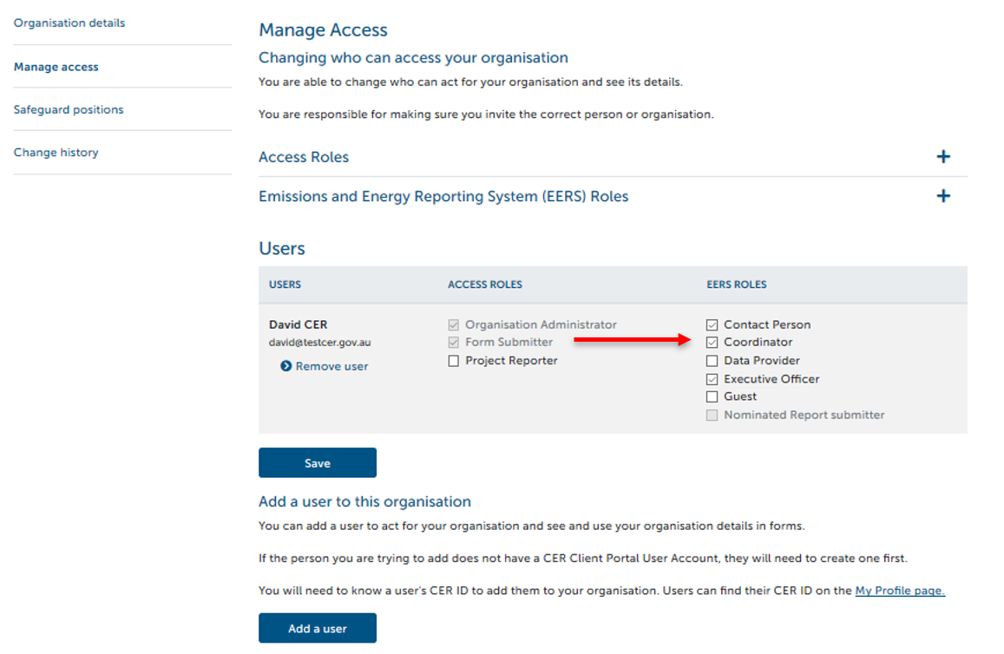

## How to remove a role

An Organisation Administrator can remove a role that has been assigned to a user. To remove a role from a user:

* select the organisation that you wish to manage
* click on ‘Manage access’ from the left-hand side menu options
* click in the check box next to the role to ‘untick’ it
* select ‘Save’ at the bottom of the screen.

Figure 6: Screenshot showing where the 'Changes saved' success notification appears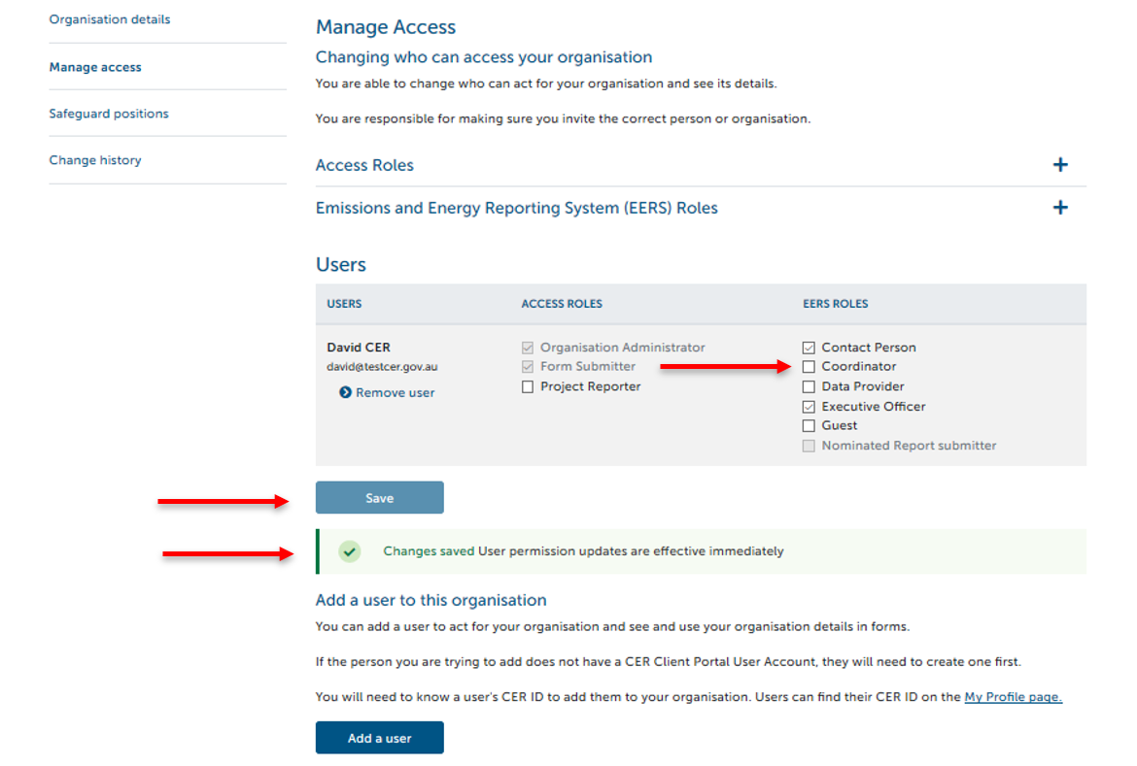

**An** **organisation must always have at least one** **Executive Officer** **and one** **NGER Contact Person**. If you attempt to remove the last NGER Executive Officer or NGER Contact Person roles, one of the following error messages will occur.

Figure 7: Screenshot of error message if you attempt to remove the last Executive Officer



Figure 8: Screenshot of error message if you attempt to remove the last Contact Person



To remove a user’s role that is an organisation’s only Executive Officer or NGER Contact Person, firstly assign the role to another user linked to the organisation, or add a new user and then assign the role to the new user.

## How to remove a user

An Organisation Administrator can remove a user’s access to the organisation’s EERS account. To remove a user’s access:

* select the organisation that you want to manage
* click on ‘Manage access’ from the left-hand side menu options
* select the ‘Remove user’ option next to that person
* select ‘Save’ at the bottom of the screen.

Figure 9: Screenshot showing where to remove a user 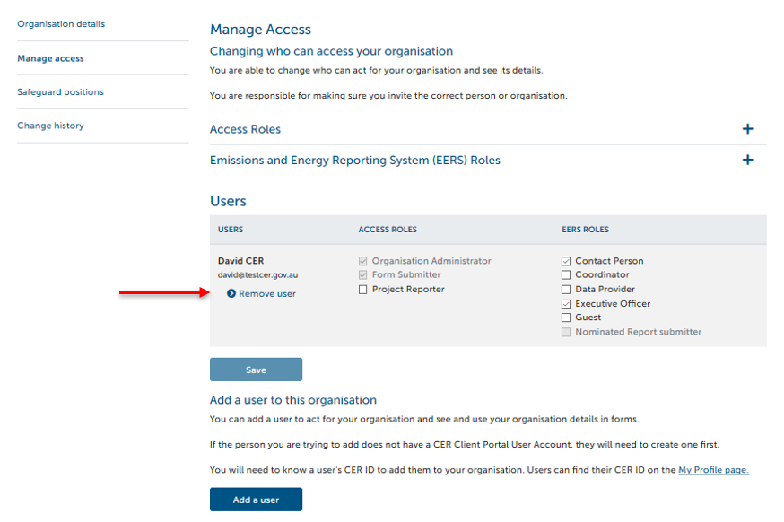

## More information

Email: [reporting@cleanenergyregulator.gov.au](mailto:reporting@cleanenergyregulator.gov.au)

Phone: 1300 553 542 within Australia

Web: [www.cleanenergyregulator.gov.au](http://www.cleanenergyregulator.gov.au/)