
National Greenhouse Energy Reporting (NGER) Uncertainty Calculator User Guide
July 2026







Contents
Contents 1
Definitions and abbreviations 3
Disclaimer 4
2025–26 updates 5
Introduction 5
Entering data into the Calculator 5
Exporting data from EERS 5
Importing data into the Calculator 6
Finalising data in the Calculator 7
Components of the Calculator 8
Worksheets of the Calculator 8
Source and fuel input worksheet 8
Output worksheet 11
Adding your data to EERS 11
Appendix 1 – Uncertainty of Elements worksheet 12
Available inputs 12
How to calculate percentage uncertainty of samples 13
Uncertainty reporting process 14
Reporting uncertainty in EERS 14
Special cases: Emissions from entities that are not common ‘facilities’ 14
Calculating uncertainty: Industrial process sources using method 1 14
Calculating uncertainty for carbon mass balance equations using Method 1 15
Calculating uncertainty from methods 2, 3 and 1 (non-default factors) emissions 16
Calculating uncertainty from method 4 emissions estimates 17
Where a corporation exceeds the limits of the calculator 17
More information 17

Definitions and abbreviations
Term | Meaning
Consumption of energy | In relation to a facility, the use or disposal of energy from the operation of the facility, including:  - own-use  - losses in extraction, production and transmission.  See regulation 2.26 of the NGER Regulations.
EERS | Emissions and Energy Reporting System
Energy | Includes the fuels and other energy commodities listed in Schedule 1 of the NGER Regulations.
Facility | Has the meaning given by section 9 of the NGER Act. For more information on defining a facility under the NGER scheme, see What is an NGER Facility.
Fuel | A substance mentioned at items 1–57 in Schedule 1 of the NGER Regulations.
kL | Kilolitres
NGER | National Greenhouse and Energy Reporting
NGER Act | National Greenhouse and Energy Reporting Act 2007
NGER Measurement Determination | National Greenhouse and Energy Reporting (Measurement) Determination 2008
NGER Regulations | National Greenhouse and Energy Reporting Regulations 2008
Reporter | An entity required to report emissions and energy production and consumption to the Clean Energy Regulator under section 19, 22G, or 22X of the NGER Act
Scope 1 emissions | Means the release of greenhouse gas into the atmosphere as a direct result of an activity or series of activities (including ancillary activities) that constitute the facility.
t CO₂-e | Tonnes carbon dioxide equivalence
Uncertainty protocol | The publication known as the GHG Protocol guidance on uncertainty assessment in GHG inventories and calculating statistical parameter uncertainty (September 2003) v1.0 issued by the World Resources Institute and the World Business Council for Sustainable Development.
Terms in NGER legislation may have specific meanings within the law. These key words and phrases are normally identified under a heading such as Definitions, Interpretation or Dictionary or in other parts of the document.
For more information on interpreting legislation see Federal Register of Legislation - Understanding Legislation.

Disclaimer
This guideline has been developed by the Clean Energy Regulator (CER) to assist entities to comply with their reporting obligations under the National Greenhouse and Energy Reporting Act 2007 (NGER Act) and associated legislation.
This guideline only applies to the 2025–26 NGER reporting year and should be read in conjunction with the NGER Act, National Greenhouse and Energy Regulations 2008 (NGER Regulations), and National Greenhouse and Energy Reporting (Measurement) Determination 2008 (NGER Measurement Determination), as in force for this reporting period. These laws and their interpretation are subject to change, which may affect the accuracy of the information contained in the guideline.
The guidance provided in this document is not exhaustive, nor does it consider all circumstances applicable to all entities. This guidance is not intended to comprehensively deal with its subject area, and it is not a substitute for independent legal advice. Although entities are not bound to follow the guidance provided in this document, they must ensure they meet their obligations under the National Greenhouse and Energy Reporting (NGER) Scheme at all times. CER encourages all users of this guidance to seek independent legal advice before taking any action or decision based on this guidance.
CER and the Australian Government will not be liable for any loss or damage from any cause (including negligence) whether arising directly, incidentally, or as consequential loss, out of or in connection with, any use of this guideline or reliance on it, for any purpose.
If an entity chooses to meet their obligations under the NGER scheme in a manner that is inconsistent with the guidance provided in this document, CER, or an independent auditor, may require the entity to demonstrate that they are compliant with requirements of the NGER Act, NGER Regulations, and/or the NGER Measurement Determination. Entities are responsible for determining their obligations under the law and for applying the law to their individual circumstances.

2025–26 updates
Changes in this document for the 2025–26 reporting year:
- Updated instructions on exporting data from EERS.
- Added information on measurement criterion selection, notably with respect to flaring activities.
- Minor stylistic and formatting changes have been made to this document.

Introduction
The Calculator is a spreadsheet that:
- enables reporters to use relevant default uncertainty factors from the Measurement Determination
- aggregates emissions factor, energy content factor and activity data uncertainties
- aggregates uncertainties from multiple data lines to single sources and fuels as necessary.
Reporters can use a feature within the Emissions and Energy Reporting System (EERS) to export a table of data relevant to their uncertainty reporting. The data is exported to your clipboard and can be entered directly into the calculator or saved as a CSV file (a text file that can be opened using Microsoft Excel) and contains all activity data that is held in EERS at the time of the export.
The Uncertainty Calculator is available on our website. We recommend that you download and save it onto your computer before entering data.

Entering data into the Calculator
Data can be entered into the Calculator manually or by using the EERS uncertainty data export functionality.
Reporters are advised to finish entering and checking all activity data into EERS before starting uncertainty reporting. Any changes to activity data for fuels or sources with scope 1 emissions of 25,000 tonnes carbon dioxide equivalence (t CO₂-e) or more can have an effect on uncertainty reporting.

Exporting data from EERS
To use the EERS uncertainty data export functionality:
- Log into EERS.
- Click on ‘Report uncertainty’ in the ‘Function’ drop down menu.
- From the ‘Report uncertainty’ screen, click the ‘Copy to clipboard’ button.

Figure 1: ‘Report uncertainty’ screen in EERS
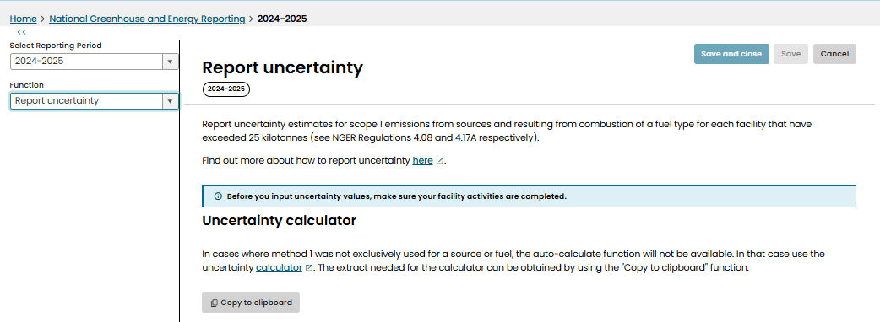

Importing data into the Calculator
To import the data into the Calculator:
- Open the Calculator.
- Select the ‘Source and fuel input’ worksheet.
- Paste data from clipboard.
Figure 2: The source and fuel input tab of the Calculator
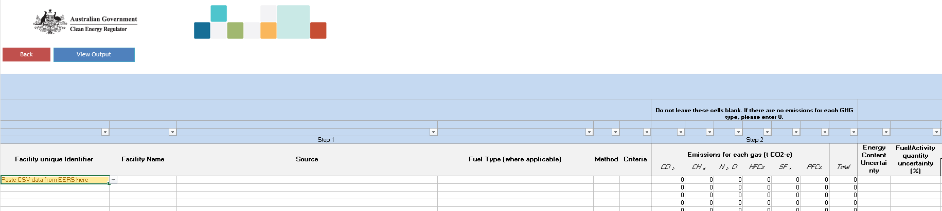
- Paste the data from EERS so that it populates the Calculator:
Figure 3: Exported data pasted into the source and fuel input tab of the Calculator
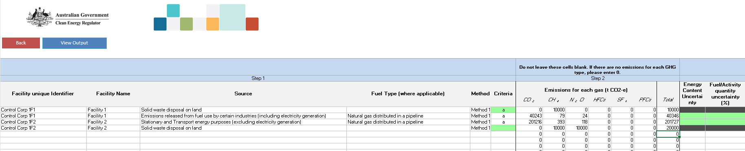

Finalising data in the Calculator
The cells in the ‘Result’ column (viewed by scrolling to the right) will display ‘OK’ on a green background when all required information has been added. For some combinations of activities, fuels and methods, this may be achieved by pasting data from EERS, while other combinations may require user input.
Figure 4: Uncertainty calculator displaying status of imported data
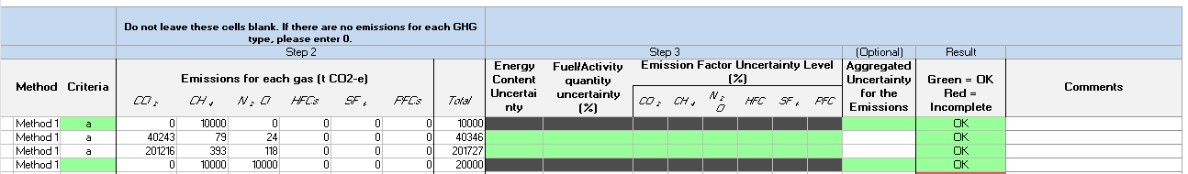
You may need to select a measurement criterion for a fuel. (In cases where the activity uses a fuel but does not require the use of a specific measurement criterion, such as flaring, please select N/A.) If a method other than method 1 is used, you will need to add uncertainty data that you have derived based on the uncertainty protocol.
When all required information has been added to the ‘Source and fuel input’ worksheet, the ‘Result’ column should display ‘OK’ in green. Go to the ‘Output’ worksheet to view the uncertainty percentages that will need to be entered directly into the ‘Uncertainty’ fields in EERS.
Figure 5: Uncertainty calculator displaying uncertainty percentages to be inputted into EERS manually
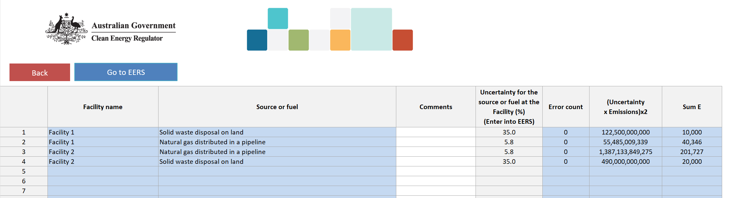

Components of the Calculator

Worksheets of the Calculator
The Calculator has an ‘Instructions’ worksheet as well as 3 worksheets for data entry and calculations:
- source and fuel input
- output
- appendix 1 - Uncertainty of Elements.
These worksheets can be accessed through the tabs along the bottom and are briefly described below.
The ‘Source and fuel input’ worksheet is where source level data is entered for each facility or Network/Pipeline. More instructions are included in row 2, at the top of the worksheet. Reporters can enter the following facility data:
- unique identifier and facility name
- source, fuel, method and measurement criteria
- scope 1 emissions for each gas, relevant quantity data (where appropriate)
- non-default uncertainty levels (for energy content, measurement, and emissions factor).
The ‘Output’ worksheet is where uncertainty is calculated for a source (or fuel) at a facility. In addition, reporters can enter details to assist record keeping.
‘Appendix 1 – Uncertainty of Elements’ is an optional worksheet for independently calculating uncertainty values rather than using the default values built into the calculator. For example, it can be used to calculate the percentage uncertainty of samples collected by a corporation. Reporters are able to distinguish between sample series, and the worksheet calculates other information such as standard deviations, mean, count of measurements, t-factor (to a 95% confidence interval) and uncertainty (at 95% confidence interval) for the sample series. This function assists reporters in calculating uncertainty in accordance with the uncertainty protocol.

Source and fuel input worksheet
Step 1: Complete columns A-G of the source and fuel input worksheet as described below. This step ensures the facility, source, fuel, criteria, and method are correctly identified. These fields do not need to be entered manually if the EERS uncertainty data export instructions are used.
- Facility unique identifier: This is a required field. The identifier is a text string that is unique to a facility (because facility names are not required to be unique). EERS automatically generates a facility unique identifier using the reporting organisation, facility name and dates of operational control.
- Facility Name: This is a required field. It is the name of the facility to which the source is to be attributed. Facility names do not have to be unique although reporters are advised to make them unique for the corporation’s group. Once a facility name has been entered it will appear in the drop-down menu and can be selected for remaining sources at the facility.
- Source: This is a required field. There is a drop-down menu that covers the source types of emissions, listed alphabetically.

Figure 6a: Fields used for data entry in Step 1, including the drop-down menus for Source of Emissions and Fuel Type
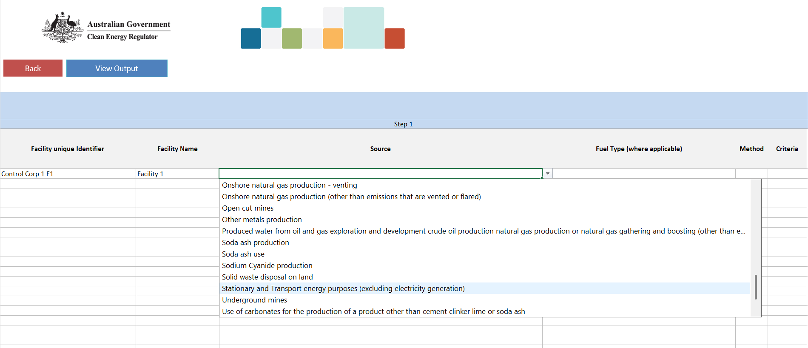
- Fuel Type (where applicable): Each row in this column has a drop-down menu containing a list of fuel and energy commodities. This list is context sensitive, depending on the source selected. Fuels are listed alphabetically.

Figure 6b: Fields used for data entry in Step 1, including the drop-down menus for Source of Emissions and Fuel Type
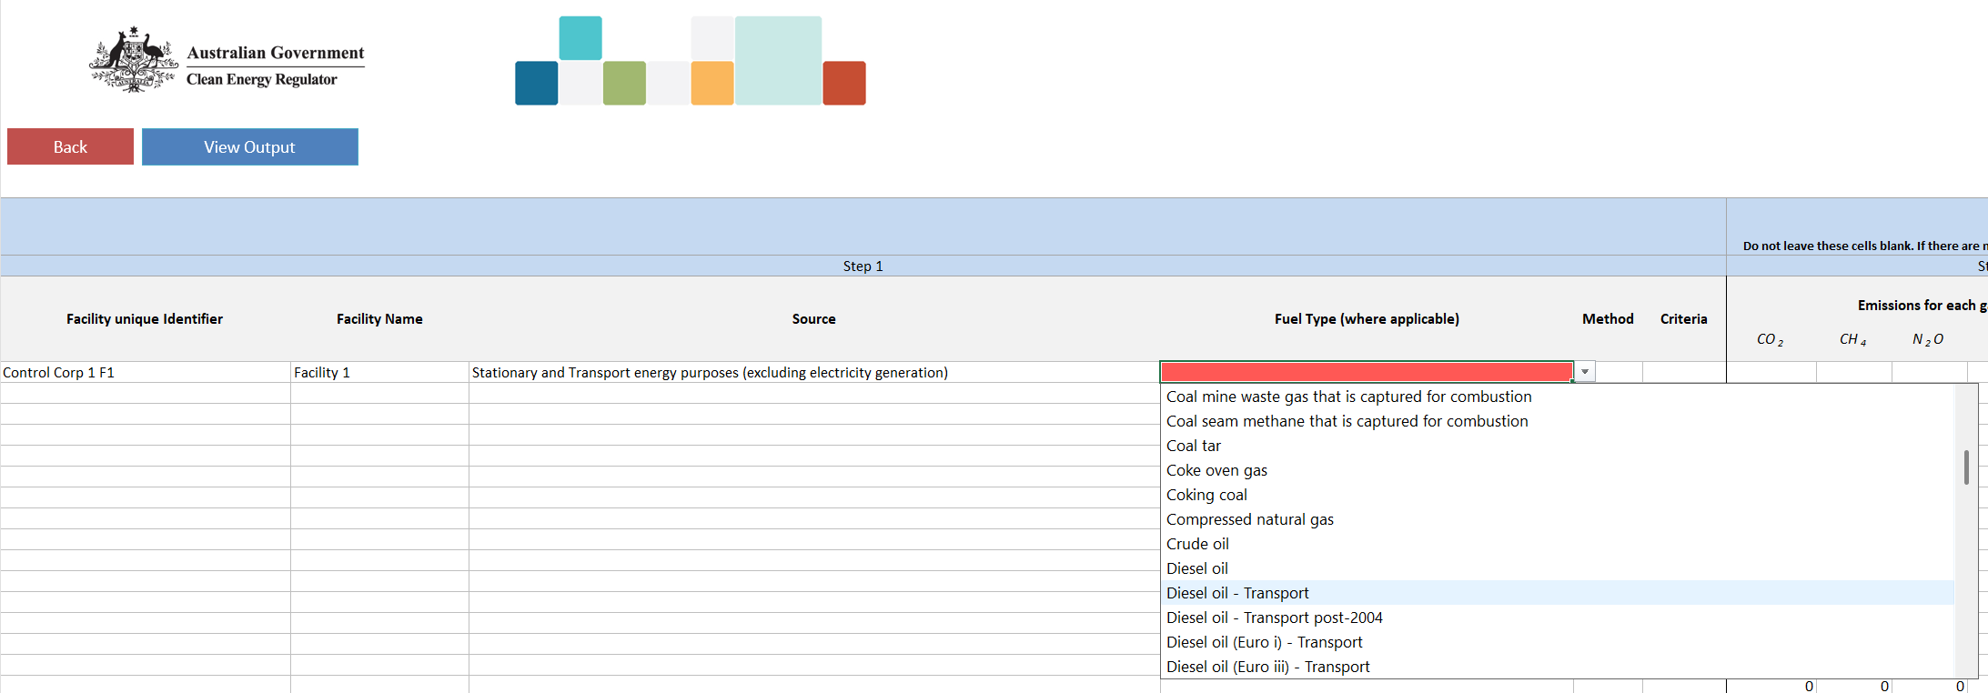

- Method: This is a required field, and shows the method used to estimate the emissions from the selected source, which will also be the method used to calculate the uncertainty for that source. Where multiple methods have been used to measure a single source of emissions, a separate line should be used for each method and for emissions amounts from gases using that method.
- Criteria: Reporters should select the criterion for measurement (A, AA, AAA or BBB) of the amount of fuel where applicable (e.g. amount of diesel oil consumed). In cases where the activity uses a fuel but does not require the use of a specific measurement criterion, such as flaring, please select N/A. See the Methods and measurements criteria guideline for more information on measurement criteria.
Step 2: Complete columns for each gas of the worksheet as described below. This step ensures the scope 1 emissions amounts and total emissions are entered. These fields do not need to be entered manually if the above data export instructions are used.
- Emissions for each gas (t CO₂-e): Each column under this heading relates to one of the 6 greenhouse gases reported under the Act, and data must be entered. Emissions estimates, in tonnes of carbon dioxide equivalence (t CO₂-e), should be entered in the column corresponding to the specific greenhouse gas. If there are no emissions of a particular greenhouse gas, then zero should be entered in the relevant cell(s).
- Total: The total of scope 1 emissions in t CO₂-e.
Step 3: Calculating your uncertainty requires correct completion of the remaining columns to give an aggregated uncertainty for the emissions source. If method 1 is used, default values will be used.
- Energy Content Uncertainty (%): Reporters should leave these cells blank if they intend to use default values under method 1. If energy content percentage uncertainty is calculated independently, enter the value as a whole number - for example, 3.3% uncertainty is entered as ‘3’.
- Fuel/Activity Quantity Uncertainty (%): Reporters should leave these cells blank if they intend to use default values under method 1. If fuel or activity quantity uncertainty is calculated independently, enter the value as a whole number - for example, 2.9% uncertainty is entered as ‘3’.
- Emission Factor Uncertainty Level (%): There are 6 columns for the reportable greenhouse gases under this heading. Reporters should leave these cells blank if they intend to use default values or if the source does not have emissions for a particular gas. Enter the percentage value as a whole number.
- Aggregated Uncertainty for the Emissions Source (%): Some sources and methods 2, 3 and 4 allow for the direct entry of aggregated uncertainty for a source. If a value is entered here, the columns for the 3 headings directly above will be blacked out. This is shown in Figure 3 above.
- If aggregated uncertainty for a source is entered, then the only other field that needs to be filled out for that source is emissions for each gas in t CO₂-e. Note: If aggregated uncertainty is used, all workings for calculating the aggregated uncertainty for the emission source must be well documented and made readily available if an audit is undertaken or requested by the agency.
- Reporters may wish to include comments in these cells.

Figure 7: Fields used for data entry in Step 3

Output worksheet
The Output worksheet shows the aggregated uncertainty for each source and fuel type for each facility.
Once a facility’s unique identifier has been entered in the ‘Source and fuel input’ worksheet, the facility name will be shown in the ‘Facility Name’ column as shown in Figure 8 (see below):
Figure 8: Output worksheet example after data has been entered

Adding your data to EERS
Once the uncertainty for a source or fuel type (at a facility) has been calculated these numbers can be entered directly into EERS.

Appendix 1 – Uncertainty of Elements worksheet
This is an optional worksheet for independently calculating uncertainty values rather than using default values built into the Calculator (see below). This worksheet helps reporters calculate the uncertainty for a set of measurements or other data. The worksheet has been developed in accordance with the Uncertainty Protocol and uses the t-factor method with a 95% confidence interval in accordance with part 8.2 of the Measurement Determination.
Figure 9: Example of the Appendix 1 - Uncertainty of Elements worksheet
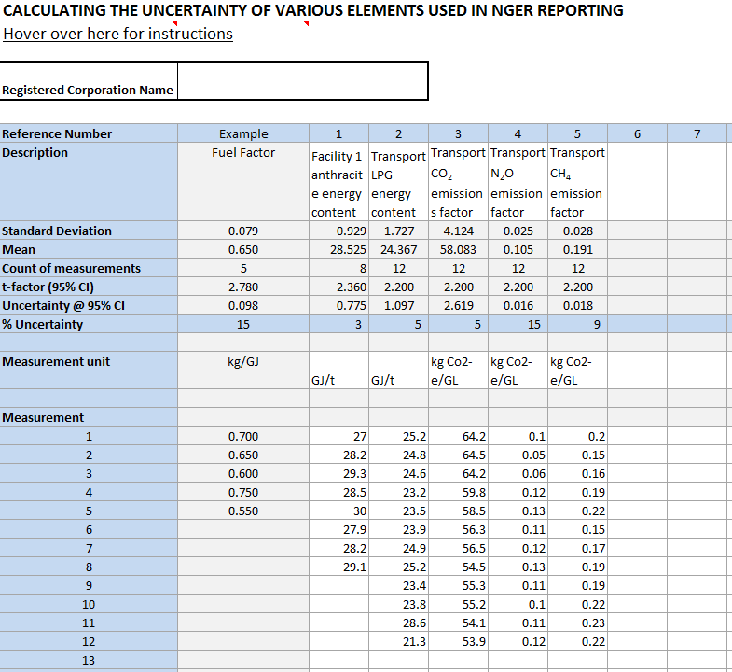

Available inputs
- Description: used to describe samples for clear identification and record keeping (e.g. Facility 1 brown coal energy content)
- Standard deviation
- Mean
- Count of measurements
- t-factor (95% confidence interval)
- Uncertainty at a 95% confidence interval
- % uncertainty
- Measurement Unit: unit in which the samples are measured, for example GJ/t
- Measurement: used for sets of samples to enter data for each individual sample
Once the Measurement samples are entered:
- standard deviation, mean, count of measurements, t-factor and % uncertainty will automatically be calculated
- manually enter the percentage uncertainty in the ‘Source and fuel input’ worksheet as discussed in
(Step 3 above)
- other variables are provided for the reporter’s information.

How to calculate percentage uncertainty of samples
Entering sample data to obtain a percentage uncertainty for the sample set can be done by following the procedures below. An example has been provided (see Figure 9).
- Under reference number 1, enter the description of the fuel source, for example facility 1 anthracite energy content.
- In the same column, enter the measurement unit used, for example GJ/t.
- In the same column, enter measurement results with one value per cell, starting at measurement 1 and progressing downwards, for example 27.0, 28.2, 29.3, etc. Enter numerical data only. Do not enter the measurement unit in these cells.
- Repeat these steps for all remaining sample sets of data.

Uncertainty reporting process

Reporting uncertainty in EERS
For instructions in how to report uncertainty in the Emissions and Energy Reporting System, see the EERS Navigation Guide.

Special cases: Emissions from entities that are not common ‘facilities’
For more information on reporting uncertainty for uncommon facility types see the Reporting uncertainty guideline.

Calculating uncertainty: Industrial process sources using method 1
The table below specifies industrial process sources that do not have default uncertainty values in the Measurement Determination. If emissions from these sources involve the combustion of a fuel, then default fuel combustion uncertainty factors may be used for emissions attributable to each fuel. Otherwise, the uncertainty must be calculated in accordance with the Uncertainty Protocol.
Source
Sodium cyanide production
Soda ash production
Ammonia production
Hydrogen production
Carbide production
Chemical or mineral production (other than carbide production) using a carbon reductant or carbon anode
Iron, steel or other metal production using an integrated metalworks
Ferroalloys production
Aluminium production (where activity relates to emissions from the production of baked carbon anodes)
Other metals production

Calculating uncertainty for carbon mass balance equations using Method 1
The Measurement Determination provides methods based on a carbon mass balance approach for estimating scope 1 emissions from sources:
- which have multiple carbon inputs and outputs
- where the integrated nature of a facility means that the emissions estimate for the process is more accurate than estimates of emissions from different aspects of the process.
A carbon mass balance approach is provided for estimating emission from some activities under the following industrial process sources:
- Division 4.2.3 – Use of carbonates for production of a product other than cement clinker, lime, or soda ash (limited use)
- Division 4.2.4 - Soda ash use and production
- Division 4.3.5 – Chemical or mineral production, other than carbide production, using a carbon reductant or carbon anode
- Division 4.4.1 – Iron, steel or other metal production using an integrated metalworks
- Division 4.4.2 – Ferroalloys production
- Division 4.4.5 – Other metals production.
The rules in the Measurement Determination for assessing the uncertainty of emissions estimates using method 1, 2 or 3 are part of the uncertainty associated with estimating based on a number of parameters, including the energy content factor, emissions factor and/or activity data.
Part 8.3 of the Measurement Determination does not set out default values for assessing the uncertainty of emissions estimates using a method based on a carbon mass balance approach, which is a function of uncertainty associated with carbon content factors and activity data.
Given this, it is reasonable for reporters to assess uncertainty of emissions estimates using a carbon mass balance approach in accordance with the uncertainty protocol.
Part 7 of the Uncertainty Protocol recommends 4 ways to quantify uncertainty ranges for indirectly measured emissions:
- Run statistical tests on one or several sets of sample data – for example, by the method explained in section 6.2 of the Uncertainty Protocol.
- Determine the instrument precision of any measurement equipment used, especially for activity data.
- Consult experts within the company to give an estimation of the uncertainty range of the data used as explained in Section 6.1 of the Uncertainty Protocol.
- Use third-hand uncertainty ranges – for example, the Intergovernmental Panel on Climate Change (IPCC) data provided in the second worksheet of the uncertainty tool).
The Uncertainty Protocol recommends item 4 is only used where it is not possible to collect facility specific data for use in items 1 to 3. Section 8.15(2) of the Measurement Determination prevents the use of Item 4 when emissions are estimated using method 2, 3, or 4.
When using method 1, if it is not feasible to use items 1 to 3 of the uncertainty protocol to assess the uncertainty of estimates of emissions. A reporter may use item 4 and the IPCC overall source uncertainty figure of 10 per cent for carbon dioxide from industrial processes sources provided in the 'Calculations' worksheet of the GHG Protocol Uncertainty Calculation Tool, if the reporter is confident it is a reasonable assessment of the uncertainty.

Calculating uncertainty from methods 2, 3 and 1 (non-default factors) emissions
Uncertainty for emissions estimates calculated under methods 2 and 3 must be calculated in accordance with the Uncertainty Protocol (Part 8.4 of the Measurement Determination). Under certain circumstances, outlined in part 8.3 of the Measurement Determination uncertainty for emissions estimated under method 1 can also be calculated in this manner.
The procedure for applying these methods to the calculator is as follows:
- Enter a description for the source, for example, ‘natural gas (pipeline) - petroleum refining’.
- Type in the facility name under the ‘Facility Name’ column or, alternatively select the facility name from the drop-down menu.
- Choose a ‘Source’, for example ‘fuel combustion’.
- Select the method used to measure the emissions of the source.
- Choose criterion for estimation (if applicable).
Note: The criterion for estimation will be blacked out, where this is not a required variable for uncertainty calculations.
- For method 2 and 3 calculations, a reporter must calculate the uncertainty according to the principles in the Uncertainty Protocol. Data may be entered into the calculator in either of 2 ways:
  - Enter: estimated scope 1 emissions (from the EERS-generated section 19 NGER report), calculated energy content uncertainty, Fuel/Activity quantity uncertainty, and emission factor uncertainty (for each of the gases). The energy content, activity/fuel quantity and emissions factor uncertainties must have been calculated in accordance with Part 8.4 of the Measurement Determination.
OR
  - Enter the emissions data and aggregated uncertainty for the emissions source. Certain cells of the worksheet become blacked out to indicate fields where data is not required.
- Reporters may use the ‘Appendix 1 – Uncertainty of Elements’ worksheet (discussed previously) to calculate uncertainties based on the principles outlined in the Uncertainty Protocol.
- For method 1 (using non-default values), where uncertainty values are calculated in accordance with the Measurement Determination and the Uncertainty Protocol, these can be entered into the relevant cells. If no value is entered, default values will be applied.
- If multiple sources are attributed to a single facility, the calculator will aggregate the uncertainty for each source. The aggregated uncertainty for each facility as well as the corporation’s total percentage uncertainty will be shown on the ‘Output’ worksheet (Figure 6).

Calculating uncertainty from method 4 emissions estimates
Assessments of uncertainty for emissions estimated under method 4 must conform to principles outlined in the Uncertainty Protocol. When using method 4 to calculate emissions estimates, only estimated emissions and aggregated uncertainty can be entered into the calculator for each emissions source. All other cells for entering uncertainty factors will be blacked out by the calculator when this is done.
Emissions data for each gas must also be entered to calculate the percentage uncertainty for the particular source.
Note: Data and methodologies associated with the calculation of the aggregated uncertainty under method 4 should be documented and retained.

Where a corporation exceeds the limits of the calculator
The calculator has been designed to meet the needs of most reporting corporations but is limited to 50 facilities and fuel combinations.
Where a corporation exceeds either of these limits, data should be split between several copies of the calculator. In doing so, reporters should ensure that all data for a single facility is in the same copy of the Calculator to avoid errors.

More information
Email mailto:cer-nger-reporting@cer.gov.au or call 1300 553 542 within Australia.

https://www.legislation.gov.au/F2008L02230/latest/versions
https://www.legislation.gov.au/C2007A00175/latest/versions
https://cer.gov.au/schemes/national-greenhouse-and-energy-reporting-scheme/assess-your-obligations#what-is-an-nger-facility
https://www.legislation.gov.au/F2008L02230/latest/versions
https://ghgprotocol.org/sites/default/files/ghg-uncertainty.pdf
https://www.legislation.gov.au/help-and-resources/understanding-legislation/reading-legislation
https://www.legislation.gov.au/C2007A00175/latest/versions
https://www.legislation.gov.au/F2008L02230/latest/versions
https://www.legislation.gov.au/F2008L02309/latest/versions
https://cer.gov.au/schemes/national-greenhouse-and-energy-reporting-scheme
https://cer.gov.au/online-systems#emissions-and-energy-reporting-system
https://cer.gov.au/schemes/national-greenhouse-and-energy-reporting-scheme/report-emissions-and-energy/nger-calculators
https://cer.gov.au/document_page/methods-and-measurement-criteria-guideline
https://cer.gov.au/document_page/emissions-and-energy-reporting-system-navigation-guide
https://cer.gov.au/document_page/reporting-uncertainty-guideline
https://ghgprotocol.org/sites/default/files/standards_supporting/Uncertainty Calculation Tool.xlsx

