National Greenhouse Energy Reporting (NGER) Uncertainty Calculator User Guide

July 2025

# Bulldozer outlineSolar Panels outlineFactory outlinePower Plant outlineContents

Contents 1

Definitions and abbreviations 3

Disclaimer 4

2024–25 updates 5

Introduction 5

Entering data into the Calculator 5

Exporting data from EERS 5

Importing data into the Calculator 6

Components of the Calculator 8

Worksheets of the Calculator 8

Source and fuel input worksheet 8

Output worksheet 11

Adding your data to EERS 11

Appendix 1 – Uncertainty of Elements worksheet 12

Available inputs 12

How to calculate percentage uncertainty of samples 13

Uncertainty reporting process 14

Reporting uncertainty in EERS 14

Special cases: Emissions from entities that are not common ‘facilities’ 14

Calculating uncertainty: Industrial process sources using method 1 14

Using default combustion uncertainty factors for industrial process sources 14

Calculating uncertainty for carbon mass balance equations using method 1 15

Calculating uncertainty from methods 2, 3 and 1 (non-default factors) emissions 16

Calculating uncertainty from method 4 emissions estimates 17

Where a corporation exceeds the limits of the calculator 17

More information 17

# Definitions and abbreviations

|  |  |
| --- | --- |
| Term | Meaning |
| Consumption of energy | In relation to a facility, the use or disposal of energy from the operation of the facility, including:   * + own-use   + losses in extraction, production and transmission.   See regulation 2.26 of the [NGER Regulations](https://www.legislation.gov.au/F2008L02230/latest/versions)[1]. |
| EERS | Emissions and Energy Reporting System |
| Energy | Includes the fuels and other energy commodities listed in Schedule 1 of the NGER Regulations. |
| Facility | Has the meaning given by section 9 of the [NGER Act](https://www.legislation.gov.au/C2007A00175/latest/versions)[2]. For more information on defining a facility under the NGER scheme, see [What is an NGER Facility](https://cer.gov.au/schemes/national-greenhouse-and-energy-reporting-scheme/assess-your-obligations#what-is-an-nger-facility)[3]. |
| Fuel | A substance mentioned at items 1–57 in Schedule 1 of the [NGER Regulations](https://www.legislation.gov.au/F2008L02230/latest/versions)[4]. |
| kL | Kilolitres |
| NGER | National Greenhouse and Energy Reporting |
| NGER Act | *National Greenhouse and Energy Reporting Act 2007* |
| NGER Measurement Determination | National Greenhouse and Energy Reporting (Measurement) Determination 2008 |
| NGER Regulations | National Greenhouse and Energy Reporting Regulations 2008 |
| Reporter | An entity required to report emissions and energy production and consumption to the Clean Energy Regulator under section 19, 22G, or 22X of the NGER Act |
| Scope 1 emissions | Means the release of greenhouse gas into the atmosphere as a direct result of an activity or series of activities (including ancillary activities) that constitute the facility. |
| t CO2-e | Tonnes carbon dioxide equivalence |

Terms in NGER legislation may have specific meanings within the law. These key words and phrases are normally identified under a heading such as Definitions, Interpretation or Dictionary or in other parts of the document.

For more information on interpreting legislation see [Federal Register of Legislation - Understanding Legislation](https://www.legislation.gov.au/help-and-resources/understanding-legislation/reading-legislation)[5].

# Disclaimer

Thisguideline has been developed by the Clean Energy Regulator (CER) to assist entities to comply with their reporting obligations under the [*National Greenhouse and Energy Reporting Act 2007*](https://www.legislation.gov.au/Series/C2007A00175)[6](NGER Act)and associated legislation.

This guideline only applies to the 2024–25 NGER reporting year and should be read in conjunction with the NGER Act, [National Greenhouse and Energy Regulations 2008](https://www.legislation.gov.au/Series/F2008L02230)[7] (NGER Regulations), and [National Greenhouse and Energy Reporting (Measurement) Determination 2008](https://www.legislation.gov.au/Series/F2008L02309)[8] (NGER Measurement Determination), as in force for this reporting period. These laws and their interpretation are subject to change, which may affect the accuracy of the information contained in the guideline.

The guidance provided in this document is not exhaustive, nor does it consider all circumstances applicable to all entities. This guidance is not intended to comprehensively deal with its subject area, and it is not a substitute for independent legal advice. Although entities are not bound to follow the guidance provided in this document, they must ensure they meet their obligations under the [National Greenhouse and Energy Reporting (NGER) Scheme](http://www.cleanenergyregulator.gov.au/NGER/Pages/default.aspx)[9] at all times. CER encourages all users of this guidance to seek independent legal advice before taking any action or decision based on this guidance.

CER and the Australian Government will not be liable for any loss or damage from any cause (including negligence) whether arising directly, incidentally, or as consequential loss, out of or in connection with, any use of this guideline or reliance on it, for any purpose.

If an entity chooses to meet their obligations under the NGER scheme in a manner that is inconsistent with the guidance provided in this document, CER, or an independent auditor, may require the entity to demonstrate that they are compliant with requirements of the NGER Act, NGER Regulations, and/or the NGER Measurement Determination. Entities are responsible for determining their obligations under the law and for applying the law to their individual circumstances.

# 2024–25 updates

Changes in this document for the 2024–25 reporting year:

* Minor stylistic and formatting changes have been made to this document.
* Relocated instructions for entering uncertainty in EERS to the [EERS Navigation Guide](https://cer.gov.au/document_page/emissions-and-energy-reporting-system-navigation-guide)[10].
* Relocated information regarding incidental emissions, facility aggregates, and percentage reporting to the [Reporting uncertainty guideline [11].](https://cer.gov.au/document_page/reporting-uncertainty-guideline)

# Introduction

The Calculator is a spreadsheet that:

* enables reporters to use relevant default uncertainty factors from the Measurement Determination
* aggregates emissions factor, energy content factor and activity data uncertainties
* aggregates uncertainties from multiple data lines to single sources and fuels as necessary.

Reporters are able to use a feature within the [Emissions and Energy Reporting System](https://cer.gov.au/online-systems#emissions-and-energy-reporting-system)[12] (EERS) to export a table of data relevant to their uncertainty reporting. The data can be saved as a CSV file (a text file that can be opened using Microsoft Excel) and contains all activity data that is held in EERS at the time of the export.

The [Uncertainty Calculator](https://cer.gov.au/schemes/national-greenhouse-and-energy-reporting-scheme/report-emissions-and-energy/nger)[13] is available on our website. We recommend that you download and save it onto your computer before entering data.

# Entering data into the Calculator

Data can be entered into the Calculator manually or by using the EERS uncertainty data export functionality.

Reporters are advised to finish entering and checking all activity data into EERS before starting uncertainty reporting. Any changes to activity data for fuels or sources with scope 1 emissions of 25,000 tonnes carbon dioxide equivalence (t CO2-e) or more can have an effect on uncertainty reporting.

## Exporting data from EERS

To use the EERS uncertainty data export functionality:

* log into EERS
* click on ‘Report Uncertainty’ in the left-hand navigation pane
* from the ‘Facility Uncertainty’ screen, click the ‘Export as CSV’ button
* save the file, which is an Exported_Activities.csv file
* open the Exported_Activities.csv file in Microsoft Excel
* select and copy the data in the CSV file, don’t copy the heading row:

Figure 1: The Exported Activities file opened in Excel showing highlighted area to be copied and pasted into the Uncertainty Calculator

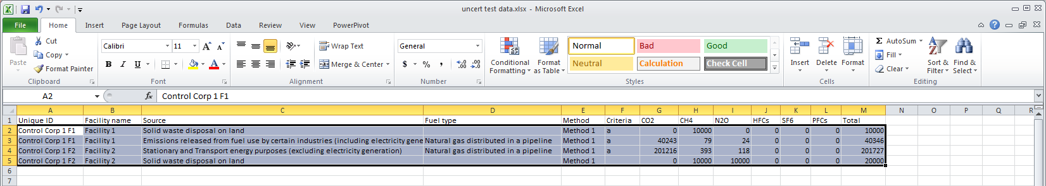

## Importing data into the Calculator

To import the data into the Calculator:

* open the Calculator
* select the ‘Source and fuel input’ worksheet
* click to highlight the cell containing the text, ‘Paste CSV data from EERS’ (yellow background):

Figure 2: CSV export file data pasted into the source and fuel input tab of the Calculator

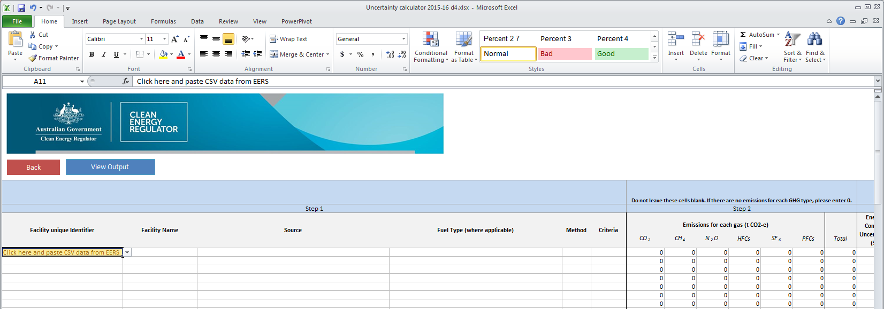

* paste the data from the CSV file so that it populates the Calculator:

Figure 3: CSV export file data pasted into the source and fuel input tab of the Calculator

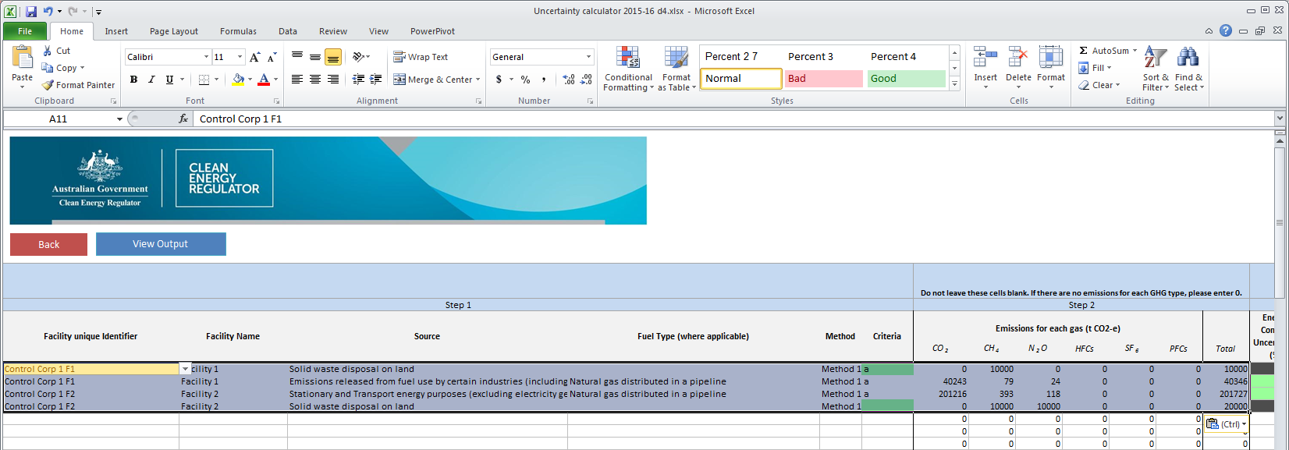

If the data has been pasted correctly, the cells in the ‘Result’ column (viewed by scrolling to the right) will display ‘OK’ on a green background. If all of the cells do not display ‘OK’, it may mean that the data was not pasted correctly. Use Excel’s undo command to reverse the pasting of the data and try again:

Figure 4: Uncertainty calculator displaying status of imported data

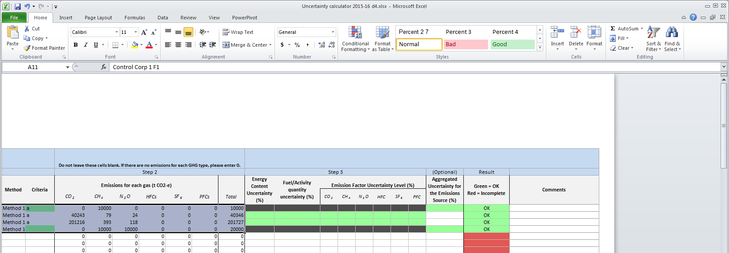

Once data has been correctly pasted, go to the ‘Output’ worksheet to view the uncertainty percentages (highlighted with yellow box) that will need to be entered into EERS:

Figure 5: Uncertainty calculator displaying uncertainty percentages to be inputted into EERS Manually entering data

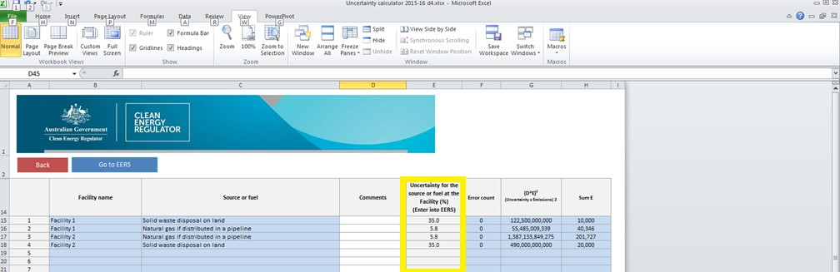

To manually enter uncertainty data into the Calculator:

* login to EERS
* click on ‘Report Uncertainty’ button
* in the ‘Facility Uncertainty’ screen, click on the pencil icon and the ‘Add/modify entry – Uncertainty’ screen will open
* open the Calculator in Excel
* ensure the Calculator is open on the ‘Source and fuel input’ tab
* enter the facility unique identifier and facility name data into the ‘Source and fuel input’ tab. Enter other data from the ‘Add/modify entry – Uncertainty’ screen in EERS.

# Components of the Calculator

## Worksheets of the Calculator

The Calculator has an ‘Instructions’ worksheet as well as 3 worksheets for data entry and calculations:

* source and fuel input
* output
* appendix 1 - Uncertainty of Elements.

These worksheets can be accessed through the tabs along the bottom and are briefly described below.

The ‘Source and fuel input’ worksheet is where source level data is entered for each facility or Network/Pipeline. More instructions are included in row 2, at the top of the worksheet. Reporters can enter the following facility data:

* unique identifier and facility name
* source, fuel, method and measurement criteria
* scope 1 emissions for each gas, relevant quantity data (where appropriate)
* non-default uncertainty levels (for energy content, measurement, and emissions factor).

The ‘Output’ worksheet is where uncertainty is calculated for a source (or fuel) at a facility. In addition, reporters can enter details to assist record keeping.

‘Appendix 1 – Uncertainty of Elements’ is an optional worksheet for independently calculating uncertainty values rather than using the default values built into the calculator. For example, it can be used to calculate the percentage uncertainty of samples collected by a corporation. Reporters are able to distinguish between sample series, and the worksheet calculates other information such as standard deviations, mean, count of measurements, t-factor (to a 95% confidence interval) and uncertainty (at 95% confidence interval) for the sample series. This function assists reporters in calculating uncertainty in accordance with the [GHG Protocol guidance on uncertainty assessment in GHG inventories and calculating statistical parameter uncertainty](https://ghgprotocol.org/sites/default/files/ghg-uncertainty.pdf)[14].

### Source and fuel input worksheet

Step 1: Complete columns A-G of the source and fuel input worksheet as described below. This step ensures the facility, source, fuel, criteria, and method are correctly identified. Note, except for column A, these fields do not need to be entered manually if the EERS uncertainty data export instructions are used.

* Facility unique identifier: This is a required field. The identifier is a text string that is unique to a facility (because facility names are not required to be unique). EERS automatically generates a facility unique identifier using the reporting organisation, facility name and dates of operational control.
* Facility Name: This is a required field. It is the name of the facility to which the source is to be attributed. Facility names do not have to be unique although reporters are advised to make them unique for the corporation’s group. Once a facility name has been entered it will appear in the drop-down menu and can be selected for remaining sources at the facility.
* Source: This is a required field. There is a drop-down menu that covers the source types of emissions, listed alphabetically.

Figure 6a: Fields used for data entry in Step 1, including the drop-down menus for Source of Emissions and Fuel Type

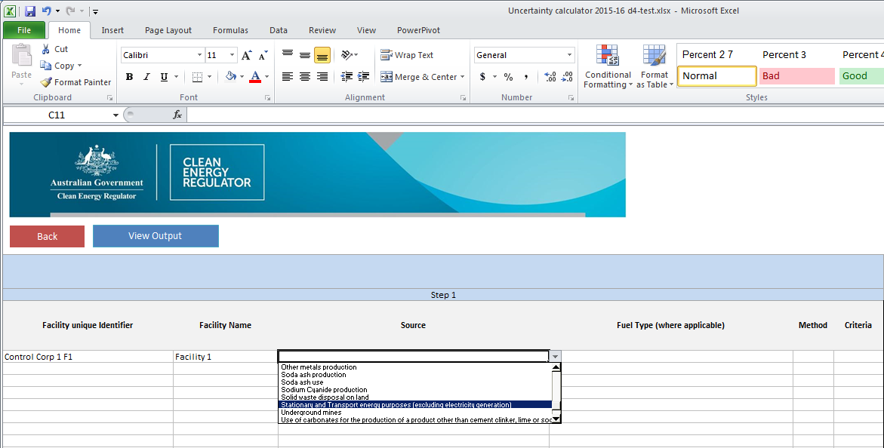

* Fuel Type (where applicable): Each row in this column has a drop-down menu containing a list of fuel and energy commodities. This list is context sensitive, depending on the source selected. Fuels are listed alphabetically.

Figure 6b: Fields used for data entry in Step 1, including the drop-down menus for Source of Emissions and Fuel Type

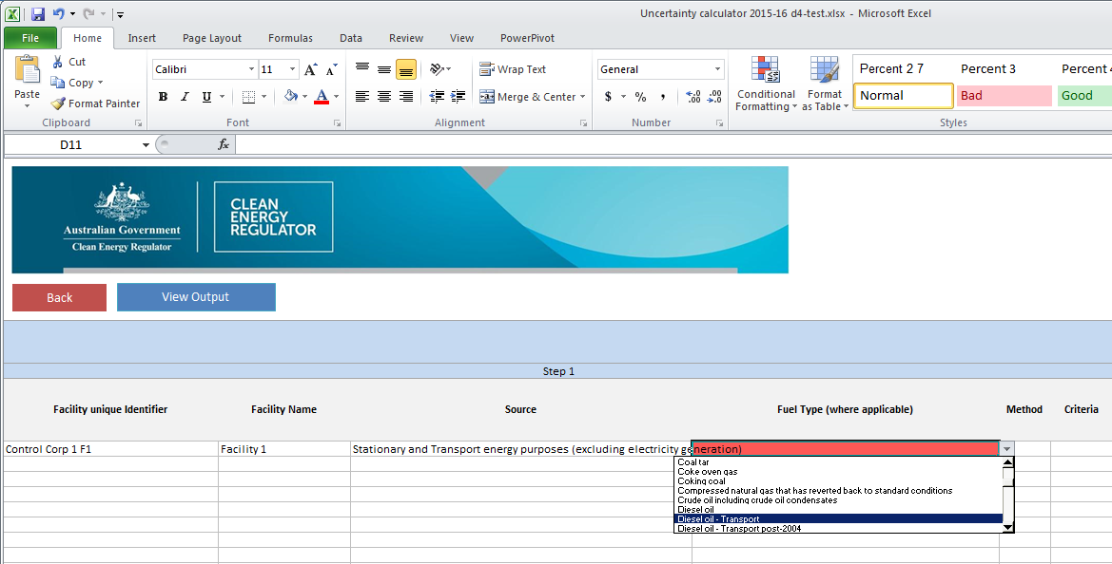

* Method: This is a required field, and shows the method used to estimate the emissions from the selected source, which will also be the method used to calculate the uncertainty for that source. Where multiple methods have been used to measure a single source of emissions, a separate line should be used for each method and for emissions amounts from gases using that method.
* Criteria: Reporters should select the criterion for measurement (A, AA, AAA or BBB) of the amount of fuel where applicable (e.g. amount of diesel oil consumed). See the [Methods and measurements criteria guideline](https://cer.gov.au/document_page/methods-and-measurement-criteria-guideline)[15] for more information on measurement criteria.

Step 2: Complete columns for each gas of the worksheet as described below. This step ensures the scope 1 emissions amounts and total emissions are entered. Note these fields do not need to be entered manually if the above data export instructions are used.

* Emissions for each gas (t CO2-e): Each column under this heading relates to one of the 6 greenhouse gases reported under the Act, and data must be entered. Emissions estimates, in tonnes of carbon dioxide equivalence (t CO2-e), should be entered in the column corresponding to the specific greenhouse gas. If there are no emissions of a particular greenhouse gas, then zero should be entered in the relevant cell(s).
* Total: The total of scope 1 emissions in t CO2-e.

Step 3: Calculating your uncertainty requires correct completion of the remaining columns to give an aggregated uncertainty for the emissions source. If method 1 is used, default values will be used.

* Energy Content Uncertainty (%): Reporters should leave these cells blank if they intend to use default values under method 1. If energy content percentage uncertainty is calculated independently, enter the value as a whole number - for example, 3.3% uncertainty is entered as ‘3’.
* Fuel/Activity Quantity Uncertainty (%): Reporters should leave these cells blank if they intend to use default values under method 1. If fuel or activity quantity uncertainty is calculated independently, enter the value as a whole number - for example, 2.9% uncertainty is entered as ‘3’.
* Emission Factor Uncertainty Level (%): There are 6 columns for the reportable greenhouse gases under this heading. Reporters should leave these cells blank if they intend to use default values or if the source does not have emissions for a particular gas. Enter the percentage value as a whole number.
* Aggregated Uncertainty for the Emissions Source (%): Some sources and methods 2, 3 and 4 allow for the direct entry of aggregated uncertainty for a source. If a value is entered here, the columns for the 3 headings directly above will be blacked out. This is shown in Figure 3 above.
* If aggregated uncertainty for a source is entered, then the only other field that needs to be filled out for that source is emissions for each gas in t CO2-e. Note: If aggregated uncertainty is used, all workings for calculating the aggregated uncertainty for the emission source must be well documented and made readily available if an audit is undertaken or requested by the agency.
* Reporters may wish to include comments in these cells.

Figure 7: Fields used for data entry in Step 3



### Output worksheet

The Output worksheet shows the aggregated uncertainty for each source and fuel type for each facility.

Once a facility’s unique identifier has been entered in the ‘Source and fuel input’ worksheet, the facility name will be shown in the ‘Facility Name’ column as shown in Figure 8 (see below):

Figure 8: Output worksheet example after data has been entered

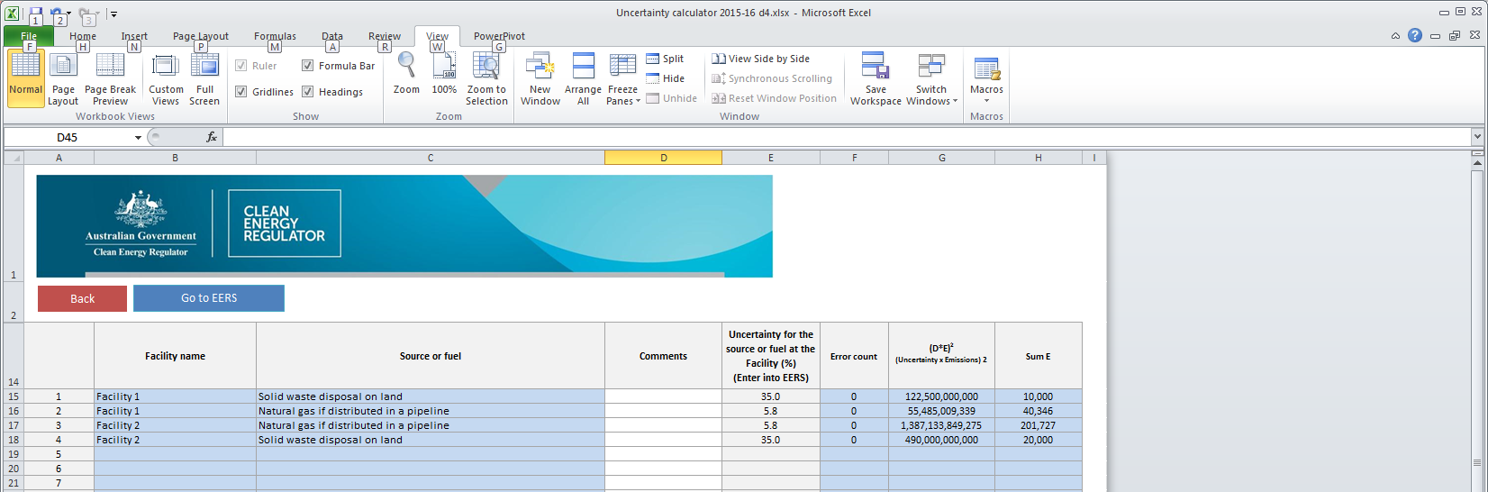

### Adding your data to EERS

Once the uncertainty for a source or fuel type (at a facility) has been calculated these numbers can be entered into the uncertainty add/modify entry screen in EERS.

### Appendix 1 – Uncertainty of Elements worksheet

This is an optional worksheet for independently calculating uncertainty values rather than using default values built into the Calculator (see below). This worksheet helps reporters calculate the uncertainty for a set of measurements or other data. The worksheet has been developed in accordance with the Uncertainty Protocol and uses the t-factor method with a 95% confidence interval in accordance with part 8.2 of the Measurement Determination.

Figure 9: Example of the Appendix 1 - Uncertainty of Elements worksheet

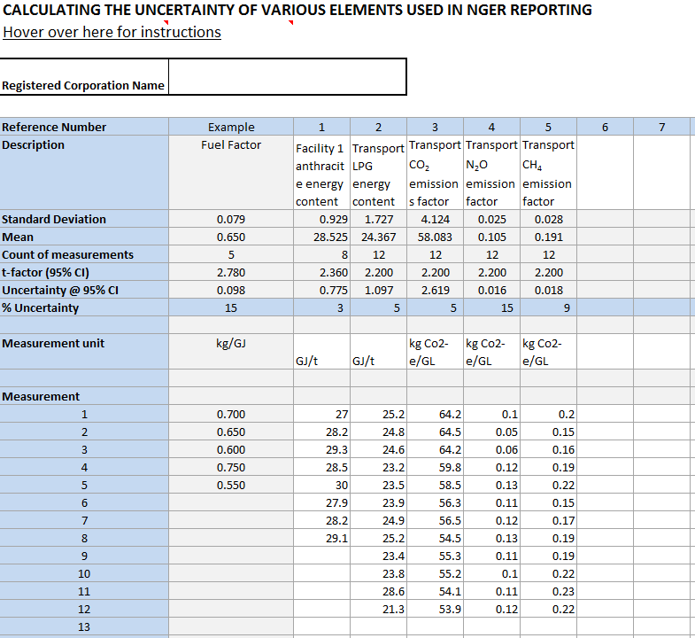

#### Available inputs

* Description: Cells in this row can be used to describe the samples which have been taken which will assist clear identification and record keeping (e.g. Facility 1 brown coal energy content).
* Standard deviation.
* Mean.
* Count of measurements.
* t-factor (95% confidence interval).
* Uncertainty at a 95% confidence interval.
* % uncertainty.
* Measurement Unit: The unit in which the samples are measured, for example GJ/t.
* Measurement: For a set of samples, each of the individual samples need to be entered (see next section). Standard deviation, mean, count of measurements, t-factor and the % uncertainty will automatically be calculated each time a new measurement sample is entered:
  + The percentage uncertainty can then be manually entered into the ‘Source and fuel input’ worksheet as part of Step 3 above. The other variables are provided for the reporter’s information.

#### How to calculate percentage uncertainty of samples

Entering sample data to obtain a percentage uncertainty for the sample set can be done by following the procedures below. An example has been provided (see Figure 9).

* Under reference number 1, enter the description of the fuel source, for example facility 1 anthracite energy content.
* In the same column, enter the measurement unit used, for example GJ/t.
* In the same column, enter measurement results with one value per cell, starting at measurement 1 and progressing downwards, for example 27.0, 28.2, 29.3, etc. Enter numerical data only. Do not enter the measurement unit in these cells.
* Repeat these steps for all remaining sample sets of data.

# Uncertainty reporting process

## Reporting uncertainty in EERS

For instructions in how to report uncertainty in the Emissions and Energy Reporting System, see the [EERS Navigation Guide](https://cer.gov.au/document_page/emissions-and-energy-reporting-system-navigation-guide)[16].

### Special cases: Emissions from entities that are not common ‘facilities’

For more information on reporting uncertainty for uncommon facility types see the [Reporting uncertainty guideline](https://cer.gov.au/document_page/reporting-uncertainty-guideline)[17].

## Calculating uncertainty: Industrial process sources using method 1

The table below specifies industrial process sources that do not have default uncertainty values in the Measurement Determination. If emissions from these sources involve the combustion of a fuel, then default fuel combustion uncertainty factors may be used for emissions attributable to each fuel. Otherwise, the uncertainty must be calculated in accordance with the Uncertainty Protocol.

|  |
| --- |
| Source |
| Sodium cyanide production |
| Soda ash production |
| Ammonia production |
| Hydrogen production |
| Carbide production |
| Chemical or mineral production (other than carbide production) using a carbon reductant or carbon anode |
| Iron, steel or other metal production using an integrated metalworks |
| Ferroalloys production |
| Aluminium production (where activity relates to emissions from the production of baked carbon anodes) |
| Other metals production |

### Using default combustion uncertainty factors for industrial process sources

In the following screenshot, the source iron, steel, or other metal production using an integrated metalworks involves the combustion of 3 fuels. The 3 example fuels are anthracite coal, blast furnace gas, and charcoal. It is necessary to understand the amount of emissions from each of these fuels. These 3 fuels and the amount of scope 1 emissions have been entered into the Calculator as shown below:

Figure 13: Fuel combustion for particular industrial processes

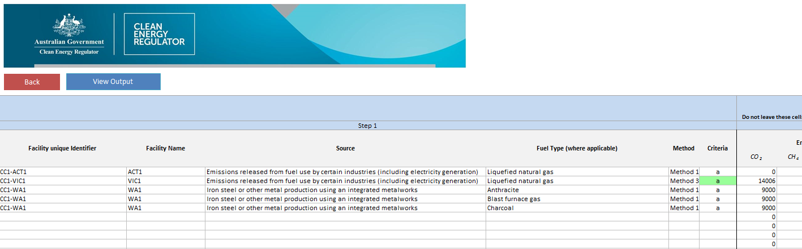

## Calculating uncertainty for carbon mass balance equations using method 1

The Measurement Determination provides methods based on a carbon mass balance approach for estimating scope 1 emissions from sources:

* which have multiple carbon inputs and outputs
* where the integrated nature of a facility means that the emissions estimate for the process is more accurate than estimates of emissions from different aspects of the process.

A carbon mass balance approach is provided for estimating emission from some activities under the following industrial process sources:

* Division 4.2.3 – Use of carbonates for production of a product other than cement clinker, lime, or soda ash (limited use)
* Division 4.2.4 - Soda ash use and production
* Division 4.3.5 – Chemical or mineral production, other than carbide production, using a carbon reductant or carbon anode
* Division 4.4.1 – Iron, steel or other metal production using an integrated metalworks
* Division 4.4.2 – Ferroalloys production
* Division 4.4.5 – Other metals production.

The rules in the Measurement Determination for assessing the uncertainty of emissions estimates using method 1, 2 or 3 are part of the uncertainty associated with estimating based on a number of parameters, including the energy content factor, emissions factor and/or activity data.

Part 8.3 of the Measurement Determination does not set out default values for assessing the uncertainty of emissions estimates using a method based on a carbon mass balance approach, which is a function of uncertainty associated with carbon content factors and activity data.

Given this, it is reasonable for reporters to assess uncertainty of emissions estimates using a carbon mass balance approach in accordance with the uncertainty protocol.

Part 7 of the Uncertainty Protocol recommends 4 ways to quantify uncertainty ranges for indirectly measured emissions:

* run statistical tests on one or several sets of sample data – for example, by the method explained in section 6.2 of the GHG Protocol
* determine the instrument precision of any measurement equipment used, especially for activity data
* consult experts within the company to give an estimation of the uncertainty range of the data used as explained in Section 6.1 of the Uncertainty Protocol
* use third-hand uncertainty ranges – for example, the Intergovernmental Panel on Climate Change (IPCC) data provided in the second worksheet of the uncertainty tool).

The Uncertainty Protocol recommends item 4 is only used where it is not possible to collect facility specific data for use in items 1 to 3. Section 8.15(2) of the Measurement Determination prevents the use of Item 4 when emissions are estimated using method 2, 3, or 4.

When using method 1, if it is not feasible to use items 1 to 3 of the uncertainty protocol to assess the uncertainty of estimates of emissions. A reporter may use item 4 and the IPCC overall source uncertainty figure of 10 per cent for carbon dioxide from industrial processes sources provided in the 'Calculations' worksheet of the GHG Protocol [Uncertainty Calculation Tool](https://ghgprotocol.org/sites/default/files/standards_supporting/Uncertainty%20Calculation%20Tool.xlsx)[18], if the reporter is confident it is a reasonable assessment of the uncertainty.

### Calculating uncertainty from methods 2, 3 and 1 (non-default factors) emissions

Uncertainty for emissions estimates calculated under methods 2 and 3 must be calculated in accordance with the Uncertainty Protocol (Part 8.4 of the Measurement Determination). Under certain circumstances, outlined in part 8.3 of the Measurement Determination uncertainty for emissions estimated under method 1 can also be calculated in this manner.

The procedure for applying these methods to the calculator is outlined as follows:

* enter a description for the source, for example, ‘natural gas (pipeline) - petroleum refining’
* type in the facility name under the ‘Facility Name’ column or, alternatively select the facility name from the drop-down menu
* choose a ‘Source’, for example ‘fuel combustion’
* select the method used to measure the emissions of the source
* choose criterion for estimation (if applicable).

Note: The criterion for estimation will be blacked out, where this is not a required variable for uncertainty calculations.

* For method 2 and 3 calculations, a reporter must calculate the uncertainty according to the principles in the Uncertainty Protocol. Data may be entered into the calculator in either of 2 ways:
  + Enter: estimated scope 1 emissions (from the EERS-generated section 19 NGER report), calculated energy content uncertainty, Fuel/Activity quantity uncertainty, and emission factor uncertainty (for each of the gases). The energy content, activity/fuel quantity and emissions factor uncertainties must have been calculated in accordance with Part 8.4 of the Measurement Determination.

OR

* + Enter the emissions data and aggregated uncertainty for the emissions source. Certain cells of the worksheet become blacked out to indicate fields where data is not required.
* Reporters may use the ‘Appendix 1 – Uncertainty of Elements’ worksheet (discussed previously) to calculate uncertainties based on the principles outlined in the Uncertainty Protocol.
* For method 1 (using non-default values), where uncertainty values are calculated in accordance with the Measurement Determination and the Uncertainty Protocol, these can be entered into the relevant cells. If no value is entered, default values will be applied.
* If multiple sources are attributed to a single facility, the calculator will aggregate the uncertainty for each source. The aggregated uncertainty for each facility as well as the corporation’s total percentage uncertainty will be shown on the ‘Output’ worksheet (Figure 6).

### Calculating uncertainty from method 4 emissions estimates

Assessments of uncertainty for emissions estimated under method 4 must conform to principles outlined in the Uncertainty Protocol. When using method 4 to calculate emissions estimates, only estimated emissions and aggregated uncertainty can be entered into the calculator for each emissions source. All other cells for entering uncertainty factors will be blacked out by the calculator when this is done.

Emissions data for each gas must also be entered to calculate the percentage uncertainty for the particular source.

Note: Data and methodologies associated with the calculation of the aggregated uncertainty under method 4 should be documented and retained.

## Where a corporation exceeds the limits of the calculator

The calculator has been designed to meet the needs of most reporting corporations but is limited to 50 facilities and fuel combinations.

Where a corporation exceeds either of these limits, data should be split between several copies of the calculator. In doing so, reporters should ensure that all data for a single facility is in the same copy of the Calculator to avoid errors.

# More information

Email [cer-nger-reporting@cer.gov.au](mailto:cer-nger-reporting@cer.gov.au) or call 1300 553 542within Australia.

1. https://www.legislation.gov.au/F2008L02230/latest/versions
2. https://www.legislation.gov.au/C2007A00175/latest/versions
3. https://cer.gov.au/schemes/national-greenhouse-and-energy-reporting-scheme/assess-your-obligations#what-is-an-nger-facility
4. https://www.legislation.gov.au/F2008L02230/latest/versions
5. https://www.legislation.gov.au/help-and-resources/understanding-legislation/reading-legislation
6. https://www.legislation.gov.au/C2007A00175/latest/versions
7. https://www.legislation.gov.au/F2008L02230/latest/versions
8. https://www.legislation.gov.au/F2008L02309/latest/versions
9. https://cer.gov.au/schemes/national-greenhouse-and-energy-reporting-scheme
10. https://cer.gov.au/document_page/emissions-and-energy-reporting-system-navigation-guide
11. https://cer.gov.au/document_page/reporting-uncertainty-guideline
12. https://cer.gov.au/online-systems#emissions-and-energy-reporting-system
13. https://cer.gov.au/schemes/national-greenhouse-and-energy-reporting-scheme/report-emissions-and-energy/nger
14. https://ghgprotocol.org/sites/default/files/ghg-uncertainty.pdf
15. https://cer.gov.au/document_page/methods-and-measurement-criteria-guideline
16. https://cer.gov.au/document_page/emissions-and-energy-reporting-system-navigation-guide
17. https://cer.gov.au/document_page/reporting-uncertainty-guideline
18. https://ghgprotocol.org/sites/default/files/standards_supporting/Uncertainty Calculation Tool.xlsx