
Emissions and Energy Threshold Calculator User Guide
July 2026





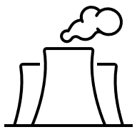

Contents
Contents 1
Definitions and abbreviations 3
Important note 4
Disclaimer 5
2025–26 updates 6
Introduction 6
What does the Threshold Calculator do? 6
How do I access the Threshold Calculator? 6
Greenhouse Gas and Energy Reporting 6
Using the Threshold Calculator 7
Start page 7
Facility worksheets (Facility 1 to 6) 7
Emissions and energy input 8
Transport fuel combustion 8
Non-transport fuel combustion 9
Purchased electricity 10
Consumed without combustion 11
Electricity/energy produced 12
Fugitive emissions (direct entry) 13
Output 14
Next steps 15
More information 15

Definitions and abbreviations
Term | Meaning
Consumption of energy | In relation to a facility, the use or disposal of energy from the operation of the facility, including:  - own-use  - losses in extraction, production and transmission.  See regulation 2.26 of the NGER Regulations.
Energy | Includes the fuels and other energy commodities listed in Schedule 1 of the NGER Regulations.
Facility | Has the meaning given by section 9 of the NGER Act. For more information on defining a facility under the NGER Scheme, see What is a Facility.
Fuel | A substance mentioned at items 1–57 in Schedule 1 of the NGER Regulations¹.
kL | Kilolitres
NGER | National Greenhouse and Energy Reporting
NGER Act | National Greenhouse and Energy Reporting Act 2007
NGER Measurement Determination | National Greenhouse and Energy Reporting (Measurement) Determination 2008
NGER Regulations | National Greenhouse and Energy Reporting Regulations 2008
Reporter | An entity required to report emissions and energy production and consumption to the Clean Energy Regulator under section 19, 22G, or 22X of the NGER Act
Scope 1 emissions | The release of greenhouse gas into the atmosphere as a direct result of an activity or series of activities (including ancillary activities) that constitute the facility.
Scope 2 emission | Per NGER Regulation 2.24, means the release of greenhouse gas into the atmosphere as a direct result of one or more activities that generate electricity, heating, cooling or steam that is consumed by the facility but that do not form part of the facility.
t CO₂-e | Tonnes carbon dioxide equivalence
Terms in NGER legislation may have specific meanings within the law. These key words and phrases are normally identified under a heading such as Definitions, Interpretation or Dictionary or in other parts of the document.
For more information on interpreting legislation see Federal Register of Legislation - Understanding Legislation.

Important note
The factors and formulas in the Emissions and Energy Threshold Calculator (Threshold Calculator) are based on the National Greenhouse and Energy Reporting (Measurement) Determination 2008 (Measurement Determination). The Measurement Determination is updated periodically, and users should note that some factors and formulas are different for earlier reporting years and may change in future years.
The Threshold Calculator is provided for information only and its use must not be construed as determinative of whether any of the thresholds for and legislative requirements under the National Greenhouse and Energy Reporting Act 2007 (NGER Act) and associated regulations have been met. The Threshold Calculator must not be used as a substitute for obtaining independent professional advice and/or undertaking independent investigations.
The Clean Energy Regulator (CER) and the Australian Government (the custodians) will not be liable for any loss, damage, expense, or cost incurred by any person or organisation arising out of the use of the Threshold Calculator, the information contained in, or derived from, the Threshold Calculator or the non-availability of the Threshold Calculator. The custodians do not warrant the accuracy, currency, reliability, or completeness of the Threshold Calculator, and in no event will the custodians be liable for any direct, incidental, or consequential loss or damage resulting from the use of the Threshold Calculator, or the information provided through the Threshold Calculator or the availability or non-availability of the Threshold Calculator.

Disclaimer
This guideline has been developed by the Clean Energy Regulator (CER) to assist entities to comply with their reporting obligations under the National Greenhouse and Energy Reporting Act 2007 (NGER Act) and associated legislation.
This guideline only applies to the 2025–26 NGER reporting year and should be read in conjunction with the NGER Act, National Greenhouse and Energy Regulations 2008 (NGER Regulations), and National Greenhouse and Energy Reporting (Measurement) Determination 2008 (NGER Measurement Determination), as in force for this reporting period. These laws and their interpretation are subject to change, which may affect the accuracy of the information contained in the guideline.
The guidance provided in this document is not exhaustive, nor does it consider all circumstances applicable to all entities. This guidance is not intended to comprehensively deal with its subject area, and it is not a substitute for independent legal advice. Although entities are not bound to follow the guidance provided in this document, they must ensure they meet their obligations under the National Greenhouse and Energy Reporting (NGER) Scheme at all times. The agency encourages all users of this guidance to seek independent legal advice before taking any action or decision based on this guidance.
CER and the Australian Government will not be liable for any loss or damage from any cause (including negligence) whether arising directly, incidentally, or as consequential loss, out of or in connection with, any use of this guideline or reliance on it, for any purpose.
If an entity chooses to meet their obligations under the NGER Scheme in a manner that is inconsistent with the guidance provided in this document, CER, or an independent auditor, may require the entity to demonstrate that they are compliant with requirements of the NGER Act, NGER Regulations, and/or the NGER Measurement Determination. Entities are responsible for determining their obligations under the law and for applying the law to their individual circumstances.

2025–26 updates
Changes in this document for the 2025–26 reporting year:
- Data-entry screenshots have been updated.
- Minor stylistic and formatting changes have been made to this document.

Introduction
The Threshold Calculator is a tool that enables operators to estimate emissions and energy consumption/production to assess if a controlling corporation could have an obligation to register and report under the NGER Act.
This guide provides step-by-step instructions and relevant background information to assist operators using the Threshold Calculator.

What does the Threshold Calculator do?
The Threshold Calculator can be used to obtain an estimate of scope 1 and scope 2 greenhouse gas emissions, energy production and energy consumption based on full, or part-year data entered by the operator. It also considers other direct (scope 1) greenhouse gas emissions from non-combustion sources such as waste treatment. For some of these sources, the operator will need to directly enter an estimate of the greenhouse gas emissions.

How do I access the Threshold Calculator?
The Threshold Calculator is available on the CER website and can be accessed without a username or password. We recommend that you download and save it onto your computer before entering data. Users will remain anonymous, and any data entered for a specific session will only be retained if the user saves it onto their computer.
If you have issues accessing the Threshold Calculator or would like to give us feedback on the tool, please call us on 1300 553 542 or email cer-nger-reporting@cer.gov.au.

Greenhouse Gas and Energy Reporting
The 2 types of thresholds that trigger a liability under the NGER Act are ‘facility’ thresholds and ‘corporate’ thresholds. Both types have a greenhouse gas threshold and an energy threshold.
Table 1: Facility and corporate thresholds
Facility threshold | Corporate threshold
25,000 tonnes or more of total greenhouse gases (carbon dioxide equivalence (CO₂-e)), or production or consumption of 100,000 gigajoules (GJ) or more of energy. | 50,000 tonnes or more of total greenhouse gases (CO₂-e), or production or consumption of 200,000 GJ or more of energy.
Total annual emissions is the sum of the direct (scope 1) and indirect (scope 2) emissions.
Data outputs from the Threshold Calculator are presented as scope 1, scope 2, total annual emissions (with sulphur hexafluoride, perfluorocarbons and hydrofluorocarbons excluded), and/or annual energy consumed or produced.
Emissions data is separated into scope 1 and scope 2 emissions. Energy consumption and production are presented as a total only. Where part-year data has been reported, the Threshold Calculator will automatically display extrapolated full-year emissions and energy data in addition to the amount based on entered data.
If the facility and/or corporate thresholds are triggered by combined scope 1 and scope 2 emissions, energy production or energy consumption, registration under the NGER Act is required. If a user’s assessment indicates that their facility and/or corporation may have had registration and reporting obligations for a previous reporting year, they must contact the CER on 1300 553 542 immediately.
See the National Greenhouse and Energy Reporting scheme for more information on the NGER Act, registration and reporting obligations.

Using the Threshold Calculator

Start page
The Start page displays information about the Threshold Calculator and provides links to NGER reporting guides on CER’s website. Please read the information before entering any data.

Facility worksheets (Facility 1 to 6)
The Threshold Calculator allows the reporting of emissions and energy data for a maximum of 6 facilities. If you need to report for more than 6 facilities, please call the CER on 1300 553 542 or email cer-nger-reporting@cer.gov.au
For each facility, you will need to select if you are reporting full year (default) or part-year data. If you are intending to enter part-year data, please enter the number of days in the field to the right of the drop-down menu.
The Threshold Calculator will calculate full-year data based on the amounts you have entered. The extrapolated data will appear in the Output screen.
Figure 1: Screenshot of facility reporting for full year

Emissions and energy input
You can enter data under the following sources:
- Transport fuel combustion: this covers the emissions and energy calculations for the combustion of fuels for transport activities. For example, fuels combusted in ships, planes, trains and road registered vehicles.
- Non-transport fuel combustion: this describes the emissions and energy calculations for the combustion of fuels for non-transport activities. This includes fuels combusted in activities that do not meet the criteria of transport. For example, fuels in vehicles that are not road registered.
- Purchased electricity: if you purchase electricity that has been generated outside of your facility, (for example from the main grid in a state/territory) then you will need to enter the amount as purchased electricity. This will result in scope 2 emissions. If you consume electricity that has been produced onsite, the amount will be entered as consumed without combustion. There are no emissions associated with electricity that is consumed without combustion, but the energy consumption is reported.
- Consumed without combustion: certain fuels and energy sources can be consumed without combustion. For example, natural gas can be consumed as a feedstock, solvents may be consumed in painting activities and electricity generated onsite is also consumed. There are no emissions from fuels and energy sources consumed without combustion, but energy consumption is reported.
- Electricity/energy produced: the production of electricity and other energy products contributes to the reporting threshold of a facility/corporation and is, therefore, reportable. Energy sources include electricity generated onsite, saleable coal, crude oil and other fuels and energy sources listed in the ‘electricity/energy produced’ drop-down menu.
- Fugitive emissions (direct entry): fugitive emissions are associated with several industry sectors including, but not limited to:
  - mining, for example, methane released as part of coal extraction
  - oil and gas, for example, release of gas from venting
  - waste, for example, emissions from decomposition of solid waste or from wastewater treatment.
The Threshold Calculator is not capable of dealing with the complex calculations associated with estimating fugitive emissions, so direct entry is the only option available. See NGER calculators and NGER reporting guides to assist with calculating fugitive emissions.
Reporting under these sources is covered in more detail below.

Transport fuel combustion
Emissions and energy are calculated based on the amount of a particular transport fuel that has been combusted. The list of transport fuels is based on those listed in Schedule 1 of the Measurement Determination. You can choose up to 7 transport fuels. If you need more transport fields, please email CER at cer-nger-reporting@cer.gov.au

Figure 2: Screenshot of transport fuels for combustion
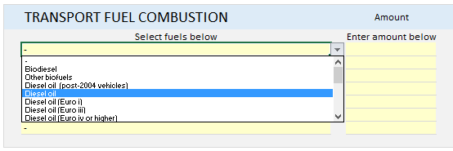
To commence, select the transport fuel from the drop-down menu.
If you select a liquid fuel, the Threshold Calculator will automatically select kilolitres (kL) as the unit of measurement. If you select a gaseous fuel, the Threshold Calculator will automatically select cubic metres (m³) as the unit of measurement. The units of measurement cannot be changed.
If you measure the amount of your gaseous fuels in GJ, use the gas conversion calculator (located in the Convert and Lookup screen) to convert the amount to m³ before entering the amount.
Next, enter the amount of fuel combusted in the Amount field. The Threshold Calculator will calculate the emissions and energy associated with the amount of fuel combusted.
Figure 3: Screenshot of transport fuel combustion calculations
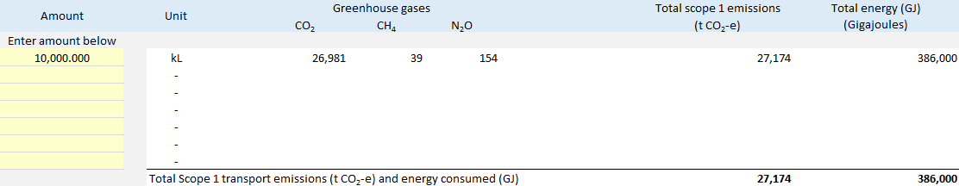
Repeat the above for each transport fuel combusted at your facility.

Non-transport fuel combustion
Emissions and energy are calculated based on the amount of a particular non-transport fuel that has been combusted. The list of non-transport fuels is based on those listed in the Measurement Determination. You can choose up to 7 fuels. If you need more fuel fields, please email CER at cer-nger-reporting@cer.gov.au
Figure 4: Screenshot of non-transport fuels for combustion
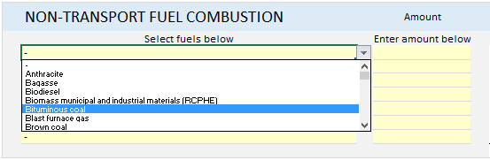
To commence, select the non-transport fuel from the drop-down menu.
If you select a liquid fuel, the Threshold Calculator will automatically select kL as the unit of measurement.
If you select a solid fuel, the Threshold Calculator will automatically select tonnes as the unit of measurement.
If you select a gaseous fuel, the Threshold Calculator will automatically select m³ as the unit of measurement. The units of measurement cannot be changed. If you measure the amount of your gaseous fuels in GJ, you can use the gas conversion calculator (located in the Convert and Lookup screen) to convert the amount to m³.
Next, enter the amount of fuel combusted in the Amount field. The Threshold Calculator will calculate the emissions and energy associated with the amount of fuel combusted.
Figure 5: Screenshot of non-transport fuel combustion calculations
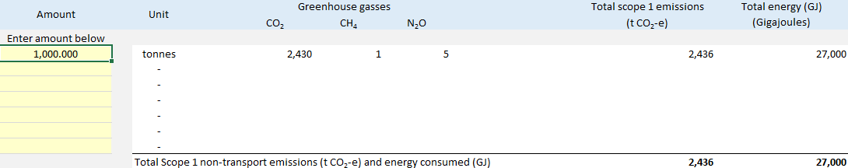
Repeat the above steps for each non-transport fuel combusted at your facility.

Purchased electricity
Purchased electricity is usually provided by the main electricity grid, that is, the grid that supplies the largest population in a state or territory. For example, the main grid in Western Australia is the South West Interconnected System.
To report the purchase of electricity, first select the state your facility is located in. Each state/territory has its own emission factor that reflects how electricity is generated.
Figure 6: Screenshot showing how to select state/territory emissions factors for purchased electricity
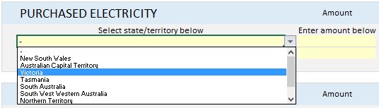
The Threshold Calculator enables the operator to select electricity purchased either from the main grid in a state/territory or from another source.
If the facility/corporation purchases electricity from the main grid and from a grid other than the main grid, select ‘Not purchased from the main grid’ using the drop-down menu.
If ‘Not purchased from the main grid’ has been selected, use the default emission factor or the one provided by the specific electricity grid supplier.
Figure 7: Screenshot showing how to select non-state/territory emissions factors for purchased electricity
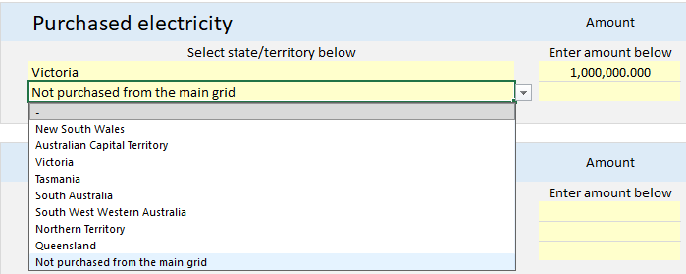

Figure 8: Screenshot of purchased electricity calculations

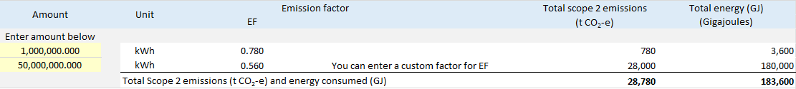
Next, enter the amount of electricity purchased in the amount fields. Electricity is always reported in kilowatt hours (kWh). If you measure electricity in GJ, you can use the electricity conversion calculator (located in the Convert and Lookup screen) to convert the amount to kWh.

Consumed without combustion
A fuel or energy source can be consumed without combustion. This can occur when a fuel is used as a feedstock in a manufacturing process, or when renewable energy is consumed to generate electricity (for example, wind power consumed to drive turbines).
There are no emissions associated with fuel or energy consumed without combustion. However, energy consumption is reportable and contributes to the overall emissions and energy consumption threshold of a facility/corporation.
Figure 9: Screenshot of fuels and other energy sources consumed without combustion
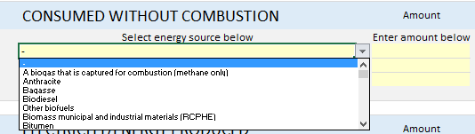
To commence, select the fuel/energy source from the drop-down menu.
If you select a liquid fuel, the Threshold Calculator will automatically select kL as the unit of measurement.
If you select a solid fuel, the Threshold Calculator will automatically select tonnes as the unit of measurement.
If you select a gaseous fuel, the Threshold Calculator will automatically select cubic metres (m³) as the unit of measurement.
If you select a renewable energy source used to generate electricity, the unit will be GJ.
The units of measurement cannot be changed. If you measure the amount of your gaseous fuels in GJ, you can use the gas conversion calculator (located in the Convert and Lookup screen) to convert the amount to m³.
Next, enter the amount of fuel/energy consumed in the Amount field. The Threshold Calculator will calculate the energy associated with the amount of fuel/energy consumed.
Figure 10: Screenshot of amount of fuel/energy
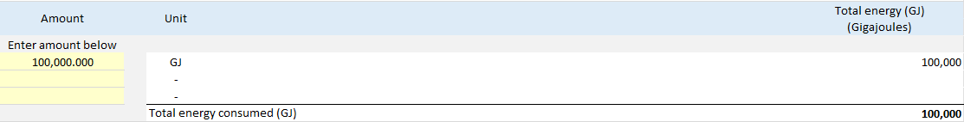

Electricity/energy produced
Energy production at a facility is reportable under the NGER legislation. Energy production can include electricity generated and either used by the facility or sent to a grid. Other energy production sources include saleable coal, crude oil and other fuels and energy sources listed in the electricity/energy produced drop-down menu.
There are no emissions associated with energy produced. However, energy production is reportable and contributes to a facility’s reporting threshold.
Figure 11: Screenshot of types of energy (including electricity) can be produced
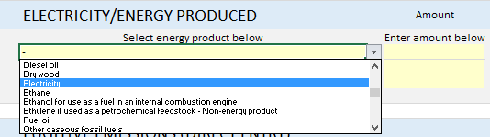
To commence, select the energy source from the drop-down menu.
The unit of measurement used by the calculator will depend on the type of fuel selected. The units of measurement cannot be changed. If you need to convert between GJ and either m³ or kWh, you can use the conversion calculators (located in the Convert and Lookup screen).
Next, enter the amount of electricity/energy produced in the ‘Amount’ field. The Threshold Calculator will calculate the energy associated with the amount of fuel/energy produced.

Figure 12: Screenshot of calculations for electricity/energy production
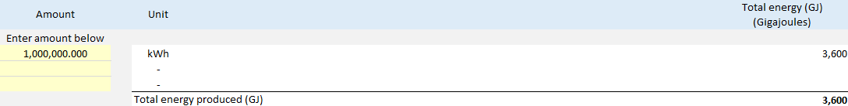

Fugitive emissions (direct entry)
Fugitive emissions are associated with certain activities including coal mining, oil and gas production and distribution and waste. The Threshold Calculator is not able to perform the calculations associated with fugitive emissions meaning that direct entry based upon measurement of the fugitive emissions is required.
To enter fugitive emissions, first enter the type of gas in the appropriate field (optional). The Threshold Calculator permits the entry of 2 sources of fugitive emissions. If you need more fugitive emission sources, please email CER at cer-nger-reporting@cer.gov.au.
Figure 13: Screenshot of fugitive emissions (direct entry)
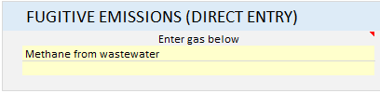
Next, enter the amount of each greenhouse gas in tonnes of CO₂-e.
Figure 14: Screenshot of amount of greenhouse gas emissions calculations
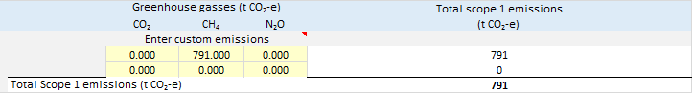
The Threshold Calculator will add up all the greenhouse gases from fugitive emissions and include them in the total scope 1 emissions from the facility/corporation.
Once all emissions and energy data has been entered for the facility, the Threshold Calculator will display the total emissions and energy consumed/produced as entered. In addition, if you have entered part-year data for emissions and energy reporting, the Threshold Calculator will display the full-year data based on the amounts you have entered for the period.
Figure 15: Screenshot of totals of facility emissions and energy consumed/produced
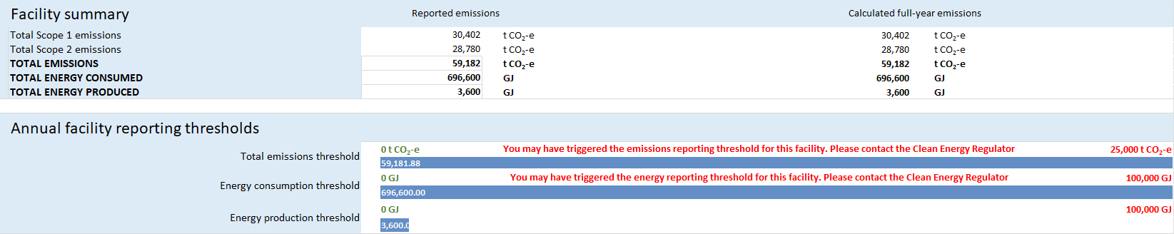
The Threshold Calculator will also show a graphical display showing how close the facility is to triggering emissions and energy thresholds. The Threshold Calculator will also display a message if thresholds are close to being, or have been, met.
Repeat the above process for each facility.

Output
Based on the data entered, the Threshold Calculator will calculate and display the greenhouse gas emissions, measured in t CO₂-e and energy consumption/production for each facility. The data is presented as scope 1, scope 2, total emissions, energy produced, and energy consumed.
Two tables are displayed on the ‘Corporation Output’ screen. The top table displays the emissions and energy data based on the data entered in the previous screens. The lower table displays the extrapolated full year data for all facilities. This will indicate the full year emission and energy data for facilities where part-year data has been entered.
Figure 16: Screenshot of emissions & energy totals for each facility
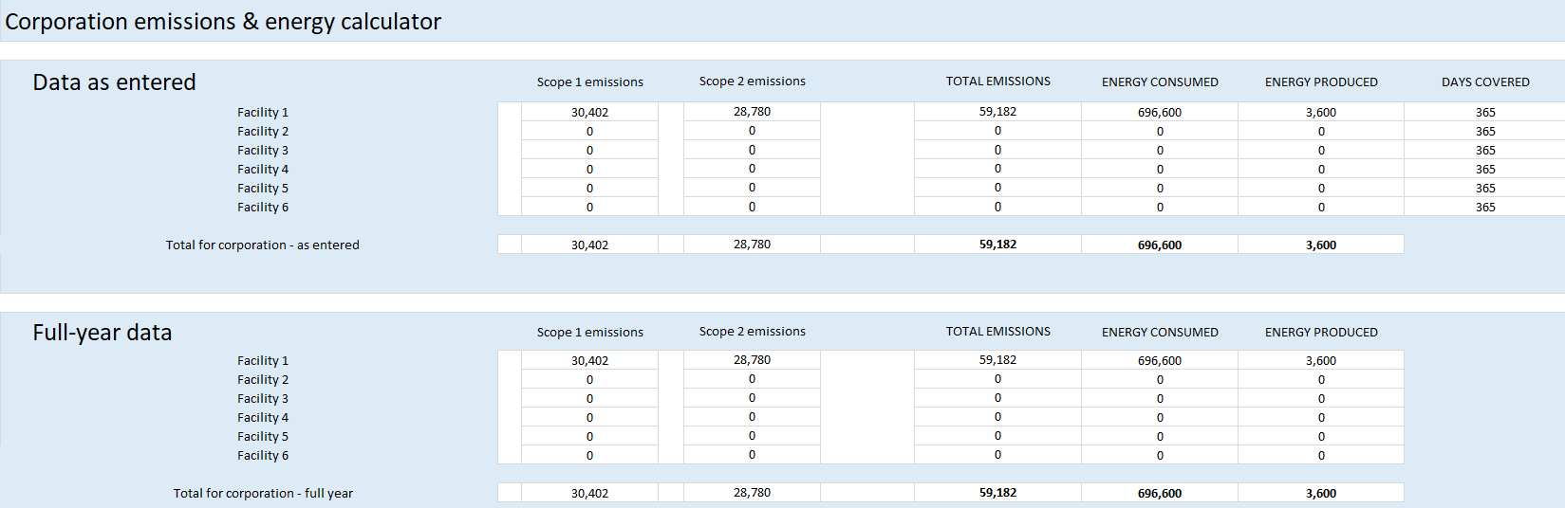
The Threshold Calculator will also display:
- which thresholds have been triggered for each facility and the corporation
- a graphical display showing how close the corporation is to triggering emissions and energy thresholds
- a message if thresholds are close to being, or have been, met.
The thresholds are based on full-year data as entered or full-year data extrapolated from entered part-year data.
Figure 17: Screenshot of annual reporting thresholds that have been met/exceeded
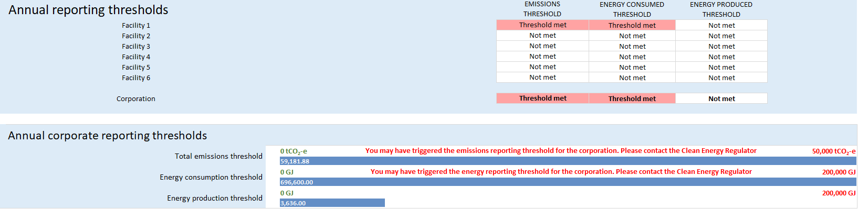

Next steps
The Threshold Calculator is for information only and its use must not be construed as determinative of whether any of the thresholds for and legislative requirements under NGER Act and the associated Regulations have been met. It must not be used as a substitute for obtaining independent professional advice and/or undertaking independent investigations.
If you have determined you are liable to report under the NGER Act, you must register with the CER. See Register and deregister for information on how to register.

More information
Email: cer-nger-reporting@cer.gov.au
Phone: 1300 553 542 within Australia
Web: www.cer.gov.au

https://www.legislation.gov.au/F2008L02230/latest/versions
https://www.legislation.gov.au/C2007A00175/latest/versions
https://cer.gov.au/schemes/national-greenhouse-and-energy-reporting-scheme/assess-your-obligations#what-is-an-nger-facility
https://www.legislation.gov.au/help-and-resources/understanding-legislation/reading-legislation
https://www.legislation.gov.au/Series/F2008L02309
https://www.legislation.gov.au/Series/C2007A00175
https://www.legislation.gov.au/Series/C2007A00175
https://www.legislation.gov.au/Series/F2008L02230
https://www.legislation.gov.au/Series/F2008L02309
http://www.cleanenergyregulator.gov.au/NGER/Pages/default.aspx
https://cer.gov.au/schemes/national-greenhouse-and-energy-reporting-scheme/report-emissions-and-energy/nger-calculators
https://cer.gov.au/schemes/national-greenhouse-and-energy-reporting-scheme
https://cer.gov.au/schemes/national-greenhouse-and-energy-reporting-scheme/report-emissions-and-energy/nger-reporting-guides
https://cer.gov.au/schemes/national-greenhouse-and-energy-reporting-scheme/report-emissions-and-energy/nger-calculators
https://cer.gov.au/schemes/national-greenhouse-and-energy-reporting-scheme/report-emissions-and-energy/nger-reporting-guides
https://cer.gov.au/schemes/national-greenhouse-and-energy-reporting-scheme/register-nger-reporter

