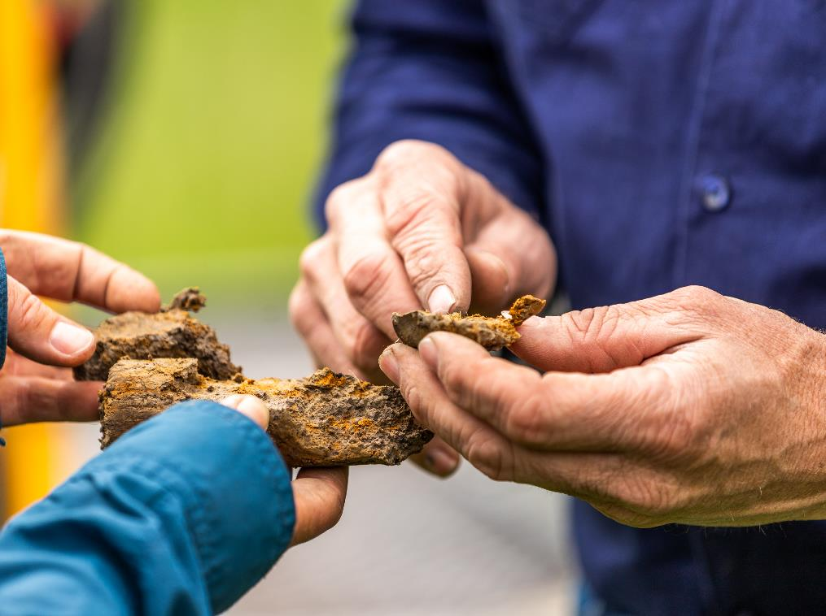Key risk areas for auditors

V1.1, 25 November 2024

# Contents

Contents 2

Purpose 3

ACCU Scheme: mandatory and CER-initiated audits 4

NGER: voluntary and CER-initiated audits 12

RET: emissions-intensive trade-exposed (EITE) applications using electricity use method 13

The Safeguard Mechanism 13

# Purpose

This document provides guidance to greenhouse and energy auditors on which risk areas to focus on when conducting audits under the schemes we administer.

It should be used in conjunction with the [compliance and enforcement priorities](https://cer.gov.au/about-us/our-compliance-approach/compliance-and-enforcement-priorities/compliance-and-enforcement-priorities-2024-2025)[1] we publish annually, and any other guidance we provide. Auditors must ensure they are aware of legislative requirements for audits under the schemes and comply with them.

This document does not provide an exhaustive list of all risks auditors are expected to address. It focuses on what we believe are the key risks that should be addressed as part of audit procedures.

Key risks are provided for audits under the following schemes:

* Australian Carbon Credit Unit (ACCU) Scheme
* National Greenhouse and Energy Reporting (NGER) Scheme
* Renewable Energy Target (RET)
* the Safeguard Mechanism.

We expect auditors to use their professional judgement in determining which risks to address when conducting audits, and what procedures to undertake to address those risks. This may entail auditors addressing risks not included in this and other guidance from the CER.

As part of exercising their professional judgement, auditors are expected to determine whether visits to facilities and other sites subject to audit are required as part of conducting audits, and to determine the nature of any such visits. We reserve the right to provide guidance on the necessity for and nature of site visits.

## ACCU Scheme: mandatory and CER-initiated audits

| Methodology | Key risks |
| --- | --- |
| All | * Project activities are undertaken * Correct inputs to calculators and accurate calculations of abatement * Report completeness and accuracy * False and misleading information has not been submitted * Record keeping systems and processes maintained in accordance with the [*Carbon Credits (Carbon Farming Initiative) Act 2011*](https://www.legislation.gov.au/C2011A00101/latest/versions)[2] (the CFI Act) and [methods](https://cer.gov.au/schemes/australian-carbon-credit-unit-scheme/accu-scheme-methods)[3] * Applicable monitoring requirements under the method are met * Restricted activities have not occurred * Legal right is obtained and maintained   + Changes to land title boundaries over time should be monitored. If changes in the land title boundary result in the project area falling outside the area in which they have legal right for, the proponent should query if the change is valid with the relevant land title office. If valid, the proponent will need to either remove the area or obtain legal right. * Consent of the relevant Eligible Interest Holders has been obtained |
| Human induced regeneration | * Geospatial data aligns with ground truths:   + carbon estimation areas (CEAs) exclude ineligible land   + baseline forest cover has been correctly identified and excluded.   + areas with no forest potential have been removed.   + vegetation in CEAs has forest potential   + adequate evidence of progress towards forest cover is obtained in compliance with CER guidelines. * FullCAM model points are representative of CEAs and meet method requirements and supporting guidelines * Disturbances affecting carbon sequestered in CEAs are monitored, detected and reflected in modelling * Project activities result in CEAs achieving forest cover * Regeneration is progressing towards or has obtained forest cover * FullCAM events are representative of management activities * Modelling commencement dates represent when regeneration/reforestation began * Evidence of management activities recorded |
| Native forest from managed regrowth | * Geospatial data aligns with ground truths:   + CEAs exclude ineligible land     - baseline forest cover has been correctly identified and excluded     - areas with no forest potential have been removed     - vegetation in CEAs has forest potential.   + CEAs have been historically comprehensively cleared     - CEAs contain regrowth of the same forest type of vegetation community, in terms of likely mature structure and dominant tree likelihood have the same vegetation type     - Adequate evidence of progress towards forest cover is obtained in compliance with CER guidelines. * FullCAM model point locations are representative of CEAs and meet method requirements and supporting guidelines * FullCAM modelling and calculations align with method and guidelines * Disturbances affecting carbon sequestered in the project area are monitored, detected and reflected in modelling * Project activities in CEAs contribute to achieving forest cover * Regeneration is progressing towards or has obtained forest cover * Grazing does not suppress regeneration |
| Soil carbon projects | * Compliance with ACCU Scheme guidelines:   + CEAs, emissions accounting areas and exclusion areas   + identification of eligible land (ensuring accurate mapping of eligible land in the CEAs including soil depth, land use and excluding ineligible land)   + verification of restricted activities and/or activities not to be conducted   + stratification. * Sampling conducted in accordance with the supplements:   + design   + independence and suitability of samplers and sample preparers   + locations   + sampling depths   + offsetting or reserve points for inaccessible sampling points (including process, plan and evidence)   + sample preparation and analysis   + timing (start and end date of sampling rounds). * Evidence to demonstrate the baseline management activities and project implementation in the project area as required for project eligibility * Newness requirement * Evidence of project activities continuing to be undertaken for the crediting period:   + start date of each eligible activity identified   + record keeping of the activities   + Land Management Strategy is regularly updated in response to any change to the eligible management activities and in line with the method requirements. |
| Savanna fire management methods | * Compliance with ACCU Scheme mapping guidelines: * If the proponent has created or revised a vegetation map, check compliance with creation and validation requirements (for example, the Savanna Technical guidance document for the 2018 methods)   + Proponents are required to use a ‘centrist approach’ where if the centre of the pixel is inside the project area, the pixel is valid, and if the centre is outside of the project area, the pixel is coded as ineligible or removed entirely. This ensures the vegetation map falls within the project area.   + Check pixels are classified appropriately - may require site visit to confirm the map accurately reflects vegetation types on the ground. * Correct SavBat inputs (baseline years, correct uncertainty buffer carried forward)   + Baseline period should end immediately before the relevant area became part of the project unless it is a ‘transferring project’ or as otherwise specified in the method. * Density of livestock has not increased as a consequence of the project * Description of fire management activities and evidence they were carried out within the relevant permit period * Relevant fire permits obtained * Fossil fuel use records are appropriate and accurate (where required). Emissions factors are applied correctly   **For projects registered under the 2018 methods**   * Relevant weed species monitoring and removal from project area * Project management plan compliant with the method |
| Landfill gas, alternative waste treatment and source-separated organic waste | **Landfill gas**   * Regulatory baseline is correct * Correct equation application * Default factors applied correctly * Electricity generation calculated in accordance with section 24(6) of the CFI Act (where appropriate) * Flare operation in accordance with the method * Monitoring and metering requirements are in accordance with the method * Calibration performed in accordance with manufacturers specifications * Methane concentration applied correctly   **Alternative waste treatment**   * Ensure eligible waste types * Ensure eligible waste treatment technologies * Baseline emissions * Waste data * Weigh bridge accuracy   **Source-separated organic waste**   * Ensure eligible waste types * Ensure eligible waste treatment technologies * Review monitoring evidence of the diverted organic waste * Correct equation application in baseline and abatement calculations |
| Agriculture | **Animal Effluent**   * Ensure eligible material produced by an eligible animal facility * Ensure ‘Listed Types’ * Correct equation application in baseline and abatement calculation * Check the records of electricity generation |
| Industrial methods | **For both the Industrial Electricity and Fuel Efficiency (IEFE) and Industrial Commercial Emissions Reduction (ICER) methods**   * Evaluation of baseline regression models:   + selection of appropriate independent variables   + ensure statistical requirements have been met   + ensure appropriate baseline period is selected   + identify static factors to ensure validity of baseline model usage. * Abatement calculations:   + check the correct electricity emissions factor is applied   + ensure independent variable data is within effective range of the baseline model   + ensure improvement factor, relative precision and accuracy factor have been calculated correctly.   **For ICER only**   * Check statements of activity intent are in place for all implementations * Evaluation of engineering/regression baseline models:   + independent professional sign off (where appropriate)   + verify non-routine adjustments   + check if new baseline emissions model has been developed * ensure industrial process emissions have been calculated in accordance with NGER Measurement Determination. |
| Beef cattle herd management | * Check the inputs and outputs of the beef cattle herd calculator:   + review herd raw data and third-party data tools used for calculator inputs   + ensure emissions intensity output in the “Results” tab does not vary greatly across reference years/reporting year   + check lactation factor corresponds to proportion of branded cattle in “Transient Herd” tab   + check for significant weight loss across herd (accounting cows that have given birth – see lactation factor)   + check the dates for “Transfer-In” transactions in “Transient Herd” for alignment with start of reference or reporting year   + ensure headcount values are positive, whole numbers. * Verify record-keeping in accordance with Part 5 of the method including Division 4 monitoring requirements and feed purchases * Verify project activities for each reporting year |
| Reforestation / afforestation | * Geospatial data aligns with ground truths:   + CEAs are accurately defined   + ineligible areas excluded from CEAs   + disturbance events have been detected and mapped accurately. * Any disturbances affecting carbon sequestered in the project area is not defined * Sampling plans are not documented * Type of sampling plan undertaken is not reported * Management records are representative of management activities * Calculation of carbon stock change is not correct |
| Avoided deforestation | * Clearing permits are eligible under the Method * Geospatial data aligns with ground truths:   + CEAs are accurately defined   + ineligible areas are excluded from CEAs * Disturbances affecting carbon sequestered in CEAs are monitored, detected and reflected in modelling. * Land in CEAs or clearing buffers remain uncleared, or addressed in accordance with method requirements. * Non-project trees are not included in CEAs |
| Avoided Clearing | * Permit for unrestricted clearing is demonstrated * Required historical clearing and regeneration events have occurred * Land has been used for grazing/cropping prior to regeneration * Geospatial data aligns with ground truths:   + CEAs are accurately defined   + ineligible areas are excluded from CEAs   + disturbances have been detected and stratified accurately * Disturbances affecting carbon sequestered in CEAs are monitored, detected and reflected in modelling * Land in CEAs isn’t cleared |
| Environmental planting | * Plantings have been undertaken in accordance with method requirements * Geospatial data aligns with ground truths:   + CEAs meet method geometry, spacing and stocking density requirements   + CEAs only include land with plantings   + plantings in CEAs has forest potential   + disturbance events have been detected and stratified accurately   + ineligible areas are excluded from CEAs. * Model point locations are representative of CEAs and meet method requirements and guidelines * Management records are representative of management activities * Planting meets the requirements for the modelling calibration applied to the CEA * Modelling events are representative of project activities * Any disturbances have been detected and represented in modelling |
| Plantation Forestry | * Project activities have been undertaken in accordance with method requirements * FullCAM inputs are consistent with the forest management plan * Carbon estimation areas have been stratified as per method requirement and guidelines * Financial assessment to support project viability has been provided if applicable * Model point locations are representative of CEAs and meet method requirements and guidelines * Management records are representative of management activities * Modelling events are representative of project activities * Any disturbances have been detected and represented in modelling |

## NGER: voluntary and CER-initiated audits

| Industry type | Key risks |
| --- | --- |
| All | * Facility boundaries * Operational control determination (including contractors) * Emissions and energy calculations * Record keeping, including any records of the process of reporting (including the basis of preparation) * Matters to be Identified (MTBIs) of any activity which requires their reporting * Use of biofuels or carbon capture and storage (CCS) with scope 1 emission estimates * Use of market-based methods to estimate scope 1 and scope 2 emissions |
| Oil and gas | * Fugitive emissions * Categorisation of fuels during energy production and consumption |
| Coal mining | * Fugitive emissions * Categorisation of fuels during energy production and consumption |
| Electricity generation, transmission and distribution | * Emissions from fuel combustion |
| Industrial processes | * Emissions from of the use of carbonate materials * Use of fuels as feedstock or reductant |
| Solid waste and landfill biogas | * Composition of solid waste streams * Activities related to handling of captured biogas * Estimations of solid waste tonnage * Waste mix types * Methane Correction Factor (MCF) determination |
| Wastewater handling | * Chemical Oxygen Demand (COD) determination * Methane Correction Factor (MCF) determination * Activities related to handling of captured biogas |

## RET: emissions-intensive trade-exposed (EITE) applications using electricity use method

|  |  |
| --- | --- |
| Audit type | Key risks |
| All | * Use amount formula used to calculate the certifiable amount is appropriate * Completeness and accuracy of electricity use data, including:   + delineation between EITE and non-EITE activity   + exclusion of non-liable on-site generation. * Identifying and reporting correct billing and other meter identifiers * EITE activity correctly identified in application and meets criteria for eligibility * Providing false or misleading information * Poor record keeping/procedural reliability |

## The Safeguard Mechanism

| Audit type | Key risks |
| --- | --- |
| Emissions-intensity determination application | * Application correctly specifies the historical production variables for the facility * Application correctly specifies the quantity of the historical production variable in the historical financial year * Application correctly specifies the amount of covered emissions for the facility in each historical financial year * Application correctly specifies the transitional production variables (if any) for the facility * If the application specifies one or more historical production variables for the facility, the application correctly specifies the amount of covered emissions of greenhouse gases from the operation of the facility that are relevantly associated with each of those production variables   + calculation of amounts of covered emissions of greenhouse gases from the operation of the facility meet the requirements. |
| Trade-exposed baseline adjusted determination application | * Whether the information included in the application is correct * Whether the primary production variable for the facility in the first financial year is a trade-exposed production variable * Reasonable assurance is provided over the revenue or EBIT (earnings before interest or tax) of the facility in the first financial year, including assumptions made in determining the relevant figure * Reasonable assurance is provided over the assessed cost impact for the facility in the first financial year and information about assumptions made when working out that value |

1. https://cer.gov.au/about-us/our-compliance-approach/compliance-and-enforcement-priorities/compliance-and-enforcement-priorities-2024-2025
2. https://www.legislation.gov.au/C2011A00101/latest/versions
3. https://cer.gov.au/schemes/australian-carbon-credit-unit-scheme/accu-scheme-methods