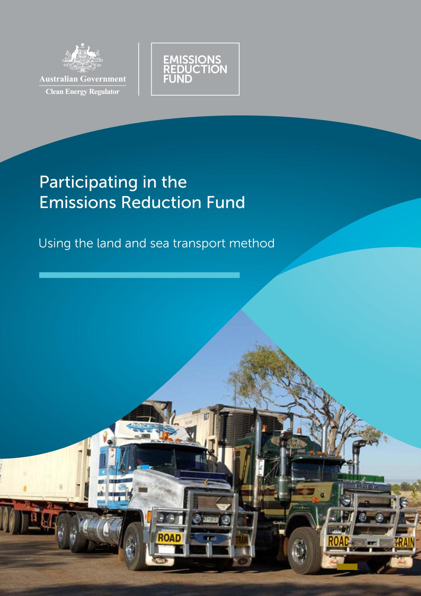
Participating in the Emissions Reduction Fund

Using the land and sea transport method
Version 1 August 2015

Contents
Why participate? 2
Using this booklet 2
Land and sea transport projects 3
Overview 3
Essential reading 3
What does a land and sea transport project look like? 5
Types of projects 5
Setting up and running a land and sea transport project 7
Establish the land and sea transport project 7
Mode switching in land and sea transport projects 8
Calculate emission reductions 9
Calculate project baseline emissions intensity 9
Calculate baseline emissions 10
Calculate emissions from the project 10
Calculating the net amount of abatement and number of ACCUs 10
Monitoring and record keeping 12
Project and audit reports 12
The role of audit 12
Making changes to a project 13
Resources 13

Version information
Version number | 1
Date published | August 2015

This document is produced for general information only and does not represent a statement of the policy of the Commonwealth of Australia. The Commonwealth of Australia and all persons acting for the Commonwealth preparing this document accept no liability for the accuracy of or inferences from the material contained in this publication, or for any action as a result of any person’s or group’s interpretations, deductions, conclusions or actions in relying on this material. It should be read in conjunction with the Carbon Credits (Carbon Farming Initiative) Act 2011 and supporting Regulations (available on the Comlaw website). Changes to the legislation may affect the information in this document. This document is not intended to provide legal advice. Entities are responsible for determining their obligations under the law and for applying the law to their individual circumstances. Entities should seek independent professional advice if they have any concerns.

The Emissions Reduction Fund
The Emissions Reduction Fund is a voluntary scheme that aims to reduce Australia’s greenhouse gas emissions by providing incentives for a range of organisations and individuals to adopt new practices and technologies to reduce their emissions.
Emissions Reduction Fund projects must be conducted according to an approved method. A number of activities are eligible under the scheme and individuals and organisations taking part may be able to earn Australian carbon credit units (ACCUs). One ACCU is earned for each tonne of carbon dioxide equivalent (tCO₂-e) stored or avoided by a project. ACCUs may be sold to generate additional income, either to the Australian Government through a Carbon Abatement Contract or in the secondary market.

Why participate?
As well as contributing to Australia’s efforts to reduce the amount of greenhouse gas entering the atmosphere and the opportunity to earn ACCUs, running an Emissions Reduction Fund project may
offer a range of other benefits for scheme participants. Examples include improved biodiversity,
better air quality, reduced energy consumption or income from electricity generation exported into the grid.
A land and sea transport project would reduce the carbon footprint of an organisation by reducing emissions from fuel use and operation, thereby improving air quality as well as reducing costs.

Using this booklet
This booklet is a guide to using the Carbon Credits (Carbon Farming Initiative - Land and Sea Transport) Methodology Determination 2015 (the method).
The booklet is complementary to the Carbon Credits (Carbon Farming Initiative) Act 2011, the associated legislative rule, approved methods and their explanatory statements, but does not replace them. It has been prepared by the Clean Energy Regulator, an independent Australian statutory authority responsible for administering the Emissions Reduction Fund and other legislation to accelerate carbon abatement for Australia.

Land and sea transport projects

Overview
A land and sea transport project involves activities such as replacing or modifying existing vehicles, changing or modifying fuel sources or improving operational practices.
In doing so, the project helps to reduce the amount of greenhouse gases entering the atmosphere resulting from the operation of land vehicles and sea vessels. The net reduction in greenhouse gas emissions as a result of a project is termed ‘abatement’.
The emissions avoided by a land and sea transport project are calculated by using the total ‘emissions intensity’ of vehicles before the project and the actual emissions after the project, to determine the decrease in emissions from the project for a reporting period. Emissions intensity means the emissions that are produced compared with the service output; for example, the emissions per vehicle kilometres travelled (vkt). Using emissions intensity to calculate abatement allows emissions reductions to be credited independent of the level of service provided by an organisation. This means emissions after the project implementation may increase, but abatement is still created as abatement is determined on the basis of service output (e.g. vkt) for the reporting period.

Essential reading
To conduct a land and sea transport project and earn ACCUs, make sure you read and understand the method and other legislative requirements. You will need to:
- Review the Carbon Credits (Carbon Farming Initiative – Land and Sea Transport) Methodology Determination 2015 and its Explanatory Statement from www.legislation.gov.au .
- Download and understand how the following apply to the project:
  - Carbon Credits (Carbon Farming Initiative) Act 2011 (the CFI Act)
  - Carbon Credits (Carbon Farming Initiative) Regulations 2011 (CFI Regulations), and
  - Carbon Credits (Carbon Farming Initiative) Rule 2015.
- Ensure you have the legal rights required to conduct your project.
- Apply to register as a scheme participant, to open an account in the Australian National Registry of Emissions Units (ANREU) and to conduct a land and sea transport project.
- Set up your project according to the instructions in Parts 2 and 3 of the method. Set up record keeping and monitoring systems for your project as required by Part 5 of the method and Part 17 of the legislative rule.
- Estimate the average annual abatement of your project, obtain an audit schedule for your project from the Clean Energy Regulator and engage a Category 2 Greenhouse and Energy Auditor early. Submit audits of your project according to your audit schedule.
- Determine the amount of emissions using the calculations in Part 4 of the method. Convert the amount of carbon captured into tCO₂-e.
- Submit your project reports and application(s) for ACCUs, along with audit reports where scheduled.

What does a land and sea transport project look like?
A land and sea transport project only covers vehicles and vessels being used within Australia. International usage, such as export shipping, is not eligible under the method.
A project must involve implementing emissions reduction activities on at least one vehicle or group of vehicles. Depending on the type of project, eligible vehicles may include light vehicles, trucks, buses, trains, marine vessels or mobile equipment such as mining and agricultural vehicles. You may include only land vehicles, only marine vessels, or a combination of both. Air transport is excluded, because is covered under a separate aviation method.
The land and sea transport method allows you to choose the activities you wish to implement, provided they fall into at least one of the following categories:
- replacing vehicles
- modifying existing vehicles
- changing the energy source or the mix of energy sources used by vehicles
- improving operational practices in relation to vehicles.

Each activity you undertake must be reasonably expected to reduce vehicle emissions. Examples of the types of activities that could be undertaken in a land and sea transport project include:
- replacing existing vehicles with more efficient ones of a similar type (e.g. light trucks)
- increasing the use of biofuel
- installing low rolling resistance tyres
- optimising vehicle scheduling.

The project activities must be specific to the chosen vehicles and aimed at reducing their emissions intensity. They cannot be activities that are aimed at reducing emissions from vehicles generally; for example, an activity cannot be designing a mobile phone app that allows users to run their vehicle or vehicles more efficiently.

Types of projects
Land and sea transport projects must be set up as one of the following two types:
- Group of Vehicles project or
- Aggregated Vehicles project.
Splitting the land and sea transport method in this way provides flexible options for different transport businesses. For example, a group of vehicles project is more likely to suit public or hire fleets and logistics companies that do not collect data at the level of individual vehicles. In contrast, an aggregated individual vehicles project would suit those operations with vehicle-specific data, such as railways, shipping and some trucking operations. Such operations may plan to include only a few trains or ships in their project.

Table 1 - Comparison of project types
Group of Vehicles project | Aggregated Individual Vehicles project
Refer to Division 2 of the method | Refer to Division 3 of the method
Includes light vehicles | Excludes light vehicles
Excludes mobile equipment (e.g. mining and agricultural vehicles and other off –road self-propelled machinery) | Includes mobile equipment (e.g. mining and agricultural vehicles and other off –road self-propelled machinery)
Can use the Australian Government’s Green Vehicle Guide to set the baseline emissions intensity for light vehicles in some situations OR Requires 3 years of specific data for groups or sub-groups of vehicles to calculate baseline emissions | Requires 3 years of specific data for individual vehicles to calculate baseline emissions
Suitable project type for public or hire fleets where individual vehicles fuel data cannot be monitored | Cannot use the Australian Government’s Green Vehicle Guide

Setting up and running a land and sea transport project
How a land and sea transport project is set up and run is critical for calculating the amount of emissions avoided as a result of a project, which in turn determines the amount of abatement that has occurred and how many ACCUs can be issued for a project. Parts 3 and 4 of the method and explanatory statement describe in detail the project requirements and how to calculate the volume of emissions avoided, as well as the net abatement that has occurred. When considering whether running a land and sea transport would benefit your business you should familiarise yourself with how abatement is calculated under the method and use the same process to estimate possible abatement.
Setting up and running a land and sea transport project can be divided into the following parts. Each part refers to the relevant sections of the method, which explain the project in more detail.
Remember to download a copy of the explanatory statement to read along with the land and sea transport method. The explanatory statement provides further detail and is an important document for interpreting and understanding the method.

Establish the land and sea transport project
You first need to determine which type of project to use; a group of vehicles project or an aggregated individual vehicles project. The type of project you choose will depend on your type of business operation and what historical data you have available. You will then need to work out which vehicles to include and which emissions reductions activities to perform.
Light Vehicles – Green Vehicle Guide
Note that for light vehicles in which fuel data cannot be monitored, such as hire cars and fleet lease companies, the baseline emissions intensity can instead be set using the Australian Government’s Green Vehicle Guide (Section 28 in the method). In these cases, the only eligible project activity is vehicle replacement, because reductions in fuel use due to other activities cannot be measured. Data from the Green Vehicle Guide is used when calculating the emissions intensity (Equation 15 in Figure 1).
If using the Green Vehicle Guide to calculate the net abatement amount, the following information must also be provided in each offsets report: the details (make, model and fuel type) of the vehicles; any details of replacement vehicles; evidence of the replacement.
A group of vehicles project involves implementing project activities and monitoring emissions reductions at the level of all the vehicles in a vehicle sub-group (Section 11 in the method). Each sub-group contains all vehicles of the same vehicle category in a business unit or transport operation. Light vehicles, trucks, buses, trains and marine vessels sub-groups can be included, but mobile equipment is excluded (e.g. off road self-propelled machinery). Light vehicles must use this project type. Section 12 of the method describes the information you must provide for each sub-group of vehicles when applying to run a group of vehicles project.
An aggregated individual vehicles project may involve one or more vehicles (Section 14 in the method), but not necessarily all the vehicles in a sub-group of a business unit or transport operation. Where multiple vehicles are included, they may belong to different vehicle categories. Trucks, buses, trains, marine vessels and mobile equipment can be included, but light vehicles are excluded. This is the project type to use for mobile equipment. Section 15 of the method describes the information you must provide when applying to register this type of project. To allow for shorter applications, you may provide the information by class of vehicle, rather than by individual vehicle.
You need to choose the service unit that best reflects the vehicles used in your project and include these in your project application.
Emissions intensity and service units
Emissions intensity is a measure of the level of emissions produced per unit of transport services provided. Emissions are always measured in tCO₂-e. Transport service is measured using different service units.
Check the method to determine which service units are applicable to the vehicle categories in your project. The service units for vehicle categories are set out in Schedule 1 and defined in section 5 of the method. The number of passengers can be converted into cargo weight by using a conversion factor of 78kg for each passenger (see section 16 of the method).
For most vehicle categories, participants may choose from a selection of service units to measure emissions intensity. For example, the emissions intensity of passenger transport can be measured as emissions per passenger kilometre* (tCO₂-e/pkm), whereas the intensity of freight transport can be measured as emissions per tonne kilometer (tCO₂-e/tkm). For some vehicle categories there is no choice of service unit.
*A passenger kilometre is the carriage of a single passenger over a distance of one kilometre. It is calculated by multiplying the number of passengers carried over the number of kilometres travelled. So, a bus that carried 50 people for 100 kilometres would have performed 5000 passenger kilometres.

Mode switching in land and sea transport projects
Transport mode switching refers to changing between vehicle categories (e.g. between rigid trucks and rail freight). In the context of the current emissions reduction fund land and sea transport method, a mode shift project is possible only where a proponent conducts operations across both vehicle categories and providing that the duty cycle of the replacement vehicle is the same as the replaced vehicle. Any abatement created is not based on the difference in emissions intensity between categories of vehicles. Rather, abatement is created by improvements in emissions intensity within the categories of vehicles involved in the project. Under the current method mode switching projects are unlikely to result in the creation of abatement.
Participants are advised to note the following when assessing the benefit of including mode switching activities:
- The replaced vehicle must be sold or disposed of within 90 days of the first use of the replacement vehicle (as per 24 (1) (a) (ii) of the method).
- Careful consideration needs to be given to the potential amount of abatement possible using mode switching, given that the baseline is calculated using the lower of:
  - the lowest of the previous 3 years’ emissions intensity of the replaced vehicle (see subsection 24(5) of the method), and
  - the lowest of the average emissions intensity over the previous 3 years of each vehicle in a reference group comprised of vehicles in the same vehicle category as the replacement vehicle which were used within the transport operation of the participant (see subsection 24(6) of the method).
This means that unless the replacement vehicle is significantly more efficient than the vehicles in the reference group, abatement may be zero.
To meet the requirements of the method, participants will need to ensure that they have access to three years of relevant historical data required to calculate project baseline emissions intensity (e.g. amount of fuel consumed, distances travelled, tonnage), this may be complex where the new mode of transport is not owned or operated by the participant. The land and sea transport method does not allow for this historical data to be modelled so actual data must be available.

Calculate emission reductions

Figure 1 – Calculating abatement, simple example
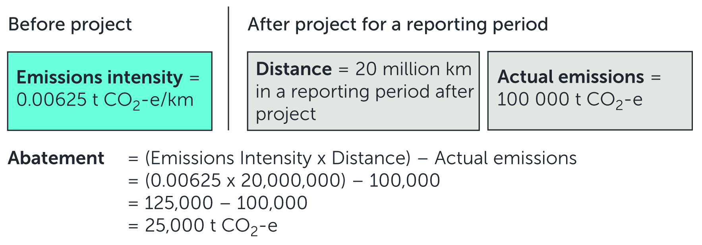
There are several steps involved in calculating the net emissions reductions from the project and these are discussed below. Figure 1 shows the key steps and equations used.

What’s tCO₂-e?
CO₂-e is a measure of the warming effect of different greenhouse gases that allows them to be compared to the equivalent amount of carbon dioxide. It refers to the amount of carbon dioxide that would give the same warming effect as each greenhouse gas that is emitted or stored by an activity.

Calculate project baseline emissions intensity
To calculate the project baseline, you first need to determine the baseline emissions intensity for each sub-group of vehicles or individual vehicle. The process can be broken into the following five steps.
- Determine emissions intensity for three previous years.
- Use the lowest historic intensity to determine baseline emissions.
- For the reporting period calculate abatement by subtracting the actual emissions from the baseline emissions.
- Apply decline rate if a group of vehicles project.
- If the abatement calculated is negative the abatement is considered to be zero.

Calculate baseline emissions
As for the baseline emissions intensity, calculating the baseline emissions depends on the type of project.
For a group of vehicles project, baseline emissions must be calculated for each sub-group separately, because each sub-group will have a different baseline emissions intensity and level of service. The baseline emissions are calculated by multiplying the sub-group’s baseline emissions intensity by the quantity of transport service in a reporting period (see Subsection 21(3) and Equation 3 in the method).
For an aggregated individual vehicles project, you will need to work out baseline emissions for each vehicle. This is calculated by multiplying the baseline emissions intensity of the vehicle by the quantity of transport service in a reporting period (see Subsection 24(2) and Equation 7 in the method).

Calculate emissions from the project
Every project needs to take into account emissions that arise from running it (see Part 4 in the method). This is to ensure these emissions are included in calculations that determine net abatement for a reporting period and crediting period.
For land and sea transport projects, the greenhouse gases that are accounted for in the calculations are listed in Section 18 of the method. Emissions sources that must be included are transport fuel use and electricity when it is used as a transport energy source. For an explanation of the sources of greenhouse gas that are excluded from the calculations, see Section 18 in the explanatory statement.
The project emissions for a reporting period are calculated using Equations 16–18 (see also Section 25 in the method) by working out the total emissions from:
- all vehicles within a sub-group, for a group of vehicles project
- individual vehicles, for an aggregated individual vehicles project.

Calculating the net amount of abatement and number of ACCUs
This is the final step in the calculations to determine the number of ACCUs that may be issued for a reporting period. At this stage the total emissions avoided by the project are calculated and then converted to tCO₂-e (Sections 21 & 24 and equations 1, 2 and 6 of the method).
Abatement is calculated by subtracting the project emissions from the baseline emissions for each sub-group or individual vehicle. Where a sub-group or individual vehicle results in negative abatement, the abatement for that sub-group or vehicle is set as zero.
For a group of vehicles project, total net abatement is the sum of abatement across all sub-groups (Section 21 in the method). For an aggregated individual vehicles project, total net abatement is the sum of abatement across all individual vehicles (Section 24 in the method).

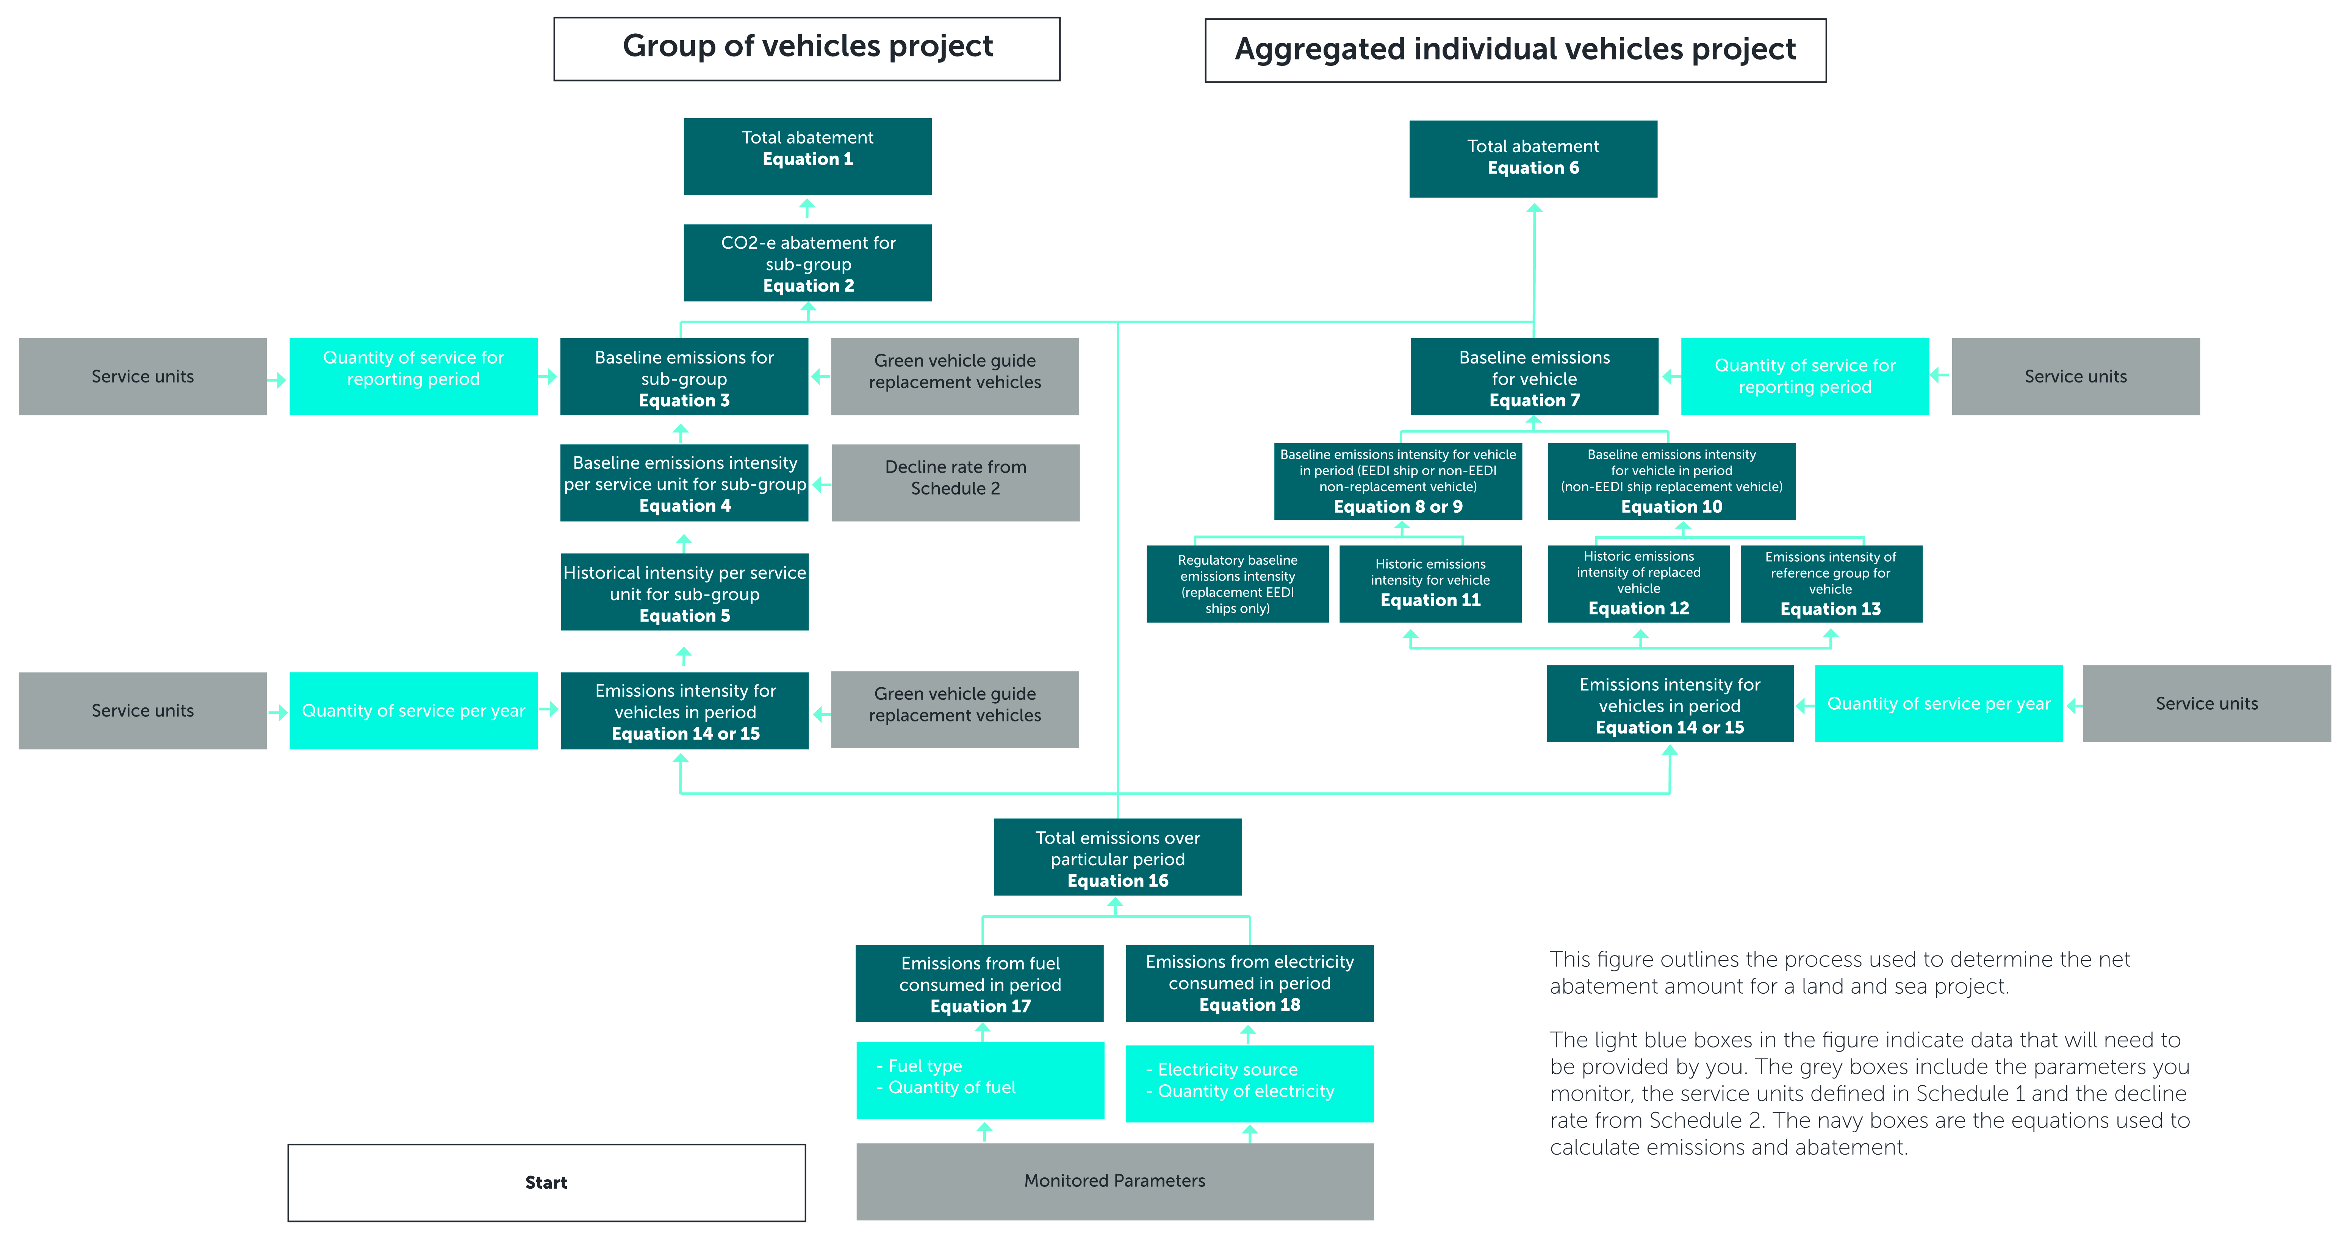
Figure 2 – Equations used to calculate abatement

Monitoring and record keeping
The Clean Energy Regulator recommends you draw up a plan for the monitoring, data collecting and record keeping required for a project report as specified in Part 5 of the method. The means of collecting and recording data will need to be in place from the start of the project. Should a project report and associated audit show that data collecting and record keeping has not been in place for the entire reporting period, ACCUs may not be issued for some or all of that reporting period.
When developing your plan, make sure you have the right controls and processes around your data. You will need to be able to maintain your data in the event of an emergency such as a computer failure.
Monitoring involves collecting service unit and energy consumption data for each sub-group (for a group of vehicles project) or each individual vehicle (for an aggregated individual vehicles project). The method includes a number of options for collecting this data, including approaches that are used in various transportation industries to collect data for other purposes.
Section 31 of the method specifies the records which need to be kept for each reporting period for each vehicle in the project. For details of which parameters to monitor see the table in Section 33 in the method. If you are unable to monitor any of the specified parameters during a reporting period, you must estimate their value (Section 34 in the method).

Project and audit reports
You need to report on your project to the Clean Energy Regulator and may report as frequently as every month where allowed for in the legislative rules made under the Carbon Farming Initiative Act (2011). Audits are required where indicated in your project’s audit schedule, which the Clean Energy Regulator will provide following registration of your project. These reports are called project or offsets reports.
For land and sea transport projects, the first project report must be made between six months to two years from the date the project was registered and then up to every two years thereafter. Under section 68 of the legislative rules, large projects can have a shorter reporting period.
Part 5 Division 1 of the method lists the information that must be included in your reports. If one or more elements of a project change at any time after registering the project, the report must include details of the change (see section 53 of the method). Other record-keeping requirements are specified in sections 57, 100 and 101 of the legislative rules.
Applications for ACCUs can be made at the same time as you submit your project and audit reports by using the electronic ERF Project Reporting and Crediting Application form through the Clean Energy Regulator Client Portal. Full reporting, record keeping and monitoring requirements are set out in regulations and rules made under the Act. You should familiarise yourself with these requirements.

The role of audit
Audits assess whether a project complies with the project registration, the relevant method and legislative requirements. Audit reports must be prepared by a registered Category 2 Greenhouse and Energy Auditor. A list of auditors is available on the Clean Energy Regulator website.
The Clean Energy Regulator recommends you engage your auditor early when developing your project to ensure the project is auditable and to assist the auditor to plan activities throughout the reporting and post-reporting periods. The costs of any audit are your responsibility or the responsibility of your organisation. You must make available to the auditor all necessary documents and information, including data records, receipts and other supporting documentation, and calculation spread sheets.

Making changes to a project
You must notify the Clean Energy Regulator of any changes to your or your project’s circumstances or operations that may affect project ownership, the project’s eligibility or the amount of abatement reported and the number of ACCUs claimed. A project owner must seek approval from the Clean Energy Regulator if they intend to make a significant change from the project as outlined in the application.

Resources
- For more information on participating in the Emissions Reduction Fund, see the Clean Energy Regulator website
- For more information on method development, see the Department of the Environment website
- For enquiries about participating in the ERF, contact the Clean Energy Regulator:
  - 1300 553 542
  - enquiries@cleanenergyregulator.gov.au
- The Federal Register of Legislation is the site where you can find all legislative instruments, including the:
  - Carbon credits (Carbon Farming Initiative) Act 2011
  - Carbon credits (Carbon Farming Initiative) Regulations 2011
  - Carbon Credits (Carbon Farming Initiative) Rule 2015
  - Carbon Credits (Carbon Farming Initiative—Land and Sea Transport) Methodology Determination 2015 (current version)
  - The method Explanatory statement
- Register of Greenhouse and Energy Auditors

https://www.legislation.gov.au/Details/F2015L00163
https://www.legislation.gov.au/Details/C2016C00727
https://www.legislation.gov.au/Details/F2015L00163
https://www.legislation.gov.au/Details/F2015L00163/Explanatory%20Statement/Text
https://www.legislation.gov.au/Details/C2016C00727
https://www.legislation.gov.au/Details/F2015C00658
https://www.legislation.gov.au/Details/F2016C00128
http://www.cleanenergyregulator.gov.au/ERF/Want-to-participate-in-the-Emissions-Reduction-Fund/Planning-a-project/Legal-right
http://www.cleanenergyregulator.gov.au/ERF/Want-to-participate-in-the-Emissions-Reduction-Fund/Step-1-Apply
http://www.cleanenergyregulator.gov.au/ERF/Forms-and-resources/reporting-and-auditing
https://www.legislation.gov.au/Details/F2015L00163/Explanatory%20Statement/Text
https://www.greenvehicleguide.gov.au/
https://www.legislation.gov.au/Details/F2015L00163/Explanatory%20Statement/Text
http://www.cleanenergyregulator.gov.au/OSR/CP
http://www.cleanenergyregulator.gov.au/ERF/Want-to-participate-in-the-Emissions-Reduction-Fund/Step-3-Reporting-and-auditing/Audit-Requirements
http://www.cleanenergyregulator.gov.au/NGER/For-auditors/Register-of-auditors
http://www.cleanenergyregulator.gov.au/
http://www.environment.gov.au/
https://www.legislation.gov.au/
https://www.legislation.gov.au/Details/C2016C00727
https://www.legislation.gov.au/Details/F2015C00658
https://www.legislation.gov.au/Details/F2016C00128
https://www.legislation.gov.au/Details/F2015L00163
https://www.legislation.gov.au/Details/F2015L00163/Explanatory%20Statement/Text
http://www.cleanenergyregulator.gov.au/NGER/For-auditors/Register-of-auditors

