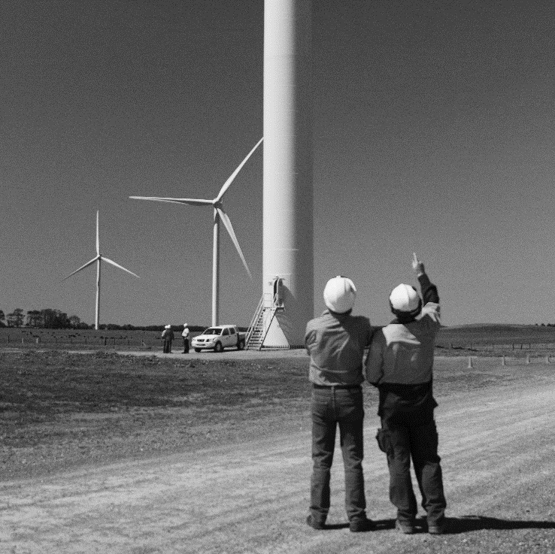Guidance for legal arrangements

between Installer App Providers and Verification Service Providers under the Solar Panel Validation Initiative

Version 2  
April 2024



## Purpose of this guidance

Installer App Providers (App Provider) and Verification Service Providers (VSP) have complementary roles under the Solar Panel Validation (SPV) Initiative. All participant obligations are set out in their relevant Deed with the Clean Energy Regulator (CER) to participate in the SPV Initiative (SPV Deed). SPV Deeds require partnering App Providers and VSPs to have appropriate legal arrangements in place between them.

It is critical that both parties collaborate and act in the best interests of the SPV Initiative. This will protect the integrity of the Small-scale Renewable Energy Scheme (SRES) and the Australian solar industry. Parties must negotiate and comply with legal arrangements in line with their SPV Deed obligations.

This document provides guidance about what App Providers and VSPs might include in their mutual legal arrangements for the use of their app or verification service. This guidance does not displace the participant obligations set out in the SPV Deeds.

## Disclaimer

This guidance is to assist SPV initiative participants. It is not exhaustive and does not consider all circumstances applicable to the parties. **This guidance is not legal advice**.

App Providers and VSPs are not required to follow this guidance. However, they must meet their obligations under the SPV Deeds, the [*Renewable Energy (Electricity) Act 2000*](https://www.legislation.gov.au/C2004A00767/latest/text) (the REE Act) and any associated legislation at all times.

To the extent that this guidance is inconsistent with the SPV Deeds, the SPV Deeds prevail.

Participants may want to obtain independent legal advice before entering a contract or arrangement.

The CER and the Commonwealth of Australia will not be liable for any loss or damage from any cause (including negligence) arising directly, incidentally, or as consequential loss, out of or in connection with any use of this guidance or reliance on it, for any purpose.

## Possible provisions in the legal arrangement

Legal arrangements between App Providers and VSPs must comply with requirements under the SPV Deeds. The table below sets out the relevant clauses.

|  |  |
| --- | --- |
| Type of SPV Deed | Relevant clauses in the SPV Deed |
| Verification Service Provider | 3.1.2(d), 3.3.1(b), 3.3.9(a) to (f) |
| Installer App Provider | 3.1.2(c), 3.3.8(a) to (f) |

The SPV Deeds also set out obligations on participants that are not specifically required to be set out in a legal arrangement between participants, but the parties might find it convenient to do so.

The below lists are drafting suggestions for optional provisions the parties may want to include.

#### Provisions relating to Verification Service providers and Installer App Providers

These provisions could include:

* Confirmation that both parties understand and will comply with the requirements and obligations of the SPV Deeds and the SPV Message Interface Standard (MIS).
* Confirmation that both parties understand their obligations under the REE Act and its associated legislation, as well as other regulatory requirements, standards and guidelines.
* An agreed dispute resolution process for resolving complaints, disputes, and breaches of obligations under the arrangement.
* A process for agreeing on and allowing access to Optional Functions, including any applicable fees.
* Agreed response times between apps and verification services.
* An outline of the rights and responsibilities of both parties when dealing with service issues.
* Any warranties, guarantees or indemnities that the parties consider necessary.
* A statement about each party’s compliance framework which could include:
  + regular checks to ensure the integrity of a verification service or an app. This includes regular conformance testing and reviews of the party’s processes,
  + policies and procedures to manage how information is collected, used, disclosed and stored. This may include recording the written consent of the person or entity that owns, or is providing the information and the intended purpose,
  + management and protection of intellectual property, privacy and confidential information. This includes monitoring arrangements to identify unauthorised access, use or disclosure.
* A statement about each party’s process to notify the CER if it is suspected that an Approved Entity, App Provider or User is in breach of the REE Act or any other legislation. This also includes if it is suspected that solar PV panels do not meet Australian Standards or other requirements for inclusion in the Clean Energy Council’s Approved PV Modules list.

#### Provisions relating to the Verification Service Provider

These provisions could include:

* Guarantees of accuracy, currency, and completeness of data in the verification service and database.
* How often the VSP will check its verification service and database information for any compliance issues relating to the SPV Deed or SPV MIS obligations and how it will fix any issues found.
* How the VSP will identify and address improper use of the verification service.

#### Provisions relating to the Installer App Provider

These provisions could include:

* Undertakings to get the necessary rights, licences and consents from Users to use their information for the verification service.
* A requirement for the App Provider to take reasonable steps to ensure information from Users is accurate, complete and current and to report changes to this information to the VSP as soon as possible.
* The processes of the App Provider to check the app’s performance to ensure compliance with the SPV MIS and the SPV Deeds.
* Arrangements for notifying the VSP Provider if the App Provider becomes aware of an issue that affects the use of the app, including issues with the integrity of the App Provider’s data.