Guidance on aggregated facility reporting, percentage estimates, and incidental emissions and energy

August 2024

# Bulldozer outlineSolar Panels outlineFactory outlinePower Plant outlineContents

Contents 1

Definitions and abbreviations 3

Disclaimer 4

2023–24 updates 5

Purpose 5

Aggregating facility data 6

When can facility data be reported as an aggregate? 6

What must be reported? 6

Reporting aggregated amounts in the Emissions and Energy Reporting System 7

Aggregating by group member 7

Aggregating by business unit 8

Reporting by business unit 9

More complex corporate structures 10

Percentage reporting 12

What is percentage reporting? 12

When can facility data be provided as a percentage estimate? 12

What must be reported? 13

How are percentage estimates calculated? 13

Making percentage estimates 15

Example of method 15

Record keeping 16

Incidental reporting 16

What are incidental emissions and energy? 16

When are sources incidental? 17

What must be reported? 18

Incidental reporting in EERS 18

Measuring emissions and energy from incidental sources 18

Example of method 19

Record keeping 20

Optional reporting of small amounts of fuel combustion and electricity consumption 20

Small amounts of fuel combustion 20

Small amounts of electricity consumption 21

More information 21

# Definitions and abbreviations

|  |  |
| --- | --- |
| Term | Meaning |
| ANZSIC | Australian and New Zealand Standard Industrial Classification |
| EERS | Emissions and Energy Reporting System |
| Facility | Has the meaning given by section 9 of the NGER Act. For more information on defining a facility under the NGER scheme, see [What is a Facility[1]](https://cer.gov.au/schemes/national-greenhouse-and-energy-reporting-scheme/assess-your-obligations#n3-1) |
| NGER | National Greenhouse and Energy Reporting |
| NGER Act | *National Greenhouse and Energy Reporting Act 2007* |
| NGER legislation | The NGER Act, the NGER Regulations and the NGER Measurement Determination |
| NGER Measurement Determination | National Greenhouse and Energy Reporting (Measurement) Determination 2008 |
| NGER Regulations | National Greenhouse and Energy Reporting Regulations 2008 |

Please refer to Division 2 of the NGER Act, NGER Regulation 1.03 and Division 1.1.2 of the NGER Measurement Determination for defined terms in NGER legislation.

# Disclaimer

Thisguideline has been developed by the Clean Energy Regulator (CER) to assist entities to comply with their reporting obligations under the [*National Greenhouse and Energy Reporting Act 2007*](https://www.legislation.gov.au/Series/C2007A00175)[2](NGER Act)and associated legislation.

This guideline only applies to the 2023–24 NGER reporting year and should be read in conjunction with the NGER Act, [National Greenhouse and Energy Regulations 2008](https://www.legislation.gov.au/Series/F2008L02230)[3] (NGER Regulations), and [National Greenhouse and Energy Reporting (Measurement) Determination 2008](https://www.legislation.gov.au/Series/F2008L02309)[4] (NGER Measurement Determination), as in force for this reporting period. These laws and their interpretation are subject to change, which may affect the accuracy of the information contained in the guideline.

The guidance provided in this document is not exhaustive, nor does it consider all circumstances applicable to all entities. This guidance is not intended to comprehensively deal with its subject area, and it is not a substitute for independent legal advice. Although entities are not bound to follow the guidance provided in this document, they must ensure they meet their obligations under the [National Greenhouse and Energy Reporting (NGER) scheme](https://cer.gov.au/schemes/national-greenhouse-and-energy-reporting-scheme)[5] at all times. CER encourages all users of this guidance to seek independent legal advice before taking any action or decision based on this guidance.

CER and the Australian Government will not be liable for any loss or damage from any cause (including negligence) whether arising directly, incidentally, or as consequential loss, out of or in connection with, any use of this guideline or reliance on it, for any purpose.

If an entity chooses to meet their obligations under the NGER scheme in a manner that is inconsistent with the guidance provided in this document, CER, or an independent auditor, may require the entity to demonstrate that they are compliant with requirements of the NGER Act, NGER Regulations, and/or the NGER Measurement Determination. Entities are responsible for determining their obligations under the law and for applying the law to their individual circumstances.

# 2023–24 updates

Changes in this document for the 2023–24 reporting year:

* Minor stylistic and formatting changes have been made to this document.

Read about the [changes to the NGER Legislation for the 2023–24 reporting period[6].](https://cer.gov.au/schemes/national-greenhouse-and-energy-reporting-scheme/report-emissions-and-energy/amendments)

# Purpose

The NGER legislation sets out the requirements for corporations to report their greenhouse gas emissions, energy consumption and energy production.

The NGER legislation contains special provisions that apply to reporting for smaller facilities and reporting of low levels of greenhouse gas emissions, energy consumption and energy production. These provisions exist to reduce the reporting burden for registered corporations.

The following topics are covered in this guidance:

* Aggregating facility data – applies to section 19 and 22X reports.
  + In certain circumstances, reporters can report data for a group of facilities that individually have not triggered the facility threshold, as an aggregated amount. That is, instead of reporting data for each facility, an aggregated amount for several facilities may be reported.
  + When reporting facility data in this way, a registered corporation also has the option of aggregating the data by business unit, rather than by group member with operational control. A 'business unit' is a unit that is recognised by a registered corporation as having administrative responsibility for one or more facilities of the corporation (regulation 2.01A (NGER Regulations)).
* Percentage reporting – applies to section 19 and 22X reports.
  + In certain circumstances, very low levels of greenhouse gas emissions, energy consumption and energy production from one or more facilities may be reported as a percentage estimate of the reporter’s total emissions and energy.
* Incidental reporting – applies to section 19, 22G and 22X reports.
  + In certain circumstances, greenhouse gas emissions, energy consumption and energy production figures for a facility will be classified as 'incidental' and reporters may provide an estimated figure, provided this estimate is consistent with principles set out in the NGER Measurement Determination.
* Optional reporting of small amounts of fuel combustion and electricity consumption – applies to section 19, 22G and 22X reports.
  + Reporting of small amounts of emissions and energy from the combustion of solid, gaseous, and liquid fuel is optional, provided they fall below specified thresholds.

# Aggregating facility data

## When can facility data be reported as an aggregate?

Criteria for reporting facility data as an aggregated amount are laid out in regulation 4.25 of the NGER Regulations.

This regulation applies only to a report provided by a corporation to CER under section 19 or 22X of the NGER Act. Reporting Transfer Certificate (RTC) holders are not able to use facility aggregates in their 22G reports.

Section 19 and 22X reports can only contain aggregated amounts from facilities if, in the reporting year, the following apply:

* The reporter is reporting on more than one facility whose operation falls below all the facility thresholds set out in section 13(d) of the NGER Act. That is, each facility in a facility aggregate must have:
  + emissions of greenhouse gases less than 25 kilotonnes (kt) carbon dioxide equivalent (CO2-e)
  + production of energy less than 100 terajoules (TJ)
  + consumption of energy less than 100 TJ.
* The facilities are located within one state or territory. Facilities cannot be aggregated unless they are all located in the same state or territory. If there are below-threshold facilities located in more than one state or territory, aggregated reporting is still possible. However, in these circumstances, multiple facility aggregates (one for each state or territory) would be required.
* The facilities are attributable to one industry sector. Facilities can only be aggregated if they all have the same Australian and New Zealand Standard Industrial Classification (ANZSIC) industry code.
* None of the facilities are designated generation facilities (facilities attributable to the electricity generation ANZSIC industry classification – see section 7 of the NGER Act and item 54 of Schedule 2 to the NGER Regulations).
* The facilities that are being aggregated must all be under the operational control of the same group member or under the administrative responsibility of the same business unit.
* The aggregated data from facilities that do not meet the facility level threshold can be reported by either a group member or a business unit. It is not possible to aggregate data by both group member and business unit, one or the other must be chosen.

## What must be reported?

The reporter must provide data on greenhouse gas emissions (scope 1 and scope 2), energy consumption and energy production from the operation of the aggregated facilities, in accordance with the classification of fuels and energy commodities in Schedule 1 of the NGER Regulations.

Other information to be provided in the report is:

* the number of facilities within the aggregate
* the state or territory to which each facility’s activities are attributable
* the ANZSIC code to which each facility’s activities are attributable
* if aggregated by group member—the group member details
* if aggregated by business unit—the business unit details.

## Reporting aggregated amounts in the Emissions and Energy Reporting System

Reporters using facility aggregates should create a 'facility aggregate' entity in the Emissions and Energy Reporting System (EERS), instead of creating individual facilities. The facility aggregate entity will be set up under a group member or business unit, depending on how the reporter has chosen to report.

## Aggregating by group member

A reporter may report greenhouse gas emissions, energy consumption and energy production as aggregated amounts for facilities that are under the operational control of the same group member.

Figure 1 provides an example of a controlling corporation’s structure. For simplicity, only greenhouse gas emissions (CO2-e) figures are provided here. Reporters also need to consider each facility's energy production and consumption when considering whether a facility threshold has been triggered.

In this example, all the facilities are attributable to the same industry sector, none of the facilities are designated generation facilities, and all facilities are in the same state.

Figure 1—Corporation arranged by group member.

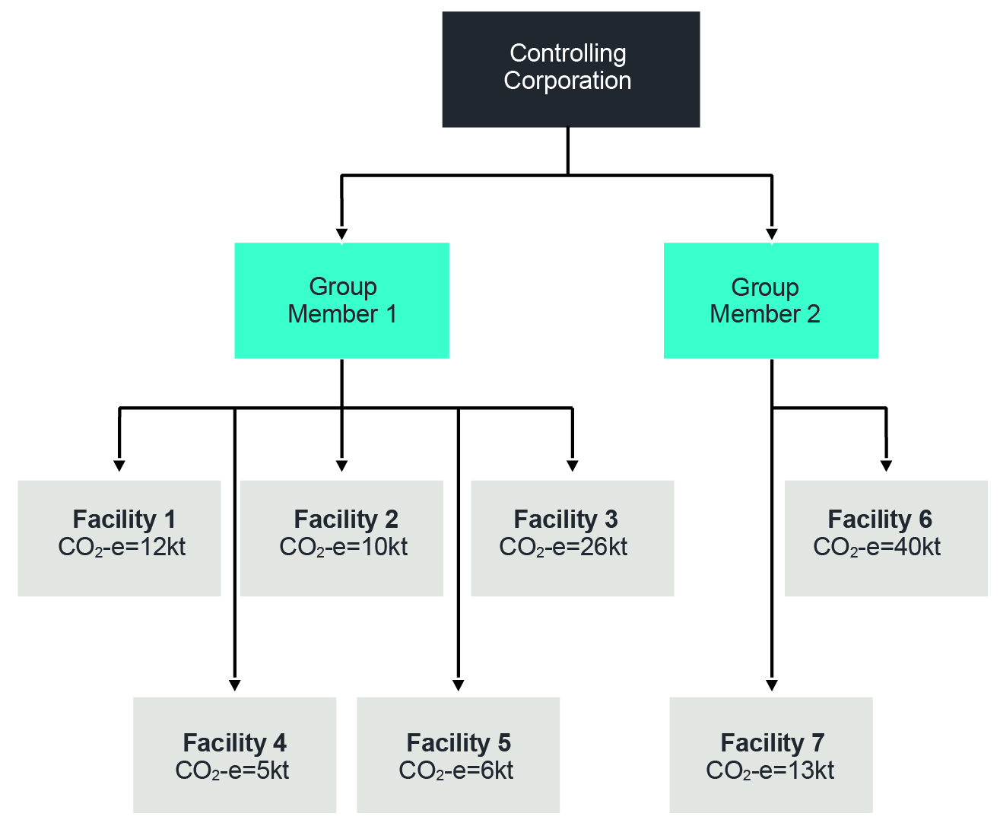

* Group Members 1 and 2 are subsidiaries of the controlling corporation. Group Member 1 has operational control over Facilities 1 to 5 and Group Member 2 has operational control over Facilities 6 and 7.
* The total greenhouse gas emissions for this corporate group are 112 kt CO2-e, triggering the corporate threshold of 50 kt. The controlling corporation must therefore report on all facilities under the operational control of its group members.
* To aggregate by group member, there must be more than one facility under the operational control of that group member that comes below the facility threshold of 25 kt CO2-e.
* Facilities 1, 2, 4 and 5 can be aggregated (assuming they all share the same ANZSIC code and are in the same state or territory) under Group Member 1. However, Facility 3 cannot be aggregated as its greenhouse gas emissions of 26 kt CO2-e is above the facility threshold.

Group Member 2 cannot aggregate any facilities as Facility 6 is over the greenhouse gas emissions threshold and the remaining facility (Facility 7) cannot be aggregated on its own.

Figure 2—Reporting the same corporate group with facilities aggregated.

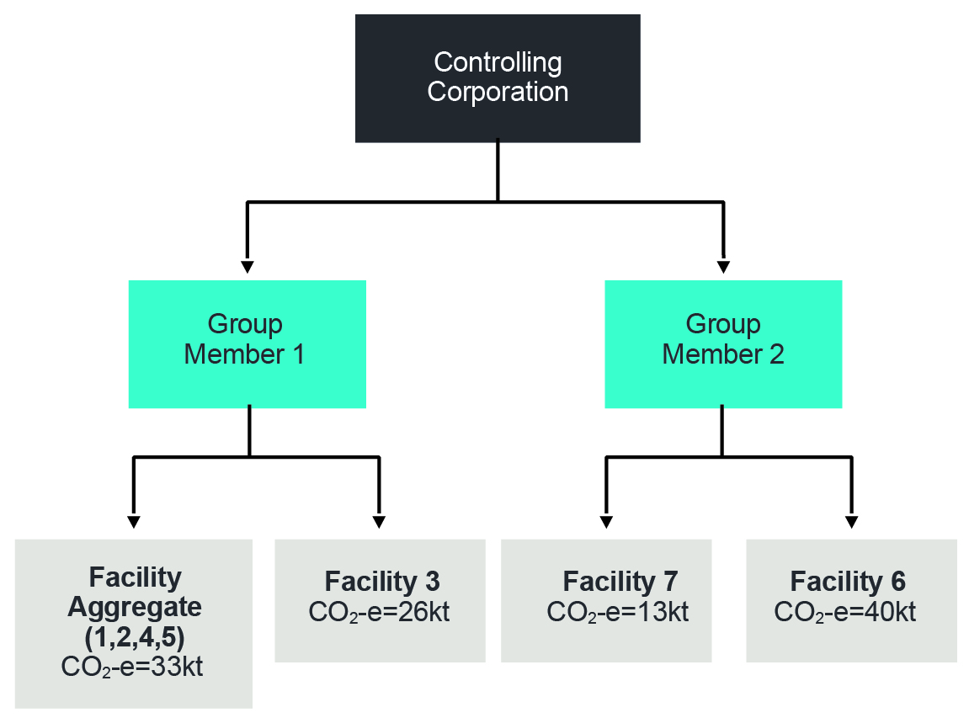

* Aggregated data for Facilities 1, 2, 4 and 5 is reported under a facility aggregate.
* Facility 3 data is reported separately from the aggregated facilities as it triggers a facility threshold.
* Facilities 6 and 7 are reported separately as Group Member 2 is unable to aggregate facilities.

## Aggregating by business unit

A reporter may alternatively report aggregated greenhouse gas emissions and energy data by business unit. Aggregation of facility data by business unit is permitted to reduce the reporting burden and facilitate matching of greenhouse gas emissions and energy data reporting with the internal corporate structures of reporters.

Business unit reporting may be preferred by some corporate groups that internally aggregate their data by product or service. For example, a reporter may choose to aggregate their data and report 3 separate business units: a cement business unit, a brick business unit, and a corporate services business unit.

### Reporting by business unit

As previously stated, a 'business unit' is a unit that is recognised by a reporter as having administrative responsibility for one or more facilities (NGER Regulation 2.01A).

Important: Business units can only be used by reporters as a method of grouping and reporting data. The legislation does not recognise a business unit as a legal entity, so the reporter still needs to consider questions of thresholds and operational control using the controlling corporation, group member and facility structure set out in the NGER legislation. In EERS, business units can only be set up directly under the reporting entity, that is, the controlling corporation or 22X reporter.

Aggregating by business units will be particularly helpful in situations where the reporter wishes to aggregate several facilities under the operational control of different group members. If these facilities are under the administrative control of the same business unit and the other requirements for aggregated reporting are met, the reporter can pull these facilities out of the group member / subsidiary corporate structure and report them as facility aggregates under a single business unit.

Figure 3—Corporation with facilities arranged by business unit.

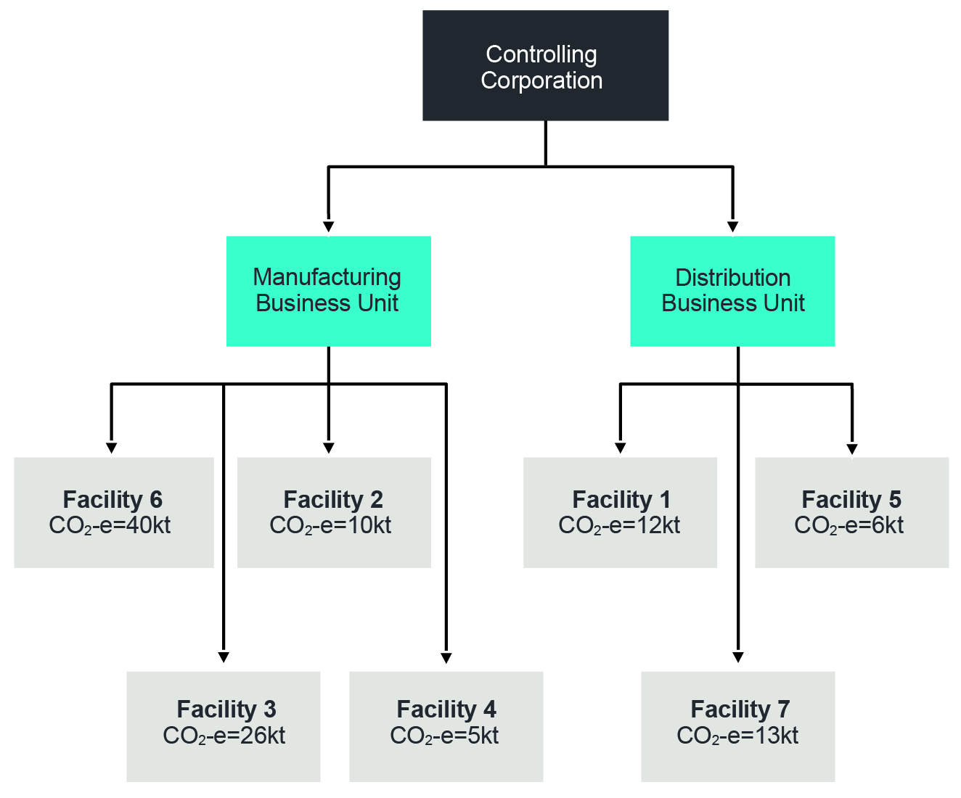

* As noted in Figure 1, the total greenhouse gas emissions for this corporate group are 112 kt, triggering the corporate threshold, so the corporation must report on all facilities.
* The Manufacturing Business Unit has administrative responsibility for Facilities 2, 3, 4 and 6. The Distribution Business Unit has administrative responsibility for Facilities 1, 5 and 7. To aggregate by business unit, there must be more than one below-threshold facility for which the business unit has administrative responsibility.
* Facilities 2 and 4 may be reported as an aggregated amount under the Manufacturing Business Unit, and Facilities 1, 5 and 7 may be reported as an aggregated amount under the distribution business unit.

Facilities 3 and 6 each trigger a facility threshold, so are ineligible to be aggregated. These facilities must be reported under the group member that has operational control over the facility.

Figure 4—Reporting by business unit.

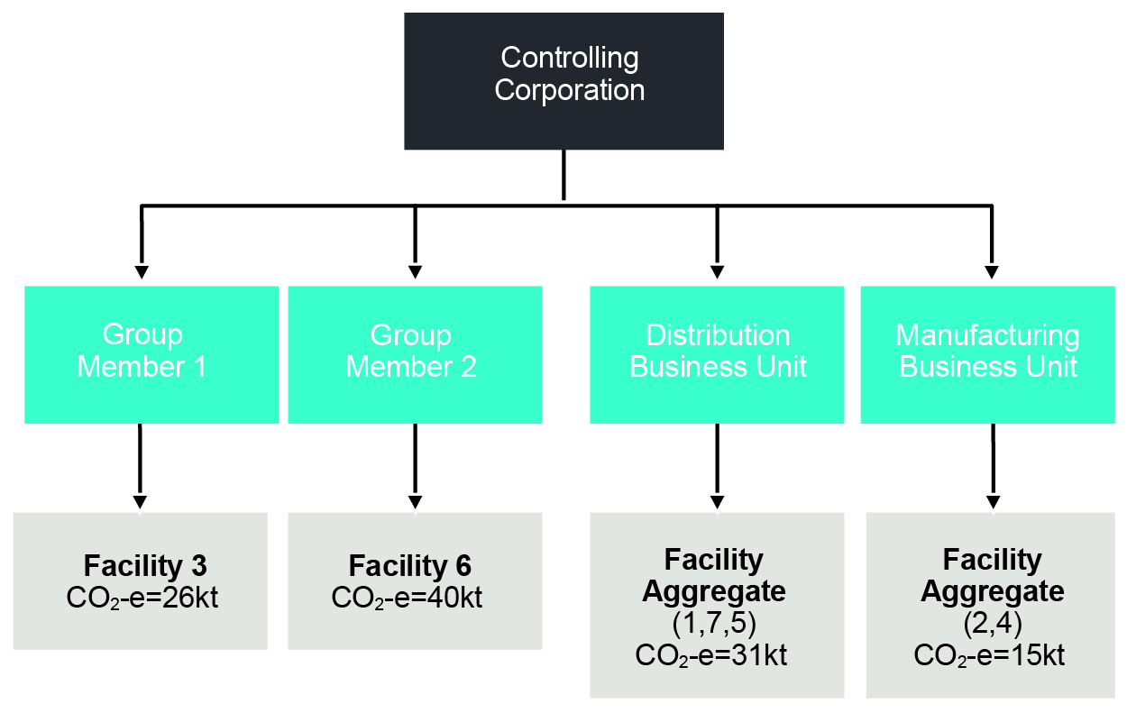

## More complex corporate structures

A business unit can never be set up below a group member, for the purposes of NGER reporting. As noted above, the NGER legislation does not recognise business units as legal entities, but rather as a method of grouping and reporting data. As a result, a facility aggregate will either be set up within the legally recognised corporate group structure underneath a group member, or under a business unit which will always be created beneath the controlling corporation.

This is the case even for more complex corporate structures. For example, where there are multiple layers of affected group members. Figure 5 below includes the same facilities as earlier examples, but this corporate structure contains more affected group members.

Figure 5—More complex corporate structure.

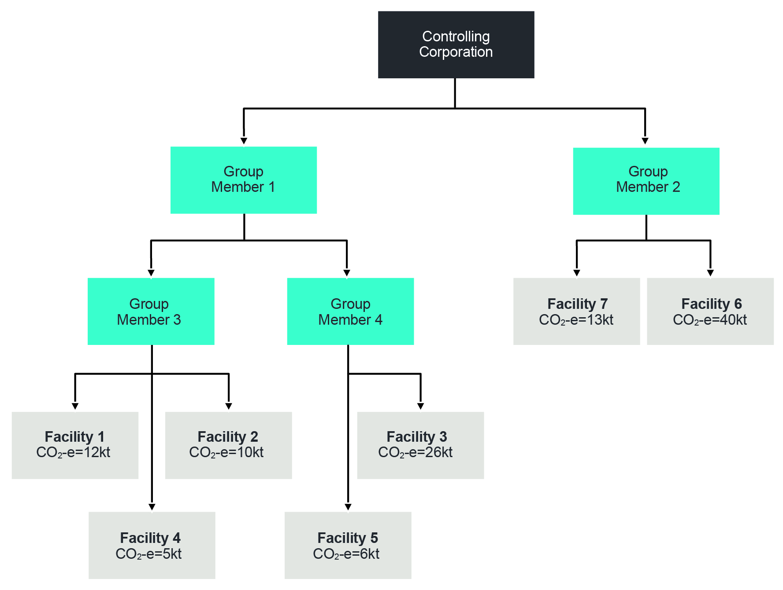

* If the corporation chose to aggregate by group member, only Facilities 1, 2 and 4 could be reported as a facility aggregate under Group Member 3.
* If the corporation chose to aggregate by business unit (assuming the business units and facilities for which they have administrative responsibility are the same as in previous examples), then the facilities could be aggregated as set out in Figure 6.

Figure 6— More complex corporate structure, aggregated by business unit.

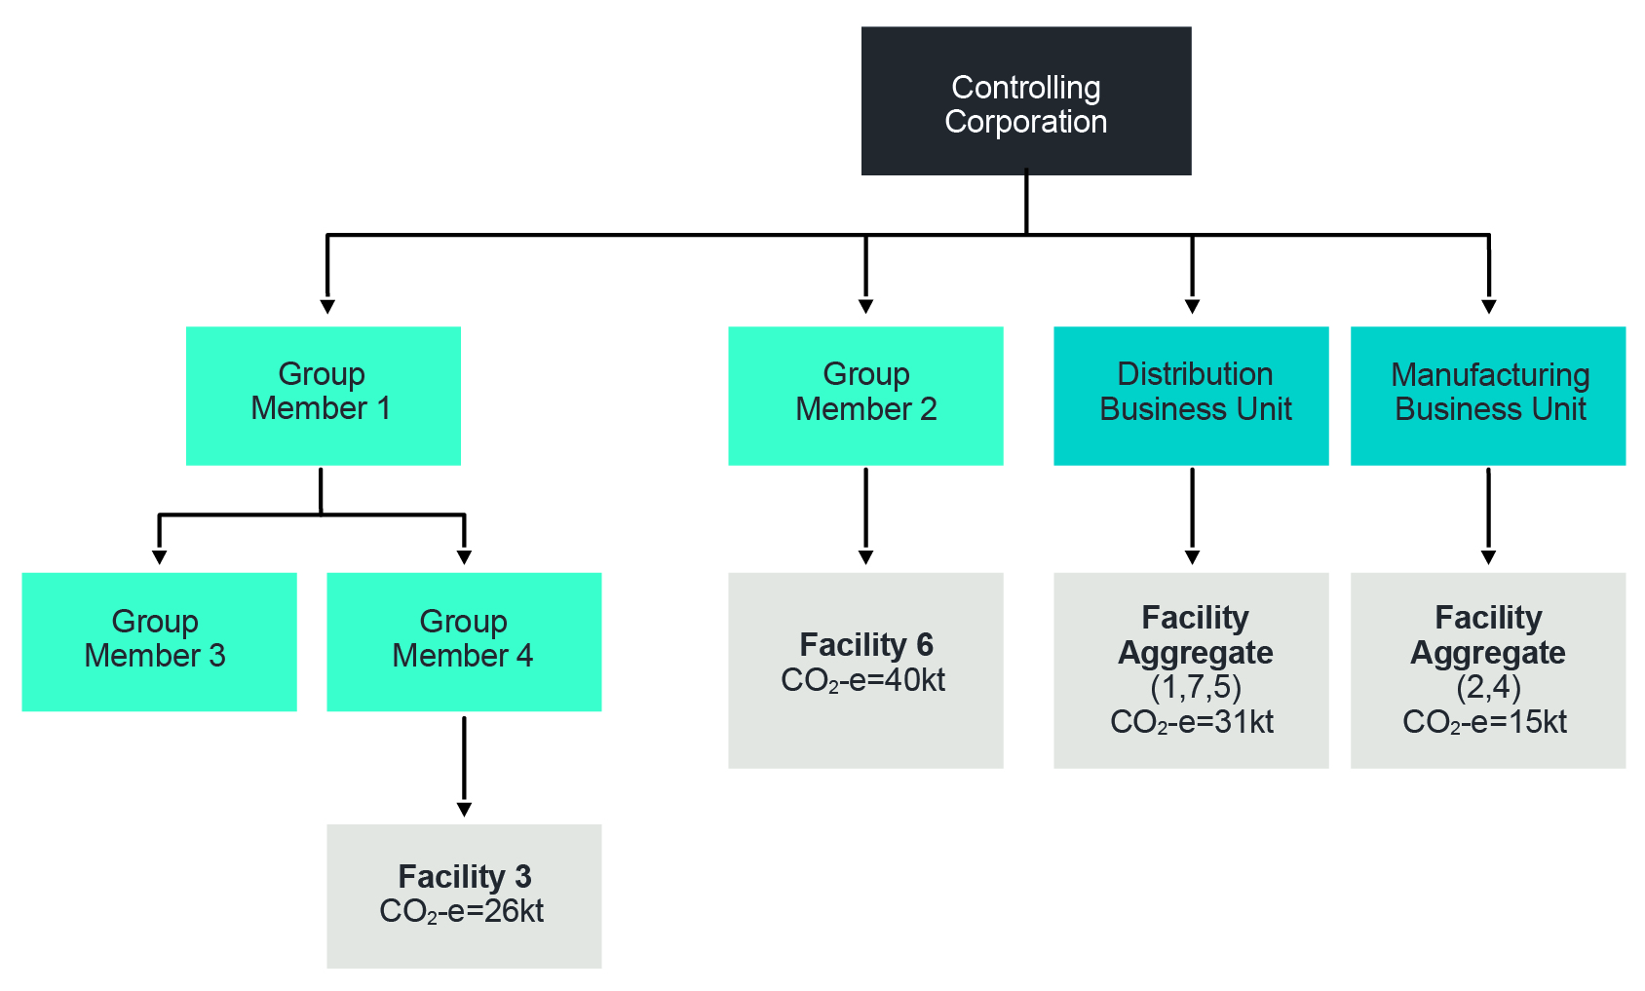

# Percentage reporting

## What is percentage reporting?

Reporters with small facilities can develop and use their own simplified methods for estimating greenhouse gas emissions and energy production and consumption, provided specified thresholds are met.

The circumstances in which percentage reporting can be used are set out in regulation 4.26 of the NGER Regulations.

## When can facility data be provided as a percentage estimate?

Regulation 4.26 applies in relation to a report given to CER under section 19 of the NGER Act by a controlling corporation, or under section 22X of the NGER Act by a responsible member of the controlling corporation’s group. RTC holders are not able to use percentage reporting in their 22G reports.

A reporter may report amounts from facilities as a percentage estimate, provided the thresholds for scope 1 and scope 2 emissions and energy production and consumption are not exceeded. Table 1 below shows the thresholds that are currently in place.

All thresholds in relation to (1) below and all thresholds at either (2) or (3) must be met for scope 1 emissions, scope 2 emissions, energy production and energy consumption.

Table 1—Percentage reporting thresholds

|  |  |  |  |  |
| --- | --- | --- | --- | --- |
| Application type and level | Scope 1 emissions (CO2-e) | Scope 2 emissions (CO2-e) | Energy production | Energy consumption |
| (1) Amount for a facility | 3 kt or less | 3 kt or less | 30 TJ or less | 30 TJ or less |
| (2) Amount of the group’s total for all facilities of the corporation | 12 kt or less | 12 kt or less | 120 TJ or less | 120 TJ or less |
| (3) Percentage of the total amount for the corporation’s group of facilities | Less than 5% of scope 1 and scope 2 emissions | Less than 5% of scope 1 and scope 2 emissions | Less than 5% | Less than 5% |

Percentage reporting cannot be used if a reporter is required to collect or provide information about greenhouse gas emissions, energy consumption or energy production from the facility under any other Commonwealth, state or territory law.

## What must be reported?

The reporter must provide the following in their report:

* the number of facilities for which data is being reported as a percentage
* the greenhouse gas emissions, energy consumption and energy production from the facilities as an estimated percentage of the corporate group's total greenhouse gas emissions, energy consumption and energy production.

## How are percentage estimates calculated?

To report under regulation 4.26, a reporter must first have some idea of what its corporate group's total emissions, energy production and energy consumption are (including the emissions, energy production and energy consumption for the facilities that it wishes to report as a percentage figure). This will ensure the data being reported as a percentage falls below the percentage reporting thresholds set out in regulation 4.26 (as outlined above).

The NGER Measurement Determination does not specify a particular method or criteria for measuring emissions and energy reported as a percentage— this is left to the reporter to determine. However, an example of a possible methodology is discussed below in 'Making percentage estimates'.

Figure 7 depicts an example of a registered controlling corporation reporting under the NGER Act. For simplicity, only greenhouse gas emissions (CO2-e) figures are provided here, however corporations will also need to consider each facility's energy production and consumption when considering whether a threshold has been triggered. In this example, the registered corporation may choose to report on Facilities 2, 3 and 5 as a percentage estimate.

It is assumed in this example that the reporter is not required, under Commonwealth, state or territory law, to collect emissions and energy data from the operation of facilities that it wishes to report as a percentage figure.

Figure 7—Reporting facility data as a percentage estimate.

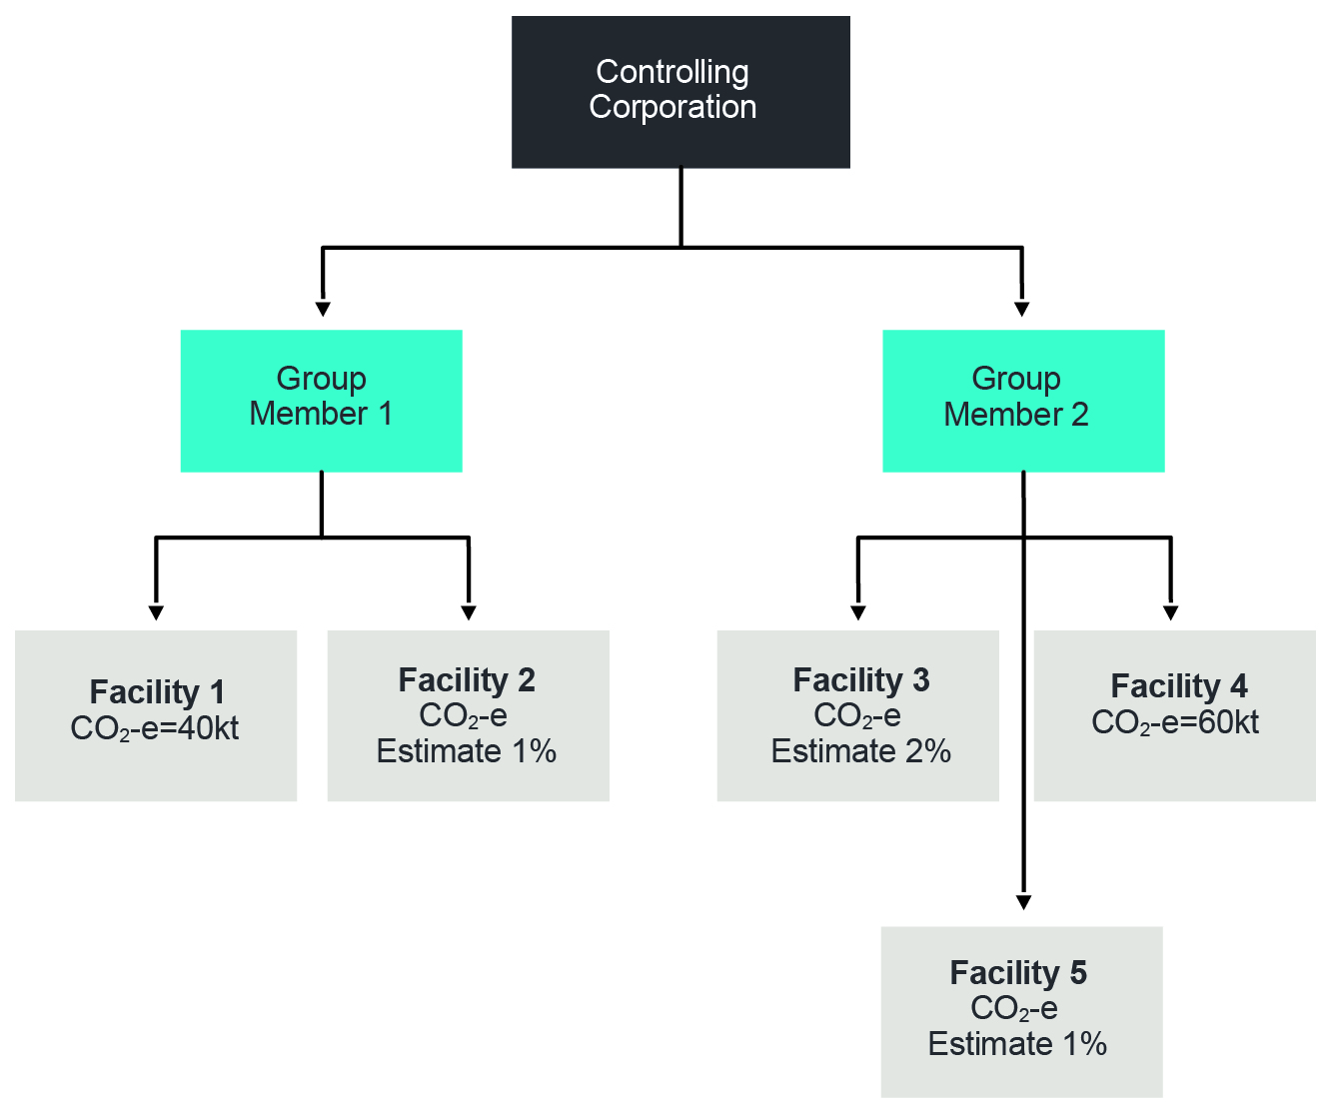

* In this example, Facilities 1 and 4 have combined greenhouse gas emissions of 100 kt. The figures for the remaining facilities are small enough to be reported as an estimated percentage.
* When a reporter makes a percentage estimate for smaller facilities, these estimated figures are in addition to the measured 100 kt figure. The amount reported is:   
  100 kt + (1% of the total) + (2% of the total) + (1% of the total)
* The reporter's total greenhouse gas emissions are the measured amount, divided by   
  (100 - estimated percentage), and multiplied by 100.   
  For the Figure 7 example, the reporter’s total greenhouse gas emissions will be:   
  (100 kt ÷ (100 - 4)) x 100 = 104.167 kt
* The corporate total of each individual greenhouse gas is not adjusted. The corporate total is the same as the measured amount (100 kt in this example).
* The total scope 1 emissions are the actual emissions and the percentage value emissions summed (104.167 kt in this example).
* For energy production and consumption, the same process is followed, and the actual and percentage value are also summed.

Note: The requirement to report on uncertainty levels (regulation 4.08 and 4.17A) does not apply to data that is reported under regulation 4.26.

## Making percentage estimates

Percentage estimates under regulation 4.26 do not need to be made in accordance with any specific method or criteria mentioned in the NGER Measurement Determination. It is the responsibility of the registered corporation to determine an appropriate means of estimating the percentage figure.

CER recommends that reporters, when estimating percentages, have regard to the general principles set out in section 1.13 of the NGER (Measurement) Determination. Namely, transparency, comparability, accuracy and completeness.

Reporters are encouraged to develop their own method for:

* determining which facilities data can be reported as a percentage estimate under regulation 4.26
* estimating greenhouse gas emissions, energy production and energy consumption as a percentage figure.

Reporters may need to seek expert advice in relation to their circumstances.

### Example of method

Set out below is some general guidance on a possible method of making percentage estimates. This guidance is provided as an example only and is not intended to be legal advice.

The reporter needs to assess which facilities are likely to fall within the thresholds and other conditions for making a percentage estimate (as per NGER regulation 4.26).

Then:

* In the first year:
  + Using a suitable methodology for identified facilities, the reporter could estimate greenhouse gas emissions, energy consumption and energy production for the first year, confirming that the resulting total estimates for the corporation and each facility fall within the percentage reporting thresholds (as set out in Table 1).
  + This year one estimate will provide the basis for pro-rata estimation in the following 4-year period. Registered corporations can develop year one data estimations based on a mix of statistically appropriate sampling and deeming (with expert advice as needed).
* For the next 4 years:
  + Using an appropriate correlative indicator for each facility or 'category' (a certain size or type) of facility identified in year one, the registered corporation can estimate pro-rata emissions and energy for that year based on change in the chosen indicator from year one.
  + Choosing a suitable indicator:
    - The choice of indicators for assessing change to emissions and energy is best determined by the reporting corporation, based on expert opinion if needed.
    - Sometimes it is likely that emissions and energy totals for a facility or category of facility is unlikely to change perceptibly over a 4-year period. If so, the corporation should document this, including a justification for this conclusion based on statistically valid sampling or on the known activities at the facilities. In this case, the number of facilities which meet the profile is the only element which will change the percentage report from year-to-year.
    - For some facilities, production may be an appropriate indicator of changes in emissions and energy over time. Another correlative indicator might be total fuel use at the facility.
* Reviewing the methodology:
  + Each year registered corporations should review their methodology in the light of changes to the NGER legislation or to the corporation's structure, activity levels, or reported facilities. For example, a change in activities at a facility may mean that reportable emissions and energy will exceed the percentage estimate thresholds and other conditions set out in regulation 4.26. Changes in the NGER legislation may also affect the validity of the established methodology.
  + The chosen methodology could be followed for the 4 years following the first year, that is, for a 5-year total before re-examining the appropriateness of the methodology in the fifth year.
  + A review of the methodology might be based on matters identified by the registered corporation and documented in the methodology. A review might cover the facilities chosen in year one and subsequently, the continued appropriateness of the chosen indicators (perhaps with the benefit of expert opinion), together with representative sampling and deeming in relation to the corporation's total facilities to provide a new 'year one' base for estimations. There may also be a need to review decisions made initially concerning operational control.

## Record keeping

Under sections 22 and 22XA of the NGER Act, reporters are required to keep adequate records of their activities and the activities of the members of its group. These records should allow reporters to demonstrate to CER that they have complied with obligations under the NGER Act. These records must be kept for 5 years from the end of the year in which the activities that the records relate to took place.

Reporters using regulation 4.26 should keep a record of the decisions made in determining which facilities can be reported as a percentage and in estimating the percentage figure. These records should also include the estimation method chosen and what reviews of the methodology have been performed.

# Incidental reporting

## What are incidental emissions and energy?

Incidental reporting can be used to report on small, ‘incidental’ amounts of greenhouse gas emissions or energy consumption and production at a facility.

Controlling corporations reporting under section 19, RTC holders reporting under 22G and responsible members reporting under section 22X, are all able to report using the incidentals provisions.

NGER Regulation 4.27 allows for NGER reports to include an estimated figure for greenhouse gas emissions, energy consumption or energy production that is incidental to the facility's total greenhouse gas emissions, energy consumption, or energy production. What is considered as ‘incidental’ is explained below. The estimate must be consistent with the general principles set out in section 1.13 of the NGER Measurement Determination. See the following section on Measuring emissions and energy from incidental sources for more information.

This provision recognises that monitoring and measuring very small amounts of greenhouse gas emissions, energy consumption or energy production within a facility may be difficult and costly for registered corporations and aims to reduce the burden and cost of measuring these amounts where possible.

Incidental reporting can only be used where the information about the greenhouse gas emissions, energy consumption or energy production is not otherwise required to be collected or provided under any other Commonwealth, state, or territory law.

## When are sources incidental?

For sources to be considered 'incidental', they must be below the following thresholds (as set out in sub‑regulations 4.27(5), (6) and (7) of the NGER Regulations).

Table 2—Greenhouse gas emissions incidental reporting thresholds

|  |  |  |
| --- | --- | --- |
| Application type and level | Scope 1 emissions (CO2-e) | Scope 2 emissions (CO2-e) |
| Total emissions from fuel combustion at a facility, being reported as incidental | 12 kt or less | 12 kt or less |
| Amount for emissions from an individual source, other than combustion of fuel, at a facility | 3 kt or less | 3 kt or less |
| Total emissions from sources being reported as incidental, other than those from the combustion of fuel, at a facility | 12 kt or less | 12 kt or less |

Table 3—Energy consumption and energy production incidental reporting thresholds

|  |  |
| --- | --- |
| Application type and level | Energy production or energy consumption |
| Amount of a particular fuel or energy commodity at a facility (excluding fuel combustion) | Less than 30 TJ |
| Total amount of all the fuel or energy commodities for a facility (including fuel combustion) | Less than 120 TJ |

## What must be reported?

If a reporter chooses to include estimated figures for incidental sources in their NGER report, it needs to separately identify:

* the greenhouse gas emissions from the operation of the facility that are incidental
* the energy consumption or energy production from the operation of the facility that is incidental
* the type of fuel or energy commodity as set out in Schedule 1 of the NGER Regulations
* the criteria in the NGER Measurement Determination used to make the estimate (if the registered corporation did not make an estimate based only on the general principles specified in section 1.13 of the NGER Measurement Determination).

While regulation 4.27 allows reporters to 'estimate' greenhouse gas emissions, energy consumption and energy production that are 'incidental', these estimates must be made in accordance with the NGER Measurement Determination (see 'Measuring emissions and energy from incidental sources' below).

Note: The requirement to report on uncertainty (regulation 4.08 and 4.17A) does not apply to data that is reported under regulation 4.27.

## Incidental reporting in EERS

Reporters that are reporting on incidental greenhouse gas emissions, energy consumption or energy production will enter incidentals data into EERS by selecting ‘Yes’ for the ‘Incidental Emissions’ and/or ‘Incidental Energy’ fields in the ‘Activity Attributes’ data entry screen.

When reporting incidental greenhouse gas emissions, EERS will automatically select 'Other Method (Incidental)' for estimating greenhouse gas emissions once ‘Yes’ has been selected in the ’Incidental Emissions’ field. This is to highlight that those corporations which can estimate their data using Methods 1-4 should be reporting under the relevant method, and not reporting the data under regulation 4.27. Reporting by 'other method' requires the input of emission and energy content factors as well as the calculated CO2-e data.

## Measuring emissions and energy from incidental sources

The NGER legislation allows reporters to estimate incidental sources provided the method of estimating the figure is consistent with the general principles specified in section 1.13 of the NGER Measurement Determination. These principles are:

* transparency*—*emissions estimates must be documented and verifiable
* comparability*—*emission estimates using a particular method and produced by a registered corporation in an industry sector must be comparable with emission estimates produced by similar corporations in that industry sector using the same method, and must be consistent with the emission estimates published by the Department of Climate Change, Energy, the Environment and Water in the [National Greenhouse Accounts](https://www.greenhouseaccounts.climatechange.gov.au/)[7]
* accuracy—having regard to the availability of reasonable resources by a registered corporation and the requirements of the NGER Measurement Determination, uncertainties in emission estimates must be minimised and any estimates must neither be over nor under the estimates of the true values at a 95% confidence level
* completeness—all identifiable emission sources within the energy, industrial process and waste sectors as identified by the [National Inventory Report](https://www.dcceew.gov.au/climate-change/publications/national-inventory-reports)[8] must be accounted for.

Reporters are encouraged to use the most suitable method for estimating incidental greenhouse gas emissions, energy production and energy consumption, whether that be using the methods outlined in the NGER Measurement Determination for a particular source, or developing their own method aligned to the principles described above.

### Example of method

Set out below is some general guidance on possible methods of estimating incidental emissions in accordance with regulation 4.27. This guidance is provided as an example of a method which may be suitable; however, it is not intended to be legal advice.

Corporations may need to obtain advice (including use of expert opinion) on the best way to proceed to ensure the principles of section 1.13 of the NGER Measurement Determination are met in their circumstances.

For each facility, reporters can assess which sources of greenhouse gas emissions and energy activity data are likely to fall within the quantitative limits and other conditions of regulation 4.27 (outlined above).

Then:

* In the first year:
  + Using a suitable methodology, estimate emissions and energy production/consumption for the first year, ensuring that the resulting estimates do indeed fall within the incidental emissions and energy limits for each facility.
  + The year one activity data estimation provides the basis for the pro-rata estimation in the following 4-year period. Registered corporations can therefore develop year one data estimations based on statistically appropriate sampling and deeming as necessary, with expert advice as needed.
* For the next 4 years:
  + Using an appropriate correlative indicator for each source activity area identified in year one, the registered corporation can estimate pro-rata incidental emissions and energy for that year based on change in the chosen indicator from year one.
  + Choosing a suitable indicator:
    - The choice of indicators for each source is best determined by the registered corporation, based on expert opinion if needed. Sometimes, production at the facility may be an appropriate indicator of changes in source activity data over time. Another correlative indicator could be fuel use. However, for some sources, changes in fixed assets would be an appropriate indicator, such as for SF6 used in switch gear.
* Review of the methodology:
  + Each year, registered corporations should review the methodology considering changes to the NGER legislation or to the corporation's structure, activity levels, or reported sources. For example, a change in activities at a facility may mean that emissions from some sources exceed the conditions of regulation 4.27. Changes in the NGER legislation may also affect the established methodology.
  + The methodology chosen in the first year could be followed for the following 4 years (that is, for 5 years in total), before re-examining the appropriateness of the methodology in the fifth year.
  + A review of the methodology might be based on matters identified by the registered corporation, including a review of the source activity areas chosen in year one, the continued appropriateness of the chosen indicators (perhaps with the benefit of expert opinion), together with a comprehensive sampling of the source activity areas to provide a new year one base for estimations.

## Record keeping

Sections 22, 22H, 22XA and 22XC of the NGER Act require reporters to keep adequate records of their activities and the activities of the members of their groups. These records should allow the reporter to demonstrate to CER that it has complied with its obligations under the NGER Act. These records must be kept for 5 years from the end of the year in which the activities that the records relate to took place.

Reporters reporting under regulation 4.27 should keep a record of any decisions made in relation to determining which sources are incidental, the methods used for arriving at the estimated figure and, in later years, should indicate that this methodology has been reviewed considering any changes, as outlined above.

# Optional reporting of small amounts of fuel combustion and electricity consumption

## Small amounts of fuel combustion

The NGER Measurement Determination includes materiality thresholds for the amount of solid, gaseous and liquid fuel combusted. Consequently, reporting is not required for small amounts of emissions and energy from these sources. A reporter may still choose to report amounts below the reporting threshold (for example, if doing so is more efficient for the reporter).

Reporting is not required in the following circumstances:

* solid fuel combustion—the quantity of solid fuel combusted in relation to a separate instance of a source is 1 tonne (t) or less (NGER Measurement Determination section 2.2 and 6.5)
* gaseous fuels combustion—the quantity of gaseous fuels combusted in relation to a separate instance of a source is 1000 cubic metres (m3) or less (NGER Measurement Determination section 2.18 and 6.5)
  + to inform conversion between m3 and gigajoules (GJ), Part 2 of Schedule 1 of the NGER Measurement Determination provides approximate conversion factors for gaseous fuels. For example, 1000 m3 of natural gas is approximately 39 GJ or less
* liquid fuel combustion—the quantity of liquid fuel combusted in relation to a separate instance of a source is:
  + 5 kilolitres (kL) or less for the total amount of petroleum-based oils (other than petroleum-based oil used as fuel) and of the petroleum-based greases (collectively known as PBOG)
  + 1 kL or less for all other liquid fuels (NGER Measurement Determination section 2.39 and 6.5).

'Separate instance of a source' means that an activity is performed by a class of equipment different from those used by other activities with the same source of emissions (section 1.9A of the NGER Measurement Determination).

Note that different thresholds apply for fuel consumed without combustion (NGER Measurement Determination section 2.68).

## Small amounts of electricity consumption

Sections 2.68(b) and 7.1(2) of the NGER Measurement Determination stipulate reporting thresholds for reporting consumption of electricity (scope 1 and scope 2, respectively):

* for self-generated electricity consumption at a facility, if the reportable generating unit has a maximum capacity of less than 0.5 megawatts (MW) of electricity and produces 100,000 kilowatt hours (kWh) of electricity or less in the reporting year, energy, and scope 1 emissions from electricity consumption are not required to be reported
* if the amount of electricity consumed at a facility, but not generated at that facility, is 20,000 kWh or less in a reporting year, energy and scope 2 emissions from that electricity consumption are not required to be reported.

Section 2.68 of the NGER Measurement Determination also includes other thresholds that limit reporting requirements for energy consumed without combustion. Reporting of energy consumed without combustion is not required if the consumption of the fuel in that reporting year is less than:

* 20 t of solid fuel
* 13,000 m3 of gaseous fuel, or
* 15 kL of liquid fuel.

# More information

Email: [reporting@cleanenergyregulator.gov.au](mailto:reporting@cleanenergyregulator.gov.au)

Phone: 1300 553 542 within Australia

Web: [www.cer.gov.au](http://www.cer.gov.au)

1. <https://cer.gov.au/schemes/national-greenhouse-and-energy-reporting-scheme/assess-your-obligations#n3-1>
2. <https://www.legislation.gov.au/Series/C2007A00175>
3. [https://www.legislation.gov.au/Series/F2008L0223](https://www.legislation.gov.au/Series/F2008L02230)
4. <https://www.legislation.gov.au/Series/F2008L02309>
5. <https://cer.gov.au/schemes/national-greenhouse-and-energy-reporting-scheme>
6. <https://cer.gov.au/schemes/national-greenhouse-and-energy-reporting-scheme/report-emissions-and-energy/amendments>
7. <https://www.greenhouseaccounts.climatechange.gov.au/>
8. <https://www.dcceew.gov.au/climate-change/publications/national-inventory-reports>