
Guarantee of Origin user access and permissions guide
V1.1 June 2026
Contents
Permissions overview 3
Navigating to the form 3
Adding users 3
Editing contacts 4
Updating user details 4
Managing users 4
Assigning general permissions 5
Assigning scheme specific permissions 5
Removing a user 6

Permissions overview
Permissions ensure that only authorised individuals within an organisation can view, edit, or declare and submit information. They safeguard the integrity of data and compliance with regulatory requirements.
Each organisation is assigned admin permissions once they complete a person registration application. The admin holds full access rights, including the ability to add and remove users, and assign permissions.
Permissions can be tailored, for example:
- A Compliance Officer may require the ability to Declare and Submit.
- A Technical Officer may only require View or Edit permissions for a profile.
This approach ensures that responsibilities between users are clearly defined and that sensitive information remains secure.
Use this step-by-step guide to add and manage users in a registered person account and give them the right permissions in Online Services.

Navigating to the form
- Log in to Online Services.
- Ensure you are acting on behalf of your organisation.
You may need to ‘Switch account’ to ensure you’re acting on behalf of your organisation if it is already registered in Online Services.

Adding users
Before a new user can be added, they will need to have an Online Services account. Read more about creating an Online Services account.
A new user can be added by an organisation’s admin.
- Click ‘Manage account’ and then ‘Manage users’.
- Click ‘Add user’.
- Provide details of the new user including:
- an email address
- the relationship type (agent or employee).
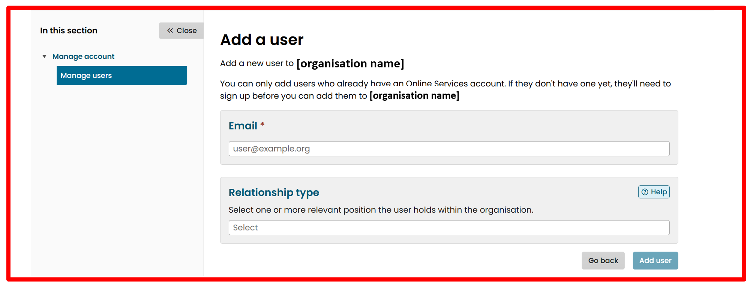
- Click ‘Add user’.
The new user will then appear as invited until they accept their invitation in their Online Services inbox.
Error messages
If the error message ‘There doesn’t seem to be a CER account associated with this email address’ appears, the new user needs to create an Online Services account.
If the error message ‘This user is already associated with this account’ appears, the user already has access to the registered person account.

Editing contacts
The Edit Contacts feature allows you to update the primary contact for an application. The Primary Contact dropdown list displays all users currently associated with the application. To change the primary contact, simply select a different user from this list. This is useful when the current contact is no longer responsible for the application, and a new contact needs to be assigned.

- Click ‘Manage account’.
- Click ‘Edit contacts’.
- Select a primary contact person from the dropdown list.
- Click ‘Update’.

Updating user details
Updating user details allows for the details of the primary contact to be updated.
- Click ‘Manage account’.
- Click ‘Edit details’.
- Update the registered person’s street or postal address.
- Click ‘Update’.

Managing users
- Click ‘Manage account’ and then ‘Manage users’.
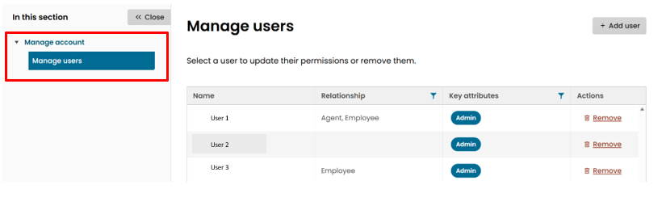
- Select a user to update their permissions.

Assigning general permissions
- Select ‘General’.
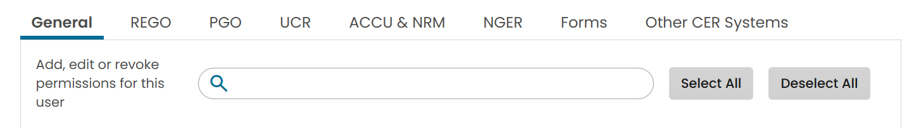

- Select the relevant checkboxes to assign their permissions.
Permissions can be set to:
- Admin: allows a user to edit account details and manage other user’s permissions/access
- Basic: allows a user to view other users and their permissions.
You can also update a user’s relationship to the organisation here.
- Click ‘Update’ to save any changes.
Users will be notified of changes to their permissions.

Assigning scheme specific permissions
This feature is used to control what each user can see or do within the application. Permissions can be assigned to users linked to an application so that each user can have their own level of access. This means different users can have different permissions for the same application. Access can be given in 2 ways: either to apply the same permissions to all profiles by allowing users to view, edit, declare, and submit or assign permissions individually for each profile.
- Select either ‘REGO’ or ‘PGO’.
Under these permissions, an admin will be able View, Edit, and Declare and Submit information about facilities (REGO) and profiles (PGO).
- Select the relevant checkboxes to assign their permissions.
- Assign relevant permissions to a single user individually or apply to all users to control what the user can see or do:
- View: allows the user to view application.
- Edit: allows the user to edit profile-related information. This permission requires View access.
- Declare and submit: allows the user to submit applications. This permission requires both View and Edit access.
For REGO, permissions can be set to:
- View
- Edit
- Declare and submit
To allow a user to create and manage REGO certificates, you need to update their permissions in the UCR tab and allow them to access the Unit and Certificate Registry holding account.
- Click ‘Update’ to save any changes.
Users will be notified of changes to their permissions.

Removing a user
- Click ‘Manage account’ and then ‘Manage users’.
- Click ‘Remove’ for the user that you want to remove.

- Click ‘Yes, remove’ to confirm the action in the pop-up box.

https://onlineservices.cer.gov.au/
https://onlineservices.cer.gov.au/switch-account

