
Guarantee of Origin person registration
User guide
V1 July 2026

Overview - Person Registration 3
Navigating to the form 3
Step 1: Before you start 3
Step 2: Application details 4
Individuals 4
Organisations 6
Trustee(s) 9
Step 3: Fit and proper person (FPP) test 10
Individuals and organisations 10
Trustee(s) 10
Step 4: Signatory 11
Individuals 11
Organisations 11
Trusts 11
Step 5: Verify identity 11
Individuals 12
Organisations and Trusts 12
Step 6: Review and declaration 12

Person registration overview
Whether you’re planning to participate in the Product Guarantee of Origin (PGO) or the Renewable Electricity Guarantee of Origin (REGO), the first step is to create an Online Services account and apply to become a registered person. This can be completed in Online Services.
To complete the Register for GO form, you will need to follow a 6-step process:
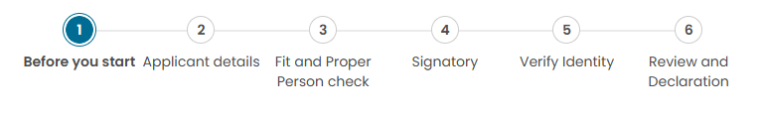
You can complete this application as an:
- individual
- organisation (existing or new)
- trustee(s).

Online Services account configuration
If you are an employee acting on behalf of an organisation and are new to our Online Services platform, you must first create an Online Services account.

Online Services account
Use your individual employee contact details when setting up your account — do not use the organisation’s details. After creating your account, you can provide information about your relationship to the organisation you represent.
To create an account:
- Go to Online Services.
- Select Sign up now.
- Follow the prompts to enter the required details.
- Select ‘Sign up’
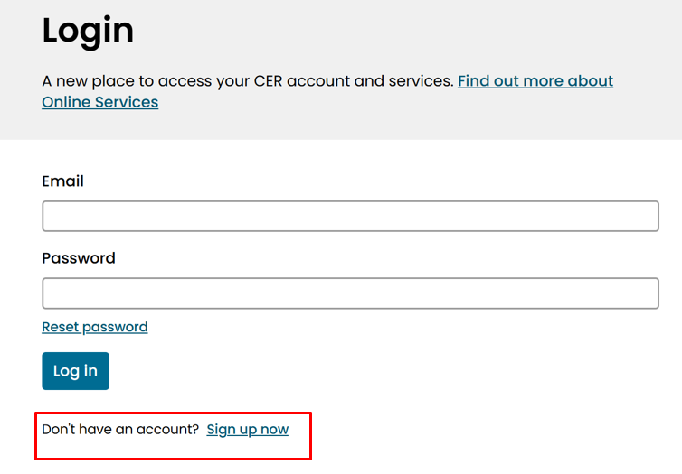

Navigating to the Person Registration form
- Log in to Online Services.
- Search or filter by scheme for 'Register for GO'.
- Click on the 'Register for GO' form.
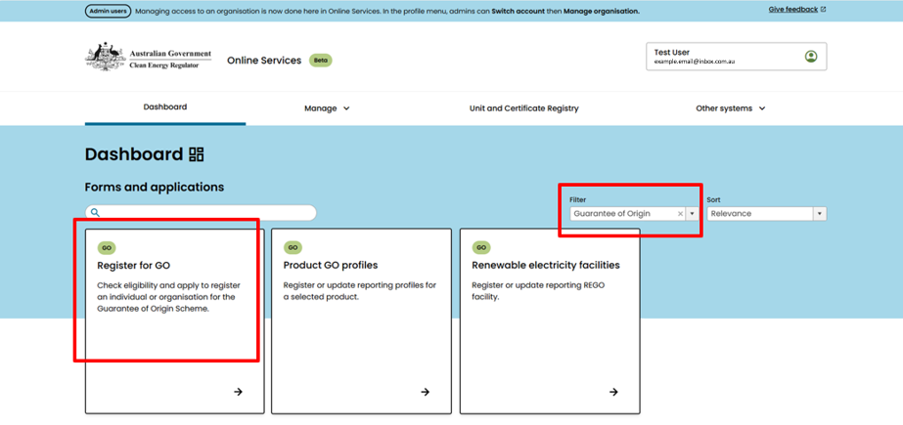

Step 1: Before you start
- Read the Before you start information.
- Ensure you have all the information you need to complete the registration process.

Step 2: Applicant details
Select the applicant type that matches your organisation from the four available options, then complete the required details for that applicant type.

Individuals
- Describe how you intend to participate in the GO Scheme.
Selecting ‘Other’ will give you a free-text box to input your answer. You may select more than one item.
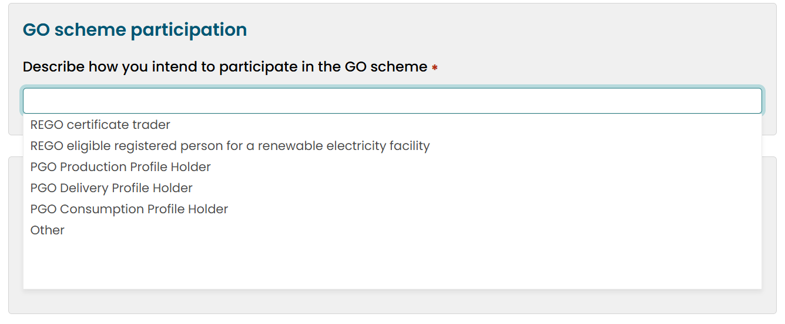
- Declare if you participate in a related scheme.
If yes, enter the relevant scheme information.
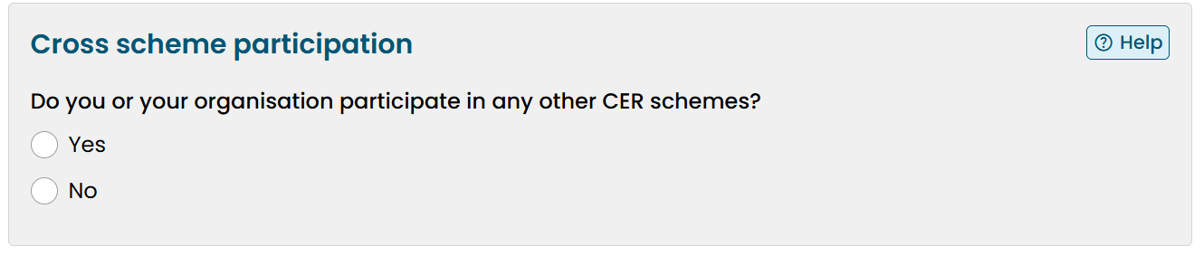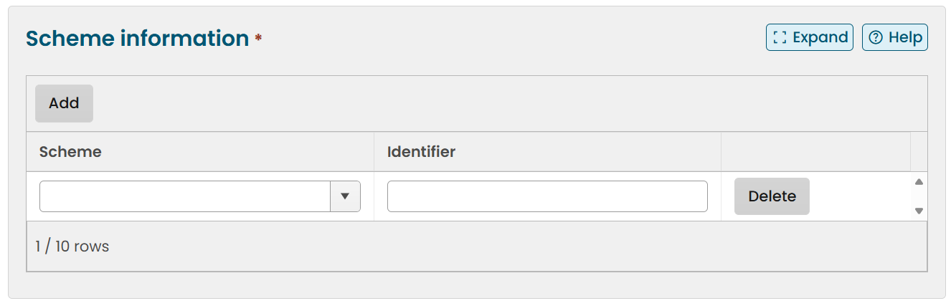
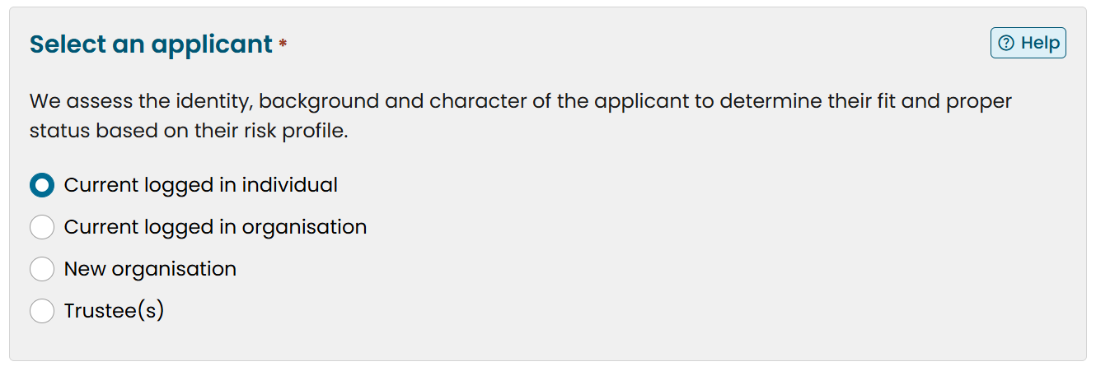
- Select ‘Current logged in individual’ and confirm that your details are correct.

- If any of your details are incorrect you will need to update them. Go to manage account and then click the link that takes you to the Client Portal.

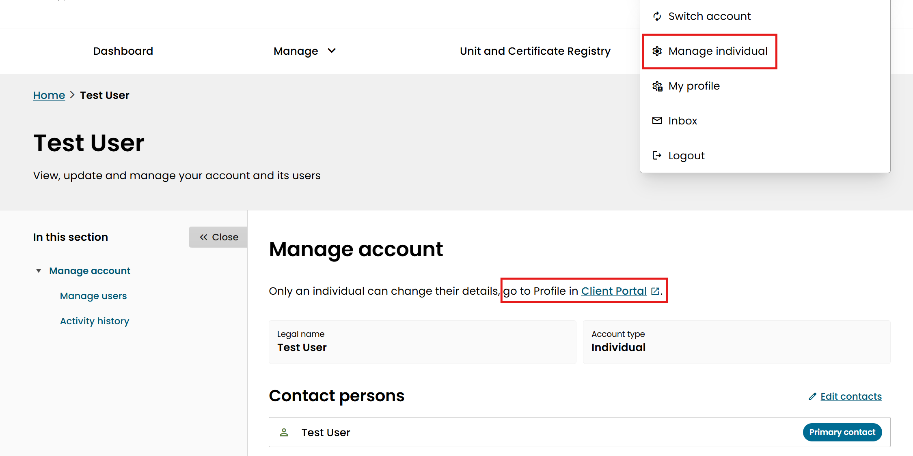
In the Client Portal update your details under the ‘My profile’ tab.
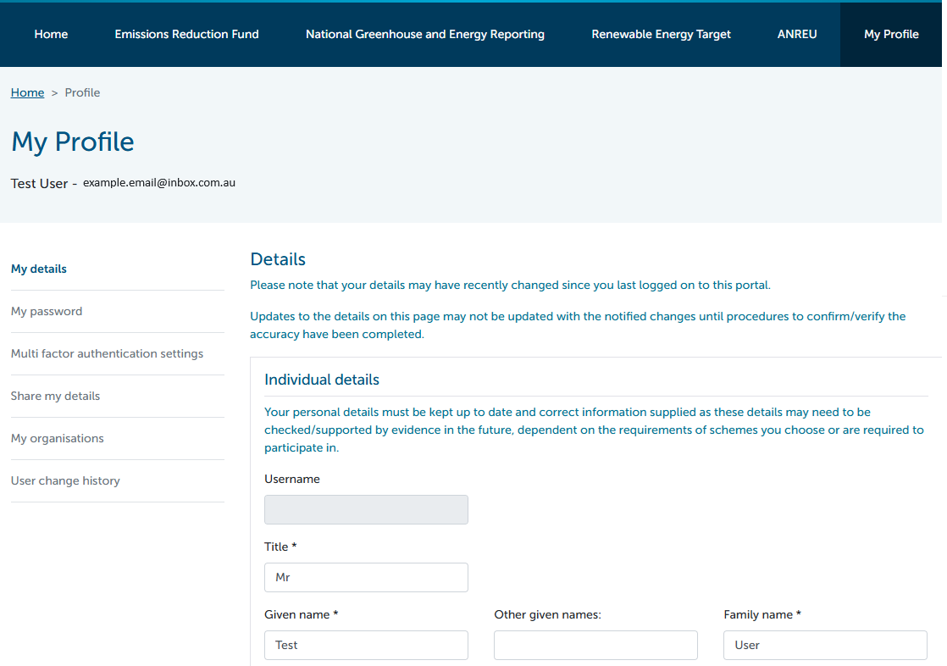

- Once your details are updated continue to complete the applicant details. Declare whether any other person controls the applicant. This applies when a person holds power to exercise or control the registered person in some way.
If yes, provide further details.
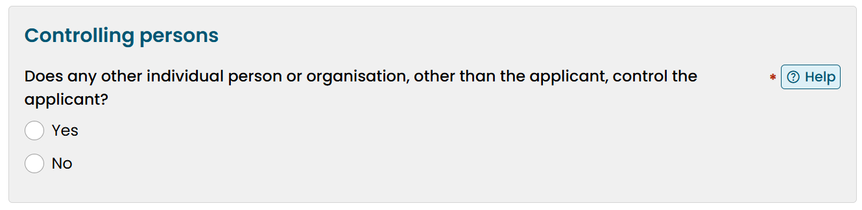
- Declare whether you intend to participate as a sole trader.
If yes, provide your business identifier, organisation address, and states and territories of operation.

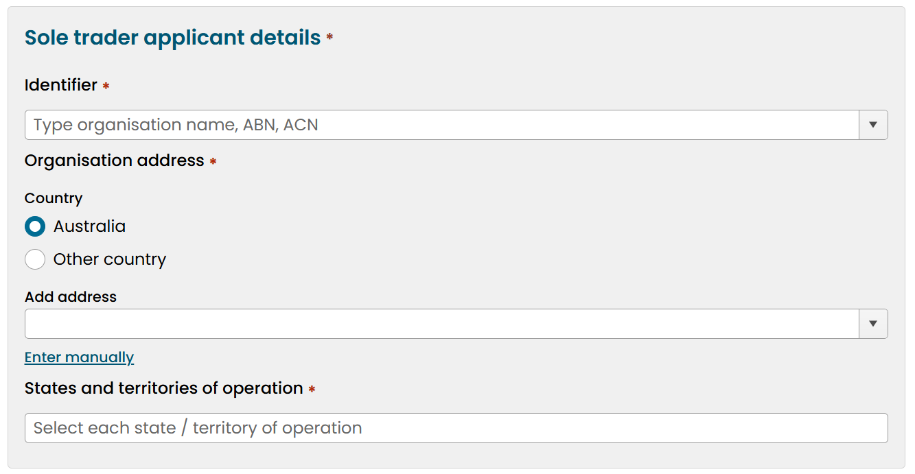
- Select the primary contact for the application.
You may either nominate yourself or another person. If you nominate another person, they will become the primary contact for this organisation in the GO Scheme. If you nominate another person:
Provide the other person’s full name, phone and email address.
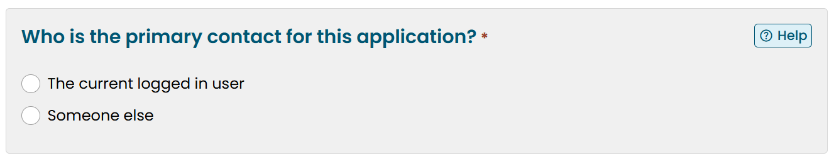
- Once all application details have been provided, click ‘Next’.

Organisations
- Describe how you intend to participate in the GO Scheme.
Selecting ‘Other’ will give you a free-text box to input your answer. You may select more than one item.
- Declare if you participate a related scheme.
If ‘Yes’, select the relevant scheme and add if available, add the scheme identifier if available.
- Select an applicant.
For organisations, this will either be as an existing organisation or new organisation.
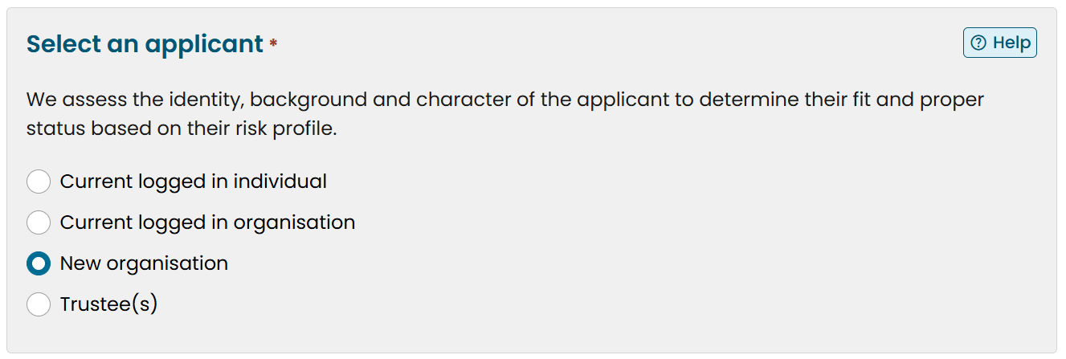
If you are applying on behalf of an existing organisation, select ‘Current logged in organisation’ option and continue. Your organisation’s details will pre-fill the organisation’s business identifier(s) and address according to the CER system.
If you are applying for a new organisation, select ‘New organisation’ and enter the identification details.
This section will ask different questions depending on whether you are applying for a domestic or a foreign organisation. If you are applying for a foreign organisation you will need to provide further information.
- Declare whether any other person controls the applicant.
If yes, provide further details.
- Select the primary contact for the application.
You may either nominate yourself or another person. If you nominate another person, they will become the primary contact for this organisation in the GO Scheme. If you nominate another person:
Provide the other person’s full name, phone and email address.
- Once all application details have been provided, click ‘Next’.

Trustee(s)
- Describe how you intend to participate in the GO Scheme.
Selecting ‘Other’ will give you a free-text box to input your answer. You may select more than one item.
- Declare if you participate a related scheme.
If ‘yes’, select the relevant scheme and add if available, add the scheme identifier if available.
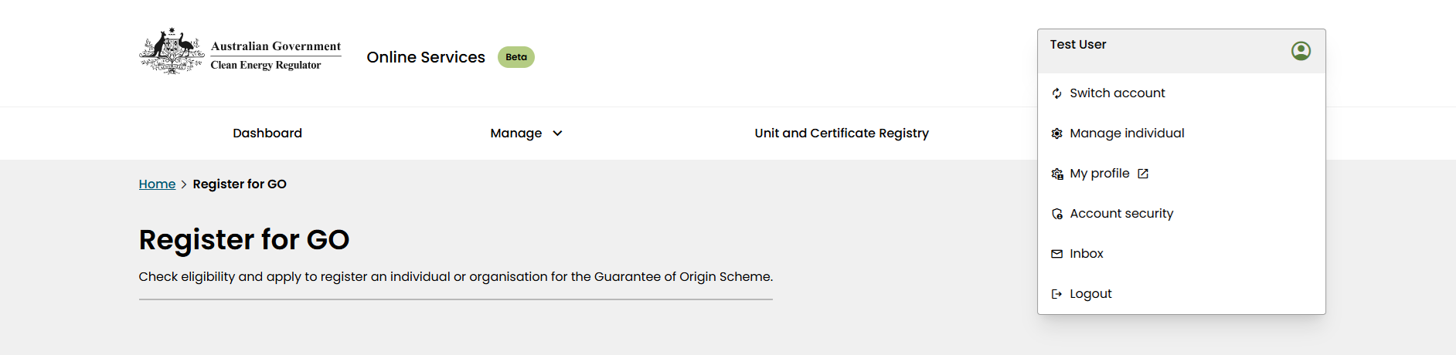
- Select ‘Trustee(s)’.
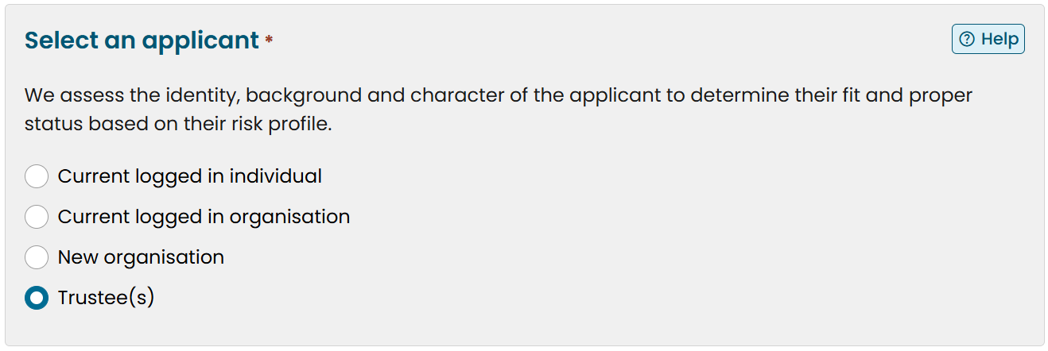
Provide details about the organisation that you are a trustee for.
You must also complete the downloadable ‘GO Trust Form’.
- Select the primary contact for the application.
You may either nominate yourself or another person. If you nominate another person, they will become the primary contact for this organisation in the GO Scheme. If you nominate another person:
Provide the other person’s full name, phone and email address.
- Once all application details have been provided, click ‘next’.

Step 3: Fit and proper person (FPP) test

The fit and proper person (FPP) page follows the completion of the application details.

Individuals and organisations
- Read the FPP information.
- Provide answers to all the questions. If you have responded yes to any of the questions, provide details of the event.
- Complete the National Police Check question by either:
  - uploading a National Police Certificate
  - consenting for the CER to obtain one on your behalf.
- Once FPP details have been provided, click ‘Next’.

Trustee(s)
- Ensure all required trust documents are uploaded to the ‘Applicant details’ page.
- Click ‘Next’.

Step 4: Signatory

Individuals
- Declare who will be signing the application.
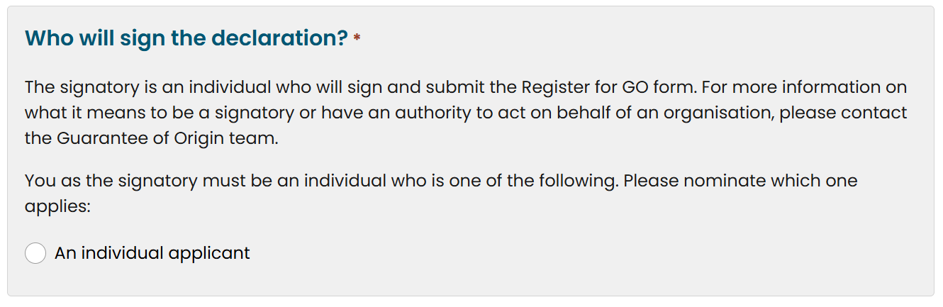
- Once signatory details have been provided, click ‘Next’.

Organisations
- Declare who will be signing the application.
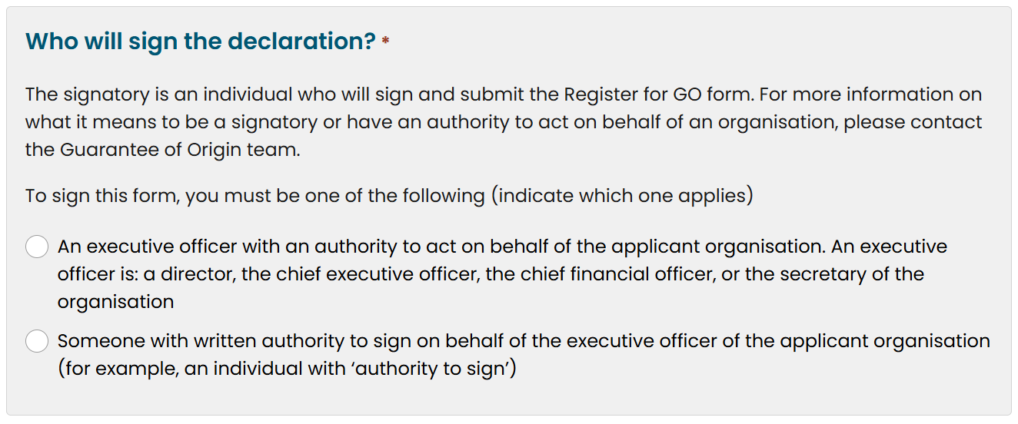
- Once signatory details have been provided, click ‘Next’.

Trusts
- Ensure all required trust documents are uploaded to the ‘Applicant details’ page.
- Click ‘Next’.

Step 5: Verify identity

Tell us once
- If you have already verified your identity with the CER, you will not be asked to provide additional information in this section.
- If this is the case, you will be shown the below screenshot.
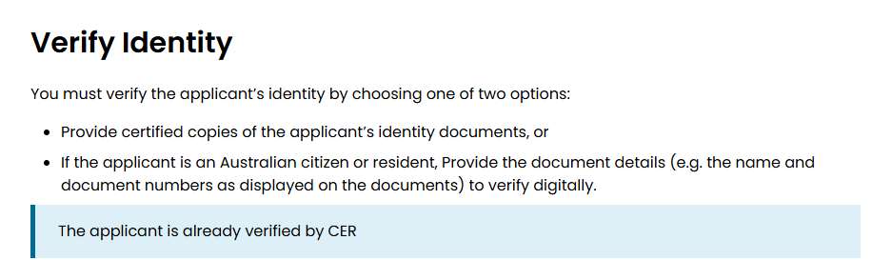
See identity verification for more information.

Individuals
- Verify the applicant’s identity by choosing one of 2 options:
- If the applicant is an Australian citizen or resident, provide the document details (e.g. the name and document numbers as displayed on the documents) to verify digitally.
- Provide certified copies of the applicant’s identity documents.

Organisations and Trusts
- Ensure all required documents are uploaded to the ‘Applicant details’ page.
- Click ‘Next’.

Step 6: Review and declaration
- Review application details.
- Resolve any errors that have been flagged.
- Read the declaration.
- Select the check box to sign the declaration.

https://onlineservices.cer.gov.au/
https://onlineservices.cer.gov.au/
https://cer.gov.au/document_page/cer-go-001-application-guarantee-origin-scheme-registration-trust
https://cer.gov.au/online-systems/identity-verification

