# Factsheet: Soil carbon projects

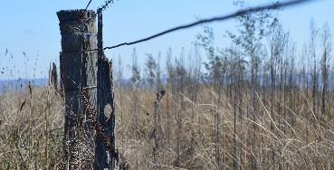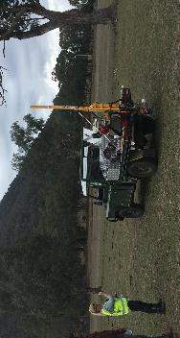

## The benefits of running a soil carbon project

A soil carbon project stores carbon in agricultural soil. This earns Australian carbon credit units (carbon credits) for reducing the level of greenhouse gases in the atmosphere.

Increasing your farm’s soil carbon has a number of benefits for agricultural productivity and profitability:

|  |  |  |  |
| --- | --- | --- | --- |
| **Diversified revenue** Carbon credits provide another income stream for your property. | **Farm benefits** Improved soil health, enhanced water retention and drought resilience, and better crop and pasture yields. | **Ecosystem health** Helps regenerate degraded land and unlock it for more productive use. | **Understand your soil** Manage your land more efficiently using your soil’s nutrient data. |

## How soil carbon project work

Soil carbon is a part of the organic matter in soil. It comes from the breakdown of plants, microorganisms and animal waste material.

A soil carbon project involves managing your land to encourage increases in soil carbon. Increases occur by building carbon stores in the soil. Sampling your soil measures changes in soil carbon and provides you information about soil nutrition and health. Increases in measured and modelled soil carbon earns you carbon credits.

## Soil carbon project activities

Improve your soil carbon levels by introducing one or more new eligible land management activities, such as:

* applying nutrients, lime, or gypsum
* seeding a pasture
* changing stocking rates, or the duration or intensity of grazing.

Increases in your soil carbon can be dependent on existing carbon levels, soil type, management history, rainfall and prevailing seasonal weather (for example, if are you in a drought).

## How the Emissions Reduction Fund works

The Emissions Reduction Fund offers landholders, communities and businesses the opportunity to run new projects that reduce or remove greenhouse gas emissions from the atmosphere.

In running an Emissions Reduction Fund project, you can earn carbon credits and sell them to the Australian Government, or to companies and other private buyers. Each carbon credit represents one tonne of carbon dioxide equivalent greenhouse gas emissions stored or avoided.

## How to participate

*Emissions Reduction Fund project lifecycle*

## Make sure you are eligible to participate

To be eligible you must:

* Identify eligible land on your property – land was pasture, cropping or bare fallow for the last five years.
* Establish legal right (the right to run your project and claim carbon credits) – for example, holding a lease or other land title, or having a signed agreement with other landholders to run a project on their land.
* Obtain regulatory approvals and consent from everyone with an eligible interest in the project land. Consent holders will vary. They may include banks, state governments (if the land is leased) or relevant native title bodies corporate.
* Make sure your project is new – you will need to adopt a new land management activity after you register your soil carbon project.

## Running and reporting on your project

As part of registering a project, you will need to prepare a land management strategy (explaining what activities you will undertake) and calculate your expected carbon credits.

There are operating, sampling, reporting and audit obligations in running a soil carbon project. You will need to report on your project at least once every five years. You receive carbon credits each time you report increases in soil carbon levels over a period of 25 years.

Your project must store carbon for 25 or 100 years to deliver a long-term benefit to the atmosphere (known as ‘permanence’) and there are obligations associated with this.

## Further information

Visit our website [www.cleanenergyregulator.gov.au](http://www.cleanenergyregulator.gov.au/) or contact us on 1300 553 542.