# Factsheet: Plantation forestry projects

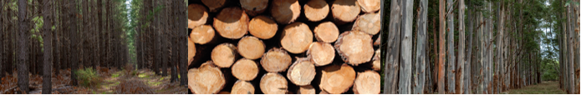

### The benefits of running a plantation forestry project

A plantation forestry project stores carbon in plantation trees. This earns Australian carbon credit units (ACCUs) in return for reducing the level of greenhouse gases in the atmosphere.

Establishing a plantations project has a number of benefits:

|  |  |  |
| --- | --- | --- |
| Diversify revenue ACCUs provide income stream for your business. | Ecosystem benefits Strategically-placed and well-managed plantations can improve soil, water quality and salinity. | Environmental recognition Be recognised for your contribution  to Australia’s emissions reductions. |

### How plantation forestry projects work

Plantation forestry projects involve establishing a new plantation or changing from short rotation to long rotation plantations, increasing the amount of carbon captured in trees as they grow. Carbon can continue to be stored in timber products from   
harvested plantations.

You need to use the free [Full Carbon Accounting Model](https://www.industry.gov.au/data-and-publications/full-carbon-accounting-model-fullcam)[1] (FullCAM) software to model the carbon stored in your plantation.   
You earn carbon credits for modelled increases in stored carbon.

### Plantation forestry project activities

You can run a plantations project by undertaking a range of new activities, such as:

* establishing a new plantation.
* converting a short rotation plantation to a long rotation plantation. This activity involves thinning or pruning a plantation after the start date for the long rotation, and ensuring the long rotation is at least 10 years longer than the original short rotation.
* continuing planting forestry in circumstances where it would have otherwise been converted to non-forested land.
* transitioning to a permanent planting in circumstances where it would have otherwise been converted to non-forested land.

### How the Emissions Reduction Fund works

The Emissions Reduction Fund offers landholders, communities and businesses the opportunity to run new projects that reduce or remove greenhouse gas emissions from the atmosphere.

In running an Emissions Reduction Fund project, you can earn ACCUs and sell them to the Australian Government, or to companies and other private buyers. Each ACCU represents one tonne of carbon dioxide equivalent greenhouse gas emissions stored or avoided.

### How to participate

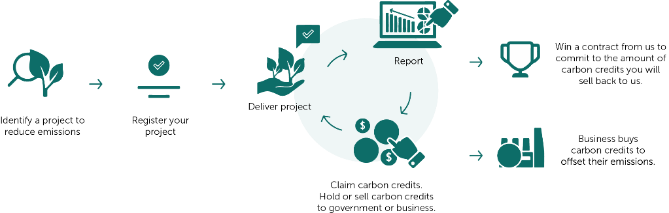

*Emissions Reduction Fund project lifecycle*

### Make sure you are eligible to participate

To be eligible you must:

* Identify eligible land – eligibility requirements will vary depending on project activity. For example, you cannot establish a new plantation on land that has hosted a plantation within the previous seven years.
* Establish legal right (the right to run your project and claim carbon credits) – for example, holding a lease or other land title, or having a signed agreement with other landholders to run a project on their land.
* Obtain regulatory approvals and consent from everyone with an eligible interest in the land. Consent holders will vary. They may include banks, state governments (if the land is leased) or relevant native title bodies corporate.
* Make sure your project is new – you cannot have started your project activities until your project is registered, although certain project activities are permitted after a complete application has been submitted.

### Running and reporting on your project

If you are establishing a new plantation, you will need to submit a [plantation forestry notification](https://www.agriculture.gov.au/ag-farm-food/climatechange/cfi/plantation-forestry-notifications)[2] for assessment by the Department of Agriculture, Water and the Environment.

There are operating, monitoring, reporting and audit obligations in running a plantation forestry project. You will need to report on your project at least once every five years. You will receive ACCUs each time you report modelled increases in carbon stored by your plantation over a period of 25 years.

Your project must store carbon for 25 or 100 years to deliver a long-term benefit to the atmosphere (known as ‘permanence’).

## Further information

Visit our website [www.cleanenergyregulator.gov.au](http://www.cleanenergyregulator.gov.au/) or contact us on 1300 553 542.

1. <https://www.industry.gov.au/data-and-publications/full-carbon-accounting-model-fullcam>
2. <https://www.agriculture.gov.au/ag-farm-food/climatechange/cfi/plantation-forestry-notifications>