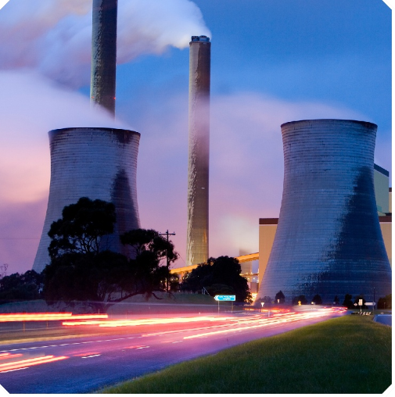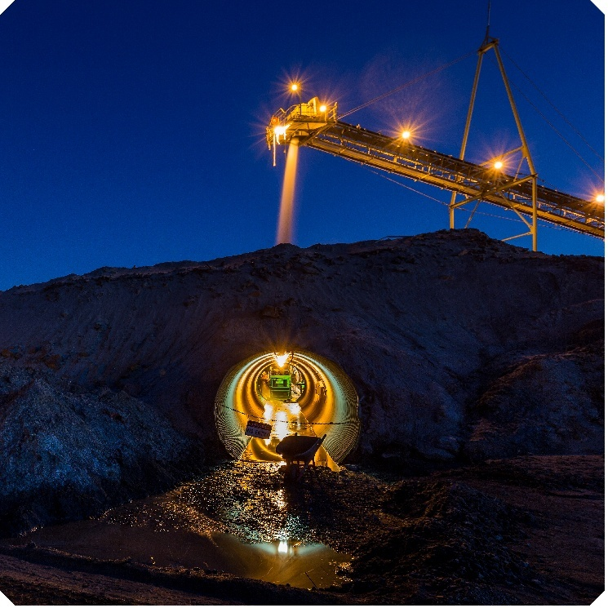Exemption declaration guideline

Safeguard Mechanism

Version 1.0 4 September 2025

Contents

Disclaimer 3

Definitions and abbreviations 4

Who is this guideline for? 6

Part 1 Introduction 7

1.1 Safeguard compliance obligations 7

1.2 Application deadline 7

1.3 What is criminal activity? 8

1.4 What is a natural disaster? 9

Part 2 Eligibility requirements 10

2.1 Providing an explanation as to why an exemption declaration is being sought 10

2.2 Distinguishing between direct and indirect causes of an excess 10

2.3 Reasonable steps before and after the event occurred, to mitigate risks of an excess 11

2.3 Other factors that have significantly impacted covered emissions 12

Part 3 Application process 13

3.1 Preparing and submitting the application 13

3.2 What happens once the exemption declaration application is submitted? 13

# Disclaimer

This guideline has been developed by the Clean Energy Regulator (CER) to assist responsible emitters to assess their eligibility or apply for an exemption declaration under the Safeguard Mechanism. This guideline must be read in conjunction with the [*National Greenhouse and Energy Reporting Act 2007*](https://www.legislation.gov.au/C2007A00175/latest/text)*[1]* (the NGER Act), the [*National Greenhouse and Energy Reporting Regulations 2008*](https://www.legislation.gov.au/F2008L02230/latest/text)[2] (the NGER Regulations), the [*National Greenhouse and Energy Reporting (Safeguard Mechanism) Rule 2015*](https://www.legislation.gov.au/F2015L01637/latest/text)[3] (the Safeguard Rule), and any other legislative instrument referenced in this document in their current form at the time of reading.

Changes to the legislation may affect the information in this document. It is intended that this document will be updated in line with any legislative changes or if further clarity on a particular issue is required.

The information contained in this document is provided as guidance only.

This document is general in nature and does not cover every situation that may arise in relation to an exemption declaration, or the Safeguard Mechanism more broadly.

Responsible emitters are responsible for determining their obligations under the Safeguard Rule, the NGER Regulations and the NGER Act and for applying the legislation to their individual circumstances. They should seek professional advice relevant to their circumstances if they have any concerns.

This document does not contain legal advice and is not a substitute for independent legal advice.

The CER and the Commonwealth of Australia will not be liable for any loss or damage from any cause (including negligence) whether arising directly, incidentally, or as consequential loss or damage, out of or in connection with, any use of this guideline or reliance on it, for any purpose.

# Definitions and abbreviations

| Term | Meaning |
| --- | --- |
| Criminal activity | Any activity that the Regulator has reasonable cause to believe involves the commission of an offence by one or more persons. |
| Excess emissions situation | Where the net emissions number for a facility for a monitoring period exceeds the facility’s baseline emissions number for that monitoring period. |
| Executive officer (EO) | An executive officer is defined as a:   * Director * Chief Executive Officer (however described) * Chief Financial Officer (however described) * Company Secretary. |
| Facility | Under section 9 of [the NGER Act](https://www.legislation.gov.au/C2007A00175/latest/versions)[4] a facility is an activity, or a series of activities (including ancillary activities), that involve greenhouse gas emissions, the production of energy or the consumption of energy and that:   * form a single undertaking or enterprise and meet the requirements of [the NGER Regulations](https://www.legislation.gov.au/F2008L02230/latest/text)[5], or * are declared to be a facility under section 54, 54A or 54B of the NGER Act. |
| Monitoring period | One of the following:   * A full financial year that is not included in a declared multi-year monitoring period (MYMP), and during which a responsible emitter had operational control over the facility for the whole of that financial year, * Part of a financial year, if a responsible emitter only had operational control over a facility for that part and the financial year is not included in a MYMP, * A MYMP for a facility, where the facility is a designated large facility for at least one of the financial years in the MYMP, and a responsible emitter had operational control over the facility for the whole of that MYMP, or * Part of a MYMP, if a responsible emitter only had operational control over a facility for that part and the facility is a designated large facility for at least one of the financial years in the MYMP. |
| Natural disaster | A sudden and extreme event caused by natural forces that causes serious harm to people, property, and/or the environment. These events often happen with little warning and can disrupt communities, damage infrastructure, and require emergency responses to protect lives and/or support recovery. |
| Net emissions number | The total amount of covered emissions in tCO2-e for a facility during a period, plus any ACCUs issued in relation to the facility during that period, minus any ACCUs and/or SMCs surrendered for the facility for that period. |
| Operational control | A person is considered to have operational control over a facility if that person has authority to introduce and implement operating, health and safety, and/or environmental policies, or if the CER declares under section 55 or 55A of the NGER Act that the person has operational control over the facility.  If there is uncertainty about which person has operational control over a facility and the agency has not made a declaration under section 55 or 55A of the NGER Act, the person having operational control over the facility will be the one with the greatest authority to introduce and implement operating and environmental policies in relation to the facility.  If among 2 or more persons neither has the greatest authority to introduce and implement operating and environmental policies in relation to a facility, and the CER has not made a declaration under section 55 of 55A of the NGER Act:   * if a nomination by those persons is in force, then the nominated person will be taken to have operational control, or * if there is no nomination in force, each of those persons will be taken to have operational control over the facility. |
| Person | Means any of the following:   * a body corporate * a trust * a corporation sole * a body politic * a local governing body * an individual. |
| Responsible emitter | The person with operational control of a Safeguard facility. The responsible emitter is responsible for meeting the Safeguard Mechanism requirements if the facility exceeds the safeguard threshold for a financial year and must ensure its net emissions number for a monitoring period do not exceed its baseline for that period.  The responsible emitter may be an individual, a body corporate, a trust, a corporation sole, a body politic or a local governing body. |

**Who is this guideline for?**

This guideline provides information about the eligibility requirements of an exemption declaration and guidance on how to complete an application.

The CER recommends that responsible emitters applying for an exemption declaration for a facility consider this guideline.

All references to legislative provisions in this guideline relate to the Safeguard Rule unless otherwise indicated.

# 

# Part 1 Introduction

## 1.1 Safeguard compliance obligations

Section [22XE of the NGER](https://www.legislation.gov.au/C2007A00175/2024-10-14/2024-10-14/text/original/epub/OEBPS/document_1/document_1.html#_Toc177213663)[6] Act defines an excess emissions situation as the situation where a safeguard facility’s net emissions number for a monitoring period exceeds its baseline.

Under [section 22XF of the NGER Act](https://www.legislation.gov.au/C2007A00175/2024-10-14/2024-10-14/text/original/epub/OEBPS/document_1/document_1.html#_Toc177213664)[7] responsible emitters of safeguard facilities whose net emissions number exceeds their baseline for a monitoring period must [manage the excess emissions situation](https://cer.gov.au/schemes/safeguard-mechanism/managing-excess-emissions)[8] to ensure the excess emissions situation does not exist before 1 April following the end of the financial year in which the monitoring period ended.

|  |
| --- |
| **What is an exemption declaration?**  In limited circumstances, an exemption declaration is an applicable option for responsible emitters of safeguard facilities in excess. [Section 62 of the Safeguard Rule](https://www.legislation.gov.au/F2015L01637/2024-08-31/2024-08-31/text/original/epub/OEBPS/document_1/document_1.html#_Toc178768300)[9] empowers the CER to declare that an excess emissions situation does not exist in relation to a facility for a specified monitoring period, if specific requirements of the Safeguard Rule are met.  **An exemption declaration can only be made if a facility demonstrates that the entire excess for a specific** **monitoring period was the direct result of:**   * **a natural disaster, and/or** * **criminal activity.**   The CER does not have the power to grant an exemption declaration for any other exceptional circumstances.  *Part 2 will explore in more detail the exemption declaration eligibility criteria.* |

## 1.2 Application deadline

Applications must be received no later than the **31 October** immediately following the end of the monitoring period relating to the proposed exemption declaration. For example, on or before 31 October 2025 is the deadline for an exemption declaration proposed to apply to the monitoring period beginning on 1 July 2024 and ending on 30 June 2025.

## 1.3 What is criminal activity?

One of the circumstances where the Safeguard Rule allows the CER to issue an exemption declaration is if an excess for a particular monitoring period is the direct result of criminal activity.

|  |
| --- |
| [The Safeguard Rule](https://www.legislation.gov.au/F2015L01637/2024-08-31/2024-08-31/text/original/epub/OEBPS/document_1/document_1.html#_Toc178768211)[10] defines criminal activity as ‘*any activity that the Regulator has reasonable cause to believe involves the commission of an offence by one or more persons*.’ |

**‘**Reasonable cause to believe’ means the CER does not need absolute proof that a criminal offence has occurred. However, it does require more than a mere suspicion. In other words, a criminal conviction is not necessarily needed for the CER to have reasonable cause to believe that criminal activity has occurred. However, the CER’s belief must be based on objective facts or circumstances and not suspicions or assumptions. It is up to the responsible emitter of a facility to provide sufficient evidence to the CER to enable it to form reasonable cause to believe an offence has occurred.

‘Involves the commission of an offence by one or more persons’ means that the activity involves one or more persons doing something that is against the criminal law (an offence). This includes a criminal offence under Commonwealth, State or Territory law. As an indicator of the meaning of this phrase, the Criminal Code Act 1995 (the Criminal Code) distinguishes between the commission of an offence and the attribution of criminal responsibility for that offence. The Safeguard Rule does not require responsible emitters to attribute legal liability for an offence to any particular person/s, but only to demonstrate that an offence occurred.

### 1.3.1 What is complicity in criminal activity?

An exemption declaration can only be granted for an excess directly caused by criminal activity if the CER is satisfied that the responsible emitter was not complicit in the criminal activity. The responsible emitter does not have to be found guilty of a criminal offence for the CER to have reasonable cause to believe that the responsible emitter was complicit in criminal activity.

As an indicator of the meaning of ‘complicit’, [the Criminal Code](https://www.legislation.gov.au/C2004A04868/2025-02-08/2025-02-08/text/original/epub/OEBPS/document_1/document_1.html#_Toc189835196)[11] describes complicity as occurring when a person intentionally ‘aids, abets, counsels or procures the commission of an offence by another person’.

Omission to perform a duty may also amount to complicity by way of encouraging criminal activity by an offender who takes the omission as implied permission or as aid to the offender.

Complicity does not require that a person be aware of what specific offence the main offender commits. It is enough if they intended to aid an offence of the same general type as the offence that is committed.

## 1.4 What is a natural disaster?

|  |
| --- |
| The CER considers that a natural disaster would generally mean **a sudden and extreme event caused by natural force that causes serious harm to people, property, and/or the environment. These events often happen with little warning and can disrupt communities, damage infrastructure, and require emergency responses to protect lives and/or support recovery.** |

The second circumstance where the Safeguard Rule allows the CER to issue an exemption declaration is if an excess for a particular monitoring period is the direct result of a natural disaster.

Natural forces may include events such as storms, floods, earthquakes or bushfires.

Events caused by human factors are not a natural disaster and include acts of war or terrorism. Events which are not caused by human factors, but are also not natural disasters, may include industrial faults or accidents.

Natural disasters are distinguished from events caused by less-disastrous weather or environmental conditions by their characteristic to causes a serious harm to people, property and/or the environment. This may include loss of life, injury, distress or danger to persons, or loss of, or damage to, property. Natural disasters are typically events of such a nature or magnitude that they are beyond the scope of a community's own resources to manage, requiring assistance on a national scale to restore safe conditions, functioning communications and a continuing livelihood for people.

The CER will consider whether a particular event constitutes a natural disaster on a case-by-case basis considering the full circumstances.

# Part 2 Eligibility requirements

In making an exemption declaration, the CER can declare that an excess emissions situation does not exist for a facility for a specified monitoring period under [section 22XE of the NGER Act](https://www.legislation.gov.au/C2007A00175/2024-10-14/2024-10-14/text/original/epub/OEBPS/document_1/document_1.html#_Toc177213663).[12] The CER can only make an exemption declaration if satisfied that the excess is the direct result of a natural disaster and/or criminal activity. Additionally, the CER must be satisfied that the responsible emitter has taken reasonable steps to mitigate risks of an excess being caused by the event/s, both before and after the event/s occur.

## 2.1 Providing an explanation as to why an exemption declaration is being sought

[Section 60 of the Safeguard Rule](https://www.legislation.gov.au/F2015L01637/2024-08-31/2024-08-31/text/original/epub/OEBPS/document_1/document_1.html#_Toc178768298)[13] requires the responsible emitter to provide information and documents substantiating why an exemption declaration is being sought. This explanation should detail the event/s to which the application relates. A responsible emitter is only eligible for an exemption declaration if their facility’s entire excess is the direct result of a natural disaster and/or criminal activity. The CER has no power to issue an exemption declaration where the excess is the result of any other type of exceptional circumstances.[14]

Criminal activity and natural disasters are described above in **Part 1.3** and **1.4** respectively.

## 2.2 Distinguishing between direct and indirect causes of an excess

[Section 22XE of the NGER Act](https://www.legislation.gov.au/C2007A00175/2024-10-14/2024-10-14/text/original/epub/OEBPS/document_1/document_1.html#_Toc177213663)[15] requires that for an exemption declaration to be made, the excess must be the direct result of a natural disaster and/or criminal activity.

|  |
| --- |
| The CER must calculate the excess as the net emissions number for the relevant facility for the relevant monitoring period, excluding any ACCUs or SMCs surrendered for the purpose of reducing the net emissions number for the facility for the period, less the baseline emissions number for the facility for the period. |

An excess is a direct result of an event of these types if there is a direct causal link between the natural disaster or criminal activity and the increase in emissions at the facility which cause the facility to be in excess.

|  |
| --- |
| **Example of an excess emission situation that is likely the direct result of a natural disaster.**  An earthquake opened a methane seam at a coal mine. The opening of the seam caused the release of a large amount of methane from the mine, which caused the mine’s net emissions number to exceed its baseline emissions number. Without the earthquake, the mine’s net emissions number would have been below its baseline emissions number. |

|  |
| --- |
| **Example of an excess emission situation that is likely the indirect result of a natural disaster.**  A smelter normally acquires high-grade coal from a particular mine. The mine ceases operation because of a major flooding event. As a substitute the smelter switches to a lower-grade coal because the price of high-grade coal has dramatically increased, due to supply stopping from the flooded mine.  The excess is likely the direct result of the smelter’s decision to use a more emissions intensive coal, not the natural disaster itself. |

Conversely, excesses which are the indirect result of an event often involve a choice or financial decision in response to a market circumstance caused by the event. In this case the potential excess will not be considered to be the direct result of the event, regardless of the nature or severity of the event.

The CER will consider what constitutes a direct result of an event on a case-by-case basis, considering the full circumstances.

## 2.3 Reasonable steps before and after the event occurred, to mitigate risks of an excess

To issue an exemption declaration, [section 62 of the Safeguard Rule](https://www.legislation.gov.au/F2015L01637/2024-08-31/2024-08-31/text/original/epub/OEBPS/document_1/document_1.html#_Toc178768300)[16] requires the CER be satisfied that the responsible emitter has taken reasonable steps to mitigate the risks of the natural disaster or criminal activity resulting in an excess, both before and after the event occurred.

|  |
| --- |
| **Examples of likely reasonable steps before an event to mitigate the risk that an excess may occur include:**   * industrial design aimed at improving resilience to extreme weather conditions * procedures for greenhouse gas management during natural disasters * security arrangements * emergency shut-down procedures. |

|  |
| --- |
| **Example of likely reasonable steps after an event** **to mitigate the risk that an excess may occur include:**   * promptly acting to replace damaged emissions reduction equipment * utilising low emissions fuel sources * taking reasonable actions to limit emissions in the remaining part of the applicable monitoring period. |

The CER will consider what constitutes reasonable steps before and after an event on a case-by-case basis considering the full circumstances.

## 2.3 Other factors that have significantly impacted covered emissions

Under [section 60 of the Safeguard Rule](https://www.legislation.gov.au/F2015L01637/2024-08-31/2024-08-31/text/original/epub/OEBPS/document_1/document_1.html#_Toc178768298)[17] it is an application requirement for the responsible emitter to provide detail of any other factors that have significantly impacted the covered emissions of the facility over the monitoring period.

This provides the CER with relevant contextual background on how the facility entered into an excess, in order to assess whether the entire excess is the direct result of the criminal activity or natural disaster. Although the inclusion of ‘any other factors’ is important in creating a comprehensive picture of the facility’s circumstances, this inclusion does not change the primary requirement that the entire excess must be the direct result of criminal activity and/or a natural disaster.

# Part 3 Application process

## 3.1 Preparing and submitting the application

Responsible emitters who wish to apply for an exemption declaration are required to contact the CER via email at [cer-safeguardbaselines@cer.gov.au](mailto:cer-safeguardbaselines@cer.gov.au) or through the general enquiries line on 1300 553 542. You will be provided with an application form.

CER encourages responsible emitters who wish to apply for an exemption declaration to contact the Safeguard team as early as possible to allow time to submit a thorough application before the **deadline:** **31 October after the end of a monitoring period for which the exemption declaration is sought.**

Your application for an exemption declaration must also include supporting documentation to substantiate any claims made. Supporting documentation can be sent to [cer-safeguardbaselines@cer.gov.au](mailto:cer-safeguardbaselines@cer.gov.au) alongside the completed application form and is subject to the same deadline.

The CER requires the exemption declaration application form to be signed and submitted by the responsible emitter’s executive officer.

## 3.2 What happens once the exemption declaration application is submitted?

On receipt of the application, the CER will begin a formal assessment of the application.

If the CER requires additional information in order to assess the application, the CER may request further information in connection with the application under [section 61 of the Safeguard Rule](https://www.legislation.gov.au/F2015L01637/2024-08-31/2024-08-31/text/original/epub/OEBPS/document_1/document_1.html#_Toc178768299).[18] The request will specify the period in which the information must be provided, which is typically within 14 days. If the requested information is not provided within the specified period, the CER may with written notice refuse to consider the application.

The CER will take all reasonable steps to ensure a decision is made by 60 days after receiving the application or 60 days after the end of the specified period in the notice to provide additional information if a request for further information was made.

If the CER intends to refuse the application, it will generally provide the responsible emitter with written notice of its intended decision and an opportunity to provide comment on this written notice.

A responsible emitter may provide written notice to the CER to withdraw an application at any time before a decision is made on the application.

### 3.2.1 Review rights

A person whose interests are affected by a decision of the CER to make or refuse to make an exemption declaration and who is not satisfied with the decision may apply to the Administrative Review Tribunal for review of the decision (refer to [section 56 of the NGER Act](https://www.legislation.gov.au/C2007A00175/2024-10-14/2024-10-14/text/original/epub/OEBPS/document_1/document_1.html#_Toc177213742) for more details).

##### The CER will notify the responsible emitter of their review rights in the notice of any decision to refuse to make an exemption declaration.

### 3.2.3 Revoking an exemption declaration

Under [section 63 of the Safeguard Rule](https://www.legislation.gov.au/F2015L01637/2024-08-31/2024-08-31/text/original/epub/OEBPS/document_1/document_1.html#_Toc178768301)[19], the CER may revoke an exemption declaration if satisfied that information provided by the responsible emitter in connection with the making of the declaration was false or misleading and the declaration would have otherwise not been made.

If the CER intends to revoke an exemption declaration, the responsible emitter will be notified in writing and given an opportunity to respond before a decision is made.

The CER is required to publish the details of the revocation of an exemption declaration on its website as soon as practicable after the revocation.

### 3.2.4 Publication

The CER is required to publish the details of an approved exemption declaration on its website as soon as practical to do so. The information published would include details such as the name of the facility and responsible emitter, the monitoring period, and whether the exemption declaration was made due to a natural disaster or criminal activity.

Under specific circumstances responsible emitters can apply under [section 25 of the NGER Act](https://www.legislation.gov.au/C2007A00175/2024-10-14/2024-10-14/text/original/epub/OEBPS/document_1/document_1.html#_Toc177213702)[20] to request that some information included in an exemption declaration not be published.

The CER can only not publish the information if satisfied that it reveals or could be capable of revealing:

* trade secrets, or
* any other commercially valuable matter, where the information disclosure would, or could reasonably be expected to, destroy or diminish the commercial value;

about a specific facility, technology or corporate initiative relating to the responsible emitter.

In assessing a request not to publish information, the CER will consider whether the applicant has demonstrated that there are real and substantial grounds to find that publishing the information will (or could reasonably) reveal a trade secret or affect commercial value, about a specific facility, technology, or corporate initiative. Grounds that are speculative, hypothetical, or theoretical will not be sufficient. For more information about how to make a request for information not to be published see [Application for information not to be published.](https://cer.gov.au/document/cer-nger-009-application-information-not-to-be-published)[21]

1. https://www.legislation.gov.au/C2007A00175/latest/text
2. https://www.legislation.gov.au/F2008L02230/latest/text
3. https://www.legislation.gov.au/F2015L01637/latest/text
4. https://www.legislation.gov.au/C2007A00175/latest/versions
5. https://www.legislation.gov.au/F2008L02230/latest/text
6. https://www.legislation.gov.au/C2007A00175/2024-10-14/2024-10-14/text/original/epub/OEBPS/document_1/document_1.html#_Toc177213663
7. https://www.legislation.gov.au/C2007A00175/2024-10-14/2024-10-14/text/original/epub/OEBPS/document_1/document_1.html#_Toc177213664
8. https://cer.gov.au/schemes/safeguard-mechanism/managing-excess-emissions
9. https://www.legislation.gov.au/F2015L01637/2024-08-31/2024-08-31/text/original/epub/OEBPS/document_1/document_1.html#_Toc178768300
10. https://www.legislation.gov.au/F2015L01637/2024-08-31/2024-08-31/text/original/epub/OEBPS/document_1/document_1.html#_Toc178768211
11. https://www.legislation.gov.au/C2004A04868/2025-02-08/2025-02-08/text/original/epub/OEBPS/document_1/document_1.html#_Toc189835196
12. https://www.legislation.gov.au/C2007A00175/2024-10-14/2024-10-14/text/original/epub/OEBPS/document_1/document_1.html#_Toc177213663
13. https://www.legislation.gov.au/F2015L01637/2024-08-31/2024-08-31/text/original/epub/OEBPS/document_1/document_1.html#_Toc178768298
14. This is because the Safeguard Rule currently does not make any provision for the purposes of s 22XE(b)(iii) of the NGER Act.
15. https://www.legislation.gov.au/C2007A00175/2024-10-14/2024-10-14/text/original/epub/OEBPS/document_1/document_1.html#_Toc177213663
16. https://www.legislation.gov.au/F2015L01637/2024-08-31/2024-08-31/text/original/epub/OEBPS/document_1/document_1.html#_Toc178768300
17. https://www.legislation.gov.au/F2015L01637/2024-08-31/2024-08-31/text/original/epub/OEBPS/document_1/document_1.html#_Toc178768298
18. https://www.legislation.gov.au/F2015L01637/2024-08-31/2024-08-31/text/original/epub/OEBPS/document_1/document_1.html#_Toc178768299
19. https://www.legislation.gov.au/F2015L01637/2024-08-31/2024-08-31/text/original/epub/OEBPS/document_1/document_1.html#_Toc178768301
20. https://www.legislation.gov.au/C2007A00175/2024-10-14/2024-10-14/text/original/epub/OEBPS/document_1/document_1.html#_Toc177213702
21. https://cer.gov.au/document/cer-nger-009-application-information-not-to-be-published