Estimating emissions and energy from electricity production and consumption guideline

 August 2025

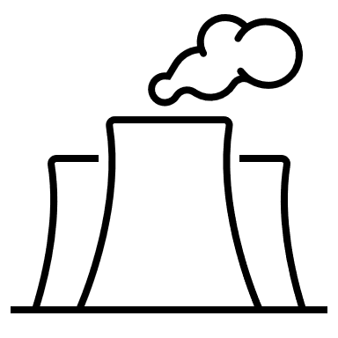

# P4#y3P4#y2P4#y1P4#y4Contents

Contents 1

Definitions and abbreviations 5

Disclaimer 7

2024–25 updates 8

1. Purpose of this guideline 9

1.1. Focus of this guideline 9

2. Good reporting practices 9

2.1. Applying the principles for complying under the NGER Act 11

2.2. Working with financial and process control data 12

3. General principles on estimating scope 1 emissions 12

3.1. Common emissions sources for electricity production 12

Identifying reportable scope 1 emissions sources 14

3.2. Methods for estimating emissions 15

3.3. Thresholds for estimating and reporting emissions 16

Separate instance of a source 16

Thresholds for estimating incidental emissions 16

3.4. Uncertainty 17

4. Estimating emissions from fuel combustion 18

**Example – difference between estimating emissions using emission factors and energy content of fuel combusted, and direct measurement of emissions** 18

4.1. Method 1, 2 and 3 – using emission factors and energy content of fuel combusted 18

Quantity of fuel combusted required for Methods 1, 2 and 3 19

Method 1 – default emission factors 19

Methods 2 and 3 – fuel sampling and analysis 19

4.2. Method 4 – Direct measurement of emissions 19

4.3. Estimating emissions from combustion of solid fuels 20

4.3.1. Sampling and analysis requirements for Methods 2 and 3 for solid fuels 21

Bias testing 22

4.4. Emissions from combustion of gaseous fuels 23

4.4.1. Sampling and analysis requirements for Methods 2 and 3 for gaseous fuels 24

Bias testing 25

4.5. Emissions from combustion of liquid fuels 26

4.5.1. Sampling and analysis requirements for Methods 2 and 3 for liquid fuels 26

Bias testing 27

4.6. Emissions from consumption of PBOGs 27

5. Estimating emissions of sulphur hexafluoride 28

6. Reporting scope 2 emissions from purchased, acquired or lost electricity 29

6.1. When to report scope 2 emissions 29

6.1.1. Meaning of ‘purchased’ or ‘acquired’ electricity 29

**Example – Purchased electricity** 30

6.1.2. Loss of electricity from an electricity transmission or distribution network 30

6.1.3. Unaccounted for energy 30

6.2. Methods for estimating scope 2 emissions 32

6.2.1. Mandatory location-based methods for scope 2 emissions 32

Emission factors for electricity from the main electricity grid (Method A1) 33

Emission factors for electricity from other sources (Method A2) 33

6.2.2. Voluntary market-based method for estimating scope 2 emissions 34

6.3. Reporting scope 2 emissions in EERS 34

6.4. Evidence to keep for scope 2 emissions estimates 35

7. Electricity production and consumption 36

7.1. Energy as a fuel or energy commodity 36

**Example – Energy production and consumption from a gas-fired power station** 37

7.2. Estimating energy production and consumption 37

7.3. Electricity production and consumption 37

**Electricity threshold example** 39

7.3.1. Quantifying electricity consumption 39

**Example – Quantifying electricity consumption at a hydro power plant** 40

7.3.2. Quantifying electricity production 40

Reporting consumption and production of electricity for use onsite in EERS 41

**Example – Reporting consumption and production of electricity for use onsite in EERS** 42

Measuring electricity production 42

**Example – Quantifying electricity production at a gas-fired power plant** 43

7.3.3. Cogeneration 43

7.4. Renewable energy commodity production and consumption 44

**Example – Consumption of a renewable energy commodity** 44

**Example – Reporting production of electricity from a renewable energy commodity** 45

7.4.1. Reporting of NGER data alongside RET data 45

7.5. Energy consumption from fuel use 45

7.5.1. Blended fuels and other fuel mixes 46

7.6. Reporting of battery energy storage system (BESS) activities 47

7.6.1. Principles of BESS reporting 47

7.6.2. Reporting VPP activities (a ‘BESS network’) 47

7.7. Net Energy Consumption 47

Defining primary and secondary energy commodities 47

Calculating net energy consumption 48

8. Measurement requirements 49

8.1. Measurement Criteria 49

Specific notes regarding measurement criteria per fuel states 50

8.2. Metering considerations 50

8.3. Industry practice (measurement criterion BBB) 53

Measuring fuel consumption based on electricity production 54

8.4. Temporarily unavailability of a method of estimating emissions 54

9. More information and references 55

More information 55

References 55

Appendices 56

Appendix A – Case examples for electricity sector facilities 56

Case example 1: Gas-fired power plant 56

NGER activities and industry sector 56

Case example 2: Hydro power plant 61

NGER activities and industry sector 61

Definitions and abbreviations

| Term | Meaning |
| --- | --- |
| ANZSIC | Australian and New Zealand Standard Industrial Classification |
| BoP | Basis of Preparation |
| CEM | Continuous emissions monitoring |
| Department | The Australian Government Department of Climate Change, Energy, the Environment and Water |
| EERS | Emissions and Energy Reporting System |
| GJ | Gigajoules |
| GWh | Gigawatt hours |
| ISO | International Organisation for Standardisation |
| kt | Kilotonne |
| kWh | Kilowatt hours |
| MTBI | Matters to be identified, as specified in Schedule 4 of the NGER Measurement Determination |
| MW | Megawatts |
| MWh | Megawatt hours |
| NGER | National Greenhouse and Energy Reporting |
| NGER Act | *National Greenhouse and Energy Reporting Act 2007* |
| NGER Legislation | The NGER Act, the NGER Regulations, the NGER Measurement Determination, and the National Greenhouse and Energy Reporting (Safeguard Mechanism) Rule 2015 (Safeguard Mechanism Rule) |
| NGER Measurement Determination | National Greenhouse and Energy Reporting (Measurement) Determination 2008 |
| NGER Regulations | National Greenhouse and Energy Reporting Regulations 2008 |
| PBOGs | Petroleum-based oils and greases |
| PEM | Periodic Emissions Monitoring |
| Reporter | An entity required to report emissions and energy production and consumption to the Clean Energy Regulator under section 19, 22G, or 22X of the NGER Act |
| Safeguard Mechanism | The Australian Government’s mechanism to contribute to the achievement of Australia’s greenhouse gas emissions reduction targets. See [the Safeguard Mechanism](https://cer.gov.au/schemes/safeguard-mechanism" \o "A link to the Safeguard Mechanism scheme page of the Clean Energy Regulator website) for more information0F[1] |
| Scope 1 emission | Scope 1 greenhouse gas emissions are emissions released into the atmosphere as a direct result of the activities at your facility. Scope 1 emissions are also referred to as direct emissions. Scope 2 emissions are also referred to as indirect emissions. |
| Scope 2 emission | Scope 2 emissions for a facility represent the emissions that were released outside your facility boundary to produce the electricity that you imported into the facility and used. |
| t CO2-e | Tonnes of carbon dioxide equivalence |

Please refer to Division 2 of the NGER Act, 1.03 of the NGER Regulations and Division 1.1.2 of the NGER Measurement Determination for defined terms in NGER legislation.

# Disclaimer

Thisguideline has been developed by the Clean Energy Regulator (CER) to assist entities to comply with their reporting obligations under the [*National Greenhouse and Energy Reporting Act 2007*](https://www.legislation.gov.au/Series/C2007A00175)1F[2](NGER Act)and associated legislation.

This guideline only applies to the 2024–25 NGER reporting year and should be read in conjunction with the NGER Act, [National Greenhouse and Energy Regulations 2008](https://www.legislation.gov.au/Series/F2008L02230)2F[3] (NGER Regulations), and [National Greenhouse and Energy Reporting (Measurement) Determination 2008](https://www.legislation.gov.au/Series/F2008L02309)3F[4] (NGER Measurement Determination), as in force for this reporting period. These laws and their interpretation are subject to change, which may affect the accuracy of the information contained in the guideline.

The guidance provided in this document is not exhaustive, nor does it consider all circumstances applicable to all entities. This guidance is not intended to comprehensively deal with its subject area, and it is not a substitute for independent legal advice. Although entities are not bound to follow the guidance provided in this document, they must ensure they meet their obligations under the [National Greenhouse and Energy Reporting (NGER) scheme](https://cer.gov.au/schemes/national-greenhouse-and-energy-reporting-scheme)4F[5] at all times. The CER encourages all users of this guidance to seek independent legal advice before taking any action or decision based on this guidance.

CER and the Australian Government will not be liable for any loss or damage from any cause (including negligence) whether arising directly, incidentally, or as consequential loss, out of or in connection with, any use of this guideline or reliance on it, for any purpose.

If an entity chooses to meet their obligations under the NGER scheme in a manner that is inconsistent with the guidance provided in this document, CER, or an independent auditor, may require the entity to demonstrate that they are compliant with requirements of the NGER Act, NGER Regulations, and/or the NGER Measurement Determination. Entities are responsible for determining their obligations under the law and for applying the law to their individual circumstances.

# 2024–25 updates

Changes in this document for the 2024–25 reporting year:

* Chapter 6: Additional discussion of scope 2 reporting methods, in relation to electricity purchased, acquired or lost from other sources and the new MTBI for this method.
* Chapter 7.3.1: Clarification of reporting requirements for electric vehicle charging.
* Chapter 7.6: Further principles of reporting for battery energy storage systems (BESS) and virtual power plants (VPP).
* Minor stylistic and formatting changes, including correction of references to tables and figures.

Read about the [changes to the NGER Legislation for the 2024–25 reporting period](https://cer.gov.au/schemes/national-greenhouse-and-energy-reporting-scheme/report-emissions-and-energy/amendments)5F[6].

# Purpose of this guideline

This guideline provides information to assist NGER reporters to report emissions and energy from electricity production and consumption under the NGER Act and other requirements under the[National Greenhouse and Energy Reporting (Safeguard Mechanism) Rule 2015](https://www.legislation.gov.au/Series/F2015L01637)6F[7] (Safeguard Mechanism Rule).

## Focus of this guideline

The guideline focuses on:

* good reporting practices — section 2
* estimating scope 1 emissions — section 3
* estimating emissions from fuel combustion for electricity production— section 4
* estimating emissions of sulphur hexafluoride — section 5. Additional guidance is also provided in the [Reporting Hydrofluorocarbons and Sulphur Hexafluoride gases guideline](https://cer.gov.au/document_page/reporting-hydrofluorocarbons-and-sulphur-hexafluoride-gases-guideline)7F[8].
* scope 2 emissions from electricity use — section 6. Additional guidance is also provided in the [Voluntary market-based scope 2 emissions guideline](https://cer.gov.au/document_page/voluntary-market-based-scope-2-emissions-guideline)8F[9]
* reporting energy production and consumption — section 7
* measurement requirements — section 8.

This document will not cover other NGER reporting requirements such as determining facility and operational control and using the Emissions and Energy Reporting System (EERS). See [NGER Reporting Guides](https://cer.gov.au/schemes/national-greenhouse-and-energy-reporting-scheme/report-emissions-and-energy/nger-reporting-guides)9F[10] for more guidance.

# Good reporting practices

NGER reporters must keep accessible records of their activities and facilities that are subject to the NGER Act. These records must be kept for 5 years and enable the CER to ascertain whether the NGER reporter has complied with the NGER Act.

The record-keeping requirements include preparing and documenting source and activity data capture, as well as recording and processing data using the general estimation principles in section 1.13 of the NGER Measurement Determination.

Table 1 – General estimation principles for NGER reporting.

| General estimation principles | Example for NGER reporting |
| --- | --- |
| Transparency  Emission estimates must be documented and verifiable. | * All key decisions and assumptions made to prepare NGER reporting, including decision on sampling frequency and method selection for each activity should be documented and updated each year. This includes decisions regarding selection of the NGER executive officer, and where relevant the NGER nominated report submitter. * All activity data should be recorded with a clear audit trail. This includes all sampling parameters, data and techniques used to calculate emissions, as well as records for how the sampling performed meets the sampling requirements irrespective of whether the sampling is performed by a third party. * All data processing should be kept for 5 years. This may include identifying how records for all samples are kept easily accessible. For example, if a facility changes ownership. |
| Comparability  Emission estimates using a particular method and produced by a registered corporation or liable entity in an industry sector must be comparable with emission estimates produced by similar corporations or entities in that industry sector using the same method and consistent with the emission estimates published by the Department in the National Greenhouse Accounts. | * Appropriately using the rules and requirements of the NGER Measurement Determination will achieve this for most activity data and emissions estimates. |
| Accuracy  Having regard to the availability of reasonable resources by a registered corporation or liable entity and the requirements of the NGER Measurement Determination, uncertainties in emission estimates must be minimised and any estimates must neither be over nor underestimates of the true values at a 95% confidence level. | * This is particularly relevant:   + in respect to sampling, for example when higher order methods are used, sampling should occur in a manner and frequency which minimises uncertainties so that estimates within a 95% confidence interval lie as close to the true values as possible   + where industry practice may be used to capture data, for example, BBB criteria – see chapter 8.1 of this guideline. * Estimates should be neutral without bias. * Bias testing for fuel combustion emissions from coal fired power plants should be performed and documented. |
| Completeness  Subject to any applicable reporting thresholds, all emission sources identified in section 1.10 of the NGER Measurement Determination, and production and consumption of all fuels and energy commodities listed in Schedule 1 of the NGER Regulations, must be accounted for. | * All reportable emissions and energy should be accounted for, including the fuel combustion emissions that occur through contractor activities considered to form part of the facility, for example, for electricity transmission or distribution networks or contractor activities at new facility being commissioned within the operational control of the reporter. * All energy production and consumption, subject to relevant thresholds, should be reported – including reporting the use of own produced electricity at electricity generators. |

## Applying the principles for complying under the NGER Act

Executive officers must approve the submission of a report to CER, declaring that the report has been prepared in accordance with the NGER legislation. This includes confirming that the general principles have been appropriately applied.

Registered corporations and the accountable executive officer are responsible for determining appropriate internal reporting processes and controls. Consideration should be given to the following:

* The NGER reporting responsibility may be delegated to an individual with limited control over the activity and source data required to prepare the report. In these circumstances, it may be difficult to confirm whether data is complete and accurate. Reporters are responsible for having processes in place to ensure the quality of NGER data.
* Formalising reliance on existing data processes which may be suitable to rely upon for NGER reporting, for example:
  + Electricity generation data, including delivery to an electricity network such as the National Electricity Market, to estimate and report energy production data. This data may be controlled by engineering or accounting departments
  + Fuel consumption data measured based on invoices for fuel deliveries. For example, criteria ‘A’ or ‘AA’, see chapter 8.1 of this guideline. Purchasing or accounts teams may be in control of this data, with reconciliation of the amounts paid for fuel deliveries and recorded in the accounting system.
* Accountability for ensuring the data used for NGER reporting is complete and accurate should be formalised. This includes:
  + formal approval of the data
  + sense checks on total amounts to be reported
  + a formal process to inform the person(s) responsible for submitting the NGER report of any changes to the data – in live production environments, changes to source measurements are common over the course of a reporting year and can be caused by a range of factors.
* Using a Basis of Preparation (BoP)– a BoP supports a reporter in meeting the record keeping requirements under the NGER Act. A BoP records the methodology used to prepare the NGER report, including details such as facility layout, data sources and calculation methods. Read more about the BoP in the [NGER quick help topics](https://cer.gov.au/document_page/nger-quick-help-topics)10F[11]. The CER encourages reporters to voluntarily submit their BoP (or a summary thereof) with each year’s NGER report.

## Working with financial and process control data

Facilities constituted by electricity generation, transmission and distribution activities are characterised by a high degree of metering and measurement conducted for both financial and process control purposes. Typical parameters which are directly metered include electricity consumed, electricity produced, electricity sold, and fuels purchased. Meters and other measurement devices can be owned and controlled by the reporting organisation, or by customers, vendors and third-party intermediaries.

Much of this metered information may be suitable for use in the preparation of NGER reports. Staff responsible for process control and financial accounting are usually important contributors to a complete and accurate NGER report and should be involved in ensuring that the measurement requirements for NGER reporting are met and appropriately documented.

NGER can be prescriptive in terms of the location of metering points (for example, measuring electricity production ‘at the terminals’), the types of measurement devices and how they are to be calibrated, and the extent of sampling which is considered representative.

# General principles on estimating scope 1 emissions

Direct, or scope 1 emissions, are defined in 2.23 of the NGER Regulations as ‘the release of greenhouse gas into the atmosphere as a direct result of an activity or series of activities (including ancillary activities) that constitute the facility’.

## Common emissions sources for electricity production

Sources of emissions that are reportable under the NGER legislation are defined under section 1.10 of the NGER Measurement Determination. Sources of scope 1 emissions common to facilities producing electricity from generating units are shown below.

Table 2 – Common scope 1 emissions sources related to electricity production.

| Emissions source | Activity releasing emission |
| --- | --- |
| Fuel combustion  (Item 1A in s1.10)  See chapter 4 of this guideline. | **Electricity generation purposes**  This is combustion of fuel to generate electricity either for use in own facility or for use in an outside facility (including delivery into an electricity network). These are the most significant emissions from electricity production. Examples include:   * coal fired power station (solid fuel combustion) * gas fired power station (gaseous fuel combustion) * diesel fired electricity generator (liquid fuel combustion).   Note: It is important that fuel combustion for electricity generation purposes be reported as such and not reported as fuel combustion for stationary energy purposes. Fuel combustion for generating units that do not meet the electricity production reporting threshold (Regulation 4.19) can be reported as fuel combustion for stationary energy purposes. See Table 10 for more information. |
| **Stationary energy purposes**  ‘Stationary energy purposes’ means fuel combusted for ‘stationary equipment’ or non-transport energy purposes. Stationary equipment includes:   * onsite mobile equipment that is not registered for road use, such as diesel-powered dozers, forklifts, and excavators * portable generators that do not meet the electricity production reporting threshold (Regulation 4.19) * portable lighting towers * gas compressors. |
| **Transport energy purposes**  ‘Transport energy purposes’ means fuel combusted for:   * transport by vehicles registered for road use * rail transport * waterborne transport * air transport. |
| **Combustion of petroleum-based oils and greases (PBOGs)**  When used as lubricants, PBOGs are partly oxidised, resulting in fuel combustion emissions. See chapter 4.6 of this guideline for more information.  Note: PBOGs consumed without combustion must be reported as energy consumed without combustion. |
| Emissions of sulphur hexafluoride gases  (Item 30 in s1.10)  See chapter 5 of this guideline and the separate guidance document. | Emissions of sulphur hexafluoride (SF6) occur when the gas leaks from switch gear and circuit breaker equipment, which is widely used at facilities constituted by electricity transmission and distribution activities.  SF6 has a global warming potential of 23,500 t CO2-e per t of SF6.  The CER publishes separate guidance for [reporting hydrofluorocarbons and sulphur hexafluoride gases](https://cer.gov.au/document_page/reporting-hydrofluorocarbons-and-sulphur-hexafluoride-gases-guideline)11F[12]. |

Other reportable scope 1 emissions sources may occur at a facility that generates electricity. However, this guideline will only cover emissions sources commonly associated with electricity generation.

#### Identifying reportable scope 1 emissions sources

Emissions from the sources listed in section 1.10 of the NGER Measurement Determination are required to be estimated and reported for the facilities at which they occur and for which a method exists in the NGER Measurement Determination. Reporters must identify and document all emissions sources occurring at reportable facilities.

However, if there is no source or method in NGER, the emissions are not reportable. For example, a gas fired power station may engage in occasional flaring or venting of fuels, but as there is no source or method in NGER to estimate these emissions, they are not reportable.

Additionally, separate occurrences of an emissions source can be identified in accordance with section 1.9B of the NGER Measurement Determination. This allows reporters flexibility to measure, estimate and report separate occurrences of a source differently where appropriate.

## Methods for estimating emissions

Available emissions estimation methods differ by emissions source, activity, fuel type and greenhouse gas. Up to 4 alternative methods for estimating emissions are provided in the NGER Measurement Determination, as detailed in Table 3.

Table 3 – General estimation methods available in NGER.

| Method 1 | Method 2 | Method 3 | Method 4 |
| --- | --- | --- | --- |
| Use of default emission factors for fuel types and emissions sources | Use of industry sampling methods and Australian or international standards for analysis of fuels and raw materials to determine emission factor. | Use of Australian or international standards for sampling and analysis of fuels and raw materials to determine emission factor. | Use of direct measurement of emissions released from the source |
| Useful when emission source is fairly homogenous, for example, liquid fuels | Useful when fuels exhibit some variability in key qualities, for example gaseous fuels. | Useful when fuels exhibit some variability in key qualities, for example, gaseous fuels. | Useful when a high level of accuracy is desired, for example for large emission sources. |
| **Generally least accurate**  **Generally most accurate** | | | |

In selecting available methods for estimating emissions, reporters can make their own judgements to balance the costs of using the higher-order methods with the benefits of potentially improved accuracy of emissions estimates.

In some circumstances, the NGER legislation restricts the different types of Methods available. For example, Method 1 **cannot be** used to estimate emissions of carbon dioxide for the main fuel combusted from the operation of the facilities with the Australian and New Zealand Standard Industrial Classification (ANZSIC) code of 2611 where the generating unit has the capacity to produce 30 MW or more of electricity and generates more than 50,000 MWh of electricity in a reporting year.12F[13] This requirement is based on total generation and production capacity of the generating units at the facility.

## Thresholds for estimating and reporting emissions

All emissions from the use of sulphur hexafluoride must be reported. The emissions from the combustion of fuels must be reported if the quantity consumed is greater than the thresholds listed below.

*Table 4 – Thresholds for emission estimation.*

| Emission source | Estimation threshold per each separate instance of the source during the reporting year |
| --- | --- |
| Solid fuel combustion | 1 t (per section 2.2 of the NGER Measurement Determination) |
| Liquid fuel combustion | * 1 kL * 5 kL for petroleum-based oils (other than those used as fuels) and petroleum-based greases.   (per section 2.39 of the NGER Measurement Determination) |
| Gaseous fuel combustion | 1000 m3 (per section 2.18 of the NGER Measurement Determination) |
|  |  |

#### Separate instance of a source

The estimation thresholds apply to each ‘instance of a source’, which is defined by section 1.9A of the NGER Measurement Determination as follows:

* If 2 or more different activities of a facility have the same source of emissions, each activity is taken to be a separate ‘instance of the source’ if the activity is performed by a class of equipment different from that used by another activity.

For example, 2 compressors at a facility that are the same class of equipment and perform the same activity from the combustion of natural gas will be the same instance of the source. However, diesel may be combusted in generators used for electricity production and in light vehicles. In this example each class of equipment has the same source of emissions (see 1A ‘Fuel combustion’ in section 1.10 of the NGER Measurement Determination) but are separate instances of the source as they are 2 different classes of equipment used in different activities.

#### Thresholds for estimating incidental emissions

NGER allows smaller ‘incidental emissions’ to be estimated without using a prescribed estimation method. Incidental emissions can be estimated using another method, so long as that method satisfies the general estimation principles in section 1.13 of the NGER Measurement Determination.

4.27(5) of the NGER Regulations prescribes maximum thresholds per facility for this allowance to estimate incidental emissions without using a prescribed method:

Table 5 – Greenhouse gas emissions incidental reporting thresholds.

| Application type and level | Scope 1 emissions (CO2-e) | Scope 2 emissions (CO2-e) |
| --- | --- | --- |
| Total emissions from fuel combustion at a facility | 12 kt or less | 12 kt or less |
| Amount of emissions from a source, other than combustion of fuel, at a facility | 3 kt or less | 3 kt or less |
| Total emissions, from a source other than combustion of fuel, at a facility | 12 kt or less | 12 kt or less |

This allowance provides some flexibility to estimate smaller incidental emissions without having to meet all requirements of prescribed methods. However, the emissions must be appropriately estimated each reporting year.

Note: It is also important to note this is an annual allowance, accordingly, emissions sources considered incidental one reporting year may not be so the following year. Reporters must check they meet the threshold each reporting year.

See the [Guidance on aggregated facility reporting, percentage estimates, and incidental emissions and energy](https://cer.gov.au/document_page/guidance-aggregated-facility-reporting-percentage-estimates-and-incidental-emissions-and-energy)13F[14] for more information.

## Uncertainty

Uncertainty must be reported for a facility if the scope 1 emissions from the combustion of an energy type or for a source are 25,000 t CO2-e or more in a reporting year (regulations 4.08 and 4.17A of the NGER Regulations). This may particularly be the case for fuel combustion in electricity generators, for example coal or gas fired power stations.

The NGER Measurement Determination sets out how to assess uncertainty as follows:

* Part 8.3 – where Method 1 is used to estimate scope 1 emissions.
* Part 8.4 – where Method 2, 3 or 4 is used to estimate scope 1 emissions.

See the [Reporting uncertainty guideline](https://cer.gov.au/document_page/reporting-uncertainty-guideline)14F[15] for more information.

# Estimating emissions from fuel combustion

Fuel combustion accounts for a large proportion of scope 1 emissions from the electricity sector. Available estimation methods are provided in chapter 2 of the NGER Measurement Determination and vary according to:

* the physical state of the fuel being combusted, for example:
* Part 2.2 – combustion of solid fuel
* Part 2.3 – combustion of gaseous fuel
* Part 2.4 – combustion of liquid fuel
* the type of greenhouse gas emitted, being carbon dioxide, methane and nitrous oxide (as applicable).

Depending on the applicable greenhouse gas, emissions from fuel combustion can be estimated by:

* the use of emission factors and energy content of the fuel combusted (Methods 1, 2 or 3)
* direct measurement of emissions (Method 4).

|  |
| --- |
| 3B**Example – difference between estimating emissions using emission factors and energy content of fuel combusted, and direct measurement of emissions** Case example 1 in Appendix A illustrates the principal difference in respect of a gas-fired power station between estimating emissions using emission factors and energy content of fuel combusted, and direct measurement of emissions.  Scope 1 emissions occur when carbon dioxide (CO2), methane (CH4) and nitrous oxide (N2O) are released through the discharge point as a result of combusting gaseous fuel to generate electricity.   * Estimating emissions using emission factors and energy content of fuel combusted involves estimating the gases released through the chimney using the amount of fuel combusted (number 2 in the diagram provided in the case example) – it then applies energy content and emission factors for the gaseous fuel combusted to estimate the emissions, rather than measuring the emissions directly. * Direct measurement of emissions involves direct measurement of the gases released through the chimney using appropriate gas monitoring equipment at the chimney (see number 3 in the case example). |

## Method 1, 2 and 3 – using emission factors and energy content of fuel combusted

For Methods 1, 2 and 3, greenhouse gas emissions from fuel combustion are based on:

* measuring the fuel consumed for combustion during the reporting year (Q)
* applying appropriate energy content and emission factors for carbon dioxide, methane and nitrous oxide.

#### Quantity of fuel combusted required for Methods 1, 2 and 3

The accuracy and completeness of the emissions estimates depend on measurement of the quantity of fuel consumed for combustion during the reporting year (Q).

Whilst these differ for each fuel category (solid, gaseous and liquid), there is significant commonality.

More detail on measurement requirements is available in chapter 8 of this guideline.

#### Method 1 – default emission factors

Method 1 requires measuring the quantity of fuel combusted, determining the correct fuel type from Schedule 1 of the NGER Measurement Determination and use of the corresponding default emission factors listed within Schedule 1 of the NGER Measurement Determination.

Reporters can use either the default energy content factor for the fuel type listed within Schedule 1 of the NGER Measurement Determination or a non-default energy content factor estimated under section 6.5 of the NGER Measurement Determination.

Method 1 must not be used to estimate carbon dioxide emissions from the combustion of a solid or gaseous fossil fuel if the following conditions are met:

* the solid or gaseous fuel is the main fuel combusted for the operation of the facility
* the principal activity of the facility is electricity generation from fossil fuels (ANZSIC code 261115F[16])
* the total capacity of all generating units combined at the facility is 30 MW or more
* the facility generates more than 50,000 MWh of electricity in a reporting year.

#### Methods 2 and 3 – fuel sampling and analysis

Methods 2 and 3 require sampling and analysis of the properties of the fuel combusted to estimate a facility specific emission factor rather than using the default emission factor.

Reporters can use either the default energy content factor for the fuel type listed within Schedule 1 of the NGER Measurement Determination or a non-default energy content factor estimated under section 6.5 of the NGER Measurement Determination.

Method 3 generally only differs from Method 2 in requiring the use of an international or Australian standard for sampling and analysis.

The sampling and analysis requirements differ considerably per fuel category: solid, gaseous or liquid fuel. See chapters 4.3, 4.4 and 4.5 of this guideline for guidance on emissions estimation methods for each fuel category.

## Method 4 – Direct measurement of emissions

Part 1.3 of the NGER Measurement Determination provides the requirements for direct measurement of emissions under Method 4. There are 2 monitoring approaches:

* continuous emissions monitoring (CEM)
* periodic emissions monitoring (PEM).

Application of Method 4 to estimate emissions requires compliance with specific requirements for representative sampling, analysis of samples, and the use of equipment.

See chapter 8.2 of this guideline for more information on the use of metering equipment for Method 4.

## Estimating emissions from combustion of solid fuels

In the electricity sector, solid fuels are primarily combusted for electricity generation purposes, for example, at coal fired power stations. The methods available for estimating emissions from the combustion of solid fuels are outlined below.

Figure 1 – Available methods for estimating emissions from the combustion of solid fuels.

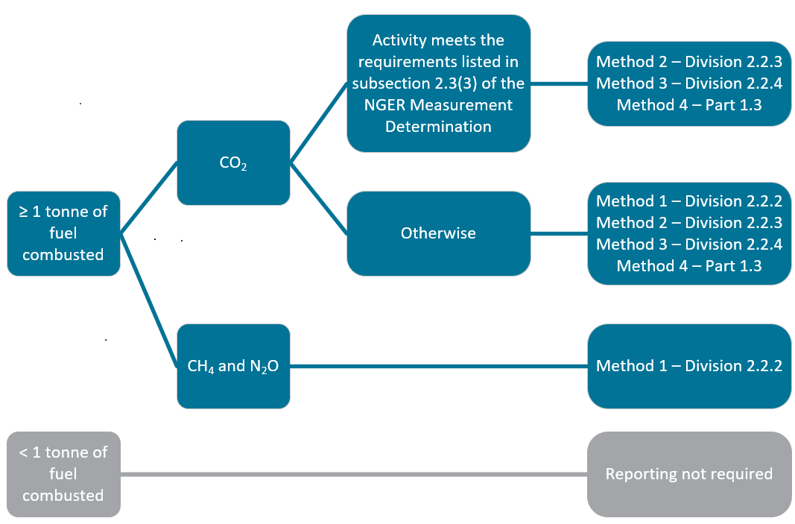

For Methods 1, 2 and 3, fuel quantities of solid fuels combusted should be measured per the measurement requirements in Division 2.2.5 of the NGER Measurement Determination – see Chapter 8 of this guideline.

Method 1, set out in Division 2.2.2 of the NGER Measurement Determination, uses the default emission factors set out in Schedule 1 of the NGER Measurement Determination. Method 1 is the only method available for estimation of emissions of methane and nitrous oxide from the combustion of solid fuels. Method 1 may be used for estimating emissions of carbon dioxide, subject to the criteria in subsection 2.3(3) of the NGER Measurement Determination. Method 1 must not be used if:

* the principal activity of the facility is electricity generation (ANZSIC industry classification and code 2611)
* the total capacity of all generating units at the facility is 30 MW or more
* the facility generates more than 50,000 MWh in a reporting year.

The energy content factor used to estimate emissions under Method 1 can either be taken from Part 1 of Schedule 1 of the NGER Measurement Determination or estimated via analysis of the fuel in accordance with the standard listed in Schedule 2 of the NGER Measurement Determination, or equivalent.

If performing analysis to determine an energy content factor, see Table 6 for further information.

### Sampling and analysis requirements for Methods 2 and 3 for solid fuels

Method 2 is derived from the methodologies published in the Technical Guidelines for the Generator Efficiency Standards program16F[17] and is designed to enable more accurate emissions estimates to be made.

Under Methods 2 and 3, representative and unbiased samples of consumed fuels must be analysed for carbon, ash or moisture content in accordance with the prescribed Australian or international documentary standards or their equivalent. Two different versions of Method 2 are available. The first, which uses a default oxidation factor, is set out in subdivision 2.2.3.1 of the NGER Measurement Determination. The second allows reporters to use an estimated oxidation factor determined by reference to additional information about the fuels combusted by the facility and is set out in subdivision 2.2.3.2. Default oxidation factors are drawn from those utilised in the National Greenhouse Accounts.

The energy content factor used to estimate emissions under Methods 2 and 3 can either be taken from Part 1 of Schedule 1 of the NGER Measurement Determination or estimated via analysis of the fuel in accordance with the standard listed in Schedule 2 of the NGER Measurement Determination or equivalent.

Table 6 – Solid fuel sampling and analysis frequency.

| Parameter | Minimum fuel sampling and analysis frequency | Furnace ash and fly ash sampling and analysis frequency |
| --- | --- | --- |
| Energy content factors | Monthly composite sample.  Samples must be taken on ‘enough occasions to produce a representative sample’, per subsection 2.7(2) of the NGER Measurement Determination.  A mechanical sampling system designed and operated in accordance with AS 4264 must be used to sample the solid fuel. Ideally, this would be set up to obtain coal as it is either being loaded at the coal source, unloaded at the facility or at a point immediately prior to combustion.  If necessary, manual sampling of the coal may be used provided that the sampling equipment and procedure used is in accordance with AS 4264.  Analysis must be undertaken in line with the standards listed for the fuel listed in Schedule 2 of the NGER Measurement Determination.  A standard that is equivalent to a standard set out in Schedule 2 may also be used. | NA |
| Carbon | Fly ash must be sampled as per section 2.11 of the NGER Measurement Determination.  Furnace ash must be analysed and sampled according to section 2.9 and 2.10 of the NGER Measurement Determination. |
| Moisture | One delivery of coal will normally represent one day or one trainload of coal. As such, if the delivery of coal is continuous, sampling for moisture and ash should be undertaken daily. | NA |
| Ash | NA |
| Exceptions | If delivery lasts one month or less, analysis must be carried out on each delivery unless fuel properties do not change significantly between deliveries over a period of a month, in which case analysis may be carried out monthly.  If a delivery of fuel lasts for more than a month and fuel properties do not change significantly before the next delivery, energy content and carbon analysis may be conducted on a delivery basis, rather than monthly basis. | NA |

#### Bias testing

When Method 2 or 3 is selected, samples must be ‘free of bias so that any estimates are neither over nor under-estimates of the true value’, per section 2.7 of the NGER Measurement Determination. Bias must be tested in accordance with an appropriate standard, for example, AS 4264.4 -1996 *Coal and coke – Sampling – Determination of precision and bias*.

In the case of bias testing of mechanical samplers, the reference samples are usually ‘stopped belt samples’ off a conveyor belt. For the purposes of verification of a coal sampling system, the coal samples taken for bias testing (pairs consisting of a reference sample and a sample taken by the coal sampler) should be analysed for total moisture and ash.

Bias testing should always be carried out on a new sampling system. For an existing system, the following verification procedure may be followed if there is some doubt about the conformance of the sampling system:

* conduct a detailed technical audit of the sampling system
* correct any non-conformances that have been observed
* conduct a limited bias test on the system, usually with the coal that exhibits the widest stochastic variability in total moisture or ash, to provide a more quantitative verification that the sampling system is performing correctly.

If you are aware of bias, it must be eliminated where possible. Following the implementation of measures to eliminate bias, the presence of residual bias must be retested and assessed. If any remaining bias exists which cannot feasibly be eliminated, data must be corrected to account for the bias, the corrections documented, and records kept.

## Emissions from combustion of gaseous fuels

In the electricity sector, gaseous fuels can be combusted for generation purposes (for example at a gas-fired power plant) or in other equipment. The methods available for estimating emissions from the combustion of liquid fuels are outlined below.

Figure 2 – Available methods for estimating emissions from the combustion of gaseous fuels.

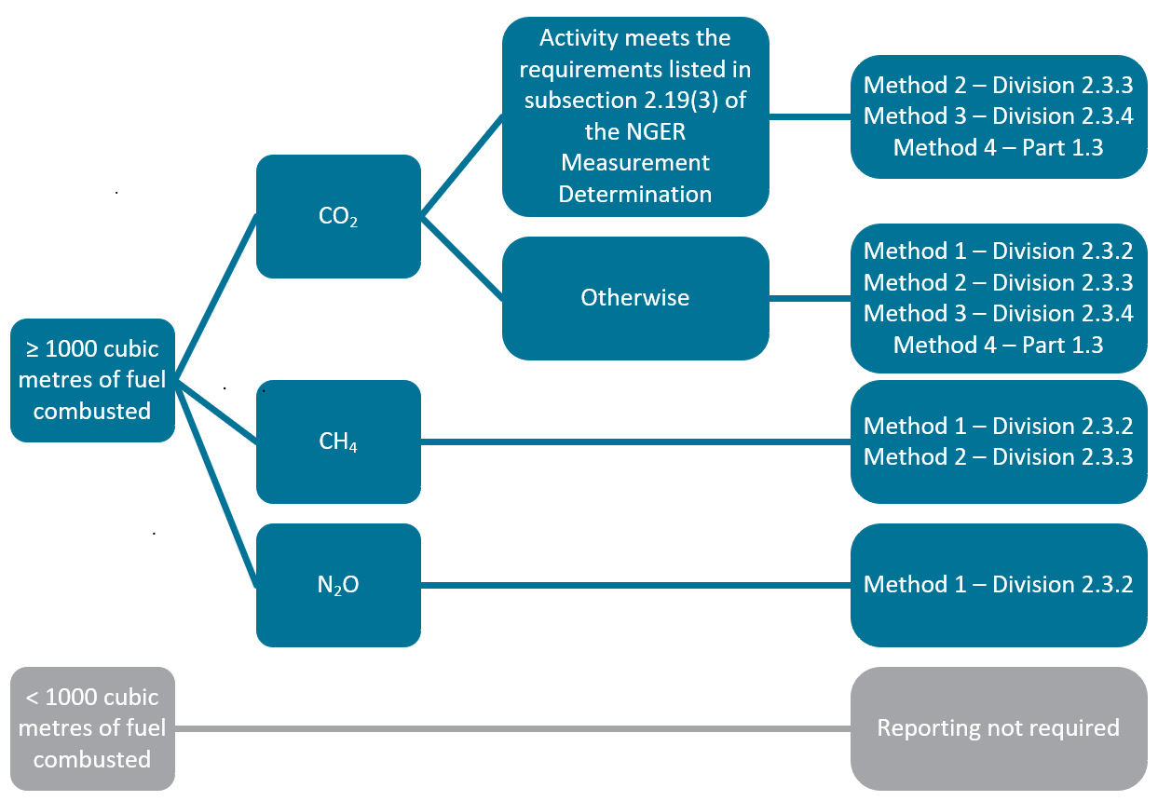

For Methods 1, 2 and 3, fuel quantities of gaseous fuels combusted should be measured per Division 2.3.6 in the NGER Measurement Determination. See Chapter 8 of this guideline for more information on measurement requirements.

The energy content factor used to estimate emissions under Method 1, 2 and 3 can either be:

* taken from Part 2 of Schedule 1 of the NGER Measurement Determination
* estimated via analysis of the fuel in accordance with the standard listed in Subdivision 2.3.3.2 of the NGER Measurement Determination, or equivalent
* equal to one, if the quantity of fuel has been measured in GJ.

If performing analysis to determine an energy content factor, see Table 7 and Table 8 for further information.

Method 1, set out in Division 2.3.2 of the NGER Measurement Determination, uses the default emission factors set out in Schedule 1 of the NGER Measurement Determination. Method 1 is the only method available for estimation of emissions of methane and nitrous oxide from the combustion of gaseous fuels. Method 1 may be used for estimating emissions of carbon dioxide, subject to the criteria in subsection 2.19(3) of the NGER Measurement Determination. Method 1 must not be used if:

* the principal activity of the facility is electricity generation (ANZSIC industry classification code 2611)
* the total capacity of all generating units at the facility is 30 MW or more
* the facility generates more than 50,000 MWh in a reporting year.

### Sampling and analysis requirements for Methods 2 and 3 for gaseous fuels

Sampling and analysis should be undertaken for the parameters listed and at the frequencies indicated in Table 7 and Table 8as per the following divisions of the NGER Measurement Determination:

* Method 2: Subdivision 2.3.3.2 (CO2), and Division 2.3.5 (CH4).
* Method 3: Division 2.3.4.

An accredited laboratory or similar laboratory complying with International Organization for Standardization (ISO) 17025 should be used to conduct gas analysis. If an online analyser is used, it must be calibrated in line with an appropriate standard – for example, ISO 6975:1997.

The density of a gaseous fuel must be analysed in accordance with ISO 6976:1995 or in accordance with a standard that is equivalent to that standard.

Table 7 – Gaseous fuel sampling and analysis frequency – Pipeline quality gases.

|  |  |
| --- | --- |
| Parameter | Minimum fuel sampling and analysis frequency |
| Gas composition | Monthly |
| Energy content | Monthly if category 1 or 2 gas measuring equipment used  Continuous if category 3 or 4 gas measuring equipment used |

See section 2.31 of the NGER Measurement Determination for classifications of measuring equipment.

Table 8 – Gaseous fuel sampling and analysis frequency – All other gases (including fugitive emissions).

|  |  |
| --- | --- |
| Parameter | Minimum fuel sampling and analysis frequency |
| Gas composition | Monthly |
| Energy content | Monthly |
| Exception | If a reporter certifies in writing that such frequency of analysis will cause significant hardship or expense, the analysis may be undertaken at a frequency that will allow an unbiased estimate to be obtained |

Note: Gaseous fuel is typically delivered with set energy content specifications. Whilst these specifications can be useful to sense-check fuel sampling and analysis, they may not meet the NGER requirements for fuel sampling and analysis. The reporter should establish and document that sufficient fuel sampling and analysis has been performed. Alternatively, the reporter can use the default energy content factor for the fuel type specified in Part 2 of Schedule 1 of the NGER Measurement Determination.

#### Bias testing

Samples must be ‘free of bias so that any estimates are neither over nor under-estimates of the true value’, per section 2.44 of the NGER Measurement Determination.

Bias is less likely to occur in the sampling and analysis of gaseous fuels. If you are aware of bias, it must be eliminated where possible. Following the implementation of measures to eliminate bias, the presence of residual bias must be retested and assessed. If any remaining bias exists which cannot feasibly be eliminated, data must be corrected to account for the bias, the corrections documented, and the records kept.

## Emissions from combustion of liquid fuels

In the electricity sector, liquid fuels can be combusted for generation purposes or in other equipment – including for transport purposes, for example, road-registered combustion engine vehicles. The methods available for estimating emissions from the combustion of liquid fuels are outlined below.

Figure 3 – Available methods for estimating emissions from the combustion of liquid fuels.

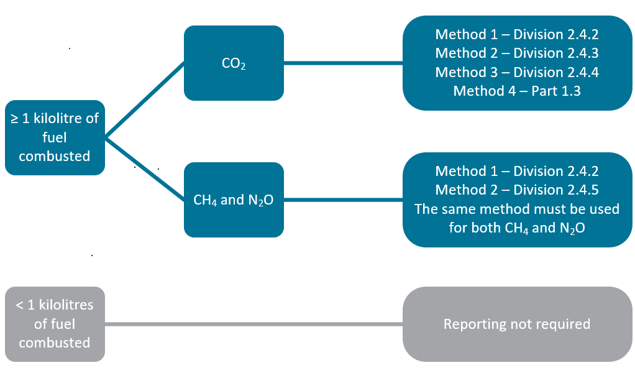

Method 1 is available for estimating emissions of carbon dioxide for all liquid fuel power generators.

For Methods 1, 2 and 3, fuel quantities of liquid fuels combusted should be measured as per Division 2.4.6 in the NGER Measurement Determination. See Chapter 8 of this guideline for more information.

The energy content factor used to estimate emissions under Method 1, 2 and 3 can either be:

* taken from Part 3 of Schedule 1 of the NGER Measurement Determination for stationary energy purposes
* taken from Division 4.1 of Schedule 1 of the NGER Measurement Determination for transport energy purposes
* estimated via analysis of the fuel in accordance with the standard listed in Subdivision 2.4.3.2 of the NGER Measurement Determination or equivalent.

### Sampling and analysis requirements for Methods 2 and 3 for liquid fuels

Sampling and analysis must be undertaken for the parameters listed and at the frequencies indicated in Table 9 as per the following divisions of the NGER Measurement Determination:

* Method 2 - Subdivision 2.4.3.2 (CO2) and Division 2.4.5 (CH4 and N2O)
* Method 3 - Division 2.4.4.

An accredited laboratory or a laboratory that meets requirements equivalent to those in AS ISO/IEC 17025:2005 must be used to conduct liquid analysis.

Table 9 – Liquid fuel sampling and analysis frequency.

| Parameter | Minimum fuel sampling and analysis frequency for all liquid fuel types |
| --- | --- |
| Energy | Quarterly or by delivery |
| Carbon | Quarterly or by delivery |

Standards for analysis of liquid fuels are listed in subdivision 2.4.3.2 of the NGER Measurement Determination. If a reporter is considering the use of Method 2 or Method 3 for a liquid fuel type which does not have an analysis standard, they should [contact the CER](https://cer.gov.au/about-us/contact-us)17F[18] to discuss options for fuel sampling and analysis.

#### Bias testing

Samples must be ‘free of bias so that any estimates are neither over nor under-estimates of the true value’, per section 2.44 of the NGER Measurement Determination. Bias is less likely to occur in the sampling and analysis of liquid fuels.

If a reporter is aware of bias, it must be eliminated where possible. Following implementation of measures to eliminate bias, the presence of residual bias must be retested and assessed. If any remaining bias exists that cannot feasibly be eliminated, data must be corrected to account for the bias, the corrections documented, and the records kept.

## Emissions from consumption of PBOGs

PBOGs used as lubricants are considered to have undergone a degree of oxidation and are therefore reported under the fuel combustion emissions source. Available emissions estimation methods are summarised below.

Figure 4 – Available methods for estimating emissions from consumption of PBOGs when they are used as a lubricant.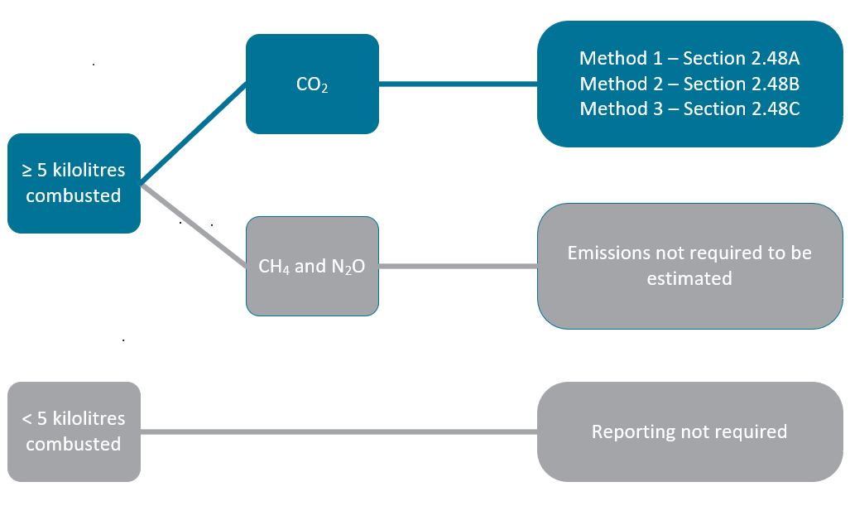

When PBOGs are used as a fuel, the emissions should be estimated as per ‘liquid fuels other than PBOGs’.

See the [Fuel combustion guideline](https://cer.gov.au/document_page/estimating-emissions-and-energy-fuel-combustion-guideline)18F[19] and the [Petroleum-based oils and greases guideline](https://cer.gov.au/document_page/petroleum-based-oils-and-greases-guideline)19F[20] for more information on reporting emissions from the consumption of PBOGs.

# Estimating emissions of sulphur hexafluoride

Sulphur hexafluoride (SF6) is used in many electricity sector facilities, for example, in electrical switchgear. Any emissions of SF6 where it is used in gas insulated switch gear and circuit breakers is required to be reported as there is no reporting threshold listed within the NGER legislation.

The following methods are available for estimating emissions of sulphur hexafluoride.

Figure 5 – Available methods for estimating emissions of sulphur hexafluoride.

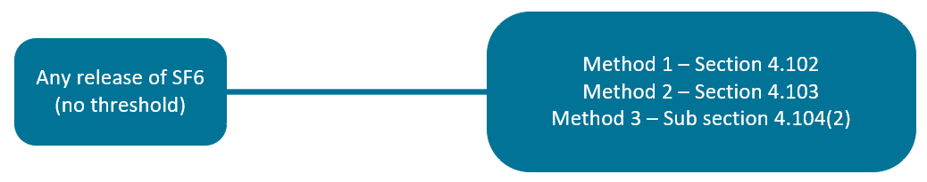

See the [Reporting Hydrofluorocarbons and Sulphur Hexafluoride gasesguideline](https://cer.gov.au/document_page/reporting-hydrofluorocarbons-and-sulphur-hexafluoride-gases-guideline)20F[21] for more information.

# Reporting scope 2 emissions from purchased, acquired or lost electricity

[Scope 2 emissions](https://cer.gov.au/schemes/national-greenhouse-and-energy-reporting-scheme/about-emissions-and-energy-data/emissions#types-of-emissions)21F[22] are defined in 2.24 of the NGER Regulations as greenhouse gases released into the atmosphere as a direct result of one or more activities that generate electricity, heating, cooling, or steam that is consumed by the facility but not created at the facility.

Scope 2 emissions are reported for:

* purchased or acquired electricity consumed during the operation of your facility
* the loss of electricity from an electricity transmission or distribution network, usually due to line losses
* electricity consumed by utility scale batteries and battery electric vehicles (BEVs).

Read section 7.6 of this guideline for principles about reporting emissions from the operation of a battery at a facility under the NGER Scheme.

## When to report scope 2 emissions

You must report scope 2 emissions using a location-based approach if your facility consumes more than 20,000 kWh of purchased, acquired or lost electricity in the reporting year and the electricity:

* is used for the operation of a facility
* is purchased or acquired from the main electricity grid in your state or territory (most common example) or from a network other than the main electricity grid in a State or Territory (for example, a microgrid or other ‘behind the meter’ configurations).

Additionally, you may choose to also report scope 2 emissions using a market-based approach. The methods required for these approaches will be described in chapter 6.2 of this guideline.

### Meaning of ‘purchased’ or ‘acquired’ electricity

‘Purchased’ electricity includes obtaining electricity:

* through a commercial transaction
* through a contractual arrangement or
* by providing financial, service, product, or other consideration to the electricity provider.

If you decide that your electricity is ‘acquired’ rather than ‘purchased,’ we expect you to keep records of the basis for this decision. These records should include details of how the electricity was acquired.

|  |
| --- |
| 4B**Example – Purchased electricity** Case example 1 in Appendix A illustrates how electricity produced at one facility leads to scope 2 emissions at another facility.   * Electricity produced at the gas-fired power plant (see number 4 in Figure 7) is delivered to a separate facility without passing through a main electricity grid (see number 6 in Figure 7). * For the electricity used at the separate facility, scope 2 emissions must be reported by that facility. The emission factor applicable for the electricity produced from the gas-fired power plant can be obtained from the supplier to estimate accurate scope 2 emissions. If that emission factor is unavailable, the emission factor for the Northern Territory must be used.   In addition, the gas-fired power station uses some of its own produced electricity (see number 5 in Figure 7). This is not ‘purchased or acquired electricity’ leading to scope 2 emissions. It is instead consumption of own produced electricity – see Chapter 7.3 of this guideline for more information. Scope 1 emissions are estimated from fuel combustion. |

### Loss of electricity from an electricity transmission or distribution network

A facility that operates a transmission or distribution network must report scope 2 emissions covering the amount of electricity lost from transmission or distribution of the electricity through the network.

As electricity flows through transmission and distribution networks, energy is lost due to electrical resistance and the heating of conductors. This lost energy in NGER is referred as “the loss of electricity from an electricity transmission or distribution network in the main electricity grid or in a network other than the main electricity grid in the state or territory”.

We have adopted the definition of a network from the [National Electricity Rules](https://energy-rules.aemc.gov.au/ner/594)22F[23] made by the Australian Energy Market Commission (AEMC). A network is defined as “the apparatus, equipment, plant and buildings used to convey, and control the conveyance of, electricity to customers (whether wholesale or retail) excluding any connection assets. In relation to a Network Service Provider, a network owned, operated or controlled by that Network Service Provider”. A single connection between two facilities would be included in this definition.

Generally, calculations of transmission or distribution losses from a facility are based on the amount of electricity entering the network and the amount of electricity leaving the network measured at the connection points.

### Unaccounted for energy

In May 2022, the Australian Energy Market Operator (AEMO) introduced a [Global Settlement Framework](https://aemo.com.au/-/media/files/electricity/nem/5ms/program-information/2020/global-settlement-fact-sheet-updated-july2020.pdf)23F[24] to invoice all retailers for unaccounted for energy (UFE) within a distribution area.

UFE is the discrepancy between the amount of electricity **supplied** into a distribution area and the amount of electricity **consumed** in that distribution area based on electricity end-user metering.

Electricity retailers may adjust customer invoices for UFE. As a result, some electricity users may notice UFE on their invoices. The quantity of UFE may be positive or negative.

If a retailer includes an item in your invoice for UFE, you should not include it in your electricity consumption for reporting scope 2 emissions under NGER. That is, you should only report the total of the other electricity quantities in your customer invoice, without adjustment for UFE.

If you are aware that your electricity invoice includes UFE, but it’s not explicitly quantified, you should:

* consult your electricity retailer to obtain more information
* document the method you used for estimating UFE in your BoP.

|  |  |  |  |  |  |  |  |  |  |  |  |  |  |  |  |  |  |  |  |  |  |  |  |  |
| --- | --- | --- | --- | --- | --- | --- | --- | --- | --- | --- | --- | --- | --- | --- | --- | --- | --- | --- | --- | --- | --- | --- | --- | --- |
| Example: Reporting scope 2 emissions based on an electricity bill that includes UFE  This electricity invoice displays the quantities of electricity that add up to your total consumption charges. This includes a quantity of unaccounted for energy which should not be included in your electricity consumption reported under NGER.   |  |  |  |  | | --- | --- | --- | --- | | **Energy charges** | **Contract rate x (DLF x MLF)** | **Metered rate** | **Quantity** | | **Peak energy** | 7.2440 c/kWh x (1.0680 x 0.9747) | 7.5409 c/kWh | 15,591.29 kWh | | **Shoulder energy** | 6.3420 c/kWh x (1.0680 x 0.9744) | 6.5998 c/kWh | 6,075.95 kWh | | **Off peak energy** | 4.8757 c/kWh x (1.0680 x 0.9747) | 5.0755 c/kwh | 82,523.46 kWh | | **Unaccounted for energy** |  |  | -3,214.90 kWh | | **Total consumption charges** |  |  | 100,975.80 kWh |   You should add up the electricity quantities without including the UFE:  15,591.29 kWh (Peak energy)  + 6,075.95 kWh (Shoulder energy)  + 82,523.46 kWh (Off peak energy)   104,190.70 kWh   This is the amount of electricity that you should report as scope 2 emissions from the consumption of electricity purchased from the grid.  The UFE guidance provided above is for facilities that are electricity retail customers.   If your facility has a principal activity of electricity transmission (ANZSIC code 262) or electricity distribution (ANZSIC code 263), you should continue to report line losses according to section 7.2 (1A) of the NGER Determination. |

## Methods for estimating scope 2 emissions

Most methods for estimating emissions under the NGER Scheme are location-based methods. This means that the emissions are tied to a time and physical location. Location-based emissions estimation methods are based on onsite consumption multiplied by industry averages and typically do not reflect a company’s decision to purchase renewable energy or products.

Location-based and market-based accounting methods are distinct and complementary approaches for estimating emissions. For scope 2 emissions, they are different ways of accounting for the indirect emissions from the consumption of electricity. Together, these methods provide a more complete picture of emissions from electricity use.

Chapter 7 of the NGER Measurement Determination specifies the two types of methods for reporting scope 2 emissions:

* Mandatory location-based method for purchased, acquired or lost electricity
* Voluntary market-based method for purchased or acquired electricity

|  |
| --- |
| When determining [your reporting obligations](https://cer.gov.au/schemes/national-greenhouse-and-energy-reporting-scheme/assess-your-obligations)24F[25], you must use a location-based method to estimate scope 2 emissions.  Location-based methods are described in section 7.2 and 7.3 of the NGER Measurement Determination.  You cannot use the voluntary market-based method for scope 2 emissions (Method B) to determine if your controlling corporation’s group meets [an NGER reporting threshold](https://cer.gov.au/schemes/national-greenhouse-and-energy-reporting-scheme/assess-your-obligations#nger-thresholds)25F[26]. |

### Mandatory location-based methods for scope 2 emissions

If your facility consumes more than 20,000 kWh of electricity from outside your facility during the reporting year, you must report scope 2 emissions using at least one of the location-based methods: Method A1 or Method A2.

The location-based formula estimates scope 2 emissions by applying an emission factor to the amount of electricity purchased, acquired or lost from:

* the main electricity grid, as per section 7.2 of the Measurement Determination (Method A1)
* other sources, as per section 7.3 of the Measurement Determination (Method A2).

The “main” electricity grid is defined in subsection 7.2(4) of the NGER Measurement Determination as:

1. for Western Australia – the Southwest Interconnected System
2. for the Northern Territory – the Darwin-Katherine Interconnected System
3. for each other state and territory – the electricity grid listed in Part 6 of Schedule 1 that provides electricity to the largest percentage of the state or territory population

The main electricity grid for the Australian Capital Territory, New South Wales, South Australia, Tasmania, Queensland, and Victoria is the National Electricity Market (NEM). If you acquire electricity through any of these networks, you must use method A1 to report scope 2 emissions

If your purchased, acquired or lost electricity is from a source other than the main electricity grid, you must use method A2 to report scope 2 emissions. This includes networks in the Christmas and Cocos (Keeling) Islands, Norfolk Island, and Northwest Interconnected Systems in Western Australia. It also includes other private networks and direct connections to generators outside of your facility.

For both method A1 and method A2, location-based scope 2 emissions must be estimated using this formula:

P686#yIS1

Where:

**Y** is the scope 2 emissions measured in tonnes carbon dioxide equivalence (t CO2-e).

**Q** is the quantity of electricity purchased, acquired or lost from the operation of the facility measured in kilowatt-hours. If the electricity is measured in gigajoules, convert the quantity to kilowatt hours by dividing the amount in gigajoules by 0.0036.

**EF** is the scope 2 location-based emission factor in kilograms of CO2-e emissions per kilowatt-hours.

##### Emission factors for electricity from the main electricity grid (Method A1)

When you estimate scope 2 emissions from the main grid you must use the state or territory scope 2 emissions factors listed within Part 6 of Schedule 1 of the NGER Measurement Determination. These emissions factors are calculated by the Department of Climate Change, Energy, the Environment and Water (DCCEEW) and are updated each year. Updates to these [emission factors](https://cer.gov.au/schemes/national-greenhouse-and-energy-reporting-scheme/report-emissions-and-energy/amendments-to-national-greenhouse-and-energy-reporting-legislation)26F[27] are also published on our website. Please ensure that you are referring to the correct Compilation of the NGER Measurement Determination.

##### Emission factors for electricity from other sources (Method A2)

The facility can use scope 2 location-based emission factor either:

1. provided by the supplier of the electricity, or
2. if that factor is not available, the emission factor for the Northern Territory as mentioned in Part 6 of Schedule 1.

You must use the emissions factors listed above, irrespective of whether you have purchased GreenPower electricity or purchased electricity through a power purchase agreement.

|  |
| --- |
| **Additional information for electricity purchased, acquired or lost from other sources**  From the 2024–25 reporting year, if a registered corporation has reported scope 1 emissions from the combustion of fuel for the purpose of generating electricity at certain facilities and has also reported scope 2 emissions from the consumption of that electricity by other facilities within their operational control, the corporation must report:   1. The identity of the facility generating the electricity, and 2. The identity of the facility consuming that electricity.   The additional information is to be reported in EERS as matters to be identified (MTBI), as described in Part 7 of Schedule 4 of the NGER Measurement Determination for the facility that consumed the electricity.  The NGER Measurement Determination has included this requirement in relation to reporting scope 2 emissions under methods A1, A2 and B. However, for the 2024–25 reporting year, the CER considers that this requirement applies only to reporting under method A2 (location‑based method—electricity purchased, acquired or lost from other sources).  Method A2 and these MTBIs should be used for any arrangement of electricity connection infrastructure between facilities under the operational control of the same corporation.  For example, consider a situation where facility A is connected to facility B which is in turn connected to facility C, and facility A produces electricity for facilities B and C. In this case, even though only facility B has a direct connection to facility A, facilities B and C should both report scope 2 emissions using method A2. Both facilities should also specify that the electricity was generated in facility A when reporting the MTBIs. |

### Voluntary market-based method for estimating scope 2 emissions

In addition to the location-based method, you may also choose to use the voluntary market-based method regardless of the amount of purchased electricity consumed from the operation of a facility during a year. The [Voluntary market-based scope 2 emissions guideline](https://cer.gov.au/document_page/voluntary-market-based-scope-2-emissions-guideline)27F[28] contains instructions and examples for reporting under voluntary market-based Method B.

## Reporting scope 2 emissions in EERS

Select ‘Scope 2 emissions’ as the source category in EERS and choose the relevant activity from the drop-down menu.

**Method A1 – ‘location-based method - electricity purchased, acquired or lost from the main electricity grid in a State or Territory’**

You must enter the quantity of electricity consumed by your facility in kWh.   
  
When you press ‘calculate’ and ‘save’, EERS will calculate the energy consumption and scope 2 emissions based on the scope 2 emissions factor for the applicable state or territory.

**Method A2 – ‘location-based method - electricity purchased, acquired or lost from other sources’**

You must enter the quantity of electricity consumed by your facility in kWh and the emission factor provided by the electricity supplier. If your supplier cannot provide an emission factor, you must use the emission factor for the Northern Territory from Part 6 of Schedule 1 of the NGER Measurement Determination.

When adding the activity in EERS, tick the box to use the Northern Territory factor as shown in Figure 6.

Figure 6 – Selecting the default emission factor for Method A2 in EERS

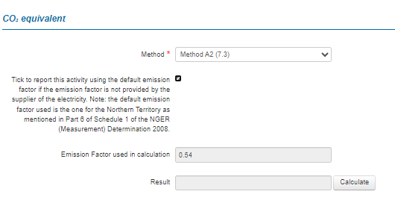

**Method B – ‘market-based method’**

If you choose to additionally report scope 2 emissions using the market-based method there are different requirements for what you must report. For more information on what to report if you use the market-based method, see the [Voluntary market-based scope 2 emissions guideline](https://cer.gov.au/document_page/voluntary-market-based-scope-2-emissions-guideline)28F[29].

## Evidence to keep for scope 2 emissions estimates

In accordance with section 6.5 of the NGER Measurement Determination, the amount of electricity consumed by your facility (Q) must be evidenced by:

* invoices, contractual arrangements or industry metering records
* records of estimates made in line with industry practice or if such evidence is not available.

Additional evidence will be required if you also choose to report using the market-based method. This additional evidence is described further in the Voluntary market-based scope 2 emissions guideline.

# Electricity production and consumption

This chapter provides an overview of how to report activities associated with electricity production and consumption.

## Energy as a fuel or energy commodity

In NGER, the term ‘energy’ is defined within regulation 2.03 of the NGER Regulations. It is used to describe individual fuels and energy commodities as listed in Schedule 1 of the NGER Regulations. These comprise a range of solid, liquid and gaseous fuels, including naturally occurring materials and fuels derived from other sources. Other energy commodities such as electricity, as well as renewable energy commodities such as wind and solar energy used for electricity generation are also covered.

Correct reporting of energy flows under NGER requires 3 totals to be prepared:

* production of energy– defined in 2.25 of the NGER Regulations as:
  + extraction or capture of energy from natural sources for final consumption by or from the operation of the facility, or for use other than in the operation of the facility
  + manufacture of energy by the conversion of energy from one form to another form for final consumption by or from the operation of the facility, or for use other than in the operation of the facility
* consumption of energy– defined in 2.26 of the NGER Regulations as the use or disposal of energy from the operation of the facility, including own-use and losses in extraction, production and transmission
* net energy consumption – as determined in 5.03 of the NGER Regulations. See chapter 7.7 of this guideline for further information.

The 3 totals described above are prepared by aggregating estimates of the calorific values of individual energy flows across a facility over the reporting year (measured in gigajoules (GJ)). When reporting energy production and consumption, only those fuels and energy commodities that are listed in Schedule 1 of the NGER Regulations and for which there are applicable methods in the NGER Measurement Determination should be reported.

For generation facilities, the majority of energy produced is electricity for supply onto a network outside of the facility. For non-renewable or non-biogas generation facilities, the majority of energy consumed is from fuels combusted for electricity generation and any electricity used or lost on site. For transmission and distribution facilities, electricity line losses usually constitute the majority of energy consumed with minimal or no energy production.

|  |
| --- |
| 5B**Example – Energy production and consumption from a gas-fired power station** Case example 1 in Appendix A in respect of a gas-fired power station illustrates the concept of energy as a commodity with reference to energy production and energy consumption.  In this case, energy production comprises of:   * electricity produced and consumed at the facility (see numbers 4 and 5 in Figure 7) * electricity produced and delivered directly to the nearby facility (see number 6 in Figure 7) * electricity transferred to an electricity network (see number 7 in Figure 7).   In this case, energy consumption comprises:   * gas combusted for generation purposes (see number 2 in Figure 7) * own produced electricity consumed by facility (see number 5 in Figure 7). |

## Estimating energy production and consumption

Both total energy production and total energy consumption from the operation of a facility during a reporting year are estimated using the following equation:

**Z = Q x EC**

Where:

**Z** is the amount of an individual fuel or energy commodity produced or consumed in GJ.

**Q** is the physical quantity of the fuel or energy commodity produced or consumed during the reporting year.

**EC** is the energy content factor of the fuel or energy commodity.

Individual energy flows on a per-gigajoule basis are aggregated to derive total energy production and energy consumption figures. In the case of electricity production and consumption, Q is measured in kWh, and the energy content factor is 0.0036 GJ/kWh.

## Electricity production and consumption

Electricity production and consumption must be reported if it exceeds the thresholds listed in 4.19, 4.20 and 4.23 of the NGER Regulations, and section 2.68 of the NGER Measurement Determination, summarised in Table 10 and Table 11.

Table 10 – Thresholds for reporting on electricity generated onsite.

| Individual generating unit capacity | Generation by the unit in the reporting period | Electricity production reporting | Electricity consumption from onsite generation | Consumed fuel purpose as per Regulation 4.22 |
| --- | --- | --- | --- | --- |
| < 0.5 MW | Any | Optional | Required (and automatic in EERS) if electricity production is reported, otherwise not to be reported | Electricity generation if production and consumption is reported, otherwise stationary | |
| ≥ 0.5 MW | > 100,000 kWh | Optional | Required (and automatic in EERS) if electricity production is reported, otherwise not to be reported | Electricity generation if production and consumption is reported, otherwise stationary | |
| ≥ 0.5 MW | > 100,000 kWh | Required | Required (and automatic in EERS) | Electricity generation | |

Table 11 – Other electricity reporting thresholds.

| Reporting type | Threshold for the facility | Reporting requirement |
| --- | --- | --- |
| Cogeneration | The cogeneration process has a capacity of ≥ 30 MW and production of > 30 GWh in the reporting period | Must be reported under cogeneration provisions as described in Chapter 7.3.3 of this guideline |
| Location-based scope 2 emissions | ≥ 20,000 kWh purchased or acquired in the reporting period | Must be reported as described in Chapter 6 of this guideline, even if market-based scope 2 emissions are also reported |
| Market-based scope 2 emissions | Any amount of purchased or acquired electricity | Optional to report, in addition to mandatory location-based scope 2 reporting |

Any fuel that is combusted to generate electricity is subject to reporting thresholds detailed in section 2.2 (solid fuels), section 2.18 (gaseous fuels) and section 2.39 (liquid fuels) of the NGER Measurement Determination.

|  |  |  |  |  |  |  |  |  |  |  |  |  |
| --- | --- | --- | --- | --- | --- | --- | --- | --- | --- | --- | --- | --- |
| 6B**Electricity threshold example** A gas power plant has 2 electricity generating units, although only one is predominantly used, with the following electricity produced in the reporting year.  Table 12 – Two electricity generating units, capacity and production in the reporting year.   |  |  |  | | --- | --- | --- | | Unit | Capacity (MW) | Electricity production in the reporting year (kWh) | | 1 | 20 | 10,000,000 | | 2 | 20 | 90,000 | | Total | 40 | 10,090,000 |   The gas power plant does not have to report electricity production for unit 2, since its generation in the reporting year did not meet the 100,000 kWh threshold. If the following reporting year, unit 2 generates greater than 100,000 kWh, its electricity production would have to be reported. |

A reporter may choose to report electricity production where the above thresholds, in accordance with 4.19(2) of the NGER Regulations, have not been met. Where this occurs, the corresponding onsite consumption from electricity produced onsite must also be reported (produced for the purposes of the operation of the facility).

### Quantifying electricity consumption

Electricity consumption must be reported in accordance with 2.26 and 4.4.5 of the NGER Regulations, and Chapter 6 of the NGER Measurement Determination. The following all give rise to electricity consumption:

* Electricity used in the operation of the facility, including the charging of any electric vehicles which belong to the facility
* Electricity lost in battery energy storage systems
* Transmission losses and parasitic loads

Subject to the thresholds described in Table 10 and Table 11, electricity consumption must be reported in the following ways, depending on the origin of the electricity:

* When electricity is drawn from an external source and consumed within the facility (including line losses for electricity transmission and distribution facilities), you must report a scope 2 emissions activity. See chapter 6 of this guideline for information on reporting these activities.
* When electricity is produced within the facility and consumed within the facility, you must report an energy consumption activity.

|  |
| --- |
| There are no associated scope 2 emissions from the consumption of electricity which has been produced within the same facility. |

Consumption of electricity produced onsite at a generation facility is equal to the difference between the quantity of electricity production as measured at the terminals of the generating units, and the quantity of electricity delivered for use outside the facility measured at the connection point. That is, supplied to an electricity transmission or distribution network, or for other use outside the facility.

In accordance with section 6.5 of the NGER Measurement Determination, the amount of electricity consumed (*Q*) must be evidenced by:

* invoices, contractual arrangements or industry metering records
* records of estimates made in line with industry practice if such evidence is not available.

|  |
| --- |
| 7B**Example – Quantifying electricity consumption at a hydro power plant** Case example 2 in Appendix A illustrates how electricity consumption should be quantified.   * Electricity is produced in the turbine and electricity production is measured using metering at the terminals (see number 4 in Figure 8). * Electricity delivered to an electricity transmission network is metered at the network connection point (see number 7 in Figure 8). * Reportable consumption of electricity produced for use in the operation of the facility (‘for use onsite’) is the difference between the two above amounts.   The consumption of electricity produced for use onsite comprises both electricity for use onsite (see number 5 in Figure 8) and losses of electricity in line between terminal and the network connection point (see number 6 in Figure 8). |

### Quantifying electricity production

4.20(2) of the NGER Regulations describes the 3 reportable ‘purposes’ for producing electricity:

1. for use in the operation of the facility (that is, ‘for use onsite’)
2. for use outside the operation of the facility other than for supply to an electricity transmission or distribution network, that is, ‘for use offsite, not supplied to network’
3. for use outside the operation of the facility for supply to an electricity transmission or distribution network, that is, ‘for use offsite, supplied to network’.

Electricity production should be reported against these 3 purposes (where applicable) using the formula described in chapter 7.2 of this guideline.

Subsection 6.2(1)(c) to (e) of the NGER Measurement Determination set out the requirements for quantifying the electricity for the 3 purposes, as outlined below.

Table 13 – Measuring electricity production.

| Purpose of produced electricity | Measuring the quantity of electricity produced (Q) |
| --- | --- |
| For use onsite | Electricity production (Q) is equal to:  The electricity produced by the electricity generating unit(s) as measured at the terminals  minus  Electricity supplied for use outside the operation of the facility that is not supplied to the network  minus  Electricity supplied to a transmission or distribution network measured at the network connection point. |
| For use offsite, not supplied to network | Electricity production (Q) is equal to:  Electricity supplied for use outside the facility that is not supplied to the network measured at the agreed connection point and evidenced by invoices, contractual arrangements or industry metering records. |
| For use offsite, supplied to network | Electricity production (Q) is equal to:  Electricity supplied to a transmission or distribution network measured at the network connection point. |

#### Reporting consumption and production of electricity for use onsite in EERS

EERS was updated for the 2019–20 reporting year (and onwards) so that it automatically reports an amount of consumption of electricity produced ‘for use for the purposes of the facility (for use onsite)’, which is equal to the reported amount of electricity produced ‘for use for the purposes of the facility’. Where electricity produced ‘for use for the purposes of the facility (for use onsite)’ is inputted into EERS, consumption of that electricity must not be inputted separately. This is described in the example below.

|  |
| --- |
| 2B**Example – Reporting consumption and production of electricity for use onsite in EERS** The electricity produced by a facility includes 100,000 kWh of electricity produced ‘for use for the purposes of the facility’. The reporter inputs 100,000 kWh into EERS as electricity produced ‘for use for the purposes of the facility’.  EERS then records:   * 100,000 kWh (360 GJ) of electricity produced ‘for use for the purposes of the facility’ * 100,000 kWh (360 GJ) of consumption of electricity produced ‘for use for the purposes of the facility’.   These values will be included in the NGER report generated by EERS and should not be deleted.  The reporter is not required to manually input consumption of electricity produced ‘for use for the purposes of the facility (for use onsite)’ because it is automatically recorded by EERS. |

See ‘reporting consumption of electricity that was produced for use during the operation of the facility’ in the [NGER quick help topics](https://cer.gov.au/document_page/nger-quick-help-topics)29F[30] for more information and guidance for reporting in EERS.

#### Measuring electricity production

Produced electricity delivered to an electricity transmission or distribution network must be measured according to either Chapter 7 of the [National Electricity Rules](https://www.aemc.gov.au/regulation/energy-rules/national-electricity-rules/current)30F[31] per the *National Electricity (South Australia) Act 1996* (SA) or the metering requirements applicable to the region in which the facility is located (section 6.2 of the NGER Measurement Determination).

For other electricity production, subsection 6.3(2) of the NGER Measurement Determination clarifies that the amount of electricity produced from the operation of the facility during the reporting year must be evidenced by invoices, contractual arrangements or industry metering records**.**

In practice:

* the electricity produced at the terminals of the generating unit should be measured and evidenced using metering per industry standard
* for electricity delivered for use at another facility, the delivered electricity must be evidenced using invoices, contractual arrangements or industry metering records.

|  |
| --- |
| 8B**Example – Quantifying electricity production at a gas-fired power plant** Case example 1 in Appendix A illustrates how electricity production should be quantified.   * Electricity is produced in the turbine and electricity production is measured using metering at the terminal (see number 4 in Figure 7). * Electricity delivered to an electricity transmission network is metered at the network connection point (see number 7 in Figure 7). This meter determines the amount of reportable electricity produced for the purpose of delivering to the network. * Electricity delivered directly to a neighbouring facility is metered at an agreed connection point (see number 6 in the diagram), per commercial transaction. This meter determines the amount of reportable electricity produced for the purpose of being used at another facility (and not delivered to the network). * The electricity produced for use onsite (see number 5 in Figure 7) is determined as electricity at number 4 minus (electricity at number 6 + electricity at number 7). |

### Cogeneration

Cogeneration is defined in 1.03 of the NGER Regulations as a process that combines the generation of heat and power to produce electricity and another product within one integrated production process.

In practice, cogeneration occurs when energy (other than electricity) is consumed and results in the production of electricity and another product, for example, heat or steam. When this occurs, assuming that the appropriate thresholds (see Table 10 and Table 11) have been met, the report for the facility must identify the amount and energy content of the energy type consumed to produce the electricity and the other product during the reporting year.

The amount of electricity produced as a result of the cogeneration process is also required to be reported. However, it is not necessary to report the production of the other product if that product is heat.

The methods available for determining the amount and energy content of the energy type consumed to produce the electricity and the other product are specified in section 2.70 of the NGER Measurement Determination as:

* the ‘efficiency method’, which is stipulated for cogeneration processes
* the ‘work potential method’, which may be used where heat is to be used mainly for producing mechanical work. These methods are described in the [Allocation of GHG Emissions from a Combined Heat and Power (CHP) Plant](https://www.ghgprotocol.org/sites/default/files/ghgp/CHP_guidance_v1.0.pdf)31F[32] guide, issued by the World Resource Institute and World Business Council for Sustainable Development. See GHG Protocol’s [calculation tools](https://ghgprotocol.org/calculation-tools-and-guidance)32F[33] for more information on these methods, including a calculator that can be used when applying the efficiency method.

## Renewable energy commodity production and consumption

Four renewable energy commodities are listed in Schedule 1 of the NGER Regulations for electricity generation: solar, wind, water, and geothermal. Production of these energy commodities is not required to be reported.

Consumption of these energy commodities is only required to be reported where they are used to generate reportable electricity production, that is, in a generating unit exceeding the reporting threshold (see Table 10).

A 100% conversion efficiency is assumed between the renewable energy commodity consumed and the electricity produced - they are of equal magnitude. For example, if a wind farm generates 1,000,000 GJ of electricity it is assumed to have consumed 1,000,000 GJ of the renewable energy commodity ‘wind energy for electricity generation’.

Reporting of electricity production and consumption from renewable sources follows the electricity reporting thresholds set out in chapter 7.3 of this guideline.

Note: Reporting electricity production even when below the threshold is allowed, as per 4.19(2) of the NGER Regulations – see chapter 7.3 of this guideline for more information. Where a renewable generator chooses to do this, the corresponding consumption of renewable energy commodity must also be reported.

|  |
| --- |
| 0B**Example – Consumption of a renewable energy commodity** Case example 2 in Appendix A, water energy is consumed for electricity production (see number 3 in Figure 8).  In this case, the quantity of water energy consumed is equal to the amount of electricity produced as measured in the terminals of the generating unit and converted to GJ.  The storing of water at elevation behind a dam (see number 1 in Figure 8) contains the potential energy to generate electricity. The ‘production’ of this potential energy is not reportable under NGER. |

Note: EERS was updated for the 2019–20 reporting year (and onwards) to automatically report consumption of the relevant energy commodity, which is equal to the reported amount of electricity production from solar, wind, water, or geothermal energy. Where electricity production from solar, wind, water or geothermal energy is inputted into EERS, the consumption of solar, wind, water or geothermal energy must not be inputted separately. This is described in the example below.

|  |
| --- |
| 1B**Example – Reporting production of electricity from a renewable energy commodity** A wind farm generates 1,000,000 kWh of electricity. The reporter inputs 1,000,000 kWh into EERS as electricity produced using wind generation:  EERS then records:   * 1,000,000 kWh (3600 GJ) of electricity produced using wind generation * 3,600 GJ of consumption of the primary energy commodity ‘wind energy for electricity generation’.   These values will be automatically included in the NGER report generated by EERS and should not be deleted.  The reporter is not required to manually report consumption of ‘wind energy for electricity generation’, because it is automatically recorded by EERS when the value of electricity production is reported. |

See 'Report consumption of renewable energy commodities for electricity generation' in the [NGER quick help topics](https://cer.gov.au/document_page/nger-quick-help-topics)33F[34] for more information on reporting solar, wind, water and geothermal energy commodities in EERS.

### Reporting of NGER data alongside RET data

Under the Renewable Energy Target (RET), liable entities are classified as an individual or company who is the first person to acquire electricity on a network that has an installed capacity of 100 MW or more. Liable entities are required to lodge an energy acquisition statement each year, which includes reporting the amount of liable electricity acquired.

CER expects that where electricity acquired from a network is reported under both the NGER and RET schemes, RET liable entities and corresponding NGER facilities have consistent reporting.

## Energy consumption from fuel use

Consumption of fuels must be reported if the quantity exceeds the thresholds listed below. Fuel use in electricity generation would typically be the largest source, but minor instances of fuel use should also be considered.

Table 14 – Thresholds for energy reporting from fuel use.

| Energy type | Consumption by combustion  (apply to each instance of the combustion source) |
| --- | --- |
| Solid fuel | 1 t |
| Liquid fuel | 1 kL or 5 kL for petroleum-based oils (other than petroleum-based oils used as fuels) and petroleum-based greases |
| Gaseous fuel | 1,000 m3 |

Measurement of fuel quantities is covered in detail in Chapter 8 of this guideline. ‘Instance of a source’ is defined in section 3.3 of this guideline.

Energy content factors can either be selected from default values listed in Schedule 1 of the NGER Measurement Determination or derived from sampling and analysis of a fuel. A summary of the location of the specified sampling and analysis requirements within the NGER Measurement Determination is described in Table 15 below. Energy consumption from the combustion of fuel is calculated automatically when emissions from the fuel combustion are entered in EERS.

Table 15 – Energy content factors by fuel type as prescribed in the NGER Measurement Determination.

| Fuel category | Predetermined value | Estimation technique |
| --- | --- | --- |
| Solid fuels | Refer to Part 1 of Schedule 1 | Refer to standards indicated in Schedule 2 (or equivalent standards) |
| Gaseous fuels (in GJ per m3) | Refer to Part 2 of Schedule 1 | Refer to the requirements of Subdivision 2.3.3.2, also described in chapter 4.4.1 of this guideline |
| Liquid fuels | Refer to Part 3 of Schedule 1 | Refer to Subdivision 2.4.3.2, also described in chapter 4.5.1 of this guideline |

### Blended fuels and other fuel mixes

Energy production and consumption must be reported using fuel types listed within Schedule 1 of the NGER Regulations. Many of the fuels listed in Schedule 1 of the NGER Regulations are defined within 1.03 of the NGER Regulations and section 1.8 of the NGER Measurement Determination. Common usage and dictionary definition should be used when not otherwise defined within the NGER legislation.

The requirements for reporting blended fuels and fuels mixes will depend on the fuels in the blend or mix, the product created by the blending or mixing, and the end use of the blended fuel or fuel mix.

See the [Reporting blended fuels, other fuel mixes, bitumen and explosives guideline34F[35]](https://cer.gov.au/document_page/reporting-blended-fuels-other-fuel-mixes-bitumen-and-explosives-guideline) for more information on reporting requirements and calculation methodologies.

## Reporting of battery energy storage system (BESS) activities

A battery energy storage system (BESS) converts electrical energy to chemical potential energy for storage in batteries and converts that stored energy back to electricity for use on demand.

### Principles of BESS reporting

A key principle of NGER reporting for the operation of a BESS at an NGER facility is that they are not considered to generate or produce electricity. Instead, they are considered to only consume electricity due to electricity conversion and storage losses, and auxiliary system power consumption. It is not necessary to consider the quantity of energy stored in the BESS at any time.

A BESS may be set up to be charged from a single source of electricity: that is, from the main grid, from onsite generation, or from another source outside the facility. For single-source charging, electricity consumption from the BESS should be reported as associated with *that* source of electricity. If the electricity comes from the main grid or another offsite source, it should be reported as a scope 2 emissions activity with the appropriate emission factor. If the electricity came from onsite generation, the conversion and storage losses should be included in the energy consumption activity and incorporated into the quantity of electricity produced onsite for use onsite.

If your BESS charges from more than one source (such as charging from the grid as well as onsite generation or another offsite source), you will need to allocate the BESS’s electricity consumption to each of the applicable sources. You may estimate the BESS’s electricity consumption for each source by apportioning the BESS’s energy consumption according to the amount of electricity entering the facility from each source.

Please contact us at [cer-nger-reporting@cer.gov.au](mailto:cer-nger-reporting@cer.gov.au) for further guidance. Please include information about your facility-specific system configuration and metered data when you contact us.

### Reporting VPP activities (a ‘BESS network’)

A Virtual Power Plant (VPP) is a network of distributed solar panel and battery energy storage systems where the BESS may be charged from the co-located solar panels or from the associated grid. A VPP is considered a ‘designated generation facility’ for the purposes of NGER reporting. Electricity losses from a BESS are likely be the main activities reported at a VPP facility. The threshold for reporting consumption of electricity from outside the facility is 20,000 kWh, as described in Table 10 and Table 11.

As a decentralised facility, the facility boundary of a VPP may be defined by contractual or operational factors rather than geographic proximity. The head office, or the location from which the VPP is controlled, is usually an appropriate address for the facility.

## Net Energy Consumption

CER is required to publish information on the net energy consumption of corporations registered under the NGER scheme by 28 February each year. The accuracy of this information is dependent on the quality of information provided in corporate NGER reports.

#### Defining primary and secondary energy commodities

The calculation of net energy consumption is determined in part by the classification of each energy commodity defined in schedule 1 of the NGER Regulations as either primary or secondary energy. These designations are defined as follows in 1.03 of the NGER Regulations:

* primary fuel or energy commoditymeans a fuel or energy commodity extracted or captured from natural sources with minimal processing
* secondary fuel or energy commoditymeans a fuel or energy commodity produced by converting energy from one form to another form for consumption.

In the electricity generation sector, primary energy commodities are typically fuels and renewable energy commodities consumed by generating facilities. Electricity is a secondary energy commodity under NGER.

#### Calculating net energy consumption

5.03 of the NGER Regulations defines the calculation for net energy consumption as follows:

* Step 1: For each facility of the corporation’s group, adjust the facility’s energy consumption by deducting the energy content of the secondary fuels and energy commodities produced from the operation of the facility from the total energy consumed by the operation of the facility.
* Step 2: Add together each result in step 1.

This can be represented by the following equation:

$$Net Energy Consumption=\sum{Energy Consumption}- \sum{Secondary Energy Production}$$

Given EERS automates this calculation, the allocation of individual energy commodities as either primary or secondary is critical to ensuring the net energy consumption is appropriately calculated.

# Measurement requirements

To estimate emissions and report energy data accurately and completely, appropriate measurements of activity or source data should be performed. Along with the quantity of electricity produced, measurement of the quantity of fuel combusted for generation comprises the key activity data to measure for NGER purposes.

This chapter provides a summary of the measurement requirements.

## Measurement Criteria

The measurement requirements for measuring quantities of solid, gaseous, and liquid fuels are set out in Divisions 2.2.5, 2.3.6 and 2.4.6 respectively of the NGER Measurement Determination.

Table 16 provides the general measurement requirements available in NGER for measurement of fuel quantities.

Table 16 – Measurement requirements generally available in NGER.

| Criterion | Criterion AAA | Criterion AA | Criterion A | Criterion BBB |
| --- | --- | --- | --- | --- |
| Description | Quantity measured at point of sale or consumption | Quantity verified by stockpile change estimation and invoices | Quantity verified by invoices | Quantity measured or estimated in line with industry practice |
| Example | Mass measurement of solid fuel quantities at point of combustion using equipment calibrated to the measurement requirement | Estimating the change in the quantity of the stockpile of gaseous fuel as evidenced by invoices from a fuel vendor | Using vendor invoices as evidence of quantity of gaseous fuel purchased | Calculation based on metering which does not meet AAA requirements |
| Restrictions | Available whether or not acquisition of fuel involves a commercial transaction | Only available where acquisition of fuel involves a commercial transaction | Only available where acquisition of fuel involves a commercial transaction | Not available where acquisition of fuel involves a commercial transaction |

The availability of individual measurement criteria for a given source is dependent on:

* whether or not a commercial transaction took place for the fuel
* the measurement criterion selected for that source in preceding reporting years.

In general, when the fuel is acquired via a commercial transaction, measurement criteria A, AA and AAA are permitted. This represents most situations in the electricity industry for fuels combusted for generation purposes.

Note: Once criteria AA or AAA (measured at point of consumption) have been used for a fuel acquired by commercial transaction for a given reporting year, the same criteria must be used in subsequent years.

Industry practice required for BBB is not defined in the NGER legislation. Industry practice is taken to mean that which would reasonably be expected to occur at a competent, similar facility type of a similar size and age. The following may be used as a guide when establishing the standards to be used for making estimations using industry practice:

* equipment used is maintained in good working order
* equipment used is calibrated in accordance with and at the frequency stipulated by the manufacturer
* faulty equipment is replaced
* appropriate corrections for temperature and pressure are made where required, and assumptions, inherent or applied to the measurement equipment are clarified. For example, set densities or gas composition are updated at a frequency that ensures that these assumptions are representative of the commodity being measured during the reporting period
* reporters should document their assessment of how their application of criterion BBB meets industry practice in the BoP. When applying criterion BBB, reporters are required to consider the principles in section 1.13 of the NGER Measurement Determination

See the [Measurement Criteria Guideline](https://cer.gov.au/document_page/methods-and-measurement-criteria-guideline)35F[36] for more information.

#### Specific notes regarding measurement criteria per fuel states

The NGER Measurement Determination also contains requirements of individual measurement criteria specific to the physical phase of the fuel in question.

* AA for solid fuels – where measurement criterion AA is used in a given reporting year, the specific approach to estimating the change in stockpile quantity should remain consistent throughout the entire reporting period unless there is a significant change which would result in the approach becoming less accurate.
* AAA for gaseous fuels – sections 2.31–2.37 of the NGER Measurement Determination prescribe detailed requirements for the application of criterion AAA. This includes measuring gas on a dry basis, corrected to the standard conditions defined in subsection 2.32(7) of the NGER Measurement Determination.

Measurement equipment must meet specific operational requirements depending on equipment type, the amount of gas combusted per day, and whether the gas is super-compressed.

Reporters should satisfy themselves that the measurement equipment used in preparation of NGER reports has been operated and maintained in accordance with the requirements stipulated. In cases where reporters rely on measurements provided by vendors or by third parties, reporters should make sufficient enquiries of the providers of these measurements to enable them to have confidence that the requirements of the NGER Measurement Determination are being complied with.

* AAA for liquid fuels – should criterion AAA be selected, fuel volumes must be corrected to standard temperature of 15°C.

## Metering considerations

Table 17 shows summary metering and calibration requirements from the NGER Measurement Determination. The most accurate meters available (such as regulated meters at the network connection points) should be used preferentially for NGER measurements and as a basis for any mass or energy balance calculations, in accordance with the general principles listed in section 1.13 of the NGER Measurement Determination.

Table 17 – Metering and calibration requirements.

| Metering Purpose | Application | Requirements (references are to the NGER Measurement Determination where not stated) |
| --- | --- | --- |
| Fuel Quantity | Solid fuels (in tonnes) | Criterion AAA: metering equipment must follow the requirements set out in section 2.16. Equipment must be calibrated to a ‘measurement requirement’, which in this case means the standards required for measurement to support all commercial transactions covered by the *National Measurement Act 1960* and associated instruments.  These requirements are summarised in section 2.16 of the NGER Technical Guidelines. |
| Criterion BBB: metering equipment must follow the requirements set out in section 2.17 of the NGER Measurement Determination, which refer to industry practice. |
| Gaseous fuels (in cubic metres) | Criterion AAA: measurement equipment must be calibrated to requirements set out in sections 2.31–2.37 of the NGER Measurement Determination. Specific requirements depend on equipment type, the amount of gas consumed per day, and whether the gas is super-compressed. |
| Criterion BBB: metering equipment must follow the requirements set out in section 2.38 of the NGER Measurement Determination, which refer to industry practice. |
| Liquid fuels (in kilolitres) | Criterion AAA: metering equipment must follow the requirements set out in section 2.52 of the NGER Measurement Determination. Equipment must be calibrated to a ‘measurement requirement’. This refers to the standards required for measurement to support excise taxation arrangements. |
| Criterion BBB:metering equipment must follow the requirements set out in section 2.53 of the NGER Measurement Determination, which refer to industry practice. |
| Sampling and analysis (for example, where Method 2 or 3 is applied to estimate emissions) | Solid fuels  Gaseous fuels  Liquid fuels | Sampling and analysis must be undertaken using metering and calibration procedure specified in a relevant standard (refer sections 4.3.1, 4.4.1, and 4.5.1 of this guideline).  This is typically the responsibility of the party completing the sampling and analysis, either the reporting company or a contractor. However, NGER reporters remain accountable for ensuring that sampling and analysis is performed and documented according to the requirements – this responsibility cannot be delegated to a contractor, with the NGER reporter expected to have ready access to the documentation for compliant sampling and analysis. |
| Direct measurement of emissions (for example, where Method 4 is applied to estimate emissions) | CEM | Measurement of flow rates: an appropriate standard should be chosen and followed as set out in section 1.24 of the NGER Measurement Determination.  Measurement of gas concentrations: an appropriate standard should be chosen and followed as set out in section 1.25 of the NGER Measurement Determination.  Performance characteristics:the performance characteristics of CEM equipment should be measured in accordance with section 1.34 of the NGER Measurement Determination. |
| PEM | Measurement of flow rates: an appropriate standard should be chosen and followed as set out in section 1.31 of the NGER Measurement Determination.  Measurement of gas concentrations: an appropriate standard should be chosen and followed as set out in section 1.32 of the NGER Measurement Determination.  Performance characteristics:the performance characteristics of PEM equipment should be measured in accordance with section 1.34 of the NGER Measurement Determination. |

## Industry practice (measurement criterion BBB)

Measurement criterion BBB in the NGER Measurement Determination provides for use of industry practice for measurement of quantities of fuels when measurement equipment does not meet the requirements of criterion AAA. The use of industry practice is also permitted for the estimation of the amount of fuel consumed from the operation of a facility in certain circumstances.

Industry practice is not defined in the NGER legislation. The CER requires that use of industry practice and measurement criterion BBB includes application of the general principles in section 1.13 of the NGER Measurement Determination - that is, transparency, comparability, accuracy and completeness when making estimates of quantities of fuel. For example, this may include:

* where meters are used and:
  + manufacturer’s standards are available, meters are calibrated at the standard stipulated by the manufacturer
  + manufacturer’s standards are unavailable, a risk assessment must be undertaken and documented to demonstrate that measurement uncertainty has been minimised or would not significantly affect the measured amount
* appropriate corrections for temperature and pressure where required
* assumptions inherent or applied to the measured data are clarified and documented – for example, set densities or gas composition, are updated at a frequency which ensures that these assumptions are representative of the fuel being measured during the reporting period.

CER does not consider industry practice to include:

* estimates of quantities based on unrepresentative historic facility data
* estimates of quantities based on unrepresentative industry data.

#### Measuring fuel consumption based on electricity production

If fuel combusted to produce electricity is acquired without a commercial transaction, and no reliable metering of the fuel combusted exists, a back-calculation methodology based on measured electricity production is acceptable.

For example, if natural gas is combusted to generate electricity, the amount of gas combusted may be back-calculated using the amount of electricity produced, an engine electricity efficiency (for example, manufacturer’s specification) and the energy content of the natural gas.

## Temporarily unavailability of a method of estimating emissions

Reporters must observe the requirements in section 1.19 of the NGER Measurement Determination with respect to down time of equipment to monitor fuels and emissions:

* if the down time in a reporting year is 6 weeks (42 days) or less, each day of the down time can be estimated consistent with the principles of section 1.13 of the NGER Measurement Determination
* if the down time exceeds 6 weeks in a reporting year, and within 6 weeks after the day when down time exceeds 6 weeks, the registered controlling corporation or responsible emitter must inform the CER in writing of the following:
  + the reason why down time is more than 6 weeks
  + how the corporation or entity plans to minimise down time
  + how emissions have been estimated during the down time.

This ‘down time’ requirement is applicable to all emissions sources. It is of relevance to thermal power stations conducting continuous monitoring of fuel quantities (for example, flow meters or weightometers under Methods 1, 2 and 3) and composition under Method 2 or 3.

This is also relevant to the use of CEM and PEM under NGER Method 4. Note that for this to be applicable to CEM, the down time cannot exceed 10% of the reporting year (36.5 or 36.6 days) – for example, maximum 5 weeks and one day (excluding down time for calibration), per subsection 1.26(4). For PEM, if monthly emissions monitoring is applied, only one measurement period can be missed.

# More information and references

CER has developed this guideline for use by the electricity sector to assist in the consistent accounting and reporting of greenhouse gas emissions, energy consumption and energy production in accordance with the NGER legislation.

## More information

For more information, please contact CER:

Email: [cer-nger-reporting@cer.gov.au](mailto:cer-nger-reporting@cer.gov.au)

Phone: 1300 553 542within Australia

Website: [www.cer.gov.au](http://www.cer.gov.au/)

## References

See [NGER reporting guides](https://cer.gov.au/schemes/national-greenhouse-and-energy-reporting-scheme/report-emissions-and-energy/nger-reporting-guides)36F[37] for guidance on:

* defining a facility
* operational control
* measurement criteria
* reporting energy production and consumption
* reporting fuel combustion
* reporting hydrofluorocarbons and sulphur hexafluoride gases
* reporting petroleum-based oils and greases
* reporting blended fuels, other fuel mixes, bitumen and explosives
* reporting uncertainty
* voluntary market-based scope 2 emissions

# Appendices

## Appendix A – Case examples for electricity sector facilities

### Case example 1: Gas-fired power plant

Figure 7 shows an overview of the main types of energy production and consumption processes at a gas-fired power plant. Each circled number on the diagram relates to a main process point. Table 18 shows the emissions, energy consumption, energy production reporting requirements associated with each of these process points.

#### NGER activities and industry sector

The gas-fired power plant has been classified as a single facility for NGER reporting purposes. The correct Australian and New Zealand Standard Industrial Classification (ANZSIC) code is ‘261 Electricity generation’. It includes the following reportable activities.

**Fuel combustion emissions from combustion of gaseous fuel**

* ‘Natural gas transmitted or distributed in a pipeline’37F[38] enters the power plant through a pipeline which is outside the facility boundary (number 1).
* The gas is combusted (number 2) to generate electricity.
* This results in emissions through the chimney of by-product gases (number 3), including greenhouse gases carbon dioxide (CO2), methane (CH4) and nitrous oxide (N2O).

See Chapter 4 of this guideline for estimating scope 1 emissions from fuel combustion (assuming more than 1,000 cubic metres of gas is combusted).

See Chapter 7 of this guideline for reporting fuel consumption.

**Energy reporting for electricity produced**

* Electricity is produced in a turbine (number 4).
* A portion of the electricity generated is fed back into the facility for plant operations (number 5).
* Another portion is delivered directly to a nearby manufacturing facility (number 6), which is a separate facility to the gas-fired power station.
* The remaining electricity generated is transferred to an electricity network (number 7).

See Chapter 7 of this guideline for reporting of electricity production and for electricity produced for use onsite.

Other reportable NGER activities not included in the example are likely to occur, including:

* scope 1 fuel combustion emissions from transport, stationary energy purposes (other than electricity generation) – for example, liquid fuel combustion in light vehicles
* the consumption of PBOGs. Read the [Petroleum-based oils and greases guideline](https://cer.gov.au/document_page/petroleum-based-oils-and-greases-guideline) 38F[39].
* contractor energy and emissions data if part of the facility’s production process (likely to include fuel combustion emissions and consumption, if occurring). Read [Defining a facility for National Greenhouse and Energy Reporting](https://cer.gov.au/document_page/defining-facility-national-greenhouse-and-energy-reporting)39F[40] and the [Contracts and leasing guideline](https://cer.gov.au/document_page/contracts-and-leasing-guideline)40F[41] for more information.
* uncertainty assessment for occurrences of scope 1 emissions exceeding 25,000 kt CO2-e.

Figure 7 – Gas-fired power plant diagram.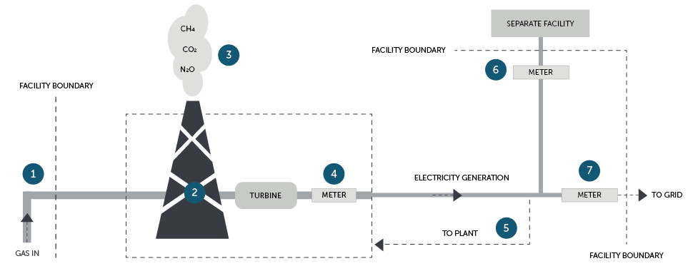

Table 18 – Summary of emissions and energy from the gas power plant.

| Process Point | | Reportable emissions | Reportable energy production | Reportable energy consumption | Notes |
| --- | --- | --- | --- | --- | --- |
| 1 | ‘Natural gas transmitted or distributed in a pipeline’ enters plant | None | None | None | Gas supply pipeline is outside of the facility boundary and hence leaks from the pipeline do not need to be reported. |
| 2 | Gas combustion | If generation unit < 30 MW or production < 50,000 MWh in the reporting year, emissions estimation can be made using default emission factors under Method 1.  Otherwise, minimum Method 2, and Method 3 also available.  Fuel combustion emissions | None  Electricity is not produced at this process point – these are produced at number 4. | ‘Natural gas transmitted or distributed in a pipeline’ is consumed through combustion for the purpose of producing electricity. | See chapter 4 of this guideline for estimating emissions from fuel combustion.  Only one method for estimating emissions should be used for the single occurrence of the source in the case example.  In selecting an appropriate method, reporters must observe the restrictions for using a lower method from previous year in section 1.18 of the NGER Measurement Determination. |
| 3 | Direct measurement of carbon dioxide emissions (if using Method 4) | If direct measurement of emissions using Method 4:  Fuel combustion emissions. | None.  Energy consumption is reported at number 2. |
| 4 | Electricity generation at turbine | None | None  ‘Electricity’ is produced from the turbine and generator but is reported at numbers 5 to 7. | None | Electricity produced must be metered at the terminal directly after the turbine - see chapter 7.3.1 of this guideline. |
| 5 | Own produced electricity consumed by facility | None  This is not a scope 2 emission, because direct emissions caused by facility discharged at (number 3). | Electricity produced ‘for use for the purpose of the operation of the facility’ - that is, for ‘for use onsite’.  Calculated as residual amount of number 4 not delivered at number 6 or 7. | ‘Own produced electricity’ is consumed for use in own facility. | Electricity consumed by the plant must be calculated as per chapter 7.3.1 of this guideline. |
| 6 | Produced electricity delivered directly to nearby facility | None | Electricity produced ‘for use outside the operation of the facility other than for the supply to an electricity transmission or distribution network’ - that is, for ‘use offsite, not supplied to network’. | None | The amount of electricity should be measured as delivered (as close to boundary as possible).  That other facility should report this electricity use as scope 2 emission (provided it is acquired through a commercial transaction).  The gas-fired power station should preferably provide the other facility with the emissions factor for the produced electricity. |
| 7 | Electricity transferred to an electricity network | None | Electricity produced ‘for use outside the operation of the facility for supply to an electricity transmission or distribution network’ – that is, ‘for use offsite, supplied to network’. | None | Electricity transferred to the electricity network must be metered at the network connection point by the distributor - see chapter 7.3.1 of this guideline. |

### Case example 2: Hydro power plant

Figure 8 shows an overview of the main types of energy production and consumption processes at a hydro power plant. Each circled number on the diagram relates to a main process point.

Table 19 shows the emissions, energy consumption, energy production, and additional reporting requirements associated with each of these process points.

#### NGER activities and industry sector

The hydro power plant has been classified as a single facility for NGER reporting purposes. The correct ANZSIC code is ‘261 Electricity generation’. It includes the following reportable activities.

**Energy reporting for electricity produced**

* Electricity is produced in a turbine (number 3 as metered at number 4).
* A portion of the electricity generated is fed back into the facility for plant operations (number 5), and some is lost in a 50 km transmission line to the delivery point to the electricity network (number 6).
* The remaining electricity generated is transferred to an electricity network (number 7).

See chapter 7 of this guideline for reporting of electricity production and for electricity produced for use onsite.

Other reportable NGER activities not included in the example are likely to occur, including:

* scope 1 fuel combustion emissions from transport, stationary energy purposes (other than electricity generation) – for example, liquid fuel combustion in light vehicles
* the consumption of PBOGs. Read the [Petroleum-based oils and greases guideline](https://cer.gov.au/document_page/petroleum-based-oils-and-greases-guideline) 41F[42].
* contractor energy and emissions data if part of the facility’s production process under the operational control of the facility (likely to include fuel combustion emissions and consumption, if occurring). Read the Guideline NGER defining facilities42F[43] and the [Contracts and leasing guideline](https://cer.gov.au/document_page/contracts-and-leasing-guideline)43F[44].

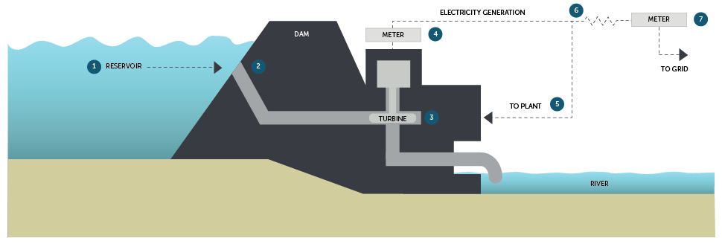.

Figure 8 – Hydro power plant diagram

Table 19 – Energy summary for hydro power plant.

| Process point | | Reportable energy production | Reportable energy consumption | Notes |
| --- | --- | --- | --- | --- |
| 1 | Water retained by dam | None | None | Water storage is not a reportable activity under the NGER Scheme. |
| 2 | Water transferred through dam | None | None | Water transfer is not a reportable activity under the NGER Scheme. |
| 3 | Water turning turbine | None | ‘Water energy for electricity generation’ is consumed through non-combustion when water turns a turbine to create electricity. | The energy consumption activity is automatically generated by EERS when you report the activity for generation of electricity from water (process point 4 below).  See Chapter 7.4 of this guideline for more information. |
| 4 | Electricity generated | None  Electricity is produced from the turbine and generator but is reported in process points 5 to 7. | None | Electricity produced should be metered at the terminal directly after the turbine - see Chapter 7.3.1 of this guideline. |
| 5 | Electricity consumed by plant | Electricity produced ‘for use for the purpose of the operation of the facility’. | Consumption of the electricity produced ‘for use onsite’. | Own produced electricity consumed by own facility should be calculated as per Chapter 7.3.1 of this guideline.  All produced electricity that is consumed or lost between production at the terminals (number 4) and delivered to network (number 7) should be reported as electricity (water generation) ‘for use onsite’.  The associated energy consumption activity is automatically generated by EERS when you report the activity for generation of electricity (water generation) ‘for use onsite’. |
| 6 | Transmission line losses |
| 7 | Electricity transferred to an electricity network | Electricity produced ‘for use outside the operation of the facility for supply to an electricity transmission or distribution network’. | None | Electricity transferred to the electricity network must be metered at the network connection point by the distributor - see Chapter 7.3.1 of this guideline. |

1. https://cer.gov.au/schemes/safeguard-mechanism
2. https://www.legislation.gov.au/Series/C2007A00175
3. https://www.legislation.gov.au/Series/F2008L0223
4. https://www.legislation.gov.au/Series/F2008L02309
5. https://cer.gov.au/schemes/national-greenhouse-and-energy-reporting-scheme
6. https://cer.gov.au/schemes/national-greenhouse-and-energy-reporting-scheme/report-emissions-and-energy/amendments
7. https://www.legislation.gov.au/Series/F2015L01637
8. https://cer.gov.au/document_page/reporting-hydrofluorocarbons-and-sulphur-hexafluoride-gases-guideline
9. https://cer.gov.au/document_page/voluntary-market-based-scope-2-emissions-guideline
10. https://cer.gov.au/schemes/national-greenhouse-and-energy-reporting-scheme/report-emissions-and-energy/nger-reporting-guides
11. https://cer.gov.au/document_page/nger-quick-help-topics
12. https://cer.gov.au/document_page/reporting-hydrofluorocarbons-and-sulphur-hexafluoride-gases-guideline
13. This requirement applies to the combustion of solid and gaseous fuels. See section 2.3(3) and section 2.19(3) of the NGER Measurement Determination relating to the combustion of solid and gaseous fuels.
14. https://cer.gov.au/document_page/guidance-aggregated-facility-reporting-percentage-estimates-and-incidental-emissions-and-energy
15. https://cer.gov.au/document_page/reporting-uncertainty-guideline
16. Schedule 2 of the NGER Regulations provides the meaning of industry sector under the NGER legislation, including an ANZSIC code (261) for ‘Electricity generation’. Subsections 2.3(3)(a) for solid fuels and 2.19(3)(a) for gaseous fuels of the NGER Measurement Determination only apply to the ANZSIC Class code (2611) for ‘Fossil Fuel Electricity Generation’ which is within the ANZSIC Group 261. Facilities classed as 2611 for ‘Fossil Fuel Electricity Generation’ must not use method 1 to estimate emissions from their main fuel combusted to operate the facility.
17. Generator Efficiency Standards program was released in December 2006 by the former Australian Greenhouse Office, Department of Environment and Heritage
18. https://cer.gov.au/about-us/contact-us
19. https://cer.gov.au/document_page/estimating-emissions-and-energy-fuel-combustion-guideline
20. https://cer.gov.au/document_page/petroleum-based-oils-and-greases-guideline
21. https://cer.gov.au/document_page/reporting-hydrofluorocarbons-and-sulphur-hexafluoride-gases-guideline
22. https://cer.gov.au/schemes/national-greenhouse-and-energy-reporting-scheme/about-emissions-and-energy-data/emissions#types-of-emissions
23. https://energy-rules.aemc.gov.au/ner/594
24. https://aemo.com.au/-/media/files/electricity/nem/5ms/program-information/2020/global-settlement-fact-sheet-updated-july2020.pdf
25. https://cer.gov.au/schemes/national-greenhouse-and-energy-reporting-scheme/assess-your-obligations
26. https://cer.gov.au/schemes/national-greenhouse-and-energy-reporting-scheme/assess-your-obligations#nger-thresholds
27. https://cer.gov.au/schemes/national-greenhouse-and-energy-reporting-scheme/report-emissions-and-energy/amendments-to-national-greenhouse-and-energy-reporting-legislation
28. https://cer.gov.au/document_page/voluntary-market-based-scope-2-emissions-guideline
29. https://cer.gov.au/document_page/voluntary-market-based-scope-2-emissions-guideline
30. https://cer.gov.au/document_page/nger-quick-help-topics
31. https://www.aemc.gov.au/regulation/energy-rules/national-electricity-rules/current
32. https://www.ghgprotocol.org/sites/default/files/ghgp/CHP_guidance_v1.0.pdf
33. https://ghgprotocol.org/calculation-tools-and-guidance
34. https://cer.gov.au/document_page/nger-quick-help-topics
35. https://cer.gov.au/document_page/reporting-blended-fuels-other-fuel-mixes-bitumen-and-explosives-guideline
36. https://cer.gov.au/document_page/methods-and-measurement-criteria-guideline
37. https://cer.gov.au/schemes/national-greenhouse-and-energy-reporting-scheme/report-emissions-and-energy/nger-reporting-guides
38. As defined in 1.03 of the NGER Regulations
39. https://cer.gov.au/document_page/petroleum-based-oils-and-greases-guideline
40. https://cer.gov.au/document_page/defining-facility-national-greenhouse-and-energy-reporting
41. https://cer.gov.au/document_page/contracts-and-leasing-guideline
42. https://cer.gov.au/document_page/petroleum-based-oils-and-greases-guideline
43.
44. https://cer.gov.au/document_page/contracts-and-leasing-guideline