Estimating emissions and energy in the electricity generation, transmission, and distribution sectors guideline

July 2022

# Bulldozer outlinePower Plant outlineContents

Contents 1

Definitions and abbreviations 5

Disclaimer 7

2021–22 updates 8

1. Purpose of this guideline 8

1.1. Focus of this guideline 8

2. Good practice NGER reporting in the electricity sector 9

2.1. Applying the principles in the electricity sector 11

2.2. Working with financial and process control data 12

3. General principles on estimating scope 1 emissions 12

3.1. Common emissions sources for the electricity sector 12

Identifying reportable scope 1 emissions sources 13

3.2. – Methods for estimating emissions 14

3.3. Thresholds for estimating and reporting emissions 15

Separate instance of a source 15

Thresholds for estimating incidental emissions 15

3.4. Uncertainty 16

4. Estimating emissions from fuel combustion 16

Example – difference between estimating emissions using emission factors and energy content of fuel combusted, and direct measurement of emissions 17

4.1. Method 1, 2 and 3 – using emission factors and energy content of fuel combusted 17

Quantity of fuel combusted required for methods 1, 2 and 3 17

Method 1 – default emission factors 17

Methods 2 and 3 – fuel sampling and analysis 18

4.2. Method 4 – Direct measurement of emissions 18

4.3. Estimating emissions from combustion of solid fuels 19

4.3.1. Sampling and analysis requirements for Methods 2 and 3 for solid fuels 20

Bias testing 21

4.4. Emissions from combustion of gaseous fuels 22

4.4.1. Sampling and analysis requirements for Methods 2 and 3 for gaseous fuels 22

Bias testing 23

4.5. Emissions from combustion of liquid fuels 24

4.5.1. Sampling and analysis requirements for methods 2 and 3 for liquid fuels 24

Bias testing 25

4.6. Emissions from consumption of PBOGs 25

5. Estimating emissions of sulphur hexafluoride 26

6. Scope 2 emissions from electricity use 26

20,000 kilowatt hours reporting threshold 27

Meaning of ‘purchased electricity’ 27

Example – Purchased electricity 28

6.1. Purchase or loss of electricity from the main electricity grid 28

6.2. Purchase or loss of electricity from other sources 29

6.3. Scope 2 emission factors 29

Main electricity grid 29

7. Energy production and consumption 30

7.1. Energy as a fuel or energy commodity 30

Example – Energy production and consumption from a gas fired power station 31

7.2. Estimating energy production and consumption 31

7.3. Electricity production and consumption 31

Electricity threshold example 32

7.3.1. Quantifying electricity consumption 32

Example – Quantifying electricity consumption at a hydro power plant 33

7.3.2. Quantifying electricity production 33

Reporting consumption and production of electricity for use onsite in EERS 34

Example – Reporting consumption and production of electricity produced ‘for use for the purposes of facility’ 35

Measuring electricity production 35

Example – Quantifying electricity production at a gas fired power plant 36

7.3.3. Cogeneration 36

7.4. Renewable energy commodity production and consumption 37

Example – Consumption of a renewable energy commodity 37

Example – Reporting production of electricity from a renewable energy commodity 38

7.4.1. Reporting of NGER data alongside RET data 38

7.5. Energy consumption from fuel use 38

7.5.1. Blended fuels and other fuel mixes 39

7.6. Reporting of battery activities 40

7.6.1. Recording starting stock of battery at July 1 of the next reporting year 41

7.6.2. Reporting Virtual Power Plant (VPP) activities 41

7.7. Net Energy Consumption 41

Defining primary and secondary energy commodities 42

Calculating net energy consumption 42

8. Measurement requirements 43

8.1. Measurement Criteria 43

Specific notes regarding measurement criteria per fuel states 44

8.2. Metering considerations 44

8.3. Industry practice (measurement criterion BBB) 47

Measuring fuel consumption based on electricity production 47

8.4. Temporarily unavailability of a method of estimating emissions 47

9. More information and references 49

More information 49

References 49

Appendices 50

Appendix A – Case examples for electricity sector facilities 50

Case example 1: Gas-fired power plant 50

NGER activities and industry sector 50

Case example 2: Hydro power plant 55

NGER activities and industry sector 55

Definitions and abbreviations (Table 1)

| Term | Meaning |
| --- | --- |
| ANZSIC | Australian and New Zealand Standard Industrial Classification |
| BoP | Basis of Preparation |
| CEM | Continuous Emissions Monitoring |
| Department | The Australian Government Department of Climate Change, Energy, the Environment and Water |
| EERS | Emissions and Energy Reporting System |
| Emissions Reduction Fund | The Australian Government’s voluntary scheme that provides incentives for a range of organisations and individuals to adopt new practices and technologies to reduce their emissions |
| GJ | Gigajoules |
| GWh | Gigawatt hours |
| ISO | International Organisation for Standardisation |
| kt | Kilotonne |
| kWh | Kilowatt hours |
| NGER | National Greenhouse and Energy Reporting |
| NGER Act | *National Greenhouse and Energy Reporting Act 2007* |
| NGER legislation | The NGER Act, the NGER Regulations and the NGER Measurement Determination |
| NGER Measurement Determination | National Greenhouse and Energy Reporting (Measurement) Determination 2008 |
| NGER Regulations | National Greenhouse and Energy Reporting Regulations 2008 |
| MW | Megawatts |
| MWh | Megawatt hours |
| PBOGs | Petroleum-based oils and greases |
| PEM | Periodic Emissions Monitoring |
| Reporter | An entity required to report emissions and energy production and consumption to the Clean Energy Regulator under section 19, 22G, or 22X of the NGER Act |
| Safeguard mechanism | The Australian Government’s means of ensuring that emissions reductions purchased through the [Emissions Reduction Fund](http://www.cleanenergyregulator.gov.au/ERF/About-the-Emissions-Reduction-Fund) are not offset by significant increases in emissions above business-as-usual levels elsewhere in the economy. This is prescribed by the National Greenhouse and Energy Reporting (Safeguard Mechanism) Rule 2015. |
| t CO2-e | Tonnes of carbon dioxide equivalence |

# Disclaimer

Thisguideline has been developed by the Clean Energy Regulator (the agency) to assist entities to comply with their reporting obligations under the [*National Greenhouse and Energy Reporting Act 2007*](https://www.legislation.gov.au/Series/C2007A00175)[1](NGER Act)and associated legislation.

This guideline only applies to the 2021–22 NGER reporting year and should be read in conjunction with the NGER Act, [National Greenhouse and Energy Regulations 2008](https://www.legislation.gov.au/Series/F2008L02230)[2] (NGER Regulations), and [National Greenhouse and Energy Reporting (Measurement) Determination 2008](https://www.legislation.gov.au/Series/F2008L02309)[3] (NGER Measurement Determination), as in force for this reporting period. These laws and their interpretation are subject to change, which may affect the accuracy of the information contained in the guideline.

The guidance provided in this document is not exhaustive, nor does it consider all circumstances applicable to all entities. This guidance is not intended to comprehensively deal with its subject area, and it is not a substitute for independent legal advice. Although entities are not bound to follow the guidance provided in this document, they must ensure they meet their obligations under the [National Greenhouse and Energy Reporting (NGER) scheme](http://www.cleanenergyregulator.gov.au/NGER/Pages/default.aspx)[4] at all times. The agency encourages all users of this guidance to seek independent legal advice before taking any action or decision based on this guidance.

The agency and the Australian Government will not be liable for any loss or damage from any cause (including negligence) whether arising directly, incidentally, or as consequential loss, out of or in connection with, any use of this guideline or reliance on it, for any purpose.

If an entity chooses to meet their obligations under the NGER scheme in a manner that is inconsistent with the guidance provided in this document, the agency, or an independent auditor, may require the entity to demonstrate that they are compliant with requirements of the NGER Act, NGER Regulations, and/or the NGER Measurement Determination. Entities are responsible for determining their obligations under the law and for applying the law to their individual circumstances.

# 2021–22 updates

* Page 3 – updated disclaimer
* Table 7 - added furnace ash to solid fuel sampling and analysis frequency table
* Page 41 - added section for reporting for Virtual Power Plant (VPP).

# Purpose of this guideline

Electricity generators and electricity transmission or distribution companies have reporting obligations under the National Greenhouse and Energy Reporting (NGER) legislation, comprising the NGER Act, the NGER Regulations, theNGER Measurement Determination and the[National Greenhouse and Energy Reporting (Safeguard Mechanism) Rule 2015](https://www.legislation.gov.au/Series/F2015L01637)[5] (Safeguard Mechanism Rule).

It is important for users of NGER data to have accurate information related to a corporation’s greenhouse gas emissions, energy consumption and energy production. NGER data is used to:

* inform Australian Government policy formulation and the Australian public
* meet Australia’s international reporting obligations
* assist Commonwealth, State and Territory government programs and activities
* ensure that, under the safeguard mechanism, net covered emissions of greenhouse gases from (amongst other sectors) the electricity sector do not exceed the baseline applicable to the sector.

This guideline is intended to promote better reporting by assisting electricity sector entities to:

* estimate and report emissions from key electricity sector emissions, particularly from fuel combustion
* report accurately on energy production and consumption.

It may also be useful for preparers and approvers of NGER reports, and auditors providing assurance over NGER data or reporting prepared in accordance with the NGER legislation.

## Focus of this guideline

The objective of this guideline is to promote consistent reporting across electricity sector companies in Australia. The guideline focuses on the following electricity sector-related activities:

* good practice NGER reporting in the electricity sector — refer section 2
* estimating scope 1 emissions — refer section 3
* estimating emissions from fuel combustion — refer section 4
* estimating emissions of sulphur hexafluoride — refer section 5 and the separate guidance document [Reporting Hydrofluorocarbons and Sulphur Hexafluoride gases guideline](http://www.cleanenergyregulator.gov.au/DocumentAssets/Pages/Reporting-Hydrofluorocarbons-and-Sulphur-Hexafluoride-gases-guideline.aspx)[6]
* scope 2 emissions from electricity use — refer section 6
* reporting energy production and consumption — refer section 7
* measurement requirements — refer section 8.

This document will not cover general NGER reporting requirements such as determining facility and operational control and using the Emissions and Energy Reporting System (EERS). See [forms and resources](http://www.cleanenergyregulator.gov.au/NGER/Forms-and-resources)[7] for more guidance.

# Good practice NGER reporting in the electricity sector

Electricity sector entities registered to report under the NGER scheme must keep records of the activities and facilities across their group to ensure accuracy when reporting in accordance with the NGER Act. Records must be kept for 5 years and enable the agency to ascertain whether the registered corporation or liable entity has complied with the obligations under the NGER Act 2007. This includes keeping records that are easily accessible for inspection and audit.

The record-keeping requirements include preparing and documenting source and activity data capture, as well as recording and processing data using the general estimation principles in section 1.13 of the NGER Measurement Determination (Table 2).

Table 2 – General estimation principles for NGER reporting in the electricity sector

| General estimation principles | Example implication for electricity sector NGER reporting |
| --- | --- |
| Transparency  Emission estimates must be documented and verifiable. | * All key decisions and assumptions made to prepare NGER reporting, including decision on sampling frequency and method selection for each activity should be documented and updated each year. This includes decisions regarding selection of the NGER executive officer, and where relevant the NGER nominated report submitter. * All activity data should be recorded with a clear audit trail. This includes all sampling parameters, data and techniques used to calculate emissions, as well as records for how the sampling performed meets the sampling requirements irrespective of whether the sampling is performed by a third party. * All data processing should be kept for 5 years. This may include identifying how records for all samples are kept easily accessible, for example, if a generation facility changes control. |
| Comparability  Emission estimates using a particular method and produced by a registered corporation or liable entity in an industry sector must be comparable with emission estimates produced by similar corporations or entities in that industry sector using the same method and consistent with the emission estimates published by the Department in the National Greenhouse Accounts. | * Appropriately using the rules and requirements of the NGER Measurement Determination will achieve this for most activity data and emissions estimates in the electricity sector. |
| Accuracy  Having regard to the availability of reasonable resources by a registered corporation or liable entity and the requirements of the NGER Measurement Determination, uncertainties in emission estimates must be minimised and any estimates must neither be over nor under estimates of the true values at a 95% confidence level. | * This is particularly relevant:   + in respect of sampling, for example when higher order methods are used, sampling should occur in a manner and frequency which minimises uncertainties so that estimates within a 95% confidence interval lie as close to the true values as possible   + where industry practice may be used to capture data, for example, BBB criteria – see chapter 8.1 of this guideline. * Estimates should be neutral without bias. * Bias testing for fuel combustion emissions from coal fired power plants should be performed and documented. |
| Completeness  Subject to any applicable reporting thresholds, all emission sources identified in section 1.10 of the NGER Measurement Determination, and production and consumption of all fuels and energy commodities listed in Schedule 1 of the NGER Regulations, must be accounted for. | * All reportable emissions and energy should be accounted for, including the fuel combustion emissions that occur through contractor activities considered to form part of the facility, for example, for electricity transmission or distribution networks or contractor activities at new facility being commissioned within the operational control of the reporter. * All energy production and consumption, subject to relevant thresholds, should be reported – including reporting the use of own produced electricity at electricity generators. |

## Applying the principles in the electricity sector

Executive officers must approve the submission of a report to the agency, declaring that the report has been prepared in accordance with the NGER legislation. This includes confirming that the general principles have been appropriately applied.

Registered corporations and the accountable executive officer are responsible for determining appropriate internal reporting processes and controls. In doing so, consideration should be given to the following key observations for electricity sector NGER reporting:

* NGER process owner may potentially not control the source or activity data – at electricity sector entities, the NGER reporting responsibility may be delegated to an individual with limited control over the activity and source data required to prepare the report.
  + The individual may have other daily responsibilities, for example an environmental advisor typically has primary responsibility for ensuring the electricity entity meets its environmental licence conditions.
  + Whilst delegation of reporting responsibility may be appropriate for the report compilation process, it may be difficult under these circumstances for the NGER process owner to confirm whether data is complete and accurate. Reporters are responsible for having processes in place to ensure the quality of NGER data.
* Formalising reliance on existing data processes – existing data processes controlled by different data owners may be suitable to rely upon for NGER reporting in the electricity sector, for example:
  + Electricity generation data, including delivery to an electricity network (for example, the national electricity market) to estimate and report energy production data. These data may be controlled by engineering or accounting departments.
  + Fuel consumption data measured based on invoices for fuel deliveries, for example, criteria ‘A’ or ‘AA’, see chapter 8.1 of this guideline. Purchasing or accounts teams may be in control of these data, with reconciliation of the amounts paid for fuel deliveries and recorded in the accounting system.
* Accountability for ensuring the data used for NGER reporting is complete and accurate should be formalised. This includes:
  + Formal approval of completeness and accuracy of the annual activity data.
  + Sense checks on total amounts to be reported– where possible, it can be useful to perform ‘sense-checks’ on total amounts to be reported in the NGER report to underlying systems.

For example, comparing the amount paid for fuel purchases during the year as recorded in the accounting system, to the NGER quantities to be reported (such as tonnes for solid fuel, or cubic metres for gaseous fuels), and sense-checking the implied amount paid per unit of fuel quantity. A similar analysis to accounting records may be feasible for electricity production data.

Such analysis can form part of the data-owner sign-off process.

* + A formal process to manage changes and re-issue data – in live production environments, changes to source measurements are common over the course of a reporting year and can be caused by a range of factors. Accordingly, formalising a process for notifying the individual(s) accountable for overall NGER reporting in instances where such changes occur can be beneficial.
* Creating a formal Basis of Preparation (BoP)– although not a mandatory requirement, a BoP supports a reporter in meeting NGER record keeping requirements under section 22 of the NGER Act. A BoP illustrates the methodology by which a NGER report has been prepared, including details such as facility layout, data sources and calculation methods.

The agency encourages reporters to voluntarily submit their BoP (or a summary thereof) with each year’s NGER report.

## Working with financial and process control data

Facilities constituted by electricity generation, transmission and distribution activities are characterised by a high degree of metering and measurement conducted for both financial and process control purposes. Typical parameters which are directly metered include electricity consumed, electricity produced, electricity sold and fuels purchased. Meters and other measurement devices can be owned and controlled by the reporting organisation, or by customers, vendors and third-party intermediaries.

Much of this metered information may be suitable for use in the preparation of NGER reports. Staff responsible for process control and financial accounting are usually important contributors to a complete and accurate NGER report and should be involved in ensuring that the measurement requirements for NGER reporting are met and appropriately documented.

NGER can be prescriptive in terms of the location of metering points (for example, measuring electricity production ‘at the terminals’), the types of measurement devices and how they are to be calibrated, and the extent of sampling which is considered representative. These requirements are described in chapter 4 and chapter 8 of this guideline.

# General principles on estimating scope 1 emissions

Direct, or scope 1 emissions, are defined in NGER Regulation 2.23 as ‘the release of greenhouse gas into the atmosphere as a direct result of an activity or series of activities (including ancillary activities) that constitute the facility’.

## Common emissions sources for the electricity sector

Sources of emissions that are reportable under the NGER legislation are defined under section 1.10 of the NGER Measurement Determination. Sources of scope 1 emissions that are common to facilities in the electricity sector are shown below.

Table 3 – Common scope 1 emissions sources in the electricity sector

| Emissions source | Typical electricity sector activity causing emissions |
| --- | --- |
| Fuel combustion  (Item 1A in s1.10)  See chapter 4 of this guideline. | **Electricity generation purposes**  This is combustion of fuel to generate electricity either for use in own facility or for use in an outside facility (including delivery into an electricity network). These are the most significant emissions from the sector. Examples include:   * coal fired power station (solid fuel combustion) * gas fired power station (gaseous fuel combustion) * diesel fired electricity generator (liquid fuel combustion). * Note: It is important that fuel combustion for electricity generation purposes be reported as such, and not reported as fuel combustion for stationary energy purposes. |
| **Stationary energy purposes**  This is combustion of fuel to power stationary equipment on site. Stationary equipment includes any onsite mobile equipment that is not road-registered, such as a diesel-powered dozer. |
| **Transport energy purposes**  This is combustion of fuel to power transport vehicles that are used to operate or maintain the facility. Land-based vehicles must be road-registered to consume fuel for transport energy purposes. |
| **Combustion of petroleum-based oils and greases (PBOGs)**  When used as lubricants, PBOGs are partly oxidised, resulting in fuel combustion emissions. See chapter 4.6 of this guideline for more information.  Note: PBOGs consumed without combustion must be reported as energy consumed without combustion. |
| Emissions of hydrofluorocarbons and sulphur hexafluoride gases  (Item 30 in s1.10)  See chapter 5 of this guideline and the separate guidance document. | Emissions of sulphur hexafluoride (SF6) occur when the gas leaks from switch gear and circuit breaker equipment, which is widely used at facilities constituted by electricity transmission and distribution activities.  SF6 has a global warming potential of 23,500 t CO2-e per t of SF6.  Emissions from hydrofluorocarbons most commonly occur from the use of commercial or industrial refrigeration equipment.  Note: Facilities with the principal activity of electricity generation (ANZSIC code 261) or electricity transmission (ANZSIC code 262) are not required to report emissions from the use of hydrofluorocarbons.  The agency publishes a separate guidance for [Reporting Hydrofluorocarbons and Sulphur Hexafluoride gases guideline](http://www.cleanenergyregulator.gov.au/DocumentAssets/Pages/Reporting-Hydrofluorocarbons-and-Sulphur-Hexafluoride-gases-guideline.aspx)[8]. |

Other reportable scope 1 emissions sources may occur however this guideline does not cover other emissions sources that may occur at electricity sector facilities.

#### Identifying reportable scope 1 emissions sources

Emissions from the sources listed in section 1.10 of the NGER Measurement Determination are required to be estimated and reported for the facilities at which they occur and for which a method exists in the NGER Measurement Determination. For example, although a gas fired power station may engage in occasional flaring or venting of fuels, no source or methods exist in the NGER Measurement Determination to estimate these emissions. Therefore, they are not reportable.

Reporters must identify and document all emissions sources occurring at reportable facilities.

Additionally, separate occurrences of an emissions source can be identified in accordance with section 1.9B of the NGER Measurement Determination. This allows reporters flexibility to measure, estimate and report separate occurrences of a source differently where appropriate.

## – Methods for estimating emissions

Available emissions estimation methods differ by emissions source, activity, fuel type and greenhouse gas. Up to 4 alternative methods for estimating emissions are provided in the NGER Measurement Determination, as detailed in Table 4.

Table 4 – General estimation methods available in NGER

|  |  |  |  |
| --- | --- | --- | --- |
| *Method 1 | Method 2 | Method 3 | Method 4 |
| * Use of default emission factors * Use of default emission factors for fuel types and emissions sources | * Sampling and analysis to determine emission factor of fuel * Use of industry sampling methods and Australian or international standards for analysis of fuels and raw materials | * Sampling and analysis to determine emission factor of fuel. * Use of Australian or international standards for sampling and analysis of fuels and raw materials. | * Direct monitoring of greenhouse gas emissions * Use of direct measurement of emissions released from the source |
| Useful when emission source is fairly homogenous, for example liquid fuels | Useful when fuels exhibit some variability in key qualities, for example gaseous fuels. | Useful when fuels exhibit some variability in key qualities, for example, gaseous fuels. | Useful when a high level of accuracy is desired, for example for large emission sources. |
| **Generally least accurate**  **Generally most accurate** | | | |

In selecting available methods for estimating emissions, reporters can make their own judgements to balance the costs of using the higher-order methods with the benefits of potentially improved accuracy of emissions estimates.

Method 1 must not be used to estimate emissions of carbon dioxide for the main fuel combusted from the operation of the facilities with the industry classification of 2611 where the generating unit has the capacity to produce 30 MW or more of electricity and generates more than 50,000 MWh of electricity in a reporting year.[9] This requirement is based on total generation and production capacity of the generating units at the facility.

## Thresholds for estimating and reporting emissions

The estimation and reporting of emissions from the combustion of fuels and use of sulphur hexafluoride gas is required if the quantity consumed is greater than the thresholds listed below.

*Table 5 – Thresholds for emission estimation*

|  |  |
| --- | --- |
| Emission source | Estimation threshold per each separate instance of the source per year |
| Solid fuel combustion | 1 tonne (per section 2.2 of the NGER Measurement Determination) |
| Liquid fuel combustion | * 1 kilolitre * 5 kilolitres for petroleum-based oils (other than those used as fuels) and petroleum-based greases.   (per section 2.39 of the NGER Measurement Determination) |
| Gaseous fuel combustion | 1000 cubic metres (per section 2.18 of the NGER Measurement Determination) |
| Emissions of hydrofluorocarbons and sulphur hexafluoride gases | There is no threshold for use of sulphur hexafluoride gas – all emissions must be reported |

#### Separate instance of a source

The estimation thresholds apply to each ‘instance of a source’, which is defined by section 1.9A of the NGER Measurement Determination as follows:

* If 2 or more different activities of a facility have the same source of emissions, each activity is taken to be a separate ‘instance of the source’ if the activity is performed by a class of equipment different from that used by another activity.

For example, 2 compressors at a facility that are the same class of equipment and perform the same activity from the combustion of natural gas will be the same instance of the source. However, diesel may be combusted in generators used for electricity production and in light vehicles. In this example each class of equipment has the same source of emissions (see 1A ‘Fuel combustion’ in section 1.10 of the NGER Measurement Determination) but are separate instances of the source as they are 2 different classes of equipment used in different activities.

#### Thresholds for estimating incidental emissions

NGER allows smaller ‘incidental emissions’ to be estimated without using a prescribed estimation method. Incidental emissions can be estimated using another method, so long as that method satisfies the general estimation principles in section 1.13 of the NGER Measurement Determination.

NGER sub regulation 4.27(5) prescribes maximum thresholds per facility for this allowance to estimate incidental emissions without using a prescribed method:

*Table 6 – Greenhouse gas emissions incidental reporting thresholds*

|  |  |  |
| --- | --- | --- |
| Application type and level | Scope 1 emissions (CO2-e) | Scope 2 emissions (CO2-e) |
| Total emissions from fuel combustion at a facility | 12 kt or less | 12 kt or less |
| Amount of emissions from a source, other than combustion of fuel, at a facility | 3 kt or less | 3 kt or less |
| Total emissions, from a source other than combustion of fuel, at a facility | 12 kt or less | 12 kt or less |

This allowance provides some flexibility to estimate smaller incidental emissions without having to meet all requirements of prescribed methods. However, the emissions must be appropriately estimated each year.

*Note: It is also important to note this is an annual allowance, accordingly, emissions sources considered incidental one year may not be so the following year. Reporters must check they meet the threshold each year.*

## Uncertainty

Uncertainty must be reported for a facility if the scope 1 emissions from the combustion of an energy type or for a source are 25,000 t CO2-e or more in a reporting year (regulations 4.08 and 4.17A of the NGER Regulations). This may particularly be the case for fuel combustion in electricity generators, for example coal or gas fired power stations. Uncertainty is not required to be aggregated to the facility or corporation levels.

The NGER Measurement Determination sets out how to assess uncertainty as follows:

* Part 8.3 – where method 1 is used to estimate scope 1 emissions.
* Part 8.4 – where method 2, 3 or 4 is used to estimate scope 1 emissions.

See the [Reporting uncertainty guideline](http://www.cleanenergyregulator.gov.au/DocumentAssets/Pages/Reporting-uncertainty-guideline.aspx)[10] for more information.

# Estimating emissions from fuel combustion

Fuel combustion accounts for a large proportion of scope 1 emissions from the electricity sector. Available estimation methods are provided in chapter 2 of the NGER Measurement Determination and vary according to:

* The physical state of the fuel being combusted, for example if it is combustion of:
  + solid fuel (Part 2.2)
  + gaseous fuel (Part 2.3)
  + liquid fuel (Part 2.4).
* The type of greenhouse gas emitted, being carbon dioxide, methane and nitrous oxide (as applicable). Depending on the applicable greenhouse gas, emissions from fuel combustion can be estimated by:
  + the use of emission factors and energy content of the fuel combusted (methods 1, 2 or 3)
  + direct measurement of emissions (method 4).

Reporters should ensure that only methods listed in the NGER Measurement Determination are used to estimate each greenhouse gas emission and that the method used is reported correctly.

|  |
| --- |
| **Example – difference between estimating emissions using emission factors and energy content of fuel combusted, and direct measurement of emissions** Case example 1 in Appendix A illustrates the principle difference in respect of a gas-fired power station between estimating emissions using emission factors and energy content of fuel combusted, and direct measurement of emissions.  Scope 1 emissions occur when carbon dioxide (CO2), methane (CH4) and nitrous oxide (N2O) are released through the discharge point as a result of combusting gaseous fuel to generate electricity.   * Estimating emissions using emission factors and energy content of fuel combusted involves estimating the gases released through the chimney using the amount of fuel combusted (number 2 in the diagram provided in the case example) – it then applies energy content and emission factors for the gaseous fuel combusted to estimate the emissions, rather than measuring the emissions directly. * Direct measurement of emissions involves direct measurement of the gases released through the chimney using appropriate gas monitoring equipment at the chimney (see number 3 in the case example). |

Many reporters estimate emissions using emission factors and energy content of fuel combusted, these methods will be the focus in this chapter of this guideline.

## Method 1, 2 and 3 – using emission factors and energy content of fuel combusted

For methods 1, 2 and 3, greenhouse gas emissions from fuel combustion are based on:

* measuring the fuel consumed for combustion during the year (Q)
* applying appropriate energy content and emission factors for carbon dioxide, methane and nitrous oxide.

#### Quantity of fuel combusted required for methods 1, 2 and 3

The accuracy and completeness of the emissions estimates depend on measurement of the quantity of fuel consumed for combustion during the year (Q).

Whilst these differ for each fuel category (solid, gaseous and liquid), there is significant commonality.

More detail on measurement requirements is available in chapter 8 of this guideline.

#### Method 1 – default emission factors

Method 1 requires measuring the quantity of fuel combusted, determining the correct fuel type from Schedule 1 of the NGER Measurement Determination and use of the corresponding default emission factors listed within Schedule 1 of the NGER Measurement Determination.

Reporters can use either the default energy content factor for the fuel type listed within Schedule 1 of the NGER Measurement Determination or a non-default energy content factor estimated under section 6.5 of the NGER Measurement Determination.

Method 1 must not be used to estimate carbon dioxide emissions from the combustion of solid or gaseous fossil fuels if:

* the solid or gaseous fuels are the main fuel combusted for the operation of the facility
* the principal activity of the facility is electricity generation from fossil fuels (ANZSIC code 2611[11])
* the combined capacity of all generating units at the facility is 30 MW or more
* the facility generates more than 50,000 MWh in a reporting year.

#### Methods 2 and 3 – fuel sampling and analysis

Methods 2 and 3 require sampling and analysis of the properties of the fuel combusted to estimate a facility specific emission factor rather than using the default emission factor.

Reporters can use either the default energy content factor for the fuel type listed within Schedule 1 of the NGER Measurement Determination or a non-default energy content factor estimated under section 6.5 of the NGER Measurement Determination.

Method 3 generally only differs from method 2 in requiring the use of an International or Australian standard for sampling and analysis.

The sampling and analysis requirements differ considerably per fuel category: solid, gaseous or liquid fuel. See chapters 4.3, 4.4 and 4.5 of this guideline for guidance on emissions estimation methods for each fuel category.

## Method 4 – Direct measurement of emissions

Part 1.3 of the NGER Measurement Determination provides the requirements for direct measurement of emissions under method 4. There are 2 monitoring approaches:

* continuous emissions monitoring (CEM)
* periodic emissions monitoring (PEM).

Application of method 4 to estimate emissions requires compliance with specific requirements for representative sampling, analysis of samples, and the use of equipment.

See chapter 8.2 of this guideline for more information on the use of metering equipment for method 4.

## Estimating emissions from combustion of solid fuels

In the electricity sector, solid fuels are primarily combusted for electricity generation purposes, for example, at coal fired power stations. The methods available for estimating emissions from the combustion of solid fuels are outlined below.

Figure 1 – Available methods for estimating emissions from the combustion of solid fuels

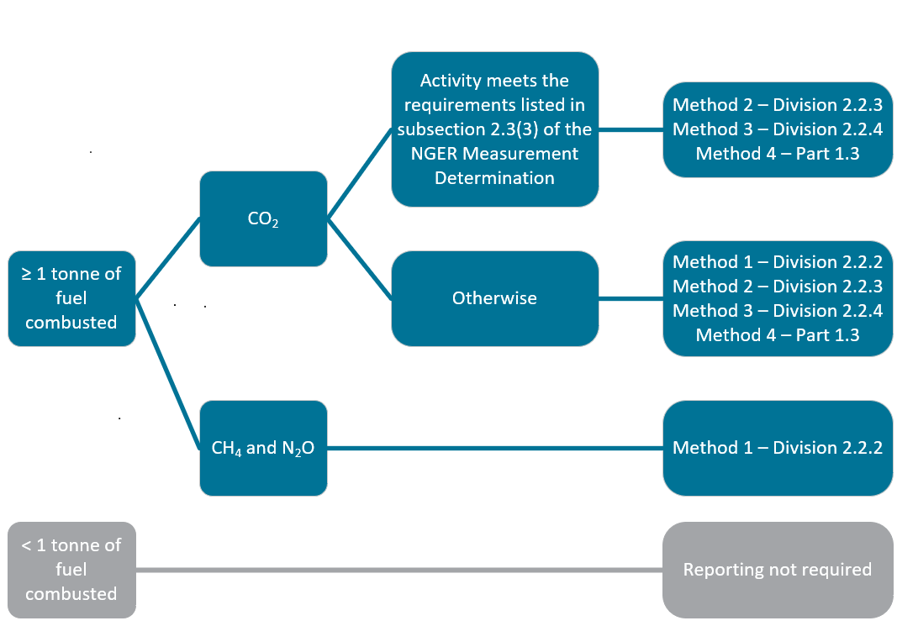For methods 1, 2 and 3, fuel quantities of solid fuels combusted should be measured per the measurement requirements in Division 2.2.5 of the NGER Measurement Determination – see Chapter 8 of this guideline.

Method 1, set out in Division 2.2.2 of the NGER Measurement Determination, uses the default emission factors set out in Schedule 1 of the NGER Measurement Determination. Method 1 is the only method available for estimation of emissions of methane and nitrous dioxide from the combustion of solid fuels. Method 1 may also be used for estimating emissions of carbon dioxide, subject to the criteria in subsection 2.3(3) of the NGER Measurement Determination. These criteria are applied so that method 1 must not be used if:

* the principal activity of the facility is electricity generation (ANZSIC industry classification and code 2611)
* the combined capacity of all generating units at the facility is 30 MW or more
* the facility generates more than 50,000 MWh in a reporting year.

### Sampling and analysis requirements for Methods 2 and 3 for solid fuels

Method 2 is derived from the methodologies published in the Technical Guidelines for the Generator Efficiency Standards program[12] and is designed to enable more accurate emissions estimates to be made.

Under method 2, representative and unbiased samples of consumed fuels must be analysed for carbon, energy, ash or moisture content in accordance with the prescribed Australian or international documentary standards or their equivalent. Two different versions of method 2 are available. The first, which uses a default oxidation factor, is set out in subdivision 2.2.3.1 of the NGER Measurement Determination. The second allows reporters to use an estimated oxidation factor determined by reference to additional information about the fuels combusted by the facility and is set out in subdivision 2.2.3.2. Default oxidation factors are drawn from those utilised in the National Greenhouse Accounts.

Table 7 – Solid fuel sampling and analysis frequency

| Parameter | Minimum fuel sampling and analysis frequency | Furnace ash and fly ash sampling and analysis frequency |
| --- | --- | --- |
| Energy content factors | Monthly composite sample:  Samples must be taken on ‘enough occasions to produce a representative sample’, per subsection 2.7(2) of the NGER Measurement Determination.  A mechanical sampling system designed and operated in accordance with AS 4264 must be used to sample the solid fuel. Ideally, this would be set up to obtain coal as it is either being loaded at the coal source, unloaded at the facility or at a point immediately prior to combustion.  If necessary, manual sampling of the coal may be used provided that the sampling equipment and procedure used is in accordance with AS 4264.  Analysis must be undertaken in line with the respective standards listed for solid fuels, including those for the different classes of coal, listed in Schedule 2 of the NGER Measurement determination. | NA |
| Carbon | Fly ash must be sampled as per section 2.11 of the NGER Measurement Determination.  Furnace ash must be analysed and sampled according to section 2.9 and 2.10 of the NGER Measurement Determination. |
| Moisture | One delivery of coal will normally represent one day or one trainload of coal. As such, if the delivery of coal is continuous, sampling for moisture and ash should be undertaken daily. | NA |
| Ash | NA |
| Exceptions | If delivery lasts one month or less, analysis must be carried out on each delivery unless fuel properties do not change significantly between deliveries over a period of a month, in which case analysis may be carried out monthly.  If a delivery of fuel lasts for more than a month and fuel properties do not change significantly before the next delivery, energy content and carbon analysis may be conducted on a delivery basis, rather than monthly basis. | NA |

#### Bias testing

Regardless of whether method 2 or 3 is selected, samples must be ‘free of bias so that any estimates are neither over nor under-estimates of the true value’, per section 2.7 of the NGER Measurement Determination. Bias must be tested in accordance with an appropriate standard, for example, AS 4264.4 -1996 *Coal and coke – Sampling – Determination of precision and bias*.

In the case of bias testing of mechanical samplers, the reference samples are usually stopped belt samples off a conveyor belt. For the purposes of verification of a coal sampling system, the coal samples taken for bias testing (pairs consisting of a reference sample and a sample taken by the coal sampler) should be analysed for total moisture and ash.

Bias testing should always be carried out on a new sampling system. For an existing system, the following verification procedure may be followed if there is some doubt about the conformance of the sampling system:

* conduct a detailed technical audit of the sampling system
* correct any non-conformances that have been observed
* conduct a limited bias test on the system, usually with the coal that exhibits the widest stochastic variability in total moisture or ash, to provide a more quantitative verification that the sampling system is performing correctly.

If you are aware of bias, it must be eliminated where possible. Following the implementation of measures to eliminate bias, the presence of residual bias must be retested and assessed. If any remaining bias exists which cannot feasibly be eliminated, data must be corrected to account for the bias, the corrections documented, and records kept.

## Emissions from combustion of gaseous fuels

In the electricity sector, gaseous fuels can be combusted for generation purposes (for example at a gas-fired power plant) or in other equipment. The methods available for estimating emissions from the combustion of liquid fuels are outlined below.

Figure 2 – Available methods for estimating emissions from the combustion of gaseous fuels

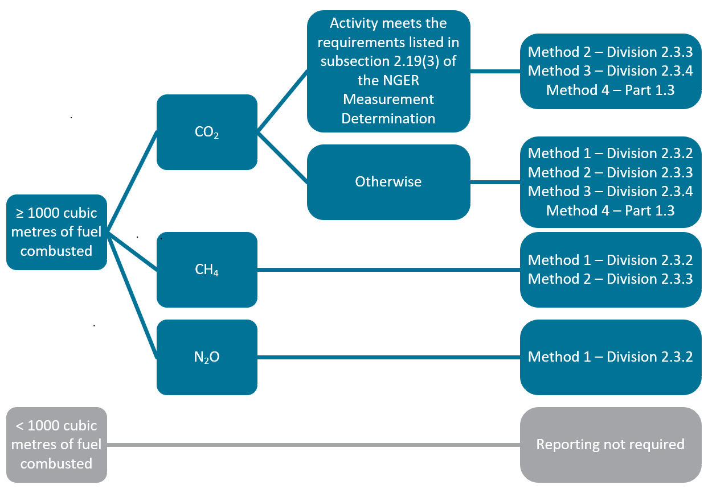

For methods 1, 2 and 3, fuel quantities of gaseous fuels combusted should be measured per Division 2.3.6 in the NGER Measurement Determination. See chapter 8 of this guideline for more information on measurement requirements.

Method 1, set out in Division 2.3.1 of the NGER Measurement Determination, uses the default emission factors set out in Schedule 1 of the NGER Measurement Determination. Method 1 is the only method available for estimation of emissions of methane and nitrous dioxide from the combustion of gaseous fuels. Method 1 may also be used for estimating emissions of carbon dioxide, subject to the criteria in subsection 2.19(3) of the NGER Measurement Determination. These criteria are applied so that method 1 must not be used if:

* the combined capacity of all generating units at the facility is 30 MW or more
* the principal activity of the facility is electricity generation (ANZSIC industry classification and code 2611)
* the facility generates more than 50,000 MWh in a reporting year.

### Sampling and analysis requirements for Methods 2 and 3 for gaseous fuels

Sampling and analysis should be undertaken for the parameters listed and at the frequencies indicated in Table 7 as per the following divisions of the NGER Measurement Determination:

* Method 2: Subdivision 2.3.3.2 (CO2), and Division 2.3.5 (CH4).
* Method 3: Division 2.3.4.

An accredited laboratory or similar laboratory complying with International Organization for Standardization (ISO) 17025 should be used to conduct gas analysis. If an online analyser is used, it must be calibrated in line with an appropriate standard – for example, ISO 6975:1997.

The density of a gaseous fuel must be analysed in accordance with ISO 6976:1995 or in accordance with a standard that is equivalent to that standard.

Table 8.1 – Gaseous fuel sampling and analysis frequency - Pipeline quality gases

|  |  |
| --- | --- |
| Parameter | Minimum fuel sampling and analysis frequency |
| Gas composition | Monthly |
| Energy content | Monthly if category 1 or 2 gas measuring equipment used  Continuous if category 3 or 4 gas measuring equipment used |

Table 8.2 – Gaseous fuel sampling and analysis frequency - All other gases (including fugitive emissions)

|  |  |
| --- | --- |
| Parameter | Minimum fuel sampling and analysis frequency |
| Gas composition | Monthly |
| Energy content | Monthly |
| Exception | If a reporter or liable entity certifies in writing that such frequency of analysis will cause significant hardship or expense, the analysis may be undertaken at a frequency that will allow an unbiased estimate to be obtained |

See section 2.31 of the NGER Measurement Determination for classifications of measuring equipment.

Note: Gaseous fuel is typically delivered with set energy content specifications. Whilst these specifications can be useful to sense-check fuel sampling and analysis, they may not meet the NGER requirements for fuel sampling and analysis. The reporter should establish and document that sufficient fuel sampling and analysis has been performed. Alternatively, the reporter can use the default energy content factor for the fuel type specified in Part 2 of Schedule 1 of the NGER Measurement Determination.

#### Bias testing

Samples must be ‘free of bias so that any estimates are neither over nor under-estimates of the true value’, per section 2.44 of the NGER Measurement Determination.

Bias is less likely to occur in the sampling and analysis of gaseous fuels. If you are aware of bias, it must be eliminated where possible. Following the implementation of measures to eliminate bias, the presence of residual bias must be retested and assessed. If any remaining bias exists which cannot feasibly be eliminated, data must be corrected to account for the bias, the corrections documented, and the records kept.

## Emissions from combustion of liquid fuels

In the electricity sector, liquid fuels can be combusted for generation purposes or in other equipment – including for transport purposes, for example, road-registered combustion engine vehicles. The methods available for estimating emissions from the combustion of liquid fuels are outlined below.

Figure 3 – Available methods for estimating emissions from the combustion of liquid fuels

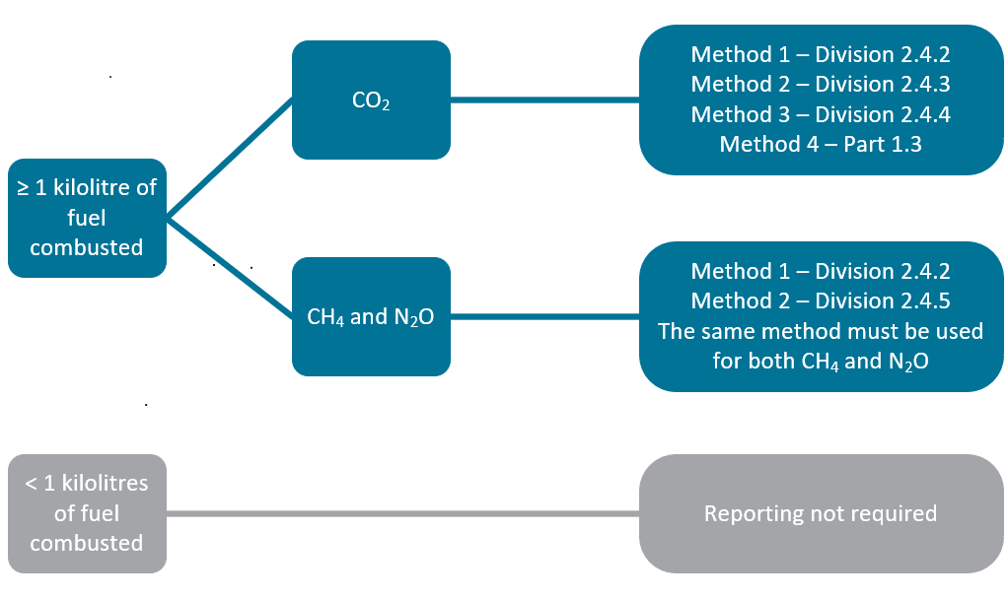

Method 1 is available for estimating emissions of carbon dioxide for all liquid fuel power generators.

For methods 1, 2 and 3 fuel quantities of liquid fuels combusted should be measured as per Division 2.4.6 in the NGER Measurement Determination. See Chapter 8 of this guideline for more information.

### Sampling and analysis requirements for methods 2 and 3 for liquid fuels

Sampling and analysis must be undertaken for the parameters listed and at the frequencies indicated in Table as per the following divisions of the NGER Measurement Determination:

* Method 2 - Subdivision 2.4.3.2 (CO2) and Division 2.4.5 (CH4 and N2O)
* Method 3 - Division 2.4.4.

An accredited laboratory or a laboratory that meets requirements equivalent to those in AS ISO/IEC 17025:2005 must be used to conduct liquid analysis.

Table 9 – Liquid fuel sampling and analysis frequency

|  |  |
| --- | --- |
| Parameter | Minimum fuel sampling and analysis frequency for all liquid fuel types |
| Energy | Quarterly or by delivery |
| Carbon | Quarterly or by delivery |

Standards for analysis of liquid fuels are listed in subdivision 2.4.3.2 of the NGER Measurement Determination. If a reporter is considering the use of method 2 or method 3 for a liquid fuel type which does not have an analysis standard, then they should [contact the agency](http://www.cleanenergyregulator.gov.au/About/Contact-us)[13] to discuss options for fuel sampling and analysis.

#### Bias testing

Samples must be ‘free of bias so that any estimates are neither over nor under-estimates of the true value’, per section 2.44 of the NGER Measurement Determination. Bias is less likely to occur in the sampling and analysis of liquid fuels.

If a reporter is aware of bias, it must be eliminated where possible. Following implementation of measures to eliminate bias, the presence of residual bias must be retested and assessed. If any remaining bias exists that cannot feasibly be eliminated, data must be corrected to account for the bias, the corrections documented, and the records kept.

## Emissions from consumption of PBOGs

PBOGs used as lubricants are considered to have undergone a degree of oxidation and are therefore reported under the fuel combustion emissions source. Available emissions estimation methods are summarised below.

Figure 4 – Available methods for estimating emissions from consumption of PBOGs

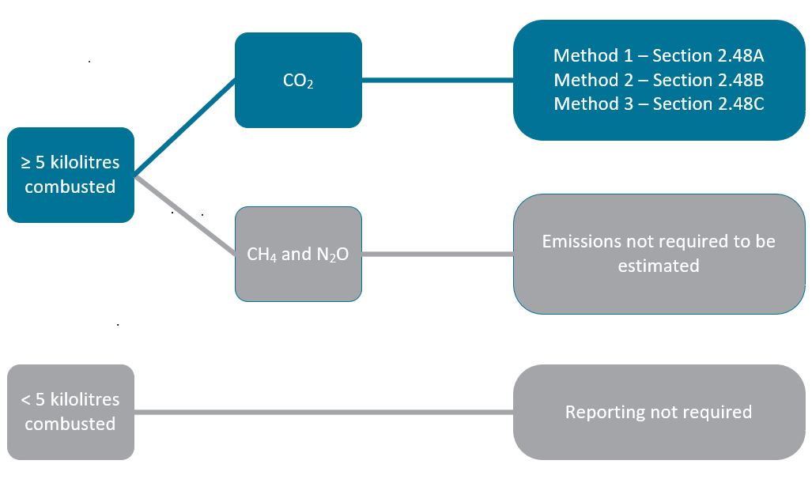

Where PBOGs are used as a fuel, emissions should be calculated as per ‘liquid fuels other than PBOGs’.

See the [Petroleum-based oils and greases guideline](http://www.cleanenergyregulator.gov.au/DocumentAssets/Pages/Petroleum-based-oils-and-greases-guideline.aspx)[14] for more information.

# Estimating emissions of sulphur hexafluoride

Sulphur hexafluoride (SF6) is used in many electricity sector facilities, for instance in electrical switchgear. Any emissions of SF6 where it is used in gas insulated switch gear and circuit breakers is required to be reported as there are no reporting threshold listed within the NGER legislation.

The following methods are available for estimating emissions of sulphur hexafluoride.

Figure 5 – Available methods for estimating emissions of sulphur hexafluoride

Flow chart of the methods available for estimating emissions of sulphur hexafluoride

Flow chart of the available methods for estimating emissions of sulphur hexafluoride


See the [Reporting Hydrofluorocarbons and Sulphur Hexafluoride gasesguideline](http://www.cleanenergyregulator.gov.au/DocumentAssets/Pages/Reporting-Hydrofluorocarbons-and-Sulphur-Hexafluoride-gases-guideline.aspx)[15] for more information.

# Scope 2 emissions from electricity use

Indirect, or scope 2, emissions are defined in NGER regulation 2.24 as the release of greenhouse gas into the atmosphere as a direct result of one or more activities that generate electricity, heating, cooling or steam that is consumed by the facility but that do not form part of the facility.

In the electricity sector, scope 2 emissions primarily occur through consumption of purchased electricity or the loss of electricity from an electricity transmission network or distribution network that has not been generated by the facility itself. This includes:

* Purchased electricity used at the facility – any electricity purchased from outside the facility for use at the facility. For example:
  + electricity purchased from an electricity network or grid for use in own facility
  + electricity purchased directly from another facility, for example, an electricity generator, for use in own facility.
* Transmission or distribution network losses – any electricity acquired from outside the facility, which is lost within the facility in association with transmission and distribution activities. The electricity is not required to have been purchased. For example:
  + line losses through resistive heating within an electricity transmission or distribution facility, which are usually the most significant emissions from electricity transmission and distribution networks.

#### 20,000 kilowatt hours reporting threshold

Subsection 7.1(2) of the NGER Measurement Determination states that scope 2 emissions must be reported if the amount of electricity consumed from the operation of a facility during a year that results in scope 2 emissions is more than 20,000 kilowatt hours (kWh).

#### Meaning of ‘purchased electricity’

Where Chapter 7 of the NGER Measurement Determination uses the phrase ‘purchased electricity’, it refers to the acquisition of the electricity through a commercial transaction – that is where electricity for use at the facility is acquired by providing financial or other consideration to the provider of the electricity.

Note: If a facility uses electricity acquired from outside its own facility that it considers is not reportable as ‘purchased electricity’, the agency expects the reporter to document the basis for this determination, how the electricity has been acquired without any consideration for its delivery that may otherwise indicate that the electricity was ‘purchased’.

|  |
| --- |
| **Example – Purchased electricity** Case example 1 in Appendix A illustrates how electricity produced at one facility leads to scope 2 emissions at another facility.   * Electricity produced at the gas-fired power plant (see number 4 in figure 8) is delivered to a separate facility without passing through an electricity grid (see number 6 in figure 8). * If the electricity used at the separate facility is ‘purchased’ by that facility, scope 2 emissions must be reported by that facility. The emission factor applicable for the electricity produced from the gas-fired power plant can be obtained from the supplier to estimate accurate scope 2 emissions. If that emission factor is unavailable, the emission factor for the main electricity grid emissions factor for the Northern Territory may be used.   In addition, the gas-fired power station uses some of its own produced electricity (see number 5 in the figure 8). This is not ‘purchased electricity’ leading to scope 2 emissions. It is instead consumption of own produced electricity – see chapter 7.3 of this guideline for more information. Scope 1 emissions are estimated from fuel combustion. |

## Purchase or loss of electricity from the main electricity grid

Scope 2 emissions are released from:

* electricity purchased from the main electricity grid in a State or Territory
* electricity losses from a transmission and distribution network that is, or is part of, the main electricity grid in a State or Territory.

Scope 2 emissions must be calculated in accordance with section 7.2 of the NGER Measurement Determination. This applies if the amount of purchased electricity consumed is more than 20,000 kWh. All electricity consumed or lost connected to the ‘main electricity grid’ in a State or Territory must be estimated using these State or Territory based emissions factors.

Scope 2 emissions released from electricity purchased from the main electricity grid in a State or Territory are to be estimated using:

* The amount of electricity purchased for the facility and consumed from the operation of the facility.
* The applicable State or Territory emission factor in Part 6 of Schedule 1 of the NGER Measurement Determination.

Scope 2 emissions from electricity losses from an electricity transmission or distribution network which is, or is part of, the main electricity grid, are estimated using:

* The amount of electricity losses from the network.
* The applicable State or Territory emission factor in Part 6 of Schedule 1 of the NGER Measurement Determination.

Generally, ‘losses’ in a facility that comprises a transmission and distribution network are calculated based on the amount of electricity entering the network and the amount of electricity leaving the network.

Note: The agency has adopted the Australian Energy Market Commission’s <https://www.aemc.gov.au/regulation/energy-rules/national-electricity-rules> [National Electricity Rules](https://www.aemc.gov.au/regulation/energy-rules/national-electricity-rules/current)[16], definition of a network, that is ‘the apparatus, equipment, plant and buildings used to convey, and control the conveyance of, electricity to customers (whether wholesale or retail) excluding any connection assets. In relation to a Network Service Provider, a network owned, operated or controlled by that Network Service Provider.’

## Purchase or loss of electricity from other sources

If electricity is purchased from an electricity network other than the main electricity grid, or if the reporting facility is constituted by an electricity transmission or distribution network that is not part of the main electricity grid in a state or territory, emission factors provided by the supplier of the electricity may be used. If those emission factors are unavailable, the emission factor for the Northern Territory must be used. Scope 2 emissions released from electricity purchased from these other sources are to be calculated in accordance with method 1 in section 7.3 in the NGER Measurement Determination.

## Scope 2 emission factors

Scope 2 emission factors are updated annually to reflect the changes in the mixture of electricity sources within the main electricity grid in a State or Territory. EERS will automatically calculate energy consumption based upon the data entered for scope 2 emissions and the relevant emission factor for the State or Territory.

Scope 2 emission factors are listed in Part 6 of Schedule 1 of the NGER Measurement Determination. Please ensure that you are referring to the correct Compilation of the NGER Measurement Determination for the reporting year. For 2020–21 reporting, this is Compilation No. 12.

#### Main electricity grid

The ‘main electricity grid’ for a State or Territory is defined in subsection 7.2(4) of the NGER Measurement Determination as:

* For Western Australia – the Southwest Interconnected System.
* For each other State or Territory – the electricity grid that provides electricity to the largest percentage of the State’s or Territory’s population.

# Energy production and consumption

This chapter provides an overview of how to report energy under NGER for organisations in the electricity generation, transmission, and distribution sectors. It is intended to supplement the [Reporting energy production and consumption guideline](http://www.cleanenergyregulator.gov.au/DocumentAssets/Pages/Reporting-energy-production-and-consumption-guideline.aspx)[17].

Reporting energy consumption and production in the electricity sector can be complex. Given the large quantities of energy involved, any errors can have a substantial impact on the information used to meet Australia’s international reporting obligations, and the information used to inform policy and government programs.

## Energy as a fuel or energy commodity

In NGER, the term ‘energy’ is defined within regulation 2.03 of the NGER Regulations. It is used to describe individual fuels and energy commodities as defined in Schedule 1 of the NGER Regulations. These comprise a range of solid, liquid and gaseous fuels, including naturally occurring materials and fuels derived from other sources. Other energy commodities such as electricity, as well as renewable energy commodities such as wind and solar energy used for electricity generation are also covered.

Correct reporting of energy flows under NGER requires 3 totals to be prepared:

* Production of energy– defined in NGER regulation 2.25 as:
  + extraction or capture of energy from natural sources for final consumption by or from the operation of the facility, or for use other than in the operation of the facility
  + manufacture of energy by the conversion of energy from one form to another form for final consumption by or from the operation of the facility, or for use other than in the operation of the facility.
* Consumption of energy– defined in NGER regulation 2.26 as the use or disposal of energy from the operation of the facility, including own-use and losses in extraction, production and transmission*.*
* Net energy consumption – see chapter 7.6 of this guideline.

These totals are prepared by aggregating estimates of the calorific values of individual energy flows across a facility over the reporting year (measured in gigajoules (GJ)). When reporting energy production and consumption, only those fuels and energy commodities that are listed in Schedule 1 of the NGER Regulations and for which there are applicable methods in the NGER Measurement Determination should be reported.

For generation facilities, the majority of energy produced is electricity delivered off-site and the majority of energy consumed is fuels for generation plus any electricity used or lost on site. For transmission and distribution facilities, line losses usually constitute the majority of energy consumed with minimal or no energy production.

|  |
| --- |
| **Example – Energy production and consumption from a gas fired power station** Case example 1 in Appendix A in respect of a gas-fired power station illustrates the concept of energy as a commodity with reference to energy production and energy consumption.  In this case, energy production comprises:   * electricity produced and consumed at the facility (see numbers 4 and 5 in figure 8) * electricity produced and delivered directly to the nearby facility (see number 6 in figure 8) * electricity transferred to an electricity network (see number 7 in figure 8).   In this case, energy consumption comprises:   * gas combusted for generation purposes (see number 2 in figure 8) * own produced electricity consumed by facility (see number 5 in figure 8). |

## Estimating energy production and consumption

Both total energy production and total energy consumption from the operation of a facility during a reporting year are estimated using the following equation:

**Z = Q x EC**

**where:**

**Z is the amount of an individual fuel or energy commodity produced or consumed in GJ**

**Q is the physical quantity of the fuel or energy commodity produced or consumed during the year**

**EC is the energy content factor of the fuel or energy commodity.**

Individual energy flows on a per-gigajoule basis are aggregated to derive total energy production and energy consumption figures. In the case of electricity production and consumption, Q is measured in kWh, and the energy content factor is 0.0036 GJ per kWh.

In the case of hydrogen production and consumption, Q is measured in tonnes, and the energy content factory is 143 GJ per tonne. There is no threshold for the reporting of hydrogen production or consumption which occurs at a facility.

## Electricity production and consumption

Electricity production is typically the largest individual energy flow within the electricity generation sector. Electricity production and consumption must be reported if it exceeds the thresholds listed in NGER Regulations 4.19, 4.20 and 4.23, and section 2.68 of the NGER Measurement Determination, summarised below.

Table 10 – Thresholds for energy reporting from electricity production and consumption (amount of electricity in a reporting year)

|  |  |  |  |  |
| --- | --- | --- | --- | --- |
| Individual generating unit capacity | Electricity production by the unit | Electricity consumption from onsite generation | Electricity consumption from generation offsite (associated with scope 2 emissions) | Energy consumption during cogeneration |
| < 0.5 MW | Reporting not required | Reporting not required | ≥ 20,000 kWh p.a. | Capacity to produce ≥ 30 MW of electricity and production of ≥ 30 GWh p.a. of electricity | |
| ≥ 0.5 MW | ≥ 100,000 kWh p.a. | ≥ 100,000 kWh p.a. | ≥ 20,000 kWh p.a. |

Any fuel that is combusted to generate electricity is subject to reporting thresholds detailed in section 2.2 (solid fuels), section 2.18 (gaseous fuels) and section 2.39 (liquid fuels) of the NGER Measurement Determination. For energy consumed in a cogeneration process, see chapter 7.3.3 of this guideline.

|  |  |  |  |  |  |  |  |  |  |  |  |  |
| --- | --- | --- | --- | --- | --- | --- | --- | --- | --- | --- | --- | --- |
| **Electricity threshold example** A gas power plant has 2 generating units although only one is predominantly used, with the following annual generation:  Table 11 – 2generating units, capacity and annual generation   |  |  |  | | --- | --- | --- | | Unit | Capacity (MW) | Annual generation (kWh) | | 1 | 20 | 10,000,000 | | 2 | 20 | 90,000 | | Total | 40 | 10,090,000 |   The gas power plant does not have to report electricity production for unit 2, since its annual generation did not meet the 100,000 kWh threshold. If, the following year, unit 2 generates greater than 100,000 kWh, its electricity production would have to be reported. |

A reporter may choose to report electricity production where the above thresholds in sub regulation 4.19(2) of the NGER Regulations have not been met. Where this occurs, the corresponding onsite consumption from own produced electricity generation must also be reported (produced for the purposes of the operation of the facility).

### Quantifying electricity consumption

Electricity consumption must be reported in accordance with regulation 2.26 and subdivision 4.4.5 of the NGER Regulations, and Chapter 6 of the NGER Measurement Determination. Accordingly, electricity consumption can be interpreted as the total of:

* Electricity generated within the facility and consumed within the facility, for example:
  + for use in buildings/ancillary facilities
  + losses and parasitic loads.
* Electricity drawn from an external source and consumed within the facility.

Losses through resistive heating are of primary concern for electricity transmission and distribution facilities (as associated with scope 2 emissions). Where they occur as part of the facility that generated the electricity, they must be measured and reported as consumption of electricity, which has been produced for use onsite - that is, produced for the purpose of the operation of the facility.

Consumption of electricity produced onsite at a generation facility is equal to the difference between the quantity of electricity produced at the terminals of the generating units, and the quantity of electricity delivered for use outside the facility – that is, supplied to an electricity transmission or distribution network, or for other use outside the facility.

In accordance with section 6.5 of the NGER Measurement Determination, the amount of electricity consumed (*Q*) may be evidenced by:

* invoices, contractual arrangements or industry metering records, or if such evidence is not available
* records of estimates made in line with industry practice.

|  |
| --- |
| **Example – Quantifying electricity consumption at a hydro power plant** Case example 2 in Appendix A illustrates how electricity consumption should be quantified.   * Electricity is produced in the turbine and electricity production is measured using metering at the terminal (see number 4 in figure 9). * Electricity delivered to an electricity transmission network is metered at the network connection point (see number 7 in figure 9). * Reportable consumption of own produced electricity is the difference between the two above numbers, that is, reportable consumption of own produced electricity is 1 – 2.   The use of own produced electricity comprises both electricity for use onsite (see number 5 in figure 9) and losses of electricity in line between terminal and the network connection point (see number 6 in figure 9). |

### Quantifying electricity production

NGER sub-regulation 4.20(2) describes3 alternate ‘purposes’ for producing reportable electricity:

1. for use in the operation of the facility (i.e. ‘for use onsite’)
2. for use outside the operation of the facility other than for supply to an electricity transmission or distribution network, that is, ‘for use offsite, not supplied to network’
3. for use outside the operation of the facility for supply to an electricity transmission or distribution network, that is, ‘for use offsite, supplied to network’.

Electricity production should be reported against these 3 purposes (where applicable) using the formula described in chapter 7.2 of this guideline.

Subsection 6.2(1)(c) to (e) of the NGER Measurement Determination set out the requirements for quantifying the electricity for the 3 purposes, as outlined below.

Table 62 – Measuring electricity production

|  |  |
| --- | --- |
| Purpose of produced electricity | Measuring the quantity of electricity produced (Q) |
| For use onsite  Electricity produced for use for the purpose of the operation of the facility.   * This is all residual electricity produced at the facility and not delivered for outside use, that is, all electricity produced at the terminals that is not delivered for outside use. | Electricity production (Q) is equal to:  The electricity produced by the electricity generating unit(s) as measured at the terminals  minus  Electricity supplied for use outside the operation of the facility that is not supplied to the network  minus  Electricity supplied to a transmission or distribution network measured at the network connection point. |
| For use offsite, not supplied to network  Electricity produced for use outside the operation of the facility other than supply to an electricity transmission or distribution network. | Electricity production (Q) is equal to:  Electricity supplied for use outside the facility that is not supplied to the network. |
| For use offsite, supplied to network  Electricity produced for use outside the operation of the facility for supply to an electricity transmission or distribution network. | Electricity production (Q) is equal to:  Electricity supplied to a transmission or distribution network measured at the network connection point. |

#### Reporting consumption and production of electricity for use onsite in EERS

EERS was updated for the 2019–20 reporting year (and onwards) so that it automatically reports an amount of consumption of electricity produced ‘for use for the purposes of the facility (for use onsite)’, which is equal to the reported amount of electricity produced ‘for use for the purposes of the facility’. Where electricity produced ‘for use for the purposes of the facility (for use onsite)’ is inputted into EERS, consumption of that electricity must not be inputted separately. This is described in the example below.

|  |
| --- |
| **Example – Reporting consumption and production of electricity produced ‘for use for the purposes of facility’** The electricity produced by a facility includes 100,000 kWh of electricity produced ‘for use for the purposes of the facility’. The reporter inputs 100,000 kWh into EERS as electricity produced ‘for use for the purposes of the facility’.  EERS then records:   * 100,000 kWh (360 GJ) of electricity produced ‘for use for the purposes of the facility’ * 100,000 kWh (360 GJ) of consumption of electricity produced ‘for use for the purposes of the facility’.   These values will be included in the NGER report generated by EERS.  The reporter correctly does not manually input consumption of electricity produced ‘for use for the purposes of the facility (for use onsite)’ because it has been automatically recorded by EERS |

See [How do I report consumption of electricity that was produced for use during the operation of the facility?](http://www.cleanenergyregulator.gov.au/OSR/EERS/Tools-to-assist-you/Frequently-asked-questions#How-do-I-report-consumption-of-electricity-that-was-produced-for-use-during-the-operation-of-the-facility)[18] for more information and guidance for reporting in EERS.

#### Measuring electricity production

Produced electricity delivered to an electricity transmission or distribution network must be measured according to either Chapter 7 of the [National Electricity Rules](https://www.aemc.gov.au/regulation/energy-rules/national-electricity-rules/current)[19] per the *National Electricity (South Australia) Act 1996* or the metering requirements applicable to the region in which the facility is located (section 6.2 of the NGER Measurement Determination).

For other electricity production, subsection 6.3(2) of the NGER Measurement Determination clarifies that the amount of electricity produced from the operation of the facility during the year must be evidenced by invoices, contractual arrangements or industry metering records**.**

In practice:

* The electricity produced at the terminals should be measured and evidenced using metering per industry standard.
* For electricity delivered for use at another facility, the delivered electricity must be evidenced using invoices, contractual arrangements or industry metering records.

|  |
| --- |
| **Example – Quantifying electricity production at a gas fired power plant** Case example 1 in Appendix A illustrates how electricity production should be quantified.   * Electricity is produced in the turbine and electricity production is measured using metering at the terminal (see number 4 in figure 8). * Electricity delivered to an electricity transmission network is metered at the network connection point (see number 7 in figure 8). This meter determines the amount of reportable electricity produced for the purpose of delivering to the network. * Electricity delivered directly to a neighbouring facility is metered (see number 6 in the diagram), per commercial transaction. This meter determines the amount of reportable electricity produced for the purpose of being used at another facility (and not delivered to the network). * The electricity produced for use onsite (see number 5 in figure 8) is determined as electricity at number 4 minus (electricity at number 6 + electricity at number 7). |

### Cogeneration

Cogeneration is defined in NGER Regulation 1.03 as a process that combines the generation of heat and power to produce electricity and another product within one integrated production process.

In practice, cogeneration occurs when energy (other than electricity) is consumed and results in the production of electricity and another product, for example, heat or steam. When this occurs, assuming that the appropriate thresholds (see Table 10 ) have been met, the report for the facility must identify the amount and energy content of the energy type consumed to produce the electricity and the other product during the year.

The amount of electricity produced as a result of the cogeneration process is also required to be reported. However, it is not necessary to report the production of the other product if that product is heat.

The methods available for determining the amount and energy content of the energy type consumed to produce the electricity and the other product are specified in section 2.70 of the NGER Measurement Determination as:

* The efficiency method, which is stipulated for cogeneration processes.
* The work potential method, which may be used where heat is to be used mainly for producing mechanical work. These methods are described in the [Allocation of GHG Emissions from a Combined Heat and Power (CHP) Plant](https://www.ghgprotocol.org/sites/default/files/ghgp/CHP_guidance_v1.0.pdf)[20] guide, issued by the World Resource Institute and World Business Council for Sustainable Development. See GHG Protocol’s [calculation tools](https://ghgprotocol.org/calculation-tools)[21] for more information on these methods, including a calculator that can be used when applying the efficiency method.

## Renewable energy commodity production and consumption

Four renewable energy commodities are listed in Schedule 1 of the NGER Regulations for electricity generation: solar, wind, water, and geothermal. Production of these energy commodities is not required to be reported.

Consumption of these energy commodities is only required to be reported where they are used to generate reportable electricity production, that is, in a generating unit exceeding the reporting threshold (see Table 10).

A 100% conversion efficiency is assumed between the renewable energy commodity consumed and the electricity produced; they are of equal magnitude. For example, if a wind farm generates 1,000,000 GJ of electricity it is assumed to have consumed 1,000,000 GJ of the renewable energy commodity ‘wind energy for electricity generation’.

Reporting of electricity production and consumption from renewable sources follows the electricity reporting thresholds set out in chapter 7.3 of this guideline.

Note: Reporting electricity production even when below the threshold is allowed, per NGER Regulation 4.19(2) - see chapter 7.3 of this guideline for more information. Where a renewable generator chooses to do this, the corresponding consumption of renewable energy commodity must also be reported.

|  |
| --- |
| **Example – Consumption of a renewable energy commodity** Case example 2 in Appendix A, water energy is consumed for electricity production (see number 3 in figure 9).  In this case, the quantity of water energy consumed is equal to the amount of electricity produced as measured in the terminals of the generating unit and converted to GJ.  The storing of water at elevation behind a dam (see number 1 in figure 9) contains the potential energy to generate electricity. The ‘production’ of this potential energy is not reportable under NGER. |

Note: EERS was updated for the 2019–20 reporting year (and onwards) to automatically report consumption of the relevant energy commodity, which is equal to the reported amount of electricity production from solar, wind, water, or geothermal energy. Where electricity production from solar, wind, water or geothermal energy is inputted into EERS, the consumption of solar, wind, water or geothermal energy must not be inputted separately. This is described in the example below.

|  |
| --- |
| **Example – Reporting production of electricity from a renewable energy commodity** A wind farm generates 1,000,000 kWh of electricity. The reporter inputs 1,000,000 kWh into EERS as electricity produced using wind generation:  EERS then records:   * 1,000,000 kWh (3600 GJ) of electricity produced using wind generation * 3,600 GJ of consumption of the primary energy commodity ‘wind energy for electricity generation’.   These values will be included in the NGER report generated by EERS.  The reporter does not manually report consumption of ‘wind energy for electricity generation’, because it has automatically been recorded by EERS. |

See [How do I report consumption of renewable energy commodities for electricity generation?](http://www.cleanenergyregulator.gov.au/OSR/EERS/Tools-to-assist-you/Frequently-asked-questions#How-do-I-report-consumption-of-renewable-energy-commodities-for-electricity-generation)[22] for more information and guidance for reporting solar, wind, water and geothermal energy commodities in EERS.

### Reporting of NGER data alongside RET data

Under the Renewable Energy Target (RET), liable entities are classified as an individual or company who is the first person to acquire electricity on a network that has an installed capacity of 100 MW or more. Liable entities are required to lodge an energy acquisition statement each year, which includes reporting the amount of liable electricity acquired.

The agency expects that where electricity acquired from a network is reported under both the NGER and RET schemes, RET liable entities and corresponding NGER facilities have consistent reporting.

## Energy consumption from fuel use

Consumption of fuels must be reported if the quantity exceeds the thresholds listed below. Fuel use in electricity generation would typically be the largest source, but minor instances of fuel use should also be considered.

Table 13 – Thresholds for energy reporting from fuel use

|  |  |  |
| --- | --- | --- |
| Energy type | Consumption by combustion (apply to each instance of the combustion source) | Consumption without combustion (applies to each fuel type) |
| Solid fuel | 1 tonne | 20 tonnes |
| Liquid fuel | 1 kilolitre or 5 kilolitres for petroleum-based oils (other than petroleum-based oils used as fuels) and petroleum-based greases | 15 kilolitres |
| Gaseous fuel | 1,000 cubic metres | 13,000 cubic metres |

Measurement of fuel quantities is covered in detail in chapter 8 of this guideline.

Energy content factors can either be selected from default values listed in Schedule 1 of the NGER Measurement Determination or derived from sampling and analysis of a fuel. A summary of the location of the specified sampling and analysis requirements within the NGER Measurement Determination is described in Table 7 below. Energy consumption from the combustion of fuel is calculated automatically when emissions from the fuel combustion are entered in EERS.

Table 7 – Energy content factors by fuel type as prescribed in the NGER Measurement Determination.

|  |  |  |
| --- | --- | --- |
| Fuel category | Predetermined value | Estimation technique |
| Solid fuels | Refer to Part 1 of Schedule 1 | Refer to standards indicated in Schedule 2 (or equivalent standards) |
| Gaseous fuels (in GJ per m3) | Refer to Part 2 of Schedule 1 | Refer to the requirements of Subdivision 2.3.3.2, also described in chapter 4.4.1 of this guideline |
| Liquid fuels | Stationary energy purposes: refer to Part 3 of Schedule 1  Transport energy purposes: refer to Division 4.1 of Schedule 1 | Refer to Subdivision 2.4.3.2, also described in chapter 4.5.1 of this guideline |

### Blended fuels and other fuel mixes

Energy production and consumption must be reported using fuel types listed within Schedule 1 of the NGER Regulations. Many of the fuels listed in Schedule 1 of the NGER Regulations are defined within regulation 1.03 of the NGER Regulations and section 1.8 of the NGER Measurement Determination. Common usage and dictionary definition should be used when not otherwise defined within the NGER legislation.

The requirements for reporting blended fuels and fuels mixes will depend on the fuels in the blend or mix, the product created by the blending or mixing, and the end use of the blended fuel or fuel mix.

See the [Reporting blended fuels and other fuel mixes guideline[23]](http://www.cleanenergyregulator.gov.au/DocumentAssets/Pages/Reporting-blended-fuels-other-fuel-mixes-and-bitumen-guidelin.aspx) for more information on reporting requirements and calculation methodologies.

## Reporting of battery activities

This section provides guidance for facilities that use batteries to store and discharge electricity.

Electricity production must be reported for electricity that is sent from a generator to a battery. This includes:

* reporting the energy source (e.g. thermal, wind, solar) used to produce the electricity
* reporting of the usage.

Usage is determined when the battery is discharged, for example, for use onsite or for use offsite supplied to a network. In principle, electricity that is produced and sent to a battery cannot be reported until that electricity is discharged from the battery.

Only consumption of electricity consumed onsite needs to be reported. In the diagram below, the electricity storage and discharge of the battery is shown and the reporting options in are EERS included.

Figure 6 — Data sources required for reporting for battery storage activities related to onsite electricity generation sources

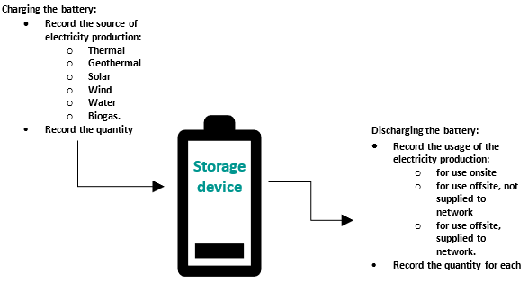

Once data has been collected (see Figure 6), electricity production and consumption activities can be entered into EERS.

Electricity consumption and scope 2 emissions must be reported by the consumer when electricity is discharged from a battery and consumed at the facility, if that electricity was originally imported to charge the battery.

In a case where the imported energy is sent back to the grid, ‘net scope 2 emissions’ can be calculated using the amount of electricity imported minus the amount of that imported electricity that is exported back to the grid.

Figure 7 — Scope 2 reporting for battery storage device

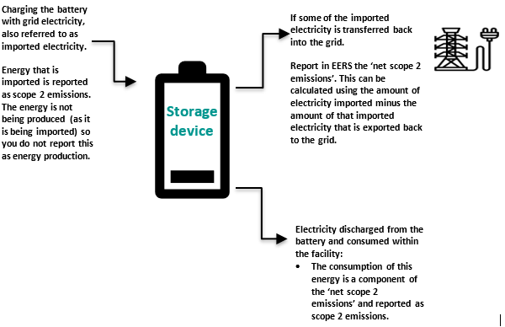

### Recording starting stock of battery at July 1 of the next reporting year

If all electricity stored in a battery was not discharged in the same reporting year it was stored, there will be energy remaining in the battery at the end of the reporting period. This means at the start of the next reporting year on July 1, the battery already holds some stored electricity. In this case, it is important that the starting stock of stored electricity at July 1 of the next reporting year is recorded. This value in kWh at July 1 should be added to the amount of storage that occurs during the new reporting year.

### Reporting Virtual Power Plant (VPP) activities

A Virtual Power Plant (VPP) is a network of connected solar batteries that meets the definition of designation generation facility in section 7 of the NGER Act.

Electricity production and consumption at VPPs must be reported if it exceeds the thresholds listed in NGER Regulations 4.19, 4.20 and 4.23, and section 2.68 of the NGER Measurement Determination, summarised in table 10.

In EERS, VVPs must be reported as facility and the reporting of activities should be done in accordance with the guidance in section 7.6, reporting battery activities. The head office, or wherever the VVP is controlled can be the appropriate address for the facility.

## Net Energy Consumption

The agency is required to publish information on the net energy consumption of corporations registered under the NGER scheme by 28 February each year. The accuracy of this information is dependent on the quality of information provided in corporate NGER reports.

#### Defining primary and secondary energy commodities

The calculation of net energy consumption is determined in part by the classification of each energy commodity defined in schedule 1 of the NGER Regulations as either primary or secondary energy. These designations are defined as follows in NGER Regulation 1.03:

* Primary fuel or energy commoditymeans a fuel or energy commodity extracted or captured from natural sources with minimal processing.
* Secondary fuel or energy commoditymeans a fuel or energy commodity produced by converting energy from one form to another form for consumption.

In the electricity generation sector, primary energy commodities are typically fuels and renewable energy commodities consumed by generating facilities. Electricity is a secondary energy commodity under NGER.

#### Calculating net energy consumption

NGER Regulation 5.3 defines the calculation for net energy consumption as follows:

* Step 1: For each facility of the corporation’s group, adjust the facility’s energy consumption by deducting the energy content of the secondary fuels and energy commodities produced from the operation of the facility from the total energy consumed by the operation of the facility.
* Step 2: Add together each result in step 1.

This can be represented by the following equation:

$$Net Energy Consumption=\sum{Energy Consumption}- \sum{Secondary Energy Production}$$

Given EERS automates this calculation, the allocation of individual energy commodities as either primary or secondary is critical to ensuring the net energy consumption is appropriately calculated.

# Measurement requirements

To estimate emissions and report energy data accurately and completely, appropriate measurements of activity or source data should be performed. Along with the quantity of electricity produced, measurement of the quantity of fuel combusted for generation comprises the key activity data to measure for NGER purposes.

This chapter provides a summary of the measurement requirements.

## Measurement Criteria

The measurement requirements for measuring quantities of solid, gaseous, and liquid fuels are set out in Divisions 2.2.5, 2.3.6 and 2.4.6 respectively of the NGER Measurement Determination.

Table 8 provides the general measurement requirements available in NGER for measurement of fuel quantities.

Table 8 – Measurement requirements generally available in NGER

|  |  |  |  |
| --- | --- | --- | --- |
| Criterion AAA | Criterion AA | Criterion A | Criterion BBB |
| Quantity measured at point of sale or consumption | Quantity verified by stockpile change estimation and invoices | Quantity verified by invoices | Quantity measured or estimated in line with industry practice |
| For example, mass measurement of solid fuel quantities at point of combustion using equipment calibrated to the measurement requirement | For example, estimating the change in the quantity of the stockpile of gaseous fuel as evidenced by invoices from a fuel vendor | For example, using vendor invoices as evidence of quantity of gaseous fuel purchased | For example, calculation based on metering which does not meet AAA requirements |
| Available where acquisition of fuel may or may not involve a commercial transaction | Only available where acquisition of fuel involves a commercial transaction | | Not available where acquisition of fuel involves a commercial transaction |

The availability of individual measurement criteria for a given source is dependent on:

* whether or not a commercial transaction took place for the fuel
* the measurement criterion selected for that source in preceding reporting years.

In general, when the fuel is acquired via a commercial transaction, measurement criteria A, AA and AAA are permitted. This represents most situations in the electricity industry for fuels combusted for generation purposes.

Note: Once criteria AA or AAA (measured at point of consumption) have been used for a fuel acquired by commercial transaction for a given reporting year, the same criteria must be used in subsequent years.

Industry practice required for BBB is not defined in the NGER legislation. Industry practice is taken to mean that which would reasonably be expected to occur at a competent, similar facility type of a similar size and age. The following may be used as a guide when establishing the standards to be used for making estimations using industry practice:

* Equipment used is maintained in good working order.
* Equipment used is calibrated in accordance with and at the frequency stipulated by the manufacturer.
* Faulty equipment is replaced.
* Appropriate corrections for temperature and pressure are made where required, and assumptions, inherent or applied to the measurement equipment, are clarified. For example, set densities or gas composition are updated at a frequency that ensures that these assumptions are representative of the commodity being measured during the reporting period.
* Reporters should document their assessment of how their application of criterion BBB meets industry practice in the BoP. When applying criterion BBB, reporters are required to consider the principles in section 1.13 of the NGER Measurement Determination.

See the [Measurement Criteria Guideline](http://www.cleanenergyregulator.gov.au/DocumentAssets/Pages/Methods-and-measurements-criteria-guideline.aspx)[24] for more information.

#### Specific notes regarding measurement criteria per fuel states

The NGER Measurement Determination also contains requirements of individual measurement criteria specific to the physical phase of the fuel in question.

* AA for solid fuels – where measurement criterion AA is used in a given reporting year, the specific approach to estimating the change in stockpile quantity should remain consistent throughout the entire reporting period unless there is a significant change which would result in the approach becoming less accurate.
* AAA for gaseous fuels – sections 2.31– 2.37 of the NGER Measurement Determination prescribe detailed requirements for the application of criterion AAA. This includes measuring gas on a dry basis, corrected to the standard conditions defined in subsection 2.32(7) of the NGER Measurement Determination.

Measurement equipment must meet specific operational requirements depending on equipment type, the amount of gas combusted per day, and whether the gas is super-compressed.

Reporters should satisfy themselves that the measurement equipment used in preparation of NGER reports has been operated and maintained in accordance with the requirements stipulated. In cases where reporters rely on measurements provided by vendors or by third parties, reporters should make sufficient enquiries of the providers of these measurements to enable them to have confidence that the requirements of the NGER Measurement Determination are being complied with.

* AAA for liquid fuels – should criterion AAA be selected, fuel volumes must be corrected to standard temperature of 15°C.

## Metering considerations

Table 9 shows summary metering and calibration requirements from the NGER Measurement Determination. The most accurate meters available (such as regulated meters at the network connection points) should be used preferentially for NGER measurements and as a basis for any mass or energy balance calculations, in accordance with the general principles listed in section 1.13 of the NGER Measurement Determination.

Table 9 – Metering and calibration requirements

|  |  |  |
| --- | --- | --- |
| Metering Purpose | | Requirements (references are to the NGER Measurement Determination where not stated) |
| Fuel Quantity | Solid fuels (in tonnes) | Criterion AAA: metering equipment must follow the requirements set out in section 2.16. Equipment must be calibrated to a ‘measurement requirement’, which in this case means the standards required for measurement to support all commercial transactions covered by the *National Measurement Act 1960* and associated instruments.  These requirements are summarised in section 2.16 of the NGER Technical Guidelines. |
| Criterion BBB: metering equipment must follow the requirements set out in section 2.17 of the NGER Measurement Determination, which refer to industry practice. |
| Gaseous fuels (in cubic metres) | Criterion AAA: measurement equipment must be calibrated to requirements set out in sections 2.31 – 2.37 of the NGER Measurement Determination. Specific requirements depend on equipment type, the amount of gas consumed per day, and whether the gas is super-compressed. |
| Criterion BBB: metering equipment must follow the requirements set out in section 2.38 of the NGER Measurement Determination, which refer to industry practice. |
| Liquid fuels (in kilolitres) | Criterion AAA: metering equipment must follow the requirements set out in section 2.52 of the NGER Measurement Determination. Equipment must be calibrated to a ‘measurement requirement’. This refers to the standards required for measurement to support excise taxation arrangements. |
| Criterion BBB:metering equipment must follow the requirements set out in section 2.53 of the NGER Measurement Determination, which refer to industry practice. |
| Sampling and Analysis (for example, where method 2 or 3 is applied to estimate emissions) | Solid fuels  Gaseous fuels  Liquid fuels | Sampling and analysis must be undertaken using metering and calibration procedure specified in a relevant standard (refer sections 4.3.1, 4.4.1, and 4.5.1 of this guideline).  This is typically the responsibility of the party completing the sampling and analysis, either the reporting company or a contractor. However, NGER reporters remain accountable for ensuring that sampling and analysis is performed and documented according to the requirements – this responsibility cannot be delegated to a contractor, with the NGER reporter expected to have ready access to the documentation for compliant sampling and analysis. |
| Direct measurement of emissions (for example, where method 4 is applied to estimate emissions) | CEM | Measurement of flow rates: an appropriate standard should be chosen and followed as set out in section 1.24.  Measurement of gas concentrations: an appropriate standard should be chosen and followed as set out in section 1.25.  Performance characteristics:the performance characteristics of CEM equipment should be measured in accordance with section 1.34. |
| PEM | Measurement of flow rates: an appropriate standard should be chosen and followed as set out in section 1.31.  Measurement of gas concentrations: an appropriate standard should be chosen and followed as set out in section 1.32.  Performance characteristics:the performance characteristics of PEM equipment should be measured in accordance with section 1.34. |

## Industry practice (measurement criterion BBB)

Measurement criterion BBB in the NGER Measurement Determination provides for use of industry practice for measurement of quantities of fuels, when measurement equipment does not meet the requirements of criterion AAA. The use of industry practice is also permitted for the estimation of the amount of electricity consumed from the operation of a facility in certain circumstances.

Industry practice is not defined in the NGER legislation. The agency requires that use of industry practice and measurement criterion BBB includes application of the general principles in section 1.13 of the NGER Measurement Determination - that is, transparency, comparability, accuracy and completeness when making estimates of quantities of fuel. For example, this may include:

* where meters are used and:
  + manufacturer’s standards are available, meters are calibrated at the standard stipulated by the manufacturer
  + manufacturer’s standards are unavailable, a risk assessment must be undertaken and documented to demonstrate that measurement uncertainty has been minimised or would not significantly affect the measured amount.
* appropriate corrections for temperature and pressure are made where required
* assumptions inherent or applied to the measured data are clarified and documented – for example, set densities or gas composition, are updated at a frequency which ensures that these assumptions are representative of the fuel being measured during the reporting period.

The agency does not consider industry practice to include:

* estimates of quantities based on unrepresentative historic facility data
* estimates of quantities based on unrepresentative industry data.

#### Measuring fuel consumption based on electricity production

If fuel combusted to produce electricity is acquired without a commercial transaction, and no reliable metering of the fuel combusted exists, a back-calculation methodology based on measured electricity production is acceptable.

For example, if natural gas is combusted to generate electricity, the amount of gas combusted may be back-calculated using the amount of electricity produced, an engine electricity efficiency (for example, manufacturer’s specification) and the energy content of the natural gas.

## Temporarily unavailability of a method of estimating emissions

Reporters must observe the requirements in section 1.19 of the NGER Measurement Determination with respect to down time of equipment to monitor fuels and emissions:

* If the down time in a year is 6 weeks (42 days) or less, each day of the down time can be estimated consistent with the principles of section 1.13 of the NGER Measurement Determination.
* If the down time exceeds 6 weeks in a year, and within 6 weeks after the day when down time exceeds 6 weeks, the registered controlling corporation or responsible emitter must inform the agency in writing of the following:
  + the reason why down time is more than 6 weeks
  + how the corporation or entity plans to minimise down time
  + how emissions have been estimated during the down time.

This ‘down time’ requirement is applicable to all emissions sources. It is of particularly relevance to thermal power stations conducting continuous monitoring of fuel quantities (for example, flow meters or weightometers under methods 1, 2 and 3) and composition under method 2 or 3.

In addition, this is also relevant to the use of CEM and PEM under NGER method 4. Note that for this to be applicable to CEM, the down time cannot exceed 10% of the year (36.5 or 36.6 days) – for example, maximum 5 weeks and one day (excluding down time for calibration), per subsection 1.26(4). For PEM, if monthly emissions monitoring is applied, only one measurement period can be missed.

# More information and references

The agency has developed this guideline for use by the electricity sector to assist in the consistent accounting and reporting of greenhouse gas emissions, energy consumption and energy production in accordance with the NGER legislation.

## More information

For more information, please contact the agency:

Email: [reporting@cleanenergyregulator.gov.au](mailto:reporting@cleanenergyregulator.gov.au)

Phone: 1300 553 542within Australia

Website: [www.cleanenergyregulator.gov.au](http://www.cleanenergyregulator.gov.au/)

## References

[*National Greenhouse and Energy Reporting Act 2007*](https://www.legislation.gov.au/Series/C2007A00175)*[25]* (NGER Act)

[National Greenhouse and Energy Reporting Regulations 2008](https://www.legislation.gov.au/Series/F2008L02230)[26] (NGER Regulations)

[National Greenhouse and Energy Reporting (Measurement) Determination 2008](https://www.legislation.gov.au/Series/F2008L02309)[27] (NGER Measurement Determination).

See [Guidelines](http://www.cleanenergyregulator.gov.au/NGER/Forms-and-resources/Guidelines)[28] for guidance on:

* defining a facility
* operational control
* measurement criteria
* reporting energy production and consumption
* reporting consumption of liquid fuels guideline
* reporting hydrofluorocarbons and sulphur hexafluoride gases
* petroleum-based oils and greases
* reporting blended fuels and other fuel mixes
* reporting uncertainty.

# Appendices

## Appendix A – Case examples for electricity sector facilities

### Case example 1: Gas-fired power plant

Figure 8 shows an overview of the main types of energy production and consumption processes at a gas-fired power plant. Each circled number on the diagram relates to a main process point.

Table 10 shows the emissions, energy consumption, energy production reporting requirements associated with each of these process points.

#### NGER activities and industry sector

The gas power plant facility has been classified as a single facility for NGER reporting purposes. The correct Australian and New Zealand Standard Industrial Classification (ANZSIC) code is ‘261 Electricity generation’. It includes the following reportable activities:

* **Fuel combustion emissions from combustion of gaseous fuel**:
  + natural gas transmitted or distributed in a pipeline’ enters the power plant through a pipeline which is outside the facility boundary (number 1).
  + The gas is combusted (number 2) to generate electricity.
  + This results in emissions through the chimney of by-product gases (number 3), including greenhouse gases carbon dioxide (CO2), methane (CH4) and nitrous oxide (N2O).

See chapter 4 of this guideline for estimating scope 1 emissions from fuel combustion (assuming that more than 1,000 cubic metres of gas is combusted).

See chapter 7 of this guideline for reporting fuel consumption.

* **Energy reporting for electricity produced**:
  + Electricity is produced in a turbine (number 4).
  + A portion of the electricity generated is fed back into the facility for plant operations (number 5).
  + Another portion is delivered directly to a nearby manufacturing facility (number 6), which is a separate facility to the gas-fired power station.
  + The remaining electricity generated is transferred to an electricity network (number 7).

See chapter 7 of this guideline for reporting of electricity production and for electricity produced for use onsite.

Other reportable NGER activities not included in the example are likely to occur, including:

* Scope 1 fuel combustion emissions from transport, stationary energy purposes (other than electricity generation) – for example, liquid fuel combustion in light vehicles.
* The consumption of PBOGs.
* Contractor energy and emissions data if part of the facility’s production process (likely to include fuel combustion emissions and consumption, if occurring).
* Uncertainty assessment for occurrences of scope 1 emissions exceeding 25,000 kt of CO2-e.

Figure 8 – Gas-fired power plant diagram

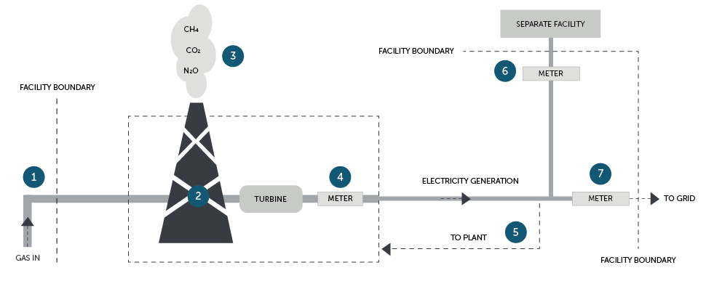

Table 10 – Summary of emissions and energy from the gas power plant

| Process Point | | Reportable emissions | Reportable energy production | Reportable energy consumption | Notes |
| --- | --- | --- | --- | --- | --- |
| 1 | ‘Natural gas transmitted or distributed in a pipeline enters plant | None | None | None | Gas supply pipeline is outside of the facility boundary and hence leaks from the pipeline do not need to be reported |
| 2 | Gas combustion. | If generation unit < 30 MW or production < 50,000 MWh in the reporting year, emissions estimation can be made using default emission factors under method 1  Otherwise minimum method 2, and method 3 also available  Fuel combustion emissions | None  Electricity is not produced at this process point – these are produced at number 4 | ‘Natural gas transmitted or distributed in a pipeline’ is consumed through combustion for the purpose of producing electricity | See chapter 4 of this guideline for estimating emissions from fuel combustion  Only one method for estimating emissions should be used for the single occurrence of the source in the case example  In selecting an appropriate method, reporters must observe the restrictions for using a lower method from previous year in section 1.18 of the NGER Measurement Determination |
| 3 | Direct measurement of carbon dioxide emissions (if using method 4) | If direct measurement of emissions using method 4:  Fuel combustion emissions | None.  Energy consumption is reported at number 2 |
| 4 | Electricity generation at turbine | None | None  ‘Electricity’ is produced from the turbine and generator, but is reported at numbers 5 to 7 | None | Electricity produced must be metered at the terminal directly after the turbine - see chapter 7.3.1 of this guideline |
| 5 | Own produced electricity consumed by facility | None  This is not a scope 2 emission, because direct emissions caused by facility discharged at (number 3) | Electricity produced ‘for use for the purpose of the operation of the facility’ - that is, for ‘for use onsite’  Calculated as residual amount of number 4 not delivered at number 6 or 7. | ‘Own produced electricity’ is consumed for use in own facility | Electricity consumed by the plant must be calculated as per chapter 7.3.1 of this guideline |
| 6 | Produced electricity delivered directly to nearby facility | None | Electricity produced ‘for use outside the operation of the facility other than for the supply to an electricity transmission or distribution network’ - that is, for ‘use offsite, not supplied to network’ | None | The amount of electricity should be measured as delivered (as close to boundary as possible)  That other facility should report this electricity use as scope 2 emission (provided it is acquired through a commercial transaction)  The gas-fired power station should preferably provide the other facility with the emissions factor for the produced electricity |
| 7 | Electricity transferred to an electricity network | None | Electricity produced ‘for use outside the operation of the facility for supply to an electricity transmission or distribution network’ – that is, ‘for use offsite, supplied to network’ | None | Electricity transferred to the electricity network must be metered at the network connection point by the distributor - see chapter 7.3.1 of this guideline |

### Case example 2: Hydro power plant

Figure 9 shows an overview of the main types of energy production and consumption processes at a hydro power plant. Each circled number on the diagram relates to a main process point.

Table shows the emissions, energy consumption, energy production, and additional reporting requirements associated with each of these process points.

#### NGER activities and industry sector

The hydro power plant facility has been classified as a single facility for NGER reporting purposes. The correct ANZSIC code is ‘261 Electricity generation’. It includes the following reportable activities:

* **Energy reporting for electricity produced**:
  + Electricity is produced in a turbine (number 3 as metered at number 4).
  + A portion of the electricity generated is fed back into the facility for plant operations (number 5), and some is lost in a 50 km transmission line to the delivery point to the electricity network (number 6).
  + The remaining electricity generated is transferred to an electricity network (number 7).

See chapter 7 of this guideline for reporting of electricity production and for electricity produced for use onsite.

Other reportable NGER activities not included in the example are likely to occur, including:

* Scope 1 fuel combustion emissions from transport, stationary energy purposes (other than electricity generation) – for example, liquid fuel combustion in light vehicles.
* The consumption of PBOGs.
* Contractor energy and emissions data if part of the facility’s production process under the operational control of the facility (likely to include fuel combustion emissions and consumption, if occurring).

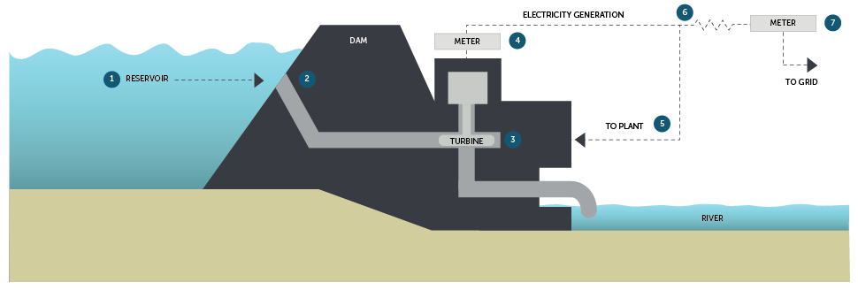Figure 9 – Hydro power plant diagram

Table 18 – Energy summary for hydro power plant

| Process point | | Reportable energy production | Reportable energy consumption | Notes |
| --- | --- | --- | --- | --- |
| 1 | Water retained by dam | None | None | The water stored at elevation by a dam contains the potential energy used to generate electricity - this is not reportable  ‘Water energy for electricity generation’ is defined as an energy commodity defined in Schedule 1 of the NGER Regulations but is only reportable as an energy consumption when used to generate electricity  The energy consumption in number 3 can be assumed to be equal to the electricity energy produced as metered at number 4 - see chapter 7.4 of this guideline |
| 2 | Water transferred through dam |
| 3 | Water turning turbine | None | ‘Water energy for electricity generation’ is consumed through non-combustion |
| 4 | Electricity generated | None  ‘Electricity’ is produced from the turbine and generator but is reported in number 5 to 7. | None | Electricity produced should be metered at the terminal directly after the turbine - see chapter 7.3.1 of this guideline |
| 5 | Electricity consumed by plant | Electricity produced ‘for use for the purpose of the operation of the facility’  Calculated as residual amount of number 4 not delivered at number 7 | Electricity production for use onsite is consumed  All produced electricity consumed or lost between production at the terminals and delivered to other facilities or network should be reported as ‘consumed by own facility’ | Own produced electricity consumed by own facility should be calculated as per chapter 7.3.1 of this guideline  All produced electricity that is consumed or lost between production at the terminals and delivered to network should be reported as ‘consumed by own facility’ |
| 6 | Transmission line losses |
| 7 | Electricity transferred to an electricity network | Electricity produced ‘for use outside the operation of the facility for supply to an electricity transmission or distribution network’ | None | Electricity transferred to the electricity network must be metered at the network connection point by the distributor - see chapter 7.3.1 of this guideline |

1. <https://www.legislation.gov.au/Series/C2007A00175>
2. [https://www.legislation.gov.au/Series/F2008L0223](https://www.legislation.gov.au/Series/F2008L02230)
3. <https://www.legislation.gov.au/Series/F2008L02309>
4. <http://www.cleanenergyregulator.gov.au/NGER/Pages/default.aspx>
5. <https://www.legislation.gov.au/Series/F2015L01637>
6. <http://www.cleanenergyregulator.gov.au/DocumentAssets/Pages/Reporting-Hydrofluorocarbons-and-Sulphur-Hexafluoride-gases-guideline.aspx>
7. <http://www.cleanenergyregulator.gov.au/NGER/Forms-and-resources>
8. <http://www.cleanenergyregulator.gov.au/DocumentAssets/Pages/Reporting-Hydrofluorocarbons-and-Sulphur-Hexafluoride-gases-guideline.aspx>
9. This requirement applies to the combustion of solid and gaseous fuels. See section 2.3(3) and section 2.19(3) of the NGER Measurement Determination relating to the combustion of solid and gaseous fuels.
10. <http://www.cleanenergyregulator.gov.au/DocumentAssets/Pages/Reporting-uncertainty-guideline.aspx>
11. Schedule 2 of the NGER Regulations provides the meaning of industry sector under the NGER legislation, including an ANZSIC code (261) for ‘Electricity generation’. Subsections 2.3(3)(a) for solid fuels and 2.19(3)(a) for gaseous fuels of the NGER Measurement Determination only apply to the ANZSIC Class code (2611) for ‘Fossil Fuel Electricity Generation’ which is within the ANZSIC Group 261. Facilities classed as 2611 for ‘Fossil Fuel Electricity Generation’ must not use method 1 to estimate emissions from their main fuel combusted to operate the facility.
12. Generator Efficiency Standards program was released in December 2006 by the former Australian Greenhouse Office, Department of Environment and Heritage
13. <http://www.cleanenergyregulator.gov.au/About/Contact-us>
14. <http://www.cleanenergyregulator.gov.au/DocumentAssets/Pages/Petroleum-based-oils-and-greases-guideline.aspx>
15. <http://www.cleanenergyregulator.gov.au/DocumentAssets/Pages/Reporting-Hydrofluorocarbons-and-Sulphur-Hexafluoride-gases-guideline.aspx>
16. <https://www.aemc.gov.au/regulation/energy-rules/national-electricity-rules/current>
17. <http://www.cleanenergyregulator.gov.au/DocumentAssets/Pages/Reporting-energy-production-and-consumption-guideline.aspx>
18. <http://www.cleanenergyregulator.gov.au/OSR/EERS/Tools-to-assist-you/Frequently-asked-questions#How-do-I-report-consumption-of-electricity-that-was-produced-for-use-during-the-operation-of-the-facility>
19. <https://www.aemc.gov.au/regulation/energy-rules/national-electricity-rules/current>
20. <https://www.ghgprotocol.org/sites/default/files/ghgp/CHP_guidance_v1.0.pdf>
21. <https://ghgprotocol.org/calculation-tools>
22. <http://www.cleanenergyregulator.gov.au/OSR/EERS/Tools-to-assist-you/Frequently-asked-questions#How-do-I-report-consumption-of-renewable-energy-commodities-for-electricity-generation>
23. <http://www.cleanenergyregulator.gov.au/DocumentAssets/Pages/Reporting-blended-fuels-other-fuel-mixes-and-bitumen-guidelin.aspx>
24. <http://www.cleanenergyregulator.gov.au/DocumentAssets/Pages/Methods-and-measurements-criteria-guideline.aspx>
25. <https://www.legislation.gov.au/Series/C2007A00175>
26. <https://www.legislation.gov.au/Series/F2008L02230>
27. <https://www.legislation.gov.au/Series/F2008L02309>
28. <http://www.cleanenergyregulator.gov.au/NGER/Forms-and-resources/Guidelines>