Enabling deep, liquid, transparent and accessible carbon markets in Australia

Discussion paper

October 2024

# The Clean Energy Regulator (CER)

We are an independent statutory agency responsible for administering legislation that reduces greenhouse gas emissions and increases the use of renewable energy.

Our purpose is accelerating carbon abatement for Australia. We achieve this by administering schemes that:

* measure, manage, reduce or offset Australia’s carbon emissions
* encourage investment in renewable energy.

The schemes we administer are the:

* National Greenhouse and Energy Reporting (NGER) Scheme
* reformed Safeguard Mechanism
* Australian Carbon Credit Unit Scheme (ACCU Scheme) (formerly known as the Emissions Reduction Fund)
* Renewable Energy Target (RET).

We provide market integrity by ensuring units and certificates are underpinned by the best available science and are validly registered/issued against legislative requirements including:

* Australian National Registry of Emissions Units (ANREU) – Australian carbon credit units (ACCUs) and Safeguard Mechanism credits (SMCs)
* Renewable Energy Certificate (REC) Registry – large-scale generation certificates (LGCs) and small-scale technology certificates (STCs)

We are preparing for new schemes being implemented by the Government including:

* Guarantee of Origin (GO) Scheme – Renewable Energy Guarantee of Origin (REGO) certificates and GO certificates
* Nature Repair Market Scheme – biodiversity certificates

Table of Contents

The Clean Energy Regulator (CER) 2

1. Purpose 4

2. Strategic context 5

3. Australia’s environmental and carbon markets 6

3.1 ACCUs 6

3.2 Renewable energy 6

4. Australia’s carbon marketplace and infrastructure 8

4.1 Current state of play 8

4.2 Developing a new modern unit and certificate registry 9

4.3 Improved user experience and accessibility of unit and certificate data 9

4.4 Connectivity to external digital OTC platforms 10

4.5 Consultation questions (registry) 11

5. Exchange-trading of ACCUs 13

5.1 Summary of potential benefits and rationale for the proposed exchange-trading model for ACCUs 13

5.2 Consultation questions (exchange trading model) 15

Appendix A: Prototype exchange-trading model 17

A.1 Fungibility, liquidity and longevity considerations for a carbon exchange 17

A.2 Identification and usability of ACCUs for offset purposes 18

A.3 Settlement of carbon exchange trades in ACCUs 19

A.4 Timeliness of establishment of an ANREU account 20

A.5 Converting ACCU holdings into CDI holdings 21

A.6 Converting CDI holdings into ACCU holdings 22

Appendix B: Schemes administered by the CER 23

B.1 ACCU Scheme 23

B.1.1 ACCU projects and methods 23

B.1.2 Audit and integrity of ACCU projects 24

B.2 NGER and the Safeguard Mechanism 24

B.3 Cost containment measure 25

B.4 REGO, GO and nature repair certificates 26

# 1. Purpose

Efficient, deep and transparent carbon markets play an important role in supporting Australia to meet its legislated climate targets of reducing net greenhouse gas emissions to 43% below 2005 levels by 2030 and achieving net zero by 2050. Carbon markets provide the necessary signals to reduce emissions and attract investment into carbon abatement and renewable energy projects.

The CER supports carbon markets through the provision of key system infrastructure, information and reporting processes to record, track and monitor the trading of ACCUs, SMCs, LGCs and STCs.

On 19 December 2023, the CER announced Trovio Group was selected to develop and deliver a modern Unit & Certificate Registry (the registry).

This registry will be an important foundation to modernise our registries by providing future interoperability options so that other trading platforms, exchanges and other service providers can connect directly via application programming interfaces (APIs), facilitating increased access and real time connectivity, for the trading in carbon, renewable energy, and nature repair markets, fostering market innovation, interoperability and growth.

Additionally, users of the registry will have improved real-time visibility of their unit and certificate holdings and enhanced filtering, sorting and data extraction capabilities through direct API connectivity with the registry and Online Services. The registry will also be better integrated with the CER’s other online services, giving users a more seamless user experience.

While we expect users through the CER’s new online services will have a much-improved user experience, we are **not** building functionality to replace or compete with current over the counter (OTC) and other existing exchange trading platforms. The CER will not be a market operator but seeks to enable and facilitate new exchange trading platforms, services and market operators.

In this paper we explore the potential for interoperability between the CER’s new registry (and systems) and other existing (or future) digital platforms and exchanges. This includes understanding potential market benefits from interoperability and the potential operating models.

This consultation paper seeks stakeholder feedback for the following two purposes:

1. Identify key market needs and priorities for the establishment of new market infrastructure, including a modern registry, that allows market participants multiple pathways to access carbon markets.
2. Test the feasibility of establishing a mechanism for exchange trading of ACCUs.

We acknowledge the assistance of the Australian Securities Exchange (ASX) on the options outlined in this paper for the exchange trading of ACCUs.

# 2. Strategic context

Australian Government policies have played a pivotal role in supporting the development and growth of environmental markets by providing investment signals and incentives for entities to reduce and offset emissions, and shift to clean energy sources. This has been driven by Australia’s legislated greenhouse gas emissions reduction targets and reinforced by regulatory schemes and reporting settings, such as the NGER Scheme, the ACCU Scheme, the RET and the Safeguard Mechanism. Future schemes such as GO and Nature Repair Market will provide an accreditation system and regulatory frameworks for products, including hydrogen, green metals, carbon liquid fuels, all forms of renewable electricity, and biodiversity.

Mandatory climate risk disclosure reporting and market-based accounting will hold corporate entities accountable for informing the public and markets on their exposure to climate-related financial risk and opportunities.

Looking ahead carbon markets will increasingly continue to play a crucial role in supporting capital flows and reducing emissions. Declining emissions baselines under the Safeguard Mechanism will incentivise industry to reduce emissions, invest in onsite carbon abatement and either generate or source SMCs and ACCUs from the market to offset residual emissions.

Globally, the race to secure critical capital and investment into clean energy is becoming more competitive with countries implementing significant clean energy and critical minerals programs, such as the United States’ Inflation Reduction Act, the European Green Deal and Japan’s Green Transformation Policy. As part of the 2024-25 Budget, the Australian Government has announced the Future Made in Australia agenda which will maximise the economic and industrial benefits of moving to net zero emissions and assist in securing Australia’s position in an evolving economic and geopolitical landscape.

# 3. Australia’s environmental and carbon markets

Broadly Australia’s environmental and carbon markets cover ACCUs, and renewable energy related certificates, such as LGCs and STCs.

With the introduction of the GO Scheme and Nature Repair Market Scheme, certificate markets will further expand to include REGO certificates (which includes replacing LGCs post 2030) and biodiversity certificates. Further information on these schemes can be found in Appendix B.

## 3.1 ACCUs

Demand sources for ACCUs are driven by compliance obligations, voluntary purposes and delivery against Commonwealth carbon abatement contracts. Initially the Commonwealth of Australia, through the Commonwealth carbon abatement contract process, was the main demand source for ACCUs. However, non-Commonwealth demand for voluntary and non-Safeguard compliance purposes has grown significantly over the years. In the coming years, demand from Safeguard entities is expected to increase as they acquire and surrender ACCUs to meet their regulatory obligations under the reformed Safeguard Mechanism.

Figure 1: Non-Commonwealth ACCU cancellations by demand source over time.

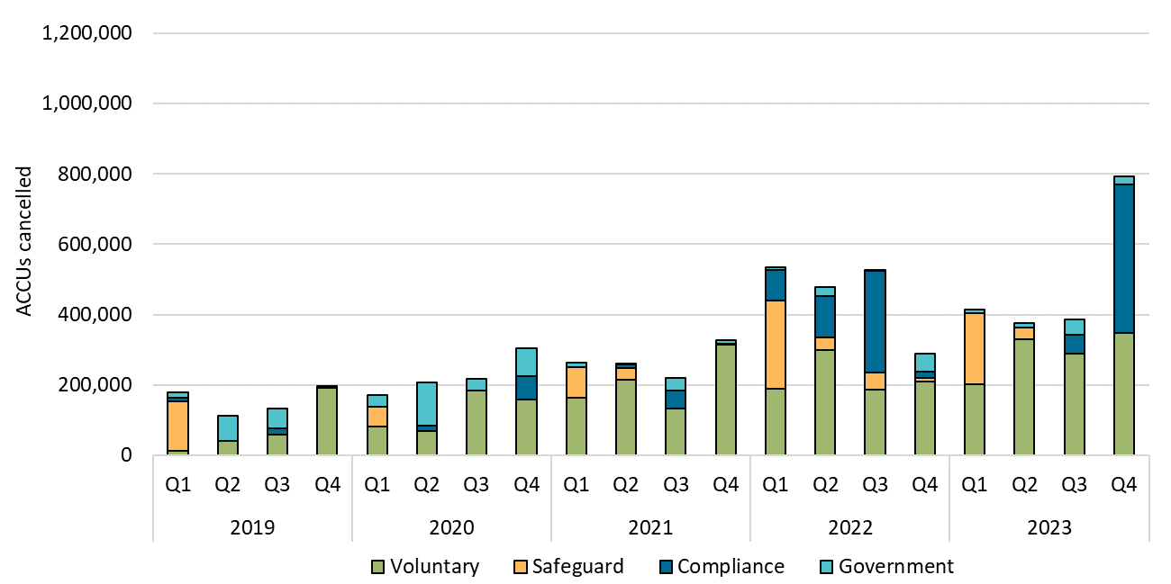

ACCU supply continues to grow steadily each year. At the end of 2023, a total of 17.2 million ACCUs were issued. This was slightly lower than 2022, when 17.7 million ACCUs were issued. For 2024, it is expected that around 20 million ACCUs will be issued. As of June 2024, using the average generic ACCU spot price of $34.00, these ACCU holdings are currently worth approximately $1.3 billion.

## 3.2 Renewable energy

Investment in renewables is supported by the RET through the supply and demand of around 35 million LGCs and STCs in total each year. LGCs and STCs provide incentives for additional investment into renewable energy and drives new projects and installations.

In 2023, the total estimated generation incentivised by the Small-scale Renewable Energy Scheme (SRES) and Large-scale Renewable Energy Target (LRET) was 27,900 gigawatt hours (GWh) and 48,800 GWh respectively. This represented around 28% of all electricity generation in Australia, 12% higher than 2022. For completeness, the large-scale renewable energy that is ineligible for LGCs is on average about 12,000 GWh per annum. This may be eligible for REGOs under the proposed GO scheme.

For 2024, we expect 3.1 GW of rooftop solar and 3-4 GW of large-scale renewables to be installed.

The primary sources of demand for LGCs are the renewable power percentage (RPP) compliance obligations, cancellations for shortfall charge refunds and voluntary demand to prove the use of renewable energy. In 2023, liable entities surrendered 29.9 million LGCs toward their 2023 RPP compliance obligations, 5.3 million LGCs were cancelled for shortfall refund and 8.7 million LGCs were cancelled for non-RET demand.

Figure 2: Annual LGC cancellations by demand source

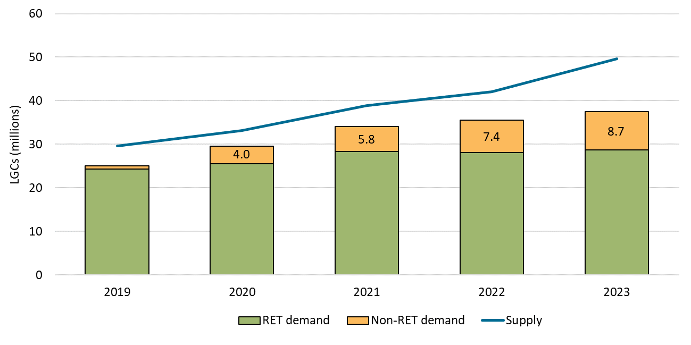

On the supply side, a total of 49.6 million LGCs were validated for 2023 (up from 42.1 million from 2022). This was made up of 15.5 million for solar, 30 million for wind and the remaining was from hydroelectricity, biomass and other sources.

# 4. Australia’s carbon marketplace and infrastructure

## 4.1 Current state of play

The carbon market has expanded significantly in recent years, and this has created opportunities for different business models and services to emerge to facilitate trading of ACCUs, LGCs and STCs. Trading currently occurs through ‘OTC’ trading, either involving the services of a broker or an intermediary to facilitate the trade, or direct trading between buyers and sellers. The transfer of units and their legal title is undertaken through a direct transfer within the registries operated by the CER.

For ACCUs (and in the future, SMCs), this is the ANREU, and for LGCs and STCs, the REC Registry. Any financial settlement associated with a transfer takes place externally to the ANREU and REC Registry. Once transferred, units and certificates can be held, further transferred, voluntarily cancelled and surrendered.

Overall, the ANREU and REC Registry have facilitated a secure functioning market to date, through accurately recording and tracking units and certificates. However, they are based on aging technology, and it is clear that fit-for-purpose, modern infrastructure is required to facilitate further innovation and scaling within the carbon market and accelerate institutional adoption. Some of the challenges and complexities faced by the current registry infrastructure include:

* **Market accessibility and transaction costs -** it can be difficult for new buyers and sellers to connect with each other. While digital OTC trading platforms and brokerage services have emerged to facilitate this connection, they are restricted by the need for manual settlement within the registries, increasing the cost and risks of doing business for all participants. This is a particular barrier for retail buyers as it makes purchasing small volumes of units and certificates less economical. For brokers and intermediaries, small trades can represent a disproportionate cost. Accessible infrastructure that consolidates multiple types of units and certificates in one location and enables trusted digital trading platforms and account holder systems to connect directly has the potential to improve market accessibility and reduce transaction costs. This includes the ability to facilitate an end-to-end process automation, where the API could integrate with Enterprise Resource Planning (ERP) processes to link risk, and inventory management systems in the back office.
* **Accessibility and transparency of unit and certificate attributes -** ensuring buyers and sellers have access to the same, complete, trusted and accurate data that underpins units and certificates is central to efficient and effective markets. The current registries are limited in their ability to enable the market to access and share that data.There is demand for units and certificates both for their carbon value and co-benefits associated with specific attributes, such as project methodology, location and broader socio-economic co-benefits. The accessibility of data stored on the registers, and the ability to manage, export and filter holdings of units and certificates based on that data, is integral to meeting the needs of the market and ensuring that the whole market has access to consistent and trusted information.
* **Management of counter-party risk –** while the registries are able to facilitate OTC markets, this requires buyers and sellers to manage counterparty risk themselves in the absence of access to licensed clearing and settlement facilities. This presents a risk to market participation.
* **Automated account management** - current registries provide most of the required functionality to manage unit and certificate inventories manually over dedicated online interfaces. However, to ensure the registry is fit for purpose for institutional adoption and capital flows, the registry requires automation of transaction and information flows aligning with global institutional market standards. Without the integration of approved external systems, business processes are inefficient with heightened operational risks and capital costs, which can result in hindering innovation.
* **Integration with innovative future services –** the market forservices and solutions directly integrating with environmental assets is still in its infancy. Yet many innovations and promising business models that could further generate mainstream adoption, and therefore growth of demand from carbon offsets, are restricted or even stifled by the lack of integration options with existing registries.

## 4.2 Developing a new modern unit and certificate registry

To address the infrastructure challenges currently faced by carbon markets, the CER is developing a modernised unit and certificate registry (the registry) built on Trovio’s CorTenX - a scalable, customisable and interoperable digital registry technology designed exclusively for environmental assets.

Units and certificates will be progressively moved to the registry, with SMCs being onboarded first in 2024, followed by REGOs, Nature Repair Market certificates and ACCUs during 2025. LGCs and STCs will remain in the current REC Registry for the foreseeable future.

The registry will have the potential to support the following functionality:

* provide account holders with an improved user experience for the management, transfer of holdings, and accessibility of unit and certificate attribute data,
* provide API access to account holders via approved external systems and platforms for real-time reconciliations and retirements,
* enable external digital OTC platforms to connect directly via API, and
* enable exchange-based trading, including new futures markets and (if possible) trading of units and certificates.

## 4.3 Improved user experience and accessibility of unit and certificate data

An enhanced registry user interface will make it easier for account holders to trade, meet their regulatory obligations and engage in voluntary emissions reduction by consolidating multiple unit and certificate types in a single location. The registry and new user interface will improve the accessibility of holdings data, and the ability to manage, export and filter holdings based on specific attributes. The comprehensive API functionality has the potential to allow easy integration with market participants’ back-office systems enabling efficient information retrieval and transaction automation.

The user interface will be able to show other attributes to unit and certificate holdings that may be deemed important to informing the relevant markets. In the case of ACCUs, this includes relevant information specific to the time of issuance of the ACCU, including project name, location, and methodology. This will allow improved visibility, management and filterability of ACCUs by attributes that may influence decisions regarding their use. For example, ACCU project methodology is a publication requirement for ACCUs surrendered for Safeguard Mechanism compliance purposes.

Other project related information such as co-benefits could also be potentially supported to provide greater transparency on ACCU projects that deliver co-benefits and better inform price premiums. This in turn would facilitate greater investment in projects not just for their carbon value, but broader economic, cultural and environmental benefits. Co-benefits can support companies who are looking to align their carbon strategies with their environment, social and governance objectives.

However, a key challenge is the absence of a regulatory framework that governs co-benefit claims and reporting processes that accurately and reliably quantify, measure, report and verify co-benefits. These processes would be needed to underpin the integrity of co-benefit information and provide market confidence.

## 4.4 Connectivity to external digital OTC platforms

CorTenX’s ‘API-first’ solution design will provide the architecture for approved external systems to connect to CER’s systems via APIs. A robust cryptographic framework of access keys and transaction signing ensures irrefutable system-to-system authentication and secure end-to-end communication, creating a trusted, highly interoperable registry environment. Allowing the market to innovate and form by leveraging direct access and functional integration will foster transparency, growth and scalability. Online services will give users different pathways to participate, in turn increasing market accessibility and information transparency.

The eligibility of an external system to connect with the registry will be subject to system specific criteria and authentication of access. The CER has identified the below criteria to be applied when determining whether an external system would be eligible to connect directly to the registry.

|  |  |
| --- | --- |
| Criteria | Matters for consideration |
| Security and privacy | 1. Protection of registry data through the implementation of secure data handling and protection regulations and standards. 2. Verification of account users accessing the registry through external systems by implementing robust authentication mechanisms. |
| Compatibility and interoperability | 1. Use of standardised APIs to facilitate communication between the registry and external systems. 2. Use of compatible data formats and structures to allow efficient data exchange. 3. Technical capability and resources of the external system to support integration with the registry. 4. Establishment of maintenance and support processes of the external system. |
| Legal and regulatory compliance | 1. The legal jurisdictions involved and compliance with relevant laws and regulations. 2. Establishment of clear contractual agreements between parties, outlining responsibilities, liabilities, and terms of service. |
| Strategic fit | 1. Alignment of the business goals and strategies of the external system with the objectives of the CER and broader carbon market. |
| Scalability | 1. Ability of the external system to handle increased traffic and transactions without degradation in performance. 2. Use of scalable infrastructure to support growth and spikes in demand. |
| Trust and reputation | 1. The reputation, trustworthiness and track record of reliability of the external system and the system operator. |
| Financial considerations | 1. Costs of the connectivity and ongoing operation. |
| Monitoring and analytics | 1. Implementation of monitoring and analytical tools to track the performance, health and effectiveness of the connection. |

Clear governance arrangements and rules for connecting to the registry will be required to address these criteria.

## 4.5 Consultation questions (registry)

1. What registry features and functionality will be the most important to address the current challenges faced by carbon markets?
2. What registry features and functionality will be the most important to take advantage of the opportunities presented by the growth in carbon markets?
3. Should information about the co-benefits associated with units and certificates, (for example First Nation community outcomes and environmental benefits) be made available in the registry? If so, should this include third-party verified and unverified information?
   1. What existing frameworks could be relied upon to verify co-benefits?
4. What types of digital platforms and marketplaces would be useful to have connected directly to the registry? What are the key benefits and risks of allowing this connectivity?
5. Are the criteria to allow external systems to connect directly to the registry (as listed in the table above) appropriate? Are there any other considerations that should be taken into account?
6. What registry data would external systems connecting directly to the registry need access to?
7. Are there any other areas, suggestions or concerns with the registry that should be noted?

# 5. Exchange-trading of ACCUs

## 5.1 Summary of potential benefits and rationale for the proposed exchange-trading model for ACCUs

The exchange trading of ACCUs could be beneficial to the development of the carbon market, including by:

* **Supporting market liquidity -** a centralised exchange would provide a centralised opportunity to support seller and buyer demand, with substantial supply or volume and enhanced price discovery, and facilitating the execution of advanced, high volume trading strategies.
* **Providing greater transparency and standardisation** - trading of standardised products (i.e. fungible products) to reduce complexity, improve transparency of pricing and product information (as an alternative to existing stratification), and also to provide access to market data.
* **Providing certainty and risk management** – a centralised exchange is charged with providing fair, orderly and transparent markets supported by fair and effective clearing and settlement arrangements, with established processes from trade, clearing risk management through to settlement.
* **Transparent transaction costs –** transaction costs for trading, clearing and settlement on exchange are readily available and reasonably standardised, potentially leading to lower costs for users compared to the OTC market.
* **Increasing market sophistication and access –** a centralised exchange has a dynamic network in play and supports a range of issuers, products and stakeholders, including millions of investors alongside their brokers, clearers and other intermediaries, as well as regulators. The centralised carbon exchange could further increase this network across additional and new stakeholders, including retail investors.

The [ASX](https://www.asx.com.au/markets/trade-our-derivatives-market/environmental-futures)[1] and [FEX Global](https://www.fexglobal.com.au/fex-globals-physically-deliverable-large-scale-generation-certificate-lgc-monthly-futures-contract)[2] have already moved to establish environmental futures markets with the registry playing a critical role in underpinning the settlement of physically delivered contracts for ACCUs, LGCs and New Zealand emission units.

In addition to the development of futures markets, the CER and the ASX have worked together to develop a prototype exchange trading model for ACCUs.

The exchange model would operate in a similar way to the cash equities market where ACCUs can be traded, cleared and settled, using existing market infrastructure with an end-to-end solution, including integration with the issuer (CER) registry.

A key challenge has been to develop a model that could operate in a manner consistent with the current *Carbon Credits (Carbon Farming Initiative) Act 2011* (CFI Act), *Australian National Registry of Emissions Units Act 2011* (ANREU Act) and *National Greenhouse and Energy Reporting Act 2007* (NGER Act), and provisions and the requirements for licensed markets clearing and settlement facilities, without the need for significant legislative amendments.

A summary of some of the challenges arising and how they are addressed in the design of the proposed exchange-trading model is set out below. **These are further detailed in Appendix A and should be considered prior to answering the consultation questions.**

Due to the legislative constraints preventing ACCUs from leaving the registry and the requirement that a clearing and settlement facility controls movement of assets traded on the exchange for settlement purposes, the model proposes the exchange-trading of a beneficial interest in an ACCU.

The beneficial interest would take the form of a Clearing House Electronic Subregister System (CHESS) Depository Interest (**CDI**), a mechanism already used to allow the exchange trading of interests in bonds and some international shares. The beneficial interest can be traded and could also be converted into an ACCU.

Under this model, an ANREU account would **not** be required to buy beneficial interests in ACCUs, through CDIs, via the exchange. However, if the holder of the CDI wishes to convert it into the underlying ACCU, they would need an ANREU account at this point. Removing the need for an ANREU account to trade in CDIs avoids some of the challenges arising from the timeframe for the establishment of an ANREU account for each buyer.

To support sufficient liquidity and longevity of each class of ACCU traded on an exchange, the model proposes that the beneficial interest in ACCUs would be traded through the listing of a limited number of classes, being either:

* one generic class encompassing all ACCUs; or
* two classes such as ‘carbon sequestration’ and ‘emissions avoidance’ based on the method of the ACCU project that generated the ACCU.

If a single class was listed, all ACCUs would still represent one tonne of carbon abatement.

The listing of two classes of ACCUs could allow for some market differentiation in value ascribed on the basis of whether the ACCU was classified as involving ‘carbon sequestration’ or ‘emissions avoidance’. However, with the expected growth in the demand for ACCUs from Safeguard entities over the coming years, there may be a price convergence among ACCU classes except for highly sought after ACCUs that have tangible co-benefits

While limiting the number of classes would support a cost effective, deep and liquid exchange market, it does not allow for buyers and sellers looking to trade ACCUs with specific attributes or co-benefits.

Another component of the proposed model is the process of how a CDI is converted back into an ACCU, allowing the underlying ACCU to be moved into the holder’s ANREU account. As part of this process, the relevant number of ACCUs from the nominee’s ANREU account would be transferred into the buyer’s ANREU account following a system-generated allocation process which allocates ACCUs from the underlying class to the holder.

This means the attributes (including method) of the ACCU would not be known to the holder until the ACCU has been transferred into their ANREU account. Where two classes of ACCUs were listed, the ACCUs which would be allocated under that process would be limited to ACCUs generated under a project method classified as involving ‘carbon sequestration’ or ‘emissions avoidance’ (as applicable to the class of ACCUs traded).

Where holders are not satisfied with the ACCU allocated under this process, this could create an incentive for them to cycle ACCUs through the conversion process off and onto the exchange, until they are allocated an ACCU with specific attributes that they want. The proposed model contemplates potential for controls or disincentives to address the risk of that behaviour, for example, limiting the uses of an ACCU that has been acquired via the exchange to final use (e.g. these ACCUs can only be voluntarily cancelled or used for Safeguard compliance purposes).

The exchange-trading model is not intended to be the only solution for the trading of ACCUs. It is intended to provide buyers and sellers with an alternative path to accessing ACCU markets. The OTC market would still play an important role in facilitating trades for ACCUs, particularly for those seeking to trade in ACCUs with specific attributes. In this way, an effective carbon exchange could complement the OTC market and associated online marketplaces.

## 5.2 Consultation questions (exchange trading model)

**Please read the detailed outline of the proposed exchange-trading model at Appendix A before answering the consultation questions.**

1. Please identify the specific carbon exchange user segment(s) applicable to you:
   1. Project proponent
   2. Emitter – compliance market (Safeguard responsible emitter)
   3. Emitter – voluntary market (not a Safeguard responsible emitter)
   4. Exchange participants
   5. Investor in ACCUs
   6. Other – please specify
2. Does the market need a central carbon exchange to be established?
3. Are there alternative options to a carbon exchange that could provide greater accessibility, liquidity and price discovery for ACCUs and other certificates?
4. What challenges do you foresee in the use of the CDI framework to support the carbon exchange and the proposed process to convert CDI holdings into ACCU holdings? How might these challenges be mitigated?
5. Would you use a carbon exchange that is developed using the prototype model outlined above and in Appendix A, and if so:
   1. what quantities of ACCUs do you anticipate buying or selling through the carbon exchange?
   2. how frequently do you anticipate buying or selling ACCUs through the carbon exchange?
6. Do you prefer the quotation of ACCUs on the carbon exchange to be:
   1. as a single generic class (option 1); or
   2. bifurcated into 2 classes – carbon sequestration and emissions avoidance (option 2)?
7. Do you anticipate any market implications from bifurcating listing to carbon sequestration and emissions avoidance?
8. Are there other classes that should be considered for quotation of ACCUs on the carbon exchange?
9. Would the public disclosure of the project method of an ACCU that is received, and then subsequently surrendered or cancelled, under a system generated random allocation process when converting CDIs to ACCUs:
   1. adversely impact your intended use of the carbon exchange? and
   2. is any such adverse impact mitigated by option 2 above, that is, limiting ACCUs received to those generated under a project method classified as involving ‘carbon sequestration’ or ‘emissions avoidance’ (as applicable to the class of ACCUs traded)?
10. Do you support placing controls or disincentives on the cycling of ACCUs off and onto the exchange with the intention of exchanging one ACCU with certain attributes for another, or should such cycling be allowed?
11. If controls or disincentives against cycling off and onto the exchange are to be introduced, should they involve:
    1. Restrictions on the use of ACCUs following the collapse of a CDI so that they must be surrendered for Safeguard Mechanism compliance or voluntary cancellation for offsetting purposes?
    2. Restrictions or economic disincentives on cycling ACCUs allocated upon conversion from CDIs back onto the exchange but not otherwise restricting the use of those ACCUs (e.g. so that they may be sold on the OTC market)?
    3. Some other form of restriction or disincentive?
12. Will the proposed exchange model complement the OTC market?
13. Are there other issues beyond those set out in this paper with only identifying the project method and other specific attributes of an ACCU after conversion from a CDI?
14. Are there any other areas, suggestions or concerns with the proposed exchange trading model that should be noted?

# Appendix A: Prototype exchange-trading model

Existing legislative requirements for ACCUs pose several key challenges to establishing a carbon exchange. Such challenges are described below, together with potential solutions for a prototype carbon exchange model.

Feedback on such potential solutions is sought from the various segments of the market required to make the carbon exchange a success, for example:

* ACCU project proponents
* emitters (compliance and voluntary market)
* exchange market participants
* investors in ACCUs.

This includes whether each market segment would use the carbon exchange if developed based on the solutions proposed, or if changes are required in order for them to use the carbon exchange. Specific questions for this purpose are set out under the above consultation questions.

## A.1 Fungibility, liquidity and longevity considerations for a carbon exchange

A challenge to establishing a successful carbon exchange for trading ACCUs arises from having multiple classes of ACCU based on the different and evolving project methods and additional project specific attributes for each ACCU.

This poses a challenge to the successful operation of a carbon exchange for ACCUs in three key (competing) ways:

* **Fungibility across ACCUs**: varying demand or value across different ACCUs in existing markets due to method or specific ACCU attributes (for example, premiums paid for ACCUs arising from savanna burning projects with co-benefits for First Nations people or ACCUs generated from projects in specific locations) means that not all ACCUs are perceived in those markets to be equal and interchangeable (that is, fungible), despite 1 ACCU equalling 1 tonne of carbon dioxide equivalent abated.

For the purpose of establishing a carbon exchange, this suggests there should be a segmentation of ACCUs into such number of groupings (classes) as is required so that buyers and sellers in that market view each ACCU allocated to a class as fungible with other ACCUs allocated to that class.

* **Liquidity in each class of ACCUs**: increased segmentation of ACCUs into multiple classes fragments the aggregate demand and supply for ACCUs, thereby reducing the demand and supply required to support a liquid (and clearable) market in each class of ACCUs.

For example, segregation based on the method for an ACCU project (‘project method’) would mean that demand and supply for ACCUs generated across ACCU projects would be fragmented over:

* + the 29 existing project methods, and
  + additional project methods approved under the new ‘proponent led’ process for method development launched in May 2024.

Where such segmentation also extended to additional project specific attributes this would lead to further fragmentation of demand and supply for ACCUs.

* **Longevity of each class of ACCUs**: changes arising in the ordinary course of the ACCU Scheme can affect the ongoing viability of a market in an ACCU class or necessitate new classes of ACCUs on an ongoing basis. For example, in the case of a segmentation of ACCUs into classes based on method, changes to approved methods for registering ACCU projects due to:
  + the sunsetting of existing methods, can lead to diminishing numbers of ACCUs in the affected classes (through their surrender and cancellation), impacting the liquidity and viability of that existing class, and
  + approval of new methods, can lead to the creation of further segmentation of ACCUs, raising uncertainty as to liquidity and viability of each new class, particularly if the new ‘proponent-led’ process for method development leads to a significant expansion of methods or a diminishing number of projects and ACCUs generated under each new method.

In designing the prototype model for the proposed carbon exchange, two options have been identified for consultation under this paper as potential solutions to the above challenges, with:

* both options seeking to keep the number of available ACCU classes to a minimum to enhance liquidity and longevity of each ACCU class
* the second option seeking to accommodate, at a broad level, fungibility considerations for ACCUs in each class.

**Option 1** - The quotation of all ACCUs on the carbon exchange under one generic class. This would treat all ACCUs on the single basis of representing one tonne of carbon abatement, and not allow for segmentation of ACCUs based on method or other attributes.

**Option 2** - The quotation of all ACCUs on the carbon exchange to be split (‘bifurcated’) into two classes - ‘carbon sequestration’ and ‘emissions avoidance’. While this would also treat all ACCUs based on representing one tonne of carbon abatement, it allows for the grouping of ACCUs reflective of the two broad basis for ‘carbon abatement’ contemplated under the legislation covering ACCUs, relevantly:

* the sequestrationof one or more greenhouse gases from the atmosphere, and
* the *avoidance* of emissions of one or more greenhouse gases.

The bifurcation would occur based on whether the project method under which the ACCU has been generated, has been classified by the CER as involving either ‘carbon sequestration’ or ‘emissions avoidance’. This grouping of ACCUs can allow for any difference in demand or value ascribed by the market to ACCUs on such broad basis, and so enhance fungibility of ACCUs within that grouping.

For the duration that beneficial interests in the ACCUs in the form of CDIs (as referred to below) are available for trading on the exchange, the ACCUs would be held in a specific ANREU account (**relevant ANREU account**), with in the case of Option 2, the potential for separate ANREU accounts reflecting the bifurcation of project methods, i.e. so that each account only contains ACCUs whose project methods have been classified as ‘carbon removal’ or ‘emissions avoidance’ (as applicable).

## A.2 Identification and usability of ACCUs for offset purposes

A potential impediment to the potential solutions for a prototype carbon exchange model under options 1 and 2 above relates to the need for the specific ACCUs being used to offset emissions to be identifiable, affecting the disclosures to be made in connection with such offset, with potential scope also to impact offset values for Safeguard facilities.

When ACCUs are sought to be used for offset purposes, for example surrendering ACCUs for the purpose of compliance under the Safeguard Mechanism, the ACCUs being used for that purpose must be specifically identified to the CER to allow for the corresponding cancellation and removal of those ACCUs from the ANREU.

For beneficial interests in ACCUs in the form of CDIs (as referred to below) acquired on the carbon exchange which are sought to be used for offset purposes, this will require that there is a process to allocate specific ACCUs for that purpose.

It is proposed that this allocation be performed by the CER on a system-generated basis to randomly allocate ACCUs, using in the case of:

* option 1, any of the ACCUs recorded in that ANREU account to the single general class, or
* option 2, where the ACCU acquired on the carbon exchange was in the:
  + ‘carbon sequestration’ class, any of the ACCUs recorded in that ANREU account to that class;
  + ‘emissions avoidance’ class, any of the ACCUs recorded in that ANREU account to that class.

As result of that allocation process, the attributes for each of the ACCUs allocated will be identifiable in the account of the ACCU holder seeking to use the ACCUs for offset purposes.

Under the NGER Act, the CER is required to publish the project method(s) for the ACCUs being surrendered by a Safeguard facility for compliance with Safeguard obligations under that legislation, with the publication proposed to be made on the CER’s website. Accordingly, the system-generated allocation of ACCUs in the ANREU will determine the method that is published by the CER in connection with that surrender. No equivalent publication obligation exists in relation to the voluntary cancellation of ACCUs.

Where holders are not satisfied with the ACCU allocated, this could create an incentive for the cycling of ACCUs onto and off the exchange with the intention of exchanging one ACCU with certain attributes for another (e.g. based on project method or other ACCU specific attributes) until they are allocated an ACCU with specific attributes that they want.

Potential controls for this could include requiring ACCUs that are removed from trading on the exchange can only be used for either surrendering for the purpose of compliance under the Safeguard Mechanism or for voluntary cancellation for offsetting emissions. This would mean the ACCUs cannot continue to be held on the ANREU or be sought to be made available for trading again on the exchange or through an OTC market.

## A.3 Settlement of carbon exchange trades in ACCUs

A further challenge to establishing a carbon exchange which facilitates the clearing and settlement of ACCU trades in the same way as for other securities arises due to the need for ACCUs to be registered in the ANREU.

Under the CFI Act, ACCUs exist by being recorded in a holder’s account on the ANREU, with legal title to ACCUs unable to be held outside the ANREU.

For all classes of financial products (referred to generally as ‘securities’ in this paper) traded on Australian cash equities markets using ASX clearing and settlement services, while legal title to the securities in that class does not need to be held in CHESS at all times, movement of title onto CHESS is a requirement for settlement of market trades in those securities.

This is fundamental to the performance of clearing and settlement of trades on those markets on a delivery versus payment (DvP) basis by ASX Clear and ASX Settlement as licensed clearing and settlement (CS) facilities, and also assists with timely settlement – currently trade date + 2 business days (T+2).

In designing the prototype model for the proposed carbon exchange, it has been sought to satisfy both of the above requirements regarding the holding of ACCUs.

This seeks to leverage a model currently in place for the trading, clearing and settlement of securities of foreign issuers whose place of incorporation doesn’t recognise electronic transfer of their securities in CHESS and for Australian government bonds recorded in Austraclear.

Where CHESS cannot be used directly for the transfer of some types of securities, ASX utilises the CDI structure, pursuant to which a CDI is maintained and transferred in CHESS in respect of the underlying securities.

Under this structure, a nominee appointed by the issuer holds legal title to the underlying security on the primary register for those securities, with the issuer in turn issuing CDIs which are recorded on the CDI register and can be maintained in CHESS or otherwise moved to CHESS to facilitate settlement of trades. CDI holders have legal title to the CDI and through the CDI a beneficial (but not legal) interest in the underlying security. ASX currently operates a nominee entity -CHESS Depositary Nominees Pty Limited (CDN) which issuers can, but are not required to use for this purpose.

Under this model, it is legal title to the CDI that is traded on the carbon exchange and transferred in CHESS as part of settlement of a trade.

In the case of ACCUs, this would involve the ACCUs continuing to be held on the ANREU in the relevant ANREU account of the nominee appointed by the CER, with CDIs being issued by the CER in relation to each underlying ACCU in that account on a 1:1 basis. This would give a CDI holder legal title to the CDI and a beneficial interest in an underlying ACCU maintained in the nominee’s ANREU account.

The CDIs will be able to be traded on the carbon exchange and transferred in CHESS as part of settlement of such trades, and also be transferable on the register maintained for CDI holdings (whether in CHESS or the issuer subregister) as requested by CDI holders, in the same way as other securities.

For the duration that a CDI is on issue and available for trading on the carbon exchange, an underlying ACCU will be held and maintained in the relevant ANREU account of the nominee appointed by the CER, so at all times an ACCU underlies each CDI.

The CDI will also be convertible into a legal interest in the ACCU where the CDI holder also maintains an ANREU account as referred to below under ‘Converting CDI holdings into ACCU holdings’.

## A.4 Timeliness of establishment of an ANREU account

An additional challenge arising from requirements for ACCUs to be registered and recorded in a holder’s account on the ANREU, is that it currently takes approximately 90 days for a person to establish an ANREU account, including to allow them to satisfy the requirement under the ANREU Regulation that they meet a fit and proper person test as prescribed in related legislative rules.

This would prevent the transfer of ACCUs to a buyer under a trade on the carbon exchange until an ACCU account has been established for ACCU holdings of the buyer on the ANREU. Given that market trades in securities are currently settled on a T+2 basis, this would be a significant impediment to transfers to holders in connection with settlement of trades on the carbon exchange, noting that the cash equities market is currently accessible by several million investors.

The design of the prototype model for the proposed carbon exchange proposes to address this challenge by using the CDI structure referred to above.

The nominee appointed by the issuer would establish an account on the ANREU for the holding of ACCUs, including satisfying the fit and proper person test, prior to commencement of the carbon exchange.

Holdings of CDIs issued in relation to those underlying ACCUs would be recorded in the accounts of CDI holders on a separate CDI register maintained by the issuer, in the same way as holdings of other securities traded on the cash equities market.

Consistent with the model that generally applies for CDIs (and other securities) traded on the cash equities market, it is anticipated that such CDI holder accounts can be recorded on the:

* CHESS subregister against the CDI holder’s holder identification number (**HIN**); or
* issuer subregister against the CDI holder’s security holder reference number (**SRN**),

with these subregisters together constituting the issuer’s CDI register.

This avoids the need for a buyer of CDIs on the carbon exchange to hold a corresponding account in the ANREU, allowing for prompt accessibility to trading across the range of buyers, whether emitters, investors or otherwise, with brokers able to then facilitate buy and sell transactions for a client via the client’s CDI holding recorded under their HIN or SRN.

To have a HIN recorded on the CHESS subregister, the ACCU holder must have a sponsorship arrangement in place with a participant of ASX Settlement. Where CDIs in relation to underlying ACCUs are held in the holder’s HIN, this allows the holder to aggregate such CDI holdings with their other security holdings.

CDIs can also be moved between the issuer subregister and CHESS subregister following their issue to the CDI holder.

CDIs will also be convertible into a legal interest in ACCUs where the CDI holder also maintains an ANREU account.

Further information on the proposed process by which:

* ACCUs can be converted to CDIs at the nomination of ACCU holders to allow for trading of CDIs on the carbon exchange, and
* CDIs to be converted to ACCUs at the nomination of CDI holders to allow for emissions offsets,

is set out below.

## A.5 Converting ACCU holdings into CDI holdings

Under the prototype model for the proposed carbon exchange, holders of ACCUs in an ANREU account who wish to sell them via the carbon exchange would nominate the ACCUs that they wish to make available for sale via the exchange.

The ACCUs would then be transferred from the holder’s ANREU account to the nominee’s ANREU account. Upon transfer, the nominee would no longer be able to view the attributes of the ACCU holdings in its ANREU account.

A CDI would then be issued into the ACCU holder’s nominated HIN or SRN (as applicable). One CDI will be created for every ACCU transferred into the nominee’s ANREU account. Fractional units of ACCUs will not be available.

The process of converting an underlying security into a CDI and back is referred to as ‘transmutation’.

Figure 3: Process to convert ACCU holdings into CDI holdings

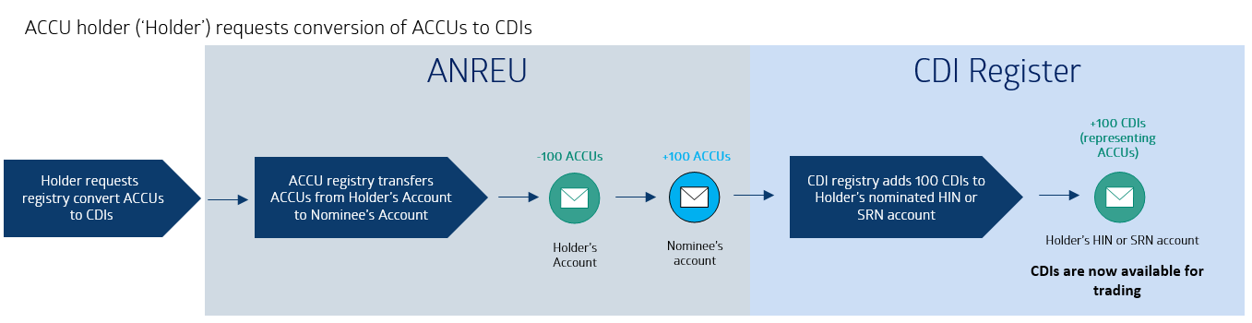

## A.6 Converting CDI holdings into ACCU holdings

Where the CDI holder also maintains an ANREU account, it could request that its CDI holding be converted to a direct holding of ACCUs.

This could occur if the CDI holder sought to use the ACCUs to offset emissions. For example, surrendering ACCUs for the purpose of compliance under the Safeguard Mechanism or for voluntary offsetting of emissions.

The CDI would then be removed from the CDI holder’s HIN or SRN (as applicable) and an ACCU (allocated from within the corresponding class of ACCUs quoted on the carbon exchange as indicated above) would then be transferred from the nominee’s ANREU account to the holder’s ANREU account.

Upon transfer from the nominee’s ANREU account, the attributes of the ACCU would then be visible in the holder’s ANREU account. That is, the method (for example, human induced regeneration (HIR)) and other specific ACCU attributes would be unknown until after the transfer from the nominee’s ANREU account.

Figure 4: Process to covert CDI holdings into ACCU holdings

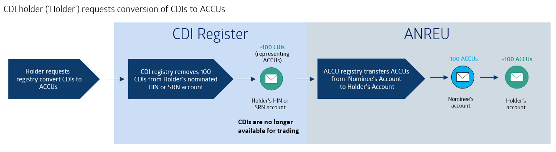

# Appendix B: Schemes administered by the CER

## B.1 ACCU Scheme

The CFI Act establishes that one ACCU represents one tonne of verified carbon dioxide equivalent (tCO2-e) captured or avoided. The ACCU market evolved as part of the Carbon Pricing Mechanism which commenced from 1 July 2012 and was repealed in 2014. The CFI Act underpinned the subsequent Emissions Reduction Fund, which is now known as the ACCU Scheme.

Since 2012, over 146 million ACCUs have been issued and more than 80 million ACCUs have been delivered under contracts to the Commonwealth of Australia. In addition, ACCU holdings by private and non-Commonwealth entities have grown to over 40 million from less than 0.4 million at the end of 2012.

### B.1.1 ACCU projects and methods

Projects that reduce emissions or store carbon in soils and vegetation form the basis of an ACCU using prescribed methodologies. Currently, there are around 30 methods available for registering a project under the ACCU Scheme. Further information about available [ACCU Scheme methods](https://cer.gov.au/schemes/australian-carbon-credit-unit-scheme/accu-scheme-methods) can be found on the CER’s website.

HIR, landfill gas and avoided deforestation methods have generated the greatest volume of ACCUs over the years, with HIR producing the majority of ACCUs. Under the HIR method, ACCUs are credited to landholders who regenerate native forest by changing land management practices. However, the HIR method has expired, with no new projects being registered under this method from 1 October 2023.

In line with a recommendation made by the Independent Review of Australian Carbon Credit Units (the ACCU Review), developing a method is now an open process where anyone can propose new methods or changes to existing methods whilst leading the development. In order to maintain integrity and consistency, methods must still satisfy the legislated offsets integrity standards to ensure the emission reductions are real and in addition to business-as-usual operations. Methods are subject to periodic review by the Emissions Reduction Assurance Committee (soon to be renamed the Carbon Abatement Integrity Committee) and approval by the Minister for Climate Change and Energy.

Figure 5: Total number of ACCUs issued by project method, 2019 to 30 April 2024

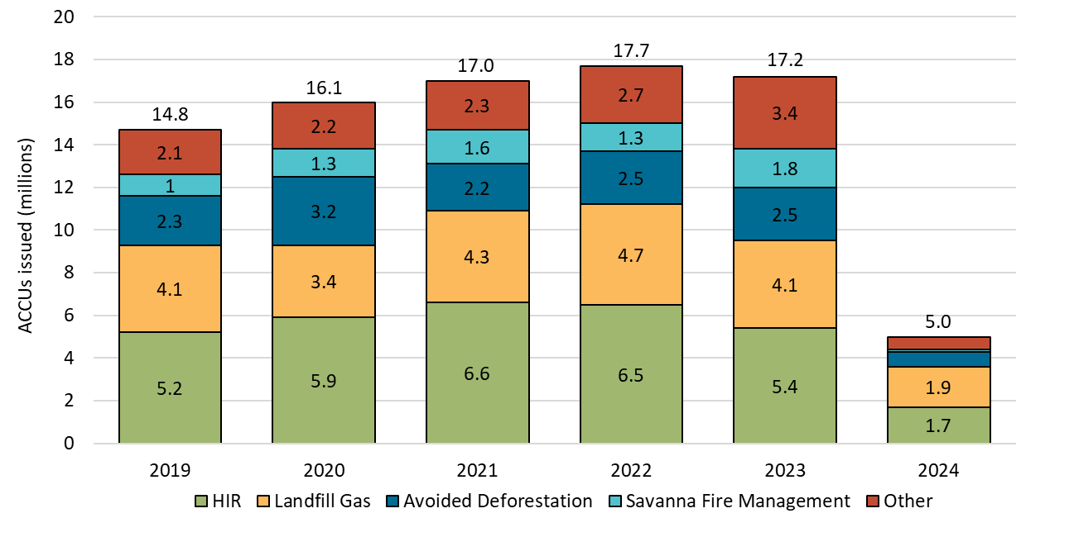

### B.1.2 Audit and integrity of ACCU projects

Under the ACCU Scheme, projects are subject to audit and reporting processes to assure the amount of emissions reduction or the storage of carbon in soils and vegetation. The integrity of ACCU projects is crucial, as projects ultimately underpin the value of ACCUs, and provides confidence to the market that the carbon abatement achieved is real, additional and measurable.

In January 2023, the final report of the ACCU Review was released and found that the ACCU Scheme was essentially sound. It made 16 recommendations to clarify governance, improve transparency, facilitate positive project outcomes and co-benefits, and enhance confidence in the integrity and effectiveness of the scheme. The Australian Government accepted all 16 recommendations in-principle and has been progressively implementing reforms recommended in the final report.

ACCU Scheme projects are subject to rigorous reporting and audit requirements. Project participants must report at least every two years for emissions avoidance projects, and five years for sequestration projects. If a project applies an area-based method, geospatial data must be provided. Projects must also be regularly audited and once a project is registered, an audit schedule is developed which sets out the level of assurance, frequency of audits and scope. For some low-risk projects, there is an exception to this. Auditors must be registered as a category 2 greenhouse and energy auditor, and it is encouraged that at least two different auditors from different companies be engaged over the life of the project.

## B.2 NGER and the Safeguard Mechanism

The NGER framework is a primary plank that underpins the Australian Government’s climate and emissions policies and regulatory frameworks. The NGER framework establishes:

* the NGER Scheme, which requires certain companies to report their greenhouse gas emissions and energy production and consumption,
* the Safeguard Mechanism, which places emissions limits on large industrial facilities, and
* the compliance and administration frameworks to support reporting and emissions limits.

NGER is the key data reporting tool that provides transparency and integrity to greenhouse emissions and energy production and consumption levels within Australia.

The Safeguard Mechanism complements the NGER Scheme by driving down emissions from Australia’s largest emitting facilities. Under the Safeguard Mechanism, legislated baselines are applied to the scope 1 greenhouse gas emissions of these facilities. Prior to 2023, these baselines remained relatively static. However, from 1 July 2023 Safeguard entities are subject to declining baselines to ensure facilities contribute to the Australian Government’s emission reduction targets of 43% below 2005 levels by 2030, and net zero emissions by 2050.

Safeguard facilities that exceed their baseline can choose to surrender ACCUs or SMCs, or apply (if eligible) to either become a trade-exposed baseline-adjusted (TEBA) facility, borrow baseline from the following financial year, or move to a multi-year monitoring period (MYMP).

Where a facility is successful in reducing its emissions below its baseline, subject to conditions, a SMC can be issued for each tCO2-e reduced below the baseline. SMC crediting will be determined from annual emissions reporting under the NGER Scheme.

Figure 6: SMCs – supply, demand and outcomes

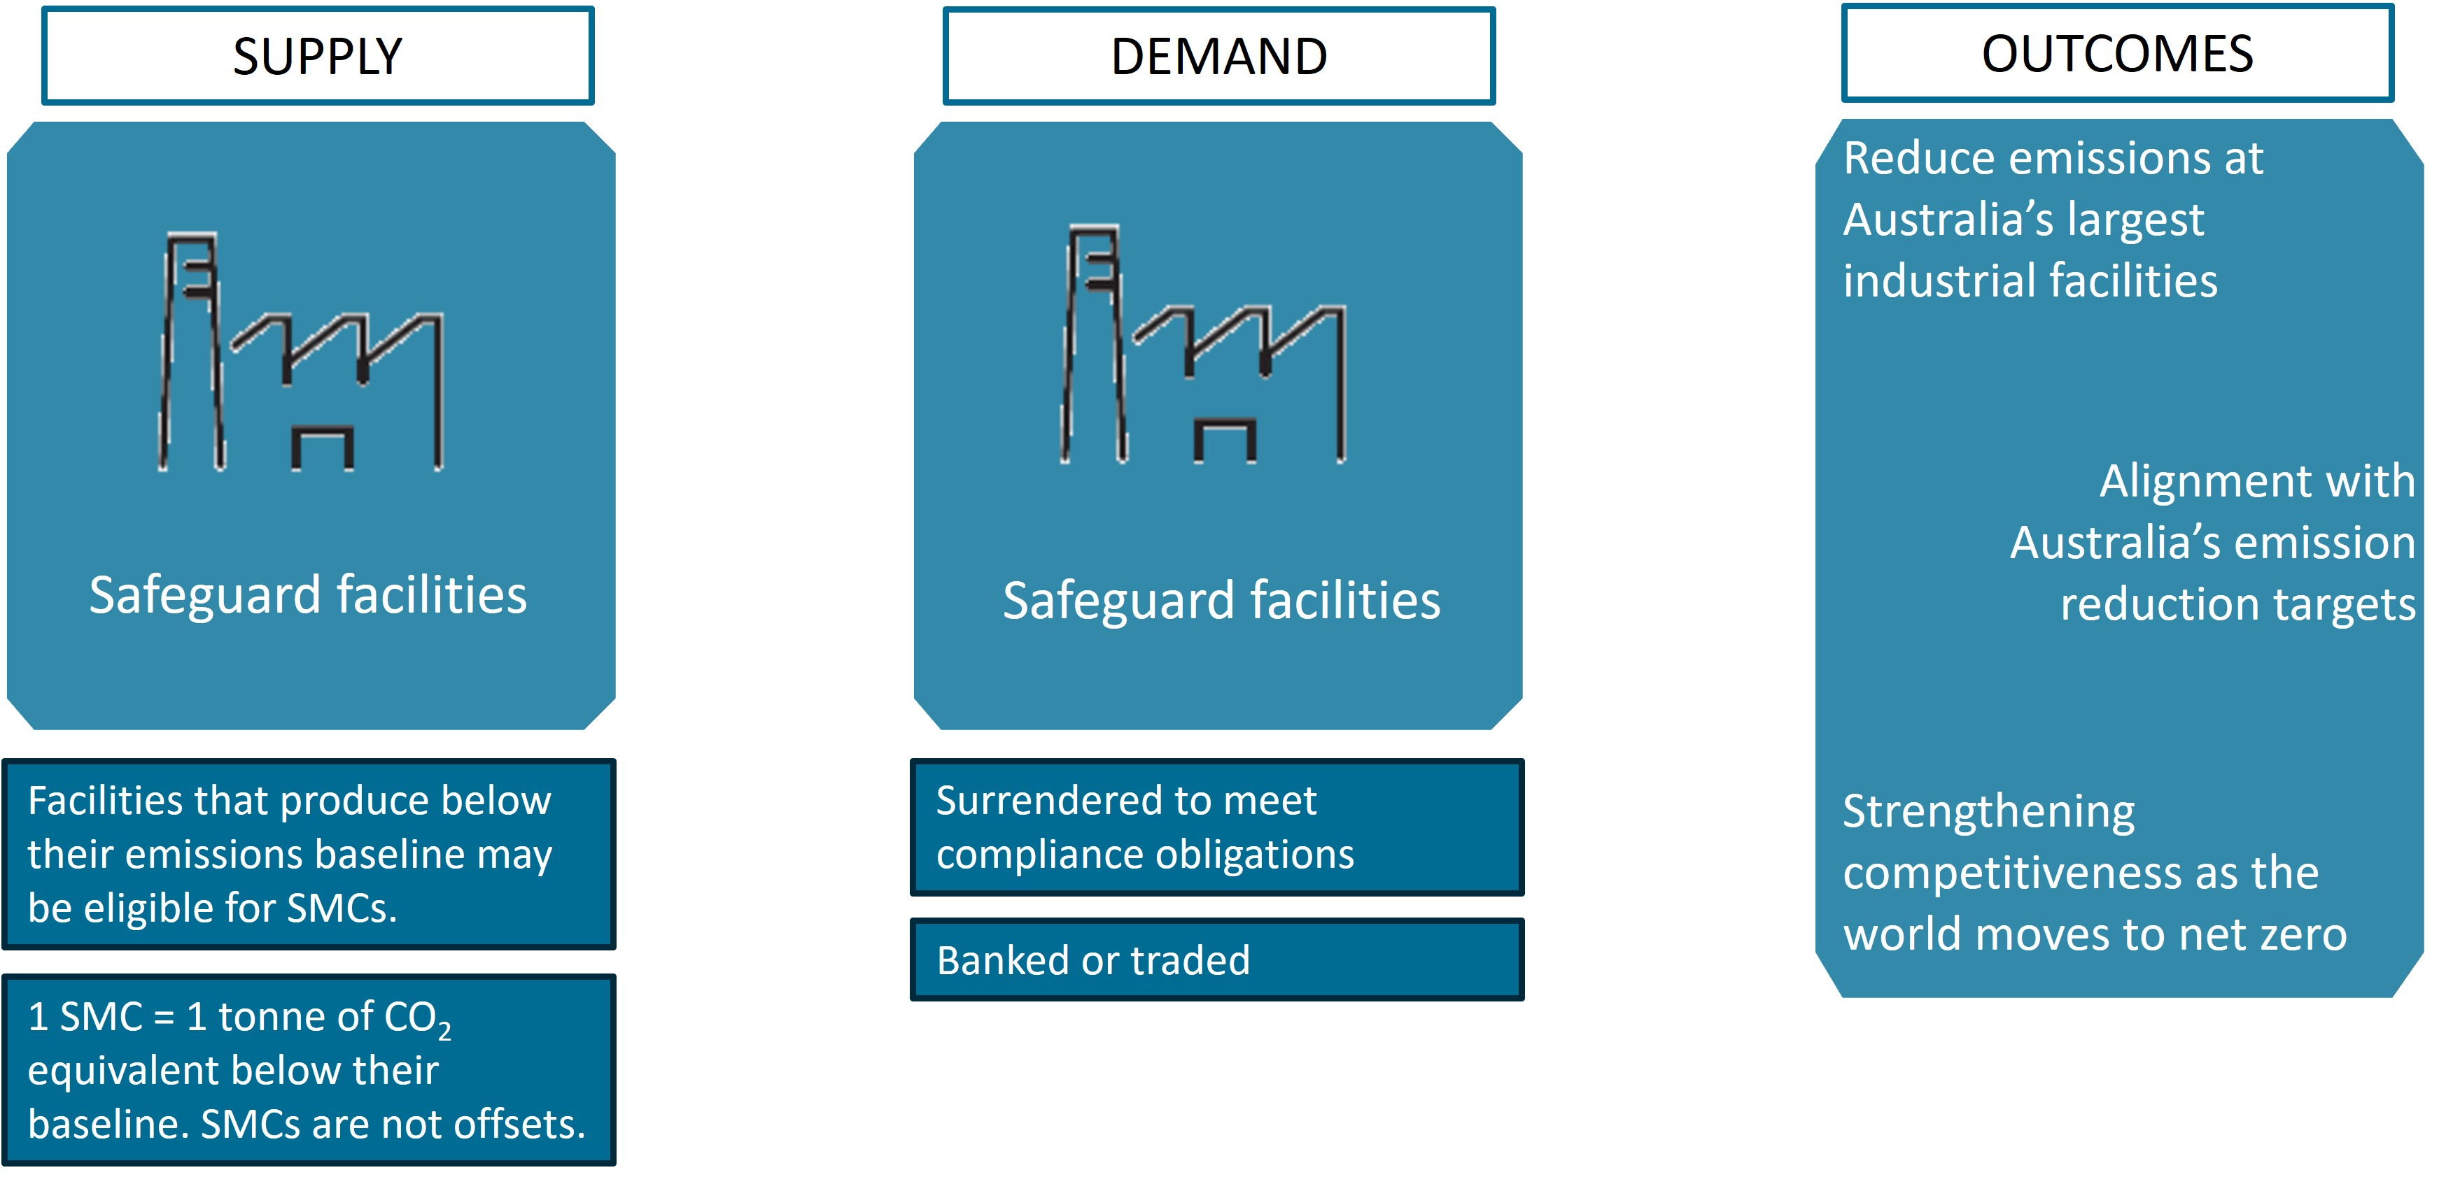

ACCUs and SMCs are both tradeable financial products. They can be traded between any holders of an ANREU account. SMCs provide an incentive for Safeguard entities to operate under their baseline and provide flexibility for some entities with less scope for onsite emissions reduction to comply under the Safeguard Mechanism.

## B.3 Cost containment measure

To manage concerns about price volatility and cost constraints, the Australian Government has established a cost containment measure alongside the reformed Safeguard Mechanism. The cost containment measure enables Safeguard entities to purchase ACCUs from the Commonwealth of Australia under specific circumstances at a controlled price (of $75 per ACCU should the situation arise in 2023-24, increasing with the consumer price index (CPI) plus 2% annually) when they are unable to meet their baseline by sourcing ACCUs or SMCs from the market. As of September 2024, there were approximately 3.5 million ACCUs available for use from the cost containment measure, less than 8% of the total private and non-Commonwealth holdings of ACCUs.

## B.4 REGO, GO and Biodiversity certificates

The RET sets a target to deliver an extra 33,000 gigawatt-hours (GWh) of electricity from renewable sources by 2020. This target has been met, but Australia’s renewable capacity continues to grow at a healthy average rate of around 6 GW annually.

The chart below shows the share of generation contributed by renewables in the National Electricity Market (NEM) since 2011 to the end of 2023. It also shows the emissions intensity of the NEM as tonnes of carbon dioxide equivalent per megawatt hour (MWh).

Figure 7: Share of NEM generation from 2011 to 2023

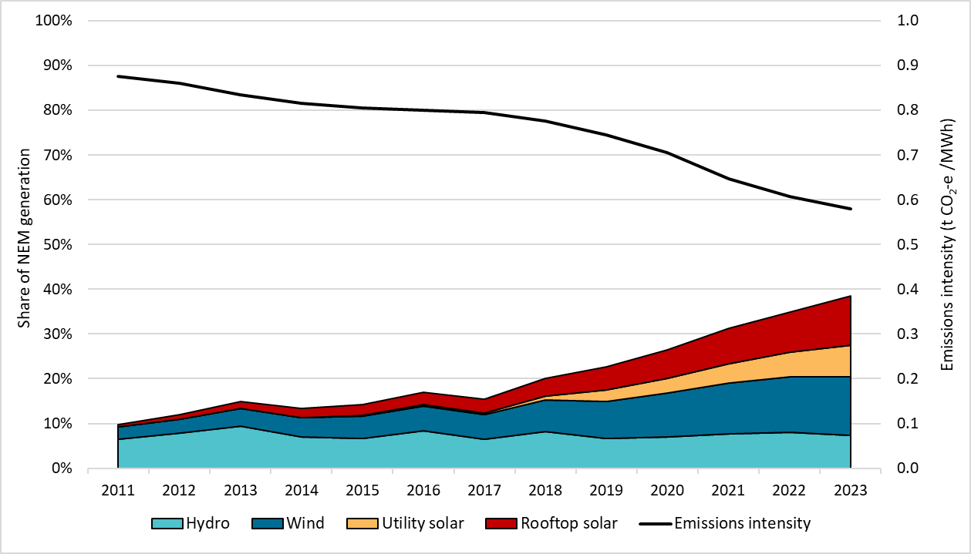

Future schemes that are due to be implemented or legislated include the Nature Repair Market and the GO Scheme. Similar to the ACCU Scheme and the RET, these schemes will generate tradeable certificates, and apply a regulatory and assurance framework. In the case of the GO scheme, only REGOs will be tradeable certificates (GO certificates will not be tradeable).

The Nature Repair Market came into effect on 15 December 2023 and establishes a national voluntary biodiversity market. It will incentivise private investment to enhance and protect natural environments. The scheme will support projects that improve biodiversity and issue landholders with tradeable biodiversity certificates.

Over the next 12 months, the Department of Climate Change, Energy, the Environment and Water (DCCEEW) and the CER will be progressing key elements of the Nature Repair Market, including its governance structure, assessment processes and legislative rules. Given the interconnectedness of biodiversity and carbon storage within the environment, there will be opportunities to leverage and align existing projects under the ACCU Scheme.

The GO scheme is a voluntary assurance scheme designed to track and verify emissions associated with hydrogen, green metals, low carbon liquid fuels and renewable electricity made in Australia, with potential to be expanded to other products.

The GO scheme will also include the REGO certificate mechanism that will build on the LGC framework, scheduled to end after 2030. However, it may be possible that some new power stations will choose to use REGOs over LGCs before 2030, including for below baseline generation, that is not eligible for LGCs.

1. https://www.asx.com.au/markets/trade-our-derivatives-market/environmental-futures
2. https://www.fexglobal.com.au/fex-globals-physically-deliverable-large-scale-generation-certificate-lgc-monthly-futures-contract