Emissions and Energy Reporting System validations guideline

August 2025

Contents

Disclaimer 3

2024–25 updates 4

1. Introduction 4

2. Complying with the NGER Scheme 4

3. Validations in EERS 4

3.1. Navigating the Validate Page 5

3.2. Addressing validations 5

3.3. Acknowledging validations 6

4. List of validation messages in EERS 7

Electricity production 8

Electricity consumption 9

Uncertainty 10

5. More information 11

# Disclaimer

Thisguideline has been developed by the Clean Energy Regulator (CER) to assist entities to comply with their reporting obligations under the [*National Greenhouse and Energy Reporting Act 2007*](https://www.legislation.gov.au/Series/C2007A00175)[1](NGER Act)and associated legislation.

This guideline only applies to the 2024–25 NGER reporting year and should be read in conjunction with the NGER Act, [National Greenhouse and Energy Regulations 2008](https://www.legislation.gov.au/Series/F2008L02230)[2] (NGER Regulations), and [National Greenhouse and Energy Reporting (Measurement) Determination 2008](https://www.legislation.gov.au/Series/F2008L02309)[3] (NGER Measurement Determination), as in force for this reporting period. These laws and their interpretation are subject to change, which may affect the accuracy of the information contained in the guideline.

The guidance provided in this document is not exhaustive, nor does it consider all circumstances applicable to all entities. This guidance is not intended to comprehensively deal with its subject area, and it is not a substitute for independent legal advice. Although entities are not bound to follow the guidance provided in this document, they must ensure they meet their obligations under the [National Greenhouse and Energy Reporting (NGER) scheme](https://cer.gov.au/schemes/national-greenhouse-and-energy-reporting-scheme)[4] at all times. CER encourages all users of this guidance to seek independent legal advice before taking any action or decision on the basis of this guidance.

CER and the Australian Government will not be liable for any loss or damage from any cause (including negligence) whether arising directly, incidentally, or as consequential loss, out of or in connection with, any use of this guideline or reliance on it, for any purpose.

If an entity chooses to meet their obligations under the NGER scheme in a manner that is inconsistent with the guidance provided in this document, CER, or an independent auditor, may require the entity to demonstrate that they are compliant with requirements of the NGER Act, NGER Regulations, and/or the NGER Measurement Determination. Entities are responsible for determining their obligations under the law and for applying the law to their individual circumstances.

# 2024–25 updates

Changes in this document for the 2024–25 reporting year:

* Revisions to reflect the process for addressing and acknowledging validation messages in new EERS.
* Minor stylistic and formatting changes have been made to this document.

Read about the [changes to the NGER Legislation for the 2024–25 reporting period[5].](https://cer.gov.au/schemes/national-greenhouse-and-energy-reporting-scheme/report-emissions-and-energy/amendments)

# Introduction

This guide aims to assist reporting entities to further understand and comply with their legal obligations for reporting emissions and energy data through providing general information about validation messages in the [Emissions and Energy Reporting System](https://cer.gov.au/online-systems" \l "emissions-and-energy-reporting-system" \o "A link to the EERS section of the Online Systems page of the Clean Energy Regulator webiste)[6] (EERS). EERS is the system reporters use to comply with legislative requirements for reporting annual emissions and energy data under the National Greenhouse and Energy Reporting (NGER) Scheme.

# Complying with the NGER Scheme

CER has published a range of [resources](https://cer.gov.au/schemes/national-greenhouse-and-energy-reporting-scheme/report-emissions-and-energy/nger-reporting)[7] on its website to help you to report compliantly under the NGER Act. Our approach to compliance is outlined in the [compliance, education and enforcement policy](https://cer.gov.au/about-us/our-compliance-approach/compliance-policy-education-monitoring-and-enforcement-activities" \o "A link to the Compliance, education and enforcement policy page the Clean Energy Regulator website)[8] available on our website.

Corporations that fail to register and report or otherwise comply with their obligations may face significant penalties outlined in the NGER Act.

# Validations in EERS

Validation messages – referred to throughout this guideline as ‘validations’ – are automated alerts generated by EERS. These messages will appear on the Validate Page when EERS identifies issues with the entered data entered. Validations are designed to assist corporations in submitting reports that comply with the requirements of the NGER Scheme and reduce the need for post-submission corrections.

Validations may arise for a range of reasons, including:

* required data has not been entered
* data has been entered incorrectly
* data appears inconsistent with other reported information
* thresholds or legislative requirements have not been met
* uncertainty reporting is triggered but not completed
* safeguard production variable reporting is triggered but not completed.

All validations must be addressed – either by correcting the data or acknowledging the message – before a report can be generated and submitted in EERS. Addressing a validation enables submission of the report in EERS. However this does not confirm the report is complete, accurate, or compliant with legislative requirements.

## Navigating the Validate Page

The Validate Page in EERS is accessed via the ‘Function’ dropdown menu. It provides a central location for reviewing and managing validations. EERS checks data in real time for completeness, consistency with NGER legislation, and alignment with other reported activities.

Validations are grouped into the following categories:

* incomplete records – missing required data
* safeguard production variables – checks related to Safeguard Mechanism thresholds
* uncertainty – triggered when emissions sources require uncertainty reporting
* small facility thresholds – alerts when thresholds are not met or exceeded
* related activities – checks for consistency across linked activities.

Up to 25 validations are displayed at a time. All validations must be addressed and rectified (or in some cases, simply acknowledged), before an NGER report can be generated and submitted.

For returning reporters, EERS workspaces will be pre-populated with some activity information reported in the previous reporting period. Fields that require a numerical quantity to be entered will not be pre-populated. This means the first time a returning reporter opens the EERS workspace, the validate page will display a series of *‘Required field (s) incomplete’* validations. These will clear automatically once the relevant activity data is entered. For more information on pre-populated data in an EERS workspace, read ‘Carrying information over from the previous reporting period for an existing reporter’ in [NGER quick help topics](https://cer.gov.au/document_page/nger-quick-help-topics)[9].

## Addressing validations

To address a validation in EERS, select ‘Validate’ from the Function drop-down menu. Click on the associated ‘Edit’ hyperlink under ‘Actions’ in the table. This will take you to the relevant record within the ‘Data Entry’ function. The validation will no longer be displayed once it has been successfully addressed.

Figure 1 Example of Validation summary page in EERS.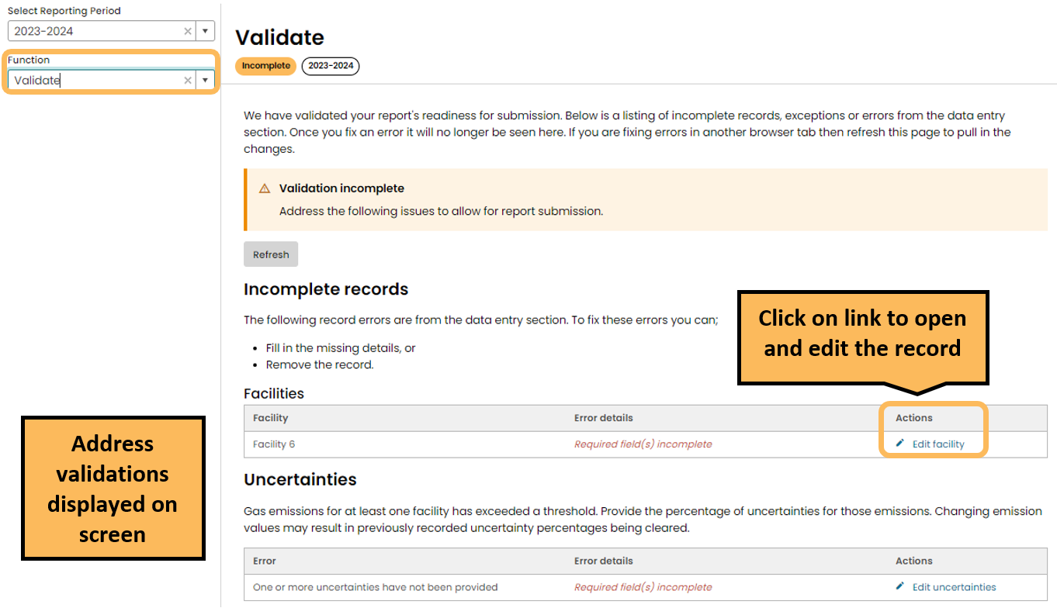

## Acknowledging validations

Sometimes it is appropriate to acknowledge a validation without changing your data. This will generally mean the reporting entity understands the validation, and notes that it is not applicable to their situation. For example, a reporting entity may report a fuel combustion activity designated for the purposes of electricity production and a validation could advise that an electricity production activity also needs to be reported. However, if the amount of electricity produced is below the reporting threshold, an electricity production activity may not need to be reported in EERS and this validation can just be acknowledged.

Once a reporting entity has confirmed that a validation does not apply to their situation, the validation can be acknowledged by clicking ‘Acknowledge’ under the ‘Actions’ heading in the table. You may provide comments in the free text field to explain the decision to acknowledge rather than address the validation. Select the ‘Acknowledge’ button in the pop out window to complete the validation.

Acknowledgements and any comments you provide will remain on the Validate page and will appear in the NGER pdf report when it is generated.

Figure 2 Example of Acknowledgement of Validation

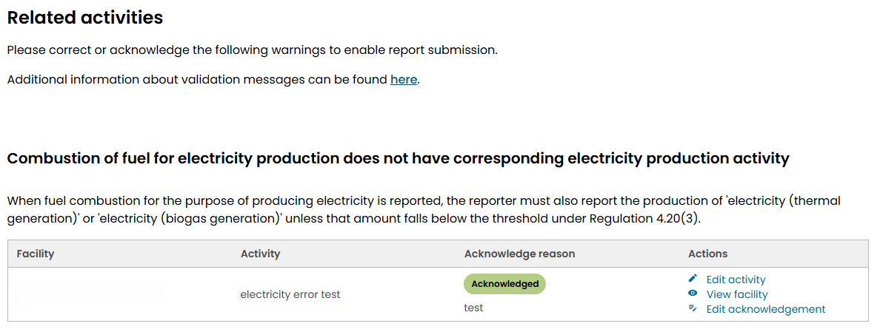

When a source of emissions is reported which triggers the requirement to report uncertainty, and uncertainty has not been entered, a validation will appear. Validations relating to uncertainty cannot be resolved with an acknowledgement and must be addressed before you can generate and submit a report. See the below list of validations in EERS for more information.

# List of validation messages in EERS

The tables below present information on the various validations in EERS. The tables provide brief explanations and links to relevant NGER legislation and additional guidance. If you require additional information regarding any of the following validations, please [contact CER](https://cer.gov.au/about-us/contact-us)[10].

### Electricity production

|  |  |
| --- | --- |
| Validation message | “Production of thermally generated electricity does not have corresponding fuel combustion activity  When the production of electricity (thermal generation) is reported, the reporter must also report the combustion of any fuel used to produce that electricity if the amount of electricity produced exceeds the threshold under Regulation 4.22(1)(a)(i).” |
| Explanation | The above validation will appear when production of thermally generated electricity has been reported but there is no corresponding amount of fuel combusted to generate electricity.  If electricity has been generated from a thermal process (for example, the combustion of a fuel in an engine used to drive a generator or produce steam used to drive a turbine), the amount of electricity generated and the amount of fuel combusted in the process must be reported, if relevant reporting thresholds have been met. |
| Suggested resolution | The thresholds for reporting the combustion of fuels to generate electricity are the same as for transport and stationary energy purposes.  The following activities need to be reported if the relevant reporting threshold has been met. The combustion of fuels to generate electricity when used in:   * dedicated generators * co-generation units * engines that generate electricity in addition to performing another function.   Please refer to 4.22(1)(a)(i) of the NGER Regulations. Guidance material for reporting fuel combustion and electricity production can be found in the [NGER reporting guides](https://cer.gov.au/schemes/national-greenhouse-and-energy-reporting-scheme/report-emissions-and-energy/nger-reporting-guides" \o "A link to the NGER reporting guides page of the Clean Energy Regulator website)[11].  If the amount of fuel combusted to generate electricity falls below the reporting thresholds, and you have chosen not to include it in your report, you should acknowledge the validation message. You may also choose to include a comment to this effect. |

### Electricity consumption

|  |  |
| --- | --- |
| Validation message | “Combustion of fuel for electricity production does not have corresponding electricity production activity  When fuel combustion for the purpose of producing electricity is reported, the reporter must also report the production of 'electricity (thermal generation)' or 'electricity (biogas generation)' unless that amount falls below the threshold under Regulation 4.20(3).” |
| Explanation | The above validation will appear when the amount of electricity generated from a thermal process has not been reported for a facility, when the fuel combusted to generate electricity has been reported.  If electricity has been generated from a thermal process, both the amount of fuel combusted in the process and the amount of electricity generated must be reported, if the relevant reporting threshold has been met. For example, the combustion of a fuel in an engine used to drive a generator or the production of steam to drive a turbine. |
| Suggested resolution | If electricity has been generated at a facility from the combustion of fuels, the amount of electricity generated must be reported when the reporting threshold has been met.  You will need to report separately each quantity of electricity that has been:   * supplied to an electricity transmission or distribution network * supplied to another facility via direct connection * generated for use onsite at the facility.   Please refer to Part 6.1 of the NGER Measurement Determination and Regulation 4.20 of the NGER Regulations.  Guidance material for reporting fuel combustion and electricity production can be found on the [NGER reporting guides](https://cer.gov.au/schemes/national-greenhouse-and-energy-reporting-scheme/report-emissions-and-energy/nger-reporting-guides)[12] page of our website. |

### Uncertainty

|  |  |
| --- | --- |
| Validation message | “Uncertainties  Gas emissions for at least one facility has exceeded a threshold. Provide the percentage of uncertainties for those emissions. Changing emission values may result in previously recorded uncertainty percentages being cleared.” |
| Explanation | The above validation will appear when a reporting entity has triggered the threshold~~s~~ for the reporting of uncertainty **but** has failed to enter the uncertainty percentage in EERS. The validation will display as ‘incomplete’ (see Figure 3 below). In this case, uncertainty must be reported before a report can be generated and submitted.  This validation will also appear if any relevant activity data is altered after reporting uncertainty. If relevant activity data is altered, the uncertainty values will be cleared and will need to be recalculated. |
| Suggested resolution | Uncertainty must be reported for a facility if the [scope 1 emissions](https://cer.gov.au/schemes/national-greenhouse-and-energy-reporting-scheme/about-emissions-and-energy-data/emissions-and-energy-types#types-of-emissions)[13] from the combustion of an energy type or for a source are 25 kilotonnes carbon dioxide equivalence (kt CO2-e) or more in a reporting year. Uncertainty is not required to be aggregated to the facility**,** corporation or group levels.  Please refer to 4.17A and 4.08 of the NGER Regulations and Chapter 8 of the NGER Measurement Determination.  Guidance material for reporting of uncertainty can be found on the [NGER reporting guides](https://cer.gov.au/schemes/national-greenhouse-and-energy-reporting-scheme/report-emissions-and-energy/nger-reporting-guides)[14] page of our website. |

Figure 3 Example of Incomplete uncertainty error

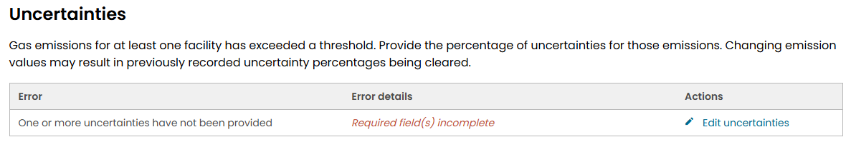

**Safeguard Mechanism**

|  |  |
| --- | --- |
| Validation message | “Safeguard production variables  Production variable quantities must be reported where a facility’s scope 1 [covered emissions](https://cer.gov.au/schemes/safeguard-mechanism) (tCO2-e) exceed the Safeguard threshold of 100,000 tCO2-e in a financial year, or the facility has a [multi-year monitoring period](https://cer.gov.au/schemes/safeguard-mechanism/managing-excess-emissions#apply-for-a-multi-year-monitoring-period), or the facility is an ‘eligible facility’ as defined under section 58B of the [Safeguard Rule](https://www.legislation.gov.au/F2015L01637/latest/versions).  Production variable quantities are used to calculate the facility’s [baseline emissions number](https://cer.gov.au/schemes/safeguard-mechanism/safeguard-baselines) for the financial year, or part of a financial year if applicable.” |
| Explanation | The above validation will appear when a reporting entity has a requirement under the Safeguard Mechanism to provide the quantity of all production variables relevant to a facility in the report.  Further information on the [Safeguard Mechanism](https://cer.gov.au/schemes/safeguard-mechanism)[15] is available on our website. |
| Suggested resolution | Click the ‘Edit production variables’ link under ‘Actions’ in the validation table. This takes you to the ‘Production variables’ tab in the ‘Data entry’ function, where you can read information about reporting production variables and report production variable data for your facility. |

# More information

For more information about EERS, please contact CER:

Email: [cer-nger-reporting@cer.gov.au](mailto:cer-nger-reporting@cer.gov.au)

Phone: 1300 553 542 within Australia

See [the Reporter support dashboard](https://cer.gov.au/schemes/national-greenhouse-and-energy-reporting-scheme/report-emissions-and-energy/reporter-support)[16] for more guidance with reporting in EERS:

* training videos
* EERS user guide
* Online Services user guide.

1. https://www.legislation.gov.au/Series/C2007A00175
2. https://www.legislation.gov.au/Series/F2008L0223
3. https://www.legislation.gov.au/Series/F2008L02309
4. https://cer.gov.au/schemes/national-greenhouse-and-energy-reporting-scheme
5.
6. https://cer.gov.au/online-systems#emissions-and-energy-reporting-system
7. https:/cer.gov.au/schemes/national-greenhouse-and-energy-reporting-scheme/report-emissions-and-energy/nger-reporting
8. https://cer.gov.au/about-us/our-compliance-approach/compliance-policy-education-monitoring-and-enforcement-activities
9. https://cer.gov.au/document_page/nger-quick-help-topics
10. https://cer.gov.au/about-us/contact-us
11. https://cer.gov.au/schemes/national-greenhouse-and-energy-reporting-scheme/report-emissions-and-energy/nger-reporting-guides
12. https://cer.gov.au/schemes/national-greenhouse-and-energy-reporting-scheme/report-emissions-and-energy/nger-reporting-guides
13. https://cer.gov.au/schemes/national-greenhouse-and-energy-reporting-scheme/about-emissions-and-energy-data/emissions-and-energy-types#types-of-emissions

    14 https://cer.gov.au/schemes/national-greenhouse-and-energy-reporting-scheme/report-emissions-and-energy/nger-reporting-guides
14.
15. https://cer.gov.au/schemes/safeguard-mechanism
16. https://cer.gov.au/schemes/national-greenhouse-and-energy-reporting-scheme/report-emissions-and-energy/reporter-support