
Emissions and Energy Reporting System (EERS) navigation guide






V1.0 17 June 2025
Contents
National Greenhouse and Energy Reporting (NGER) Scheme 4
How to access EERS 4
Switch account in Online Services 6
NGER reports landing page 9
EERS workspace 9
Select Reporting Period 10
Function 10
Record tags 10
Entity types 11
Manage corporate structure 12
Add a new entity to the corporate structure 12
Add mandatory information for an entity 13
Add or edit entity details from the summary page 15
Delete an existing entity 16
Set entity reporting status 17
Reporting (all entities) 17
Operational control (facility) 18
Connected electricity generator (facility) 19
Add or edit facility activity data by direct entry 20
Add a new activity 20
Selecting an activity 21
Enter activity values 21
Edit activity values 23
Add or edit facility data using Bulk Upload 23
Review corporate structure and facility activities 24
Generate and download the bulk upload template 24
Edit the ‘.csv’ template 26
Enter contractor data to a facility 28
Add a new contractor 28
Edit existing contractor 29
Delete existing contractor 30
Production variable reporting for safeguard facilities 30
Report small facilities percentage 31
Report uncertainty 32
Validate 34
Generate and submit a report 35
More information for NGER reporting 39

National Greenhouse and Energy Reporting (NGER) Scheme
The NGER Scheme is a single national framework for reporting and disseminating company information about greenhouse gas emissions, energy production and energy consumption. Corporations that meet an NGER Scheme threshold must register and once registered, report each year.
The Emissions and Energy Reporting System (EERS) must be used for all reporting under the NGER Scheme. NGER reporters can both prepare and submit their emissions and energy reports in EERS.
Your organisation needs to be registered as an NGER reporter before you can access EERS.
Contact us if you have questions.

How to access EERS
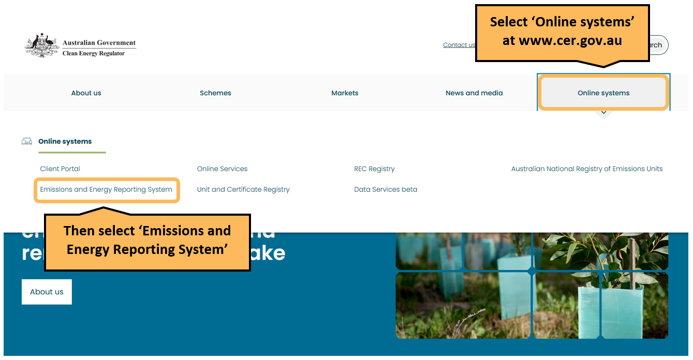
You can access EERS from the Clean Energy Regulator website.
This will take you to the EERS section of the ‘Online systems’ page.
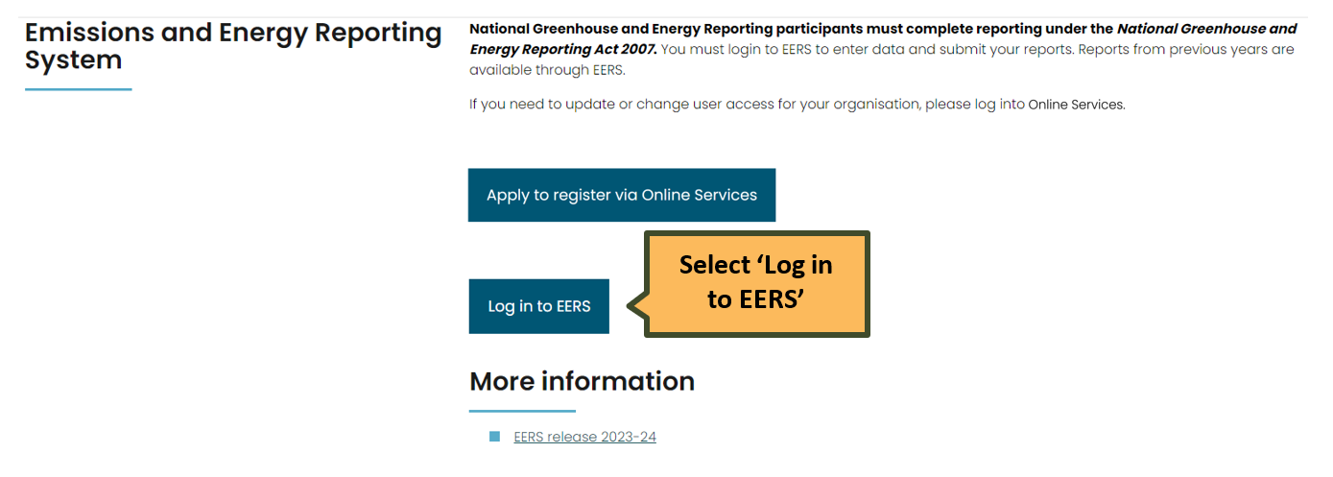

Log in to Online Services which is a secure login and includes a verification step.
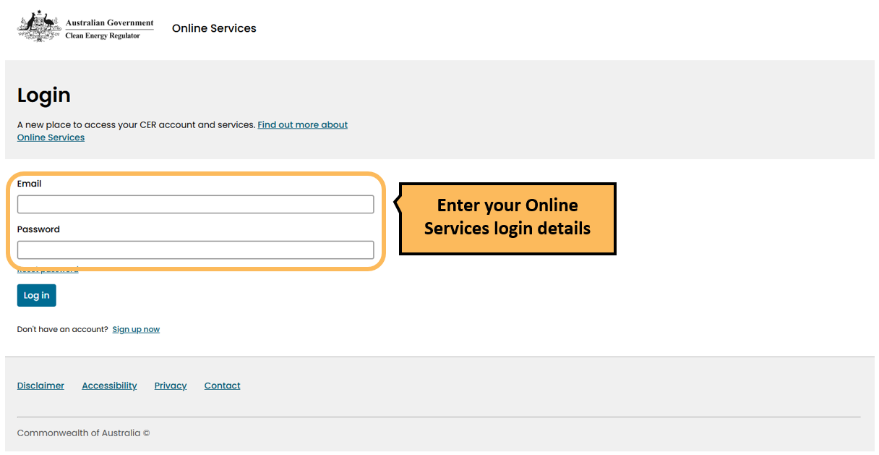

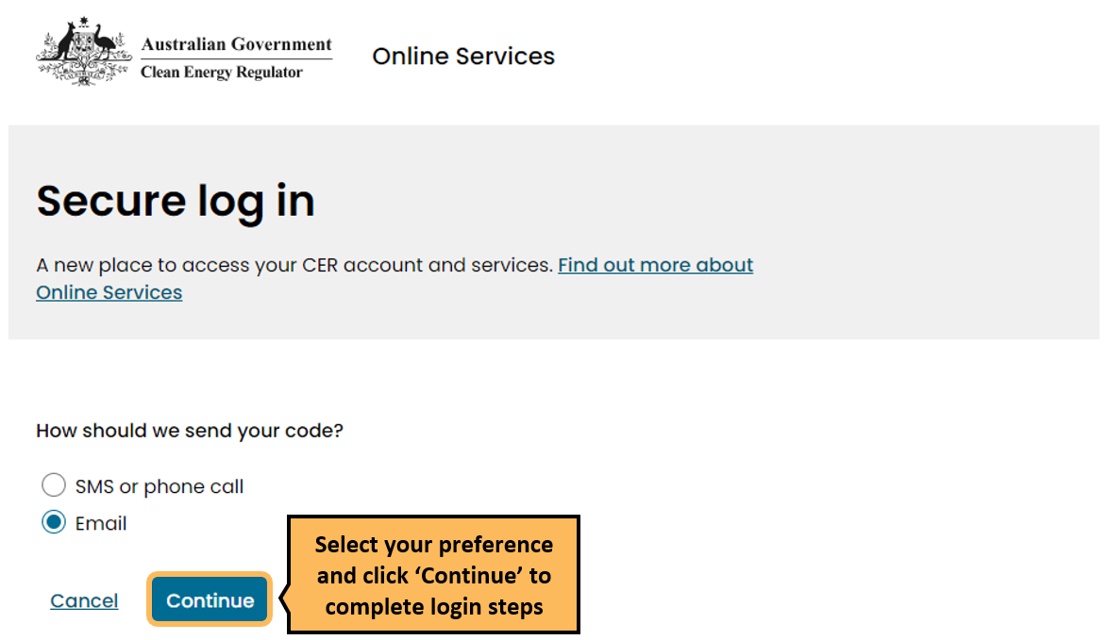

Switch account in Online Services
Once you have completed the login steps, the Online Services Dashboard will load.
If you’re new to Online Services a pop-up window will appear asking if you want to ‘Switch account’ or ‘Continue as myself’. You will need to switch account to act on behalf of an organisation to access that organisation’s NGER/EERS data. Select the organisation you wish to view, edit, or act on behalf of. After this, you can set a default so when you login to Online Services, you will immediately be set as acting on behalf of that organisation, and the pop-up window does not appear.
If you cannot see your organisation, you will need to be added by another user in your organisation with the Online Services manage users permission.
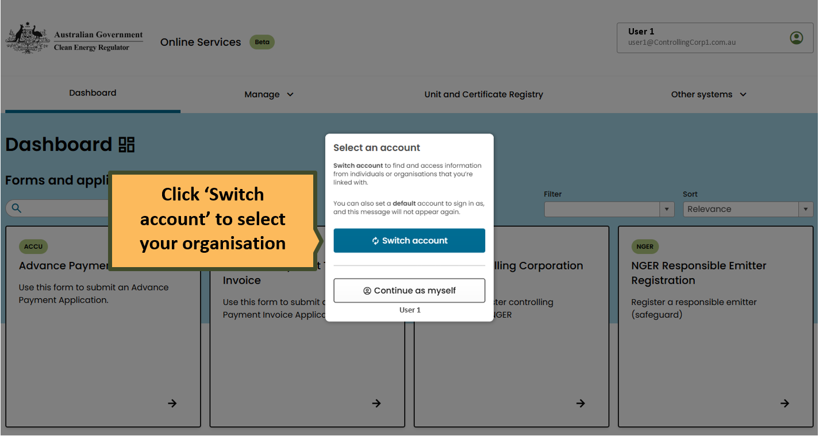

If you are logged into Online Services and wish to change the entity you are ‘acting on behalf of’, click the profile menu box at the top right of the screen, then click ‘switch account’ and select your organisation. If you have not already selected a company to act on behalf of, your name will appear in the profile menu box.
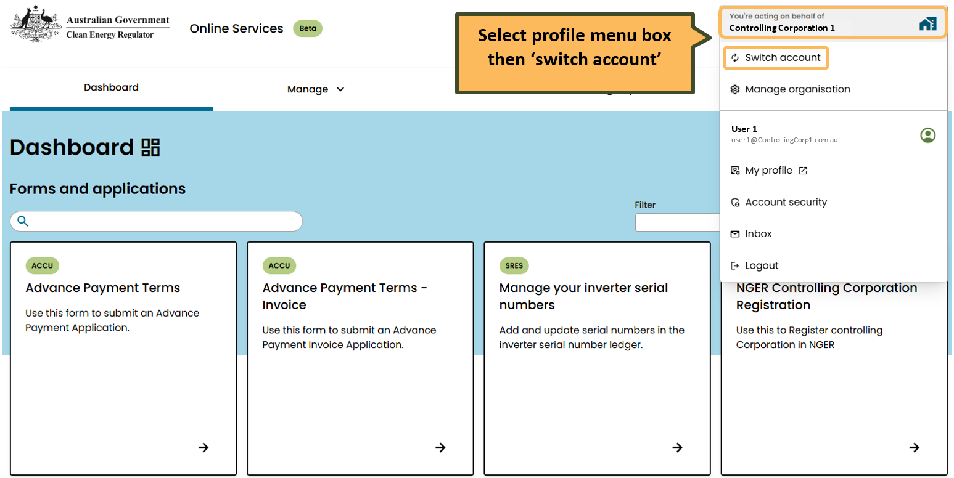

Read the Online Services user guide for more information about:
- setting a default account to ‘act on behalf of’, and
- managing access for your users.

Once you are acting on behalf of your organisation, click ‘Manage’ and then ‘NGER reports’ from the Online Services Dashboard. This will take you to the NGER reports landing page.

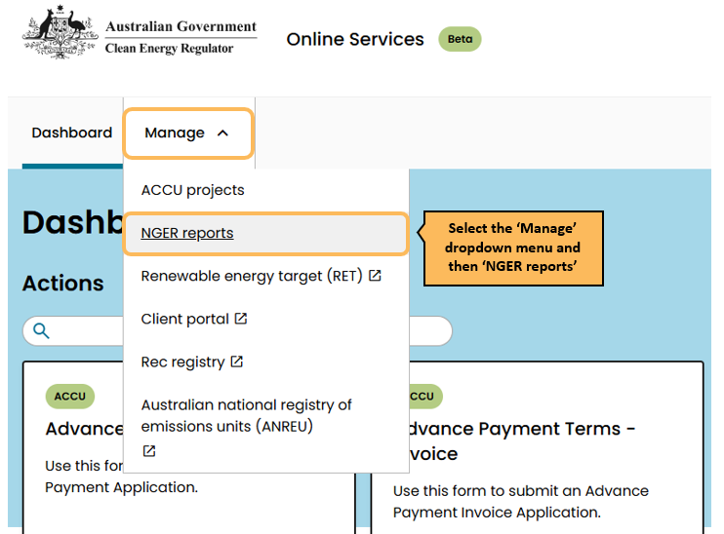

NGER reports landing page
The ‘NGER reports’ landing page displays the following information for each reporting period:
- a link to the EERS workspace/s
- report status
- a link to generated reports:
  - for 2023–24 and earlier there will be summaries of historically submitted NGER data
  - for 2024–25 onwards there will be a copy of the NGER PDF report available after report submission

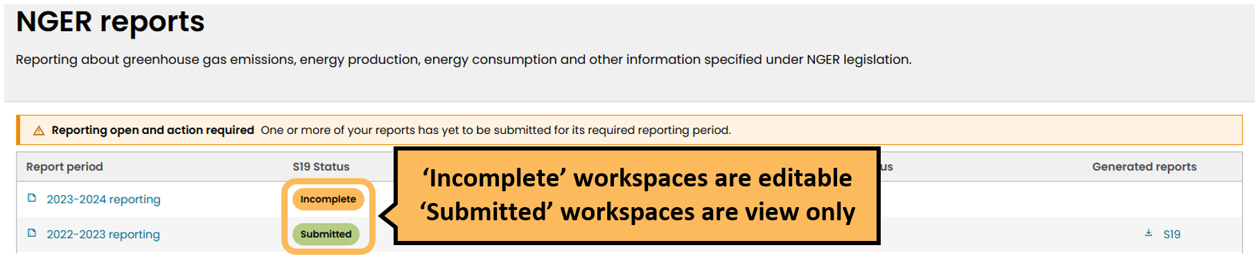

The status tags for the NGER report periods are:
- Incomplete: Data exists in the workspace but a draft report has not yet been generated. Click on the reporting period link to open the EERS workspace for editing. While you are editing the workspace the status will remain as ‘Incomplete’.
- Draft: When a draft PDF report has been generated but not yet submitted, the status will display as ‘Draft’. The workspace is locked and you may ‘review and submit’ the report or ‘withdraw’ the report to make additional changes.
- Submitted: Once you submit your NGER report, the status tag will display as ‘Submitted’. These workspaces will open in EERS as ‘view only’ and cannot be edited.
Contact us if you need data from a reporting period that is not shown in EERS.

EERS workspace
When you click a reporting period link, the EERS workspace opens at the controlling corporation summary page. This page displays the emissions and energy totals reported for the entire controlling corporation’s corporate group.
For returning reporters, your organisation’s corporate structure and activities will be migrated from your previous reporting period.
There are two drop-down menus on the left side of the screen.

Select Reporting Period
The ‘Select Reporting Period’ drop-down menu will default to the reporting year you selected from the NGER
reports landing page during the previous login step. Use the drop-down menu to switch between available reporting periods.

Function
The ‘Function’ drop-down menu defaults to the ‘Data entry’ function. The function drop down menu options are:
- Data entry
- Small facility percentages
- Report uncertainty
- Validation
- Report

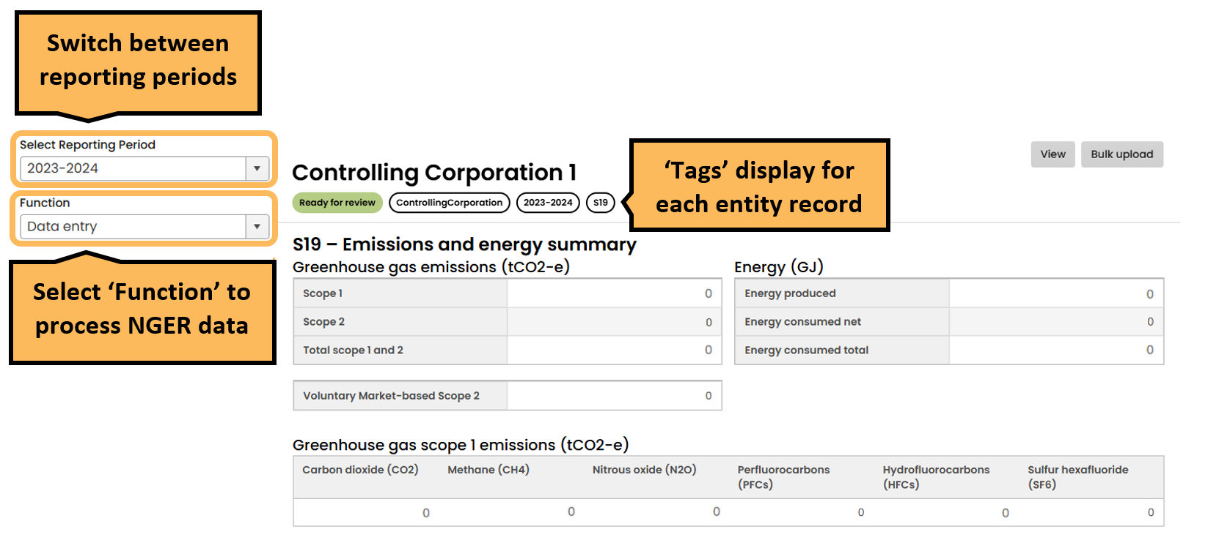

Record tags
All entity records in EERS will display tags to denote record status, entity level, reporting year and report type.
Record status includes:
- Ready for review: the record is not missing mandatory data and is ready for review. Only records showing ‘Ready for review’ status can be submitted in EERS.
- Incomplete: the record has missing mandatory data and needs to be completed before submission can occur.
- Not reporting: the entity has been flagged as ‘Not reporting’ in the entity record.

Entity types
There are several different entity types that can be created in EERS to reflect your corporate structure.
- Group member – set up a group member in EERS if your controlling corporation has a subsidiary with operational control over a facility or where a subsidiary of a subsidiary has operational control. The group member itself does not generate emissions.
- Business unit – a business unit is a unit that is recognised by a reporter as having administrative responsibility for one or more facilities. The legislation does not recognise a business unit as a legal entity. Business units can only be used by reporters as a method of grouping and reporting the data of individual facilities that do not meet any of the facility thresholds and facility aggregates under the operational control of different group members. The business unit itself does not generate emissions.
- Facility – facility is defined in Section 9 of the NGER Act. A facility is an activity or series of activities that involve the production of greenhouse gas emissions or the production or consumption of energy. For more information on defining a facility under the NGER Scheme, see What is a Facility.
- Facility aggregate – a collection of facilities, each of which does not meet individual reporting threshold that are within a single state and territory and single industry sector.
- Network and pipeIine – this is a special category of facility where a facility’s activities cross state boundaries, and the activities are covered by a specific range of Australian and New Zealand Standard Industrial Classification (ANZSIC) codes. These codes relate to electricity or telecommunications networks or pipelines for gas, water, drainage and other functions.
- Multi-site cement facility (only available on application to the CER) – this is a special category of facility that allows a clinker producing facility and downstream cement producing facilities to be reported as a single facility. This facility type will only be available to reporters who have had an application for a multi-site cement facility approved by the Clean Energy Regulator.
- National transport facility (only available on application to the CER) – this is a special category of facility that allows transport facilities in the same industry sector in different states and territories to be reported as a single facility. This facility type will only be available to reporters who had a nomination of a national transport facility approved by the Clean Energy Regulator.
Group members and business units are used to reflect an organisation’s corporate structure and show which entity within an organisation is responsible for a facility. Group members and business units do not have emissions or energy data associated with them.
Entities in the corporate structure are ordered alphabetically, depending on the entity type.
- Facilities with the controlling corporation as the parent entity are displayed in alphabetical order directly under the controlling corporation.
- Group Members / Business Units are then displayed in alphabetical order. The facilities associated with each business unit are listed in alphabetical order underneath the parent Group Member / Business Unit.

Manage corporate structure
Manage the corporate structure in EERS for your reporting requirements by:
- adding a new entity to your corporate structure
- adding mandatory information for an entity
- viewing and editing an existing entity in your corporate structure
- deleting an existing entity.

Add a new entity to the corporate structure
You can add an entity to the corporate structure from any summary page in the EERS workspace. You do not need to click on the parent entity first.
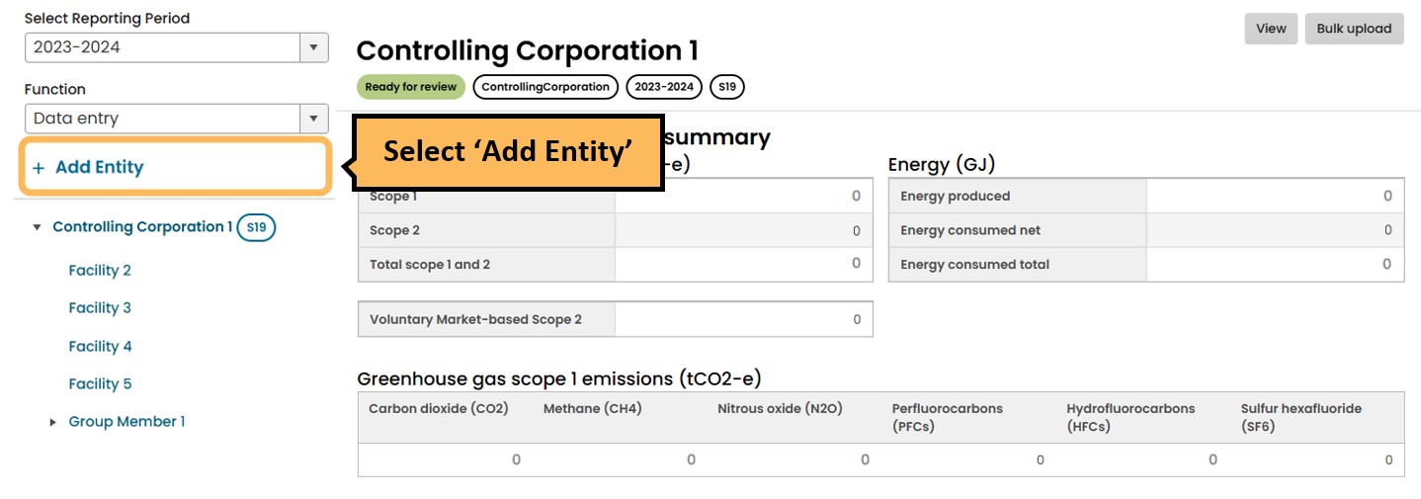

After selecting ‘Add Entity’, a pop-up will appear. Enter the entity name and select ‘Entity type’ and ‘Entity parent’. After entering this information, you can either click:
- ‘Add another entity’ which will add the new entity to the corporate structure and present a new pop-up which allows you to add another entity to the corporate structure without leaving the page. If you do this, you will have to later click into the newly created entity to add the required details. See the ‘Add or edit entity details from the summary page ’ section below.
- ‘Save and edit’ which adds the entity to the corporate structure and opens the entity details page so you can add the mandatory information. An entity will have a status of ‘Incomplete’ until all mandatory record details are entered.

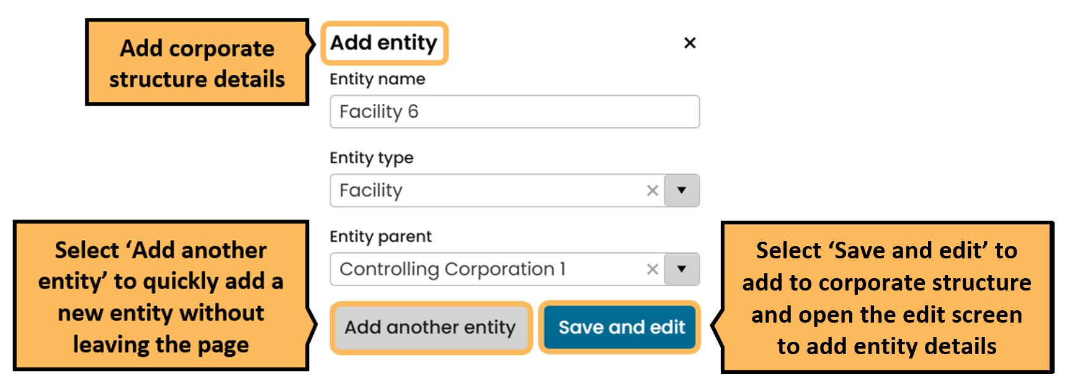

Add mandatory information for an entity
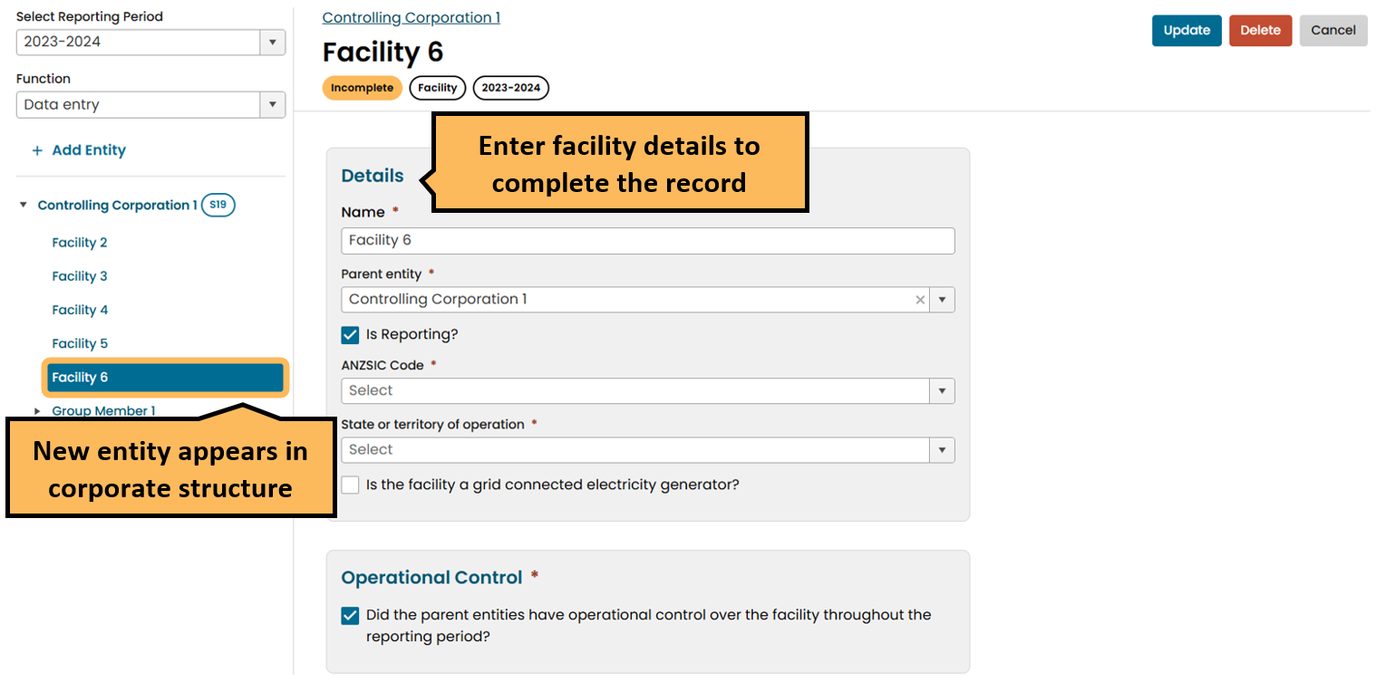
If you clicked ‘Save and edit’ in the previous step, the entity details page will open.
A facility details page is shown below. Enter the information required to complete the entity record. The record must be completed before you can add activities to a facility.

Scroll down further to enter location information.
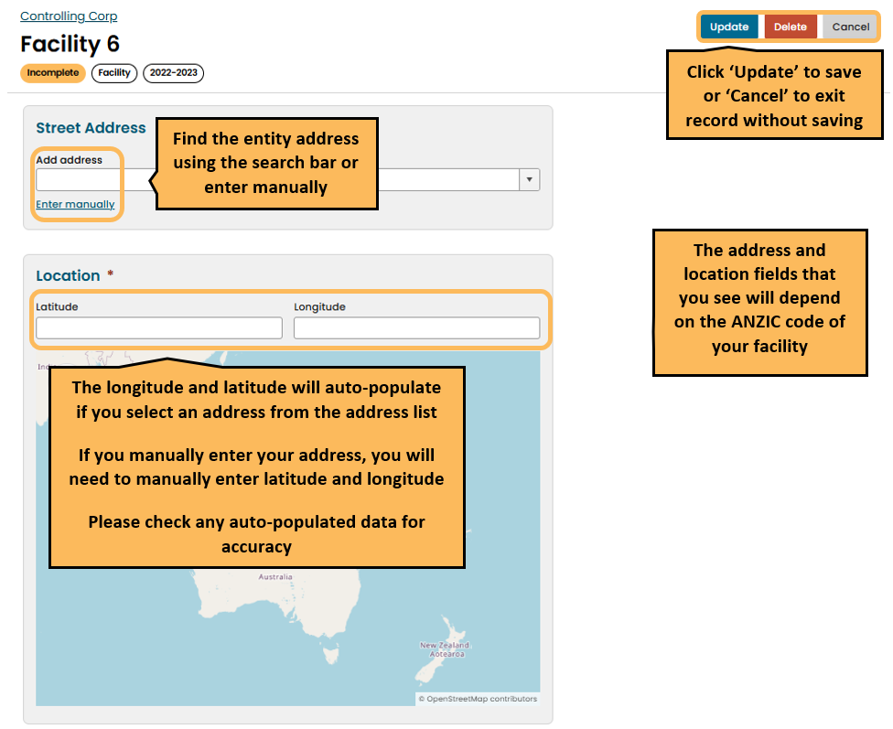

Once you enter all mandatory information and click update, the facility record status tag changes to ‘ready for review’.

Add or edit entity details from the summary page
You can open the entity record from the entity summary page to complete an entity record or review and edit an existing entity record.

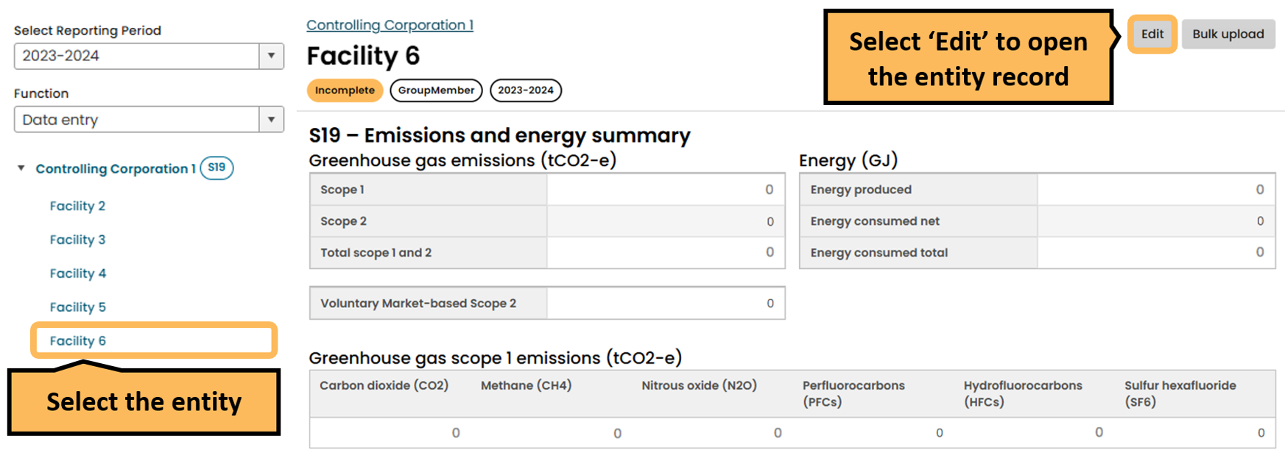

This opens the entity record. The status tag will display as ‘Incomplete’ until you complete all mandatory fields.
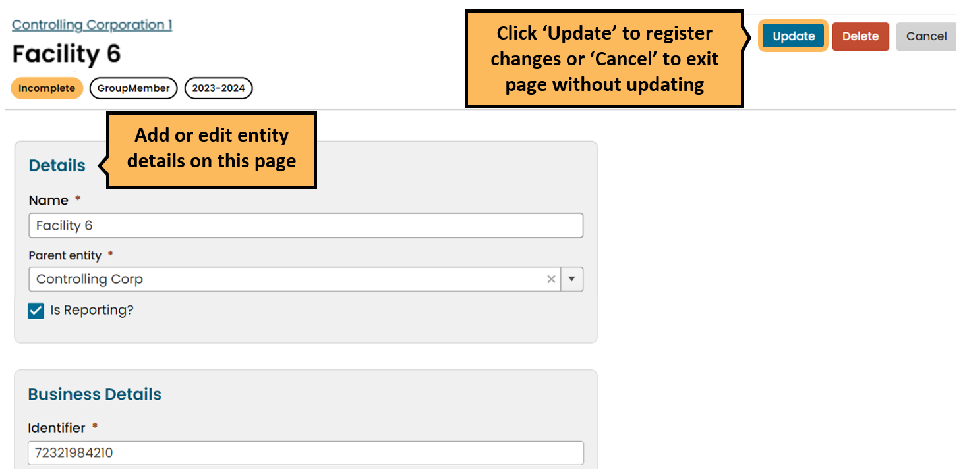
Read the ‘Adding a new facility’ section in this document for more information about adding a new facility entity.

Delete an existing entity
When you delete an entity, all children entities/facilities will be deleted. Data for previous reporting periods will not be deleted.
Click on the entity in the corporate structure and then click ‘Edit’ to open the entity record.
Click delete.

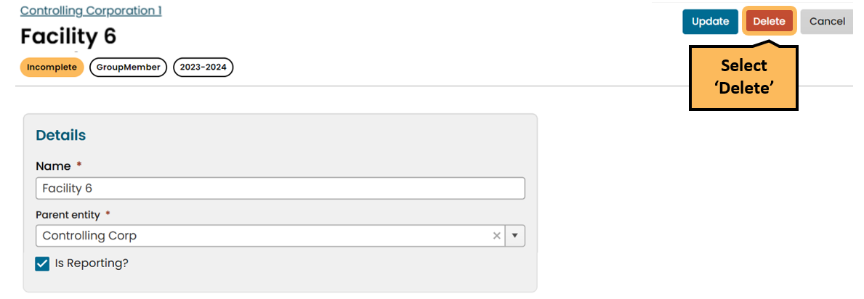
After clicking ‘Delete’, a pop-up will appear. Click ‘Yes, delete’ to delete the entity.
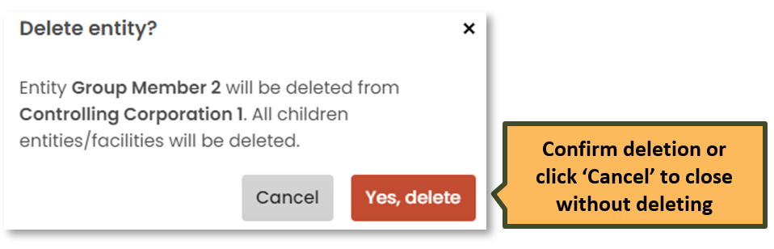

Set entity reporting status

Reporting (all entities)
When you create a new facility, the ‘Is Reporting?’ checkbox will default to checked and the entity will appear in your submitted report. If you have an entity that you do not want to appear in your report for a particular reporting period, but do not want to remove from your corporate structure, uncheck the box.
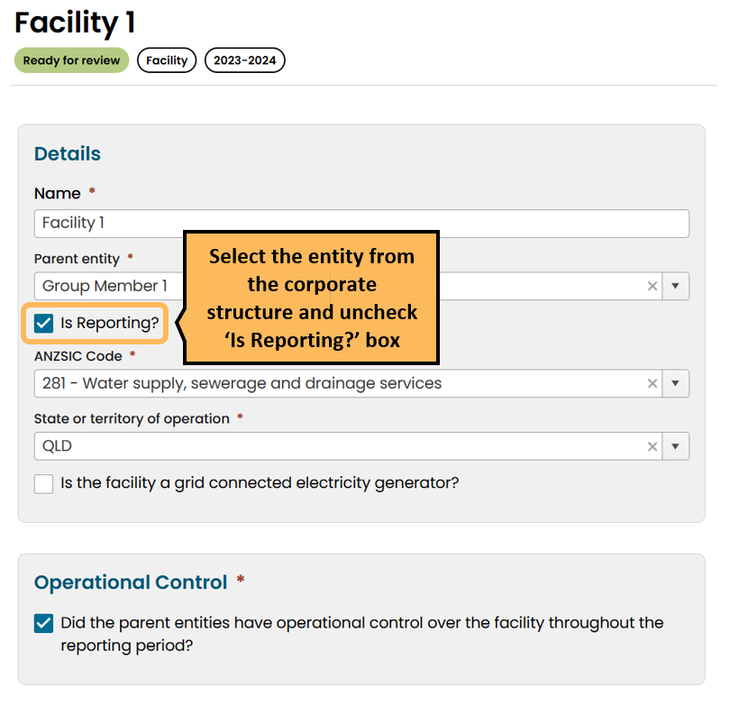

Operational control (facility)
When you add a new facility, the ‘Operational Control’ checkbox will default to checked, which means you are reporting that the parent entity had operational control over the facility for the full reporting period. If the parent entity did not have operational control over a facility for the full reporting period, uncheck the ‘Operational Control’ checkbox.
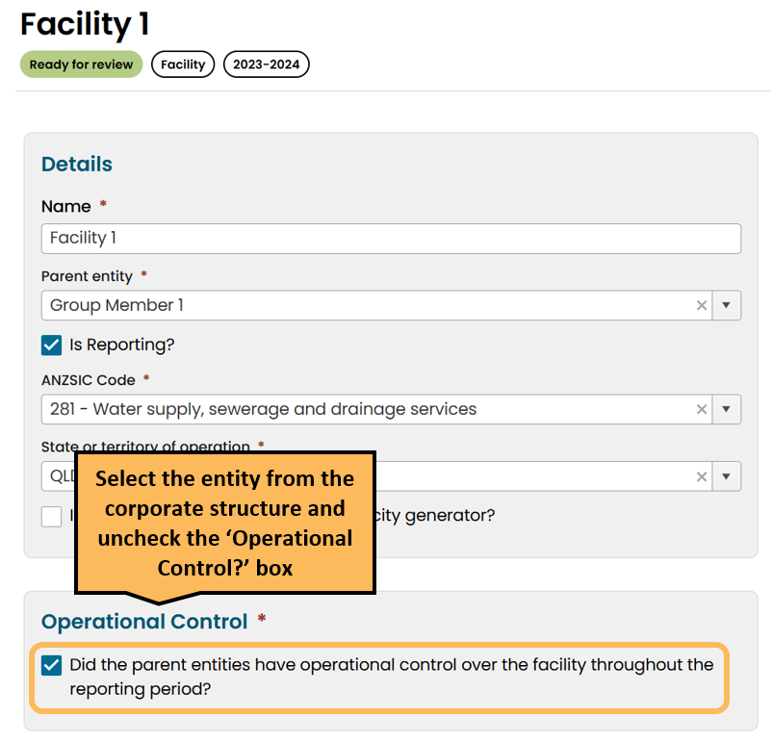

When the ‘Operational Control’ checkbox is unchecked, enter part-year operational control details by adding a ‘Start Date’ and ‘End Date’. The dates must be within the current reporting period. The total days of operation will be automatically calculated from the dates you enter.
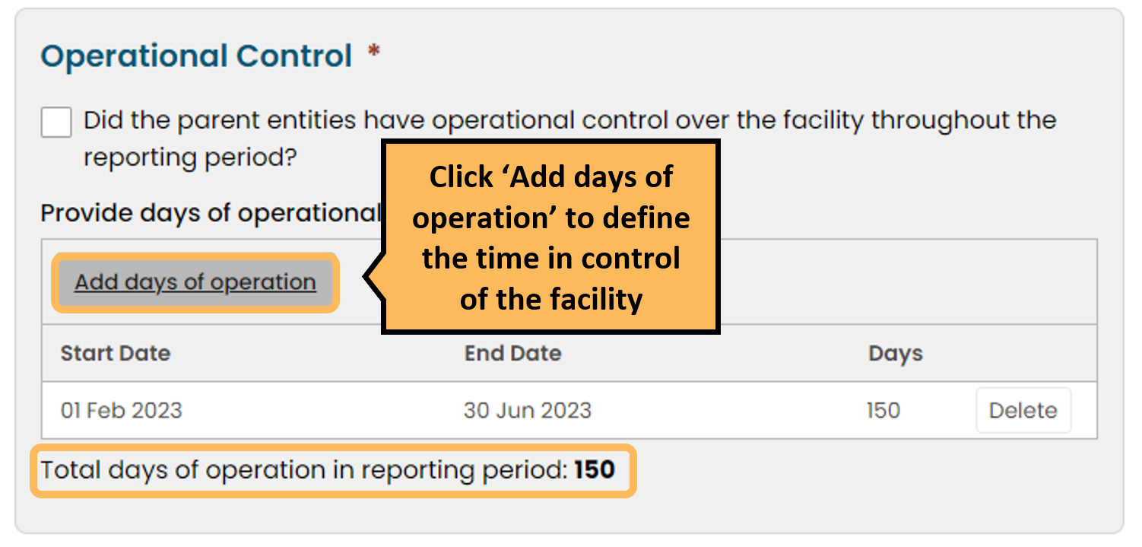

For more information on operational control refer to the Operational control guideline.

Connected electricity generator (facility)
The ‘Is the facility a grid connected electricity generator?’ checkbox will default to unchecked for a newly created facility. Click the checkbox if the facility is a grid connected electricity generator.
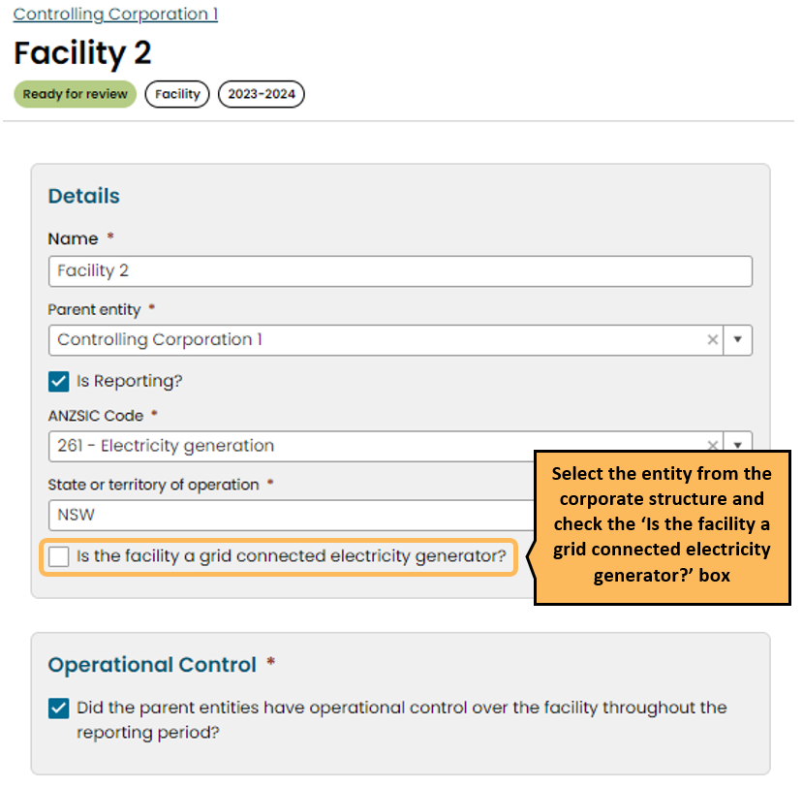

Add or edit facility activity data by direct entry
Add or edit emissions and energy data for facilities by direct entry in the EERS workspace. This includes adding facility activities, entering activity data and matters to be identified (MTBIs).
Each activity record in EERS will display tags to denote status, facility and reporting year.
For more information on reporting activities see the NGER reporting guides.

Add a new activity
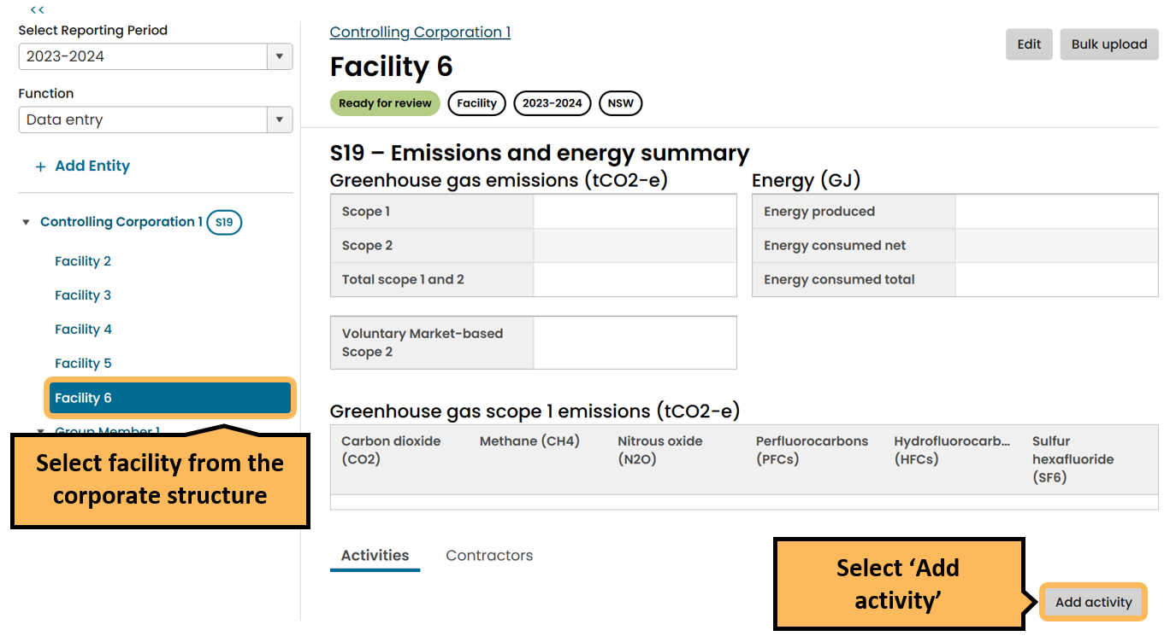

Selecting an activity
When adding a new activity, you must first select the source category, source type, and activity type from the drop-down menus. Once you have selected the activity type, the form will update and you can enter the information relevant to the activity.
The ‘activity descripton’ is optional and will not appear in the generated PDF report.
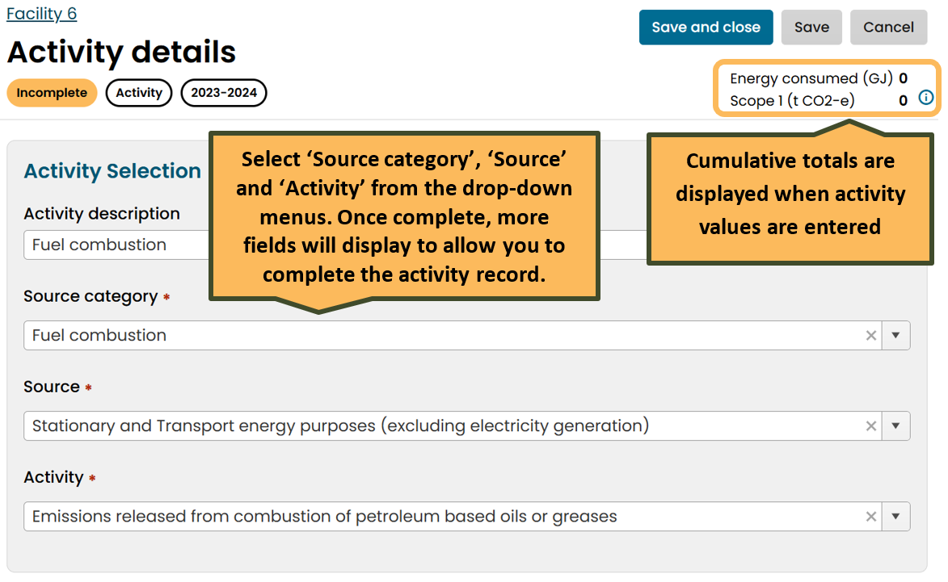

Enter activity values
Enter activity values to complete the record and change the status to ‘Ready for review’. To save or exit the record:
- ‘Cancel’ to exit screen without saving
- ‘Save’ to save partially completed record and remain on screen.
- ‘Save and close’ to save completed record and close screen.
Once you save the activity information, it will appear on the activity summary section on the facility emissions and energy summary.

You can only select checkboxes and options from drop-down menus in the EERS interface. You cannot update these items using the Bulk Upload function.
You should leave the quanity value and MTBI fields blank if you plan to use the Bulk Upload function.
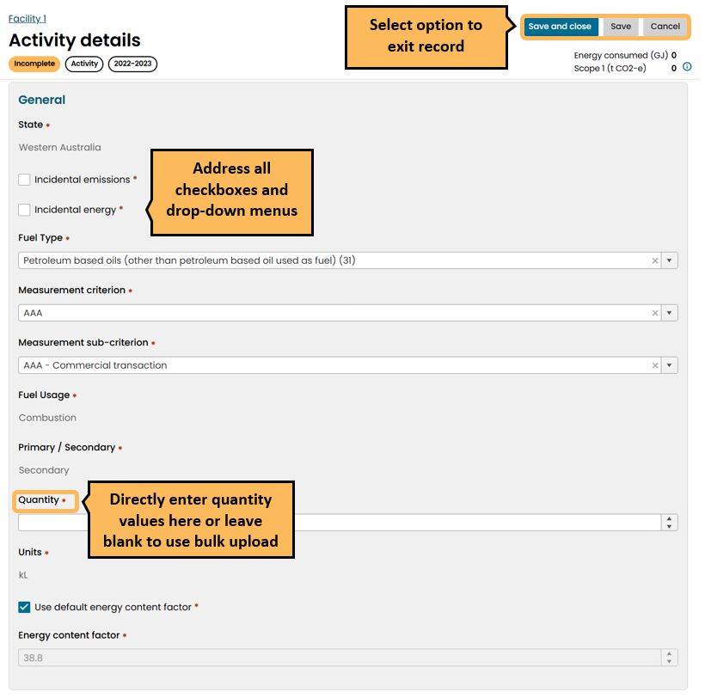

Edit activity values
To edit activity values for an existing activity, click the pencil icon in the activities tab. This will also show additional activity information which is not displayed in the summary table.
To delete an activity, click the bin icon and then click ‘confirm’ when the pop up appears.
In the activity list, incomplete activities are flagged by an orange exclamation mark icon.
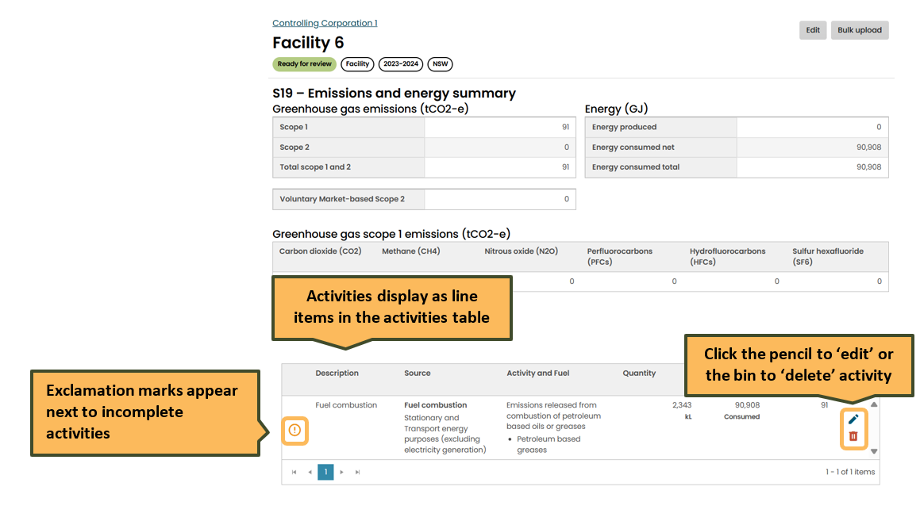

Add or edit facility data using Bulk Upload
The bulk upload function updates activity and MTBI quantity values only.
The following updates need to be made in the EERS workspace:
- changes to facility information in the facility record (for example ANZSIC code or location)
- activity types (add or remove)
- check boxes
- drop-down menus (including changes to methods)

To perform a bulk upload to enter activity and MTBI data:
- Review your corporate structure and facility activities
- Generate a template to extract a set of activity data that matches the EERS workspace. You can generate the template at any entity level.
- Download the template to review and add activity data.
- Bulk upload the changes into EERS to update your activity data.

Review corporate structure and facility activities
Review your organisation’s corporate structure and facility activities in EERS before generating the template to ensure you extract the most up-to-date data.
- Review your corporate structure and add, remove or edit entities as required. This includes group members, business units and facilities.
- Review your facility structure and facility information including facility type, ANZSIC codes and location information.
- Review the activities for each facility. Add, remove or edit activities but you do not need to enter activity or MTBI data yet. You can do this in the bulk upload template.
- Select all drop-down menu options and checkboxes in the EERS workspace as these cannot be edited through the bulk load function.

Generate and download the bulk upload template
Select the entity level for the bulk upload. You may select:
- Controlling corporation – all facilities will be included
- Group member or business unit – all children facilities will be included
- A single facility
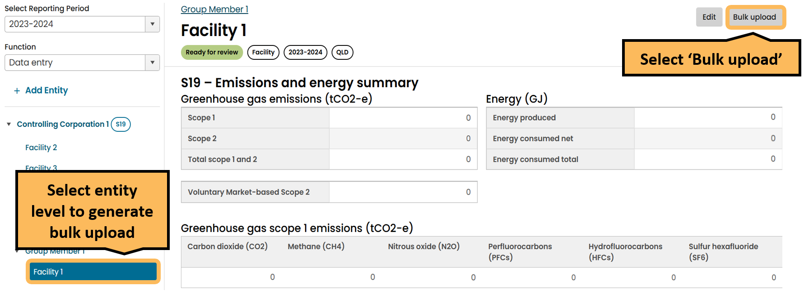
Select the entity level in the corporate structure and then click the ‘Bulk upload’ button. A single facility has been selected in the example below.
On the Bulk upload page, select ‘Generate template’. When the template has generated, click the ‘Download template’ button to download the template. The file type will be a ‘.csv’ which is a simple file type that does not allow for advanced formatting.
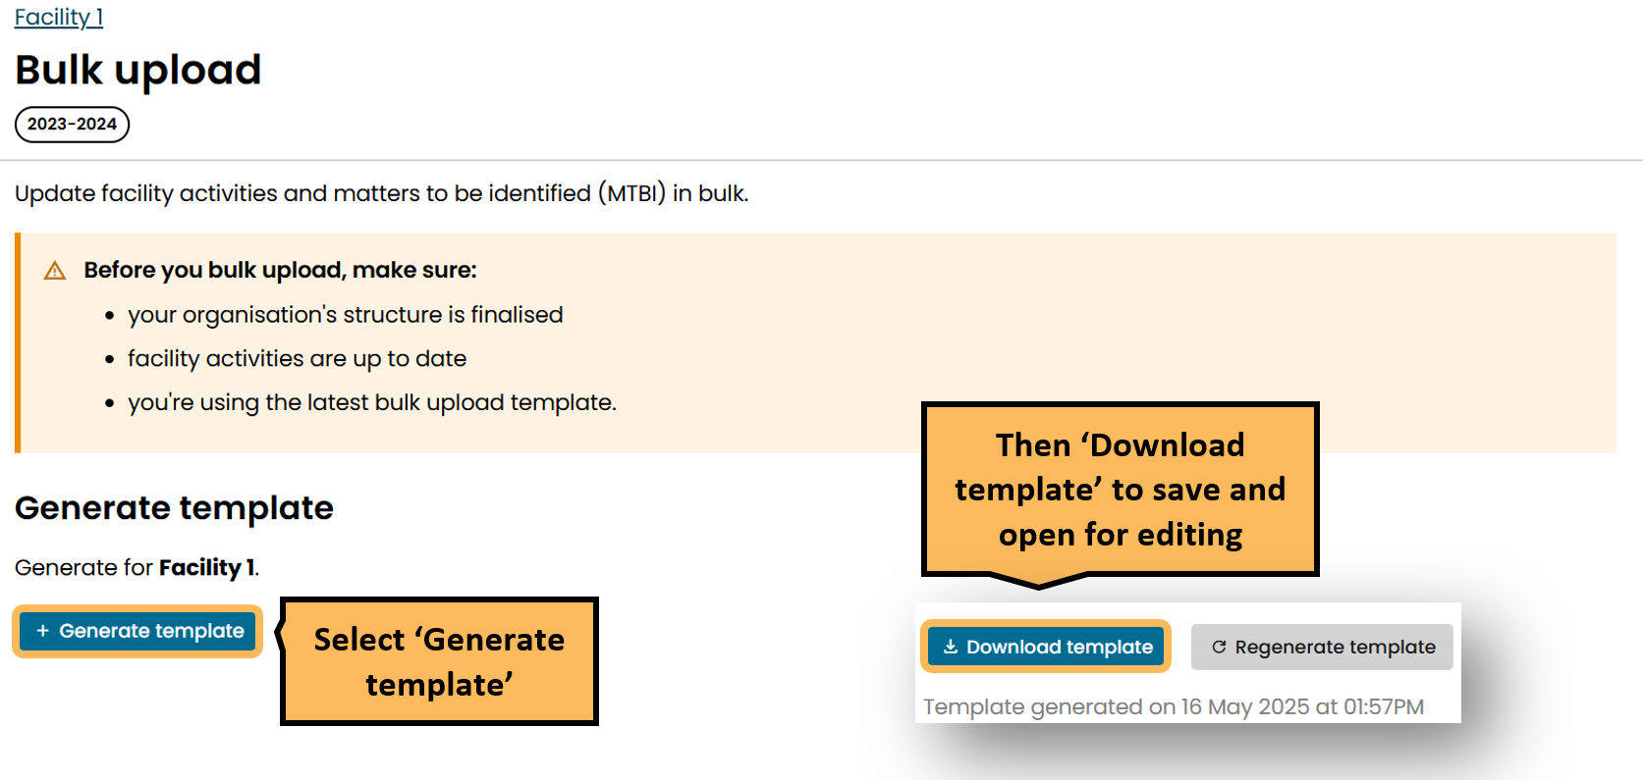

You can generate and regenerate the bulk upload template as many times as required.
Facility data can be updated directly in the EERS workspace at any time, even if you are using the bulk upload function. If changes are made directly in EERS, your template may not match the EERS workspace which could cause issues when you try to perform a bulk upload.
You should not make any changes to facilities in the EERS interface between generating the template and performing the bulk upload.
If changes are made to facility or activity data in the EERS workspace after generating the template, you can regenerate and download a refreshed template so your template matches your EERS workspace.

Edit the ‘.csv’ template
Enter activity values into the ‘Value’ column only if the ‘Help Text’ row is flagged as ‘Mandatory’. In this context, ‘Mandatory’ means that this data is required to complete the activity.
Do not edit data in other columns, or non-mandatory rows.
It is important to retain the ‘.csv’ format. You cannot bulk upload other file types into EERS. Do not change the order of rows or columns or edit header descriptions. This may cause the bulk upload process to fail.
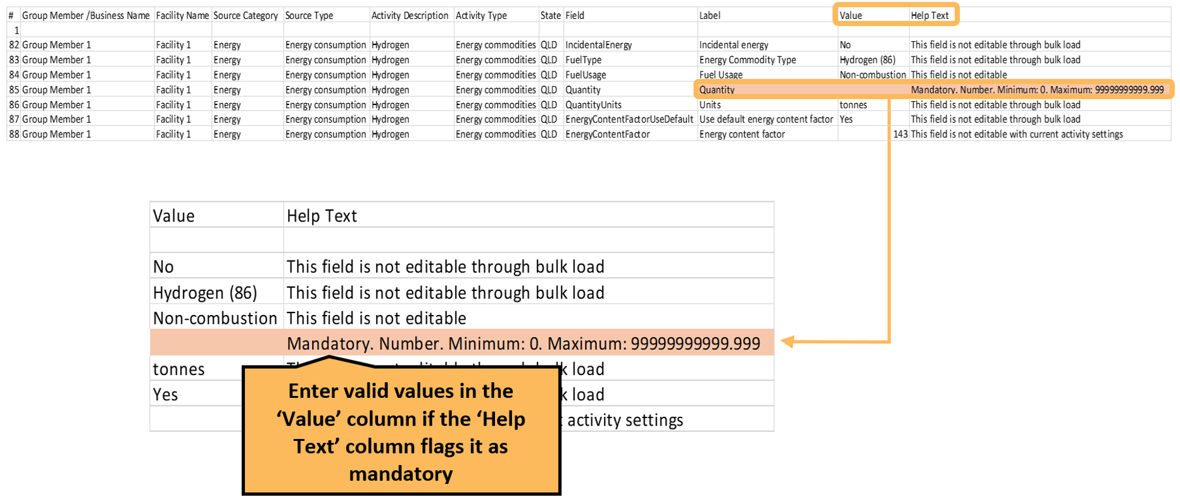
A sample of the bulk upload template is shown below.

Enter all quantity values then save the template as a ‘.csv’.

On the ‘Bulk upload’ page, bulk upload the template into EERS by:
- clicking ‘select files’ and selecting your file, or
- drag and drop the files into the bar.
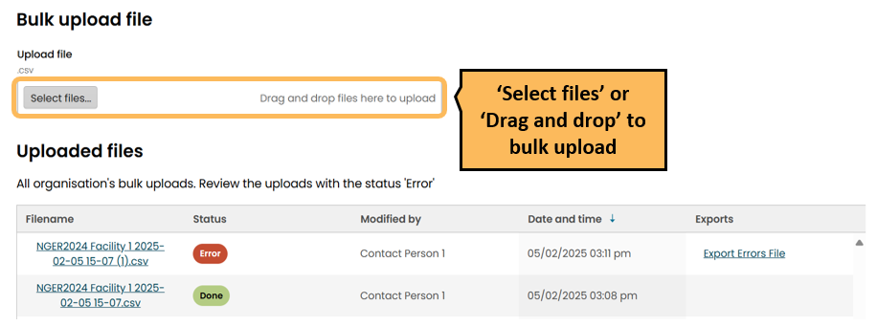

The ‘Uploaded files’ table will display a status for each ‘bulk upload’:
- Done: All valid quantity values have been successfully uploaded into the EERS workspace.
- Error: There were errors with some or all activity data.
If there are errors:
- Activity data will pass into the EERS workspace for activities that had no errors
- The ‘Export Errors File’ will contain only those activities in the uploaded template where the quantity value was not valid.
Download the ‘Export Errors File’ and review error message.
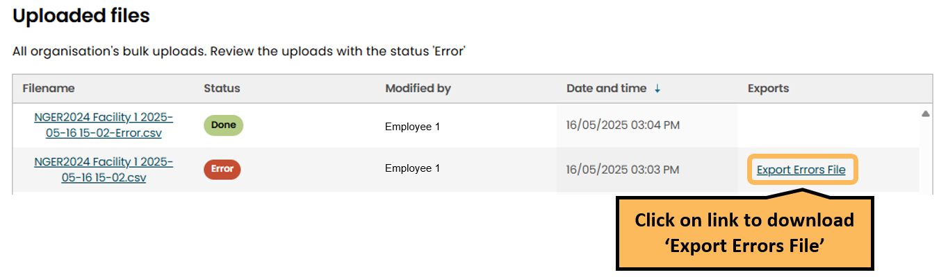
The ‘Export Errors File’ will show the reason for the error in the ‘Error Message’ column, which may include:
- A required field was not provided (left blank)
- An inputted value was outside the permitted range.
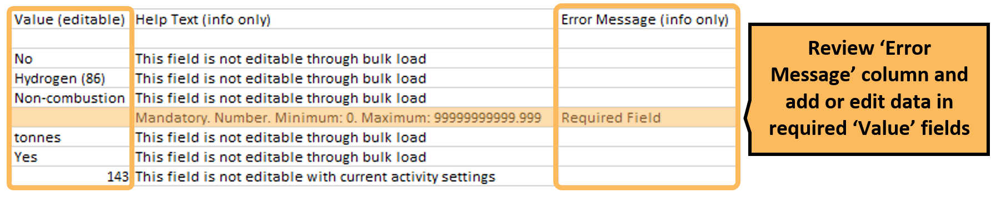
To correct the activity data, you can:
- correct the data in the errors file and bulk upload into EERS
- directly edit the data in the EERS workspace.

For more information on the Bulk upload process, watch the ‘How to use the bulk upload function’ video.

Enter contractor data to a facility
The organisation with operational control is responsible for collecting contractor data and incorporating the data in EERS. You will do this by adding activity data for the facility as shown in Chapter 8 and Chapter 9.
The ‘Contractor’ tab is where you flag the emissions and energy that is attributable to individual contractors, provided the relevant thresholds are met. The energy and emissions totals that you add in the contractor tab are not added to the facility totals.
You can add a new contractor or edit data for an existing contractor. Each contractor record in EERS will display tags to denote status and reporting year.
Read more about adding contractor data and the relevant thresholds in the Contracts and leasing guideline.

Add a new contractor
Select a facility from the corporate structure, select the ‘Contractors’ tab for a facility, and then click the ‘Add contractor’ button.
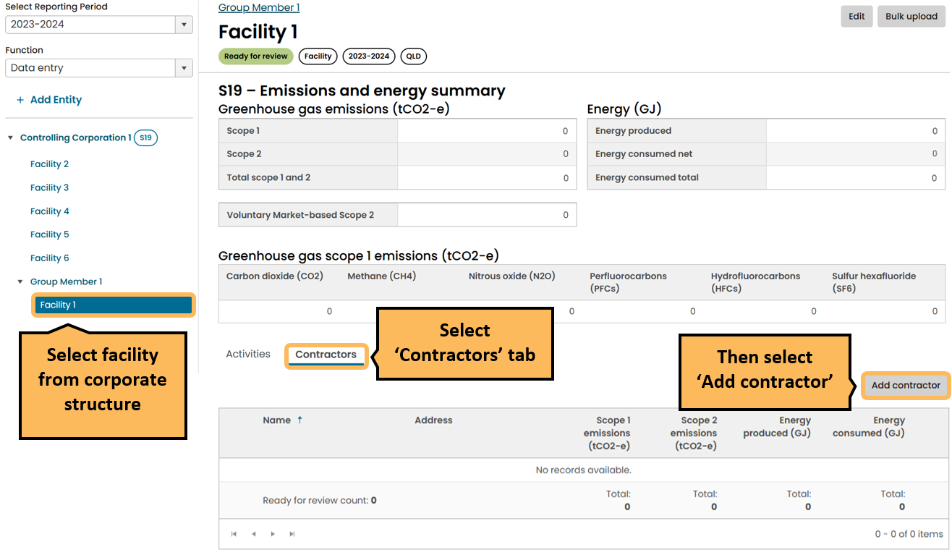
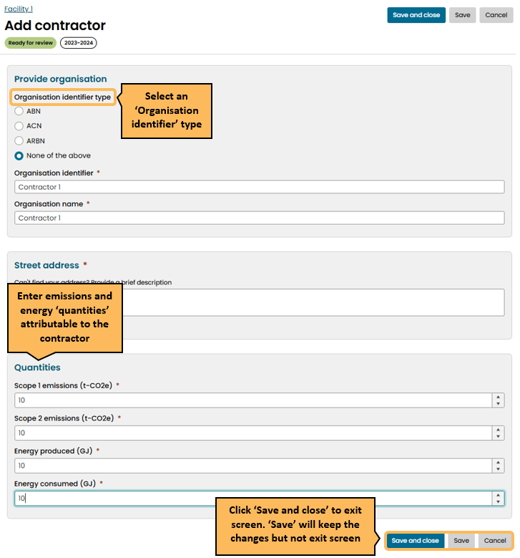
Fill in the required data for the contractor. Click ‘Save and close’ to exit the screen.

Edit existing contractor
Select the ‘Contractors’ tab and click the edit icon on the right side of the table. This will take you to the contractor information page where you can edit contractor details. Contractors that are below threshold are flagged.
Read more about adding contractor data and the relevant thresholds in the Contracts and leasing guideline.
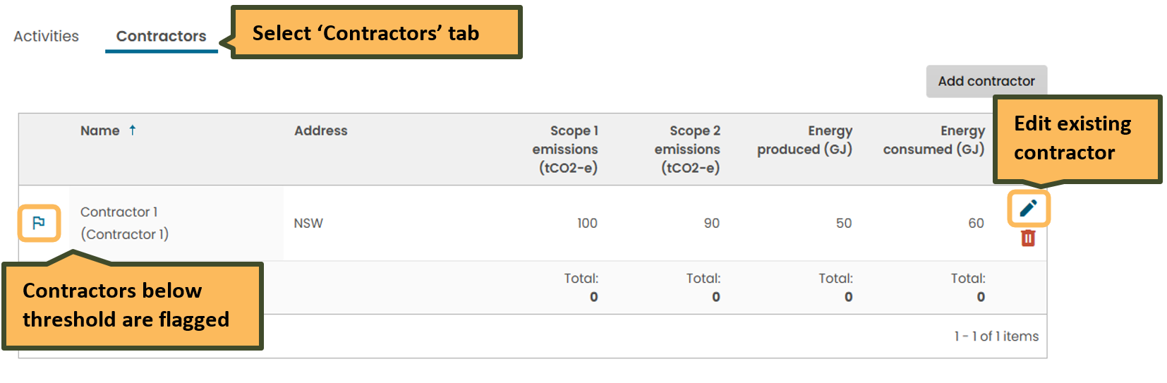

Delete existing contractor
To delete an existing contractor, click the small rubbish bin symbol in the far-right column. This will trigger a pop-up to confirm you want to delete the contractor.

Production variable reporting for safeguard facilities
The ‘Production variables’ tab will appear alongside the ‘Activities’ and ‘Contractors’ tabs near the bottom of the individual facility summary pages. Enter production variables for Safeguard facilities by clicking the ‘Add production variable’ button.
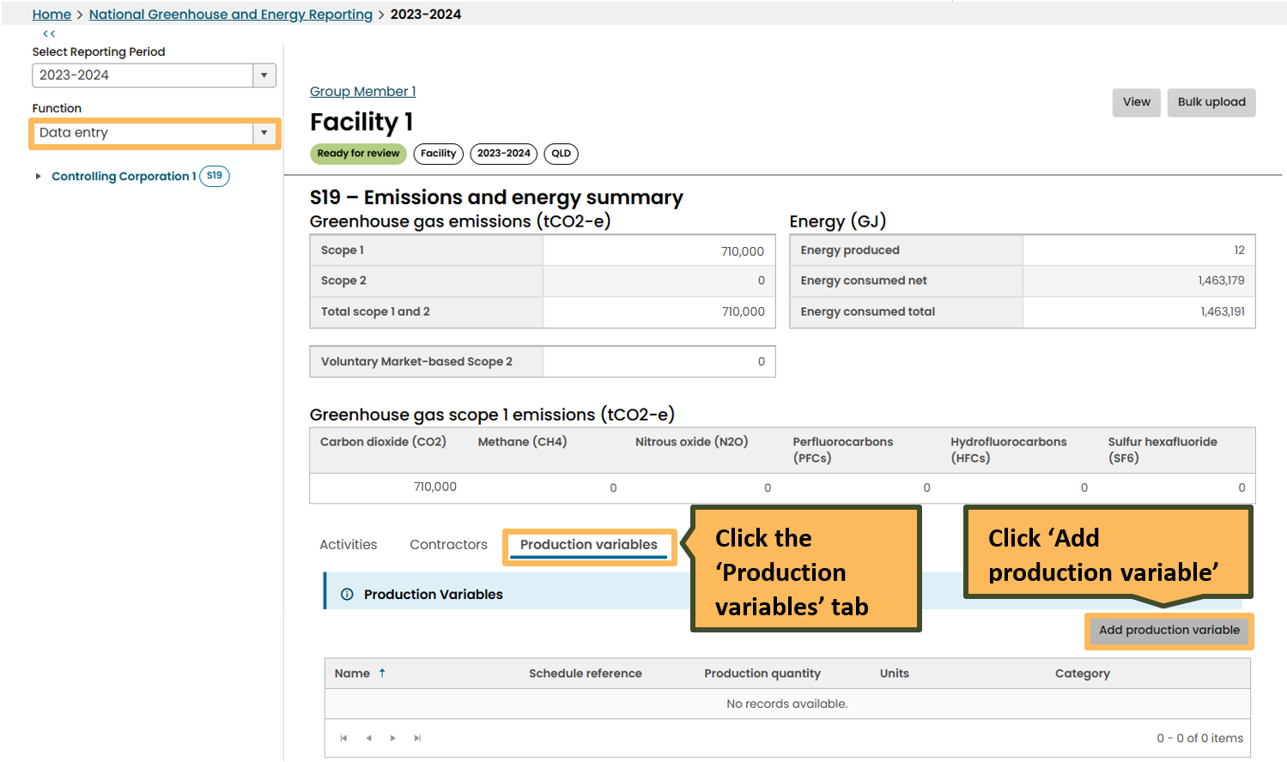
For further information see the ‘Production variable reporting for Safeguard facilities’ section of the NGER quick help topics.

Report small facilities percentage
In the ‘Small facility percentages’ function, very low levels of greenhouse gas emissions, energy consumption and energy production from one or more facilities may be reported as a percentage estimate of the reporter’s total emissions and energy.
The small facilities percentage record in EERS will display tags to denote status and reporting year.
Enter the number of small facilities and emissions and energy percentages. Then ‘Save and close’ to save and exit the screen.
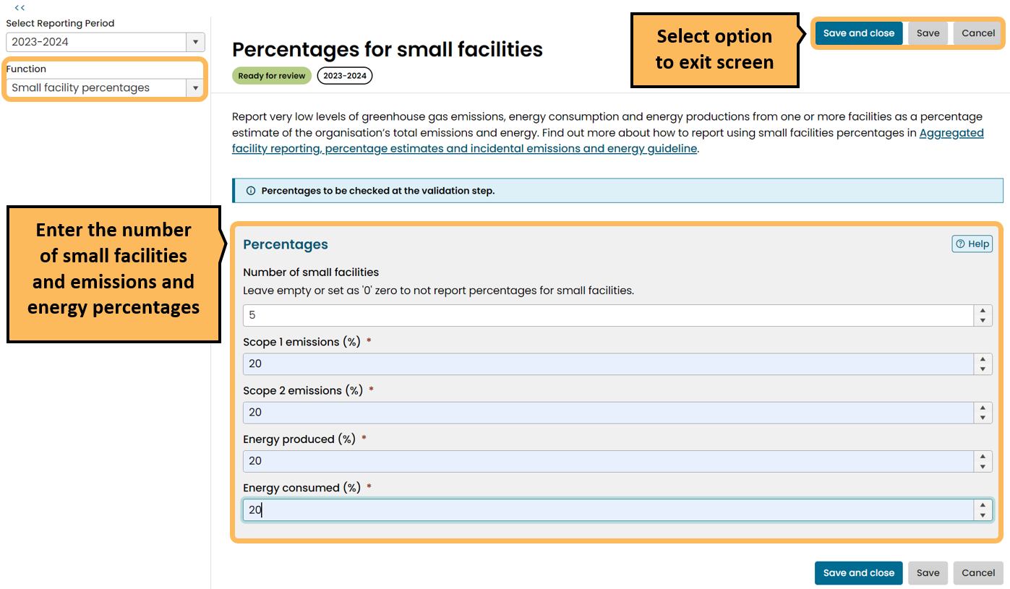
For more information refer to the Aggregated facility reporting, percentage estimates and incidental emissions and energy guideline. Learn about ways to Simplify your reporting.

Report uncertainty
You may need to report uncertainty for sources or fuel types that are above a certain reporting threshold. Enter all activity information before using this function. To report uncertainty in EERS, select ‘Report uncertainty’ from the function drop down menu.
The ‘Report uncertainty’ page shows all sources and fuels that exceed the uncertainty reporting threshold for each facility.
For a facility, where ‘method 1’ has been exclusively used for a source or fuel type, you can use the ‘auto-calculate’ option. When you check the ‘auto-calc’ box, EERS will calculate and display the uncertainty as a percentage for that source or fuel. If you choose to manually enter the uncertainty, de-select the ‘Auto-calc’ checkbox.
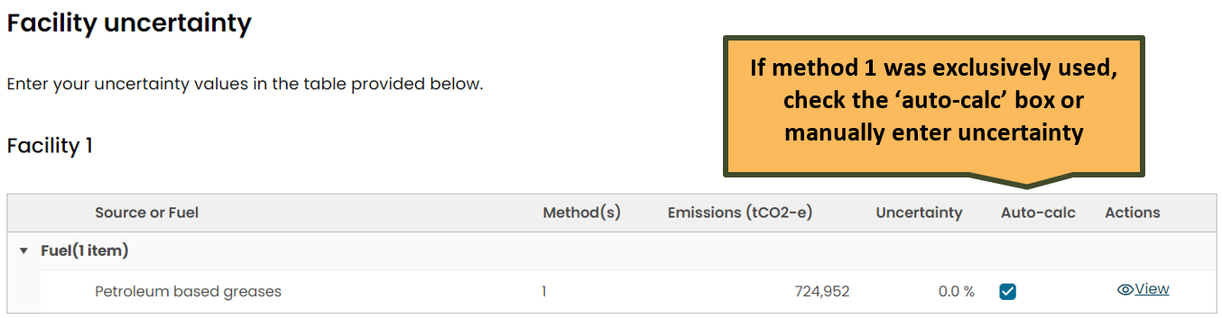

Where higher order methods have been used, you must manually calculate the uncertainy. You may either use the Clean Energy Regulator’s ‘Uncertainty calculator’ or use your own method in line with the NGER Measurement Determination.
When using the CER’s Uncertainty calculator:
- Download the Uncertainty calculator and the Uncertainty Calculator User Guide for the relevant reporting year.
- Click ‘Copy to clipboard’ and paste data into the uncertainty calculator.
- Click on the uncertainty fields for each facility to enter the value from the uncertainty calculator.

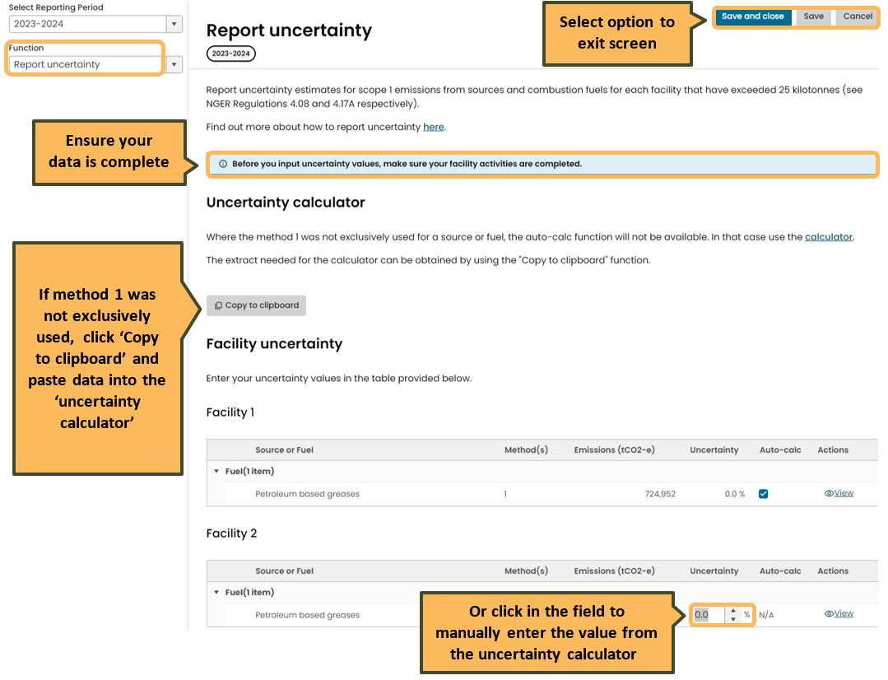

Changes to relevant activity data after you report uncertainty will clear uncertainty from EERS. In this case uncertainty will need to be recalculated.
For more information on reporting uncertainty, read the reporting uncertainty guideline for the relevant reporting year.

Validate
The ‘Validate’ function, displays validation issues which must be addressed prior to draft report generation and report submission.

Validation issues are categorised under the following validation types:
- incomplete records
- safeguard production variables
- uncertainty
- small facility thresholds
- related activities.

The screen will only display 25 validation issues at a time per validation type. Address the validation issues on the screen to display more.

You can acknowledge, rather than fix, a validation issue for a ‘related activity’ if the suggested related activity is not applicable for your reporting. Acknowledgements will not clear from the Validate page and will appear in the NGER pdf report when it is generated.
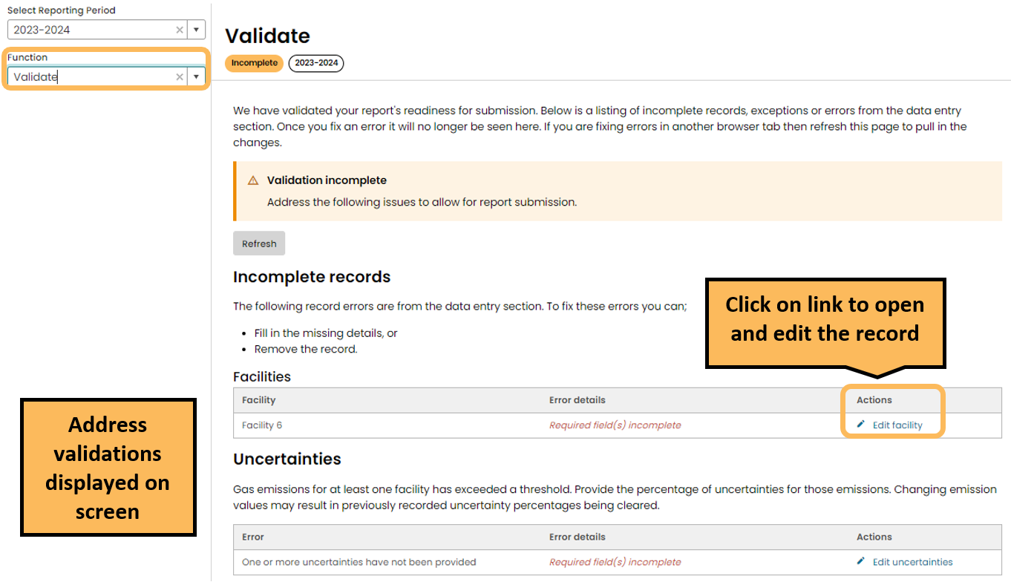
Click on the link under the Actions heading in the ‘Incomplete records’ table to open the record.
If there are no validations, the page will display ‘Validation checks passed’.

Generate and submit a report
In the ‘Reports’ function you can perform these actions, provided you have the required permissions:
- add supporting information as attachments
- generate a draft report
- withdraw a draft report so changes can be made
- submit your organisation’s NGER report (Executive Officer or officer with written authorisation to submit on behalf of the organisation)
- view generated reports and submitted attachments from previous reporting periods in the ‘Submitted reports’ table.
If you are unable to perform one of these actions, or need to update your permissions, contact your organisation’s administrator.
Before you generate a report, attach any supporting documentation by clicking ‘Add’. These will display in the report.
To commence the process for generating the draft report, click ‘Generate’ from the Reports page.

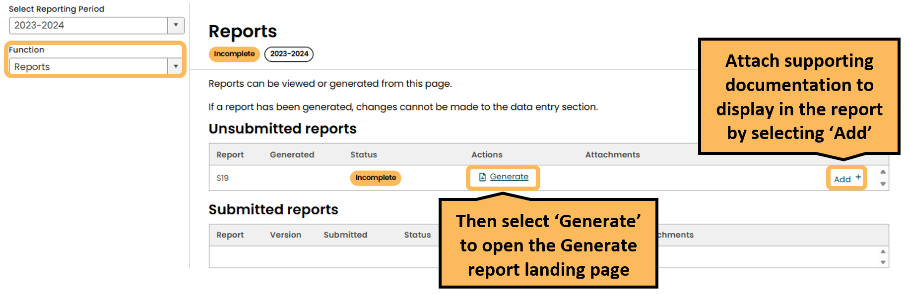

This will open the ‘Generate report’ landing page. You will need to confirm the details of your NGER contact person and Executive Officer. If they are satisfactory, click the blue ‘generate’ button at the bottom of the screen to generate your report. If the ‘generate’ button is not available to click, check that you have addressed all validations in the ‘Validate’ function.
Updates to the NGER Contact Person or Executive Officers need to be done through the Manage access function by your organisation administrator. See the NGER Online Services user guide for more information.
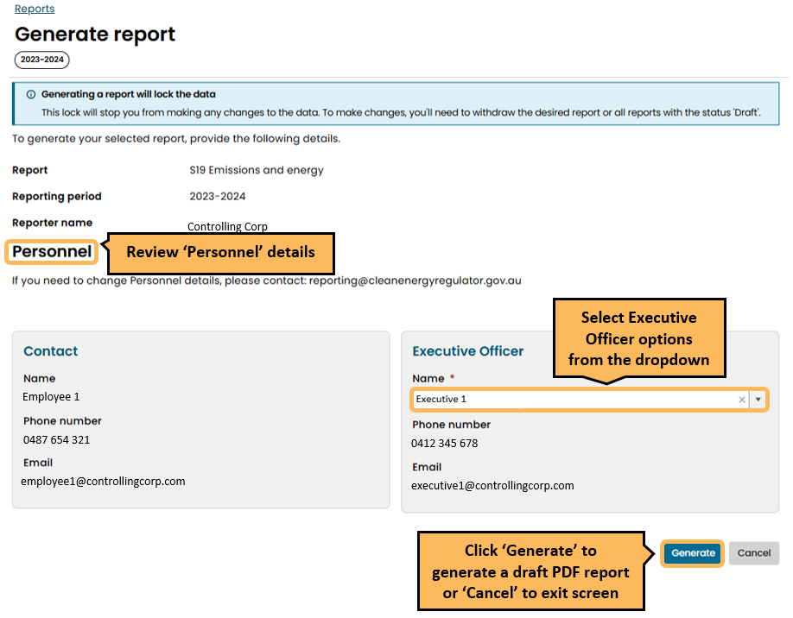

When you click ‘Generate’ the ‘Review and submit report’ landing page will load.

The workspace will be locked to prevent any changes to the data and the status tag on the ‘NGER reports’ landing page will display as ‘Draft’. To make changes to the data, you will need to withdraw the report.

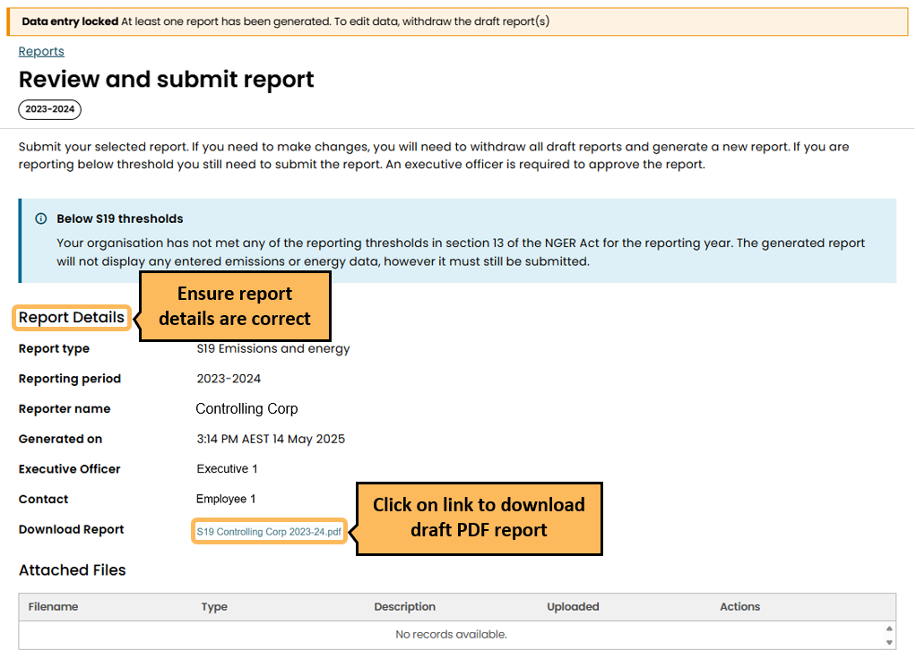
Review the draft and if data needs to be added or edited, withdraw the draft, make changes to data and then generate the report again. You can withdraw the report by clicking ‘withdraw’ from the Reports landing page.
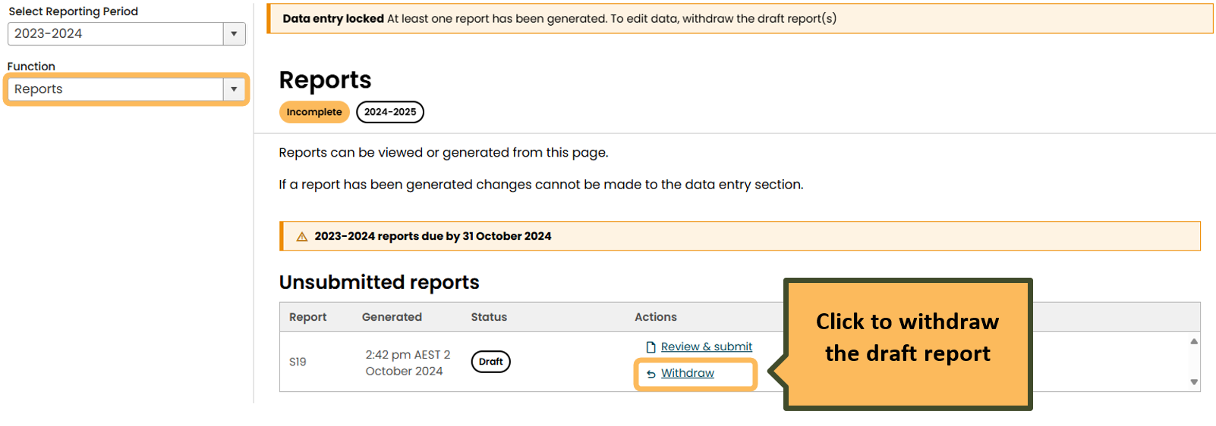

A draft PDF report can be withdrawn and regenerated as many times as required.
Data entered in new EERS may not appear in a generated report. If this occurs, check if the:
- facility and/or corporate threshold has been met
- facility is marked as ‘Not reporting’.
Scroll down to read the Declaration before submitting the NGER report.

Only an Executive Officer or an officer with written permission to submit on behalf of the organisation may submit the report.
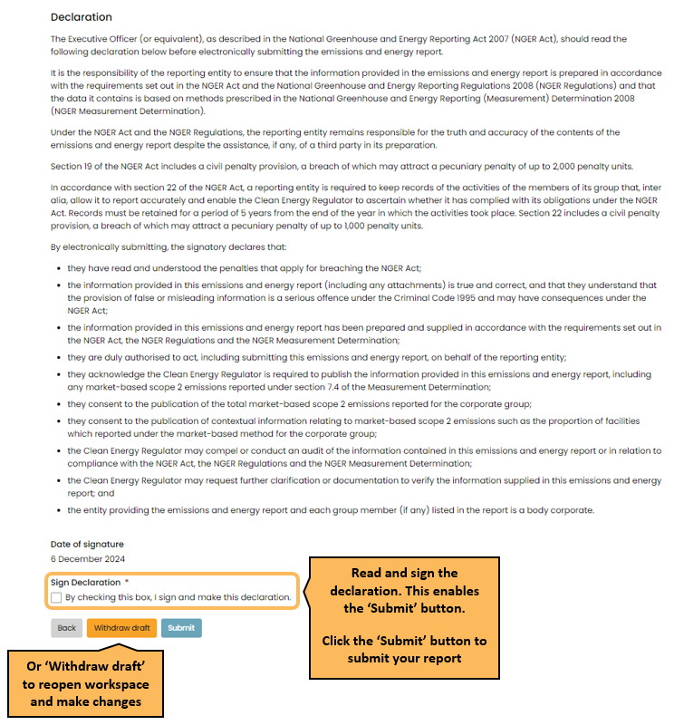
If your Executive Officer or officer with written authorisation to submit on behalf of the organisation are unable to submit the report, you will need to contact your organisation’s administrator.
You can confirm you have submitted your report by checking the submitted reports table on the NGER reports landing page. If the status does not say ‘submitted’ it means you have not yet successfully submitted your report.
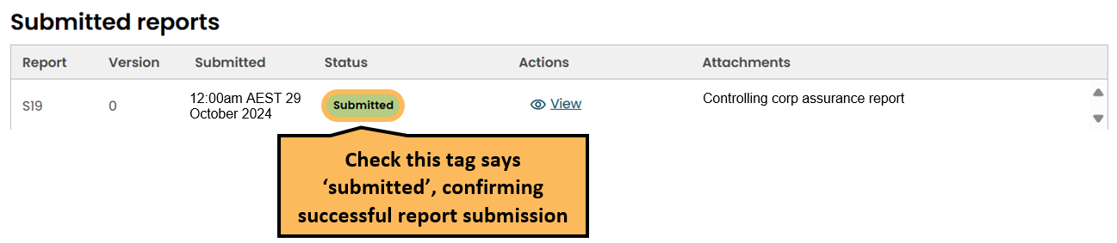

More information for NGER reporting
Visit our reporter support dashboard on the CER website to access:
- NGER Online Services user guide
- NGER reporting guidelines
- Emissions and Energy Reporting System (EERS)
- New EERS videos
  - What to expect in new EERS
  - How to generate and submit your report
  - Reading the new-look PDF report
- Webinars
- Training videos

If you have any questions, get in touch:
- 1300 553 542
- cer-nger-reporting@cer.gov.au

https://cer.gov.au/schemes/national-greenhouse-and-energy-reporting-scheme/assess-your-obligations#nger-thresholds
https://cer.gov.au/about-us/contact-us
https://cer.gov.au/
https://cer.gov.au/document_page/nger-online-services-user-guide
https://cer.gov.au/about-us/contact-us
https://cer.gov.au/schemes/national-greenhouse-and-energy-reporting-scheme/assess-your-obligations#what-is-an-nger-facility
https://cer.gov.au/document_page/operational-control-supplementary-guideline
https://cer.gov.au/schemes/national-greenhouse-and-energy-reporting-scheme/report-emissions-and-energy/nger-reporting-guides
https://cer.gov.au/document_page/contracts-and-leasing-guideline
https://cer.gov.au/document_page/contracts-and-leasing-guideline
https://cer.gov.au/schemes/national-greenhouse-and-energy-reporting-scheme/report-emissions-and-energy/nger-reporting-guides#nger-quick-help-topics
https://cer.gov.au/document_page/guidance-aggregated-facility-reporting-percentage-estimates-and-incidental-emissions-and-energy
https://www.youtube.com/watch?v=SGDAKT-a158&list=PL45ht4q-mldVSxiniYeP7t_Jkk62SvZ7L&index=8&pp=iAQB
https://cer.gov.au/schemes/national-greenhouse-and-energy-reporting-scheme/report-emissions-and-energy/nger-calculators
https://cer.gov.au/document/nger-uncertainty-calculator-user-guide-2023-24
https://cer.gov.au/document_page/reporting-uncertainty-guideline
https://cer.gov.au/document_page/nger-online-services-user-guide
https://cer.gov.au/schemes/national-greenhouse-and-energy-reporting-scheme/report-emissions-and-energy/reporter-support

