# Contracts and leasing guideline

January 2025

# Disclaimer

Thisguideline has been developed by the Clean Energy Regulator (CER) to assist entities to comply with their reporting obligations under the [*National Greenhouse and Energy Reporting Act 2007*](https://www.legislation.gov.au/Series/C2007A00175)[1](NGER Act)and associated legislation.

This guideline should be read in conjunction with the NGER Act, [National Greenhouse and Energy Regulations 2008](https://www.legislation.gov.au/Series/F2008L02230)[2] (NGER Regulations), and [National Greenhouse and Energy Reporting (Measurement) Determination 2008](https://www.legislation.gov.au/Series/F2008L02309)[3] (NGER Measurement Determination), as in force for this reporting period. These laws and their interpretation are subject to change, which may affect the accuracy of the information contained in the guideline.

The guidance provided in this document is not exhaustive, nor does it consider all circumstances applicable to all entities. This guidance is not intended to comprehensively deal with its subject area, and it is not a substitute for independent legal advice. Although entities are not bound to follow the guidance provided in this document, they must ensure they meet their obligations under the [National Greenhouse and Energy Reporting (NGER) Scheme](https://cer.gov.au/schemes/national-greenhouse-and-energy-reporting-scheme/record-keeping-and-compliance-greenhouse)[4] at all times. The CER encourages all users of this guidance to seek independent legal advice before taking any action or decision on the basis of this guidance.

The CER and the Australian Government will not be liable for any loss or damage from any cause (including negligence) whether arising directly, incidentally or as consequential loss, out of or in connection with, any use of this guideline or reliance on it, for any purpose.

If an entity chooses to meet their obligations under the NGER scheme in a manner that is inconsistent with the guidance provided in this document, the CER, or an independent auditor, may require the entity to demonstrate that they are compliant with requirements of the NGER Act, NGER Regulations, and/or the NGER Measurement Determination. Entities are responsible for determining their obligations under the law and for applying the law to their individual circumstances.

# Introduction

The purpose of this guidance is to assist corporations in identifying their reporting obligations for contractors and subcontractors under the *National Greenhouse and Energy Reporting Act 2007* and National Greenhouse and Energy Reporting Regulations 2008*.*

## NGER legislation and reporting contractors

Division 2.4 of the NGER Regulations looks at different circumstances in which an activity or activities will 'form a single undertaking or enterprise' for the purposes of section 9 of the NGER Act. Many of these regulations allow for activities falling within the one sector (and any ancillary activities) to be linked, meaning they will be treated as a single facility. The facility’s reportable activities may then include external workers, such as contractors, who have been employed to perform activities within the facility.

The company that has operational control of a facility is responsible for collecting all greenhouse gas emissions and energy data for that facility. This includes the activities of contractors and subcontractors and their greenhouse gas emissions, as well as energy they use and produce.

This means the company with operational control is responsible for collecting contractor data and incorporating the data in its own NGER report.

In addition to reporting your contractor’s activities as part of your facility’s detailed activity data, you may also need to provide additional details about your contractor. This will be required if the activities they perform at your facility meet the thresholds listed under Regulation 4.30.

## How to determine if contractors should be part of an NGER report

A company should take the following steps to determine if contractors should be reported as a part of a facility:

* identify all contractors working at the facility
* determine if contractor activities form part of the facility
* collect greenhouse gas emissions, energy consumption and energy production data from all contractors that form part of the facility
* combine contractor data with the emissions and energy data from activities attributable to the company with operational control over the facility
* determine if any contractors meet the additional contractor reporting information under regulation 4.30 of the NGER Act and report this as required.

For more information, refer to Contractors that meet NGER thresholds.

### Examples

#### Single site facility

‘Mining Company A’ mines and processes mineral ore at a single site. A contractor provides transport of the ore from the mine to the processing plant. Together these activities make up a facility.

Mining Company A has operational control of the facility and is required to report the emissions and energy associated with the contractor's deliveries.

#### Transport facility

'Transport Company A' uses a subcontractor to move some of its freight. Applying the concept of overall control, if Transport Company A was deemed to have overall control of the subcontractor's activities for the facility, then Transport Company A would be required to report the emissions and energy associated with the subcontractor's deliveries.

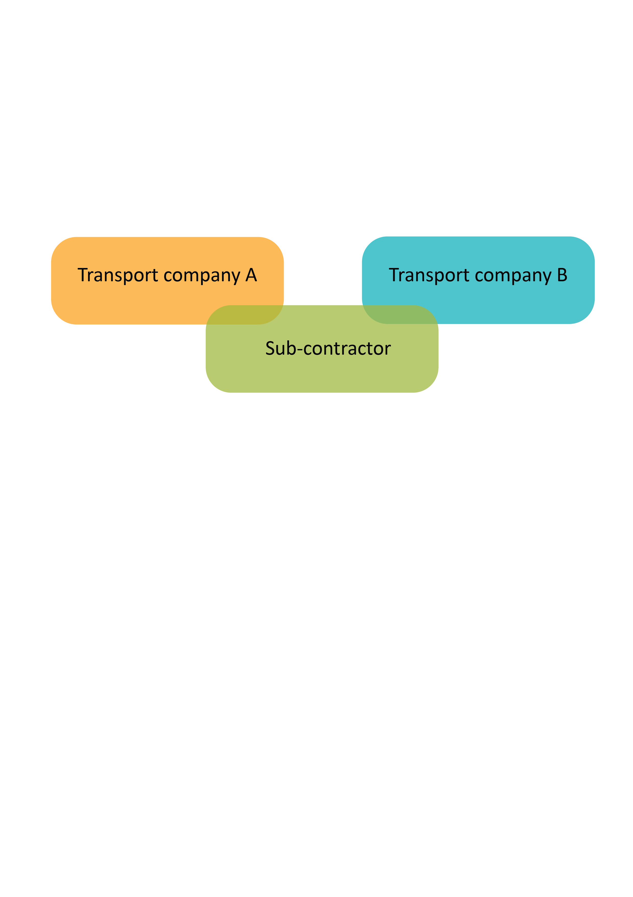

The subcontractor may also carry out activities for another corporation, Transport Company B, independently of Transport Company A. In this scenario, the concept of overall control would need to be applied again between Transport Company B and the subcontractor.

When overall control has been applied and the facility boundary is defined, the term ‘operational control’ is used. Operational control is the same as overall control except it relates to an entire facility while overall control relates to activities that constitute the facility.

### Other contractor scenarios

#### Third party managers or operators

The conditions specified in a contract will determine who is required to report when there is a third-party contractor or operator. Normally the authority to introduce policies is expected to be shared between the owner and the manager or operator. The greatest authority to introduce policies is dependent on the contractual relationship. In some circumstances the greatest authority will rest with the facility manager as the corporation with day-to-day on-site managerial responsibility. This is, however, balanced against the ability to introduce operating and environmental policies, which may rest with the owner.

See the Operational control supplementary guideline on our website.

#### Leasing – novated leases and salary packaged vehicles

Where corporations have their own vehicle fleets that are used in day-to-day operations and/or those purchased for employees under a novated lease (salary packaged), overall control is applied to determine reporting responsibility.

If a vehicle purchased or leased by the corporation is used mainly for activities associated with the operation of the facility, it would fall within the definition of the facility. The emissions and energy consumption from this vehicle must be reported by the controlling corporation.

If the employee has overall control of the salary packaged vehicle, it will fall outside the definition of the facility. The emissions and energy consumption from this vehicle would not be reported.

## Reporting contractor activities

### Reporting minor activities

If the greenhouse gas emissions, energy consumption, or energy production attributable to contractor activities are relatively minor in comparison to the facility’s emissions and energy totals, it may be possible to use incidental reporting under Regulation 4.27. This allows you to use your own method of estimation rather than a prescribed method in the Determination.

The limits on the quantities of emissions and energy that can be reported using incidental provisions are provided in Regulation 4.27. Using the incidental method reduces the amount of information you need to include in your report about an activity.

For more information on how to use the incidental method, please see the Aggregated facility reporting, percentage estimates and incidental emissions and energy guideline on our website.

### Contractors that meet NGER thresholds

In cases where contractors meet an NGER threshold, they are required to report emissions and energy from all facilities under their operational control. In these scenarios, ‘double counting’ should be avoided if the concepts of overall control and operational control are applied correctly and consistently.

For example, if Contractor A carries out an activity for Corporation B which is deemed under the overall control of Corporation B, then the emissions and energy associated with the activity will be reported by Corporation B, which has operational control of the facility. These emissions and energy are only counted once, by Corporation B, and are only included in Corporation B's NGER report.

The concepts of overall control and operational control are applied on a case-by-case basis. Overall control is applied to activities to determine if associated emissions and energy fall inside the definition of the facility. The reporting obligation lies with the corporation with operational control of the facility.

Reporting on contractor activity must be undertaken when the contractor’s activities alone meet any of these thresholds:

* produce 25 kilotonnes or more of greenhouse gas emissions
* produce 100 terajoules or more of energy
* consume 100 terajoules or more of energy.

If required to report on a contractor’s activities you will need to include the following details:

* name of the contractor
* contractor’s identifying details (ABN, ACN, ARBN)
* total greenhouse gas emissions produced by the contractor’s activity or activities
* total energy produced by the contractor’s activity or activities
* total energy consumed by the contractor’s activity or activities.

## Further information

Email: [reporting@cer.gov.au](mailto:reporting@cer.gov.au)

Phone: 1300 553 542

Website: [www.cer.gov.au](https://www.cer.gov.au/)

1. https://www.legislation.gov.au/Series/C2007A00175
2. https://www.legislation.gov.au/Series/F2008L0223
3. https://www.legislation.gov.au/Series/F2008L02309
4. https://cer.gov.au/schemes/national-greenhouse-and-energy-reporting-scheme