**Corporate Emissions Reduction Transparency Report**

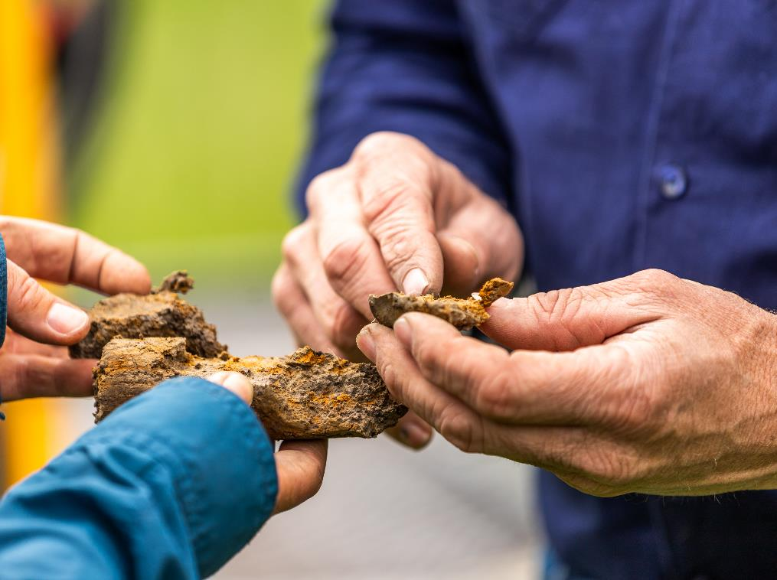Reporting Guidance and

Supporting Examples

FY2021-22 and CAL2022

March 2023

# Contents

Introduction 3

Disclaimer 3

Reporting guidance 4

Calendar year and equity share reporting - *Section 7 of the CERT Guidelines* 4

Independently Assured Commitments - *Section 3 of the CERT Guidelines* 6

Revising a Base Period - *Section 7 of the CERT Guidelines* 9

Renewable Electricity Use - *Section 5 and 6 of the CERT Guidelines* 11

Supporting Examples 14

Eligible commitments – *Section 3 of the CERT Guidelines* 14

Emissions accounting – *Section 5 of the CERT Guidelines* 17

Renewable electricity accounting – *Section 6 of the CERT Guidelines* 21

Accounting options and adjustments – *Section 7 of the CERT Guidelines* 23

Revising a Base Period *– Section 7 of the CERT Guidelines* 26

Calculating progress – *Section 8 of the CERT Guidelines* 28

Reporting – *Section 10 of the CERT Guidelines* 31

# Introduction

This document provides detailed reporting guidance for some more technical aspects of Corporate Emissions Reduction Transparency (CERT) reporting, as well a series of worked examples of how some aspects of the [CERT report guidelines](https://www.cleanenergyregulator.gov.au/DocumentAssets/Pages/CERT-Report-Guidelines-FY2021-22-and-CY2022.aspx)[1] may apply to hypothetical companies and their commitments. These examples align with certain sections of the guidelines, specified throughout. This document aims to assist existing and potential CERT participants understand the application of the CERT guidelines, and address frequently asked questions, particularly regarding CERT emissions accounting, double counting provisions, independent assurance and equity and calendar year adjustments. It is not intended as an exhaustive list of potential scenarios, and companies are encouraged to contact the Clean Energy Regulator (CER) via [CER-CERT@cer.gov.au](mailto:CER-CERT@cer.gov.au) for further information and clarification if needed.

### Disclaimer

Before reading this Guidance document, please be advised:

* The Clean Energy Regulator publishes the CERT report and these guidance materials in good faith to increase market transparency and to disseminate statistical information relevant to the operation of the legislation and schemes administered by the Clean Energy Regulator including the *Carbon Credits (Carbon Farming Initiative) Act 2011*.
* The material in this document is provided for general information only, and is not legal, business or financial advice. You should obtain your own independent professional advice for your particular circumstances before making any investment decisions.
* The entity that supplies the information in the CERT report publication is responsible for that information. In particular, you are responsible for the accuracy and quality of data and information which you provide to the Clean Energy Regulator for CERT. It is also your responsibility to ensure you comply with legal or regulatory requirements, including any ASIC guidance on climate risk disclosure and legal requirements regarding the provision of false or misleading information.
* To the extent permitted by law, neither the Clean Energy Regulator nor the Commonwealth of Australia accepts responsibility or liability for any direct, incidental or consequential loss or damage resulting from a CERT report, the information provided (or not provided) through a CERT report, or the availability or non-availability of a CERT report. The Clean Energy Regulator and the Commonwealth reserve their rights in relation to the provision of incorrect, false or misleading information.

# Reporting guidance

## Calendar year and equity share reporting - *Section 7 of the CERT Guidelines*

Recognising that data reported under the National Greenhouse and Energy Reporting (NGER) scheme may not align with a company’s own sustainability reporting approach, the CERT report allows participants to present their emissions and energy data and calculate progress based on calendar year or equity share reporting (or both). There are two options for reporting data under these arrangements:

* By adjusting data already reported under NGER using a set of multipliers.
* By providing an alternative, independently assured emissions and energy data set.

#### Which approach should I use to report calendar year or equity share data?

If you have complex equity share arrangements or reporting structures you may find reporting independently assured data more suitable. Complex arrangements might include jointly owned facilities that form part of an aggregated facility under NGER, or a large number of jointly owned facilities where equity share changes regularly. If you have only a few jointly owned facilities or wish to report any of your commitments as ‘CER data verified’, you should choose the NGER multiplier approach. Note that commitments are unable to be presented as ‘CER data verified’ under the independent assurance approach.

#### How do I work out what my NGER multipliers are?

##### Determining calendar year multipliers

For calendar year reporting using multipliers, you must provide multipliers **for each commitment entity[2] and, if not covered by a commitment, the reporting entity[3]** for gross scope 1 and 2 emissions, imported electricity, and renewable and non-renewable on-site electricity consumption. These represent the change in these quantities from the most recent NGER reporting year to the calendar reporting year as a percentage, with 100 representing no change. Definitions for these quantities can be found in the guidelines.

Calendar year multipliers can be worked out by dividing the previous financial year’s NGER-reported quantity by the calendar year value for the reporting year, as follows:

$$Multiplier=\left(\frac{Value (Calendar Year)}{Value (NGER)}\right)×100$$

For example, a CERT participant nominates the 2022 calendar year for their 2023 CERT report commitments. Their NGER-reported gross scope 1 and scope 2 emissions were 200 kt CO2-e and 110 kt CO2-e respectively for the 2021-22 financial year. In the 2022 calendar year, their scope 1 emissions increased to 204 kt CO2-e, while their scope 2 emissions decreased to 94 kt CO2-e. For these quantities, the participant would report the following multipliers:

$$Scope 1 multiplier=\left(\frac{204}{200}\right)×100=102$$

$$Scope 2 multiplier=\left(\frac{94}{110}\right)×100=97$$

The participant would similarly calculate multipliers for their imported electricity, and renewable and non-renewable on-site electricity consumption.

Multipliers may be expressed to four decimal places.

##### Determining equity share multipliers

For equity share reporting using multipliers, you must provide multipliers **for each jointly owned facility reported under NGER** either by you or a joint venture partner, both for base period years and the reporting year. These multipliers represent your working interest in the facility as a percentage and are used to calculate the relevant share of emissions and energy usage to be included in the participant’s commitment progress. See **Supporting Examples 15 to 17**.

Note the CERT report adopts the principles of the Greenhouse Gas Protocol in determining equity share of emissions and energy data, which states that equity share emissions should be calculated based on working interest.

Where working interest changes over the course of a year, you can report equity share percentages in blocks by specifying the number of days at which the equity share percentage was held. For a full year this is 365 days (or 366 days for a leap year). If not specified, the CERT report will assume the equity share covers the full year.

#### How do I work out my multipliers if using both equity-share and calendar year reporting?

The order of operations when we calculate your CERT emissions position is to first apply equity share multipliers, then apply calendar year multipliers. If you choose both calendar year and equity share reporting you should provide equity share multipliers relevant to the NGER reporting year to determine your financial year position, and then work out the correct calendar multipliers based on this.

#### Why do I need to provide three different electricity multipliers for calendar year reporting?

Evaluation of the CERT pilot report identified that using one electricity multiplier for all quantities did not allow the flexibility to reflect changes in electricity mix. By separating out the electricity multipliers into imports, on-site renewables, and on-site non-renewables, you can more accurately reflect changes in the mix of imports, on-site renewables, and other on-site generation over time.

#### Can I report global emissions and energy data using the independent assurance approach?

The CERT report presents emissions and energy data, commitments, and progress for Australian activities only. If data for Australian activities has not been independently assured, you must choose the NGER multipliers approach to calculate equity share or calendar year emissions and energy data.

#### Why do I need to provide all the electricity quantities for the independent assurance approach?

The calculation methodology for market-based scope 2 emissions and renewable electricity use is based on electricity amounts provided both as part of the CERT reporting process and under NGER reporting. If providing independently assured calendar year or equity share data, participants must provide their own independently assured electricity quantities that would otherwise be sourced from the NGER scheme. This allows us to apply a consistent and comparable calculation methodology according to section 5.2 and section 7 of the [*2023 CERT report guidelines*](https://www.cleanenergyregulator.gov.au/DocumentAssets/Pages/CERT-Report-Guidelines-FY2021-22-and-CY2022.aspx)*[4]*. If the required electricity data has not been independently assured, we may at our discretion decide not to publish the dependent calculated values.

## Independently Assured Commitments - *Section 3 of the CERT Guidelines*

#### What is an independently assured commitment?

Independently assured commitments (see section 3.4 of [CERT report guidelines](https://www.cleanenergyregulator.gov.au/Infohub/Markets/cert-report)[5]) are commitments where a participant has chosen to use independently assured emissions and/or energy data to calculate their commitment progress. This provides greater flexibility for presenting climate-related commitments and progress metrics and may be useful where progress cannot be verified using agency-held data, for example:

* Scope 3 commitments
* International emissions
* Emissions intensity commitments
* Installed renewable capacity commitments

You may also use independent assurance for other eligible commitments that meet the criteria set out in section 3.1 of the [CERT report guidelines](https://www.cleanenergyregulator.gov.au/Infohub/Markets/cert-report)5.

#### How will independently assured commitments be presented in the CERT report?

Independently assured commitments will be displayed similarly to CER data verified commitments in a company’s CERT report, with a progress bar and progress statement. They will also feature an additional section that details the assurance engagement and accounting approach to assist readers in understanding and differentiating between commitments. Additional information includes the assurance provider used, the level of assurance provided (e.g., limited or reasonable), the assurance standard adhered to (e.g., ASAE 3410) and the accounting methodology used (e.g., NGER scheme legislation).

#### How is progress calculated for independently assured commitments?

We calculate your progress towards independently assured commitments based on the data and framing elements you provide. The calculation methodology will depend on whether the commitment is to reduce emissions or emissions intensity, increase renewable electricity use, or other type of commitment. For other commitment types, additional information is required to determine the appropriate progress calculation, including the direction of positive progress, and whether progress is measured from a base period. See **Supporting Examples 23 and 24**.

#### What assurance frameworks will my data need to be verified under?

When reporting independently assured commitments, you must demonstrate that the assurance has been completed in accordance with at least one of the following standards:[6]

* [ASAE 3000: Assurance Engagements Other than Audits or Reviews of Historical Finance Information](https://auasb.gov.au/standards-guidance/auasb-standards/other-assurance/)[7]
* [ASAE 3410: Assurance Engagements on Greenhouse Gas Statements](https://auasb.gov.au/standards-guidance/auasb-standards/other-assurance/)[8]
* [ISAE 3000: Assurance Engagements Other than Audits or Reviews of Historical Financial Information[9]](https://www.iaasb.org/publications/international-standard-assurance-engagements-isae-3000-revised-assurance-engagements-other-audits-or-0)
* [ISAE 3410: Assurance Engagements on Greenhouse Gas Statements](https://www.iaasb.org/publications/glance-international-standard-assurance-engagements-isae-3410-assurance-engagements-greenhouse-gas)[10]
* [ISO 14064-3: Specification with guidance for the verification and validation of greenhouse gas statements](https://www.iso.org/standard/66455.html)[11]

To report independently assured data, you must supply us with a copy of your assurance report stating that the assurance engagement has been conducted in accordance with at least one of the above standards.

#### Who can provide the assurance?

The assurance engagement must be performed by a suitably qualified assurance practitioner.[12] Our [Register of Greenhouse and Energy Auditors](https://www.cleanenergyregulator.gov.au/DocumentAssets/Pages/Register-of-Greenhouse-and-Energy-Auditors.aspx)[13] provides a list of auditors qualified to provide the required assurance, but any auditor may be selected provided the following requirements are met:

* the engagement provides limited or reasonable assurance of the company’s relevant greenhouse gas and/or energy data and,
* the engagement is conducted in accordance with the accepted standards listed above, and
* we are provided with a copy of the assurance report(s)

#### What data needs to be independently assured?

For independently assured commitments, you must have obtained independent assurance over the data that we use to calculate your progress towards the commitment. At a minimum, this includes assurance over the measurement of the relevant metric for the reporting year and, if applicable, the base period.

Where [global warming potentials](https://www.cleanenergyregulator.gov.au/NGER/About-the-National-Greenhouse-and-Energy-Reporting-scheme/global-warming-potentials)[14] have changed, your independently assured base period measurements should use the most up-to-date values.

#### What level of assurance should I be seeking for my climate-related reporting? What standards should be used?

Assurance over climate-related reporting is a critical part of the reporting ecosystem that provides credibility and trust over the information reported. We recommend companies seek reasonable assurance of their scope 1, 2 and 3 greenhouse gas emissions data, although limited assurance of scope 3 emissions may be appropriate where the participant has incomplete or limited access to the emissions data of their supply chain. The level of assurance received is presented in your CERT report.

The ASAE/ISAE 3410 assurance standard should be used to provide assurance of companies’ greenhouse gas and/or energy data, as necessary for the reporting of independently assured data in the CERT report. For companies seeking assurance of their sustainability- or climate-related reports, the ASAE/ISAE 3000 standard is sufficient. The ISO 14064-3 standard may also be used, although we note this standard is not publicly available.

For further information, see the Australian Auditing and Assurance Standards Board’s [Sustainability Assurance Update](https://www.auasb.gov.au/media/lhwp1rep/sustainabilityassuranceupdate_10-22.pdf)[15].

#### How do I report on my independently assured commitments? What information do I need to provide?

For independently assured commitments, you must provide the progress metric used, measurements of the progress metric for the reporting year and the base period (if applicable) to allow progress calculations, and framing elements to allow the commitments to be presented in a consistent and comparable way. Framing elements may include the commitment goal, commitment year, base period (for emissions reduction commitments), reporting boundary and reporting period. See section 9.3 the [CERT report guidelines](https://www.cleanenergyregulator.gov.au/DocumentAssets/Pages/CERT-Report-Guidelines-FY2021-22-and-CY2022.aspx)[16] for more information.

#### Do I need to seek independent assurance of my base period emissions? What should I do if I have undergone a significant merger, acquisition or divestment since my base period?

For independently assured commitments, if progress is calculated from a base period, the base period measurement must also be independently assured. If this assurance cannot be obtained (e.g., in the case of mergers or acquisitions where historic data is not available and/or has not been assured), commitment progress cannot be presented as independently assured.

## Revising a Base Period - *Section 7 of the CERT Guidelines*

#### What is a base period?

For the 2023 CERT report, we have replaced the term ‘baseline year/s’ with ‘base period’ to align with international standards, including the International Sustainability Standards Board (ISSB). The base period for a commitment is the nominated year or years from which progress towards a commitment is measured.

#### In what circumstances do I need to revise a base period?

In accordance with the [*Greenhouse Gas Protocol Corporate Standard*](https://ghgprotocol.org/corporate-standard)*[17]* (the GHG Protocol), your base period measurement for a commitment should be revised following significant changes to your corporate structure or emissions accounting. This is to allow meaningful comparison of emissions over time. Examples of a significant change requiring a revised base period measurement may include:

* a change in the organisational or operational boundaries of a company that result in the transfer of ownership or control of emissions from one company to another (e.g. acquisition, divestiture, mergers, outsourcing or insourcing of emitting activities)
* A change in calculation methodology or improvements in the accuracy of emission factors or activity data
* The discovery of significant errors in a previous base period measurement

Such changes should be considered significant if, when aggregated, they would alter your base period measurement by more than 5 per cent.

#### Why has CER stipulated that companies should revise their base period emissions?

As climate-related disclosure standards develop internationally, we recognise a need for consistency and comparability to ensure corporate disclosures provide a meaningful basis for assessing performance in relation to climate-related commitments. The ISSB has put forward an exposure draft on the new global standard for climate-rated disclosures and cites the GHG Protocol as the standard accounting methodology to be used. As such, the CERT report aims to align with best practice set out in the GHG Protocol.

#### I have a CER data verified commitment(s). What information do I need to supply to CER to adjust my NGER data in my base period? How does this work?

For an adjusted base period, you must provide the revised base period measurement based on the addition, revision, or removal of facility data reported under the NGER scheme. You must also provide a description of the NGER facilities in question and how this has impacted the base period emissions if this has not already been provided to the agency as part of your NGER reporting. We then validate the updated base period against historic NGER data when assessing your CERT report.

#### I have an independently assured commitment(s). Do I need to re-assure my base period emissions every year if they haven’t changed?

Assurance for a base period measurement can be sought at any time, so long as it assures the base period measurement reported for the commitment. If a base period measurement remains unchanged from a previous CERT reporting period, there is no need to conduct another assurance engagement, as the previously provided assurance report contains the assurance of the relevant information.

#### I have an independently assured commitment(s) and have undergone a significant merger, acquisition or divestment. How should my base period emissions be re-calculated?

Your base period measurement should be revised such that it reflects the same corporate structure for your company as the current reporting year. This allows for meaningful and comparable representation of progress across years.

For example, if you have acquired a large industrial facility in the reporting year that represents a significant increase in your progress metric, you should revise your base period measurement to include the historic emissions/relevant measurement of the new facility for the base period.

Note that where [global warming potentials](https://www.cleanenergyregulator.gov.au/NGER/About-the-National-Greenhouse-and-Energy-Reporting-scheme/global-warming-potentials)[18] have changed, your independently assured base period measurements should be using the most up-to-date values.

See **Supporting** **Examples 18 to 20** for guidance on how to recalculate your base period emissions.

## Renewable Electricity Use - *Section 5 and 6 of the CERT Guidelines*

#### How do I claim my share of the national renewable energy target?

Under market-based scope 2 emissions accounting, we automatically treat a percentage of all imported electricity reported under the National Greenhouse and Energy Reporting (NGER) scheme as renewable. This percentage is the [renewable power percentage](https://www.cleanenergyregulator.gov.au/RET/Scheme-participants-and-industry/the-renewable-power-percentage)[19] (RPP), and represents the percentage of electricity acquisitions that liable entities under the Renewable Energy Target must surrender LGCs for. The RPP is 0.1859 (18.59%) for FY2021-22 and 0.1864 (18.64%) for CY2022.

#### How do I claim my share of state government renewable energy schemes?

Under market-based scope 2 emissions accounting, in addition to the RPP, we automatically treat a percentage of all imported electricity reported under NGER for activities within the Australian Capital Territory (ACT) as renewable. This is the jurisdictional renewable power percentage (JRPP) and represents the LGCs that the ACT Government surrenders on behalf of constituents as a proportion of total ACT electricity consumption. Currently, the ACT is the only jurisdiction that surrenders LGCs to meet its renewable energy target. The JRPP is 74.13%for both FY2021-2022 and CY2022.

#### How is the residual mix factor applied for the 2023 CERT report?

We automatically apply the residual mix factor when calculating your market-based scope 2 missions. Any residual electricity, that is, electricity not claimed as renewable through demonstrated small-scale onsite consumption, GreenPower or LGC surrenders (including RPP/JRPP), is multiplied by the residual mix factor to determine residual emissions. You can further reduce your residual emissions through the voluntary surrender of eligible carbon units.

#### What evidence do I need to provide about GreenPower purchases?

An electricity bill showing the period of consumption, total GreenPower consumed, and your company name is accepted as evidence. If this cannot be provided, a tax invoice, contractual agreement, or other document detailing the same information and signed/executed by a relevant authority may be accepted as evidence instead.

#### What are onsite renewables?

On-site renewables refer to electricity that is generated and consumed onsite (i.e., ‘behind the meter’) from renewable energy sources. This may include electricity from rooftop photovoltaic (PV) systems or from large-scale power stations.

The CERT report defines on-site renewables as electricity reported to CER under paragraph 4.20(2)(a) of the National Greenhouse and Energy Reporting Regulations 2008 (NGER Regulations)as *‘*electricity that was produced for use to operate the facility’ where the energy source is reported under subregulation 4.20(1) of the NGER Regulations as:

1. geothermal generation, or
2. solar generation, or
3. wind generation, or
4. water generation, or
5. electricity generation from biogas, or
6. thermal generation if the fuel used to produce the electricity is listed as an eligible renewable energy source under Section 17 of the REE Act.

Electricity from large-scale power stations can only be claimed if any LGCs associated with that generation are voluntarily surrendered.

On-site electricity consumption reported voluntarily as part of the CERT reporting process will be considered renewable if:

* evidence of the generating system can be provided (see questions 7 and 8 below), and
* the reported electricity consumption would meet the above criteria if it were reported voluntarily under the NGER scheme.

#### Why report my onsite renewables if they are already reported under NGER?

The CERT report assumes all renewable onsite electricity reported under NGER has been credited with LGCs, and therefore requires the surrender of an equivalent quantity of LGCs to be claimed as renewable under the market-based accounting approach. If you are claiming consumption of onsite electricity from small-scale solar (or other onsite renewable electricity not credited with LGCs), you need to report this separately as part of the CERT reporting process.

The CERT report also assumes all onsite electricity reported under NGER with the energy source listed as ‘thermal generation’ is from non-renewable sources, including biomass or bagasse generation. If you are claiming consumption of onsite renewables from biomass or bagasse generation you need to report this separately as part of the CERT reporting process.

#### What information do I need to provide about onsite renewables I’m claiming?

If you are claiming onsite renewables as part of the CERT reporting process, you must include:

* Whether the generated electricity was credited with LGCs or not to determine how this should be treated under the market-based accounting approach.
* Whether the generated electricity was reported under NGER to determine whether this is additional to existing NGER data.
* Evidence of the existence and operation of the generating system. This should be the ABN of the Renewable Energy Certificates (REC) Registry account holder that registered the generating system/s (e.g. the ABN of the installation company that registered the small-scale rooftop PV system or, for a large-scale power station, the ABN of the nominated person that lodged the accreditation application). Other evidence may be accepted in lieu of an ABN.

#### What other evidence may be considered if I don’t provide an ABN?

If a relevant ABN cannot be provided, we may accept documentation or information that demonstrates the size of generating system(s) installed, the operation of the system for the relevant dates, and that the system can be linked to the claiming entity. For example, photographic evidence of the generating system/s, installation agreements or contracts, meter data, reports from building owners. Other evidence may also be considered.

#### How should I report onsite renewables if I’m using calendar year or equity share reporting?

If you are using multipliers to adjust your NGER data you should report onsite renewables for each relevant NGER reporting year (financial year), even if using calendar year reporting. We will automatically adjust these quantities using provided calendar year multipliers, or the averaging method for base period calendar years (see Section 7.4 of the *2023 CERT Report Guidelines*). For an equity share approach, you should report the equity-adjusted amount for onsite renewables consumed at a facility. See **Supporting Example 25**.

If you use independently assured data instead of multipliers applied to NGER data, you should report the quantity for the current reporting year only. Any base period amounts do not need to be reported in Section 7 of the reporting form, as these should be accounted for when reporting the base period measurements for an independently assured commitment in Section 4 of the form.

#### Are renewable Power Purchase Agreements recognised as renewable electricity in CERT?

Renewable power purchase agreements (PPA) are not counted towards renewable electricity consumption under the CERT report. The [Greenhouse Gas Protocol Scope 2 Guidance](https://ghgprotocol.org/sites/default/files/standards/Scope%202%20Guidance_Final_Sept26.pdf)[20] states in relation to “contracts such as power purchase agreements” (Section 6.11.2) where certificates are issued, the certificates themselves serve as the emission factor for the market-based method. If the certificates are bundled with the contract, the purchaser can claim the certificates. If the certificates are sold separately, the power recipient cannot claim the attributes of the specific generator.

# Supporting Examples

## Eligible commitments – *Section 3 of the CERT Guidelines*

Examples 1-3 show different types of CER data verified commitments, examples 4 and 5 show independently assured commitments and example 6 shows a company assured commitment. Example 1 identifies the relevant framing elements from a commitment statement that are necessary for it to be reported as a CER data verified commitment. Examples 4 and 5 provide background information on how companies meet the ‘independently assured’ criteria.

#### Example 1 – Combined net and gross emissions reduction (CER data verified) period

*“Company A is targeting net zero Scope 1 and Scope 2 emissions on a disclosed 2017-18 base period by 2030 (market-based).”*

**Commitment type** Commitment (CER data verified) **e**missions reduction (net and gross)

**Commitment goal** 100% reduction (net zero)

**Commitment year** 2030

**Coverage** Both Scope 1 and Scope 2 emissions

**Basis** Net basis

**Base period** 2017-2018

**Base period basis** Gross basis

**Reporting boundary** Operational control (default)

**Reporting year** Financial year (baseline is in financial year terms)

**Scope 2 accounting approach** Market-based (default)

#### Example 2 – Gross-only emissions reduction (CER data verified)

*“75%* *reduction in* *gross Scope 1 emissions below 2020 gross emissions by 2030.”*

#### Example 3 – Renewable electricity commitment (CER data verified)

*“Company B will source 50% of electricity used by facilities under its operational control from renewable sources by 2025.”*

#### Example 4 – Gross-only emissions intensity reduction (independently assured)

*“Company C will reduce its gross operated Scope 1 and 2 emissions intensity per unit of energy produced by 50% by 2030 relative to 2016 gross levels (from 40 kg CO2-e/BOE to 20 kg CO2-e/BOE)”*

**Commitment type** Other commitment (independently assured)

**Other commitment type** Emissions intensity reduction (gross only)

**Commitment goal** 50% reduction

**Commitment year** 2030

**Base period** 2016

**Coverage** Both Scope 1 and Scope 2 emissions

**Basis** Gross basis

**Progress metric** kg CO2-e/BOE

**Reporting year measurement** 35 kg CO2-e/BOE

**Base period measurement** 40 kg CO2-e/BOE

Company C reports this commitment as an “independently assured commitment” as:

* it cannot be verified using CER-held data
* they received limited assurance of their reporting year emissions intensity data
* they received limited assurance of their 2016 gross emissions intensity data
* the data was assured by a qualified assurance practitioner in accordance with the standard *ISAE 3410: Assurance Engagements on Greenhouse Gas Statements*
* the assurance report was provided to CER.

#### Example 5 – Global renewable electricity commitment (independently assured)

*“Company D will source 60% of electricity used across its global operations from renewable sources by 2025-26”*

Company D reports this commitment as an “independently assured commitment” as:

* global progress cannot be verified using CER-held data
* they receive reasonable assurance of their energy data
* the data was assured by a qualified assurance practitioner in accordance with the standard *ASAE 3000: Assurance Engagements Other than Audits or Reviews of Historical Financial Information*
* the assurance report was provided to CER.

#### Example 6 – Other commitment (company assured)

*“Company E will improve controlled generation intensity (t CO2-e/MWh) from FY18-19 levels.”*

Company E reports this commitment as a “company assured commitment” as they do not have independent assurance over the base period or reporting year measurements.

#### Example 7 – Commitments and supporting context statements

CERT participants must provide a brief supporting context statement as context for each of their commitments. The table below shows different types of commitments and examples of appropriate supporting statements.

|  |  |  |
| --- | --- | --- |
|  | Commitment statement | Supporting context statement |
| CERT Participant A | *“Company A has committed to reduce Scope 1 and Scope 2 emissions from a FY2020 baseline year quantity of 25 Mt CO2‐e to net zero in FY2040.”* | ***“Company A has committed to global net zero. Australian emissions will be targeted from 2030 onwards as current efficiency investments are realised.”*** |
| CERT Participant B | *“Company B has a goal of 50% renewable energy consumption by 2030.”* | ***“Company B has invested in rooftop solar systems for each of its stores where leasing arrangements allow. Large-scale generation certificates sourced from Power Purchase Agreements will be voluntarily surrendered in increasing quantities approaching 2030.”*** |

#### Example 8 – Company assured commitments and progress statements

In addition to a supporting context statement, CERT participants must provide a brief yearly update for each of their company assured commitments. The table below shows examples of progress statements for different company assured commitments.

|  |  |  |
| --- | --- | --- |
|  | Other commitment (company assured) | 2022 progress statement |
| CERT Participant A | “Improve controlled generation emissions intensity (t CO2-e/MWh) from FY18-19 levels.” | ***“Company A has reduced generation emissions intensity from 16 to 12 t CO2-e/MWh.”*** |
| CERT Participant B | *“Company B is working with its supply chain partners to consider and reduce Scope 3 emissions.”* | ***“Company B has improved disposal processes of packaging, reducing waste by 25%.”*** |

## Emissions accounting – *Section 5 of the CERT Guidelines*

#### Example 9 – Double counting provisions for a CERT participant with an ERF project at a non-safeguard facility

Company A has Gross Scope 1 emissions of 200,000 tonnes of carbon dioxide equivalent emissions (t CO2-e). It undertakes an Emissions Reduction Fund (ERF) project at one of its **non-safeguard NGER facilities** that reduces emissions by 5,000 t CO2-e and receives 5,000 Australian Carbon Credit Units (ACCUs). Company A’s actual reportable emissions fall to 195,000 t CO2-e. To avoid double counting, Company A’s Gross Scope 1 emissions is increased by 5,000 to 200,000 t CO2-e when the ACCUs are issued, regardless of who was issued the ACCUs.

If Company A does not voluntarily surrender the ACCUs (for example if they are sold to the Government under contract), then Company A’s emissions remain 200,000 t CO2-e. If Company A voluntarily surrenders the 5,000 ACCUs, then its gross emissions number will be reduced by 5,000 t CO2-e to 195,000 t CO2-e.

Chart that demonstrates how ACCUs issued to a company are accounted in CERT, as in the written example above.



Figure 1: Example 9 - Double counting provisions

##### Safeguard facilities

In **example 9**, if the facility where an ERF project is undertaken is a **safeguard facility**, Company A may sell the ACCUs to the Government (under contract) and report the reduction of 5,000 t CO2-e as an offset under the ‘deemed surrender’ provisions of the Safeguard Mechanism. However, Company A may also at their discretion *choose not to report* the deemed surrender as an offset for the purposes of their CERT report.

#### Example 10 – A company’s Scope 2 emissions under location-based accounting (Section 5.3 of Guidelines)

In 2019-20, a CERT Participant consumes 140 MWh of total electricity. 50 MWh is imported from one state (e.g. NSW), 50 MWh is imported from a second state (e.g. VIC), and the remaining 40 MWh is supplied by onsite renewables. The 40 MWh supplied by onsite renewables generate 40 large-scale generation certificates (LGCs), which the participant voluntarily surrenders. In addition to this, 30 ACCUs are purchased and voluntarily surrendered against Scope 2 emissions.

The participant’s Net Scope 2 emissions (location-based) is calculated by subtracting eligible unit surrenders from Gross Scope 2 emissions. Under location-based accounting, the onsite renewable consumption is automatically zero emissions (as reported in NGER), **and no LGC surrenders apply**. The grid-imported electricity use for each state is multiplied by the relevant emissions factor for that state.

Calculation of **Gross Scope 2 emissions:**

$$={(Gross Scope 2 emissions)}_{NSW}+{(Gross Scope 2 emissions)}_{VIC}$$

$$=\left({Imported Electricity}_{NSW}×{Emissions factor}_{NSW}\right)+({Imported Electricity}_{VIC}×{Emissions factor}_{VIC})$$

$$=\left(50 MWh ×0.81 {t CO}_{2}e/MWh\right)+(50 MWh ×1.02 {t CO}_{2}e/MWh)$$

$$=92.31 {t CO}_{2}e$$

Any eligible carbon units are then deducted to obtain the Participant’s Net Scope 2 emissions. In this case, the 30 ACCUs purchased and voluntarily cancelled correspond to a 30 t CO2-e reduction of gross emissions.

Calculation of **Net Scope 2 emissions:**

$$=Gross Scope 2 emissions-Eligible offsets (Scope 2)$$

$$=92.31 {t CO}_{2}e-30 {t CO}_{2}e$$

$$=62.31 {t CO}_{2}e$$

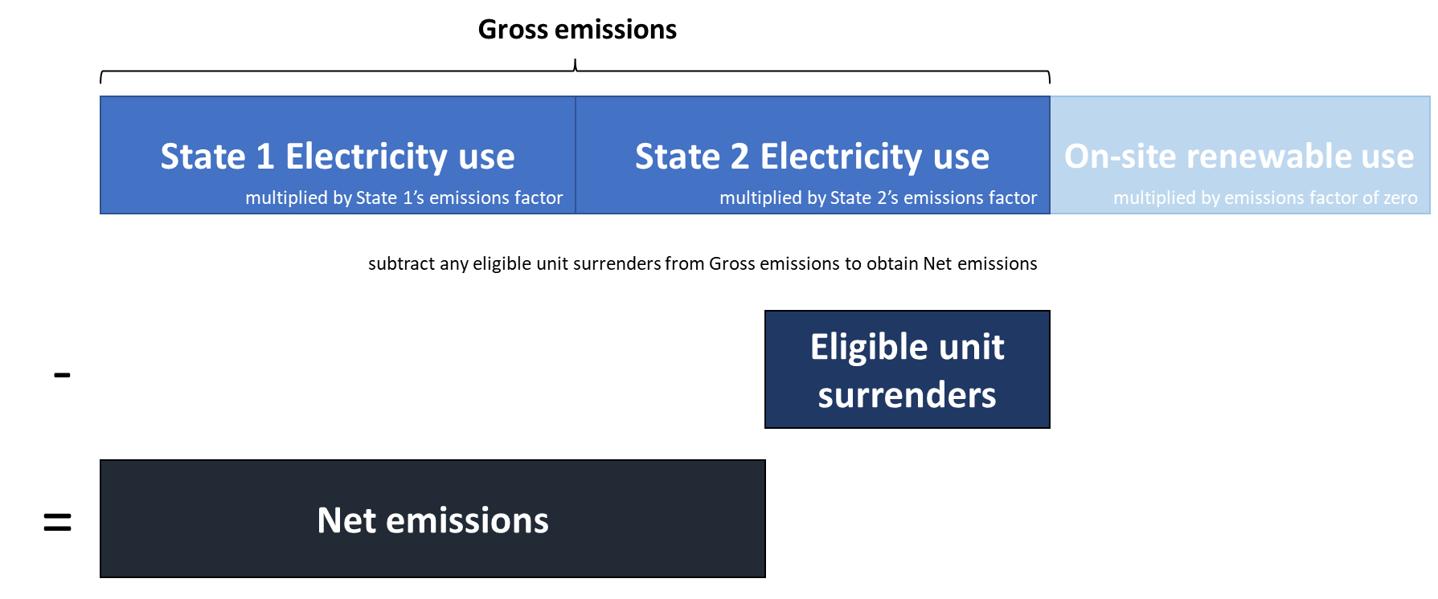

Figure 2: Visual representation of Location-based accounting method (NGER-aligned)

#### Example 11 – A company’s Scope 2 emissions under market-based accounting (Section 5.3 of Guidelines)

In 2020-2021, a New South Wales-based CERT Participant consumes 100 MWh of total electricity. 50 MWh is imported and consumed within New South Wales and 20 MWh is imported and consumed within the Australian Capital Territory. The remaining 30 MWh is generated onsite from renewable sources and credited with 30 LGCs, which are voluntarily surrendered by the Participant. Additionally, 20 ACCUs are purchased and voluntarily cancelled against Scope 2 emissions.

This CERT Participant is not conducting Emissions Intensive Trade-Exposed (EITE) activities.

The Participant’s Net Scope 2 emissions (market-based) is calculated through several steps and **considers LGC surrenders**. First, ‘residual electricity’ is calculated and assigned a **residual mix factor** to determine ‘residual emissions’. Then any eligible unit surrenders are subtracted from residual emissions to obtain Net Scope 2 emissions.

Calculation of **residual electricity use** (used to calculate residual emissions):

As the Participant is not conducting any EITE activities, the Renewable Power Percentage (RPP) can be applied to their entire imported electricity use. The equation for residual electricity (section 5.3.9 of Guidelines) simplifies to:[21] [22]

This number is then multiplied by the residual mix factor to determine residual emissions.

Calculation of **residual emissions**:

$$=Residual electricity use×Residual mix factor$$

$$=41.7 MWh×0.962 \frac{t {CO}_{2}e}{MWh}$$

$$=40.12 t {CO}_{2}e$$

Note the residual mix factor is an example.

Any other eligible carbon units (20 ACCUs = 20 t CO2-e) are then deducted to obtain Net Scope 2 emissions.

Calculation of **Net Scope 2 emissions**:

$$=40.12 t {CO}_{2}e-20 t {CO}_{2}e$$

$$=20.12 t {CO}_{2}e$$

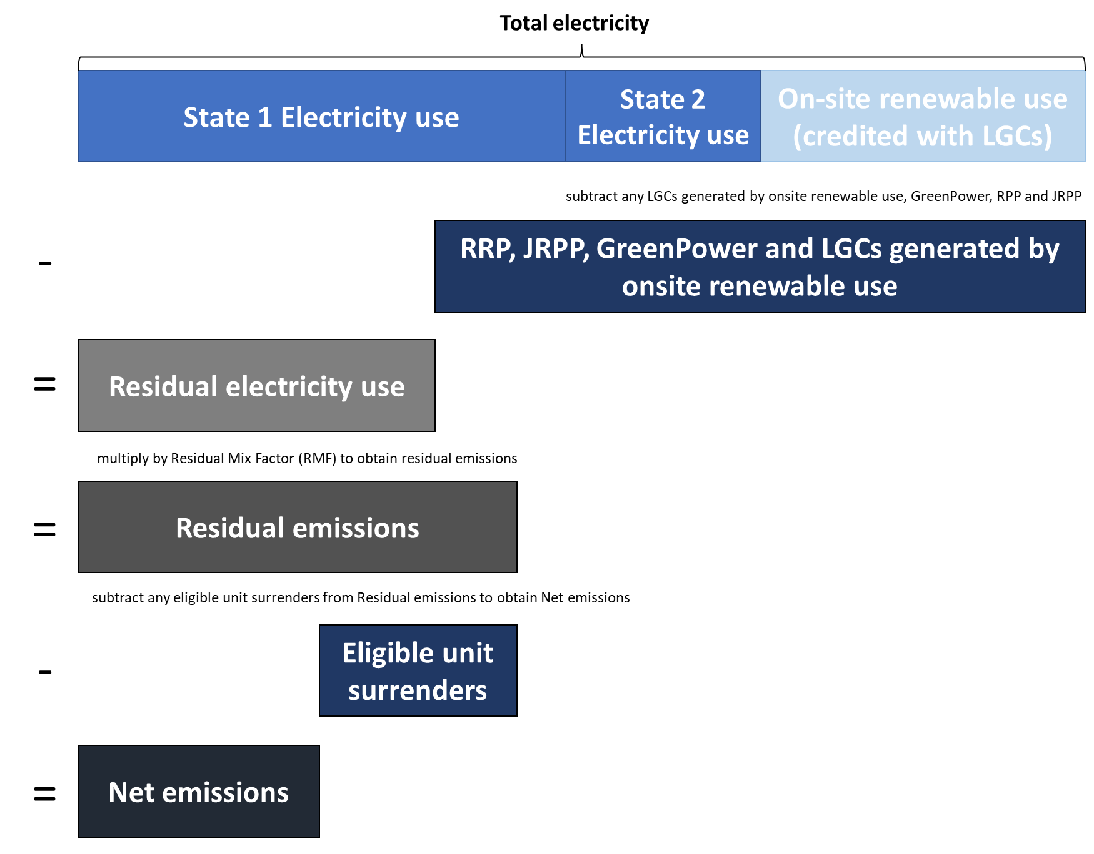

Figure 3: Visual representation of Market-based accounting method

## Renewable electricity accounting – *Section 6 of the CERT Guidelines*

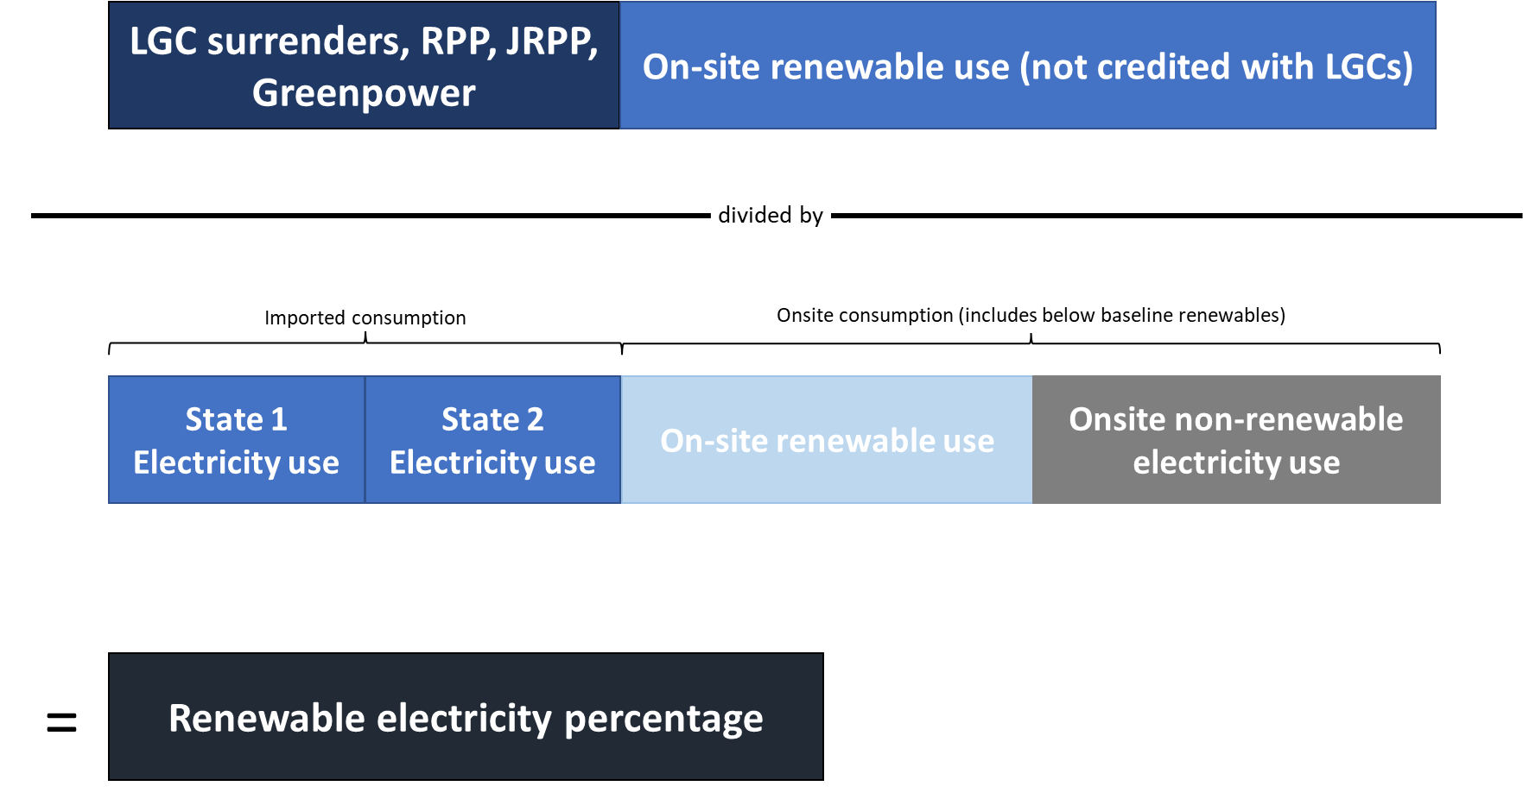

***On-site renewable use*** may be reported either in NGER or as part of the CERT reporting process if claiming on-site renewables not reported in NGER.

***On-site renewable use (not credited with LGCs)*** includes on-site consumption of generation from small-scale (<100 kW) systems and renewables generated below the pre-1997 RET baseline.

Figure 4: Visual representation of renewable electricity percentage (%) calculation

#### Example 12 – Renewable Electricity percentage (%) calculation

Company A has an eligible renewable electricity commitment to achieve 100% renewable electricity by 2025. They consume 100,000 MWh of electricity. 60,000 MWh is imported from New South Wales and 19,890 MWh from the Australian Capital Territory. Company A is not an EITE entity.

Company A’s onsite electricity consumption consists of several small-scale (<100 kW) systems across different sites, totalling 10 MWh, several large-scale systems, totalling 20,000 MWh, and one diesel genset totalling 100 MWh. The large-scale systems also export a further 20,000 MWh to the grid. Company A voluntarily surrenders all the LGCs they create.

Their **Renewable Electricity Percentage** is calculated as: [23] [24]

#### Example 2 – Pre-Renewable Energy Target baseline electricity generated and consumed on-site (behind the meter)

Company B owns a RET-accredited power station with a pre-1997 baseline and generates 100 MWh of NGER-reportable renewable electricity. The electricity is consumed onsite but is not credited with LGCs. If Company B reports the quantity of consumption as having not received LGCs (as part of the CERT reporting process) and this is visible through REC Registry generation data, then Company B may claim it as zero emissions (under the market-based accounting approach) or renewable without surrendering LGCs.

If this information is not provided, Company B would need to voluntarily surrender LGCs against this portion of electricity to claim it as zero emissions or renewable.

#### Example 14 – Small-scale electricity generated and consumed on-site (behind the meter)

Company C owns a fleet of small-scale photovoltaic (PV) systems registered under the Small-scale Renewable Energy scheme (SRES). The on-site consumption from these systems is reported voluntarily in NGER as it is under the NGER reporting thresholds. If Company C reports the quantity of consumption as having not received LGCs (as part of the CERT reporting process), and these systems are visible through REC Registry small-scale registrations data, then Company C may claim it as zero emissions (under the market-based accounting approach) or renewable without surrendering LGCs. However, if this information is not provided, then Company C would need to voluntarily surrender LGCs against this portion of electricity to make a zero emissions or renewable claim.

## Accounting options and adjustments – *Section 7 of the CERT Guidelines*

CERT Participants that nominate calendar year or equity share reporting can choose to adjust their NGER data using a multiplier *or* provide independently assured emissions and energy data.

If providing independently assured data, participants must provide quantities for gross emissions and electricity use to replace data that would otherwise be sourced from the NGER scheme to calculate net emissions and renewable electricity use (See Reporting Guidance for Calendar year and equity share reporting).

Under the multiplier approach for calendar or equity share reporting gross emissions and electricity quantities are calculated by adjusting NGER data according to examples 15-17.

#### Example 15 – Operation control vs equity-based reporting adjustments

CERT Participants A and B both report under NGER. Under NGER, Participant A has operational control of Facility 1 and reports only its energy and emissions. Participant B has operational control of both Facility 2 and Facility 3. Facility 1 and 2 are partly owned by both Participants. This breakdown is below:

|  |  |  |  |  |  |  |  |  |  |  |  |  |  |  |  |  |  |  |  |  |  |  |  |  |  |  |  |  |  |  |  |  |  |  |  |  |  |  |  |  |  |  |  |  |  |  |  |  |  |  |  |
| --- | --- | --- | --- | --- | --- | --- | --- | --- | --- | --- | --- | --- | --- | --- | --- | --- | --- | --- | --- | --- | --- | --- | --- | --- | --- | --- | --- | --- | --- | --- | --- | --- | --- | --- | --- | --- | --- | --- | --- | --- | --- | --- | --- | --- | --- | --- | --- | --- | --- | --- | --- |
| |  |  |  |  |  |  |  | | --- | --- | --- | --- | --- | --- | --- | | Facility | Controller of operations/Reporter Name (under which facility is reported in Emission and Energy Reporting System) | Participant A’s equity share (%) | Participant B’s equity share (%) | Scope 1 Emissions from Facility (t CO2-e) | Scope 2 Emissions from Facility (t CO2-e) | Electricity consumed (MWh) | | Facility 1 | CERT Participant A | 40 | 60 | 100 | 500 | 400 | | Facility 2 | CERT Participant B | 50 | 50 | 50 | 50 | 200 | | Facility 3 | CERT Participant B | 0 | 100 | 25 | 50 | 250 | | Total | - | - | - | 175 | 600 | 850 |   Under NGER (which is based on the company with operation control), the gross emissions and electricity use for the two Participants would be as follows:   |  |  |  |  | | --- | --- | --- | --- | | CERT Participant | Gross Scope 1 emissions (t CO2-e) | Gross Scope 2 emissions (t CO2-e) | Electricity Consumed (MWh) | | CERT Participant A | 100 | 500 | 400 | | CERT Participant B | 75 | 100 | 450 | | Total | 175 | 600 | 850 |   If both Participants nominate operational-control reporting under the CERT report, the gross Scope 1 and 2 emissions and the electricity consumed for both Participants would be the same as reported in NGER.  If both Participants nominated equity-based reporting under CERT and choose to adjust NGER data using multipliers, their gross emissions would be: |

|  |  |  |  |
| --- | --- | --- | --- |
| CERT Participant | Gross Scope 1 emissions (t CO2-e) | Gross Scope 2 emissions (t CO2-e) | Electricity Consumed (MWh) |
| CERT Participant A | = (40% of 100) + (50% of 50) + (0% of 25)  = 65 | = (40% of 500) + (50% of 50) + (0% of 50)  = 225 | = (40% of 400) + (50% of 200) + (0% of 250)  = 260 |
| CERT Participant B | = (60% of 100) + (50% of 50) + (100% of 25)  = 110 | = (60% of 500) + (50% of 50) + (100% of 50)  = 375 | = (60% of 400) + (50% of 200) + (100% of 250)  = 590 |
| Total | 175 | 600 | 850 |

**Please note:** CERT Participants are not bound by the reporting choices of other CERT Participants, including Participants that they share ownership of facilities with. However, if nominating equity share reporting using NGER multipliers, CERT Participants must ensure they have the authority to disclose the equity share for all facilities they share (see section 7.3.1 of the [CERT Guidelines](https://www.cleanenergyregulator.gov.au/DocumentAssets/Pages/CERT-Report-Guidelines-FY2021-22-and-CY2022.aspx)[25]).

#### Example 16 – Impact of reporting boundaries adjustments on Renewable Electricity percentage (%) calculations

Company C nominates an equity-based reporting boundary and jointly owns an aluminium smelter with a 40% equity share. The aluminium smelter is an EITE site that is also reported under NGER and has received 20,000 MWh of EITE exemption certificates for the reporting year under the Renewable Energy Target (RET). In calculating the Company C’s Renewable Electricity Percentage, the ‘EITE electricity consumption’ for Company C is 8,000 MWh for that facility (40% of 20,000 MWh).

#### Example 17 – Multipliers for calendar year adjustments

Company D nominates the 2022 calendar year for their reporting in the CERT reporting form and chooses to adjust NGER data using multipliers. Company D compares their 2022 calendar year emissions and electricity consumption to their NGER reported values (for the 2021-22 financial year). They then provide multipliers (shown below) in their CERT reporting to reflect the change in these values as a percentage. For example, they report a multiplier of 97 for their Scope 1 emissions as their Scope 1 emissions in the 2022 calendar year are 97% of their value in the 2021-22 financial year.

Company D’s emissions and electricity consumption for calendar year 2022 are then estimated to be:

| Quantity | NGER reported value | Participant supplied multiplier | CERT calculated calendar year estimate |
| --- | --- | --- | --- |
| Scope 1 emissions | 200 kt CO2-e | 97 | = 200 × 0.97 = **194 kt CO2-e** |
| Scope 2 emissions | 100 kt CO2-e | 95 | = 100 × 0.95 = **95 kt CO2-e** |
| Imported electricity | 100 MWh | 95 | = 100 × 0.95 = **95 MWh** |
| Onsite renewable electricity | 50 MWh | 110 | = 50 × 1.10 = **55 MWh** |
| Onsite non-renewable electricity | 50 MWh | 80 | = 50 × 0.80 = **40 MWh** |

These multipliers are applied uniformly to all facilities within Company D’s reporting boundary. When NGER data is submitted for the relevant calendar year, any discrepancies in estimates will be updated and footnoted in subsequent CERT reports that rely on data from that year.

##### Base period calendar year data

If Company D is nominating a base period as part of their CER data verified commitment, emissions will be determined based on the average of the two NGER reporting years that overlap the relevant calendar year.

## Revising a Base Period *– Section 7 of the CERT Guidelines*

#### Example 18 – Revising base period emissions due to acquisition

Figure 5: Example 18 – Revising base period emissions due to acquisition

A company operates facility A, which emitted 25 tonnes of CO2-e during the company’s base period, and 30 tonnes of CO2-e during the reporting year for the CERT report. At the beginning of the reporting period they acquired facility B from a different company, which emitted 15 tonnes of CO2-e during the base period and 20 tonnes of CO2-e during the reporting period. The company therefore recalculates their base period to include facility B as if they operated facility B during that base period. This makes for a total of 40 tonnes of CO2-e in the base period, and 50 tonnes of CO2-e in the reporting period.

#### Example 19 – Revising base period emissions due to divestment

A company operates facility A and B, which emitted 25 and 15 tonnes of CO2-e during the company’s base period respectively (for a total of 40 tonnes of CO2-e), and 30 and 20 tonnes of CO2-e during the reporting period. At the beginning of the reporting period the company divests facility B making their total emissions for the reporting period 30 tonnes of CO2-e. They accordingly recalculate their baseline to exclude facility B as if they didn’t operate facility B during the base period. This brings their total emissions for the base period to 25 tonnes of CO2-e.

#### Example 20 – Base period emissions following the construction of a facility after the base period

Figure 6: Example 19 - Revising base period emissions due to divestment

A company operates facility A, which emitted 25 tonnes of CO2-e during the company’s base period, and 30 tonnes of CO2-e during the reporting period. At the beginning of the reporting period they finished construction of a new facility (facility B) which emitted 20 tonnes of CO2-e during the reporting period. Facility B did not come into existence until after the base period, therefore their base period emissions (25 tonnes of CO2-e) remain unchanged and no recalculation is required. Their total emissions for the reporting period are 50 tonnes of CO2-e.

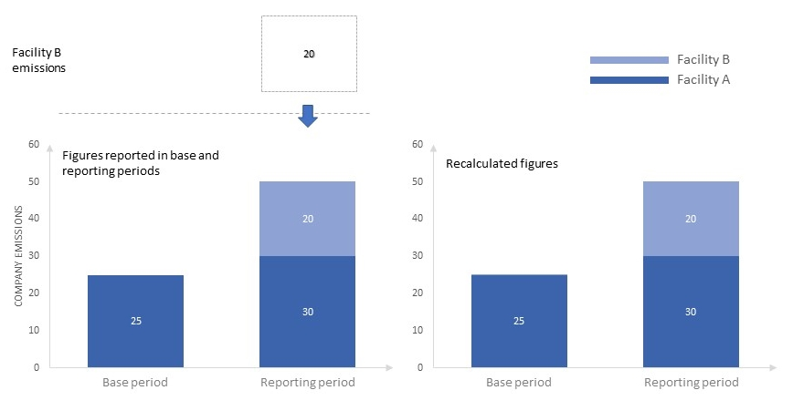

Figure 7: Example 20 - Revising base period emissions due to construction of a facility after the base period

## Calculating progress – *Section 8 of the CERT Guidelines*

**Please note:** progress is only calculated in CERT for commitments that meet the eligibility requirements specified in Section 3 of the [CERT Guidelines](https://www.cleanenergyregulator.gov.au/DocumentAssets/Pages/CERT-Report-Guidelines-FY2021-22-and-CY2022.aspx)[26].

#### Example 21 – Progress for a net zero commitment of a CERT Participant with subsidiaries

Company A has a commitment to achieve net zero emissions by 2050, down from a 2018-19 baseline of 3 Mt CO2-e. They nominate location-based Scope 2 emissions accounting. They have surrendered some carbon unit offsets towards their commitment goal but have also made absolute emissions reductions to reach a position of 2.225 Mt CO2-e.

Company A (as the parent company) surrenders LGCs to meet a commitment made by a subsidiary, but these are not counted as progress towards their location-based commitment (see *Example 10 – A company’s Scope 2 emissions under location-based accounting*). Therefore, their net emissions position is their combined gross Scope 1 and 2 emissions as reported in NGER minus any eligible carbon units.

*Their current emissions position is:*

$$=1-\frac{Net Scope 1 and 2 emissions}{Base period emissions}$$

$$=1-\frac{2.225 Mt{ CO}_{2}e}{3 Mt {CO}_{2}e}$$

$$=0.26 or 26\%$$

*Their emissions progress is:*

$$=\frac{Current emissions position }{Commitment goal}$$

$$=\frac{0.26}{1.00 (100\%, net zero)}$$

$$=0.26 or 26\%$$

#### Example 22 – Progress percentage (%) calculation for renewable electricity percentage commitment

Company B has a commitment to achieve 50% renewable electricity consumption by 2025. Company B is not an EITE entity and has no ‘behind the meter’ generation. Their ‘Renewable Electricity %’ is calculated as 36% (see Example 12 for how that percentage can be calculated). Their **progress percentage** is:

$$=\frac{Current position}{Commitment goal}$$

$$=\frac{36\%}{50\%}$$

$=72\%$ progress towards commitment goal

For company assured commitments, progress percentage would be provided as a progress update statement by the Participant and is not calculated by CER.

#### Example 23 – Progress percentage (%) calculation for independently assured commitments – emissions intensity reduction

Company C has an independently assured commitment to reduce global scope 1, 2 and 3 emissions intensity to 2 kg CO2-e/BOE by 2030 from a 2020 base period intensity of 4 kg CO2-e/BOE. This equates to and is reported as a commitment goal of 50% reduction from their base period. Company C reports their current year emissions intensity as 2.15 kg CO2-e/BOE. Progress for independently assured commitments is calculated by CER using independently assured data provided by the participant.

Their **absolute progress** is calculated as:

$$=Reported base period emissions intenstity-Reported current year emissions intensity$$

$$=4 kg {CO}_{2}e/BOE-2.15 kg {CO}_{2}e/BOE$$

$$=1.85 kg {CO}_{2}e/BOE$$

Their current year percentage reduction (**current position**) is calculated as:

$$=1-\frac{Reported current year emissions intensity}{Reported base period emissions intensity}$$

$$=1-\frac{2.15 kg {CO}_{2}e/BOE}{4 kg {CO}_{2}e/BOE}$$

$$=46.25 \% reduction$$

Company B’s **progress percentage** is calculated as:

$$=\frac{Current position}{Commitment Goal}$$

$$=\frac{46.25\%}{50\%}$$

$=92.5\%$ progress towards commitment goal

#### Example 24 – Progress percentage (%) calculation for an independently assured commitment (other)

Company D has a commitment to install 2 GW of rooftop solar PV capacity by 2030. CER does not have sufficient data to verify progress towards this commitment, so Company B chooses to report this as an independently assured commitment. They currently have 1.2 GW of installed rooftop solar. Progress may or may not be measured against a base period. Company D indicates in their form that progress is measured as an increase in installed capacity.

**Commitment type**  Other commitment (independently assured)  
**Other commitment type** Other  
**Commitment Goal**  2 GW  
**Progress metric** GW   
**Reporting year measurement**  1.2 GW  
**Progress measured as an increase in metric** Yes

##### With a base period:

*Company D measures progress against a base period of 2020, for which they report an installed capacity of 1 GW:*

**Progress measured from a base period**  Yes  
**Base period** 2020  
**Base period measurement** 1 GW

**Progress percentage** towards this commitment is calculated as:

$$\frac{=Current year measurement-Base period measurement}{Commitment goal-Base period measurement}$$

$$=\frac{1.2 GW-1 GW}{2 GW-1 GW}$$

$$=0.2 or 20\% progress towards commitment goal$$

**Absolute progress** is simply 1.2 GW minus 1 GW = **0.2 GW**.

##### Without a base period:

*Company D measures progress without a base period (i.e. 0 GW baseline):*

**Progress measured from a base period**  No

**Progress percentage** towards this commitment is calculated as:

$$\frac{=Current year measurement}{Commitment goal}$$

$$=\frac{1.2 GW}{2 GW}$$

$$=0.6 or 60\% progress towards commitment goal$$

**Absolute progress** is simply **1.2 GW**.

## Reporting – *Section 10 of the CERT Guidelines*

#### Example 25 – Equity share adjustments to electricity generated and consumed on-site (behind the meter)

A CERT Participant has nominated equity share reporting. They have a 50% share in a facility that they have operational control of for the purposes of the NGER Act. The facility consumes 100 MWh of LGC-credited renewable electricity generated on-site for the reporting year and would report as such in their NGER report. For CERT reporting, because their equity share of the facility is 50% the CERT Participant should report the on-site renewable electricity use as 50 MWh.

If the equity share of the facility changes throughout the reporting year then this must be included in the calculation of renewable electricity use. If the CERT Participant changed their equity share in the facility from 50% to 100% half-way through the year, this would mean their renewable electricity use reported in CERT would be 75 MWh.

1. https://www.cleanenergyregulator.gov.au/DocumentAssets/Pages/CERT-Report-Guidelines-FY2021-22-and-CY2022.aspx
2. Commitment entity refers to the entity selected when reporting a commitment in section 4 of the reporting form.
3. Reporting entity refers to the participating entity selected in section 2 of the reporting form.
4. https://www.cleanenergyregulator.gov.au/DocumentAssets/Pages/CERT-Report-Guidelines-FY2021-22-and-CY2022.aspx
5. https://www.cleanenergyregulator.gov.au/Infohub/Markets/cert-report
6. Australian participants are strongly encouraged to have the independent assurance completed in accordance with ASAE 3000 or ASAE 3410, consistent with other assurance engagements performed under the NGER scheme.
7. https://auasb.gov.au/standards-guidance/auasb-standards/other-assurance/
8. https://auasb.gov.au/standards-guidance/auasb-standards/other-assurance/
9. https://www.iaasb.org/publications/international-standard-assurance-engagements-isae-3000-revised-assurance-engagements-other-audits-or-0
10. https://www.iaasb.org/publications/glance-international-standard-assurance-engagements-isae-3410-assurance-engagements-greenhouse-gas
11. https://www.iso.org/standard/66455.html
12. For further information, see the requirements of the [*Standard on Assurance Engagements ASAE 3000* [PDF 695KB]](http://www.auasb.gov.au/admin/file/content102/c3/ASAE_3000_revised_2017.pdf), pp.13-27.
13. https://www.cleanenergyregulator.gov.au/DocumentAssets/Pages/Register-of-Greenhouse-and-Energy-Auditors.aspx
14. https://www.cleanenergyregulator.gov.au/NGER/About-the-National-Greenhouse-and-Energy-Reporting-scheme/global-warming-potentials
15. https://www.auasb.gov.au/media/lhwp1rep/sustainabilityassuranceupdate_10-22.pdf
16. https://www.cleanenergyregulator.gov.au/DocumentAssets/Pages/CERT-Report-Guidelines-FY2021-22-and-CY2022.aspx
17. https://ghgprotocol.org/corporate-standard
18. https://www.cleanenergyregulator.gov.au/NGER/About-the-National-Greenhouse-and-Energy-Reporting-scheme/global-warming-potentials
19. https://www.cleanenergyregulator.gov.au/RET/Scheme-participants-and-industry/the-renewable-power-percentage
20. https://ghgprotocol.org/sites/default/files/standards/Scope 2 Guidance_Final_Sept26.pdf
21. The RPP component is an example of 19% (0.19)
22. The JRPP component is an example of 75% (0.75)
23. The RPP component is an example of 19% (0.19)
24. The JRPP component is an example of 75% (0.75)
25. https://www.cleanenergyregulator.gov.au/DocumentAssets/Pages/CERT-Report-Guidelines-FY2021-22-and-CY2022.aspx
26. https://www.cleanenergyregulator.gov.au/DocumentAssets/Pages/CERT-Report-Guidelines-FY2021-22-and-CY2022.aspx