Registered native title body corporate consent

under section 15(6)(b) and 18A(3) of the *Nature Repair Act 2023*

|  |
| --- |
| FORM |
| CER- NR-RNTBC-006 |
| V1.1 24/01/2025 |

# Purpose of this form

The purpose of the form is for project proponents or proposed project proponents to obtain consent from a registered native title body corporate to register and carry out a biodiversity project under the *Nature Repair Act 2023* (the Act). This consent must be obtained when the project area wholly or partially covers non-exclusive or exclusive possession native title area.

This consent is not required when the registered native title body corporate for the native title area is the project proponent for the biodiversity project.

Completing this form **prior to registration** demonstrates that the registered native title body corporate has consented to either:

* **the carrying out of the project on or in the native title area as a registered biodiversity project by the proposed project proponent(s)** under section 15(6)(b)(iv) of the Act
* If the registered native title body corporate consents, prior to registration, to the proposed project proponent(s) carrying out the project as a registered biodiversity project, the project proponent would not be required to obtain any further consent from the registered native title body corporate.
* This consent can also be set out in a registered indigenous land use agreement (ILUA) that is made and registered under the Native Title Act 1993.
* **the registration of the project** under section 15(6)(b)(v).
* The registered native title body corporate must be aware that with this consent, the project proponent may start to conduct activities for this project.
* If the registered native title body corporate chooses to only consent to the registration of the project, the registration will be subject to the condition that a biodiversity certificate is not to be issued in respect of the project, until consent is obtained from the registered native title body corporate to the carrying out of the project as a registered project by the project proponent.

Completing this form if the **project is registered conditionally** demonstrates that the registered native title body corporate has consented to:

* **the carrying out of the project on or in the native title area as a registered biodiversity project by the project proponent** under section 18A(2) of the Act
* If the project is registered conditionally, and this form is used to obtain consent from the registered native title body corporate under section 18A(2) of the Act, this form will also be required to accompany the application for variation of conditional registration of the project to remove the condition under section 18A of the Act.
* This consent can also be set out in a registered ILUA that is made and registered under the Native Title Act 1993.

This consent promotes the engagement and cooperation of the registered native title body corporate in the enhancement or protection of biodiversity in native species in Australia. The registered native title body corporate will have the final say on whether projects can be registered and/or carried out on or in native title areas.

The flow chart below provides an overview for the process on the above consent requirements.

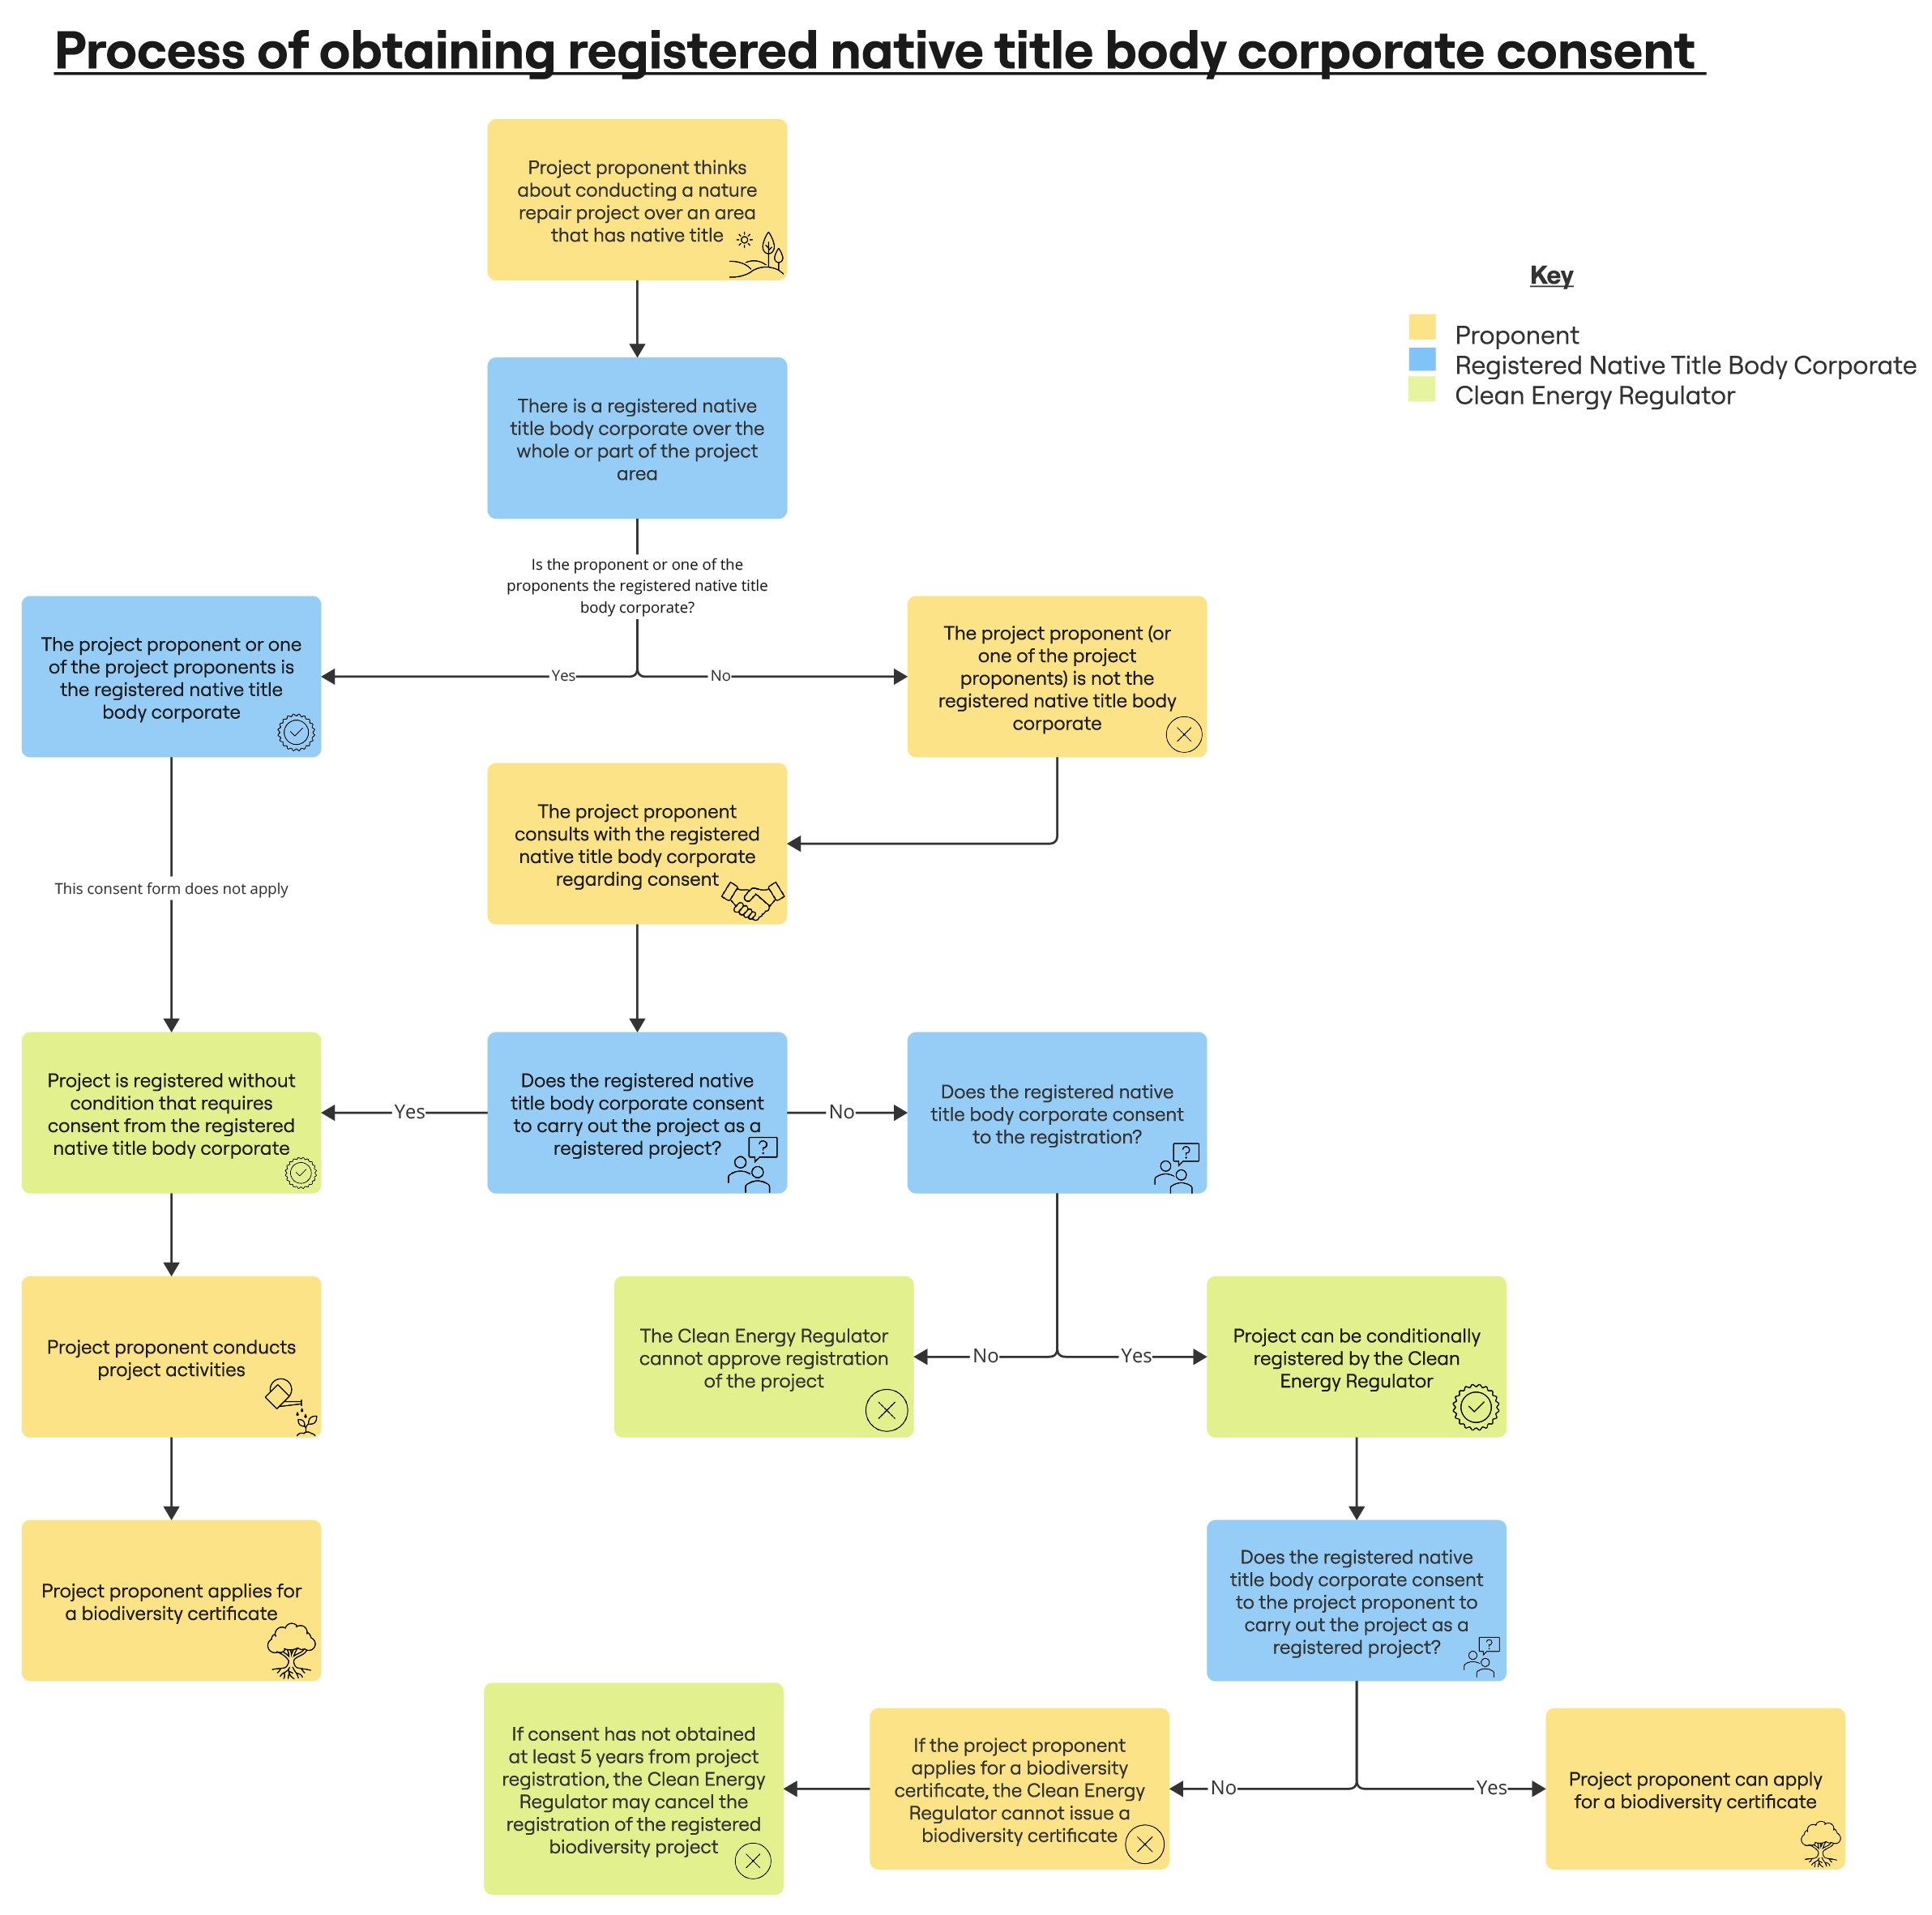

## Biodiversity Market Register

The Biodiversity Market Register is publicly available information regarding the projects being conducted and the biodiversity certificates that have been issued. The status of whether the registration of the project is subject to a condition under section 18A (condition about obtaining consent from registered native title body corporate) will be published on the Biodiversity Market Register.

# Instructions for completing this form

Before signing this form, its recommended that registered native title body corporates understand:

* the biodiversity project associated with this form and if the project is conditionally registered, the notice of approval as a registered biodiversity project, including its specific activities to be conducted or being conducted
* the requirements associated with conducting a biodiversity project and the obligations placed on project proponents under the *Nature Repair Act 2023* and subordinate legislation
* the obligations to maintain biodiversity outcomes for the permanence period of the project, which has long term implications for the land on which biodiversity projects take place.

Where necessary, the registered native title body corporate should obtain independent legal advice in relation to providing consent.

You can choose to complete this form by:

* printing the form and filling it in by hand
* saving the form and filling in an electronic copy.

This form enables consent to be provided for one registered native title body corporate. If there is more than one registered native title body corporate for the project area or part of the project area, complete a separate form for each registered native title body corporate and attach each form to the application to register a biodiversity project or/and, for projects that are conditionally registered, an application for variation of conditional registration of the project to remove the condition under section 18A of the Act.

You must complete and submit:

* **Part A: Applicant details**
* **Part B: Project details**
* **Part C**: **Registered native title body corporate details**
* **Part D: Obtaining consent post registration**
* **Part E**: **Declaration**

|  |  |
| --- | --- |
| Pen colours | Please use a **black** or **blue** pen to write on the form. |
| Check boxes | Mark boxes like this £ with a ✔ or ✘. When an instruction asks you to ‘tick’ the box, you can still use either ✔ or ✘. |
| Go to | Where you see an instruction like this - **£** Go to **question 5** - mark the relevant box with a ✔ or ✘and then skip to the question number shown. You do not need to answer the question(s) in between.  Where an instruction has a black double arrow (8), go to the next indicated part/section. Where an instruction has a black single arrow (4), go to the next question. Where an instruction has a black single arrow pointing down (6), fill in the field(s) directly below. |
| Mandatory questions | If all fields in a question are mandatory and must be completed, **(required)** is added to the end of the question label text. If a field in a question is mandatory only IF a condition is met, **(required if any)** is added to the end of the question label text. |
| 4 | This symbol indicates an instruction on what to do next. |
| i | This symbol indicates additional useful guidance to filling in the adjacent field or section. |
| 4 | This symbol advises that more than one entry may be required for the section and therefore you may need to photocopy or print the section or fill in a duplicate section. |
| ë | This symbol advises that additional documentation to support a claim may need to be attached to the application. |

Help filling in this form

If you require assistance or have any questions regarding this application process, please contact the Clean Energy Regulator general enquiries line on **1300 553 542** or email [enquiries@cer.gov.au](mailto:enquiries@cer.gov.au).

Submitting this form

Registered native title body corporates should keep a signed copy of this form for their records.

### Lodging this consent with the Clean Energy Regulator

Proposed project proponent(s) required to obtain consent from a registered native title body corporate to carry out or to register a project must attach this form with the application to register the project in [Online Services](https://onlineservices.cer.gov.au/).

Project proponents of projects that have been conditionally registered must provide this form with an application to vary the conditional registration of a project.

1. Applicant details

Complete this part to identify the project proponent, or proposed project proponent, of the project identified in Part B of this form.

* If there is more than one project proponent, please list the details of each project proponent for the project and if necessary photocopy or print this part.

1. Project proponent (required)

|  |  |  |  |  |  |  |  |  |  |  |
| --- | --- | --- | --- | --- | --- | --- | --- | --- | --- | --- |
| Project proponent |  | | | | | | | | | |
| Date of birth  (individuals only) | Day (dd) | | | Month (mm) | | | | Year (yyyy) | | |
|  | | |  | | | |  | | |
| Organisation identifier (organisations only) | ABN |  | ACN | |  | ARBN |  | | ICN |  |
|  | | | | | | | | | |

1. Multiple project proponents (if required)

|  |  |  |  |  |  |  |  |  |  |  |
| --- | --- | --- | --- | --- | --- | --- | --- | --- | --- | --- |
| Project proponent |  | | | | | | | | | |
| Date of birth  (individuals only) | Day (dd) | | | Month (mm) | | | | Year (yyyy) | | |
|  | | |  | | | |  | | |
| Organisation identifier (organisations only) | ABN |  | ACN | |  | ARBN |  | | ICN |  |
|  | | | | | | | | | |

|  |  |  |  |  |  |  |  |  |  |  |
| --- | --- | --- | --- | --- | --- | --- | --- | --- | --- | --- |
| Project proponent |  | | | | | | | | | |
| Date of birth  (individuals only) | Day (dd) | | | Month (mm) | | | | Year (yyyy) | | |
|  | | |  | | | |  | | |
| Organisation identifier (organisations only) | ABN |  | ACN | |  | ARBN |  | | ICN |  |
|  | | | | | | | | | |

1. Project details

This section must be completed by the person or organisation that is applying to be the project proponent of a biodiversity project or is the project proponent of a registered biodiversity project.

* For new projects, provide the ‘register a project’ submission number found in Online Services.  For registered projects, provide the Project ID issued to the project (for example, NR123456 or SUB-24-G9Z02213095).

1. Project details

|  |  |
| --- | --- |
| Project name (required) |  |
| Project or submission number (if applicable) |  |

1. List the address/location and the land title reference/s for the project area that overlaps with the native title area for the project named in question 2 (required)

* The land title reference number(s), or identifiers in relation to Australian waters including, where applicable, the state/territory, block number, section number, volume, folio and edition.
* If the project area covers multiple land titles and addresses that overlap with native title areas, please list the detail for additional locations for the project by photocopying this part.

|  |  |
| --- | --- |
| Address / location | Land title reference / other (as appropriate) |
|  |  |
|  |  |
|  |  |
|  |  |
|  |  |

1. What is the duration of the permanence period of the project?

* The permanence period is requested by the project proponent during the project registration. The permanence period is the period of time beginning when the approval of project registration takes effect in which the project proponent(s) has obligations under the Nature Repair Act 2023 to monitor and maintain biodiversity outcomes achieved by the project.
* Provide the permanence period of the project.

|  |  |
| --- | --- |
| Project’s permanence period | years |

1. Registered native title body corporate details

* This section should be completed by an authorised representative of the registered native title body corporate

1. Provide details of the registered native title body corporate (required)

|  |  |
| --- | --- |
| Name of registered native title body corporate |  |
| Tribunal file no. |  |
| Federal Court determination no. |  |
| Contact name |  |
| Contact number | (  ) |
| Email address |  |

1. Project consent (required)

* Tick which type of consent the registered native title body corporate gives for this project**.**

|  |  |
| --- | --- |
|  | **Prior to the registration of the project, consent to carry out the project** as listed in Part B of this form on or in the native title area as a registered biodiversity project by the proposed project proponent   * If the registered native title body corporate consents, prior to registration, to the project proponent carrying out the project as a registered biodiversity project, the project proponent would not be required to obtain any further consent from the registered native title body corporate unless specified by the method. |
|  | **Prior to the registration of the project, consent to the registration** of the project listed in Part B of this form, or   * If the registered native title body corporate chooses to only consent to the registration of the project, the registration will be subject to the condition that a biodiversity certificate is not to be issued in respect of the project, until registered native title body corporate consent is obtained to the carrying out of the project * The proponent will also need to provide details of how this consent will be obtained by filling out Part D of this form. |
|  | **If the project is registered conditionally, consent carry out the project** as listed in Part B of this form on or in the native title area as a registered biodiversity project by the project proponent   * If the project is registered conditionally, and this form is used to obtain consent from the registered native title body corporate under section 18A(2) of the Act, this form will also be required to accompany the application for variation of conditional registration of the project to remove the condition under section 18A of the Act. |

Part D: Obtaining consent post-registration (if required)

* *This section should be completed by the project proponent or the proposed project proponent of the project.*
* *Under* *section 11(6)(b)(iii )of the Nature Repair Rules 2024, if consent to the registration of the project has been selected in Part C of this form, the project proponent or proposed project proponent must provide details on how consent to carry out the project will be obtained from the registered native title body corporate before an application is made for a biodiversity certificate in respect of the project.*

1. How will consent to carry out of the project be obtained?

* Provide details on how consent to carry out the project will be obtained from the registered native title body corporate.

|  |  |
| --- | --- |
| Details |  |

Part E: Declaration

* Where an authorised representative is signing on behalf of a registered native title body corporate, attached evidence of the authority to sign the declaration on behalf of the registered native title body corporate is required.

Under the *Criminal Code Act 1995* it is an offence for a person to give information or documentation to a Commonwealth entity if the person providing the information or documentation knows that the information or documentation is false or misleading.

By making this declaration, the authorised representative declares that they have the legal capacity and authority to make this declaration on behalf of the registered native title body corporate named below, and declares and acknowledges for and on behalf of the registered native title body corporate, that:

* The registered native title body corporate named below provides the following consent (as applicable):

*[with the project registration application]*

* + to the project identified in Part B to be registered on the area of land specified in Part B by the proposed project proponent(s) named in Part A, or
  + to the project identified in Part B to be registered and carried out on the area of land specified in Part B by the proposed projects proponent(s) named in Part A, or

*[with the application to vary the conditional registration of a project]*

* + to the project identified in Part B to be carried out on the area of land specified in Part B by the projects proponent(s) named in Part A, as the case may be.
* all information provided in and in relation to this application (including attachments and any other supporting information) is, having made all reasonable enquiries, complete, true and correct and not misleading by inclusion or omission
* the provision of false or misleading information is a serious offence and carries penalties under the *Criminal Code 1995* and may have consequences under the *Nature Repair Act 2023* and other laws
* any of the information provided in this application may be copied, recorded, used or disclosed by the Clean Energy Regulator for the purpose of assessing and making a decision on the application, auditing compliance, enforcement of laws, regulations and legislative rule, the performance of the Clean Energy Regulator’s statutory functions and for related purposes subject to the requirements of relevant laws, in particular the *Privacy Act 1988* and Part 3 of the *Clean Energy Regulator Act 2011*
* that the Clean Energy Regulator does not have any powers or role in enforcing work health and safety, environmental protection, or planning laws. If you are unsure of your responsibilities under these laws, you should contact the relevant local authorities
* the registered native title body corporate consents to the Clean Energy Regulator sharing any information in relation to them or their projects with any Commonwealth, State or Territory government agencies for the purpose of assisting those agencies in the performance of their functions or powers relating to environmental protection and/or health and safety
* that the registered native title body corporate has seen a completed copy of the registration application form and a copy of the notice of approval of registration (if applicable)
* the registered native title body corporate understands that the permanence period of the project has the duration stated in Part B of this form and that the permanence obligations under the *Nature Repair Act 2023* in relation to the project will last for that period, if not terminated earlier or extended under the provisions of the *Nature Repair Act 2023*
* the registered native title body corporate understands that a biodiversity maintenance declaration may be placed over the project area during the term of the permanence period of the project.

**Signed on behalf of:**

|  |  |
| --- | --- |
| Name of registered native title body corporate |  |

**By:**

|  |  |  |  |
| --- | --- | --- | --- |
| Authorised representative name: |  | | |
| Signature |  | | |
| Position |  | | |
| Phone number | (  ) | | |
| Email address |  | | |
| Signature date | Day (dd) | Month (mm) | Year (yyyy) |
|  |  |  |

Additional information

About the Nature Repair Market

The Nature Repair Market, established under the *Nature Repair Act 2023*, is a voluntary market that delivers improved biodiversity outcomes. Project proponents who undertake projects that enhance or protect native species would be able to receive a tradeable certificate that will be tracked through a national register. The Nature Repair Market will make it easier for companies and businesses to voluntarily invest in nature repair projects across Australia.

Conditional Registration

The Clean Energy Regulator must set out in the notice under subsection 15(7) that the registration is subject to the condition under section 18A, that a biodiversity certificate is not to be issued in respect of the project, until the written consent of the registered native title body corporate is obtained to the carrying out of the project on or in the native title area as a registered biodiversity project by the project proponent.

Native Title Act 1993

The *Native Title Act 1993* requires native title holders to establish a corporation to represent them and their interests. These organisations are known as registered native title bodies corporate. These have prescribed functions under the *Native Title Act 1993* to:

* hold, protect and manage determined native title in accordance with the objectives of the native title holders
* ensure certainty for governments and other parties interested in accessing or regulating native title land and waters by providing a legal entity to manage and conduct the affairs of the native title holders.

Seeking legal advice

The Clean Energy Regulator provides guidance for general information purposes only. The information in this form and supplied by the Clean Energy Regulator should not be interpreted as independent professional advice. You should not rely solely on this information and should get professional legal advice relevant to your individual circumstances.

Protection of information

The Clean Energy Regulator is bound by the secrecy provisions of Part 3 of the *Clean Energy Regulator Act 2011* for the information it collects in relation to this application and by the *Privacy Act 1988* in regard to personal information it collects.

Privacy statement

‘Personal information' is defined in the *Privacy Act 1988* to mean information or an opinion about an identified individual, or an individual who is reasonably identifiable:

* whether the information or opinion is true or not
* whether the information or opinion is recorded in a material form or not.

The collection of personal information relating to this application is authorised by the *Nature Repair Act 2023*, Nature Repair Rules 2024, the *Privacy Act 1988*, *Clean Energy Regulator Act 2011* and relevant legislative instruments made under those Acts.

Personal information collected in relation to this application will be used for the purposes of assessing the application, auditing compliance, enforcement of relevant laws, regulations and legislative rule, the performance of our statutory functions and for related purposes. We will also use the personal information which you provide for our administrative purposes, for example, to pre-populate other Clean Energy Regulator forms which you wish to fill out online in the future, in line with the *Nature Repair Act 2023*, and for improving our service delivery to you.

The Clean Energy Regulator’s [Privacy Policy](https://cer.gov.au/about-us/our-policies/privacy-policy) contains information about the agency’s procedures for handling personal information including how a person can access their personal information held by the agency, and how to seek correction of such information. The Privacy Policy also contains information about how to complain about a breach of the Australian Privacy Principles.

Disclosure of information

The Clean Energy Regulator is only able to disclose information relating to this application (including personal information) in accordance with the Clean Energy Act, the *Privacy Act 1988* or as otherwise required by law.

The circumstances in which such information may be disclosed include:

* disclosure to other agencies, persons or organisations to enable the verification of information contained in the application
* disclosure to the Secretary or authorised officer of a department for the purpose of advising the minister, monitoring the operation of a climate change or biodiversity law or evaluating the effectiveness of a climate change or biodiversity law
* disclosure to certain agencies, bodies or persons where the Regulator is satisfied that disclosure will enable or assist those agencies, bodies or persons to perform or exercise their functions or powers, including the Australian Securities and Investments Commission, the Australian Competition and Consumer Commission and the Commissioner of Taxation
* disclosure for the purposes of law enforcement
* disclosure or use for the purposes of climate change or biodiversity law or for the purposes of the performance of our functions under a climate change or biodiversity law.

Accessibility disclaimer

Whilst the Clean Energy Regulator has worked to ensure this document is accessible, please contact us to obtain an alternative version if you are having difficulty, or you have specific accessibility needs.

Please call **1300 553 542** or email the name of the form and your needs to [enquiries@cer.gov.au](mailto:enquiries@cer.gov.au).