FORM
CER-RET-046
v1.0 06/06/2023
Application to use the Solar Irradiance methodology to calculate large-scale generation certificate (LGC) eligibility of an accredited power station

Purpose of this form
The purpose of this form is to change the active methodology of a power station to the Solar Irradiance methodology. It is to be used by the current nominated person of the accredited power station.
The Solar Irradiance methodology is an automated system used to calculate LGC entitlement for eligible power stations of over 100 kilowatts (kW) and under one megawatt (MW).
For more information visit Solar Irradiance methodology.

Eligibility
The Solar Irradiance methodology is suitable for power stations which meet the following conditions:
- solely uses mono-facial photovoltaic panels to generate power used to calculate LGC eligibility
- does not use solar tracking technologies
- has a DC capacity between 0.1 megawatts (MW) and 1.0 megawatts (MW).
The Solar Irradiance methodology may be discontinued for a power station without prior notice at the Clean Energy Regulator’s discretion. If the Solar Irradiance methodology is discontinued, the power station will revert to using a meter based LGC methodology.
It is important to keep a record of your supporting documentation as the Clean Energy Regulator may request them for auditing or compliance activities. Notification of changes to the operation of a power station is a requirement and will be necessary when your electricity generation return (EGR) is due.

Instructions for completing this form
Please read each part of the application carefully, fully answer all the questions, sign where indicated, and attach the required documentation.
You must complete the relevant parts and submit:
- Part A: Eligibility
- Part B: Nominated person details
- Part C: Power station details
- Part D: Array details
- Part E: Power station location and usage details
- Part F: Solar Irradiance Methodology requirements
- Part G: Declaration.
You can choose to complete this form by:
- printing the form and filling it in by hand
- saving the form and filling in an electronic copy.
Note that if you choose the second option, there may be times when you will need to print certain sections to sign them or to complete multiple entries for a single set of questions. These sections may be scanned back into the computer and submitted electronically with the rest of the form.
Pen colours | Please use a black or blue pen to write on the form.
Check boxes | Mark boxes like this £ with a ✔ or ✘. When an instruction asks you to ‘tick’ the box, you can still use either ✔ or ✘.
Go to | Where you see an instruction like this - £ Go to question 5 - mark the relevant box with a ✔ or ✘and then skip to the question number shown. You do not need to answer the question(s) in between.  Where an instruction has a black double arrow (8), go to the next indicated part/section. Where an instruction has a black single arrow (4), go to the next question. Where an instruction has a black single arrow pointing down (6), fill in the field(s) directly below.
Mandatory questions | If all fields in a question are mandatory and must be completed, (required) is added to the end of the question label text. If a field in a question is mandatory only IF a condition is met, (required if any) is added to the end of the question label text.
4 | This symbol indicates an instruction on what to do next.
ë | This symbol advises that additional documentation to support a claim may need to be attached to the application.
i | This symbol indicates additional useful guidance to filling in the adjacent field or section.

Help filling in this form
If you require assistance or have any questions regarding this application process, please contact the Clean Energy Regulator general enquiries line on 1300 553 542 or email CER-RET-LGCValidation@cer.gov.au.

Submitting this form
A signed copy of this form should be kept for your records.

By post
Post your completed application with any accompanying documentation to:
Clean Energy Applications
Clean Energy Regulator
GPO Box 621
Canberra ACT 2601

By email
Email the completed application to the Clean Energy Regulator at CER-RET-LGCValidation@cer.gov.au.
If the email and its attachments (the application and supporting documents) are larger than 10MB, they must be sent using multiple emails that are clearly marked (for example, by including an identifier in the subject line, '1 of 3', '2 of 3', '3 of 3'). The signed application form must be saved as a single scanned file and not split into parts. Files may be zipped to reduce their size.

- Eligibility
- Eligibility criteria for a power station to use the Solar Irradiance methodology to calculate large-scale generation certificate (LGC) entitlement (required)
- Does the power station meet all following eligibility requirements?
The power station’s DC capacity is under 1 megawatt (MW).
Solar is the only generation source of the power station.
The framework or housing of the power station does not use tracking technologies.
The components of the power station match the details currently on the REC Registry.
- The components of the power station are those that are used in the regular operation of the power station. This includes the panels, inverters, meters, and zero export devices.
- If the components of the power station have changed have not been previously communicated to the Clean Energy Regulator, please complete an Application to vary what constitutes a power station (CER-RET-036) form as per Section 30C of the Renewable Energy (Electricity) Act 2000. Both forms may be submitted at the same time but note the CER-RET-036 application must be approved by the Clean Energy Regulator before this application can be approved.
- Nominated person details
- Please enter details of the nominated person and the primary contact for the accredited power station.
- Nominated person name (required)
- The name must be the same as listed in the REC Registry.
Company or individual name
- Nominated person’s account ID (required)
Account ID
- Details of primary contact (required)
- The primary contact is the person that maintains the REC Registry account for the nominated person.
Title (Mr, Ms, Mrs, Mx, Dr)
Name
Position

- Power station details
- Please provide details of the power station.
- Power station name (required)
- The power station name must be the same as listed in the REC Registry.
Name
- Power station accreditation code (required)
- The code given to the power station at the time of accreditation. It must be the same as listed in the REC Registry.
Accreditation code
- Will the power station use the Solar Irradiance methodology for a specific time period? (required)
No |  | An effective end date of 31 December 2030 will be applied. Go to question 8. 4
Yes |  | Provide the number of months for opt-in. A minimum of 3 months is recommended. 6
- If yes, the opt-in period will be from the month after approval of this application until the end of the specified period.
- Array details
- Provide the following details for each sub-array in your power station (required)
- Sub-arrays or subsystems are distinct sections of your power station where azimuth and pitch differ from one another.
- Tilt is defined as degrees from horizontal. 0-degree tilt describes a completely horizontal panel, and 90-degree tilt describes a completely vertical panel.
- Orientation (or azimuth) of the panels is defined as the variation of facing from north in degrees. Panels that face east are expressed in negative values from 0 to -180, and panels that face west are expressed in positive values from 0 to 180. Please refer to the outermost number in the diagram below for clarification.
- Sub-arrays can be grouped into a single entry if the sub-arrays have same orientation and tilt within 5 degrees.
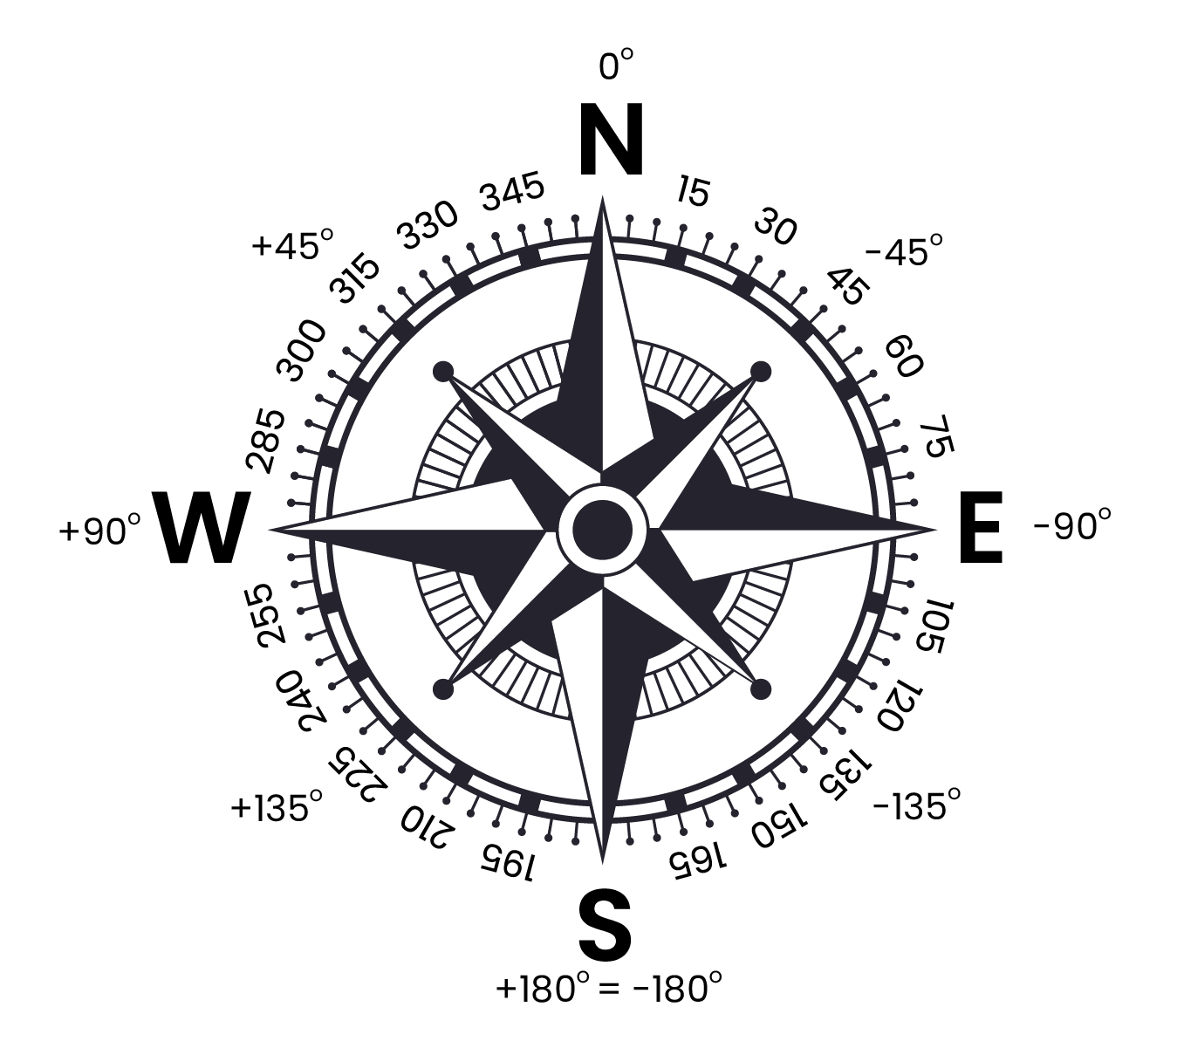

Option A: Fill out the table |  | If your power station has six or less sub-arrays, please fill out the table below.

Sub-array (for example, Roof 1, Roof 2) | Tilt | Orientation | Panel model | Panel quantity

Option B: Attach an excel spreadsheet |  | If your power station has more than six sub-arrays, please attach an excel spreadsheet with the same format and information in the table above.

- Power station location and usage details
- Identify which rainfall region your power station is located in by selecting one of the options below (required)
Option A: Allow the Clean Energy Regulator to calculate average annual rainfall on your behalf |  | The Clean Energy Regulator will calculate the average annual rainfall on your behalf. Go to the question 13. 4
Option B: Select the zone from the map below |  | Go to question 12 to select the zone. 4

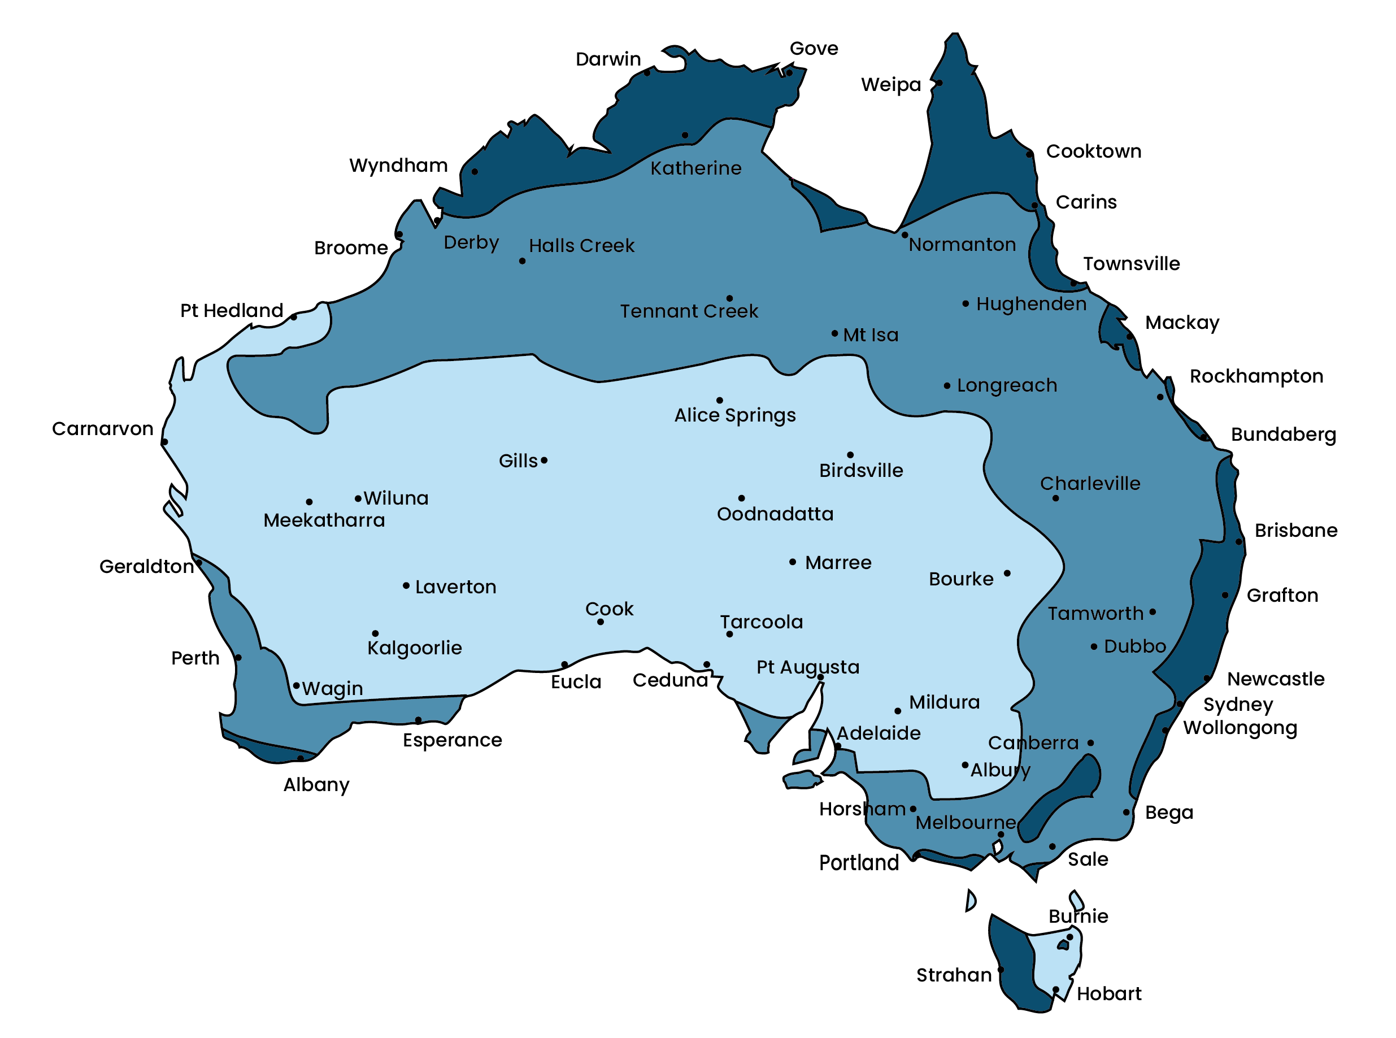
- If Option B has been selected in question 10, identify which rainfall region your power station is located using the map above

Zone 1: High rainfall regions (>1000 mm of rain on average annually)
Zone 2: Intermediate rainfall regions (400-1000 mm on rain of average annually)
Zone 3: Low rainfall regions (<400 mm of rain on average annually)

- Are there any structures that may cast a shadow on the solar panels during the day? (required)
- For example, air conditioning units, neighbouring buildings or nearby vegetation.
No |  | Go to question 13. 4
Yes |  | Provide details of any surrounding structures. 6

- If you answered yes to question 11, what proportion of panels are shaded over the course of a normal day?
- Shading negatively impacts the generation of all photovoltaic panels in the string attached to the shaded panel unless microinverters are used to counteract this issue. This commonly affects panels in the early morning and late evening unless the panels have been installed in a disadvantageous position.
- Estimate how many panels of your power station are shaded by surrounding structures during the day to the nearest 5%.
- Estimate how long your power station is shaded by surrounding structures to the nearest hour.
Provide details below of the percentage of shaded panels, and how long the panels are shaded for. 6

- Is there an export limitation or control device at this power station? (required)
- If yes, specify the megawatt (MW) limit of the device, the type, make, and model.
No |  | Go to the next question. 4
Yes |  | Provide details below of the device. 6

- Is there a regular pattern of curtailment at your power station? (required)
- Identify the pattern if you have a device to control the export of electricity to the distribution network over the course of a day or year which results in a regular pattern of curtailment. These details will be compared to historical meter data as part of the process of modelling your power station. You may be ineligible from participating in the scheme if there are significant discrepancies.
- An example of a curtailment pattern could be “from January-March on-site energy usage is reduced and so eligible generation is limited to export only for these months”.
No |  | Go to the next question. 4
Yes |  | Provide details below of the curtailment pattern. 6

- Solar Irradiance methodology requirements
- Agree to the following requirements of the methodology (required)
- The Solar Irradiance methodology calculates eligible generation for your power station under normal operating conditions. The following requirements are to ensure you understand your responsibilities under the methodology and agree to the abstractions used to model on-site conditions.
- You must agree to the following requirements to participate in this methodology:
- You must report to the Clean Energy Regulator if the power station is switched off, disconnected, or has suffered from a fault or condition that affects the system’s ability to generate power.
- When determining the appropriate action required to correct any instance of over or under crediting, the Clean Energy Regulator will take into consideration any suspected or known fraud and non-compliance, and whether the participant has come forward voluntarily.
- The Clean Energy Regulator may also use its compliance and enforcement powers. This includes audits and a review of a participant’s fit and proper person status.
- You must provide generation data from the approved LGC meter, as requested by the Clean Energy Regulator.
- We will occasionally request data which will feed into the Solar Irradiance methodology review and validation process.
- It is important to keep a record of your supporting documents as the Clean Energy Regulator may request them for auditing or compliance activities.
- LGC entitlement that has been calculated using the Solar Irradiance methodology cannot be varied by the nominated person unless there was a fault in the power station’s generation.
- Calculated auxiliary must be used as determined by the standby power rating of the components of the power station.
- The calculated auxiliary will use the components of the power station and assumptions around operating time to estimate Auxiliary Loss (AUX) of the power station. The calculated auxiliary assumes that the operating time for the power station is only 8 hours a day and that the night-time or standby consumption of the components fully represents the total consumption of the power station when it is not generating power.
The below equation determines the calculated auxiliary:
AUX = (standby power of each device x 16hrs x 365 days/year)
- Effective capacity of the power station may be affected due to shading, soiling and other location specific factors that the model will correct for.
- Soiling and shading may both reduce the effective capacity of a power station as they lower the amount of solar irradiance that a solar panel can receive. There is a strong correlation between the amount of rainfall in a region and the amount of soiling that remains upon a surface. A derating factor on the effective capacity of the sub-arrays of your power station will be used to model real-world conditions of your power station.
- Inform the Clean Energy Regulator if the conditions at the power station significantly change.
- Examples include the construction of a neighbouring building, or planting of a tree that now casts shade upon your solar panels. The removal of obstructions like this would also constitute a change.
- The Clean Energy Regulator may determine the Solar Irradiance methodology is not suitable for your power station and discontinue the use of the method at any time.
- You will revert to the previously agreed methodology for the power station if this occurs.
- Meter data-based LGCs must be created before the proposed effective start date of the Solar Irradiance methodology.
- The effective start date for this application will be determined by the Clean Energy Regulator. The applicant will be notified of the effective start date in an email communicating the success of your application. LGCs for generation prior to the effective start date are still required to be created.
I agree and accept to all the requirements of the Solar Irradiance methodology as listed above.

Part G: Declaration
This section must be signed by the applicant, if an individual, or by a representative of the applicant on their behalf.
The representative must be:
- For a body corporate, the executive officer for whom details are provided in this application.
- For a trust, one of the trustees for whom details are provided in this application.
- For a corporation sole, the individual constituting the corporation sole for whom details are provided in this application.
- For a body politic or local governing body, the officeholder for whom details are provided in this application.
By signing below, the signatory:
- declares that the information supplied in this form is true and correct and that they are authorised to make this application on behalf of the applicant named in the form
- declares that each other stakeholder in relation to the power station has agreed to the making of this application
- acknowledges that giving false or misleading information is a serious offence and carries penalties under the Criminal Code Act 1995.
Full name of signatory
Title/position
Nominated person name (as listed on REC Registry)
Primary contact email address
Signature

 | Day (dd) | Month (mm) | Year (yyyy)
Signature date

Application checklist
Have you completed the following? Tick the box when you have completed the task beside it.
Part A: Eligibility
This section must be completed.
Part B: Nominated person details
This section must be completed.
Part C: Power station details
This section must be completed.
Part D: Array details
This section must be completed. Specify in detail the components of the system that the applicant considers to be part of the power station.
Part E: Power station location and usage details
This section must be completed.
Part F: Solar Irradiance methodology requirements
This section must be completed. Agreement to the entries in the section is required for the reliable operation of the Solar Irradiance Methodology.
Part G: Declaration
This section must be completed.

Protection of information
The Clean Energy Regulator is bound by the secrecy provisions in Part 3 of the Clean Energy Regulator Act 2011 for the information it collects in relation to this application and also and by the Privacy Act 1988 in regard to personal information it collects.

Privacy statement
'Personal information', is defined in the Privacy Act 1988, to mean information or an opinion about an identified individual, or an individual who is reasonably identifiable:

a) whether the information or opinion is true or not; and
b) whether the information or opinion is recorded in a material form or not.

The collection of personal information relating to this application is authorised by the Renewable Energy (Electricity) Act 2000 (Cth).
Personal information collected in relation to this application will be used for the purpose of assessing the application, auditing compliance, enforcement of relevant laws and regulations and for related purposes. We cannot process the application if we do not collect relevant personal information.
The Clean Energy Regulator’s Privacy Policy contains information about the agency’s procedures for handling personal information including how a person can access their personal information held by the agency and how to seek correction of such information. The Privacy Policy also contains information about how to complain about a breach of the Australian Privacy Principles. The Clean Energy Regulator’s Privacy Policy can be found on the Clean Energy Regulator’s website.

Disclosure of information
The Clean Energy Regulator and authorised staff are only able to disclose information relating to the affairs of a person (including personal information) collected in relation to this application in accordance with the Clean Energy Regulator Act 2011 or as otherwise required by law.
Part 3 of the Clean Energy Regulator Act 2011 prevents disclosure of relevant information except in circumstances set out in that Part. Those circumstances include disclosure:
- for the purposes of a climate change law
- to the relevant Minister
- of summaries or statistics if those summaries or statistics are not likely to enable the identification of a person
- to certain bodies where the Chair of the Clean Energy Regulator is satisfied that disclosure will assist those bodies in the performance of their functions or powers, including the Australian Securities and Investment Commission, and the Australian Competition and Consumer Commission
- for the purposes of enforcement of the criminal law, enforcement of a law imposing a pecuniary penalty or for protection of the public revenue, if the Chair of the Clean Energy Regulator is satisfied that disclosure is reasonably necessary for such purpose.

Accessibility disclaimer
The Clean Energy Regulator has worked to ensure that this document is accessible. Please contact us to obtain an alternative version if you are having difficulty or have specific accessibility needs. Please call 1300 553 542 or email the name of the form and your needs to enquiries@cleanenergyregulator.gov.au.

https://www.cleanenergyregulator.gov.au

