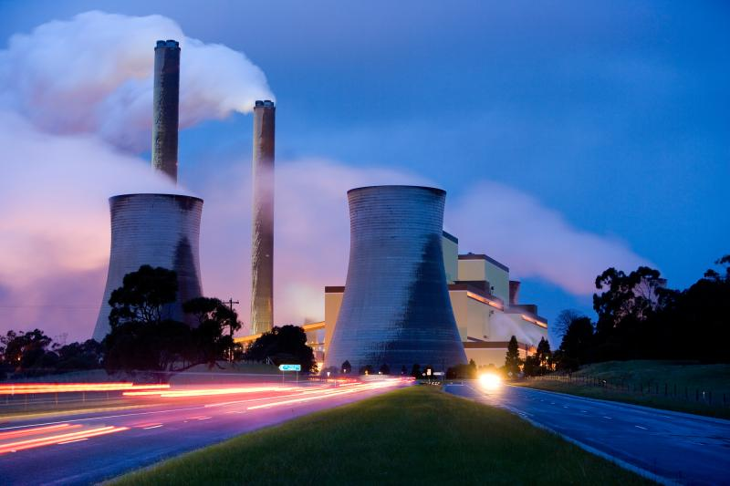
2024–25 Safeguard Mechanism data insights

Contents
2024–25 Safeguard Mechanism data highlights 3
Background 5
How the mechanism works 5
Managing excess emissions 5
ACCUs and SMCs 5
Flexibility measures 6
Compliance and enforcement 6
Upcoming scheme review 6
2024–25 Safeguard Mechanism data trends 7
The mechanism continues to work as expected 7
Compliance remains high 7
Declining baselines maintain downward pressure on emissions 7
Covered emissions by sector 9
Unit surrenders 10
Use of flexibility measures 12
Key issues beyond 2024–25 13
Continued investment in decarbonisation is needed 13
Spotlight: decarbonisation technologies 13
Conclusion: promising progress, but continued action is needed 14

2024–25 Safeguard Mechanism data highlights
The Safeguard Mechanism, administered by the Clean Energy Regulator (CER), is designed to deliver greenhouse gas emissions reductions at Australia’s largest emitting facilities on a trajectory consistent with achieving Australia’s emissions reduction targets of 43% below 2005 levels by 2030, and net zero by 2050.
To achieve this, the scheme’s objectives outline net emissions from all safeguard facilities should not exceed:
- 100 million tonnes carbon dioxide equivalent (Mt CO₂-e) in 2029–30
- zero tonnes carbon dioxide equivalent (tCO₂-e) per year from 2049–50
- 1,233 Mt CO₂-e in total over the decade from 1 July 2020 to 30 June 2030.
This will deliver over 200 million tonnes of abatement by the end of the decade.
Over the 2024–25 compliance period, the Safeguard Mechanism has operated consistently with the policy settings of government.
Key outcomes from the 2024–25 compliance period are reported below. All numbers in this report are correct as at 1 April 2026. They may be subject to minor change due to resubmission of NGER reporting.
- 208 facilities were covered by the Safeguard Mechanism.
  - This is lower than the 219 facilities covered in the 2023–24 reporting period .
  - Since the preliminary data was published, the review of NGER data led to 2 facilities moving above the Safeguard threshold and 1 facility dropping below.
- Total covered emissions were 132.8 Mt CO₂-e – a 2.3% reduction from 136.0 Mt CO₂-e in 2023–24.
- Total net emissions were 120.3 Mt CO₂-e following the surrender of Australian carbon credit units (ACCUs) and Safeguard Mechanism credit units (SMCs) – a 5.5% reduction from 127.3 Mt CO₂-e in 2023–24.
- Total baselines were 126.2 Mt CO₂-e – a 7.3% reduction from 136.1 Mt CO₂-e in 2023–24.
- Once flexibility measures for the 2024–25 reporting period were finalised, 141 facilities’ net emissions exceeded their baselines, with a total excess of 13.7 Mt CO₂-e.
  - This is an increase of 4.5 Mt CO₂-e, from the 9.2 Mt CO₂-e total excess in 2023–24.
- To manage excess emissions, entities surrendered:
- 2.6 million SMCs
- 10.8 million ACCUs.
- SMC issuances for 2024–25 totalled 6.7 million – a 19.4% reduction from 8.3 million in 2023–24. SMCs were issued to 54 responsible emitters.
- 10 facilities accessed flexibility measures, comprising:
- 7 new trade-exposed baseline adjustment (TEBA) determinations
- 2 new multi-year monitoring period (MYMP) declarations
- 1 new borrowing adjustment determination
- zero exemption declarations
- The new MYMPs and borrowing adjustments for 2024–25 covered approximately 87,000 tCO₂-e of excess emissions, reducing the need for ACCU or SMC surrenders. These deferred liabilities will need to be brought to account in subsequent years.
- 1 new Emissions Intensity Determination (EID) was made for 2024–25.
  - 2 EIDs were varied following facilities moving to higher order emissions estimation methods. The variations reflect material changes in emissions and ensure consistency between baseline calculations and annual emissions reporting for these facilities.
- The 5‑year rolling average covered emissions for 2024–25 was 136.4 Mt CO₂-e.
- From 1 July 2020 to 30 June 2025, total net emissions were 659.6 Mt CO₂-e.
  - It is an objective of the Safeguard Mechanism that total net emissions for the decade from 1 July 2020 to 30 June 2030 do not exceed 1,233 Mt CO₂-e.
The complete Safeguard Mechanism data for 2024–25 is published on our website.

Background
The Safeguard Mechanism provides industry with a stepped and predictable regulatory incentive to reduce their emissions in line with Australia’s emissions reduction targets. It is designed to incentivise emissions reduction projects at large facilities, while allowing for the time and capital investment that may be required to deliver onsite emissions reductions.

How the mechanism works
The Safeguard Mechanism applies to any facility in Australia that emits more than the safeguard threshold of 100,000 tCO₂-e of covered scope 1 emissions in a financial year. This includes facilities across a range of sectors – including coal mining, metal ore mining, oil and gas extraction, manufacturing, and transport. In 2024–25, covered emissions from safeguard facilities made up 29.9% of Australia’s total emissions.
The scheme sets limits, known as baselines, on the greenhouse gas emissions of covered facilities. These baselines generally decline by 4.9% each year, placing downward pressure on industrial emissions to meet Australia’s emissions reduction targets.
Data reported under the National Greenhouse and Energy Reporting (NGER) Scheme is used to calculate the emissions covered by the scheme for each facility in a financial year (covered emissions). This is used to calculate the facility’s net emissions number.
If a facility’s net emissions number is under its baseline, the company with operational control of the facility (its responsible emitter) may be eligible to receive SMCs.

Managing excess emissions
If a facility’s net emissions number is over its baseline, its responsible emitter is required to manage excess emissions.
A responsible emitter can manage excess emissions by surrendering ACCUs or SMCs or by accessing flexibility measures.

ACCUs and SMCs
The use of ACCUs and SMCs to manage excess emissions is an important design feature of the scheme, allowing facilities to meet their safeguard obligations while they transition to low-emissions technologies that reduce the emissions released from their facilities.
An ACCU represents one tCO₂-e of emissions sequestered or avoided by an eligible offsets project registered with the CER. ACCUs are a high integrity, globally recognised product backed by the Australian Government. Safeguard facilities are playing a central role in the development of Australia’s carbon markets by using ACCUs to support their compliance with the Safeguard Mechanism.
An SMC represents one tCO₂-e by which a facility’s total covered emissions are below its baseline for a financial year. SMCs are an incentive for facilities to reduce their emissions below their baselines.

Flexibility measures
Responsible emitters can also manage their excess emissions by accessing the scheme’s flexibility measures, if their circumstances meet the eligibility criteria. The following flexibility measures are available:
- TEBA: Facilities with a TEBA receive a reduced baseline decline rate for up to 3 financial years. To be eligible for a TEBA, the facility must satisfy strict criteria related to trade exposure and the cost impact of Safeguard compliance on their revenue or earnings.
- MYMPs: These help responsible emitters implement decarbonisation projects that take multiple financial years to deploy. A MYMP gives a facility up to 5 financial years to implement a decarbonisation project that will reduce its cumulative emissions below its cumulative baseline for the period.
- Borrowing adjustment: Borrowing adjustments help responsible emitters manage their emissions across 2 financial years. A facility’s baseline for a financial year is increased by a number of tCO₂-e up to 10% of the baseline emissions number. The facility’s baseline for the following year is reduced by the number of tCO₂-e that was borrowed, plus a further amount of reduction, which can be thought of as ‘interest’ on the borrowed amount.
- Exemption declaration: Where an emitter can demonstrate that their facility’s emissions exceeded its baseline as a direct and entire result of a natural disaster or criminal activity, the facility can be exempt from the operation of the Safeguard Mechanism for one financial year.

Compliance and enforcement
The CER has a range of enforcement powers where responsible emitters fail to manage excess emissions. We can take enforcement action drawing from our full suite of compliance and enforcement powers.
As described in our compliance and enforcement priorities, our responses to non-compliance are proportionate to the relevant circumstances. Safeguard emitters who fail to meet their obligations by the relevant deadline should expect that the CER will take strong enforcement action.
The CER publishes quarterly updates on compliance activity.

Upcoming scheme review
The government’s review of the Safeguard Mechanism in 2026–27 will consider whether its policy settings are appropriately calibrated – these matters are set on the Department of Climate Change, Energy, the Environment and Water’s website.
The review will consider matters such as baseline calculation, options to manage excess emissions, flexibility mechanisms, trade-exposed industry sectors, availability of SMCs and overall scheme coverage.

2024–25 Safeguard Mechanism data trends

The mechanism continues to work as expected
2024–25 was the second compliance period to be completed since the Safeguard Mechanism reform in 2023. The data shows the Safeguard Mechanism continues to progress well in line with expectations and policy settings.
The cumulative impact of the scheme since its reform includes a total reduction in covered emissions of 5.8 Mt CO₂-e across the 2 completed years, with net emissions falling by 17.5 Mt CO₂-e. Baselines have reduced by a total of 45.4 Mt CO₂-e in the 2 years, resulting in the total removal of aggregate headroom (the difference between total covered emissions and total baselines across the scheme).

Compliance remains high
Compliance with the Safeguard Mechanism was again high, with 205 (98.6%) of the 208 covered facilities being compliant with the requirement to not be in an excess emissions situation on the compliance deadline of 1 April 2026.
There were 3 facilities under the operational control of 3 responsible emitters (all of which are related to 1 corporate group) that did not meet the surrender deadline, resulting in excess emissions situations totalling 317,212 tCO₂-e on 1 April. Of those responsible emitters, 1 is in liquidation and 2 are in administration.
Further details are published in the excess emissions situations table.
The CER takes all non-compliance seriously and is considering appropriate and proportionate responses to each instance of non-compliance on a case-by-case basis. We publish our annual compliance and enforcement priorities and quarterly updates on our website.

Declining baselines maintain downward pressure on emissions
Each Safeguard facility’s baseline is published in the baselines and emissions table.
Details of facilities whose baseline is calculated using a facility-specific emissions intensity under an emissions-intensity determination (EID) are published in the EID table.
Following the 2023 reforms, baselines were recalculated and the 4.9% baseline decline rate was applied to most facilities. In 2023–24, the remaining difference between total covered emissions and total baselines across the scheme (referred to as aggregate headroom) was almost completely removed.
2024–25 was the first time that total covered emissions were higher than total baselines, meaning aggregate headroom was removed. As baselines continue to decline each year, downward pressure on net emissions will continue, thereby requiring greater use of ACCUs and SMCs and incentivising further decarbonisation.
Graph 1: Cumulative baselines and emissions
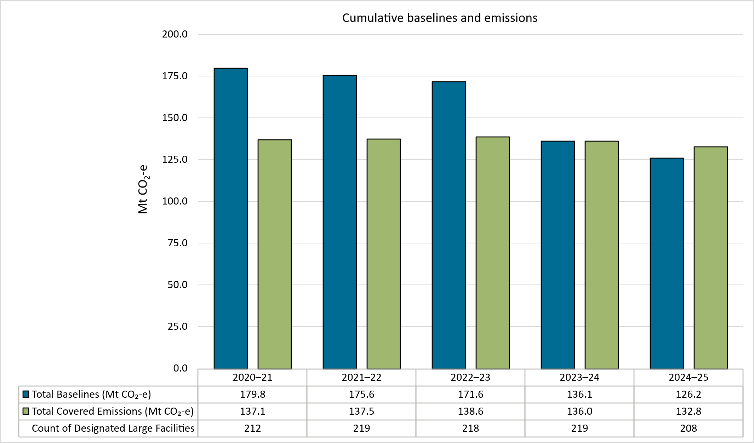
In 2024–25, the total amount by which covered emissions exceeded baselines across the scheme (total excesses) increased by 48.8% from 2023–24. Rising excesses are a likely outcome of the continued baseline decline and the removal of aggregate headroom.
Total baselines for 2024–25 were 7.3% lower than for 2023–24, reflecting the application of the decline rate, changes in which facilities are covered by the Safeguard Mechanism and changes to individual facilities’ production.

Despite total covered emissions modestly reducing by 3.2 Mt CO₂-e in 2024–25, aggregate baselines fell more sharply by 9.9 Mt CO₂-e. This indicates higher excesses are not driven by facilities emitting more, but because baselines are declining faster than emissions are falling. Over time this creates a progressively stronger incentive for emitters to invest in onsite abatement.

Covered emissions by sector
Each Safeguard facility’s covered emissions are published in the baselines and emissions table.
In 2024–25 the distribution of covered emissions by industry sectors remained consistent with the distribution observed for 2023–24. The largest emitting industries in the Safeguard Mechanism are oil and gas, coal mining, metal manufacturing, other manufacturing (including cement), metal ore mining and transport.
Graph 2: Covered emissions by sector
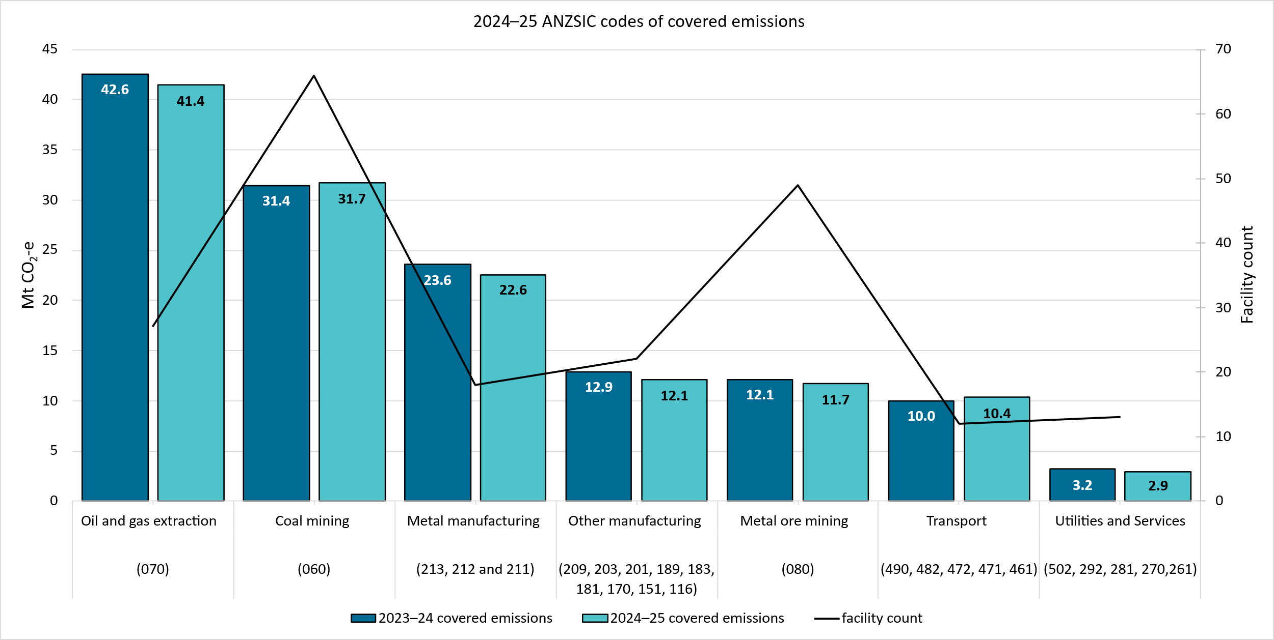
Changes in covered emissions from 2023–24 to 2024–25 are due to a combination of changes in production, operational circumstances, and emissions intensities. The CER has performed additional analysis to distinguish changes in covered emissions caused by changes in production from those caused by changes in emissions intensity.

A reduction in a sector’s overall emissions intensity indicates that facilities are producing less emissions per unit of production. If the reduction of emissions intensity is greater than the effect of the baseline decline rate, generally excess emissions will decrease. Conversely if a sector’s overall emissions intensity increases, generally excess emissions will also increase.
The oil and gas sector had the largest covered emissions reduction in 2024–25. Our analysis estimates that approximately half of these emissions reductions were due to production reductions, and half due to reductions in individual facilities’ emissions intensities. A lower emissions intensity indicates that the facility is releasing fewer emissions per unit of production. The successful implementation of carbon capture and storage (CCS) at the Moomba Plant facility has contributed to the reduction in the oil and gas sector’s emissions intensity.
Conversely, when viewed as a whole, the coal mining sector saw a greater increase in total emissions than production in 2024–25. This reflected an increase in emissions intensity in that sector. The rise in emissions intensity indicates that the coal mining sector released more emissions per unit of production than in 2023–24. Increases in emissions intensity at some facilities can be attributed to the mining of gassier areas, decommissioning activities for underground mines, and disruptions to production. However, there were also decreases in emissions intensity at other facilities with some coal mines taking actions to reduce emissions, such as capturing and combusting coal mine waste gas.
The CER will continue to examine other industry sectors’ performance under the Safeguard Mechanism, such as through its regular Quarterly Carbon Market Reports.

Unit surrenders
The number of units surrendered by each Safeguard facility for 2024–25 is published in the baselines and emissions table.
The methodology determination for each ACCU surrendered for a safeguard facility for 2024–25 is published in the ACCU methods table.
Safeguard facilities can manage excess emissions by surrendering either one ACCU or one SMC per tCO₂-e by which their net emissions number exceeds their baseline. For the 2024–25 compliance period, 139 facilities surrendered 10.8 million ACCUs and 2.6 million SMCs – totalling 13.4 million units surrendered altogether. This is an increase of 49% of unit surrenders from 2023–24.
Graph 3: Surrendered prescribed carbon units and SMCs issued
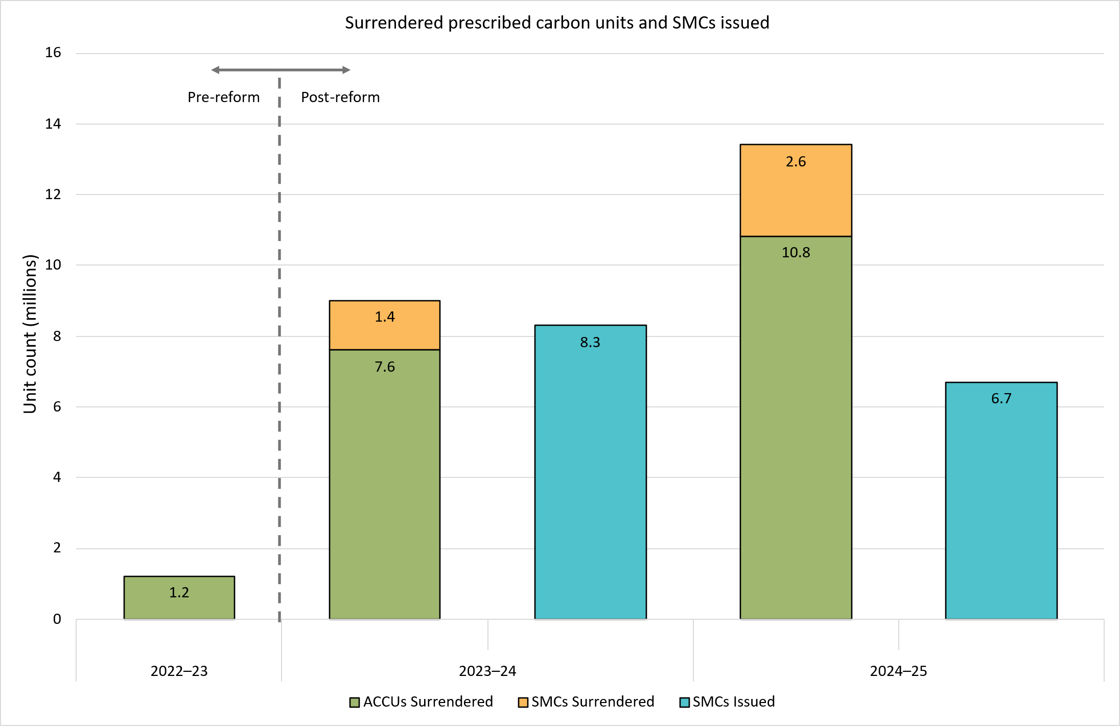
This increase in surrenders reflects the baseline decline rate, alongside the fact that many emitters are yet to adopt large-scale decarbonisation initiatives. ACCUs and SMCs are likely to remain key to emitters’ safeguard compliance strategies while decarbonisation technologies are developed and established.
For both 2023–24 and 2024–25, the number of SMCs surrendered was significantly less than the number issued. This suggests that many emitters that earn SMCs are choosing to bank them for a future compliance year, rather than trade them to another emitter for immediate surrender.
The CER is required the publish the applicable ACCU Scheme methodology determination under which each ACCU surrendered for Safeguard compliance was issued. The split of methodology determinations for surrendered ACCUs for 2024–25 is shown in the graphic below.
Graph 4: ACCU surrenders by method type
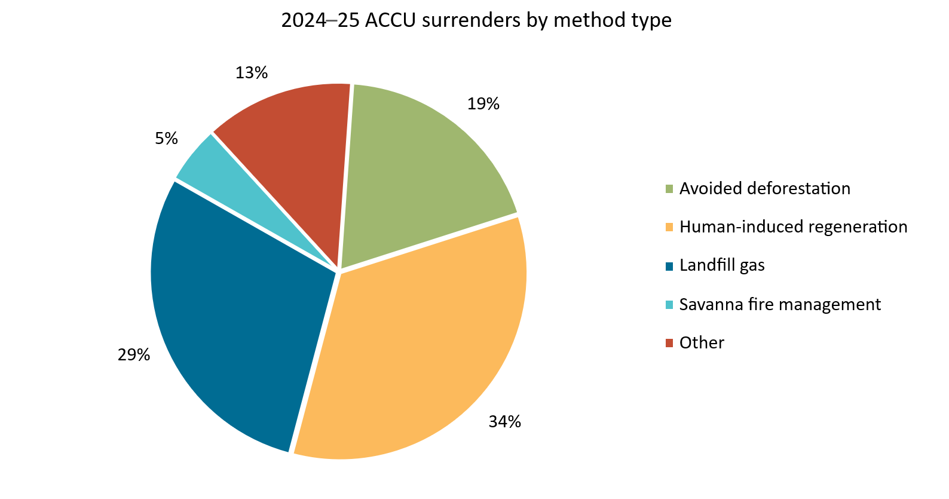
Safeguard facilities that surrender ACCUs equivalent to 30% or more of their baseline must provide a statement explaining why the responsible emitter has not undertaken more onsite abatement. These often cite low availability of affordable decarbonisation technologies, and facilities’ operational circumstances, as the reasons why more onsite abatement did not occur. For 2024–25, 23 facilities triggered this requirement.
The statements by each facility that surrendered ACCUs equivalent to 30% or more of their baseline are published at ACCU surrender statements.

Use of flexibility measures
Facilities’ access to Safeguard Mechanism flexibility measures is published in the:
- TEBA table
- MYMP table.
For each facility with a MYMP, the CER publishes the responsible emitter’s MYMP emissions reduction summary plan. When a MYMP concludes, the CER publishes the responsible emitter’s MYMP explanation of performance.
Borrowing adjustments are detailed in the baselines and emissions table.
10 facilities accessed flexibility measures for 2024–25, comprising 7 new TEBAs, 2 new MYMPs and 1 new borrowing adjustment determination. Zero facilities accessed exemption declarations.
Several facilities had pre-existing flexibility measures in train for 2024–25:
- 16 TEBAs commenced in previous years remained ongoing in 2024–25. 1 was revoked and replaced by a new TEBA for the same facility for a period that overlapped with the original TEBA’s period.
- 7 MYMPs commenced in previous years remained ongoing in 2024–25, including 1 which concluded at the end of the financial year with its cumulative net emissions for its MYMP below its cumulative baseline resulting in an SMC issuance.
- 3 facilities had accessed borrowing adjustments for 2023–24 and had their baselines for 2024–25 decreased by the borrowed amount plus 2% ‘interest’.

Key issues beyond 2024–25

Continued investment in decarbonisation is needed
Although the reformed scheme is still in its early years, the Safeguard Mechanism continues to operate as expected and will continue to play a pivotal role by progressively incentivising high-emissions facilities to invest in strategies and new technologies to drive decarbonisation in future years.
Some facilities have already implemented commercial decarbonisation projects, and several others are in the process of developing projects (see Spotlight: decarbonisation technologies). These early signs are promising. However, as baselines progressively decline, on-site abatement will become increasingly key for responsible emitters to meet their safeguard obligations. On-site abatement can consist of abatement technologies, fuel switching or operational improvements such as minimising gas leaks and using more efficient equipment.
Making the significant capital investments to reduce on-site emissions is challenging and takes time so responsible emitters should be actively investigating opportunities, and beginning to implement plans for emissions reductions wherever possible.
Support such as the Powering the Regions Fund Safeguard Transformation Stream may also be available to emitters beginning to decarbonise.

Spotlight: decarbonisation technologies
Early progress in safeguard decarbonisation has primarily involved concentrated deployment of emerging technologies in the manufacturing, oil and gas, and metal ore mining sectors. Some of the technologies currently being used by safeguard emitters to decarbonise are tertiary abatement, carbon capture and storage, and electrification.
Tertiary abatement
Tertiary abatement is an emissions reduction technology that is being used by safeguard facilities in the chemical manufacturing industry to reduce nitrous oxide (N₂O) emissions, a large contributor to scope 1 emissions. Nitrous oxide has a global warming potential 265 times greater than carbon dioxide. It is often released as a by-product of nitric acid production.
Tertiary abatement systems use a catalytic process to break down nitrous oxide into nitrogen and oxygen, removing its global warming potential. These projects have reduced nitrous oxide emissions from their facilities by 95% or more. The technology is currently used by several safeguard facilities across the chemical manufacturing sector due to its proven commercial viability.
Carbon capture and storage (CCS)
CCS is a decarbonisation technology used for managing emissions from the oil and gas industry. CCS systems capture carbon dioxide emissions from oil and gas extraction, production and transport processes and permanently store them underground in geological formations so that they are not released into the atmosphere.
While the scale and performance of CCS projects vary, the technology has potential to achieve large‑volume abatement when geological conditions, capture feasibility and supporting infrastructure align. There are currently 2 CCS projects in commercial operation by safeguard emitters. A number of other CCS projects are under development in Australia.
Electrification
Electrification remains a critical pathway for reducing industrial emissions, particularly where equipment and vehicles can be powered by renewable electricity. Advances in battery storage, electric motors and charging systems are expanding the range of applications suited to electrification.
Safeguard facilities have conducted trials of electric haulage systems, charging depots and electrified production equipment. The scale and pace of electrification adoption vary, and some projects have experienced setbacks due to supplier delays or commercial costs. However, electrification could provide many safeguard facilities with the opportunity for reliable long‑term emissions reductions.

Conclusion: promising progress, but continued action is needed
While only 2 reporting periods have been completed since the Safeguard Mechanism was reformed, initial results are positive, with emissions continuing a downward trajectory consistent with the scheme’s objectives. Net emissions have declined by 17.5 Mt CO₂-e (12.7%) since the reform of the scheme and are tracking below the trajectory for the scheme’s objective of ≤ 100 Mt CO₂-e of net emissions in the 2029–30 financial year.
Graph 5: Progress towards net emissions target of ≤ 100 Mt CO₂-e in 2029–30
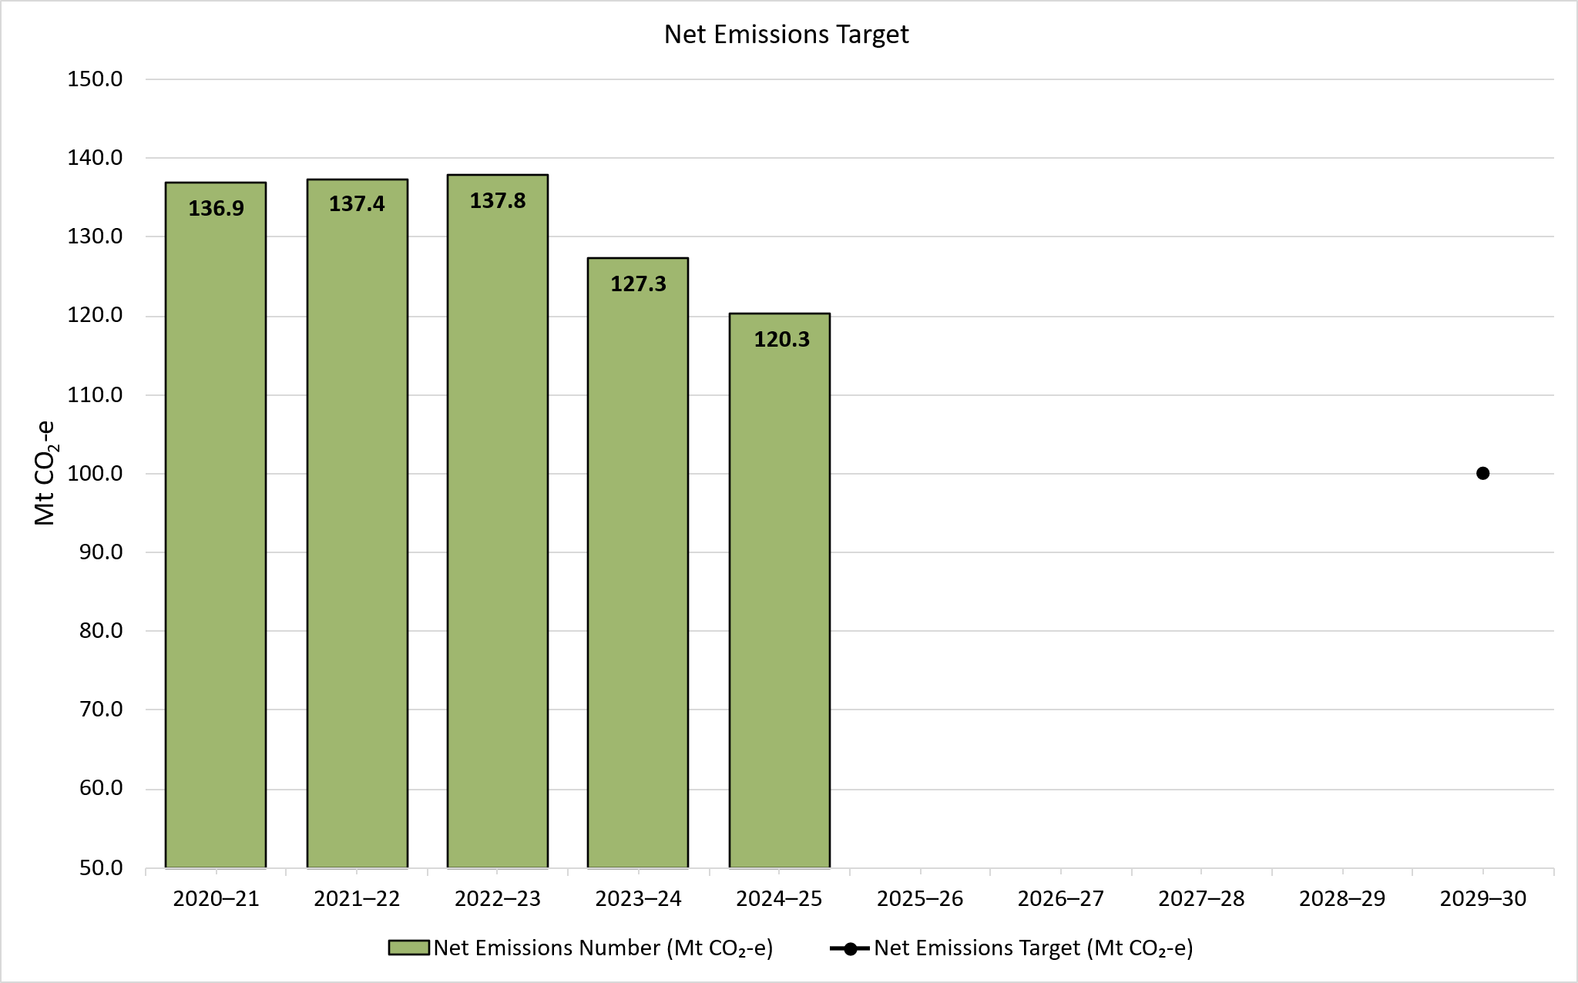

Emitters need to sustain this good early progress by investing in available technologies and continuing to support research and develop in sectors where these are still emerging.
In addition, responsible emitters should look to develop and deploy technologies that will reduce their onsite emissions over the medium and long term. Doing so will place emitters in the most advantageous position for future years. Without direct facility-level emissions reductions, declining baselines will progressively increase the cost of Safeguard Mechanism compliance through increased dependence on the ACCU and SMC market. The CER will continue to track and analyse Safeguard entities’ plans for onsite abatement.

Yearly changes in the number of covered facilities reflect facilities rising and falling above and below the 100,000 tCO₂-e Safeguard threshold. This may be due to a combination of decarbonisation efforts and changes in facilities’ operational circumstances such as openings and closures, shifts in economic conditions, world events, and changes in product demand. This figure has changed since our preliminary data publication due to NGER data quality assurance and resubmissions.
The remaining approximately 300,000 tCO₂-e stayed in an excess emissions situation on 1 April: see Compliance and enforcement
Total covered emissions from 1 July 2020 to 30 June 2025 were 681.9 Mt CO₂-e
https://cer.gov.au/markets/reports-and-data/safeguard-data
A facility’s net emissions number for a financial year is its total covered emissions for that financial year, minus the number of any surrendered ACCUs or SMCs, plus any ACCUs issued during the financial year that represent abatement of the facility’s covered emissions
https://cer.gov.au/schemes/safeguard-mechanism/managing-excess-emissions
https://cer.gov.au/about-us/our-compliance-approach/compliance-and-enforcement-priorities/compliance-and-enforcement-priorities-2025-26
https://www.dcceew.gov.au/climate-change/emissions-reporting/national-greenhouse-energy-reporting-scheme/safeguard-mechanism/overview#_202627-review-of-the-safeguard-mechanism
https://cer.gov.au/schemes/safeguard-mechanism/managing-excess-emissions/excess-emissions-situation-data#excess-emissions-situation-table
https://cer.gov.au/about-us/our-compliance-approach/compliance-and-enforcement-priorities/compliance-and-enforcement-priorities-2025-26
https://cer.gov.au/markets/reports-and-data/safeguard-data/2024-25-baselines-and-emissions-data#baselines-and-emissions-table
https://cer.gov.au/markets/reports-and-data/safeguard-data/emissions-intensity-determination-data#emissions-intensity-determinations-table
https://cer.gov.au/schemes/safeguard-mechanism/safeguard-baselines#standard-baseline
A facility’s baseline is calculated each year based on the quantity of each production variable produced in that year multiplied by the relevant emissions intensity value. The decline rate, which is typically 4.9%, is then applied. The emissions intensity value used to calculate baselines for existing facilities is set using a hybrid approach initially weighted towards the use of facility-specific emissions intensity values (set by the CER under an EID based on historical production and emissions data), and transitioning to default emissions intensity values based on industry averages by 2030. Default emissions intensity values based on industry averages provide an incentive for production to occur where it is least emissions intensive.
https://cer.gov.au/markets/reports-and-data/safeguard-data/2024-25-baselines-and-emissions-data#baselines-and-emissions-table
Other industries covered by the Safeguard Mechanism for 2024–25 included Electricity generation (ANZSIC code 261), Gas supply (270), Pipeline and other transport (502), Waste treatment, disposal and remediation services (292), Water supply, sewerage and drainage services (281).
https://cer.gov.au/markets/reports-and-data/quarterly-carbon-market-reports
https://cer.gov.au/markets/reports-and-data/safeguard-data/2024-25-baselines-and-emissions-data#baselines-and-emissions-table
https://cer.gov.au/markets/reports-and-data/safeguard-data/2024-25-baselines-and-emissions-data#accu-methods-table
https://cer.gov.au/markets/reports-and-data/safeguard-data/2024-25-baselines-and-emissions-data#accu-surrender-statements
https://cer.gov.au/markets/reports-and-data/safeguard-data/trade-exposed-baseline-adjusted-facility-data#safeguard-teba-table
https://cer.gov.au/markets/reports-and-data/safeguard-data/multi-year-monitoring-period-data#multi-year-monitoring-period-table
https://cer.gov.au/markets/reports-and-data/safeguard-data/multi-year-monitoring-period-data#mymp-emission-reduction-summary-plan
https://cer.gov.au/markets/reports-and-data/safeguard-data/multi-year-monitoring-period-data#mymp-explanation-of-performance
https://cer.gov.au/markets/reports-and-data/safeguard-data/2024-25-baselines-and-emissions-data#baselines-and-emissions-table
https://business.gov.au/grants-and-programs/powering-the-regions-fund-safeguard-transformation-stream-round-2

