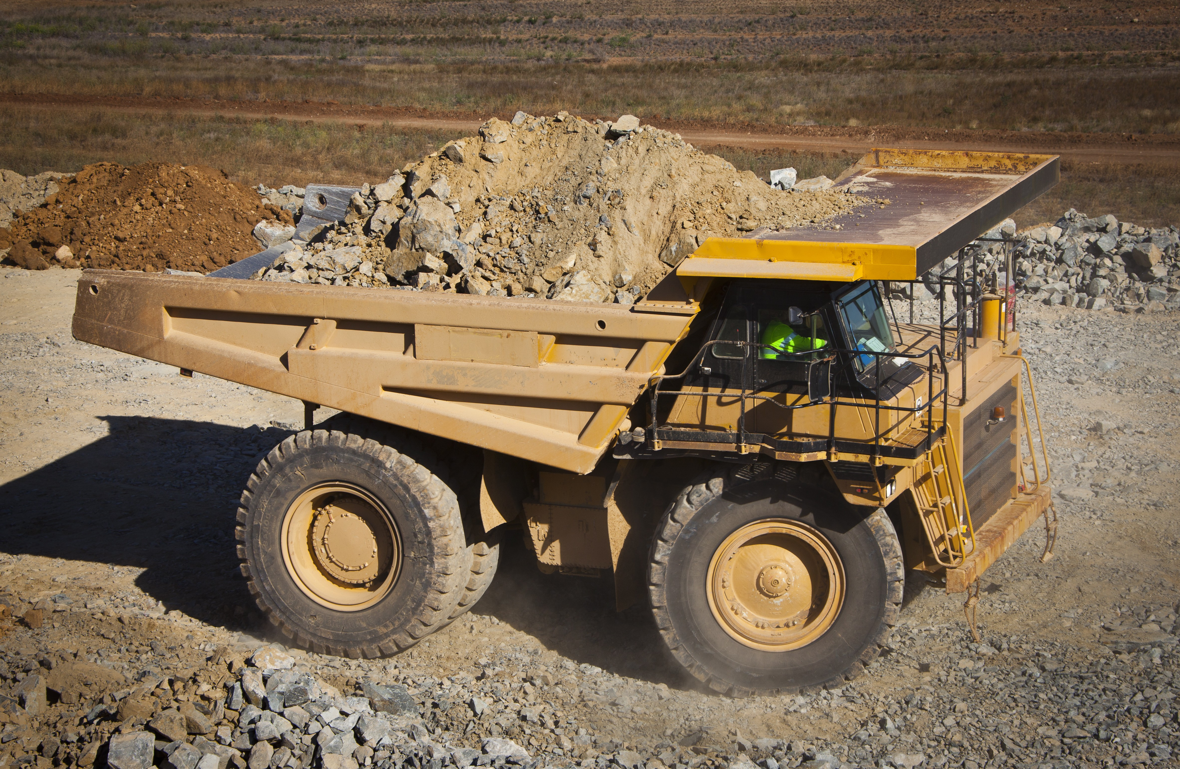2023–24 safeguard data insights

# Contents

Contents 2

2023–24 safeguard data insights 3

Purpose of the Safeguard Mechanism 3

Key elements of the Safeguard Mechanism 3

2023–24 Highlights 4

Safeguard Mechanism Outcomes for 2023–24 5

Reduced cumulative baselines have removed headroom 5

Setting baselines 6

First issuances of SMCs in 2023–24 6

Facilities used flexibility options and surrendered ACCUs and SMCs to comply with the Safeguard Mechanism 7

TEBA 7

MYMP 7

Borrowing adjustments 8

Surrendering prescribed carbon units 8

Early signs are promising, but continued action is needed 9

# 2023–24 safeguard data insights

## Purpose of the Safeguard Mechanism

The safeguard reforms are designed to deliver greenhouse gas emissions reductions at Australia’s largest emitting facilities on a trajectory consistent with achieving Australia’s climate targets of 43% below 2005 levels by 2030 and net zero by 2050.

To achieve this, net emissions from all safeguard facilities should not exceed:

* 100 Mt CO2-e in 2029–30
* zero t CO2-e from 2049–50
* 1,233 Mt CO2-e in total over the decade from 1 July 2020 to 30 June 2030.

This will deliver over 200 million tonnes of abatement by the end of the decade.

The Safeguard Mechanism provides industry with a stepped and predictable path over time to reduce emissions and meet Australia’s legislated targets. It is designed to incentivise emissions reduction projects at large facilities but recognises that time and capital investment is needed before onsite emissions reductions can be realised.

## Key elements of the Safeguard Mechanism

The Safeguard Mechanism applies to facilities across a range of sectors – including coal mining, metal ore mining, oil and gas extraction, manufacturing, and transport – that emit more than 100,000t CO 2-e in a year. In 2023–24 covered emissions from safeguard facilities made up 31% of Australia’s total emissions in that year.

The Safeguard Mechanism sets limits, known as baselines, on the greenhouse gas emissions of covered facilities. Under the reformed mechanism these baselines generally decline by 4.9% each year to make sure net emissions fall in-line with the legislated targets.

If facilities are under their baseline, they may be eligible to generate Safeguard Mechanism credits (SMCs).

If facilities are over their baseline they are required to manage these excess emissions. Facilities have several available options for managing excess emissions, including surrendering Australian carbon credit units (ACCUs) and SMCs, or accessing a range of flexibility measures subject to meeting the required eligibility criteria.

Flexibility measures include trade-exposed baseline adjustment (TEBA) determinations, multi-year monitoring period (MYMP) declarations, and borrowing adjustment determinations.

The use of ACCUs and SMCs to [manage excess emissions](https://cer.gov.au/schemes/safeguard-mechanism/managing-excess-emissions)[1] is an important design feature allowing facilities to meet their legislative obligations as they transition to low-emissions technology that reduces emissions at the source.

## 2023–24 Highlights

The 2023–24 safeguard publication includes the first data from the reformed scheme after declining baselines were introduced.

The data shows the Safeguard Mechanism is progressing well, and results align with the expectations established through the reformed policy settings.

2023–24 data highlights include:

* 219 facilities were covered by the Safeguard Mechanism
* Emissions reduced from 138.7 million tonnes of carbon dioxide equivalent (Mt CO2-e) in 2022-23, to 136.0 Mt CO2-e in 2023–24.
* [Emissions Intensity Determinations](https://cer.gov.au/schemes/safeguard-mechanism/safeguard-baselines#apply-for-an-emissions-intensity-determination)[2] (EIDs) were made for 221 facilities.
* At a scheme level, the EIDs removed nearly all headroom from aggregate facility baselines. Aggregate baselines for 2023–24 are 136.1 Mt CO2-e.
* To ensure consistency between baseline calculation and annual emissions reporting, 7 EIDs were varied to reflect a material change in a facility’s emissions as a result of the facility moving to a higher order method for estimating its emissions.
* 62 facilities received an approximate total of 8.3 million SMCs as their emissions were below their baseline.
* 142 facilities incurred a total liability of 9.2 Mt CO2-e because their emissions were above their baseline. To manage excess emissions, facilities surrendered:
* 1.4 million SMCs
* 7.1 million ACCUs.[3]
* Following the surrender of ACCUs and SMCs, net safeguard emissions fell to 127.8 Mt CO2-e.
* 26 facilities accessed flexibility measures, including:
* 17 TEBA determinations
* 6 new MYMP declarations
* 3 borrowing adjustment determinations.

The new MYMP and borrowing adjustments for 2023–24 covered approximately 549,376 t CO2-e that would otherwise have been needed to be met through ACCU or SMC surrenders. These deferred liabilities will need to be brought to account in subsequent years.

Implementation of the Safeguard Mechanism was managed through the Clean Energy Regulator’s (CER) new Online Services and the first issuance of SMCs were processed through the CER’s new Unit and Certificate Registry.

Compliance with the Safeguard Mechanism was high, with 98 per cent of the 219 safeguard facilities not in an excess emissions situation on 1 April. Five facilities under the operational control of three responsible emitters did not meet the surrender deadline. Of these responsible emitters, two are in voluntary administration and the remaining responsible emitter, Fitzroy (CQ) Pty Ltd, has entered into a court enforceable undertaking.

The CER engaged with a wide range of regulated facilities over the course of the year and has observed a significant uplift in planning for the development and implementation of emissions reduction strategies. We will continue to closely monitor and report progress.

# Safeguard Mechanism Outcomes for 2023–24

## Reduced cumulative baselines have removed headroom

Due to the reforms, baselines were reset and the 4.9% baseline decline rate was applied to most facilities. This resulted in aggregate headroom being almost completely removed. Aggregate headroom is the difference between total covered emissions and total baselines.

* Aggregate covered emissions from safeguard facilities for 2023–24 reduced to approximately 136.0 Mt CO2-e, down from 138.7 Mt CO2-e in 2022-23.
* Aggregate net safeguard emissions for 2023–24 were 127.8 Mt CO2-e

As the baseline decline rate compounds each year, this will continue to place downward pressure on emissions.

*Graph 1: Cumulative baselines and emissions*

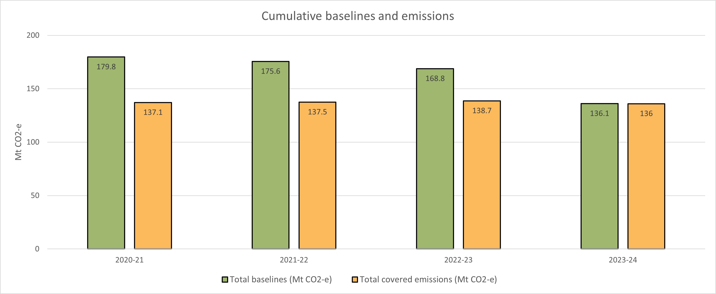

## Setting baselines

A facility’s baseline is calculated each year based on the sum of the quantity of each [production variable](https://cer.gov.au/schemes/safeguard-mechanism/safeguard-baselines#standard-baseline)[4] produced for that year multiplied by the relevant emissions intensity value. The decline rate, which is typically 4.9%, is then applied.

The emissions intensities used to calculate baselines for existing facilities are set using a hybrid approach initially weighted towards the use of facility-specific emissions intensity values. This will move to default emissions intensity values, based on industry averages, by 2030.

Industry average baselines provide an incentive for production to occur where it is least emissions-intensive, while facility-specific baselines recognise individual facility circumstances.

Facility-specific emissions-intensity values are set through the CER’s Emissions-Intensity Determination (EID) process. This process set facility-specific emissions-intensities for each product produced at the facility, based on the facility’s historical production and emissions data.

EID applications are required to be independently audited before being assessed by the CER. The CER made and [published 221 EIDs](https://cer.gov.au/markets/reports-and-data/emissions-intensity-determination-data-safeguard-facilities)[5] over the last year to reset baselines.

Once EIDs are set the CER can only vary them in certain circumstances, for example, to ensure that baselines are not distorted by significant changes in the way that activities at a facility are reported, such as by a change in method used to estimate its emissions. For 2023–24, the CER varied 7 EIDs due to facilities changing method, where the change in method resulted in a material impact on the facility’s emissions profile. This led to some baselines increasing and some decreasing.

The ability to vary EIDs in these circumstances allows the CER to make sure a facility’s baseline, and the facility’s covered emissions that are compared to that baseline, are calculated in a consistent manner.

## First issuances of SMCs in 2023–24

The 2023–24 compliance period was the first period in which SMCs were issued. SMCs can be issued when a facility is below its baseline and are designed to incentivise facilities to further reduce their emissions below baseline. A total of 8.3 million SMCs were issued to 62 facilities for the 2023–24 period.

In the short term, efficiency gains may be easier to make in some sectors and at some facilities, while for others, emissions reduction projects may take longer to implement but may then provide a step change in an emissions profile.

The ability to trade SMCs also enables hard to abate sectors the ability to access lower cost abatement from other safeguard facilities, reducing overall scheme costs.

Facilities were more likely to be eligible for SMCs in 2023–24 if they started from a lower emissions intensity or had efficiency gains that were further progressed or could be implemented quickly. These facilities will need to maintain their efficiency efforts if they are to continue to receive SMCs, as the declining baseline will require ongoing emissions reduction.

Other types of emissions reduction projects, such as electrification projects and the replacement of industrial processing equipment, can be capital intensive and take several years to implement. In future years projects of this nature are expected to be a substantial driver of emissions reduction.

## Facilities used flexibility options and surrendered ACCUs and SMCs to comply with the Safeguard Mechanism

To meet compliance obligations, safeguard facilities have several flexibility options to manage excess emissions.

For the 2023–24 compliance period the CER approved:

* 17 Trade-Exposed Baseline Adjusted (TEBA) applications
* 6 Multi-Year Monitoring Period (MYMP) applications to commence in 2023–24
* 3 borrowing adjustment applications.

### TEBA

To be eligible for a TEBA determination, a facility must demonstrate the cost of acquiring ACCUs and/or SMCs to comply with its safeguard obligations meet a set financial test. This varies depending on whether the facility is a manufacturing or non-manufacturing facility.

In 2023–24 all facilities that applied were manufacturing facilities and were required to demonstrate the cost of compliance would be greater than 3% of the facility’s Earnings Before Interest and Tax (EBIT). All 17 facilities were eligible to receive the minimum 1% decline rate (instead of the standard 4.9%). The reduced decline rate will apply for a 3-year period.

Facilities were required to provide a rigorous third-party audit as part of the TEBA application process.

### MYMP

MYMPs allow a facility an extended time for compliance of between 2 and 5 years to enable the implementation of on-site emissions reduction plans.

Proposed emissions reduction activities for the 6 MYMPs starting in 2023-23 included:

* electrification
* tertiary abatement at a manufacturing facility
* efficiency and flaring measures at coal mines.

These MYMP plans demonstrate that investment in projects has begun. MYMP data and summary plans are [published](https://cer.gov.au/markets/reports-and-data/multi-year-monitoring-period-data).[6]

The extended time for compliance under MYMPs reduced required surrenders of ACCUs and SMCs by 513,682 t CO2-e. This will need to be brought to account in following years under MYMP compliance arrangements.

### Borrowing adjustments

Facilities can borrow up to 10% of their baseline from the following year. The amount borrowed, plus 2% interest, will then be subtracted from their baseline in the following year. Across 3 facilities, the total amount added to baselines for 2023–24 is 35,694 t CO2-e. This number, plus 2% interest, will be added to the respective baselines next year.

## Surrendering prescribed carbon units

Safeguard facilities can surrender one prescribed carbon unit (PCU) per t CO2-e they exceed their baseline. For the 2023–24 compliance period, 138 facilities surrendered 7.1 million ACCUs and 1.4 million SMCs.

*Graph 2: Surrendered prescribed carbon units and SMCs issued*

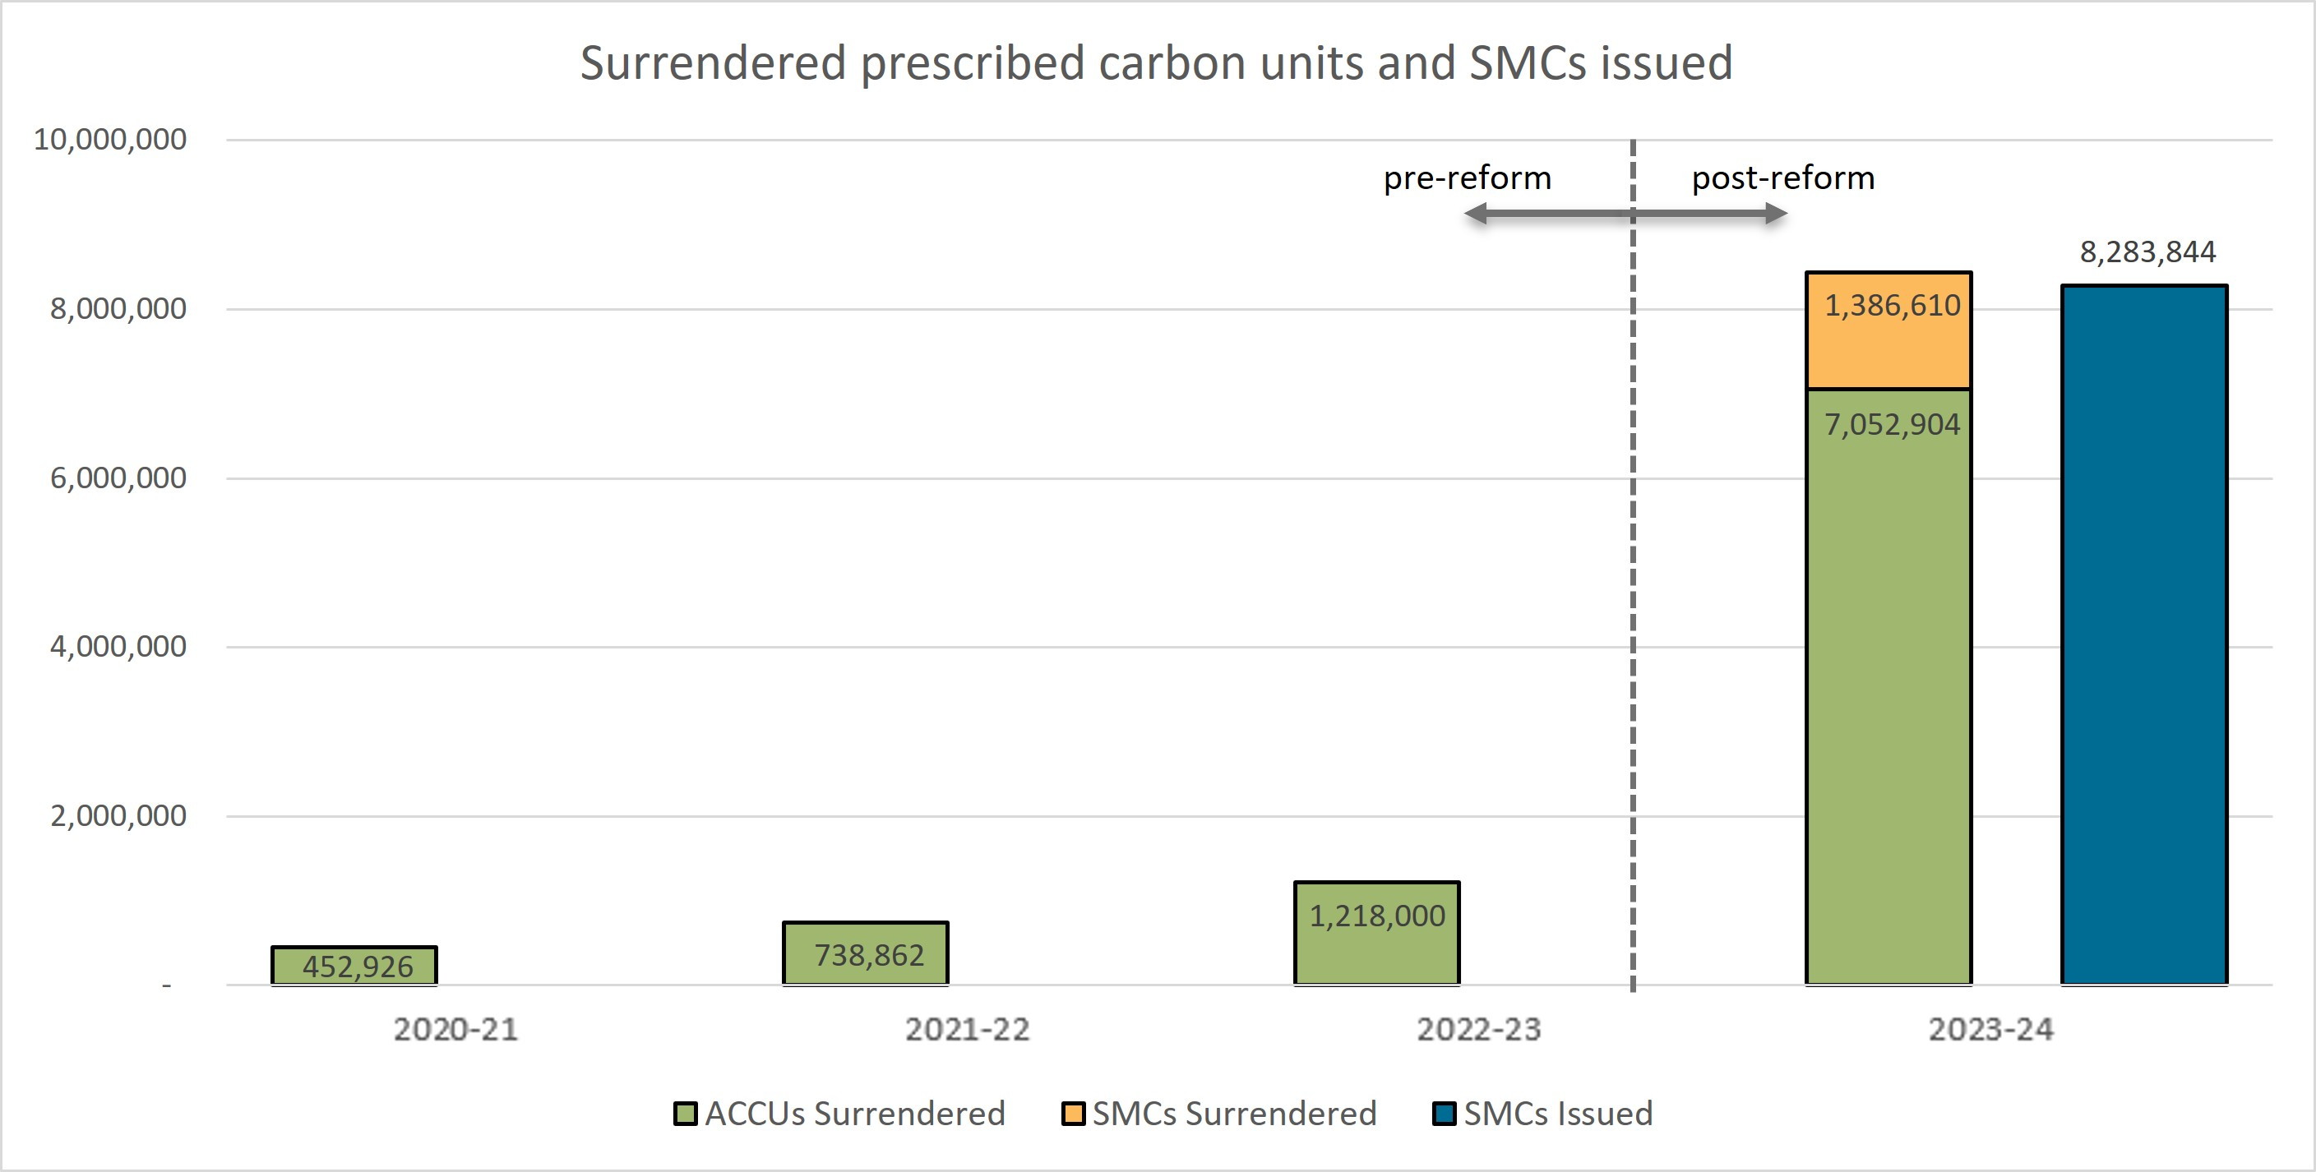

The significant increase of surrendered ACCUs from 1.2 million in 2023-23 to 7.1 million in 2023–24 is a result of the reformed scheme. Safeguard entities can use SMCs and ACCUs to manage their excess emissions while onsite emissions reduction plans are developed and executed.

For safeguard facilities that surrender ACCUs equivalent to 30% or more of their baselines, a statement explaining why the responsible emitter hasn’t undertaken more on-site abatement must be published. For 2023–24, 18 facilities triggered this requirement and their statements [have been published](https://cer.gov.au/markets/reports-and-data/safeguard-data/multi-year-monitoring-period-data).[7]

In subsequent years, declining baselines will tend to reduce SMC issuances and increase total ACCU and SMC surrenders, subject to declines in emissions from investment in low emissions intensive technology.

## Early signs are promising, but continued action is needed

The first full compliance period of the reformed Safeguard Mechanism shows:

* covered emissions have reduced by 2.7 Mt CO2-e to 136 Mt CO2-e
* the 5‑year rolling average of covered safeguard emissions for 2023–24 is 138.4 Mt CO2-e
* net emissions have reduced from 137.9 Mt CO2-e in 2022-23 to 127.8 Mt CO2-e in 2023–24
* total safeguard emissions from 1 July 2020 – 30 June 2024 were approximately 549.1 Mt CO2-e.
* Total net emissions are required to be below 1,233 Mt CO2-e over the decade from 1 July 2020 to 30 June 2030. From 1 July 2020 to 30 June 2024, total net emissions are 540 Mt CO2-e.

‘Covered emissions’ are the emissions from a facility covered by the Safeguard Mechanism as defined under the Safeguard Rule. ‘Net safeguard emissions’ are the total number of covered emissions minus (-) the number of surrendered carbon units (ACCUs and SMCs), plus (+) any ACCUs issued in relation to the reduction of covered emissions at a safeguard facility during the year.

Under the Safeguard Mechanism, net emissions must reduce to 100 Mt CO2-e by 2029-30.

*Graph 3: Net emissions target*

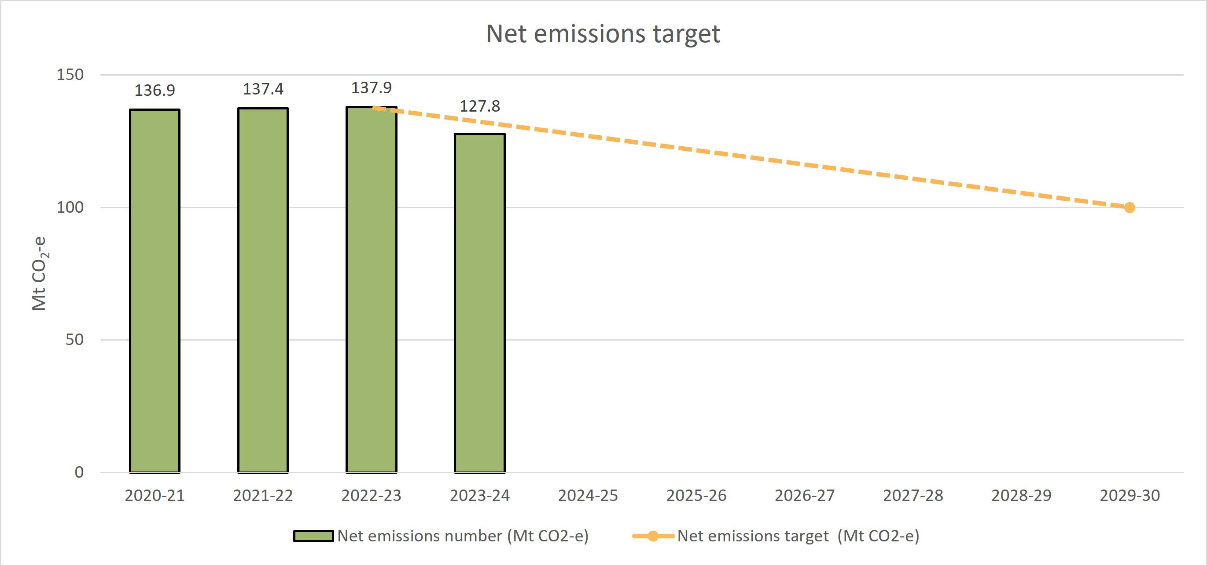

The CER has seen increased investments in emissions reduction projects and will continue to track, analyse and publish information about Safeguard entities’ detailed compliance strategies, including for onsite abatement. This is consistent with the government’s [Annual Climate Change Statement 2024.](https://www.dcceew.gov.au/climate-change/strategies/annual-climate-change-statement-2024)[8]

1. https://cer.gov.au/schemes/safeguard-mechanism/managing-excess-emissions
2. https://cer.gov.au/schemes/safeguard-mechanism/safeguard-baselines#apply-for-an-emissions-intensity-determination
3. The remaining approximately 0.8 Mt CO2-e remained in an excess emissions situation on 1 April.
4. https://cer.gov.au/schemes/safeguard-mechanism/safeguard-baselines#standard-baseline
5. https://cer.gov.au/markets/reports-and-data/emissions-intensity-determination-data-safeguard-facilities
6. https://cer.gov.au/markets/reports-and-data/multi-year-monitoring-period-data
7. https://cer.gov.au/markets/reports-and-data/safeguard-data/multi-year-monitoring-period-data
8. https://www.dcceew.gov.au/climate-change/strategies/annual-climate-change-statement-2024